Name of Journal: World Journal of Gastroenterology
Manuscript NO: 59465
Manuscript Type: ORIGINAL ARTICLE

Retrospective Study
Clinical features of multiple gastrointestinal stromal tumors: a pooling analysis combined with evidence and gap map

Li C et al. Clinical features of MGISTs

Chen Li, Ke-Lu Yang, Quan Wang, Jin-Hui Tian, Yang Li, Zhi-Dong Gao, Xiao-Dong Yang, Ying-Jiang Ye, Ke-Wei Jiang

Chen Li, Quan Wang, Yang Li, Zhi-Dong Gao, Xiao-Dong Yang, Ying-Jiang Ye, Ke-Wei Jiang, Department of Gastroenterological Surgery, Peking University People's Hospital, Beijing 100044, China

Ke-Lu Yang, Evidence-Based Nursing Center, School of Nursing, Lanzhou University, Lanzhou 730000, Gansu Province, China

Jin-Hui Tian, Evidence Based Medicine Center, School of Basic Medical Science of Lanzhou University, Lanzhou 730000, Gansu Province, China

Author contributions: Li C and Yang KL designed and performed the research and wrote the paper; Tian JH and Wang Q supervised the research and contributed to analysis; Li Y, Gao ZD, Yang XD, and Ye YJ provided the clinical advice and supervised the manuscript.

Corresponding author: Ke-Wei Jiang, MD, PhD, Adjunct Professor, Chairman, Chief Doctor, Director, Surgeon, Surgical Oncologist, Department of Gastroenterological Surgery, Peking University People's Hospital, No. 11 Xizhimen South Street, Xicheng District, Beijing 100044, China. jiangkewei@pkuph.edu.cn

Received: September 12, 2020
Revised: November 9, 2020
Accepted: November 21, 2020
Published online:

Abstract
BACKGROUND
Multiple gastrointestinal stromal tumors (MGISTs) are a very rare type of gastrointestinal stromal tumor (GIST) and are usually observed in syndrome.

AIM
To describe the clinical and oncological features of MGISTs and to offer evidence for the diagnosis and treatment MGISTs.

METHODS
Data of consecutive patients with MGISTs who were diagnosed at Peking University People’s Hospital (PKUPH) from 2008 to 2019 were retrospectively evaluated. Further, a literature search was conducted by retrieving data from PubMed, EMBASE, and the Cochrane library databases from inception up to November 30, 2019.

RESULTS
In all, 12 patients were diagnosed with MGISTs at PKUPH, and 43 published records were ultimately included following the literature review. Combined analysis of the whole individual patient data showed that female (59.30%), young (14.45%), and syndromic GIST (63.95%) patients comprised a large proportion of the total patient population. Tumors were mainly located in the small intestine (58.92%), and both CD117 and CD34 were generally positive. After a mean 78.32-mo follow-up, the estimated median overall survival duration (11.5 years) was similar to single GISTs, but recurrence-free survival was relatively poorer.

CONCLUSION
The clinical and oncological features are potentially different between MGISTs and single GIST. Further studies are needed to explore appropriate surgical approach and adjuvant therapy.

Key Words: Gastrointestinal stromal tumor; Multiple; Pooling analysis; Cross sectional study; Evidence and gap map

Li C, Yang KL, Wang Q, Tian JH, Li Y, Gao ZD, Yang XD, Ye YJ, Jiang KW. Clinical features of multiple gastrointestinal stromal tumors: a pooling analysis combined with evidence and gap map. World J Gastroenterol 2020; In press

Core Tip: The study retrospectively collected 12 patients of Peking University People’s Hospital and 161 patients of literature research to illustrate the demographic, oncological, and surgical features of patients with multiple gastrointestinal stromal tumors (MGISTs). After analysis, MGISTs might have unique characteristics, such as lower morbidity, female predominance, young age, multiple organ involvement, and more likely to occur in syndrome. Although overall survival was similar to single gastrointestinal stromal tumor, the high rate of metastasis resulted in a poor recurrence free survival in MGISTs. Based upon evidence and gap map, gene detection and molecular biological analysis are necessary to explore the mechanism and provide appropriate therapy.
INTRODUCTION
Gastrointestinal (GI) stromal tumor (GIST) is the most common mesenchymal tumor of the GI tract, with an estimated unadjusted yearly incidence of 1-1.5 per 100000 individuals^{[1]}. GISTs, with variable biological behavior ranging from benign to malignant types, usually occur in elderly individuals (age, 55-65 years; median age, 63 years) and are seldom observed in young individuals aged below 20 years (0.4%)^{[2,3]}. The tumors generally occur in the stomach (55%-60%) and small intestine (30%-35%) and rarely in the esophagus (< 1%) and colon/rectum (5%)^{[1,2,4,5]}. Particularly, GIST found elsewhere within the abdominal cavity, usually in the omentum, mesentery, or the retroperitoneum (accounting for < 5% of all GISTs), are referred to as extra-GI tract tumors (E-GISTs)^{[2,6]}; these are considered to have metastasized from the stomach and/or small intestine during their development^{[2,7]}. These tumors are derived from (or share a common stem cell with) intestinal Cajal cells^{[8,9]} and have histological features including spindle, epithelioid, and mixed. Several immunohistochemical (IHC) markers such as CD117 (95%), CD34 (70%), DOG-1 (96%), SMA (25%), desmin (< 5%), and S100 (rare) are observed in GISTs^{[7,10]}. Most GISTs show an oncogenic mutation in the KIT gene (80%-85%) or platelet-derived growth factor receptor alpha (PDGFRA, 5%-7%) gene^{[11]}.
Multiple GISTs (MGISTs) are very rare and are commonly observed in cases of syndromic GISTs, such as type 1 neurofibromatosis (NF1)-associated GISTs^{[12]}, familial GIST^{[13]}, pediatric GIST^{[14]}, Carney triad^{[15]}, and Carney-Stratakis syndrome^{[16]}. Further, MGISTs are often misinterpreted as metastasis or recurrence using conventional diagnosis techniques^{[12,13,17-20]}. During the past decades, few studies have been conducted on MGISTs, and the guidelines from National Comprehensive Cancer Network^{[21]}, European Society for Medical Oncology^{[22]}, United Kingdom^{[23]}, and France^{[24]} in addition to Asian^{[25]} and Chinese^{[26]} consensus fail to describe specific diagnosis, treatment, and follow-up strategies for MGISTs. Therefore, it is urgently required to understand deeply these serious tumors and to determine whether single GIST diagnosis, treatment, and follow-up strategies are appropriate for diagnosing and treating MGISTs and whether they offer a worthwhile reference for precise and individualized medical measures in the future.
The present study was performed in accordance with Surgical Case Report (SCARE) Guidelines^{[27]} and Preferred Reporting Items for Systematic Reviews and Meta-Analyses (PRISMA) statement^{[28]}, which provide the standard reporting guidelines for case reports and literature reviews, respectively.

MATERIALS AND METHODS
Definition
Multiple GISTs, also called multicentric or multifocal GISTs, do not have a formal definition at present. In our study, we defined MGISTs as no less than two GISTs located in the GI tract without any evidence of recurrence or metastasis despite one or more organs being involved^{[17,29]}. Especially, GISTs located in the extra-GI tract are usually considered to have metastasized, although a small portion of them are primary. Because patients with MGISTs comprise only a small proportion of patients with GISTs, we excluded multiple EGIST patients (or those with only one tumor located in the GI tract and the others in the extra-GI tract) to prevent the interference of metastatic EGIST.

Peking University People’s Hospital patients
As shown in Figure 1, there were two inclusion criteria for patients at Peking University People’s Hospital: (1) Diagnosis of GIST based on pathological results and (2) existence of multiple neoplasms (≥ 2 tumors). Patients were excluded if they: (1) Had only one tumor or none located in the GI tract and others were located in extra-GI tract sites, which are usually considered to have metastasized including mesentery, omentum, peritoneum, or abdomen; and (2) substantial patient information such as baseline information or tumor features among others was missing.

Literature search
We searched the following electronic databases from inception up to November 30, 2019: PubMed, EMBASE, and the Cochrane library. All published studies were searched without any language restriction. Search items including gastrointestinal stromal tumor, multiple, multicentric, and multifocal were searched using Medical Subject Headings terms combined with free text terms. We also performed a supplemental literature search through Google Scholar and identified two studies by manual search.

Study selection
Endnote software (version X9.2, Thomson Reuters, Philadelphia, PA, United States) was used for removing duplicates and facilitating the screening process. After two reviewers independently screened the titles and abstracts, unsuitable studies were excluded; further, observational studies were excluded after reading the full text, and the eligible trials were finally identified. Disagreements between reviewers were resolved through discussions. In some cases, case reports may be used as a part of patients group in same author’s or other author’s studies, and we excluded these patients’ data from the latter and reserved the case reports.

Data extraction
Two reviewers independently extracted the following data after literature search: Titles, years of publication, demographics and baseline characteristics, perioperative information, tumor features, pathological results, and follow-up duration. Meanwhile, methodological and reporting qualities were assessed by two reviewers as well.

Literature-based patients
As shown in Figure 2, we retrieved studies focusing on patients with MGISTs from PubMed, EMBASE, and the Cochrane library using keywords mentioned before. After screening titles and abstracts, studies such as case reports, case series, or retrospective studies with detailed patient information were included. Following this, full-text articles were assessed for eligibility: Studies with either metastatic GIST or incomplete patient information (such as lack of tumor location data) were excluded. Finally, combined with two articles shortlisted by manual search, the evaluation of studies for inclusion was completed.
During full-text article assessment, data of literature review-based patients were included if they were diagnosed with GIST based on pathological results and if they had ≥ 2 tumors. Accordingly, studies were excluded if patients had only one tumor in the GI tract and others were located in sites that are usually considered as metastasis sites and if explicit patient and tumor information was missing.

Assessment of reporting and methodological quality of including studies
The SCARE guideline is a consensus-based surgical case report guideline^{[27]}. Another tool, Joanna Briggs Institute (JBI) model, was used to enable the assessment of evidence-based healthcare and its role in improving global health^{[30]}. We assessed the methodological and reporting quality of the included studies on the basis of the SCARE guideline and JBI model for quality evaluation. We recorded the issues, and each of the criteria was assigned different scores including “1 = Yes,” “0 = No,” and “0.5 = Unclear” to estimate the quality of the included studies. Particularly, some items were not applicable to certain articles; these were marked as “NA”. Subsequently, we classified the JBI model (case report/case series) and SCARE guideline points as follows: JBI-I (high, 6-8/8-10), JBI-II (intermediate, 3-5/5-7), JBI-III (low, 0-2/0-4); SCARE-A (very high, 28-30), SCARE-B (high, 21-27), SCARE-C (intermediate, 14-20), SCARE-D (low, 7-13), and SCARE-E (very low, 0-6). A detailed rating scale for the JBI model and SCARE guidelines is available in Supplementary Tables 1 and 2. Each study was subjected to quality assessment by two reviewers, and discrepancies were resolved by a discussion.

Evidence and gap map
Evidence and gap map (EGM) is a method of systematically identifying, reporting, and visualizing a body of evidence on a specific topic, which may show high-quality studies and the emphasis of studies. The scope of the EGM in our study was to cover the different types of MGISTs and their clinical and pathological information. The EGM adopted in our study was classified into five categories: Baseline characteristics, tumor features, pathological characteristics, perioperative information, and follow-up results. Further, the population was classified into six categories: Sporadic MGISTs, NF1-associated MGISTs, familial MGISTs, pediatric MGISTs, Carney triad syndrome, and Carney-Stratakis syndrome. A bubble diagram was used to visualize the EGM via Excel (Microsoft, 2016, Redmond, WA, United States). The size of a bubble represented the sample, and the color indicated whether the clinical characteristic was fully or partly reported in each study.

Statistical analysis
The statistical methods of this study were reviewed by Tian JH from Evidence-Based Medicine Center of Lanzhou University. Continuous variables are expressed as means, and categorical variables are expressed as numbers (%). Kaplan–Meier survival function and statistical analyses were performed using the SPSS software (version 25.0, SPSS Inc., Armonk, NY, United States), unless indicated otherwise.

RESULTS
Peking University People’s Hospital patients
During the period between January 2008 and November 2019, 12 identified individual patients (males, six; females, six) aged 53 to 88 years (mean age, 65.33 years) were admitted to the Peking University People’s Hospital. All detailed information is available in Supplementary Table 3. Based on the patient age groups, we could determine that patients aged between 61 and 80 years comprised the major proportion of patients (9/12). With regard to the common symptoms, incidental finding without any subjective discomfort occurred in seven patients, and GI bleeding and abdominal pain were the most common symptoms (both 2/12). Sporadic MGISTs (10/12) were predominant and the others were NF1-associated type; no patient had familial history of GIST. Only one in 12 patients had a secondary malignant tumor (breast cancer). All patients at the Peking University People’s Hospital underwent computed tomography (CT), and half of them underwent an endoscopy; only two patients underwent magnetic resonance imaging. During the surgery, laparoscopy was performed in seven patients, and nine patients received en bloc (R0) resection. Among the 40 tumors of 12 patients, 22 tumors were located in the stomach and 17 in the small intestine. Three quarters of patients showed the involvement of only a single organ. With regard to the pathological results, minimal and maximum sizes were 0.10 cm and 8.00 cm, respectively. All tumors showed spindle morphology, and > 90% had a low mitosis rate (≤ 5), with a mean tumor size of 3.86 cm. Interestingly, more than half of the tumors were micro-GIST (sized < 1 cm). Because of the small size of tumors, the risks were predominantly low or very low (more than 85%). On immunohistochemical analysis, CD117 was extensively positive in 12 patients, and only one-third of the tumors were positive for CD34. Desmin, smooth muscle actin (SMA), and S-100 were almost negative, and Ki-67 level ranged from 0% to 20% with a mean value of 3.83%. After a mean 33.75-mo follow-up in the form of telephonic conversations and outpatient visits, imatinib was administered as an adjuvant therapy in seven patients, and all patients were alive without any evidence of metastasis or recurrence.

Literature-based patients
After literature retrieval, 43 published records were included in the study (Supplementary Table 4). Of these, 21 showed high-quality (level I) methodology, and the other 22 were of the intermediate level based on the JBI model. Meanwhile, level C (23/43) and level D (15/43) comprised the main proportion of the identified records with regard to reporting quality (according to SCARE guidelines). Finally, 161 patients with more than 798 tumors were recorded in total. Accordingly, SCARE guidelines (Supplementary Table 5) and PRISMA statement (Supplementary Table 6) were adopted in the present study for improving the reporting quality.
On observing the bubble diagram (Figure 3), we could see that the baseline characteristics and tumor features showed high-level evidence, and perioperative information showed a lower level. In contrast, sporadic and NF1-associated MGISTs were reported more frequently than other types. In correspondence, partially reported articles were more frequently observed. Compared with the abovementioned types, familial type MGISTs showed a lack of evidence with regard to pathological characteristics and perioperative information. Further, pediatric and Carney triad syndromic MGISTs showed a weak evidence level, and evidence gaps were observed with regard to perioperative information in Carney triad syndromic and Carney-Stratakis syndromic MGISTs.
As shown in Supplementary Tables 7 and 8, there was a female predominance in literature-based patients (96/160, one patient’s gender is unknown), with a mean age of female patients being 48.70 years. The highest number of patients were admitted to the hospital after GI bleeding as the first symptom, followed by abdominal pain and incidental findings. Apart from sporadic GISTs, NF1-associated MGISTs were the most common in the 161 patients. Unlike patients from Peking University People’s Hospital, literature-based patients underwent endoscopy more frequently than CT and predominantly underwent laparotomy. Referring to tumor features, 201 tumors were located in the small intestine and 121 in the stomach. Of these, most tumors were spindle type and had a low mitosis rate (< 5/50 high-power fields). Accordingly, low and very low risk tumors comprised the highest proportion among all tumors. Both CD117 and CD34 were extensively positive in tumors; further, the mean value of Ki-67 was similar between literature review patients and Peking University People’s Hospital patients, and desmin, SMA, and S-100 were almost negative, although 29.63% tumors were S-100 positive. After a mean 83.01-mo follow-up, 62.60% patients were alive without any evidence of recurrence, and seven patients died of MGISTs. The frequency of recurrence was 2.75% and in all, 16 patients showed evidence of metastasis. Peritoneum, liver, and lymph nodes were the common sites of metastasis.

Individual patient data
Among the 173 patients shown in Table 1, 102 (59.30%) were females and 70 (40.70%) were males, with a mean age of 49.85 years. Patients between 41 to 60 years (n = 53; 30.81%) and 61 to 80 years (n = 60; 34.88%) comprised the majority among patients with MGISTs.
The dominant symptom was GI bleeding (33/67), followed by incidental finding and abdominal pain. NF1-associated (42.77%) and sporadic type (36.42%) MGISTs were the predominant types among patients; pediatric-type MGISTs comprised 16.18% of all cases, followed by familial MGISTs (4.62%). With regard to secondary malignant tumors, the breast (4.62%), genitourinary tract (2.89%), and gastrointestinal tract (1.73%) were the three common sites.
Among 218 tumors located in the small intestine (58.92%), the jejunum (19.46%) was the most common site compared with the ileum (7.57%) and duodenum (7.57%). The stomach was the second most common site, comprising 38.65% of all tumors. In addition to the tumors in the stomach and small intestine, tumors at rare sites such as the colon (case 5, 6, 9,14 and 124) and rectum (case 5, 145) were also observed (2.43%). Approximately 69.64% patients had only a single organ involved. Tumors sized ≤ 1 cm and 2-5 cm were the most common, accounting for 32.68% and 30.70% of all tumors, respectively; the mean tumor size was 3.12 cm.
As shown in Table 2, most tumors had a spindle morphology (80.46%), low mitosis rate (< 5/50 high power fields, 87.34%), and low or very low risk classification (69.36%). Among the resected specimens, 179 (97.28%) and 126 (72.00%) were positive for CD117 and CD34, respectively. Further, Ki-67 value ranged from 0% to 33.8% with a mean value of 3.91%; simultaneously, positivity for desmin, S-100, and SMA was rare, accounting for 1.50%, 23.08%, and 15.48% of all specimens.
On considering the Peking University People’s Hospital and literature review-based patient data (Table 3), CT (31/41) was the most commonly used detection method for patients with MGISTs, followed by endoscopy (27/41). A traditional open surgery was conducted in 23 (23/37) patients, and 31 (31/42) patients underwent a radical operation. After surgery, imatinib was administered to 32 (32/49) patients as adjuvant therapy.
After a mean 78.32-mo follow-up, 65.93% (89/135) patients were alive without any evidence of recurrence or metastasis. Unfortunately, 5.19% patients died of MGISTs. Of 121 patients with clear follow-up results, 2.48% patients had a relapse, and 13.22% patients were metastatic. Common sites of metastasis were the peritoneum (7.44%), liver (6.61%), and lymph nodes (4.13%). As shown in Figure 4 and Figure 5, all patients at the Peking University People’s Hospital showed an estimated median overall survival (OS) duration of 11.5 years (138 mo, 95% confidence interval: 8.7-14.3) and estimated 5-year, 10-year, and 15-year recurrence-free (RF) survival rates of 89.4%, 76.3%, and 50.8%, respectively.

DISCUSSION
The majority of GISTs occur as sporadic solitary neoplasms resulting from somatic mutations in KIT or PDGFRA genes^{[8]}. MGISTs are rare and were often misinterpreted previously as a recurrent or metastatic disease^{[20]}, leading to inappropriate treatment. Until now, there are no established criteria for confirming the diagnosis and treatment of MGISTs. Given the lack of clinical trials, single GIST therapy has conflicts in MGIST patients with regard to factors such as surgical excision and perioperative adjuvant therapy. KIT or PDGFRA mutation analysis and pattern of muscularis involvement can contribute to differential diagnosis^{[13,17,20]}. As molecular analysis is generally not available in routine practices, basic clinical characteristics, distinctive syndromic manifestation, and pathological features of MGISTs are required to be known in routine examination.
In this study, unlike the similar prevalence of men and women in GISTs^{[31]}, female prevalence (F/M = 1.46) was higher in MGISTs, which may because of female predominance in syndromic GIST. GIST can develop at any age, but no less than 80% of these were reported in middle-aged and elderly patients (mean age, 64-69 years)^{[5,32,33]}. Compared with single GIST, MGISTs were usually observed in younger individuals (mean, 49.85 years) and showed a variant age predominance in different types. Sporadic MGISTs comprise the highest proportion of cases among all types and have similar demographics with single GIST^{[5,12,19,29,34,35]}. According to published studies, NF1-associated GIST patients were younger (49 years) than single GIST patients without obvious sex predominance^{[12]}. Similarly, familial GISTs equally appear in men and in women and are observed in younger patients, with a mean age of 46 years^{[13]}. Moreover, pediatric, Carney triad, and Carney-Stratakis syndromic GIST often occur in young patients (approximately 80% being women) who are < 20-years-old^{[36-38]}. Because of the lack of department of pediatric surgery and Grade 3A classification of the Peking University People’s Hospital, fewer young female patients and more elderly patients may have been included in the study.
On MGISTs classification, NF1-associated GIST and sporadic GIST were found to be the main types. Although multiplicity is very rare (1.1%-1.6%) in sporadic GIST^{[20, 29]}, it was the second frequent type due to the large cardinal number. In contrast, multiple growth patterns are a characteristic feature of NF1-associated GIST and familial GISTs^{[13]} (up to 70% NF1-associated GIST patients have multiple lesions^{[36,39,40]}). Pediatric, Carney triad, and Carney-Stratakis syndromic GISTs showed multiplicity in approximately 23%-81%, 40%, and 80% cases, respectively, and GIST may be the first sign in the latter two syndromes^{[41-43]}. In particular, Armed Forces Institute of Pathology (Washington, DC, United States) revealed that GIST in young patients who lack other features of the Carney triad syndrome are clinically, phenotypically, and molecularly similar to those in patients with Carney triad syndromic GIST and might represent an attenuated manifestation of the triad^{[19]}. We could infer that pediatric MGIST patients may be heterogeneous and may include Carney triad syndrome, Carney-Stratakis syndrome, or an attenuated manifestation of them. Hereinafter, we use “pediatric-type MGISTs” to represent pediatric, Carney triad syndromic, and Carney-Stratakis syndromic MGISTs. Interestingly, some previous studies^{[38,44]} indicated that some adult GIST patients also have clinical and pathological characteristics similar to those of pediatric GIST patients, and these special groups are also included under pediatric-type GISTs. However, these may have been classified under sporadic GISTs in our study because of the ambiguous diagnosis criteria, and this may have led to an increase in the number of sporadic MGIST cases.
With regard to clinical symptoms, some infrequent and specific symptoms require to be paid more attention. Patients with NF1 often present with specific subcutaneous nodules and Cafe-au-Lait Spots; Carney triad patients manifest pulmonary chondroma and paraganglioma; and Carney-Stratakis syndrome patients present with only paraganglioma. Further, familial GIST patients normally suffer from skin pigmentation and dysphagia^{[45]}. Although most patients had symptoms or syndromes, approximately 30% patients were diagnosed incidentally during imaging or surgery for other disorders, and quite a few were diagnosed during autopsy. It is worth noting that specific symptoms and family history are vital information for our surgeons to make a correct clinical diagnosis.
CT is currently the preferred imaging examination^{[46-49]} because it can clearly show GISTs in the small intestine. Small-sized GISTs in the small intestine usually show higher enhancement than those in the stomach^{[50]}. More remarkable, micro-GISTs that comprise the main parts of MGISTs are, however, difficult to detect by CT. Therefore, to avoid a misdiagnosis, preoperative endoscopy is necessary. However, we should factor in that small GISTs may have a large extra-extension that is not visible during endoscopy. Thus, CT and endoscopy are complementary to each other.
A previous systemic review showed that 49% of single GIST were measured to be 5-10 cm in size^{[1,2]}. In this study, groups of ≤ 1 cm (called as micro-GISTs) and 2-5 cm tumors were the main components of MGISTs, which may be because of satellite tumors. Roughly 30% of middle-aged and elderly general population may be detected with micro-GISTs, which have a high frequency of KIT mutation and almost no malignant potential, although they are considered to be a precursor lesion or the origin of GIST^{[31,34,51]}. According to previous studies, sporadic, NF1-associated, and pediatric-type GISTs are mainly located in the stomach^{[12,36,52,53]}. Interestingly, we found that MGISTs in our study usually affected the small intestine, followed by stomach and other sites. On considering both Peking University People’s Hospital and literature review, approximately 30% tumors were shown to affect two or more organs.
En bloc (R0) resection and minimally invasive surgery are the first choice of treatment. For some local MGISTs (≥ 2 cm), a segmental or wedge resection instead of an extended anatomic resection is appropriate to obtain negative margins. Especially, unlike single GISTs, MGISTs may affect one or more long segments of the GI tract; therefore, segmental resection is performed more frequently. A multidisciplinary team (MDT, including experienced oncologists, gastroenterologists, and radiologists among others) are needed in all MGIST patients, especially in patients with multiple organ involvement, to assess surgical excision and perioperative adjuvant therapy. All 12 patients form the Peking University People’s Hospital were assessed by MDT and underwent the most current appropriate individual-based treatment. Lymphadenectomy might not be required in most MGIST patients. A laparoscopic approach by experienced surgeons could be considered for select MGISTs located at favorable anatomic locations because of the fragile texture of tumors. Either laparotomy or laparoscopy must follow the basic oncological principles of GIST resection, and generally, multi-visceral resection and re-resection are not indicated. Imatinib was used as an auxiliary therapy in KIT/PDGFRA mutation MGISTs^{[29]}. Gene detection is vital in precision therapy, as cases without KIT or PDGFRA mutation, such as syndromic MGISTs cases, may not respond to Imatinib^{[38,54,55]}, although some patients^{[56]} have reported contrasting outcomes.
The most important independent prognostic factor for GIST recurrence after surgery is a high tumor mitotic rate^{[2,35,57,58]}. Of note, IHC staining for Ki-67 antigen has been suggested as an alternative to mitosis rate counting, which is affected by subjective factors to some extent^{[59,60]}. As approximately 70% of overall tumors in this study were low or very low risk tumors compared with 30%-45%^{[5,57,58]} reported in previous studies, small satellite tumors may interfere with the results. Interestingly, pediatric-type GISTs are slightly unpredictable and have an indolent clinical progression; further, they may be more prone to be metastatic irrespective of the prognostic criteria used in adults, such as tumor site, size, and mitotic rate^{[7,37,61,62]}.
With regard to IHC results, a number of previous studies have documented only one tumor’s results, even though multiple lesions were observed; and this phenomenon was also observed in patients of the Peking University People’s Hospital. Accordingly, it was difficult to determine the accurate IHC manifestation of each tumor and summarize the different marker expressions of the main large tumor and small satellite tumors in each MGIST patient. Therefore, we recommend that, if possible, appropriately detailed pathological examination should be conducted for each tumor.
In an analysis including 10 population-based series and 2459 patients^{[2]}, the estimated median OS duration was 12.4 years (95% confidence interval: 10.8-14.0), and the estimated 5-year, 10-year, and 15-year RF survival rates of patients with GISTs treated via surgery alone were 70.5%, 62.9%, and 59.9%, respectively. Only a few tumors relapsed after the first 10 years of follow-up, suggesting that most patients (approximately 60%) with operable GIST were probably cured by surgery^{[31]}. Tumor size, site, and rupture before or during surgery were independent prognostic factors recurrence^{[2,57,58,63-66]}. Despite the high tendency for metastasis and recurrence in syndromic MGISTs (particularly in pediatric-type MGISTs after up to 3-5 years, predominantly via a hematogenous pathway)^{[38,67]}, the 5-year and 10-year clinical course is usually indolent with a favorable prognosis similar to that of (or even better than that of) single GISTs but 15-year RF survival rate is poorer.
As per the evidence gap map (Figure 3), most of the current studies mainly focus on the demographic and oncological characteristics, but few pay attention to perioperative and operative information. In other words, patients benefit from treatment strategies such as neoadjuvant chemotherapy, selection of operative extensions, or genetic detection. Furthermore, it is necessary to form a standard medical diagnosis and surgical procedures of the MGISTs
There were some limitations to the current study. First, inclusion bias existed among Peking University People’s Hospital patients because of the hospital category and the lack of pediatric surgery at the hospital; this may have led to the recruitment of few young female patients and more elderly patients. Further, all 12 patients were unwilling to undergo gene detection because of the high cost and limited medical insurance coverage. Second, in the present study, we only included articles published in English; this may cause a language bias. Moreover, only case reports and series, as the current best evidence, were included, and SCARE and JBI data were not completely available for all included studies.

CONCLUSION
In conclusion, MGISTs may have unique characteristics such as lower morbidity, female predominance, young age, multiple organ involvement, and possible syndromic GIST. Although OS was similar between single GISTs and MGISTs, a high rate of metastasis in MGIST patients resulted in a poor long-time RF survival rate. Based on the current EGM, focusing on gene detection and molecular biological analysis can contribute to the determination of the mechanism underlying this special type of GIST in future studies. Furthermore, an appropriate surgical approach and auxiliary therapy are urgently need to be determined by prospective, multicenter, and large-scale studies.

ARTICLE HIGHLIGHTS
Research background
Multiple gastrointestinal stromal tumors (MGISTs) is a very rare type of gastrointestinal stromal tumor (GIST) and is usually misdiagnosed as metastatic tumors.

Research motivation
As physicians become more aware of MGISTs, researchers believed that it was imperative to describe MGISTs to help surgeons make appropriate diagnosis and treatment.

Research objectives
The study aimed to describe the clinical and oncological features of MGISTs and to offer evidence for MGISTs diagnosis and treatment.

Research methods
Data of consecutive patients with MGISTs who were diagnosed at Peking University People’s Hospital (PKUPH) from 2008 to 2019 were retrospectively evaluated. Further, a literature search was conducted by retrieving data from PubMed, EMBASE, and the Cochrane library databases from inception up to November 30, 2019.

Research results
In all, 12 patients were diagnosed with MGISTs at PKUPH, and 43 published records were ultimately included following literature review. Combined analysis of all the individual patient data showed that female (59.30%), young (14.45%), and syndromic GIST (63.95%) patients comprised a large proportion of the total patient population. Tumors were mainly located in the small intestine (58.92%), and both CD117 and CD34 were generally positive. After a mean 78.32-mo follow-up, the estimated median overall survival duration (11.5 years) was similar to single GISTs, but recurrence-free survival was relatively poorer.

Research conclusions
The clinical and oncological features are potentially different between MGISTs and single GIST, such as lower morbidity, female predominance, young age, multiple organ involvement, and possible syndromic GIST. Although overall survival was similar between single GISTs and MGISTs, a high rate of metastasis in MGIST patients resulted in a poorer long-time RF survival rate.

Research perspectives
In further studies, focusing on gene detection and molecular biological analysis can contribute to the understanding of the mechanism underlying this special type of GIST in future studies. Moreover, an appropriate surgical approach and auxiliary therapy are urgently need to be determined by prospective, multicenter, and large-scale studies.

ACKNOWLEDGEMENTS
We would like to thank the library of Peking University for database accessing and acquiring full texts and Dai JL from the Liver Transplantation Center, West China Hospital of Sichuan University for providing help with the diagram. Finally, we give our respect to all patients involved in the study.

REFERENCES
1 Søreide K, Sandvik OM, Søreide JA, Giljaca V, Jureckova A, Bulusu VR. Global epidemiology of gastrointestinal stromal tumours (GIST): A systematic review of population-based cohort studies. Cancer Epidemiol 2016; 40: 39-46 [PMID: 26618334 DOI: 10.1016/j.canep.2015.10.031]
2 Joensuu H, Vehtari A, Riihimäki J, Nishida T, Steigen SE, Brabec P, Plank L, Nilsson B, Cirilli C, Braconi C, Bordoni A, Magnusson MK, Linke Z, Sufliarsky J, Federico M, Jonasson JG, Dei Tos AP, Rutkowski P. Risk of recurrence of gastrointestinal stromal tumour after surgery: an analysis of pooled population-based cohorts. Lancet Oncol 2012; 13: 265-274 [PMID: 22153892 DOI: 10.1016/S1470-2045(11)70299-6]
3 Ducimetière F, Lurkin A, Ranchère-Vince D, Decouvelaere AV, Péoc'h M, Istier L, Chalabreysse P, Muller C, Alberti L, Bringuier PP, Scoazec JY, Schott AM, Bergeron C, Cellier D, Blay JY, Ray-Coquard I. Incidence of sarcoma histotypes and molecular subtypes in a prospective epidemiological study with central pathology review and molecular testing. PLoS One 2011; 6: e20294 [PMID: 21826194 DOI: 10.1371/journal.pone.0020294]
4 Gatta G, van der Zwan JM, Casali PG, Siesling S, Dei Tos AP, Kunkler I, Otter R, Licitra L, Mallone S, Tavilla A, Trama A, Capocaccia R; RARECARE working group. Rare cancers are not so rare: the rare cancer burden in Europe. Eur J Cancer 2011; 47: 2493-2511 [PMID: 22033323 DOI: 10.1016/j.ejca.2011.08.008]
5 Nilsson B, Bümming P, Meis-Kindblom JM, Odén A, Dortok A, Gustavsson B, Sablinska K, Kindblom LG. Gastrointestinal stromal tumors: the incidence, prevalence, clinical course, and prognostication in the preimatinib mesylate era--a population-based study in western Sweden. Cancer 2005; 103: 821-829 [PMID: 15648083 DOI: 10.1002/cncr.20862]
6 Kim KH, Nelson SD, Kim DH, Choi KU, Kim SJ, Min KW, Jang KS, Paik SS, Oh YH, Chae SW, Sohn JH, Kim HJ, Cho YK, Kim BI, Park DI, Sohn CI, Oh S, Choi SH, Choi YJ, Woo HY, Park YL, Park SJ, Lee SH, Ryu S, DO SI, Kang G, Kim K, Cho YH, Pyo JS. Diagnostic relevance of overexpressions of PKC-θ and DOG-1 and KIT/PDGFRA gene mutations in extragastrointestinal stromal tumors: a Korean six-centers study of 28 cases. Anticancer Res 2012; 32: 923-937 [PMID: 22399613 DOI: 10.1111/j.1442-2042.1997.tb00317.x]
7 Charville GW, Longacre TA. Surgical Pathology of Gastrointestinal Stromal Tumors: Practical Implications of Morphologic and Molecular Heterogeneity for Precision Medicine. Adv Anat Pathol 2017; 24: 336-353 [PMID: 28820749 DOI: 10.1097/PAP.0000000000000166]
8 Corless CL, Barnett CM, Heinrich MC. Gastrointestinal stromal tumours: origin and molecular oncology. Nat Rev Cancer 2011; 11: 865-878 [PMID: 22089421 DOI: 10.1038/nrc3143]
9 Min KW. Gastrointestinal stromal tumor: an ultrastructural investigation on regional differences with considerations on their histogenesis. Ultrastruct Pathol 2010; 34: 174-188 [PMID: 20455665 DOI: 10.3109/01913121003689075]
10 Wang C, Jin MS, Zou YB, Gao JN, Li XB, Peng F, Wang HY, Wu ZD, Wang YP, Duan XM. Diagnostic significance of DOG-1 and PKC-θ expression and c-Kit/PDGFRA mutations in gastrointestinal stromal tumours. Scand J Gastroenterol 2013; 48: 1055-1065 [PMID: 23862765 DOI: 10.3109/00365521.2013.816770]
11 Heinrich MC, Corless CL, Demetri GD, Blanke CD, von Mehren M, Joensuu H, McGreevey LS, Chen CJ, Van den Abbeele AD, Druker BJ, Kiese B, Eisenberg B, Roberts PJ, Singer S, Fletcher CD, Silberman S, Dimitrijevic S, Fletcher JA. Kinase mutations and imatinib response in patients with metastatic gastrointestinal stromal tumor. J Clin Oncol 2003; 21: 4342-4349 [PMID: 14645423 DOI: 10.1200/JCO.2003.04.190]
12 Miettinen M, Fetsch JF, Sobin LH, Lasota J. Gastrointestinal stromal tumors in patients with neurofibromatosis 1: a clinicopathologic and molecular genetic study of 45 cases. Am J Surg Pathol 2006; 30: 90-96 [PMID: 16330947 DOI: 10.1097/01.pas.0000176433.81079.bd]
13 Haller F, Schulten HJ, Armbrust T, Langer C, Gunawan B, Füzesi L. Multicentric sporadic gastrointestinal stromal tumors (GISTs) of the stomach with distinct clonal origin: differential diagnosis to familial and syndromal GIST variants and peritoneal metastasis. Am J Surg Pathol 2007; 31: 933-937 [PMID: 17527083 DOI: 10.1097/01.pas.0000213440.78407.27]
14 Kang G, Park YS, Jung ES, Joo M, Kang MS, Ahn S, Kang GH, Kim KM. Gastrointestinal stromal tumors in children and young adults: a clinicopathologic and molecular genetic study of 22 Korean cases. APMIS 2013; 121: 938-944 [PMID: 23755839 DOI: 10.1111/apm.12085]
15 Zhang L, Smyrk TC, Young WF Jr, Stratakis CA, Carney JA. Gastric stromal tumors in Carney triad are different clinically, pathologically, and behaviorally from sporadic gastric gastrointestinal stromal tumors: findings in 104 cases. Am J Surg Pathol 2010; 34: 53-64 [PMID: 19935059 DOI: 10.1097/PAS.0b013e3181c20f4f]
16 Pasini B, McWhinney SR, Bei T, Matyakhina L, Stergiopoulos S, Muchow M, Boikos SA, Ferrando B, Pacak K, Assie G, Baudin E, Chompret A, Ellison JW, Briere JJ, Rustin P, Gimenez-Roqueplo AP, Eng C, Carney JA, Stratakis CA. Clinical and molecular genetics of patients with the Carney-Stratakis syndrome and germline mutations of the genes coding for the succinate dehydrogenase subunits SDHB, SDHC, and SDHD. Eur J Hum Genet 2008; 16: 79-88 [PMID: 17667967 DOI: 10.1038/sj.ejhg.5201904]
17 Kang DY, Park CK, Choi JS, Jin SY, Kim HJ, Joo M, Kang MS, Moon WS, Yun KJ, Yu ES, Kang H, Kim KM. Multiple gastrointestinal stromal tumors: Clinicopathologic and genetic analysis of 12 patients. Am J Surg Pathol 2007; 31: 224-232 [PMID: 17255767 DOI: 10.1097/01.pas.0000213318.66800.94]
18 Gasparotto D, Rossi S, Bearzi I, Doglioni C, Marzotto A, Hornick JL, Grizzo A, Sartor C, Mandolesi A, Sciot R, Debiec-Rychter M, Dei Tos AP, Maestro R. Multiple primary sporadic gastrointestinal stromal tumors in the adult: an underestimated entity. Clin Cancer Res 2008; 14: 5715-5721 [PMID: 18779314 DOI: 10.1158/1078-0432.CCR-08-0622]
19 Agaimy A, Dirnhofer S, Wünsch PH, Terracciano LM, Tornillo L, Bihl MP. Multiple sporadic gastrointestinal stromal tumors (GISTs) of the proximal stomach are caused by different somatic KIT mutations suggesting a field effect. Am J Surg Pathol 2008; 32: 1553-1559 [PMID: 18724245 DOI: 10.1097/PAS.0b013e31817587ea]
20 Agaimy A, Märkl B, Arnholdt H, Wünsch PH, Terracciano LM, Dirnhofer S, Hartmann A, Tornillo L, Bihl MP. Multiple sporadic gastrointestinal stromal tumours arising at different gastrointestinal sites: pattern of involvement of the muscularis propria as a clue to independent primary GISTs. Virchows Arch 2009; 455: 101-108 [PMID: 19572146 DOI: 10.1007/s00428-009-0803-1]
21 von Mehren M, Randall RL, Benjamin RS, Boles S, Bui MM, Ganjoo KN, George S, Gonzalez RJ, Heslin MJ, Kane JM, Keedy V, Kim E, Koon H, Mayerson J, McCarter M, McGarry SV, Meyer C, Morris ZS, O'Donnell RJ, Pappo AS, Paz IB, Petersen IA, Pfeifer JD, Riedel RF, Ruo B, Schuetze S, Tap WD, Wayne JD, Bergman MA, Scavone JL. Soft Tissue Sarcoma, Version 2.2018, NCCN Clinical Practice Guidelines in Oncology. J Natl Compr Canc Netw 2018; 16: 536-563 [PMID: 29752328 DOI: 10.6004/jnccn.2018.0025]
22 Casali PG, Abecassis N, Aro HT, Bauer S, Biagini R, Bielack S, Bonvalot S, Boukovinas I, Bovee JVMG, Brodowicz T, Broto JM, Buonadonna A, De Álava E, Dei Tos AP, Del Muro XG, Dileo P, Eriksson M, Fedenko A, Ferraresi V, Ferrari A, Ferrari S, Frezza AM, Gasperoni S, Gelderblom H, Gil T, Grignani G, Gronchi A, Haas RL, Hassan B, Hohenberger P, Issels R, Joensuu H, Jones RL, Judson I, Jutte P, Kaal S, Kasper B, Kopeckova K, Krákorová DA, Le Cesne A, Lugowska I, Merimsky O, Montemurro M, Pantaleo MA, Piana R, Picci P, Piperno-Neumann S, Pousa AL, Reichardt P, Robinson MH, Rutkowski P, Safwat AA, Schöffski P, Sleijfer S, Stacchiotti S, Sundby Hall K, Unk M, Van Coevorden F, van der Graaf WTA, Whelan J, Wardelmann E, Zaikova O, Blay JY; ESMO Guidelines Committee and EURACAN. Gastrointestinal stromal tumours: ESMO-EURACAN Clinical Practice Guidelines for diagnosis, treatment and follow-up. Ann Oncol 2018; 29: iv267 [PMID: 30188977 DOI: 10.1093/annonc/mdy320]
23 Judson I, Bulusu R, Seddon B, Dangoor A, Wong N, Mudan S. UK clinical practice guidelines for the management of gastrointestinal stromal tumours (GIST). Clin Sarcoma Res 2017; 7: 6 [PMID: 28465823 DOI: 10.1186/s13569-017-0072-8]
24 Landi B, Blay JY, Bonvalot S, Brasseur M, Coindre JM, Emile JF, Hautefeuille V, Honore C, Lartigau E, Mantion G, Pracht M, Le Cesne A, Ducreux M, Bouche O; «Thésaurus National de Cancérologie Digestive (TNCD)» (Fédération Francophone de Cancérologie Digestive (FFCD); Fédération Nationale de Centres de Lutte Contre les Cancers (UNICANCER); Groupe Coopérateur Multidisciplinaire en Oncologie (GERCOR); Société Française de Chirurgie Digestive (SFCD); Société Française de Radiothérapie Oncologique (SFRO); Société Française d’Endoscopie Digestive (SFED); Société Nationale Française de Gastroentérologie (SNFGE). Gastrointestinal stromal tumours (GISTs): French Intergroup Clinical Practice Guidelines for diagnosis, treatments and follow-up (SNFGE, FFCD, GERCOR, UNICANCER, SFCD, SFED, SFRO). Dig Liver Dis 2019; 51: 1223-1231 [PMID: 31387778 DOI: 10.1016/j.dld.2019.07.006]
25 Koo DH, Ryu MH, Kim KM, Yang HK, Sawaki A, Hirota S, Zheng J, Zhang B, Tzen CY, Yeh CN, Nishida T, Shen L, Chen LT, Kang YK. Asian Consensus Guidelines for the Diagnosis and Management of Gastrointestinal Stromal Tumor. Cancer Res Treat 2016; 48: 1155-1166 [PMID: 27384163 DOI: 10.4143/crt.2016.187]
26 Li J, Ye Y, Wang J, Zhang B, Qin S, Shi Y, He Y, Liang X, Liu X, Zhou Y, Wu X, Zhang X, Wang M, Gao Z, Lin T, Cao H, Shen L, Chinese Society Of Clinical Oncology Csco Expert Committee On Gastrointestinal Stromal Tumor. Chinese consensus guidelines for diagnosis and management of gastrointestinal stromal tumor. Chin J Cancer Res 2017; 29: 281-293 [PMID: 28947860 DOI: 10.21147/j.issn.1000-9604.2017.04.01]
27 Agha RA, Fowler AJ, Saeta A, Barai I, Rajmohan S, Orgill DP; SCARE Group. The SCARE Statement: Consensus-based surgical case report guidelines. Int J Surg 2016; 34: 180-186 [PMID: 27613565 DOI: 10.1016/j.ijsu.2016.08.014]
28 Moher D, Liberati A, Tetzlaff J, Altman DG; PRISMA Group. Preferred reporting items for systematic reviews and meta-analyses: the PRISMA statement. BMJ 2009; 339: b2535 [PMID: 19622551 DOI: 10.1136/bmj.b2535]
29 Li K, Tjhoi W, Shou C, Yang W, Zhang Q, Liu X, Yu J. Multiple gastrointestinal stromal tumors: analysis of clinicopathologic characteristics and prognosis of 20 patients. Cancer Manag Res 2019; 11: 7031-7038 [PMID: 31413638 DOI: 10.2147/CMAR.S197560]
30 Pearson A, Wiechula R, Court A, Lockwood C. The JBI model of evidence-based healthcare. Int J Evid Based Healthc 2005; 3: 207-215 [PMID: 21631749 DOI: 10.1111/j.1479-6988.2005.00026.x]
31 Rubin BP, Heinrich MC, Corless CL. Gastrointestinal stromal tumour. Lancet 2007; 369: 1731-1741 [PMID: 17512858 DOI: 10.1016/S0140-6736(07)60780-6]
32 Ma GL, Murphy JD, Martinez ME, Sicklick JK. Epidemiology of gastrointestinal stromal tumors in the era of histology codes: results of a population-based study. Cancer Epidemiol Biomarkers Prev 2015; 24: 298-302 [PMID: 25277795 DOI: 10.1158/1055-9965.EPI-14-1002]
33 Tryggvason G, Gíslason HG, Magnússon MK, Jónasson JG. Gastrointestinal stromal tumors in Iceland, 1990-2003: the icelandic GIST study, a population-based incidence and pathologic risk stratification study. Int J Cancer 2005; 117: 289-293 [PMID: 15900576 DOI: 10.1002/ijc.21167]
34 Corless CL, McGreevey L, Haley A, Town A, Heinrich MC. KIT mutations are common in incidental gastrointestinal stromal tumors one centimeter or less in size. Am J Pathol 2002; 160: 1567-1572 [PMID: 12000708 DOI: 10.1016/S0002-9440(10)61103-0]
35 DeMatteo RP, Lewis JJ, Leung D, Mudan SS, Woodruff JM, Brennan MF. Two hundred gastrointestinal stromal tumors: recurrence patterns and prognostic factors for survival. Ann Surg 2000; 231: 51-58 [PMID: 10636102 DOI: 10.1097/00000658-200001000-00008]
36 Miettinen M, Lasota J, Sobin LH. Gastrointestinal stromal tumors of the stomach in children and young adults: a clinicopathologic, immunohistochemical, and molecular genetic study of 44 cases with long-term follow-up and review of the literature. Am J Surg Pathol 2005; 29: 1373-1381 [PMID: 16160481 DOI: 10.1097/01.pas.0000172190.79552.8b]
37 Agaram NP, Laquaglia MP, Ustun B, Guo T, Wong GC, Socci ND, Maki RG, DeMatteo RP, Besmer P, Antonescu CR. Molecular characterization of pediatric gastrointestinal stromal tumors. Clin Cancer Res 2008; 14: 3204-3215 [PMID: 18483389 DOI: 10.1158/1078-0432.CCR-07-1984]
38 Rege TA, Wagner AJ, Corless CL, Heinrich MC, Hornick JL. "Pediatric-type" gastrointestinal stromal tumors in adults: distinctive histology predicts genotype and clinical behavior. Am J Surg Pathol 2011; 35: 495-504 [PMID: 21358303 DOI: 10.1097/PAS.0b013e31820e5f7d]
39 Andersson J, Sihto H, Meis-Kindblom JM, Joensuu H, Nupponen N, Kindblom LG. NF1-associated gastrointestinal stromal tumors have unique clinical, phenotypic, and genotypic characteristics. Am J Surg Pathol 2005; 29: 1170-1176 [PMID: 16096406 DOI: 10.1097/01.pas.0000159775.77912.15]
40 Maertens O, Prenen H, Debiec-Rychter M, Wozniak A, Sciot R, Pauwels P, De Wever I, Vermeesch JR, de Raedt T, De Paepe A, Speleman F, van Oosterom A, Messiaen L, Legius E. Molecular pathogenesis of multiple gastrointestinal stromal tumors in NF1 patients. Hum Mol Genet 2006; 15: 1015-1023 [PMID: 16461335 DOI: 10.1093/hmg/ddl016]
41 Carney JA. Gastric stromal sarcoma, pulmonary chondroma, and extra-adrenal paraganglioma (Carney Triad): natural history, adrenocortical component, and possible familial occurrence. Mayo Clin Proc 1999; 74: 543-552 [PMID: 10377927 DOI: 10.4065/74.6.543]
42 Carney JA, Stratakis CA. Familial paraganglioma and gastric stromal sarcoma: a new syndrome distinct from the Carney triad. Am J Med Genet 2002; 108: 132-139 [PMID: 11857563 DOI: 10.1002/ajmg.10235]
43 Diment J, Tamborini E, Casali P, Gronchi A, Carney JA, Colecchia M. Carney triad: case report and molecular analysis of gastric tumor. Hum Pathol 2005; 36: 112-116 [PMID: 15712189 DOI: 10.1016/j.humpath.2004.10.003]
44 Pappo AS, Janeway KA. Pediatric gastrointestinal stromal tumors. Hematol Oncol Clin North Am 2009; 23: 15-34, vii [PMID: 19248968 DOI: 10.1016/j.hoc.2008.11.005]
45 Maeyama H, Hidaka E, Ota H, Minami S, Kajiyama M, Kuraishi A, Mori H, Matsuda Y, Wada S, Sodeyama H, Nakata S, Kawamura N, Hata S, Watanabe M, Iijima Y, Katsuyama T. Familial gastrointestinal stromal tumor with hyperpigmentation: association with a germline mutation of the c-kit gene. Gastroenterology 2001; 120: 210-215 [PMID: 11208730 DOI: 10.1053/gast.2001.20880]
46 Vernuccio F, Taibbi A, Picone D, LA Grutta L, Midiri M, Lagalla R, Lo Re G, Bartolotta TV. Imaging of Gastrointestinal Stromal Tumors: From Diagnosis to Evaluation of Therapeutic Response. Anticancer Res 2016; 36: 2639-2648 [PMID: 27272772 DOI: 10.1097/MD.0000000000019275]
47 Parab TM, DeRogatis MJ, Boaz AM, Grasso SA, Issack PS, Duarte DA, Urayeneza O, Vahdat S, Qiao JH, Hinika GS. Gastrointestinal stromal tumors: a comprehensive review. J Gastrointest Oncol 2019; 10: 144-154 [PMID: 30788170 DOI: 10.21037/jgo.2018.08.20]
48 Werewka-Maczuga A, Osiński T, Chrzan R, Buczek M, Urbanik A. Characteristics of computed tomography imaging of gastrointestinal stromal tumor (GIST) and related diagnostic problems. Pol J Radiol 2011; 76: 38-48 [PMID: 22802840]
49 King DM. The radiology of gastrointestinal stromal tumours (GIST). Cancer Imaging 2005; 5: 150-156 [PMID: 16361144 DOI: 10.1102/1470-7330.2005.0109]
50 Inoue A, Ota S, Nitta N, Murata K, Shimizu T, Sonoda H, Tani M, Ban H, Inatomi O, Ando A, Kushima R, Watanabe Y. Difference of computed tomographic characteristic findings between gastric and intestinal gastrointestinal stromal tumors. Jpn J Radiol 2020; 38: 771-781 [PMID: 32246352 DOI: 10.1007/s11604-020-00962-0]
51 Duensing A, Heinrich MC, Fletcher CD, Fletcher JA. Biology of gastrointestinal stromal tumors: KIT mutations and beyond. Cancer Invest 2004; 22: 106-116 [PMID: 15069768 DOI: 10.1081/cnv-120027585]
52 Prakash S, Sarran L, Socci N, DeMatteo RP, Eisenstat J, Greco AM, Maki RG, Wexler LH, LaQuaglia MP, Besmer P, Antonescu CR. Gastrointestinal stromal tumors in children and young adults: a clinicopathologic, molecular, and genomic study of 15 cases and review of the literature. J Pediatr Hematol Oncol 2005; 27: 179-187 [PMID: 15838387 DOI: 10.1097/01.mph.0000157790.81329.47]
53 Miettinen M, Lasota J. Gastrointestinal stromal tumors--definition, clinical, histological, immunohistochemical, and molecular genetic features and differential diagnosis. Virchows Arch 2001; 438: 1-12 [PMID: 11213830 DOI: 10.1007/s004280000338]
54 Mussi C, Schildhaus HU, Gronchi A, Wardelmann E, Hohenberger P. Therapeutic consequences from molecular biology for gastrointestinal stromal tumor patients affected by neurofibromatosis type 1. Clin Cancer Res 2008; 14: 4550-4555 [PMID: 18628470 DOI: 10.1158/1078-0432.CCR-08-0086]
55 Neppala P, Banerjee S, Fanta PT, Yerba M, Porras KA, Burgoyne AM, Sicklick JK. Current management of succinate dehydrogenase-deficient gastrointestinal stromal tumors. Cancer Metastasis Rev 2019; 38: 525-535 [PMID: 31773431 DOI: 10.1007/s10555-019-09818-0]
56 Bamba S, Hirota S, Inatomi O, Ban H, Nishimura T, Shioya M, Imaeda H, Nishida A, Sasaki M, Murata S, Andoh A. Familial and multiple gastrointestinal stromal tumors with fair response to a half-dose of imatinib. Intern Med 2015; 54: 759-764 [PMID: 25832938 DOI: 10.2169/internalmedicine.54.3585]
57 Miettinen M, Sobin LH, Lasota J. Gastrointestinal stromal tumors of the stomach: a clinicopathologic, immunohistochemical, and molecular genetic study of 1765 cases with long-term follow-up. Am J Surg Pathol 2005; 29: 52-68 [PMID: 15613856 DOI: 10.1097/01.pas.0000146010.92933.de]
58 Miettinen M, Makhlouf H, Sobin LH, Lasota J. Gastrointestinal stromal tumors of the jejunum and ileum: a clinicopathologic, immunohistochemical, and molecular genetic study of 906 cases before imatinib with long-term follow-up. Am J Surg Pathol 2006; 30: 477-489 [PMID: 16625094 DOI: 10.1097/00000478-200604000-00008]
59 Jiang J, Jin MS, Suo J, Wang YP, He L, Cao XY. Evaluation of malignancy using Ki-67, p53, EGFR and COX-2 expressions in gastrointestinal stromal tumors. World J Gastroenterol 2012; 18: 2569-2575 [PMID: 22654456 DOI: 10.3748/wjg.v18.i20.2569]
60 Liang YM, Li XH, Li WM, Lu YY. Prognostic significance of PTEN, Ki-67 and CD44s expression patterns in gastrointestinal stromal tumors. World J Gastroenterol 2012; 18: 1664-1671 [PMID: 22529697 DOI: 10.3748/wjg.v18.i14.1664]
61 Fletcher CD, Berman JJ, Corless C, Gorstein F, Lasota J, Longley BJ, Miettinen M, O'Leary TJ, Remotti H, Rubin BP, Shmookler B, Sobin LH, Weiss SW. Diagnosis of gastrointestinal stromal tumors: A consensus approach. Hum Pathol 2002; 33: 459-465 [PMID: 12094370 DOI: 10.1053/hupa.2002.123545]
62 Price VE, Zielenska M, Chilton-MacNeill S, Smith CR, Pappo AS. Clinical and molecular characteristics of pediatric gastrointestinal stromal tumors (GISTs). Pediatr Blood Cancer 2005; 45: 20-24 [PMID: 15795882 DOI: 10.1002/pbc.20377]
63 Hohenberger P, Ronellenfitsch U, Oladeji O, Pink D, Ströbel P, Wardelmann E, Reichardt P. Pattern of recurrence in patients with ruptured primary gastrointestinal stromal tumour. Br J Surg 2010; 97: 1854-1859 [PMID: 20730857 DOI: 10.1002/bjs.7222]
64 Dematteo RP, Gold JS, Saran L, Gönen M, Liau KH, Maki RG, Singer S, Besmer P, Brennan MF, Antonescu CR. Tumor mitotic rate, size, and location independently predict recurrence after resection of primary gastrointestinal stromal tumor (GIST). Cancer 2008; 112: 608-615 [PMID: 18076015 DOI: 10.1002/cncr.23199]
65 Rutkowski P, Bylina E, Wozniak A, Nowecki ZI, Osuch C, Matlok M, Switaj T, Michej W, Wroński M, Głuszek S, Kroc J, Nasierowska-Guttmejer A, Joensuu H. Validation of the Joensuu risk criteria for primary resectable gastrointestinal stromal tumour - the impact of tumour rupture on patient outcomes. Eur J Surg Oncol 2011; 37: 890-896 [PMID: 21737227 DOI: 10.1016/j.ejso.2011.06.005]
66 Miettinen M, Lasota J. Gastrointestinal stromal tumors: pathology and prognosis at different sites. Semin Diagn Pathol 2006; 23: 70-83 [PMID: 17193820 DOI: 10.1053/j.semdp.2006.09.001]
67 Iwasaki M, Morimoto T, Sano K, Fukumitsu K, Takeda R, Iwata S, Nakamura Y, Yasui H, Urata Y, Mukaihara S. A case of pediatric gastrointestinal stromal tumor of the stomach. Pediatr Int 2005; 47: 102-104 [PMID: 15693878 DOI: 10.1111/j.1442-200x.2004.02016.x]

Footnotes
Institutional review board statement: This study was reviewed and approved by the Ethics Committee of the Peking University People’s Hospital.

Informed consent statement: Patients were not required to give informed consent to the study because the analysis used anonymous clinical data that were obtained after each patient agreed to treatment by written consent. The sample of informed consent had already uploaded.

Conflict-of-interest statement: We have no financial relationships to disclose.

Data sharing statement: The datasets used and/or analyzed during the current study are available from the corresponding author on reasonable request.

Open-Access: This article is an open-access article that was selected by an in-house editor and fully peer-reviewed by external reviewers. It is distributed in accordance with the Creative Commons Attribution NonCommercial (CC BY-NC 4.0) license, which permits others to distribute, remix, adapt, build upon this work non-commercially, and license their derivative works on different terms, provided the original work is properly cited and the use is non-commercial. See: http://creativecommons.org/Licenses/by-nc/4.0/

Manuscript source: Unsolicited manuscript

Peer-review started: September 12, 2020
First decision: October 27, 2020
Article in press:

Specialty type: Gastroenterology and hepatology
Country/Territory of origin: China
Peer-review report’s scientific quality classification
Grade A (Excellent): A
Grade B (Very good): 0
Grade C (Good): C
Grade D (Fair): 0
Grade E (Poor): 0

P-Reviewer: Bhat YR, Hann HW S-Editor: Gao CC L-Editor: Filipodia P-Editor:

Figure Legends
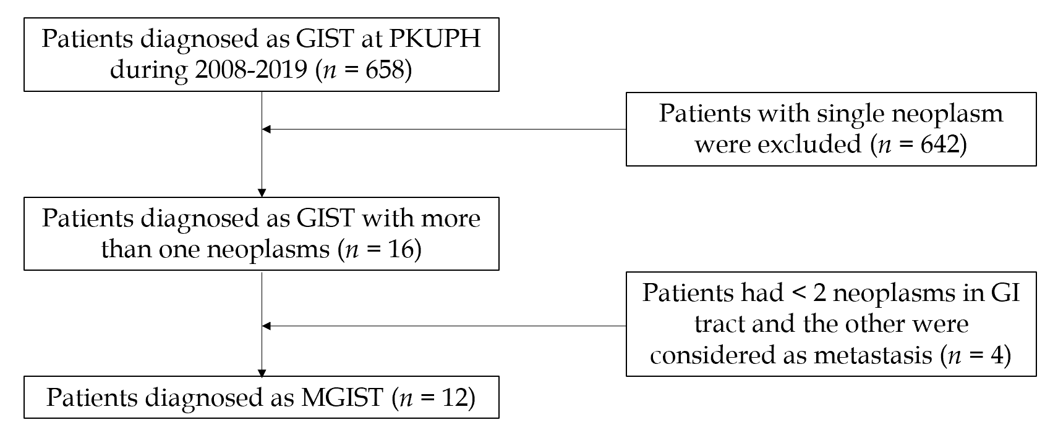
Figure 1 Flowchart of patient inclusion and exclusion criteria at Peking University People’s Hospital. GI: Gastrointestinal; GIST: Gastrointestinal stromal tumor; MGIST: Multiple gastrointestinal stromal tumor; PKUPH: Peking University People’s Hospital.
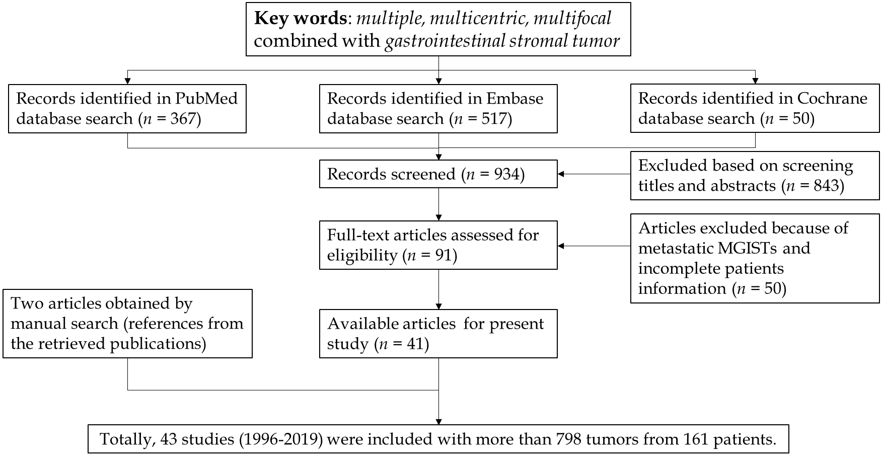
Figure 2 Flowchart of literature selection.
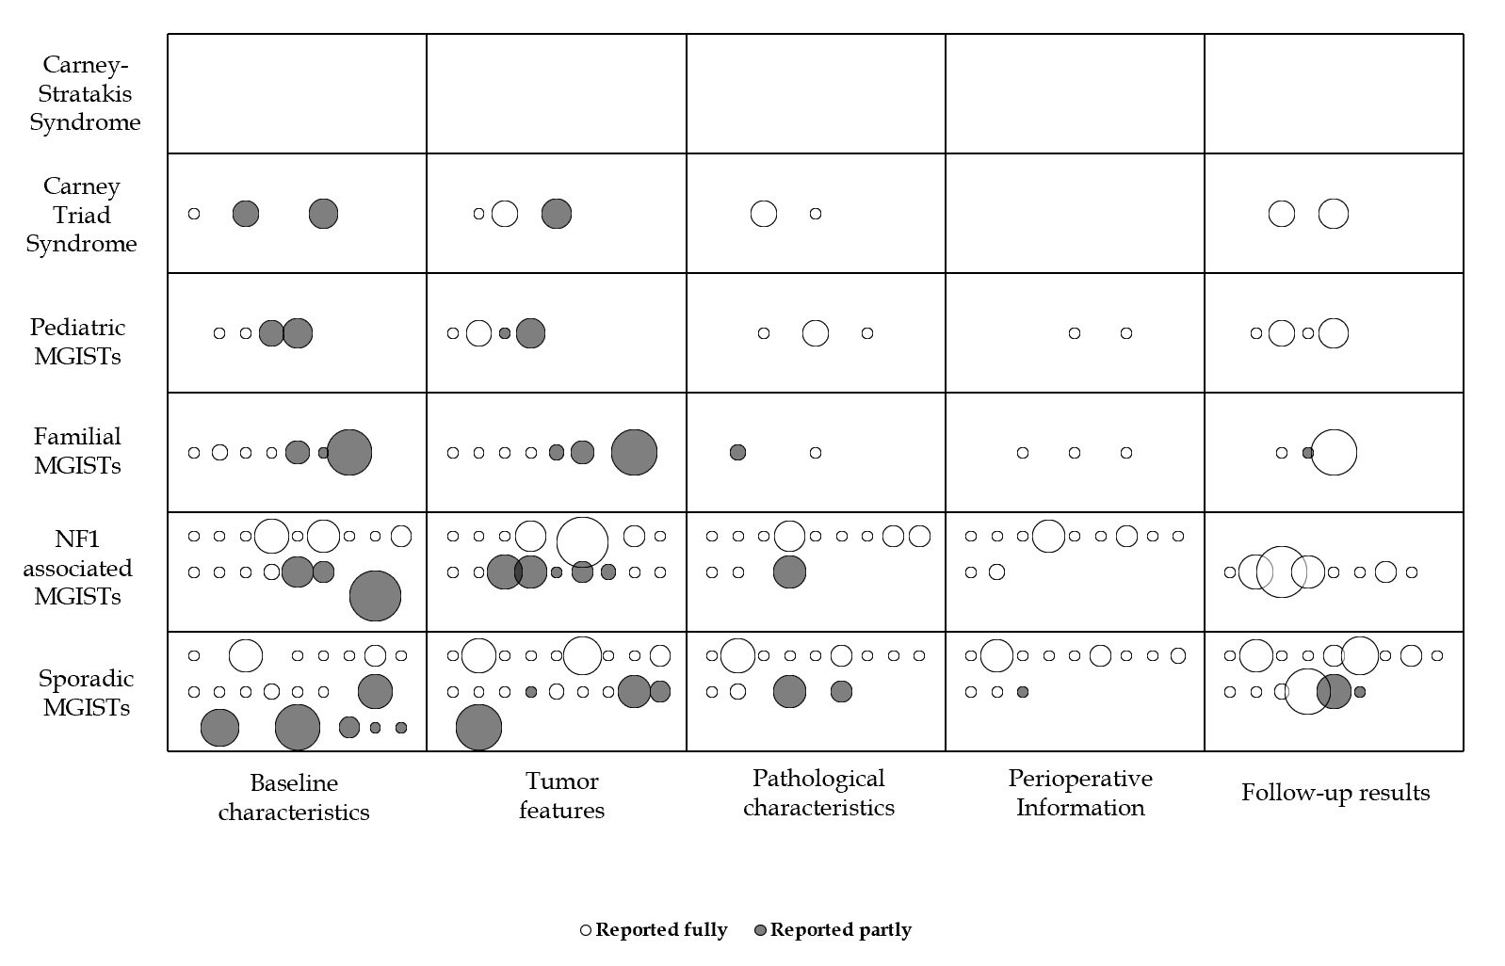
Figure 3 Evidence and gap map of multiple gastrointestinal stromal tumors (Bubble diagram). MGISTs: Multiple gastrointestinal stromal tumors; NF1: Type 1 neurofibromatosis.
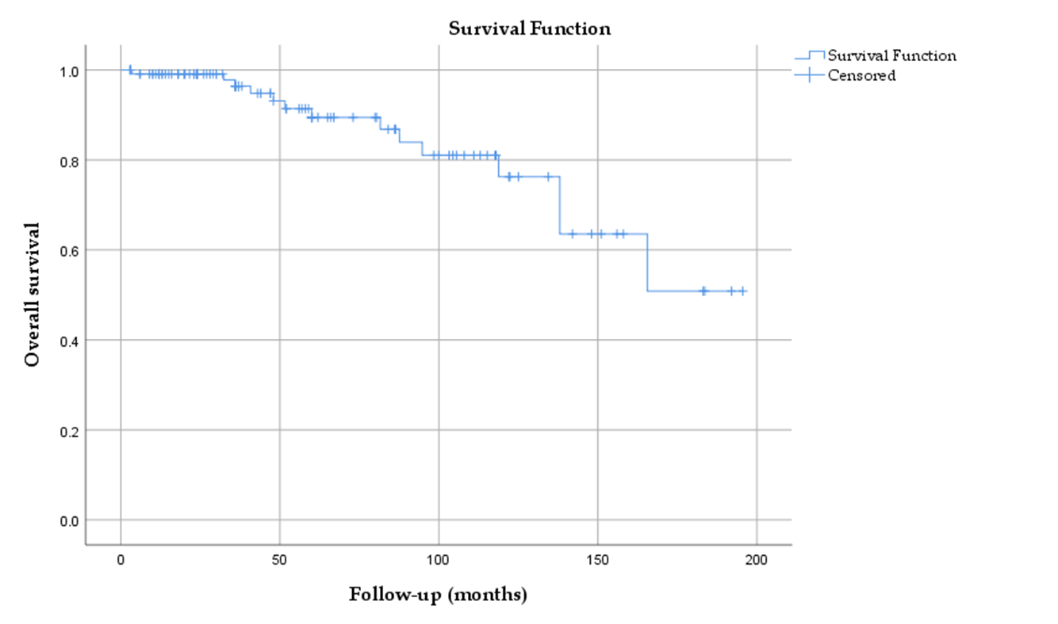
Figure 4 Overall survival of patients with multiple gastrointestinal stromal tumors.
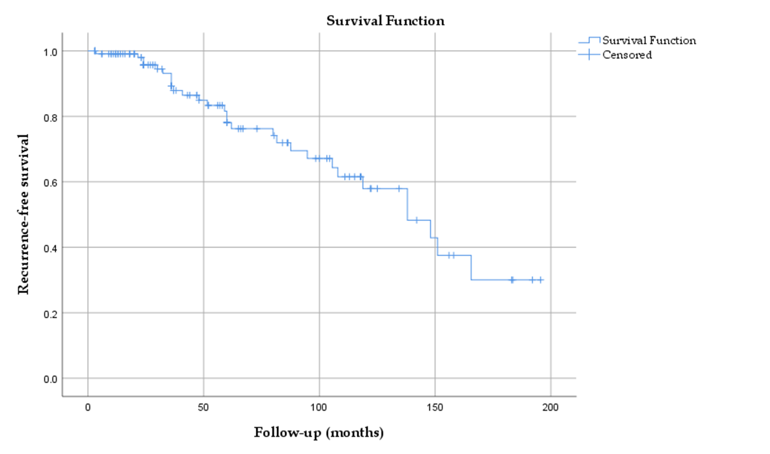
Figure 5 Recurrence-free survival of patients with multiple gastrointestinal stromal tumors.
Table 1 Baseline characteristics of patients with multiple gastrointestinal stromal tumors, n (%)
 | PKUPH patients, n = 12¹ | Literature-based patients, n = 161¹ | Total patients, n = 173¹
Sex | n = 12 | n = 160 | n = 172
Female | 6 (50.00) | 96 (60.00) | 102 (59.30)
F/M | 1.00 | 1.48 | 1.46
Age in yr | n = 12 | n = 161 | n = 173
Range | 53-88 | 8-84 | 8-88
≤ 20 | 0 (0.00) | 25 (15.63) | 25 (14.45)
21-40 | 0 (0.00) | 29 (18.12) | 29 (16.86)
41-60 | 2 (16.67) | 51 (31.88) | 53 (30.81)
61-80 | 9 (75.00) | 51 (31.88) | 60 (34.88)
> 80 | 1 (8.33) | 5 (3.13) | 6 (3.49)
Mean (SD) | 65.33 (9.48) | 48.70 (21.17) | 49.85 (20.99)
Symptoms | n = 12 | n = 55 | n = 67
GI bleeding | 2 (16.67) | 31 (56.36) | 33 (49.25)
Hematochezia | 1 (8.33) | 13 (24.07) | 14 (21.21)
Anemia | 0 (0.00) | 11 (20.37) | 11 (16.67)
Hematemesis | 1 (8.33) | 2 (3.70) | 3 (4.55)
Incidental finding | 7 (58.33) | 15 (27.27) | 22 (32.83)
Abdominal pain | 2 (16.67) | 14 (25.45) | 16 (23.88)
Palpable mass | 0 (0.00) | 2 (3.64) | 2 (2.99)
Others | 1 (8.33) | 11 (20.00) | 12 (17.91)
Classification | n = 12 | n = 161 | n = 173
Sporadic multiple GIST | 10 (83.33) | 53 (32.92) | 63 (36.42)
NF-1 associated GIST | 2 (16.67) | 72 (44.72) | 74 (42.77)
Primary familial GIST | 0 (0.00) | 8 (4.97) | 8 (4.62)
Pediatric GIST | 0 (0.00) | 25 (15.53) | 25 (14.45)
Carney-Stratakis syndrome | 0 (0.00) | 0 (0.00) | 0 (0.00)
Carney triads | 0 (0.00) | 3 (1.86) | 3 (1.73)
Combined diseases | n = 12 | n = 161 | n = 173
GI tumors | 0 (0.00) | 3 (1.86) | 3 (1.73)
GU tumors | 0 (0.00) | 5 (3.11) | 5 (2.89)
Breast tumors | 1 (8.33) | 7 (4.35) | 8 (4.62)
Other tumors | 0 (0.00) | 5 (3.11) | 5 (2.89)
¹n For total number of patients, other n for number of patients with relevant data. GI: Gastrointestinal; GIST: Gastrointestinal stromal tumor; GU: Genitourinary tract; PKUPH: Peking University People’s Hospital; SD: Standard deviation.
Table 2 Tumor and pathological features of patients with multiple gastrointestinal stromal tumors, n (%)
 | PKUPH patients, n = 12¹ | Literature-based patients, n = 161¹ | Total patients, n = 173¹
Site | n = 40 | n = 330 | n = 370
Stomach | 22 (55.00) | 121 (36.67) | 143 (38.65)
Small intestine | 17 (42.50) | 201 (60.91) | 218 (58.92)
Duodenum | 1 (2.50) | 27 (8.18) | 28 (7.57)
Jejunum | 4 (10.00) | 68 (20.61) | 72 (19.46)
Ileum | 3 (7.50) | 25 (7.58) | 28 (7.57)
Other sites | 1 (2.50) | 8 (2.42) | 9 (2.43)
Involving organ | n = 12 | n = 156 | n = 168
Single | 9 (75.00) | 108 (69.23) | 117 (69.64)
Two or more | 3 (25.00) | 48 (30.77) | 51 (30.36)
Size in cm | n = 40 | n = 315 | n = 355
Range | 0.10-8.00 | 0.05-27.00 | 0.05-27.00
≤ 1 | 22 (55.00) | 94 (29.84) | 116 (32.68)
1-2 | 4 (10.00) | 65 (20.64) | 69 (19.44)
2-5 | 11 (27.75) | 98 (31.11) | 109 (30.70)
5-10 | 3 (7.50) | 45 (14.29) | 48 (13.52)
> 10 | 0 (0.00) | 13 (4.13) | 13 (3.56)
Mean (SD) | 2.00 (2.16) | 3.26 (3.50) | 3.12 (3.40)
Cellular type | n = 40 | n = 180 | n = 220
Spindle | 40 (100.00) | 137 (76.11) | 177 (80.46)
Epithelial | 0 (0.00) | 23 (12.78) | 23 (10.46)
Mixed | 0 (0.00) | 20 (11.11) | 20 (9.09)
Mitosis, /50 HPFs | n = 35 | n = 202 | n = 237
Range | 0-9 | 0-48 | 0-48
≤ 5 | 33 (94.29) | 174 (86.14) | 207 (87.34)
5-10 | 2 (5.71) | 15 (7.43) | 17 (7.17)
> 10 | 0 (0.00) | 13 (6.44) | 13 (5.49)
Mean (SD) | 3.86 (1.87) | 3.32 (5.91) | 3.40 (5.50)
Risk classification | n = 35 | n = 249 | n = 284
Very low risk | 20 (57.14) | 54 (21.69) | 74 (26.05)
Low risk | 10 (28.57) | 113 (45.38) | 123 (43.31)
Median risk | 3 (8.57) | 26 (10.44) | 29 (10.21)
High risk | 2 (5.71) | 56 (22.49) | 58 (20.42)
CD117 | n = 35 | n = 149 | n = 184
Positive | 35 (100.00) | 144 (96.64) | 179 (97.28)
CD34 | n = 35 | n = 140 | n = 175
Positive | 12 (34.29) | 114 (81.43) | 126 (72.00)
Ki-67 | n = 35 | n = 47 | n = 82
Range | 0-20 | 1-33.8 | 0-33.8
Mean (SD) | 3.83 (4.85) | 3.96 (5.11) | 3.91 (4.97)
Desmin | n = 35 | n = 98 | n = 133
Positive | 1 (2.86) | 1 (1.02) | 2 (1.50)
S-100 | n = 35 | n = 108 | n = 143
Positive | 1 (2.86) | 32 (29.63) | 33 (23.08)
SMA | n = 35 | n = 120 | n = 155
Positive | 5 (14.29) | 19 (15.83) | 24 (15.48)
¹n For total number of patients, other n for number of patients with relevant data. HPFs: High-power fields; PKUPH: Peking University People’s Hospital; SD: Standard deviation.
Table 3 Perioperative information and follow-up results of patients with multiple gastrointestinal stromal tumors, n (%)
 | PKUPH patients, n = 12¹ | Literature-based patients, n = 161¹ | Total patients, n = 173¹
Preoperative I.E. | n = 12 | n = 29 | n = 41
CT | 12 (100.00) | 19 (65.52) | 31 (75.61)
MRI | 2 (16.67) | 2 (6.90) | 4 (9.76)
Endoscopy | 6 (50.00) | 21 (72.41) | 27 (65.85)
Approach | n = 12 | n = 25 | n = 37
Laparotomy | 5 (41.67) | 18 (72.00) | 23 (62.16)
Laparoscopy | 7 (58.33) | 7 (28.00) | 14 (37.84)
Excision extension | n = 12 | n = 30 | n = 42
Radical resection | 9 (75.00) | 22 (73.33) | 31 (73.81)
Palliative resection | 3 (25.00) | 8 (26.67) | 11 (26.19)
Imatinib | n = 12 | n = 37 | n = 49
Apply | 7 (58.33) | 25 (67.57) | 32 (65.31)
Not apply | 5 (41.67) | 12 (32.43) | 17 (34.70)
Follow-up time in mo | n = 12 | n = 114 | n = 126
Range | 3-86 | 3-396 | 3-396
Mean (SD) | 33.75 (27.28) | 83.01 (82.26) | 78.32 (79.96)
Outcome | n = 12 | n = 123 | n = 135
ANED | 12 (100.00) | 77 (62.60) | 89 (65.93)
AWD | 0 (0.00) | 21 (17.07) | 21 (15.56)
ATSU | 0 (0.00) | 2 (1.63) | 2 (1.48)
DOD | 0 (0.00) | 7 (5.69) | 7 (5.19)
DUC | 0 (0.00) | 9 (7.32) | 9 (6.67)
DOPC | 0 (0.00) | 2 (1.63) | 2 (1.48)
DUNC | 0 (0.00) | 5 (4.07) | 5 (3.70)
Recurrence | 0/12 (0.00) | 3/123 (2.44) | 3/135 (2.22)
Metastasis | n = 12 | n = 123 | n = 135
Lymph node | 0 (0.00) | 5 (4.07) | 5 (3.70)
Liver | 0 (0.00) | 8 (6.50) | 8 (5.93)
Peritoneum | 0 (0.00) | 9 (7.32) | 9 (6.67)
Lung | 0 (0.00) | 1 (0.76) | 1 (0.74)
Abdomen | 0 (0.00) | 1 (0.76) | 1 (0.74)
Omentum | 0 (0.00) | 1 (0.76) | 1 (0.74)
¹n For total number of patients, other n for number of patients with relevant data. CT: Computed tomography; I.E.: Imaging examinations; MRI: Magnetic resonance imaging; PKUPH: Peking University People’s Hospital; SD: Standard deviation.

