Name of Journal: World Journal of Gastroenterology
ESPS Manuscript NO: 25916
Manuscript Type: Topic Highlights

2016 Gastrointestinal Endoscopy: Global view

Management of a large mucosal defect after duodenal endoscopic resection

Fujihara S et al. Closure technique after duodenal endoscopic treatment

Shintaro Fujihara, Hirohito Mori, Hideki Kobara, Noriko Nishiyama, Tae Matsunaga, Maki Ayaki, Tatsuo Yachida, Tsutomu Masaki

Shintaro Fujihara, Hirohito Mori, Hideki Kobara, Noriko Nishiyama, Tae Matsunaga, Maki Ayaki, Tatsuo Yachida, Tsutomu Masaki, Departments of Gastroenterology and Neurology, Faculty of Medicine, Kagawa University, Kagawa 761-0793, Japan

Author contributions: Shintaro F analyzed the literature and wrote the manuscript; Hirohito M, Hideki K, Nishiyama N, Matsunaga T, Ayaki M and Yachida T made substantial contributions to acquisition and interpretation of data; and Masaki T gave final approval of the version to be published.

Conflict-of-interest statement: The authors have no conflict of interest to report.

Open-Access: This article is an open-access article which was selected by an in-house editor and fully peer-reviewed by external reviewers. It is distributed in accordance with the Creative Commons Attribution Non Commercial (CC BY-NC 4.0) license, which permits others to distribute, remix, adapt, build upon this work non-commercially, and license their derivative works on different terms, provided the original work is properly cited and the use is non-commercial. See: http://creativecommons.org/licenses/by-nc/4.0/

Manuscript source: Invited manuscript

Correspondence to: Shintaro Fujihara, MD, PhD, Department of Gastroenterology and Neurology, Kagawa University Faculty of Medicine / Graduate School of Medicine, 1750-1 Ikenobe, Miki-cho, Kita-gun, Kagawa 761-0793 Japan. sannai@kms.ac.jp
Telephone: +81-87-8912156
Fax: +81-87-8912158

Received: March 25, 2016
Peer-review started: March 26, 2016
First decision: May 12, 2016
Revised: May 23, 2016
Accepted: June 15, 2016
Article in press:
Published online:

Abstract
Duodenal endoscopic resection is the most difficult type of endoscopic treatment in the gastrointestinal tract (GI) and is technically challenging because of anatomical specificities. In addition to these technical difficulties, this procedure is associated with a significantly higher rate of complication than surgery in other parts of the GI tract. Postoperative delayed perforation and bleeding are hazardous complications, and emergency surgical intervention is sometimes required. Therefore, it is urgently necessary to establish a management protocol for preventing serious complications. For instance, the prophylactic closure of large mucosal defects after endoscopic resection may reduce the risk of hazardous complications. However, the size of mucosal defects after endoscopic submucosal dissection (ESD) is relatively large compared with the size after endoscopic mucosal resection, making it impossible to achieve complete closure using only conventional clips. The over-the-scope clip and polyglycolic acid (PGA) sheets with fibrin gel make it possible to close large mucosal defects after duodenal ESD. In addition to the combination of laparoscopic surgery and endoscopic resection, endoscopic full-thickness resection holds therapeutic potential for difficult duodenal lesions and may overcome the disadvantages of endoscopic resection in the near future. This review aims to summarize the complications and closure techniques of large mucosal defects and to highlight some directions for management after duodenal endoscopic treatment.

Key words: Endoscopic mucosal resection; Endoscopic submucosal dissection; Duodenum; Complication; Bleeding; Perforation; Over-the-scope clip; Clip; Closure; Endoscopic full-thickness resection

© The Author(s) 2016. Published by Baishideng Publishing Group Inc. All rights reserved.

Core tip: The duodenum is the most difficult and risky location for endoscopic treatment in the gastrointestinal tract. The risk of delayed perforation and bleeding is unacceptably high, and it is urgently necessary to establish a management protocol to prevent these serious complications. Prophylactic closure of mucosal defects after endoscopic resection is already known to prevent post-procedure-related complications. Conventional clips are primarily used, although these make it difficult to close the mucosal defect completely. Over-the-scope clips and polyglycolic acid sheets can overcome the disadvantage of conventional clips, and laparoscopic-endoscopic cooperative surgery and endoscopic full-thickness resection hold therapeutic potential for duodenal endoscopic treatment without hazardous complications.

Fujihara S, Mori H, Kobara H, Nishiyama N, Matsunaga T, Ayaki M, Yachida T, Masaki T. Management of a large mucosal defect after duodenal endoscopic resection. World J Gastroenterol 2016; In press

Introduction
Endoscopic mucosal resection (EMR) is a widely recognized treatment for early gastrointestinal malignancies and might be indicated for nonampullary duodenal tumors, neuroendocrine tumors (NET), and submucosal tumors (SMT)^{[1,2]}. Endoscopic submucosal dissection (ESD) is accepted as a minimally invasive treatment for early-stage gastrointestinal cancer, and it enables en bloc resection of the specimen^{[3,4]}. The advantage of ESD over EMR is an increased rate of en bloc curative resection^{[2-5]} and the potential to perform endoscopic resection of duodenal subepithelial tumors (SETs)^{[4,6-8]}. On the other hand, the disadvantage of ESD is an increased complication rate and procedure time compared to EMR. However, there exists no consensus as to whether EMR and ESD represent reliable treatments for duodenal tumors.
Duodenal ESD is technically challenging because of anatomical specificities, and its technical difficulties and an increased rate of complications have limited its application in the duodenum^{[2,9,10]}. In particular, postoperative delayed perforation and bleeding, which are extremely hazardous complications, can develop after endoscopic resection. In some cases, endoscopic treatment and conservative therapy are insufficient for disease control, and emergency surgical intervention is required. Therefore, it is urgently necessary to establish a management protocol for preventing these serious complications.
The prophylactic closure of mucosal defects after colorectal EMR and ESD is known to prevent postoperative bleeding and transmural burn syndrome in colorectal lesions^{[11-14]}. Therefore, there is a possibility that the prophylactic closure of large mucosal defects might reduce the risk of hazardous complications after duodenal endoscopic treatment^{[3,15-17]}. However, the size of the mucosal defect after ESD is relatively large compared with the size after EMR, making it impossible to achieve complete closure using only conventional clips. The combination of conventional clips and the Endoloop was previously reported for closing large mucosal defects^{[18-20]}. However, these techniques are rather complex and require specially designed devices. The over-the-scope clip (OTSC; Ovesco Endoscopy AG, Tubingen, Germany) is a new endoscopic device developed for the closure of mucosal defects, acute GI perforation, anastomotic leaks, and bleeding lesions^{[21,22]}. More recent studies have suggested that polyglycolic acid (PGA) sheets (Neoveil; Gunze Co., Kyoto, Japan) and fibrin gel (Beriplast P combiset; CSL Behring Pharma, Tokyo, Japan) can prevent delayed perforation after endoscopic treatment. Thus, these new devices and closure methods might overcome the disadvantage of conventional closure techniques as a substitute for closure with clips.
The combination of laparoscopic surgery and endoscopic resection represents a new frontier in cancer treatment. Recent developments in endoscopic full-thickness resection (EFTR) and minimally invasive surgical techniques hold therapeutic potential for difficult duodenal lesions and overcoming the disadvantages of endoscopic resection. Considering the higher complication rate and technical difficulties of duodenal endoscopic resection, recent technical advances might contribute to the management of large mucosal defects after treatment. The present manuscript aims to review and discuss the complications and management of duodenal endoscopic resection and the closure techniques for large mucosa defects after duodenal endoscopic treatment.

Incidence and risk factors of complications after endoscopic treatment
Perforation and bleeding are the major complications of duodenal endoscopic treatment. The incidence of complications after duodenal EMR and ESD is high compared with the complication rate after procedures in the esophagus, stomach, and colon (other GI tract)^{[23-28]}. More recent studies comparing EMR and ESD showed greater en bloc and complete resection rates following duodenal ESD, which were offset by longer a operation time and higher perforation rate^{[4,29]}. The reasons for the higher complication rate are as follows: (1) a thinner duodenal wall than in other organs of the digestive tract; (2) difficulty working the scope; (3) location in the retroperitoneum; and (4) existence of abundant blood vessels in the submucosal layer and thin muscle layer. The outcomes of duodenal EMR and ESD, obtained from a literature review, are summarized in Tables 1 and 2.

Immediate and delayed perforation
Immediate perforation is defined as perforation during the procedure, while delayed perforation is defined as no perforation during the EMR and ESD procedure and no symptoms of free air on X-ray immediately after tumor removal with the subsequent sudden appearance of high fever with peritoneal or retroperitoneal free air on computed tomography (CT)^{[30]}. The incidence of immediate perforation during EMR ranges from 0%-13.3% (Table 1). More perforation occurs during ESD, and duodenal ESD has a reported risk of immediate perforation of 6.3% to 75% (Table 2). Additionally, the incidence of delayed perforation ranges from 0-7% after EMR^{[3,4,16,23,29,31-41]} and 0%-21.4% after ESD^{[3,4,15,23,29,41-45]}, which is high compared with that following colorectal ESD, which ranges from 0.4% to 0.7%^{[24]}. Therefore, perforation is a serious complication of duodenal ESD, and its risk is much higher in the duodenum than in other parts of the GI tract, including the esophagus, stomach, colon, and rectum^{[23]}.
According to the Conference of Japan Gastroenterological Endoscopy Society, which conducted a multicenter questionnaire survey in 13 facilities in Japan, the intraoperative and delayed perforation rates were 9.3% and 3.1% in duodenal EMR and ESD cases, respectively, resulting in a 12% total perforation rate. Intraoperative perforation occurred in 3.9% and 24% of EMR and ESD cases, respectively, whereas delayed perforation occurred in 1.2% and 6% of EMR and ESD cases, respectively^{[46]}. By location, 0.8% of delayed perforation after duodenal EMR and ESD occurred in the duodenal bulb, and 4.1% occurred in the second and third portion of the duodenum. In particular, the risk of perforation in the distal duodenum is much higher at 7.2% after ESD compared with 1.8% after EMR^{[46]}. The most important result of this study was the lack of any difference in the overall perforation rate between lesions in the first and second portions of the duodenum, while delayed perforation was mostly observed in the second portion^{[46]}.
Risk factors for perforation have been associated with the resection method and tumor location. For instance, a tumor location distal to the ampulla of Vater and resection method (ESD) have been reported as predictive factors of delayed perforation^{[30]}. The reasons for the higher incidence of perforation with duodenal ESD than with EMR are as follows: (1) longer time of electrical cautery during ESD, which causes ischemic changes and damage in the muscularis propria, with resulting necrosis^{[47]}; and (2) the resection area is larger than that of EMR. Generally, extensive piecemeal EMR for large lesions might increase the risk of delayed perforation^{[23,30]}.
Additionally, the artificial ulcer base of mucosal defects is directly exposed to pancreatic and bile juices, causing delayed perforation with digestion of the muscularis propria. In particular, there are high concentrations of digestive enzymes in the area distal to the ampulla of Vater, and this contributes to a higher delayed perforation rate^{[23,48]}. In addition, the duodenum is a retroperitoneal organ, and the finding of retroperitonitis and retroperitoneal abscess due to delayed perforation results in a trend of misdiagnosis and delayed diagnosis^{[49]}. If delayed perforation is suspected, an immediate CT to evaluate the patient’s indication for emergency surgery is strongly recommended^{[49]}.

Bleeding
Bleeding is the most frequent complication and usually occurs within 24 hours after the procedure^{[34-37]}. According to the time of onset, bleeding can be subdivided into intraoperative bleeding, which occurs during the procedure, and delayed bleeding, which occurs after the procedure^{[25]}. The rate of intraoperative bleeding during duodenal EMR is reported to range from 0%-39%. Intraoperative bleeding might be more frequent with duodenal EMR and ESD techniques than at other GI tract locations, and it is very common with duodenal ESD.
Delayed bleeding is defined as hematemesis or melena and requires an endoscopic hemostatic procedure using hemostatic forceps or clips^{[15]}. The incidence of delayed bleeding is 0%-17% after EMR (Table 1) and 0%-22% after ESD (Table 2), which is high compared with the rate of delayed bleeding complicating colorectal ESD, which ranges from 0.5% to 9.5%^{[24]}.
A multicenter questionnaire survey reported that delayed bleeding occurred in 5.5% and 8.4% of EMR and ESD cases, respectively^{[46]}. The reason for the higher rate of delayed bleeding is that abundant blood vessels exist in the submucosal layer and thin muscle layer of the duodenum^{[30]}. Additionally, the extensive second-order arterial blood supply of the duodenum is an independent risk factor for immediate and delayed bleeding^{[50]}.
One risk factor for delayed bleeding is tumor size^{[15,51]}. In particular, delayed bleeding was shown to be more common for lesions larger than 30 mm but was not influenced by the endoscopic resection method (EMR and hybrid EMR-ESD)^{[51]}. According to a retrospective study on duodenal ESD and delayed bleeding, the mean time after ESD to initial delayed bleeding was 4.2 ± 2.9 d, all patients with delayed bleeding were treated successfully by endoscopic clipping or electronic coagulation, and none required blood transfusion or emergency surgery^{[15]}.
Considering the higher complication rate after duodenal endoscopic treatment, managing large mucosal defects, including prophylactic closure, is essential and might contribute to a decreased risk of delayed perforation and bleeding because the mucosa is the most important factor in protecting the visceral wall from digestive enzymes.

Management of complications and prophylactic closure for large mucosal defects after duodenal endoscopic treatment
Prevention
The most important factor in avoiding delayed perforation is the prevention of thermal injury to the thin muscle layer during the procedure. This can be achieved by keeping a safe distance from the muscle layer during submucosal dissection, with maintenance of its thickness using the above-mentioned injection and techniques^{[15]}. To prevent delayed bleeding, it is also important to treat visible vessels in the floor of the ulcer after endoscopic resection using hemostatic forceps^{[44]}.
To avoid the hazardous effects of pancreatic and bile juices, closure of the mucosal defect with clip placement should be effective. When closure of the mucosal defect is technically impossible due to the size or location of the defect, placement of an endoscopic nasopancreatic drainage (ENPD) tube should be considered^{[15]}.
A proton pump inhibitor is usually prescribed for 4-8 wk after endoscopic treatment^{[3,15]}. However, these drugs are mainly administered for ESD in the duodenal bulb, and their use remains controversial for duodenal ESD in the second and third portions of the duodenum^{[52]}. Synthetic protease inhibitors such as Nafamostat mesylate could be useful to reduce the risk of hazardous complications by preventing the activity of pancreatic enzymes^{[23,42,52]}. Additionally, it is prudent to extend the fasting period for a few days for patients receiving duodenal ESD compared with other ESDs^{[15,52]}. Hoteya et al^{[15]} noted that delayed bleeding occurred at a median of 4 d after duodenal ESD and recommended a hospitalization stay of 10 d in total.

Endoscopic closure for immediate perforation and intraoperative bleeding
The following currently available clips can be delivered through the endoscope (through-the-scope clips: TTSCs): Quick Clip (Olympus Japan Inc., Natick, MA, United States), Resolution Clip (Boston Scientific Inc., Natick, MA, United States), and Instinct Clip (Cook Medical Inc., Bloomington, IN, United States). Over-the-scope clips (OTSC system; Ovesco Endoscopy AG, Tübingen, Germany) are also available^{[53]}. Endoscopic closures are classified into the following two types: inverted closure and everted closure. TTSC and OTSC devices mainly result in an inverted closure (Figure 1). Endoscopic closure with TTSCs for immediate perforation and intraoperative bleeding was reported to be effective in a series of consecutive cases^{[3,54]}.
Immediate perforations during endoscopic resection are small, and it is possible to close the area of a small perforation using multiple hemoclips and other devices (Figure 2). However, completely closing a perforation is very difficult in the distal portion of the duodenum, and emergency surgical operation is required for difficult cases^{[45]}. Similarly, most cases with immediate bleeding during the procedure can be controlled using hemoclips, injection of an epinephrine mixture, argon plasma coagulation, and hemostatic forceps (Figure 3). However, repeat endoscopy and clipping are required because of recurrent bleeding, and few cases will develop massive, uncontrolled bleeding requiring surgery^{[50]}.

Prophylactic closure with TTSCs
The most appropriate prophylactic treatment intervention and most effective management protocol for large mucosal defects after endoscopic treatment in the duodenum have not been fully established. However, prophylactic clip closure of mucosal defects after endoscopic treatment in patients with larger colorectal tumors resulted in a decrease in endoscopic resection-related complications^{[11-14]}. In a retrospective study, prophylactic clip closure after endoscopic resection of sessile colorectal polyps or flat colorectal lesions 2 cm or larger was reported to be effective for preventing delayed bleeding^{[11]}. In our previous study, prophylactic clip closure after colorectal ESD reduced the inflammatory reaction and postpolypectomy coagulation syndrome^{[13]}. Additionally, a prospective randomized controlled study showed that prophylactic clip closure contributed to decreasing the rate of delayed postoperative bleeding and postpolypectomy coagulation syndrome compared with the non-closure group^{[12]}.
Similarly, prophylactic closure with hemoclips after duodenal EMR reduced the risk of delayed bleeding^{[16,17]}. The presence or absence of prophylactic closure after duodenal endoscopic resection is shown in Table 1 and Table 2. Lépilliez et al^{[16]} reported that prophylactic closure for mucosal defects after duodenal endoscopic resection was useful in the prevention of delayed bleeding. Additionally, according to a retrospective study focusing on delayed bleeding after duodenal ESD in 63 patients, prophylactic endoscopic closure was associated with a reduced risk of delayed bleeding^{[15]}. Yamamoto et al also reported the absence of bleeding after prophylactic closure with hemoclips in duodenal endoscopic resection^{[3]}. Considering that delayed perforation is mostly observed in the distal duodenum^{[30,46]}, some retrospective studies have revealed that prophylactic closure was mainly performed in the descending part of the duodenum after duodenal ESD^{[3,4]}.
However, delayed perforation might occur despite carrying out prophylactic clipping^{[30,55]}. According to a retrospective cohort study, delayed perforation occurred in two patients (2/63, 3.2%) who underwent prophylactic clipping because some of the clips had fallen off^{[30]}. In another case report with lesions located in the first portion of the duodenum, closure of the mucosal defect by conventional clips was difficult, and some cases showed perforation after closure of the large mucosal defect by clipping^{[55]}. TTSCs are quite small, and the size of clip is insufficient to close a large mucosal defect successfully. Thus, prophylactic closure is not performed in the large mucosal defects (> 2 cm) and residual cases essentially in our institute.

Closure technique of TTSCs
The single closure method is performed to treat small mucosal defects and starts from the edges of the mucosal defect rather than from the center (Figure 4). Closure of large mucosal defects is difficult with conventional clips only, and several closure techniques have been previously described with the additional use of an Endoloop^{[18]}, 8-ring loop^{[19]}, or loop clip^{[20]} in the colon and rectum. These closure methods have been applied to closing mucosal defects in the duodenum (Figure 5). Matsuda et al^{[18]} described complete closure using a two-channel colonoscope, an Endoloop snare, and a conventional clip. Fujii et al^{[19]} used an 8-ring (small metallic figure 8-shaped ring) and a special clip (Resolution Clip Device; Boston Scientific, Natick, MA) that could be closed and released as necessary before the final attachment. Sakamoto et al^{[20]} developed a loop clip consisting of a metallic clip attached to a nylon string loop for complete closure without using a 2-channel scope. However, all of these techniques are rather complex and require specially designed devices. Otake et al^{[56]} made a small incision around the mucosal defect using a needle-type knife, and the incisions provided a better grip for clipping across the defect, resulting in complete closure of the large mucosal defect after colorectal ESD. Recently, Mori et al reported a new closure method called “endoscopic sliding closure” for large mucosal defects after ESD^{[57]} (Figure 6). This method resembles the closure method using an Endoloop snare and conventional clips but is different in that it does not use a two-channel scope. This procedure is described as follows: (1) a ring-shaped thread is inserted into the duodenum and clipped at the two points across the maximal diameter; (2) a third clip grasps one side of the ring thread, which is drawn across to a distant point from the edge of the mucosal defect; (3) the first two clips are pulled, the ulcer slides together, and this process is repeated; and (4) the mucosal defect is smaller, and closing it with additional clips is easier (Figure 7).

Advanced techniques and recent topics in endoscopic closure
The size of mucosal defects after EMR is relatively small compared with the large ulcers often observed with ESD, making closure in the latter cases impossible using only conventional clips and, indeed, risking the induction of severe perforation. The reason for this difficulty is that the grasping power of the conventional clip is insufficient to hold a large mucosal defect^{[58]}, and delayed bleeding and perforation can occur as a result of several clips falling off. Additionally, the thin wall of the duodenum poses a risk of transmural injury by the clip itself when it cannot be anchored by the residual mucosa on both sides of the large mucosal defect^{[50]}. OTSCs and PGA sheets and fibrin glue might overcome the disadvantages of conventional clips, and the sheets have the therapeutic potential of closing large mucosal defects after duodenal endoscopic treatment.

OTSCs
OTSCs (Ovesco Endoscopy AG, Tubingen, Germany) have gained popularity for the closure of GI tract defects. OTSCs are made of elastic, biocompatible nitinol and are capable of full-thickness closure defects measuring 2 cm in diameter^{[59]}. A twin-grasper and a 3-pronged tissue anchor are supportive devices available for use in conjunction with OTSCs. Either device can be passed through the working channel and is used to secure the edges of the mucosal defect; these devices are drawn up into the cap prior to deployment of the OTSC. The disadvantages of TTSCs compared with OTSCs are as follows: (1) TTSCs are so small that they can damage the thin muscle propria after duodenal ESD; (2) the size of the clip is insufficient to close the post-ESD ulcer successfully; and (3) the grasping force of the TTSC is insufficient to hold the post-ESD ulcer^{[58,60]}.
OTSCs have been reported in many case series and retrospective studies to be successful in closing acute perforations, leaks, and fistulae^{[7,61]}. However, there is inadequate evidence supporting prophylactic closure with OTSCs for large mucosal defects after endoscopic treatment. We treated 9 lesions with prophylactic closure after colorectal ESD using OTSCs, and we were able to close large mucosal defects after colorectal ESD without severe complications^{[13]}. Importantly, prophylactic closure with TTSCs and OTSCs contributes to reducing the inflammatory reaction and abdominal symptoms, which has been called postpolypectomy coagulating syndrome or transmural burn syndrome. In a retrospective study in our department, prophylactic clip closure with TTSCs and OTSCs after duodenal endoscopic resection of adenoma, carcinoma, and submucosal epithelial tumors was reported to be effective for preventing complications^{[62]}. The rate of delayed bleeding decreased from 25% (clip closure with TTSC group) to 0% (clip closure with OTSC group), and delayed perforation did not occur in either group (TTSC or OTSC)^{[62]}. Therefore, prophylactic closure without serious complications enables closing large mucosal defects without severe procedure-related complications.
In our experience, lesions located in the posterior wall of the second and third portions of the duodenum are more difficult to close than those located in the bulb of the duodenum because of poor maneuverability of the endoscope. Additionally, one disadvantage of OTSCs is that the medical costs are 6-7 times more expensive than that of TTSCs. Furthermore, if a mucosal defect after endoscopic treatment is less than 20 mm in diameter, a conventional clip closure might be more suitable with regard to the prevention of delayed complications and medical costs^{[62]}. On the other hand, for large mucosal defects greater than 20 mm in diameter, the OTSC closure is a more reliable method for complete closure of the mucosal defect^{[48]}. The key to success of the OTSC procedure is sufficient aspiration of air as the target is suctioned into the application cap before releasing, which prevents escape of both edges of the defect. Moreover, a twin-grasper is an important tool for complete closure of large mucosal defects (> 2 cm) in the proximal portion of duodenum^{[48]}. However, prophylactic closure using OTSCs with the assistance of a twin-grasper is difficult in the distal portion of the duodenum because of poor maneuverability. The key to success is targeting the edges of the mucosal defect, suctioning into the transparent cap, and then deploying the OTSC in difficult situations.

PGA sheets and fibrin gel
In recent years, a treatment technique in which PGA sheets (Neoveil 015G; Gunze Ltd., Kyoto, Japan) are applied to ESD-induced ulcers with fibrin glue (Bolheal; Kaketsuken, Kumamoto-shi, Japan) has exhibited great potential clinically for preventing procedural complications after ESD, such as postoperative bleeding and perforation^{[63-65]}. These sheets consist of a soft, elastic, nonwoven fabric made of PGA, and they are hydrolyzed in vivo, after which they undergo degradation and absorption within approximately 15 weeks. The sheets are hydrophilic, and their coating effect is known to be enhanced if they are administered together with fibrin gel^{[65]}. This combination therapy of PGA sheets and fibrin glue has been widely used in multiple surgical fields, and studies have reported its safety and efficacy^{[66-69]}.
Tissue shielding with PGA sheets and fibrin glue decreases the risk of post-ESD bleeding after gastric ESD^{[70]}. Additionally, a preliminary study showed that the shielding method is safe and useful for the prevention of postoperative adverse events after colorectal ESD^{[64]}. On the other hand, the PGA sheets slip easily in the duodenal lumen, and additional clips might improve the coverage of the PGA sheets over postoperative ulcers^{[71]}.

Laparoscopic-endoscopic cooperative surgery (LECS) for duodenal tumors
Conventional surgical operations might be excessively invasive for early duodenal tumors, and determination of the proper extent of resection of duodenal lesions is difficult^{[72]}. Recently, there have been an increasing number of institutions in which endoscopists and surgeons cooperate to perform laparoscopy and endoscopy cooperative surgery (LECS). LECS was first reported by Hiki et al^{[73]} and has the advantage of a minimum extent of resection, and full-thickness cuts along the designated margins are performed endoscopically. However, there are few case reports of LECS for duodenal lesion^{[72,74-76]}. LECS was considered suitable for the anterior wall of the duodenum, although mobilization of the duodenum might be needed for lesions in the posterior or the third portion of the duodenum^{[72]}. However, an endoscopic circumferential incision for a duodenal lesion is extremely technically difficult and time-consuming. On the other hand, laparoscopy-assisted endoscopic full-thickness resection (LAEFR) using an ESD technique has been reported in case reports and series^{[74,77,78]}. Ohata et al^{[77]} reported that the perforated marking method is a comparatively easy and quick technique that can enable time saving, and coagulation marking of the involved serosa can be seen by the laparoscopist. The limitations of this procedure are as follows: (1) cases in which the target lesion involves the papilla or nearby region because the pancreas is located posteriorly; and (2) the development of postoperative duodenal stenosis, if the duodenal wall defect after full-thickness resection is too large (up to 50% of the duodenal lumen)^{[77]}.

EFTR with suturing devices
EFTR in the duodenum with the FTRD (full-thickness resection device; Ovesco Endoscopy AG, Tubingen, Germany) shows great potential to spare surgical resection. EFTR after the application of an OTSC has been recently described to be feasible for small neuroendocrine tumors (NET)^{[79,80]}. The FTRD is a novel, over-the-scope device designed for EFTR using a 1-step clip-and-snare technique. The device has been investigated for colon EFTR in preclinical and clinical studies^{[81-84]}. According to a preclinical study, four patients with adenomas or SETs underwent duodenal EFTR by using FTRD, and all patients had successful resection without adverse events^{[85]}. With regard to full-thickness resection, the use of OTSCs for closing GI defects up to approximately 2 cm has been reported, with successful closure of incisions < 2 cm^{[79,86,87]}. However, closing post-resection defects > 2 cm after EFTR is beyond the limits of mechanical sutures that use only OTSCs.
The Overstitch Endoscopic Suturing System (Apollo Endosurgery, Austin, TX) is a disposable, single-use suturing device that is mounted onto a double-channel therapeutic endoscope and allows for the placement of either running or interrupted full-thickness sutures. This suturing device has been used successfully for the closure of mucosal defects after colorectal endoscopic treatment without severe complications^{[88,89]}. Recently, our department has performed an EFTR using the ESD method and suturing a large mucosal defect using a new suturing system^{[90-92]}. For the suturing of resection wounds > 40 mm in the GI tract, these devices enable the complete closure of large mucosal defects. We aim to improve these devices so that large mucosal defects can be sutured more simply and quickly in the near future.

Conclusion
The duodenum is the most difficult and risky place in the gastrointestinal tract to perform endoscopic treatment. The indications for EMR and ESD for superficial non-ampullary duodenal tumors are not well established, and the final decision depends on the endoscopist’s preference. A large number of case series would be required to precisely determine the effect of prophylactic closure for large mucosal defects after duodenal endoscopic treatment. Several studies raise the possibility that prophylactic closure contributes to preventing hazardous delayed complications after duodenal endoscopic treatment. However, it can be very difficult to achieve complete closure using conventional clips; in these difficult situations, the advanced closure techniques, OTSCs, and PGA might be useful. In the near future, LECS and EFTR might enable the resection of duodenal tumors more safety without hazardous complications.

References
1 Kakushima N, Kanemoto H, Tanaka M, Takizawa K, Ono H. Treatment for superficial non-ampullary duodenal epithelial tumors. World J Gastroenterol 2014; 20: 12501-12508 [PMID: 25253950 DOI: 10.3748/wjg.v20.i35.12501]
2 Matsumoto S, Miyatani H, Yoshida Y. Future directions of duodenal endoscopic submucosal dissection. World J Gastrointest Endosc 2015; 7: 389-395 [PMID: 25901218]
3 Gaspar JP, Stelow EB, Wang AY. Approach to the endoscopic resection of duodenal lesions. World J Gastroenterol 2016; 22: 600-617 [PMID: 26811610 DOI: 10.3748/wjg.v22.i2.600]
4 Yamamoto Y, Yoshizawa N, Tomida H, Fujisaki J, Igarashi M. Therapeutic outcomes of endoscopic resection for superficial non-ampullary duodenal tumor. Dig Endosc 2014; 26 Suppl 2: 50-56 [PMID: 24750149 DOI: 10.1111/den.12273]
5 Matsumoto S, Yoshida Y. Selection of appropriate endoscopic therapies for duodenal tumors: an open-label study, single-center experience. World J Gastroenterol 2014; 20: 8624-8630 [PMID: 25024618 DOI: 10.3748/wjg.v20.i26.8624]
6 Harada H, Suehiro S, Shimizu T, Katsuyama Y, Hayasaka K, Ito H. Ligation-assisted endoscopic submucosal resection with circumferential mucosal incision for duodenal carcinoid tumor. World J Gastroenterol 2015; 21: 10041-10044 [PMID: 26379409 DOI: 10.3748/wjg.v21.i34.10041]
7 Matsumoto S, Miyatani H, Yoshida Y, Nokubi M. Duodenal carcinoid tumors: 5 cases treated by endoscopic submucosal dissection. Gastrointest Endosc 2011; 74: 1152-1156 [PMID: 21944312 DOI: 10.1016/j.gie.2011.07.029]
8 Kobara H, Mori H, Rafiq K, Fujihara S, Nishiyama N, Ayaki M, Yachida T, Tani J, Miyoshi H, Kamada H, Morishita A. Indications of endoscopic submucosal dissection for symptomatic benign gastrointestinal subepithelial or carcinoid tumors originating in the submucosa. Mol Clin Oncol 2013; 1: 1002-1008 [PMID: 24649284]
9 Marques J, Baldaque-Silva F, Pereira P, Arnelo U, Yahagi N, Macedo G. Endoscopic mucosal resection and endoscopic submucosal dissection in the treatment of sporadic nonampullary duodenal adenomatous polyps. World J Gastrointest Endosc 2015; 7: 720-727 [PMID: 26140099]
10 Bourke MJ. Endoscopic resection in the duodenum: current limitations and future directions. Endoscopy 2013; 45: 127-132 [PMID: 23364840 DOI: 10.1055/s-0032-1326177]
11 Liaquat H, Rohn E, Rex DK. Prophylactic clip closure reduced the risk of delayed postpolypectomy hemorrhage: experience in 277 clipped large sessile or flat colorectal lesions and 247 control lesions. Gastrointest Endosc 2013; 77: 401-407 [PMID: 23317580 DOI: 10.1016/j.gie.2012.10.024]
12 Zhang QS, Han B, Xu JH, Gao P, Shen YC. Clip closure of defect after endoscopic resection in patients with larger colorectal tumors decreased the adverse events. Gastrointest Endosc 2015; 82: 904-909 [PMID: 25975527 DOI: 10.1016/j.gie.2015.04.005]
13 Fujihara S, Mori H, Kobara H, Nishiyama N, Kobayashi M, Rafiq K, Masaki T. The efficacy and safety of prophylactic closure for a large mucosal defect after colorectal endoscopic submucosal dissection. Oncol Rep 2013; 30: 85-90 [PMID: 23674165]
14 Kim JS, Kim BW, Kim JI, Kim JH, Kim SW, Ji JS, Lee BI, Choi H. Endoscopic clip closure versus surgery for the treatment of iatrogenic colon perforations developed during diagnostic colonoscopy: a review of 115,285 patients. Surg Endosc 2013; 27: 501-504 [PMID: 22773239 DOI: 10.1007/s00464-012-2465-3]
15 Hoteya S, Kaise M, Iizuka T, Ogawa O, Mitani T, Matsui A, Kikuchi D, Furuhata T, Yamashita S, Yamada A, Kimura R, Nomura K, Kuribayashi Y, Miyata Y, Yahagi N. Delayed bleeding after endoscopic submucosal dissection for non-ampullary superficial duodenal neoplasias might be prevented by prophylactic endoscopic closure: analysis of risk factors. Dig Endosc 2015; 27: 323-330 [PMID: 25186455 DOI: 10.1111/den.12377]
16 Lépilliez V, Chemaly M, Ponchon T, Napoleon B, Saurin JC. Endoscopic resection of sporadic duodenal adenomas: an efficient technique with a substantial risk of delayed bleeding. Endoscopy 2008; 40: 806-810 [PMID: 18828076 DOI: 10.1055/s-2008-1077619]
17 Maruoka D, Arai M, Kishimoto T, Matsumura T, Inoue M, Nakagawa T, Watanabe Y, Katsuno T, Tsuyuguchi T, Imazeki F, Yokosuka O. Clinical outcomes of endoscopic resection for nonampullary duodenal high-grade dysplasia and intramucosal carcinoma. Endoscopy 2013; 45: 138-141 [PMID: 23322475 DOI: 10.1055/s-0032-1325799]
18 Matsuda T, Fujii T, Emura F, Kozu T, Saito Y, Ikematsu H, Saito D. Complete closure of a large defect after EMR of a lateral spreading colorectal tumor when using a two-channel colonoscope. Gastrointest Endosc 2004; 60: 836-838 [PMID: 15557972 DOI: 10.1016/S0016-5107(04)02033-4]
19 Fujii T, Ono A, Fu KI. A novel endoscopic suturing technique using a specially designed so-called "8-ring" in combination with resolution clips (with videos). Gastrointest Endosc 2007; 66: 1215-1220 [PMID: 17945221 DOI: 10.1016/j.gie.2007.05.054]
20 Sakamoto N, Beppu K, Matsumoto K, Shibuya T, Osada T, Mori H, Shimada Y, Konno A, Kurosawa A, Nagahara A, Otaka M, Ohkusa T, Ogihara T, Watanabe S. "Loop Clip", a new closure device for large mucosal defects after EMR and ESD. Endoscopy 2008; 40 Suppl 2: E97-E98 [PMID: 19085714 DOI: 10.1055/s-2007-995604]
21 Kirschniak A, Kratt T, Stüker D, Braun A, Schurr MO, Königsrainer A. A new endoscopic over-the-scope clip system for treatment of lesions and bleeding in the GI tract: first clinical experiences. Gastrointest Endosc 2007; 66: 162-167 [PMID: 17591492 DOI: 10.1016/j.gie.2007.01.034]
22 Nishiyama N, Mori H, Kobara H, Rafiq K, Fujihara S, Kobayashi M, Oryu M, Masaki T. Efficacy and safety of over-the-scope clip: including complications after endoscopic submucosal dissection. World J Gastroenterol 2013; 19: 2752-2760 [PMID: 23687412 DOI: 10.3748/wjg.v19.i18.2752]
23 Honda T, Yamamoto H, Osawa H, Yoshizawa M, Nakano H, Sunada K, Hanatsuka K, Sugano K. Endoscopic submucosal dissection for superficial duodenal neoplasms. Dig Endosc 2009; 21: 270-274 [PMID: 19961529 DOI: 10.1111/j.1443-1661.2009.00908.x]
24 Tanaka S, Terasaki M, Hayashi N, Oka S, Chayama K. Warning for unprincipled colorectal endoscopic submucosal dissection: accurate diagnosis and reasonable treatment strategy. Dig Endosc 2013; 25: 107-116 [PMID: 23368854 DOI: 10.1111/den.12016]
25 Oda I, Suzuki H, Nonaka S, Yoshinaga S. Complications of gastric endoscopic submucosal dissection. Dig Endosc 2013; 25 Suppl 1: 71-78 [PMID: 23368986 DOI: 10.1111/j.1443-1661.2012.01376.x]
26 Fujihara S, Mori H, Kobara H, Nishiyama N, Matsunaga T, Ayaki M, Yachida T, Morishita A, Izuishi K, Masaki T. Current innovations in endoscopic therapy for the management of colorectal cancer: from endoscopic submucosal dissection to endoscopic full-thickness resection. Biomed Res Int 2014; 2014: 925058 [PMID: 24877148]
27 Oyama T, Tomori A, Hotta K, Morita S, Kominato K, Tanaka M, Miyata Y. Endoscopic submucosal dissection of early esophageal cancer. Clin Gastroenterol Hepatol 2005; 3: S67-S70 [PMID: 16013002 DOI: 10.1016/S1542-3565(05)00291-0]
28 Hoteya S, Yahagi N, Iizuka T, Kikuchi D, Mitani T, Matsui A, Ogawa O, Yamashita S, Furuhata T, Yamada A, Kimura R, Nomura K, Kuribayashi Y, Kaise M. Endoscopic submucosal dissection for nonampullary large superficial adenocarcinoma/adenoma of the duodenum: feasibility and long-term outcomes. Endosc Int Open 2013; 1: 2-7 [PMID: 26135505 DOI: 10.1055/s-0033-1359232]
29 Nonaka S, Oda I, Tada K, Mori G, Sato Y, Abe S, Suzuki H, Yoshinaga S, Nakajima T, Matsuda T, Taniguchi H, Saito Y, Maetani I. Clinical outcome of endoscopic resection for nonampullary duodenal tumors. Endoscopy 2015; 47: 129-135 [PMID: 25314330 DOI: 10.11641/pde.87.1_53]
30 Inoue T, Uedo N, Yamashina T, Yamamoto S, Hanaoka N, Takeuchi Y, Higashino K, Ishihara R, Iishi H, Tatsuta M, Takahashi H, Eguchi H, Ohigashi H. Delayed perforation: a hazardous complication of endoscopic resection for non-ampullary duodenal neoplasm. Dig Endosc 2014; 26: 220-227 [PMID: 23621427 DOI: 10.1111/den.12104]
31 Hirasawa R, Iishi H, Tatsuta M, Ishiguro S. Clinicopathologic features and endoscopic resection of duodenal adenocarcinomas and adenomas with the submucosal saline injection technique. Gastrointest Endosc 1997; 46: 507-513 [PMID: 9434217 DOI: 10.1016/S0016-5107(97)70005-1]
32 Ahmad NA, Kochman ML, Long WB, Furth EE, Ginsberg GG. Efficacy, safety, and clinical outcomes of endoscopic mucosal resection: a study of 101 cases. Gastrointest Endosc 2002; 55: 390-396 [PMID: 11868015 DOI: 10.1067/mge.2002.121881]
33 Oka S, Tanaka S, Nagata S, Hiyama T, Ito M, Kitadai Y, Yoshihara M, Haruma K, Chayama K. Clinicopathologic features and endoscopic resection of early primary nonampullary duodenal carcinoma. J Clin Gastroenterol 2003; 37: 381-386 [PMID: 14564184 DOI: 10.1097/00004836-200311000-00006]
34 Apel D, Jakobs R, Spiethoff A, Riemann JF. Follow-up after endoscopic snare resection of duodenal adenomas. Endoscopy 2005; 37: 444-448 [PMID: 15844023 DOI: 10.1055/s-2005-861287]
35 Alexander S, Bourke MJ, Williams SJ, Bailey A, Co J. EMR of large, sessile, sporadic nonampullary duodenal adenomas: technical aspects and long-term outcome (with videos). Gastrointest Endosc 2009; 69: 66-73 [PMID: 18725157 DOI: 10.1016/j.gie.2008.04.061]
36 Sohn JW, Jeon SW, Cho CM, Jung MK, Kim SK, Lee DS, Son HS, Chung IK. Endoscopic resection of duodenal neoplasms: a single-center study. Surg Endosc 2010; 24: 3195-3200 [PMID: 20490557 DOI: 10.1007/s00464-010-1114-y]
37 Kim HK, Chung WC, Lee BI, Cho YS. Efficacy and long-term outcome of endoscopic treatment of sporadic nonampullary duodenal adenoma. Gut Liver 2010; 4: 373-377 [PMID: 20981216 DOI: 10.5009/gnl.2010.4.3.373]
38 Kedia P, Brensinger C, Ginsberg G. Endoscopic predictors of successful endoluminal eradication in sporadic duodenal adenomas and its acute complications. Gastrointest Endosc 2010; 72: 1297-1301 [PMID: 20970793 DOI: 10.1016/j.gie.2010.07.039]
39 Conio M, De Ceglie A, Filiberti R, Fisher DA, Siersema PD. Cap-assisted EMR of large, sporadic, nonampullary duodenal polyps. Gastrointest Endosc 2012; 76: 1160-1169 [PMID: 23021169 DOI: 10.1016/j.gie.2012.08.009]
40 Min YW, Min BH, Kim ER, Lee JH, Rhee PL, Rhee JC, Kim JJ. Efficacy and safety of endoscopic treatment for nonampullary sporadic duodenal adenomas. Dig Dis Sci 2013; 58: 2926-2932 [PMID: 23695872 DOI: 10.1007/s10620-013-2708-8]
41 Seo JY, Hong SJ, Han JP, Jang HY, Myung YS, Kim C, Lee YN, Ko BM. Usefulness and safety of endoscopic treatment for nonampullary duodenal adenoma and adenocarcinoma. J Gastroenterol Hepatol 2014; 29: 1692-1698 [PMID: 24720570 DOI: 10.1111/jgh.12601]
42 Jung JH, Choi KD, Ahn JY, Lee JH, Jung HY, Choi KS, Lee GH, Song HJ, Kim DH, Kim MY, Bae SE, Kim JH. Endoscopic submucosal dissection for sessile, nonampullary duodenal adenomas. Endoscopy 2013; 45: 133-135 [PMID: 23364841 DOI: 10.1055/s-0032-1326178]
43 Takahashi T, Ando T, Kabeshima Y, Kawakubo H, Shito M, Sugiura H, Omori T. Borderline cases between benignancy and malignancy of the duodenum diagnosed successfully by endoscopic submucosal dissection. Scand J Gastroenterol 2009; 44: 1377-1383 [PMID: 19821793 DOI: 10.3109/00365520903287551]
44 Endo M, Abiko Y, Oana S, Kudara N, Chiba T, Suzuki K, Koizuka H, Uesugi N, Sugai T. Usefulness of endoscopic treatment for duodenal adenoma. Dig Endosc 2010; 22: 360-365 [PMID: 21175499 DOI: 10.1111/j.1443-1661.2010.01014.x]
45 Ishii N, Akiyama H, Suzuki K, Fujita Y. Safety and Efficacy of Endoscopic Submucosal Dissection for Non-Ampullary Duodenal Neoplasms: A Case Series. ACG Case Rep J 2015; 2: 146-149 [PMID: 26157945 DOI: 10.14309/crj.2015.36]
46 Ono H, Nonaka S, Uedo N, Kaise M, Oyama T, Doyama H, Kokawa A, Kaneko K, Kodashima S, Tanabe S et al. Clinical issues of duodenal emr/esd (in japanese with an english abstract). Stomach Intestine 2011; 46: 1669–1677
47 Hanaoka N, Uedo N, Ishihara R, Higashino K, Takeuchi Y, Inoue T, Chatani R, Hanafusa M, Tsujii Y, Kanzaki H, Kawada N, Iishi H, Tatsuta M, Tomita Y, Miyashiro I, Yano M. Clinical features and outcomes of delayed perforation after endoscopic submucosal dissection for early gastric cancer. Endoscopy 2010; 42: 1112-1115 [PMID: 21120780 DOI: 10.1055/s-0030-1255932]
48 Kobara H, Mori H, Fujihara S, Nishiyama N, Ayaki M, Oryu M, Masaki T. A novel strategy for complete duodenal endoscopic submucosal dissection involving prophylactic defect closure with over-the-scope clips. Endoscopy 2016; 48 Suppl 1: E190-E191 [PMID: 27213975 DOI: 10.1055/s-0042-107596]
49 Taku K, Sano Y, Fu KI, Saito Y, Matsuda T, Uraoka T, Yoshino T, Yamaguchi Y, Fujita M, Hattori S, Ishikawa T, Saito D, Fujii T, Kaneko E, Yoshida S. Iatrogenic perforation associated with therapeutic colonoscopy: a multicenter study in Japan. J Gastroenterol Hepatol 2007; 22: 1409-1414 [PMID: 17593224 DOI: 10.1111/j.1440-1746.2007.05022.x]
50 Fanning SB, Bourke MJ, Williams SJ, Chung A, Kariyawasam VC. Giant laterally spreading tumors of the duodenum: endoscopic resection outcomes, limitations, and caveats. Gastrointest Endosc 2012; 75: 805-812 [PMID: 22305507 DOI: 10.1016/j.gie.2011.11.038]
51 Basford PJ, George R, Nixon E, Chaudhuri T, Mead R, Bhandari P. Endoscopic resection of sporadic duodenal adenomas: comparison of endoscopic mucosal resection (EMR) with hybrid endoscopic submucosal dissection (ESD) techniques and the risks of late delayed bleeding. Surg Endosc 2014; 28: 1594-1600 [PMID: 24442676 DOI: 10.1007/s00464-013-3356-y]
52 Yamamoto H, Miura Y. Duodenal ESD: conquering difficulties. Gastrointest Endosc Clin N Am 2014; 24: 235-244 [PMID: 24679234 DOI: 10.1016/j.giec.2013.11.007]
53 Raju GS. Endoscopic clip closure of gastrointestinal perforations, fistulae, and leaks. Dig Endosc 2014; 26 Suppl 1: 95-104 [PMID: 24373001 DOI: 10.1111/den.12191]
54 Kakushima N, Ono H, Takao T, Kanemoto H, Sasaki K. Method and timing of resection of superficial non-ampullary duodenal epithelial tumors. Dig Endosc 2014; 26 Suppl 2: 35-40 [PMID: 24750146 DOI: 10.1111/den.12259]
55 Takimoto K, Imai Y, Matsuyama K. Endoscopic tissue shielding method with polyglycolic acid sheets and fibrin glue to prevent delayed perforation after duodenal endoscopic submucosal dissection. Dig Endosc 2014; 26 Suppl 2: 46-49 [PMID: 24750148 DOI: 10.1111/den.12280]
56 Otake Y, Saito Y, Sakamoto T, Aoki T, Nakajima T, Toyoshima N, Matsuda T, Ono H. New closure technique for large mucosal defects after endoscopic submucosal dissection of colorectal tumors (with video). Gastrointest Endosc 2012; 75: 663-667 [PMID: 22341112 DOI: 10.1016/j.gie.2011.10.037]
57 Mori H, Kobara H, Nishiyama N, Fujihara S, Kobayashi N, Masaki T. Simple but reliable endoscopic sliding closure with ring-shaped surgical thread after endoscopic submucosal dissection. Endoscopy 2015; 47 Suppl 1 UCTN: E428-E429 [PMID: 26397854 DOI: 10.1055/s-0034-1392605]
58 Mori H, Shintaro F, Kobara H, Nishiyama N, Rafiq K, Kobayashi M, Nakatsu T, Miichi N, Suzuki Y, Masaki T. Successful closing of duodenal ulcer after endoscopic submucosal dissection with over-the-scope clip to prevent delayed perforation. Dig Endosc 2013; 25: 459-461 [PMID: 23368742 DOI: 10.1111/j.1443-1661.2012.01363.x]
59 Al Ghossaini N, Lucidarme D, Bulois P. Endoscopic treatment of iatrogenic gastrointestinal perforations: an overview. Dig Liver Dis 2014; 46: 195-203 [PMID: 24210991 DOI: 10.1016/j.dld.2013.09.024]
60 Winder JS, Pauli EM. Comprehensive management of full-thickness luminal defects: The next frontier of gastrointestinal endoscopy. World J Gastrointest Endosc 2015; 7: 758-768 [PMID: 26191340]
61 Haito-Chavez Y, Law JK, Kratt T, Arezzo A, Verra M, Morino M, Sharaiha RZ, Poley JW, Kahaleh M, Thompson CC, Ryan MB, Choksi N, Elmunzer BJ, Gosain S, Goldberg EM, Modayil RJ, Stavropoulos SN, Schembre DB, DiMaio CJ, Chandrasekhara V, Hasan MK, Varadarajulu S, Hawes R, Gomez V, Woodward TA, Rubel-Cohen S, Fluxa F, Vleggaar FP, Akshintala VS, Raju GS, Khashab MA. International multicenter experience with an over-the-scope clipping device for endoscopic management of GI defects (with video). Gastrointest Endosc 2014;80: 610-622 [PMID: 24908191 DOI: 10.1016/j.gie.2014.03.049]
62 Mori H, Ayaki M, Kobara H, Fujihara S, Nishiyama N, Matsunaga T, Yachida T, Masaki T. Suitable closure for post-duodenal endoscopic resection taking medical costs into consideration. World J Gastroenterol 2015; 21: 5281-5286 [PMID: 25954101 DOI: 10.3748/wjg.v21.i17.5281]
63 Takimoto K, Toyonaga T, Matsuyama K. Endoscopic tissue shielding to prevent delayed perforation associated with endoscopic submucosal dissection for duodenal neoplasms. Endoscopy 2012; 44 Suppl 2 UCTN: E414-E415 [PMID: 23169042 DOI: 10.1055/s-0032-1325739]
64 Tsuji Y, Ohata K, Gunji T, Shozushima M, Hamanaka J, Ohno A, Ito T, Yamamichi N, Fujishiro M, Matsuhashi N, Koike K. Endoscopic tissue shielding method with polyglycolic acid sheets and fibrin glue to cover wounds after colorectal endoscopic submucosal dissection (with video). Gastrointest Endosc 2014; 79: 151-155 [PMID: 24140128 DOI: 10.1016/j.gie.2013.08.041]
65 Shinya N, Oka S, Miyabashira S, Kaetsu H, Uchida T, Sueyoshi M, Takase K, Akuzawa M, Miyamoto A, Shigaki T. Improvement of the tissue-adhesive and sealing effect of fibrin sealant using polyglycolic acid felt. J Invest Surg 2009; 22: 383-389 [PMID: 19842894 DOI: 10.1080/08941930903214743]
66 Takeuchi J, Suzuki H, Murata M, Kakei Y, Ri S, Umeda M, Komori T. Clinical evaluation of application of polyglycolic acid sheet and fibrin glue spray for partial glossectomy. J Oral Maxillofac Surg 2013; 71: e126-e131 [PMID: 23164997 DOI: 10.1016/j.joms.2012.08.012]
67 Terasaka S, Iwasaki Y, Shinya N, Uchida T. Fibrin glue and polyglycolic Acid nonwoven fabric as a biocompatible dural substitute. Neurosurgery 2006; 58: ONS134-ONS19; discussion ONS134-ONS19; [PMID: 16543871]
68 Kawai H, Harada K, Ohta H, Tokushima T, Oka S. Prevention of alveolar air leakage after video-assisted thoracic surgery: comparison of the efficacy of methods involving the use of fibrin glue. Thorac Cardiovasc Surg 2012; 60: 351-355 [PMID: 22207372 DOI: 10.1055/s-0031-1293599]
69 Hayashibe A, Sakamoto K, Shinbo M, Makimoto S, Nakamoto T. New method for prevention of bile leakage after hepatic resection. J Surg Oncol 2006; 94: 57-60 [PMID: 16788945 DOI: 10.1002/jso.20548]
70 Tsuji Y, Fujishiro M, Kodashima S, Ono S, Niimi K, Mochizuki S, Asada-Hirayama I, Matsuda R, Minatsuki C, Nakayama C, Takahashi Y, Sakaguchi Y, Yamamichi N, Koike K. Polyglycolic acid sheets and fibrin glue decrease the risk of bleeding after endoscopic submucosal dissection of gastric neoplasms (with video). Gastrointest Endosc 2015; 81: 906-912 [PMID: 25440679 DOI: 10.1016/j.gie.2014.08.028]
71 Doyama H, Tominaga K, Yoshida N, Takemura K, Yamada S. Endoscopic tissue shielding with polyglycolic acid sheets, fibrin glue and clips to prevent delayed perforation after duodenal endoscopic resection. Dig Endosc 2014; 26 Suppl 2: 41-45 [PMID: 24750147 DOI: 10.1111/den.12253]
72 Tsushimi T, Mori H, Harada T, Nagase T, Iked Y, Ohnishi H. Laparoscopic and endoscopic cooperative surgery for duodenal neuroendocrine tumor (NET) G1: Report of a case. Int J Surg Case Rep 2014; 5: 1021-1024 [PMID: 25460463 DOI: 10.1016/j.ijscr.2014.10.051]
73 Hiki N, Yamamoto Y, Fukunaga T, Yamaguchi T, Nunobe S, Tokunaga M, Miki A, Ohyama S, Seto Y. Laparoscopic and endoscopic cooperative surgery for gastrointestinal stromal tumor dissection. Surg Endosc 2008; 22: 1729-1735 [PMID: 18074180 DOI: 10.1007/s00464-007-9696-8]
74 Sakon M, Takata M, Seki H, Hayashi K, Munakata Y, Tateiwa N. A novel combined laparoscopic-endoscopic cooperative approach for duodenal lesions. J Laparoendosc Adv Surg Tech A 2010; 20: 555-558 [PMID: 20578925 DOI: 10.1089/lap.2009.0392]
75 Ohi M, Yasuda H, Ishino Y, Katsurahara M, Saigusa S, Tanaka K, Tanaka K, Mohri Y, Inoue Y, Uchida K, Kusunoki M. Single-incision laparoscopic and endoscopic cooperative surgery for gastrointestinal stromal tumor arising from the duodenum. Asian J Endosc Surg 2013; 6: 307-310 [PMID: 24308591 DOI: 10.1111/ases.12059]
76 Tsujimoto H, Ichikura T, Nagao S, Sato T, Ono S, Aiko S, Hiraki S, Yaguchi Y, Sakamoto N, Tanimizu T, Yamamoto J, Hase K. Minimally invasive surgery for resection of duodenal carcinoid tumors: endoscopic full-thickness resection under laparoscopic observation. Surg Endosc 2010; 24: 471-475 [PMID: 19517164 DOI: 10.1007/s00464-009-0574-4]
77 Ohata K, Murakami M, Yamazaki K, Nonaka K, Misumi N, Tashima T, Minato Y, Shozushima M, Mitsui T, Matsuhashi N, Fu K. Feasibility of endoscopy-assisted laparoscopic full-thickness resection for superficial duodenal neoplasms. ScientificWorldJournal 2014; 2014: 239627 [PMID: 24550694]
78 Abe N, Takeuchi H, Shibuya M, Ohki A, Yanagida O, Masaki T, Mori T, Sugiyama M. Successful treatment of duodenal carcinoid tumor by laparoscopy-assisted endoscopic full-thickness resection with lymphadenectomy. Asian J Endosc Surg 2012; 5: 81-85 [PMID: 22776369 DOI: 10.1111/j.1758-5910.2011.00120.x]
79 Sarker S, Gutierrez JP, Council L, Brazelton JD, Kyanam Kabir Baig KR, Mönkemüller K. Over-the-scope clip-assisted method for resection of full-thickness submucosal lesions of the gastrointestinal tract. Endoscopy 2014; 46: 758-761 [PMID: 24830398 DOI: 10.1055/s-0034-1365513]
80 Fähndrich M, Sandmann M. Endoscopic full-thickness resection for gastrointestinal lesions using the over-the-scope clip system: a case series. Endoscopy 2015; 47: 76-79 [PMID: 25221859]
81 Schurr MO, Baur FE, Krautwald M, Fehlker M, Wehrmann M, Gottwald T, Prosst RL. Endoscopic full-thickness resection and clip defect closure in the colon with the new FTRD system: experimental study. Surg Endosc 2015; 29: 2434-2441 [PMID: 25318369 DOI: 10.1007/s00464-014-3923-x]
82 Schmidt A, Damm M, Caca K. Endoscopic full-thickness resection using a novel over-the-scope device. Gastroenterology 2014; 147: 740-742.e2 [PMID: 25083605 DOI: 10.1053/j.gastro.2014.07.045]
83 Valli PV, Kaufmann M, Vrugt B, Bauerfeind P. Endoscopic resection of a diverticulum-arisen colonic adenoma using a full-thickness resection device. Gastroenterology 2014; 147: 969-971 [PMID: 25093544 DOI: 10.1053/j.gastro.2014.07.053]
84 Schmidt A, Bauerfeind P, Gubler C, Damm M, Bauder M, Caca K. Endoscopic full-thickness resection in the colorectum with a novel over-the-scope device: first experience. Endoscopy 2015; 47: 719-725 [PMID: 25763833 DOI: 10.1055/s-0034-1391781]
85 Schmidt A, Meier B, Cahyadi O, Caca K. Duodenal endoscopic full-thickness resection (with video). Gastrointest Endosc 2015; 82: 728-733 [PMID: 26077454 DOI: 10.1016/j.gie.2015.04.031]
86 Dray X, Gabrielson KL, Buscaglia JM, Shin EJ, Giday SA, Surti VC, Assumpcao L, Marohn MR, Magno P, Pipitone LJ, Redding SK, Kalloo AN, Kantsevoy SV. Air and fluid leak tests after NOTES procedures: a pilot study in a live porcine model (with videos). Gastrointest Endosc 2008; 68: 513-519 [PMID: 18402950 DOI: 10.1016/j.gie.2007.12.052]
87 Parodi A, Repici A, Pedroni A, Blanchi S, Conio M. Endoscopic management of GI perforations with a new over-the-scope clip device (with videos). Gastrointest Endosc 2010; 72: 881-886 [PMID: 20646699 DOI: 10.1016/j.gie.2010.04.006]
88 Kantsevoy SV, Bitner M, Hajiyeva G, Mirovski PM, Cox ME, Swope T, Alexander K, Meenaghan N, Fitzpatrick JL, Gushchin V. Endoscopic management of colonic perforations: clips versus suturing closure (with videos). Gastrointest Endosc 2015; Epub ahead of print [PMID: 26364965 DOI: 10.1016/j.gie.2015.08.074]
89 Kantsevoy SV, Bitner M, Mitrakov AA, Thuluvath PJ. Endoscopic suturing closure of large mucosal defects after endoscopic submucosal dissection is technically feasible, fast, and eliminates the need for hospitalization (with videos). Gastrointest Endosc 2014; 79: 503-507 [PMID: 24332082 DOI: 10.1016/j.gie.2013.10.051]
90 Mori H, Kobara H, Fujihara S, Nishiyama N, Rafiq K, Oryu M, Fujiwara M, Suzuki Y, Masaki T. Feasibility of pure EFTR using an innovative new endoscopic suturing device: the Double-arm-bar Suturing System (with video). Surg Endosc 2014; 28: 683-690 [PMID: 24202707 DOI: 10.1007/s00464-013-3266-z]
91 Mori H, Kobara H, Rafiq K, Nishiyama N, Fujihara S, Kobayashi M, Oryu M, Fujiwara M, Suzuki Y, Masaki T. New flexible endoscopic full-thickness suturing device: a triple-arm-bar suturing system. Endoscopy 2013; 45: 649-654 [PMID: 23881805 DOI: 10.1055/s-0033-1344156]
92 Mori H, Kobara H, Kazi R, Fujihara S, Nishiyama N, Masaki T. Balloon-armed mechanical counter traction and double-armed bar suturing systems for pure endoscopic full-thickness resection. Gastroenterology 2014; 147: 278-80.e1 [PMID: 24973723 DOI: 10.1053/j.gastro.2014.06.030]
93 Park SM, Ham JH, Kim BW, Kim JS, Kim CW, Kim JI, Lim CH, Oh JH. Feasibility of endoscopic resection for sessile nonampullary duodenal tumors: a multicenter retrospective study. Gastroenterol Res Pract 2015; 2015: 692492 [PMID: 25810715 DOI: 10.1155/2015/692492]

P-Reviewer: Guo xz, Luigiano c S-Editor: Ma YJ L-Editor: E-Editor:

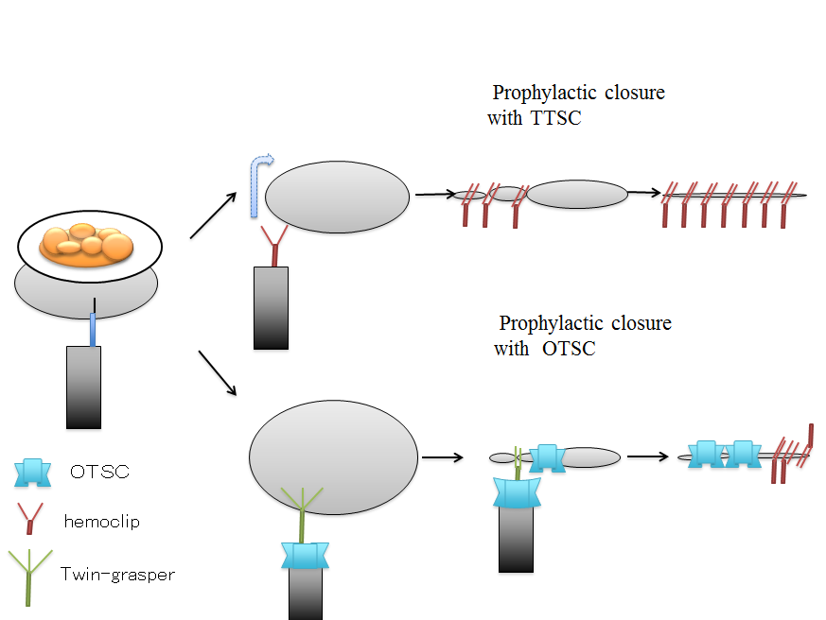Figure 1 Schema of endoscopic closure with through-the-scope-clips and over-the scope-clip. TTSC: through-the-scope-clips; OTSC: over-the scope-clip.

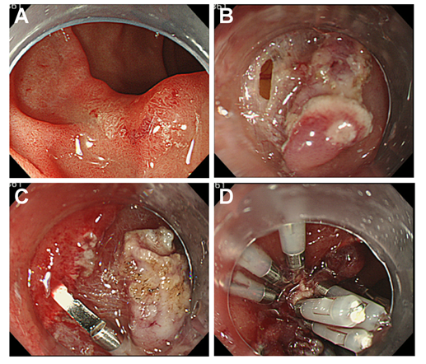
Figure 2 Immediate perforation after duodenal endoscopic mucosal resection with circumferential mucosal incision. A: An adenoma, 20 mm in size with an ulcer scar, was located in the inferior wall of the duodenal bulb; B: After duodenal EMR, immediate perforation occurred; C, D: The perforation was closed using multiple hemoclips. EMR: endoscopic mucosal resection.

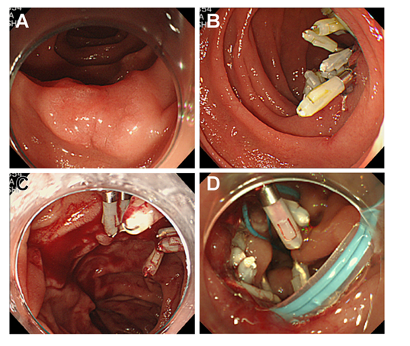
Figure 3 Delayed bleeding after duodenal endoscopic submucosal dissection. A: An adenoma, 20 mm in size, was located in the posterior wall of the second part of the duodenum; B: Prophylactic closure with a hemoclip was performed after ESD; C: The patient complained of melena at post-ESD day 13, and esophagoduodenoscopy revealed bleeding at the base of the ulcer because several clips had fallen off; D: The large mucosal defect was closed with multiple clips and Endoloops. ESD: endoscopic submucosal dissection.

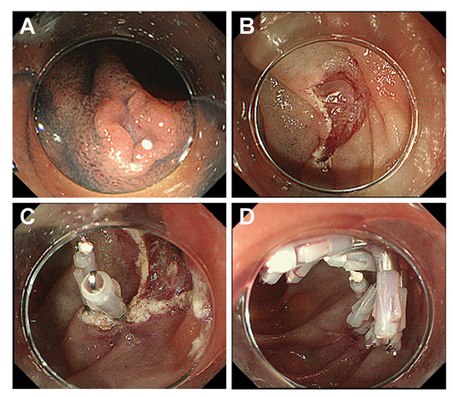
Figure 4 Prophylactic closure after duodenal endoscopic mucosal resection. A: Chromoendoscopy with indigo carmine was performed before endoscopic resection; B: A small-sized mucosal defect was detected; C, D: Prophylactic closure was performed with a hemoclip.

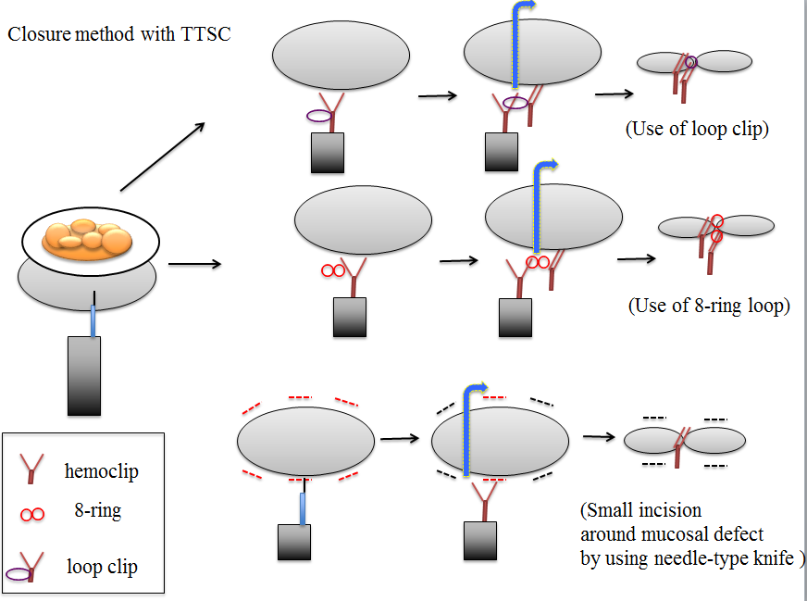
Figure 5 Diagram of a closure technique with the additional use of a loop clip, 8-ring loop, and small incision around the mucosal defect using a needle-type knife.

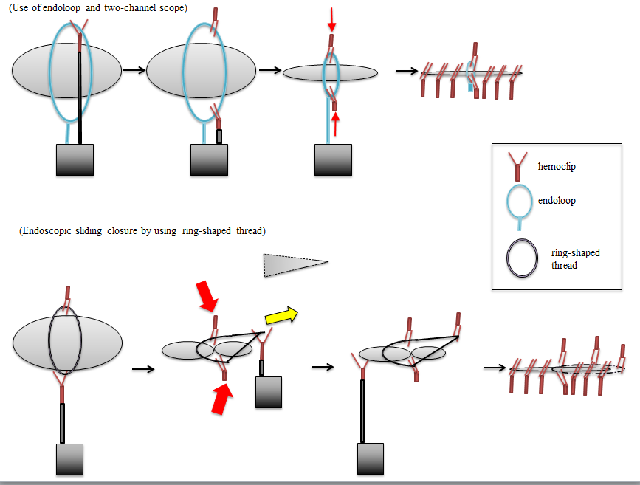
Figure 6 Diagram of a closure technique with the additional use of endoloop and a ring-shaped thread.

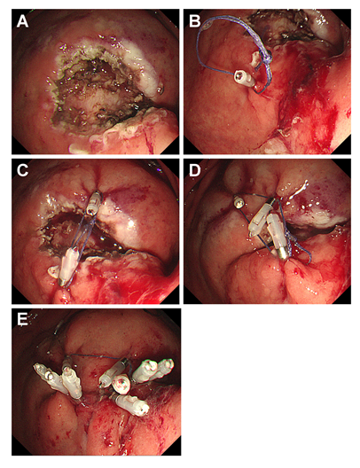
Figure 7 methods for endoscopic sliding closure after endoscopic submucosal dissection. A: A mucosal defect was identified after ESD; B, C: The ring thread was clipped at two points across the maximal diameter of the mucosal defect; D: A third clip was placed across to the edge of the mucosal defect, and after pulling the first and second clips, the mucosal defect area slid together; E: The mucosal defect was smaller, and closing it with additional clips was easier. ESD: endoscopic submucosal dissection.

Table 1 Outcomes of duodenal endoscopic mucosal resection for non-ampullary duodenal neoplasm in the literature n (%)
Ref. | Year | Methods | No.lesions | Mean tumor size (mm) | En bloc resection rate | Operation time (min) | Perforation |  | Bleeding rate |  | Surgical conversion | Prophylactic closure
Hirasawa et al^{[31]} | 1997 | EMR | 14 | 12.7 | 12 (86) | - | 0 (0) | - | 0 (0) | - | 0 (0) | -
Ahmad et al^{[32]} | 2002 | EMR | 27 | - | 23 (85) | - | 0 (0) | - | 9 (33) | - | 0 (0) | Several patients with minor bleeding and resuming anticoagulants
Oka et al^{[33]} | 2003 | EMR, polypectomy | 15 | 9.4 | - | - | 0 (0) | - | 1 (6) | - | 0 (0) | -
Apel et al^{[34]} | 2005 | EMR | 20 | Median 27.5 | - | - | 0 (0) | - | 2 (10) | - | 0 (0) | -
Lépilliez et al^{[16]} | 2008 | EMR | 43 | 19 | 21 (48.8) | - | 1 (2.3) | Delayed (1) | 11 (25.6) | Intraoperative (6) , Delayed (5) | 1 (2.3) | 14 patients in which they were used for hemostasis or prevention by using either hemoclips or APC, no delayed bleeding was observed after the procedures.
Alexander et al^{[35]} | 2009 | EMR | 23 | 27.6 | 18 (78) | - | 0 (0) | - | 1 (4) | Early (1) | 0 (0) | 2 patients with antiplatelet therapy by using hemoclip.
Honda et al^{[23]} | 2009 | EMR+EMRSH | 6 | 7.5 | 5 (83) | 15.8 | 0 (0) | - | 1 (17) | Delayed (1) | 1 (17) | -
Endo et al^{[44]} | 2010 | EMR | 11 | 9.5 | 10 (90.1) | - | 0 (0) | - | 0 (0) | - | 0 (0) | -
Sohn et al^{[36]} | 2010 | EMR, EMR-L, polypectomy | 24 | - | 21 (87.5) | - | 0 (0) | - | 7 (29) | Intraoperative (7) | 0 (0) | -
Kim et al^{[37]} | 2010 | EMR | 17 | 15.1 | 14 (82) | - | 0 (0) | - | 1 (6) | Delayed (1) | 0 (0) | All cases with hemoclip and injection of 1:10000 epinephrin solution
Kedia et al^{[38]} | 2010 | EMR | 33 | - | 23 (69.7) | - | 0 (0) | - | 5 (14) | Intraoprative (5) | 0 (0) | -
Conio et al^{[39]} | 2012 | EMR-C | 26 | Median 15 | - | 30 | 0 (0) | - | 3 (12) | Intraoprative (3) | 0 (0) | -
Min et al^{[40]} | 2013 | EMR | 23 | - | 20 (87) | - | 1 (4.3) | Immediate (1) | 2 (8.7) | - | 0 (0) | -
Fannig et al^{[50]} | 2013 | EMR | 50 | - | 25 (50) | - | 2 (4) | Immediate (1), Delayed (1) | 20 (40) | Intraoperative (17) , Delayed (3) | 2 (4)
Maruoka et al^{[17]} | 2013 | EMR ( including 7 cases with strip biopsy, 1 cases with ESD) | 26 | 10 | 18 (69.2) | - | 0 (0) | - | 12 (46.2) | Intraoperative (9) , Delayed (3) | 0 (0) | 19 lesions [19 (73.1)] with hemoclip
Matsumoto et al^{[5]} | 2014 | EMR | 31 | 11.4 | 26 (83.9) | 13.2 | 0 (0) | - | 1 (3.2) | Intraoperative (1) | 0 (0) | 24 cases of lesions [24 (77.4)] located in bulb and descending part of duodenum
Basford et al^{[51]} | 2014 | EMR, hybrid EMR-ESD (including 1 case with ESD) | 34 | 25 | 17 (50) | - | 0 (0) |  | 3 (8.8) | Delayed (3) | 0 (0) | 11 (32) of the 34 cases, clip were used to close the mucosal defect.
Yamamoto et al^{[4]} | 2014 | EMR | 17 | 9.4 | 14 (82) | 9 | 0 (0) | - | 0 (0) | - | 0 (0) | Limited cases of lesions located in the distal of duodenum with hemoclip
Kakushima et al^{[54]} | 2014 | EMR, polypectomy | 10 | Median 15 | 10 (100) | - | 0 (0) | - | 0 (0) | - | 0 (0) | -
Seo et al^{[41]} | 2014 | EMR | 33 | - | - | - | 0 (0) | - | 2 (6) | Delayed (2) | 0 (0) | -
Park et al^{[93]} | 2015 | EMR | 45 | - | 35 (77.8) | Median 13 | 2 (4.5) | - | 1 (2.2) | Delayed (1) | .- | -
Nonaka et al^{[29]} | 2015 | EMR | 113 | Median 12 | 71 (63) | - | 0 (0) | - | 14 (12) | Delayed (14) | 0 (0) | Immediate prophylactic closure was perforrmed in 99 lesions [99 (81.8)] including 7 ESD cases with hemoclip
EMRSH: EMR with circumferential mucosal incision assisted by submucosal injection of sodium hyaluronate; EMR-L: EMR with ligation; EMR-C: Cap-assisted EMR; EMR: endoscopic mucosal resection.
Table 2 Outcomes of duodenal endoscopic submucosal dissection for nonampullary duodenal neoplasm in the literature n (%)

Author | Year | No. lesions | Mean tumor size(mm) | R0 resection rate | Operation time (min) | Perforation |  | Delayed bleeding | Surgical conversion | Prophylactic closure
Honda et al^{[23]} | 2009 | 9 | 23.7 | 9 (100) | 80 | 2 (22.2) | Immediate (1), Delayed (1) | 2 (22) | 1 (11) | -
Takahashi et al^{[43]} | 2009 | 4 | 20.5 | 4 (100) | - | 2 (50) | Immediate (2) | 0 (0) | 0 (0) | -
Endo et al^{[44]} | 2010 | 5 | 10 | 5 (100) | - | 1 (20) | Immediate (1) | 0 (0) | 0 (0) | -
Jung et al^{[42]} | 2013 | 14 | 17.1 | 12 (85.7) | 32 | 5 (35.7) | Immediate (5), Delayed (3) | 1 (7.1) | 2 (14.3) | -
Matsumoto et al^{[5]} | 2014 | 15 | 12.9 | 13 (86.7) | 86.5 | 3 (20) | Immediate (3) | 3 (20) | 2 (13.3) | 4 of the 5 cases of lesion [4 (26.7)] located in descending part of the duodenum with hemoclip
Yamamoto et al^{[4]} | 2014 | 30 | 13.7 | 27 (90.0) | 79.5 | 3 (10) | Immediate (2), Delayed (1) | 0 (0) | 1 (3) | Limited cases of lesions located in the distal of duodenum with hemoclip
Seo et al^{[41]} | 2014 | 7 | - | - | - | 3 (75) | Immediate (3) | 0 (0) | 0 (0) | -
Kakushima et al^{[54]} | 2014 | 13 | Median 13.5 | 13 (100) | - | 4 (40) | Immediate (3), Delayed (1) | 0 (0) | 1 (7.7) | -
Park et al^{[93]} | 2015 | 6 | - | 5 (83.3) | Median 41.5 | 2 (33.3) | - | 0 (0) | - | -
Hoteya et al^{[15]} | 2015 | 63 | 24.6 | 55 (87.3) | 116.4 | 21 (31.3) | - | 11 (17.5) | 4 (6.2) | 23 patients [23 (36.5)] with hemoclip
Ishii et al^{[45]} | 2015 | 16 | Median 13 | 13 (81.3) | Median 66 | 1 (6.3) | Immediate (1) | 0 (0) | 1 (6.3) | 10 patients [10 (93)] with hemoclip (8 patients) and PGA sheets (2 patients)
Nonaka et al^{[29]} | 2015 | 8 | Median 18 | - | - | 2 (25.0) | Delayed (1) | 0 (0) | 1 (12.5) | Immediate closure was perforrmed in 99 lesions (99/121) including 113 EMR cases with hemoclip
PGA: polyglycolic acid; EMR: Endoscopic mucosal resection.

Table 3 Outocome of duodenal endoscopic mucosal resection/endoscopic submucosal dissection in a previous multicenter questionnaire survey conducted in endoscopic submucosal dissection expert facilities in Japan

Ref. | Year | Methods | No. lesions | Perforation | Immediate perforation | Delayed perforation | Delayed bleeding | Surgical conversion
Ono et al^{[46]} | 2011 | EMR | 254 | 10 (3.9) | 7 (2.8) | 3 (1.2) | 14 (5.5) | 2 (0.8)
 |  | ESD | 167 | 42 (25) | 32 (19) | 10 (6.0) | 14 (8.4) | 9 (5.4)
EMR: endoscopic mucosal resection; ESD: endoscopic submucosal dissection.

