Name of Journal: World Journal of Clinical Cases
Manuscript NO: 89783
Manuscript Type: CASE REPORT

Metastatic clear cell sarcoma of the pancreas: A rare case report

Liu YJ et al. Metastatic clear cell sarcoma of the pancreas

Yu-Jing Liu, Chen Zou, Yong-You Wu

Yu-Jing Liu, General Surgery II, Suzhou Hospital, The Affiliated Hospital of Medical School, Nanjing University, Suzhou 215000, Jiangsu Province, China

Chen Zou, Department of General Surgery, The Affiliated People's Hospital of Jiangsu University, Suzhou 215000, Jiangsu Province, China

Yong-You Wu, Department of Gastrointestinal Surgery, The Second Affiliated Hospital of Soochow University, Suzhou 215008, Jiangsu Province, China

Co-first authors: Yu-Jing Liu and Chen Zou.

Author contributions: Liu YJ collected data and wrote the manuscript; Zou C revised the manuscript; Wu YY reviewed the manuscript; All authors have read and approved the final manuscript.

Corresponding author: Yong-You Wu, MM, PhD, Chief Doctor, Professor, Department of Gastrointestinal Surgery, The Second Affiliated Hospital of Soochow University, No. 1055 Sanxiang Road, Suzhou 215008, Jiangsu Province, China. wuyongyou72@163.com

Received: November 13, 2023
Revised: January 11, 2024
Accepted: February 18, 2024
Published online:

Abstract
BACKGROUND
Clear cell sarcoma (CCS) is a rare soft-tissue sarcoma. The most common metastatic sites for CCS are the lungs, bones and brain. CCS is highly invasive and mainly metastasizes to the lung, followed by the bone and brain; however, pancreatic metastasis is relatively rare.

CASE SUMMARY
We report on a rare case of CCS with pancreatic metastasis in a 47-year-old man. The patient had a relevant medical history 3 years ago, with abdominal pain as the main clinical manifestation. No abnormalities were observed on physical examination and the tumor was found on abdominal computed tomography. Based on the medical history and postoperative pathology, the patient was diagnosed with CCS with pancreatic metastasis. The patient was successfully treated with surgical interventions, including distal pancreatectomy and splenectomy.

CONCLUSION
This report summarizes the available treatment modalities for CCS and the importance of regular postoperative follow-up for patients with CCS.

Key Words: Clear cell sarcoma; Pancreas; Metastasis; Follow-up; Case report

Liu YJ, Zou C, Wu YY. Metastatic clear cell sarcoma of the pancreas: A rare case report. World J Clin Cases 2024; In press

Core Tip: Clear cell sarcoma (CCS) is a rare soft tissue sarcoma accounting for less than 1% of sarcomas and was originally reported in 1965. CCS is a type of highly invasive cancer which mainly metastasizes to the lungs, followed by the bones and brain, but pancreatic metastasis is relatively rare. Here, we give details of the clinical manifestations and imaging features of a case of metastatic CCS of the pancreas.

INTRODUCTION
Clear cell sarcoma (CCS) is a rare soft-tissue sarcoma (STS) that accounts for less than 1% of all cases and was originally reported in 1965^{[1,2]}. The incidence of CCS is estimated to be approximately 0.014/100000 depending on the surveillance, epidemiology and end results databases^{[3]}. CCS originates from the tendon and aponeurosis, and is characterized by local invasive growth of the tendon and other soft tissues^{[4]}. CCS is a highly invasive type that mainly metastasizes to the lungs, followed by the bones and brain; however, pancreatic metastasis is relatively rare^{[3-8]}. To our knowledge, only two cases of primary pancreatic CCS have been reported^{[9,10]}. Here, we provide details of the clinical manifestations and imaging features of a patient with metastatic CCS of the pancreas.

CASE PRESENTATION
Chief complaints
A 47-year-old male presented with abdominal pain and diarrhea.

History of present illness
Symptoms started more than a half month before presentation with abdominal pain and diarrhea.

History of past illness
No special notes.

Personal and family history
No special notes.

Physical examination
No special notes.

Laboratory examinations
No special notes.

Imaging examinations
Computed tomography (CT) and magnetic resonance imaging (MRI) revealed an isolated lesion in the pancreatic tail without metastasis (Figures 1 and 2).

FINAL DIAGNOSIS
The preoperative diagnosis did not rule out the possibility of CCS recurrence combined with the patient's disease history.

TREATMENT
The patient underwent surgical treatment. Under general anesthesia, the abdomen was prepped and draped in the usual fashion, with the patient in the supine position. A midline incision of the abdomen was made, and the peritoneal cavity was entered. Generalized abdominal exploration revealed no metastases to the liver, spleen, or peritoneal omentum of the abdominopelvic cavity. The gastrocolic ligament was opened in the avascular zone, and the stomach was turned upward to reveal the pancreas. A solid tumor measuring 3 cm × 3 cm × 4 cm with a hard texture and smooth surface located in the pancreatic body was found during surgery. A distal pancreatectomy and splenectomy were successfully performed. The posterior, transverse, caudal, and dorsal pancreatic arteries and pancreatic freeing were ligated. The pancreatic tissues were gradually dissected by suturing 2 cm away from the tumor, close to the neck of the pancreas. The pancreatic body and tail, and the spleen were excised. No tumor residue was found in the pancreatic margins or the spleen (Figure 3).

OUTCOME AND FOLLOW-UP
The patient recovered well after surgery without complications and was free of any discomfort until the last follow-up (6 mo postoperatively), with refusal of any other therapy or examination.

DISCUSSION
CCS is a malignant tumor arising from the neural spinal cells caused by the EWSR1-ATF1 gene fusion resulting from t(12;22) (q13;q12) translocation^{[11]}. CCS often occurs in the second to fourth decades of life and affects the lower extremities. CCS metastasis to the gastrointestinal system (CCSLGT) is rare and was first reported by Zambrano et al^{[12]} in 2003. CCSLGT is prevalent in the walls of the small intestine, stomach, colon, and peritoneum, but is rare in the pancreas^{[13,14]}. The manifestations of CCSLGT include abdominal pain, intestinal obstruction, anemia, nausea, and vomiting. The clinical presentation in this case was abdominal pain with nausea, which is consistent with the literature.
Currently, there is no unified management method for advanced CCS, and surgery remains the standard treatment, similar to most STSs^{[4,7,15,16]}. Ensuring that the margins of the tumor are clean and retaining a ring of normal tissue around the tumor is essential. Preoperative imaging assessment in conjunction with patient history is appropriate. CT provides initial postoperative follow-up and evaluation. MRI is an important modality that can reveal the location and extent of tumor invasion^{[17,18]}. In this case, the patient was initially diagnosed with metastatic CCS on preoperative MRI, thus providing a good plan for surgery and ensuring clean surgical margins.
CCS has a poor prognosis, with limited effectiveness of other postoperative treatments. According to the literature, chemotherapy and radiotherapy for CCS are unsatisfactory^{[19-22]}. Some studies have demonstrated that targeted therapy or immunotherapy may be effective; however, no confirmatory clinical trials have been conducted^{[23-27]}.
Despite optimal management of local disease, CCS has a high probability of recurrence or metastasis, and when it progresses to stages III and IV, the 5-year survival rate significantly reduces to 15%-35%^{[3]}. Long-term follow-up is necessary for patients with CCS, because new metastatic lesions may appear after a longer period^{[28]}. Postoperative management is important in CCS to effectively detect early metastases. In this case, the patient was not followed up after the first operation until symptoms appeared, leading to delayed treatment. At this time, the patient resisted follow-ups and examinations that would have facilitated disease monitoring.

CONCLUSION
A rare case of CCS in a patient who developed pancreatic metastases 3 years after surgery has been reported. Regularized follow-up and re-examination were not performed after the first operation, resulting in the patient being seen only after the onset of symptoms, which may have delayed the treatment. Therefore, regular postoperative follow-up is important for patients with CCS because recurrence has a long-term course.

REFERENCES
1 Dim DC, Cooley LD, Miranda RN. Clear cell sarcoma of tendons and aponeuroses: a review. Arch Pathol Lab Med 2007; 131: 152-156 [PMID: 17227118 DOI: 10.5858/2007-131-152-CCSOTA]
2 Enzinger FM. Clear-cell sarcoma of tendons and aponeuroses. An analysis of 21 cases. Cancer 1965; 18: 1163-1174 [PMID: 14332545 DOI: 10.1002/1097-0142(196509)18:9<1163::aid-cncr2820180916>3.0.co;2-0]
3 Gonzaga MI, Grant L, Curtin C, Gootee J, Silberstein P, Voth E. The epidemiology and survivorship of clear cell sarcoma: a National Cancer Database (NCDB) review. J Cancer Res Clin Oncol 2018; 144: 1711-1716 [PMID: 29961184 DOI: 10.1007/s00432-018-2693-6]
4 Kawai A, Hosono A, Nakayama R, Matsumine A, Matsumoto S, Ueda T, Tsuchiya H, Beppu Y, Morioka H, Yabe H; Japanese Musculoskeletal Oncology Group. Clear cell sarcoma of tendons and aponeuroses: a study of 75 patients. Cancer 2007; 109: 109-116 [PMID: 17133413 DOI: 10.1002/cncr.22380]
5 Basile G, Mattei JC, Alshaygy I, Griffin AM, Catton CN, Chung PW, Shultz DB, Razak ARA, Demicco EG, Ferguson PC, Wunder JS. Curability of patients with lymph node metastases from extremity soft-tissue sarcoma. Cancer 2020; 126: 5098-5108 [PMID: 32910462 DOI: 10.1002/cncr.33189]
6 Sara AS, Evans HL, Benjamin RS. Malignant melanoma of soft parts (clear cell sarcoma). A study of 17 cases, with emphasis on prognostic factors. Cancer 1990; 65: 367-374 [PMID: 2295060 DOI: 10.1002/1097-0142(19900115)65:2<367::AID-CNCR2820650232>3.0.CO;2-X]
7 Hocar O, Le Cesne A, Berissi S, Terrier P, Bonvalot S, Vanel D, Auperin A, Le Pechoux C, Bui B, Coindre JM, Robert C. Clear cell sarcoma (malignant melanoma) of soft parts: a clinicopathologic study of 52 cases. Dermatol Res Pract 2012; 2012: 984096 [PMID: 22693489 DOI: 10.1155/2012/984096]
8 Li AB, Jiang BJ, Wang HH, Yang YS, Zhang XB, Lan GH, Shu WB. Prognostic Factors for Survival in Patients with Clear Cell Sarcoma: An Analysis of the Surveillance, Epidemiology, and End Results (SEER) Database. Med Sci Monit 2019; 25: 6950-6956 [PMID: 31522190 DOI: 10.12659/MSM.916705]
9 Huang J, Luo RK, Du M, Zeng HY, Chen LL, Ji Y. Clear cell sarcoma of the pancreas: a case report and review of literature. Int J Clin Exp Pathol 2015; 8: 2171-2175 [PMID: 25973121]
10 Xiang H, Xiang W, Wang L. Primary clear cell-sarcoma of the pancreas: A case report. Asian J Surg 2023; 46: 4842-4843 [PMID: 37308378 DOI: 10.1016/j.asjsur.2023.05.129]
11 Mavrogenis A, Bianchi G, Stavropoulos N, Papagelopoulos P, Ruggieri P. Clinicopathological features, diagnosis and treatment of clear cell sarcoma/melanoma of soft parts. Hippokratia 2013; 17: 298-302 [PMID: 25031505]
12 Zambrano E, Reyes-Mugica M, Franchi A, Rosai J. An osteoclast-rich tumor of the gastrointestinal tract with features resembling clear cell sarcoma of soft parts: reports of 6 cases of a GIST simulator. Int J Surg Pathol 2003; 11: 75-81 [PMID: 12754623 DOI: 10.1177/106689690301100202]
13 Yegen G, Güllüoğlu M, Mete Ö, Önder S, Kapran Y. Clear cell sarcoma-like tumor of the gastrointestinal tract: a case report and review of the literature. Int J Surg Pathol 2015; 23: 61-67 [PMID: 25145707 DOI: 10.1177/1066896914547046]
14 Huang W, Zhang X, Li D, Chen J, Meng K, Wang Y, Lu Z, Zhou X. Osteoclast-rich tumor of the gastrointestinal tract with features resembling those of clear cell sarcoma of soft parts. Virchows Arch 2006; 448: 200-203 [PMID: 16220298 DOI: 10.1007/s00428-005-0051-y]
15 Lucas DR, Nascimento AG, Sim FH. Clear cell sarcoma of soft tissues. Mayo Clinic experience with 35 cases. Am J Surg Pathol 1992; 16: 1197-1204 [PMID: 1463095 DOI: 10.1097/00000478-199212000-00006]
16 Kuiper DR, Hoekstra HJ, Veth RP, Wobbes T. The management of clear cell sarcoma. Eur J Surg Oncol 2003; 29: 568-570 [PMID: 12943620 DOI: 10.1016/S0748-7983(03)00115-X]
17 Cheney MD, Giraud C, Goldberg SI, Rosenthal DI, Hornicek FJ, Choy E, Mullen JT, Chen YL, Delaney TF. MRI surveillance following treatment of extremity soft tissue sarcoma. J Surg Oncol 2014; 109: 593-596 [PMID: 24374823 DOI: 10.1002/jso.23541]
18 Liburd CG, Gibson TN, Hanchard B, Waugh N, McNaughton D. Cutaneous Malignant Melanoma in Jamaica, 1958 to 2007. West Indian Med J 2014; 63: 717-720 [PMID: 25867558 DOI: 10.7727/wimj.2013.265]
19 Jones RL, Constantinidou A, Thway K, Ashley S, Scurr M, Al-Muderis O, Fisher C, Antonescu CR, D'Adamo DR, Keohan ML, Maki RG, Judson IR. Chemotherapy in clear cell sarcoma. Med Oncol 2011; 28: 859-863 [PMID: 20390470 DOI: 10.1007/s12032-010-9502-7]
20 Stacchiotti S, Palassini E, Negri T, Orsenigo M, Bertulli R, Morosi C, Pilotti S, Fiore M, Gronchi A, Casali PG. Clear cell sarcoma (CCR): Clinical behavior and response to chemotherapy. J Clin Oncol 2010; 28 [DOI: 10.1200/jco.2010.28.15_suppl.10096]
21 Clark MA, Johnson MB, Thway K, Fisher C, Thomas JM, Hayes AJ. Clear cell sarcoma (melanoma of soft parts): The Royal Marsden Hospital experience. Eur J Surg Oncol 2008; 34: 800-804 [PMID: 18042498 DOI: 10.1016/j.ejso.2007.10.006]
22 Deenik W, Mooi WJ, Rutgers EJ, Peterse JL, Hart AA, Kroon BB. Clear cell sarcoma (malignant melanoma) of soft parts: A clinicopathologic study of 30 cases. Cancer 1999; 86: 969-975 [PMID: 10491522]
23 Kataria B, Sharma A, Biswas B, Bakhshi S, Pushpam D. Pazopanib in rare histologies of metastatic soft tissue sarcoma. Ecancermedicalscience 2021; 15: 1281 [PMID: 34824604 DOI: 10.3332/ecancer.2021.1281]
24 Chi Y, Fang Z, Hong X, Yao Y, Sun P, Wang G, Du F, Sun Y, Wu Q, Qu G, Wang S, Song J, Yu J, Lu Y, Zhu X, Niu X, He Z, Wang J, Yu H, Cai J. Safety and Efficacy of Anlotinib, a Multikinase Angiogenesis Inhibitor, in Patients with Refractory Metastatic Soft-Tissue Sarcoma. Clin Cancer Res 2018; 24: 5233-5238 [PMID: 29895706 DOI: 10.1158/1078-0432.CCR-17-3766]
25 Smrke A, Frezza AM, Giani C, Somaiah N, Brahmi M, Czarnecka AM, Rutkowski P, Van der Graaf W, Baldi GG, Connolly E, Duffaud F, Huang PH, Gelderblom H, Bhadri V, Grimison P, Mahar A, Stacchiotti S, Jones RL. Systemic treatment of advanced clear cell sarcoma: results from a retrospective international series from the World Sarcoma Network. ESMO Open 2022; 7: 100522 [PMID: 35717681 DOI: 10.1016/j.esmoop.2022.100522]
26 Wang J, Gao S, Yang Y, Liu X, Zhang P, Dong S, Wang X, Yao W. Clinical Experience with Apatinib and Camrelizumab in Advance Clear Cell Sarcoma: A Retrospective Study. Cancer Manag Res 2021; 13: 8999-9005 [PMID: 34887682 DOI: 10.2147/CMAR.S337253]
27 Protsenko SA, Semionova AI, Komarov YI, Aleksakhina SN, Ivantsov AO, Iyevleva AG, Imyanitov EN. BRAF-mutated clear cell sarcoma is sensitive to vemurafenib treatment. Invest New Drugs 2015; 33: 1136-1143 [PMID: 26286452 DOI: 10.1007/s10637-015-0280-0]
28 Bianchi G, Charoenlap C, Cocchi S, Rani N, Campagnoni S, Righi A, Frisoni T, Donati DM. Clear cell sarcoma of soft tissue: a retrospective review and analysis of 31 cases treated at Istituto Ortopedico Rizzoli. Eur J Surg Oncol 2014; 40: 505-510 [PMID: 24560887 DOI: 10.1016/j.ejso.2014.01.016]

Footnotes
Informed consent statement: Informed written consent was obtained from the patient for publication of this report and any accompanying images.

Conflict-of-interest statement: All authors declare that they have no conflict of interest to disclose.

CARE Checklist (2016) statement: The authors have read the CARE Checklist (2016), and the manuscript was prepared and revised according to the CARE Checklist (2016).

Open-Access: This article is an open-access article that was selected by an in-house editor and fully peer-reviewed by external reviewers. It is distributed in accordance with the Creative Commons Attribution NonCommercial (CC BY-NC 4.0) license, which permits others to distribute, remix, adapt, build upon this work non-commercially, and license their derivative works on different terms, provided the original work is properly cited and the use is non-commercial. See: https://creativecommons.org/Licenses/by-nc/4.0/

Provenance and peer review: Unsolicited article; Externally peer reviewed.
Peer-review model: Single blind

Peer-review started: November 13, 2023
First decision: December 18, 2023
Article in press:

Specialty type: Oncology
Country/Territory of origin: China
Peer-review report’s scientific quality classification
Grade A (Excellent): 0
Grade B (Very good): 0
Grade C (Good): 0
Grade D (Fair): D, D, D
Grade E (Poor): 0

P-Reviewer: Kim SY, South Korea; Lieto E, Italy; Vinh-Hung V, Martinique S-Editor: Liu JH L-Editor: Filipodia P-Editor:
Figure Legends
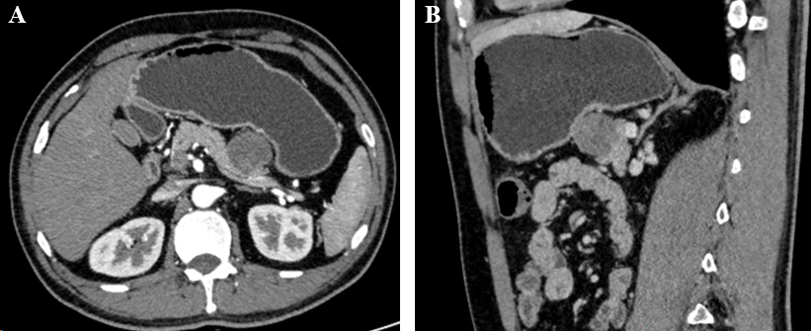
Figure 1 Abdominal computer tomograph showed a 3.2 cm × 3.0 cm round lesion in the tail of the pancreas, which was uneven and mildly enhanced under enhanced scan. A: The boundary between the posterior margin and the pancreas was not clear, and was not combined with the pancreatic duct; B: Multiple lymph nodes were also seen in the mesentery area, with the width of about 1.3 cm for the largest one.
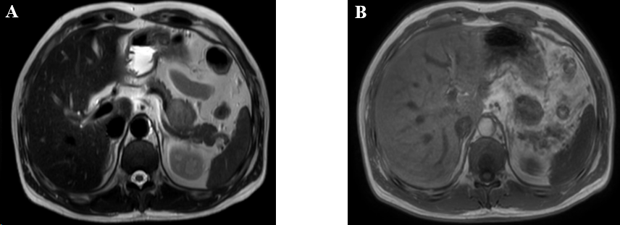
Figure 2 Magnetic resonance imaging showed an abnormal blocky signal found in the pancreato-gastric space, with a size of about 3.1 cm × 2.9 cm × 2.7 cm. The boundary between the local lesion and the pancreatic body was not clear. A: T1W1 showed equal and slightly lower signal; B: T2W1 showed a slightly higher signal. The enhanced scan showed progressive uneven enhancement.
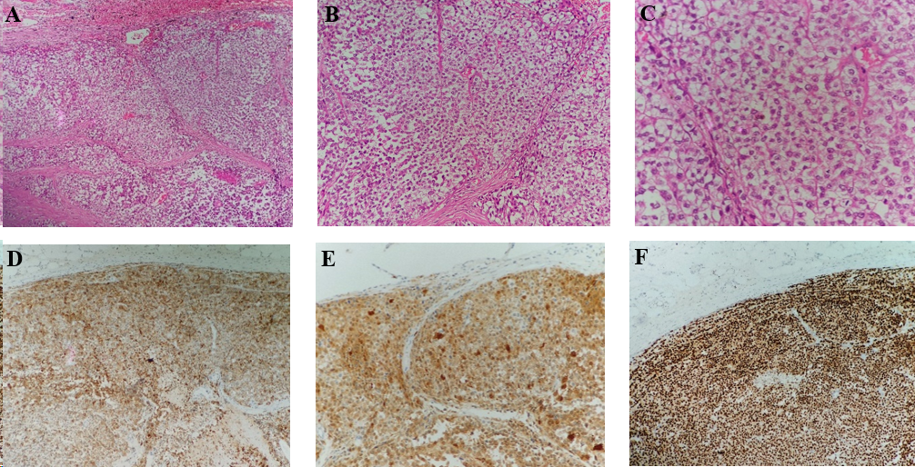
Figure 3 The malignant tumor of the pancreatic body was accompanied by massive necrosis. A and B: Hematoxylin and eosin (H&E) showed tumor cells arranged in nests (A; × 10), with fibrous and vascular separation around the nests (B; × 20); C: The cells were oval or polygonal, with obvious nucleoli, and some cytoplasm was lightly stained or vacuolated (H&E, × 40); D-F: No metastasis was found in the surrounding lymph nodes and no tumor involvement was found in the resection margin. Immunohistochemical results: AE1/3 (-), CD56 (-), CgA (-), CK8/18(-), HMB45(+), Melan-A (+) (D), Ki-67 (60%+), S-100 (+)(E), SOX10 (+)(F), syn (-), β-catenin (+), PR (-).

