Name of journal: World Journal of Gastroenterology
ESPS Manuscript NO: 22716
Manuscript Type: ORIGINAL ARTICLE

Observational Study
Endoscopic dilation of complete oesophageal obstructions with a combined antegrade-retrograde rendezvous technique

Bertolini R et al. Rendezvous dilation in complete oesophageal obstruction

Reto Bertolini, Christa Meyenberger, Paul Martin Putora, Franziska Albrecht, Martina Anja Broglie, Sandro J Stoeckli, Michael Christian Sulz

Reto Bertolini, Christa Meyenberger, Franziska Albrecht, Michael Christian Sulz, Division of Gastroenterology and Hepatology, Kantonsspital St. Gallen, 9007 St. Gallen, Switzerland

Paul Martin Putora, Department of Radiation Oncology, Kantonsspital St. Gallen, 9007 St. Gallen, Switzerland

Martina Anja Broglie, Department of Otorhinolaryngology, Head and Neck Surgery, Kantonsspital St. Gallen, 9007 St. Gallen, Switzerland

Author contributions: Sulz MC designed the study together with Bertolini R; all authors provided data; Sulz MC, Bertolini R, Putora PM, Albrecht F and Broglie MA analysed and interpreted the data and wrote the manuscript; Meyenberger C and Stoeckli SJ interpreted the data and revised the manuscript; all authors approved the final version of the manuscript.

Institutional review board statement: The study was reviewed and approved by the Institutional Review Board of the Cantonal Hospital St. Gallen.
Informed consent statement: All study participants, or their legal guardian, provided informed written consent prior to study enrolment.

Conflict-of-interest statement: All authors disclosed no financial relationships relevant to this publication.

Open-Access: This article is an open-access article which was selected by an in-house editor and fully peer-reviewed by external reviewers. It is distributed in accordance with the Creative Commons Attribution Non Commercial (CC BY-NC 4.0) license, which permits others to distribute, remix, adapt, build upon this work non-commercially, and license their derivative works on different terms, provided the original work is properly cited and the use is non-commercial. See: http://creativecommons.org/licenses/by-nc/4.0/

Correspondence to: Michael Christian Sulz, MD, Division of Gastroenterology and Hepatology, Kantonsspital St. Gallen, 9007 St. Gallen, Switzerland. michael.sulz@kssg.ch
Telephone: +41-71-4941245
Fax: +41-71-4946327

Received: September 17, 2015
Peer-review started: September 17, 2015
First decision: October 14, 2015
Revised: November 3, 2015
Accepted: December 8, 2015
Article in press:
Published online:

Abstract
AIM: To investigate the combined antegrade-retrograde endoscopic rendezvous technique for complete oesophageal obstruction and the swallowing outcome.

METHODS: This single-centre case series includes consecutive patients who were unable to swallow due to complete oesophageal obstruction and underwent combined antegrade-retrograde endoscopic dilation (CARD) within the last 10 years. The patients’ demographic characteristics, clinical parameters, endoscopic therapy, adverse events, and outcomes were obtained retrospectively. Technical success was defined as effective restoration of oesophageal patency. Swallowing success was defined as either percutaneous endoscopic gastrostomy (PEG)-tube independency and/or relevant improvement of oral food intake, as assessed by the functional oral intake scale (FOIS) (≥ level 3).

RESULTS: The cohort consisted of six patients (five males; mean age 71 years [range 54-74]). All but one patient had undergone radiotherapy for head and neck or oesophageal cancer. Technical success was achieved in five out of six patients. After discharge, repeated dilations were performed in all five patients. During follow-up (median 27 mo, range 2-115), three patients remained PEG-tube dependent. Three of four patients achieved relevant improvement of swallowing (two patients: FOIS 6, one patient: FOIS 7). One patient developed mediastinal emphysema following CARD, without a need for surgery.

CONCLUSION: The CARD technique is safe and a viable alternative to high-risk blind antegrade dilation in patients with complete proximal oesophageal obstruction. Although only half of the patients remained PEG-tube independent, the majority improved their ability to swallow.

Key words: Oesophageal obstruction; Rendezvous technique; Combined antegrade-retrograde endoscopic dilation; Endoscopic dilation; Head and neck cancer; Radiotherapy

©The Author(s) 2015. Published by Baishideng Publishing Group Inc. All rights reserved.

Core tip: Complete obstruction in the proximal oesophagus is rare after radiotherapy for head and neck cancers. We present our institutional experience with endoscopic rendezvous dilation and the clinical outcomes. This technique offers a safe and viable alternative to high-risk blind antegrade dilation. In our series, the rate of technical success was high. Although half of the patients remained percutaneous endoscopic gastrostomy-tube dependent, the majority showed relevant improvement in their ability to swallow and, consequently, in their quality of life.

Bertolini R, Meyenberger C, Putora PM, Albrecht F, Broglie MA, Stoeckli SJ, Sulz MC. Endoscopic dilation of complete oesophageal obstructions with a combined antegrade-retrograde rendezvous technique. World J Gastroenterol 2015; In press

INTRODUCTION
Complete obstruction in the proximal oesophagus is a rare but severe complication after radiotherapy in head and neck cancer patients^{[1-3]}. Less common causes are gastro-oesophageal reflux disease, Plummer-Vinson-Syndrome, or caustic injury^{[4-7]}. Antegrade reopening and dilation of a complete oesophageal obstruction is difficult and carries a high risk of oesophageal perforation. A combined antegrade-retrograde endoscopic rendezvous procedure offers better visualisation and safer dilation. The antegrade–retrograde rendezvous technique was first described by van Twisk et al^{[8]} in 1998, followed by Bueno in 200^{[9]}. This technique is also termed combined antegrade-retrograde endoscopic dilation (CARD). Several other small series^{[10-14]} were subsequently reported. Most series reported on the technical feasibility of the procedure, but rarely on the functional assessment of swallowing. Therefore, our primary aim was to describe the swallowing outcome, including the dependency on a percutaneous endoscopic gastrostomy (PEG)-tube, using the functional objective oral intake scale (FOIS) to assess patients undergoing this rare endoscopic treatment.

MATERIALS AND METHODS
Patients and endoscopic technique
This single-centre case series included a consecutive cohort of patients who underwent CARD for complete obstruction in the area of the pharyngoesophageal segment at the Cantonal Hospital, St. Gallen between July 2005 and February 2015. Prior to the intervention, all patients were completely unable to swallow and PEG-tube dependent. The diagnosis of complete obstruction was confirmed by endoscopic and/or radiologic findings. Data extracted included demographic characteristics, clinical parameters, endoscopic therapy, adverse events, and outcome. Approval for using pseudoanymized patient data was obtained from the local ethics committee and all study participants, or their legal guardian, provided informed written consent prior to study enrollment.
The procedures were performed jointly by experienced endoscopists and head and neck surgeons with the patient under general anaesthesia. The existing PEG-tube gastrostomy is a condition to get access to the stomach for the retrograde part of this rendezvous procedure. The first step was to remove the PEG-tube carefully and to keep access to the stomach with a guidewire through the gastrostomy. Then, dilation of the gastrostomy with Savary bougies (Cook Medical, United Kingdom) up to 12 mm over the guidewire was necessary to pass the endoscope. In our experience, balloon dilation was not effective. All retrograde endoscopies were performed with extra-slim nasal endoscopes (Olympus, Tokyo, Japan) (Figure 1). Antegrade endoscopy was performed transorally with rigid and/or flexible endoscopes (left to the discretion of the head and neck surgeon). The obstruction within the oesophagus was identified with both endoscopes (Figure 2). Fluoroscopy on the one hand and antegrade transillumination on the other hand are important tools to guide the retrograde and the antegrade endoscope towards each other. Fluoroscopy helps to estimate the length of the obstructed oesophagus and the direction of both endoscopes. Furthermore, the retrograde puncture of the complete obstruction was directed by transillumination (Figure 3). It was crucial to use the hard end of the wire, as it is impossible to succeed puncture of the completely obstructed oesophagus with the soft tip of the wire. The puncture procedure was documented by endoscopy and fluoroscopy (Figure 3). After successful puncture the wire was passed through the obstruction and finally picked up by the operator performing the antegrade endoscopy. Then, dilation was started using small Savary bougies (Cook Medical, United Kingdom) from the antegrade site, followed by insertion of a nasogastric tube to maintain the patencyand balloon dilations (Figure 4). Nasogastric tubes were re-inserted after subsequent dilations until the dilated oesophageal lumen was large enough, according to the discretion of the operators. After the procedure a new PEG-tube was placed percutaneously to provide additional nutritional support. Video 1 summarizes the single steps of the procedure. The details of the procedure were not based on a strict protocol. The endoscopists were allowed to choose any available endoscopic device to succeed.

Outcome parameters
Technical success was defined as effective restoration of oesophageal patency. The swallowing success was defined as either PEG-tube independency or relevant improvement of oral food intake, as assessed by the FOIS, a 7-point ordinal scale documenting the functional level of oral intake of food and liquids^{[15]}. The scale focuses on the patient’s intake by mouth on a daily basis (Table 1).Though the pre-therapeutic FOIS level was not assessed formally, the score of all patients corresponded to a FOIS level 1 (nothing by mouth, PEG-tube dependent) as they were unable to swallow anything due to complete obstruction. Relevant improvement of swallowing (FOIS ≥ level 3) at the time of follow-up was defined as swallowing success.

RESULTS
Patients’ characteristics
The cohort consisted of six patients [five males; mean age 71 years (range 54-74)].Patients’ characteristics are shown in Table 2. Two patients died due to their underlying tumour disease 4 and 20 mo after the endoscopic rendezvous intervention. Death was associated with cancer.

Procedure characteristics
Technical details concerning the endoscopic rendezvous intervention are summarized in Table 3. Rigid endoscopes were used in four of six patients by head and neck surgeons; while flexible instruments were applied in two patients for the antegrade access. The retrograde puncture of the obstruction was achieved with a VisiGlide guidewire (Olympus, Tokyo, Japan) in four of six cases (Figure 3). In each case, once a lumen was established, a wire was cautiously passed through, and dilation (median 10 mm, range 6 - 10 mm) was performed with Savary bougies (Cook Medical, United Kingdom). After the first intervention, nasogastric tubes were inserted in all cases to keep the dilated obstruction open and a new PEG-tube was placed successfully in all patients.

Outcome
Technical success: Technical success was achieved in five out of six patients (Tables 2 and 3). In one patient with squamous carcinoma of the proximal oesophagus, the complete obstruction in the proximal oesophagus could not be punctured retrogradely by VisiGlide wire, super stiff wire, Savary wire, or argon beamer. All five patients with successful puncture were treated with Savary bougies [median size of first dilation 10 mm (range 6-10 mm)]. However, all five patients with technical success needed subsequent dilations; three were treated with balloons (size range 15-16.5 mm, Figure 4) and the other two patients with bougies (size range 12-15mm) (Table 3). After discharge, repeated dilations or stenting were performed in all five patients during long-term follow-up; however the number of interventions and the time interval varied significantly between the individual patients, depending on their symptoms.

Swallowing success: At the date of follow-up (median 27 mo, range 2-115 mo), the FOIS results of all patients who survived were available (Table 3). Before the procedure, all patients were completely unable to swallow correlating with FOIS level 1: Nothing by mouth, dependent from PEG-tube feeding. After the endoscopic treatment, containing the initial rendez-vous procedure and the following dilations, in three patients clinical success with a FOIS score more than 6 was reached. Unfortunately, two patients died before the authors could draw any conclusion regarding swallowing during the follow up. One patient had a poor result with a FOIS level of 2 and did not reach swallowing success (defined as FOIS ≥ 3).

Adverse events: One patient developed a mediastinal emphysema following CARD, without a need for surgery. There were no deaths associated with the endoscopic procedure (Table 3).

DISCUSSION
We present a retrospective single-centre case series of all patients over the last 10 years who were treated with endoscopic antegrade-retrograde rendezvous dilation for complete obstruction in the proximal oesophagus or hypopharynx. The majority of patients had undergone previous radiotherapy, for treatment of head and neck and proximal oesophagus cancers, which is a major cause of stricture or obstruction in the proximal oesophagus^{[1-3]}. Pharyngoesophageal stricture or stenosis necessitating dilations have been described in up to one fifth of patients after radio(chemo)therapy for head and neck cancer^{[16,17]}. A correlation has been described between radiation stricture induction and radiation dose, as well as volume of irradiation to organs at risk (e.g., upper oesophagus)^{[18]}. Complete obstruction may also occur in a minority of affected patients^{[2]}.
While intensity modulated radiotherapy better spares the parotid gland and reduces xerostomia rates^{[19]}, a review of published literature suggested there is a higher rate of oesophageal stricture with this treatment compared with 3D conventional radiotherapy^{[20]}. Chen et al^{[21]} demonstrated that when planning target volumes were reduced (from 5 to 3 mm) and there was daily imaging of the application of radiotherapy treatment, the rate of radiation-induced oesophageal stricture was reduced from 14% to 7%. There is currently a stronger focus on sparing the dose to the pharyngeal constrictor muscles and the cervical oesophagus when feasible; thus, lower rates of (pharyngo-) oesophageal stricture might be expected in the future as a side-effect of radiotherapy.
This is one of the first series presenting clinical outcome data based on assessment of the patient’s oral ingestion ability after rendezvous treatment using a validated score. Grootemann et al^{[22]} used the Dakkak and Bennett score. Goguen et al^{[23]}reported the outcome in terms of the achieved diet and the PEG-tube dependency, and the clinical outcome was recorded by the swallow therapists. The limited data on this topic illustrate that professional medical teams who take care of patients suffering from dysphagia after head and neck surgery or radiotherapy in the head and neck region (e.g., speech therapists, head and neck surgeons, medical radio-oncologists, and gastroenterologists) rarely assess and publish the patients’ functional oral food in takes using objective scores of their daily routine. In our study, the patients’ abilities to intake food orally were assessed using the FOIS. This tool was initially designed to document changes in functional oral intake of food and liquid in stroke patients^{[15]}. The scale is useful to document a clinical change, for example before and after an intervention, such as with speech therapy^{[15,24]}.
Other scales are available, such as the Mann Assessment of Swallowing Ability (MASA), Acute Stroke Dysphagia Screen (ASDS), and the Dysphagia Outcome and Severity Scale (DOSS). However, they are often disease-specific. The FOIS offers an easy and quick assessment to reflect the individual patient’s situation in daily life and to document a clinical change. The FOIS can be easily used by physicians and other professional health workers who are not experienced in adult dysphagia management. However, although FOIS is a useful tool to document oral intake, it is also important to pay attention to other characteristics, such as quality of life and nutritional status.
Although only half of our patients remained PEG-tube independent, the majority (three of four patients) had relevant improvement of swallowing (FOIS ≥ level 3) and, therefore, gained quality of life. The largest case series to date^{[22]} reported that 44% of the patients were able to eat at least soft food; whereas, 56% of their patients needed permanent PEG-tube feeding after a median follow-up of 1.8 years. Other authors reported a clinical success rate without PEG-tube dependency between 30% and 60%^{[13,23,25,26]}. Previous reports found oral intake was possible in 45% and 80% of subjects after these procedure^{[22,23,25,26]}. Grooteman et al^{[22]} reported that only 24% of the patients were dysphagia-free. We did not investigate dysphagia; rather, we evaluated the diet that was possible during follow-up as this is easy for patients to report on. The findings in literature concerning the dependency on PEG-tube feeding and oral intake are similar to our study.
The most difficult part of the antegrade–retrograde rendezvous procedure is to gain access through the completely obstructed oesophagus. Our data regarding technical success (five of six patients) are in line with the findings of other studies, which reported technical success rates of 83%-100%^{[13,23,25,26]}, demonstrating that this procedure is technically feasible. In our series, we started all punctures with guide wires (0.035 inch). It is crucial to puncture with the hard end of the wire, as it is impossible to succeed puncture of a complete oesophageal obstruction with the soft tip of the wire. Furthermore, it is important to reach a good transillumination from the antegradely inserted laryngoscope. The combination of an adequate transillumination and fluoroscopy helps the two operators to bring the two endoscopes as near as possible and to have the best condition to puncture into the complete obstruction. The endoscopist has to be patient. One can try also other wires as super stiff or Savary wires. One of our cases was a technical failure, after trying to puncture with a super stiff wire, a Savary wire, and argon beamer. In most series^{[9,13,14,22,26]}, guidewires were also used. Grootemann et al^{[22]} also used electrocautery. Other devices utilized were biopsy forceps^{[27]}, needle knifes (e.g., biliary needle knifes)^{[11,22]}, and needles, e.g., used in endoscopic ultrasound for fine-needle aspiration^{[11,14,27]}. Schembre et al^{[14]} mentioned severe complications, such as abscesses, after using needles and concluded that operators should be very cautious. In a single case, we utilized argon beamer coagulation in addition to the wire and succeeded. Overall, we think that the operator should be aware of the armentarium of various devices for puncture and should feel confident with the tools utilized.
In our case series, a single case of mediastinal emphysema occurred as a complication of the rendezvous procedure. Fortunately, no surgery was needed. Goguen et al^{[23]} reported pneumomediastinum in 18% of subjects, but also oesophageal perforation in 5% and gastrostomy tube site problems in 16% (e.g., leakage by pulling the stomach away from abdominal wall). We only used thin nasal gastroscopes that may have prevented local complications at the gastrostomy tube site; whereas, Goguen et al^{[23]} used adult endoscopes. Dellon et al^{[26]} also described an oesophageal perforation that could be managed without surgery. However, Zald et al^{[28]} reported a fatal venous air embolism after dilation by rendezvous.
One of our patients (a 59-year-old male) developed complete oesophageal obstruction due to toxic epidermal necrolysis (TEN), an idiosyncratic, potentially life-threatening disease characterized by widespread inflammation and necrosis of the epidermis and mucous membranes^{[29,30]}. Mostly caused by a severe adverse event to drugs (e.g., allopurinol or methazolamide)^{[29]}, TEN is a very rare disease with an incidence of 0.4-1.2 cases per million person-years. There are very few cases in the literature, with most encountered in children, of TEN that resulted in narrowing of the oesophageal lumen through fibrosis and oesophageal obstruction^{[31]}. As far as we know, this is the first report of a rendezvous dilation in a patient suffering from oesophageal complete obstruction caused by TEN.
Several limitations need to be addressed. This is a retrospective study with a small sample size showing a single-centre experience. However, the low number of cases throughout the literature is explained by the rarity of complete obstruction of the hypopharynx/oesophagus. Due to the retrospective nature of this study, we were not to obtain patients’ FOIS levels prior to the endoscopic rendezvous procedure. However, all patients could not swallow at all prior to the procedure, and this correlates to FOIS level 1. Furthermore, details regarding subsequent dilations after rendezvous procedure were not assessed. However, the time interval between and number of dilations over time varied relevantly, based on individual symptoms.
In conclusion, Endoscopic retrograde rendezvous dilation offers a safe and viable alternative to high-risk blind dilation of the proximal oesophagus and hypopharynx or surgical approaches in patients with complete proximal oesophageal obstruction. Although only half of the patients remained PEG-tube independent, the majority of patients improved their ability to swallow. We suggest using scores like the FOIS for standardised clinical follow-up.

COMMENT
Background
Complete oesophageal obstruction is rare and may occur after radiotherapy of head and neck cancers. As antegrade dilation is often unsuccessful, retrograde endoscopic rendezvous dilation can be used to restore oesophageal patency.

Research frontiers
This special endoscopic technique is rarely used. Therefore, it is important to analyse its technical and clinical success.

Innovations and breakthroughs
This case series focuses on the clinical outcome of endoscopic retrograde-antegrade rendezvous dilation.

Applications
This case series showed a fairly good success rate and noticeably few complications. We contributed further information to the existing literature.

Terminology
Gastroscopes are instruments for the examination of the upper gastrointestinal tract. A complete obstruction is a completely occluded lumen. Rendezvous procedure means that one endoscope is used from the proximal part and one from the distal part of the complete obstruction.

Peer-review
This case series provides information about the technical and clinical success of antegrade-retrograde rendezvous dilation of complete oesophageal obstructions, which are rare. This endoscopic technique is interesting for other gastroenterologists.

REFERENCES
1 Coia LR, Myerson RJ, Tepper JE. Late effects of radiation therapy on the gastrointestinal tract. Int J Radiat Oncol Biol Phys 1995; 31: 1213-1236 [PMID: 7713784 DOI: 10.1016/0360-3016(94)00419-l]
2 Laurell G, Kraepelien T, Mavroidis P, Lind BK, Fernberg JO, Beckman M, Lind MG. Stricture of the proximal esophagus in head and neck carcinoma patients after radiotherapy. Cancer 2003; 97: 1693-1700 [PMID: 12655526 DOI: 10.1002/cncr.11236]
3 Francis DO, Hall E, Dang JH, Vlacich GR, Netterville JL, Vaezi MF. Outcomes of serial dilation for high-grade radiation-related esophageal strictures in head and neck cancer patients. Laryngoscope 2015; 125: 856-862 [PMID: 25345779 DOI: 10.1002/lary.24987]
4 Erdoğan E, Eroğlu E, Tekant G, Yeker Y, Emir H, Sarimurat N, Yeker D. Management of esophagogastric corrosive injuries in children. Eur J Pediatr Surg 2003; 13: 289-293 [PMID: 14618516 DOI: 10.1055/s-2003-43581]
5 Brette M, Aidan K, Halimi B, Cattan P, Grozier F, Sarfati E, Monteil J. [Pharyngo-esophagoplasty by right coloplasty for the treatment of post-caustic pharyngo-laryngeal-esophageal burns: a report of 13 cases]. Ann Otolaryngol Chir Cervicofac 2000; 117: 147-154 [PMID: 10863199 DOI: AORL-06-2000-117-3-0003-438X-101019-ART3]
6 Novacek G. Plummer-Vinson syndrome. Orphanet J Rare Dis 2006; 1: 36 [PMID: 16978405 DOI: 10.1186/1750-1172-1-36]
7 Thomas GR, Raynor T. Complete esophageal stenosis secondary to peptic stricture in the cervical esophagus: case report. Ear Nose Throat J 2006; 85: 187-189 [PMID: 16615603]
8 van Twisk JJ, Brummer RJ, Manni JJ. Retrograde approach to pharyngo-esophageal obstruction. Gastrointest Endosc 1998; 48: 296-299 [PMID: 9744609 DOI: 10.1016/S0016-5107(98)70195-6]
9 Bueno R, Swanson SJ, Jaklitsch MT, Lukanich JM, Mentzer SJ, Sugarbaker DJ. Combined antegrade and retrograde dilation: a new endoscopic technique in the management of complex esophageal obstruction. Gastrointest Endosc 2001; 54: 368-372 [PMID: 11522984 DOI: 10.1067/mge.2001.117517]
10 Al-Haddad M, Pungpapong S, Wallace MB, Raimondo M, Woodward TA. Antegrade and retrograde endoscopic approach in the establishment of a neo-esophagus: a novel technique. Gastrointest Endosc 2007; 65: 290-294 [PMID: 17258990 DOI: 10.1016/j.gie.2006.08.008]
11 Moyer MT, Stack BC, Jr., Mathew A. Successful recovery of esophageal patency in 2 patients with complete obstruction by using combined antegrade retrograde dilation procedure, needle knife, and EUS needle. Gastrointest Endosc 2006; 64: 789-792. [PMID: 17055876 DOI: 10.1016/j.gie.2006.06.081]
12 Petro M, Wein RO, Minocha A. Treatment of a radiation-induced esophageal web with retrograde esophagoscopy and puncture. Am J Otolaryngol 2005; 26: 353-355 [PMID: 16137538 DOI: 10.1016/j.amjoto.2005.02.007]
13 Maple JT, Petersen BT, Baron TH, Kasperbauer JL, Wong Kee Song LM, Larson MV. Endoscopic management of radiation-induced complete upper esophageal obstruction with an antegrade-retrograde rendezvous technique. Gastrointest Endosc 2006; 64: 822-828 [PMID: 17055888 DOI: 10.1016/j.gie.2006.06.026]
14 Schembre D, Dever JB, Glenn M, Bayles S, Brandabur J, Kozarek R. Esophageal reconstitution by simultaneous antegrade/retrograde endoscopy: re-establishing patency of the completely obstructed esophagus. Endoscopy 2011; 43: 434-437 [PMID: 21360424 DOI: 10.1055/s-0030-1256075]
15 Crary MA, Mann GD, Groher ME. Initial psychometric assessment of a functional oral intake scale for dysphagia in stroke patients. Arch Phys Med Rehabil 2005; 86: 1516-1520 [PMID: 16084801 DOI: 10.1016/j.apmr.2004.11.049]
16 Caudell JJ, Schaner PE, Desmond RA, Meredith RF, Spencer SA, Bonner JA. Dosimetric factors associated with long-term dysphagia after definitive radiotherapy for squamous cell carcinoma of the head and neck. Int J Radiat Oncol Biol Phys 2010; 76: 403-409 [PMID: 19467801 DOI: 10.1016/j.ijrobp.2009.02.017]
17 Lee WT, Akst LM, Adelstein DJ, Saxton JP, Wood BG, Strome M, Butler RS, Esclamado RM. Risk factors for hypopharyngeal/upper esophageal stricture formation after concurrent chemoradiation. Head Neck 2006; 28: 808-812 [PMID: 16732601 DOI: 10.1002/hed.20427]
18 Mavroidis P, Laurell G, Kraepelien T, Fernberg JO, Lind BK, Brahme A. Determination and clinical verification of dose-response parameters for esophageal stricture from head and neck radiotherapy. Acta Oncol 2003; 42: 865-881 [PMID: 14968948]
19 Nutting CM, Morden JP, Harrington KJ, Urbano TG, Bhide SA, Clark C, Miles EA, Miah AB, Newbold K, Tanay M, Adab F, Jefferies SJ, Scrase C, Yap BK, A'Hern RP, Sydenham MA, Emson M, Hall E. Parotid-sparing intensity modulated versus conventional radiotherapy in head and neck cancer (PARSPORT): a phase 3 multicentre randomised controlled trial. Lancet Oncol 2011; 12: 127-136 [PMID: 21236730 DOI: 10.1016/s1470-2045(10)70290-4]
20 Wang JJ, Goldsmith TA, Holman AS, Cianchetti M, Chan AW. Pharyngoesophageal stricture after treatment for head and neck cancer. Head Neck 2012; 34: 967-973 [PMID: 21953721 DOI: 10.1002/hed.21842]
21 Chen AM, Yu Y, Daly ME, Farwell DG, Benedict SH, Purdy JA. Long-term experience with reduced planning target volume margins and intensity-modulated radiotherapy with daily image-guidance for head and neck cancer. Head Neck 2014; 36: 1766-1772 [PMID: 24174221 DOI: 10.1002/hed.23532]
22 Grooteman KV, Wong Kee Song LM, Vleggaar FP, Siersema PD, Baron TH. Functional outcome of patients treated for radiation-induced complete esophageal obstruction after successful endoscopic recanalization (with video). Gastrointest Endosc 2014; 80: 175-181 [PMID: 24810592 DOI: 10.1016/j.gie.2014.03.007]
23 Goguen LA, Norris CM, Jaklitsch MT, Sullivan CA, Posner MR, Haddad RI, Tishler RB, Burke E, Annino DJ. Combined antegrade and retrograde esophageal dilation for head and neck cancer-related complete esophageal stenosis. Laryngoscope 2010; 120: 261-266 [PMID: 19998421 DOI: 10.1002/lary.20727]
24 Huang KL, Liu TY, Huang YC, Leong CP, Lin WC, Pong YP. Functional outcome in acute stroke patients with oropharyngeal Dysphagia after swallowing therapy. J Stroke Cerebrovasc Dis 2014; 23: 2547-2553 [PMID: 25245482 DOI: 10.1016/j.jstrokecerebrovasdis.2014.05.031]
25 Fowlkes J, Zald PB, Andersen P. Management of complete esophageal stricture after treatment of head and neck cancer using combined anterograde retrograde esophageal dilation. Head Neck 2012; 34: 821-825 [PMID: 22127917 DOI: 10.1002/hed.21826]
26 Dellon ES, Cullen NR, Madanick RD, Buckmire RA, Grimm IS, Weissler MC, Couch ME, Shaheen NJ. Outcomes of a combined antegrade and retrograde approach for dilatation of radiation-induced esophageal strictures (with video). Gastrointest Endosc 2010; 71: 1122-1129 [PMID: 20421101 DOI: 10.1016/j.gie.2009.12.057]
27 Mukherjee K, Cash MP, Burkey BB, Yarbrough WG, Netterville JL, Melvin WV. Antegrade and retrograde endoscopy for treatment of esophageal stricture. Am Surg 2008; 74: 686-67; discussion 688 [PMID: 18705567]
28 Zald PB, Andersen PE. Fatal central venous air embolism: a rare complication of esophageal dilation by rendezvous. Head Neck 2011; 33: 441-444 [PMID: 19953633 DOI: 10.1002/hed.21304]
29 Ellender RP, Peters CW, Albritton HL, Garcia AJ, Kaye AD. Clinical considerations for epidermal necrolysis. Ochsner J 2014; 14: 413-417 [PMID: 25249808]
30 Sun J, Liu J, Gong QL, Ding GZ, Ma LW, Zhang LC, Lu Y. Stevens-Johnson Syndrome and toxic epidermal necrolysis: a multi-aspect comparative 7-year study from the People's Republic of China. Drug Des Devel Ther 2014; 8: 2539-2547 [PMID: 25548516 DOI: 10.2147/dddt.s71736]
31 Njei B, Schoenfeld A, Vaziri H. Esophageal stricture secondary to drug-induced toxic epidermal necrolysis presenting in an adult: an unusual complication of a rare disease. Conn Med 2013; 77: 541-544 [PMID: 24273804]

P-Reviewer: Campo SMA, Rabago L S-Editor: Qi Y L-Editor: E-Editor:

Table 1 Functional oral intake scale items^{[15]}
Level 1 | Nothing by mouth
Level 2 | Tube dependent with minimal attempts of food or liquid.
Level 3 | Tube dependent with consistent oral intake of food or liquid.
Level 4 | Total oral diet of a single consistency.
Level 5 | Total oral diet with multiple consistencies, but requiring special preparation or compensations.
Level 6 | Total oral diet with multiple consistencies without special preparation, but with specific food limitations.
Level 7 | Total oral diet with no restrictions.

Table 2 Patients’ characteristics and outcomes
No | Sex | Age | Diagnosis | Prior radiotherapy  (max dose i. Gy) | Surgery | chemotherapy | Technical success | FOIS | Notes
1 | F | 68 | Hypopharyngeal carcinoma T3 N0 and Oropharyngeal carcinoma T2 N0 | 68 | No | Yes | Yes | 6
2 | M | 59 | Complete occlusion of sinus piriformis after Lyell syndrome | No | No | No | Yes | 6
3 | M | 54 | Squamous carcinoma of the cervical oesophagus cT3 cN2 cM0 | 66 | No | Yes | No | - | Died before follow-up with PEG-tube
4 | M | 74 | Proximal oesophageal carcinoma and carcinoma of the glottic larynx cT2 cN0 | Glottis:66  oesophagus: 68 | Yes | Yes | Yes | - | died before follow-up with PEG-tube
5 | M | 68 | Carcinoma of the hypopharynx  initial cT2c No cM0 | 70 | Yes | No | Yes | 2
6 | M | 71 | Carcinoma of the larynx cT3 cN2 | 68 | No | No | Yes | 7

Table 3 Technical details and clinical success of endoscopic rendezvous dilation in patients with complete obstruction of the proximal oesophagus

Type of antegrade endoscope  - rigid, flexible | 4, 2
Method of retrograde puncture of the obstruction  - VisiGlide guidewire  - Argon beamer | 4/6  1/6
First stricture dilation  - with Savarybougie  - Size | 5/5  median 10 mm (range 6 - 10 mm)
Subsequent dilations before discharge  with balloon  - size range  with bougie  - size range | 3/5 patients  15-16.5 mm  2/5 patients  12-15 mm
Success rate of rendezvous procedures  Technical success  Need for recurrent dilations after discharge  Swallowing success  - Time of follow-up, median (range)  - Need for long-term PEG-tube  - Functional oral intake  - Tube dependent with minimal attempts of food or liquid (level 2)  - Total oral diet with multiple consistencies without special preparation, but with specific food limitations (level 6)  - Total oral diet with no restrictions (level 7) | 5/6 (83%)  5/5  27 mo (2-115)  3/6  1  2  1
Complications of rendezvous procedures  - Mediastinal emphysema (no surgery needed)  - Death | 1/6  0/6
FOIS: Functional oral intake.

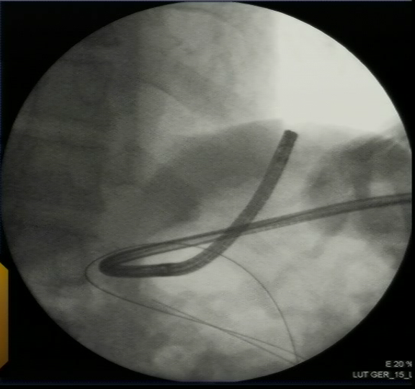
Figure 1 Fluoroscopy. Gastroscope in the stomach, inserted through the existing gastrostomy and used for retrograde puncture.

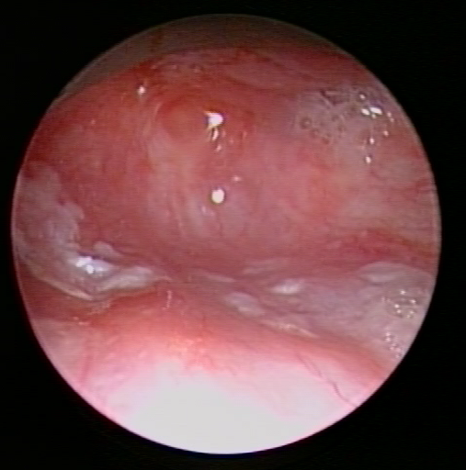
Figure 2 View from the antegrade site. Complete obstruction in the proximal oesophagus.

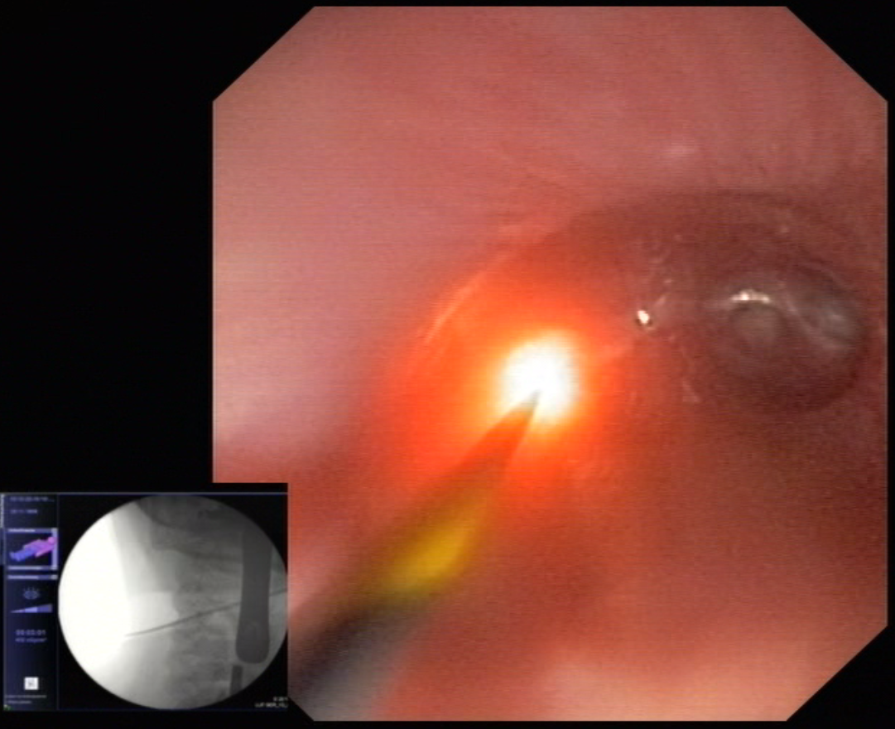

Figure 3 Rendezvous. Retrograde view, transillumination from the proximal site before puncture of the complete obstruction with a VisiGlide guidewire (Olympus, Tokyo, Japan). Inlet: Fluoroscopy showing the antegrade laryngoscope and the retrograde gastroscope opposite each other.

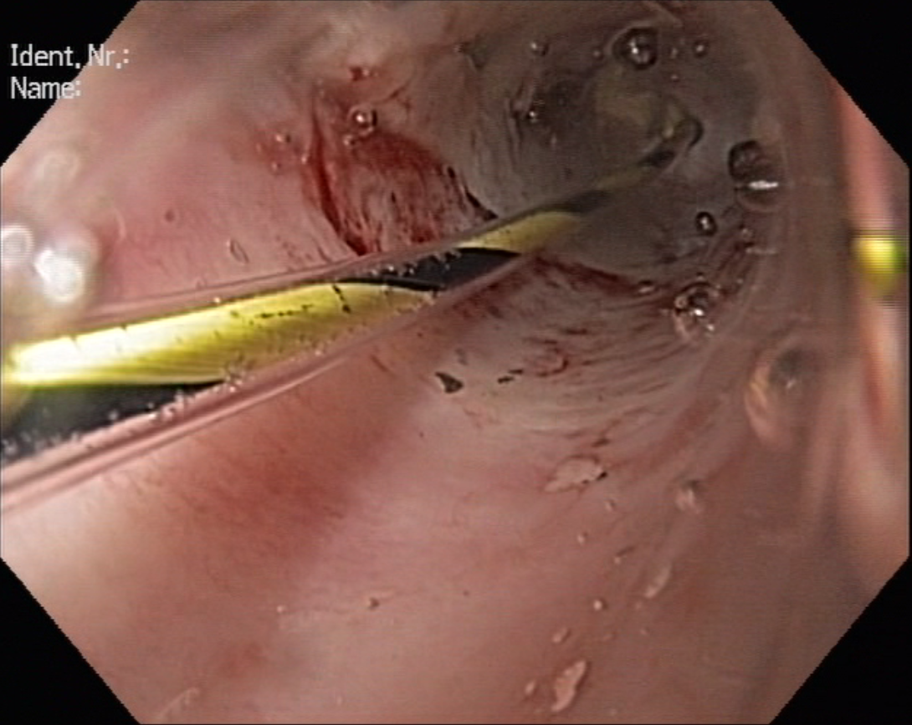

Figure 4 Balloon dilation of the punctured obstruction. A Hercules balloon, 6 mm, was used.

