Name of Journal: World Journal of Clinical Cases
Manuscript NO: 67103
Manuscript Type: CASE REPORT

Surgical treatment of abnormal systemic artery to the left lower lobe: A case report

Zhang YY et al. Surgical treatment case of ASALLL

Yi-Yuan Zhang, Xiao-Ying Gu, Jia-Lin Li, Zhao Liu, Guo-Yue Lv

Yi-Yuan Zhang, Jia-Lin Li, Zhao Liu, Department of Thoracic Surgery, The First Hospital of Jilin University, Changchun 130021, Jilin Province, China

Xiao-Ying Gu, Department of Anesthesiology, The First Hospital of Jilin University, Changchun 130021, Jilin Province, China

Guo-Yue Lv, Department of Hepatobiliary and Pancreatic Surgery, The First Hospital of Jilin University, Changchun 130021, Jilin Province, China

Author contributions: Zhang YY performed the study and wrote the paper; Gu XY provided technical advice and co-wrote the article; Li JL and Liu Z collected clinical data; Lv GY designed and supervised the study; All authors have read and approved the manuscript.

Corresponding author: Guo-Yue Lv, PhD, Chief Doctor, Department of Hepatobiliary and Pancreatic Surgery, The First Hospital of Jilin University, No. 71 Xinmin Street, Changchun 130021, Jilin Province, China. lvgy@jlu.edu.cn

Received: April 23, 2021
Revised: June 30, 2021
Accepted: August 3, 2021
Published online: September 26, 2021

Abstract
BACKGROUND
Abnormal systemic artery to the left lower lobe is a rare congenital abnormality characterized by anomalous communication between the systemic and pulmonary circulation. Owing to its rarity, there is limited clinical experience with respect to the diagnosis and treatment of this disease.

CASE SUMMARY
We report a 60-year-old man who presented with a history of hemoptysis for 20 d. Contrast-enhanced computed tomography of the chest confirmed the diagnosis of abnormal systemic artery to the left lower lobe, and surgical treatment was performed. The aberrant artery arising from the descending thoracic aorta was ligated, followed by removal of the left lower lobe. The patient showed good recovery and was discharged 6 d after the surgery. At the 1-year follow-up, the patient had recovered completely, and lung CT showed no abnormal findings.

CONCLUSION
We present a case of abnormal systemic artery to the left lower lobe that was successfully managed by surgical resection of the aberrant artery and the left lower lobe. This case report adds to the clinical experience of diagnosing and treating this rare entity.

Key Words: Abnormal systemic artery to the left lower lobe; Diagnosis and treatment; Surgery; Rare disease; Computed tomography; Case report

©The Author(s) 2021. Published by Baishideng Publishing Group Inc. All rights reserved.

Citation: Zhang YY, Gu XY, Li JL, Liu Z, Lv GY. Surgical treatment of abnormal systemic artery to the left lower lobe: A case report. World J Clin Cases 2021; 9(27): 8192-8198
URL: https://www.wjgnet.com/2307-8960/full/v9/i27/8192.htm
DOI: https://dx.doi.org/10.12998/wjcc.v9.i27.8192

Core Tip: Abnormal systemic artery to the left lower lobe is a rare congenital vascular malformation. Experience in diagnosis and treatment remains limited. Here we presented the clinical presentation, contrast-enhanced computed tomography, surgical procedure and follow-up result of an abnormal systemic artery to the left lower lobe case. We discussed the difference between abnormal systemic artery to the left lower lobe and pulmonary sequestration and different treatment strategies. This case report adds to the clinical experience with regard to the diagnosis and treatment of this rare disease.
INTRODUCTION
Abnormal systemic artery to the left lower lobe (ASALLL) is a rare congenital anomaly that creates an anomalous communication between the systemic and the pulmonary circulation^{[1]}. It is characterized by aberrant systemic arterial blood flow to the left lower lobe of the lung, which drains into the pulmonary vein^{[1,2]}. Owing to its rarity, only a few reports have described this entity. Hemoptysis is the most common manifestation, while some patients may exhibit no symptoms; in rare cases, patients may develop fever and cough with or without expectoration^{[2-4]}. Surgical resection or therapeutic embolization are the main treatment modalities, while some cases may require vascular reconstruction^{[2,5,6]}. We report a senile patient with ASALLL who was successfully treated by surgical resection. In addition, we summarize the diagnosis and treatment of ASALLL based on literature review.

CASE PRESENTATION
Chief complaints
A 60-year-old man was admitted to our hospital in October 2019 with a chief complaint of hemoptysis in the past 20 d. There was no obvious cause of hemoptysis, and it was not accompanied by any other symptoms like chest pain, cough, expectoration or fever.

History of present illness
The symptoms started 20 d ago with no obvious cause of hemoptysis.

History of past illness
The past history was unremarkable apart from a history of appendicectomy. The patient was otherwise healthy and had no history of hypertension, diabetes mellitus, coronary heart disease or infectious disease.

Personal and family history
The patient is a life-long non-smoker. He denied any family history of related diseases.

Physical examination
The general condition of the patient at presentation was good. His vital signs were normal with stable hemodynamic status. Breath sounds were clear, and no pulmonary crackles were detected on auscultation.

Laboratory examinations
The laboratory parameters of the patient were almost normal.

Imaging examinations
Pulmonary contrast-enhanced computed tomography (CT) with three-dimensional reconstruction performed immediately after admission revealed an aberrant vessel supplying the left lower lung lobe (Figure 1); its origin was traced to the descending thoracic aorta. At the same time, pulmonary artery of the left lower lobe of the lung was absent. There were no abnormalities in the left lower pulmonary vein or in the bronchus of the left lower lobe of the lung.

FINAL DIAGNOSIS
The potential differential diagnoses in this case were ASALLL and pulmonary sequestration (PS). The corresponding pulmonary artery is usually absent in ASALLL, but the bronchus is usually normally developed. PS is characterized by the absence of normal communication with the bronchial tree, which helps differentiate it from ASALLL. The final diagnosis of the presented case was ASALLL.

TREATMENT
Routine preoperative workup did not reveal any other abnormality, and the patient underwent surgical treatment in November 2019. After general anesthesia and intubation with double lumen tube, the thoracic cavity was opened via the fifth intercostal space. An anomalous systemic artery arising from the thoracic aorta and supplying blood to the left lower lobe was identified during surgery; the anomalous artery was ligated by vascular stapler and subsequently sutured. The pulmonary artery supplying the left lower lobe was absent, while the corresponding pulmonary artery and bronchus were normal and were all sundered during the removal of the left lower lobe. The surgery was uneventful, and the thoracic cavity was closed after the placement of a closed drainage tube.

OUTCOME AND FOLLOW-UP
The patient showed good recovery and was discharged after removal of the drainage tube 6 d after the surgery. At the 1-year follow-up, the patient had recovered completely, and no abnormalities were detected on lung CT.

DISCUSSION
ASALLL is a rare congenital arterial malformation that is relatively more common in the Asian population^{[7]}. Pathologically, an aberrant artery originates from the descending aorta and supplies blood to the left lower lobe. It is usually associated with the absence of the corresponding pulmonary artery, but the bronchus is normal. It is believed that insufficient blood supply to the lung tissue during embryo development stimulates the abnormal branching of the systemic artery. ASALLL needs to be differentiated from another rare congenital disease, PS, which is characterized by nonfunctional pulmonary tissue that lacks normal communication with the bronchial tree and is also supplied by a non-pulmonary systemic artery^{[8]}. ASALLL was previously categorized as Pryce type Ⅰ pulmonary sequestration; however, this categorization was contested due to the presence of normal bronchus in the affected pulmonary tissue^{[4]}. ASALLL also differs from PS in terms of clinical manifestations, as respiratory symptoms are more common in patients with ASALLL due to the normal communication between the involved lung tissue and the airway.
We conducted a literature search in the PubMed database for all papers written in English utilizing the search term: “Abnormal Systemic Artery to the Left Lower Lobe.” A total of 82 previous cases published since 1976 were retrieved. A summary of the 83 cases (including the present case) is presented in Table 1. Among these, 59% of patients (48 cases) manifested with hemoptysis, 8% (7 cases) with tachypnea or dyspnea, 6% (5 cases) with cough, 4% patients (3 cases) with chest pain and 33% patients (27 cases) were asymptomatic. Hemoptysis was the most commonly reported manifestation of ASALLL and was also the sole symptom in the present case.
The blood pressure in the systematic circulation is considerably higher than that in the pulmonary circulation; therefore, perfusion of pulmonary tissue by the systematic circulation can result in alveolar bleeding, leading to hemoptysis^{[9]}. As hemoptysis can also occur in PS^{[10]}, the differentiation between ASALLL and PS relies on further investigations. Contrast-enhanced chest CT with three-dimensional reconstruction is the main modality for diagnosis of ASALLL, as it can easily delineate the aberrant artery supplying the left lower lobe^{[1]}. However, differentiation of ASALL from PS based on CT findings can be challenging, as both conditions exhibit similar arterial malformation. In a study, the diameter of the abnormal artery of ASALLL was significantly greater than that of PS (11.88 ± 1.13 mm vs 5.96 ± 0.98 mm), which can facilitate differentiation between the two conditions on CT^{[11]}. Moreover, patients with ASALLL commonly exhibit ground-glass opacity on CT, which is attributable to alveolar bleeding; in contrast, the typical manifestation of PS on CT scan is solid or solid-cystic mass, which is attributable to coinfection^{[11]}.
Persistent communication between the systematic circulation and the pulmonary circulation in the pulmonary tissue results in a series of consequences such as alveolar hemorrhage, increase in cardiac load and impaired oxygenation. The therapeutic goal for this disease is to correct the left-to-right shunt, which can be achieved by pulmonary lobar or segmental resection, embolism or ligation of the aberrant artery and anastomosis between the abnormal systemic artery and left pulmonary artery^{[2,12,13]}. All these therapeutic techniques have been applied in the clinical practice. Our retrospective analysis of previous cases showed that 39% of patients underwent surgical treatment (15 cases lobectomy, 7 cases segmentectomy, 3 cases anastomosis, 2 cases ligation), 23% of patients (19 cases) were treated with embolization, and 17% of patients (14 cases) did not receive any treatment. No complications were reported in patients who underwent surgery, while 47% of patients (9 cases) who underwent embolization developed symptoms of chest pain lasting for weeks (Table 1). Some patients developed chest pain after artery embolism, which was attributable to pulmonary infarction, as identified on postoperative CT scan^{[14]}. Inadequate tissue perfusion was also reported in patients who underwent anastomosis, which is likely attributable to the vascular damage in the aberrant artery caused by prolonged high-pressure blood flow^{[15,16]}. Thus, anastomosis is preferred in asymptomatic pediatric patients, as these patients tend to have better vascular status and can easily endure this procedure. However, pulmonary resection or artery embolism are recommended for senile patients, especially those who present with hemoptysis^{[2]}. Owing to the limited clinical experience with this disease, further studies are required to identify optimal treatment for this rare disease.

CONCLUSION
ASALLL is a rare congenital vascular malformation with limited knowledge about its diagnosis and treatment. Our experience in the management of ASALLL highlights the importance of contrast-enhanced computed tomography in the diagnosis of this disease. Specifically, ASALLL needs to be differentiated from PS as these two conditions require different treatment strategies. This case report adds to the clinical experience of this rare disease.

REFERENCES
1 Ashizawa K, Ishida Y, Matsunaga N, Otsuji H, Sakamoto I, Hayashi K. Anomalous systemic arterial supply to normal basal segments of left lower lobe: characteristic imaging findings. J Comput Assist Tomogr 2001; 25: 764-769 [PMID: 11584238 DOI: 10.1097/00004728-200109000-00016]
2 Miller JR, Lancaster TS, Abarbanell AM, Manning PB, Eghtesady P. Anomalous Systemic Artery to the Left Lower Lobe: Literature Review and a New Surgical Technique. World J Pediatr Congenit Heart Surg 2018; 9: 326-332 [PMID: 29692233 DOI: 10.1177/2150135118755986]
3 Yamanaka A, Hirai T, Fujimoto T, Hase M, Noguchi M, Konishi F. Anomalous systemic arterial supply to normal basal segments of the left lower lobe. Ann Thorac Surg 1999; 68: 332-338 [PMID: 10475391 DOI: 10.1016/s0003-4975(99)00533-0]
4 Yan M, Khan A, Cheng G. The abnormal systemic artery to the left lower lobe (ASALLL): a report of two cases. Radiol Case Rep 2020; 15: 1960-1964 [PMID: 32874391 DOI: 10.1016/j.radcr.2020.07.024]
5 Saida T, Ninomiya H, Hojo F, Nakayama M, Yamauchi T, Saida Y. Systemic arterial supply to the normal basal segments of the left lower lobe treated by coil embolization, with long-term follow-up. Radiat Med 2006; 24: 365-368 [PMID: 16958415 DOI: 10.1007/s11604-005-0028-4]
6 Lim HH, Huh JK, Kim JH, No HS, Choe du H, Kim CH, Lee JC. Therapeutic embolization of systemic arterial supply to normal basal segments of the left lower lobe of the lung. Respirology 2009; 14: 606-608 [PMID: 19402839 DOI: 10.1111/j.1440-1843.2009.01522.x]
7 Wu KA, Wu CP, Perng WC. Ethnicity relation to anomalous systemic arterial supply to normal basal segments of the left lower lobe. Clin Imaging 2008; 32: 477-479 [PMID: 19006778 DOI: 10.1016/j.clinimag.2008.04.010]
8 Alizadeh E, Suliman H. Intralobular pulmonary sequestration. JBR-BTR 2013; 96: 208-209 [PMID: 24224295 DOI: 10.5334/jbr-btr.277]
9 Mautone M, Naidoo P. A case of systemic arterial supply to the right lower lobe of the lung: imaging findings and review of the literature. J Radiol Case Rep 2014; 8: 9-15 [PMID: 24967023 DOI: 10.3941/jrcr.v8i3.2047]
10 Ellis J, Brahmbhatt S, Desmond D, Ching B, Hostler J. Coil embolization of intralobar pulmonary sequestration - an alternative to surgery: a case report. J Med Case Rep 2018; 12: 375 [PMID: 30572944 DOI: 10.1186/s13256-018-1915-5]
11 Qin J, Wang XL, Bai MJ, Huang SH, Chen XZ, Shan H. Comparison of anomalous systemic artery to left lower lobe and pulmonary sequestration in left lower lobe by computed tomography. Acta Radiol 2015; 56: 1100-1104 [PMID: 25168022 DOI: 10.1177/0284185114545149]
12 Kim DW, Jeong IS, Kim JH, Kim YH, Cho HJ. Operation for an anomalous systemic arterial supply to the left lower lobe using an anastomosis procedure in an infant. J Thorac Dis 2018; 10: E301-E303 [PMID: 29850173 DOI: 10.21037/jtd.2018.04.05]
13 Abe T, Mori K, Shiigai M, Okura N, Okamoto Y, Saida T, Sakai M, Minami M. Systemic arterial supply to the normal basal segments of the left lower lobe of the lung--treatment by coil embolization--and a literature review. Cardiovasc Intervent Radiol 2011; 34 Suppl 2: S117-S121 [PMID: 20094717 DOI: 10.1007/s00270-010-9798-x]
14 Jiang S, Yu D, Jie B. Transarterial Embolization of Anomalous Systemic Arterial Supply to Normal Basal Segments of the Lung. Cardiovasc Intervent Radiol 2016; 39: 1256-1265 [PMID: 27150806 DOI: 10.1007/s00270-016-1361-y]
15 Jaspers R, Barendregt W, Limonard G, Visser F. Necessary resection of the left lower lobe due to systemic arterial supply. J Thorac Cardiovasc Surg 2007; 133: 1384-1385 [PMID: 17467471 DOI: 10.1016/j.jtcvs.2007.01.020]
16 Iizasa T, Haga Y, Hiroshima K, Fujisawa T. Systemic arterial supply to the left basal segment without the pulmonary artery: four consecutive cases. Eur J Cardiothorac Surg 2003; 23: 847-849 [PMID: 12754047 DOI: 10.1016/s1010-7940(03)00087-3]

Footnotes
Informed consent statement: Written informed consent was obtained from the patient for publication of this case report.

Conflict-of-interest statement: The authors declared no potential conflicts of interest with respect to the research, authorship, and/or publication of this article.

CARE Checklist (2016) statement: The authors have read the CARE Checklist (2016), and the manuscript was prepared and revised according to the CARE Checklist (2016).

Open-Access: This article is an open-access article that was selected by an in-house editor and fully peer-reviewed by external reviewers. It is distributed in accordance with the Creative Commons Attribution NonCommercial (CC BY-NC 4.0) license, which permits others to distribute, remix, adapt, build upon this work non-commercially, and license their derivative works on different terms, provided the original work is properly cited and the use is non-commercial. See: http://creativecommons.org/Licenses/by-nc/4.0/

Manuscript source: Unsolicited manuscript

Peer-review started: April 23, 2021
First decision: June 6, 2021
Article in press: August 3, 2021

Specialty type: Surgery
Country/Territory of origin: China
Peer-review report’s scientific quality classification
Grade A (Excellent): 0
Grade B (Very good): 0
Grade C (Good): C
Grade D (Fair): 0
Grade E (Poor): 0

P-Reviewer: Naseer M S-Editor: Zhang H L-Editor: Filipodia P-Editor: Yuan YY

Figure Legends
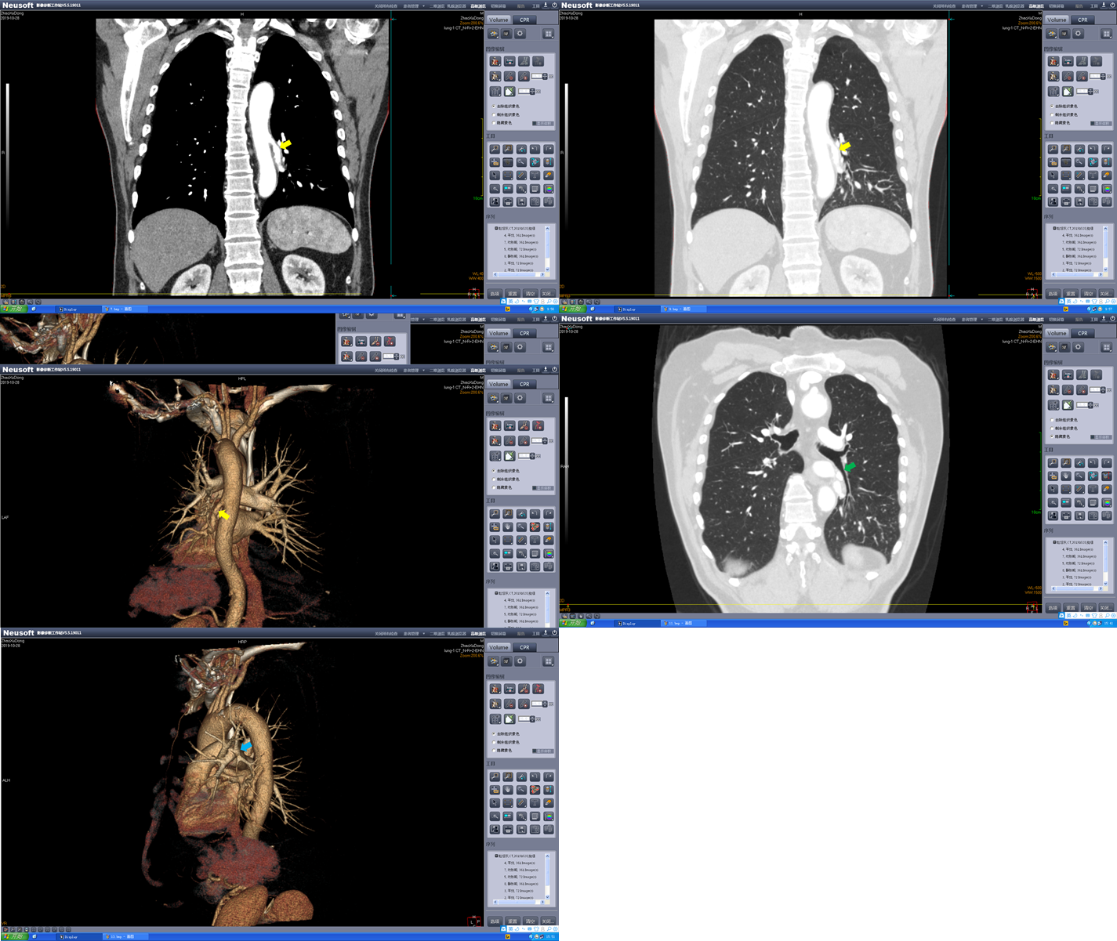
Figure 1 Contrast-enhanced computed tomography scan images with three-dimensional imaging. The yellow arrows show the abnormal systemic artery. The green arrow shows the normal left inferior lobar bronchus. The blue arrow shows the left superior lobe pulmonary artery and its branches, and the left lower lobe pulmonary artery is missing.

Table 1 Summary of previously reported cases of abnormal systemic artery to the left lower lobe published since 1976
Yr | Author | n | Age in yr | Symptoms | Treatment | Follow-up | Complication
1976 | Kirks | 2 | 6 mo | Asymptomatic | Lobectomy | - | -
 |  |  | 17 mo | Asymptomatic | Lobectomy
1979 | Ishihara | 1 | 5 | Asymptomatic | Lobectomy | - | -
1981 | Yabek | 1 | 6 mo | Tachypnea | Lobectomy | 6 mo | None
1992 | Tao | 1 | 38 | Dyspnea | Lobectomy | - | -
1993 | Kurosaki | 3 | 59 | Hemoptysis | - | - | -
 |  |  | 54 | Asymptomatic | Lobectomy
 |  |  | 46 | Asymptomatic | Segmentectomy
1996 | Hirai | 2 | 29 | Hemoptysis | Lobectomy | 6 mo | None
 |  |  | 30 | Asymptomatic | Anastomosis
1999 | Yamanka | 2 | 46 | Cough | Lobectomy | - | -
 |  |  | 68 | Dyspnea, hemoptysis | Segmentectomy
2000 | Ko | 3 | 39 | Hemoptysis | Lobectomy | 9 mo | None
 |  |  | 58 | Asymptomatic | None | 6 mo | None
 |  |  | 47 | Pain, hemoptysis | None | 2 yr | Chest pain
2001 | Ashizawa | 5 | 29 | Asymptomatic | Surgery (5) | - | -
 |  |  |  | Asymptomatic
 |  |  |  | Asymptomatic
 |  |  |  | Dyspnea
 |  |  |  | Hemoptysis
2002 | Kim | 11 | 49 | Asymptomatic (11) | None (11) | - | -
2003 | Iizasa | 4 | 50 | Asymptomatic | Segmentectomy | - | -
 |  |  | 17 | Hemoptysis | Segmentectomy
 |  |  | 43 | Hemoptysis | Segmentectomy
 |  |  | 20 | Asymptomatic | Lobectomy
2004 | Haraguchi | 1 | 29 | Hemoptysis | Lobectomy | - | -
2006 | Saida | 1 | 41 | Hemoptysis | Embolization | 6 yr | Chest pain for 1 mo
2008 | Albertini | 1 | 21 | Dyspnea, hemoptysis | Lobectomy | - | -
2008 | Wu | 1 | 24 | Hemoptysis | None | 2.5 yr | Hemoptysis
2009 | Wong | 1 | 10 mo | Tachypnea | Lobectomy | - | -
2009 | Lim | 1 | 26 | Hemoptysis, chest pain | Embolization | 6 mo | None
2011 | Jiang | 4 | 33 | Hemoptysis | Embolization | 2 wk | 2 patients with chest pain for 2 wk
 |  |  | 28 | Hemoptysis | Embolization
 |  |  | 24 | Hemoptysis | Embolization
 |  |  | 19 | Hemoptysis | Embolization
2011 | Abe | 1 | 24 | Hemoptysis | Embolization | 1 yr | None
2011 | Canyigit | 1 | 53 | Chest pain | Embolization | 10 mo | Chest pain for 1 wk
2012 | Anil | 1 | 23 | Hemoptysis | Embolization | 6 mo | Chest discomfort for 2 d
2013 | Higuchi | 1 | 58 | Asymptomatic | Segmentectomy | - | -
2013 | Sugihara | 1 | 67 | Fatigue | Embolization | 9 mo | None
2015 | Kawaguchi | 1 | 25 | Hemoptysis | Ligation | 4 yr | None
2015 | Qin | 16 | 23 | Hemoptysis (16), Cough (4), Sputum (2) | - | - | -
2016 | Jiang | 9¹ | 32.7 | Hemoptysis (9) | Embolization (9) | 42.1 mo | 4 patients with chest pain for weeks
2017 | Miller | 1 | 2 mo | Tachypnea | Anastomosis | 6 wk | None
2018 | Thakur | 1 | 18 | Hemoptysis | Ligation | 6 wk | None
2018 | Kim | 1 | 7 mo | Asymptomatic | Anastomosis | 3 yr | None
2020 | Utsumi | 1 | 42 | Asymptomatic | Lobectomy | 6 mo | None
2020 | Hu | 1 | 53 | Hemoptysis | Medical treatment | - | -
2021 | Ema | 1 | 39 | Asymptomatic | Segmentectomy | 2 mo | None
2021 | Current case | 1 | 60 | Hemoptysis | Lobectomy | 1 yr | None
¹Previously reported cases have been eliminated.
“-“: No record.

Published by Baishideng Publishing Group Inc
7041 Koll Center Parkway, Suite 160, Pleasanton, CA 94566, USA
Telephone: +1-925-3991568
E-mail: bpgoffice@wjgnet.com
Help Desk: https://www.f6publishing.com/helpdesk
https://www.wjgnet.com

© 2021 Baishideng Publishing Group Inc. All rights reserved.

