Name of Journal: World Journal of Gastrointestinal Surgery
Manuscript NO: 87272
Manuscript Type: CASE REPORT

Portal vein embolization for closure of marked arterioportal shunt of hepatocellular carcinoma to enable radioembolization: A case report

Wang XD et al. PVE to close APS before radioembolization

Xiang-Dong Wang, Nai-Jian Ge, Ye-Fa Yang

Xiang-Dong Wang, Nai-Jian Ge, Ye-Fa Yang, Department of Interventional Radiology, Shanghai Eastern Hepatobiliary Surgery Hospital, Shanghai 200438, China

Author contributions: Wang XD composed and drafted the paper; Ge NJ revised and edited the draft; Yang YF conceptualized, designed, revised, and edited the draft.

Corresponding author: Ye-Fa Yang, MD, Chief Doctor, Professor, Department of Interventional Radiology, Shanghai Eastern Hepatobiliary Surgery Hospital, No. 700 Moyu North Road, Shanghai 200438, China. decentofni@163.com

Received: August 17, 2023
Revised: October 24, 2023
Accepted: December 4, 2023
Published online:

Abstract
BACKGROUND
Marked arterioportal shunt (APS) can be a contraindication for transarterial radioembolization (TARE) because of the risk of radiation-induced liver toxicity or pneumonitis. To date, the best method to close marked APS to reduce intrahepatic shunt (IHS) and hepatopulmonary shunt (HPS) before TARE has not been elucidated.

CASE SUMMARY
This case report describes a novel strategy of embolization of the portal venous outlet to reduce IHS and HPS caused by marked APS before TARE in a patient with advanced hepatocellular carcinoma (HCC). The patient had a significant intratumoral shunt from the tumor artery to the portal vein and had already been suspected based on pre-interventional magnetic resonance angiography, and digital subtraction angiography (DSA) confirmed the shunt. Selective right portal vein embolization (PVE) was performed to close the APS outlet and DSA confirmed complete closure. Technetium-99m macroaggregated albumin was administered and single photon emission computed tomography revealed a low HPS with 8.4%. Successful TARE was subsequently performed. No major procedure-related complication occurred.

CONCLUSION
Closure of APS with PVE during mapping angiography of advanced-stage HCC to enable reduction of HPS and subsequent TARE is feasible.

Key Words: Portal vein embolization; Arterioportal shunt; Intrahepatic shunt; Hepatopulmonary shunt; Transarterial radioembolization; Case report

Wang XD, Ge NJ, Yang YF. Portal vein embolization for closure of marked arterioportal shunt of hepatocellular carcinoma to enable radioembolization: A case report. World J Gastrointest Surg 2023; In press

Core Tip: Marked arterioportal shunt (APS) can be a contraindication for transarterial radioembolization (TARE) because of the risk of radiation-induced liver toxicity or pneumonitis. In this case report, portal vein embolization was performed, for the first time, to close the APS outlet in a patient with advanced hepatocellular carcinoma. Single photon emission computed tomography revealed a low intrahepatic shunt and hepatopulmonary shunt, and TARE was performed successfully.

INTRODUCTION
Surgical resection and liver transplantation are the main curative treatment options for hepatocellular carcinoma (HCC), which ranks as the 5th most common malignancy and the 4th leading cause of cancer-related mortality worldwide^{[1]}. However, most patients do not meet these treatment selection criteria at the time of diagnosis^{[2]}. Transarterial radioembolization (TARE) with yttrium-90 is a mature method for unresectable HCC, because it can deliver high radiation energy selectively targeting the tumor while sparing the surrounding normal parenchyma^{[3]}.
An arterioportal shunt (APS) between a hepatic artery and portal vein is frequently observed in patients with HCC^{[4]}, resulting in potentially life-threatening complications, such as esophageal varicose rupture, refractory ascites, and hepatic encephalopathy^{[5,6]}. It was reported that marked APS of the left, right or main portal vein occurred in 30% of HCC patients^{[7]}. Marked APS can be a contraindication for TARE because the radioactive microspheres can easily pass through the shunts, potentially resulting in radiation-induced liver toxicity or pneumonitis^{[8,9]}.
To date, closure of a marked APS has been carried out with various approaches, including systemic treatment^{[9]}, transcatheter arterial occlusion^{[10,11]} and portal vein occlusion balloons^{[12]}, before patients undergo transarterial chemoembolization or TARE. However, the optimal therapy has not yet been elucidated, and other new techniques may be necessary to successfully alleviate the intrahepatic shunt (IHS) and hepatopulmonary shunt (HPS) caused by APS. Portal vein embolization (PVE) is a widely used technique for liver regeneration. PVE can completely embolize the outlet of the APS, indicating its potential to reduce IHS and HPS. This report describes PVE for closure of marked APS in a patient with HCC to enable TARE.

CASE PRESENTATION
Chief complaints
A 58-year-old man presented himself with fatigue, poor appetite and weight loss.

History of present illness
The symptoms started 2 mo previously. Ultrasonography detected multifocal hepatic lesions in the left outer lobe and right lobe.

History of past illness
The patient had no medical history previously.

Personal and family history
Nothing in particular.

Physical examination
There are no obvious abnormalities in the physical examination, and the vital signs are within the normal range. No jaundice was observed.

Laboratory examinations
Hepatitis B virus DNA was 2 × 10⁹ IU/mL (< 40); liver function tests were normal; tumor markers were as follows: α-fetoprotein 4.1 ng/mL (< 20.0), PIVKA-II 3454 mAU/mL (< 40.0).

Imaging examinations
At admission, abdominal enhanced computed tomography (CT) and magnetic resonance imaging (MRI) showed that most lesions were in the right liver lobe; carcinoma thrombus formation in the main and right portal vein branches; and collateral circulation with spongy degeneration. A marked APS was revealed, and hence, early contrast enhancement of the left portal vein was seen on MRI (Figure 1A).

FINAL DIAGNOSIS
The final diagnosis of the presented case was BCLC-C stage HCC.

TREATMENT
The MDT made the treatment plan of combining Y-90 TARE with the anti-PD-1 antibody and the anti-VEGF bevacizumab. Following the decision of MDT, the patient was evaluated for Y-90 TARE. Mapping angiography demonstrated a large hypervascular mass in the right hepatic lobe with the main arterial supply coming from the right hepatic artery, and digital subtraction angiography (DSA) before 99m-technetium-macroaggregated albumin (MAA) injection revealed widespread IHSs to the portal vein in the patient (Figure 1B). Due to the possibility of radiation-induced liver failure and lung injury, the patient was excluded from TARE before closure of the marked APS. After identification of the right portal vein branch responsible for APS, we performed PVE. An EV needle (Hakko, Nagano, Japan) was used to puncture the right portal vein branch under ultrasound guidance. Inserting a 0.035-inch guidewire into the portal vein, then we placed a 5F catheter (Hanaco Medical, Tianjin, China) at the main portal vein for angiography, which displayed carcinoma thrombus in the main and right portal vein branches, and collateral circulation with spongy degeneration (Figure 2A). The proximal portion of the right portal vein was embolized with interlock microcoils (Tornado, Cook, Bloomington, IN, United States; Azur, Terumo, Somerset, NJ, United States) to prevent ectopic reverse embolization, followed by N-butyl cyanoacrylate (NBCA) (Compont, Beijing, China) embolization of the distal branches. NBCA was mixed with ethiodized oil (Lipiodol; Andre Guerbet, Aulnay-Sous-Bois, France) in a 1:1 ratio. Re-examination using hepatic arteriography revealed that the embolization was effective and the APS was successfully closed (Figure 2B). Finally, the puncture tract of the trans-hepatic PVE was embolized using the mixture of NBCA and lipiodol. Super-selective hepatic arteriography was implemented by canulation of the tumor feeding arteries with a 2.6-F microcatheter (Cook Medical). Cone beam CT with contrast administration through the microcatheter was operated to determine tumor feeding arteries and the correct position of the microcatheter. 99mTc MAA (4.5 mCi) (Xinke, Shanghai, China) was injected through the three tumor-feeding arteries to determine HPS, and single photon emission CT (SPECT)/CT (Symbia T16; Siemens Healthcare, Germany) was performed after 99mTc MAA injection.

OUTCOME AND FOLLOW-UP
SPECT confirmed the absence of a relevant HPS with 8.4% (Figure 3). TARE was carried out successfully in the next week. Referring to the recommendations of the Cardiovascular and Interventional Radiological Society of Europe^{[13]}, the patient had no serious adverse event (grades 3-6) in the perioperative period.

DISCUSSION
There has been increased use of TARE in patients with intermediate- to advanced-stage HCC in recent years. Not all patients are candidates for this treatment due to a number of technical and clinical factors that need to be taken into consideration. One is the presence of APS bypass in the tumor capillary bed because TARE can cause liver failure due to extensive radioembolization in nontumorous liver parenchyma, or lung injury due to elevated HPS. Therefore, timely and complete closure of shunts is necessary before TARE for advanced HCC with marked APS.
Systemic antiangiogenic therapy has been described for reduction of IHS and HPS^{[9,14]} caused by APS or arteriovenous shunt. Theysohn et al^{[14]} reported on seven patients with elevated HPS who treated with oral sorafenib for an average of 138 d (ranging from 72-297 d). Four of the patients had significant reduction in their HPS and had successful TARE. The remaining three patients had disease progression and did not survive to undergo TARE. For patients to be treated with systemic antiangiogenic drug to relieve high HPS, it is a main challenge to balance the time between treatment and conducting TARE^{[15]}. To reduce the HPS, sufficient time must be given for observing the efficacy of the systemic antiangiogenic therapy regimen. In patients with rapidly growing tumor types, the window of opportunity for TARE treatment may be lost. Standard techniques of transarterial bland embolization or chemoembolization can be used to shut down large arteriovenous and APS^{[16,17]}. Ward et al^{[17]} reported a 29%-69% decrease in HPS in five patients receiving embolization procedures. However, excessive transarterial embolization may theoretically lead to unsatisfactory treatment response following TARE due to uneven microsphere distribution. Therefore, the best treatment strategy to reduce IHS and HPS for HCC complicated with APS remains to be determined.
PVE has been widely used to expand the indications for hepatectomy for HCC in patients with insufficient future liver remnant. In the present case, PVE was applied to reduce IHS and HPS in advanced HCC with marked APS by complete embolization of the corresponding portal veins to prevent Tc-99m MAA or radio-microspheres moving through the APS. In our case, marked APS was shown by initial DSA. It has been shown that TARE for large IHS and HPS is unsafe, and it is necessary to reduce the therapeutic dose, but the efficacy may be compromised^{[17]}. After we performed PVE using interlock microcoils and NBCA, the APS disappeared, and SPECT after injection of TC99m-MAA showed low uptake in normal liver and lung tissue, which made treatment with TARE viable.
Timely and completely embolization of shunts using PVE to reduce extensive portal vein radioembolization and HPS before TARE may represent a suitable treatment approach for HCC with marked APS. However, this technique remains technically difficult in cases with multiple APSs. In addition, PVE may further exacerbate portal hypertension and lead to gastrointestinal bleeding. Future prospective studies should investigate the safety and efficiency of PVE in pretreatment angiography with Tc-99m MAA mapping.

CONCLUSION
Our clinical observations suggest the feasibility of closure of APS with PVE during mapping angiography for patients with advanced-stage HCC to enable reduction of HPS and subsequent TARE.

ACKNOWLEDGEMENTS
The authors would like to express their deep gratitude to all staff who participated in the endovascular procedures for the study patient.

REFERENCES
1 Chidambaranathan-Reghupaty S, Fisher PB, Sarkar D. Hepatocellular carcinoma (HCC): Epidemiology, etiology and molecular classification. Adv Cancer Res 2021; 149: 1-61 [PMID: 33579421 DOI: 10.1016/bs.acr.2020.10.001]
2 Makary MS, Khandpur U, Cloyd JM, Mumtaz K, Dowell JD. Locoregional Therapy Approaches for Hepatocellular Carcinoma: Recent Advances and Management Strategies. Cancers (Basel) 2020; 12 [PMID: 32679897 DOI: 10.3390/cancers12071914]
3 Ponziani FR, Santopaolo F, Posa A, Pompili M, Tanzilli A, Maestri M, Pallozzi M, Ibba F, Manfredi R, Gasbarrini A, Iezzi R. SIRT in 2025. Cardiovasc Intervent Radiol 2022; 45: 1622-1633 [PMID: 35941244 DOI: 10.1007/s00270-022-03228-6]
4 Wu H, Zhao W, Zhang J, Han J, Liu S. Clinical characteristics of hepatic Arterioportal shunts associated with hepatocellular carcinoma. BMC Gastroenterol 2018; 18: 174 [PMID: 30419830 DOI: 10.1186/s12876-018-0899-3]
5 Ratti F, Cipriani F, Paganelli M, Ferla G, Aldrighetti LA. Surgical approach to multifocal hepatocellular carcinoma with portal vein thrombosis and arterioportal shunt leading to portal hypertension and bleeding: a case report. World J Surg Oncol 2012; 10: 34 [PMID: 22330617 DOI: 10.1186/1477-7819-10-34]
6 Lencioni R, Llovet JM, Han G, Tak WY, Yang J, Guglielmi A, Paik SW, Reig M, Kim DY, Chau GY, Luca A, Del Arbol LR, Leberre MA, Niu W, Nicholson K, Meinhardt G, Bruix J. Sorafenib or placebo plus TACE with doxorubicin-eluting beads for intermediate stage HCC: The SPACE trial. J Hepatol 2016; 64: 1090-1098 [PMID: 26809111 DOI: 10.1016/j.jhep.2016.01.012]
7 Okuda K, Musha H, Yamasaki T, Jinnouchi S, Nagasaki Y, Kubo Y, Shimokawa Y, Nakayama T, Kojiro M, Sakamoto K, Nakashima T. Angiographic demonstration of intrahepatic arterio-portal anastomoses in hepatocellular carcinoma. Radiology 1977; 122: 53-58 [PMID: 186844 DOI: 10.1148/122.1.53]
8 Park J, Oh D, Paeng JC, Lee M, Chung JW, Kim HC. Radioembolization for Hepatocellular Carcinoma: The Effects of Arterioportal Shunts on Nontargeted Liver Hypertrophy. J Vasc Interv Radiol 2022; 33: 787-796.e4 [PMID: 35346860 DOI: 10.1016/j.jvir.2022.03.023]
9 Balli HT, Aikimbaev K, Burak IG, Pehlivan UA, Piskin FC, Sozutok S. Reduction of Hepatopulmonary and Intrahepatic Shunts after Treatment with Sorafenib in Hepatocellular Carcinoma Patients. Cardiovasc Intervent Radiol 2022; 45: 1842-1847 [PMID: 36175653 DOI: 10.1007/s00270-022-03283-z]
10 Hoshiai S, Mori K, Ishiguro T, Konishi T, Uchikawa Y, Fukuda K, Minami M. Balloon-Assisted Chemoembolization Using a Micro-Balloon Catheter Alongside a Microcatheter for a Hepatocellular Carcinoma with a Prominent Arterioportal Shunt: A Case Report. Cardiovasc Intervent Radiol 2017; 40: 625-628 [PMID: 27987001 DOI: 10.1007/s00270-016-1530-z]
11 Duan F, Bai Y, Cui L, Li X, Yan J, Zhu H. Transarterial embolization with N-butyl 2-cyanoacrylate for the treatment of arterioportal shunts in patients with hepatocellular carcinoma. J Cancer Res Ther 2017; 13: 631-635 [PMID: 28901305 DOI: 10.4103/jcrt.JCRT_286_17]
12 Murata S, Tajima H, Nakazawa K, Onozawa S, Kumita S, Nomura K. Initial experience of transcatheter arterial chemoembolization during portal vein occlusion for unresectable hepatocellular carcinoma with marked arterioportal shunts. Eur Radiol 2009; 19: 2016-2023 [PMID: 19238387 DOI: 10.1007/s00330-009-1349-y]
13 Sacks D, McClenny TE, Cardella JF, Lewis CA. Society of Interventional Radiology clinical practice guidelines. J Vasc Interv Radiol 2003; 14: S199-S202 [PMID: 14514818 DOI: 10.1097/01.rvi.0000094584.83406.3e]
14 Theysohn JM, Schlaak JF, Müller S, Ertle J, Schlosser TW, Bockisch A, Lauenstein TC. Selective internal radiation therapy of hepatocellular carcinoma: potential hepatopulmonary shunt reduction after sorafenib administration. J Vasc Interv Radiol 2012; 23: 949-952 [PMID: 22720895 DOI: 10.1016/j.jvir.2012.04.007]
15 Schiro BJ, Amour ES, Harnain C, Gandhi RT. Management of High Hepatopulmonary Shunts in the Setting of Y90 Radioembolization. Tech Vasc Interv Radiol 2019; 22: 58-62 [PMID: 31079711 DOI: 10.1053/j.tvir.2019.02.004]
16 McGregor H, Hill M, Kuo P, Woodhead G, Patel M. Same-Day Repeat Hepatopulmonary Shunt Measurement during Planning Angiography for Hepatic Radioembolization. J Vasc Interv Radiol 2020; 31: 1069-1073 [PMID: 32439249 DOI: 10.1016/j.jvir.2020.03.006]
17 Ward TJ, Tamrazi A, Lam MG, Louie JD, Kao PN, Shah RP, Kadoch MA, Sze DY. Management of High Hepatopulmonary Shunting in Patients Undergoing Hepatic Radioembolization. J Vasc Interv Radiol 2015; 26: 1751-1760 [PMID: 26525118 DOI: 10.1016/j.jvir.2015.08.027]

Footnotes
Informed consent statement: All study participants, or their legal guardian, provided informed written consent prior to study enrolment. Approval for publishing the study data was obtained from the patient.

Conflict-of-interest statement: All the authors report no relevant conflicts of interest for this article.

CARE Checklist (2016) statement: The authors have read the CARE Checklist (2016), and the manuscript was prepared and revised according to the CARE Checklist (2016).

Open-Access: This article is an open-access article that was selected by an in-house editor and fully peer-reviewed by external reviewers. It is distributed in accordance with the Creative Commons Attribution NonCommercial (CC BY-NC 4.0) license, which permits others to distribute, remix, adapt, build upon this work non-commercially, and license their derivative works on different terms, provided the original work is properly cited and the use is non-commercial. See: https://creativecommons.org/Licenses/by-nc/4.0/

Provenance and peer review: Unsolicited article; Externally peer reviewed.
Peer-review model: Single blind

Peer-review started: August 17, 2023
First decision: October 17, 2023
Article in press:

Specialty type: Gastroenterology and hepatology
Country/Territory of origin: China
Peer-review report’s scientific quality classification
Grade A (Excellent): 0
Grade B (Very good): B
Grade C (Good): 0
Grade D (Fair): D
Grade E (Poor): 0

P-Reviewer: Baiocchi L, Italy; Giacomelli L, Italy S-Editor: Wang JJ L-Editor: A P-Editor:
Figure Legends
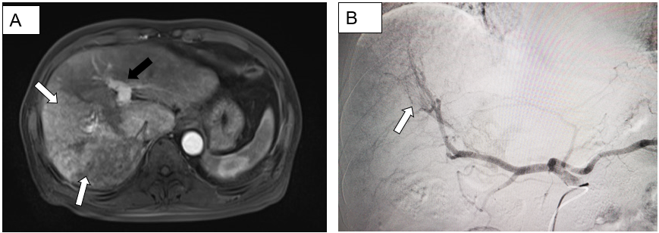
Figure 1 A 58-year-old man with hepatocellular carcinoma and marked arterioportal shunt due to portal vein tumor thrombus. A: Axial magnetic resonance imaging T1 post contrast weighted image showing a large hypervascular mass in the right hepatic lobe (white arrows). Note enhancement of the portal vein (black arrow) in the arterial phase denoting an underlying arterioportal shunt; B: Digital subtraction angiography showing opacified portal vein (white arrows) during the early arterial phase.

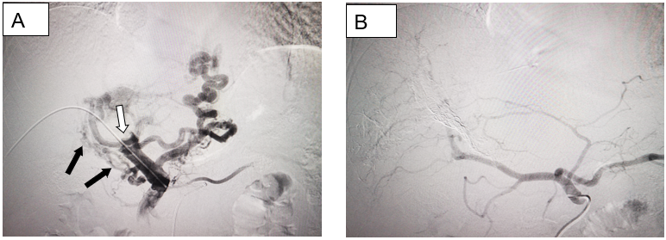
Figure 2 Direct portography and hepatic arteriography after portal vein embolization. A: Direct portography revealed carcinoma thrombus formed in the main portal vein (white arrow), and collateral circulation formed with spongy degeneration (black arrows); B: Hepatic arteriography after portal vein embolization demonstrates non-visualized arterioportal shunt.

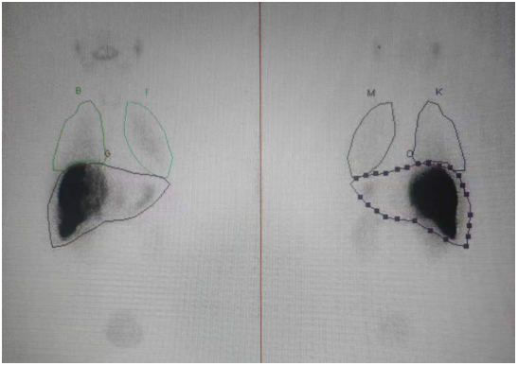
Figure 3 Planar scintigraphy following injection of 4.5 mCi of technetium-99m macroaggregated albumin into the right hepatic artery after using portal vein embolization to embolize the outlet of the arterioportal shunt. The calculated hepatopulmonary shunt was 8.4%.

