Name of journal: World Journal of Gastroenterology
ESPS Manuscript NO: 18327
Manuscript Type: ORIGINAL ARTICLE

Basic Study
Heat shock pretreatment improves mesenchymal stem cells repair of hepatic ischemia-reperfusion injury in rats through activation of autophagy

Qiao PF et al. HSP improves MSCs survival

Peng-Fei Qiao, Lei Yao, Xin-Chen Zhang, Guo-Dong Li, De-Quan Wu

Peng-Fei Qiao, Lei Yao, Xin-Chen Zhang, De-Quan Wu, Department of General Surgery, the Second Affiliated Hospital of Harbin Medical University, Harbin 150001, Heilongjiang Province, China

Guo-Dong Li, Department of General Surgery, the Fourth Affiliated Hospital of Harbin Medical University, Harbin 150001, Heilongjiang Province, China

Author contributions: Wu DQ and Qiao PF designed the research and drafted the manuscript; Qiao PF, Yao L, Zhang XC and Li GD carried out all the experiments; all the authors have read and approved the final version to be published.

Supported by grants from the Clinical Research Special Fund of Wu Jieping Medical Foundation, No. 320.6750.12263.

Ethics approval: All of the study procedures were reviewed and approved by the Medical Ethics Committee of Harbin Medical University, Harbin, China.

Institutional animal care and use committee statement: This study was conducted in compliance with the Guide for the Care and Use of Laboratory Animals published by the National Academy Press. All procedures involving animals were reviewed and approved by the Harbin Medical University Institutional Animal Care and Use Committee. All efforts were made to minimize suffering.

Conflict-of-interest statement: The authors declare that they have no conflicts of interest in this study.

Data sharing statement: Technical appendix, statistical code and dataset available from the corresponding author at wudequanhum@163.com. Participants gave informed consent for data sharing. No additional data are available.

Open-Access: This article is an open-access article which was selected by an in-house editor and fully peer-reviewed by external reviewers. It is distributed in accordance with the Creative Commons Attribution Non Commercial (CC BY-NC 4.0) license, which permits others to distribute, remix, adapt, build upon this work non-commercially, and license their derivative works on different terms, provided the original work is properly cited and the use is non-commercial. See: http://creativecommons.org/licenses/by-nc/4.0/

Correspondence to: De-Quan Wu, PhD, Professor, Department of General Surgery, the Second Affiliated Hospital of Harbin Medical University, No. 246, Xuefu Road, Nangang District, Harbin 150001, China. wudequanhmu@163.com
Telephone: +86-13796635887
Fax: +86-451-86605535

Received: April 16, 2015
Peer-review started: April 18, 2014
First decision: June 19, 2015
Revised: July 2, 2015
Accepted: September 2, 2015

Article in press:
Published online:

Abstract
AIM: To demonstrate that heat shock pretreatment (HSP) improves mesenchymal stem cells (MSCs) repair of hepatic ischemia-reperfusion injury (HIRI) in rats through activation of autophagy.

METHODS: Apoptosis of MSCs was induced by 250 mM hydrogen peroxide (H₂O₂) for 6 h. HSP was performed using a 42 °C water bath for 1, 2 and 3 h. The apoptosis of MSCs was analyzed by flow cytometer and the detection of Bcl-2, Bax and cytochrome C expression by Western blot. Autophagy of MSCs was analyzed by FACs and transmission electron microscopy, and the detection of beclin I and LC3-II expression by Western blot. In vivo MSCs were labeled with the fluorescent dye, CM-Dil, and subsequently transplanted into the portal veins of rats that had undergone HIRI. The labeled cells in the liver were then studied using fluorescent microscopy and the levels of proliferating cell nuclear antigen (PCNA) were quantified. Serum aminotransferase activity and histology were also monitored at appropriate time points.

RESULTS: HSP for 2 h reduced apoptosis of MSCs induced by H₂O₂ as shown by a decrease in apoptotic rate, Bax and cytochrome C expression and an increase in Bcl-2 expression (P < 0.001). In addition, HSP for 2 h induced autophagy of MSCs under H₂O₂ conditions as shown by more acidic vesicular organelle–positive cells, beclin 1 and LC3-II expression, and autophagosome formation (P < 0.05). Treated with 3-methyladenine attenuated HSP-induced autophagy and abolished the protective effects of HSP on MSCs apoptosis. Rapamycin failed to cause additional effects on either autophagy or apoptosis compared with HSP alone. The phosphorylation of p38MAPK was highly expressed, whereas the phosphorylation of mTOR was downregulated in heat shock pretreated MSCs. Treatment with the p38MAPK inhibitor, SB203580, reduced HSP-induced autophagy in MSCs. In vivo, more double-positive cells labeled by CM-Dil and PCNA, lower serum aminotransferase levels, Suzuki scores, improved histopathology and number of PCNA-positive cells were observed in response to transplantation of HSP-MSCs (P < 0.05).

CONCLUSION: HSP effectively induces autophagy via the p38MAPK/mTOR pathway to enhance MSCs survival under H₂O₂ conditions and improves MSCs repair of HIRI in rats.

Key words：Hepatic ischemia-reperfusion injury; Mesenchymal stem cells; Transplantation; Heat shock pretreatment; Autophagy

© The Author(s) 2015. Published by Baishideng Publishing Group Inc. All rights reserved.

Core tip: We investigated the interaction between autophagy and apoptosis in mesenchymal stem cells (MSCs) under H₂O₂ conditions and heat shock pretreatment (HSP)-induced autophagy served as a protective mechanism. HSP for 2 h improved the therapeutic potential of MSCs in treatment of hepatic ischemia-reperfusion injury in rats and enhanced autophagy via p38MAPK/mTOR pathway, which involved in the protective effects of HSP on MSCs apoptosis under H₂O₂ conditions. When administered systemically, more viable HSP-MSCs homed to I/R liver than MSCs, which led to a significant improvement in liver function, an accelerated mitogenic response and alleviation of histopathological damage in rats.

Qiao PF, Yao L, Zhang XC, Li GD, Wu DQ. Heat shock pretreatment improves mesenchymal stem cells repair of hepatic ischemia-reperfusion injury in rats through activation of autophagy. World J Gastroenterol 2015; In press

INTRODUCTION
Clinical settings such as such as liver surgery, trauma repair especially liver transplantation might induce hepatic ischemia-reperfusion injury (HIRI), which is associated with significant reduced liver function^{[1,2]}. Therefore, effective treatment strategies aimed at reducing HIRI could offer major benefits in hepatic surgery and liver transplantation. A previous study demonstrated the specific involvement of bone marrow mesenchymal stem cells (MSCs) in the repair of HIRI^{[3]}. However, due to local hypoxia, inflammation, and especially oxidative stress in the targeted tissue, the transplanted MSCs poorly withstood the difficult microenvironment due to I/R injury and low cell survival reduced the therapeutic effect^{[4]}. It was also reported that less than 1% of transplanted MSCs survived to day 4 in an immunodeficient mouse heart model^{[5]}. This poor survival rate of MSCs was also observed after transplantation into lungs and kidneys with I/R injury^{[6,7]}. Therefore, it is imperative to protect MSCs from the rigorous microenvironment in I/R tissues due to oxidative stress and other pro-apoptotic factors to improve the therapeutic effect.
Heat shock pretreatment (HSP) is known to activate types of self-protective proteins and protects cells in vitro from various environmental insults^{[8-10]}. Several reports have shown that prior heat shock treatment of transplanted cells enhanced their survival in a heart model both in vivo and in vitro^{[11,12]}. Thus, we hypothesized that HSP of MSCs could enhance their survival following transplantation into the liver after I/R injury. More recently, the induction of autophagy has been noted as a novel method of protecting MSCs from apoptosis^{[13,14]}. Moreover, several reports have shown that heat shock treatment can significantly activate autophagy in multiple cells^{[15,16]}. However, whether autophagy can be activated by heat shock treatment and its effect on MSCs are unknown.
Autophagy is a cardinal cellular mechanism that occurs in eukaryotic cells^{[17,18]}. In recent years, autophagy contributes a vital role in cell apoptosis. Recent evidence supports the view that depend on different cell types and conditions, appropriate autophagy contributes to pro-survial way, whereas inappropriate autophagy could induce cell death^{[19]}. Under ischemia or hypoxia/serum deprivation (H/SD) conditions, autophagy can protect MSCs from apoptosis by eliminating reactive oxygen species and damaged organelles to provide energy^{[13,20]}. Moreover, H/SD-induced autophagy also has been proved to induce apoptosis in some cell types, leading to cell death, or autophagy itself can promote autophagic cell death as type II programmed cell death^{[21]}. However, the functional role of autophagy in oxidative stress-induced apoptosis in MSCs has not been fully elucidated.
p38MAPK (mitogen-activated protein kinase), which is mediated by heat shock treatment to improve cardiac cells survial, is also a positive regulator of autophagy^{[8]}. p38MAPK can be activated in response to exogenous stress, such as hypoxia, starvation and heat shock, which can induce the activation of MKK3/4/6 and their effector kinases to stimulate autophagy^{[22]}. However, little is known about the function of the p38MAPK pathway in regulating the activation of autophagy in MSCs following heat shock treatment.
Therefore, the aim of this study was to examine the function of autophagy in MSCs apoptosis induced by oxidative stress injury, and HSP activates autophagy via the p38MAPK/mTOR pathway to protect MSCs from apoptosis.

MATERIALS AND METHODS
Animals
Thirty-two Male Sprague-Dawley rats (weighing about 220 g and aged about 10 wk) from Animal Center of the Second Affiliated Hospital, Harbin Medical University were used in this study. The rats were cared for in accordance with US National Institutes of Health guidelines published by the National Institutes of Health. All the study procedures were approved by the Harbin Medical University Institutional Animal Care and Use Committee. The study was conducted in compliance with the Guide for the Care and Use of Laboratory Animals published by the National Academy Press.

Cell culture and treatment
The MSCs were obtained as described previously^{[3]}. Density centrifugation method was performed to isolate MSCs^{[23]}. The femurs and tibias from male Wistar rats aged 4 wk were flushed and the whole bone marrow cells were collected and then fractionated in Lymphoprep™ density solution. Following centrifugation at 800 × g for 20 min, the cells at the interface were collected and cultured in Dulbecco's modified Eagle's medium (DMEM, Gibco, United States) containing 10% fetal bovine serum and 1% penicillin/streptomycin. Cells were incubated at 37 ˚C with 95% humidity and 5% CO₂. 48 h later, the culture medium was changed to remove non-adherent cells. The 4th passage MSCs were washed with phosphate buffered saline (PBS), exposed to HSP for different time periods (1, 2 and 3 h) using a 42 °C water bath (HSP-MSCs), and then incubated at 37 °C in a humidified atmosphere containing 5% CO₂ and 95% air for 24 h. As a control, cells were cultured under normal conditions without HSP (MSCs). To simulate tissue I/R microenvironment in vitro, MSCs were treated with 250 mM H₂O₂ (Sigma-Aldrich, United States) for 6 h^{[24,25]}. 3-methyladenine (3-MA) (Sigma-Aldrich, United States) at 5 mM, an autophagy inhibitor and the autophagy promoter, rapamycin (Cell Signaling Technology, United States), at 10 nM or the p38MAPK inhibitor, SB203580 (Beyotime, China), at 5 mM was added to further examine the role of autophagy on MSCs apoptosis.

Evaluation of autophagy and apoptosis by flow cytometry
Cell apoptosis was examined by Annexin V-FITC/PI Kit (Becton-Dickinson, United States). Briefly, MSCs were collected in 200 mL medium buffer. Following resuspended, approximately 10 mL of Annexin V solution was added and incubated for 15 min at room temperature in the dark. Then 300 mL medium buffer and 5 mL propidium iodide (PI) were added and the cell suspension was incubated for 15 min at room temperature in the dark. Then the cell suspension was analyzed by flow cytometry immediately. 10⁴ cells were placed in the flow cytometer (Becton-Dickinson, United States) and analyzed with Cell Quest software.
Cell autophagy was examined by detecting acidic vesicular organelles (AVO) using acridine orange (AO) (Solarbio, China) stained according to published procedures^{[26]}. Briefly, cells were stained with 1 mg/mL AO for 15 min and collected in PBS. In the AO-stained cells, the cytoplasm fluoresce bright green, whereas the AVO, including lysosomes and autolysosomes, fluoresce bright red. Green (510–530 nm) and red (650 nm) fluorescence emission from 10⁴ cells illuminated with blue (488 nm) excitation light was measured by flow cytometryusing Cell Quest software.

Transmission electron microscopy analysis

MSCs were harvested and fixed with 2.5% glutaraldehyde at 4 °C for 2 h. Then the cells were suspended in PBS contained 1% osmic acid at 4 °C for 2 h. Followed by dehydrated and embedded^{[13]}, the ultrathin sections were prepared on uncoated copper grids with an Ultrotome (Leica, Reichert Ultracuts) and stained with uranyl acetate and lead citrate. Images were recorded under a transmission electron microscope (JEM1230; JEOL).

Western blot

Protein lysates were separated using SDS-PAGE gel electrophoresis then transferred to nitrocellulose membranes (Amersham Pharmacia Biotech, United States). The membrane was probed with the relevant antibodies. Finally, the membrane was probed with Alexa Fluor® 680 donkey anti-mouse IgG (H + L) or Alexa Fluor® 680 donkey anti-rabbit IgG (H + L) (1:5000) (Invitrogen, United States). The binding was detected by Odyssey™ Infrared Imaging System (Li-Cor, Lincoln, NE, United States). The antibodies used are listed in Supplemental Table 1.

Labeling of MSCs
To trace the transplanted MSCs, we labeled the cells with 10 μmol/L CM-Dil (Invitrogen, United States) according to published procedures^{[27]}.

Model of HIRI and cell transplantation
The HIRI procedure in a rat model was performed as described previously^{[3]}. Briefly, a midline laparotomy was performed after the rats were anesthetized by intraperitoneal injection of sodium pentobarbital (60 mg/kg). Then, the left lateral and median lobes of the liver were clamped at its base using an atraumatic clip. This treatment caused ischemia of 70% in the segmental liver and prevented ischemia in mesenteric veins^{[28]}. Throughout anesthesia, body temperature was monitored by a rectal probe and maintained at 37 °C by a heating lamp. The clamp was removed after 60 min, and immediately, 1 × 10⁶ CM-Dil-labeled MSCs or HSP-MSCs suspended in 200 µL PBS were transplanted into the portal vein with a 30-gauge needle, in the MSCs group and HSP-MSCs group, respectively. The normal control group rats received only laparotomy, and 200 µL PBS was given alone to rats in the I/R control group. The 32 rats were randomly divided into 4 groups. At 24 h after transplantation, 2 mL blood was harvested from the inferior vena cava of rats before the animals were sacrificed by cervical spine dislocation and their livers were harvested.

Immunofluorescence microscopy
The chest was opened following tracheal intubationand, the rats were perfused with 4% paraformaldehyde (Sigma-Aldrich, United States) in 0.01 M PBS under an overdose of anesthesia (sodium pentobarbital 100 mg/kg, intraperitoneal) for 2 min at 120 mmHg^{[29]}. Harvested livers were cryopreserved in 30% sucrose at 4 °C overnight, embedded into optimal cutting temperature (OCT) compound, then cut into 4 µm-thick sections using a cryostat. The sections were rinsed twice with PBS, fixed in 4% paraformaldehyde for 20 min at room temperature then washed 3 times with PBS. After permeabilization using 0.2% Triton X-100, sections were blocked at 4 °C overnight in 1% BSA/0.05% Triton X-100. Sections were then incubated with an antibody against PCNA (1:200) at 37 °C for 2 h. After washing 3 times with PBS, the sections were incubated with Alexa Fluor® 488-conjugated affinipure goat anti-rabbit IgG (H + L) (1:200) (ZSGB-Bio, China) for 1 h at room temperature. After extensive washing, the sections were then examined under a fluorescence microscope^{[30]}.

Measurement of liver function
To evaluate the severity of HIRI, the levels of aspartate aminotransferase (AST) and alanine aminotransferase (ALT) in serum were examined by an automatic analyzer (Hitachi, Japan) as described previously^{[31]}.

Immunohistochemical staining
Tissue sections of 1.5 cm × 1.5 cm × 2 mm were subject to immunohistochemical staining to assess PCNA 24 h after cell transplantation. Immunohistochemical staining of sections for PCNA expression was performed by a standard streptavidin-biotin peroxidase complex method^{[32]}. Tissue sections (4mm) were deparaffinized and rehydrated by standard protocols followed by autoclaved at 95 °C for 20 min and then cooled to 30 °C. 10% normal rabbit serum was used to blocke non-specific binding sites. The sections were then incubated with anti-PCNA primary antibodies at a dilution of 1:100 in PBS containing 1% bovine serum albumin at 4 °C overnight. After washed in PBS, incubated with biotinylated anti-rabbit IgG for 30 min at room temperature, and finally incubated in a streptavidin-biotin peroxidase complex solution (Nichirei, Japan). The chromogen, 3, 3’-diaminobenzidine tetra-hydrochloride, was used as a 0.02% solution containing 0.005% H₂O₂ in 50 mM ammonium acetate-citrate acid buffer (pH 6.0). The sections were lightly counterstained with Mayer’s hematoxylin and mounted. Negative controls were established by replacing the primary antibody with normal rabbit serum. No detectable staining was evident in the negative controls.

Histological analysis
The degree of HIRI was assessed by histological analysis as described previously^{[3]}.

Statistical analysis
All the presented data were expressed as the mean ± SD and representative results were from at least three independent experiments. For quantitative continuous data, differences between two groups were examined and the data were analyzed by the t-test. When multiple comparisons were possible, ANOVA coupled with Tukey’s post-hoc test correction was used. P < 0.05 was considered statistically significant. Statistical analysis was carried out using SPSS 21 (IBM Corporation Software Group) or the GraphPad Prism 5.0 software package (GraphPad Software, Inc.).

RESULTS
Heat shock pretreatment protected MSCs from apoptosis under H₂O₂ treatment
The apoptotic rate and pro-apoptotic proteins Bax and cytochrome C were reduced, while the anti-apoptotic protein Bcl-2 was increased in the HSP_{1h} and HSP_{2h} groups, especially in the HSP_{2h} group compare to the control and H₂O₂ group (Figure 1, P < 0.01). However, compared to the control and H₂O₂ groups, the apoptotic rate and the expression of Bax, cytochrome C were increased, while Bcl-2 expression was reduced in the HSP_{3h} group (Figure 1, P < 0.01). These results suggested that HSP for 2 h protected MSCs from H₂O₂-induced apoptosis.

HSP induced time-dependent autophagy in MSCs
To examine HSP could activate autophagy in MSCs, the cells were performed with heat shock for 1, 2 and 3 h, and then exposed the cells to H₂O₂ for 6 h. The rate of AVO-positive cells identified by flow cytometry was increased in the HSP groups compared with the control group (Figure 2A, P < 0.05), and different periods of HSP ranging from 1 to 3 h led to a time-dependent increase in the action of autophagy in MSCs under H₂O₂ conditions, which peaked in the HSP_{3h} group (P < 0.01). Moreover, HSP-MSCs showed a significant time-dependent higher expression of LC3B-II and the autophagic marker beclin 1 compared to the control group (Figure 2D). As shown in Figure 3, the autophagosomes observed in HSP-MSCs under H₂O₂ conditions. These results suggested that HSP time-dependently promoted autophagic activity in MSCs under H₂O₂ condition.

HSP protects MSCs against H₂O₂-induced apoptosis through activating autophagy
We confirmed that HSP_{2h} achieved the greatest protective effect against H₂O₂-induced apoptosis using flow cytometry and Western blot in the present study (Figure 1). To determine the role of autophagy in MSCs, we exposed cells to HSP for 2 h with 3-MA or rapamycin under H₂O₂ treatment for 6 h, and then assessed the autophagy and apoptosis rate. During 6 h of H₂O₂ treatment, 3-MA attenuated both the activation of autophagy and the anti-apoptotic capacity in MSCs treated with heat shock for 2 h, as shown by fewer AVO-positive MSCs (Figure 2C), lower expression of LC3-II and beclin 1 (Figure 4B) and autophagosomes in MSCs (P < 0.01) (Figure 3). In addition, higher apoptotic rate (Figure 4A), increased expression of Bax and cytochrome C, and decreased expression of Bcl-2 (Figure 4B) were found compared with the control group (P < 0.01) and the HSP_{2h} group (P < 0.05). On the other side, rapamycin failed to have any effect on autophagy activity and apoptotic rate in MSCs pretreated with heat shock for 2 h. These results indicated that activation of autophagy by HSP for 2 h may serve as a protective mechanism against apoptosis in MSCs under H₂O₂ condition.

p38MAPK/mTOR pathway is involved in HSP-induced autophagy
To investigate whether HSP induced autophagy by activating p38MAPK pathway, the p38MAPK inhibitor, SB203580, was performed and the levels of autophagy were evaluated in HSP-MSCs under H₂O₂ conditions. The results revealed that the expression of p38MAPK and mTOR did not change dramatically among the groups, the phosphorylation of p38MAPK was upregulated and the phosphorylation of mTOR was downregulated in the HSP_{2h} group compared with the control group (Figure 5). SB203580 reduced autophagy in the HSP_{2h} group as shown by a decreased rate of AVO-positive MSCs (P < 0.05) (Figure 2C), expression of LC3-II and beclin 1 (Figure 5) and autophagosome formation (Figure 3). Furthermore, treatment with SB203580 abrogated the effects of p38MAPK phosphorylation, but failed to have any effect on the phosphorylation of mTOR expression. These data suggested that p38MAPK/mTOR signaling pathway served as a stimulative role in the effects of HSP on MSCs autophagy under H₂O₂ treatment.

HSP increased the homing and survival rate of transplanted MSCs to I/R livers in vivo
To investigate the survival rate and homing of transplanted MSCs to livers, representative liver fluorescence microscopic images after transplantation of MSCs are shown in Figure 6. CM-Dil-labeled cells were detected only in sections that received transplantation of MSCs. The total number of double-positive MSCs labeled by CM-Dil and proliferating cell nuclear antigen (PCNA) in the HSP-MSC-treated group was higher than that in the MSC-treated group (P < 0.05). CM-Dil-labeled MSCs emerged to co-localize with PCNA reactivity.

HSP improved the therapeutic potential of MSCs for the treatment of HIRI in rats
Twenty four hours after MSCs transplantation, liver function was assessed by serum AST and ALT levels. Compared with control group, transplantation of MSCs improved liver function in rats. However, HSP-MSCs-treated rats had lower AST and ALT levels compared with MSCs-treated animals (Figure 7A, P < 0.05). To further demonstrate above-mentioned results, histologic examinations including histological score of the liver and the expression of PCNA were examined 24 h after transplantation. As expected, all IR-induced livers showed sinusoidal congestion, cytoplasmic vacuolization, and focal necrosis, which are indicative of severe damage. When compared with the I/R control group and the MSCs-treated group, the HSP-MSCs-treated group showed significantly improved histopathology and lower Suzuki scores 24 h after transplantation (Figure 7B). Moreover, compared with the I/R control group from PBS-treated rats, the livers from HSP-MSCs or MSCs-treated rats showed a significantly increased number of PCNA-positive cells. Interestingly, the number of PCNA-positive cells in livers from HSP-MSCs-treated rats was significantly increased compared with MSCs-treated rats (Figure 7C, P < 0.05).

DISCUSSION
In the present study, we investigated the interaction between autophagy and apoptosis and the protective mechanism of autophagy activation by HSP in MSCs under H₂O₂ treatment. Our results showed that HSP for 2 h improved the therapeutic potential of MSCs in the treatment of HIRI in rats and enhanced autophagy via the p38MAPK/mTOR pathway, which at least partly acted as a protective role of HSP on MSCs apoptosis under H₂O₂ conditions. When administered systemically, more viable HSP-MSCs homed to the I/R liver than MSCs, which led to a significant improvement in liver function, an accelerated mitogenic response and alleviated histopathological damage in the rat model.
In a previous study, we found that MSCs transplantation could attenuate HIRI by suppressing oxidative stress and inhibiting apoptosis in rats^{[3]}. However, the I/R microenvironment is detrimental to graft cells and induce cell death, which attenuates the therapeutic effect of stem cells transplantation^{[5-7]}. The implanted MSCs need to live longer to maintain a long-term MSC-based therapy in I/R tissues. It has been reported that short-term of HSP can significantly improve the viability of transplanted cells and thus enhance their tissue repairing capabilities in I/R tissues^{[10,11]}. As H₂O₂ was previously shown to be a critical mediator of I/R-induced cell death^{[24,32]}, we induced a HIRI microenvironment by treating MSCs with H₂O₂ to investigate the function of HSP in vitro. We found that HSP for 2 h resulted in the most significant anti-apoptotic effects in MSCs under H₂O₂ conditions compared to the other groups. In addition, H₂O₂-induced apoptosis in MSCs was aggravated in the HSP_{3h} group (Figure 1). More importantly, MSCs exposed to HSP for 2 h before transplantation enhanced the survival rate and therapeutic outcome of MSCs in vivo. These data suggested that HSP at 42 °C for 2 h was the optimum period for improving the effect of MSCs transplantation on the repair of HIRI in rats. The HSP procedure for implanted cells before transplantation is a simple method to improve cell survival with little risk and this procedure could be performed to not only the liver but also other organs.
Autophagy has been implicated in many processes, including differentiation, growth, development and survival of cells^{[33]}. Autophagy can be activated by various stresses involved in mediating cell survival or death^{[25]}. In the present study, we found that different periods of HSP ranging from 1 to 3 h led to a time-dependent increase in the action of autophagy in MSCs under H₂O₂ conditions (Figure 2A, 2D; Figure 3). Together with the anti-apoptotic effect of HSP in MSCs, these findings suggested that autophagy induced by HSP for 2 h resulted in the most significant anti-apoptotic effect in MSCs under H₂O₂ condition, therefore we performed HSP for 2 h as the time point to examin the effect of H₂O₂ induced-apoptosis and the protective effect of autophagy against apoptosis in MSCs. The protective effect of autophagy against apoptosis has been previously reported in models of I/R injury^{[34]}, and under H₂O₂ conditions, one well-established view is that appropriate autophagy is essential for cell survival^{[35]}. More recently, Herberg et al^{[20]} reported that the SDF-1/CXCR4 axis plays a key role in mediating MSCs survival under H₂O₂ conditions by activating autophagy. In agreement with these results, our data showed that the autophagy inhibitor, 3-MA, abrogated the anti-apoptotic effect observed in the HSP_{2h} group, and the autophagy inducer, rapamycin, did not further reduce apoptosis of MSCs under H₂O₂ treatment, suggesting that moderate activation of autophagy which was mediated by HSP for 2 h, may play a critical role in of HSP to improve MSCs survival under H₂O₂ conditions. It is known, depending on the context, that autophagy is considered a double-edged sword in cell survival. Moreover, we found that the activation of autophagy by HSP in MSCs was not paralleled by a corresponding increase in tolerance to H₂O₂-induced apoptosis. HSP for 1 and 2 h induced autophagy, which was an anti-apoptosis mechanism rather than a pro-apoptosis pathway in MSCs under H₂O₂ conditions, and prolonged or excessive autophagy which was mediated by HSP for 3 h may digest essential components and lead to cell death. Thus, activation of autophagy may be a new mechanism of HSP protecting MSCs from apoptosis under H₂O₂ conditions.
p38MAPK appears to have a dual role and serve as a positive or negative role of autophagy depending on conditions, cell type or cell stress^{[36-39]}. In the present study, we detected p38MAPK/mTOR pathway activation levels to determine the mechanisms underlying HSP-induced autophagy in MSCs under H₂O₂ conditions. Interestingly, we found that HSP for 2 h increased p38MAPK activation and correspondingly alleviated mTOR activation obviously. Moreover, p38MAPK inhibition abrogated autophagy induced by HSP for 2 h, but could not significantly impair mTOR suppression. In addition, our results indicated that treatment with rapamycin could not further induce the autophagy of MSCs compared with HSP alone under H₂O₂ conditions, indicating that HSP may involve in the same mechanism as rapamycin to activate autophagy in MSCs. These data suggested that p38MAPK/mTOR signal pathway acts as one of a potential mechanism of HSP to induce autophagy in MSCs under H₂O₂ conditions.
In agreement with observations in the in vitro assay, we further investigated the protective effect of HSP on MSCs in vivo. We observe whether and to what extent the MSCs localized in the I/R livers of the recipient group by counting the numbers of CM-Dil fluorescent labeled cells. It is well established that PCNA, which is synthesized in the cell nucleus, is a nuclear antigen related to the cell life cycle. PCNA is expressed in the G1 and S phases, and performs the essential function of providing replicative DNA polymerases in eukaryotic cells. The quantity of PCNA is low in resting cells, but is substantially increased in multiplying and transformed cells^{[40,41]}. As shown in Figure 6, the HSP-MSCs group showed more double-positive cells labeled by CM-Dil and PCNA than the MSCs group, which indicated that more HSP-MSCs subsequently underwent cell division and HSP enhanced the survival rate of transplanted MSCs in the liver. Furthermore, a marked decrease in serum aminotransferase levels, improved histopathology, lower Suzuki scores and an increased number of PCNA-positive cells in response to transplantation of HSP-MSCs were observed compared with the MSCs group and the control group (Figure 7). These results indicated that HSP increased the homing and survival rate of transplanted MSCs, and thus improved the therapeutic potential of MSCs in the treatment of HIRI in vivo.
In summary, we found, for the first time, that HSP effectively enhanced MSCs homing and survival rate, and thus improved the therapeutic outcome of MSCs in the treatment of HIRI. The activation of autophagy through p38MAPK/mTOR pathway may be a novel mechanism of HSP to improve MSCs survival under H₂O₂ conditions. Activation of autophagic by HSP may be an attractive system to prevent apoptosis of MSCs and promote their application in cellular therapies in regenerative medicine.

COMMENTS
Background
Mesenchymal stem cells (MSCs) exert a protective effect in hepatic ischemia-reperfusion injury (HIRI). However, due to local hypoxia, inflammation, and especially oxidative stress in the targeted tissue, the transplanted MSCs poorly withstand the difficult microenvironment due to I/R injury and low cell survival reduces the therapeutic effect. Autophagy is a complex ‘‘self-eating’’ process and can reduce apoptosis in MSCs under H₂O₂ conditions. Heat shock pretreatment (HSP) is known to protect cells from various environmental insults and has been proved to induce autophagy in some cell lines. Some reports have previously shown that HSP can regulate p38MAPK (mitogen-activated protein kinase), a positive modulator of autophagy in MSCs. Therefore, the authors designed this study to determine the role of HSP in autophagy activation via the p38MAPK/mTOR pathway to protect MSCs from apoptosis induced by oxidative stress injury.

Research frontiers
Autophagy is an evolutionarily conserved process that occurs in all eukaryotic cells. There is evidence showing that under hypoxia/serum deprivation (H/SD) conditions, autophagy can protect MSCs by providing energy or eliminating reactive oxygen species and damaged organelles, and can reduce apoptosis. Additionally, several reports have shown that HSP enhanced the survival rate after cell transplantation in the heart. However, whether autophagy can be activated by HSP, its effect and the exact mechanism in MSCs are unknown.

Innovations and breakthroughs
This study found that autophagy activation was a protective mechanism of HSP in MSCs. The results showed that HSP for 2 h improved the therapeutic potential of MSCs in the treatment of HIRI in rats and enhanced autophagy via the p38MAPK/mTOR pathway, which mediated, at least partly, the protective effects of HSP on MSC apoptosis under H₂O₂ conditions. When administered systemically, more viable HSP-MSCs homed to the I/R liver than MSCs, which led to a significant improvement in liver function, an accelerated mitogenic response and alleviated histopathological damage in the rat model.

Applications
This study indicated that HSP effectively enhanced MSCs homing and survival rate, and thus improved the therapeutic outcome of MSCs in the treatment of HIRI in rats. The activation of autophagy via the p38MAPK/mTOR pathway may be a novel mechanism of HSP to enhance MSCs survival under H₂O₂ conditions. The regulation of autophagic activity by HSP may be an attractive strategy to prevent apoptosis of MSCs, thus promoting their application in cellular therapies in regenerative medicine.

Terminology
HIRI is an inevitable event and occurs in a number of clinical settings, including liver surgery, hemorrhagic shock with subsequent fluid resuscitation, sepsis, hepatic artery ligation, trauma, and some vascular lesions, and especially in liver transplantation. Autophagy is an evolutionarily conserved process that occurs in all eukaryotic cells and is considered a double-edged sword in cell survival. Heat shock pretreatment is short-term exposure to mild hyperthermia which can significantly enhance cell tolerance and viability.

Peer-review
It is an interesting contribution which evidenced the interaction of autophagy with apoptosis on MSCs under H₂O₂ conditions and autophagy activation as a protective mechanism of HSP on MSCs.

REFERENCES
1 Montalvo-Jave EE, Escalante-Tattersfield T, Ortega-Salgado JA, Piña E, Geller DA. Factors in the pathophysiology of the liver ischemia-reperfusion injury. J Surg Res 2008; 147: 153-159 [PMID: 17707862 DOI: 10.1016/j.jss.2007.06.015]
2 Walsh KB, Toledo AH, Rivera-Chavez FA, Lopez-Neblina F, Toledo-Pereyra LH. Inflammatory mediators of liver ischemia-reperfusion injury. Exp Clin Transplant 2009; 7: 78-93 [PMID: 19715511]
3 Jin G, Qiu G, Wu D, Hu Y, Qiao P, Fan C, Gao F. Allogeneic bone marrow-derived mesenchymal stem cells attenuate hepatic ischemia-reperfusion injury by suppressing oxidative stress and inhibiting apoptosis in rats. Int J Mol Med 2013; 31: 1395-1401 [PMID: 23589072 DOI: 10.3892/ijmm.2013.1340]
4 Wang X, Jameel MN, Li Q, Mansoor A, Qiang X, Swingen C, Panetta C, Zhang J. Stem cells for myocardial repair with use of a transarterial catheter. Circulation 2009; 120: S238-S246 [PMID: 19752374 DOI: 10.1161/CIRCULATIONAHA.109.885236]
5 Toma C, Pittenger MF, Cahill KS, Byrne BJ, Kessler PD. Human mesenchymal stem cells differentiate to a cardiomyocyte phenotype in the adult murine heart. Circulation 2002; 105: 93-98 [PMID: 11772882 DOI: 10.1161/hc0102.101442]
6 Atashi F, Modarressi A, Pepper MS. The role of reactive oxygen species in mesenchymal stem cell adipogenic and osteogenic differentiation: a review. Stem Cells Dev 2015; 24: 1150-1163 [PMID: 25603196 DOI: 10.1089/scd.2014.0484]
7 Mias C, Trouche E, Seguelas MH, Calcagno F, Dignat-George F, Sabatier F, Piercecchi-Marti MD, Daniel L, Bianchi P, Calise D, Bourin P, Parini A, Cussac D. Ex vivo pretreatment with melatonin improves survival, proangiogenic/mitogenic activity, and efficiency of mesenchymal stem cells injected into ischemic kidney. Stem Cells 2008; 26: 1749-1757 [PMID: 18467662 DOI: 10.1634/stemcells.2007-1000]
8 Yamashita N, Hoshida S, Nishida M, Igarashi J, Taniguchi N, Tada M, Kuzuya T, Hori M. Heat shock-induced manganese superoxide dismutase enhances the tolerance of cardiac myocytes to hypoxia-reoxygenation injury. J Mol Cell Cardiol 1997; 29: 1805-1813 [PMID: 9236135 DOI: 10.1006/jmcc.1997.0415]
9 Venkatakrishnan CD, Tewari AK, Moldovan L, Cardounel AJ, Zweier JL, Kuppusamy P, Ilangovan G. Heat shock protects cardiac cells from doxorubicin-induced toxicity by activating p38 MAPK and phosphorylation of small heat shock protein 27. Am J Physiol Heart Circ Physiol 2006; 291: H2680-H2691 [PMID: 16782845 DOI: 10.1152/ajpheart.00395.2006]
10 Jiang B, Xiao W, Shi Y, Liu M, Xiao X. Heat shock pretreatment inhibited the release of Smac/DIABLO from mitochondria and apoptosis induced by hydrogen peroxide in cardiomyocytes and C2C12 myogenic cells. Cell Stress Chaperones 2005; 10: 252-262 [PMID: 16184770 DOI: 10.1379/csc-124R.1]
11 Suzuki K, Smolenski RT, Jayakumar J, Murtuza B, Brand NJ, Yacoub MH. Heat shock treatment enhances graft cell survival in skeletal myoblast transplantation to the heart. Circulation 2000; 102: III216-III221 [PMID: 11082390 DOI: 10.1161/01.CIR.102.suppl_3.III-216]
12 Bhora FY, Wise RM, Foster AH. Heat shock protects cardiomyocytes from hypoxia-mediated apoptosis by attenuation of nitric oxide. In Vivo; 14: 597-602 [PMID: 11125543]
13 Zhang Q, Yang YJ, Wang H, Dong QT, Wang TJ, Qian HY, Xu H. Autophagy activation: a novel mechanism of atorvastatin to protect mesenchymal stem cells from hypoxia and serum deprivation via AMP-activated protein kinase/mammalian target of rapamycin pathway. Stem Cells Dev 2012; 21: 1321-1332 [PMID: 22356678 DOI: 10.1089/scd.2011.0684]
14 Hou J, Han ZP, Jing YY, Yang X, Zhang SS, Sun K, Hao C, Meng Y, Yu FH, Liu XQ, Shi YF, Wu MC, Zhang L, Wei LX. Autophagy prevents irradiation injury and maintains stemness through decreasing ROS generation in mesenchymal stem cells. Cell Death Dis 2013; 4: e844 [PMID: 24113178 DOI: 10.1038/cddis.2013.338]
15 Zhao Y, Gong S, Shunmei E, Zou J. Induction of macroautophagy by heat. Mol Biol Rep 2009; 36: 2323-2327 [PMID: 19152020 DOI: 10.1007/s110033-009-9451-4]
16 Han J, Xu X, Qin H, Liu A, Fan Z, Kang L, Fu J, Liu J, Ye Q. The molecular mechanism and potential role of heat shock-induced p53 protein accumulation. Mol Cell Biochem 2013; 378: 161-169 [PMID: 23456460 DOI: 10.1007/s11010-013-1607-9]
17 Virgin H W, Levine B. Autophagy genes in immunity [J]. Nature immunology, 2009, 10(5): 461-470. [PMID: doi: 10.1038/ni.1726]
18 Chen W, Zhang L, Zhang K, Zhou B, Kuo ML, Hu S, Chen L, Tang M, Chen YR, Yang L, Ann DK, Yen Y. Reciprocal regulation of autophagy and dNTP pools in human cancer cells. Autophagy 2014; 10: 1272-1284 [PMID: 24905824 DOI: 10.4161/auto.28954]
19 Ravikumar B, Sarkar S, Davies JE, Futter M, Garcia-Arencibia M, Green-Thompson ZW, Jimenez-Sanchez M, Korolchuk VI, Lichtenberg M, Luo S, Massey DC, Menzies FM, Moreau K, Narayanan U, Renna M, Siddiqi FH, Underwood BR, Winslow AR, Rubinsztein DC. Regulation of mammalian autophagy in physiology and pathophysiology. Physiol Rev 2010; 90: 1383-1435 [PMID: 20959619 DOI: 10.1152/physrev.00030.2009]
20 Herberg S, Shi X, Johnson MH, Hamrick MW, Isales CM, Hill WD. Stromal cell-derived factor-1β mediates cell survival through enhancing autophagy in bone marrow-derived mesenchymal stem cells. PLoS One 2013; 8: e58207 [PMID: 23472159 DOI: 10.1371/journal.pone.0058207]
21 Azad MB, Chen Y, Henson ES, Cizeau J, McMillan-Ward E, Israels SJ, Gibson SB. Hypoxia induces autophagic cell death in apoptosis-competent cells through a mechanism involving BNIP3. Autophagy 2008; 4: 195-204 [PMID: 18059169 DOI: 10.4161/auto.5278]
22 Filippi-Chiela EC, Silva MM, Thomé MP, Lenz G. Single-cell analysis challenges the connection between autophagy and senescence induced by DNA damage. Autophagy 2015; 11: 1099-1113 [PMID: 25701485 DOI: 10.0180/15548627.2015.1009795]
23 Zhang XM, Du F, Yang D, Yu CJ, Huang XN, Liu W, Fu J. Transplanted bone marrow stem cells relocate to infarct penumbra and co-express endogenous proliferative and immature neuronal markers in a mouse model of ischemic cerebral stroke. BMC Neurosci 2010; 11: 138 [PMID: 20973978 DOI: 10.1186/1471-2202-11-138]
24 Liu H, Liu S, Li Y, Wang X, Xue W, Ge G, Luo X. The role of SDF-1-CXCR4/CXCR7 axis in the therapeutic effects of hypoxia-preconditioned mesenchymal stem cells for renal ischemia/reperfusion injury. PLoS One 2012; 7: e34608 [PMID: 22511954 DOI: 10.1371/journal.pone.0034608]
25 Shintani T, Klionsky DJ. Autophagy in health and disease: a double-edged sword. Science 2004; 306: 990-995 [PMID: 15528435 DOI: 10.1126/science.1099993]
26 Paglin S, Hollister T, Delohery T, Hackett N, McMahill M, Sphicas E, Domingo D, Yahalom J. A novel response of cancer cells to radiation involves autophagy and formation of acidic vesicles. Cancer Res 2001; 61: 439-444 [PMID: 11212227]
27 Tong J, Ding J, Shen X, Chen L, Bian Y, Ma G, Yao Y, Yang F. Mesenchymal stem cell transplantation enhancement in myocardial infarction rat model under ultrasound combined with nitric oxide microbubbles. PLoS One 2013; 8: e80186 [PMID: 24244646 DOI: 10.1371/journal.pone.0080186]
28 Nauta RJ, Tsimoyiannis E, Uribe M, Walsh DB, Miller D, Butterfield A. Oxygen-derived free radicals in hepatic ischemia and reperfusion injury in the rat. Surg Gynecol Obstet 1990; 171: 120-125 [PMID: 2382188]
29 Sheikh AY, Lin SA, Cao F, Cao Y, van der Bogt KE, Chu P, Chang CP, Contag CH, Robbins RC, Wu JC. Molecular imaging of bone marrow mononuclear cell homing and engraftment in ischemic myocardium. Stem Cells 2007; 25: 2677-2684 [PMID: 17628019 DOI: 10.1634/stemcells.2007-0041]
30 Kim HJ, Moradi H, Yuan J, Norris K, Vaziri ND. Renal mass reduction results in accumulation of lipids and dysregulation of lipid regulatory proteins in the remnant kidney. Am J Physiol Renal Physiol 2009; 296: F1297-F1306 [PMID: 19357177 DOI: 10.1152/ajprenal.90761.2008]
31 Katoh K, Nakanishi Y, Akimoto S, Yoshimura K, Takagi M, Sakamoto M, Hirohashi S. Correlation between laminin-5 gamma2 chain expression and epidermal growth factor receptor expression and its clinicopathological significance in squamous cell carcinoma of the tongue. Oncology 2002; 62: 318-326 [PMID: 12138239 DOI: 10.1159/000065063]
32 Sachse A, Wolf G. Angiotensin II-induced reactive oxygen species and the kidney. J Am Soc Nephrol 2007; 18: 2439-2446 [PMID: 17687073 DOI: 10.1681/ASN.2007020149]
33 Mathew R, White E. Autophagy in tumorigenesis and energy metabolism: friend by day, foe by night. Curr Opin Genet Dev 2011; 21: 113-119 [PMID: 21255998 DOI: 10.1016/j.gde.2010.12.008]
34 Wang D, Ma Y, Li Z, Kang K, Sun X, Pan S, Wang J, Pan H, Liu L, Liang D, Jiang H. The role of AKT1 and autophagy in the protective effect of hydrogen sulphide against hepatic ischemia/reperfusion injury in mice. Autophagy 2012; 8: 954-962 [PMID: 22694815 DOI: 10.4161/auto.19927]
35 Zhou J, Wu S, Chen Y, Zhao J, Zhang K, Wang J, Chen S. microRNA-143 is associated with the survival of ALDH1+CD133+ osteosarcoma cells and the chemoresistance of osteosarcoma. Exp Biol Med (Maywood) 2015; 240: 867-875 [PMID: 25576341 DOI: 10.1177/1535370214563893]
36 Webber JL, Tooze SA. Coordinated regulation of autophagy by p38alpha MAPK through mAtg9 and p38IP. EMBO J 2010; 29: 27-40 [PMID: 19893488 DOI: 10.1038/emboj.2009.321]
37 Comes F, Matrone A, Lastella P, Nico B, Susca FC, Bagnulo R, Ingravallo G, Modica S, Lo Sasso G, Moschetta A, Guanti G, Simone C. A novel cell type-specific role of p38alpha in the control of autophagy and cell death in colorectal cancer cells. Cell Death Differ 2007; 14: 693-702 [PMID: 17159917 DOI: 10.1038/sj.cdd.4402076]
38 Doyle A, Zhang G, Abdel Fattah EA, Eissa NT, Li YP. Toll-like receptor 4 mediates lipopolysaccharide-induced muscle catabolism via coordinate activation of ubiquitin-proteasome and autophagy-lysosome pathways. FASEB J 2011; 25: 99-110 [PMID: 20826541 DOI: 10.1096/fj.10-164152]
39 Matsuzawa T, Kim BH, Shenoy AR, Kamitani S, Miyake M, Macmicking JD. IFN-γ elicits macrophage autophagy via the p38 MAPK signaling pathway. J Immunol 2012; 189: 813-818 [PMID: 22675202 DOI: 10.4049/jimmunol.1102041]
40 Maga G, Hubscher U. Proliferating cell nuclear antigen (PCNA): a dancer with many partners. J Cell Sci 2003; 116: 3051-3060 [PMID: 12829735 DOI: 10.1242/jcs.00653]
41 Shizhu J, Xiangwei M, Xun S, Mingzi H, Bingrong L, Dexia K, Xinghong W, Fenghua P. Bone marrow mononuclear cell transplant therapy in mice with CCl4-induced acute liver failure. Turk J Gastroenterol 2012; 23: 344-352 [PMID: 22965505 DOI: 10.4318/tjg.2012.0344]

P-Reviewer: Keyashian K, Kamiya T, Tsujikawa T S-Editor: Yu J
L-Editor: E-Editor:

Figure 1 Heat shock pretreatment protected mesenchymal stem cells from apoptosis under H₂O₂ treatment. Apoptosis was analyzed using flow cytometry (A) and Western blot (B). The apoptotic rate and pro-apoptotic proteins Bax and cytochrome C were reduced, while the anti-apoptotic protein Bcl-2 was increased in the HSP_{1h} and HSP_{2h} group, especially in the HSP_{2h} group (P < 0.01). However, the apoptotic rate, Bax and cytochrome C were increased, while Bcl-2 was reduced in the HSP_{3h} group. The data represent the results of 3 separate experiments. ªP < 0.05, ^{e}P < 0.01 compared with the normal control group; ^{b}P < 0.05, ^{f}P < 0.01 compared with the H₂O₂ group. HSP: Heat shock pretreatment.

Figure 2 Autophagy was determined by AVO-positive mesenchymal stem cells (labeled in the circle) using a fluorescent dye (AO) and flow cytometry. A: Different periods of heat shock pretreatment (HSP) ranging from 1 to 3 h led to a time-dependent increase in autophagy in mesenchymal stem cells (MSCs) under H₂O₂ conditions which peaked in the HSP_{3h} group; B: 3-MA attenuated, whereas rapamycin failed to further increase HSP-induced autophagy; C: SB203580 significantly suppressed HSP-induced autophagy in MSCs under H₂O₂ conditions; D: Western blot showed a significant time-dependent higher expression of the autophagic marker LC3B-II and beclin 1 in MSCs. The data represent the results of 3 separate experiments. ªP < 0.05, ^{e}P < 0.01 compared with the normal control group; ^{c}P < 0.05, ^{f}P < 0.01 compared with the HSP_{2h} control group.

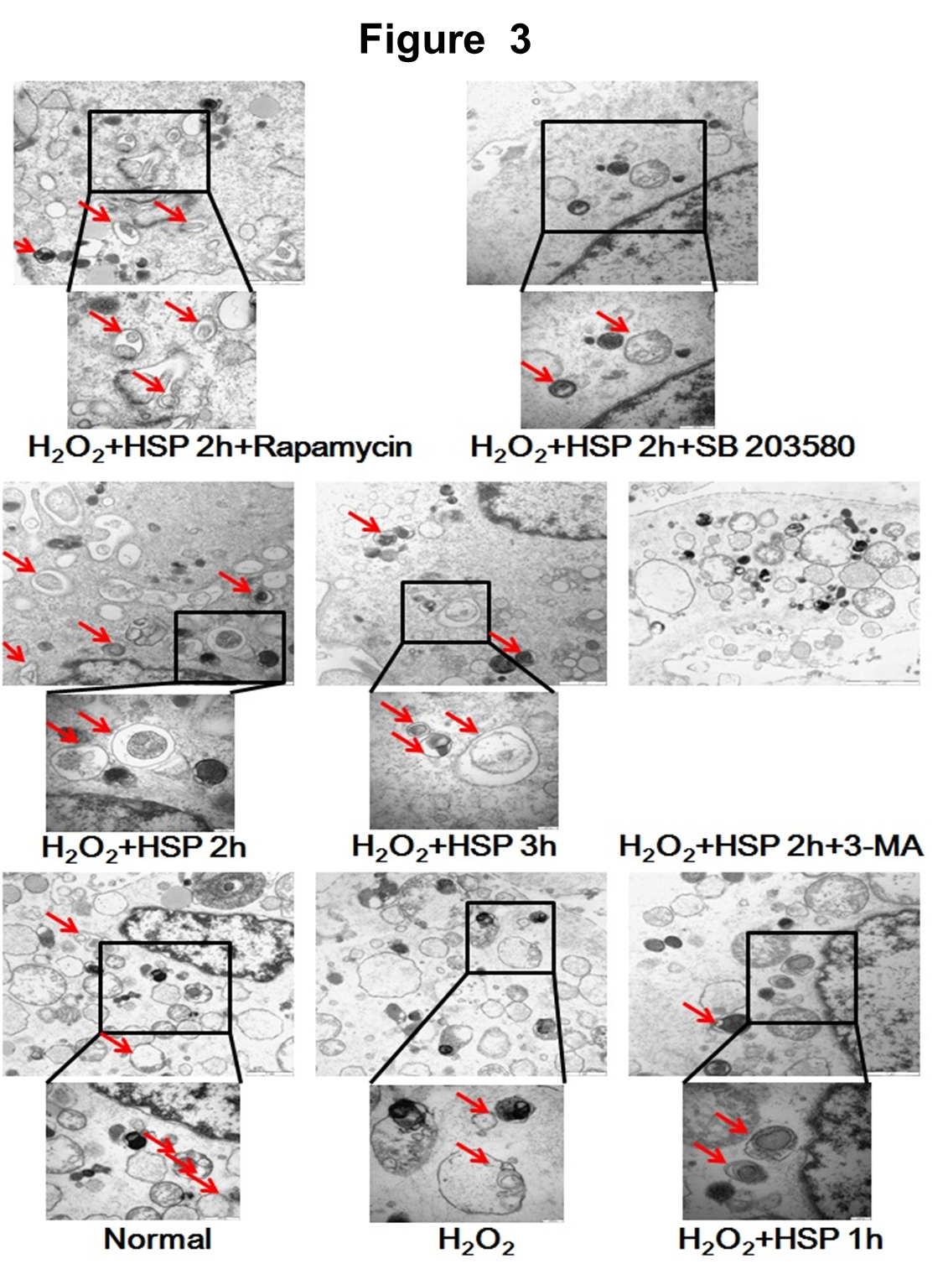
Figure 3 Representative electron micrographs demonstrating autophagic vacuole formation in each group. The arrows indicate the double-membraned vacuoles digesting organelles or cytosolic contents.

Figure 4 Inhibition of autophagy abrogated the effects of heat shock pretreatment on apoptosis reduction in mesenchymal stem cells under H₂O₂ treatment. A: Flow cytometry indicated that 3-MA significantly increased the apoptotic rate in heat shock pretreatment (HSP)-treated mesenchymal stem cells; B: Western blot showed that 3-MA significantly increased Bax and cytochrome C expression, and decreased Bcl-2, LC3-II and beclin 1 expression. The data represent the results of 3 separate experiments. ^{c}P < 0.05, ^{e}P < 0.01 compared with the control group; ^{f}P < 0.01 compared with the HSP_{2h} group.
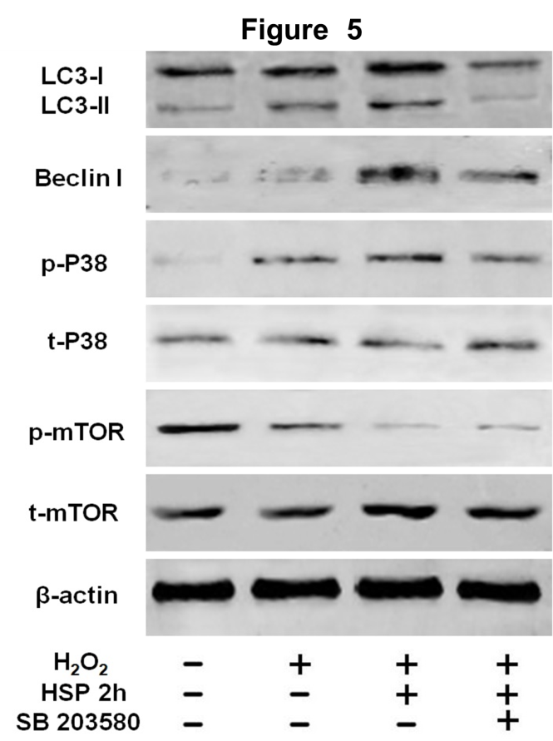
Figure 5 p38MAPK/mTOR pathway was involved in autophagy activation by heat shock pretreatment in mesenchymal stem cells. Western blot showed that p-p38MAPK was upregulated and p-mTOR was downregulated by heat shock pretreatment (HSP) in mesenchymal stem cells. The p38MAPK inhibitor, SB203580, counteracted the effects of HSP on LC3-II, beclin 1 and p-p38MAPK expression. The data represent the results of 3 separate experiments.

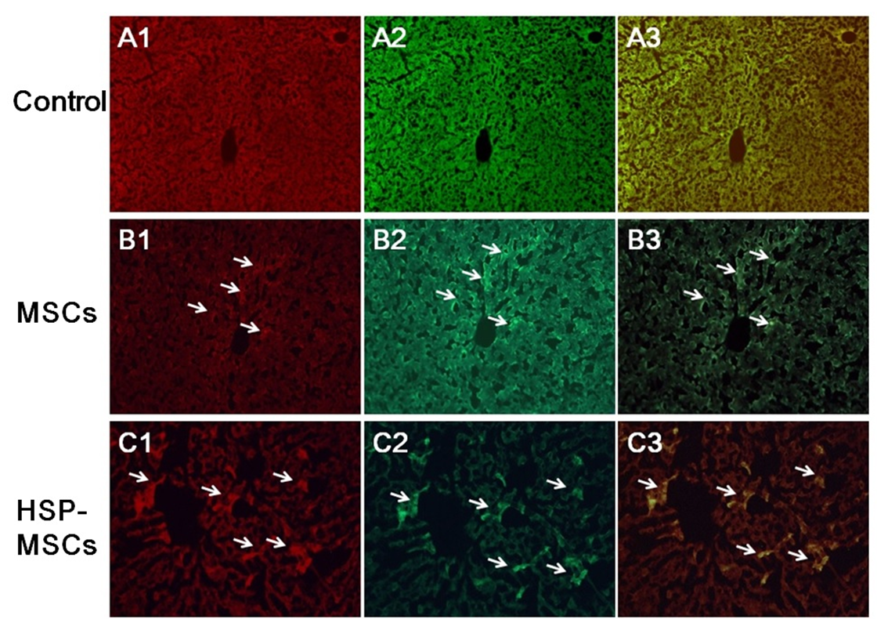
Figure 6 Heat shock pretreatment increases the homing and survival rate of transplanted mesenchymal stem cells to I/R livers in vivo. CM-Dil-labeled positive cells (red color, B1, C1), PCNA-conjugated with FITC (green color, B2, C2) and their co-localization (yellow color, B3, C3) were detected by immunofluorescence microscopy, respectively (magnification × 100). The total number of double-positive cells labeled by CM-Dil and PCNA in the heat shock pretreatment (HSP)-mesenchymal stem cells (MSCs)-treated group was higher than that in the MSCs-treated group. The arrows indicate positive stained cells by CM-Dil, PCNA or their co-localization, respectively. The data represent the results of 3 separate experiments.

Figure 7 Heat shock pretreatment improves the therapeutic potential of mesenchymal stem cells in the treatment of HIRI in vivo. A: Serum aminotransferase levels were measured using an automatic analyzer following treatment; B: Histopathological analysis of livers from the normal control, IR-control, mesenchymal stem cells (MSCs) and HSP-MSCs groups. Liver tissue sections were stained with H&E and scored according to the Suzuki Scoring System. Original magnification, × 100 and × 400 respectively, for each slide; C: Expression of PCNA by immunohistochemistry in liver tissues (magnification × 100 and × 400). The arrows indicate positive stained cells by PCNA. The data represent the results of 3 separate experiments. ªP < 0.05, ^{e}P < 0.01 compared with the normal control group; ^{f}P < 0.01 compared with the I/R control group; ^{c}P < 0.05 compared with the MSCs group.

