Name of Journal: World Journal of Stem Cells
Manuscript NO: 52207
Manuscript Type: ORIGINAL ARTICLE

Basic Study
C-C chemokine receptor type 2-overexpressing exosomes alleviated experimental post-stroke cognitive impairment by enhancing microglia/macrophage M2 polarization

Yang HC et al. Exosomes on PSCI

Huai-Chun Yang, Min Zhang, Rui Wu, Hai-Qing Zheng, Li-Ying Zhang, Jing Luo, Li-Li Li, Xi-Quan Hu

Huai-Chun Yang, Rui Wu, Hai-Qing Zheng, Li-Ying Zhang, Jing Luo, Li-Li Li, Xi-Quan Hu, Department of Rehabilitation Medicine, the Third Affiliated Hospital, Sun Yat-sen University, Guangzhou 510000, Guangdong Province, China

Min Zhang, Department of Andrology, the First Affiliated Hospital, Sun Yat-sen University, Guangzhou 510000, Guangdong Province, China

Author contributions: Hu XH, Yang HC, and Zhang M conceived and designed the experiments. Yang HC and Zhang M performed the experiments. Yang HC, Zhang M and Wu R acquired, analyzed and interpreted the data. Hu XH, Yang HC, and Zhang M wrote the manuscript. All authors have read and revised the final manuscript and approved it for publication.

Supported by the National Natural Science Foundation of China, No. 81871847 and No. 81672261.

Corresponding author: Xi-Quan Hu, MD, PhD, Chief Physician, Professor, Department of Rehabilitation Medicine, the Third Affiliated Hospital, Sun Yat-sen University, No. 600 Tianhe Road, Guangzhou 510000, Guangdong Province, China. sysu_hu@163.com

Received: October 22, 2019
Revised: December 27, 2019
Accepted: January 19, 2020
Published online:
Abstract
BACKGROUND
Human-derived mesenchymal stromal cells have been shown to improve cognitive function following experimental stroke. The activity of exosomes has been verified to be comparable to the therapeutic effects of mesenchymal stromal cells. However, the effects of exosomes derived from human umbilical cord mesenchymal stem cells (HUC-MSCs) (Exo^{Ctrl}) on post-stroke cognitive impairment (PSCI) have rarely been reported. Moreover, whether exosomes derived from C-C chemokine receptor type 2 (CCR2)-overexpressing HUC-MSCs (Exo^{CCR2}) can enhance the therapeutic effects on PSCI and the possible underlying mechanisms have not been studied.

AIM
To investigate the effects of Exo^{Ctrl} on PSCI and whether Exo^{CCR2} can enhance therapeutic effects on PSCI.

METHODS
Transmission electron microscopy, qNano® particles analyzer, and Western blotting were employed to determine the morphology and CCR2 expression of Exo^{Ctrl} or Exo^{CCR2}. ELISA was used to study the binding capacity of exosomes to CC chemokine ligand 2 (CCL2) in vivo. After the intravenous injection of Exo^{Ctrl} or Exo^{CCR2} into experimental rats, the effect of Exo^{Ctrl} and Exo^{CCR2} on PSCI was assessed by Morris water maze. Remyelination and oligodendrogenesis were analyzed by Western blotting and immunofluorescence microscopy. QRT-PCR and immunofluorescence microscopy were conducted to compare the microglia/macrophage polarization. The infiltration and activation of hematogenous macrophages were analyzed by Western blotting and transwell migration analysis.

RESULTS
CCR2-overexpressing HUC-MSCs loaded the CCR2 receptor into their exosomes. The morphology and diameter distribution between Exo^{Ctrl} and Exo^{CCR2} showed no significant difference. Exo^{CCR2} bound significantly to CCL2 but Exo^{Ctrl} showed little CCL2 binding. Although both Exo^{CCR2} and Exo^{Ctrl} showed beneficial effects on PSCI, oligodendrogenesis, remyelination, and microglia/macrophage polarization, Exo^{CCR2} exhibited a significantly superior beneficial effect. We also found that Exo^{CCR2} could suppress the CCL2-induced macrophage migration and activation in vivo and in vitro, compared with Exo^{Ctrl} treated group.

CONCLUSION
CCR2 over-expression enhanced the therapeutic effects of exosomes on the experimental PSCI by promoting M2 microglia/macrophage polarization, enhancing oligodendrogenesis and remyelination. These therapeutic effects are likely through suppressing the CCL2-induced hematogenous macrophage migration and activation.

Key words: Cognitive impairment; Stroke; Exosomes; C-C chemokine receptor type 2; Microglia/macrophage polarization; Remyelination

Yang HC, Zhang M, Wu R, Zheng HQ, Zhang LY, Luo J, Li LL, Hu XQ. C-C chemokine receptor type 2-overexpressing exosomes alleviated experimental post-stroke cognitive impairment by enhancing microglia/macrophage M2 polarization. World J Stem Cells 2020; In press

Core tip: Exosomes have been reported to possess the therapeutic benefit comparable to the therapeutic effects of mesenchymal stromal cells. However, the effects of exosomes derived from human umbilical cord mesenchymal stem cells (Exo^{Ctrl}) on post-stroke cognitive impairment (PSCI) have rarely been reported. Moreover, whether exosomes derived from C-C chemokine receptor type 2 (CCR2)-overexpressing human umbilical cord mesenchymal stem cells (Exo^{CCR2}) have better therapeutic effects on PSCI and the possible mechanisms underlying these effects remained unclear. This study provides new insights into the use of genetically modified exosomes for PSCI treatment, offering new ideas for the clinical application of exosome-based therapies for PSCI.

INTRODUCTION
Post-stroke cognitive impairment (PSCI) occurs frequently after stroke. The prevalence of PSCI in ischemic stroke patients ranges from 25% to 30%^{[1]}, which has been increasing gradually due to the development of modern medicine and the increasing survival rate of stroke patients^{[2,3]}. PSCI imposes a heavy burden on the patients, their families, and societies. However, the treatment of PSCI is still not satisfactory and requires further improvement.
Previous research has shown that mesenchymal stem cell (MSC) therapy faciliates the cognitive recovery after stroke^{[4,5]}. However, the disadvantages of therapies involving MSCs, such as their high in vivo clearance rate after transplantion^{[6,7]}, limited capacity to cross blood-brain barrier^{[8,9]}, potential immunogenicity^{[10,11]}, and unpredictability of cell growth and differentiation^{[12]}, have emerged with the development of research. Recent studies have indicated that MSCs mostly act via specific paracrine mechanisms, while exosomes play a key role in the general progress and recovery under conditions of disease^{[13]}. MSC-derived exosomes have displayed positive effects in animal models of various ischemic injuries such as stroke^{[14]}, myocardial infarction^{[15]}, and renal ischemic injury^{[16]}. To a certain extent, MSC-derived exosomes exert therapeutic effects comparable to those of MSCs and overcome the potential risks and disadvantages associated with MSCs^{[17,18]}. However, there are only a few studies focusing on exosome-based treatments for PSCI.
CC chemokine ligand 2 (CCL2) is highly expressed in the ischemic hemisphere after a stroke; this mediates the migration of C-C chemokine receptor type 2 (CCR2)-positive blood-derived macrophages, thus exacerbating brain tissue damage^{[19,20]}. CCR2 knockout mice^{[21]} or CCL2 knockout^{[22]} mice have shown a significant reduction of macrophage proliferation within 2 wk after a stroke, accompanied by neuronal regeneration and decreased infarct volume, suggesting that inhibition of the CCL2/CCR2 axis may play a neuroprotective role after strokes. In addition, CCR2 antagonism^{[23]} or CCR2 knockout^{[24]} can promote the M2 polarization of microglia/macrophages by inhibiting CCR2+ macrophages and improve cognitive impairment in mice with traumatic brain injury.
It is noticeable that in recent years, exosomes secreted by human umbilical cord MSCs (HUC-MSCs) have shown powerful effects on microglia/macrophage activation and polarization in animal models such as the Alzheimer's disease model^{[25]}, hypoxic-ischemic encephalopathy model^{[26]}, and the peripheral nerve injury model^{[27]}. However, the effects of HUC-MSC-derived exosomes (Exo^{Ctrl}) on microglia/macrophage polarization and cognitive function after stroke have not yet been reported. Furthermore, we hypothesize that CCR2-overexpressing HUC-MSC-derived exosomes (Exo^{CCR2}) further promote microglia/macrophage M2 polarization by competitively binding to the CCR2 ligand CCL2 and inhibiting the CCL2-mediated infiltration of blood-derived mononuclear macrophages. Particularly, we compared the therapeutic effects of the systemic administration of Exo^{CCR2} and Exo^{Ctrl} on PSCI, which will provide new insights into genetically modified exosome-based therapies for PSCI treatment and serve as a preclinical study on cerebral protection after stroke

MATERIALS AND METHODS
Establishment of the tMCAO model and animals grouping
Adult Sprague-Dawley rats (male, weighing 280-350 g) were underwent the right transient middle cerebral occlusion (tMCAO) for 2 h in accordance with the method as Longa et al^{[28]} described with modifications. Experimental procedures were approved by the Institutional Animal Ethics Committee of Life Sciences School, Sun Yat-sen University. The modified neurological severity score (mNSS) and 2,3,5-Triphenyltetrazolium chloride (TTC) (G3005, Solarbio, China) staining were utilized to confirm the establishment of the tMCAO model. Rats with moderate injury (mNSS values 7-12) were randomly divided into the sham group, tMCAO group, Exo^{Ctrl} treatment group, and Exo^{CCR2} treatment group. As described in a previous study, 100 µg of the exosomes was dissolved in 500 µL of phosphate-buffered saline (PBS)^{[29]}. One day after operation, the rats from sham and tMCAO groups were injected with 500 µL of PBS, the rats in the Exo^{Ctrl} and Exo^{CCR2} treatment groups were injected with equal volumes of the respective exosomal solutions via tail vein injections. BrdU (50 mg/kg/d; B5002, Sigma, United States) was injected intraperitoneally for 14 continuous d one day after the induction of tMCAO.

Transfection of HUC-MSCs with lentiviral vectors and comparison of their biological characteristics
HUC-MSCs were obtained from three healthy donors after they signed the informed consent forms. Briefly, the Wharton gum tissues with blood vessels removed were cut up and digested with collagenase II (1 mg/mL, 234155, Millipore) under 37 °C for 30 min with shaking. The cells were filtered from the suspensions with a cell strainer (diameter 70 μm). The cells were washed with Hank's Balanced Salt Solution (SH30031.02, Hyclone) and cultured in low-glucose DMEM (L-DMEM) (C11885500BT, Gibco) containing 10% fetal bovine serum (04-001-1A, Biological Industries, Israel) in a 5% CO2 incubator.
At passage 3, the HUC-MSCs were transfected with lentiviral vectors expressing both the CCR2 and eGFP genes, and vectors expressing the eGFP gene in accordance with the manufacturer’s instructions. The vector construction is indicated in Supplementary Figure 1. Three days after the transfection, the HUC-MSCs transfected with lentiviral vectors encoding CCR2 (namely HUC-MSCs^{CCR2}) or eGFP (namely HUC-MSCs^{Ctrl}), were sorted using fluorescence-activated cell sorting (Influx, Becton Dickinson). The HUC-MSCs^{Ctrl} and HUC-MSCs^{CCR2} (passage 6) were identified by microscopic analysis, flow cytometry analysis for detecting the following surface markers: CD13-APC (1:50, 17-0138-41, eBioscience, United States), CD29-APC (1:50, 559883, BD Bioscience, United States), CD44-APC (1:50, 559942, BD Bioscience, United States), CD34-PE (1:50, 550761, BD Bioscience, United States), CD45-PE (1:50, 560975, BD Bioscience, United States), CD73-PE (1:50, 60044, Stemcell Technologies, Canada), CD90-PE-Cy7 (1:50, 561558, BD Bioscience, United States), CD105-PerCP-Cy5.5 (1:50, 560819, BD Bioscience, USA), HLA-DR-V500 (1:50, 561225, BD Bioscience, United States). Osteogenesis and lipogenesis induction experiments were conducted with modification as described in a previous study^{[30]}. Briefly, for osteogenisis induction experiments, cells were cultured in L-DMEM containing fetal bovine serum (20%), ascorbic acid (100 μg/mL), β-glycerophosphate (10 mmol) and dexamethasone (100 nmol) for three weeks with medium changed every 3 d. For adipogenesis induction experiments, the cells were induced in L-DMEM supplemented with FBS (10%), dexamethasone (100 nmol), indomethacin (0.2 mmol), insulin (10 μg/mL), 3-isobutyl-1-methylxanthine (0.5 mmol). After 3 wk, Osteogenic and adipogenic differentiation were confirmed by oil red O staining and alizarin red staining.

Exosome isolation and identification
The isolation of exosome was performed according to a previous study^{[31]}. Briefly, the exosomes were collected by differential ultracentrifugation, and their morphology was analyzed by transmission electron microscopy. The distribution of the exosomes based on their diameters was performed using a qNano® system (Izon Science, Oxford, United Kingdom). Western blotting was used to detect the CCR2 expression and the exosome-specific markers CD9, CD63, and CD81.

Enzyme-linked immunosorbent assay (ELISA)
To test the CCL2-binding capacity of the exosomes, Exo^{Ctrl} and Exo^{CCR2} were co-incubated with recombinant rat CCL2 (100 ng/well, 400-12, PeproTech, United States). Differential ultracentrifugation was performed to obtain exosome-free supernatants. ELISA kits (CSB-E07429r, Cusabio Biotech, China) were utilized to detect the CCL2-binding capacity of Exo^{CCR2} and Exo^{Ctrl}, according to the protocol of manufacturer.

Cognitive function test
The Morris water maze test was conducted as our previous study described^{[32]}. The test was carried out at 23 d after the induction of tMCAO. The rats were first subjected to five consecutive days of the place navigation test. On day 6, a spatial probe test (60 s) was performed under the same condition without platform. During the test, the latency to the platform and the time recorded in the target quadrants were analysed. The mNSS values were recorded at 1, 4, 14, and 28 d after exosome treatment, as described previously^{[33]}. The rats were tested by an individual blinded to the grouping for three times, and the means of the mNSS results were recorded. The normal score is 0, while the maximal deficit score is 18. Rats with mNSS values ranging from 7-12 were included in the study.

Western blotting
Western blotting was conducted in accordance with the protocol as our previous study described^{[34]}. First, the proteins were obtained from the ischemic cerebral hemisphere or cultured cells by treatment with the kit of protein extraction (KeyGen BioTech, China) according to the protocol of manufacturer. The protein samples were loaded onto 10% polyacrylamide gels and electrophoresed under 120V voltage; the resultant bands were transferred onto polyvinylidene difluoride membranes. Next, the polyvinylidene difluoride membranes were incubated with rabbit anti-CD9 (1:2000, ab92726, Abcam, United Kingdom), rabbit anti-CD63 (1:10000, 25682-1-AP, ProteinTech, United States), rabbit anti-CD81 (1:1000, ab109201, Abcam, United States), rabbit anti-CCR2 (1:1000, DF2711, Affinity Biosciences, United States), rabbit anti-CCL2 (1:1000, ab25124, Abcam, United States), mouse anti-iba-1 (1:500, MABN92, Millipore, United States), rabbit anti-NF-κB (1:1000, ab16502, Abcam, United States), mouse anti-CD68 (1:1000, ab201340, Abcam, United States), rabbit anti-myelin basic protein (anti-MBP) (1:200, ab40390, Abcam, United States), and rabbit anti-β-actin (1:1000, #3700, Cell Signaling Technology, United States) antibodies at 4 °C overnight, and then with peroxidase-conjugated secondary antibodies at 37 °C for 1 h. The protein bands were developed using a specific chromogenic substrate (ECL, KeyGen BioTech, China), according to the manufacturer’s instructions.

RNA isolation, reverse transcription, and real-time PCR
Total RNA from the ischemic cerebral hemispheres or cultured cells was extracted by TRIzol (Invitrogen, United States), according to the protocol of manufacturer. Reverse transcription for synthesizing the cDNA was performed using the PrimeScript™ RT Master Mix (Takara, Japan), according to the manufacturer's instructions. The resulting cDNA was then subjected to quantitative real-time PCR for the evaluation of the relative mRNA levels. The real-time PCR amplifications were performed with a final reaction volume of 20 μL using the TB Green™ Premix Ex Taq™ II kit (Takara, Japan), according to the manufacturer's instructions. The reaction mixtures were preheated at 95°C (30 s) for one cycle and then amplified at 95°C (5 s) and 60°C (34 s) for 40 cycles. The Ct (threshold cycle) value of each sample was analyzed by the 2^{-△△Ct} method, and the mRNA expression levels of the target genes were normalized to the expression level of β-actin to obtain the relative expression levels. The sequences of the used primers are as follows (Table 1).

Immunofluorescence
Frozen sections for immunofluorescence staining were prepared as described in our previous study^{[34]}. First, the frozen sections were treated for 5 min with hot EDTA-citrate buffer (95 °C) (P0085, Beyotime Biotechnology, China) for antigen retrieval, followed by treatment with a blocking reagent (Beyotime Biotechnology, China) for 1 h at 25 ℃. Then, the sections were incubated with mouse anti-iba1 (1:200, MABN92, Millipore, United States), rabbit anti-CD206 (1:200, ab64693, Abcam, United States), rabbit anti-CD16 (1:100, ab211151, Abcam, United States), and rabbit anti-MBP (1:200, ab40390, Abcam, United States) antibodies overnight at 4 °C. The sections were rinsed in PBS for 5 min each for three times, and were then incubated with goat anti-mouse secondary antibodies and goat anti-rabbit secondary antibodies for 1 h at 25 ℃. Fluorescence signals were detected using a confocal laser scanning microscope (Dragonfly, Oxford Instruments, United Kingdom). For Brdu/NG2 double immunostaining, rabbit anti-NG2 (1:200, AB5320, Millipore, United States) and rat anti-BrdU (1:200, ab6326, Abcam, United Kingdom) antibodies were used according the protocol described in our previous study^{[32]}.

Transwell assays
The transwell assay was performed for examining the migration of mouse macrophages (raw 264.7 cells, CC9001, CELLCOOK, China), according to a previous study^{[35]}. The macrophage suspension (10⁶/mL, 100 µL) was transferred into the upper transwell chamber (pore size of 8 μm; Corning, United States). Cells from the CCL2 control, CCL2 + Exo^{Ctrl} and CCL2 + Exo^{CCR2} groups, which were subjected to different treatments, were added into the lower transwell chamber. After co-incubation for 16 h at 37 °C, the macrophages remained in the upper transwell chamber were scraped. The membranes were fixed using 4% paraformaldehyde and stained with DAPI (F6057, Sigma, United States). The macrophages that remained in the lower chamber were observed using a fluorescence microscope (Leica DM6B, Germany).

Statistical Analysis
The results were expressed as the mean ± standard error of mean (SEM). SPSS22.0 for Windows was applied for the statistical analysis. One-way Analysis of Variance (ANOVA), followed by Least Significant Difference (LSD)-t test procedure or Student’s T test, was applied for comparing the statistical differences. P < 0.05 was statistically significant.

RESULTS
CCR2-overexpressing HUC-MSCs load the CCR2 receptor into their exosomes
Cultured human MSCs express extremely low levels of the CCR2 receptor during continuous passage^{[30]}. This result was consistent with that of the study by Huang et al^{[30]}, as indicated by flow cytometry, Western blotting, and quantitative real-time PCR (qRT-PCR) analyses, which indicated that the HUC-MSCs^{Ctrl} (passage 6), following the fluorescent-activated cell sorting analysis, showed a low CCR2 protein and mRNA expression. Moreover, the CCR2 protein and mRNA expression in HUC-MSCs^{CCR2} increased significantly (Figure 1A-1D). Since HUC-MSCs are characterized by specific surface markers such as CD13, CD29, CD44, CD34, CD45, CD73, CD90, CD105, HLA-DR^{[36,37]}, and the osteogenesis and lipogenesis capacity^{[38]}, we checked the biological characteristics changes by flow cytometry analysis, and osteogenesis and lipogenesis induction experiments. The results showed CCR2 overexpression had no significant effects on the biological characteristics of the HUC-MSCs (Supplementary Figure 2). The morphology and diameter distribution of Exo^{Ctrl} and Exo^{CCR2} were confirmed using transmission electron microscopy and the qNano® system (Izon Science, Oxford, United Kingdom), respectively; there was no significant difference between the Exo^{Ctrl} and Exo^{CCR2} (Figure 1E, 1F). Since exosomes are characterized by specific marker CD9, CD63, and CD81^{[38,39]}, we investigated the expressions of them by Western blotting. The results indicated both Exo^{Ctrl} and Exo^{CCR2} expressed CD9, CD63, and CD81(Figure 1G); however, Exo^{CCR2} expressed high amounts of CCR2, while Exo^{Ctrl} expressed extremely low amounts of CCR2 (Figure 1H).
To further compare the CCL2-binding capacity of Exo^{CCR2} and Exo^{Ctrl}, ELISA was performed. The results suggested that Exo^{CCR2} bound significantly to CCL2, compared to Exo^{Ctrl}, while Exo^{Ctrl} showed little CCL2-binding capacity, compared to the case for the CCL2 control group (Figure 1J).

Exo^{CCR2} showed more beneficial effects against PSCI than Exo^{Ctrl}
The Morris water maze is a common tool for performing cognition tests in animals with experimental stroke^{[40,41]}. The establishment of tMCAO were confirmed mNSS behavioral test and TTC staining at 1 d after surgery, as indicated in Supplementary Figure 3. Compared with the tMCAO group, the rats in both the Exo^{CCR2} and Exo^{Ctrl} treatment groups showed a significant decrease in the escape latency spent finding the platform (indicating spatial learning) from day 4 and day 5 during the navigation test. The latency spent finding the platform in case of the animals from the Exo^{CCR2} treatment group further decreased significantly compared to the case for the animals from the Exo^{Ctrl} treatment group at day 4 and day 5 during the navigation test (Figure 2B). During the spatial probe test, the rats from both the Exo^{CCR2} treatment and Exo^{Ctrl} treatment groups showed a significant increase in the time spent in the target quadrant (indicating spatial memory). Moreover, the rats from the Exo^{CCR2} treatment group showed a further improvement with regards to the time spent in the target quadrant, compared to those from the Exo^{Ctrl} treatment group (Figure 2C). At the same time, the mNSS values of the rats in the Exo^{CCR2} and Exo^{Ctrl} treatment groups decreased significantly compared to those of the rats from the tMCAO group; the mNSS values of the rats from the Exo^{CCR2} treatment group showed a further decrease compared to those of the rats from the Exo^{Ctrl} treatment group (Figure 2D).

Exo^{CCR2} showed more beneficial effects with regards to oligodendrogenesis and remyelination than Exo^{Ctrl}
Oligodendrogenesis and remyelination contribute to the recovery from PSCI^{[42,43]}. Therefore, we examined the fluorescence intensity of MBP indicating the integrity of myelination and the number of BrdU+/NG2+ cells indicating the proliferation status of oligodendrocyte around the ischemic area by immunofluorescence staining; the expression of the MBP protein extracted from the ischemic hemispheres was quantified by Western blotting analysis. Compared to the samples obtained from rats in the tMCAO group, samples from the rats subjected to the Exo^{Ctrl} and Exo^{CCR2} treatments exhibited increased fluorescence intensity and protein expression of MBP at day 28 after tMCAO. Moreover, Exo^{CCR2} treatment showed superior effects on the fluorescence intensity and protein expression of MBP compared to that showed by Exo^{Ctrl} treatment (Figure3A-D). Compared to the samples from rats in the tMCAO group, the samples obtained from rats in both the Exo^{Ctrl} and Exo^{CCR2} treatment groups showed an increased number of BrdU+/NG2+ cells around the ischemic area at day 28 after tMCAO. Moreover, the changes in samples obtained from rats in the Exo^{CCR2} treatment group were more enhanced than those in the samples obtained from rats in the Exo^{Ctrl} treatment group (Figure 3E, 3F).

Exo^{CCR2} promoted microglia/macrophage M2 polarization and inhibited microglia/macrophage M1 polarization in vivo compared to that by Exo^{Ctrl}
Since microglia/macrophage polarization plays an important role in the process of oligodendrogenesis and remyelination after stroke^{[40,44]}, we performed qRT-PCR analysis to quantify the mRNA levels of the M1 markers CD16 and IL-1β and the M2 markers CD206 and Arg-1; we also performed immunofluorescence staining to detect CD16/iba-1 and CD206/iba-1, to compare the effects of Exo^{Ctrl} and Exo^{CCR2} on microglia/macrophage polarization. The CD16 and IL-1β mRNA expression levels in samples obtained from rats after Exo^{CCR2} and Exo^{Ctrl} treatment decreased significantly and the mRNA expression levels of CD206 and Arg-1 increased significantly compared to those in samples obtained from rats in the tMCAO group at day 4 and day 14 after tMCAO. The changes in rats from the Exo^{CCR2} treatment group were more enhanced compared to those in rats from the Exo^{Ctrl} treatment group (Figure 4A-H). These results were validated by immunofluorescence staining for CD16/iba-1 and CD206/iba-1 at day 14 after tMCAO (Figure 4I, 4J).

Exo^{CCR2} suppressed CCL2-induced macrophage migration and activation in vivo and in vitro compared to Exo^{Ctrl}
In pathological conditions such as cerebral ischemia, numerous CCR2+ blood-derived macrophages migrate into the ischemic area due to the high in situ expression of CCL2^{[19,20]}, which plays a critical role in microglia/macrophage activation and polarization. Downregulation of the CCL2/CCR2 axis inhibits mononuclear macrophage infiltration, which reduces the over-activation and M1 polarization of microglia/macrophages and promotes the alternative M2 activation of microglia/macrophages^{[21-23,45]}. Therefore, we examined the expression of the CCL2, nuclear factor kappa B (NF-κB), ionized calcium-binding adapter molecule 1 (iba-1), and CD68 proteins by Western blotting analysis. The results showed that the expression levels of CCL2, NF-κB, iba-1, and CD68 in samples obtained from rats in the Exo^{CCR2} and Exo^{Ctrl} treatment groups decreased significantly compared to the samples obtained from rats in the tMCAO group; additionally, the changes in samples from rats in the Exo^{CCR2} treatment group were more enhanced compared to those in samples from rats in the Exo^{Ctrl} treatment group (Figure 5A-E).
To further confirm these results in vitro, a transwell assay for quantifying the number of migrated macrophages, qRT-PCR analysis for quantifying the mRNA expression levels of IL-1β and tumor necrosis factor α (TNF-α), and Western blotting analysis for quantifying the NF-κB protein expression were performed to evaluate the effects of Exo^{CCR2} and Exo^{Ctrl} on the migration and activation of macrophages in vitro. The results indicated that Exo^{CCR2} treatment significantly inhibited macrophage infiltration, and reduced the mRNA expression levels of IL-1β and TNF-α and the expression levels of the NF-κB protein, compared to the cells from the Exo^{Ctrl} treatment and CCL2 control group; on the contrary, Exo^{Ctrl} showed no significant effects on macrophage migration, the mRNA expression levels of IL-1β and TNF-α, and the expression levels of the NF-κB protein, compared to the case for cells from the CCL2 control group (P > 0.05) (Figure 5F-5K).

DISCUSSION
With increasing studies seeking to isolate the specific paracrine factors that mediate the therapeutic effects of MSCs, the therapeutic efficacy of exosomes derived from their parent cells has been found to be comparable to that of MSC therapies^{[13,14]}. Intravenous administration of MSC-derived exosomes to a rodent model of stroke or a rodent model of traumatic brain injury has been shown to substantially promote white matter damage repair, thereby improving the behavioral and cognitive outcomes^{[29,46]}. Moreover, genetically modified exosomes such miR-17-92- or miR-133b-overexpressing exosomes have been found to enhance the therapeutic effects of exosome-based treatment in a model of experimental stroke^{[47,48]}. Exosome-mediated intercellular communications via the transfer of exosomal proteins or RNAs between the source and target cells have been extensively evaluated^{[49]}. However, only a few studies have focused on the surface receptors on exosomes. Ciullo et al^{[50]} have found that treatment with C-X-C motif chemokine receptor 4 (CXCR4)-overexpressing exosomes showed more beneficial outcomes in a myocardial infarction animal model than the treatment with control exosomes, suggesting that the receptors on exosomes may also contribute to their therapeutic effects. Shen et al^{[35]} have found that CCR2-positive exosomes suppress macrophage migration and alleviate ischemic renal injury. Since Huang et al^{[30]} have demonstrated that CCR2-overexpressing MSCs enhance the therapeutic effects of MSC treatment in rats with tMCAO, we further explored whether exosomes derived from CCR2-overexpressing MSCs can show enhanced therapeutic effects. The results indicate that HUC-MSCs^{Ctrl} and their secreted Exo^{Ctrl} expressed low amounts of CCR2, while HUC-MSCs^{CCR2} and Exo^{CCR2} showed a high expression of CCR2. Moreover, the results showed that Exo^{CCR2} showed significant binding capacity to the ligand CCL2 in vitro compared to Exo^{Ctrl}; this is consistent with the results of the study by Shen et al^{[35]}, Based on this finding, we hypothesize that when present on exosomes, the CCR2 receptor may exert more powerful therapeutic effects for the treatment of PSCI.
MSC-based treatments have been evaluated to promote cognitive recovery in an animal model of stroke^{[4]} or traumatic brain injury^{[51]}. Previous studies have indicated that exosome treatment can promote the repair of white matter damage after stroke and facilitate the recovery of neurological function after stroke^{[48,52]}. Exosomes produced by MSCs mediate several therapeutic effects of MSCs; however, reports about the effects of exosome treatment on cognitive impairment after stroke are rare. Since HUC-MSC-derived exosomes have shown potent effects on microglial activation and polarization in animal models such as the hypoxic-ischemic encephalopathy model^{[26]} and the peripheral nerve injury model^{[27]}, and improved the cognitive function in an Alzheimer's disease model by modulating microglial polarization ^{[25]}, we utilized HUC-MSC-derived exosomes in this study. The results showed that the spatial learning and memory in the rats from the Exo^{Ctrl} and Exo^{CCR2} treatment groups were significantly better than those in the rats from the tMCAO group; additionally, Exo^{CCR2} treatment significantly promoted the recovery of spatial learning and memory in rats, compared to that by Exo^{Ctrl} treatment.
Although PSCI is a heterogeneous disease, white matter damage is the most common pathological change observed in almost all cases of vascular dementia^{[53]} and most types of stroke^{[54]}. Both basic medical studies and clinical studies have suggested that white matter damage after stroke is highly correlated with PSCI^{[43,55,56]}. In the acute phase of stroke, oligodendrocyte damage causes the demyelination of the white matter, leading to neurotransmission disorders. During the recovery phase of stroke, oligodendrocytes and their precursor cells proliferate and differentiate into mature oligodendrocytes, which play a key role in remyelination^{[57]}. Thus, facilitating the proliferation of oligodendrocytes and their precursor cells promotes remyelination and cognitive function after stroke^{[58]}. Our finding is consistent with that of Xin et al^{[48,52]}, who also found that exosomes promote oligodendrogenesis and remyelination following experimental stroke. Another important finding is that Exo^{CCR2} treatment further promoted oligodendrogenesis and remyelination, compared with Exo^{Ctrl} treatment. These results indicate that Exo^{CCR2} treatment notably promoted the recovery from PSCI by enhancing oligodendrogenesis and remyelination compared to that by Exo^{Ctrl} treatment.
Microglia, which are the resident macrophages in the central nervous system, as well as blood-derived macrophages, activate and display dynamic M1 and M2 polarization after stroke^{[59]}. Since activated microglia and blood-derived macrophages are similar with regards to morphology and biological function, and co-express iba-1, CD11b, and F4/80, many scholars have referred to activated microglia and blood-derived macrophages as the same group of cells^{[60,61]}. M1 microglia/macrophage polarization deteriorates oligodendrogenesis and white matter damage by releasing inducible nitric oxide synthase and pro-inflammatory factors such CD16, IL-1β, and TNF-α, while M2 microglia/macrophage polarization facilitates oligodendrogenesis and white matter repair by releasing the mannose receptor CD206 and anti-inflammatory factors such as IL-10, Ym-1 and Arg-1 and engulfing tissue fragments after stroke^{[40,43,62]}. Promoting M2 polarization and inhibiting M1 polarization boosts oligodendrogenesis and remyelination^{[63,64]}, and facilitates the recovery from PSCI ^{[40]}. The results of our study show that both the Exo^{Ctrl} and Exo^{CCR2} treatments promoted M2 microglia/macrophage polarization and inhibited M1 microglia/macrophage polarization, compared to the case for the rats in the tMCAO group, and Exo^{CCR2} showed enhanced effects compared to Exo^{Ctrl}. Therefore, the enhanced beneficial effects of Exo^{CCR2} against PSCI may be related to their more effective regulation of microglial polarization-mediated oligodendrogenesis and remyelination.
It is well-known that CCL2 is expressed in high amounts in the ischemic hemisphere after stroke, which mediates the infiltration of CCR2+ mononuclear macrophages into the ischemic site and aggravates the excessive activation and M1 polarization of microglia/macrophages^{[23,45]}. Therefore, we postulate that CCR2-overexpressing exosomes may function as endogenous CCL2 sponges binding to these ligands, block the over-infiltration of macrophages, and subsequently inhibit the excessive activation and M1 polarization of microglia/macrophages. These results support the findings from previous studies, which have reported that MSC-derived exosomes downregulate CCL2 overexpression^{[65]} and microglia/macrophage overactivation^{[27]}; Exo^{Ctrl} significantly downregulated the expression of CCL2, iba-1, CD68, and NF-κB in vivo, compared to the case for rats in the tMCAO group. Moreover, Exo^{CCR2} further downregulated the expression of CCL2, iba-1, CD68, and NF-κB. To verify this in vivo finding, in vitro experiments were performed, which showed that Exo^{CCR2} bound significantly to CCL2 in vitro compared with Exo^{Ctrl}, while Exo^{Ctrl} showed a low degree of binding to CCL2. Meanwhile, Exo^{CCR2} significantly inhibited in vitro macrophage infiltration and the release of inflammatory factors, and reduced the NF-κB expression, compared to Exo^{Ctrl}. Therefore, CCR2 molecules on exosomes may function as endogenous CCL2 sponges that bind to these ligands and inhibit the infiltration of macrophages and the subsequent over-activation and M1 polarization of microglia/macrophages.
In conclusion, the present study demonstrated that both Exo^{Ctrl} and Exo^{CCR2} improved the cognitive function in rats after ischemic stroke by promoting M2 microglia/macrophage polarization, thereby enhancing oligodendrogenesis and remyelination. Furthermore, this study is the first to provide evidence that Exo^{CCR2} have enhanced beneficial effects compared to Exo^{Ctrl}, partially due to the action of CCR2 molecules as endogenous CCL2 sponges, whereby they bind to these ligands and inhibit the infiltration and activation of macrophages. Since we utilized human MSC-derived exosomes, our research serves as a pre-clinical study; further studies on stroke patients are required to confirm our hypothesis.

ARTICLE HIGHLIGHTS
Research background
Post-stroke cognitive impairment (PSCI) is a common sequela of stroke with considerable impact on the health well-being and quality of life to patients, and poses significant financial burden on society. Exosomes have been shown to possess therapeutic effects that are comparable to the mesenchymal stromal cells. However, few studies have focused on the effects of exosomes derived from human umbilical cord mesenchymal stem cells (HUC-MSCs) (Exo^{Ctrl}) on PSCI. Here in this study, we aimed to explore the if exosomes derived from C-C chemokine receptor type 2 (CCR2)-overexpressing HUC-MSCs (Exo^{CCR2}) have any therapeutic effects on PSCI, and clarify the possible underlying mechanisms.

Research motivation
Effective treatment strategies for PSCI in stroke patients are an unmet clinical need.

Research objectives
In the present study, we aimed to: (1) investigate whether CCR2 over-expressing exosomes possess improved therapeutic effects on PSCI; and (2) the possible underlying mechanisms involved in the therapeutic benefits of exosomes.

Research methods
The morphology of Exo^{Ctrl} and Exo^{CCR2} were determined by transmission electron microscopy and qNano® particles analyzer; the CCR2 expression in the Exo^{Ctrl} and Exo^{CCR2} was evaluated by Western blotting; the binding capacity of exosomes to CC chemokine ligand 2 (CCL2) in vivo was examined by ELISA; the effects of Exo^{Ctrl} and Exo^{CCR2} on PSCI in experimental stroke rats were assessed by Morris water maze. Remyelination and oligodendrogenesis was analyzed by Western blotting and immunofluorescence microscopy, and microglia/macrophage polarization were investigated by qRT-PCR and immunofluorescence imaging. The infiltration and activation of hematogenous macrophages were analyzed by transwell migration analysis and Western blotting.

Research results
CCR2-overexpressing HUC-MSCs could deliver CCR2 receptor rich exosomes. There were not significant difference in the size and morphology between Exo^{Ctrl} and Exo^{CCR2}. Exo^{CCR2} showed more powerful binding capacity to CCL2, while Exo^{Ctrl} hardly bound to CCL2. Exo^{CCR2} enhanced the beneficial effects of Exo^{Ctrl} on PSCI through further promoting microglia/macrophage polarization-mediated oligodendrogenesis and remyelination. Compared with Exo^{Ctrl}, Exo^{CCR2} showed more powerful suppression on CCL2-induced macrophage migration and activation in vivo and in vitro.

Research conclusions
CCR2 over-expressing on exosomes showed enhanced therapeutic benefits on PSCI through more powerful modulation on microglia/macrophage polarization-mediated oligodendrogenesis and remyelination. The additional therapeutic effect maybe related to the suppression on CCL2-induced macrophage infiltration and activation.

Research perspectives
Our study provides great insight in the application of stem cells-based therapies for neural degenerative disorders. Comparisons of the therapeutic effects of Exo^{Ctrl} and Exo^{CCR2} on more clinically relevant animal models of stroke are warranted.

ACKNOWLEDGEMENTS
Authors are grateful to the generous support of the Center for Stem Cell Biology and Tissue Engineering, Sun Yat-Sen University.

REFERENCES
1 Kalaria RN, Akinyemi R, Ihara M. Stroke injury, cognitive impairment and vascular dementia. Biochim Biophys Acta 2016; 1862: 915-925 [PMID: 26806700 DOI: 10.1016/j.bbadis.2016.01.015]
2 Qu Y, Zhuo L, Li N, Hu Y, Chen W, Zhou Y, Wang J, Tao Q, Hu J, Nie X, Zhan S. Prevalence of post-stroke cognitive impairment in china: a community-based, cross-sectional study. PLoS One 2015; 10: e0122864 [PMID: 25874998 DOI: 10.1371/journal.pone.0122864]
3 Béjot Y, Giroud M. Mean age at stroke onset: an instructive tool from epidemiological studies. Eur J Neurol 2009; 16: e3 [PMID: 19087137 DOI: 10.1111/j.1468-1331.2008.02360.x]
4 Sammali E, Alia C, Vegliante G, Colombo V, Giordano N, Pischiutta F, Boncoraglio GB, Barilani M, Lazzari L, Caleo M, De Simoni MG, Gaipa G, Citerio G, Zanier ER. Intravenous infusion of human bone marrow mesenchymal stromal cells promotes functional recovery and neuroplasticity after ischemic stroke in mice. Sci Rep 2017; 7: 6962 [PMID: 28761170 DOI: 10.1038/s41598-017-07274-w]
5 Moisan A, Favre I, Rome C, De Fraipont F, Grillon E, Coquery N, Mathieu H, Mayan V, Naegele B, Hommel M, Richard MJ, Barbier EL, Remy C, Detante O. Intravenous Injection of Clinical Grade Human MSCs After Experimental Stroke: Functional Benefit and Microvascular Effect. Cell Transplant 2016; 25: 2157-2171 [PMID: 26924704 DOI: 10.3727/096368916X691132]
6 Fischer UM, Harting MT, Jimenez F, Monzon-Posadas WO, Xue H, Savitz SI, Laine GA, Cox CS Jr. Pulmonary passage is a major obstacle for intravenous stem cell delivery: the pulmonary first-pass effect. Stem Cells Dev 2009; 18: 683-692 [PMID: 19099374 DOI: 10.1089/scd.2008.0253]
7 Barbash IM, Chouraqui P, Baron J, Feinberg MS, Etzion S, Tessone A, Miller L, Guetta E, Zipori D, Kedes LH, Kloner RA, Leor J. Systemic delivery of bone marrow-derived mesenchymal stem cells to the infarcted myocardium: feasibility, cell migration, and body distribution. Circulation 2003; 108: 863-868 [PMID: 12900340 DOI: 10.1161/01.CIR.0000084828.50310.6A]
8 Gervois P, Wolfs E, Ratajczak J, Dillen Y, Vangansewinkel T, Hilkens P, Bronckaers A, Lambrichts I, Struys T. Stem Cell-Based Therapies for Ischemic Stroke: Preclinical Results and the Potential of Imaging-Assisted Evaluation of Donor Cell Fate and Mechanisms of Brain Regeneration. Med Res Rev 2016; 36: 1080-1126 [PMID: 27439773 DOI: 10.1002/med.21400]
9 Acosta SA, Tajiri N, Hoover J, Kaneko Y, Borlongan CV. Intravenous Bone Marrow Stem Cell Grafts Preferentially Migrate to Spleen and Abrogate Chronic Inflammation in Stroke. Stroke 2015; 46: 2616-2627 [PMID: 26219646 DOI: 10.1161/STROKEAHA.115.009854]
10 Huang XP, Sun Z, Miyagi Y, McDonald Kinkaid H, Zhang L, Weisel RD, Li RK. Differentiation of allogeneic mesenchymal stem cells induces immunogenicity and limits their long-term benefits for myocardial repair. Circulation 2010; 122: 2419-2429 [PMID: 21098445 DOI: 10.1161/CIRCULATIONAHA.110.955971]
11 Barry FP, Murphy JM, English K, Mahon BP. Immunogenicity of adult mesenchymal stem cells: lessons from the fetal allograft. Stem Cells Dev 2005; 14: 252-265 [PMID: 15969620 DOI: 10.1089/scd.2005.14.252]
12 Gomzikova MO, Rizvanov AA. Current Trends in Regenerative Medicine: From Cell to Cell-Free Therapy. BioNanoScience. 2017; 7: 240-245 [DOI:10.1007/s12668-016-0348-0]
13 Phinney DG, Pittenger MF. Concise Review: MSC-Derived Exosomes for Cell-Free Therapy. Stem Cells 2017; 35: 851-858 [PMID: 28294454 DOI: 10.1002/stem.2575]
14 Zhang ZG, Buller B, Chopp M. Exosomes - beyond stem cells for restorative therapy in stroke and neurological injury. Nat Rev Neurol 2019; 15: 193-203 [PMID: 30700824 DOI: 10.1038/s41582-018-0126-4]
15 Suzuki E, Fujita D, Takahashi M, Oba S, Nishimatsu H. Therapeutic Effects of Mesenchymal Stem Cell-Derived Exosomes in Cardiovascular Disease. Adv Exp Med Biol 2017; 998: 179-185 [PMID: 28936740 DOI: 10.1007/978-981-10-4397-0_12]
16 Farzamfar S, Hasanpour A, Nazeri N, Razavi H, Salehi M, Shafei S, Nooshabadi VT, Vaez A, Ehterami A, Sahrapeyma H, Ai J. Extracellular micro/nanovesicles rescue kidney from ischemia-reperfusion injury. J Cell Physiol 2019; 234: 12290-12300 [PMID: 30609022 DOI: 10.1002/jcp.27998]
17 Phinney DG, Di Giuseppe M, Njah J, Sala E, Shiva S, St Croix CM, Stolz DB, Watkins SC, Di YP, Leikauf GD, Kolls J, Riches DW, Deiuliis G, Kaminski N, Boregowda SV, McKenna DH, Ortiz LA. Mesenchymal stem cells use extracellular vesicles to outsource mitophagy and shuttle microRNAs. Nat Commun 2015; 6: 8472 [PMID: 26442449 DOI: 10.1038/ncomms9472]
18 Zagrean AM, Hermann DM, Opris I, Zagrean L, Popa-Wagner A. Multicellular Crosstalk Between Exosomes and the Neurovascular Unit After Cerebral Ischemia. Therapeutic Implications. Front Neurosci 2018; 12: 811 [PMID: 30459547 DOI: 10.3389/fnins.2018.00811]
19 Rajan WD, Wojtas B, Gielniewski B, Gieryng A, Zawadzka M, Kaminska B. Dissecting functional phenotypes of microglia and macrophages in the rat brain after transient cerebral ischemia. Glia 2019; 67: 232-245 [PMID: 30485549 DOI: 10.1002/glia.23536]
20 Chen Y, Hallenbeck JM, Ruetzler C, Bol D, Thomas K, Berman NE, Vogel SN. Overexpression of monocyte chemoattractant protein 1 in the brain exacerbates ischemic brain injury and is associated with recruitment of inflammatory cells. J Cereb Blood Flow Metab 2003; 23: 748-755 [PMID: 12796723 DOI: 10.1097/01.WCB.0000071885.63724.20]
21 Dimitrijevic OB, Stamatovic SM, Keep RF, Andjelkovic AV. Absence of the chemokine receptor CCR2 protects against cerebral ischemia/reperfusion injury in mice. Stroke 2007; 38: 1345-1353 [PMID: 17332467 DOI: 10.1161/01.STR.0000259709.16654.8f]
22 Hughes PM, Allegrini PR, Rudin M, Perry VH, Mir AK, Wiessner C. Monocyte chemoattractant protein-1 deficiency is protective in a murine stroke model. J Cereb Blood Flow Metab 2002; 22: 308-317 [PMID: 11891436 DOI: 10.1097/00004647-200203000-00008]
23 Morganti JM, Jopson TD, Liu S, Riparip LK, Guandique CK, Gupta N, Ferguson AR, Rosi S. CCR2 antagonism alters brain macrophage polarization and ameliorates cognitive dysfunction induced by traumatic brain injury. J Neurosci 2015; 35: 748-760 [PMID: 25589768 DOI: 10.1523/JNEUROSCI.2405-14.2015]
24 Hsieh CL, Niemi EC, Wang SH, Lee CC, Bingham D, Zhang J, Cozen ML, Charo I, Huang EJ, Liu J, Nakamura MC. CCR2 deficiency impairs macrophage infiltration and improves cognitive function after traumatic brain injury. J Neurotrauma 2014; 31: 1677-1688 [PMID: 24806994 DOI: 10.1089/neu.2013.3252]
25 Ding M, Shen Y, Wang P, Xie Z, Xu S, Zhu Z, Wang Y, Lyu Y, Wang D, Xu L, Bi J, Yang H. Exosomes Isolated From Human Umbilical Cord Mesenchymal Stem Cells Alleviate Neuroinflammation and Reduce Amyloid-Beta Deposition by Modulating Microglial Activation in Alzheimer's Disease. Neurochem Res 2018; 43: 2165-2177 [PMID: 30259257 DOI: 10.1007/s11064-018-2641-5]
26 Thomi G, Surbek D, Haesler V, Joerger-Messerli M, Schoeberlein A. Exosomes derived from umbilical cord mesenchymal stem cells reduce microglia-mediated neuroinflammation in perinatal brain injury. Stem Cell Res Ther 2019; 10: 105 [PMID: 30898154 DOI: 10.1186/s13287-019-1207-z]
27 Shiue SJ, Rau RH, Shiue HS, Hung YW, Li ZX, Yang KD, Cheng JK. Mesenchymal stem cell exosomes as a cell-free therapy for nerve injury-induced pain in rats. Pain 2019; 160: 210-223 [PMID: 30188455 DOI: 10.1097/j.pain.0000000000001395]
28 Longa EZ, Weinstein PR, Carlson S, Cummins R. Reversible middle cerebral artery occlusion without craniectomy in rats. Stroke 1989; 20: 84-91 [PMID: 2643202 DOI: 10.1161/01.str.20.1.84]
29 Otero-Ortega L, Laso-García F, Gómez-de Frutos MD, Rodríguez-Frutos B, Pascual-Guerra J, Fuentes B, Díez-Tejedor E, Gutiérrez-Fernández M. White Matter Repair After Extracellular Vesicles Administration in an Experimental Animal Model of Subcortical Stroke. Sci Rep 2017; 7: 44433 [PMID: 28300134 DOI: 10.1038/srep44433]
30 Huang Y, Wang J, Cai J, Qiu Y, Zheng H, Lai X, Sui X, Wang Y, Lu Q, Zhang Y, Yuan M, Gong J, Cai W, Liu X, Shan Y, Deng Z, Shi Y, Shu Y, Zhang L, Qiu W, Peng L, Ren J, Lu Z, Xiang AP. Targeted homing of CCR2-overexpressing mesenchymal stromal cells to ischemic brain enhances post-stroke recovery partially through PRDX4-mediated blood-brain barrier preservation. Theranostics 2018; 8: 5929-5944 [PMID: 30613272 DOI: 10.7150/thno.28029]
31 Ouyang X, Han X, Chen Z, Fang J, Huang X, Wei H. MSC-derived exosomes ameliorate erectile dysfunction by alleviation of corpus cavernosum smooth muscle apoptosis in a rat model of cavernous nerve injury. Stem Cell Res Ther 2018; 9: 246 [PMID: 30257719 DOI: 10.1186/s13287-018-1003-1]
32 Jiang T, Zhang L, Pan X, Zheng H, Chen X, Li L, Luo J, Hu X. Physical Exercise Improves Cognitive Function Together with Microglia Phenotype Modulation and Remyelination in Chronic Cerebral Hypoperfusion. Front Cell Neurosci 2017; 11: 404 [PMID: 29311834 DOI: 10.3389/fncel.2017.00404]
33 Liu N, Zhang Y, Fan L, Yuan M, Du H, Cheng R, Liu D, Lin F. Effects of transplantation with bone marrow-derived mesenchymal stem cells modified by Survivin on experimental stroke in rats. J Transl Med 2011; 9: 105 [PMID: 21733181 DOI: 10.1186/1479-5876-9-105]
34 Zheng HQ, Zhang LY, Luo J, Li LL, Li M, Zhang Q, Hu XQ. Physical exercise promotes recovery of neurological function after ischemic stroke in rats. Int J Mol Sci 2014; 15: 10974-10988 [PMID: 24945308 DOI: 10.3390/ijms150610974]
35 Shen B, Liu J, Zhang F, Wang Y, Qin Y, Zhou Z, Qiu J, Fan Y. CCR2 Positive Exosome Released by Mesenchymal Stem Cells Suppresses Macrophage Functions and Alleviates Ischemia/Reperfusion-Induced Renal Injury. Stem Cells Int 2016; 2016: 1240301 [PMID: 27843457 DOI: 10.1155/2016/1240301]
36 Yan Y, Xu W, Qian H, Si Y, Zhu W, Cao H, Zhou H, Mao F. Mesenchymal stem cells from human umbilical cords ameliorate mouse hepatic injury in vivo. Liver Int 2009; 29: 356-365 [PMID: 19141029 DOI: 10.1111/j.1478-3231.2008.01855.x]
37 Monguió-Tortajada M, Roura S, Gálvez-Montón C, Pujal JM, Aran G, Sanjurjo L, Franquesa M, Sarrias MR, Bayes-Genis A, Borràs FE. Nanosized UCMSC-derived extracellular vesicles but not conditioned medium exclusively inhibit the inflammatory response of stimulated T cells: implications for nanomedicine. Theranostics 2017; 7: 270-284 [PMID: 28042333 DOI: 10.7150/thno.16154]
38 Xiong ZH, Wei J, Lu MQ, Jin MY, Geng HL. Protective effect of human umbilical cord mesenchymal stem cell exosomes on preserving the morphology and angiogenesis of placenta in rats with preeclampsia. Biomed Pharmacother 2018; 105: 1240-1247 [PMID: 30021360 DOI: 10.1016/j.biopha.2018.06.032]
39 Zhang Y, Hao Z, Wang P, Xia Y, Wu J, Xia D, Fang S, Xu S. Exosomes from human umbilical cord mesenchymal stem cells enhance fracture healing through HIF-1α-mediated promotion of angiogenesis in a rat model of stabilized fracture. Cell Prolif 2019; 52: e12570 [PMID: 30663158 DOI: 10.1111/cpr.12570]
40 Han L, Cai W, Mao L, Liu J, Li P, Leak RK, Xu Y, Hu X, Chen J. Rosiglitazone Promotes White Matter Integrity and Long-Term Functional Recovery After Focal Cerebral Ischemia. Stroke 2015; 46: 2628-2636 [PMID: 26243225 DOI: 10.1161/STROKEAHA.115.010091]
41 Bouët V, Freret T, Toutain J, Divoux D, Boulouard M, Schumann-Bard P. Sensorimotor and cognitive deficits after transient middle cerebral artery occlusion in the mouse. Exp Neurol 2007; 203: 555-567 [PMID: 17067578 DOI: 10.1016/j.expneurol.2006.09.006]
42 Dufouil C, Godin O, Chalmers J, Coskun O, MacMahon S, Tzourio-Mazoyer N, Bousser MG, Anderson C, Mazoyer B, Tzourio C; PROGRESS MRI Substudy Investigators. Severe cerebral white matter hyperintensities predict severe cognitive decline in patients with cerebrovascular disease history. Stroke 2009; 40: 2219-2221 [PMID: 19390070 DOI: 10.1161/STROKEAHA.108.540633]
43 Suenaga J, Hu X, Pu H, Shi Y, Hassan SH, Xu M, Leak RK, Stetler RA, Gao Y, Chen J. White matter injury and microglia/macrophage polarization are strongly linked with age-related long-term deficits in neurological function after stroke. Exp Neurol 2015; 272: 109-119 [PMID: 25836044 DOI: 10.1016/j.expneurol.2015.03.021]
44 Wang G, Zhang J, Hu X, Zhang L, Mao L, Jiang X, Liou AK, Leak RK, Gao Y, Chen J. Microglia/macrophage polarization dynamics in white matter after traumatic brain injury. J Cereb Blood Flow Metab 2013; 33: 1864-1874 [PMID: 23942366 DOI: 10.1038/jcbfm.2013.146]
45 He S, Liu R, Li B, Huang L, Fan W, Tembachako CR, Zheng X, Xiong X, Miyata M, Xu B, Li Y, Fang W. Propagermanium, a CCR2 inhibitor, attenuates cerebral ischemia/reperfusion injury through inhibiting inflammatory response induced by microglia. Neurochem Int 2019; 125: 99-110 [PMID: 30794846 DOI: 10.1016/j.neuint.2019.02.010]
46 Zhang Y, Chopp M, Meng Y, Katakowski M, Xin H, Mahmood A, Xiong Y. Effect of exosomes derived from multipluripotent mesenchymal stromal cells on functional recovery and neurovascular plasticity in rats after traumatic brain injury. J Neurosurg 2015; 122: 856-867 [PMID: 25594326 DOI: 10.3171/2014.11.JNS14770]
47 Xin H, Katakowski M, Wang F, Qian JY, Liu XS, Ali MM, Buller B, Zhang ZG, Chopp M. MicroRNA cluster miR-17-92 Cluster in Exosomes Enhance Neuroplasticity and Functional Recovery After Stroke in Rats. Stroke 2017; 48: 747-753 [PMID: 28232590 DOI: 10.1161/STROKEAHA.116.015204]
48 Xin H, Li Y, Liu Z, Wang X, Shang X, Cui Y, Zhang ZG, Chopp M. MiR-133b promotes neural plasticity and functional recovery after treatment of stroke with multipotent mesenchymal stromal cells in rats via transfer of exosome-enriched extracellular particles. Stem Cells 2013; 31: 2737-2746 [PMID: 23630198 DOI: 10.1002/stem.1409]
49 Zhang ZG, Chopp M. Exosomes in stroke pathogenesis and therapy. J Clin Invest 2016; 126: 1190-1197 [PMID: 27035810 DOI: 10.1172/JCI81133]
50 Ciullo A, Biemmi V, Milano G, Bolis S, Cervio E, Fertig ET, Gherghiceanu M, Moccetti T, Camici GG, Vassalli G, Barile L. Exosomal Expression of CXCR4 Targets Cardioprotective Vesicles to Myocardial Infarction and Improves Outcome after Systemic Administration. Int J Mol Sci 2019; 20 [PMID: 30678240 DOI: 10.3390/ijms20030468]
51 Zhao Y, Gibb SL, Zhao J, Moore AN, Hylin MJ, Menge T, Xue H, Baimukanova G, Potter D, Johnson EM, Holcomb JB, Cox CS Jr, Dash PK, Pati S. Wnt3a, a Protein Secreted by Mesenchymal Stem Cells Is Neuroprotective and Promotes Neurocognitive Recovery Following Traumatic Brain Injury. Stem Cells 2016; 34: 1263-1272 [PMID: 26840479 DOI: 10.1002/stem.2310]
52 Xin H, Li Y, Cui Y, Yang JJ, Zhang ZG, Chopp M. Systemic administration of exosomes released from mesenchymal stromal cells promote functional recovery and neurovascular plasticity after stroke in rats. J Cereb Blood Flow Metab 2013; 33: 1711-1715 [PMID: 23963371 DOI: 10.1038/jcbfm.2013.152]
53 Kalaria RN. Neuropathological diagnosis of vascular cognitive impairment and vascular dementia with implications for Alzheimer's disease. Acta Neuropathol 2016; 131: 659-685 [PMID: 27062261 DOI: 10.1007/s00401-016-1571-z]
54 Deramecourt V, Pasquier F. Neuronal substrate of cognitive impairment in post-stroke dementia. Brain 2014; 137: 2404-2405 [PMID: 25125586 DOI: 10.1093/brain/awu188]
55 Molad J, Kliper E, Korczyn AD, Ben Assayag E, Ben Bashat D, Shenhar-Tsarfaty S, Aizenstein O, Shopin L, Bornstein NM, Auriel E. Only White Matter Hyperintensities Predicts Post-Stroke Cognitive Performances Among Cerebral Small Vessel Disease Markers: Results from the TABASCO Study. J Alzheimers Dis 2017; 56: 1293-1299 [PMID: 28157096 DOI: 10.3233/JAD-160939]
56 Jokinen H, Kalska H, Mäntylä R, Ylikoski R, Hietanen M, Pohjasvaara T, Kaste M, Erkinjuntti T. White matter hyperintensities as a predictor of neuropsychological deficits post-stroke. J Neurol Neurosurg Psychiatry 2005; 76: 1229-1233 [PMID: 16107356 DOI: 10.1136/jnnp.2004.055657]
57 Itoh K, Maki T, Lok J, Arai K. Mechanisms of cell-cell interaction in oligodendrogenesis and remyelination after stroke. Brain Res 2015; 1623: 135-149 [PMID: 25960351 DOI: 10.1016/j.brainres.2015.04.039]
58 Wang Y, Liu G, Hong D, Chen F, Ji X, Cao G. White matter injury in ischemic stroke. Prog Neurobiol 2016; 141: 45-60 [PMID: 27090751 DOI: 10.1016/j.pneurobio.2016.04.005]
59 Hu X, Li P, Guo Y, Wang H, Leak RK, Chen S, Gao Y, Chen J. Microglia/macrophage polarization dynamics reveal novel mechanism of injury expansion after focal cerebral ischemia. Stroke 2012; 43: 3063-3070 [PMID: 22933588 DOI: 10.1161/STROKEAHA.112.659656]
60 Ginhoux F, Greter M, Leboeuf M, Nandi S, See P, Gokhan S, Mehler MF, Conway SJ, Ng LG, Stanley ER, Samokhvalov IM, Merad M. Fate mapping analysis reveals that adult microglia derive from primitive macrophages. Science 2010; 330: 841-845 [PMID: 20966214 DOI: 10.1126/science.1194637]
61 Wang J. Preclinical and clinical research on inflammation after intracerebral hemorrhage. Prog Neurobiol 2010; 92: 463-477 [PMID: 20713126 DOI: 10.1016/j.pneurobio.2010.08.001]
62 Lan X, Han X, Li Q, Yang QW, Wang J. Modulators of microglial activation and polarization after intracerebral haemorrhage. Nat Rev Neurol 2017; 13: 420-433 [PMID: 28524175 DOI: 10.1038/nrneurol.2017.69]
63 Miron VE, Boyd A, Zhao JW, Yuen TJ, Ruckh JM, Shadrach JL, van Wijngaarden P, Wagers AJ, Williams A, Franklin RJM, Ffrench-Constant C. M2 microglia and macrophages drive oligodendrocyte differentiation during CNS remyelination. Nat Neurosci 2013; 16: 1211-1218 [PMID: 23872599 DOI: 10.1038/nn.3469]
64 Miron VE, Franklin RJ. Macrophages and CNS remyelination. J Neurochem 2014; 130: 165-171 [PMID: 24601941 DOI: 10.1111/jnc.12705]
65 Yu B, Shao H, Su C, Jiang Y, Chen X, Bai L, Zhang Y, Li Q, Zhang X, Li X. Exosomes derived from MSCs ameliorate retinal laser injury partially by inhibition of MCP-1. Sci Rep 2016; 6: 34562 [PMID: 27686625 DOI: 10.1038/srep34562]
Footnotes
Institutional review board statement: The study was reviewed and approved by the Institutional Animal Ethics Committee of Life Sciences School, Sun Yat-sen University.

Institutional animal care and use committee statement: Animal studies were reviewed and approved by the Institutional Animal Ethics Committee of Life Sciences School, Sun Yat-sen University.

Conflict-of-interest statement: The authors declare no conflicts of interest.

Data sharing statement: The data used to support the findings of this study are available from the corresponding author upon request.

ARRIVE guidelines statement: The manuscript has been prepared and revised according to the ARRIVE guidelines.

Open-Access: This article is an open-access article which was selected by an in-house editor and fully peer-reviewed by external reviewers. It is distributed in accordance with the Creative Commons Attribution Non Commercial (CC BY-NC 4.0) license, which permits others to distribute, remix, adapt, build upon this work non-commercially, and license their derivative works on different terms, provided the original work is properly cited and the use is non-commercial. See: http://creativecommons.org/licenses/by-nc/4.0/

Manuscript source: Invited manuscript

Peer-review started: October 22, 2019
First decision: November 18, 2019
Article in press:

Specialty type: Cell and tissue engineering
Country of origin: China
Peer-review report classification
Grade A (Excellent): A
Grade B (Very good): B
Grade C (Good): 0
Grade D (Fair): 0
Grade E (Poor): 0

P-Reviewer: Fatkhudinov T, Oltra E S-Editor: Dou Y L-Editor: E-Editor:

Figure Legends
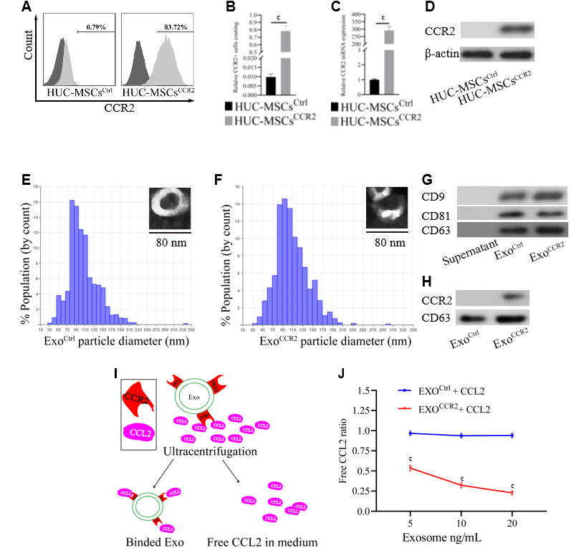
Figure 1 Human umbilical cord mesenchymal stem cells^{CCR2} load the C-C chemokine receptor type 2 receptor into their exosomes. A, B: Flow cytometry analysis of the C-C chemokine receptor type 2 (CCR2) receptor on human umbilical cord mesenchymal stem cells (HUC-MSCs)^{Ctrl} and HUC-MSCs^{CCR2}, n = 3, ^{c}P < 0.001; C: CCR2 mRNA expression in HUC-MSCs^{Ctrl} vs HUC-MSCs^{CCR2}, n = 3, ^{c}P < 0.001; D: Western blotting analysis for the quantification of the CCR2 expression in HUC-MSCs^{Ctrl} vs HUC-MSCs^{CCR2}, n = 3; E, F: Analysis of the exosomal morphology and diameter distribution of Exo^{Ctrl} and Exo^{CCR2} using transmission electron microscopy and the qNano® system, respectively, n = 3; G: Western blotting analysis for the detection of the exosomal specific markers CD9, CD63, and CD81 in Exo^{Ctrl} and Exo^{CCR2}, n = 3; H: Western blotting analysis for the quantification of the exosomal CCR2 expression in the Exo^{Ctrl} and Exo^{CCR2} samples, n = 3; I: Schematic diagram describing the extraction of the exosomes from the medium; J: Detection of the CCL2-binding ability of the exosomes by ELISA, n = 3, ^{c}P < 0.001.

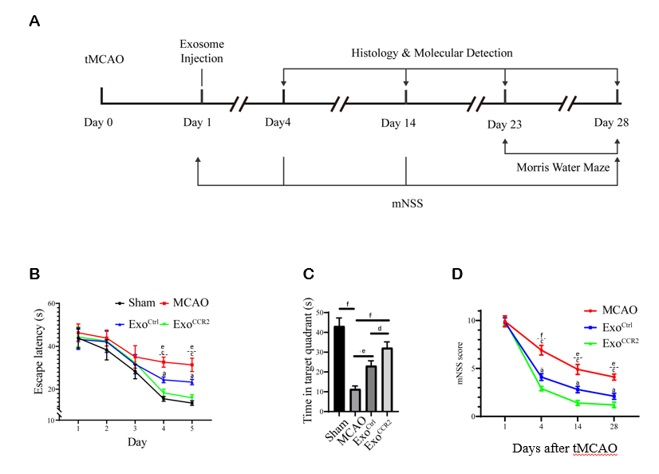
Figure 2 Exo^{CCR2} improved the spatial learning and memory at day 28 after transient middle cerebral occlusion compared to Exo^{Ctrl}. A: Experimental schedule to observe the effects of exosomes on rats with transient middle cerebral occlusion (tMCAO); B: Effect of exosomes on the mean escape latency to find the platform in each group. n = 10, ^{e}P < 0.01, Exo^{Ctrl} vs tMCAO, ^{c}P < 0.001, Exo^{CCR2} vs tMCAO, ªP < 0.05, Exo^{CCR2} vs Exo^{Ctrl}; C: Effect of exosomes on the time spent in the target quadrant in case of rats from each group. n = 10. ^{d}P < 0.05, ^{e}P < 0.01, ^{f}P < 0.001; D: Effect of exosomes on the mNSS values of rats from each group. n = 10. ^{e}P < 0.01, Exo^{Ctrl} vs tMCAO, ^{f}P < 0.001, Exo^{Ctrl} vs tMCAO, ^{c}P < 0.001, Exo^{CCR2} vs tMCAO, ªP < 0.05, Exo^{CCR2} vs Exo^{Ctrl}.

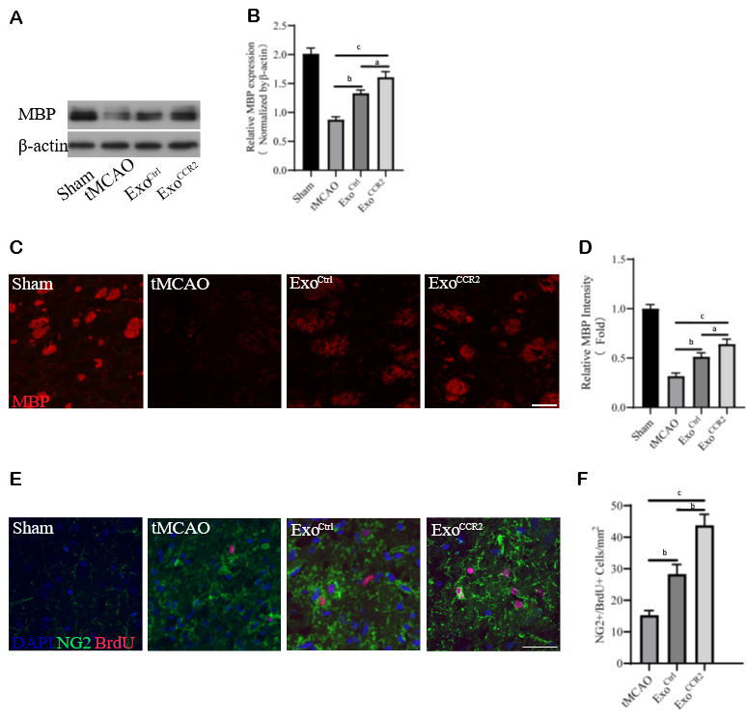
Figure 3 Exo^{CCR2} exerts superior beneficial effects on remyelination and oligodendrogenesis at day 28 after transient middle cerebral occlusion compared to Exo^{Ctrl}. A, B: Western blotting analysis of the MBP expression in samples from rats in each group. n = 5, ªP < 0.05, ^{b}P < 0.01, ^{c}P < 0.001; C, D: Analysis of MBP fluorescence intensity in samples from rats in each group. Scale bar = 50 μm, n = 6, ªP < 0.05, ^{b}P < 0.01, ^{c}P < 0.001; E, F: NG2+/ BrdU+ cell colocalization count by immunofluorescence staining. Scale bar = 50 μm, n = 6. ^{b}P < 0.01, ^{c}P < 0.001.

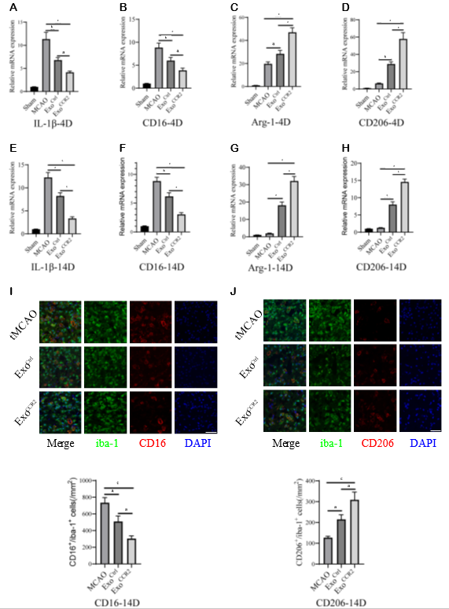
Figure 4 Exo^{CCR2} drove microglia/macrophage M2 polarization and inhibited microglia/macrophage M1 polarization at day 4 and day 14 after transient middle cerebral occlusion compared to Exo^{Ctrl}. A-D: Relative CD16, IL-1β, CD206, and Arg-1 mRNA expression changes in samples obtained from rats in each group on day 4 after transient middle cerebral occlusion (tMCAO), n = 6, ªP < 0.05, ^{b}P < 0.01, ^{c}P < 0.001; E-H: Relative CD16, IL-1β, CD206, and Arg-1 mRNA expression changes in samples obtained from rats in each group on day 14 after tMCAO, n = 6, ^{b}P < 0.01, ^{c}P < 0.001; I: CD16/iba-1 immunofluorescence staining and cell colocalization counts 14 d after tMCAO. Scale bar = 50 μm, n = 6, ªP < 0.05, ^{c}P < 0.001; J: CT206/iba-1 immunofluorescence staining and cell colocalization counts 14 d after tMCAO. Scale bar = 50 μm, n = 6, ªP < 0.05, ^{c}P < 0.001.

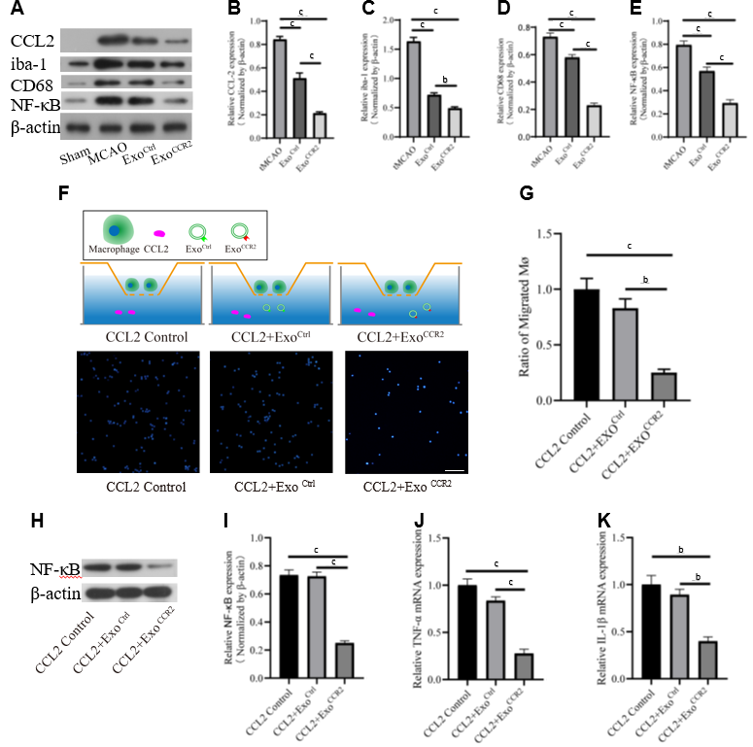
Figure 5 Exo^{CCR2} showed more powerful effects on CCL2-induced macrophage migration and activation in vivo and in vitro than Exo^{Ctrl}. A-E: Comparison of the expression levels of the CCL2, iba-1, CD68, and NF-κB proteins in samples from rats in each group (in vivo) at day 4 after transient middle cerebral occlusion, n = 6, ^{b}P < 0.01, ^{c}P < 0.001; F: Schematic diagram of the transwell experiment. Immunofluorescence detection of the migrated macrophages in case of each treatment group (in vitro), n = 3; scale bar = 200 μm, ^{b}P < 0.01, ^{c}P < 0.001; D-K: Comparison of the mRNA expression levels of TNF-α and IL-1β and the expression levels of the NF-κB protein in cells from each group (in vitro), n = 3, ^{b}P < 0.01, ^{c}P < 0.001.

Table 1 Lists of the sequences of the used primers
Gene | Primer sequences (5’-3’)
Human-β-actin | F | GGCTGTATTCCCCTCCATCG | R | CCAGTTGGTAACAATGCCATGT
Human-CCR2 | F | TACGGTGCTCCCTGTCATAAA | R | TAAGATGAGGACGACCAGCAT
Rat-β-actin | F | GCCCTGAGGCTCTTTTCCAG | R | TGCCACAGGATTCCATACCC
Rat-CD16 | F | TGTGTGTCGTCGTAGACGGT | R | TTCGCACATCAGTGTCACCA
Rat-IL-1β | F | GGCAACTGTCCCTGAACT | R | TCCACAGCCACAATGAGT
Rat-CD206 | F | ACTGCGTGGTGATGAAAGG | R | TAACCCAGTGGTTGCTCACA
Rat-Arg-1 | F | TGGCGTTGACCTTGTCTTGT | R | TTTGCTGTGATGCCCCAGAT
Mouse-IL-1β | F | TTGTTGCTGTGGAGAAGCTGT | R | AACGTCACACACCAGCAGGTT
Mouse-TNF-α | F | AGCAAACCACCAAGTGAGGA | R | GCTGGCACCACTAGTTGGTTGT

