Name of Journal: World Journal of Clinical Cases
Manuscript NO: 72899
Manuscript Type: ORIGINAL ARTICLE

Retrospective Cohort Study
Role of clinical data and multidetector computed tomography findings in acute superior mesenteric artery embolism

Yang J et al. Combining clinical data and MDCT findings

Ju-Shun Yang, Zhen-Yu Xu, Fei-Xiang Chen, Mei-Rong Wang, Ruo-Chen Cong, Xiao-Le Fan, Bo-Sheng He, Wei Xing

Ju-Shun Yang, Wei Xing, Department of Radiology, The Third Affiliated Hospital of Soochow University, Changzhou 213003, Jiangsu Province, China

Ju-Shun Yang, Fei-Xiang Chen, Mei-Rong Wang, Ruo-Chen Cong, Xiao-Le Fan, Bo-Sheng He, Department of Radiology, The Second Affiliated Hospital of Nantong University, Nantong 226001, Jiangsu Province, China

Zhen-Yu Xu, Department of Ultrasonography, The Second People's Hospital of Nantong, Nantong 226002, Jiangsu Province, China

Author contributions: Yang JS, He BS and Xing W were responsible for design of the study and reviewed the manuscript; Yang JS drafted the manuscript; Xu ZY, Chen FX and Wang MR performed data collection and analysis; Yang JS, Fan XL and Cong RC prepared the figures and tables; He BS and Xing W were responsible for revising manuscript. All authors have read and approved the final manuscript.

Supported by The "333" Talent Funding Project of Jiangsu Province, No. BRA2020198; Nantong City Social Development Project-Standardized Diagnosis and Treatment of Key Diseases No. HS2019002; and The Youth Project of Nantong City Health Committee, No. QA2019006 and QA2020002.

Corresponding author: Wei Xing, MD, Doctor, Department of Radiology, The Third Affiliated Hospital of Soochow University, No. 185 Juqian Street, Tianning District, Changzhou 213003, Jiangsu Province, China. suzhxingwei@suda.edu.cn

Received: November 2, 2021
Revised: February 25, 2022
Accepted:
Published online:

Abstract
BACKGROUND
Superior mesenteric artery embolism (SMAE) has acute onset and fast progression, which seriously threatens the life of patients. Multidetector computed tomography (MDCT) is one of the most important diagnostic methods for SMAE, which plays an important role in the diagnosis and prognosis of SMAE.

AIM
To evaluate the value of combined clinical data and MDCT findings in the diagnosis of acute SMAE and predict the risk factors for SMAE-related death.

METHODS
Data from 53 SMAE patients who received abdominal MDCT multi-phase enhancement and superior mesenteric artery digital subtraction angiography examinations were collected. Univariate cox regression and multivariate cox model were used to analyze the correlation between death risk and clinical and computed tomography features in SMAE patients.

RESULTS
Univariate Cox regression model showed that intestinal wall thinning, intestinal wall pneumatosis, blood lactate > 2.1 mmol/L and blood pH < 7.35 increased the risk of death in patients with SMAE. After adjusting for age, sex, embolic involvement length and embolic distribution region, multivariate Cox regression model I showed that blood lactate > 2.1 mmol/L (HR = 5.26, 95%CI: 1.04-26.69, P = 0.045) and intestinal wall thinning (HR = 9.40, 95%CI: 1.05-83.46, P = 0.044) were significantly increases the risk of death in patients with SMAE.

CONCLUSION
For patients with SAME, increased blood lactate and intestinal wall thinning are the risk factors for death; hence, close monitoring may reduce the mortality rate. Clinical observation combined with MDCT signs can significantly improve SMAE diagnosis.

Key Words: Multidetector computed tomography; Superior mesenteric artery; Embolization; Blood lactate

Yang J, Xu Z, Chen F, Wang M, Cong R, Fan X, He B, Xing W. Role of clinical data and multidetector computed tomography findings in acute superior mesenteric artery embolism. World J Clin Cases 2022; In press

Core Tip: Acute superior mesenteric artery embolism (SAME) has a rapid onset and progression and lacks specific clinical and biochemical diagnostic indicators, resulting in delayed diagnosis and poor prognosis. Currently, multidetector computed tomography (MDCT) is recommended as the first-line examination method for diagnosing mesenteric vascular diseases. However, when there is no clinical doubt, radiologists can easily miss SMAE with length ≤ 20 mm and in regions III and IV, affecting early treatment of patients. We found that a serum lactate level > 2.1 mmol/L and intestinal wall thinning on MDCT could independently predict the risk factors of death in patients with SMAE.
INTRODUCTION
Superior mesenteric artery embolism (SMAE) has a rapid onset and progression and lacks specific clinical and biochemical diagnostic indicators, which leads to delayed diagnosis and increased mortality^{[1,2]}. Early and accurate diagnosis can shorten duration of intestinal ischemia, reduce the occurrence of intestinal ischemic necrosis, and improve outcomes of clinical treatment and prognosis.
Multidetector computed tomography (MDCT) is a fast, accurate, and noninvasive method that has been recommended as a first-line imaging in diagnosing mesenteric vascular disease^{[3,4]}, with the sensitivity of 93% and specificity of 100%^{[5-7]}. In addition, MDCT can assess extravascular conditions, including the intestine, mesentery, and other abdominal organs, which can help distinguish non-SMAE abdominal pain and evaluate complications.
Irreversible intestinal necrosis in patients with SMAE often indicates poor prognosis. To date, few studies have integrated clinical data, biochemical indicators and imaging signs to predict the occurrence of irreversible intestinal necrosis and patient death in the early stage of SMAE^{[8-10]}. This study aimed to evaluate the value of combining clinical data and MDCT findings in the diagnosis of SMAE and to predict the risk factors for patient death. The results can provide a reference for clinical decision-making and improve the survival rate of patients.

MATERIALS AND METHODS
This was a retrospective, observational, single-center study. The study was approved by the ethics committee of the Second Affiliated Hospital of Nantong University (No. 2021KT154). Since this was a retrospective study, informed consent was waived.
The data of 84 patients who were suspected of having SMAE and treated at the 2nd Affiliated Hospital of Nantong University from January 2012 to December 2020 were collected. The exclusion criteria were as follows: no computed tomography (CT) examination (n = 2), no enhanced CT examination (n = 7), no digital subtraction angiography (DSA) examination (n = 12), superior mesenteric artery dissection (n = 3), pancreatic cancer invading superior mesenteric artery (SMA) (n = 2), pancreatitis (n = 1), portal vein thrombosis (n = 2), mesenteric torsion (n = 1), and lung cancer (n = 1). Finally, 53 patients with SMAE were enrolled. The patients were then divided into a survival group (n = 44) and a death group (n = 9). General clinical data (including sex, age, history of heart disease, smoking, alcohol, hypertension, diabetes, surgery, time of abdominal pain and body temperature at admission) and biochemical indicators at admission (including blood cell count, D-dimers, blood lactic acid, blood pH) were collected from the patients.

MDCT scanning protocol
Siemens Somatom Sensation 64-slice spiral CT, Siemens Definition Flash CT, or Siemens Somatom FORCE CT were used to perform three-phase scans (unenhanced phase, arterial phase and venous phase). The scan parameters are listed in Table 1.

Post-processing of MDCT image
All collected raw images were sent to a Synovia post-processing workstation. Multiplanar reconstruction was performed on the three-phase image, with slice thickness of 2 mm and 2 mm increments. The maximum intensity projection (MIP) was reconstructed in the arterial phase, and the conventional coronary thin-MIP image (parallel to the SMA trunk, with a slice thickness 10 mm, and 5 mm increments), oblique coronal thin-MIP image (parallel to the long axis of the ileocolonic and jejunal arteries, with a slice thickness 10 mm, and 5 mm increments) and sagittal thin-MIP image (slice thickness 10 mm, 5 mm increments) were reconstructed as needed. The images in the arterial phase were used to reconstruct the volume rendered technique (VRT) images of the blood vessels.

MDCT image analysis
MDCT images were independently evaluated by two radiologists, A and B, with experience in abdominal CT diagnosis. Only doctor B was informed that the patients had been initially diagnosed with or suspected of having mesenteric vascular disease. The main CT findings included SMAE length (divided into three groups: ≤ 20 mm, 20-50 mm, and ≥ 50 mm), distribution area (SMA was divided into four regions: I, II, III, and IV^{[11]}), thickening of intestinal wall (≥ 3 mm), intestinal wall thinning (same thickness as paper), decreased or no enhancement of intestinal wall (compared to the CT value of the adjacent normal intestinal wall), pneumatosis intestinalis, mesenteric fat stranding, and infarction of other abdominal organs. Blood vessel conditions were evaluated using DSA as the reference standard, and inconsistent CT evaluations were discussed between the two doctors. The imaging data of typical patients are shown in Figures 1-3.
The prognoses of these patients were followed up after admission. The follow-up period was 15 (3, 24) mo.

Statistical analysis
Quantitative data were expressed as median (range). The normal range was used to classify some continuous variables into two categories: D-dimer, blood lactic acid level, blood pH, blood amylase, and blood creatinine. Qualitative data were recorded as patient numbers (percentages). Pearson χ² test or Fisher's exact test was used to compare categorical variables, and the independent sample t-test was used for normally distributed continuous variables.
Univariate Cox regression and multivariate Cox models with adjusted confounding factors were used to analyze the correlation and effect size between the death risk of SMAE patients and general clinical data, biochemical indicators, and MDCT findings. The risk ratio and 95%CI for each influencing factor were analyzed and calculated.
The stata16 software was used for statistical analysis, with a two-sided α of 0.05. Statistical significance was set at P < 0.05.

RESULTS
Among the 53 SMAE patients diagnosed by DSA, 41 patients received endovascular or surgical treatment after admission and subsequent anticoagulation, and two died. One patient died of intracerebral hemorrhage after surgery; another patient progressed to extensive small intestinal necrosis after conservative treatment, followed by laparotomy for ischemic and necrotic parts of the jejunum, ileum and ileocecal area, and finally died during hospitalization. Twelve patients chose medical anticoagulant therapy, and seven died, of which four died during hospitalization, two within 30 d of follow-up, and one after 9 mo of follow-up. Causes of death included multiple organ failure and extensive intestinal avascular necrosis.

General data
The median age of nine died patients who died was 75 (73, 82) years, including five men and four women; the duration of abdominal pain at admission was 1 d (0.75, 2). Among the 44 surviving patients, the median age was 72 (range, 62.25-80) years, including 28 males and 16 females; and the duration of abdominal pain at admission was 2 (range, 1-5) d. There were no significant difference in sex (P = 0.938), age (P = 0.231), duration of abdominal pain at admission (P = 0.298), or basic clinical history between the two groups, as shown in Table 2.

Biochemical indicators
A comparison of the biochemical indicators between the death and survival groups is shown in Table 3. Among the nine patients in the death group, five had blood lactate > 2.1 mmol/L, four had blood pH < 7.35, while the corresponding numbers in the survival group were four and two, respectively; the difference was significant (P = 0.004). Blood amylase indices were collected from 38 cases, including six cases in the death group (three with increased blood amylase) and 32 in the survival group (six with increased blood amylase), and the difference was significant (P = 0.027). There was no statistical difference in the other biochemical indicators between the two groups.

Evaluation of MDCT image
The 53 patients with SMAE were confirmed to have SMAE using DSA. The length and distribution of the SMAE were (Table 4): ≤ 20 mm (14/53), 20-50 mm (11/53), ≥ 50 mm (28/53); I (5/53), II (1/53), III (2/53), IV (8/53), I + II (2/53), III + IV (19/53), I + II + III (1/53), II + III + IV (7/53) and I + II + III + IV (8/53). Doctor B was significantly better than doctor A in the diagnosis of embolism with a length ≤ 20 mm (P = 0.014) and in regions III and IV (P = 0.024). The length and distribution of SMAE were not statistically different between the death and survival groups.
Among the nine patients in the death group, four (44%) had varying degrees of intestinal wall thickening, eight (89%) had intestinal wall thinning, nine (100%) had decreased intestinal wall enhancement, three (33%) had pneumatosis intestinalis, five (56%) had infarction of other organs, seven (78%) had mesenteric fat stranding. Among these indicators, the proportions of patients with decreased intestinal wall enhancement (P = 0.004), intestinal wall thinning (P = 0.002), and pneumatosis intestinalis (P = 0.007) were higher in the death group than in the survival group. There was no difference between doctor A and B in the diagnosis of extravascular CT signs (Table 5).

Predictive factors for SMAE caused death
As shown in Table 6, the results of the univariate Cox regression analysis showed that intestinal wall thinning (HR, 13.35, 95%CI: 1.54-99.01) and pneumatosis intestinalis (HR, 5.73, 95%CI: 1.41-23.35) increased the risk of death in patients with SMAE. Blood lactate levels > 2.1 mmol/L and blood pH < 7.35 caused a 6.82-fold (HR, 6.82; 95%CI: 1.82-25.60) and 7.36-fold (HR, 7.36; 95%CI: 1.94-27.86) increase in risk of death, respectively.
As shown in Table 7, the multivariate Cox regression model I, adjusted for age, sex, embolic involvement range, and embolic distribution area, showed that intestinal wall thinning (HR, 9.40, 95%CI: 1.05-83.46) and blood lactate > 2.1 mmol/L (HR, 5.26, 95%CI: 1.04-26.69) increased the risk of death in SMAE patients. Multivariate Cox regression model II, adjusted for age, sex and embolic distribution showed that intestinal wall thinning (HR, 9.66, 95%CI: 1.15-81.03), intestinal wall pneumatosis (HR, 6.09, 95%CI: 1.25-29.69), blood lactic acid > 2.1 mmol/L (HR, 5.26, 95%CI: 1.04-26.69) and pH < 7.35 (HR, 5.59, 95%CI: 1.26-24.88) increased the risk of death in SMAE patients. Multivariate Cox regression model III, adjusted for sex, embolic involvement range and embolic distribution area, showed that intestinal wall thinning (HR, 11.01, 95%CI: 1.32-92.22), intestinal wall pneumatosis (HR, 6.01, 95%CI: 1.25-28.97), blood lactic acid > 2.1 mmol/L (HR, 6.34, 95%CI: 1.56-25.73) and pH < 7.35 (HR, 6.26, 95%CI: 1.47-26.59) increased the risk of death in SMAE patients.

DISCUSSION
Early diagnosis and treatment is key to reduce the mortality of patients with SMAE, but it is also a clinical challenge. Intestinal ischemia during the early stage of SMAE is often reversible. At this stage, the physical examination and laboratory findings are non-specific. As the disease progresses, intestinal ischemia becomes irreversible, and patients may experience multiple organ failure^{[8,10,12]}, increased blood lactate levels^{[8,12]}, increased blood amylase^{[13]}, increased white blood cells^{[14]} and other abnormal clinical and laboratory findings. Even with clinical intervention, the patient's prognosis is poor. In this study, we also observed that the increase in blood lactate level was an important factor in the death of patients with SMAE, because it usually represents the late stage of intestinal ischemia. In this study, the mortality rate of patients with SMAE was approximately 17%, which was lower than that reported in the literature^{[15]}. It is possible that most of the enrolled patients were in a state of reversible intestinal ischemia. After vascular recanalization through intravascular thrombectomy or thrombolysis, intestinal blood supply can be restored.
The difficulty in the early diagnosis of SMAE also lies in the interference from other common acute abdominal pain lesions, such as acute appendicitis, peptic ulcer, acute pancreatitis, digestive tract inflammation, cholecystitis, especially when the two are concurrent. Therefore, clinicians should consider SMAE from the above-mentioned common diseases as critical to the final diagnosis. According to previous reports^{[16]}, SMAE is not uncommon in patients aged > 75 years, with a higher incidence than that of appendicitis. Cardiovascular and cerebrovascular diseases, such as cerebral infarction, hypertension, heart disease, are risk factors for SMAE^{[17]}. In this study, 49.1% and 50.9% of patients with SMAE had hypertension and heart-related diseases, respectively. Therefore, SMAE should be considered in elderly patients with abdominal pain and a history of cardiovascular and cerebrovascular diseases.
Clinically suspected SMAE is helpful for accurate MDCT diagnosis. Multi-phase MDCT enhanced scanning has become an important means of diagnosing SMAE^{[3,4,18]}, which can not only accurately assess the embolism of mesenteric vessels, but also assess the conditions of the extravascular digestive tract and solid organs. Wadman et al^{[19]} found that SMAE patients with multi-phase enhanced CT scan had lower hospital mortality rates than those with unenhanced CT scans. Nuzzo et al^{[20]} proposed that if SMAE is suspected clinically, an unenhanced CT scan may delay its diagnosis and treatment, and a CT multi-phase enhanced scan should be performed immediately. In addition, if SMAE is clinically suspected before a MDCT scan, the accuracy of the radiologist's diagnosis can be significantly increased^{[19,21]}. There are differences in the length and region of involvement of the SMAE. For SMA peripheral blood vessels or embolism with a small length, MDCT diagnosis may not be optimal; if SMAE is clinically suspected before a CT scan, purposeful inspection of the image by a radiologist will help detect concealed embolism. This study found that a radiologist (doctor B) who was informed of clinical suspicion of SAME before the CT scan was significantly better in diagnosing SMAE ≤ 20 mm (P = 0.014) and in regions III and IV (P = 0.024) than an uninformed radiologist (doctor A). Therefore, if SMAE is highly suspected, and the CT scan is negative, SMAE cannot be excluded with certainty, and the SMA peripheral blood vessels or small embolism should be paid more attention.
SMAE usually co-occurs with extravascular CT signs such as intestinal wall thickening, intestinal wall thinning, decreased enhancement of intestinal wall, pneumatosis intestinalis, mesenteric fat stranding, and infarction of other solid organs. Careful search for the above CT signs can help in the diagnosis of SMAE^{[22,23]} and the prediction of prognosis^{[8,24-26]}. In our study, three Cox regression models were established by adjusting for confounding factors, such as age, sex and embolism. Each model showed that intestinal wall thinning in CT signs significantly increased the risk of death in SMAE patients. Early intestinal ischemia caused by SMAE usually shows intestinal wall thickening due to intestinal mucosal edema, which is the most common CT sign. With the continuation of the ischemic state, the capillary blood volume in the intestinal wall mucosa decreases, the nerves and muscle layers in the mucosa are destroyed, the intestinal tension is lost and expanded, the intestinal wall becomes as thin as paper, and the degree of enhancement is further reduced, and even the intestinal wall necrosis and gas accumulation. It is usually accompanied by an increase in blood lactate levels, suggesting irreversible intestinal ischemia and an increased risk of death. In this study, the signs of intestinal wall thinning, decreased intestinal wall enhancement, and intestinal wall pneumatosis in the SMAE death group were significantly higher than those in the survival group, Similar to the findings of previous studies^{[8,12]}.
This study had some limitations. First, because this was a retrospective study, patient selection bias might have occurred, and some clinical or biochemical data were incomplete. Second, the clinical treatment schemes of patients with SMAE were different, and their impact on prognosis was not considered in this study.

CONCLUSION
In summary, for patients with abdominal pain and previous cardiovascular or cerebrovascular events, clinicians should consider the possibility of SMAE and perform MDCT multi-phase enhanced scanning. Active and effective communication between clinicians and radiologists before the examination is particularly useful in rapidly and accurately detecting SMAE ≤ 20 mm and in regions III and IV. Simultaneously, the combination of patients' MSCT imaging signs and clinical information can provide important information for the prognosis of patients with SMAE and a basis for reasonable treatment of the disease.

ARTICLE HIGHLIGHTS
Research background
Superior mesenteric artery embolism (SMAE) has acute onset and fast progression, which seriously threatens the life of patients. The early diagnosis of SMAE is related to the patients’ recovery. However, to date, there are serious challenges in the early diagnosis of SMAE, and clinical suspicion is the key to diagnosis. MDCT is one of the most important diagnostic methods for SMAE, which plays an important role in the diagnosis and prognosis of SMAE.

Research motivation
Superior mesenteric artery (SMA) in peripheral vessels or small-scale emboli is easy to be missed, leading to irreversible intestinal necrosis, which affects the prognosis of patients. High clinical suspicion and some extra-vascular computed tomography (CT) signs are helpful for the diagnosis of SMAE. Currently, few studies have combined clinical, biochemical and MDCT to predict the risk of irreversible intestinal necrosis and death in SMAE at early stages.

Research objectives
The purpose of this study is to evaluate the value of combining clinical data and MDCT in the diagnosis of SMAE and to predict the risk factors for death.

Research methods
We retrospectively analyzed the clinical and MDCT data of 53 patients with SMAE confirmed by digital subtraction angiography. We analyzed the impact of a high clinical suspicion on the radiologist's diagnosis of SAME on MDCT. The patients were divided into two groups: the death and survival groups. Univariate cox regression and multivariate cox model adjusted for confounding factors were used to analyze the association trend of mortality risk with clinical and CT signs in SMAE patients.

Research results
Under the premise of high clinical suspicion of SMAE, the radiologist was able to more accurately diagnose emboli with lengths ≤ 20 mm(P = 0.014) and in areas III and IV (P = 0.024). Univariate cox regression and multivariate cox model analysis adjusted for confounding factors determined that blood lactate > 2.1 mmol/L (HR, 5.26, 95%CI: 1.04-26.69, P = 0.045) and intestinal wall thinning (HR, 9.40, 95%CI: 1.05-83.46, P = 0.044) were consistently significantly associated with mortality in SAME patients.

Research conclusions
Increased blood lactate and intestinal wall thinning are risk factors for death in patients with SMAE. Meaningful clinical cues combined with MDCT can significantly improve the accuracy of radiologists in diagnosing SMAE with the length ≤ 20 mm and embolism in regions III and IV.

Research perspectives
With clinical suspicion of SMAE, a multiphase enhanced CT should be performed immediately to observe the SMA trunk and peripheral vessels, as well as extravascular MDCT. Intestinal wall thinning and increased blood lactate levels might be effective predictors for death in patients with SMAE, although further validation in large sample, prospective and multicenter studies is needed. With the advent of dual-energy CT, new post-processing techniques (Iodine mapping, virtual monoenergetic imaging) may provide important information on SMA peripheral small vessel embolization and whether intestinal wall is enhanced.

REFERENCES
1 Tang W, Jin B, Kuang LQ, Zhang J, Li CX, Wang Y. Risk factors of geriatrics index of comorbidity and MDCT findings for predicting mortality in patients with acute mesenteric ischemia due to superior mesenteric artery thromboembolism. Br J Radiol 2020; 93: 20190605 [PMID: 32886528 DOI: 10.1259/bjr.20190605]
2 Zhang Z, Wang D, Li G, Wang X, Wang Y, Li G, Jiang T. Endovascular Treatment for Acute Thromboembolic Occlusion of the Superior Mesenteric Artery and the Outcome Comparison between Endovascular and Open Surgical Treatments: A Retrospective Study. Biomed Res Int 2017; 2017: 1964765 [PMID: 29204438 DOI: 10.1155/2017/1964765]
3 Expert Panels on Vascular Imaging and Gastrointestinal Imaging, Ginsburg M, Obara P, Lambert DL, Hanley M, Steigner ML, Camacho MA, Chandra A, Chang KJ, Gage KL, Peterson CM, Ptak T, Verma N, Kim DH, Carucci LR, Dill KE. ACR Appropriateness Criteria® Imaging of Mesenteric Ischemia. J Am Coll Radiol 2018; 15: S332-S340 [PMID: 30392602 DOI: 10.1016/j.jacr.2018.09.018]
4 Bala M, Kashuk J, Moore EE, Kluger Y, Biffl W, Gomes CA, Ben-Ishay O, Rubinstein C, Balogh ZJ, Civil I, Coccolini F, Leppaniemi A, Peitzman A, Ansaloni L, Sugrue M, Sartelli M, Di Saverio S, Fraga GP, Catena F. Acute mesenteric ischemia: guidelines of the World Society of Emergency Surgery. World J Emerg Surg 2017; 12: 38 [PMID: 28794797 DOI: 10.1186/s13017-017-0150-5]
5 Cudnik MT, Darbha S, Jones J, Macedo J, Stockton SW, Hiestand BC. The diagnosis of acute mesenteric ischemia: A systematic review and meta-analysis. Acad Emerg Med 2013; 20: 1087-1100 [PMID: 24238311 DOI: 10.1111/acem.12254]
6 Menke J. Diagnostic accuracy of multidetector CT in acute mesenteric ischemia: systematic review and meta-analysis. Radiology 2010; 256: 93-101 [PMID: 20574087 DOI: 10.1148/radiol.10091938]
7 Yikilmaz A, Karahan OI, Senol S, Tuna IS, Akyildiz HY. Value of multislice computed tomography in the diagnosis of acute mesenteric ischemia. Eur J Radiol 2011; 80: 297-302 [PMID: 20719444 DOI: 10.1016/j.ejrad.2010.07.016]
8 Nuzzo A, Maggiori L, Ronot M, Becq A, Plessier A, Gault N, Joly F, Castier Y, Vilgrain V, Paugam C, Panis Y, Bouhnik Y, Cazals-Hatem D, Corcos O. Predictive Factors of Intestinal Necrosis in Acute Mesenteric Ischemia: Prospective Study from an Intestinal Stroke Center. Am J Gastroenterol 2017; 112: 597-605 [PMID: 28266590 DOI: 10.1038/ajg.2017.38]
9 Zogheib E, Cosse C, Sabbagh C, Marx S, Caus T, Henry M, Nader J, Fumery M, Bernasinski M, Besserve P, Trojette F, Renard C, Duhaut P, Kamel S, Regimbeau JM, Dupont H. Biological scoring system for early prediction of acute bowel ischemia after cardiac surgery: the PALM score. Ann Intensive Care 2018; 8: 46 [PMID: 29671149 DOI: 10.1186/s13613-018-0395-5]
10 Grotelüschen R, Bergmann W, Welte MN, Reeh M, Izbicki JR, Bachmann K. What predicts the outcome in patients with intestinal ischemia? A single center experience. J Visc Surg 2019; 156: 405-411 [PMID: 30745185 DOI: 10.1016/j.jviscsurg.2019.01.007]
11 Ottinger LW. The surgical management of acute occlusion of the superior mesenteric artery. Ann Surg 1978; 188: 721-731 [PMID: 736650 DOI: 10.1097/00000658-197812000-00003]
12 Canfora A, Ferronetti A, Marte G, Maio VD, Mauriello C, Maida P, Bottino V, Aprea G, Amato B. Predictive Factors of Intestinal Necrosis in Acute Mesenteric Ischemia. Open Med (Wars) 2019; 14: 883-889 [PMID: 31934635 DOI: 10.1515/med-2019-0104]
13 Acosta-Mérida MA, Marchena-Gómez J, Cruz-Benavides F, Hernández-Navarro J, Roque-Castellano C, Rodríguez-Méndez A, Alonso-Alvarado A, Hernández-Romero J. [Predictive factors of massive intestinal necrosis in acute mesenteric ischemia]. Cir Esp 2007; 81: 144-149 [PMID: 17349239 DOI: 10.1016/s0009-739x(07)71286-1]
14 Emile SH. Predictive Factors for Intestinal Transmural Necrosis in Patients with Acute Mesenteric Ischemia. World J Surg 2018; 42: 2364-2372 [PMID: 29387956 DOI: 10.1007/s00268-018-4503-3]
15 Acosta S, Ogren M, Sternby NH, Bergqvist D, Björck M. Clinical implications for the management of acute thromboembolic occlusion of the superior mesenteric artery: autopsy findings in 213 patients. Ann Surg 2005; 241: 516-522 [PMID: 15729076 DOI: 10.1097/01.sla.0000154269.52294.57]
16 Kärkkäinen JM, Lehtimäki TT, Manninen H, Paajanen H. Acute Mesenteric Ischemia Is a More Common Cause than Expected of Acute Abdomen in the Elderly. J Gastrointest Surg 2015; 19: 1407-1414 [PMID: 25917534 DOI: 10.1007/s11605-015-2830-3]
17 Wyers MC. Acute mesenteric ischemia: diagnostic approach and surgical treatment. Semin Vasc Surg 2010; 23: 9-20 [PMID: 20298945 DOI: 10.1053/j.semvascsurg.2009.12.002]
18 Chen YC, Huang TY, Chen RC, Tsai SH, Chang WC, Fan HL, Huang GS, Ko KH, Chou YC, Hsu HH. Comparison of Ischemic and Nonischemic Bowel Segments in Patients With Mesenteric Ischemia: Multidetector Row Computed Tomography Findings and Measurement of Bowel Wall Attenuation Changes. Mayo Clin Proc 2016; 91: 316-328 [PMID: 26809547 DOI: 10.1016/j.mayocp.2015.11.005]
19 Wadman M, Block T, Ekberg O, Syk I, Elmståhl S, Acosta S. Impact of MDCT with intravenous contrast on the survival in patients with acute superior mesenteric artery occlusion. Emerg Radiol 2010; 17: 171-178 [PMID: 19657684 DOI: 10.1007/s10140-009-0828-4]
20 Nuzzo A, Joly F, Ronot M, Castier Y, Huguet A, Paugam-Burtz C, Cazals-Hatem D, Tran-Dinh A, Becq A, Panis Y, Bouhnik Y, Maggiori L, Corcos O; SURVI group. Normal Lactate and Unenhanced CT-Scan Result in Delayed Diagnosis of Acute Mesenteric Ischemia. Am J Gastroenterol 2020; 115: 1902-1905 [PMID: 33156109 DOI: 10.14309/ajg.0000000000000836]
21 Lehtimäki TT, Kärkkäinen JM, Saari P, Manninen H, Paajanen H, Vanninen R. Detecting acute mesenteric ischemia in CT of the acute abdomen is dependent on clinical suspicion: Review of 95 consecutive patients. Eur J Radiol 2015; 84: 2444-2453 [PMID: 26413771 DOI: 10.1016/j.ejrad.2015.09.006]
22 Olson MC, Fletcher JG, Nagpal P, Froemming AT, Khandelwal A. Mesenteric ischemia: what the radiologist needs to know. Cardiovasc Diagn Ther 2019; 9: S74-S87 [PMID: 31559155 DOI: 10.21037/cdt.2018.09.06]
23 Barmase M, Kang M, Wig J, Kochhar R, Gupta R, Khandelwal N. Role of multidetector CT angiography in the evaluation of suspected mesenteric ischemia. Eur J Radiol 2011; 80: e582-e587 [PMID: 21993179 DOI: 10.1016/j.ejrad.2011.09.015]
24 Atre ID, Eurboonyanun K, O'Shea A, Lahoud RM, Shih A, Kalva S, Harisinghani MG, Hedgire S. Predictors of transmural intestinal necrosis in patients presenting with acute mesenteric ischemia on computed tomography. Abdom Radiol (NY) 2020 [PMID: 32382818 DOI: 10.1007/s00261-020-02558-8]
25 Wang X, Chu C, Sun S, Xie T, Duan Z, Wang K, Liu B, Fan X, Wu X, Ding W. Outcomes and clinical characteristics of transmural intestinal necrosis in acute mesenteric ischemia. Scand J Gastroenterol 2019; 54: 953-959 [PMID: 31361977 DOI: 10.1080/00365521.2019.1646800]
26 Emile SH, Khan SM, Barsoum SH. Predictors of bowel necrosis in patients with acute mesenteric ischemia: systematic review and meta-analysis. Updates Surg 2021; 73: 47-57 [PMID: 32728981 DOI: 10.1007/s13304-020-00857-9]

Footnotes
Institutional review board statement: The study was approved by the ethics committee of the Second Affiliated Hospital of Nantong University. Since this study is a retrospective study.

Informed consent statement: No informed consent was needed.

Conflict-of-interest statement: No financial or nonfinancial benefits have been received or will be received from any party related directly or indirectly to the subject of this article.

Data sharing statement: All data generated or analyzed during this study are available from the corresponding author Wei Xing upon reasonable request.

STROBE statement: The authors have read the STROBE Statement checklist of items, and the manuscript was prepared and revised according to the STROBE Statement checklist of items.

Open-Access: This article is an open-access article that was selected by an in-house editor and fully peer-reviewed by external reviewers. It is distributed in accordance with the Creative Commons Attribution NonCommercial (CC BY-NC 4.0) license, which permits others to distribute, remix, adapt, build upon this work non-commercially, and license their derivative works on different terms, provided the original work is properly cited and the use is non-commercial. See: https://creativecommons.org/Licenses/by-nc/4.0/

Provenance and peer review: Unsolicited article; Externally peer reviewed.
Peer-review model: Single blind

Peer-review started: November 2, 2021
First decision: February 14, 2022
Article in press:

Specialty type: Gastroenterology and hepatology
Country/Territory of origin: China
Peer-review report’s scientific quality classification
Grade A (Excellent): 0
Grade B (Very good): B, B
Grade C (Good): 0
Grade D (Fair): 0
Grade E (Poor): 0

P-Reviewer: Gumustas OG, Turkey; Yadav P, India S-Editor: Zhang H L-Editor: A P-Editor: Zhang H

Figure Legends
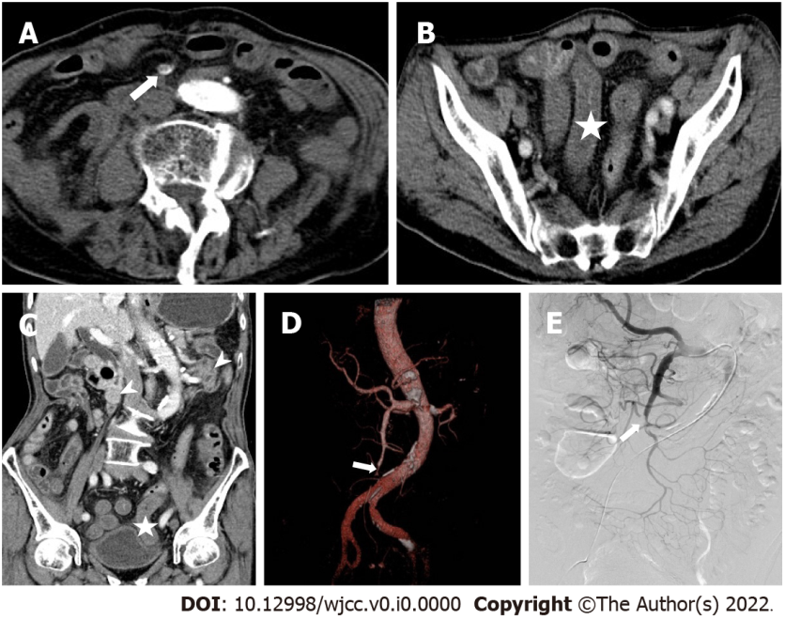
Figure 1 An 89 years old male with sudden severe abdominal pain was hospitalized for 1 d. A: The axial image of arterial phase on computed tomography enhanced scan, showing diffuse embolism (long arrow) in superior mesenteric artery III and IV regions; B: An axial image of venous phase, showing thickening of intestinal wall and decreased enhancement (asterisk) at the end of ileum; C: The coronal image of venous phase. It can be seen that the enhancement of ileum is significantly lower than that of normal intestinal wall (arrow); D and E: Volume rendered technique and digital subtraction images, respectively, the proximal ileocolic artery and ileal artery are not displayed.
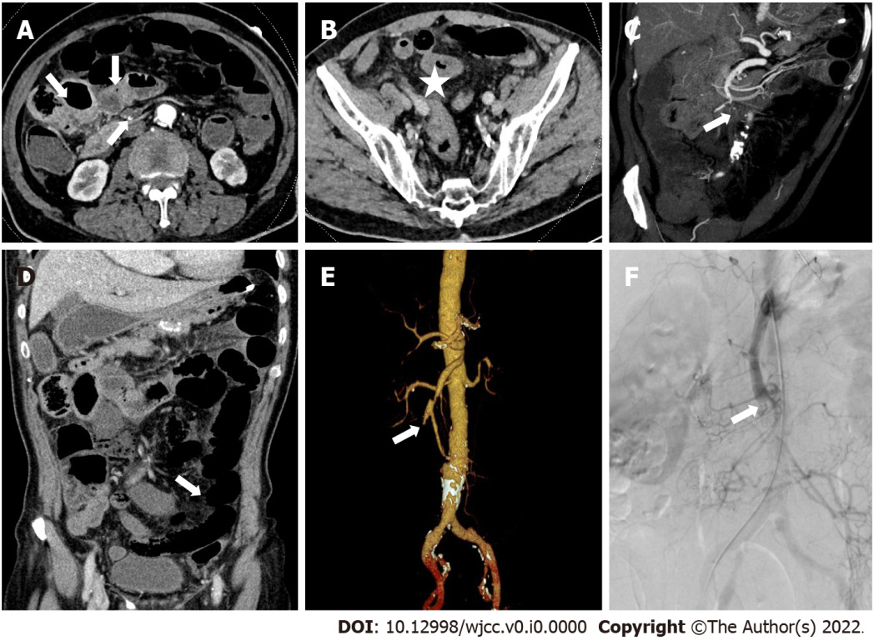
Figure 2 Male, 71 years old, abdominal pain for 18 h. A: The axial image of enhanced computed tomography in arterial phase; B and D: The axial and coronal images in venous phase; C: The oblique coronal maximum intensity projection image; E: Volume rendered technique; and F: Digital subtraction. It showed diffuse embolism (long arrow) in superior mesenteric artery III and IV regions, accompanied by intestinal wall thickening (asterisk), intestinal wall thinning (slender arrow), decreased enhancement relative to normal intestinal wall (arrow), intestinal cavity expansion and mesenteric fat stranding. Imaging diagnosis of extensive ischemia of small intestine.
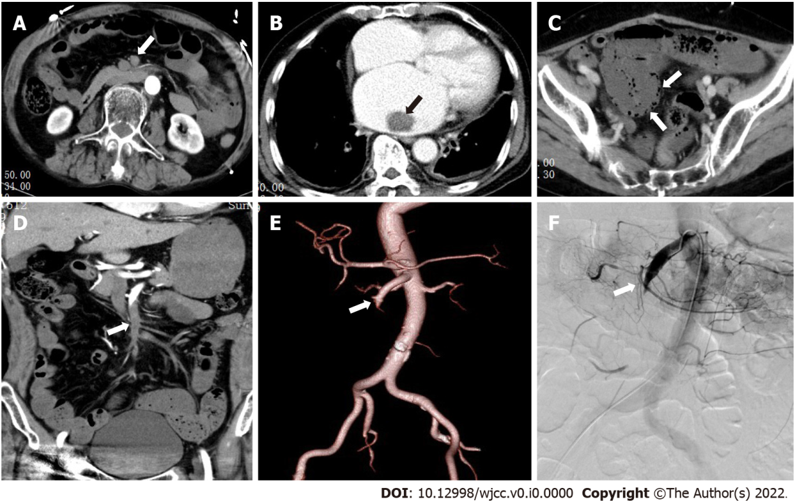
Figure 3 The patient was a 62-year-old male with history of abdominal pain, hematochezia, and atrial fibrillation. A and B: The axial images in the arterial phase; C: The axial images in the venous phase; D: The coronary images in the arterial phase; E: The volume rendered technique image; and F: The digital subtraction image. A and D show diffuse embolism in II, III, and IV regions of superior mesenteric artery (long arrows); B shows embolus in the left atrium, C shows decreased intestinal wall enhancement, and signs of pneumatosis intestinalis (arrow).
Table 1 MDCT scan parameters
Group | Scan protocol/parameters
Scan area | From diaphragm top to lower edge of symphysis pubis
Body position | Supine position
Tube voltage (kV)/tube current (mAs) | 120/care dose 4D
Linear fusion coefficient | 0.5
Pitch | 1.0
Rotate speed | 0.5 s
Collimation (mm) | 2 × 192 × 0.6
Thickness of collection layer (mm) | 1 mm
Interlayer spacing | 0.6 mm
Convolution kernel | Br40
Enhancement protocol | Arterial phase (automatic tracking technology: when the aortic monitoring threshold reached 100 HU, the arterial phase scan was triggered); intravenous phase (scan started 75 s after the contrast agent was injected)
Contrast agent (concentration) | Iopromide (370 mgI/mL)
Dose and rate of contrast agent administration | 1.5 mL/kg, 3.5 mL/s
Table 2 The demographic characteristics of death and survival groups
 | Total number (n = 53) | Survival group (n = 44) | Death group (n = 9) | P value
Sex (%) |  |  |  | 0.938
Male | 33 (62.3) | 28 (52.8) | 5 (9.4)
Female | 20 (37.7) | 16 (30.2) | 4 (7.5)
Smoking (%) |  |  |  | 1.000
No | 35 (66.0) | 29 (54.7) | 6 (11.3)
Yes | 18 (34.0) | 15 (28.3) | 3 (5.7)
Alcohol (%) |  |  |  | 0.667
No | 35 (66.0) | 28 (52.8) | 7 (13.2)
Yes | 18 (34.0) | 16 (30.2) | 2 (3.8)
Diabetes (%) |  |  |  | 0.978
No | 44 (83.0) | 36 (67.9) | 8 (15.1)
Yes | 9 (17.0) | 8 (15.1) | 1 (1.9)
Hypertension (%) |  |  |  | 1.000
No | 27 (50.9) | 22 (41.5) | 5 (9.4)
Yes | 26 (49.1) | 22 (41.5) | 4 (7.5)
Heart disease (%) |  |  |  | 1.000
No | 26 (49.1) | 22 (41.5) | 4 (7.5)
Yes | 27 (50.9) | 22 (41.5) | 5 (9.4)
Surgery (%) |  |  |  | 0.395
No | 38 (71.7) | 30 (56.6) | 8 (15.1)
Yes | 15 (28.3) | 14 (26.4) | 1 (1.9)
Vomitus (%) |  |  |  | 0.938
No | 20 (37.7) | 16 (30.2) | 4 (7.5)
Yes | 33 (62.3) | 28 (52.8) | 5 (9.4)
Age (yr) | 74 (63.50, 80.50) | 72 (62.25, 80.00) | 75 (73.00, 82.00) | 0.231
Abdominal pain duration (d) | 1.00 (1.00, 5.00) | 2.00 (1.00, 5.00) | 1.00 (0.75, 2.00) | 0.298
Body temperature at admission (℃) | 36.7 (36.5, 37.7) | 36.6 (36.4, 37.3) | 37.7 (36.6, 38.4) | 0.055
Table 3 Biochemical indicators of death and survival groups
 | Total number (n = 53) | Survival group (n = 44) | Death group (n = 9) | P value
D-dimer > 1000 μg/mL (%) |  |  |  | 0.499
No | 20 (37.7) | 18 (34.0) | 2 (3.8)
Yes | 33 (62.3) | 26 (49.1) | 7 (13.2)
Blood lactate > 2.1 mmol/L (%) |  |  |  | 0.004
No | 44 (83.0) | 40 (75.5) | 4 (7.5)
Yes | 9 (17.0) | 4 (7.5) | 5 (9.4)
Blood pH < 7.35 (%) |  |  |  | 0.004
No | 47 (88.7) | 42 (79.2) | 5 (9.4)
Yes | 6 (11.3) | 2 (3.8) | 4 (7.5)
Blood amylase > 110 U/L (%) |  |  |  | 0.027
No | 32 (84.2) | 29 (76.3) | 3 (7.9)
Yes | 6 (15.8) | 3 (7.9) | 3 (7.9)
Serum creatinine > 120 μmol/L (%) |  |  |  | 0.097
No | 36 (78.3) | 32 (69.6) | 4 (8.7)
Yes | 10 (21.7) | 6 (13.0) | 4 (8.7)
White blood cell | 10.6 (6.95, 15.45) | 9.1 (6.73, 16.48) | 10.7 (9.2, 14.6) | 0.362
Red blood cell | 4.19 (3.89, 4.64) | 4.18 (3.97, 4.63) | 4.48 (3.60, 4.94) | 0.887
Neutrophil | 8.5 (5.42, 13.66) | 7.55 (5.36, 14.46) | 9.42 (7.75, 12.90) | 0.236
Lymphocyte | 0.9 (0.6, 1.2) | 0.90 (0.60, 1.20) | 0.70 (0.55, 1.20) | 0.392
Neutrophil/lymphocyte | 9.3 (6.00, 16.22) | 8.47 (5.48, 16.42) | 13.46 (8.52, 17.33) | 0.169
Total protein | 64.4 (56.55, 70.85) | 64.2 (56.73, 69.45) | 67.0 (51.3, 76.05) | 0.713
Albumin to total protein ratio | 1.20 (1.0, 1.3) | 1.20 (1.00, 1.38) | 1.10 (1.00, 1.30) | 0.516
Blood glucose | 6.90 (5.65, 8.44) | 6.8 (4.93, 8.44) | 7.70 (6.90, 16.28) | 0.107
Data are expressed as numbers (%) or medians (range).
Table 4 Comparison of multidetector computed tomography reading results of two radiologists
 | Total number | A | B | P value
Embolus involvement length (%)
≤ 20 mm | 14 | 6 | 13 | 0.014
20-50 mm | 11 | 10 | 11 | 1
≥ 50 mm | 28 | 25 | 28 | 0.236
Embolus region (%)
I | 5 | 4 | 5 | 1
II | 1 | 1 | 1 | 1
III | 2 | 0 | 2 | 0.024
IV | 8 | 3 | 7
I + II | 2 | 2 | 2 | 1
III + IV | 19 | 18 | 19 | 1
I + II + III | 1 | 1 | 1 | 1
II + III + IV | 7 | 6 | 7 | 1
I + II + III + IV | 8 | 8 | 8 | 1
Extravascular signs (%)
Decreased intestinal wall enhancement | 30 | 24 | 28 | 0.255
Intestinal wall thinning | 22 | 9 | 14 | 0.131
Intestinal wall thickening | 14 | 14 | 14 | 1
Pneumatosis intestinalis | 5 | 3 | 3 | 1
Infarction of the organs | 22 | 18 | 22 | 0.108
Mesenteric fat stranding | 29 | 25 | 27 | 0.67
Table 5 Comparison of multidetector computed tomography signs in death and survival groups
 | Survival group (n = 44) | Death group (n = 9) | P value
Embolus involvement length (%) |  |  | 0.311
≤ 20 mm | 12 (27.27) | 1 (11.11)
20-50 mm | 10 (22.73) | 1 (11.11)
≥ 50 mm | 22 (50.00) | 7 (77.78)
Embolus region (%) |  |  | 0.212
I | 4 (9.09) | 1 (11.11)
II | 1 (2.27) | 0 (0)
III | 2 (4.55) | 0 (0)
IV | 8 (18.18) | 0 (0)
I + II | 1 (2.27) | 1 (11.11)
III + IV | 17 (38.64) | 2 (22.22)
I + II + III | 1 (2.27) | 0 (0)
II + III + IV | 6 (13.64) | 1 (11.11)
I + II + III + IV | 4 (9.09) | 4 (44.44)
Decreased intestinal wall enhancement (%) |  |  | 0.004
No | 23 (52.27) | 0 (0)
Yes | 21 (47.73) | 9 (100)
Intestinal wall thinning (%) |  |  | 0.002
No | 30 (68.18) | 1 (11.11)
Yes | 14 (31.82) | 8 (88.89)
Intestinal wall thickening (%) |  |  | 0.178
No | 34 (77.27) | 5 (55.56)
Yes | 10 (22.73) | 4 (44.44)
Pneumatosis intestinalis (%) |  |  | 0.007
No | 42 (95.45) | 6 (66.67)
Yes | 2 (4.55) | 3 (33.33)
Infarction of other organs (%) |  |  | 0.348
No | 27 (61.36) | 4 (44.44)
Yes | 17 (38.64) | 5 (55.56)
Mesenteric fat stranding (%) |  |  | 0.127
No | 22 (50) | 2 (22.22)
Yes | 22 (50) | 7 (77.78)
Table 6 Univariate cox regression
 | HR | 95%CI | P value
Intestinal wall thinking | 2.27 | (0.61-8.45) | 0.223
Intestinal wall thinning | 13.35 | (1.54-99.01) | 0.018
Pneumatosis intestinalis | 5.73 | (1.41-23.35) | 0.015
Other organ infarction | 1.79 | (0.48-6.67) | 0.386
mesenteric fat stranding | 2.96 | (0.62-14.27) | 0.176
Blood lactate > 2.1 mmol/L | 6.82 | (1.82-25.60) | 0.004
Blood pH < 7.35 | 7.36 | (1.94-27.86) | 0.003
Embolus distribution region (multi-classification variable) | 1.42 | (0.92-1.74) | 0.156
Embolus involvement length
20-50 mm (vs ≤ 20 mm) | 1.09 | (0.07-17.50) | 0.951
≥ 50 mm (vs ≤ 20 mm) | 3.14 | (0.39-25.54) | 0.284
The end point is death, and the comparison group is the survival group. Since the death number of many embolism distribution groups was 0, the dummy variable cannot be set for analysis, so it was included as a multi-classification variable in the cox regression model.
Table 7 Multivariate cox regression
 | Model¹ |  |  | Model² |  |  | Model³
 | HR | 95%CI | P value | HR | 95%CI | P value | HR |  | 95%CI | P value
Intestinal wall thinning | 9.40 | (1.05-83.46) | 0.044 | 9.66 | (1.15-81.03) | 0.037 | 11.01 | (1.32-92.22) |  | 0.027
Pneumatosis intestinalis | 4.58 | (0.86-24.36) | 0.074 | 6.09 | (1.25-29.69) | 0.025 | 6.01 | (1.25-28.97) |  | 0.025
Blood lactate > 2.1 mmol/L | 5.26 | (1.04-26.69) | 0.045 | 5.21 | (1.12-24.22) | 0.035 | 6.34 | (1.56-25.73) |  | 0.010
Blood pH < 7.35 | 4.84 | (0.94-25.09) | 0.060 | 5.59 | (1.26-24.88) | 0.024 | 6.26 | (1.47-26.59) |  | 0.013
¹Adjusted for age, gender, embolus involvement length, and embolus distribution region;
²Adjusted for age, gender, and embolus distribution region;
³Age, embolus involvement length, and embolus distribution.

