Name of Journal: World Journal of Clinical Cases
Manuscript NO: 62054
Manuscript Type: CASE REPORT

Intraoperative thromboelastography-guided transfusion in a patient with factor XI deficiency: A case report

Guo WJ et al. TEG-guided perioperative transfusion for FXI deficiency

Wen-Juan Guo, Wei-Yun Chen, Xue-Rong Yu, Le Shen, Yu-Guang Huang

Wen-Juan Guo, Wei-Yun Chen, Xue-Rong Yu, Yu-Guang Huang, Department of Anesthesiology, Peking Union Medical College Hospital, Peking Union Medical College and Chinese Academy of Medical Sciences, Beijing 100730, China

Le Shen, Department of Anesthesiology, State Key Laboratory of Complex Severe and Rare Diseases, Peking Union Medical College Hospital, Peking Union Medical College and Chinese Academy of Medical Sciences, Beijing 100730, China

Author contributions: Guo WJ contributed to the clinical conduct of the case, to data collection, and to the writing of the manuscript; Chen WY and Yu XR contributed to the intraoperative TEG assessment; Shen L and Huang YG contributed to the analysis and interpretation of the collected data and to the revision of the manuscript.

Supported by Education Reform Project Foundation for the Central Universities of Peking Union Medical College, No. 2020zlgc0105; Training Programme Foundation for Excellent Talent in Dongcheng District of Beijing, No. 2019DCT-M-08; and Non-profit Central Research Institute Fund of Chinese Academy of Medical Sciences, No. 2019XK320018.

Corresponding author: Le Shen, MD, PhD, Professor, Department of Anesthesiology, State Key Laboratory of Complex Severe and Rare Diseases, Peking Union Medical College Hospital, Peking Union Medical College and Chinese Academy of Medical Sciences, No. 1 Shuaifuyuan, Beijing 100730, China. pumchshenle@163.com

Received: December 27, 2020
Revised: July 12, 2021
Accepted: November 25, 2021
Published online:

Abstract
BACKGROUND
Factor XI (FXI) deficiency, also known as hemophilia C, is a rare bleeding disorder of unpredictable severity that correlates poorly with FXI coagulation activity. This often poses great challenges in perioperative hemostatic management. Thromboelastography (TEG) is a method for testing blood coagulation using a viscoelastic hemostatic assay of whole blood to assess the overall coagulation status. Here, we present the successful application of intraoperative TEG monitoring in an FXI-deficient patient as an individualized blood transfusion strategy.

CASE SUMMARY
A 21-year-old male patient with FXI deficiency was scheduled to undergo reconstructive surgery for macrodactyly of the left foot under general anesthesia. To minimize his bleeding risk, he was scheduled to receive fresh frozen plasma (FFP) as an empirical prophylactic FXI replacement at a dose of 15-20 mL/kg body weight (900-1200 mL) before surgery. Subsequent FFP transfusion was to be adjusted according to surgical need. Instead, TEG assessment was used at the beginning and toward the end of his surgery. According to intraoperative TEG results, the normalization of coagulation function was achieved with an infusion of only 800 mL FFP, and blood loss was minimal. The patient showed an uneventful postoperative course and was discharged on postoperative day 8.

CONCLUSION
TEG can be readily applied in the intraoperative period to individualize transfusion needs in patients with rare inherited coagulopathy.

Key Words: Factor XI deficiency; Thromboelastography; Transfusion; Intraoperative; Coagulopathy; Case report

Guo WJ, Chen WY, Yu XR, Shen L, Huang YG. Intraoperative thromboelastography-guided transfusion in a patient with factor XI deficiency: A case report. World J Clin Cases 2021; In press

Core Tip: Factor XI (FXI) deficiency is a rare bleeding disorder of unpredictable severity that correlates poorly with FXI coagulation activity and that poses great challenges for perioperative hemostatic management. Thromboelastography (TEG) is a method for testing blood coagulation using a viscoelastic hemostatic assay of whole blood to assess overall coagulation status; it is readily available and provides real-time monitoring. This case report highlights the importance of using TEG in the intraoperative period to individualize transfusion needs for patients with rare inherited coagulopathy and to minimize transfusion-related risks.

INTRODUCTION
Hemophilia C, or factor XI (FXI) deficiency, is a rare autosomal coagulation disorder^{[1]}. Patients may be asymptomatic until they are hemodynamically challenged following trauma or surgery. In other cases, these coagulopathies are discovered as incidental laboratory findings along with other medical conditions. The unpredictability of bleeding patterns often poses perioperative challenges for clinicians^{[2]}. Thromboelastography (TEG) is a method that is used to monitor and analyze the viscoelastic properties of blood clot formation and lysis. It has the advantages of working with the patient’s whole blood, providing real-time quantitative results on global hemostasis assessments^{[3]}. Its adaptability for point-of-care (POC) testing makes this test particularly useful for intraoperative blood transfusion guidance. Here, we present a case in which the patient was diagnosed with FXI deficiency during a preoperative workup for macrodactyly reconstructive surgery. POC-TEG monitoring was successfully used to help assess the need for intraoperative transfusion.

CASE PRESENTATION
Chief complaints
A 21-year-old man was scheduled to undergo reconstructive surgery for macrodactyly of the left foot under general anesthesia.

History of present illness
The patient presented with significant enlargement of his left foot since birth, complicated by recurrent episodes of paronychia. He was scheduled to have reconstructive surgery at a local hospital. However, the surgery was deferred due to the unexpected perioperative discovery of abnormal coagulation studies.

History of past illness
The patient denied a previous history of easy bleeding or bruising.

Physical examination
There was significant swelling of the patient’s left foot without erythema, rash, or discoloration. The bilateral lower extremity pulses were equal. The patient had a normal gait. Motor and sensations were intact.

Laboratory examinations
Preoperative laboratory workup showed an increased activated plasma thromboplastin time (APTT) of 83.9 s (reference: 23.3-32.5 s), a normal prothrombin time (PT) of 12 s (reference: 10.4-12.6 s), and an internationalized normal ratio (INR) of 1.04 (reference 0.86-1.14). Further workup revealed the patient’s FXI activity to be 3%. The mixing study (Table 1) showed that the patient’s APTT could be corrected by mixing his plasma 1:1 with normal serum to achieve normalization of coagulation function.

FINAL DIAGNOSIS
The diagnosis of FXI deficiency was confirmed by a hematologist.

TREATMENT
Preoperative hematology consultation suggested empirically giving fresh frozen plasma (FFP) as prophylactic FXI replacement at a dose of 15-20 mL/kg body weight (patient weight 60 kg, prophylactic dose 900-1200 mL FFP) before surgery. Subsequent FFP transfusion would be adjusted per surgical need. Oral tranexamic acid was suggested for one week postoperatively.
On the day of surgery, the patient received 400 mL FFP preoperatively. The first set of TEGs (Figure 1A) performed immediately after FFP transfusion showed moderately increased activated clotting time (ACT), R time, K time, max amplitude (MA), and alpha angle. The operation was performed under general anesthesia and lasted approximately 4 h. A tourniquet was applied above the knee to minimize blood loss. Continuous nasal temperature monitoring was used to ensure no intraoperative hypothermia was experienced. The patient received 2000 mL of Ringer’s lactate and 400 mL FFP intraoperatively. Urine output was 1400 mL, and blood loss was estimated to be approximately 300 mL. The second set of TEGs (Figure 1B) performed toward the end of surgery showed improvements in all parameters.

OUTCOME AND FOLLOW-UP
The patient had an uneventful postoperative course (Figure 2). Oral tranexamic acid 0.5 g three times per day was prescribed for one week. Surgical site drainage was 45 mL on postoperative day (POD) 1 and then decreased to a minimal level. The drain was removed on POD3. The patient received 400 mL FFP on POD 4 due to concerns of prolonged elevation of APTT levels (46.4 s, reference: 23.3-32.5 s), while the surgical dressing remained dry and clean. He was discharged on POD 8.

DISCUSSION
Hemophilia C caused by a deficiency of FXI is a rare autosomal inherited coagulopathy. FXI plays an important role not only in initiating clot formation but also in supporting clot consolidation. Conventional coagulation tests such as PT and APTT are less than satisfactory in the assessment of hemophilia C patients’ clinical profiles and bleeding risks. These tests are limited because they are endpoint assays that test only the speed of blood clot formation. However, they cannot reflect the process of further thrombin formation involved in clot consolidation and maintenance. Compared with hemophilia A and B, the clinical profile and bleeding management of hemophilia C is less clearly understood (Table 2). The relationship between bleeding phenotypes and baseline FXI level is poor, making perioperative bleeding risk hard to predict and manage^{[4]}.
TEG is a method of testing the efficiency of blood coagulation using a whole blood-based, viscoelastic hemostatic assay. It can provide a continuous assessment of the elastic properties of clot formation and lysis in both graphics and numbers. TEG measurements collected for analysis include reaction (R) time, coagulation (k) time, α angle, and maximum amplitude (MA), which are reflections of clotting factors, circulating inhibitory activity, fibrinogen and platelet levels and function, etc.^{[5]} TEG’s short turnaround time makes it a promising measurement tool for the assessment of global hemostasis in trauma or perioperative settings. It is better than conventional coagulation tests in monitoring coagulation profiles and predicting transfusion requirements^{[5]}. It reduces the total amount of blood products transfused compared with an empiric transfusion policy or a transfusion protocol guided by conventional coagulation tests^{[6]}. Study results from trauma^{[7]}, liver transplant^{[8]} and cardiac surgeries^{[9]} have shown that the goal-directed allogeneic transfusion strategy is believed to provide better hemostatic competence. This was possibly due to the more timely administration of blood products such as plasma and platelets, which in turn resulted in less blood loss^{[3]}, reduced blood transfusion needs^{[10]}, lower costs, and fewer adverse events^{[11]} in the TEG-guided transfusion group than in the conventional transfusion group. One study also suggested that TEG-guided transfusion could substantially affect patient outcomes, including length of hospital stay, odds of reoperation, and short-term mortality^{[9]}. For inherited coagulopathies such as hemophilia A and B, a combination of standard coagulation laboratory tests and TEG tests results in a better understanding of hemostasis in an individual patient, giving insights into their long-term hemostatic management^{[12]}, as well as providing vital insights in more pressing situations such as traumas or surgeries. In later cases, studies from hemophilia A and B patients suggested that TEG could be successfully used in perioperative settings to evaluate the efficacy of various hemostatic agents, such as factor VIII concentrate, cryoprecipitate, and prothrombin complex concentrates^{[3]}. TEG has the potential to assess the role FXI plays in global hemostasis. However, its application in perioperative transfusion management for hemophilia C patients has not been extensively studied.
Normally, FXI-deficient patients will require careful, individualized and multidisciplinary preprocedural planning. Such planning starts with a meticulous assessment of the patient’s bleeding history and bleeding pattern. This is followed by thorough laboratory tests, including basic coagulation function tests, such as PT, APTT, and FXI levels, and mixing studies. Moreover, the nature of the scheduled procedure must also be taken into consideration. Operations on sites with higher fibrinolytic activities, such as the pharynx and urinary tracts, put patients at higher risk for bleeding^{[13]}. The use of antifibrinolytic medication may help improve overall hemostasis^{[14]}. For major procedures in individuals with severe FXI deficiency or with a significant bleeding phenotype, prophylactic replenishment using FXI concentrates or FFP is recommended in the preoperative period^{[1]}. FXI concentrate has been associated with a higher thrombotic risk than FFP^{[15]}. Some practitioners have suggested a “wait and watch” attitude with factor replacement, giving FXI concentrate only when excessive bleeding occurs. Prophylactic FFP replacement is the most commonly used option in our institute. However, this comes with the risk of volume overload. Because FXI levels do not correlate well with bleeding phenotypes, replacement therapy remains somewhat empirical. Therapeutic plasma exchange (TPE) may lower the risk of circulatory volume overload^{[16]}. However, this is a complicated procedure with other transfusion-related adverse effects, and the added costs cannot be overlooked.
The patient we present here had no history of spontaneous bleeding and had no surgical history. This made the perioperative bleeding risk hard to predict and the prophylactic transfusion management strategy hard to plan. The consulting hematologists suggested a FFP loading dose of 15-20 mL/kg body weight to bring the FXI level within a satisfactory range (FXI: C, 30%–45%), which inevitably resulted in the need for a large volume of FFP. It is in this kind of situation that TEG monitoring is especially useful. TEG-guided prophylactic FFP replacement may allow for a more parsimonious use of replacement therapy in patients with severe FXI deficiency undergoing surgery. It can reduce the risks of volume overload, transfusion-related acute lung injury, transmission of infectious diseases, thrombosis, allergic reactions, and the development of inhibitors to FXI^{[13]}.Empirically, our patient was to receive a loading dose of 900-1200 mL FFP according to preoperative hematology consultation. In practice, however, based on the results from the intraoperative TEG monitoring, our patient received 800 mL FFP in total before and during the whole procedure with minimal blood loss and uneventful postoperative recovery. This experience is limited to a single case report. However, we believe that with improved TEG technology and accessibility, anesthesiologists and other medical practitioners will be able to provide transfusion therapy tailored to the need of each patient with FXI deficiency.

CONCLUSION
FXI deficiency is an underrecognized disorder with a wide range of clinical presentations and a poor correlation with coagulation studies. It poses great challenges for perioperative management. FXI concentrates, FFP, TPE and antifibrinolytic therapies are the mainstream treatments for FXI patients with surgical needs. POC-TEG could be readily applied in the perioperative period to individualize transfusion requirements on a case-by-case basis, providing guidance regarding the appropriate amount of blood products to be administered and thus minimizing transfusion needs and the associated risks. Further large-scale studies are needed to assess the potential for using TEG for perioperative transfusion guidance in the treatment of FXI patients.

REFERENCES
1 Jayakrishnan T, Shah D, Mewawalla P. Hemophilia C: A Case Report With Updates on Diagnosis and Management of a Rare Bleeding Disorder. J Hematol 2019; 8: 144-147 [PMID: 32300461 DOI: 10.14740/jh522]
2 Gomez K, Bolton-Maggs P. Factor XI deficiency. Haemophilia 2008; 14: 1183-1189 [PMID: 18312365 DOI: 10.1111/j.1365-2516.2008.01667.x]
3 Fahrendorff M, Oliveri RS, Johansson PI. The use of viscoelastic haemostatic assays in goal-directing treatment with allogeneic blood products - A systematic review and meta-analysis. Scand J Trauma Resusc Emerg Med 2017; 25: 39 [PMID: 28403868 DOI: 10.1186/s13049-017-0378-9]
4 Santoro C, Di Mauro R, Baldacci E, De Angelis F, Abbruzzese R, Barone F, Bochicchio RA, Ferrara G, Guarini A, Foà R, Mazzucconi MG. Bleeding phenotype and correlation with factor XI (FXI) activity in congenital FXI deficiency: results of a retrospective study from a single centre. Haemophilia 2015; 21: 496-501 [PMID: 25623511 DOI: 10.1111/hae.12628]
5 Peng HT, Nascimento B, Tien H, Callum J, Rizoli S, Rhind SG, Beckett A. A comparative study of viscoelastic hemostatic assays and conventional coagulation tests in trauma patients receiving fibrinogen concentrate. Clin Chim Acta 2019; 495: 253-262 [PMID: 31004574 DOI: 10.1016/j.cca.2019.04.066]
6 Görlinger K, Dirkmann D, Hanke AA, Kamler M, Kottenberg E, Thielmann M, Jakob H, Peters J. First-line therapy with coagulation factor concentrates combined with point-of-care coagulation testing is associated with decreased allogeneic blood transfusion in cardiovascular surgery: a retrospective, single-center cohort study. Anesthesiology 2011; 115: 1179-1191 [PMID: 21970887 DOI: 10.1097/ALN.0b013e31823497dd]
7 Gonzalez E, Moore EE, Moore HB, Chapman MP, Chin TL, Ghasabyan A, Wohlauer MV, Barnett CC, Bensard DD, Biffl WL, Burlew CC, Johnson JL, Pieracci FM, Jurkovich GJ, Banerjee A, Silliman CC, Sauaia A. Goal-directed Hemostatic Resuscitation of Trauma-induced Coagulopathy: A Pragmatic Randomized Clinical Trial Comparing a Viscoelastic Assay to Conventional Coagulation Assays. Ann Surg 2016; 263: 1051-1059 [PMID: 26720428 DOI: 10.1097/SLA.0000000000001608]
8 Graff JT, Cortez AR, Dhar VK, Wakefield C, Cuffy MC, Shah SA, Goodman MD. Perioperative thrombelastography serves as an important assessment tool of transfusion requirements during liver transplantation. Surg Open Sci 2020; 2: 70-74 [PMID: 32754709 DOI: 10.1016/j.sopen.2019.12.004]
9 Redfern RE, Fleming K, March RL, Bobulski N, Kuehne M, Chen JT, Moront M. Thrombelastography-Directed Transfusion in Cardiac Surgery: Impact on Postoperative Outcomes. Ann Thorac Surg 2019; 107: 1313-1318 [PMID: 30768933 DOI: 10.1016/j.athoracsur.2019.01.018]
10 Schmidt AE, Israel AK, Refaai MA. The Utility of Thromboelastography to Guide Blood Product Transfusion. Am J Clin Pathol 2019; 152: 407-422 [PMID: 31263903 DOI: 10.1093/ajcp/aqz074]
11 Sharp G, Young CJ. Point-of-care viscoelastic assay devices (rotational thromboelastometry and thromboelastography): a primer for surgeons. ANZ J Surg 2019; 89: 291-295 [PMID: 30253452 DOI: 10.1111/ans.14836]
12 Nogami K. The utility of thromboelastography in inherited and acquired bleeding disorders. Br J Haematol 2016; 174: 503-514 [PMID: 27264484 DOI: 10.1111/bjh.14148]
13 Salomon O, Steinberg DM, Seligshon U. Variable bleeding manifestations characterize different types of surgery in patients with severe factor XI deficiency enabling parsimonious use of replacement therapy. Haemophilia 2006; 12: 490-493 [PMID: 16919078 DOI: 10.1111/j.1365-2516.2006.01304.x]
14 Leff JD, Zumberg MS, Widyn JG, DeAnda A, Janelle GM. Hemophilia C in a patient undergoing cardiac surgery: perioperative considerations. Semin Cardiothorac Vasc Anesth 2014; 18: 297–301 [PMID: 25005855 DOI: 10.1177/1089253214541295]
15 Wheeler AP, Gailani D. Why factor XI deficiency is a clinical concern. Expert Rev Hematol 2016; 9: 629-637 [PMID: 27216469 DOI: 10.1080/17474086.2016.1191944]
16 Alsammak MS, Ashrani AA, Winters JL, Pruthi RK. Therapeutic plasma exchange for perioperative management of patients with congenital factor XI deficiency. J Clin Apher 2017; 32: 429-436 [PMID: 28295573 DOI: 10.1002/jca.21532]

Footnotes
Informed consent statement: Informed written consent was obtained from the patient for publication of this report and any accompanying images.

Conflict-of-interest statement: The authors declare that they have no conflicts of interest.

CARE Checklist (2016) statement: The authors have read the CARE Checklist (2016), and the manuscript was prepared and revised according to the CARE Checklist (2016).

Open-Access: This article is an open-access article that was selected by an in-house editor and fully peer-reviewed by external reviewers. It is distributed in accordance with the Creative Commons Attribution NonCommercial (CC BY-NC 4.0) license, which permits others to distribute, remix, adapt, build upon this work non-commercially, and license their derivative works on different terms, provided the original work is properly cited and the use is non-commercial. See: https://creativecommons.org/Licenses/by-nc/4.0/

Provenance and peer review: Unsolicited article; Externally peer reviewed.

Peer-review model: Single blind

Peer-review started: December 27, 2020
First decision: July 8, 2021
Article in press:

Specialty type: Medicine, research and experimental
Country/Territory of origin: China
Peer-review report’s scientific quality classification
Grade A (Excellent): 0
Grade B (Very good): 0
Grade C (Good): C
Grade D (Fair): 0
Grade E (Poor): 0

P-Reviewer: Villalba R S-Editor: Fan JR L-Editor: A P-Editor: Fan JR
Figure Legends
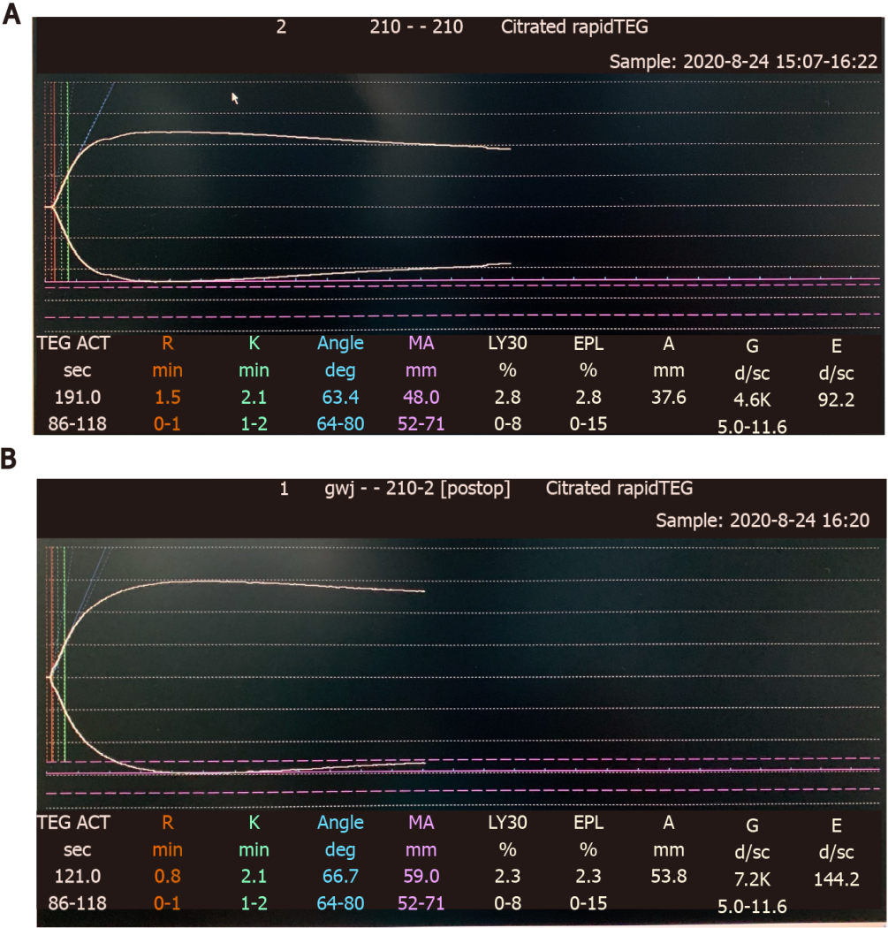
Figure 1 Intraoperative thromboelastography monitoring. A: Thromboelastography (TEG) results after 400 mL prophylactic fresh frozen plasma (FFP) transfusion; B: TEG results after a total of 800 mL FFP infusion: Improvement of all parameters.
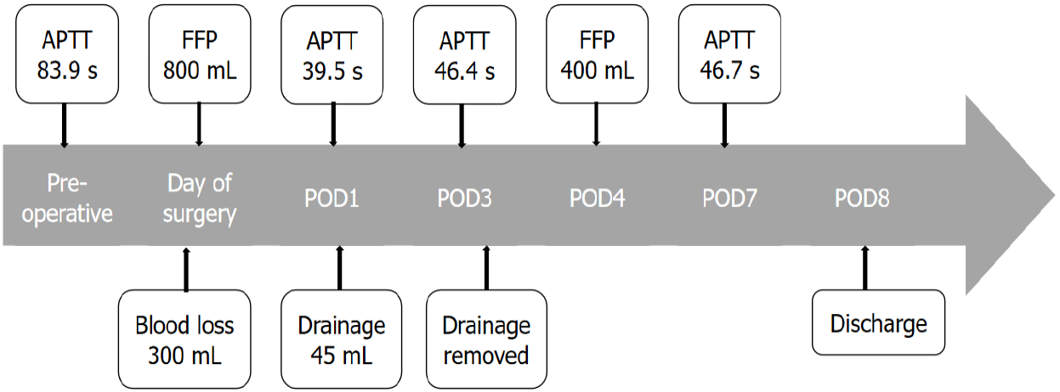
Figure 2 Major perioperative events and laboratory test results. POD: Postoperative day; APTT: Activated partial thromboplastin time; FFP: Fresh frozen plasma.
Table 1 Mixing study
APTT (normal) | APTT (normal-2 h) | APTT (patient) | APTT (patient-2 h) | APTT (1:1) | APTT (1:1-2 h)
26.1 s | 27.4 s | 84.2 s | 83.1 s | 29.8 s | 31.3 s
APTT: Activated partial thromboplastin time. APTT reference 23.3-32.5 s.
Table 2 Genetic and clinical features of different types of hemophilia and their management
 | Hemophilia A | Hemophilia B | Hemophilia C
Genetics | X-linked | X-linked | Autosomal
Pathophysiology | FVIII deficiency | FIX deficiency | FXI deficiency
Clinical manifestations | Bleeding of variable severity correlated with factor levels | Bleeding of variable severity correlated with factor levels | Variable
Routine management | Prophylactic factor replacement | Prophylactic factor replacement | None
Perioperative management | Factor replacement, Cryoprecipitate. The goal is to keep the levels of FVIII > 50% for major surgery | Factor replacement, Prothrombin complex concentrate. The goal is to keep the levels of factor IX > 50% for major surgery | Controversial. May include: FFP, antifibrinolytics, TPE, factor replacement. Optimal FXI level unclear
FVIII: Factor VIII; FIX: Factor IX; FFP: Fresh frozen plasma; TPE: Therapeutic plasma exchange.

