Name of journal: World Journal of Orthopedics
ESPS Manuscript NO: 17631
Columns: Review

Effect of bone loss in anterior shoulder instability

Garcia GH et al. Bony instability of the shoulder

Grant H Garcia, Joseph N Liu, David M Dines, Joshua S Dines

Grant H Garcia, Joseph N Liu, David M Dines, Joshua S Dines, Department of Orthopedic Surgery, Hospital for Special Surgery, New York, NY 10021, United States

Author contributions: All authors contributed to this manuscript.

Conflict-of-interest: David Dines has a patent with Biomet Inc with royalties paid. Joshua Dines reports personal fees from Arthrex, Conmed Linvatec outside of the submitted work for consulting. Dr. Dines also receives research support from Arthrex outside of the submitted work. Joseph Liu and Grant Garcia have no conflicts of interest to report.

Open-Access: This article is an open-access article which was selected by an in-house editor and fully peer-reviewed by external reviewers. It is distributed in accordance with the Creative Commons Attribution Non Commercial (CC BY-NC 4.0) license, which permits others to distribute, remix, adapt, build upon this work non-commercially, and license their derivative works on different terms, provided the original work is properly cited and the use is non-commercial. See: http://creativecommons.org/licenses/by-nc/4.0/

Correspondence to: Grant H Garcia, MD, Department of Orthopedic Surgery, Hospital for Special Surgery, 535 East 70th Street, New York, NY 10021, United States. garciagr@hss.edu

Telephone: +1-212-6061466

Received: March 16, 2015
Peer-review started: March 21, 2015
First decision: April 10, 2015
Revised: April 20, 2015
Accepted: May 5, 2015
Article in press:
Published online:

Abstract
Anterior shoulder instability with bone loss can be a difficult problem to treat. It usually involves a component of either glenoid deficiency or a Hill-Sachs lesion. Recent data shows that soft tissue procedures alone are typically not adequate to provide stability to the shoulder. As such, numerous surgical procedures have been described to directly address these bony deficits. For glenoid defects, coracoid transfer and iliac crest bone block procedures are popular and effective. For humeral head defects, both remplissage and osteochondral allografts have decreased the rates of recurrent instability. Our review provides an overview of current literature addressing these treatment options and others for addressing bone loss complicating anterior glenohumeral instability.

Key words: Latarjet; Remplissage; Glenoid deficiency; Hill-Sachs lesion; Anterior instability

© The Author(s) 2015. Published by Baishideng Publishing Group Inc. All rights reserved.

Core tip: Anterior bony instability is a multifactorial problem, with osseous lesions existing on the glenoid, the humeral head or in combination. For glenoid lesions recent data has suggested Latarjet as a good option in these patients, with the potential in the near future for a technically feasible arthroscopic approach. With humeral head lesions, remplissage has demonstrated excellent short-term outcomes and offers an arthroscopic method. In the future longer-term studies will be needed for the remplissage procedure. Overall, there are many surgical options to treat these difficult patients each with their own unique aspects.

Garcia GH, Liu JN, Dines DM, Dines JS. Effect of bone loss in anterior shoulder instability. World J Orthop 2015; In press

INTRODUCTION
The incidence of shoulder instability in the population is estimated to be as high as 2%^{[1]}. While many first-time dislocators can be managed conservatively, there are specific patient groups that have a higher risk for dislocation after a single event and may benefit from surgical stabilization. For example, Taylor et al^{[2]} found increased risk of recurrence in overhead athletes and participants in contact sports. In addition, hyper-laxity has been an identified risk factor^{[3]}. Of the risk factors for recurrence, the most predictive is age at the time of first dislocation. Increasing instability risk has been found to be inversely proportional to the age of the patient^{[4]}. For example, in older patients the risk of instability ranges from 10% to 20%^{[5]}; yet in skeletally immature patients, Marans et al^{[6]} found a re-dislocation rate of up to 100%. While demographics play a major role in anterior instability, intra-articular pathology also has a strong association.
The most difficult dislocators to treat are those with bony deficits. After first time anterior dislocation, glenohumeral deficiency (humeral head defect, glenoid defect or combination of both) has been found in up to 70% of patients^{[7]}. While small defects tend to have limited implications on overall stability, there is a significantly increased risk of instability as the size of the humeral head lesion or glenoid deficiency increases^{[8,9]}. Historically, these large defects had been treated with isolated soft tissue procedures, but further biomechanical and clinical studies have led to treatment algorithms that focus more on addressing the bone loss. Given these concerns, our purpose is to review recent data on surgical management of anterior instability with associated bone loss.

TYPES OF BONE LOSS
In bony anterior instability, both articulations of the glenohumeral joint have been associated with increased risk of further dislocations. Defects can occur on the glenoid side (i.e., Bony Bankart lesions), on the humeral side (i.e., Hill Sachs lesions), or on both sides.

Glenoid deficits
Glenoid deficiency has been found in up to 22% of patients after initial dislocation^{[10]}. In recurrent instability cases their incidence ranges from 46% to 86%^{[11,12]}. To understand the biomechanics of the glenoid deficiency, initial discussion should be begin with the discussion of small defects. First described by Dr. Arthur Bankart, these anterior labral lesions (known as Bankart lesions) increase the risk of instability. If a small piece of the anterior glenoid rim is concomitant with these labral tears some refer to this as “bony Bankart lesions. As the pieces become large the propensity for dislocation increases. As these defects approach greater than 20% to 25% of the glenoid the glenoid appearance changes. Burkhart et al^{[13]} first described this glenoid appearance as an “inverted pear”. His colleagues found in larger defects the standard pear shaped appearance of the glenoid was reversed. As a result the glenoid is wider superiorly than inferiorly, giving it an inverted pear appearance. When this occurs, they described a disruption in the arc of motion with abduction and external rotation of the arm, creating an increased risk of recurrent dislocation.
Gerber et al^{[14]} confirmed this theory in their biomechanical study. They found with subsequent loss of anterior inferior glenoid arc the resistances to dislocation decreased exponentially (Figure 1). Newer biomechanical studies have further described this “glenoid track”. This concept has shifted the previous paradigm from engaging defects to track-off track mismatch. Yamamoto et al^{[15]} evaluated 9 cadaveric shoulders and found dislocation was most likely with disruption of the medial margin of this track.
While understanding the biomechanics of glenoid defects is necessary, Bigliani’s classification of the glenoid deficit best defines clinical prognostic features^{[11]}. He defined four types of glenoid defects: type 1 involves a non-displaced anterior glenoid fragment, type 2 is a small detached anterior fragment, and type 3a involves anterior glenoid deficits of < 25%, while type 3b involves defects greater than 25%. These distinctions determine the need for bony reconstruction. They recommended soft tissue procedures for types 1, 2, 3a while Ttype 3b defects should have glenoid augmentation. Mologne et al^{[16]} also recommend glenoid restoration for defects greater than 20% to 25% of the glenoid surface. They reached this conclusion after performing soft tissue repair on 23 patients with glenoid defects greater than 20% and had a 14% failure rate at 34 mo follow up when bony incorporation did not occur. An additional study by Burkhart et al^{[17]}, who performed 194 consecutive arthroscopic Bankart repairs and found in 18 patients with glenoid defects larger than 25% of the glenoid^{[17]}. In this group they had a failure rate 67%, compared to the failure rate of patients without bony defects at 4%. As a result, they advocated for addressing the bony defects, as soft tissue repair alone did not provide adequate stability.
These glenoid cutoffs have been further supported by other biomechanical studies. Itoi et al^{[18]} evaluated 10 cadaveric shoulders and performed four separate glenoid osteotomies each with increasingly larger deficits. They found a significant decrease in stability with glenoid defects above 21%. Greis et al^{[19]}, who had similar study methods, reported significant increases in dislocation risk and contact pressures at more than 31% loss of the glenoid arc. Overall, these studies support that isolated soft tissue repair is likely insufficient in preventing recurrent instability in patients with large glenoid deficiencies.

Humeral head defects
While humeral head defects can be found concomitantly with glenoid pathology, isolated depressions can significantly affect the stability of the shoulder. These lesions have been found in up to 70% of first time dislocators^{[7]}, and up to 100% of patients with recurrent instability or after failed primary stabilization^{[7,10,20,21]}.
Hill and Sachs^{[22]} first classified these lesions in 1940; as such they are frequently referred to as “Hill-Sachs lesions”. In their landmark study they recognized these defects as markers for instability after an acute shoulder dislocation. These lesions were further defined by Boileau, who identified small to large Hill-Sachs lesions in up to 85% of their patients. They found significantly increased rates of recurrent instability in patients with these “Large” lesions^{[23]}. In a retrospective case review by Burkhart and De Beers they explained that engagement into the glenoid rim was also needed for recurrent instability, and reported 100% recurrence in patients with an engaging Hill-Sachs^{[24]}. As such this finding led them to suggest that if an engaging lesion is recognized, one must address not only the Bankart lesion but also take additional steps to treat the humeral head defect. In a follow up study, they further described this pattern of engagement, stating the Hill-Sachs lesion must be parallel to the arc of motion of the glenoid with abduction and external rotation to be truly engaging^{[17]}.
Despite previous clinical descriptions of size based on retrospective cases series, limited descriptions were available to define the percent of the humeral head defect necessary to cause recurrent instability. More recent biomechanical testing by Sekiya et al^{[25]} demonstrated that humeral head lesions greater than 25% of the articular surface significantly increase the risk of recurrent instability. They recommended directly addressing the bony defect in these patients to prevent further instability. Additional studies have found ways to calculate this percent on MRI and CT scan to better define this distinct patient population^{[26,27]}.

Combined defects

While both Hill-Sachs lesions and glenoid defects each have an effect on the stability of the glenohumeral joint, combined lesion can add a level of complexity with regards to proper treatment selection. Indications for surgical management have been well described for isolated humeral head and glenoid defects. A recent study by Arceiro et al^{[28]}, evaluated the combined biomechanical effect of concomitant lesions. They developed their model using three-dimensional printing from CT scans of 142 patients, with varying degrees glenoid and Hill-Sachs lesions. After testing they found medium size Hill-Sachs lesion became clinically significant with greater than 2 mm of glenoid bone loss. Additionally with glenoid loss greater than 4 mm even small Hill-Sachs defects significantly increased instability despite a Bankart repair. As a result, they suggested bony augmentation with these combined defects. This understanding of the effects of these lesions on one another is essential, as soft tissue repair alone is likely not adequate in these clinical scenarios.

History
Clinical assessment of bony shoulder instability begins with a detailed history. Typically, an initial high-energy dislocation event occurs with the arm in an abducted, externally rotated, and extended position. These episodes often require reduction in the emergency room. Mechanisms involving an axial load on the glenoid predispose glenoid bone involvement^{[24]}. Complaints of mechanical symptoms such as pain, crepitus, or catching when the arm is placed in the position of apprehension (abduction, external rotation) are suggestive of an engaging Hill-Sachs lesion. Subsequent instability in the midranges of motion (e.g., 20 to 60 degrees of abduction)^{[29]} or after lower energy events and with daily activities of living may suggest loss of bony constraints of the glenohumeral joint such as a large glenoid or humeral head defect^{[30-32]}. Additionally, failed arthroscopic capsulolabral reconstructions or multiple recurrences within a short timeframe are suggestive of significant bony defects.

PHYSICAL EXAM
Both shoulders should be examined for evidence of muscular atrophy, deformities, active and passive range of motion, and evidence of prior surgeries. A careful neurovascular exam, including an accurate assessment of the axillary nerve should be performed, as axillary nerve injuries are commonly observed in the acute setting^{[33]}. Assessment of the rotator cuff, with special attention to subscapularis function, should be performed particularly in patients who have undergone prior open stabilization because of potential for subscapularis repair failure. When performing provocative maneuvers, such as the apprehension test and relocation test, comparison to the contralateral shoulder is necessary to quantify the direction and magnitude of laxity. The load and shift test can identify the direction of instability as well as the adequacy of the glenoid concavity. To perform this test, a load is placed on the humeral head to center it within the glenoid, and then a displacing force, either anterior or posterior, is applied to the humeral head. A decrease in resistance may be suggestive of a glenoid defect in the direction of displacement. The patient should also be asked to demonstrate the position of the shoulder at the time of initial dislocation or other subsequent events of instability or apprehension. Unlike patients with multidirectional instability, unidirectional and greater apprehension in the early and midrange of motion (e.g., 20 to 60 degrees) is also suggestive of more significant soft-tissue pathology and/or bony involvement^{[34,35]}.

IMAGING
While plain radiographs remain the mainstay of initial assessment, they are only moderately accurate at diagnosing bony defects^{[11,36]}. Glenoid fragments may be visualized on standard AP or projects parallel to the glenoid such as an axillary or glenoid profile view^{[37]}. Angled projects, such as the apical oblique^{[38]} or Didiee^{[39]}, views have the highest yield in detecting glenoid defects on plain radiographs. The West Point view function similar to the Garth view but is designed to assess the anterior-inferior glenoid rim^{[40]} and has demonstrated a high correlation with computed tomography (CT) in estimating glenoid bone loss^{[36]}. Another view most commonly used in Europe is the Bergeneau view to assess anterior inferior bone loss. This view requires fluoroscopic imaging to get the perfect on fosse view as such its utility has been limited in the United States^{[41]}. For humeral lesions, the Stryker notch or internal rotated AP views are more sensitive^{[39]}. The Stryker notch, which can evaluate the size and orientation of a Hill-Sachs lesion^{[42]}, is obtained by placing the palm of the hand on top of the head, with fingers directed toward the back of the head. The beam is centered over the coracoid process and aimed 10 degrees cephalad.
CT with 3D reconstruction, however, remains the gold standard in the evaluation of bone deficiency^{[11]}. The sagittal 3D reconstruction with digital subtraction of the humeral head has been recommended for the evaluation of glenoid deficiency^{[32,43,44]}. Using this modality, the glenoid defect can be quantified. A best-fit circle drawn on the inferior two thirds of the glenoid and the amount of bone missing is determined as a percentage of the total surface area of the circle. This is calculated directly by CT scan software^{[26,45]} (Figure 2). To assess humeral lesions, the defect arc on coronal or axial cuts can be divided by the humeral head arc to quantify Hill-Sachs lesions^{[46]}. Magnetic resonance imaging (MRI) may be useful in evaluating glenoid rim defects, soft tissue lesions, and for quantifying humeral impaction fractures, but are generally thought to be less accurate than CT for bony assessment^{[27,47]}.

ARTHROSCOPY MEASUREMENTS
An evaluation and assessment of bony defects should be performed during the initial diagnostic arthroscopy. The bare area has been shown to reliable mark the center of the inferior glenoid^{[45,48,49]}. Using the bare area as a landmark, a calibrated probe can used to measure the distance from the bare spot to the posterior rim and compare it to the distance from the anterior rim. Assuming that the normal inferior glenoid is shaped as a nearly perfect circle^{[45]}, anterior-inferior glenoid deficiencies can then be quantified by the following^{[50]}:
$$Glenoid deficiency= \frac{Distance from bare spot to posterior rim- Distance from bare spot to anterior rim}{2 × Distance from bare area to posterior rim}$$
Quantification of glenoid bone loss should be routinely performed to determine the ideal anterior stabilization procedure (Figure 3).

OPEN VS ARTHROSCOPIC TECHNIQUES
With advancing technology, arthroscopic techniques are becoming more popular. For small defects or soft tissues avulsions, the results are fairly definitive. Recent studies have demonstrated similar recurrence rate and outcomes for arthroscopic techniques compared to open procedures in most patient populations^{[51]}. A larger systematic review by Harris et al^{[52]} evaluated longer-term outcomes of Bankart repairs from 26 studies and also found no statistical difference between open versus arthroscopic approaches^{[52]}.
Despite this data most studies have failed to evaluate specific patient groups at higher risk. Burkhart et al^{[24]} recommend open surgical management with younger patients, overhead or contact athletes. Another study by Rhee et al^{[4]} found significantly higher recurrence rates after arthroscopic stabilization at 25% compared to open procedures at 13% in these contact athletes. As such they suggested open repair in these patients. In addition, a prospective study by Mohtadi et al^{[53]} randomized 196 patients without identified bony lesions on radiographs to open versus arthroscopic repair. Additionally they matched patients by age (average age 27 years) and sex. They reported lower recurrence rates after open procedures at 11% compared to 23% for the arthroscopic stabilization group. While these are impressive results, they did have a trend towards more patients in the arthroscopic group who played a contact sport (P < 0.09). Finally a metanalysis by Chen et al^{[54]} of 16 trials with 827 shoulders compared open to arthroscopic stabilization. They found arthroscopic approaches had significantly better post-operative range of motion, but reoperation rate (10.1% vs 3.5%; OR 2.63) and recurrence rate (13.1% vs 4.5%; OR 2.63) were significantly higher than open repair. While arthroscopic techniques are more commonly chosen for soft tissue instability, there has been a trend towards open stabilization for bony defects and certain high-risk groups.

SURGICAL MANAGEMENT
Glenoid defects (Figure 4)
Large glenoid defects can be a difficult problem to manage. The initial consideration when determining the best treatment should include evaluation of the acuity of the glenoid injury. For acute lesions, Park et al^{[55]} reported good results after direct repair of the fracture. For chronic injuries there is generally no fragment and bone loss must be reconstructed. We will review surgical techniques for these chronic glenoid defects.

The bristow procedure
Helfet first described the Bristow procedure in 1958. It involved transfer of the terminal 1 cm of the coracoid to the glenoid rim^{[56]}. Usually the piece is secured with a single screw. The conjoined tendon is left intact to the transferred coracoid piece to act as a soft-tissue sling in abduction. Alternatively, detaching the tendinous attachments from the coracoid graft has been described, though we do not recommend this.
Hovelius et al^{[57]} performed one of the largest studies of the Bristow procedure. He prospectively evaluated 319 patients with an average follow was 15.2 years and an overall satisfaction rate of 95%. For outcome scores, they reported 86% excellent to good Rowe scores and WOSI scores of 84.7%. Their recurrence rate was 20%, with 5% dislocation and 15% of patients with a postoperative subluxation. Additionally they found 14% of patients had mild arthropathy on radiographs, which directly correlated with lateral misplacement of the coracoid graft.
In the study by Schroder et al^{[58]}, the authors reported results of the Bristow procedure on 52 Navy midshipmen with 26 year follow up^{[58]}. The failure rate was 15.4% with 9.6% dislocations and 5.8% subluxations. Sixty-nine percent of postoperative WOSI scores were good to excellent. They also found a significant loss in external rotation as well as an increased risk of glenohumeral arthritis in their cohort. Furthermore, 15% of the patients underwent a revision surgery on their shoulder.
Yamashita et al^{[59]} evaluated 126 patients treated with concomitant Bankart repair and Bristow procedure. Their follow up was 41 mo, with a recurrence rate at 1.6%. For range of motion they reported an average loss of external rotation of 13 degrees.
While results have been promising for the Bristow procedure, longer-term studies have demonstrated increased risk of glenohumeral arthritis and external rotation loss as well as recurrence rates of up to 18%. These factors must be taken into account in treating this difficult patient population.

The latarjet procedure
Dr. Michel Latarjet described the Latarjet procedure four years before the Bristow procedure^{[60]}. While studies have used term Latarjet-Bristow procedure synonymously, there are variable differences. Recently, the Latarjet has been the preferred technique because it uses a larger coracoid osteotomy of 2 to 3 cm. This increased length allows the surgeon to place the fragment more perpendicular to the base of the glenoid. Additionally, biomechanical evaluation has demonstrated improved stability with larger portions of the coracoid. Giles et al^{[61]} evaluated 8 cadaveric shoulders comparing the stability of the Bristow to the Latarjet procedure. They found significantly more dislocations in the Bristow group with glenoid defects of 15% and 30% in comparison to the Latarjet procedure. As a result, they recommend the Latarjet procedure for these larger glenoid defects.
For surgical technique, a 1-cm cuff of coraco-acromial ligament (CAL) is left on the coracoid process (Figure 5). The coracoid is osteotomized at the “knee” (junction of horizontal and vertical parts), perpendicular to its base. All soft tissue is removed except the conjoined tendon and the CAL stump. Next the graft is molded with an oscillating saw to expose a broad flat cancellous bed to optimize healing. The coracoid is predrilled with 2 k-wire roughly 1 cm apart. The graft is passed through a split in the mid-portion of the subscapularis tendon and is then fixed 1-2mm medial with the glenoid articular surface. This is done with two partially threaded screws, starting with the inferior screw. Following this the capsule is imbricated to the CAL stump with two sutures^{[62]} (Figure 6).
A long-term study by Allain et al^{[63]} evaluated 56 patients with an average follow up of 14.3 years who underwent the Latarjet procedure. For outcomes they reported 88% good to excellent Rowe scores. Their failure rate was 12% with no recurrent dislocations and 12% subluxations. As for range of motion, they had a significant loss of external rotation of 21 degrees. For longer-term evaluation, 65% of their patient developed glenohumeral arthritis. As a result they analyzed coracoid placement and deduced lateral overhang increased risk of arthritis while over medialization increased the risk of recurrent instability.
An additional study by Mizuno et al^{[64]} evaluated 68 patients with an average follow up of 20 years. Their average postoperative Rowe scores were 89.0 with a documented failure rate of 5.9%. With regards to arthritis, 20% of the patients had signs of glenohumeral arthritis at most recent follow up. Their risk factors for arthritis included age, high demand sports and lateral placement of coracoid.
The largest combined series reported by Young et al^{[62]} evaluates over 2000 patients treated with the open latarjet procedure. For outcomes, 76% of patients had good to excellent Rowe scores. Also, 83% of patients returned to their preinjury sports level after surgery. They reported a failure rate of 1%, with no significant loss of external rotation.
Burkhart et al^{[65]} performed a modified latarjet procedure on 102 patients with an average follow up of 4.9 years. For outcomes scores, their average Constant scores were 94.4. They reported a failure rate of 4.9% with 4 dislocations and 1 subluxation. In addition, they did not have a significant loss of external rotation with an average loss of 5.1 degrees.
While most reported series of Latarjet are performed as an open procedure, LaFosse recently described an arthroscopic technique. Dumont et al^{[66]} published these results on 62 patients who underwent arthroscopic Latarjet with an average follow up of 6.4 years. Their reported failure rate was 1.6%, with no dislocations and 1 subluxation. For outcome scores their average WOSI score was 90.6. While these results are promising the arthroscopic approach can be technically demanding.
An additional arthroscopic study by Boileau et al^{[67]} performed an arthroscopic Bristow-Latarjet procedure on 79 patients with a mean follow up of 35 mo. At final follow up, their average Rowe scores were 89.7 with a recurrence rate of 2%. For return to sport, 83% of patients returned to pre-injury level. They reported an average loss of 9 degrees of external rotation, with 73% of grafts demonstrating full healing at final follow up. They determined risk factors for non-union included age higher than 35 years old, smoking, or misplacement of screws. As such age and smoking should be taken into consideration before performing this procedure.
The Latarjet procedure offers a good option for large glenoid defects. Concerns about external rotation loss and long term arthritis still exist, though these may be minor in comparison to the reduced recurrent instability rates for this complicated patient population. An advance in techniques such as the arthroscopic methods has promise; though the learning curve needs to be improved before the full clinical application can be evaluated.

Eden-hybinette procedure
Similar to the Latarjet, the Eden-Hybinette procedure directly addresses large glenoid lesions. Hindmarsh first described this in 1967 using tibia autograft to reconstruct the glenoid track^{[68]}. Recently this technique has been broadened to the use of iliac crest, femoral head, or osteochondral allograft to re-approximate the glenoid track^{[29,69,70]}. Of these the most commonly used today is the iliac crest graft.
In this procedure, the curve of iliac wing is matched to that of the glenoid, with the concave inner table facing laterally. The graft is fixed such that the iliac wing natural contour roughly matches that of the glenoid articular arc. The cancellous base of the graft is secured to the glenoid neck with two screws. As opposed to the Latarjet, the capsule is attached anterior to the bone block, making the graft intra-articular (Figure 7).
Warner et al^{[29]} performed this procedure on 11 patients with an average follow up of 33 mo. They reported no failures and at six month CT evaluation, all grafts had fully incorporated into the glenoid.
More recently, Scheibel et al^{[71]} reported on 10 patients who underwent tricortical grafting. Their average follow up was 37.9 mo and reported no cases of recurrent instability. Average Constant scores were 88.3 and WOSI scores were 82.6. On further CT imaging they had full incorporation of all grafts and calculated that the glenoid track increased by an average of 18.4%. After examining radiographs, 30% of patients had signs of mild osteoarthritis.
A larger cohort by Auffarth et al^{[72]} reviewed 47 patients with an average Rowe score of 94.3 and no recurrent instability. Postoperatively, they had one traumatic graft failure and five iatrogenic nerve palsies at the donor site. In addition, long term data found 19.1% patients developed mild to moderate arthritis despite anatomic reduction.
Longer-term follow up Rahme et al^{[73]} found more complications than previous studies. They reported results of 77 patients with a mean follow up of 29 years. Overall 83% of patients had good to excellent Rowe scores. Of concern they had a 20% recurrence rate. Furthermore, 50% of their patients developed glenohumeral arthritis and had a significant loss of external rotation. Additionally there were risks found associated with the use of autologous iliac crest graft, including hip pain and wound complications.
While these long-term results have limited the procedure’s overall clinical use, recent reports by Lunn et al^{[74]} found it to be an adequate alternative after failed Latarjet procedure. They performed the procedure on 46 patients after recurrent instability with a previous Latarjet procedure. They reported good to excellent results in 70% of patients with a 13.0% failure rate.
As iliac crest bone graft has recently been the mainstay of allograft glenoid augmentation, additional studies have evaluated other sources for glenoid arc restoration. Provencher et al^{[69]} used distal tibia allograft for glenoid deficiencies greater than 25%. In addition they reported biomechanical data stating constant pressure remained low in the implanted allograft with range of motion testing. In their cadavers, they showed the articular deformity reconstructed by the tibial allograft was nearly identical to the intact state. For patient results, they reported good results in a series of three patients with full incorporation of the graft on CT scan at final follow up. Despite good fusions, they did not report range of motion testing or recurrence rates.
Another source a graft used by Weng et al^{[70]}, was fresh frozen glenoid allograft. They performed the procedure on 9 patients with an average follow up of 4.5 years. All patients achieved bony union at 6 mo, with a mean loss of external rotation of 7 degrees. Despite some positive aspects of their study, they had a 22.2% recurrence rate. Given this high recurrence rate it’s likely further studies are need to determine the true clinical application of this procedure.
Overall since the introduction of the Eden-Hybinette procedure, many modifications of the technique have been described. While iliac crest bone grafting has become the predominant technique it is not without complications. These must be taken in consideration, and in many cases stabilization of the glenoid deficiency is based on surgeon preference as well as training.

HUMERAL HEAD LESIONS
While many patients with recurrent instability have elements of both glenoid and humeral bone loss, the amount of deficiency of each directly impacts surgical outcomes. Even in combined cases of both glenoid and humeral bone loss, patient with large Hill-Sachs lesions continued to have instability despite glenoid reconstruction^{[75]}. These findings suggest the need to directly address these Hill-Sachs lesions. In most studies, humeral head procedures are usually reserved for patients with deficits of 25% to 40%^{[76]}. Yet while size plays an important role, the position of the engagement with abduction and external rotation (generally posterior and superior on the humeral head) increases the risk of dislocation as well^{[77]} (Figure 4).

The remplissage procedure
The remplissage technique has become more popular in recent years as one of the mainstay treatments for large engaging Hill-Sachs lesions. Originating from the French word “to fill”, it has gained further attention because it can be done arthroscopically and is technically reproducible. Purchase and Wolf originally described it in 2007. The procedure involves arthroscopic tenodesis of the infraspinatus into the humeral head defect and usually is accompanied by a Bankart repair^{[78]} (Figure 8).
Boileau et al^{[79]} evaluated 47 patients treated with remplissage with a mean follow up of 24 mo. Overall they had a 2% recurrence rate and reported an average loss of external rotation of 9 degrees. As for return to sports, 90% of patients returned to their previous sport and 68% of patients returned to their previous level of sport.
An early study by Park et al^{[80]} evaluated 20 patients at a mean follow up of 29.2 mo. Their average ASES scores were 92.5 and average WOSI scores were 72.7. They reported a recurrence rate of 15% but no range of motion testing was done. Interestingly, in their follow up study of MRIs on separate remplissage patients, they found infraspinatus integration into the humeral footprint at as early as 8 mo. They suggested this incorporation might increase the chances of longer-term success of the procedure^{[81]}. In addition, they also reported range of motion testing with a mean external rotation loss of 5.2 degrees.
Purchase et al^{[82]} published longer-term results on their original patient series. They included 59 patients with up to 10-year follow up. They found minimal complications and no significant loss of external rotation. Overall their recurrence rate at long term follow up was 4.4% and mean Rowe and Constant scores were 95.0. Despite long-term follow-up, no evaluation for signs of arthritis was done.
More recently, systematic reviews have further compiled recurrence risk after arthroscopic remplissage. Buza et al^{[83]} demonstrated low recurrence rates of all eligible studies at 5.4%, with mean external rotation loss of 2.6 degrees. Additionally Rashid et al^{[84]} found average remplissage recurrence rate at 4.2% though their overall average external rotation loss was higher at 11.3 degrees.
Overall most of the results demonstrate remplissage has a low recurrence rates, with minimal complications. Even though most studies found no significant loss in external rotation, the concerns are still present given previous case reports and cadaveric studies^{[85,86]}. Additionally, in throwing athletes where less substantial loss of external rotation are tolerated, the implications of this procedure must be discussed extensively with the patient. Despite good short term results, longer term studies are needed to evaluate long term effects, with a focus on glenohumeral arthritis which has been found with the glenoid restoring procedures.

Osteochondral allograft transplantation
Osteochondral allograft has been used for many orthopedic articular procedures. While a majority of the focus has been knee literature, humeral head defects are another area it has proven beneficial. One of the first studies by Miniaci et al^{[87]} treated 18 patients with Hill-Sachs lesions of greater than 25%. They used custom matched osteochondral allograft and reported good results with no recurrent instability. As a result they suggested the advantage of the technique is the anatomic reconstruction. Unfortunately there were other risks including: graft resportion, non-union and hardware failure.
Two further case reports by Chapovsky et al^{[88]} and Nathan et al^{[89]} reviewed two adolescent patients treated with osteochondral allograft reconstruction for large Hill-Sachs lesions. At final follow up, these patients had stable shoulders and no signs of recurrent instability.
A more recent article by Garcia et al^{[90]}, looked at outcomes of 19 patients treated with OATs for engaging large Hill-Sachs lesions with a mean follow up 32.1 mo. They reported average WOSI scores of 74.7 but a high recurrence rate of 31.5%. In addition to documenting results of osteochondral allograft, they matched 20 remplissage patients with similar preoperative Hill-Sachs lesions. They reported that remplissage patients had a 50% lower recurrence rate, and after controlling for confounding variables had significantly better WOSI scores. While they concluded OATs procedure is beneficial in this patient population they recommend performing the remplissage procedure for larger Hill-Sachs lesions.
Though limited studies are available osteochondral allograft transplantation is a reasonable alternative for large engaging Hill-Sachs lesions. Concern for graft-associated complications exist, as such further study is needed before true clinical success can be determined.

Humeralplasty
This procedure involves reducing the Hill-Sachs lesion through an anterior humeral window. In theory, by directly restoring the anatomy, this would obviate the need for potential failures such as lack of infraspinatus integration or osteochondral healing. With regards to biomechanics, two recent cadaveric studies have described such reduction techniques. The first study by Sandmann et al^{[91]} described a method using balloon humeralplasty to reduce 80% of the lesions. More recently Stachowicz et al^{[92]} used a similar method of balloon humeralplasty with 99.3% reduction of their Hill-Sachs lesions. Despite their biomechanical success, these studies were done with most of the soft tissue removed making the clinical application less relatable.
Re et al^{[93]} did one of the few clinical studies; using a bone tamp and an ACL guide to reduce their Hill-Sachs lesions. They performed this technique in 4 patients and reported 12-mo follow up. They had good results with no recurrent instability and no postoperative complications. Despite good reductions, some of these patients did require concomitant Latarjet procedure, making it difficult to discern which procedure improved stability.
A second study by Hart et al^{[94]} performed humeralplasty in 5 patients with humeral head defects of 30%. Their minimum follow up was 18 months, with 100% satisfaction at final follow up. They reported no recurrent instability or postoperative complications.
While humeralplasty seems to have the most potential for anatomic reconstruction, limited cases series are available. In addition, this procedure is technically demanding and requires an open approach. Future studies are needed to evaluated longer-term results and possibly develop a minimally invasive method before true clinical application can be considered.

Larger hill-sachs lesions and humeral replacement
Techniques for humeral head defects from 25% to 40% have been discussed. When humeral head lesions approach greater than 40%, humeral resurfacing or traditional hemiarthroplasty has been suggested. Limited studies have evaluated these patients. Pritchett et al^{[95]} described shoulder replacement results in 4 patients with humeral head defects up to 70% from chronic instability. All patients had good ROWE scores, but overall of range of motion improvement was poor. Despite these results arthroplasty techniques have improved significantly since this study and new implants have shown better longevity. Given the difficulty of dealing with these massive humeral head lesions, replacement still remains the best alternative at this point in time.

CONCLUSION
Anterior bony instability is a difficult pathology to manage and is multifactorial. As previously discussed, glenoid reconstruction is needed for defects greater than 20% to 25%. Multiple studies have shown improving the glenoid arc with a bony reconstructions is significantly better than soft tissues repair alone. Various surgical treatment options exist such as coracoid transfer, tibial autograft, iliac crest autograft, or osteochondral allograft. Each procedure has its own set of complications but has demonstrated improved recurrence rates in this patient population.
Humeral head lesions have also been identified as a source of instability. Studies have demonstrated that lesion greater than 25%-30% of the humeral head surface require reconstruction. To address these Hill-Sachs lesions, soft tissue, osteochondral allograft or anatomic reduction have been described and demonstrated significant improvement in stability of the shoulder. As bony deficiency of the glenohumeral joint is a common and difficult pathology to treat, surgeons must decide the best treatment based on the individual patient.

REFERENCES
1 Hovelius L, Augustini BG, Fredin H, Johansson O, Norlin R, Thorling J. Primary anterior dislocation of the shoulder in young patients. A ten-year prospective study. J Bone Joint Surg Am 1996; 78: 1677-1684 [PMID: 8934481]
2 Taylor DC, Krasinski KL. Adolescent shoulder injuries: consensus and controversies. J Bone Joint Surg Am 2009; 91: 462-473 [PMID: 19181993]
3 Owens BD, DeBerardino TM, Nelson BJ, Thurman J, Cameron KL, Taylor DC, Uhorchak JM, Arciero RA. Long-term follow-up of acute arthroscopic Bankart repair for initial anterior shoulder dislocations in young athletes. Am J Sports Med 2009; 37: 669-673 [PMID: 19218560 DOI: 10.1177/0363546508328416]
4 Rhee YG, Cho NS, Cho SH. Traumatic anterior dislocation of the shoulder: factors affecting the progress of the traumatic anterior dislocation. Clin Orthop Surg 2009; 1: 188-193 [PMID: 19956475 DOI: 10.4055/cios.2009.1.4.188]
5 Hovelius L, Olofsson A, Sandström B, Augustini BG, Krantz L, Fredin H, Tillander B, Skoglund U, Salomonsson B, Nowak J, Sennerby U. Nonoperative treatment of primary anterior shoulder dislocation in patients forty years of age and younger. a prospective twenty-five-year follow-up. J Bone Joint Surg Am 2008; 90: 945-952 [PMID: 18451384 DOI: 10.2106/JBJS.G.00070]
6 Marans HJ, Angel KR, Schemitsch EH, Wedge JH. The fate of traumatic anterior dislocation of the shoulder in children. J Bone Joint Surg Am 1992; 74: 1242-1244 [PMID: 1400553]
7 Robinson CM, Dobson RJ. Anterior instability of the shoulder after trauma. J Bone Joint Surg Br 2004; 86: 469-479 [PMID: 15174539 DOI: 10.1302/0301-620X.86B4]
8 Cetik O, Uslu M, Ozsar BK. The relationship between Hill-Sachs lesion and recurrent anterior shoulder dislocation. Acta Orthop Belg 2007; 73: 175-178 [PMID: 17515227]
9 Kralinger FS, Golser K, Wischatta R, Wambacher M, Sperner G. Predicting recurrence after primary anterior shoulder dislocation. Am J Sports Med 2002; 30: 116-120 [PMID: 11799007]
10 Taylor DC, Arciero RA. Pathologic changes associated with shoulder dislocations. Arthroscopic and physical examination findings in first-time, traumatic anterior dislocations. Am J Sports Med 1997; 25: 306-311 [PMID: 9167808 DOI: 10.1177/036354659702500306]
11 Bigliani LU, Newton PM, Steinmann SP, Connor PM, Mcllveen SJ. Glenoid rim lesions associated with recurrent anterior dislocation of the shoulder. Am J Sports Med 1998; 26: 41-45 [PMID: 9474399]
12 Griffith JF, Antonio GE, Yung PS, Wong EM, Yu AB, Ahuja AT, Chan KM. Prevalence, pattern, and spectrum of glenoid bone loss in anterior shoulder dislocation: CT analysis of 218 patients. AJR Am J Roentgenol 2008; 190: 1247-1254 [PMID: 18430839 DOI: 10.2214/AJR.07.3009]
13 Burkhart SS, Morgan CD, Kibler WB. Shoulder injuries in overhead athletes. The "dead arm" revisited. Clin Sports Med 2000; 19: 125-158 [PMID: 10652669 DOI: 10.1016/S0278-5919(05)70300-8]
14 Gerber C, Nyffeler RW. Classification of glenohumeral joint instability. Clin Orthop Relat Res 2002; 400: 65-76 [PMID: 12072747 DOI: 10.1097/00003086-200207000-00009]
15 Yamamoto N, Itoi E, Abe H, Minagawa H, Seki N, Shimada Y, Okada K. Contact between the glenoid and the humeral head in abduction, external rotation, and horizontal extension: a new concept of glenoid track. J Shoulder Elbow Surg 2007; 16: 649-656 [PMID: 17644006 DOI: 10.1016/j.jse.2006.12.012]
16 Mologne TS, Provencher MT, Menzel KA, Vachon TA, Dewing CB. Arthroscopic stabilization in patients with an inverted pear glenoid: results in patients with bone loss of the anterior glenoid. Am J Sports Med 2007; 35: 1276-1283 [PMID: 17387219 DOI: 10.1177/0363546507300262]
17 Burkhart SS, Danaceau SM. Articular arc length mismatch as a cause of failed bankart repair. Arthroscopy 2000; 16: 740-744 [PMID: 11027759 DOI: 10.1053/jars.2000.7794]
18 Itoi E, Lee SB, Berglund LJ, Berge LL, An KN. The effect of a glenoid defect on anteroinferior stability of the shoulder after Bankart repair: a cadaveric study. J Bone Joint Surg Am 2000; 82: 35-46 [PMID: 10653082]
19 Greis PE, Scuderi MG, Mohr A, Bachus KN, Burks RT. Glenohumeral articular contact areas and pressures following labral and osseous injury to the anteroinferior quadrant of the glenoid. J Shoulder Elbow Surg 2002; 11: 442-451 [PMID: 12378162 DOI: 10.1067/mse.2002.124526]
20 Yiannakopoulos CK, Mataragas E, Antonogiannakis E. A comparison of the spectrum of intra-articular lesions in acute and chronic anterior shoulder instability. Arthroscopy 2007; 23: 985-990 [PMID: 17868838 DOI: 10.1016/j.arthro.2007.05.009]
21 Baker CL, Uribe JW, Whitman C. Arthroscopic evaluation of acute initial anterior shoulder dislocations. Am J Sports Med 1990; 18: 25-28 [PMID: 2301687 DOI: 10.1177/036354659001800104]
22 Hill HA, Sachs MD (1940) The grooved defect of the humeral head: a frequently unrecognized complication of dislocations of the shoulder joint. Radiology 1940; 35: 690-700 [DOI: 10.1148/35.6.690]
23 Boileau P, Villalba M, Héry JY, Balg F, Ahrens P, Neyton L. Risk factors for recurrence of shoulder instability after arthroscopic Bankart repair. J Bone Joint Surg Am 2006; 88: 1755-1763 [PMID: 16882898 DOI: 10.2106/JBJS.E.00817]
24 Burkhart SS, De Beer JF. Traumatic glenohumeral bone defects and their relationship to failure of arthroscopic Bankart repairs: significance of the inverted-pear glenoid and the humeral engaging Hill-Sachs lesion. Arthroscopy 2000; 16: 677-694 [PMID: 11027751 DOI: 10.1053/jars.2000.17715]
25 Sekiya JK, Wickwire AC, Stehle JH, Debski RE. Hill-Sachs defects and repair using osteoarticular allograft transplantation: biomechanical analysis using a joint compression model. Am J Sports Med 2009; 37: 2459-2466 [PMID: 19726622 DOI: 10.1177/0363546509341576]
26 Sugaya H, Moriishi J, Dohi M, Kon Y, Tsuchiya A. Glenoid rim morphology in recurrent anterior glenohumeral instability. J Bone Joint Surg Am 2003; 85-A: 878-884 [PMID: 12728039]
27 Richards RD, Sartoris DJ, Pathria MN, Resnick D. Hill-Sachs lesion and normal humeral groove: MR imaging features allowing their differentiation. Radiology 1994; 190: 665-668 [PMID: 8115607 DOI: 10.1148/radiology.190.3.8115607]
28 Arciero RA, Parrino A, Bernhardson AS, Diaz-Doran V, Obopilwe E, Cote MP, Golijanin P, Mazzocca AD, Provencher MT. The Effect of a Combined Glenoid and Hill-Sachs Defect on Glenohumeral Stability: A Biomechanical Cadaveric Study Using 3-Dimensional Modeling of 142 Patients. Am J Sports Med 2015 [PMID: 25794869 DOI: 10.1177/0363546515574677]
29 Warner JJ, Gill TJ, O'hollerhan JD, Pathare N, Millett PJ. Anatomical glenoid reconstruction for recurrent anterior glenohumeral instability with glenoid deficiency using an autogenous tricortical iliac crest bone graft. Am J Sports Med 2006; 34: 205-212 [PMID: 16303879 DOI: 10.1177/0363546505281798]
30 Lynch JR, Clinton JM, Dewing CB, Warme WJ, Matsen FA. Treatment of osseous defects associated with anterior shoulder instability. J Shoulder Elbow Surg 2009; 18: 317-328 [PMID: 19218054 DOI: 10.1016/j.jse.2008.10.013]
31 Bushnell BD, Creighton RA, Herring MM. Bony instability of the shoulder. Arthroscopy 2008; 24: 1061-1073 [PMID: 18760215 DOI: 10.1016/j.arthro.2008.05.015]
32 Bushnell BD, Creighton RA, Herring MM. The bony apprehension test for instability of the shoulder: a prospective pilot analysis. Arthroscopy 2008; 24: 974-982 [PMID: 18760203 DOI: 10.1016/j.arthro.2008.07.019]
33 Robinson CM, Shur N, Sharpe T, Ray A, Murray IR. Injuries associated with traumatic anterior glenohumeral dislocations. J Bone Joint Surg Am 2012; 94: 18-26 [PMID: 22218378 DOI: 10.2106/JBJS.J.01795]
34 Lazarus MD, Sidles JA, Harryman DT, Matsen FA. Effect of a chondral-labral defect on glenoid concavity and glenohumeral stability. A cadaveric model. J Bone Joint Surg Am 1996; 78: 94-102 [PMID: 8550685]
35 Howell SM, Galinat BJ. The glenoid-labral socket. A constrained articular surface. Clin Orthop Relat Res 1989; 1989: 122-125 [PMID: 2721051 DOI: 10.1097/00003086-198906000-00018]
36 Itoi E, Hatakeyama Y, Kido T, Sato T, Minagawa H, Wakabayashi I, Kobayashi M. A new method of immobilization after traumatic anterior dislocation of the shoulder: a preliminary study. J Shoulder Elbow Surg 2003; 12: 413-415 [PMID: 14564258 DOI: 10.1016/S1058-2746(03)00171-X]
37 Edwards TB, Boulahia A, Walch G. Radiographic analysis of bone defects in chronic anterior shoulder instability. Arthroscopy 2003; 19: 732-739 [PMID: 12966381 DOI: 10.1016/S0749-8063(03)00684-4]
38 Garth WP, Slappey CE, Ochs CW. Roentgenographic demonstration of instability of the shoulder: the apical oblique projection. A technical note. J Bone Joint Surg Am 1984; 66: 1450-1453 [PMID: 6501340]
39 Pavlov H, Warren RF, Weiss CB, Dines DM. The roentgenographic evaluation of anterior shoulder instability. Clin Orthop Relat Res 1985; 194: 153-158 [PMID: 3978907 DOI: 10.1097/00003086-198504000-00020]
40 Rokous JR, Feagin JA, Abbott HG. Modified axillary roentgenogram. A useful adjunct in the diagnosis of recurrent instability of the shoulder. Clin Orthop Relat Res 1972; 82: 84-86 [PMID: 5011040]
41 De Beer J, Burkhart SS, Roberts CP, van Rooyen K, Cresswell T, du Toit DF (2009) The congruent-arc latarjet. Tech Shoulder Elbow Surg 2009; 10: 62-67 [DOI: 10.1097/BTE.0b013e31819ebb60]
42 Hall RH, Isaac F, Booth CR. Dislocations of the shoulder with special reference to accompanying small fractures. J Bone Joint Surg Am 1959; 41-A: 489-494 [PMID: 13641300]
43 Piasecki DP, Verma NN, Romeo AA, Levine WN, Bach BR, Provencher MT. Glenoid bone deficiency in recurrent anterior shoulder instability: diagnosis and management. J Am Acad Orthop Surg 2009; 17: 482-493 [PMID: 19652030]
44 Chuang TY, Adams CR, Burkhart SS. Use of preoperative three-dimensional computed tomography to quantify glenoid bone loss in shoulder instability. Arthroscopy 2008; 24: 376-382 [PMID: 18375267 DOI: 10.1016/j.arthro.2008.04.009]
45 Huysmans PE, Haen PS, Kidd M, Dhert WJ, Willems JW. The shape of the inferior part of the glenoid: a cadaveric study. J Shoulder Elbow Surg 2006; 15: 759-763 [PMID: 16990019 DOI: 10.1016/j.jse.2005.09.001]
46 Montgomery WH, Wahl M, Hettrich C, Itoi E, Lippitt SB, Matsen FA. Anteroinferior bone-grafting can restore stability in osseous glenoid defects. J Bone Joint Surg Am 2005; 87: 1972-1977 [PMID: 16140811 DOI: 10.2106/JBJS.D.02573]
47 Murphy DT, Koulouris GC, Gopez AG, Kavanagh EC. Humeral avulsion of the glenohumeral ligament. AJR Am J Roentgenol 2009; 193: W74-W5; author reply W76 [PMID: 19542388 DOI: 10.2214/AJR.08.2228]
48 Burkhart SS, Debeer JF, Tehrany AM, Parten PM. Quantifying glenoid bone loss arthroscopically in shoulder instability. Arthroscopy 2002; 18: 488-491 [PMID: 11987058 DOI: 10.1053/jars.2002.32212]
49 Burkhart SS. The bare spot of the glenoid. Arthroscopy 2007; 23: 449; author reply 449-450 [PMID: 17418348 DOI: 10.1016/j.arthro.2006.12.018]
50 Lo IK, Parten PM, Burkhart SS. The inverted pear glenoid: an indicator of significant glenoid bone loss. Arthroscopy 2004; 20: 169-174 [PMID: 14760350 DOI: 10.1016/j.arthro.2003.11.036]
51 Fabbriciani C, Milano G, Demontis A, Fadda S, Ziranu F, Mulas PD. Arthroscopic versus open treatment of Bankart lesion of the shoulder: a prospective randomized study. Arthroscopy 2004; 20: 456-462 [PMID: 15122134 DOI: 10.1016/j.arthro.2004.03.001]
52 Harris JD, Gupta AK, Mall NA, Abrams GD, McCormick FM, Cole BJ, Bach BR, Romeo AA, Verma NN. Long-term outcomes after Bankart shoulder stabilization. Arthroscopy 2013; 29: 920-933 [PMID: 23395467 DOI: 10.1016/j.arthro.2012.11.010]
53 Mohtadi NG, Chan DS, Hollinshead RM, Boorman RS, Hiemstra LA, Lo IK, Hannaford HN, Fredine J, Sasyniuk TM, Paolucci EO. A randomized clinical trial comparing open and arthroscopic stabilization for recurrent traumatic anterior shoulder instability: two-year follow-up with disease-specific quality-of-life outcomes. J Bone Joint Surg Am 2014; 96: 353-360 [PMID: 24599195 DOI: 10.2106/JBJS.L.01656]
54 Chen L, Xu Z, Peng J, Xing F, Wang H, Xiang Z. Effectiveness and safety of arthroscopic versus open Bankart repair for recurrent anterior shoulder dislocation: a meta-analysis of clinical trial data. Arch Orthop Trauma Surg 2015; 135: 529-538 [PMID: 25743570 DOI: 10.1007/s00402-015-2175-0]
55 Park JY, Lee SJ, Lhee SH, Lee SH. Follow-up computed tomography arthrographic evaluation of bony Bankart lesions after arthroscopic repair. Arthroscopy 2012; 28: 465-473 [PMID: 22265046 DOI: 10.1016/j.arthro.2011.09.008]
56 Helfet AJ. Coracoid transplantation for recurring dislocation of the shoulder. J Bone Joint Surg Br 1958; 40-B: 198-202 [PMID: 13539102]
57 Hovelius L, Sandström B, Saebö M. One hundred eighteen Bristow-Latarjet repairs for recurrent anterior dislocation of the shoulder prospectively followed for fifteen years: study II-the evolution of dislocation arthropathy. J Shoulder Elbow Surg 2006; 15: 279-289 [PMID: 16679226 DOI: 10.1016/j.jse.2005.09.014]
58 Schroder DT, Provencher MT, Mologne TS, Muldoon MP, Cox JS. The modified Bristow procedure for anterior shoulder instability: 26-year outcomes in Naval Academy midshipmen. Am J Sports Med 2006; 34: 778-786 [PMID: 16399933 DOI: 10.1177/0363546505282618]
59 Yamashita T, Okamura K, Hotta T, Wada T, Aoki M, Ishii S. Good clinical outcome of combined Bankart-Bristow procedure for recurrent shoulder instability: 126 patients followed for 2-6 years. Acta Orthop Scand 2002; 73: 553-557 [PMID: 12440499 DOI: 10.1080/000164702321022839]
60 Latarjet M. [Treatment of recurrent dislocation of the shoulder]. Lyon Chir 1954; 49: 994-997 [PMID: 13234709]
61 Giles JW, Degen RM, Johnson JA, Athwal GS. The Bristow and Latarjet procedures: why these techniques should not be considered synonymous. J Bone Joint Surg Am 2014; 96: 1340-1348 [PMID: 25143494 DOI: 10.2106/JBJS.M.00627]
62 Young AA, Maia R, Berhouet J, Walch G. Open Latarjet procedure for management of bone loss in anterior instability of the glenohumeral joint. J Shoulder Elbow Surg 2011; 20: S61-S69 [PMID: 21145262 DOI: 10.1016/j.jse.2010.07.022]
63 Allain J, Goutallier D, Glorion C. Long-term results of the Latarjet procedure for the treatment of anterior instability of the shoulder. J Bone Joint Surg Am 1998; 80: 841-852 [PMID: 9655102]
64 Mizuno N, Denard PJ, Raiss P, Melis B, Walch G. Long-term results of the Latarjet procedure for anterior instability of the shoulder. J Shoulder Elbow Surg 2014; 23: 1691-1699 [PMID: 24835298 DOI: 10.1016/j.jse.2014.02.015]
65 Burkhart SS, De Beer JF, Barth JR, Cresswell T, Roberts C, Richards DP. Results of modified Latarjet reconstruction in patients with anteroinferior instability and significant bone loss. Arthroscopy 2007; 23: 1033-1041 [PMID: 17916467 DOI: 10.1016/j.arthro.2007.08.009]
66 Dumont GD, Fogerty S, Rosso C, Lafosse L. The arthroscopic latarjet procedure for anterior shoulder instability: 5-year minimum follow-up. Am J Sports Med 2014; 42: 2560-2566 [PMID: 25117728 DOI: 10.1177/0363546514544682]
67 Boileau P, Thélu CÉ, Mercier N, Ohl X, Houghton-Clemmey R, Carles M, Trojani C. Arthroscopic Bristow-Latarjet combined with bankart repair restores shoulder stability in patients with glenoid bone loss. Clin Orthop Relat Res 2014; 472: 2413-2424 [PMID: 24942959 DOI: 10.1007/s11999-014-3691-x]
68 Hindmarsh J, Lindberg A. Eden-Hybbinette's operation for recurrent dislocation of the humero-scapular joint. Acta Orthop Scand 1967; 38: 459-478 [PMID: 4876082 DOI: 10.3109/17453676708989654]
69 Provencher MT, Ghodadra N, LeClere L, Solomon DJ, Romeo AA. Anatomic osteochondral glenoid reconstruction for recurrent glenohumeral instability with glenoid deficiency using a distal tibia allograft. Arthroscopy 2009; 25: 446-452 [PMID: 19341934 DOI: 10.1016/j.arthro.2008.10.017]
70 Weng PW, Shen HC, Lee HH, Wu SS, Lee CH. Open reconstruction of large bony glenoid erosion with allogeneic bone graft for recurrent anterior shoulder dislocation. Am J Sports Med 2009; 37: 1792-1797 [PMID: 19483076 DOI: 10.1177/0363546509334590]
71 Scheibel M, Nikulka C, Dick A, Schroeder RJ, Gerber Popp A, Haas NP. Autogenous bone grafting for chronic anteroinferior glenoid defects via a complete subscapularis tenotomy approach. Arch Orthop Trauma Surg 2008; 128: 1317-1325 [PMID: 18196255 DOI: 10.1007/s00402-007-0560-z]
72 Auffarth A, Schauer J, Matis N, Kofler B, Hitzl W, Resch H. The J-bone graft for anatomical glenoid reconstruction in recurrent posttraumatic anterior shoulder dislocation. Am J Sports Med 2008; 36: 638-647 [PMID: 18006673 DOI: 10.1177/0363546507309672]
73 Rahme H, Wikblad L, Nowak J, Larsson S. Long-term clinical and radiologic results after Eden-Hybbinette operation for anterior instability of the shoulder. J Shoulder Elbow Surg 2003; 12: 15-19 [PMID: 12610480 DOI: 10.1067/mse.2002.128138]
74 Lunn JV, Castellano-Rosa J, Walch G. Recurrent anterior dislocation after the Latarjet procedure: outcome after revision using a modified Eden-Hybinette operation. J Shoulder Elbow Surg 2008; 17: 744-750 [PMID: 18619868 DOI: 10.1016/j.jse.2008.03.002]
75 Palmer I, Widen A. The bone block method for recurrent dislocation of the shoulder joint. J Bone Joint Surg Br 1948; 30B: 53-58 [PMID: 18864946]
76 Bollier MJ, Arciero R. Management of glenoid and humeral bone loss. Sports Med Arthrosc 2010; 18: 140-148 [PMID: 20711045 DOI: 10.1097/JSA.0b013e3181e88ef9]
77 Kropf EJ, Sekiya JK. Osteoarticular allograft transplantation for large humeral head defects in glenohumeral instability. Arthroscopy 2007; 23: 322.e1-322.e5 [PMID: 17349479 DOI: 10.1016/j.arthro.2006.07.032]
78 Purchase RJ, Wolf EM, Hobgood ER, Pollock ME, Smalley CC. Hill-sachs "remplissage": an arthroscopic solution for the engaging hill-sachs lesion. Arthroscopy 2008; 24: 723-726 [PMID: 18514117 DOI: 10.1016/j.arthro.2008.03.015]
79 Boileau P, O'Shea K, Vargas P, Pinedo M, Old J, Zumstein M. Anatomical and functional results after arthroscopic Hill-Sachs remplissage. J Bone Joint Surg Am 2012; 94: 618-626 [PMID: 22488618 DOI: 10.2106/JBJS.K.00101]
80 Park MJ, Tjoumakaris FP, Garcia G, Patel A, Kelly JD. Arthroscopic remplissage with Bankart repair for the treatment of glenohumeral instability with Hill-Sachs defects. Arthroscopy 2011; 27: 1187-1194 [PMID: 21820842 DOI: 10.1016/j.arthro.2011.05.010]
81 Park MJ, Garcia G, Malhotra A, Major N, Tjoumakaris FP, Kelly JD. The evaluation of arthroscopic remplissage by high-resolution magnetic resonance imaging. Am J Sports Med 2012; 40: 2331-2336 [PMID: 22915480 DOI: 10.1177/0363546512456974]
82 Wolf EM, Arianjam A. Hill-Sachs remplissage, an arthroscopic solution for the engaging Hill-Sachs lesion: 2- to 10-year follow-up and incidence of recurrence. J Shoulder Elbow Surg 2014; 23: 814-820 [PMID: 24295834 DOI: 10.1016/j.jse.2013.09.009]
83 Buza JA, Iyengar JJ, Anakwenze OA, Ahmad CS, Levine WN. Arthroscopic Hill-Sachs remplissage: a systematic review. J Bone Joint Surg Am 2014; 96: 549-555 [PMID: 24695921 DOI: 10.2106/JBJS.L.01760]
84 Rashid MS, Crichton J, Butt U, Akimau PI, Charalambous CP. Arthroscopic "Remplissage" for shoulder instability: a systematic review. Knee Surg Sports Traumatol Arthrosc 2014: 1-7 [PMID: 24497056 DOI: 10.1007/s00167-014-2881-0]
85 Deutsch AA, Kroll DG. Decreased range of motion following arthroscopic remplissage. Orthopedics 2008; 31: 492 [PMID: 19292311 DOI: 10.3928/01477447-20080501-07]
86 Omi R, Hooke AW, Zhao KD, Matsuhashi T, Goto A, Yamamoto N, Sperling JW, Steinmann SP, Itoi E, An KN. The effect of the remplissage procedure on shoulder range of motion: a cadaveric study. Arthroscopy 2014; 30: 178-187 [PMID: 24388452 DOI: 10.1016/j.arthro.2013.11.003]
87 Miniaci A, Gish MW. (2004) Management of anterior glenohumeral instability associated with large Hill–Sachs defects. Tech Shoulder Elbow Surg 2004; 5: 170-175 [DOI: 10.1097/01.bte.0000137216.70574.ba]
88 Chapovsky F, Kelly JD. Osteochondral allograft transplantation for treatment of glenohumeral instability. Arthroscopy 2005; 21: 1007 [PMID: 16086562 DOI: 10.1016/j.arthro.2005.04.005]
89 Nathan ST, Parikh SN. Osteoarticular allograft reconstruction for hill-sachs lesion in an adolescent. Orthopedics 2012; 35: e744-e747 [PMID: 22588420 DOI: 10.3928/01477447-20120426-33]
90 Garcia GH, Park MJ, Baldwin K, Fowler J, Kelly JD, Tjoumakaris FP. Comparison of arthroscopic osteochondral substitute grafting and remplissage for engaging Hill-Sachs lesions. Orthopedics 2013; 36: e38-e43 [PMID: 23276350 DOI: 10.3928/01477447-20121217-16]
91 Sandmann GH, Ahrens P, Schaeffeler C, Bauer JS, Kirchhoff C, Martetschläger F, Müller D, Siebenlist S, Biberthaler P, Stöckle U, Freude T. Balloon osteoplasty--a new technique for minimally invasive reduction and stabilisation of Hill-Sachs lesions of the humeral head: a cadaver study. Int Orthop 2012; 36: 2287-2291 [PMID: 22918409]
92 Stachowicz RZ, Romanowski JR, Wissman R, Kenter K. Percutaneous balloon humeroplasty for Hill-Sachs lesions: a novel technique. J Shoulder Elbow Surg 2013; 22: e7-13 [PMID: 23473608 DOI: 10.1016/j.jse.2012.12.035]
93 Re P, Gallo RA, Richmond JC. Transhumeral head plasty for large Hill-Sachs lesions. Arthroscopy 2006; 22: 798.e1-798.e4 [PMID: 16848061 DOI: 10.1016/j.arthro.2005.12.038]
94 Hart R, Okál F, Komzák M. [Transhumeral head plasty and massive osteocartilaginous allograft transplantation for the management of large hill-sachs lesions]. Acta Chir Orthop Traumatol Cech 2010; 77: 402-410 [PMID: 21040652]
95 Pritchett JW, Clark JM. Prosthetic replacement for chronic unreduced dislocations of the shoulder. Clin Orthop Relat Res 1987; 216: 89-93 [PMID: 3815975]

P-Reviewer: Bicanic G, Lee KH, Makishima M, Patra SR, Saithna A S-Editor: Ji FF L-Editor: E-Editor:

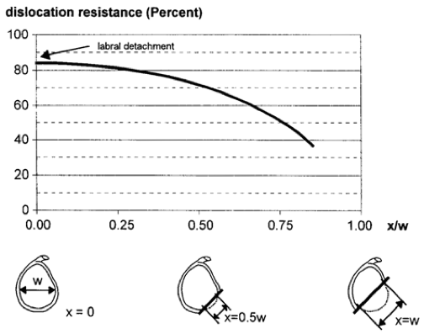

Figure 1 The graph demonstrates the relationship between the size of the glenoid rim and the dislocation risk. When defect (×) measure more than 50% of the glenoid width there is a significant drop in dislocation resistance. Adapted with permission from Clin Orthop Related Res 2002; 400: 65-76.
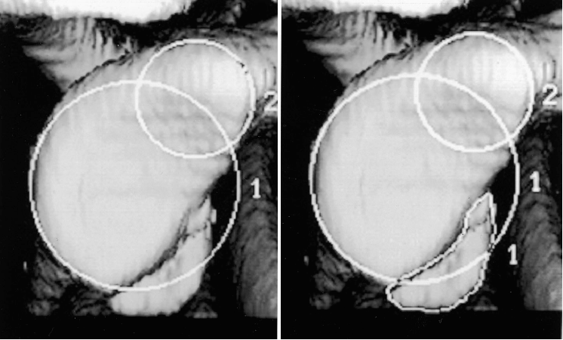

Figure 2 Using 3D reconstruction CT the size of the defect is calculated as the percentage of the on fossa glenoid. Using circle 2 as the reference selected by the radiologist, the CT software automatically calculates the deficit by using the equation (area of the deficit/circle 1 × 100%). Adapted with permission from JBJS Am 2003; 85-A:878-884
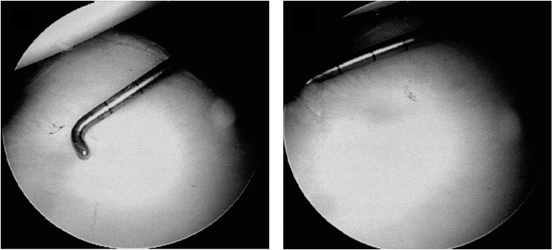

Figure 3 Through a posterior portal a 3 mm calibrate probe is inserted and the distance from the center of the bare spot to the posterior glenoid rim is measured. Following the distance from the bare sport to the anterior glenoid rim is measured. These values are used to preform the final glenoid deficit calculation. Adapted with permission from Arthroscopy 2004; 20: 169-174
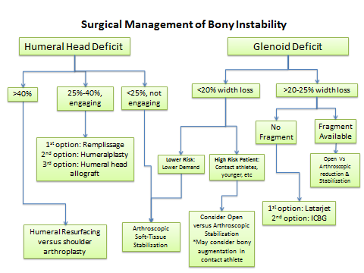

Figure 4 Our treatment algorithm of bony anterior shoulder stability. First determination of the size of the defect is done, followed by evaluation of specific risk factors. For large glenoid defects the Latarjet procedure is preferred, while Hill-Sachs defects the remplissage is our recommended procedure.
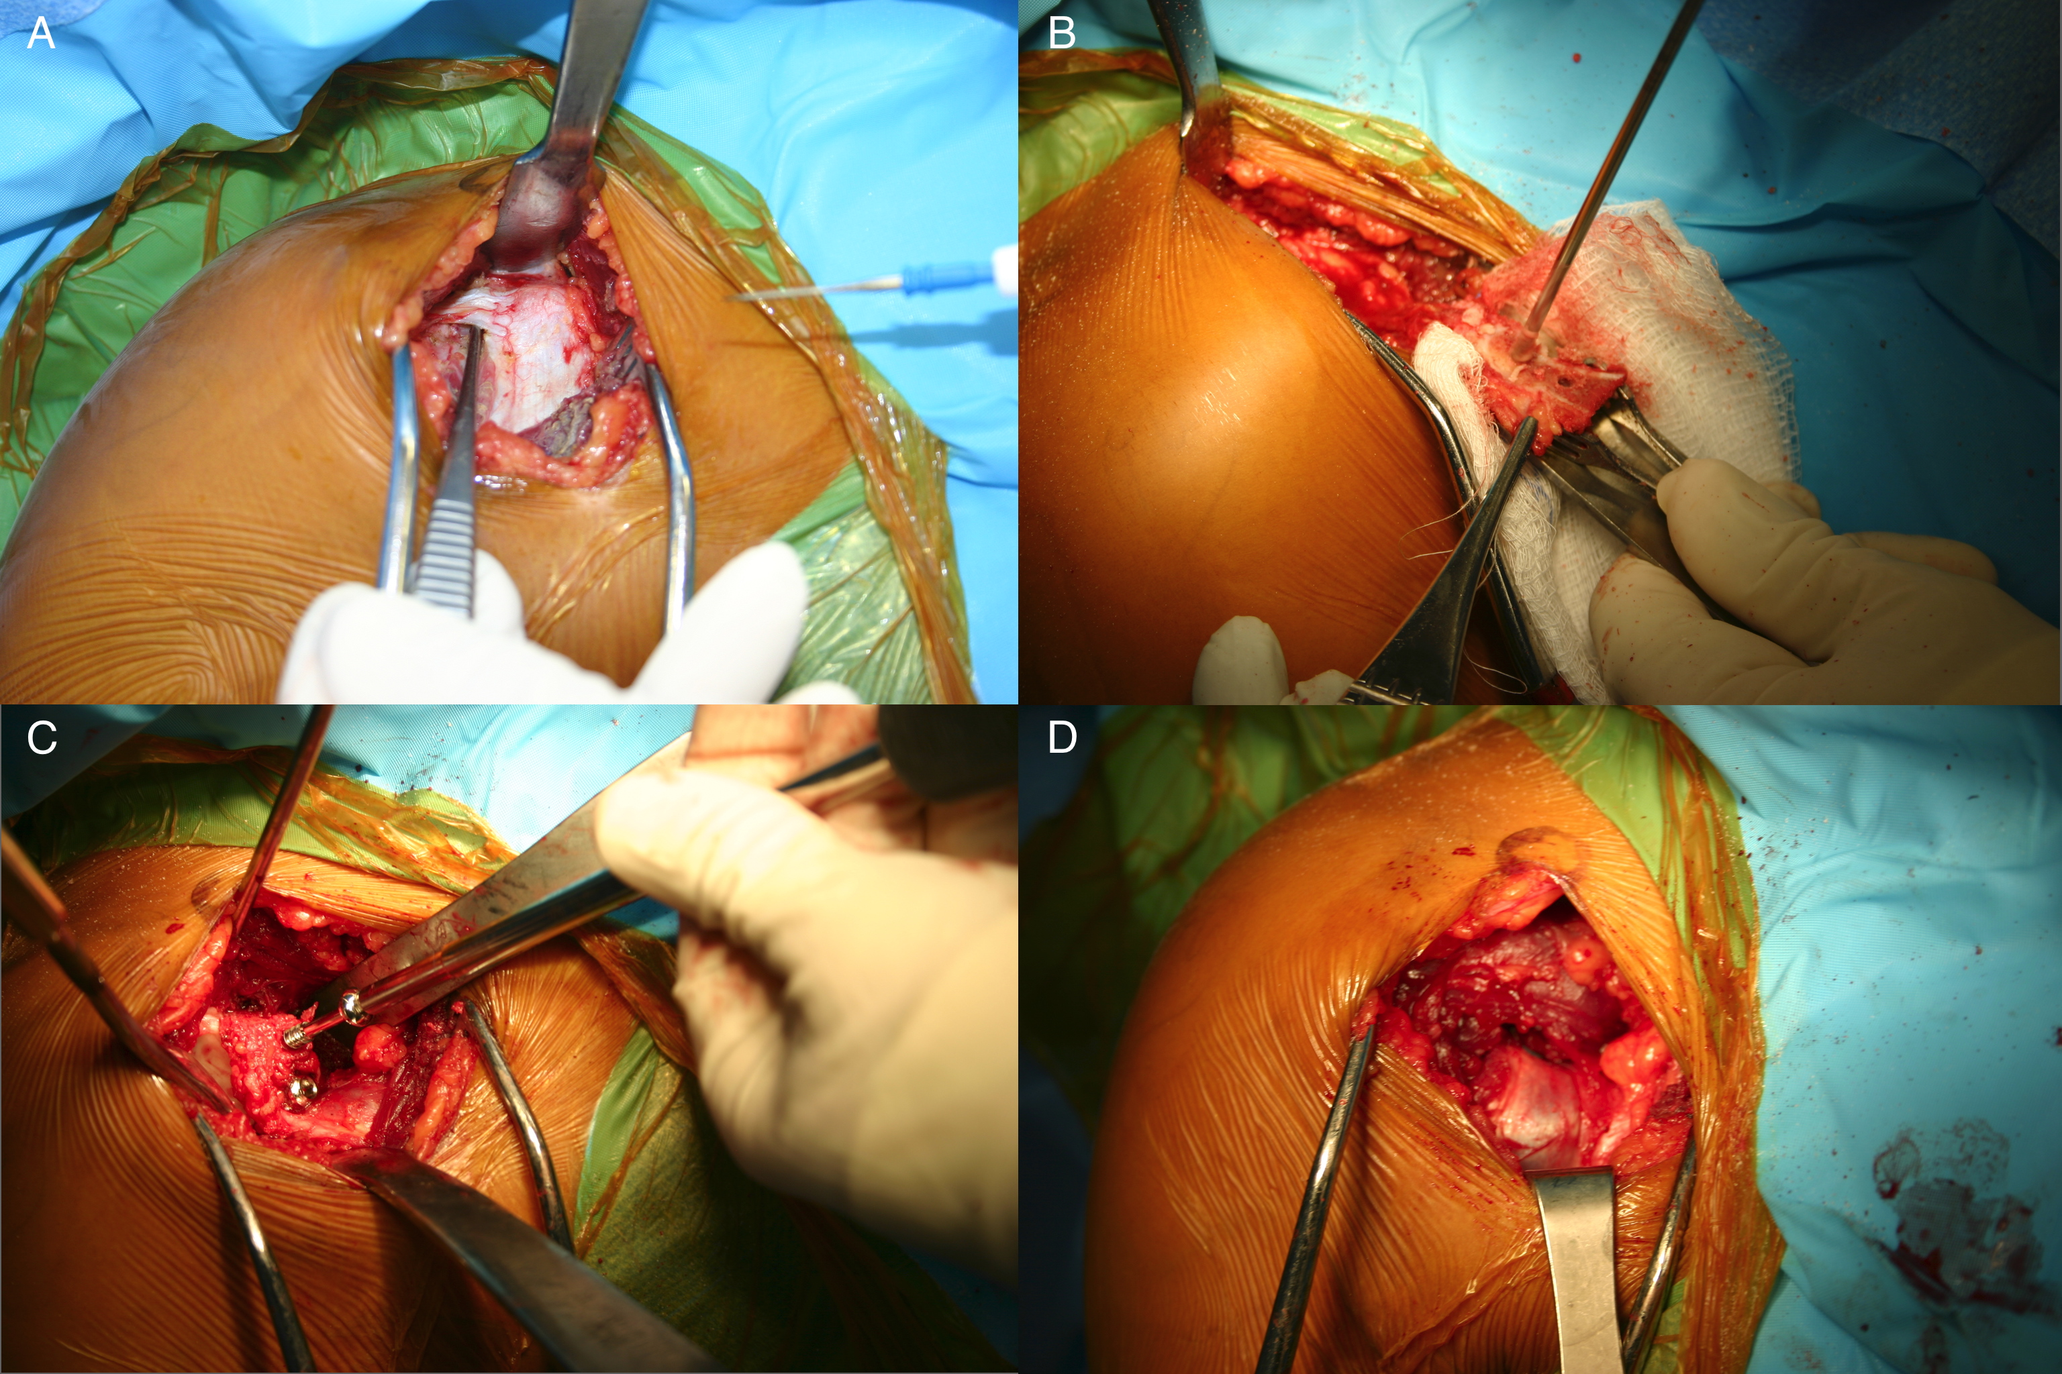

Figure 5 Intraoperative photos of the Latarjet technique. (A) Though a deltopectoral approach the coracoid is identified (B) after osteotomizing the coracoid the entry points for the 2 screws are predrilled, and the soft tissue attachments are preserved (C) The coracoid fragment is secured with 2 partially thread screws on the anterior surface of the glenoid (D) The joint capsule is secured to the coracoid fragment with 2 sutures.

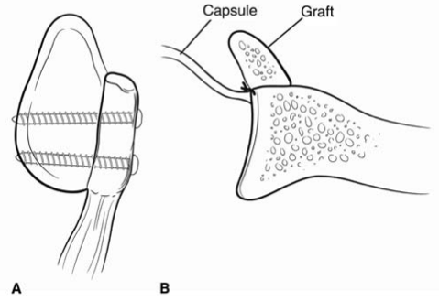

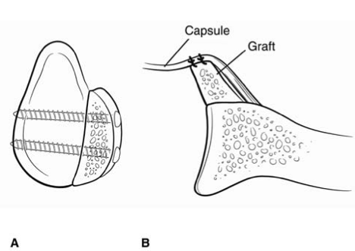
Figure 6 Represents a Latarjet procedure. A: A sagittal view with 2 screws securing the coracoid fragment; B: The capsule is secured posterior to the graft making the construct extra-articular. Adapted with permission from J Am Acad Orthop Surg 2009; 17: 482-493.

Figure 7 Represents an iliac crest autograft. A: A sagittal view with 2 screws securing the iliac crest; B: The capsule is placed anteriorly making the construct intra-articular. The graphs natural wing is facing towards the joint to better match the glenoid previous contour. Adapted with permission from J Am Acad Orthop Surg 2009; 17: 482-493.

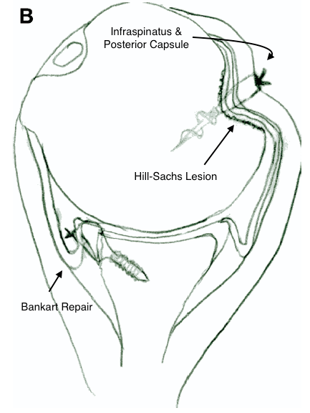

Figure 8 The remplissage technique with a suture anchor securing the infraspinatus and the posterior capsule into the Hill-Sachs defect. In addition, a Bankart repair is performed during the procedure. Adapted with permission from Arthroscopy 2008; 24: 723-6.

