Name of Journal: World Journal of Gastroenterology
Manuscript NO: 62969
Manuscript Type: ORIGINAL ARTICLE

Observational Study
Gut microbiota dysbiosis in Chinese children with type 1 diabetes mellitus: An observational study

Liu X et al. Microbial dysbiosis in T1DM

Xia Liu, Yi-Wen Cheng, Li Shao, Shu-Hong Sun, Jian Wu, Qing-Hai Song, Hong-Sheng Zou, Zong-Xin Ling

Xia Liu, Department of Intensive Care Unit, Zhejiang University, Hangzhou 310003, Zhejiang Province, China

Yi-Wen Cheng, Jian Wu, Zong-Xin Ling, Collaborative Innovation Center for Diagnosis and Treatment of Infectious Diseases, State Key Laboratory for Diagnosis and Treatment of Infectious Diseases, National Clinical Research Center for Infectious Diseases, The First Affiliated Hospital, School of Medicine, Zhejiang University, Hangzhou 310003, Zhejiang Province, China

Li Shao, Institute of Hepatology and Metabolic Diseases, Hangzhou Normal University, Hangzhou 310000, Zhejiang Province, China

Li Shao, Institute of Translational Medicine, The Affiliated Hospital of Hangzhou Normal University, Hangzhou 310000, Zhejiang Province, China

Shu-Hong Sun, Department of Laboratory Medicine, Linyi People’s Hospital, Linyi 276000, Shandong Province, China

Qing-Hai Song, Department of Geriatrics, Lishui Second People's Hospital, Lishui 323000, Zhejiang Province, China

Hong-Sheng Zou, Department of Intensive Care Unit, People’s Hospital of Rongcheng, Rongcheng 264300, Shandong Province, China

Author contributions: Ling ZX was the guarantor and designed the study; Liu X, Cheng YW, Shao L, Sun SH, Wu J, Song QH, and Zou HS participated in the acquisition, analysis, and interpretation of the data, and drafted the initial manuscript; Liu X, Cheng YW, Shao L, and Ling ZX revised the article critically for important intellectual content.

Supported by National Natural Science Foundation of China, No. 31700800, No. 81771724, and No. 81790631; and National S&T Major Project of China, No. 2018YFC2000500.

Corresponding author: Zong-Xin Ling, PhD, Professor, Collaborative Innovation Center for Diagnosis and Treatment of Infectious Diseases, State Key Laboratory for Diagnosis and Treatment of Infectious Diseases, National Clinical Research Center for Infectious Diseases, the First Affiliated Hospital, School of Medicine, Zhejiang University, No. 79 Qingchun Road, Hangzhou 310003, Zhejiang Province, China. lingzongxin_lzx@163.com

Received: January 23, 2021
Revised: February 17, 2021
Accepted: April 14, 2021
Published online:

Abstract
BACKGROUND
Gut microbiota dysbiosis is reportedly actively involved in autoimmune diseases such as type 1 diabetes mellitus (T1DM). However, the alterations in the gut microbiota and their correlation with fasting blood glucose (FBG) in Chinese children with T1DM remain unclear.

AIM
To investigate alterations in the gut microbiota in Chinese children with T1DM and their associations with clinical indicators.

METHODS
Samples from 51 children with T1DM and 47 age-matched and gender-matched healthy controls were obtained, to explore the structural and functional alterations in the fecal microbiota. The V3-V4 regions of the 16S rRNA gene were sequenced on a MiSeq instrument, and the association with FBG were analyzed.

RESULTS
We found that the bacterial diversity was significantly increased in the T1DM-associated fecal microbiota, and changes in the microbial composition were observed at different taxonomic levels. The T1DM-reduced differential taxa, such as Bacteroides vulgatus ATCC8482, Bacteroides ovatus, Bacteroides xylanisolvens, and Flavonifractor plautii, were negatively correlated with FBG, while the T1DM-enriched taxa, such as Blautia, Eubacterium hallii group, Anaerostipes hadrus, and Dorea longicatena, were positively correlated with FBG. Bacteroides vulgatus ATCC8482, Bacteroides ovatus, the Eubacterium hallii group, and Anaerostipes hadrus, either alone or in combination, could be used as noninvasive diagnostic biomarkers to discriminate children with T1DM from healthy controls. In addition, the functional changes in the T1DM-associated fecal microbiota also suggest that these fecal microbes were associated with altered functions and metabolic activities, such as glycan biosynthesis and metabolism and lipid metabolism, which might play vital roles in the pathogenesis and development of T1DM.

CONCLUSION
Our present comprehensive investigation of the T1DM-associated fecal microbiota provides novel insights into the pathogenesis of the disease and sheds light on the diagnosis and treatment of T1DM.

Key Words: Dysbiosis; Fasting blood glucose; Sequencing; Metabolism; Type 1 diabetes mellitus

Liu X, Cheng YW, Shao L, Sun SH, Wu J, Song QH, Zou HS, Ling ZX. Gut microbiota dysbiosis in Chinese children with type 1 diabetes mellitus: An observational study. World J Gastroenterol 2021; In press

Core Tip: Alterations in the gut microbiota play vital roles in the development of autoimmune diseases such as type 1 diabetes mellitus (T1DM). Our present study explores the overall structure and composition of the fecal microbiota in Chinese children with T1DM and its association with fasting blood glucose (FBG). We found that the bacterial diversity increased significantly in children with T1DM and that several key functional taxa were correlated with FBG. These key functional bacteria could be used as noninvasive diagnostic biomarkers to discriminate T1DM patients from healthy controls. This comprehensive investigation of the T1DM-associated fecal microbiota provides novel insights into the pathogenesis of T1DM.

INTRODUCTION
Type 1 diabetes mellitus (T1DM), a chronic autoimmune disease that usually begins in childhood, results from the destruction (or loss) of pancreatic β-cells, which leads to an inability to produce insulin and a need for the administration of exogenous insulin. T1DM ranks as the second most common autoimmune disease among children. The peak incidence of T1DM is clearly within the age group of 10–14 years and declines thereafter. One nationwide, population based study demonstrated that the incidence of T1DM in children is 1.93 (ranging from 0.83 to 3.03) per 100000 person-years in China, with an annual increase of approximately 6.5%^{[1]}. T1DM can cause life-changing and life-threatening health complications in many organs and tissues rich in capillary vessels, such as the kidney, retina, and nerves, resulting in premature death. Children with T1DM often have to be treated for hypertension, dyslipidemia, microalbuminuria, and nephropathy, among other conditions^{[2]}. Its early onset and chronicity make T1DM a disease of considerable importance. Currently, T1DM and its related comorbidities are considered major public health concerns.
Over the last few decades, considerable progress has been made in research on the pathogenesis and treatment of T1DM. However, its precise etiology and pathological mechanisms remain largely unclear. Both genetic susceptibility and environmental factors contribute to the development of T1DM^{[3]}. The genetic susceptibility associated with T1DM is fairly well known, whereas the environmental factors remain poorly defined despite intensive research. Among the environmental risk factors associated with T1DM are industrial and economic advances (such as high levels of hygiene), changes in diet, and the emergence of more sedentary lifestyles^{[4]}, which can affect the environmental exposure of children. This altered environmental exposures can directly and indirectly influence the early-life gut microbiota.
Numerous clinical and experimental reports provide growing evidence of a close link between an altered gut microbiota (also defined as dysbiosis) and T1DM^{[5-12]}. A previous study found that T1DM-related dysbiosis is associated with reduced integrity and increased permeability of the gut mucosa, which leads to bacterial penetration, and can stimulate the immune system to produce antibodies. Cross-reaction of these antibodies and surface antigens of pancreatic beta cells, as well as T cell cross-reactivity, results in the destruction of pancreatic β-cells and the development of T1DM^{[13]}. Specifically, the Firmicutes/Bacteroidetes ratio is significantly reduced in Finnish children with T1DM^{[14]}. Leiva-Gea et al^{[6]} demonstrated that Bacteroides and Veillonella are markedly enriched in patients with TIDM, whereas Faecalibacterium and Roseburia are significantly reduced^{[6]}. Livanos et al^{[11]} showed that early-life antibiotic treatments alter the gut microbiota and its metabolic capacities, intestinal gene expression, and T-cell populations, thereby accelerating T1DM onset in non-obese diabetic mice^{[11]}. Taken together, these findings show that early dysbiosis of the gut microbiota can be used as a promising biomarker for T1DM.
Most of the previous studies on the T1DM-associated microbiota were conducted in the United States and Europe. However, differences in lifestyle, dietary constitution, environmental exposures, and host genetic background between Chinese and Western populations may contribute to disparities in the baseline microbiota composition, which may influence the roles of specific bacteria in the etiopathology of T1DM. The present study aimed to explore the T1DM-associated gut microbiota in Chinese children by using the 16S rRNA gene high-throughput sequencing platform. We also evaluated the correlation between the T1DM-associated gut microbiota and fasting blood glucose (FBG). Our findings suggest novel targets for noninvasive early diagnosis and personalized treatment of T1DM.

MATERIALS AND METHODS
Participant selection
A total of 51 children with newly confirmed T1DM (aged 6-14 years) and 47 age-, gender-, and education-matched healthy controls were enrolled from Linyi People’s Hospital (Linyi, China) and the First Affiliated Hospital, School of Medicine, Zhejiang University (Hangzhou, China) from June 2019 to November 2019. The diagnosis of T1DM was based on the criteria of the American Diabetes Association: T1DM-associated autoimmunity (i.e., formation of islet autoantibodies); the classic trio of symptoms associated with disease onset, i.e., polydipsia, polyphagia, and polyuria along with hyperglycemia; an immediate need for exogenous insulin replacement and lifetime treatment. All the T1DM children were treated with only insulin. The FBG level of these participants was determined in the morning (Table 1). The following exclusion criteria were established: Body mass index (BMI) ≥ 30 kg/m²; use of antibiotics, probiotics, prebiotics, or synbiotics in the previous month; known active infections such as bacterial, fungal, chlamydial, or viral infections; and other diseases such as irritable bowel syndrome (IBS), inflammatory bowel disease or other autoimmune diseases. The protocols for the present study were approved by the Ethics Committee of the First Affiliated Hospital, School of Medicine, Zhejiang University. Informed written consent was obtained from the subjects’ guardians before enrollment.

Fecal sample collection and microbial DNA extraction
According to our previous studies, approximately 2 g of fresh fecal sample was collected in a sterile plastic cup, and stored at -80 °C within 15 min after preparation until use. Bacterial genomic DNA was extracted from 300 mg of homogenized feces using a QIAamp DNA Stool Mini Kit (Qiagen, Hilden, Germany) according to the manufacturer’s instructions, with additional glass-bead beating steps on a Mini-Beadbeater (FastPrep; Thermo Electron Corporation, Boston, MA, United States). The amount of DNA was determined using a NanoDrop ND-1000 spectrophotometer (Thermo Electron Corporation); the integrity and size were checked by 1.0% agarose gel electrophoresis on a gel containing 0.5 mg/mL ethidium bromide. All DNA was stored at -20 °C before further analysis.

Amplicon library construction and sequencing
Amplicon libraries were constructed with the Illumina sequencing-compatible and barcode-indexed bacterial polymerase chain reaction primers 338F (5’-ACTCCTRCGGGAGGCAGCAG-3’) and 806R (5’-GGACTACCVGGGTATCTAAT-3’), which targeted the V3-V4 regions of 16S rRNA gene. All PCRs were performed with KAPA HiFi HotStart ReadyMix using the manufacturer's protocol (KAPA Biosystems, Wilmington, MA) and approximately 50 ng of extracted DNA was used per reaction. Thermocycling conditions were as follows: 30 cycles of 95 °C for 1 min, 55 °C for 1 min, and 72 °C for 1 min, followed by a final extension at 72 °C for 5 min. All PCRs were performed in triplicate in a volume of 50 mL, and the samples were combined after PCR. The amplicon library was prepared using a TruSeqTM DNA Sample Preparation Kit (Illumina Inc, San Diego, CA, United States). Prior to sequencing, the PCR products were extracted with the MiniElute Gel Extraction Kit (Qiagen) and quantified on a NanoDrop ND-1000 spectrophotometer (Thermo Electron Corporation) and Qubit 2.0 fluorometer (Invitrogen). The purified amplicons were then pooled in equimolar concentrations and the final concentration of the library was determined by Qubit (Invitrogen). Negative DNA extraction controls (lysis buffer and kit reagents only) were amplified and sequenced as contamination controls. Sequencing was performed on a MiSeq instrument (Illumina) using a 300 × 2 V3 kit together with PhiX Control V3 (Illumina)^{[15,16]}.

Bioinformatic analysis
The 16S rRNA gene sequence data set generated from the Illumina MiSeq platform was inputted to QIIME2 (version 2020.11), and all steps of sequence processing and quality control were performed in QIIME2 with default parameters^{[15,16]}. Before the following data analysis, these reads of each sample were normalized to even sampling depths and annotated using the Greengenes reference database (version 13.8) with both the Ribosomal Database Project Classifier and UCLUST version 1.2.22 methods implemented in QIIME. Alpha diversity, including the observed species, abundance-based coverage estimator (ACE), Chao1 estimator, Shannon, Simpson, Evenness, and PD whole tree indices, was calculated at a 97% similarity level. Beta diversity was measured by the unweighted UniFrac, weighted UniFrac, Jaccard, and Bray-Curtis distances calculated by QIIME2, which were visualized by principal coordinate analysis (PCoA). The differences in the composition of the fecal microbiota at different taxonomic levels were analyzed with Statistical Analysis of Metagenomic Profiles (STAMP) software package v2.1.3 and by the linear discriminant analysis effect size (LEfSe) method. PiCRUSt v1.0.0 was used to identify predicted gene families and associated pathways from inferred metagenomes of taxa of interest identified from the compositional analyses. The sparse compositional correlation (SparCC) algorithm was used for correlation analysis, and the results were visualized using Cytoscape v3.4.1.

Statistical analysis
For continuous variables, independent t-tests, White’s nonparametric t-tests, and Mann-Whitney U-tests were applied. For categorical variables between groups, Pearson’s chi-square test or Fisher’s exact test was used, depending on assumption validity. For correlation analyses, Spearman’s rank correlation test was used. Statistical analyses were performed using SPSS V19.0 (SPSS Inc., Chicago, IL, United States) and STAMP V2.1.3. GraphPad Prism version 6.0 (San Diego, CA, United States) was used to prepare graphs. All tests of significance were two sided, and P < 0.05 or corrected P < 0.05 was considered statistically significant.

Accession number
The sequence data from this study are deposited in the GenBank Sequence Read Archive with the accession number SRP287193.

RESULTS
Altered bacterial diversity in children with T1DM
No significant differences were noted in age, gender, race, BMI, or lipid levels between Chinese children with T1DM and healthy controls (P > 0.05). The FBG level was significantly higher in children with T1DM than in healthy controls (Figure 1; P < 0.05). A total of 3961145 high-quality reads (1857135 reads in healthy controls and 2104010 reads in children with T1DM) with an average of 40420 reads per sample were obtained for subsequent microbiota analysis. Deeper sequencing identified the majority of the bacterial phylotypes [640 operational taxonomic units (OTUs)] present in the fecal microbiota. The Good’s estimator of coverage was 99.93%.
For bacterial diversity analyses, the Shannon and Simpson indices differed significantly between children with T1DM and healthy controls (P < 0.05; Figure 2A and B), with an increased diversity in the T1DM-associated fecal microbiota. However, richness indices, such as the ACE and Chao1 indices, showed no significant changes between the two groups (P > 0.05; Figure 2C and D). Owing to the significant interindividual variations, PCoA based on unweighted UniFrac, weighted UniFrac, and Bray–Curtis algorithms could not separate the two groups into different clusters (Figure 2E-G). Based on the Venn diagram in Figure 2H and Shannon rarefaction curves (Figure 2I), we observed a slightly higher number of OTUs in children with T1DM. Taken together, the results of our deeper sequencing analysis indicated increased fecal microbial diversity in children with T1DM.

Altered fecal microbiota composition in children with T1DM
The overall microbial compositions in children with T1DM and healthy controls were examined at different taxonomic levels from phylum to species. Using the RDP Classifier, sequences were annotated as follows: 11 phyla, 29 orders, 53 families, 184 genera, and 271 species. LEfSe identified many key bacterial phylotypes, mainly at the genus and species levels, that could potentially distinguish children with T1DM from healthy controls (Figure 3A and B). A representative cladogram demonstrated dysbiosis of the T1DM-associated fecal microbiota among children with T1DM.
Specifically, no one phylum was observed to differ significantly between children with T1DM and healthy controls. However, the dysbiotic indicator, the Firmicutes/Bacteroidetes (F/B) ratio, was markedly increased in children with T1DM (Supplementary Figure 1), which suggested that fecal microbial dysbiosis occurred in patients with T1DM. At the order level, we found that Erysipelotrichales, Enterobacteriales, and Coriobacteriales were enriched in children with T1DM, while Selenomonadales was markedly reduced (P < 0.05; Figure 3C). At the family level, Lachnospiraceae, Erysipelotrichaceae, Enterobacteriaceae, and Coriobacteriaceae were significantly enriched in children with T1DM (P < 0.05; Figure 3C).
At the genus level, Blautia, Anaerostipes, unclassified Lachnospiraceae, the Eubacterium hallii group, unclassified Peptostreptococcaceae, Dorea, Collinsella, and Klebsiella were significantly enriched in children with T1DM, whereas Parabacteroides, Flavonifractor, and uncultured Ruminococcaceae were markedly reduced (P < 0.05; Figure 3C). At the species level, Anaerostipes hadrus, Ruminococcus sp._5_1_39BFAA, Dorea longicatena, and Collinsella aerofaciens were enriched in children with T1DM, while seven species, namely, Bacteroides vulgatus ATCC8482, Bacteroides ovatus, Bacteroides xylanisolvens, Bacteroides dorei, Flavonifractor plautii, Parabacteroides merdae, and Parabacteroides distasonis ATCC8503 were markedly reduced (P < 0.05; Figure 3C). Figure 4 shows a heatmap of bacterial genera in children with T1DM and healthy controls, presenting the relative percentages of most genera identified in each sample.
The overall structure of the T1DM-associated fecal microbiota was the result of dynamic interactions between community members. The SparCC algorithm with false discovery rate adjustment was employed to generate correlation-based microbial interaction networks based on the relative abundance of OTUs between the two groups (Figure 5). We found a more complex network of interactions in healthy controls than in children with T1DM. More positive and negative correlations among bacteria were found in the healthy controls. Based on our present findings, dysbiosis of the T1DM-associated fecal microbiota was observed in children with T1DM.

A fecal microbiota-based signature discriminates patients with T1DM from healthy controls
As mentioned above, several taxa were identified as key functional differentially abundant bacteria. These differentially abundant taxa, including Bacteroides vulgatus ATCC8482, Bacteroides ovatus, Bacteroides xylanisolvens, and Flavonifractor plautii, were negatively correlated with FBG, while Blautia, Eubacterium hallii group, Anaerostipes hadrus, and Dorea longicatena were positively correlated with FBG (P < 0.05; Figure 6). These correlation analyses indicated that key T1DM-associated functional bacteria actively participated in the regulation of glycemic levels in children.
We evaluated the potential value of the key functional differentially abundant taxa as biomarkers, including Bacteroides vulgatus ATCC8482, Bacteroides ovatus, the Eubacterium hallii group, and Anaerostipes hadrus. First, using only one of the differential bacteria as a predictor, we generated the receiver operating characteristic curves, with the area under the curve (AUC) ranging from 0.294 to 0.690 (Figure 7A). Multivariable stepwise logistic regression analysis was then performed to evaluate the list of T1DM-associated taxa, to distinguish T1DM patients from healthy controls (Figure 7B). We found that a combination of four taxa, including Bacteroides vulgatus ATCC8482, Bacteroides ovatus, the Eubacterium hallii group, and Anaerostipes hadrus, could significantly improve the predictive performance (AUC = 0.830). Based on our present findings, these key differentially abundant taxa could be used as potential biomarkers for discriminating between T1DM patients and healthy controls.

T1DM-associated microbial functional alterations
To study the functional and metabolic changes in microbial communities between patients with T1DM and controls, we inferred the metagenomes from the 16S rRNA data and analyzed the functional potential of the fecal microbiota using PiCRUSt software, based on closed-reference OTU picking. We compared 64 Kyoto Encyclopedia of Genes and Genome (KEGG) pathways at level 2, and identified five KEGG categories with significantly differential abundances between children with T1DM and healthy controls. We found that glycan biosynthesis and metabolism and lipid metabolism were significantly reduced in children with T1DM (P < 0.05; Figure 8), which suggests that they might play crucial roles in the development of T1DM.
Specifically, nine pathways at level 3, including transcription factors, the phosphotransferase system, methane metabolism, and peptidoglycan biosynthesis, were significantly increased in the T1DM-associated fecal microbiota. Furthermore, 18 other pathways, including glycan degradation, glycosaminoglycan degradation, and insulin signaling pathway, were markedly reduced in the T1DM-associated microbiota. Together, these functional alterations in the fecal microbiota, especially that in glycan metabolism, were likely associated with the pathogenesis and development of T1DM.

DISCUSSION
As a chronic autoimmune disease, T1DM is affected by genetic and non-genetic factors. With the advent of high-throughput sequencing technology, numerous studies have found that non-genetic factors, such as an optimal balance of the gut microbiota, play vital roles in regulating the host immune system and preventing the development of T1DM. A recent study demonstrated that a dysbiotic gut microbiota limits the effects of therapy in T1DM, while depletion of gut microbiota resistance enhances stem cell therapy in T1DM^{[17]}. Our present T1DM-associated gut microbiota analysis excluded the influence of physiological factors such as the age, gender, and race of the enrolled participants. Most of the children with T1DM were newly diagnosed cases and were treated with only insulin. Without any additional treatment options, our present microbiota analysis could determine the actual correlations and roles of gut bacteria in the development of T1DM.
In the present study, the bacterial diversity of the T1DM-associated fecal microbiota was significantly increased^{[6,8,10,18]}, which is inconsistent with the findings of previous studies. Several case-control studies have reported that the bacterial diversity of the gut microbiota is not significantly different in children with T1DM^{[8,10,18]}. However, Leiva-Gea et al^{[6]} found that T1DM is associated with a significantly lower microbiota diversity^{[6]}. Furthermore, de Goffau et al^{[5]} indicated that the age of children may influence bacterial diversity, and older children with T1DM tend to have a higher bacterial diversity^{[5]}. In addition, differences in geographic location could influence the gut microbiota in early childhood, which might explain the disparity in bacterial diversity among different T1DM-associated microbiota studies. As significant inter-personal variations were observed, our PCoA could not separate the children with T1DM from healthy controls in these case-control studies. This indicates that β-diversity was similar between children with T1DM and healthy controls. In contrast to microbiota shifts in other childhood diseases, such as antibiotic-associated diarrhea, our present α- and β-diversity analyses showed increased bacterial diversity in children with T1DM, which could be used as a potential target dietary intervention in T1DM.
Inconsistent with previous findings regarding bacterial diversity, our LEfSe analysis showed that several taxa could be used as biomarkers to discriminate T1DM children from healthy controls. Consistent with previous human and animal studies, Bacteroidetes and Firmicutes were the two most predominant phyla, accounting for more than 93% of the gut microbiota in children. Most of the differentially abundant taxa at the genus and species levels belonged to these two phyla. However, the dominant phyla showed no significant differences between the two groups. The composition of the gut microbiota at the phylum level varied with age, and a greater relative abundance of Bacteroidetes was observed among older individuals. Despite the absence of differentially abundant phyla, the F/B ratio was significantly higher in children with T1DM. The F/B ratio is an indicator of gut dysbiosis, which is positively correlated with BMI^{[19]}. Alterations in the F/B ratio may be important, as this ratio can influence efficiency in the processing of indigestible complex polysaccharides in the diet^{[20,21]}. A previous study reported that the F/B ratio showed a significant decline in adults with type 2 diabetes mellitus (T2DM)^{[22]}. Although the change patterns are not always consistent in patients with diabetes, an altered F/B ratio demonstrates a dysbiotic gut microbiota compared with healthy controls.
Specifically, we found that several genera and species of the phyla Firmicutes and Bacteroidetes were significantly altered in the T1DM-associated fecal microbiota. Interestingly, the co-network analysis indicated that interactions among altered bacterial species and abundant species play an important role in shaping the overall structure and composition of the T1DM-associated fecal microbiota. We found a more complex network of interactions in healthy controls than in children with T1DM, with more positive and negative correlations in healthy controls. These differentially abundant bacterial species played vital roles in regulating blood glucose in children. Bacteroides vulgatus ATCC8482, a highly abundant gram-negative obligate anaerobe, constitutes part of the core gut microbiota in healthy humans and is generally considered beneficial^{[23]}. We found that the level of Bacteroides vulgatus ATCC8482 was significantly reduced in the T1DM-associated fecal microbiota and negatively correlated with FBG. Leiva-Gea et al^{[6]} also found that the prevalence of Bacteroides vulgatus was significantly reduced in patients with T2DM, which can be considered a gut microbiota signature associated with the development of T2DM. Pedersen et al^{[24]} identified Bacteroides vulgatus as the main species driving the association between the biosynthesis of branched-chain amino acids (BCAAs) and insulin resistance, suggesting that it may directly impact host metabolism^{[24]}. Similar to our present findings, Yoshida et al^{[25]} also revealed a significantly lower abundance of Bacteroides vulgatus in patients with coronary artery disease. Gavage with live Bacteroides vulgatus can attenuate atherosclerotic lesion formation in atherosclerosis-prone mice. Such action can thereby markedly ameliorate endotoxemia, directly reduce gut microbial lipopolysaccharide (LPS) production, and effectively suppress proinflammatory immune responses. These studies suggest that Bacteroides vulgatus plays a beneficial role in regulating blood glucose and preventing the development of T1DM.
Another dominant species of the genus Bacteroides in the human gut microbiota, Bacteroides dorei, shares similar 16S rRNA sequencing patterns with Bacteroides vulgatus. Leonard et al^{[26]} found that cesarean section delivery is associated with a reduced abundance of the beneficial species, Bacteroides vulgatus and Bacteroides dorei^{[27]}. Altered relative abundance of Bacteroides dorei can significantly influence the composition of the gut microbiota, and this species can be considered a keystone species^{[27]}. A previous study showed that increased abundance of Bacteroides dorei leads to reduced gut microbial production of LPS, which improves immune function through mechanisms such as major histocompatibility complex production and T cell activation^{[25]}. Anonye et al^{[28]} also found that Clostridium difficile growth is significantly reduced in the presence of Bacteroides dorei^{[28]}. However, a recent study on gestational diabetes identified Bacteroides dorei as a putative biomarker of impaired carbohydrate tolerance, and suggested that it played a role in the regulation of glucose tolerance in pregnant women^{[29]}. However, our present correlation analysis found no significant association between Bacteroides dorei and FBG. Inconsistent with our present alteration patterns, previous studies have found that higher levels of Bacteroides dorei may contribute to the onset of T1DM, and may be potential monitoring and therapeutic microbial markers for T1DM^{[30]}. Bacteroides ovatus is a common member of the human gut microbiota, with a broad capability to degrade complex glycans^{[31]}. It makes considerable contributions to the overall differences between T1DM cases and controls. Consistent with our results, Giongo et al^{[14]} found that Bacteroides ovatus accounted for nearly 24% of the total increase in the phylum Bacteroidetes among children with T1DM^{[14]} and for the first time established a causal relationship between Bacteroides ovatus and metabolic homeostasis. Their findings demonstrated that Bacteroides ovatus may be a potentially beneficial intestinal bacterial species. Similar to Bacteroides vulgatus, Bacteroides ovatus can also regulate BCAA metabolism, and alleviate metabolic syndrome. A recent study performed by Yang et al^{[32]} demonstrated that specific strains of Bacteroides ovatus are capable of inducing high levels of mucosal immunoglobulin A (IgA) production in the large intestine, which can be used to modulate the host immune response^{[32]}. In addition, as one of the active immunomodulators, oral gavage of Bacteroides ovatus could significantly increase the efficacy of erlotinib and induce the expression of CXCL9 and interferon-gamma in a murine lung cancer model, which was positively correlated with treatment outcomes^{[33]}. Another Bacteroides species with reduced levels in T1DM, Bacteroides xylanisolvens, is a xylan-degrading bacterium isolated from human feces. Following a safety evaluation of a Bacteroides xylanisolvens strain (DSM 23964), a previous study reported its potential probiotic properties^{[34]}. Consistent with a previous study on patients with atherosclerosis^{[35]}, Bacteroides xylanisolvens is reportedly an important contributor to folate transformations II and glycolysis III, and it is significantly more abundant in healthy controls than in patients with T1DM. Qiao et al^{[36]} also found that Bacteroides xylanisolvens can alleviate nonalcoholic hepatic steatosis and provided evidence of the benefits of the gut Bacteroides-folate-liver pathway^{[36]}. Bacteroides xylanisolvens is considered a probiotic bacterium that is positively correlated with anti-inflammatory/tumor markers and negatively correlated with proinflammatory/tumor markers^{[37]}. Sufficient evidence has supported and facilitated authorization of the use of heat-inactivated Bacteroides xylanisolvens in the European Union^{[38]}. Flavonifractor plautii, a Gram-positive anaerobic bacterium, is a member of Clostridium cluster IV in the Ruminococcaceae family, and has been isolated worldwide from human feces. Our data showed a lower level of Flavonifractor plautii in children with T1DM than in healthy controls. This finding suggests that Flavonifractor plautii plays a beneficial role in regulating the metabolism of blood glucose. Similar to our present findings, Borgo et al^{[39]} found that Flavonifractor plautii is negatively correlated with BMI^{[39]}. Kasai et al^{[40]} found that the fraction of Flavonifractor plautii is significantly lower in feces from obese subjects than in feces from non-obese^{[40]}. Recently, Mikami et al^{[41]} suggested that oral administration of Flavonifractor plautii prevents the accumulation of tumor necrosis factor-α-encoding transcripts in the adipose tissue of obese mice, thereby suppressing adipose tissue-associated chronic inflammation^{[41]}. In addition, their group also found that Flavonifractor plautii alleviates antigen-induced Th2 immune responses, and can be used as a potential anti-allergic probiotic^{[42]}. Flavonifractor plautii abundance in fecal samples has now been proposed as a biomarker of health status^{[39]}. Parabacteroides distasonis, a core member of the gut microbiota in humans, is also reportedly a beneficial commensal gut microorganism in different pathophysiological models due to its anti-inflammatory and barrier restorative abilities. The abundance of Parabacteroides distasonis is relatively low in patients affected by obesity, nonalcoholic fatty liver disease (NAFLD), and multiple sclerosis^{[43-45]}. A recent study indicated that Parabacteroides distasonis modulates host metabolism and alleviates obesity and metabolic dysfunctions via the production of succinate and secondary bile acids^{[46]}. Colonization of antibiotic-treated or germ-free mice with a single Parabacteroides distasonis strain induced Treg differentiation^{[43]}. The abundance of another Parabacteroides species, Parabacteroides merdae, was also reduced in children with T1DM, indicating its beneficial role during T1DM development. Wang et al^{[47]} recently reported that enrichment of Parabacteroides merdae is positively correlated with longevity^{[47]}. These bacteria exhibit promising potential beneficial effects on human health in a strain-dependent manner. Thus, several strains could contribute to the development of chronic diseases.
The proportional abundances of four species, namely, Anaerostipes hadrus, Ruminococcus sp. 5_1_39BFAA, Dorea longicatena, and Collinsella aerofaciens, were significantly increased in children with T1DM. Anaerostipes hadrus, one of the core species isolated from human feces, is able to produce large amounts of butyrate from both L-sorbose and xylitol and can consume acetate^{[48]}. Zhang et al^{[49]} found that Anaerostipes hadrus can significantly aggravate colitis in dextran sulfate sodium-treated mice, but exerts no detrimental effects in healthy mice^{[49]}. Recently, Zeevi et al^{[50]} observed that several genomic structural variants of Anaerostipes hadrus are negatively correlated with weight, waist circumference, median blood glucose levels, and BMI and positively correlated with HDL cholesterol levels^{[50]}. The functions of Anaerostipes hadrus structural variants are not consistent with those of the wild type, which is strongly associated with lower metabolic risk. Ruminococcus sp. 5_1_39BFAA, a member of the genus Blautia, is positively associated with FBG. A previous study reported that Ruminococcus sp. 5_1_39BFAA is enriched among elderly patients with hypertension and reduced exercise capacity^{[51]}. To date, no studies have extensively investigated the roles and mechanisms of Ruminococcus sp. 5_1_39BFAA. Blautia is associated with blood glucose regulation, lipid metabolism, and regulation of T cell differentiation^{[6,52]}. However, increased proportions of Blautia have been reported in various diseases, such as IBS, NAFLD, and Crohn’s disease. A previous case-control study also found that the abundance of Blautia is increased in children with T1DM, and is positively correlated with HbA1c, the number of T1DM autoantibodies, and the titers of tyrosine phosphatase autoantibodies^{[52]}. Consistent with the findings of Kostic et al^{[53]}, the present study demonstrated that Blautia is positively correlated with the levels of FBG in children with T1DM. Dorea longicatena, a new member of Clostridium cluster XIVa in the Lachnospiraceae family, can produce acetate as a fermentation product. Mortaş et al^{[54]} found that Dorea longicatena is significantly more abundant in individuals working the night shift^{[54]}. Yang et al^{[55]} found that Dorea is a biomarker of the risk for colorectal cancer^{[55]}. Higher abundance of the Dorea genus is associated with increased intestinal permeability. In contrast with our present findings, Brahe et al^{[56]} reported that Dorea longicatena is negatively correlated with markers for insulin resistance, such as glucose and insulin, in obese female participants^{[56]}. Nevertheless, the increased abundance of Dorea longicatena in T1DM could be actively involved in regulating host metabolism. Collinsella aerofaciens, one of the most abundant Actinobacteria in the gastrointestinal tract of healthy humans, shows increased abundance in the feces of patients with T1DM; one of its subspecies is capable of butyrate production^{[57]}. Increased Collinsella abundance has been associated with both positive and negative health conditions, but there is no consensus on its health effects. Cohort studies have identified increases in Collinsella abundance in the fecal microbiota of patients with T2DM, atherosclerosis, and IBS^{[58-60]}. Turnbaugh et al^{[61]} reported that the enrichment of Collinsella aerofaciens is linked to BMI, with an increased prominence of Collinsella aerofaciens in obese individuals than in lean twins and their mothers^{[61]}. Another abundant bacterium in T1DM, the Eubacterium hallii group (an anaerobic, Gram-positive, catalase-negative bacterium of the Lachnospiraceae family), is a metabolically versatile species that can contribute to intestinal butyrate and propionate formation^{[62,63]}. We observed a positive correlation between the Eubacterium hallii group and FBG. Consistent with the present data, Ye et al^{[64]} found that the abundance of the Eubacterium hallii group was significantly higher in patients with gestational diabetes mellitus (GDM) who failed to make lifestyle modifications for glycemic control, which is also positively correlated with FBG^{[64]}. They also showed that the Eubacterium hallii group can be used to distinguish GDM patients and patients who failed glycemic control from healthy controls. As mentioned by Schwab et al^{[63]}, the Eubacterium hallii group may actively contribute to metabolic interactions^{[63]}. However, Udayappan et al^{[65]} observed that oral treatment with the Eubacterium hallii group can improve insulin sensitivity in db/db mice^{[65]}, which is inconsistent with the present findings. Our ROC analysis found that the bacteria mentioned above, such as Bacteroides vulgatus ATCC8482, Bacteroides ovatus, the Eubacterium hallii group, and Anaerostipes hadrus, can be used as potential biomarkers to discriminate children with T1DM from healthy controls. These bacteria in patients with T1DM might contribute to alterations in microbial functions and actively participate in the development of T1DM. Therefore, they could be used as novel targets for non-invasive diagnostic biomarkers and personalized treatment of T1DM in the future.
There are several limitations of the present study. First, our case-control study only explored the characteristics of the T1DM-associated fecal microbiota, whereas alterations in the fecal microbiota after successful treatment were not investigated. Second, the fecal microbial signature and corresponding metabolites, as well as the diagnostic model associated with T1DM, still require further clinical studies with a larger sample size to validate the results. Third, the relatively weak correlations between key differential functional bacteria and FBG could not indicate an obvious primary or secondary relationship. More clinical indicators should be added into these correlation analyses in future studies. Fourth, culturomics should be used to identify T1DM-associated bacteria. Further animal experiments could help to determine the cause-effect relationship between these bacteria and the pathogenesis of T1DM.

CONCLUSION
In summary, the present study investigated the altered profiles of fecal microbiota in children with T1DM. High-throughput sequencing identified the detailed composition and diversity of the T1DM-associated fecal microbiota at a much deeper level. We found that bacterial diversity was significantly increased in the T1DM-associated fecal microbiota. We also observed microbial compositional changes at different taxonomic levels. The proportions of Bacteroides vulgatus ATCC8482, Bacteroides ovatus, Bacteroides xylanisolvens, Flavonifractor plautii, Anaerostipes hadrus, and Dorea longicatena at the species level and Blautia and the Eubacterium hallii group at the genus level showed significant differences between children with T1DM and healthy controls, and were markedly correlated with FBG. Furthermore, Bacteroides vulgatus ATCC8482 and Bacteroides ovatus, either alone or in combination, can be used as non-invasive diagnostic biomarkers to distinguish between patients with T1DM and healthy controls. In addition, functional changes in the T1DM-associated fecal microbiota suggest that the alterations are associated with the functions and metabolic activities of the microbiota, which might play vital roles in the pathogenesis and development of T1DM. Thus, our comprehensive investigation of the T1DM-associated fecal microbiota provides novel insights into the pathogenesis of T1DM.

ARTICLE HIGHLIGHTS
Research background
Gut microbiota dysbiosis is reportedly actively involved in autoimmune diseases such as type 1 diabetes mellitus (T1DM). However, the alterations in the gut microbiota and their correlation with fasting blood glucose (FBG) in Chinese children with T1DM remain unclear.

Research motivation
Most of the previous studies on the T1DM-associated microbiota were conducted in the United States and Europe. However, differences in lifestyle, dietary constitution, environmental exposure, and host genetic background between Chinese and Western populations may contribute to disparities in the baseline microbiota composition, which may influence the roles of specific bacteria in the etiopathology of T1DM.

Research objectives
Our present study aimed to investigate alterations in the gut microbiota in Chinese children with T1DM and their associations with clinical indicators.

Research methods
Samples from 51 children with T1DM and 47 age- and gender-matched healthy controls were obtained to explore the structural and functional alterations in the fecal microbiota. The V3-V4 regions of the 16S rRNA gene were sequenced on a MiSeq instrument and the association with FBG was analyzed.

Research results
We found that the bacterial diversity was significantly increased in the T1DM-associated fecal microbiota, and changes in the microbial composition were observed at different taxonomic levels. The T1DM-reduced differentially abundant taxa, such as Bacteroides vulgatus ATCC8482, Bacteroides ovatus, Bacteroides xylanisolvens, and Flavonifractor plautii, were negatively correlated with FBG, while the T1DM-enriched taxa, such as Blautia, Eubacterium hallii group, Anaerostipes hadrus, and Dorea longicatena, were positively correlated with FBG. Bacteroides vulgatus ATCC8482, Bacteroides ovatus, the Eubacterium hallii group, and Anaerostipes hadrus, either alone or in combination, could be used as non-invasive diagnostic biomarkers to discriminate children with T1DM from healthy controls. In addition, the functional changes in the T1DM-associated fecal microbiota also suggest that these fecal microbes were associated with altered functions and metabolic activities, such as glycan biosynthesis and metabolism and lipid metabolism, which might play vital roles in the pathogenesis and development of T1DM.

Research conclusions
Our present comprehensive investigation of the T1DM-associated fecal microbiota provides novel insights into the pathogenesis of the disease and sheds light on the diagnosis and treatment of T1DM.

Research perspectives
Further causal-development studies based on the present results will expand the knowledge on the pathogenesis of T1DM, which will help to provide microbiota-targeted T1DM diagnosis and treatment.

ACKNOWLEDGEMENTS
The authors thank all of the participants who recruited patients in this study.

REFERENCES
1 Weng J, Zhou Z, Guo L, Zhu D, Ji L, Luo X, Mu Y, Jia W; T1D China Study Group. Incidence of type 1 diabetes in China, 2010-13: population based study. BMJ 2018; 360: j5295 [PMID: 29298776 DOI: 10.1136/bmj.j5295]
2 Rak K, Bronkowska M. Immunomodulatory Effect of Vitamin D and Its Potential Role in the Prevention and Treatment of Type 1 Diabetes Mellitus-A Narrative Review. Molecules 2018; 24 [PMID: 30586887 DOI: 10.3390/molecules24010053]
3 Ilonen J, Lempainen J, Veijola R. The heterogeneous pathogenesis of type 1 diabetes mellitus. Nat Rev Endocrinol 2019; 15: 635-650 [PMID: 31534209 DOI: 10.1038/s41574-019-0254-y]
4 Gowd V, Xie L, Zheng X, Chen W. Dietary fibers as emerging nutritional factors against diabetes: focus on the involvement of gut microbiota. Crit Rev Biotechnol 2019; 39: 524-540 [PMID: 30810398 DOI: 10.1080/07388551.2019.1576025]
5 de Goffau MC, Fuentes S, van den Bogert B, Honkanen H, de Vos WM, Welling GW, Hyöty H, Harmsen HJ. Aberrant gut microbiota composition at the onset of type 1 diabetes in young children. Diabetologia 2014; 57: 1569-1577 [PMID: 24930037 DOI: 10.1007/s00125-014-3274-0]
6 Leiva-Gea I, Sánchez-Alcoholado L, Martín-Tejedor B, Castellano-Castillo D, Moreno-Indias I, Urda-Cardona A, Tinahones FJ, Fernández-García JC, Queipo-Ortuño MI. Gut Microbiota Differs in Composition and Functionality Between Children With Type 1 Diabetes and MODY2 and Healthy Control Subjects: A Case-Control Study. Diabetes Care 2018; 41: 2385-2395 [PMID: 30224347 DOI: 10.2337/dc18-0253]
7 Demirci M, Bahar Tokman H, Taner Z, Keskin FE, Çağatay P, Ozturk Bakar Y, Özyazar M, Kiraz N, Kocazeybek BS. Bacteroidetes and Firmicutes levels in gut microbiota and effects of hosts TLR2/TLR4 gene expression levels in adult type 1 diabetes patients in Istanbul, Turkey. J Diabetes Complications 2020; 34: 107449 [PMID: 31677982 DOI: 10.1016/j.jdiacomp.2019.107449]
8 Murri M, Leiva I, Gomez-Zumaquero JM, Tinahones FJ, Cardona F, Soriguer F, Queipo-Ortuño MI. Gut microbiota in children with type 1 diabetes differs from that in healthy children: a case-control study. BMC Med 2013; 11: 46 [PMID: 23433344 DOI: 10.1186/1741-7015-11-46]
9 Wen L, Ley RE, Volchkov PY, Stranges PB, Avanesyan L, Stonebraker AC, Hu C, Wong FS, Szot GL, Bluestone JA, Gordon JI, Chervonsky AV. Innate immunity and intestinal microbiota in the development of Type 1 diabetes. Nature 2008; 455: 1109-1113 [PMID: 18806780 DOI: 10.1038/nature07336]
10 Huang Y, Li SC, Hu J, Ruan HB, Guo HM, Zhang HH, Wang X, Pei YF, Pan Y, Fang C. Gut microbiota profiling in Han Chinese with type 1 diabetes. Diabetes Res Clin Pract 2018; 141: 256-263 [PMID: 29733871 DOI: 10.1016/j.diabres.2018.04.032]
11 Livanos AE, Greiner TU, Vangay P, Pathmasiri W, Stewart D, McRitchie S, Li H, Chung J, Sohn J, Kim S, Gao Z, Barber C, Kim J, Ng S, Rogers AB, Sumner S, Zhang XS, Cadwell K, Knights D, Alekseyenko A, Bäckhed F, Blaser MJ. Antibiotic-mediated gut microbiome perturbation accelerates development of type 1 diabetes in mice. Nat Microbiol 2016; 1: 16140 [PMID: 27782139 DOI: 10.1038/nmicrobiol.2016.140]
12 Vatanen T, Franzosa EA, Schwager R, Tripathi S, Arthur TD, Vehik K, Lernmark Å, Hagopian WA, Rewers MJ, She JX, Toppari J, Ziegler AG, Akolkar B, Krischer JP, Stewart CJ, Ajami NJ, Petrosino JF, Gevers D, Lähdesmäki H, Vlamakis H, Huttenhower C, Xavier RJ. The human gut microbiome in early-onset type 1 diabetes from the TEDDY study. Nature 2018; 562: 589-594 [PMID: 30356183 DOI: 10.1038/s41586-018-0620-2]
13 Cole DK, Bulek AM, Dolton G, Schauenberg AJ, Szomolay B, Rittase W, Trimby A, Jothikumar P, Fuller A, Skowera A, Rossjohn J, Zhu C, Miles JJ, Peakman M, Wooldridge L, Rizkallah PJ, Sewell AK. Hotspot autoimmune T cell receptor binding underlies pathogen and insulin peptide cross-reactivity. J Clin Invest 2016; 126: 2191-2204 [PMID: 27183389 DOI: 10.1172/JCI85679]
14 Giongo A, Gano KA, Crabb DB, Mukherjee N, Novelo LL, Casella G, Drew JC, Ilonen J, Knip M, Hyöty H, Veijola R, Simell T, Simell O, Neu J, Wasserfall CH, Schatz D, Atkinson MA, Triplett EW. Toward defining the autoimmune microbiome for type 1 diabetes. ISME J 2011; 5: 82-91 [PMID: 20613793 DOI: 10.1038/ismej.2010.92]
15 Ling Z, Shao L, Liu X, Cheng Y, Yan C, Mei Y, Ji F, Liu X. Regulatory T Cells and Plasmacytoid Dendritic Cells Within the Tumor Microenvironment in Gastric Cancer Are Correlated With Gastric Microbiota Dysbiosis: A Preliminary Study. Front Immunol 2019; 10: 533 [PMID: 30936882 DOI: 10.3389/fimmu.2019.00533]
16 Liu X, Shao L, Liu X, Ji F, Mei Y, Cheng Y, Liu F, Yan C, Li L, Ling Z. Alterations of gastric mucosal microbiota across different stomach microhabitats in a cohort of 276 patients with gastric cancer. EBioMedicine 2019; 40: 336-348 [PMID: 30584008 DOI: 10.1016/j.ebiom.2018.12.034]
17 Lv W, Graves DT, He L, Shi Y, Deng X, Zhao Y, Dong X, Ren Y, Liu X, Xiao E, Zhang Y. Depletion of the diabetic gut microbiota resistance enhances stem cells therapy in type 1 diabetes mellitus. Theranostics 2020; 10: 6500-6516 [PMID: 32483466 DOI: 10.7150/thno.44113]
18 Mejía-León ME, Petrosino JF, Ajami NJ, Domínguez-Bello MG, de la Barca AM. Fecal microbiota imbalance in Mexican children with type 1 diabetes. Sci Rep 2014; 4: 3814 [PMID: 24448554 DOI: 10.1038/srep03814]
19 Koliada A, Syzenko G, Moseiko V, Budovska L, Puchkov K, Perederiy V, Gavalko Y, Dorofeyev A, Romanenko M, Tkach S, Sineok L, Lushchak O, Vaiserman A. Association between body mass index and Firmicutes/Bacteroidetes ratio in an adult Ukrainian population. BMC Microbiol 2017; 17: 120 [PMID: 28532414 DOI: 10.1186/s12866-017-1027-1]
20 Turnbaugh PJ, Ley RE, Mahowald MA, Magrini V, Mardis ER, Gordon JI. An obesity-associated gut microbiome with increased capacity for energy harvest. Nature 2006; 444: 1027-1031 [PMID: 17183312 DOI: 10.1038/nature05414]
21 Turnbaugh PJ, Bäckhed F, Fulton L, Gordon JI. Diet-induced obesity is linked to marked but reversible alterations in the mouse distal gut microbiome. Cell Host Microbe 2008; 3: 213-223 [PMID: 18407065 DOI: 10.1016/j.chom.2008.02.015]
22 Larsen N, Vogensen FK, van den Berg FW, Nielsen DS, Andreasen AS, Pedersen BK, Al-Soud WA, Sørensen SJ, Hansen LH, Jakobsen M. Gut microbiota in human adults with type 2 diabetes differs from non-diabetic adults. PLoS One 2010; 5: e9085 [PMID: 20140211 DOI: 10.1371/journal.pone.0009085]
23 Bittinger K, Zhao C, Li Y, Ford E, Friedman ES, Ni J, Kulkarni CV, Cai J, Tian Y, Liu Q, Patterson AD, Sarkar D, Chan SHJ, Maranas C, Saha-Shah A, Lund P, Garcia BA, Mattei LM, Gerber JS, Elovitz MA, Kelly A, DeRusso P, Kim D, Hofstaedter CE, Goulian M, Li H, Bushman FD, Zemel BS, Wu GD. Bacterial colonization reprograms the neonatal gut metabolome. Nat Microbiol 2020; 5: 838-847 [PMID: 32284564 DOI: 10.1038/s41564-020-0694-0]
24 Pedersen HK, Gudmundsdottir V, Nielsen HB, Hyotylainen T, Nielsen T, Jensen BA, Forslund K, Hildebrand F, Prifti E, Falony G, Le Chatelier E, Levenez F, Doré J, Mattila I, Plichta DR, Pöhö P, Hellgren LI, Arumugam M, Sunagawa S, Vieira-Silva S, Jørgensen T, Holm JB, Trošt K; MetaHIT Consortium, Kristiansen K, Brix S, Raes J, Wang J, Hansen T, Bork P, Brunak S, Oresic M, Ehrlich SD, Pedersen O. Human gut microbes impact host serum metabolome and insulin sensitivity. Nature 2016; 535: 376-381 [PMID: 27409811 DOI: 10.1038/nature18646]
25 Yoshida N, Emoto T, Yamashita T, Watanabe H, Hayashi T, Tabata T, Hoshi N, Hatano N, Ozawa G, Sasaki N, Mizoguchi T, Amin HZ, Hirota Y, Ogawa W, Yamada T, Hirata KI. Bacteroides vulgatus and Bacteroides dorei Reduce Gut Microbial Lipopolysaccharide Production and Inhibit Atherosclerosis. Circulation 2018; 138: 2486-2498 [PMID: 30571343 DOI: 10.1161/CIRCULATIONAHA.118.033714]
26 Leonard MM, Karathia H, Pujolassos M, Troisi J, Valitutti F, Subramanian P, Camhi S, Kenyon V, Colucci A, Serena G, Cucchiara S, Montuori M, Malamisura B, Francavilla R, Elli L, Fanelli B, Colwell R, Hasan N, Zomorrodi AR, Fasano A; CD-GEMM Team. Multi-omics analysis reveals the influence of genetic and environmental risk factors on developing gut microbiota in infants at risk of celiac disease. Microbiome 2020; 8: 130 [PMID: 32917289 DOI: 10.1186/s40168-020-00906-w]
27 Gutiérrez N, Garrido D. Species Deletions from Microbiome Consortia Reveal Key Metabolic Interactions between Gut Microbes. mSystems 2019; 4 [PMID: 31311843 DOI: 10.1128/mSystems.00185-19]
28 Anonye BO, Hassall J, Patient J, Detamornrat U, Aladdad AM, Schüller S, Rose FRAJ, Unnikrishnan M. Probing Clostridium difficile Infection in Complex Human Gut Cellular Models. Front Microbiol 2019; 10: 879 [PMID: 31114553 DOI: 10.3389/fmicb.2019.00879]
29 Wu Y, Bible PW, Long S, Ming WK, Ding W, Long Y, Wen X, Li X, Deng X, Deng Y, Guo S, Doçi CL, Wei L, Chen H, Wang Z. Metagenomic analysis reveals gestational diabetes mellitus-related microbial regulators of glucose tolerance. Acta Diabetol 2020; 57: 569-581 [PMID: 31820107 DOI: 10.1007/s00592-019-01434-2]
30 Vatanen T, Kostic AD, d'Hennezel E, Siljander H, Franzosa EA, Yassour M, Kolde R, Vlamakis H, Arthur TD, Hämäläinen AM, Peet A, Tillmann V, Uibo R, Mokurov S, Dorshakova N, Ilonen J, Virtanen SM, Szabo SJ, Porter JA, Lähdesmäki H, Huttenhower C, Gevers D, Cullen TW, Knip M; DIABIMMUNE Study Group, Xavier RJ. Variation in Microbiome LPS Immunogenicity Contributes to Autoimmunity in Humans. Cell 2016; 165: 842-853 [PMID: 27133167 DOI: 10.1016/j.cell.2016.04.007]
31 Qin J, Li R, Raes J, Arumugam M, Burgdorf KS, Manichanh C, Nielsen T, Pons N, Levenez F, Yamada T, Mende DR, Li J, Xu J, Li S, Li D, Cao J, Wang B, Liang H, Zheng H, Xie Y, Tap J, Lepage P, Bertalan M, Batto JM, Hansen T, Le Paslier D, Linneberg A, Nielsen HB, Pelletier E, Renault P, Sicheritz-Ponten T, Turner K, Zhu H, Yu C, Li S, Jian M, Zhou Y, Li Y, Zhang X, Li S, Qin N, Yang H, Wang J, Brunak S, Doré J, Guarner F, Kristiansen K, Pedersen O, Parkhill J, Weissenbach J; MetaHIT Consortium, Bork P, Ehrlich SD, Wang J. A human gut microbial gene catalogue established by metagenomic sequencing. Nature 2010; 464: 59-65 [PMID: 20203603 DOI: 10.1038/nature08821]
32 Yang C, Mogno I, Contijoch EJ, Borgerding JN, Aggarwala V, Li Z, Siu S, Grasset EK, Helmus DS, Dubinsky MC, Mehandru S, Cerutti A, Faith JJ. Fecal IgA Levels Are Determined by Strain-Level Differences in Bacteroides ovatus and Are Modifiable by Gut Microbiota Manipulation. Cell Host Microbe 2020; 27: 467-475.e6 [PMID: 32075742 DOI: 10.1016/j.chom.2020.01.016]
33 Heshiki Y, Vazquez-Uribe R, Li J, Ni Y, Quainoo S, Imamovic L, Li J, Sørensen M, Chow BKC, Weiss GJ, Xu A, Sommer MOA, Panagiotou G. Predictable modulation of cancer treatment outcomes by the gut microbiota. Microbiome 2020; 8: 28 [PMID: 32138779 DOI: 10.1186/s40168-020-00811-2]
34 Ulsemer P, Toutounian K, Schmidt J, Karsten U, Goletz S. Preliminary safety evaluation of a new Bacteroides xylanisolvens isolate. Appl Environ Microbiol 2012; 78: 528-535 [PMID: 22101046 DOI: 10.1128/AEM.06641-11]
35 Liu S, Zhao W, Liu X, Cheng L. Metagenomic analysis of the gut microbiome in atherosclerosis patients identify cross-cohort microbial signatures and potential therapeutic target. FASEB J 2020; 34: 14166-14181 [PMID: 32939880 DOI: 10.1096/fj.202000622R]
36 Qiao S, Bao L, Wang K, Sun S, Liao M, Liu C, Zhou N, Ma K, Zhang Y, Chen Y, Liu SJ, Liu H. Activation of a Specific Gut Bacteroides-Folate-Liver Axis Benefits for the Alleviation of Nonalcoholic Hepatic Steatosis. Cell Rep 2020; 32: 108005 [PMID: 32783933 DOI: 10.1016/j.celrep.2020.108005]
37 Huang G, Khan I, Li X, Chen L, Leong W, Ho LT, Hsiao WLW. Ginsenosides Rb3 and Rd reduce polyps formation while reinstate the dysbiotic gut microbiota and the intestinal microenvironment in Apc^{Min/+} mice. Sci Rep 2017; 7: 12552 [PMID: 28970547 DOI: 10.1038/s41598-017-12644-5]
38 Brodmann T, Endo A, Gueimonde M, Vinderola G, Kneifel W, de Vos WM, Salminen S, Gómez-Gallego C. Safety of Novel Microbes for Human Consumption: Practical Examples of Assessment in the European Union. Front Microbiol 2017; 8: 1725 [PMID: 28955311 DOI: 10.3389/fmicb.2017.01725]
39 Borgo F, Garbossa S, Riva A, Severgnini M, Luigiano C, Benetti A, Pontiroli AE, Morace G, Borghi E. Body Mass Index and Sex Affect Diverse Microbial Niches within the Gut. Front Microbiol 2018; 9: 213 [PMID: 29491857 DOI: 10.3389/fmicb.2018.00213]
40 Kasai C, Sugimoto K, Moritani I, Tanaka J, Oya Y, Inoue H, Tameda M, Shiraki K, Ito M, Takei Y, Takase K. Comparison of the gut microbiota composition between obese and non-obese individuals in a Japanese population, as analyzed by terminal restriction fragment length polymorphism and next-generation sequencing. BMC Gastroenterol 2015; 15: 100 [PMID: 26261039 DOI: 10.1186/s12876-015-0330-2]
41 Mikami A, Ogita T, Namai F, Shigemori S, Sato T, Shimosato T. Oral administration of Flavonifractor plautii attenuates inflammatory responses in obese adipose tissue. Mol Biol Rep 2020; 47: 6717-6725 [PMID: 32808115 DOI: 10.1007/s11033-020-05727-6]
42 Ogita T, Yamamoto Y, Mikami A, Shigemori S, Sato T, Shimosato T. Oral Administration of Flavonifractor plautii Strongly Suppresses Th2 Immune Responses in Mice. Front Immunol 2020; 11: 379 [PMID: 32184789 DOI: 10.3389/fimmu.2020.00379]
43 Cekanaviciute E, Yoo BB, Runia TF, Debelius JW, Singh S, Nelson CA, Kanner R, Bencosme Y, Lee YK, Hauser SL, Crabtree-Hartman E, Sand IK, Gacias M, Zhu Y, Casaccia P, Cree BAC, Knight R, Mazmanian SK, Baranzini SE. Gut bacteria from multiple sclerosis patients modulate human T cells and exacerbate symptoms in mouse models. Proc Natl Acad Sci U S A 2017; 114: 10713-10718 [PMID: 28893978 DOI: 10.1073/pnas.1711235114]
44 Del Chierico F, Nobili V, Vernocchi P, Russo A, De Stefanis C, Gnani D, Furlanello C, Zandonà A, Paci P, Capuani G, Dallapiccola B, Miccheli A, Alisi A, Putignani L. Gut microbiota profiling of pediatric nonalcoholic fatty liver disease and obese patients unveiled by an integrated meta-omics-based approach. Hepatology 2017; 65: 451-464 [PMID: 27028797 DOI: 10.1002/hep.28572]
45 Verdam FJ, Fuentes S, de Jonge C, Zoetendal EG, Erbil R, Greve JW, Buurman WA, de Vos WM, Rensen SS. Human intestinal microbiota composition is associated with local and systemic inflammation in obesity. Obesity (Silver Spring) 2013; 21: E607-E615 [PMID: 23526699 DOI: 10.1002/oby.20466]
46 Wang K, Liao M, Zhou N, Bao L, Ma K, Zheng Z, Wang Y, Liu C, Wang W, Wang J, Liu SJ, Liu H. Parabacteroides distasonis Alleviates Obesity and Metabolic Dysfunctions via Production of Succinate and Secondary Bile Acids. Cell Rep 2019; 26: 222-235.e5 [PMID: 30605678 DOI: 10.1016/j.celrep.2018.12.028]
47 Wang N, Li R, Lin H, Fu C, Wang X, Zhang Y, Su M, Huang P, Qian J, Jiang F, Wang H, Jiang L, Yu X, Liu J, Chen Y, Jiang Q. Enriched taxa were found among the gut microbiota of centenarians in East China. PLoS One 2019; 14: e0222763 [PMID: 31639130 DOI: 10.1371/journal.pone.0222763]
48 Sato T, Kusuhara S, Yokoi W, Ito M, Miyazaki K. Prebiotic potential of L-sorbose and xylitol in promoting the growth and metabolic activity of specific butyrate-producing bacteria in human fecal culture. FEMS Microbiol Ecol 2017; 93 [PMID: 27810878 DOI: 10.1093/femsec/fiw227]
49 Zhang Q, Wu Y, Wang J, Wu G, Long W, Xue Z, Wang L, Zhang X, Pang X, Zhao Y, Zhao L, Zhang C. Accelerated dysbiosis of gut microbiota during aggravation of DSS-induced colitis by a butyrate-producing bacterium. Sci Rep 2016; 6: 27572 [PMID: 27264309 DOI: 10.1038/srep27572]
50 Zeevi D, Korem T, Godneva A, Bar N, Kurilshikov A, Lotan-Pompan M, Weinberger A, Fu J, Wijmenga C, Zhernakova A, Segal E. Structural variation in the gut microbiome associates with host health. Nature 2019; 568: 43-48 [PMID: 30918406 DOI: 10.1038/s41586-019-1065-y]
51 Yu Y, Mao G, Wang J, Zhu L, Lv X, Tong Q, Fang Y, Lv Y, Wang G. Gut dysbiosis is associated with the reduced exercise capacity of elderly patients with hypertension. Hypertens Res 2018; 41: 1036-1044 [PMID: 30291307 DOI: 10.1038/s41440-018-0110-9]
52 Qi CJ, Zhang Q, Yu M, Xu JP, Zheng J, Wang T, Xiao XH. Imbalance of Fecal Microbiota at Newly Diagnosed Type 1 Diabetes in Chinese Children. Chin Med J (Engl) 2016; 129: 1298-1304 [PMID: 27231166 DOI: 10.4103/0366-6999.182841]
53 Kostic AD, Gevers D, Siljander H, Vatanen T, Hyötyläinen T, Hämäläinen AM, Peet A, Tillmann V, Pöhö P, Mattila I, Lähdesmäki H, Franzosa EA, Vaarala O, de Goffau M, Harmsen H, Ilonen J, Virtanen SM, Clish CB, Orešič M, Huttenhower C, Knip M; DIABIMMUNE Study Group, Xavier RJ. The dynamics of the human infant gut microbiome in development and in progression toward type 1 diabetes. Cell Host Microbe 2015; 17: 260-273 [PMID: 25662751 DOI: 10.1016/j.chom.2015.01.001]
54 Mortaş H, Bilici S, Karakan T. The circadian disruption of night work alters gut microbiota consistent with elevated risk for future metabolic and gastrointestinal pathology. Chronobiol Int 2020; 37: 1067-1081 [PMID: 32602753 DOI: 10.1080/07420528.2020.1778717]
55 Yang J, McDowell A, Kim EK, Seo H, Lee WH, Moon CM, Kym SM, Lee DH, Park YS, Jee YK, Kim YK. Development of a colorectal cancer diagnostic model and dietary risk assessment through gut microbiome analysis. Exp Mol Med 2019; 51: 1-15 [PMID: 31582724 DOI: 10.1038/s12276-019-0313-4]
56 Brahe LK, Le Chatelier E, Prifti E, Pons N, Kennedy S, Hansen T, Pedersen O, Astrup A, Ehrlich SD, Larsen LH. Specific gut microbiota features and metabolic markers in postmenopausal women with obesity. Nutr Diabetes 2015; 5: e159 [PMID: 26075636 DOI: 10.1038/nutd.2015.9]
57 Qin P, Zou Y, Dai Y, Luo G, Zhang X, Xiao L. Characterization a Novel Butyric Acid-Producing Bacterium Collinsella aerofaciens Subsp. Shenzhenensis Subsp. Nov. Microorganisms 2019; 7 [PMID: 30871249 DOI: 10.3390/microorganisms7030078]
58 Candela M, Biagi E, Soverini M, Consolandi C, Quercia S, Severgnini M, Peano C, Turroni S, Rampelli S, Pozzilli P, Pianesi M, Fallucca F, Brigidi P. Modulation of gut microbiota dysbioses in type 2 diabetic patients by macrobiotic Ma-Pi 2 diet. Br J Nutr 2016; 116: 80-93 [PMID: 27151248 DOI: 10.1017/S0007114516001045]
59 Karlsson FH, Fåk F, Nookaew I, Tremaroli V, Fagerberg B, Petranovic D, Bäckhed F, Nielsen J. Symptomatic atherosclerosis is associated with an altered gut metagenome. Nat Commun 2012; 3: 1245 [PMID: 23212374 DOI: 10.1038/ncomms2266]
60 Masoodi I, Alshanqeeti AS, Alyamani EJ, AlLehibi AA, Alqutub AN, Alsayari KN, Alomair AO. Microbial dysbiosis in irritable bowel syndrome: A single-center metagenomic study in Saudi Arabia. JGH Open 2020; 4: 649-655 [PMID: 32782952 DOI: 10.1002/jgh3.12313]
61 Turnbaugh PJ, Hamady M, Yatsunenko T, Cantarel BL, Duncan A, Ley RE, Sogin ML, Jones WJ, Roe BA, Affourtit JP, Egholm M, Henrissat B, Heath AC, Knight R, Gordon JI. A core gut microbiome in obese and lean twins. Nature 2009; 457: 480-484 [PMID: 19043404 DOI: 10.1038/nature07540]
62 Shetty SA, Ritari J, Paulin L, Smidt H, De Vos WM. Complete Genome Sequence of Eubacterium hallii Strain L2-7. Genome Announc 2017; 5 [PMID: 29074659 DOI: 10.1128/genomeA.01167-17]
63 Schwab C, Ruscheweyh HJ, Bunesova V, Pham VT, Beerenwinkel N, Lacroix C. Trophic Interactions of Infant Bifidobacteria and Eubacterium hallii during L-Fucose and Fucosyllactose Degradation. Front Microbiol 2017; 8: 95 [PMID: 28194144 DOI: 10.3389/fmicb.2017.00095]
64 Ye G, Zhang L, Wang M, Chen Y, Gu S, Wang K, Leng J, Gu Y, Xie X. The Gut Microbiota in Women Suffering from Gestational Diabetes Mellitus with the Failure of Glycemic Control by Lifestyle Modification. J Diabetes Res 2019; 2019: 6081248 [PMID: 31772944 DOI: 10.1155/2019/6081248]
65 Udayappan S, Manneras-Holm L, Chaplin-Scott A, Belzer C, Herrema H, Dallinga-Thie GM, Duncan SH, Stroes ESG, Groen AK, Flint HJ, Backhed F, de Vos WM, Nieuwdorp M. Oral treatment with Eubacterium hallii improves insulin sensitivity in db/db mice. NPJ Biofilms Microbiomes 2016; 2: 16009 [PMID: 28721246 DOI: 10.1038/npjbiofilms.2016.9]

Footnotes
Institutional review board statement: The study was reviewed and approved by the Ethics Committee of the First Affiliated Hospital, School of Medicine, Zhejiang University (Zhejiang, China).

Informed consent statement: All study participants, or their legal guardian, provided informed written consent prior to study enrollment.

Conflict-of-interest statement: There are no conflicts of interest to report.

Data sharing statement: No additional data are available.

STROBE statement: The authors have read the STROBE Statement—checklist of items, and the manuscript was prepared and revised according to the STROBE Statement—checklist of items.

Open-Access: This article is an open-access article that was selected by an in-house editor and fully peer-reviewed by external reviewers. It is distributed in accordance with the Creative Commons Attribution NonCommercial (CC BY-NC 4.0) license, which permits others to distribute, remix, adapt, build upon this work non-commercially, and license their derivative works on different terms, provided the original work is properly cited and the use is non-commercial. See: http://creativecommons.org/Licenses/by-nc/4.0/

Manuscript source: Invited manuscript

Peer-review started: January 23, 2021
First decision: February 10, 2021
Article in press:

Specialty type: Gastroenterology and hepatology
Country/Territory of origin: China
Peer-review report’s scientific quality classification
Grade A (Excellent): A
Grade B (Very good): B, B, B, B, B
Grade C (Good): C
Grade D (Fair): 0
Grade E (Poor): 0

P-Reviewer: Athyros VG, de Souza HSP, Roysommuti S, Yang YJ S-Editor: Fan JR L-Editor: Wang TQ P-Editor:

Figure Legends
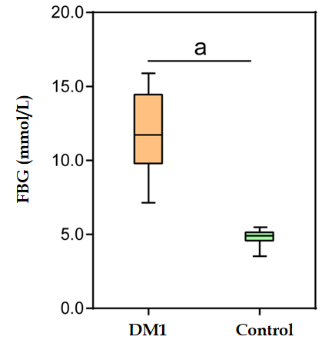
Figure 1 Comparison of the levels of fasting blood glucose between Chinese children with type 1 diabetes mellitus and healthy controls. Data are presented as the mean ± SD. ªP < 0.05, compared with control group. FBG: Fasting blood glucose; DM1: Type 1 diabetes mellitus.
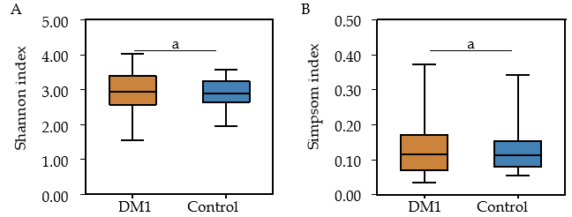
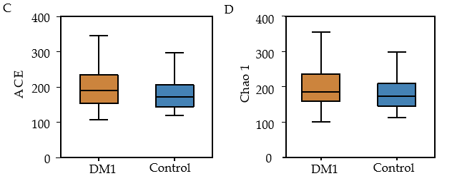
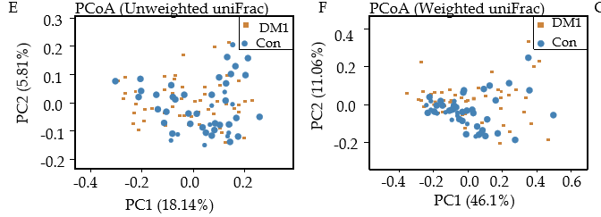
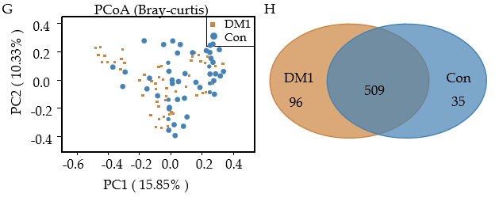
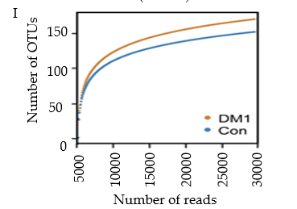
Figure 2 Altered bacterial diversity and richness of the fecal microbiota in Chinese children with type 1 diabetes mellitus. A-D: The diversity indices, such as Shannon (A), and Simpson (B), and the richness indices, such as the abundance-based coverage estimator (C), and Chao1 (D), were used to evaluate the overall structure of the fecal microbiota in patients with type 1 diabetes mellitus (T1DM) and healthy controls. Data are presented as the mean ± standard deviation. Unpaired t-tests (two-tailed) were used to analyze variation between the two groups; E-G: Principal coordinate analysis plots of individual fecal microbiota based on unweighted (E) and weighted (F) UniFrac distance, and Bray–Curtis dissimilarity (G) in patients with T1DM and healthy controls. Each symbol represents a single sample; H: Venn diagram illustrating the overlap of operational taxonomic units (OTUs) in T1DM-associated fecal microbiota between the two groups; I: Rarefaction curves used to estimate the richness (at a 97% level of similarity) of T1DM-associated fecal microbiota between the two groups. The vertical axis shows the expected number of OTUs after sampling the number of tags or sequences shown on the horizontal axis. ªP < 0.05. OTUs: Operational taxonomic units; ACE: Abundance-based coverage estimator; PCoA: Principal coordinate analysis; Con: Control; DM1: Type 1 diabetes mellitus.
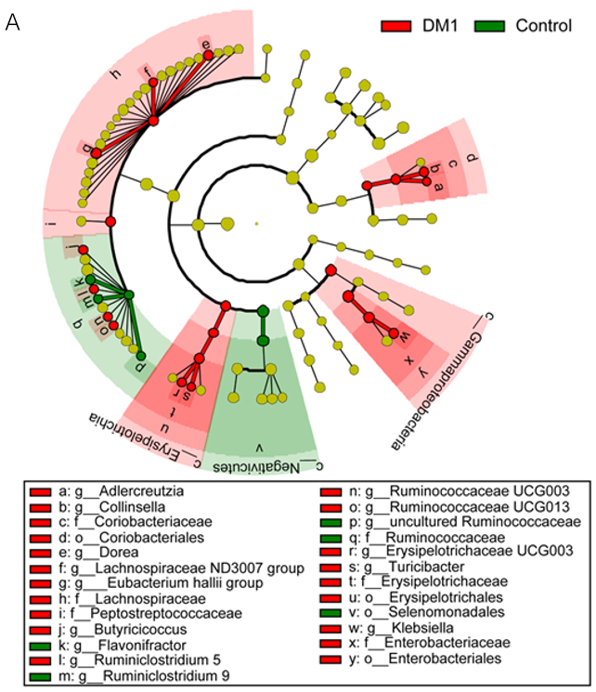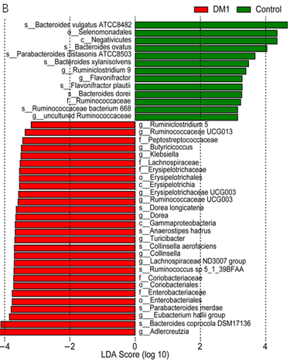
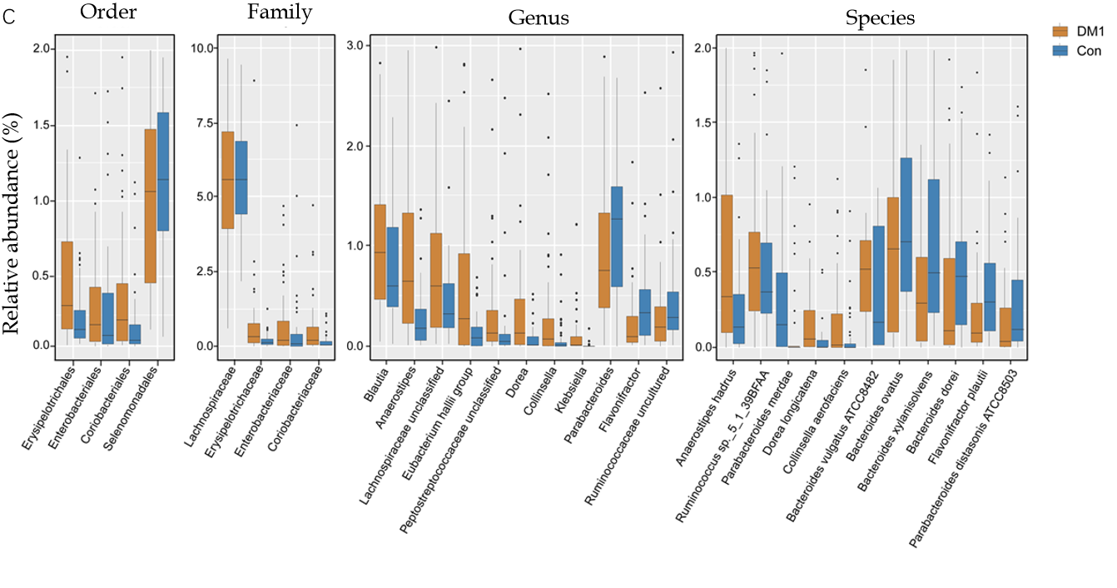

Figure 3 Differential bacterial taxa between Chinese children with type 1 diabetes mellitus and healthy controls. The linear discriminant analysis effect size identifies the taxa with the greatest differences in abundance between children with type 1 diabetes mellitus (T1DM) and healthy controls. A and B: Only the taxa meeting a significant linear discriminant analysis threshold value of > 2 are shown; C: Comparisons of the relative abundance of abundant bacterial taxa at the levels of the order, family, genus, and species. Data are presented as the mean ± SD. Mann–Whitney U-tests were used to analyze variation between children with T1DM and healthy controls. Con: Control; DM1: Type 1 diabetes mellitus.

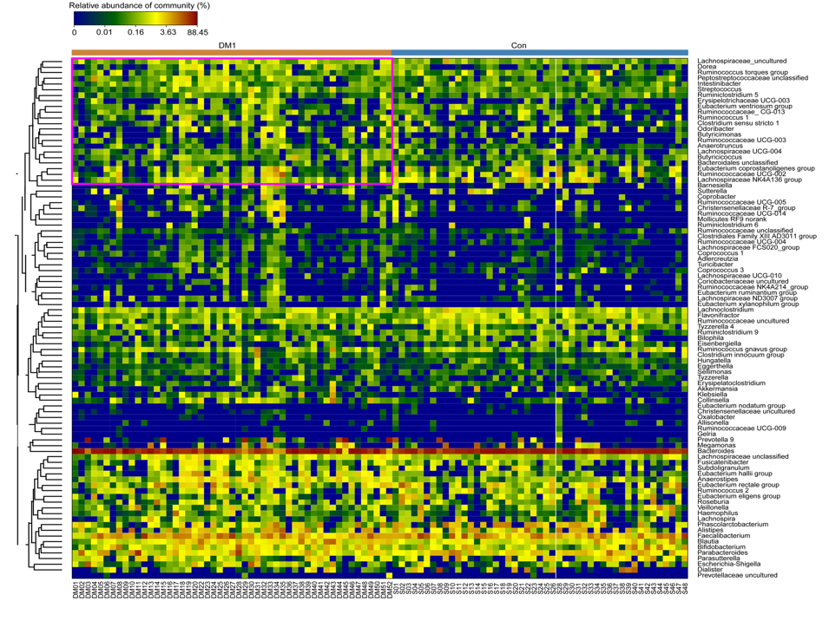
Figure 4 Heatmap of the type 1 diabetes mellitus-associated fecal microbiota at the genus level. The color of the spots in the panel represents the relative abundance (normalized and log10-transformed) of the genus in each sample. Relative abundance of the bacteria in each genus is indicated by a gradient of color from blue (low abundance) to red (high abundance). Genera were organized according to Spearman’s correlation analysis, based on their relative abundances. Taxonomic classifications of the genus are shown on the right.
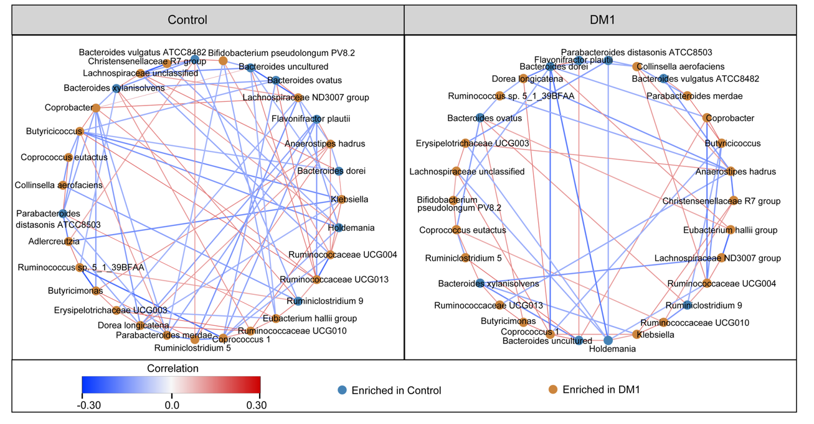
Figure 5 Correlation strengths of the abundant fecal microbiota in Chinese children with type 1 diabetes mellitus and healthy controls. Correlation network of the abundant fecal microbiota in healthy controls and children with type 1 diabetes mellitus (T1DM) is shown. Correlation coefficients were calculated with the sparse correlation for compositional data algorithm. The Cytoscape version 3.4.0 software was used for network construction. Red and blue lines represent positive and negative correlations, respectively. The correlation network became simpler in T1DM. DM1: Type 1 diabetes mellitus.

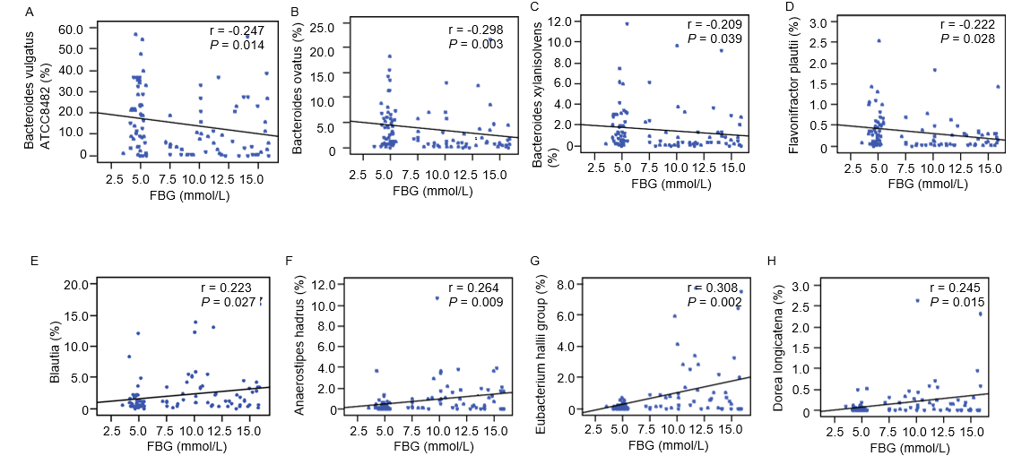
Figure 6 Correlation between key bacteria in type 1 diabetes mellitus-associated fecal microbiota and fasting blood glucose. The different taxa, including Bacteroides vulgatus ATCC8482, Bacteroides ovatus, Bacteroides xylanisolvens, and Flavonifractor plautii, were negatively correlated with fasting blood glucose (FBG), while Blautia, the Eubacterium hallii group, Anaerostipes hadrus, and Dorea longicatena were positively correlated with FBG. Spearman’s rank correlation and probability were used to evaluate statistical significance. A: Bacteroides vulgatus ATCC8482; B: Bacteroides ovatus; C: Bacteroides xylanisolvens; D: Flavonifractor plautii; E: Blautia; F: Anaerostipes hadrus; G: Eubacterium hallii; H: Dorea longicatena. FBG: Fasting blood glucose.
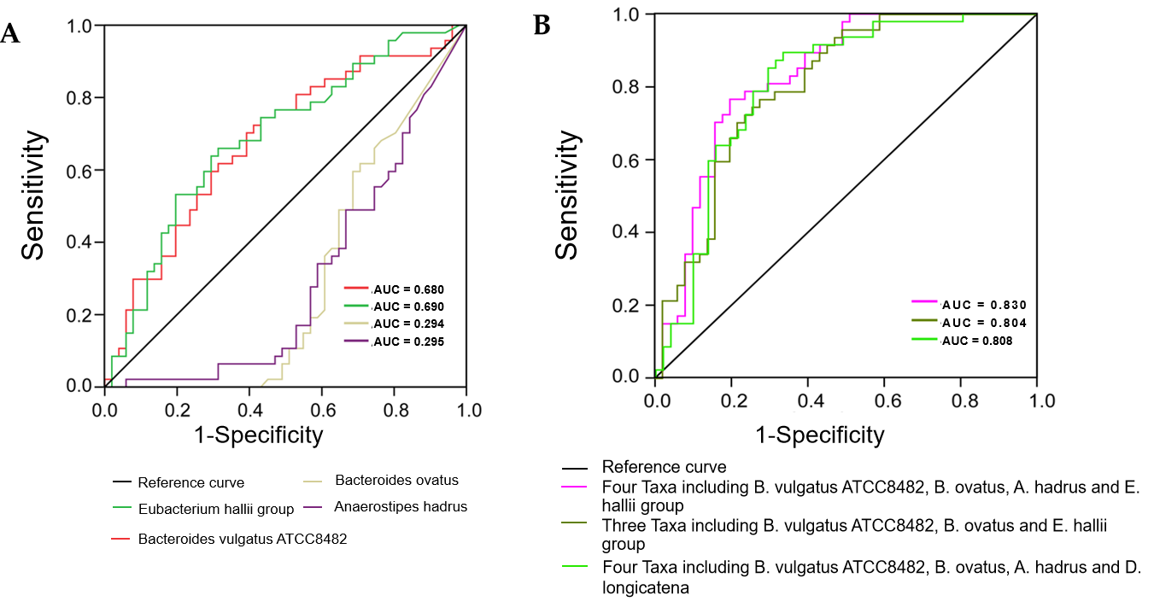
Figure 7 Receiver operating characteristic curves for different taxa, including Bacteroides vulgatus ATCC8482, Bacteroides ovatus, Anaerostipes hadrus, and the Eubacterium hallii group, which were used either alone or in combination to discriminate between patients with type 1 diabetes mellitus and healthy controls. A: Alone; B: Combination. AUC: Area under the curve.
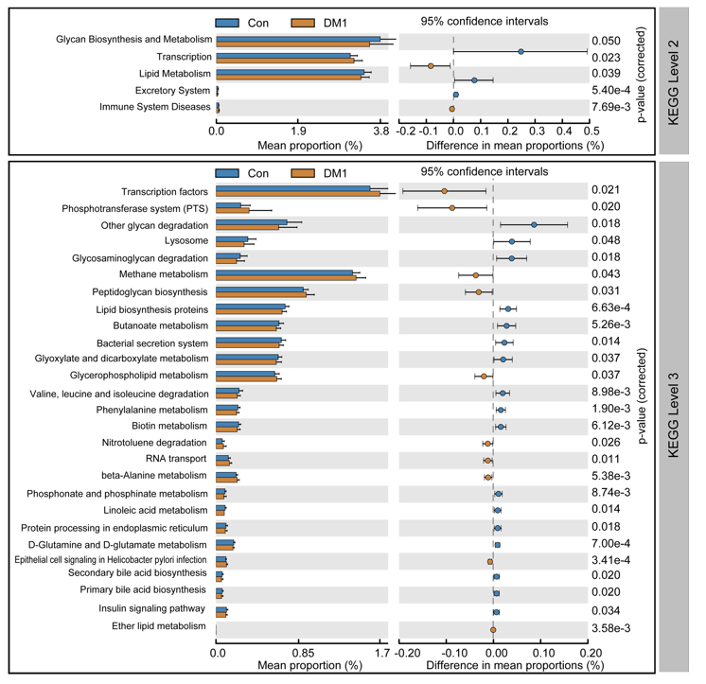
Figure 8 PiCRUSt-based fecal microbiome study among Chinese children with type 1 diabetes mellitus and healthy controls. Different bacterial functions were evaluated based on the two-sided Welch’s t-test. Comparisons between the two groups for each Kyoto Encyclopedia of Genes and Genome functional category (level 2 and level 3) are shown by percentage. The Benjamini–Hochberg method was used for multiple testing correction, based on the false discovery rate using the Statistical Analysis of Metagenomic Profiles software. KEGG: Kyoto Encyclopedia of Genes and Genome; Con: Control; DM1: Type 1 diabetes mellitus.
Table 1 Fundamental information of subjects
Parameter | T1DM children (n = 51) | Healthy controls (n = 47) | P value
Age (yr) | 10.38 ± 3.59 | 9.58 ± 4.35 | 0.284
Gender (male/female) | 24/27 | 21/26 | 0.816
BMI (mean ± SD) | 18.54 ± 4.21 | 18.98 ± 3.26 | 0.732
Age of onset (years, mean ± SD) | 5.58 ± 3.45 | - | -
FBG (mmol/L, mean ± SD) | 11.87 ± 2.75 | 4.83 ± 0.41 | 0.000
Triglycerides (mmol/L, mean ± SD) | 0.95 ± 0.38 | 0.88 ± 0.29 | 0.257
Antibiotics use, n | 0 | 0 | -
Insulin use, n | 51 | 0 | -
Other autoimmune diseases | 0 | 0 | -
T1DM: Type 1 diabetes mellitus; FBG: Fasting blood glucose; BMI: Body mass index; SD: Standard deviation.

