Name of Journal: World Journal of Medical Genetics
ESPS Manuscript NO: 24321
Manuscript Type: Review

Chitosan DNA nanoparticles for oral gene delivery

Patel BJ et al. DNA Nanoparticles for Oral Gene Therapy

Bhavika J Patel, Nithin K Vignesh, Gonzalo Hortelano

Bhavika J Patel, Nithin K Vignesh, Bachelor of Health Sciences, McMaster University, Hamilton, Ontario L8N 3Z5, Canada

Gonzalo Hortelano, Department of Biology, School of Science and Technology, Nazarbayev University, Astana 010000, Kazakhstan

Gonzalo Hortelano, School of Biomedical Engineering, McMaster University, Hamilton, Ontario L8N 3Z5, Canada

Gonzalo Hortelano, Department of Pathology and Molecular Medicine, McMaster University, Hamilton, Ontario L8N 3Z5, Canada

Author contributions: All authors contributed to this paper with conception and design of the study, literature review and analysis, drafting and critical revision and editing, and final approval of the final version.

Conflict-of-interest statement: Non declared.

Open-Access: This article is an open-access article which was selected by an in-house editor and fully peer-reviewed by external reviewers. It is distributed in accordance with the Creative Commons Attribution Non Commercial (CC BY-NC 4.0) license, which permits others to distribute, remix, adapt, build upon this work non-commercially, and license their derivative works on different terms, provided the original work is properly cited and the use is non-commercial. See: http://creativecommons.org/licenses/by-nc/4.0/

Manuscript source: Unsolicited manuscript

Correspondence to: Gonzalo Hortelano, PhD, Department of Biology, School of Science and Technology, Nazarbayev University, Astana 010000, Kazakhstan. gonzalo.hortelano@nu.edu.kz
Telephone: +7-717-2705782

Received: January 17, 2016
Peer-review started: January 18, 2016
First decision: February 29, 2016
Revised: July 20, 2016
Accepted: August 6, 2016
Article in press:
Published online:

Abstract
Gene therapy is a promising technology with potential applications in the treatment of medical conditions, both congenital and acquired. Despite its label as breakthrough technology for the 21st Century, the simple concept of gene therapy – the introduction of a functional copy of desired genes in affected individuals – is proving to be more challenging than expected. Oral gene delivery has shown intriguing results and warrants further exploration. In particular, oral administration of chitosan DNA nanoparticles, one the most commonly used formulations of therapeutic DNA, has repeatedly demonstrated successful in vitro and in vivo gene transfection. While oral gene therapy has shown immense promise as treatment options in a variety of diseases, there are still significant barriers to overcome before it can be considered for clinical applications. In this review we provide an overview of the physiologic challenges facing the use of chitosan DNA nanoparticles for oral gene delivery at both the extracellular and intracellular level. From administration at the oral cavity, chitosan nanoparticles must traverse the gastrointestinal tract and protect its DNA contents from significant jumps in pH levels, various intestinal digestive enzymes, thick mucus layers with high turnover, and a proteinacious glycocalyx meshwork. Once these extracellular barriers are overcome, chitosan DNA nanoparticles must enter intestinal cells, escape endolysosomes, and disassociate from genetic material at the appropriate time allowing transport of genetic material into the nucleus to deliver a therapeutic effect. The properties of chitosan nanoparticles and modified nanoparticles are discussed in this review. An understanding of the barriers to oral gene delivery and how to overcome them would be invaluable for future gene therapy development.

Key words: Gene therapy; Oral gene delivery; Chitosan nanoparticles; pH; Enzymes; Mucus; Glycocalyx; Intracellular transport; Endolysosomal escape; Nuclear transport

© The Author(s) 2016. Published by Baishideng Publishing Group Inc. All rights reserved.

Core tip: Gene therapy is facing considerable challenges to realize its promise, the most important which is arguably achieving effective delivery of the therapeutic gene to the target cells. Therefore, developing alternative delivery strategies is crucial. This manuscript reviews the oral administration of chitosan DNA nanoparticles as a novel gene therapy delivery strategy.

Patel BJ, Vignesh NK, Hortelano K. Chitosan DNA nanoparticles for oral gene delivery. World J Med Genet 2016; In press

INTRODUCTION
Gene therapy, broadly understood as the delivery of nucleic acids for therapeutic purposes, has therapeutic potential for a number of medical conditions. Since its first clinical trials in 1990, gene therapy research has made a number of advancements^{[1]}. Despite its tribulations there has been some success, such as the treatment of immunodeficiencies through retroviral and lentiviral transduction of stem cells^{[2]}, X-linked adrenoleukodystrophy through lentiviral transduction^{[3]}, hemophilia through Adeno-associated virus delivery^{[4]}, as well as the use of transduced T cells as a treatment for leukemia^{[5]}. Due to low cell survival upon transplantation and logistics inherent to ex vivo cell therapy, nucleic acids (including DNA, antisense oligonucleotides, and RNA interference systems) are typically delivered using viral vectors because of the high expression they induce in target cells^{[6]}. However, the ability of viral vectors to transduce cells and induce transgene expression may also trigger immune responses, and the potential activation of cancer-promoting genes in the case of integrating viral vectors^{[7]}. The safety of current gene therapy delivery systems, particularly that of integrating vectors is still not fully studied^{[8]}. Non-viral gene delivery lags behind viral vectors in targeting efficacy and transgene expression, which can be enhanced using mechanical techniques (e.g., use of electroporation or ultrasound) or chemical carriers (e.g., use of lipid, peptides, or polymers that protect the genetic material)^{[9]}. The use of non-viral DNA formulations for oral gene delivery is an area of active research interest^{[10]}.
Oral gene delivery via chemical carriers has the potential to treat a number of inherited and acquired diseases^{[11]}. The gastrointestinal (GI) tract’s large surface area provides a massive number of cells that can be potentially targeted. Successful delivery of therapeutic material to the GI is not restricted to the treatment of intestinal diseases such as inflammatory bowel disease, intestinal cancers, and intestinal symptoms of cystic fibrosis, but could also be potentially used as a treatment for systemic diseases (such as hemophilia) using the extensive capillary network for efficient distribution of the transgenes^{[6]}. Additionally, effective exogenous DNA targeting of the intestinal stem cells in the crypts of Lieberkuhn in a stable manner could lead to potential long-term therapeutic gene expression^{[6]}.
Despite such therapeutic potential, oral gene delivery must first overcome formidable extracellular and intracellular barriers in the GI tract. These include stomach acidity, glycocalyx, mucus, cell-uptake, endolysosomal escape, and nuclear import. The coupling of nucleic acids to polymers may assist in some of these challenges. Chitosan, a deacetylated form of chitin (Figure 1), which is derived from crustacean, has been shown to be an appropriate chemical polymer for overcoming such barriers. In addition to biodegradable and biocompatible properties^{[12]}, this α(1-4)2-amino 2-deoxy β-glycan can efficiently compact DNA and has mucoadhesive and absorptive properties, buffering capacity, and membrane perturbing properties that make it a promising vehicle for oral gene delivery^{[13]}. This review discusses the various extracellular and intracellular barriers of oral gene delivery and how they can be overcome using chitosan and chitosan-modified nanoparticles.

EXTRACELLULAR BARRIERS
Free DNA is quickly denatured by the acidic pH in the stomach and intestinal and cellular enzymes, so it would have no therapeutic effect^{[6]}. However, chitosan-coupled therapeutic DNA sequences formulated as chitosan nanoparticles are effectively protected from various physiological and cellular barriers.

Acidity
pH varies greatly in the gastrointestinal tract, ranging from the extremely acidic stomach (mean pH 1.7) to the slightly alkaline ileum (mean pH 7.5) (see Figure 2A)^{[14-16]}. Chitosan nanoparticles have been shown to protect enclosed nucleic acids across a wide range of pH. In the harsh stomach acid^{[17,18]} increased electrostatic interactions between positively charged chitosan and negatively charged DNA creates a more stable nanoparticle (Figure 2B). It is chitosan’s amino-group with a pKa of 6.5 (Figure 1B) that accounts for protonation of the polymer at pHs below 6.5, and the resulting binding affinity between cationic chitosan and anionic DNA^{[19]}.
As nanoparticles transit towards the small intestine, pH increases drastically from 1.7 in the stomach to 6.1 and 6.6 in the duodenum and jejunum respectively^{[14,15]}. During this shift, chitosan’s amino groups are deprotonated, decreasing chitosan’s binding affinity for DNA^{[19,20]}. Nanoparticle stability is slightly reduced, achieving an effective balance between DNA association and dissociation. It is at pH 6.8 and 7.0 that transfection efficiency of chondrocytes peaked^{[21]}. Interestingly however, Roy et al^{[17]} reported transfection of stomach tissue by chitosan nanoparticles.
As the pH continues to climb distally in the intestine, chitosan deprotonates further until it is neutral. Neutral chitosan nanoparticles are quite unstable as they easily dissociate from DNA and begin to aggregate with themselves, no longer inhibited by positive-positive repulsive forces (Figure 2B)^{[21,22]}. Transfection efficiency also decreases at these high pH levels as has been demonstrated in human-lung carcinoma A549 cells (transfection at pH 7.6 < transfection at pH 6.9)^{[23]} and HEK 293 cells (transfection at pH 7.6 < transfection at pH 6.5)^{[20]}.
Therefore, chitosan (pKa 6.5) is able to withstand a wide pH range from 1.5 (highly stabilized) to 6.8 (intermediate stability – optimal for transfection), before becoming destabilized and aggregating. In support of this model, ex vivo experiments on gastrointestinal tissue internalization of chitosan nanoparticles found internalization to be higher for the jejunum (pH 6.6) than the ileum (pH 7.5 – too basic) and duodenum (pH 6.1 – too acidic)^{[24]}.

Mucus
The gastrointestinal mucus, composed of mucin fibers linked to various proteoglycans^{[25]}, is constantly produced, secreted and shed. This rapid turnover combined with the thickness of the mucus layer (greatest in the colon at 830 μm) must be overcome by chitosan nanoparticles for effective oral gene delivery^{[26]}. There are three main mechanisms that have been explored.
For a long time mucoadhesion was thought to improve absorption by extending nanoparticle residence time in the GI tract and increasing bioavailability of nanoparticles for passive paracellular uptake^{[12,27]}. Therefore, researchers sought to improve mucoadhesion by formulating nanoparticles capable of greater interactions with mucus through electrostatic bonds, hydrogen bonds, hydrophobic interactions, and van der Waals forces^{[28]}. Chitosan is reported to have strong mucoadhesive properties^{[27]}. However mucoadhesion, on its own, will not solve this barrier to oral gene delivery, and may in fact impede drug delivery. This is because despite optimal mucoadhesion, nanoparticle delivery is limited by the rapid turnover time of mucus (50 to 270 min)^{[29]} during which the luminal layer of mucus is sloughed off taking the adherent nanoparticles with it (Figure 3)^{[27]}.
Mucopenetration, or the ability to traverse the mucus layer (Figure 3), has become the focus of overcoming the mucosal barrier in the last few years. Mucopenetration is achieved by creating a “slippery” nanoparticle that, in contrast to mucoadhesion, has decreased interactions with mucus^{[30]}. Chitosan was combined with hydrophilic 5 kDa polyethylene glycol (PEG) which would have decreased interactions with hydrophobic mucus and would not be sterically hindered^{[30]}. Nanoparticles with greater PEGylation permeated fresh mucus 5-fold compared with non-PEGylated nanoparticles (Figure 4A)^{[30]}. Pereira et al^{[31]} combined chitosan with chondroitin sulphate to create a densely charged but overall neutral nanoparticle surface that would theoretically have minimal interactions with mucus. Chitosan chondroitin sulphate nanoparticles permeated to a greater depth (4-6 mm) of fresh undiluted porcine intestinal mucus compared with PDLG “purasorb” chitosan nanoparticles (Figure 4B)^{[31]}. Importantly, mucopenetration research remains in its early stages and further studies are required. To our knowledge no studies evaluating the effect of pDNA on the performance of chitosan nanoparticles modulated for mucopenetration have been conducted. This would be important to assess in the future.
Finally disruption of the mucosal layer can be achieved by combining nanoparticles with mucolytic agents (Figure 3). Studies have shown enhanced mucodisruption ability of nanoparticles when combined with mucolytic molecules (N-acetylcystein, L-cysteine, sulfhydryl compounds)^{[32]} and mucolytic enzymes (papain, bromelain, trypsin)^{[33]}. These studies, however were not conducted with chitosan. With the mucodisruption technique, reversibility of mucolysis must continue to be assessed in order to ensure that the intestinal mucus is not completely damaged and that it retains its protective function against viruses and pathogens^{[32]}.

Enzymes
Administered genes are exposed to the harsh environment of the GI lumen, filled with resident degrading enzymes, those secreted into the lumen and those membrane bound^{[34]}. Unavoidably, therapeutic nanoparticles are also subject to the degradation processes of these enzymes and thus, pose a barrier that must be dealt with to improve the efficacy of oral gene delivery^{[34]}.
Conjugation of enzyme inhibitors with carrier vehicles was proposed a long time ago^{[35]} and has been explored using a variety of enzyme inhibitors^{[36]}. These inhibitor conjugated chitosan nanoparticles have been shown to protect a variety of drug molecules (including pDNA^{[34,37]}, insulin^{[38-40]}, and calcitonin^{[41-44]}) and thereby promote therapeutic effect (Table 1). For oral gene delivery, inhibiting nuclease destruction of genetic material is most important and can be accomplished using the following inhibitors (ranked by efficacy): Ethylendiaminetetraacetic acid (EDTA) > sodium dodecyl sulphate (SDS) > aurintricarboxylic acid (ATA) > and poly(acrylic acid) (PAA)^{[37]}. Loretz et al^{[37]} demonstrated that 50% of pDNA was protected from nuclease destruction when complexed with EDTA-conjugated chitosan. This is compared to almost complete destruction of unprotected pDNA^{[37]}. EDTA-chitosan nanoparticles also have 35% improved transfection efficiency in Caco-2 cells compared with unmodified chitosan nanoparticles^{[45]}. Similarly, Martien et al^{[34]} demonstrated almost complete protection of pDNA from lysozyme and deoxyribonuclease when packaged in ATA-chitosan conjugated nanoparticles compared with unmodified chitosan nanoparticles (complete destruction with both lysozyme and deoxyribonuclease. Conjugation of enzyme inhibitors to chitosan involves the formation of a covalent bond between a carboxylic acid group on the inhibitor and free amino acids on chitosan. Notably, the covalent conjugation ensures that the inhibitor is not orally absorbed^{[37]} and reduces the toxicity and side effects. This is supported by LDH-release cytotoxicity tests on Caco-2 cells that showed significantly less toxicity (< 1% over 4 h) for chitosan-EDTA particles and polymers compared with unmodified chitosan particles and polymers^{[45]}. It is important to note that prolonged administration of enzyme inhibitors has severe side effects including pancreatic hyperplasia and carcinoma and thus chronic effects of inhibitor-conjugated chitosan nanoparticles must be explored^{[46]}.

Glycocalyx
The fibrous brush border glycocalyx (FBBG) is a 400-500 nm thick glycoprotein network that covers the apical surface of intestinal epithelial cells, particularly enterocytes (Figure 5). As visualised through high resolution scanning electron microscopy, the FBBG consists of mucin-like glycoproteins^{[47]} that originate from the tips of tightly packed microvilli and anastomose with neighbouring glycoproteins^{[48]}. The resulting intricate mesh has the potential to affect transfection efficiency of chitosan nanoparticles. The mechanism by which this would occur is unclear as existing data is mixed.
Originally, the glycocalyx was theorized to act as a size-selective diffusion barrier, with pores between 7.4 and 28.8 nm wide, allowing only appropriately sized particles to pass through and access transmembrane receptors located on microvilli^{[49]}. More recent studies however have demonstrated that the glycocalyx does not have a diffusion effect on drug delivery (in particular insulin) but rather has a digestive effect on the therapeutic molecule due increased concentration of digestive enzymes at the FBBG^{[50]}. More research is required to better understand this potential barrier to oral gene delivery.
The data on how to overcome the intestinal glycocalyx barrier for improved drug delivery is also mixed. Some studies promote the theory that increased interaction with glycocalyx layer, similar to that of bacteria and viruses, promotes effective drug delivery due to increased bioavailability of drugs at the apical membrane^{[49]}. In contrast, other research demonstrates that electrostatic interactions between anionic glycocalyx and cantionic nanoparticles would decrease nanoparticle charge, stimulate premature released of DNA, and cause DNA relaxation^{[51]}. Overall, more research is required on the glycocalyx and its impact on transfection efficiency of nanoparticles.

INTRACELLULAR BARRIERS
Transport and cellular uptake
The process of cellular uptake of the nanoparticle is critical, such that its genetic component is internalized and functionally available to elicit the desired biological effect. In addition to the key effect of pH on transfection^{[52]} nanoparticles are internalized via a receptor-mediated endocytosis^{[53,54]}. However, it is important to note that nanoparticles of different formulations – and sizes - may not necessarily share the same mechanism for cell entry^{[55]}. Thus, chitosan may have the ability to interact with the cell membrane via electrostatic forces leading to an energy dependent adsorptive endocytosis process. Additionally, Nam et al^{[55]} showed that the uptake process of chitosan nanoparticles involved multiple distinct pathways, including the clathrin-mediated endocytosis, macropinocytosis and calveolae-mediated endocytosis. Further, they showed that each pathway was independent from the other.
In addition to delivering therapeutic nucleic acids to intestinal cells, ingested chitosan nanoparticles may also reach more distal sites by crossing the intestinal epithelium and entering the circulation system. This may be achieved through paracellular and/or transcellular transport of nanoparticles^{[56]}.
Paracellular transport is improved by chitosan’s permeation enhancing properties. Positively charged chitosan interacts with tight junction proteins (occludin, ZO-1, and F-actin) and destabilizes plasma membranes to decrease the trans-epithelial electrical resistance (TEER) of cell monolayers^{[54]}. Increased paracellular transport of macromolecules such as insulin^{[57]} has been shown to consistently occur when chitosan is in solution. The permeability influence of chitosan-nanoparticles is less conclusive, but a study by Vllasaliu et al^{[58]} showed that both chitosan and chitosan nanoparticles are effective at opening tight-junctions. Chitosan permeability depends on electrostatic interactions between chitosan and tight junction proteins, and thus, the pore-opening process may be affected by the degree of deacetylation and surface area of charge exposed on chitosan nanoparticles^{[58]}. Further, nanoparticle size may inhibit paracellular transport due to maximal widening of tight-junction pores^{[58]}. Thus far, few safety issues have been identified with chitosan’s ability to traverse across the intestinal epithelium. This is because chitosan’s ability to open tight junctions is reversible^{[58]}, and because common negatively charged GI endotoxins (such as lipopolysaccharide) are unable to cross the intestinal epithelium along with chitosan nanoparticles^{[59]}.
Transcellular transport may occur through transcytosis^{[60]}, which involves cellular uptake (pinocytosis, clatharin-mediated endocytosis, discussed earlier) at the apical membrane, transport across the cell interior, and release at the basolateral pole^{[56]}. Although M-cells make up only 1% of the total intestinal surface, it is believed that most transcytosis occurs with these cells due to higher rates of endocytosis^{[56]}. Transcytosis efficiency decreases with nanoparticle size^{[56]} and increases with nanoparticle stability^{[61]}.

Endolysosome escape
DNA escape from the endolysosomal pathway is a key barrier to chitosan gene delivery. It is theorized that chitosan nanoparticles may escape from endosomes through a “Proton Sponge Effect”^{[62,63]}. According to this theory, endocytosed chitosan nanoparticles become protonated upon fusion with acidic lyososomes. This is followed by an influx of cytosolic H⁺, Cl⁻ and H₂O, to maintain the endosomal pH, charge, and osmolarity, respectively^{[64]}. Such influx causes the lysosome to swell and rupture, thereby releasing nanoparticles into the cell cytosol (Figure 6)^{[64]}. Although the proton sponge effect is supported by cationic polymers with strong buffering capacities (e.g., PEI) chitosan has a relatively low buffering capacity over a narrow pH range (pH 5-7)^{[65]}. This makes it a poor “proton-sponge” at endosomal pH, only having a limited influx of protons^{[65]}. This is reflected in its delayed endosomal escape and transfection, observed in HEK 293 cells treated with chitosan and PEI^{[65]}. Chitosan endosomal rupture occurred at 72 h-post-treatment, compared with PEI’s escape within 24 h post-treatment^{[65]}, a delay perhaps required for a sufficient amount of chitosan to accumulate to induce a proton-sponge rupture.
Proton sponge endosomal escape can be enhanced through the addition of high buffering-capacity groups. For example, studies have examined the effect of the biocompatible and buffering imidazole ring (pKa 6.15) on the release of chitosan nanoparticles into the cytoplasm^{[66]}. In separate studies, increased expression was observed for chitosan-graft-histadine^{[67]} and chitosan-graft-urocanic acid^{[66]}, both of which bear the imidazole ring. Although expression was improved relative to chitosan, improvement was cell-specific and neither complex was able to reach the expression-levels of lipofectamine^{[67,68]}. Confocal microscopy and treatment with bafilomycin A (proton pump inhibitor) confirmed that histadine’s effect occurs due to improved endosomal escape of complexes^{[67]}. Multiple experiments have also been conducted on PEI-chitosan hybrids including chitosan/PEI mixes and chitosan-graft-PEI systems. PEI is an effective non-viral vector due to its high buffering capacity (multiple amino groups) and enhanced endosomal escape properties^{[68]}. However, PEI’s effect is limited in vivo, due to its cytotoxicity in multiple cell lines^{[69]}. Thus, combining PEI with chitosan, known for its biocompatibility and biodegradability, has shown to be particularly effective with synergistic results^{[68]}. Compared with PEI, chitosan-graft-PEI has higher transfection efficiency in vitro and in vivo (Figure 8A)^{[70]}, and has decreased cytotoxicity across three cell lines (293 T, HeLa and HepG2)^{[71]}. Transfection efficiency even reached that of lipofectamine in the human HEK293 cell line^{[71]}.
In addition to the described proton-sponge effect, there are other means by which nanoparticles escape from endosomes. Membrane destabilization by chitosan is supported by experiments tracking endocytosed nanoparticles^{[72,73]}. In these experiments, some DNA is released from early endosomes^{[72]} before the proton-sponge effect can be triggered by acidic lysosomes. Modifications to improve chitosan’s membrane perturbant properties include addition of chloroquine^{[74]}, poly(propylacrylic acid)^{[75]}, and synthetic peptides^{[76]}. Synthetic peptides are pH sensitive, changing conformation from random coils (at physiological pH) to alpha helices (at endosomal acidity) that interact with and destabilize the membrane through pore-formation^{[77]}. Second, free chitosan polymer may also aid endosomal escape. Unlike protonated nanoparticles (stabilized by DNA) that decrease in volume, free chitosan expands from its coiled form due to repulsive forces^{[78]}. This directly increases osmotic pressure and leads to endosomal rupture^{[78]}. Thibault et al^{[79]} added free chitosan at different time-points to HEK 293 cells already treated with inefficient chitosan nanoparticles (< 5 N:P levels)^{[79]}. Addition of free chitosan at 4 and 8 h post-nanoparticle treatment resulted in a near 100% rescue of transfection, reaching similar levels to the optimal N:P of 5^{[79]}.

DNA-release
In addition to the protective role of chitosan discussed above it is also important for chitosan to have a timely release of DNA. Nanoparticles of intermediate stability, associated with intermediate molecular weight and degree of deacytylation appropriately release DNA in synchrony with lysosomal escape and achieve efficient transfection^{[80]}. This is in contrast to the inefficient transfection ability of hyperstabilised and hypostabilized nanoparticles. Up to 80% of hyperstabilized nanoparticles (high molecular weight and degree of deacetylation) remained associated after lysosomal escape, and were too large to enter the nucleus^{[80]}. Hypostabilized nanoparticles (low molecular weight and/or degree of deacetylation) dissociated prematurely before endolysosomal escape and were degraded^{[80]}. Thus, chitosan nanoparticles of intermediate stability are optimal for timely release of DNA and efficient transfection.

Nuclear Import
In order to have a therapeutic effect, DNA must then enter the nucleus and be accessible to transcriptional enzymes, while siRNA – but not DNA coding for siRNA- exerts its inhibitory function in the cytoplasm. Considering that the majority of GI cells (e.g., enterocytes, goblet cells, paneth cells) are post-mitotic, genetic material must pass through nuclear pores, as opposed to waiting for the nuclear envelope to disintegrate during cell division. Import of material (> 40kDa) through the nuclear pore occurs through indirect active transport^{[81]}. It involves interactions between importins and proteins containing nuclear localization signal (NLS) (Figure 7A).
Therefore, enhanced nuclear import of pDNA is an important goal. Sequences where NLS-containing proteins bind are often added to therapeutic pDNA. The 72bp SV40 enhancer sequence upon which many mammalian transcription factors (AP1, AP2, NF-kb, Oct1, TEF1, each containing NLS sequences) bind has been used to enhance the import of perinuclear localized pDNA into the nucleus through interaction with importin proteins^{[80,82]}. Opanasopit et al^{[83]} showed increased transfection efficiency of nanoparticles containing DNA and NLS-containing peptides. Additionally, it is possible to enhance gene expression by covalently complex NLS-containing proteins onto the pDNA strand itself^{[83]}. However, it is important for the protein’s interaction with pDNA to be spatially distinct from its NLS-binding sequence so that importins are not sterically hindered from binding (Figure 7B).
Interestingly, some evidence exists for nuclear import of entire chitosan/DNA complexes. Zhao et al^{[84]} found increased localization of complexes when a synthetic protein, containing SV40 NLS signal, was covalently linked to chitosan. Further addition of kinases promoted intra-nuclear disassociation and improved transfection efficacy beyond that of lipofectamine^{[84]}. Chitosan localized in the nucleus did not interfere with gene expression^{[73]}.

Immune response
Chitosan is a biodegradable polysaccharide that has been administered to individuals without any adverse side effects^{[85]}. Chitosan is also naturally degraded through lysosome digestion according to its molecular weight and degree of deacetylation. These characteristics of chitosan have triggered the utilization of chitosan as an adjuvant in vaccines^{[86]}. The viscous nature of chitosan promotes the formation of an antigen depot. Injection of antigen with chitosan resulted in 60% of the antigen remaining at the injection site for 7 d whereas less than 9% of the antigen remained after 8 h when it was administered with saline^{[86]}. In combination with antigens, chitosan has been demonstrated to induce activation of NK cells, macrophages, inducing cytokines, stimulating antibody production and cytotoxic T lymphocyte responses^{[87]}. Chitosan has been shown to elicit a combination TH1/TH2 response, thus promoting both humoral and cell mediated immunity. The increased immune response has been reported to produce a high titer antibody response to the antigen^{[88]}.
When dealing with oral vaccination, the uptake by the Peyer’s patch is a crucial step in stimulation an immune response. Studies have developed chitosan particles that have the optimal size and zeta potential to be targeted to the M-cells of the Peyer’s patch^{[89]}. Particles that are < 10 µm are taken up by M-cells while those < 5 µm can be transported to the spleen or local lymph nodes to stimulate IgM and IgG production^{[89]}. As a result, chitosan promises to serve as a carrier system of antigens and/or antigen-coding genetic material to act as an adjuvant in vaccinations to enhance both cell mediated as well as humoral immune responses. However, chitosan’s immunomodulatory effects have also been shown in studies that utilize the nasal administration of chitosan to induce the immune system^{[90]}. Chitosan is also a viable vehicle to be used in oral administration due to its adhesive and transport properties^{[17]}. Its stability when complexed with DNA make it suitable for the delivery of the cargo to the M-cells of the GI-tract, allowing for the generation of both mucosal as well as systemic immunity^{[17]}. The immunity of chitosan nanoparticles has also been exploited to induce oral tolerance. Goldmann et al^{[91]} fed mice with oral nanoparticles complexed to ovalbumin (OVA) DNA. Despite OVA being a very good antigen, the nanoparticle treatment suppressed a humoral response after subsequent exposure to OVA protein. The authors noticed a shift from TH₁ to a TH₂/TH₃ together with the induction of OVA-specific regulatory T cells^{[91]}. The same group took this work a step further by protecting mice against abdominal aortic transplantation after feeding mice with chitosan nanoparticles containing DNA coding for k(b), one of the MHC-I molecules of the donor^{[92]}. These results open new applications for oral chitosan nanoparticles.

CONCLUSION
Oral delivery of genes specifically is an intriguing technique to treat GI pathologies as well as other chronic systemic diseases such as haemophilia^{[12,18]}. However, it should be noted that hormone related disorders are much more challenging to treat due to the strict regulation the protein expression and the systemic affect that many hormones exhibit. While oral gene therapy has shown immense promise as treatment options in a variety of diseases, there are still significant barriers to overcome before it can be considered for clinical applications. By modulating the physical and chemical characteristics of the nanoparticle both extracellular and intracellular barriers may be circumvented. By judicious design of the nanoparticles therapeutic potential for the targeting of many systemic diseases may be possible. Further research in this field is required in order to develop in the future chitosan nanoparticles of viable clinical use.

ACKNOWLEDGEMENTS
The authors thank the Canadian Hemophilia Society Bayer Inc. and Nazarbayev University ORAU for their supporting to this work.

REFERENCES
- Herzog RW, Cao O, Srivastava A. Two decades of clinical gene therapy--success is finally mounting. Discov Med 2010; 9: 105-111 [PMID: 20193635]
- Fischer A, Hacein-Bey-Abina S, Cavazzana-Calvo M. Gene therapy of primary T cell immunodeficiencies. Gene 2013; 525: 170-173 [PMID: 23583799 DOI: 10.1016/j.gene.2013.03.092]
- Cartier N, Hacein-Bey-Abina S, Bartholomae CC, Veres G, Schmidt M, Kutschera I, Vidaud M, Abel U, Dal-Cortivo L, Caccavelli L, Mahlaoui N, Kiermer V, Mittelstaedt D, Bellesme C, Lahlou N, Lefrère F, Blanche S, Audit M, Payen E, Leboulch P, l'Homme B, Bougnères P, Von Kalle C, Fischer A, Cavazzana-Calvo M, Aubourg P. Hematopoietic stem cell gene therapy with a lentiviral vector in X-linked adrenoleukodystrophy. Science 2009; 326: 818-823 [PMID: 19892975 DOI: 10.1126/science.1171242]
- Nathwani AC, Tuddenham EG, Rangarajan S, Rosales C, McIntosh J, Linch DC, Chowdary P, Riddell A, Pie AJ, Harrington C, O'Beirne J, Smith K, Pasi J, Glader B, Rustagi P, Ng CY, Kay MA, Zhou J, Spence Y, Morton CL, Allay J, Coleman J, Sleep S, Cunningham JM, Srivastava D, Basner-Tschakarjan E, Mingozzi F, High KA, Gray JT, Reiss UM, Nienhuis AW, Davidoff AM. Adenovirus-associated virus vector-mediated gene transfer in hemophilia B. N Engl J Med 2011; 365: 2357-2365 [PMID: 22149959 DOI: 10.1056/NEJMoa1108046]
- Ramos CA, Savoldo B, Dotti G. CD19-CAR trials. Cancer J 2004; 20: 112-118 [PMID: 24667955 DOI: 10.1097/PPO.0000000000000031]
- O'Neill MJ, Bourre L, Melgar S, O'Driscoll CM. Intestinal delivery of non-viral gene therapeutics: physiological barriers and preclinical models. Drug Discov Today 2011; 16: 203-218 [PMID: 21262379 DOI: 10.1016/j.drudis.2011.01.003]
- Cavazzana-Calvo M, Thrasher A, Mavilio F. The future of gene therapy. Nature 2004; 427: 779-781 [PMID: 14985734 DOI: 10.1038/427779a]
- Rothe M, Schambach A, Biasco L. Safety of gene therapy: new insights to a puzzling case. Curr Gene Ther 2014; 14: 429-436 [PMID: 25245088 DOI: 10.2174/1566523214666140918110905]
- Niidome T, Huang L. Gene therapy progress and prospects: nonviral vectors. Gene Ther 2002; 9: 1647-1652 [PMID: 12457277 DOI: 10.1038/sj.gt.3301923]
- Junquera E, Aicart E. Recent progress in gene therapy to deliver nucleic acids with multivalent cationic vectors. Adv Colloid Interface Sci 2016; 233: 161-175 [PMID: 26265376 DOI: 10.1016/j.cis.2015.07.003]
- Dolgin E. Immunology: Oral solutions. Nature 2014; 515: S166-S167 [PMID: 25427208 DOI: 10.1038/515S166a]
- Hejazi R, Amiji M. Chitosan-based gastrointestinal delivery systems. J Control Release 2003; 89: 151-165 [PMID: 12711440 DOI: 10.1016/S0168-3659(03)00126-3]
- Mao S, Sun W, Kissel T. Chitosan-based formulations for delivery of DNA and siRNA. Adv Drug Deliv Rev 2010; 62: 12-27 [PMID: 19796660 DOI: 10.1016/j.addr.2009.08.004]
- Dressman JB, Berardi RR, Dermentzoglou LC, Russell TL, Schmaltz SP, Barnett JL, Jarvenpaa KM. Upper gastrointestinal (GI) pH in young, healthy men and women. Pharm Res 1990; 7: 756-761 [PMID: 2395805 DOI: 10.1023/A: 1015827908309]
- Evans DF, Pye G, Bramley R, Clark AG, Dyson TJ, Hardcastle JD. Measurement of gastrointestinal pH profiles in normal ambulant human subjects. Gut 1988; 29: 1035-1041 [PMID: 3410329 DOI: 10.1136/gut.29.8.1035]
- Kong F, Singh RP. Disintegration of solid foods in human stomach. J Food Sci 2008; 73: R67-R80 [PMID: 18577009 DOI: 10.1111/j.1750-3841.2008.00766.x]
- Roy K, Mao HQ, Huang SK, Leong KW. Oral gene delivery with chitosan--DNA nanoparticles generates immunologic protection in a murine model of peanut allergy. Nat Med 1999; 5: 387-391 [PMID: 10202926 DOI: 10.1038/7385]
- Dhadwar SS, Kiernan J, Wen J, Hortelano G. Repeated oral administration of chitosan/DNA nanoparticles delivers functional FVIII with the absence of antibodies in hemophilia A mice. J Thromb Haemost 2010; 8: 2743-2750 [PMID: 20961391 DOI: 10.1111/j.1538-7836.2010.04116.x]
- Köping-Höggård M, Mel'nikova YS, Vårum KM, Lindman B, Artursson P. Relationship between the physical shape and the efficiency of oligomeric chitosan as a gene delivery system in vitro and in vivo. J Gene Med 2003; 5: 130-141 [PMID: 12539151 DOI: 10.1002/jgm.327]
- Lavertu M, Méthot S, Tran-Khanh N, Buschmann MD. High efficiency gene transfer using chitosan/DNA nanoparticles with specific combinations of molecular weight and degree of deacetylation. Biomaterials 2006; 27: 4815-4824 [PMID: 16725196 DOI: 10.1016/j.biomaterials.2006.04.029]
- Zhao X, Yu SB, Wu FL, Mao ZB, Yu CL. Transfection of primary chondrocytes using chitosan-pEGFP nanoparticles. J Control Release 2006; 112: 223-228 [PMID: 16556468 DOI: 10.1016/j.jconrel.2006.01.016]
- Strand SP, Danielsen S, Christensen BE, Vårum KM. Influence of chitosan structure on the formation and stability of DNA-chitosan polyelectrolyte complexes. Biomacromolecules 2005; 6: 3357-3366 [PMID: 16283766 DOI: 10.1021/bm0503726]
- Sato T, Ishii T, Okahata Y. In vitro gene delivery mediated by chitosan. effect of pH, serum, and molecular mass of chitosan on the transfection efficiency. Biomaterials 2001; 22: 2075-2080 [PMID: 11432586 DOI: 10.1016/S0142-9612(00)00385-9]
- Behrens I, Pena AI, Alonso MJ, Kissel T. Comparative uptake studies of bioadhesive and non-bioadhesive nanoparticles in human intestinal cell lines and rats: the effect of mucus on particle adsorption and transport. Pharm Res 2002; 19: 1185-1193 [PMID: 12240945 DOI: 10.1023/A: 1019854327540]
- Bowman K, Leong KW. Chitosan nanoparticles for oral drug and gene delivery. Int J Nanomedicine 2006; 1: 117-128 [PMID: 17722528 DOI: 10.2147/nano.2006.1.2.117]
- Atuma C, Strugala V, Allen A, Holm L. The adherent gastrointestinal mucus gel layer: thickness and physical state in vivo. Am J Physiol Gastrointest Liver Physiol 2001; 280: G922-G929 [PMID: 11292601]
- Lai SK, Wang YY, Hanes J. Mucus-penetrating nanoparticles for drug and gene delivery to mucosal tissues. Adv Drug Deliv Rev 2009; 61: 158-171 [PMID: 19133304 DOI: 10.1016/j.addr.2008.11.002]
- Lai SK, O'Hanlon DE, Harrold S, Man ST, Wang YY, Cone R, Hanes J. Rapid transport of large polymeric nanoparticles in fresh undiluted human mucus. Proc Natl Acad Sci USA 2007; 104: 1482-1487 [PMID: 17244708 DOI: 10.1073/pnas.0608611104]
- Lehr CM, Poelma FGJ, Junginger HE, Tukker JJ. An estimate of turnover time of intestinal mucus gel layer in the rat in situ loop. Int J Pharm 1991; 70: 235–240 [DOI: 10.1016/0378-5173(91)90287-X]
- Pereira de Sousa I, Moser T, Steiner C, Fichtl B, Bernkop-Schnürch A. Insulin loaded mucus permeating nanoparticles: Addressing the surface characteristics as feature to improve mucus permeation. Int J Pharm 2016; 500: 236-244 [PMID: 26802494 DOI: 10.1016/j.ijpharm.2016.01.022]
- Pereira de Sousa I, Steiner C, Schmutzler M, Wilcox MD, Veldhuis GJ, Pearson JP, Huck CW, Salvenmoser W, Bernkop-Schnürch A. Mucus permeating carriers: formulation and characterization of highly densely charged nanoparticles. Eur J Pharm Biopharm 2015; 97: 273-279 [PMID: 25576256 DOI: 10.1016/j.ejpb.2014.12.024]
- Sheffner AL. The reduction in vitro in viscosity of mucoprotein solutions by a new mucolytic agent, N-acetyl-L-cysteine. Ann N Y Acad Sci 1963; 106: 298-310 [PMID: 13977050]
- Samaridou E, Karidi K, de Sousa IP, Cattoz B, Griffiths P, Kammona O, Bernkop-Schnürch A, Kiparissides C. Enzyme functionalized PLGA nanoparticles with enhanced mucus permeation rate. Nano LIFE 2014; 4: 1441013 [DOI: 10.1142/S179398441441013X]
- Martien R, Loretz B, Schnürch AB. Oral gene delivery: design of polymeric carrier systems shielding toward intestinal enzymatic attack. Biopolymers 2006; 83: 327-336 [PMID: 16609969 DOI: 10.1002/bip.20521]
- Bernkop-Schnürch A, Paikl C, Valenta C. Novel bioadhesive chitosan-EDTA conjugate protects leucine enkephalin from degradation by aminopeptidase N. Pharm Res 1997; 14: 917-922 [PMID: 9244150 DOI: 10.1023/A: 1012108118670]
- Werle M, Takeuchi H, Bernkop-Schnürch A. Modified chitosans for oral drug delivery. J Pharm Sci 2009; 98: 1643-1656 [PMID: 18781621 DOI: 10.1002/jps.21550]
- Loretz B, Föger F, Werle M, Bernkop-Schnürch A. Oral gene delivery: Strategies to improve stability of pDNA towards intestinal digestion. J Drug Target 2006; 14: 311-319 [PMID: 16882551 DOI: 10.1080/10611860600823766]
- Werle M, Loretz B, Entstrasser D, Föger F. Design and evaluation of a chitosan-aprotinin conjugate for the peroral delivery of therapeutic peptides and proteins susceptible to enzymatic degradation. J Drug Target 2007; 15: 327-333 [PMID: 17541841 DOI: 10.1080/10611860701349141]
- Young LS, Searle PF, Onion D, Mautner V. Viral gene therapy strategies: from basic science to clinical application. J Pathol 2006; 208: 299-318 [PMID: 16362990 DOI: 10.1002/path.1896]
- Guggi D, Kast CE, Bernkop-Schnürch A. In vivo evaluation of an oral salmon calcitonin-delivery system based on a thiolated chitosan carrier matrix. Pharm Res 2003; 20: 1989-1994 [PMID: 14725364 DOI: 10.1023/B: PHAM.0000008047.82334.7d]
- Bernkop-Schnürch A, Giovanelli R, Valenta C. Peroral administration of enzymes: strategies to improve the galenic of dosage forms for trypsin and bromelain. Drug Dev Ind Pharm 2000; 26: 115-121 [PMID: 10697748 DOI: 10.1081/DDC-100100336]
- Werle M, Takeuchi H. Chitosan-aprotinin coated liposomes for oral peptide delivery: Development, characterisation and in vivo evaluation. Int J Pharm 2009; 370: 26-32 [PMID: 19073243 DOI: 10.1016/j.ijpharm.2008.11.013]
- Krauland AH, Guggi D, Bernkop-Schnürch A. Oral insulin delivery: the potential of thiolated chitosan-insulin tablets on non-diabetic rats. J Control Release 2004; 95: 547-555 [PMID: 15023465 DOI: 10.1016/j.jconrel.2003.12.017]
- Guggi D, Krauland AH, Bernkop-Schnürch A. Systemic peptide delivery via the stomach: in vivo evaluation of an oral dosage form for salmon calcitonin. J Control Release 2003; 92: 125-135 [PMID: 14499191 DOI: 10.1016/S0168-3659(03)00299-2]
- Loretz B, Bernkop-Schnürch A. In vitro evaluation of chitosan-EDTA conjugate polyplexes as a nanoparticulate gene delivery system. AAPS J 2006; 8: E756-E764 [PMID: 17285741 DOI: 10.1208/aapsj080485]
- Melmed RN, El-Aaser AA, Holt SJ. Hypertrophy and hyperplasia of the neonatal rat exocrine pancreas induced by orally administered soybean trypsin inhibitor. Biochim Biophys Acta 1976; 421: 280-288 [PMID: 1252469 DOI: 10.1016/0304-4165(76)90294-4]
- Maury J, Nicoletti C, Guzzo-Chambraud L, Maroux S. The filamentous brush border glycocalyx, a mucin-like marker of enterocyte hyper-polarization. Eur J Biochem 1995; 228: 323-331 [PMID: 7535695 DOI: 10.1111/j.1432-1033.1995.tb20267.x]
- Horiuchi K, Naito I, Nakano K, Nakatani S, Nishida K, Taguchi T, Ohtsuka A. Three-dimensional ultrastructure of the brush border glycocalyx in the mouse small intestine: a high resolution scanning electron microscopic study. Arch Histol Cytol 2005; 68: 51-56 [PMID: 15827378 DOI: 10.1679/aohc.68.51]
- Frey A, Giannasca KT, Weltzin R, Giannasca PJ, Reggio H, Lencer WI, Neutra MR. Role of the glycocalyx in regulating access of microparticles to apical plasma membranes of intestinal epithelial cells: implications for microbial attachment and oral vaccine targeting. J Exp Med 1996; 184: 1045-1059 [PMID: 9064322]
- Aoki Y, Morishita M, Takayama K. Role of the mucous/glycocalyx layers in insulin permeation across the rat ileal membrane. Int J Pharm 2005; 297: 98-109 [PMID: 15907598 DOI: 10.1016/j.ijpharm.2005.03.004]
- Calderon AJ, Baig M, Pichette B, Muzykantov V, Muro S, Eckmann DM. Effect of Glycocalyx on Drug Delivery Carriers Targeted to Endothelial Cells. Int J Transp Phenom 2011; 12: 63-75 [PMID: 22679359]
- Nimesh S, Thibault MM, Lavertu M, Buschmann MD. Enhanced gene delivery mediated by low molecular weight chitosan/DNA complexes: effect of pH and serum. Mol Biotechnol 2010; 46: 182-196 [PMID: 20454872 DOI: 10.1007/s12033-010-9286-1]
- Ishii T, Okahata Y, Sato T. Mechanism of cell transfection with plasmid/chitosan complexes. Biochim Biophys Acta 2001; 1514: 51-64 [PMID: 11513804 DOI: 10.1016/S0005-2736(01)00362-5]
- Oh JM, Choi SJ, Kim ST, Choy JH. Cellular uptake mechanism of an inorganic nanovehicle and its drug conjugates: Enhanced efficacy due to clathrin-mediated endocytosis. Bioconjug Chem 2006; 17: 1411-1417 [PMID: 17105218 DOI: 10.1021/bc0601323]
- Nam HY, Kwon SM, Chung H, Lee SY, Kwon SH, Jeon H, Kim Y, Park JH, Kim J, Her S, Oh YK, Kwon IC, Kim K, Jeong SY. Cellular uptake mechanism and intracellular fate of hydrophobically modified glycol chitosan nanoparticles. J Control Release 2009; 135: 259-267 [PMID: 19331853 DOI: 10.1016/j.jconrel.2009.01.018]
- des Rieux A, Fievez V, Garinot M, Schneider YJ, Préat V. Nanoparticles as potential oral delivery systems of proteins and vaccines: a mechanistic approach. J Control Release 2006; 116: 1-27 [PMID: 17050027 DOI: 10.1016/j.jconrel.2006.08.013]
- Chaudhury A, Das S. Recent advancement of chitosan-based nanoparticles for oral controlled delivery of insulin and other therapeutic agents. AAPS PharmSciTech 2011; 12: 10-20 [PMID: 21153572 DOI: 10.1208/s12249-010-9561-2]
- Vllasaliu D, Exposito-Harris R, Heras A, Casettari L, Garnett M, Illum L, Stolnik S. Tight junction modulation by chitosan nanoparticles: comparison with chitosan solution. Int J Pharm 2010; 400: 183-193 [PMID: 20727955 DOI: 10.1016/j.ijpharm.2010.08.020]
- Sonaje K, Lin KJ, Tseng MT, Wey SP, Su FY, Chuang EY, Hsu CW, Chen CT, Sung HW. Effects of chitosan-nanoparticle-mediated tight junction opening on the oral absorption of endotoxins. Biomaterials 2011; 32: 8712-8721 [PMID: 21862121 DOI: 10.1016/j.biomaterials.2011.07.086]
- Bakhru SH, Furtado S, Morello AP, Mathiowitz E. Oral delivery of proteins by biodegradable nanoparticles. Adv Drug Deliv Rev 2013; 65: 811-821 [PMID: 23608641 DOI: 10.1016/j.addr.2013.04.006]
- Kadiyala I, Loo Y, Roy K, Rice J, Leong KW. Transport of chitosan-DNA nanoparticles in human intestinal M-cell model versus normal intestinal enterocytes. Eur J Pharm Sci 2010; 39: 103-109 [PMID: 19913612 DOI: 10.1016/j.ejps.2009.11.002]
- Douglas KL, Piccirillo CA, Tabrizian M. Cell line-dependent internalization pathways and intracellular trafficking determine transfection efficiency of nanoparticle vectors. Eur J Pharm Biopharm 2008; 68: 676-687 [PMID: 17945472 DOI: 10.1016/j.ejpb.2007.09.002]
- Richard I, Thibault M, De Crescenzo G, Buschmann MD, Lavertu M. Ionization behavior of chitosan and chitosan-DNA polyplexes indicate that chitosan has a similar capability to induce a proton-sponge effect as PEI. Biomacromolecules 2013; 14: 1732-1740 [PMID: 23675916 DOI: 10.1021/bm4000713]
- Guo S, Huang L. Nanoparticles escaping RES and endosome: Challenges for siRNA delivery for cancer therapy. J Nanomater 2011; 2011: 742895 [DOI: 10.1155/2011/742895]
- Köping-Höggård M, Tubulekas I, Guan H, Edwards K, Nilsson M, Vårum KM, Artursson P. Chitosan as a nonviral gene delivery system. Structure-property relationships and characteristics compared with polyethylenimine in vitro and after lung administration in vivo. Gene Ther 2001; 8: 1108-1121 [PMID: 11526458 DOI: 10.1038/sj.gt.3301492]
- Kim TH, Ihm JE, Choi YJ, Nah JW, Cho CS. Efficient gene delivery by urocanic acid-modified chitosan. J Control Release 2003; 93: 389-402 [PMID: 14644588 DOI: 10.1016/j.jconrel.2003.08.017]
- Chang KL, Higuchi Y, Kawakami S, Yamashita F, Hashida M. Efficient gene transfection by histidine-modified chitosan through enhancement of endosomal escape. Bioconjug Chem 2010; 21: 1087-1095 [PMID: 20499901 DOI: 10.1021/bc1000609]
- Kim TH, Kim SI, Akaike T, Cho CS. Synergistic effect of poly(ethylenimine) on the transfection efficiency of galactosylated chitosan/DNA complexes. J Control Release 2005; 105: 354-366 [PMID: 15949861 DOI: 10.1016/j.jconrel.2005.03.024]
- Parhamifar L, Andersen H, Wu L, Hall A, Hudzech D, Moghimi SM. Polycation-mediated integrated cell death processes. Adv Genet 2014; 88: 353-398 [PMID: 25409612 DOI: 10.1016/B978-0-12-800148-6.00012-2]
- Wong K, Sun G, Zhang X, Dai H, Liu Y, He C, Leong KW. PEI-g-chitosan, a novel gene delivery system with transfection efficiency comparable to polyethylenimine in vitro and after liver administration in vivo. Bioconjug Chem 2006; 17: 152-158 [PMID: 16417264 DOI: 10.1021/bc0501597]
- Jiang HL, Kim YK, Arote R, Nah JW, Cho MH, Choi YJ, Akaike T, Cho CS. Chitosan-graft-polyethylenimine as a gene carrier. J Control Release 2007; 117: 273-280 [PMID: 17166614 DOI: 10.1016/j.jconrel.2006.10.025]
- Fang N, Chan V, Mao HQ, Leong KW. Interactions of phospholipid bilayer with chitosan: effect of molecular weight and pH. Biomacromolecules 2001; 2: 1161-1168 [PMID: 11777388 DOI: 10.1021/bm015548s]
- Huang M, Fong CW, Khor E, Lim LY. Transfection efficiency of chitosan vectors: effect of polymer molecular weight and degree of deacetylation. J Control Release 2005; 106: 391-406 [PMID: 15967533 DOI: 10.1016/j.jconrel.2005.05.004]
- Mao HQ, Roy K, Troung-Le VL, Janes KA, Lin KY, Wang Y, August JT, Leong KW. Chitosan-DNA nanoparticles as gene carriers: synthesis, characterization and transfection efficiency. J Control Release 2001; 70: 399-421 [PMID: 11182210 DOI: 10.1016/S0168-3659(00)00361-8]
- Kiang T, Bright C, Cheung CY, Stayton PS, Hoffman AS, Leong KW. Formulation of chitosan-DNA nanoparticles with poly(propyl acrylic acid) enhances gene expression. J Biomater Sci Polym Ed 2004; 15: 1405-1421 [PMID: 15648571 DOI: 10.1163/1568562042368112]
- Wagner E. Application of membrane-active peptides for nonviral gene delivery. Adv Drug Deliv Rev 1999; 38: 279-289 [PMID: 10837761 DOI: 10.1016/S0169-409X(99)00033-2]
- Li W, Nicol F, Szoka FC. GALA: a designed synthetic pH-responsive amphipathic peptide with applications in drug and gene delivery. Adv Drug Deliv Rev 2004; 56: 967-985 [PMID: 15066755 DOI: 10.1016/j.addr.2003.10.041]
- Yang S, May S. Release of cationic polymer-DNA complexes from the endosome: A theoretical investigation of the proton sponge hypothesis. J Chem Phys 2008; 129: 185105 [PMID: 19045433 DOI: 10.1063/1.3009263]
- Thibault M, Astolfi M, Tran-Khanh N, Lavertu M, Darras V, Merzouki A, Buschmann MD. Excess polycation mediates efficient chitosan-based gene transfer by promoting lysosomal release of the polyplexes. Biomaterials 2011; 32: 4639-4646 [PMID: 21450340 DOI: 10.1016/j.biomaterials.2011.03.010]
- Thibault M, Nimesh S, Lavertu M, Buschmann MD. Intracellular trafficking and decondensation kinetics of chitosan-pDNA polyplexes. Mol Ther 2010; 18: 1787-1795 [PMID: 20628361 DOI: 10.1038/mt.2010.143]
- Pichon C, Billiet L, Midoux P. Chemical vectors for gene delivery: uptake and intracellular trafficking. Curr Opin Biotechnol 2010; 21: 640-645 [PMID: 20674331 DOI: 10.1016/j.copbio.2010.07.003]
- Lam AP, Dean DA. Progress and prospects: nuclear import of nonviral vectors. Gene Ther 2010; 17: 439-447 [PMID: 20200566 DOI: 10.1038/gt.2010.31]
- Opanasopit P, Rojanarata T, Apirakaramwong A, Ngawhirunpat T, Ruktanonchai U. Nuclear localization signal peptides enhance transfection efficiency of chitosan/DNA complexes. Int J Pharm 2009; 382: 291-295 [PMID: 19716869 DOI: 10.1016/j.ijpharm.2009.08.029]
- Zhao R, Sun B, Liu T, Liu Y, Zhou S, Zuo A, Liang D. Optimize nuclear localization and intra-nucleus disassociation of the exogene for facilitating transfection efficacy of the chitosan. Int J Pharm 2011; 413: 254-259 [PMID: 21536119 DOI: 10.1016/j.ijpharm.2011.04.039]
- Brown BA, Cooper EL. Immunological dichotomy in the larval bullfrog spleen. Immunology 1976; 30: 299-305 [PMID: 770317]
- Zaharoff DA, Rogers CJ, Hance KW, Schlom J, Greiner JW. Chitosan solution enhances both humoral and cell-mediated immune responses to subcutaneous vaccination. Vaccine 2007; 25: 2085-2094 [PMID: 17258843 DOI: 10.1016/j.vaccine.2006.11.034]
- Yue Y, Xu W, Xiong S. Modulation of immunogenicity and immunoprotection of mucosal vaccine against coxsackievirus B3 by optimizing the coadministration mode of lymphotactin adjuvant. DNA Cell Biol 2012; 31: 479-488 [PMID: 21988406 DOI: 10.1089/dna.2011.1367]
- Xia Y, Fan Q, Hao D, Wu J, Ma G, Su Z. Chitosan-based mucosal adjuvants: Sunrise on the ocean. Vaccine 2015; 33: 5997-6010 [PMID: 26271831 DOI: 10.1016/j.vaccine.2015.07.101]
- van der Lubben IM, Verhoef JC, van Aelst AC, Borchard G, Junginger HE. Chitosan microparticles for oral vaccination: preparation, characterization and preliminary in vivo uptake studies in murine Peyer's patches. Biomaterials 2001; 22: 687-694 [PMID: 11246962 DOI: 10.1016/S0142-9612(00)00231-3]
- Nagamoto T, Hattori Y, Takayama K, Maitani Y. Novel chitosan particles and chitosan-coated emulsions inducing immune response via intranasal vaccine delivery. Pharm Res 2004; 21: 671-674 [PMID: 15139524]
- Goldmann K, Ensminger SM, Spriewald BM. Oral gene application using chitosan-DNA nanoparticles induces transferable tolerance. Clin Vaccine Immunol 2012; 19: 1758-1764 [PMID: 22933401 DOI: 10.1128/CVI.00186-12]
- Goldmann K, Hoffmann J, Eckl S, Spriewald BM, Ensminger SM. Attenuation of transplant arteriosclerosis by oral feeding of major histocompatibility complex encoding chitosan-DNA nanoparticles. Transpl Immunol 2013; 28: 9-13 [PMID: 23220147 DOI: 10.1016/j.trim.2012.11.007]
- Wu ZH, Ping QN, Lei XM, Li JY, Cai P. [Effects of the liposomes coated by chitosan and its derivatives on the gastrointestinal transit of insulin]. Yao Xue Xue Bao 2005; 40: 618-622 [PMID: 16196267]
- Smoum R, Rubinstein A, Srebnik M. Chitosan-pentaglycine-phenylboronic acid conjugate: a potential colon-specific platform for calcitonin. Bioconjug Chem 2006; 17: 1000-1007 [PMID: 16848408 DOI: 10.1021/bc050357y]

P-Reviewer: Fernandes JC, Zhao ST S-Editor: Kong JX L-Editor: E-Editor:

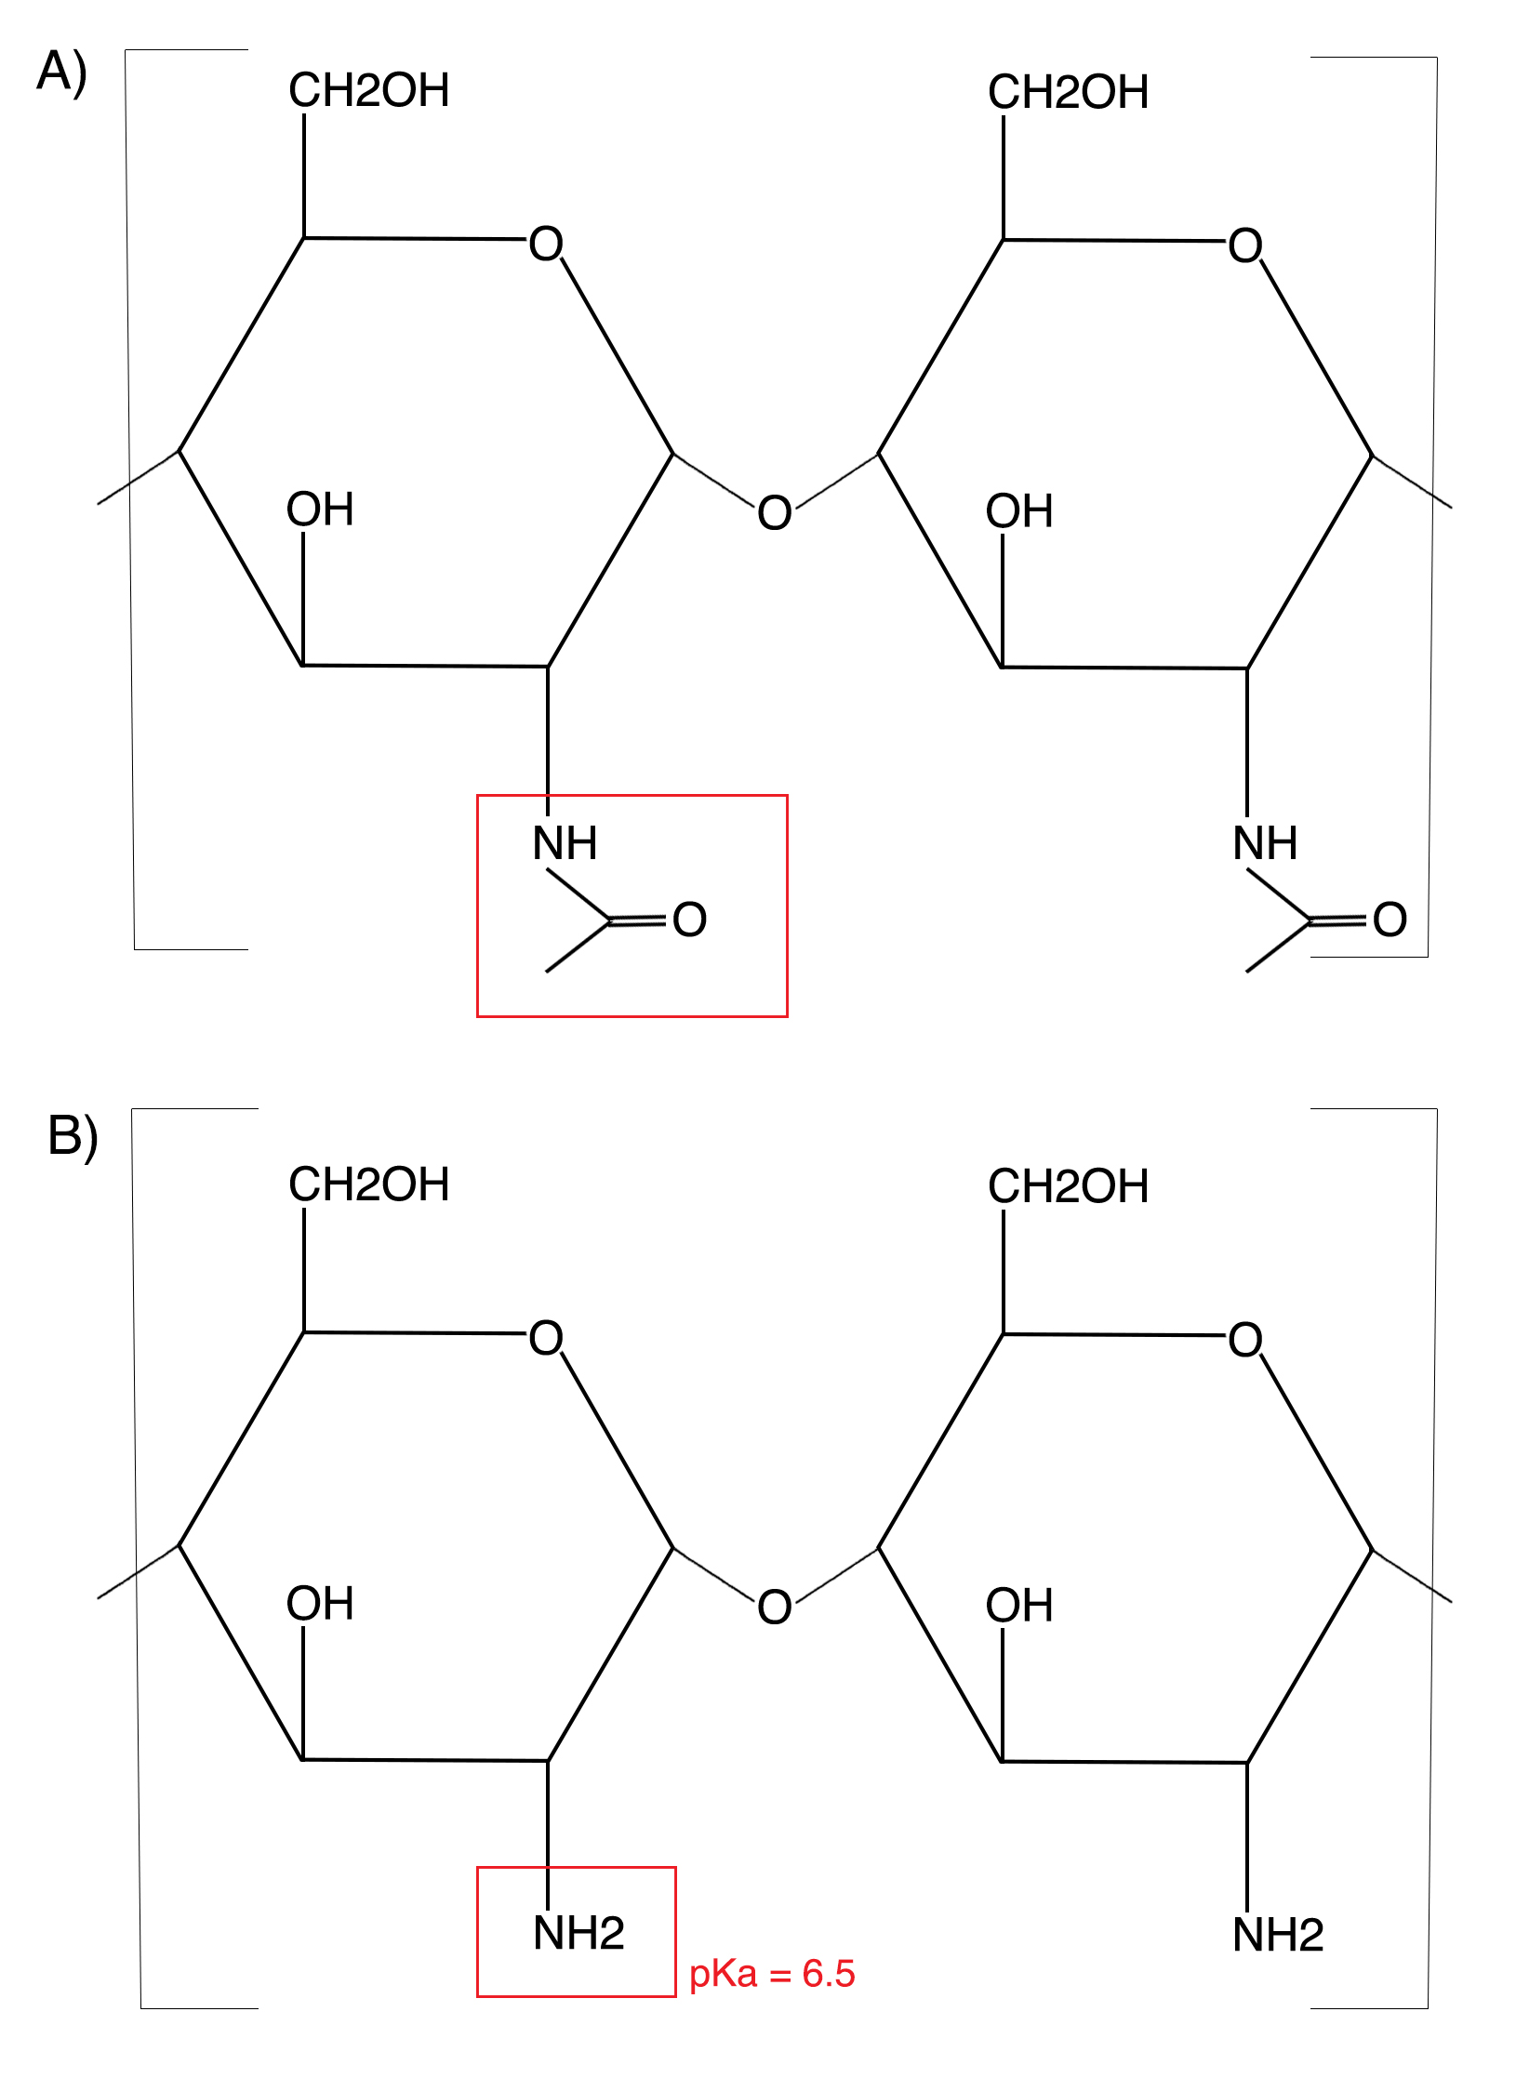
Figure 1 Chitin and chitosan molecular structure. The molecular structure of chitin (A) differs from chitosan (B) through its deacetylation. The resulting amino group on chitosan has a pKa of 6.5^{[12]}.

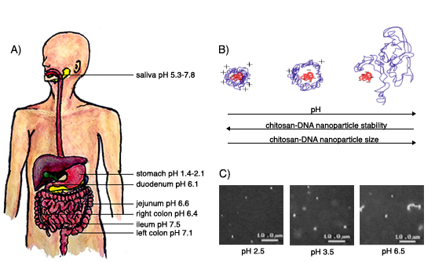
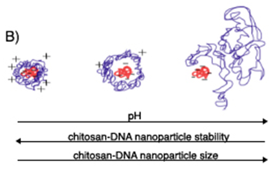
pH 2.5 pH 3.5 pH 6.5
Figure 2 Effect of gastrointestinal pH on chitosan-DNA nanoparticles. A: pH varies drastically throughout the human GI tract from acidic stomach to slightly basic distal bowel^{[14,15]}. This in turn influences how Chitosan-DNA polymers behave intraluminally; B: The conceptual interaction between negatively charged DNA and positively charged chitosan that becomes protonated at acidic pHs. This allows chitosan-DNA nanoparticles to remain stable at lower pHs.

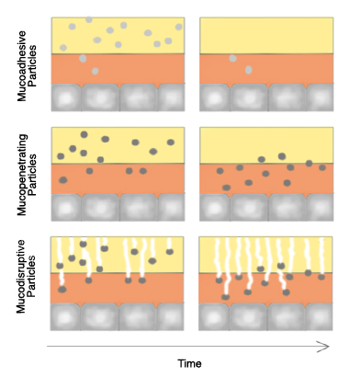
Figure 3 Gastrointestinal mucus as a barrier to Chitosan-DNA nanoparticles transfection. Overcoming the mucus layer for oral gene delivery can be accomplished through three key mechanisms. Mucoadhesive nanoparticles adhere to mucus through chemical interactions. Bioavailability is limited by time, because intestinal mucus has a rapid turnover and adhered nanoparticles would be sloughed off with the luminal layer of mucus^{[27]}. Mucopenetration involves nanoparticles that are able to traverse intestinal mucus due to chemical properties. These nanoparticles do improve bioavailability even with time^{[27]}. Mucodisruptive nanoparticles cross the mucus layer by disrupting mucus structure. This can be accomplished by various mucolytic molecules and enzymes. Bioavailability increases with this mechanism, however intestinal mucus may be affected in the long-term^{[27]}.
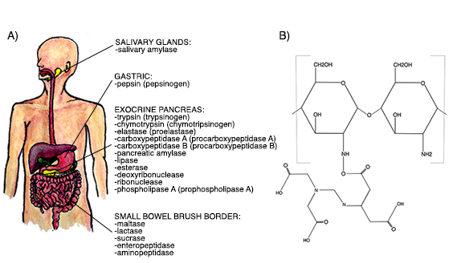
Figure 4 Effect of gastrointestinal enzymes on chitosan-DNA nanoparticles. A: Various digestive enzymes are secreted throughout the GI tract. The genetic material within chitosan nanoparticles is most threatened by pancreatic nucleases such as deoxyribonuclease and ribonuclease^{[34]}; B: Conjugation of chitosan polymer with EDTA through a covalent bond at the amino group^{[37]}.

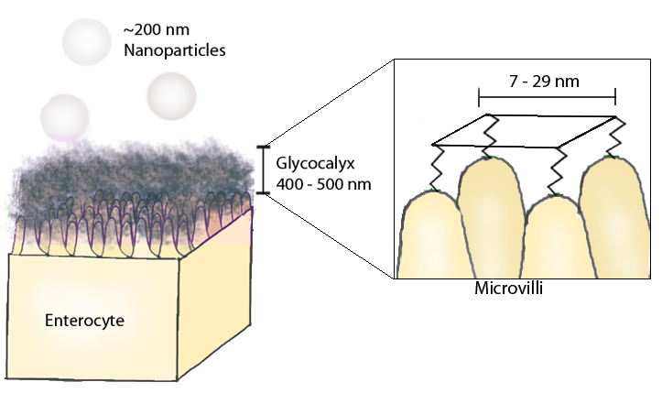
Figure 5 Glycocalyx effect on nanoparticles. A thick mesh like structure of glycocalyx proteins lines the apical membrane of the small bowel with pores 7-29 nm in size^{[49]}. It is unclear whether the glycocalyx has a size effect on diffusion, as existing literature contains mixed results.

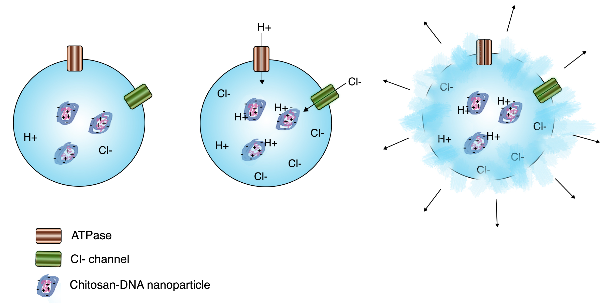
Figure 6 Proton sponge effect. Conceptual image of how chitosan-DNA nanoparticles may escape from lysosomes once endocytosed. H⁺, Cl⁻, and H₂O influx into the lysosome in order to maintain pH, charge, and osmolarity. This movement of molecules causes swelling of the lysosome, eventual bursting, and escape from lysosomal digestion^{[77]}.

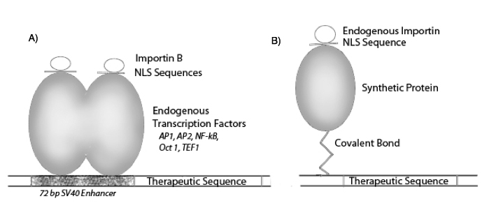
Figure 7 Model of DNA combined with importin/nuclear localization signal complex to enhance importation of DNA through nucleopores. A: Plasmid DNA bound to importins/nuclear localization signal (NLS) complex through transcription factors^{[79,81]}; B: Plasmid DNA bound to importins/NLS complex through a synthetic protein^{[83]}.

Table 1 Chitosan-enzyme inhibitor conjugates¹
 | Enzyme inhibition | Drug protection
Chitosan-ATA | DNAase  Lysozyme | pDNA^{[34]}
Chitosan-EDTA | DNAase  Trypsin  Chemotrypsin | pDNA^{[37]}  Insulin^{[39]}  Trypsin and bromelain^{[93]}
Chitosan-aprotinin | Trypsin  Chymotrypsin | Insulin^{[38]}  Calcitonin^{[41]}
Chitosan-BBI | Trypsin  Chymotrypsin | Calcitonin^{[42]}  Insulin^{[40]}
Chitosan-pepstatin | Pepsin | Calcitonin^{[43]}
Chitosan-elastinal | Elastase | Calcitonin^{[42]}  Insulin^{[40]}
Chitosan-phenylboronic acid | Trypsin  Elastase | Calcitonin^{[44]}
Chitosan-bacitracin |  | Hepatitis B surface antigen^{[94]}
¹Summary of the various enzyme inhibitors that chitosan has been conjugated with in order to decrease degradation and maximize delivery of drug product. All references of original studies are included. Chitosan-ATA and chitosan-EDTA conjugates are most relevant to gene therapy advancements, as they have been shown to protect pDNA and increase transfection efficiency. EDTA: Ethylenediaminetetraacetic acid; ATA: Aurintricarboxylic acid; BBI: Bowman-birk inhibitor.

