Name of Journal: World Journal of Pharmacology
Manuscript NO: 77176
Manuscript Type: ORIGINAL ARTICLE

Basic Study
Antidepressant-like potential of silymarin and silymarin-sertraline combination in mice: Highlighting effects on behaviour, oxidative stress, and neuroinflammation

Onaolapo AY et al. Antidepressant-like potential of silymarin/silymarin-sertraline combination

Adejoke Yetunde Onaolapo, Hameed Sulaiman, Anthony Tope Olofinnade, Olakunle James Onaolapo

Adejoke Yetunde Onaolapo, Department of Anatomy, Ladoke Akintola University of Technology, Oyo State 234, Nigeria

Hameed Sulaiman, Anthony Tope Olofinnade, Olakunle James Onaolapo, Department of Pharmacology, Ladoke Akintola University of Technology, Oyo State 234, Nigeria

Author contributions: Onaolapo AY and Onaolapo OJ conceived and designed the work that led to the submission; Sulaiman H and Olofinnade AT were responsible for the collection and collation of the data; Onaolapo AY and Onaolapo OJ were involved in the analysis of the data, interpretation of the results, and drafting of manuscript; all authors approved the final version of the manuscript.

Corresponding author: Olakunle James Onaolapo, MBBS, MSc, PhD, Reader (Associate Professor), Department of Pharmacology, Ladoke Akintola University of Technology, College of Health Sciences, P.M.B 4000, Ogbomosho 234, Oyo, Nigeria. olakunleonaolapo@yahoo.co.uk

Received: April 18, 2022
Revised: June 5, 2022
Accepted: October 19, 2022
Published online: November 28, 2022

Abstract
BACKGROUND
Currently, there is increasing advocacy for the use of diet, dietary supplements, and herbal remedies in depression management.

AIM
To determine the antidepressant effects of standardized silymarin (SILY) extract either as a sole agent or as an adjunct in depression therapy.

METHODS
Adult mice were assigned into three main groups based on the neurobehavioural models; and each main group had ten treatment groups of 10 mice each. Treatment groups were: Vehicle control group, oral sertraline (SERT) group, two groups fed SILY)-supplemented diet (SILY at 140 and 280 mg/kg of feed, respectively), dexamethasone (DEX; i.p.) group, DEX/SERT group, two groups of DEX/SILY (SILY at 140 and 280 mg/kg of feed, respectively), and another two groups of (SERT/DEX/SILY) (SILY at 140 and 280 mg/kg of feed, respectively, plus i.p. DEX plus SERT). Duration of the study was 7 wk, and treatments were administered daily.

RESULTS
SILY (alone) increased body weight, open field locomotor activity, rearing, and grooming; it also enhanced spatial working memory while decreasing anxiety-related behaviours and behavioural despair. SILY also improved antioxidant status while decreasing lipid peroxidation, acetylcholinesterase activity, and inflammatory markers. Neuronal integrity of the cerebral cortex and hippocampus was preserved. Overall, when administered alone or with SERT, SILY counteracted DEX-induced behavioural and biochemical changes while preserving neuromorphological integrity.

CONCLUSION
In conclusion, SILY is beneficial in mitigating DEX-induced central nervous system and other related changes in mice.

Key Words: Behavioural despair; Depression; Mental Health; Neurobehaviour; Neuromorphology

©The Author(s) 2022. Published by Baishideng Publishing Group Inc. All rights reserved.

Citation: Onaolapo AY, Sulaiman H, Olofinnade AT, Onaolapo OJ. Antidepressant-like potential of silymarin and silymarin-sertraline combination in mice: Highlighting effects on behaviour, oxidative stress, and neuroinflammation. World J Pharmacol 2022; 11(3): 27-47
URL: https://www.wjgnet.com/2220-3192/full/v11/i3/27.htm
DOI: https://dx.doi.org/10.5497/wjp.v11.i3.27

Core Tip: Depression is a neuropsychiatric disorder that has in recent times become a leading cause of disability and a major contributor to global disease burden and suicide. In recent times there has been increasing advocacy for the use of dietary supplements and herbal remedies in depression management. While antidepressant effects of extracts of silybum marianum seeds have been reported, there is a dearth of scientific information on the possible effect of its standardized silymarin extract either as a sole agent or as an adjunct in depression therapy.

INTRODUCTION
Depression is a neuropsychiatric disorder that has in recent times become a leading cause of disability and a major contributor to global disease burden and suicide^{[1]}. It is characterised by the presence of anhedonia and/or evidence of alterations in mood including irritability, sadness, or emptiness^{[2-6]}. In the last decade or more, the global prevalence of depression has continued to rise^{[1,7]}, with depression accounting for approximately 12% of hospital admissions, 50% of mental health consultations, and 4% of suicides^{[6,8,9]}. In addition to a high socioeconomic burden and significant morbidity/mortality, depression has been ranked as the single largest contributor to global disability and suicide deaths^{[3,5,10-13]}. Scientific evidence^{[14,15]} of the critical role of serotonin in the pathogenesis of depression was instrumental to the development of some of the current antidepressant drugs (fluoxetine and sertraline [SERT]) that selectively inhibit the reuptake of serotonin at serotonin transporters, and thereby increase serotonin concentration within the synaptic cleft^{[15,16]}. While significant strides have been made in developing newer drugs for the management of depression, the obvious advantages of more tolerable, less toxic, and more affordable treatment options continue to spur researchers to do more.
In recent times, the impact of diet, dietary supplements, and herbal remedies in the maintenance of mental health, as well as the aetiology, progression, and management of mental illness is becoming important areas of research^{[17-19]}. Specifically, the search for modifiable factors in depression has led to the study of the possible associations between the development of depressive illness and dietary patterns. A number of studies have been successful in demonstrating the value of diet and/or dietary supplements including selenium, zinc, and vitamins B, C, and K in the prevention, pathogenesis, or outcome of depression^{[20-25]}. The antidepressant effects of extracts of parts of plants such as the Silybum marianum seed have also been reported^{[26]}.
Silymarin (SILY) is a polyphenolic antioxidant complex which is derived from the fruit and seeds of the ‘milk-thistle’ plant known as Silybum marianum. While this ancient medicinal plant has been used for centuries for hepatoprotection (or the management of hepatic disorders), the production of standardised fractions of the plant has allowed for a widespread research of its medicinal potential^{[27-29]}. The antifibrotic, antioxidative, immunomodulatory, anti-inflammatory, and antinociceptive properties of SILY have been documented^{[30-33]}, and at pharmacological doses, it has been reported to be non-toxic^{[30,34]}. A number of studies have also reported the neuroprotective effects of SILY in different animal models^{[26-28,35-37]}. While there have been suggestions of the possible antidepressant effects of Silybum marianum extracts, there is a dearth of scientific information on the possible antidepressant effects of standardised formulations of SILY used alone or as an adjunct. Therefore, this study evaluated the effects of dietary supplementation with SILY, alone or in combination with SERT, on body weight, food intake, neurobehaviour, oxidative stress parameters, inflammatory markers, and acetylcholinesterase levels in a dexamethasone (DEX) model of depression in mice.

MATERIALS AND METHODS
Drugs and chemicals
SILY (Silybon-70® Micronova Pharmaceutical Industries Ltd, Lagos Nigeria), SERT capsules (Zoloft® 50 mg, Pfizer Inc. Lagos, Nigeria), and DEX phosphate injection (4 mg/mL, Vixa Pharmaceutical Co. Ltd, Lagos, Nigeria) were obtained commercially. Assay kits for lipid peroxidation (malondialdehyde [MDA] assay kit), glutathione peroxidase (GPx), reduced glutathione (GSH), superoxide dismutase (SOD), and catalase (Biovision Inc. Milpitas, CA, United States) were obtained and refrigerated until used. All other chemicals were of analytical grade.

Animals
Adult male Swiss mice (Empire Breeders, Osogbo, Osun State, Nigeria) weighing between 18-25 g each were used for this study. Mice were housed singly in cages located in temperature-controlled quarters (22 °C -25 °C) with lights on at 7.00 a.m. daily. Animal diet was commercially sourced (TOP® feeds) standard rodent chow (29% protein, 13% fat, and 58% carbohydrate). Mice had access to food and water ad libitum, except during the behavioural tests. All procedures were conducted in accordance with the approved protocols of the Ladoke Akintola University of Technology and within the provisions for animal care and use prescribed in the scientific procedures on living animals European Council Directive (EU2010/63).

Feed
Animals were fed commercially available rodent diet [(standard diet (SD)] sourced from Top Feeds Ltd, Ibadan Nigeria). SILY was incorporated into standard rodent diet at 140 and 280 mg/kg of feed, respectively.

Experimental method
Adult male mice were randomly assigned into three main groups (1-3) based on the neurobehavioural models. Group 1 animals were exposed to the elevated plus maze and tail-suspension paradigm, group 2 were exposed to the Y-maze and forced-swim paradigm, while mice in group 3 were exposed to the open-field arena and radial arm maze. Animals in the main groups were subsequently assigned into ten treatment groups of 10 mice each. Treatment groups were: Vehicle control group [fed standard diet (SD) and given intraperitoneal (i.p.) saline plus oral saline], SERT group (fed SD and given i.p. saline plus oral SERT), two groups fed SILY-supplemented diet (at 140 and 280 mg/kg of feed, respectively; SILY 140 and SILY 280) and given i.p. saline plus oral saline, DEX group (fed SD and given i.p. DEX plus oral saline), DEX/SERT group (fed SD and given i.p. DEX plus oral SERT), two groups (DEX/SILY) fed SILY-supplemented diet (at 140 and 280 mg/kg of feed, respectively) and given i.p. DEX plus oral saline (DEX/SILY 140 and DEX/SILY 280), and another two groups fed SILY-supplemented diet (at 140 and 280 mg/kg of feed, respectively) and given i.p. DEX plus oral SERT (SERT/DEX/SILY 140 and SERT/DEX/SILY 2800). SERT was administered at 5 mg/kg^{[38]}, while DEX was administered at 4 mg/kg^{[39-41]}. Total duration of the study was 7 wk, and all treatments were administered daily. Mice in all groups were weighed weekly (7.00 am, before feeding) and food intake was measured as previously described^{[42-44]} using a weighing balance (Mettler Toledo Type BD6000, Greifensee, Switzerland). Food changes occurred daily at 8.00 am. Food hoppers that contained pre-weighed quantities of food were provided daily to the mice; a thin plastic sheet was placed beneath the cages to catch food spillage. Total food consumption was then measured as the difference between the pre-weighed standard chow and the weight of chow in hopper daily. Crumbs in the plastic sheets were weighed and accounted for in the measurement of total food consumed during the 24-h period^{[42]}. At the end of the experimental period, animals were exposed to the respective paradigms. Twenty-four hours after the last behavioural test, animals in the open field and radial arm maze group were euthanised by cervical dislocation. Blood was taken for assessment of oxidative stress parameters and inflammatory markers (tumor necrosis factor (TNF)–α and interleukin-10). The hippocampus and cerebral cortex were excised and either homogenised for the assessment of inflammatory markers, antioxidant status, and acetylcholinesterase activity or processed for general histological examination.

Assessment of body weight and food intake
Body weight of animals in all groups were measured weekly using an electronic weighing balance (Mettler Toledo Type BD6000, Switzerland) while the amount of food consumed was measured daily. Relative change in body weight or food intake was calculated for each animal using the equation below following which results for all animals where computed to find the statistical mean.

Behavioural tests
Mice were transported in their home cages to the behavioural testing laboratory and allowed to acclimatise (10 min) before exposure to paradigms. Each animal was placed in the apparatus following which behaviours were recorded. On completion of the tests, each mouse was removed from the maze and returned to the respective home cages. The interior surfaces of the mazes were then cleaned with 70% ethanol and wiped dry to remove traces of conspecific odour. Behavioural parameters were then scored manually by independent observers who were blind to the groupings.

Anxiety model: Elevated plus maze
The elevated plus-maze (EPM) is a plus-shaped apparatus with four arms placed at right angles to each other. The EPM used in the study and the procedure are as previously described^{[42,45,46]}.

Open field
Ten minutes of locomotion, rearing, and grooming were observed in the open field and scored as previously described^{[47,48]}.

Tail suspension test
The tail suspension test (a measure of behavioural despair) was carried out according to the method described by Steru et al^{[49]}, Młyniec and Nowak^{[50]}, and Onaolapo et al^{[51]}. Mice were securely fastened (using a medical adhesive tape) by the tip of their tail to a flat platform and suspended for 6 min approximately 30 cm below the platform. The total time of immobility was measured during the 6-min period of the testing session. Immobility, which was defined as the period the animal hung passively without limb movement, was scored^{[40]}.

Forced swim test
The forced swim test is a measure of behavioural despair in mice. The test was carried out according to the method described by Porsolt et al^{[52]}, Kroczka et al^{[53]}, and Onaolapo et al^{[51]}. Mice were dropped individually into glass cylinders which had a height of 25 cm and diameter of 10 cm, were filled with 10 cm of water (water level was marked to ensure uniformity), and maintained at a temperature of 23-25 °C. The dimensions of the glass cylinder ensured that the mouse was unable to touch the bottom of the cylinders either with their feet or their tails, during the test. The height also prevented mice from escaping from the cylinder. Animals were then returned (they were dried with paper towels to prevent hypothermia) to their home cages after 15 min in water. They were reintroduced into the cylinders 24 h later. Mice were exposed to the forced swim paradigm for 6 min. The total duration of immobility was measured during the last 4 min of the forced swim test. The mouse was considered immobile when it had remained floating passively in the water.

Memory tests
The Y- and radial arm mazes were used to assess and score spatial working memory as previously described^{[54,55]}. The Y-maze has three arms (41 cm long and 15 cm high, 5 cm wide at an angle of 120°), while the radial arm maze apparatus has 8 arms measuring 33 cm long spaced equidistantly from each other.

Blood collection
Blood collected from each mouse via cardiac puncture was used for the estimation of lipid peroxidation, GSH, SOD, and GPx. Samples were collected into unheparinised bottles and processed as previously described^{[56,57]}.

Brain homogenization
Within 24 h of the completion of the behavioural tests, animals in all groups were euthanised by cervical dislocation post-anaesthesia with diethyl ether. Homogenates of the hippocampus and cerebral cortex were prepared in ice-cold phosphate buffered saline, using a Teflon-glass homogeniser. The homogenate was centrifuged at 5000 rpm at 4 °C for 15 mi. The supernatant obtained was then used for estimation of lipid peroxidation levels and antioxidant status.

Biochemical assays
Estimation of MDA content (lipid peroxidation): Lipid peroxidation level was measured as MDA content as previously described^{[58]}. Change in colour was measured at 532 nm. The MDA kit used had a detection range of 7.813-500 ng/mL and a sensitivity < 4.688 ng/mL. The intra-assay coefficient of variability was < 7%, and the inter-assay coefficient of variability was < 9%.

Antioxidant activity
SOD activity was determined using a commercially available assay kit. Colour changes were measured at an absorbance of 560 nm as described previously^{[29,58]}. The activity of SOD is expressed in units/mL.
Levels of GSH were determined following the instructions of the manufacturer. A yellow-coloured complex which can be measured at an absorbance of 412 nm is formed by GSH form when it reacts with Ellmans reagent (DTNB). Levels of GSH are expressed in nmol/mL.
GPx is an enzyme that catalyses the reduction of hydroperoxides, such as hydrogen peroxide. GPx activity was determined as previously described^{[29]}. The activity of GPx is expressed in units/mL.

Tumour necrosis factor-α and interleukin-10
Tumour necrosis factor-α and interleukin (IL)-10 were measured using enzyme-linked immunosorbent assay (ELISA) techniques with commercially available kits (Enzo Life Sciences Inc. NY, United States) designed to measure the ‘total’ (bound and unbound) amount of the respective cytokines.

Acetylcholinesterase activity
Brain acetylcholinesterase activity (Biovision, United States) was determined using commercially available assay kits following the instructions of the manufacturer.

Tissue histology
Sections of the cerebral cortex and hippocampus were fixed in 10% formal saline for 24 h, processed for paraffin wax embedding, dehydration, clearing, and infiltration, sectioned, and then mounted following which they were processed for general histological staining using haematoxylin and eosin as previously described^{[40]}.

Statistical analysis
Data were analysed using Chris Rorden’s analysis of variance (ANOVA) for windows, version 0.98. Data analyses were done by ANOVA, and post-hoc test (Tukey HSD) was used for within and between group comparisons. Results are expressed as the mean ± SEM. P < 0.05 was taken as the accepted level of significant difference from control or standards.

RESULTS
Effect of silymarin on body weight
Figure 1 shows the effect of SILY on the change in body weight. There was a significant [F (9, 90) = 48.1, P < 0.001] decrease in body weight in the groups administered with SERT, DEX, DEX/SERT, and DEX/SILY 140, while an increase in body weight was observed in groups administered with SILY 140 and SILY 280, DEX/SILY 280, and those administered with i.p. DEX, oral SERT, DEX/SERT/SILY 140, and DEX/SERT/SILY 280 compared to the vehicle control. Compared to SERT alone, there was a significant increase in body weight with SILY 280. While compared to DEX, body weight increased significantly with DEX/SILY 280, DEX/SERT/SILY 140, and DEX/SERT/SILY 280. Compared with the group administered with DEX/SERT, body weight increased significantly with DEX/SILY 280, DEX/SERT/SILY 140, and DEX/SERT/SILY 280. Overall, the results showed that SILY administered alone increased body weight compared to the vehicle control or SERT. SILY when administered alone (at 280 mg/kg) reversed DEX-induced changes in body weight. When co-administered with SERT, SILY at both concentrations reversed the changes in body weight induced by DEX.

Effect of silymarin on food intake
Figure 2 shows the effect of SILY on the change in food intake. There was a significant [F (9, 90) = 513, P < 0.001] decrease in food intake with DEX, DEX/SERT, DEX/SILY 140, and DEX/SILY 280, while an increase in food intake was observed with DEX/SERT/SILY 140 and DEX/SERT/SILY 280, compared to the vehicle control. Compared to SERT alone, there was no significant difference in food intake in any of the SILY alone groups. While compared to DEX, food intake increased significantly with DEX/SERT/SILY 140 and DEX/SERT/SILY 280. Compared with the group administered with DEX/SERT, food intake increased significantly with DEX/SERT/SILY 140 and DEX/SERT/SILY 280. Overall, the results showed that SILY administered alone did not significantly alter food intake compared to the vehicle control, SERT, or DEX, although co-administration of SILY with SERT was associated with an increase in food intake compared to the vehicle control, DEX, or DEX with SERT.

Effect of silymarin on locomotor and rearing activity
Figure 3 shows the effect of SILY on locomotor activity (upper panel) and rearing (lower panel). There was a significant [F (9, 90) = 26.5, P < 0.001] increase in locomotor activity with SILY 140, DEX/SILY 140, and DEX/SILY 280, and a decrease in locomotor activity with DEX compared to the vehicle control. Compared to SERT alone, there was a significant increase in locomotor activity with SILY 140. While compared to DEX, locomotor activity increased significantly with DEX/SERT, DEX/SILY 140, DEX/SILY 280, DEX/SERT/SILY 140, and DEX/SERT/SILY 280. Compared with the group administered with DEX/SERT, locomotor activity increased significantly with DEX/SILY 280 mg. Overall, the results showed that SILY (administered alone) concentration-dependently increased locomotor activity compared to the vehicle control and SERT. SILY alone or co-administered with SERT also mitigated the decrease in locomotor activity induced by DEX.
Rearing activity decreased significantly [F (9, 90) = 6.20, P < 0.001] with DEX and increased with DEX/SILY 140 and DEX/SILY 280, compared to the vehicle control. Compared to SERT alone, there was a significant increase in rearing activity with SILY 140. While compared to DEX, rearing activity increased significantly with DEX/SERT, DEX/SILY 140, DEX/SILY 280, DEX/SERT/SILY 140, and DEX/SERT/SILY 280. Compared to DEX/SERT, the rearing activity increased significantly with DEX/SILY 280. Overall, the results showed that SILY alone or co-administered with SERT also mitigated the decrease in rearing activity induced by DEX.

Effect of silymarin on grooming behaviour
Figure 4 shows the effect of SILY on self-grooming behaviour. There was a significant [F (9, 90) = 5.24, P < 0.001] increase in self-grooming with SILY, DEX/SILY, and DEX/SERT/SILY 140, while a decrease in self-grooming was observed with DEX and DEX/SERT compared to the vehicle control. Compared to SERT alone, there was a significant increase in self-grooming with SILY 140. While compared to DEX, self-grooming behaviour increased significantly with DEX/SERT, DEX/SILY 140, DEX/SILY 280, DEX/SERT/SILY 140, and DEX/SERT/SILY 280. Compared with the group administered with DEX/SERT, self-grooming increased significantly with DEX/SILY 140, DEX/SILY 280, DEX/SERT/SILY 140, and DEX/SERT/SILY 280. Overall, the results showed that SILY administered alone concentration-dependently increased self-grooming behaviour compared to the vehicle control and SERT. SILY alone or co-administered with SERT also mitigated the decrease in self-grooming behaviour induced by DEX.

Effect of silymarin on spatial working memory in the Y- and radial arm mazes
Figure 5 shows the effect of SILY on radial arm (upper panel) and Y- (lower panel) maze spatial working memory tasks. There was a significant [F (9, 90) = 9.20, P < 0.001] increase in working memory with SILY 140, SILY 280, DEX/SILY 140, DEX/SILY 280, DEX/SERT/SILY 140, and DEX/SERT/SILY 280, while a decrease in memory was observed with DEX compared to the vehicle control. Compared to SERT alone, there was a significant increase in working memory with SILY 140 and SILY 280. While compared to DEX, working memory increased significantly with DEX/SERT, DEX/SILY 140, DEX/SILY 280, DEX/SERT/SILY 140, and DEX/SERT/SILY 280. Compared with the group administered with DEX/SERT, working memory increased significantly with DEX/SILY 140, DEX/SILY 280, DEX/SERT/SILY 140, and DEX/SERT/SILY 280. Overall, the results showed that SILY administered alone increased spatial working memory scores in the radial arm maze, compared to the vehicle control and SERT. SILY alone or co-administered with SERT also counteracted the decrease in spatial working memory score induced by DEX.
Y maze spatial working memory increased significantly [F (9, 90) = 16.04, P < 0.001] with SILY 140, SILY 280, DEX/SILY 280, DEX/SERT/SILY 140, and DEX/SERT/SILY 280, and decreased with DEX compared to the vehicle control. Compared to SERT alone, there was no significant difference in working memory in any of the groups fed SILY alone. While compared to DEX, working memory increased significantly with DEX/SERT, DEX/SILY 140, DEX/SILY 280, DEX/SERT/SILY 140, and DEX/SERT/SILY 280. Compared to DEX/SERT, working memory increased significantly with DEX/SILY 140, DEX/SILY 280, DEX/SERT/SILY 140, and DEX/SERT/SILY 280. Overall, the results showed that SILY administered alone improved spatial working memory scores in the Y-maze compared to the vehicle control. SILY alone or co-administered with SERT also counteracted the decrease in spatial working memory induced by DEX.

Effect of silymarin on anxiety-related behaviours
Figure 6 shows the effect of SILY on the time spent in the open (upper panel) and closed (lower panel) arms of the elevated plus maze. There was a significant [F (9, 90) = 15.11, P < 0.001] increase in open arm time with SERT, SILY 140, SILY 280, DEX/SERT, DEX/SILY 140, DEX/SILY 280, DEX/SERT/SILY 140, and DEX/SERT/SILY 280, while a decrease was observed with DEX compared to the vehicle control. Compared to SERT alone, there was a significant increase in open arm time with SILY 280. While compared to DEX, open arm time increased significantly with DEX/SERT, DEX/SILY 140, DEX/SILY 280, DEX/SERT/SILY 140, and DEX/SERT/SILY 280. Compared with the group administered with DEX/SERT, open arm time increased significantly with DEX/SILY 140, DEX/SILY 280, DEX/SERT/SILY 140, and DEX/SERT/SILY 280. Overall, the results showed that SILY administered alone increased the time spent in the open arm of the EPM compared to the vehicle control. SILY alone or co-administered with SERT also mitigated the decrease in open arm time induced by DEX.
Time spent in the closed decreased significantly [F (9, 90) = 8.21, P < 0.001] with SERT, SILY 140, SILY 280, DEX/SERT, DEX/SILY 140, DEX/SILY 280, DEX/SERT/SILY 140, and DEX/SERT/SILY 280, and increased with DEX compared to the vehicle control. Compared to SERT alone, there was no significant difference in closed arm time in any of the groups fed SILY alone. While compared to DEX, closed arm time decreased significantly with DEX/SERT, DEX/SILY 140, DEX/SILY 280, DEX/SERT/SILY 140, and DEX/SERT/SILY 280. Compared with DEX/SERT, the time spent in the closed arm decreased significantly with DEX/SERT/SILY 280. Overall, the results showed that SILY administered alone decreased time spent in the closed arm compared to the vehicle control. SILY alone or co-administered with SERT also decreased time spent in the closed arm compared to DEX.

Effect of silymarin on behavioural despair
Figure 7 shows the effect of SILY on immobility time in the tail suspension (upper panel) and forced swim (lower panel) tests. There was a significant [F (9, 90) = 26.9, P < 0.001] decrease in immobility time with SILY 140, SILY 280, DEX/SERT, and DEX/SERT/SILY 140, and DEX/SERT/SILY 280 while an increase was observed with SERT, DEX, DEX/SILY 140, and DEX/SILY 280 compared to the vehicle control. Compared to SERT alone, there was a significant decrease in immobility time with SILY 140 and SILY 280. While compared to DEX, the immobility time decreased significantly with DEX/SERT, DEX/SILY 140, DEX/SILY 280, DEX/SERT/SILY 140, and DEX/SERT/SILY 280. Compared with the group administered with DEX/SERT, the immobility time decreased significantly with EX/SILY 140, DEX/SILY 280, DEX/SERT/SILY 140, and DEX/SERT/SILY 280. Overall, the results showed that SILY administered alone decreased immobility time compared to the vehicle control and SERT. SILY alone or co-administered with SERT also mitigated the increase in immobility time induced by DEX.
Immobility time in the forced swim test decreased significantly [F (9, 90) = 24.0, p < 0.001] with SERT, SILY 140, SILY 280, DEX/SERT, DEX/SILY 140, DEX/SILY 280, DEX/SERT/SILY 140, and DEX/SERT/SILY 280, and increased with DEX, compared to the vehicle control. Compared to SERT alone, there was a significant decrease in immobility time with SILY 140. While compared to DEX, the immobility time decreased significantly with DEX/SERT, DEX/SILY 140, and DEX/SERT/SILY. Compared to DEX/SERT, the immobility time decreased significantly with DEX/SILY 280, DEX/SERT/SILY 140, and DEX/SERT/SILY 280. Overall, the results showed that SILY administered alone decreased immobility time compared to the vehicle control and SERT. SILY alone or co-administered with SERT also mitigated the increase in immobility time induced by DEX.

Effect of silymarin on serum lipid peroxidation and antioxidant status
Table 1 shows the effect of SILY on serum lipid peroxidation and antioxidant status. SOD [F (9, 90) = 13.11, P < 0.001], increased significantly with SILY 140, SILY 280, and DEX/SILY 280, while a decrease was observed with DEX, DEX/SERT, DEX/SERT/SILY 140, and DEX/SERT/SILY 280, compared to the vehicle control. Compared to SERT alone, there was a significant increase with SILY 140 and SILY 280. While compared to DEX, there was an increase with DEX/SILY 140, DEX/SILY 280, DEX/SERT/SILY 140, and DEX/SERT/SILY 280, and decrease with DEX/SERT. Compared to DEX/SERT, there was an increase in SOD activity with DEX/SILY 140, DEX/SILY 280, DEX/SERT/SILY 140, and DEX/SERT/SILY 280. Catalase [F (9, 90) = 25.32, P < 0.001] increased significantly with SILY 140, SILY 280, and DEX/SILY 280, while a decrease was observed with DEX, DEX/SERT, and DEX/SERT/SILY 140 compared to the vehicle control. Compared to SERT alone, there was a significant increase with SILY 140 and SILY 280. While compared to DEX, there was an increase with DEX/SILY 140, DEX/SILY 280, DEX/SERT/SILY 140, and DEX/SERT/SILY 280. Compared to DEX/SERT, there was an increase in catalase activity with DEX/SILY 140, DEX/SILY 280, DEX/SERT/SILY 140, and DEX/SERT/SILY 280.
GSH [F (9, 90) = 9.23, P < 0.001] increased significantly with SILY 140 and SILY 280, DEX/SILY 280, and DEX/SERT/SILY 280, while a decrease was observed with DEX and DEX/SERT 140 compared to the vehicle control. Compared to SERT alone, there was a significant increase with SILY 140 and SILY 280. While compared to DEX, there was an increase with DEX/SILY 140, DEX/SILY 280, DEX/SERT/SILY 140, and DEX/SERT/SILY 280. Compared to DEX/SERT, there was an increase in GSH levels with DEX/SILY 140, DEX/SILY 280, DEX/SERT/SILY 140, and DEX/SERT/SILY 280.
GPx activity [F (9, 90) = 10.32, P < 0.001] increased significantly with SILY 140 and SILY 280 and decreased with DEX and DEX/SERT compared to the vehicle control. Compared to SERT alone, there was a significant increase with SILY 140 and SILY 280. While compared to DEX, there was an increase with DEX/SILY 140, DEX/SILY 280, DEX/SERT/SILY 140, and DEX/SERT/SILY 280. Compared to DEX/SERT, there was an increase in GPx levels with DEX/SILY 140, DEX/SILY 280, DEX/SERT/SILY 140, and DEX/SERT/SILY 280.
Overall, the results showed that SILY administered alone or co-administered with SERT had a mixed response with regards to antioxidant status.
Lipid peroxidation measured as MDA levels decreased significantly [F (9, 90) = 6.19, P < 0.001] with SILY 140, SILY 280, DEX/SILY 280, DEX/SERT/SILY 140, and DEX/SERT/SILY 280, while an increase was observed with DEX, DEX/SERT, and DEX/SILY 140 compared to the vehicle control. Compared to SERT alone, there was a significant decrease in MDA levels with SILY 140 and SILY 280. While compared to DEX, there was a decrease with DEX/SILY 140, DEX/SILY 280, DEX/SERT/SILY 140, and DEX/SERT/SILY 280. Compared with the group administered with DEX/SERT, there was a decrease in MDA levels with DEX/SILY 140, DEX/SILY 280, DEX/SERT/SILY 140, and DEX/SERT/SILY 280. Overall, the results showed that SILY administered alone or co-administered with SERT decreased lipid peroxidation levels.

Effect of silymarin on brain levels of inflammatory markers, acetylcholinesterase activity, lipid peroxidation, and antioxidant status
Table 2 shows the effect of SILY on brain (hippocampus and cerebral cortex) levels of inflammatory markers (TNF-α and IL-10), acetylcholinesterase activity, lipid peroxidation, and antioxidant status. Brain (hippocampus and cerebral cortex) levels of TNF-α [F (9, 90) = 65.12, P < 0.001] decreased significantly with SERT, SILY 140, SILY 280, DEX, DEX/SERT, DEX/SILY 140, DEX/SILY 280, DEX/SERT/SILY 140, and DEX/SERT/SILY 280, compared to the vehicle control. Compared to SERT alone, there was a significant increase with SILY 140 and SILY 280. While compared to DEX, there was an increase in brain (hippocampus and cerebral cortex) levels of TNF-α with DEX/SILY 140, DEX/SILY 280, DEX/SERT/SILY 140, and DEX/SERT/SILY 280. Compared with the group administered with DEX/SERT, there was an increase in brain levels of TNF-α with DEX/SILY 140, DEX/SILY 280, DEX/SERT/SILY 140, and DEX/SERT/SILY 280. Overall, the results showed that SILY administered alone decreased TNF-α levels, and when given alone or co-administered with SERT, it mitigated DEX-induced alterations in TNF-α levels.
Brain (hippocampus and cerebral cortex) levels of IL-10 [F (9, 90) = 22.36, P < 0.001] decreased significantly with SERT, DEX, DEX/SERT, DEX/SILY 140, DEX/SILY 280, DEX/SERT/SILY 140, and DEX/SERT/SILY 280, compared to the vehicle control. Compared to SERT alone, there was a significant increase with SILY 140 and SILY 280. While compared to DEX, there was an increase in brain levels of IL-10 with DEX/SILY and DEX/SERT/SILY at 140 and 280 mg/kg of feed, respectively. Compared with the group administered with DEX/SERT, there was an increase in brain levels of IL-10 with DEX/SILY 140, DEX/SILY 280, DEX/SERT/SILY 140, and DEX/SERT/SILY 280. Overall, the results showed that SILY increased IL-10 Levels; alone or co-administered with SERT, it mitigated DEX-induced alteration in IL-10 Levels.
Brain (hippocampus and cerebral cortex) acetylcholinesterase activity decreased significantly [F (9, 90) = 10.21, P < 0.001] with SERT, SILY 140, SILY 280, DEX/SILY 280, DEX/SERT/SILY 140, and DEX/SERT/SILY 280, and increased acetylcholinesterase activity with DEX and DEX/SERT compared to the vehicle control. Compared to SERT alone, there was a significant decrease in brain acetylcholinesterase activity with SILY 140 and SILY 280. While compared to DEX, a significant decrease in brain acetylcholinesterase activity was observed with DEX/SERT, DEX/SILY 140, DEX/SILY 280, DEX/SERT/SILY 140, and DEX/SERT/SILY 280. Compared with the group administered with DEX/SERT, there was a decrease in brain acetylcholinesterase activity with DEX/SILY 140, DEX/SILY 280, DEX/SERT/SILY 140, and DEX/SERT/SILY 280. Overall, the results showed that SILY decreased acetylcholinesterase activity; alone or co-administered with SERT, it mitigated DEX-induced alteration in acetylcholinesterase activity.
Brain (hippocampus and cerebral cortex) MDA levels decreased significantly [F (9, 90) = 10.21, P < 0.001] with SILY 140, SILY 280, DEX/SILY 140, DEX/SILY 280, DEX/SERT/SILY 140, and DEX/SERT/SILY 280, and increased with DEX and DEX/SERT compared to the vehicle control. Compared to SERT alone, there was a significant decrease with SILY 140 and SILY 280. While compared to DEX, there was a decrease in brain MDA levels with DEX/SILY 140, DEX/SILY 280, DEX/SERT/SILY 140, and DEX/SERT/SILY 280. Compared with the group administered with DEX/SERT, there was a decrease in MDA levels with DEX/SILY 140, DEX/SILY 280, DEX/SERT/SILY 140, and DEX/SERT/SILY 280. Overall, the results showed that SILY decreased MDA levels; alone or co-administered with SERT, it mitigated DEX-induced alteration in MDA levels.
Brain (hippocampus and cerebral cortex) levels of GSH [F (9, 90) = 5.12, P < 0.001] increased significantly with SILY 140, SILY 280, DEX/SILY 280, DEX/SERT/SILY 140, and DEX/SERT/SILY 280 and decreased with DEX, DEX/SERT, and DEX/SILY 140 compared to the vehicle control. Compared to SERT alone, there was a significant increase with SILY 140 and SILY 280. While compared to DEX, there was an increase with DEX/SILY 140, DEX/SILY 280, DEX/SERT/SILY 140, and DEX/SERT/SILY 280. Compared with the group administered with DEX/SERT, there was an increase in GSH with DEX/SILY 140, DEX/SILY 280, DEX/SERT/SILY 140, and DEX/SERT/SILY 280.
GPx activity [F (9, 90) = 6.27, P < 0.001] increased significantly with SILY 140 and SILY 280 and decreased with DEX, DEX/SERT, DEX/SILY 140, DEX/SILY 280, DEX/SERT/SILY 140, and DEX/SERT/SILY 280, compared to the vehicle control. Compared to SERT alone, there was a significant increase with SILY 140 and SILY 280. While compared to DEX, there was a decrease with DEX/SERT and an increase with DEX/SILY 140, DEX/SILY 280, DEX/SERT/SILY 140, and DEX/SERT/SILY 280. Compared with the group administered with DEX/SERT, there was an increase in GPX with DEX/SILY 140, DEX/SILY 280, DEX/SERT/SILY 140, and DEX/SERT/SILY 280. Overall, the results showed that SILY increased GPX and GSH activity; alone or co-administered with SERT, it mitigated DEX-induced alterations in GPX and GSH activity.

Effect of silymarin on cerebral cortex and hippocampal morphology
Figure 8 shows representative photomicrographs of haematoxylin and eosin stained sections of the mouse cerebral cortex. Examination of the cerebral cortex sections of mice in the vehicle control group revealed characteristic architecture of the mouse cerebral cortex showing multipolar shaped pyramidal cells with rounded vesicular nuclei, granule cells visible as circular shaped neurons with large open-face nuclei, prominent nucleoli, and scanty cytoplasm and small round-vesicular shaped glial neurons interspersed within a pink-staining neuropil. These features are in keeping with normal cerebral cortex histology. Examination of the cerebral cortex sections of the SERT, SILY 140, and SILY 280 revealed features that were in keeping with normal histology. In the group administered with DEX, there was evidence of normal pyramidal cells with deeply stained nuclei, interspersed between degenerating pyramidal cells with pale edges, shrunken and pale staining nuclei. There was also evidence of degenerating granule cells with pale staining pyknotic nuclei. These features are in keeping with neuronal injury.
Examination of sections from groups administered with DEX/SERT, DEX/SILY 140, and DEX/SILY 280 revealed presence of normal looking cells and few degenerating pyramidal/granule cells. The features are in keeping with varying degrees of protection against the development of DEX-induced neuronal injury. In the groups administered with DEX/SERT/SILY 140 and DEX/SERT/SILY 280, the features were in keeping with normal cerebral cortex histology.
Figure 9 shows representative photomicrographs of haematoxylin and eosin stained sections of the dentate gyrus of the mouse hippocampus. Examination of the dentate gyrus region of the hippocampus in the vehicle control group revealed characteristic architecture of the mouse hippocampus with a few large multipolar pyramidal cells of the cornus ammonis 4 region projecting into the concavity of the dentate gyrus. Also observed were well-compacted small granule cells with vesicular nuclei in the ascending and descending arms of the dentate gyrus. Also obvious were astrocytes and microglia, neuronal processes, and nerve cells scattered throughout the molecular layer, that is, lying between the compact zones of the cornus ammonis and dentate gyrus regions. All features are in keeping with normal hippocampal dentate gyrus histology. Examination of the hippocampal dentate gyrus sections of groups fed SERT, SILY 140, and SILY 280 revealed features that were also in keeping with normal histology. In the group administered with DEX, there were a few normal small pyramidal neurons interspersed between few degenerating pyramidal cells with pale edges, and there was also a paucity of cells in the molecular layer and loss of compactness of the granule cells in the dentate gyrus. Also observed were a few degenerating granule cells with pale staining nuclei; the features are in keeping with some neuronal injury.
Examination of sections from groups administered with DEX/SERT, DEX/SILY 140, and DEX/SILY 280 revealed presence of normal looking cells and few degenerating granule cells features, which are in keeping with varying degrees of protection against the development of DEX-induced neuronal injury. In the groups administered with DEX/SERT/SILY 140 and DEX/ SERT/SILY 280, the features are in keeping with normal dentate gyrus histology.

DISCUSSION
This study examined the antidepressant-like effects of SILY and SILY/SERT combination in mice to ascertain the role of SILY either alone or as an adjunct to SERT in mitigating DEX-induced behavioural and morphological changes in mice. The results showed that SILY administered alone increased body weight without altering food intake, increased open field locomotor activity, rearing, and grooming, enhanced spatial working memory, and decreased both anxiety-related behaviours and behavioural despair (immobility time in the forced swim and tail suspension tests). This was accompanied by an improvement in antioxidant status, and a decrease in lipid peroxidation, acetylcholinesterase activity, and inflammatory markers. Also, when administered alone or co-administered with SERT, SILY mitigated DEX-induced behavioural, biochemical, and morphological changes in relation to the cerebral cortex and hippocampus.
The impact of body weight and food intake on health, wellbeing, and disease has been reported^{[59,60]}. In this study, administration of DEX was associated with significant weight loss and decreased food intake. While depression is generally associated with excessive weight gain, which has been linked to bingeing on food, according to the Diagnostic and Statistical Manual of Mental Disorders, both weight gain and weight loss are symptoms of depression at all ages^{[2,61]}. Similarly, the choice of DEX as a model of depression is centred on its ability to cause dose-dependent weight changes^{[62,63]}. At doses similar to those used in this study, DEX had been associated with weight loss^{[63]}, corroborating the results of this study. The results of a study by Poggioli et al^{[64]} revealed that chronic administration of DEX was associated with decreased weight gain, which was attributed to its ability to accelerate fatty acid oxidation, and decrease brown adipose tissue thermogenesis and the activity of uncoupling protein-1 mRNA^{[64]}. Weight loss could also be attributed to decreased feed intake which could be secondary to early satiety. The administration of SERT to healthy mice caused a decrease in weight gain without impacting feed intake when compared to mice in the vehicle control group, while increased weight loss was observed in the group of animals administered with SERT with DEX. While there is a dearth of scientific information on the impact of SERT in healthy subjects, it is, however, generally believed that selective serotonin re-uptake inhibitors like SERT are associated with weight gain. The results of a few studies have linked weight gain mainly to long-term use of SERT^{[65,66]}; however, some clinical studies have reported reduced weight gain or weight loss following acute use of SERT in persons with depression^{[67]}. The results of a preclinical study that examined the effect of SERT on body weight parameters in monkeys administered with SERT over an 18 mo period using a placebo-controlled, longitudinal, randomized study design showed that while the body weight and body fat composition of the placebo group increased, a decrease in body weight and fat composition was observed in the SERT treatment group^{[68]}. In the groups of mice fed SILY alone, an increase in weight with no change in food intake was observed compared to mice in the vehicle control group. Also, in mice fed SILY with DEX, a reversal of DEX-induced weight loss was observed. Information from the current literature reveals that the vast majority of studies evaluating the effects of SILY on body weight have administered it in a background of disease or disorder^{[28,32,69-71]}. The results of these studies have shown that administration of SILY could be associated with either weight loss or weight gain^{[28,32,69-71]} depending on the disease model used. This would suggest that the effects of SILY on body weight are mainly modulatory or adaptogenic, having the ability to return the body back to baseline. The administration of SILY with SERT was also associated with a reversal of weight loss due to DEX-induced depressive symptoms, suggesting that compared to SERT, SILY could be beneficial in modulating the effects of SERT on body weight. However, the co-administration of SERT with SILY also in a background of DEX was associated with increased food intake compared to either SILY or SERT.
In this study, neurobehavioural tests revealed that administration of DEX was associated with a decrease in horizontal locomotion, rearing, and grooming behaviour, which is consistent with the observations of Falade et al^{[40]}. The chronic unpredictable stress model was also associated with similar neurobehavioural changes^{[55]}. The decrease in locomotor activity, rearing, and grooming is reflective of a central nervous system depressant response to DEX administration. Treatment with SERT was associated with a mitigation of the central depressant effect induced by DEX, although when administered to healthy mice, SERT did not significantly alter horizontal locomotion, rearing, or grooming, which is similar to the response observed by Pereira-Figueiredo et al^{[72]}. In healthy mice fed a SILY diet, a central excitatory response was observed at 140 mg/kg. SILY alone or co-administered with SERT reduced the changes in locomotor activity, rearing, and grooming observed in mice administered with DEX alone. The concentration-dependent increase in locomotor activity, rearing, and grooming that occurred in healthy and DEX-treated mice could be linked to its ability to increase brain levels of serotonin, dopamine, and norepinephrine, neurotransmitters that modulate central excitatory response in the brain^{[73-76]}. Also, the co-administration of SILY with SERT was associated with a significant decrease in line crossing and an increase in grooming, with no significant difference in rearing behaviour compared with mice administered with SERT alone, suggesting that SILY could amplify the effects of SERT.
The neuroprotective effects of SILY have been reported^{[28,29,77-79]} with a number of studies reporting its ability to reverse cognitive deficits and anxiety-related behaviours^{[79]}. In this study, DEX was associated with spatial working memory deficits (Y-maze and radial arm maze) and anxiogenic response in the elevated plus maze paradigm. In past times, cognitive deficits were not considered an important part of depression symptomatology, so little or no attention was paid to cognitive disorders associated with depression. However, in the light of recent knowledge, researchers now know that cognitive symptoms could significantly impact general functioning and quality of life, and risk of recurrence of depression in these individuals^{[80]}. The results of this study demonstrated that while SERT administration was associated with anxiolysis when administered alone or to DEX-treated mice, it showed no nootropic ability in healthy mice. Although it counteracted DEX-induced spatial memory deficits, the results observed with SERT in healthy mice corroborate the report of a study by Siepmann et al^{[81]} that showed that in healthy humans, SERT was not associated with cognitive deficits or improvements in cognition. Although SERT reversed memory deficits in DEX-treated mice, studies in humans have reported that a selective serotonin reuptake inhibitor such as SERT was associated with memory loss and anxiety in persons with depression^{[82]}. In groups fed SILY-supplemented diet alone, memory enhancing and anxiolytic effects were observed in both healthy and DEX-treated mice. This effect is similar to that observed by Yön et al^{[79]} in diabetic rats. A number of other studies have also reported the ability of SILY to reverse cognitive deficits following scopolamine-induced amnesia^{[83]} or mild traumatic brain injury^{[84]}, and these beneficial effects have been linked to its ability to decrease oxidative stress, inflammatory markers, and brain glutamate level, as well as increase antioxidant status and brain-derived neurotrophic factor in rodents^{[83,84]}. Although compared to SERT, the administration of SILY to DEX-treated mice was associated within reversal of memory deficits suggesting that as a sole or replacement therapy it could provide some benefits, large clinical studies are required to confirm these in humans. When co-administered with SERT, memory and anxiolytic effects improved significantly compared to DEX-treated group administered with SERT, and these suggest that SILY could also be beneficial as an adjunct with SERT in depression management.
In this study, administration of SERT or a SILY-supplemented diet was associated with a decrease in immobility time in the behavioural despair paradigm in healthy animals, while DEX caused increased immobility time compared to healthy controls. Several studies have reported that chronic administration of DEX in humans and experimental animals was associated with the development of mood disorders including psychosis and depression^{[40,85,86]}. The ability of DEX to increase immobility time has also been reported by other studies^{[40,87,88]}. However, there is an increasing need for animal models of depression other than the currently available models of behavioural despair (forced swim test and tail suspension test). Animal models such as the one employed in this study supports the glucocorticoid hypothesis of depression^{[89]} and would be valuable in the testing of novel drugs for the management of depression. In this study, chronic DEX administration was associated with weight loss, decreased food intake, locomotor retardation, cognitive deficits, anxiety, and behavioural despair, and a number of these symptoms and signs are necessary for the diagnosis of depression in humans. The mitigation of a number of features by SERT (a conventional antidepressant) supports the face and predictive validity for its possible use as a preliminary method for studying novel pharmacologic agents with possible antidepressant effects. A limitation of this study is our inability to assess plasma or brain glucocorticoid levels. SILY supplementation alone or co-administered with SERT in this study was associated with the reversal of DEX-induced behavioural despair. The antidepressant effects of SILY have been reported especially in studies that used acute restraint stress^{[76]}, the chronic unpredictable stress model of depression^{[90]} or posttraumatic stress disorder^{[91]}. In both behavioural despair paradigms, the antidepressant effects of SERT increased significantly with SILY at a concentration of 280 mg/kg of feed, although it decreased at 140 mg/kg of feed, suggesting that high concentrations of SILY could elicit an additive beneficial effect.
The antidepressant, memory enhancing, and anxiolytic effects of SILY have been attributed to its ability to decrease oxidative stress, improve antioxidant status, and increase antiinflammatory markers^{[76,90]}. In this study, dietary SILY supplementation was associated with a mitigation of DEX-induced changes in brain oxidative stress, antioxidant status, and inflammatory markers. It also counteracted DEX-induced increase in acetylcholinesterase activity which could also be responsible for the memory enhancing effects of SILY. When SILY was co-administered with SERT, we observed significant improvements in the oxidant antioxidant balance, and an antiinflammatory response over the effects observed with SERT alone, also reinforcing our opinion that SILY when examined in a rodent model of depression exhibited both adjunctive and sole therapeutic benefits.
Structural and morphological changes have been reported in humans with depression^{[92,93]}. In this study, the administration of DEX resulted in neuronal injury in the cerebral cortex and hippocampal dentate gyrus, two regions of the brain which have been implicated in depression^{[92-94]}. In this study, SERT and SILY-supplemented diet at both concentrations mitigated the structural changes induced by DEX. The co-administration of SERT with SILY showed marked mitigation of these changes, suggesting that SILY was not only beneficial when administered alone, but it also possibly accentuated the effects of SERT. While our knowledge of the structural and morphological changes in depression and how they impact pathogenesis and treatment are still evolving, it is important to realise that the use of supplements such as SILY that have validated adaptogenic, antioxidant, antiinflammatory, cognitive enhancing, anxiolytic, and neuroprotective effects could be valuable in depression management, although clinical studies and trials would be necessary to verify its usability in humans.

CONCLUSION
The ability of SILY to modulate behaviour, oxidative stress, and neuroinflammation makes it a possible monotherapeutic agent or an adjunct in the management of DEX-induced depression. In this era when clinical management of depression has continued to be challenging, the discovery and application of such an agent are likely to be of benefit in at least a certain subset of patients. The value of an agent such as SILY is likely to rest in the fact that it can employ mechanisms of action that go beyond neurotransmitter modulation.

ARTICLE HIGHLIGHTS
Research background
Depression is a neuropsychiatric disorder that has in recent times become a leading cause of disability and a major contributor to global disease burden and suicide.

Research motivation
There is increasing advocacy for the use of herbal supplements in depression management.

Research objectives
To determine the effect of silymarin dietary supplements alone or in combination with sertraline in a mouse model of depression.

Research methods
Preclinical study.

Research results
Silymarin mitigated dexamethasone-induced central nervous system changes in mice.

Research conclusions
Silymarin could have a place in the management of depression in humans.

Research perspectives
Further studies should be performed to examine the possible effects of silymarin in humans with depression.

REFERENCES
1 World Health Organization. Depression Factsheet, 2020 Newsroom, Fact sheets, 2020. Available from: https://www.who.int/news-room/fact-sheets
2 American Psychiatric Association. American Psychiatric Association: Diagnostic and Statistical Manual of Mental Disorders. 5th ed. Arlington, 2013
3 Otte C, Gold SM, Penninx BW, Pariante CM, Etkin A, Fava M, Mohr DC, Schatzberg AF. Major depressive disorder. Nat Rev Dis Primers 2016; 2: 16065 [PMID: 27629598 DOI: 10.1038/nrdp.2016.65]
4 Friedrich MJ. Depression Is the Leading Cause of Disability Around the World. JAMA 2017; 317: 1517 [PMID: 28418490 DOI: 10.1001/jama.2017.3826]
5 Nagaratnam N, Cheuk G. Mood Disorders (Major Depression, Bipolar Disorder). Geriatric Diseases: Evaluation and Management, Cham: Springer International Publishing: Imprint: Springer, 2020
6 Wang Q, Timberlake MA 2nd, Prall K, Dwivedi Y. The recent progress in animal models of depression. Prog Neuropsychopharmacol Biol Psychiatry 2017; 77: 99-109 [PMID: 28396255 DOI: 10.1016/j.pnpbp.2017.04.008]
7 GBD 2015 Disease and Injury Incidence and Prevalence Collaborators. Global, regional, and national incidence, prevalence, and years lived with disability for 310 diseases and injuries, 1990-2015: a systematic analysis for the Global Burden of Disease Study 2015. Lancet 2016; 388: 1545-1602 [PMID: 27733282 DOI: 10.1016/S0140-6736(16)31678-6]
8 Kuo DC, Tran M, Shah AA, Matorin A. Depression and the Suicidal Patient. Emerg Med Clin North Am 2015; 33: 765-778 [PMID: 26493522 DOI: 10.1016/j.emc.2015.07.005]
9 World Health Organization. Depression and other common mental disorders: global health estimates 2017. Available from: https://apps.who.int/iris/handle/10665/254610
10 Vigo D, Thornicroft G, Atun R. Estimating the true global burden of mental illness. Lancet Psychiatry 2016; 3: 171-178 [PMID: 26851330 DOI: 10.1016/S2215-0366(15)00505-2]
11 Sugawara N, Yasui-Furukori N, Tsuchimine S, Kaneda A, Tsuruga K, Iwane K, Okubo N, Takahashi I, Kaneko S. No association between dietary patterns and depressive symptoms among a community-dwelling population in Japan. Ann Gen Psychiatry 2012; 11: 24 [PMID: 23006931 DOI: 10.1186/1744-859X-11-24]
12 Cleare A, Pariante CM, Young AH, Anderson IM, Christmas D, Cowen PJ, Dickens C, Ferrier IN, Geddes J, Gilbody S, Haddad PM, Katona C, Lewis G, Malizia A, McAllister-Williams RH, Ramchandani P, Scott J, Taylor D, Uher R; Members of the Consensus Meeting. Evidence-based guidelines for treating depressive disorders with antidepressants: A revision of the 2008 British Association for Psychopharmacology guidelines. J Psychopharmacol 2015; 29: 459-525 [PMID: 25969470 DOI: 10.1177/0269881115581093]
13 Durisko Z, Mulsant BH, Andrews PW. An adaptationist perspective on the etiology of depression. J Affect Disord 2015; 172: 315-323 [PMID: 25451432 DOI: 10.1016/j.jad.2014.09.032]
14 Shaw DM, Camps FE, Eccleston EG. 5-Hydroxytryptamine in the hind-brain of depressive suicides. Br J Psychiatry 1967; 113: 1407-1411 [PMID: 6078496 DOI: 10.1192/bjp.113.505.1407]
15 Hillhouse TM, Porter JH. A brief history of the development of antidepressant drugs: from monoamines to glutamate. Exp Clin Psychopharmacol 2015; 23: 1-21 [PMID: 25643025 DOI: 10.1037/a0038550]
16 Papakostas GI. Tolerability of modern antidepressants. J Clin Psychiatry 2008; 69 Suppl E1: 8-13 [PMID: 18494538]
17 Steel Z, Marnane C, Iranpour C, Chey T, Jackson JW, Patel V, Silove D. The global prevalence of common mental disorders: a systematic review and meta-analysis 1980-2013. Int J Epidemiol 2014; 43: 476-493 [PMID: 24648481 DOI: 10.1093/ije/dyu038]
18 Patel V, Chisholm D, Parikh R, Charlson FJ, Degenhardt L, Dua T, Ferrari AJ, Hyman S, Laxminarayan R, Levin C, Lund C, Medina Mora ME, Petersen I, Scott J, Shidhaye R, Vijayakumar L, Thornicroft G, Whiteford H; DCP MNS Author Group. Addressing the burden of mental, neurological, and substance use disorders: key messages from Disease Control Priorities, 3rd edition. Lancet 2016; 387: 1672-1685 [PMID: 26454360 DOI: 10.1016/S0140-6736(15)00390-6]
19 Yeung KS, Hernandez M, Mao JJ, Haviland I, Gubili J. Herbal medicine for depression and anxiety: A systematic review with assessment of potential psycho-oncologic relevance. Phytother Res 2018; 32: 865-891 [PMID: 29464801 DOI: 10.1002/ptr.6033]
20 Woo J, Lynn H, Lau WY, Leung J, Lau E, Wong SY, Kwok T. Nutrient intake and psychological health in an elderly Chinese population. Int J Geriatr Psychiatry 2006; 21: 1036-1043 [PMID: 16955432 DOI: 10.1002/gps.1603]
21 Gilbody S, Lightfoot T, Sheldon T. Is low folate a risk factor for depression? A meta-analysis and exploration of heterogeneity. J Epidemiol Community Health 2007; 61: 631-637 [PMID: 17568057 DOI: 10.1136/jech.2006.05038]
22 Murakami K, Mizoue T, Sasaki S, Ohta M, Sato M, Matsushita Y, Mishima N. Dietary intake of folate, other B vitamins, and omega-3 polyunsaturated fatty acids in relation to depressive symptoms in Japanese adults. Nutrition 2008; 24: 140-147 [PMID: 18061404 DOI: 10.1016/j.nut.2007.10.013]
23 Lim SY, Kim EJ, Kim A, Lee HJ, Choi HJ, Yang SJ. Nutritional Factors Affecting Mental Health. Clin Nutr Res 2016; 5: 143-152 [PMID: 27482518 DOI: 10.7762/cnr.2016.5.3.143]
24 Styczeń K, Sowa-Kućma M, Siwek M, Dudek D, Reczyński W, Szewczyk B, Misztak P, Topór-Mądry R, Opoka W, Nowak G. The serum zinc concentration as a potential biological marker in patients with major depressive disorder. Metab Brain Dis 2017; 32: 97-103 [PMID: 27502410 DOI: 10.1007/s11011-016-9888-9]
25 Karimi G Evaluation of antidepressant effect of ethanolic and aqueous extracts of Silybum marianum L. Seed in mice. J Med Plants 2007; 6: 38-43
26 Khosravi M, Hosseinzadeh M. Golzar M, Majdzadeh R, Sotoudeh G Comparison between Macro & Micro Nutrient Intake in Depressed Patients with Healthy People. Journal of Nutrition and Food Security 2019; 4(2): 83-92 [DOI: 10.18502/jnfs.v4i2.769]
27 Kren V, Walterová D. Silybin and silymarin--new effects and applications. Biomed Pap Med Fac Univ Palacky Olomouc Czech Repub 2005; 149: 29-41 [PMID: 16170386]
28 Onaolapo AY, Abdusalam SZ, Onaolapo OJ. Silymarin attenuates aspartame-induced variation in mouse behaviour, cerebrocortical morphology and oxidative stress markers. Pathophysiology 2017; 24: 51-62 [PMID: 28254270 DOI: 10.1016/j.pathophys.2017.01.002]
29 Onaolapo OJ, Adekola MA, Azeez TO, Salami K, Onaolapo AY. l-Methionine and silymarin: A comparison of prophylactic protective capabilities in acetaminophen-induced injuries of the liver, kidney and cerebral cortex. Biomed Pharmacother 2017; 85: 323-333 [PMID: 27889232 DOI: 10.1016/j.biopha.2016.11.033]
30 Karimi G, Vahabzadeh M, Lari P, Rashedinia M, Moshiri M. "Silymarin", a promising pharmacological agent for treatment of diseases. Iran J Basic Med Sci 2011; 14: 308-317 [PMID: 23492971]
31 Toklu HZ, Tunali Akbay T, Velioglu-Ogunc A, Ercan F, Gedik N, Keyer-Uysal M, Sener G. Silymarin, the antioxidant component of Silybum marianum, prevents sepsis-induced acute lung and brain injury. J Surg Res 2008; 145: 214-222 [PMID: 17950327 DOI: 10.1016/j.jss.2007.03.072]
32 Vargas-Mendoza N, Madrigal-Santillán E, Morales-González A, Esquivel-Soto J, Esquivel-Chirino C, García-Luna Y González-Rubio M, Gayosso-de-Lucio JA, Morales-González JA. Hepatoprotective effect of silymarin. World J Hepatol 2014; 6: 144-149 [PMID: 24672644 DOI: 10.4254/wjh.v6.i3.144]
33 Hassani FV, Rezaee R, Sazegara H, Hashemzaei M, Shirani K, Karimi G. Effects of silymarin on neuropathic pain and formalin-induced nociception in mice. Iran J Basic Med Sci 2015; 18: 715-720 [PMID: 26351564]
34 Wu JW, Lin LC, Tsai TH. Drug-drug interactions of silymarin on the perspective of pharmacokinetics. J Ethnopharmacol 2009; 121: 185-193 [PMID: 19041708 DOI: 10.1016/j.jep.2008.10.036]
35 Nencini C, Giorgi G, Micheli L. Protective effect of silymarin on oxidative stress in rat brain. Phytomedicine 2007; 14: 129-135 [PMID: 16638633 DOI: 10.1016/j.phymed.2006.02.005]
36 Galhardi F, Mesquita K, Monserrat JM, Barros DM. Effect of silymarin on biochemical parameters of oxidative stress in aged and young rat brain. Food Chem Toxicol 2009; 47: 2655-2660 [PMID: 19647779 DOI: 10.1016/j.fct.2009.07.030]
37 Baluchnejadmojarad T, Roghani M, Mafakheri M. Neuroprotective effect of silymarin in 6-hydroxydopamine hemi-parkinsonian rat: involvement of estrogen receptors and oxidative stress. Neurosci Lett 2010; 480: 206-210 [PMID: 20600617 DOI: 10.1016/j.neulet.2010.06.038]
38 Onaolapo OJ, Paul TB, Onaolapo AY. Comparative effects of sertraline, haloperidol or olanzapine treatments on ketamine-induced changes in mouse behaviours. Metab Brain Dis 2017; 32: 1475-1489 [PMID: 28508340]
39 Skupio U, Tertil M, Sikora M, Golda S, Wawrzczak-Bargiela A, Przewlocki R. Behavioral and molecular alterations in mice resulting from chronic treatment with dexamethasone: relevance to depression. Neuroscience 2015; 286: 141-150 [PMID: 25433240 DOI: 10.1016/j.neuroscience.2014.11.035]
40 Falade J, Onaolapo AY, Onaolapo OJ. Evaluation of the Behavioural, Antioxidative and Histomorphological Effects of Folic Acid-supplemented Diet in Dexamethasone-induced Depression in Mice. Cent Nerv Syst Agents Med Chem 2021; 21: 73-81 [PMID: 33459248 DOI: 10.2174/1871524921666210114125355]
41 Onaolapo OJ, Onaolapo AY, Akinola OR, Anisulowo TO. Dexamethasone regimens alter spatial memory and anxiety levels in mice. Behav Brain Sci 2014; 4: 159-167 [DOI: 10.4236/jbbs.2014.44019]
42 Onaolapo AY, Onaolapo OJ, Nwoha PU. Alterations in behaviour, cerebral cortical morphology and cerebral oxidative stress markers following aspartame ingestion. J Chem Neuroanat 2016; 78: 42-56 [PMID: 27565676 DOI: 10.1016/j.jchemneu.2016.08.006]
43 Onaolapo AY, Odetunde I, Akintola AS, Ogundeji MO, Ajao A, Obelawo AY, Onaolapo OJ. Dietary composition modulates impact of food-added monosodium glutamate on behaviour, metabolic status and cerebral cortical morphology in mice. Biomed Pharmacother 2019; 109: 417-428 [PMID: 30399577]
44 Olofinnade AT, Onaolapo TM, Oladimeji S, Fatoki AM, Balogun CI, Onaolapo AY, Onaolapo OJ. An Evaluation of the Effects of Pyridoxal Phosphate in Chlorpromazineinduced Parkinsonism using Mice. Cent Nerv Syst Agents Med Chem 2020; 20: 13-25 [PMID: 31987026 DOI: 10.2174/1871524920666200120142508]
45 Onaolapo OJ, Onaolapo AY, Omololu TA, Oludimu AT, Segun-Busari T, Omoleke T. Exogenous Testosterone, Aging, and Changes in Behavioral Response of Gonadally Intact Male Mice. J Exp Neurosci 2016; 10: 59-70 [PMID: 27158222]
46 Olofinnade AT, Onaolapo AY, Onaolapo OJ. Concentration-dependent Effects of Dietary L-Ascorbic Acid Fortification in the Brains of Healthy Mice. Cent Nerv Syst Agents Med Chem 2021; 21: 104-113 [PMID: 33719957 DOI: 10.2174/1871524921666210315130023]
47 Onaolapo AY, Onaolapo OJ, Blessing IC, Hameed S, Raimot R. Low-dose L-methionine-associated Changes in Behavioural Indices in Young Rats. International Journal of Neuroscience and Behavioural Science 2016; 4: 11-19 [DOI: 10.13189/ijnbs.2016.040102]
48 Olofinnade AT, Onaolapo AY, Onaolapo OJ, Olowe OA. Hazelnut Modulates Neurobehaviour and Ameliorates Ageing-induced Oxidative Stress, and Caspase-3-Mediated Apoptosis in Mice. Curr Aging Sci 2021; 14: 154-162 [PMID: 33371863 DOI: 10.2174/1874609813666201228112349]
49 Steru L, Chermat R, Thierry B, Simon P. The tail suspension test: a new method for screening antidepressants in mice. Psychopharmacology (Berl) 1985; 85: 367-370 [PMID: 3923523 DOI: 10.1007/BF00428203]
50 Młyniec K, Nowak G. Zinc deficiency induces behavioral alterations in the tail suspension test in mice. Effect of antidepressants. Pharmacol Rep 2012; 64: 249-255 [PMID: 22661173 DOI: 10.1016/s1734-1140(12)70762-4]
51 Onaolapo AY, Olawore OI, Yusuf FO, Adeyemo AM, Adewole IO, Onaolapo OJ, Oral monosodium glutamate administration differentially affects novelty induced behaviours, behavioural despair and place preference in male and female mice. Current Psychoopharmacology. 2019; 8: 130-145 [DOI: 10.2174/2211556008666181213160527]
52 Porsolt RD, Anton G, Blavet N, Jalfre M. Behavioural despair in rats: a new model sensitive to antidepressant treatments. Eur J Pharmacol 1978; 47: 379-391 [PMID: 204499 DOI: 10.1016/0014-2999(78)90118-8]
53 Kroczka B, Zieba A, Dudek D, Pilc A, Nowak G. Zinc exhibits an antidepressant-like effect in the forced swimming test in mice. Pol J Pharmacol 2000; 52: 403-406 [PMID: 11334234]
54 Onaolapo OJ, Onaolapo AY, Awe, EO, Jibunor N, Oyeleke B, Ogedengbe AJ, Oral artesunate-amodiaquine combination causes anxiolysis and impaired cognition in healthy Swiss mice. IOSR Journal of Pharmacy and Biological Sciences 2013; 7: 97-102
55 Onaolapo AY, Onaolapo OJ, Nwoha PU. Aspartame and the hippocampus: Revealing a bi-directional, dose/time-dependent behavioural and morphological shift in mice. Neurobiol Learn Mem 2017; 139: 76-88 [PMID: 28049023]
56 Mollica A, Stefanucci S, Macedonio G, Locatelli M, Onaolapo OJ, Onaolapo AY, Adegoke J, Olaniyan M, Novellino E Capparis spinosa L: In vivo and in vitro evaluation of the anti-diabetic and anti-hyperlipidaemic activity. Journal of Functional Foods 2017; 35: 32-42
57 Mollica A, Zengin G, Stefanucci A, Ferrante C, Menghini L, Orlando G, Brunetti L, Locatelli M, Dimmito MP, Novellino E, Wakeel OK, Ogundeji MO, Onaolapo AY, Onaolapo OJ, Nutraceutical potential of Corylus avellana daily supplements for obesity and related dysmetabolism. Journal of Functional Foods 2018; 47: 562-574
58 Onaolapo AY, Onaolapo O.J Nevirapine mitigates monosodium glutamate induced neurotoxicity and oxidative stress changes in prepubertal mice. Ann Med Res 2018; 25: 518-524 [DOI: 10.5455/annalsmedres.2018.06.118]
59 Murphy JM, Horton NJ, Burke JD Jr, Monson RR, Laird NM, Lesage A, Sobol AM. Obesity and weight gain in relation to depression: findings from the Stirling County Study. Int J Obes (Lond) 2009; 33: 335-341 [PMID: 19139752 DOI: 10.1038/ijo.2008.273]
60 Roberts CK, Lee MM, Katiraie M, Krell SL, Angadi SS, Chronley MK, Oh CS, Ribas V, Harris RA, Hevener AL, Croymans DM. Strength fitness and body weight status on markers of cardiometabolic health. Med Sci Sports Exerc 2015; 47: 1211-1218 [PMID: 25251047 DOI: 10.1249/MSS.0000000000000526]
61 Felton J, Cole DA, Tilghman-Osborne C, Maxwell MA. The relation of weight change to depressive symptoms in adolescence. Dev Psychopathol 2010; 22: 205-216 [PMID: 20102656 DOI: 10.1017/S0954579409990356]
62 Sarcev T, Secen N, Sabo A, Povazan D. Influence of dexamethasone on appetite and body weight in lung cancer patients. Med Pregl 2008; 61: 571-575 [PMID: 19368274 DOI: 10.2298/mpns0812571s]
63 Amar MI, Adam Shama IY, Enaia AA, Hind AEO, Hager AM, Effects of Various Levels of Oral Doses Dexamethasone (Al-nagma) Abused as Cosmetic by Sudanese Women on Wistar Rats. Journal of Medical Sciences 2013; 13: 432-438
64 Poggioli R, Ueta CB, Drigo RA, Castillo M, Fonseca TL, Bianco AC. Dexamethasone reduces energy expenditure and increases susceptibility to diet-induced obesity in mice. Obesity (Silver Spring) 2013; 21: E415-E420 [PMID: 23408649 DOI: 10.1002/oby.20338]
65 Beyazyüz M, Albayrak Y, Eğilmez OB, Albayrak N, Beyazyüz E. Relationship between SSRIs and Metabolic Syndrome Abnormalities in Patients with Generalized Anxiety Disorder: A Prospective Study. Psychiatry Investig 2013; 10: 148-154 [PMID: 23798963 DOI: 10.4306/pi.2013.10.2.148]
66 Arterburn D, Sofer T, Boudreau DM, Bogart A, Westbrook EO, Theis MK, Simon G, Haneuse S. Long-Term Weight Change after Initiating Second-Generation Antidepressants. J Clin Med 2016; 5 [PMID: 27089374 DOI: 10.3390/jcm5040048]
67 Rachdi C, Damak R, Fekih Romdhane F, Ouertani H, Cheour M. Impact of sertraline on weight, waist circumference and glycemic control: A prospective clinical trial on depressive diabetic type 2 patients. Prim Care Diabetes 2019; 13: 57-62 [PMID: 30287230 DOI: 10.1016/j.pcd.2018.09.003]
68 Silverstein-Metzler MG, Shively CA, Clarkson TB, Appt SE, Carr JJ, Kritchevsky SB, Jones SR, Register TC. Sertraline inhibits increases in body fat and carbohydrate dysregulation in adult female cynomolgus monkeys. Psychoneuroendocrinology 2016; 68: 29-38 [PMID: 26939086 DOI: 10.1016/j.psyneuen.2016.02.012]
69 Feng B, Meng R, Huang B, Shen S, Bi Y, Zhu D. Silymarin alleviates hepatic oxidative stress and protects against metabolic disorders in high-fat diet-fed mice. Free Radic Res 2016; 50: 314-327 [PMID: 26758315 DOI: 10.3109/10715762.2015.1116689]
70 Guo Y, Wang S, Wang Y, Zhu T. Silymarin improved diet-induced liver damage and insulin resistance by decreasing inflammation in mice. Pharm Biol 2016; 54: 2995-3000 [PMID: 27387273 DOI: 10.1080/13880209.2016.1199042]
71 Chen Y, Chen L, Yang T. Silymarin nanoliposomes attenuate renal injury on diabetic nephropathy rats via co-suppressing TGF-β/Smad and JAK2/STAT3/SOCS1 pathway. Life Sci 2021; 271: 119197 [PMID: 33577847 DOI: 10.1016/j.lfs.2021.119197]
72 Pereira-Figueiredo I, Sancho C, Carro J, Castellano O, López DE. The effects of sertraline administration from adolescence to adulthood on physiological and emotional development in prenatally stressed rats of both sexes. Front Behav Neurosci 2014; 8: 260 [PMID: 25147514 DOI: 10.3389/fnbeh.2014.00260]
73 Fishman RH, Feigenbaum JJ, Yanai J, Klawans HL. The relative importance of dopamine and norepinephrine in mediating locomotor activity. Prog Neurobiol 1983; 20: 55-88 [PMID: 6141594 DOI: 10.1016/0301-0082(83)90010-2]
74 Bardo MT, Bowling SL, Pierce RC. Changes in locomotion and dopamine neurotransmission following amphetamine, haloperidol, and exposure to novel environmental stimuli. Psychopharmacology (Berl) 1990; 101: 338-343 [PMID: 2163539 DOI: 10.1007/BF02244051]
75 Sławińska U, Miazga K, Jordan LM. The role of serotonin in the control of locomotor movements and strategies for restoring locomotion after spinal cord injury. Acta Neurobiol Exp (Wars) 2014; 74: 172-187 [PMID: 24993627]
76 Thakare VN, Dhakane VD, Patel BM. Potential antidepressant-like activity of silymarin in the acute restraint stress in mice: Modulation of corticosterone and oxidative stress response in cerebral cortex and hippocampus. Pharmacol Rep 2016; 68: 1020-1027 [PMID: 27428764 DOI: 10.1016/j.pharep.2016.06.002]
77 Borah A, Paul R, Choudhury S, Choudhury A, Bhuyan B, Das Talukdar A, Dutta Choudhury M, Mohanakumar KP. Neuroprotective potential of silymarin against CNS disorders: insight into the pathways and molecular mechanisms of action. CNS Neurosci Ther 2013; 19: 847-853 [PMID: 24118806 DOI: 10.1111/cns.12175]
78 Devi KP, Malar DS, Braidy N, Nabavi SM, Nabavi SF. A Mini Review on the Chemistry and Neuroprotective Effects of Silymarin. Curr Drug Targets 2017; 18: 1529-1536 [PMID: 28025940 DOI: 10.2174/1389450117666161227125121]
79 Yön B, Belviranlı M, Okudan N. The effect of silymarin supplementation on cognitive impairment induced by diabetes in rats. J Basic Clin Physiol Pharmacol 2019; 30 [PMID: 31017870 DOI: 10.1515/jbcpp-2018-0109]
80 Perini G, Cotta Ramusino M, Sinforiani E, Bernini S, Petrachi R, Costa A. Cognitive impairment in depression: recent advances and novel treatments. Neuropsychiatr Dis Treat 2019; 15: 1249-1258 [PMID: 31190831 DOI: 10.2147/NDT.S199746]
81 Siepmann M, Grossmann J, Mück-Weymann M, Kirch W. Effects of sertraline on autonomic and cognitive functions in healthy volunteers. Psychopharmacology (Berl) 2003; 168: 293-298 [PMID: 12692706 DOI: 10.1007/s00213-003-1448-4.]
82 Sayyah M, Eslami K, AlaiShehni S, Kouti L. Cognitive Function before and during Treatment with Selective Serotonin Reuptake Inhibitors in Patients with Depression or Obsessive-Compulsive Disorder. Psychiatry J 2016; 2016: 5480391 [PMID: 27597949 DOI: 10.1155/2016/5480391]
83 El-Marasy SA, Abd-Elsalam RM, Ahmed-Farid OA. Ameliorative Effect of Silymarin on Scopolamine-induced Dementia in Rats. Open Access Maced J Med Sci 2018; 6: 1215-1224 [PMID: 30087724 DOI: 10.3889/oamjms.2018.257]
84 Shokouhi G, Kosari-Nasab M, Salari AA. Silymarin sex-dependently improves cognitive functions and alters TNF-α, BDNF, and glutamate in the hippocampus of mice with mild traumatic brain injury. Life Sci 2020; 257: 118049 [PMID: 32634430 DOI: 10.1016/j.lfs.2020.118049]
85 Brown ES, Chandler PA. Mood and Cognitive Changes During Systemic Corticosteroid Therapy. Prim Care Companion J Clin Psychiatry 2001; 3: 17-21 [PMID: 15014624 DOI: 10.4088/pcc.v03n0104]
86 Thibaut F. Corticosteroid-induced psychiatric disorders: genetic studies are needed. Eur Arch Psychiatry Clin Neurosci 2019; 269: 623-625 [PMID: 31388744 DOI: 10.1007/s00406-019-01049-2]
87 Mesripour A, Alhimma F, Hajhashemi V. The effect of vitamin B6 on dexamethasone-induced depression in mice model of despair. Nutr Neurosci 2019; 22: 744-749 [PMID: 29478387 DOI: 10.1080/1028415X.2018.1442184]
88 Mesripour A, Rakhshankhah P. A Synbiotic Mixture Ameliorates Depressive Behavior Induced by Dexamethasone or Water Avoidance Stress in a Mouse Model. Turk J Pharm Sci 2021; 18: 21-27 [PMID: 33631927 DOI: 10.4274/tjps.galenos.2019.71300]
89 Shishkina, G.T., Dygalo, N.N The glucocorticoid hypothesis of depression: History and prospects. Russ J Genet Appl Res 2017; 7: 128-133 [DOI: 10.1134/S2079059717010142]
90 Thakare VN, Patil RR, Oswal RJ, Dhakane VD, Aswar MK, Patel BM. Therapeutic potential of silymarin in chronic unpredictable mild stress induced depressive-like behavior in mice. J Psychopharmacol 2018; 32: 223-235 [PMID: 29215318 DOI: 10.1177/0269881117742666]
91 El-Elimat T, Alzoubi KH, AbuAlSamen MM, Al Subeh ZY, Graf TN, Oberlies NH. Silymarin Prevents Memory Impairments, Anxiety, and Depressive-Like Symptoms in a Rat Model of Post-Traumatic Stress Disorder. Planta Med 2019; 85: 32-40 [PMID: 30153692 DOI: 10.1055/a-0710-5673]
92 Miguel-Hidalgo JJ, Rajkowska G. Morphological brain changes in depression: can antidepressants reverse them? CNS Drugs 2002; 16: 361-372 [PMID: 12027783 DOI: 10.2165/00023210-200216060-00001]
93 Yao Z, Fu Y, Wu J, Zhang W, Yu Y, Zhang Z, Wu X, Wang Y, Hu B. Morphological changes in subregions of hippocampus and amygdala in major depressive disorder patients. Brain Imaging Behav 2020; 14: 653-667 [PMID: 30519998 DOI: 10.1007/s11682-018-0003-1]
94 Li Y, Wang C, Teng C, Jiao K, Song X, Tan Y, Xiao C, Zhang N, Zhong Y. Hippocampus-driving progressive structural alterations in medication-naïve major depressive disorder. J Affect Disord 2019; 256: 148-155 [PMID: 31176187 DOI: 10.1016/j.jad.2019.05.053]

Footnotes
Institutional animal care and use committee statement: All procedures were conducted in accordance with the approved protocols of the Ladoke Akintola University of Technology and within the provisions for animal care and use prescribed in the scientific procedures on living animals European Council Directive (EU2010/63).

Conflict-of-interest statement: All authors of this paper declare that there is no conflict of interest related to the content of this manuscript.

Data sharing statement: The data is presently unavailable in the public domain because the authors do not have permission to share data yet. Data would be made available only on request.

ARRIVE guidelines statement: The authors have read the ARRIVE guidelines, and the manuscript was prepared and revised according to the ARRIVE guidelines.

Open-Access: This article is an open-access article that was selected by an in-house editor and fully peer-reviewed by external reviewers. It is distributed in accordance with the Creative Commons Attribution NonCommercial (CC BY-NC 4.0) license, which permits others to distribute, remix, adapt, build upon this work non-commercially, and license their derivative works on different terms, provided the original work is properly cited and the use is non-commercial. See: https://creativecommons.org/Licenses/by-nc/4.0/

Provenance and peer review: Unsolicited article; Externally peer reviewed.
Peer-review model: Single blind

Peer-review started: April 18, 2022
First decision: May 31, 2022
Article in press: October 19, 2022

Specialty type: Behavioral sciences
Country/Territory of origin: Nigeria
Peer-review report’s scientific quality classification
Grade A (Excellent): 0
Grade B (Very good): B
Grade C (Good): C
Grade D (Fair): 0
Grade E (Poor): 0

P-Reviewer: Kaur M, United States; Wang MZ, China A-Editor: Nath L, India S-Editor: Ma YJ L-Editor: Wang TQ P-Editor: Ma YJ
Figure Legends

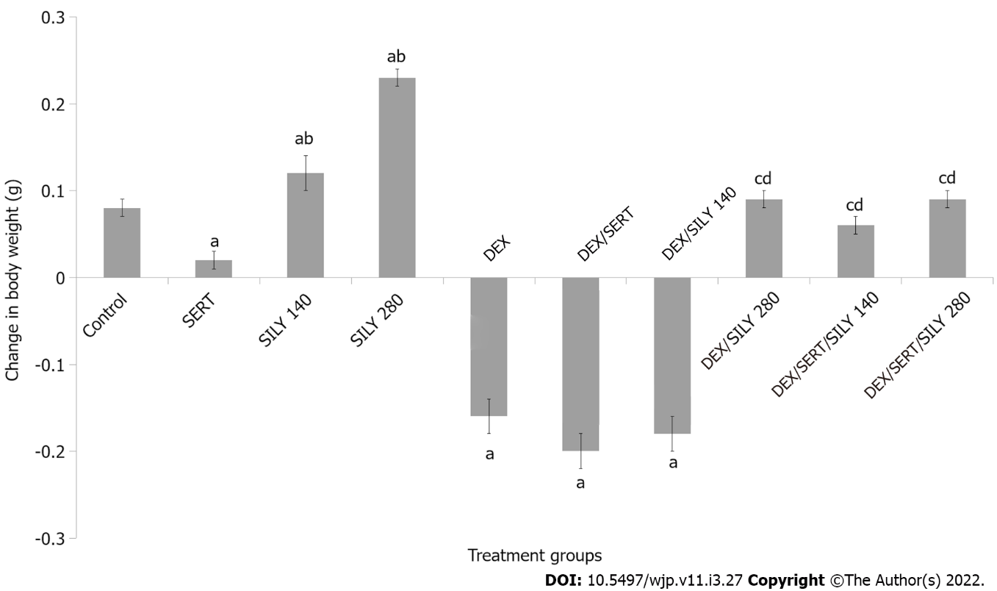
Figure 1 Effect of silymarin on change in body weight. Each bar represents the mean ± SEM, ªP < 0.05 vs control, ^{b}P < 0.05 vs SERT, ^{c}P < 0.05 vs DEX, ^{d}P < 0.05 vs DEX/SERT. SERT: Sertraline; DEX: Dexamethasone; SILY: Silymarin. Number of mice per treatment group = 10.

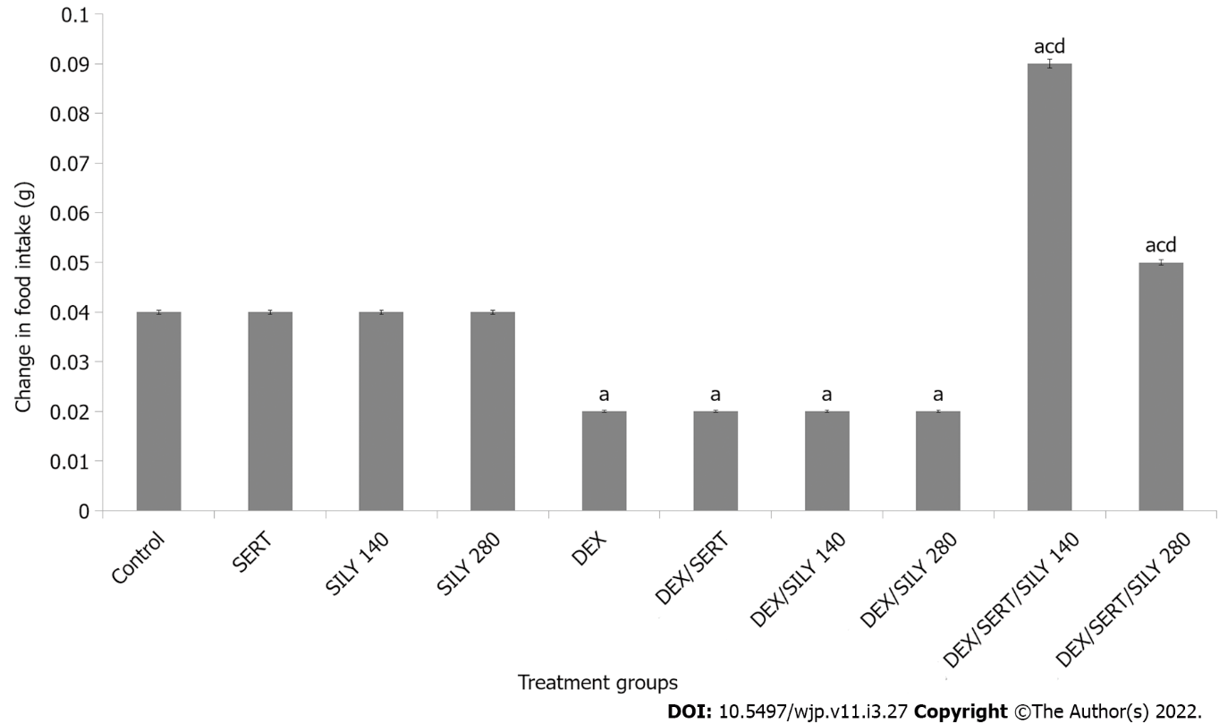
Figure 2 Effect of silymarin on changes in food intake. Each bar represents the mean ± SEM, ªP < 0.05 vs control, ^{b}P < 0.05 vs SERT, ^{c}P < 0.05 vs DEX, ^{d}P < 0.05 vs DEX/SERT. SERT: Sertraline; DEX: Dexamethasone; SILY: Silymarin. Number of mice per treatment group = 10.

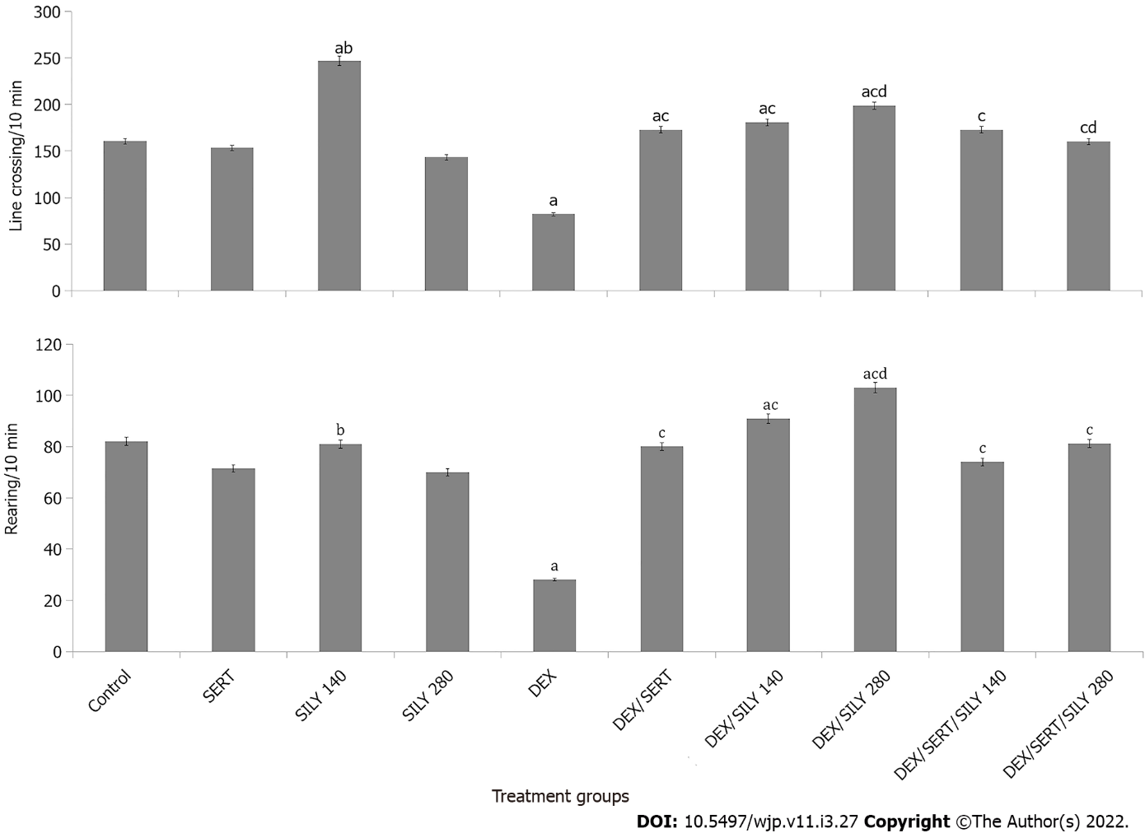
Figure 3 Effect of silymarin on locomotor activity (upper panel) and rearing activity (lower panel). Each bar represents the mean ± SEM, ªP < 0.05 vs control, ^{b}P < 0.05 vs SERT, ^{c}P < 0.05 vs DEX, ^{d}P < 0.05 vs DEX/SERT. SERT: Sertraline; DEX: Dexamethasone; SILY: Silymarin. Number of mice per treatment group = 10.

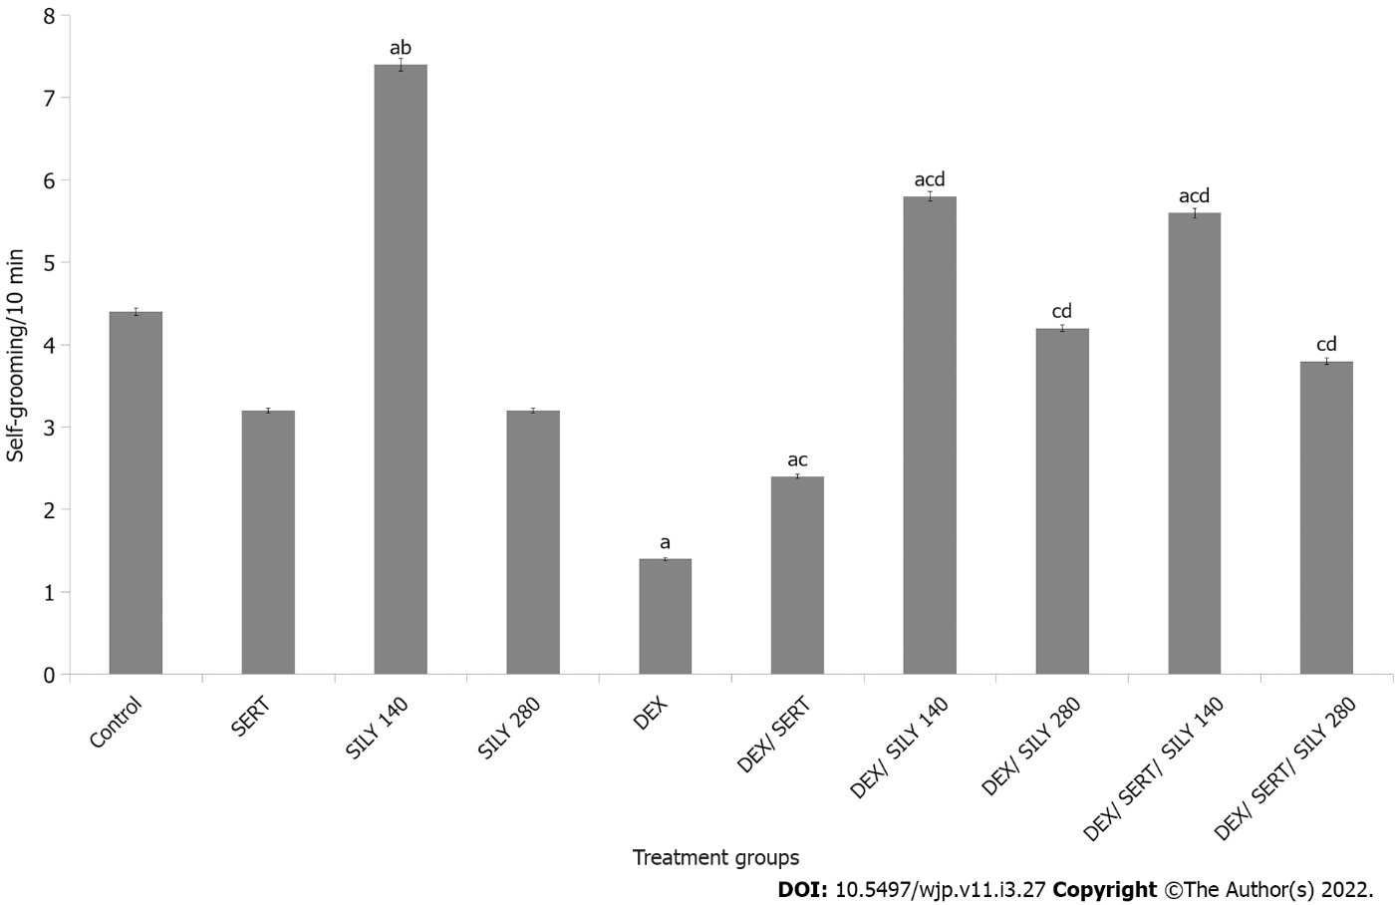
Figure 4 Effect of silymarin on self-grooming. Each bar represents the mean ± SEM, ^{c}P < 0.05 vs control, ^{b}P < 0.05 vs SERT, ^{c}P < 0.05 vs DEX, ^{d}P < 0.05 vs DEX/SERT. SERT: Sertraline; DEX: Dexamethasone; SILY: Silymarin. Number of mice per treatment group = 10.

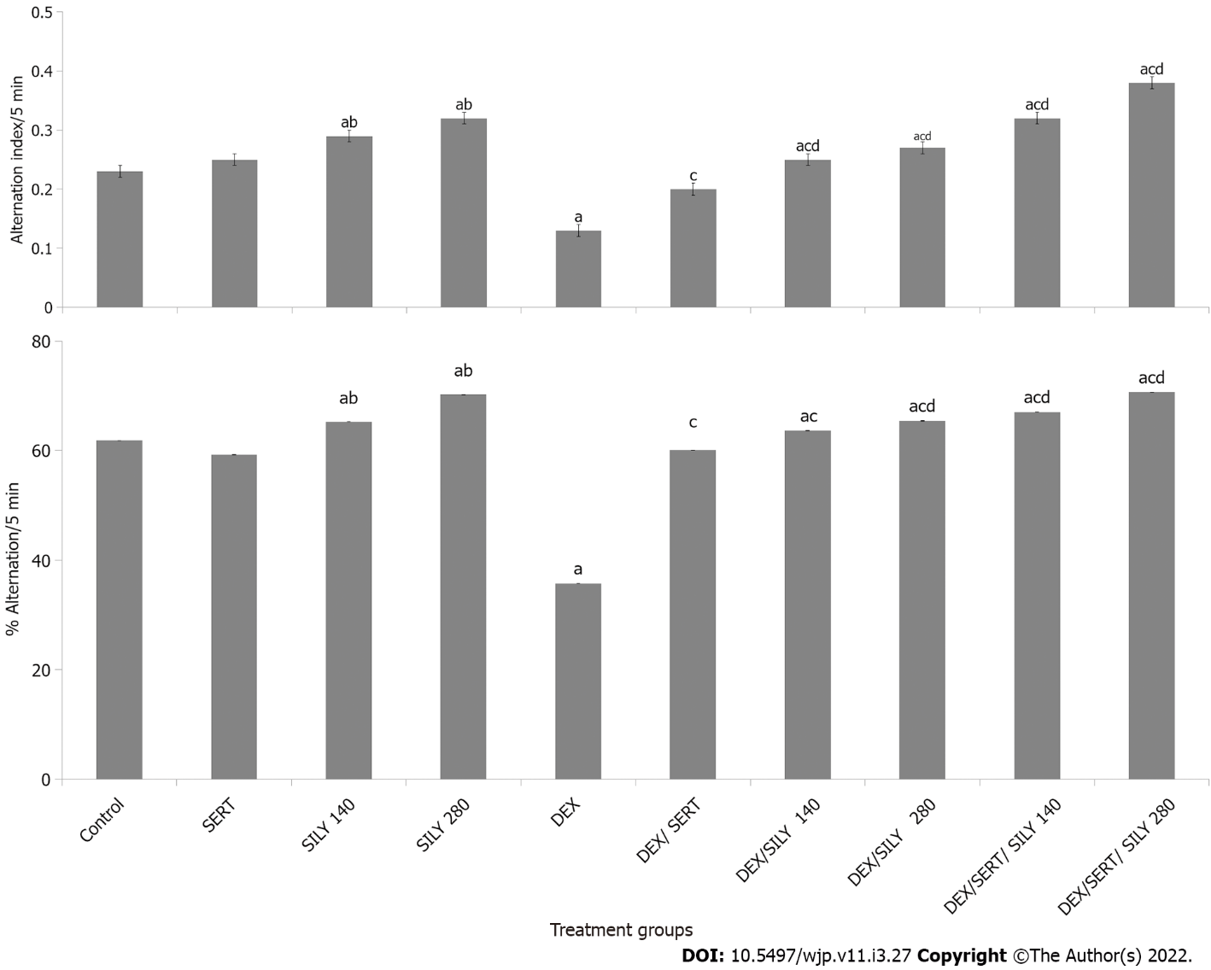
Figure 5 Effect of silymarin on radial arm maze (upper panel) and Y–maze (lower panel) spatial working memory. Each bar represents the mean ± SEM, ªP < 0.05 vs control, ^{b}P < 0.05 vs SERT, ^{c}P < 0.05 vs DEX, ^{d}P < 0.05 vs DEX/SERT. SERT: Sertraline; DEX: Dexamethasone; SILY: Silymarin. Number of mice per treatment group = 10.

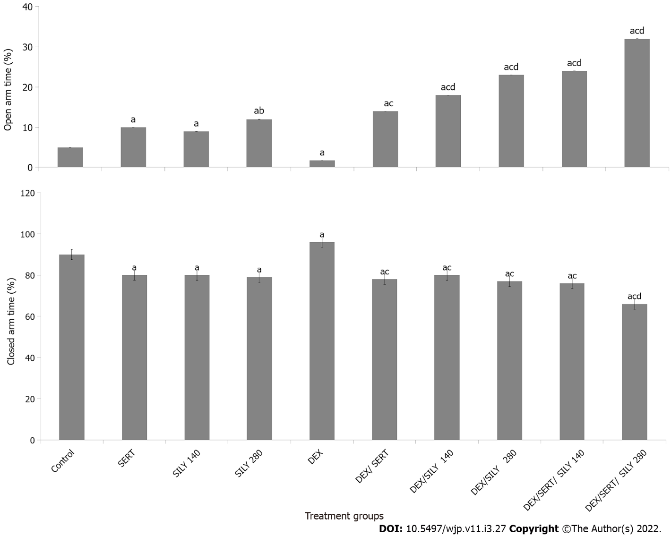
Figure 6 Effect of silymarin on time spent in the open-arm (upper panel) and closed arm (lower panel) of the elevated plus maze. Each bar represents the mean ± SEM, ªP < 0.05 vs control, ^{b}P < 0.05 vs SERT, ^{c}P < 0.05 vs DEX, ^{d}P < 0.05 vs DEX/SERT. SERT: Sertraline; DEX: Dexamethasone; SILY: Silymarin. Number of mice per treatment group = 10.

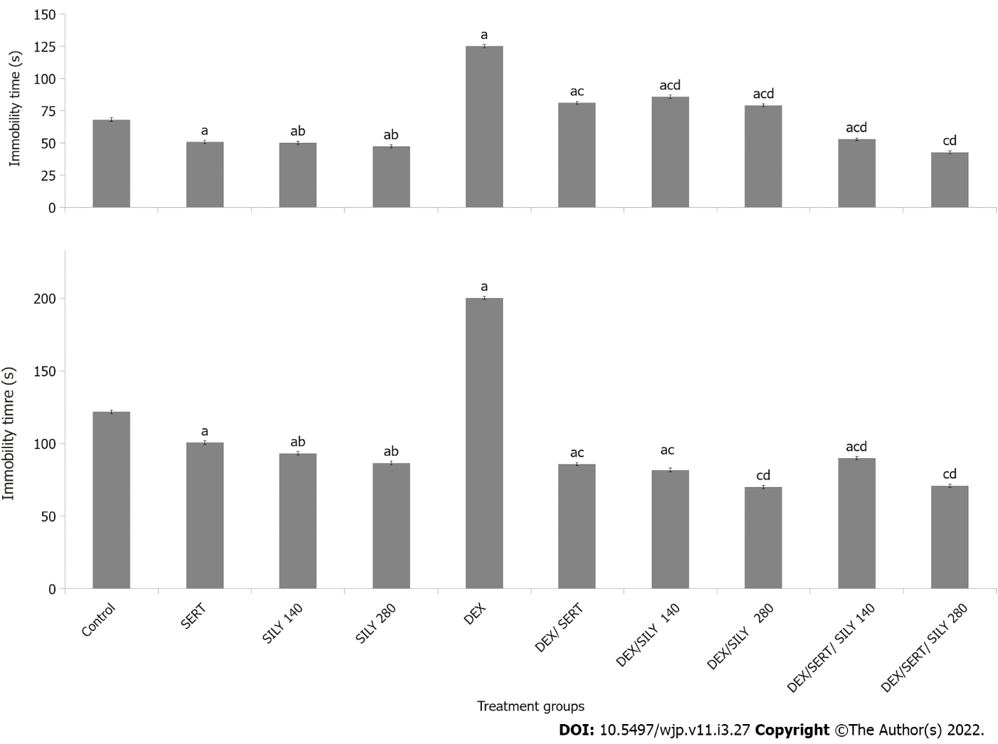
Figure 7 Effect of silymarin on immobility time in the tail suspension (upper panel) and forced swim (lower panel) tests. Each bar represents the mean ± SEM, ªP < 0.05 vs control, ^{b}P < 0.05 vs SERT, ^{c}P < 0.05 vs DEX, ^{d}P < 0.05 vs DEX/SERT. SERT: Sertraline; DEX: Dexamethasone; SILY: Silymarin. Number of mice per treatment group = 10.
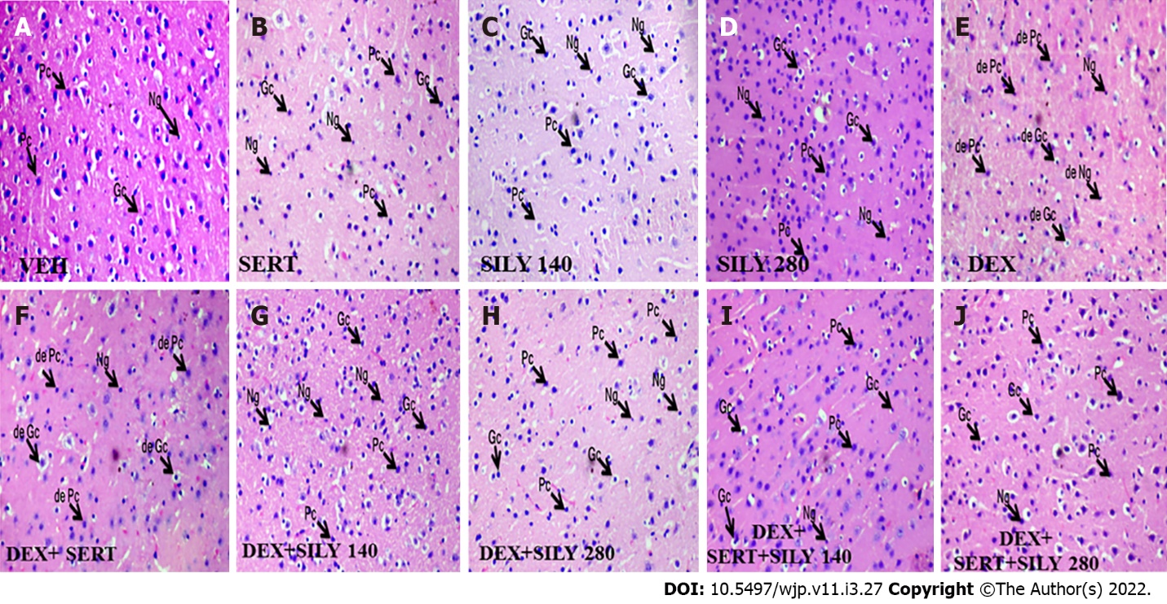
Figure 8 Effect of silymarin on histomorphology of the cerebral cortex. Photomicrographs show pyramidal cells, granule cells, and neuroglia. A: Vehicle; B: Sertraline C: Silymarin at 140mg/kg of food; D: Silymarin at 280 mg/kg of food; E: Dexamethasone, F: Dexamethasone and sertraline G: Dexamethasone and silymarin at 140; H: Dexamethasone and silymarin at 280; I: Dexamethasone, sertraline and silymarin at 140; J: Dexamethasone, sertraline and silymarin at 280. de-Pc: Degenerating pyramidal cells; de- Gc: Degenerating granule cells; de-Ng: Degenerating neuroglia; Gc: Granule cells; Pc: Pyramidal cells; Ng: Neuroglia. Number of mice per treatment group = 5.

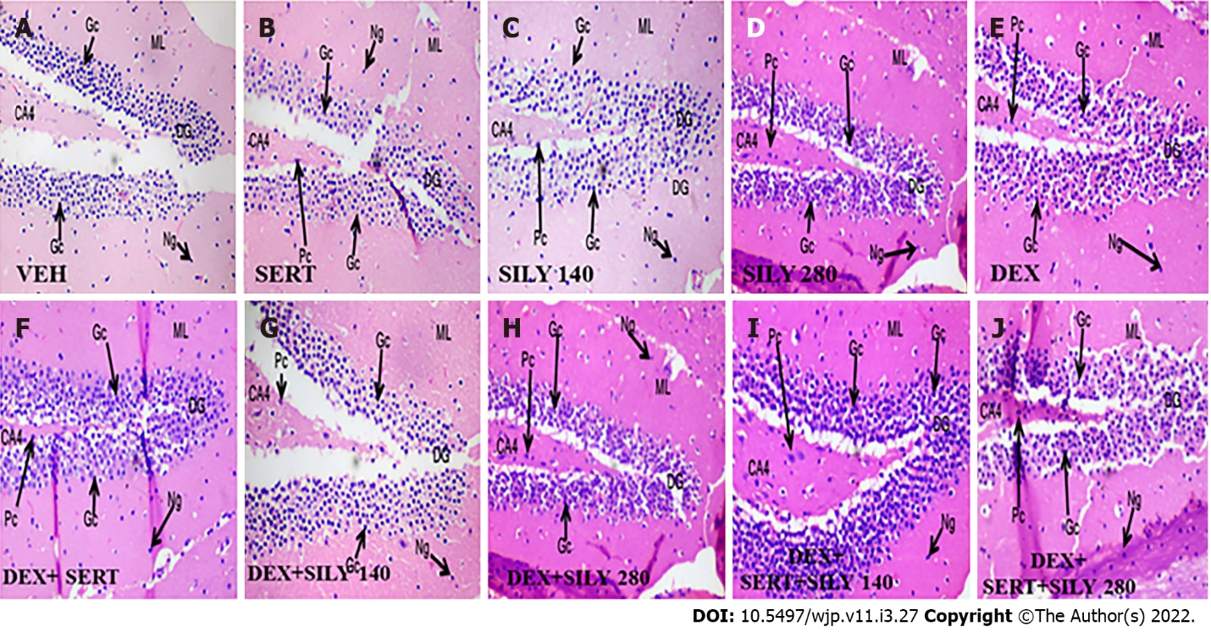
Figure 9 Effect of silymarin on histomorphology of the dentate gyrus of the hippocampus. Photomicrographs show small pyramidal cells, small granule cells within the dentate gyrus proper, and neuroglia scattered within the molecular layer. A: Vehicle; B: Sertraline; C: Silymarin at 140mg/kg of food; D: Silymarin at 280 mg/kg of food E: Dexamethasone; F: Dexamethasone and sertraline; G: Dexamethasone and silymarin at 140; H: Dexamethasone and silymarin at 280; I: Dexamethasone, sertraline and silymarin at 140; J: Dexamethasone, sertraline and silymarin at 280. Gc: Granule cells; Pc: Pyramidal cells; Ng: Neuroglia; ML: Molecular layer.Number of mice per treatment group = 5.

Table 1 Serum antioxidant status and lipid peroxidation level
Group | SOD (U/mL) | CAT (U/mL) | GSH nmol/mL | GPx IU/L | MDA μmol/L
Control | 0.92 ± 0.02 | 23.12 ± 0.21 | 0.73 ± 0.10 | 11.68 ± 1.10 | 6.42 ± 0.02
SERT | 0.93 ± 0.02 | 21.11 ± 0.20 | 0.70 ± 0.11 | 10.60 ± 2.01 | 5.40 ± 0.02
SILY 140 | 1.54 ± 0.11^{a,b} | 28.72 ± 0.23^{a,b} | 0.82 ± 0.05^{a,b} | 24.54 ± 0.34^{a,b} | 3.38 ± 0.04ª
SILY 280 | 1.98 ± 0.02^{a,b} | 31.76 ± 0.22^{a,b} | 1.12 ± 0.05^{a,b} | 30.20 ± 0.78^{a,b} | 2.33 ± 0.03^{a,b}
DEX | 0.78 ± 0.03ª | 12.78 ± 0.22ª | 0.30 ± 0.05ª | 6.65 ± 1.10ª | 14.40 ± 0.06ª
DEX/SERT | 0.67 ± 0.01^{a,c} | 13.67 ± 0.20ª | 0.35 ± 0.01^{a,c} | 6.92 ± 1.00^{c} | 14.57 ± 0.16ª
DEX/SILY 140 | 0.98 ± 0.01^{c,d} | 22.16 ± 0.10^{c,d} | 0.56 ± 0.04^{a,c} | 11.40 ± 1.23^{c,d} | 9.65 ± 0.05^{a,c,d}
DEX/SILY 280 | 1.00 ± 0.12^{a,c,d} | 27.20 ± 0.22^{a,c,d} | 0.78 ± 0.03^{a,c,d} | 12.45 ± 1.30^{c,d} | 5.57 ± 0.01^{a,c,d}
DEX/SERT/SILY 140 | 0.82 ± 0.02^{a,c,d} | 19.70 ± 0.10^{a,c,d} | 0.75 ± 0.01^{c,d} | 10.12 ± 1.01^{c,d} | 4.98 ± 0.05^{a,c,d}
DEX/SERT/SILY 280 | 0.98 ± 0.02^{a,c,d} | 21.21 ± 0.20^{c,d} | 0.88 ± 0.03^{a,c,d} | 11.32 ± 0.76^{c,d} | 4.82 ± 0.02^{a,c,d}
Values are expressed as the mean ± SEM.
ªP < 0.05 vs control.
^{b}P < 0.05 vs SERT.
^{c}P < 0.05 vs DEX.
^{d}P < 0.05 vs DEX/SERT. SOD: Superoxide dismutase; GPx: Glutathione peroxidase; MDA: Malondialdehyde; SERT: Sertraline; DEX: Dexamethasone; SILY: Silymarin. Number of mice per treatment.

Table 2 Brain levels of inflammatory markers, acetylcholinesterase activity, lipid peroxidation, and antioxidant status
Group | TNF-α ng/g/protein | IL-10 pg/mg/protein | ACHe nmol/mg | MDA nmol/g/protein | GSH nmol/mg/protein | GPx mU/mg/protein
Control | 38.78 ± 0.20 | 23.89 ± 0.20 | 32.10 ± 1.30 | 7.95 ± 0.50 | 0.75 ± 0.10 | 18.68 ± 1.10
SERT | 24.12 ± 0.10ª | 19.20 ± 0.16ª | 28.19 ± 1.03ª | 8.01 ± 0.51 | 0.73 ± 0.11 | 17.60 ± 1.01
SILY 140 | 34.18 ± 0.10ª | 23.65 ± 0.20 | 24.22 ± 1.15^{a,b} | 6.91 ± 0.70ª | 0.92 ± 0.05^{a,b} | 34.54 ± 0.44^{a,b}
SILY 280 | 33.11 ± 0.20ª | 23.80 ± 0.30 | 20.18 ± 1.15^{a,b} | 5.83 ± 0.63^{a,b} | 1.23 ± 0.05^{a,b} | 46.20 ± 0.54^{a,b}
DEX | 18.78 ± 0.13ª | 9.07 ± 0.10ª | 52.10 ± 1.25ª | 18.20 ± 0.56ª | 0.30 ± 0.05ª | 10.15 ± 0.80ª
DEX/SERT | 19.40 ± 0.10^{a,c} | 8.21 ± 0.19ª | 42.30 ± 1.11^{a,c} | 18.25 ± 0.76^{a,c} | 0.32 ± 0.02ª | 9.89 ± 0.80^{c}
DEX/SILY 140 | 25.22 ± 0.11^{c,d} | 15.22 ± 0.20^{c,d} | 33.22 ± 1.24^{c,d} | 7.60 ± 0.80^{c,d} | 0.64 ± 0.03^{a,c} | 12.40 ± 0.83^{a,c,d}
DEX/SILY 280 | 29.00 ± 0.12^{a,c,d} | 19.21 ± 0.23^{c,d} | 30.17 ± 1.13^{a,c,d} | 6.57 ± 0.63^{a,c,d} | 0.88 ± 0.03^{c,d} | 14.35 ± 0.07^{a,c,d}
DEX/SERT/SILY 140 | 23.23 ± 0.10^{a,c,d} | 14.10 ± 0.12^{a,c,d} | 28.12 ± 1.21^{c,d} | 6.38 ± 0.61^{a,c,d} | 0.78 ± 0.01^{a,c,d} | 13.42 ± 0.71^{a,c,d}
DEX/SERT/SILY 280 | 25.12 ± 0.10^{a,c,d} | 16.19 ± 0.15^{a,c,d} | 24.20 ± 1.10^{a,c,d} | 6.32 ± 0.50^{a,c,d} | 0.88 ± 0.03^{a,c,d} | 15.42 ± 0.89^{a,c,d}
Values are expressed as the mean ± SEM.
ªP < 0.05 vs control.
^{b}P < 0.05 vs SERT.
^{c}P < 0.05 vs DEX.
^{d}P < 0.05 vs DEX/SERT. GPx: Glutathione peroxidase; MDA: Malondialdehyde; SERT: Sertraline; DEX: Dexamethasone; SILY: Silymarin. Number of mice per treatment.

Published by Baishideng Publishing Group Inc
7041 Koll Center Parkway, Suite 160, Pleasanton, CA 94566, USA
Telephone: +1-925-3991568
E-mail: bpgoffice@wjgnet.com
Help Desk: https://www.f6publishing.com/helpdesk
https://www.wjgnet.com

© 2022 Baishideng Publishing Group Inc. All rights reserved.

