Name of Journal: World Journal of Clinical Cases
Manuscript NO: 66752
Manuscript Type: CASE REPORT

Non-immune hydrops fetalis: Two case reports

Maranto M et al. Non-immune hydrops fetalis

Marianna Maranto, Valentina Cigna, Emanuela Orlandi, Gaspare Cucinella, Clelia Lo Verso, Vincenzo Duca, Francesco Picciotto

Marianna Maranto, Valentina Cigna, Emanuela Orlandi, Francesco Picciotto, Fetal Medicine and Prenatal Diagnosis Unit, Villa Sofia Cervello Hospitals, Palermo 90146, Italy

Gaspare Cucinella, Health Promotion, Maternal and Infant Care Unit, Internal Medicine and Medical Specialties “G. D’Alessandro”, University of Palermo, Palermo 90100, Italy

Clelia Lo Verso, Neonatology and Neonatal Intensive Care Unit, Civico Di Cristina Benfratelli Hospital, Palermo 90100, Italy

Vincenzo Duca, Neonatology and Neonatal Intensive Care Unit, Ingrassia Hospital, Palermo 90100, Italy

Author contributions: Maranto M reviewed the literature and drafted the manuscript; Picciotto F and Cigna V were the pregnant women’s obstetricians and contributed to manuscript drafting as for maternal management; Lo Verso C and Duca V were the babies’ neonatologists, reviewed the literature and contributed to manuscript drafting as for neonatal management; Orlandi E analyzed and interpreted the imaging findings; all authors issued final approval for the version to be submitted.

Correspondence to: Marianna Maranto, MD, Doctor, Fetal Medicine and Prenatal Diagnosis Unit, Villa Sofia Cervello Hospitals, Via Trabucco180, Palermo 90146, Italy. marianna.maranto@community.unipa.it

Received: April 7, 2021
Revised: May 6, 2021
Accepted: June 4, 2021
Published online:

Abstract
BACKGROUND
Fetal hydrops is a serious condition difficult to manage, often with a poor prognosis, and it is characterized by the collection of fluid in the extravascular compartments. Before 1968, the most frequent cause was the maternal-fetal Rh incompatibility. Today, 90% of the cases are non-immune hydrops fetalis. Multiple fetal anatomic and functional disorders can cause non-immune hydrops fetalis and the pathogenesis is incompletely understood. Etiology varies from viral infections to heart disease, chromosomal abnormalities, hematological and autoimmune causes.

CASE SUMMARY
A 38-year-old pregnant woman has neck lymphoadenomegaly, fever, cough, tonsillar plaques at 14 wk of amenorrhea and a rash with widespread itching. At 27.5 wk a fetal ultrasound shows signs of severe anemia and hydrops. Cordocentesis is performed with confirmation of severe fetal anemia and subsequent fetal transfusion. The karyotype is 46, XX, array-comparative genome hybridization (CGH) negative, and infectious tests are not conclusive. In the following days there is a progressive improvement of the indirect signs of fetal anemia. At 33.6 wk, for relapse of severe fetal anemia, further fetal transfusions are necessary and an urgent cesarean section is performed. On the day 12 of life, for the detection of anemia, the newborn is subjected to transfusion of concentrated red blood cells and begins treatment with erythropoietin. Later there is a normalization of blood chemistry values and the baby does not need new transfusions. A 29-year-old pregnant woman, with Sjogren's syndrome and positive Anti-Ro/SSA antibodies, is subjected to serial fetal ecocardio for branch block. At 26.5 wk there is a finding of fetal ascites. Infectious disease tests on amniotic fluid are negative as well as quantitative fluorescent polymerase chain reaction, Array CGH. At cordocentesis Hb is 1.3 mmol/L, consequently fetal transfusion is performed. Also in this case, due to continuous episodes of relapse of fetal anemia with consequent transfusions, at 29.4 wk a cesarean section is performed. On day 9 of life, a treatment with erythropoietin is started in the newborn, but the baby needs three blood transfusions. The search for autoantibodies in the baby found SS-A Ro60 positive, SSA-Ro52 positive and SS-B negative. The hemoglobin values normalized after the disappearance of maternal autoantibodies.

CONCLUSION
An attempt to determine the etiology of hydrops should be made at the time of diagnosis because the goal is to treat underlying cause, whenever possible. Even if the infectious examinations are not conclusive, but the pregnancy history is strongly suggestive of infection as in the first case, the infectious etiology must not be excluded. In the second case, instead, transplacental passage of maternal autoantibodies caused hydrops fetalis and severe anemia. Finally, obstetric management must be aimed at fetal support up to an optimal timing for delivery by evaluating risks and benefits to increase the chances of survival without sequelae.

Key Words: Cordocentesis; Fetal anemia; Fetal transfusion; Hydrops fetalis; Preterm cesarean section; Case report

Core Tip: We present herein, two rare cases of non-immune hydrops fetalis with severe fetal anemia. Despite the similar onset, the etiology was infectious in the first case and autoimmune in the last one. In particular, we want to emphasize that even if the infectious examinations are not conclusive, but the pregnancy history is strongly suggestive of infection, the infectious etiology must not be excluded. Secondly, transplacental passage of maternal autoantibodies can cause hydrops fetalis and severe anemia. In any case, obstetric management must always be aimed at fetal support up to an optimal timing for delivery by evaluating risks and benefits.

Maranto M, Cigna V, Orlandi E, Cucinella G, Lo Verso C, Duca V, Picciotto F. Non-immune hydrops fetalis: Two case reports. World J Clin Cases 2021; In press

INTRODUCTION
Fetal hydrops (HF) is a serious condition difficult to manage, often with a poor prognosis, and it is characterized by the collection of fluid in the extravascular compartments. In particular, the diagnosis is based on the presence of two or more of the following findings on ultrasound examination: ascites (early sign), skin edema (later sign), pleural effusion, pericardial effusion^{[1,2]}.
In 1943, Potter defined two forms of HF: Immunomediated (IHF) and non-immune (NIHF). Before the use of anti-D immune globulin in 1968, the most frequent cause was the maternal-fetal Rh incompatibility, today 90% of the cases are NIHF^{[3]} with a prevalence that ranges from 1 / 1500 to 1 / 4000 births^{[4-7]}. Multiple fetal anatomic and functional disorders can cause NIHF and the pathogenesis is incompletely understood^{[8]}. Etiology varies from viral infections to heart disease, chromosomal abnormalities and hematological causes^{[9-11]}.
The purpose of this report is to describe two complex cases of NIHF diagnosed in our center between 2018 and 2019, from prenatal diagnosis to neonatal management. Clinical records and laboratory data have been collected retrospectively analyzing clinical and ultrasound documentation of the mother and child.

CASE PRESENTATION
Chief complaints
Case 1: At 27.5 wk of amenorrhea a fetal ultrasound showed signs of severe anemia, as shown in Figure 1, and hydrops (ascites, diffuse edema, pericardic effusion, severe cardiomegaly and hepatomegaly).
At cordocentesis (shown in Figure 2), fetal hemoglobin (Hb) of 1.77 mmol/L is found, therefore transfusion of concentrated and irradiated red blood cells is performed and an Hb value of 4.37 mmol/L is reached. Moreover karyotype (46, XX), array-comparative genome hybridization (CGH) (negative), and infectious tests are performed on fetal blood: Cytomegalovirus IgG positive and IgM negative, herpes simplex 1 IgG positive and IgM negative, herpes simplex 2 IgG negative and IgM positive, HBsAg negative, hepatitis C virus-DNA negative, Toxoplasma IgG and IgM negative, Epstein-Barr IgG positive and IgM negative, Parvovirus B19 IgG positive and IgM negative. In the following days there was a progressive improvement of the indirect signs of fetal anemia as shown in Figure 3 (resolution of ascites and skin edema and reduction of cardiomegaly). At 31.2 wk reappearance of fetal anemia with Hb 3.29 mmol/L and 2% reticulocytes, second transfusion is performed with achievement of Hb 6.39 mmol/L. At 33.6 wk, for relapse of severe fetal anemia, an urgent cesarean section is performed, with the birth of a female fetus, fetal weight of 2080 g, Apgar 1’: 8, 5’: 9.

Case 2: For Sjogren's syndrome, the patient was subjected to serial fetal ecocardio: The exams were always negative for branch block, but at 26.5 wk there was a finding of fetal ascites. Infectious disease tests on amniotic fluid were negative as well as quantitative fluorescent polymerase chain reaction, Array CGH. At cordocentesis Hb was 1.3 mmol/L, therefore fetal transfusion is performed with Hb 4.34 mmol/L at the end of the procedure. At 27.1 wk, after ultrasound check with indirect diagnosis of severe fetal anemia, another cordocentesis is performed with Hb 2.76 mmol/L; so the second fetal transfusion is performed with the achievement of Hb 5.24 mmol/dL. At 27.6 wk a new ultrasound check is performed with ascites and hydrothorax; fetal ascites drainage (80 mL) to perform lymphocyte count, microvillary enzymes, beta-2-microglobulin. The third fetal transfusion was performed at 28.1 wk for further detection of fetal anemia (Hb 3.66 mmol/L), with Hb of 6.58 mmol/L at the end of the procedure. On the same day, two units of blood cells concentrated to the mother are transfused with maternal Hb from 4.65 mmol/L to 5.9 mmol/L.
Due to the persistence of fetal ascites and fetal anemia, at 29.4 wk a cesarean section is performed, with the birth of a female fetus, fetal weight of 1650 g and Apgar 1’: 7, 5’: 9. The pathological examination is performed on the placenta: the diagnosis was retroplacental hematoma with adaptive modifications to hypoxic suffering.

History of present illness
Case 1: In current pregnancy, the patient performed low-risk first-trimester screening. At 14 wk, she showed neck lymphoadenomegaly, fever, cough, tonsillar plaques, followed by a rash with widespread itching.

Case 2: In current pregnancy, the patient performed low-risk first-trimester screening.

History of past illness
Case 1: Negative medical and obstetric history.

Case 2: She has β-Thalassemia intermedia and Sjogren's syndrome with positive Anti-Ro/SSA antibodies, being treated with prednisone 5 mg/d, acetylsalicylic acid 100 mg/d, calcium nadroparin 3800 UI/d and hydroxychloroquine sulphate 200 mg/d.

Personal and family history
Case 1: The first pregnant woman is a 38-year-old Caucasian woman, non-smoker, her blood type is A Rhesus positive.

Case 2: The second patient is a 29-year-old Caucasian woman, non-smoker, her blood type is 0 Rhesus positive.

FINAL DIAGNOSIS
Case 1: The first case report represents an example of NIHF caused by post-infectious fetal anemia. A diagnosis of exclusion was made, guided by the anamnesis, which highlighted the maternal symptoms between the first and second trimester of pregnancy.

Case 2: The search for autoantibodies in the baby found SS-A Ro60 positive, SSA-Ro52 positive and SS-B negative.

TREATMENT
In both cases, prenatal treatment with fetal transfusions by cordocentesis, allowed the survival of fetuses up to an appropriate time for delivery.

OUTCOME AND FOLLOW-UP
Case 1: The newborn needed ventilatory support in n-CPAP mode in the first 10 h of life. On day 12 of hospitalization, for the detection of anemia (Hb 3.91 mmol/L), she was subjected to transfusion of concentrated red blood cells and she began treatment with erythropoietin which was continued up to 4 mo of life. Later on there was a normalization of blood chemistry values and the baby did not need new transfusions. During the hospitalization an ultrasound follow-up was performed: the ecocardium on day 3 of life showed a slight dilation of the right chambers, which gradually decreased.

Case 2: In the first hours of life the patient needed ventilatory assistance, surfactant was administered with the INSURE technique. On day 9 of life treatment with erythropoietin was started, but in the following 2 mo she needed three blood transfusions.

DISCUSSION
The causes of NIHF are heterogeneous: cardiac, pulmonary, metabolic, hematologic and infectious. Hydrops is associated with an overall perinatal mortality rate from 50% to 98%^{[2,12]}. Even among liveborn infants, mortality is 43% by 1 year of age in one large series^{[7]}.
Despite advances in fetal diagnosis and therapy, the mortality rate has not changed substantially in recent years. For this reason it is essential to continue collecting data of this rare, serious and still difficult condition.
In general, early onset, the presence of pleural effusion and polyhydramnios before 20 wk, are poor prognostic factors especially due to the increased risk of pulmonary hypoplasia and preterm delivery. Instead, absence of aneuploidy and absence of major structural abnormalities confer a better prognosis^{[13,14]}.
Antenatal management includes etiological diagnosis, whenever possible. If the fetus is anemic, as in the two cases described, transfusions are carried out in the uterus waiting for the timing of delivery. Pregnancy should be managed in third-level center where a close collaboration between obstetricians and neonatologists ensures improved perinatal care.
Postnatal management initially involves stabilization of the newborn; then the goal is to identify the underlying cause and to treat it. Often, due also to pulmonary hypoplasia, these newborns need an invasive ventilatory support at birth and endotracheal intubation can be difficult due to the widespread edema that also involves the oropharynx^{[15]}. Sometimes, these patients also need hemodynamic stabilization, by intravenous fluid infusion or by using inotropic drugs to improve cardiac output. Anemia may be due to hemolysis (thalassemia, hereditary spherocytosis), blood loss from maternal-fetal hemorrhage or reduction in fetal red blood cell production (parvovirus B19 infection). In cases where red blood cell transfusion is required, an isovolemic exchange is preferred so as not to further increase central venous pressure^{[16]}.
As described in the literature, NIHF frequently has an infectious etiology, like parvovirus B19, cytomegalovirus, syphilis and toxoplasmosis. These infections can cause fetal anemia with subsequent heart failure, or to myocarditis caused by the pathogens themselves^{[17]}. Recently, two cases of fetal transient skin edema in pregnant women with coronavirus disease 2019 in their second trimester of pregnancy are described, resolved when maternal severe acute respiratory syndrome coronavirus-2 real-time reverse transcription polymerase chain reaction test results became negative. However, it is unclear whether skin edema in these cases was related to maternal infection^{[18]}.
The laboratory diagnosis of maternal parvovirus B19 infection is based on the search for specific IgG and IgM antibodies. Circulating IgM antibodies can be detected about 10 d after exposure and immediately before the onset of symptoms, they may persist for 3 mo or more^{[19]}. However, the negativity of anti-parvovirus IgM can be misleading in a patient with a history and a significant clinical history, because in some cases maternal IgM levels may be lower than the detection limit and thus give a false negative, as in case 1.
The clinical cases described represent an example of post-infectious HF, the other an immune-mediated form. The diagnosis was initially oriented by the anamnesis, which highlighted in the first case the maternal symptomatology between the first and the second trimester of pregnancy, and in the other patient the autoimmune pathology. In both cases, follow-up and prenatal treatment allowed fetal survival; the management in a third level center has guaranteed the newborn adequate care at birth, and consequently a complete diagnostic-therapeutic procedure.
Both patients had severe anemia, in the first one caused by post-infectious bone marrow aplasia and the last one of autoimmune nature, both required transfusion of red blood cells both in the prenatal and post-natal periods. However, the hemoglobin values normalized after resolution of the active infection and following the disappearance of maternal autoantibodies, respectively. Follow-up did not detect new episodes of anemia or other disorders.

CONCLUSION
In conclusion, an attempt to determine the etiology of hydrops should be made at the time of diagnosis, since several etiologies can be confirmed or excluded based upon ultrasound findings. However, the cause of hydrops can be determined prenatally or postnatally in 60%-85% of cases. In the remaining cases the cause rests unknown.

REFERENCES
1 Jones DC. Nonimmune fetal hydrops: diagnosis and obstetrical management. Semin Perinatol 1995; 19: 447-461 [PMID: 8822329 DOI: 10.1016/s0146-0005(05)80052-7]
2 Carlson DE, Platt LD, Medearis AL, Horenstein J. Prognostic indicators of the resolution of nonimmune hydrops fetalis and survival of the fetus. Am J Obstet Gynecol 1990; 163: 1785-1787 [PMID: 2256483 DOI: 10.1016/0002-9378(90)90749-w]
3 Potter EL. Universal edema of the fetus unassociated with erythroblastosis. Am J Obstet Gynecol 1943; 46: 130-134 [DOI: 10.1016/S0002-9378(16)40458-8]
4 Sohan K, Carroll SG, De La Fuente S, Soothill P, Kyle P. Analysis of outcome in hydrops fetalis in relation to gestational age at diagnosis, cause and treatment. Acta Obstet Gynecol Scand 2001; 80: 726-730 [PMID: 11531615 DOI: 10.1034/j.1600-0412.2001.080008726.x]
5 Castillo RA, Devoe LD, Hadi HA, Martin S, Geist D. Nonimmune hydrops fetalis: clinical experience and factors related to a poor outcome. Am J Obstet Gynecol 1986; 155: 812-816 [PMID: 3532802 DOI: 10.1016/s0002-9378(86)80026-6]
6 Anandakumar C, Biswas A, Wong YC, Chia D, Annapoorna V, Arulkumaran S, Ratnam S. Management of non-immune hydrops: 8 years' experience. Ultrasound Obstet Gynecol 1996; 8: 196-200 [PMID: 8915090 DOI: 10.1046/j.1469-0705.1996.08030196.x]
7 Steurer MA, Peyvandi S, Baer RJ, MacKenzie T, Li BC, Norton ME, Jelliffe-Pawlowski LL, Moon-Grady AJ. Epidemiology of Live Born Infants with Nonimmune Hydrops Fetalis-Insights from a Population-Based Dataset. J Pediatr 2017; 187: 182-188.e3 [PMID: 28533037 DOI: 10.1016/j.jpeds.2017.04.025]
8 Bellini C, Hennekam RC. Non-immune hydrops fetalis: a short review of etiology and pathophysiology. Am J Med Genet A 2012; 158A: 597-605 [PMID: 22302731 DOI: 10.1002/ajmg.a.34438]
9 Enders M, Weidner A, Zoellner I, Searle K, Enders G. Fetal morbidity and mortality after acute human parvovirus B19 infection in pregnancy: prospective evaluation of 1018 cases. Prenat Diagn 2004; 24: 513-518 [PMID: 15300741 DOI: 10.1002/pd.940]
10 Enders M, Klingel K, Weidner A, Baisch C, Kandolf R, Schalasta G, Enders G. Risk of fetal hydrops and non-hydropic late intrauterine fetal death after gestational parvovirus B19 infection. J Clin Virol 2010; 49: 163-168 [PMID: 20729141 DOI: 10.1016/j.jcv.2010.07.014]
11 Puccetti C, Contoli M, Bonvicini F, Cervi F, Simonazzi G, Gallinella G, Murano P, Farina A, Guerra B, Zerbini M, Rizzo N. Parvovirus B19 in pregnancy: possible consequences of vertical transmission. Prenat Diagn 2012; 32: 897-902 [PMID: 22777688 DOI: 10.1002/pd.3930]
12 Santo S, Mansour S, Thilaganathan B, Homfray T, Papageorghiou A, Calvert S, Bhide A. Prenatal diagnosis of non-immune hydrops fetalis: what do we tell the parents? Prenat Diagn 2011; 31: 186-195 [PMID: 21268039 DOI: 10.1002/pd.2677]
13 McCoy MC, Katz VL, Gould N, Kuller JA. Non-immune hydrops after 20 weeks' gestation: review of 10 years' experience with suggestions for management. Obstet Gynecol 1995; 85: 578-582 [PMID: 7898837 DOI: 10.1016/0029-7844(94)00444-i]
14 Iskaros J, Jauniaux E, Rodeck C. Outcome of nonimmune hydrops fetalis diagnosed during the first half of pregnancy. Obstet Gynecol 1997; 90: 321-325 [PMID: 9277637 DOI: 10.1016/s0029-7844(97)00290-1]
15 Wafelman LS, Pollock BH, Kreutzer J, Richards DS, Hutchison AA. Nonimmune hydrops fetalis: fetal and neonatal outcome during 1983-1992. Biol Neonate 1999; 75: 73-81 [PMID: 9852356 DOI: 10.1159/000014080]
16 Phibbs RH, Johnson P, Tooley WH. Cardiorespiratory status of erythroblastotic newborn infants. II. Blood volume, hematocrit, and serum albumin concentration in relation to hydrops fetalis. Pediatrics 1974; 53: 13-23 [PMID: 4588130]
17 Sampath V, Narendran V, Donovan EF, Stanek J, Schleiss MR. Nonimmune hydrops fetalis and fulminant fatal disease due to congenital cytomegalovirus infection in a premature infant. J Perinatol 2005; 25: 608-611 [PMID: 16123790 DOI: 10.1038/sj.jp.7211357]
18 Garcia-Manau P, Garcia-Ruiz I, Rodo C, Sulleiro E, Maiz N, Catalan M, Fernández-Hidalgo N, Balcells J, Antón A, Carreras E, Suy A. Fetal Transient Skin Edema in Two Pregnant Women With Coronavirus Disease 2019 (COVID-19). Obstet Gynecol 2020; 136: 1016-1020 [PMID: 32649505 DOI: 10.1097/AOG.0000000000004059]
19 Rotbart HA. Human parvovirus infections. Annu Rev Med 1990; 41: 25-34 [PMID: 2158761 DOI: 10.1146/annurev.me.41.020190.000325]

Footnotes
Informed consent statement: Informed written consent was obtained from the patient for publication of this report and any accompanying images.

Conflict-of-interest statement: The authors declare that they have no conflict of interest.

CARE Checklist (2016) statement: The authors have read the CARE Checklist (2016), and the manuscript was prepared and revised according to the CARE Checklist (2016).

Open-Access: This article is an open-access article that was selected by an in-house editor and fully peer-reviewed by external reviewers. It is distributed in accordance with the Creative Commons Attribution NonCommercial (CC BY-NC 4.0) license, which permits others to distribute, remix, adapt, build upon this work non-commercially, and license their derivative works on different terms, provided the original work is properly cited and the use is non-commercial. See: http://creativecommons.org/Licenses/by-nc/4.0/

Manuscript source: Unsolicited manuscript

Peer-review started: April 7, 2021
First decision: April 23, 2021
Article in press:

Specialty type: Obstetrics and gynecology
Country/Territory of origin: Italy
Peer-review report’s scientific quality classification
Grade A (Excellent): 0
Grade B (Very good): 0
Grade C (Good): C, C
Grade D (Fair): 0
Grade E (Poor): 0

P-Reviewer: Sergi C S-Editor: Zhang H L-Editor: Filipodia P-Editor:
Figure Legends
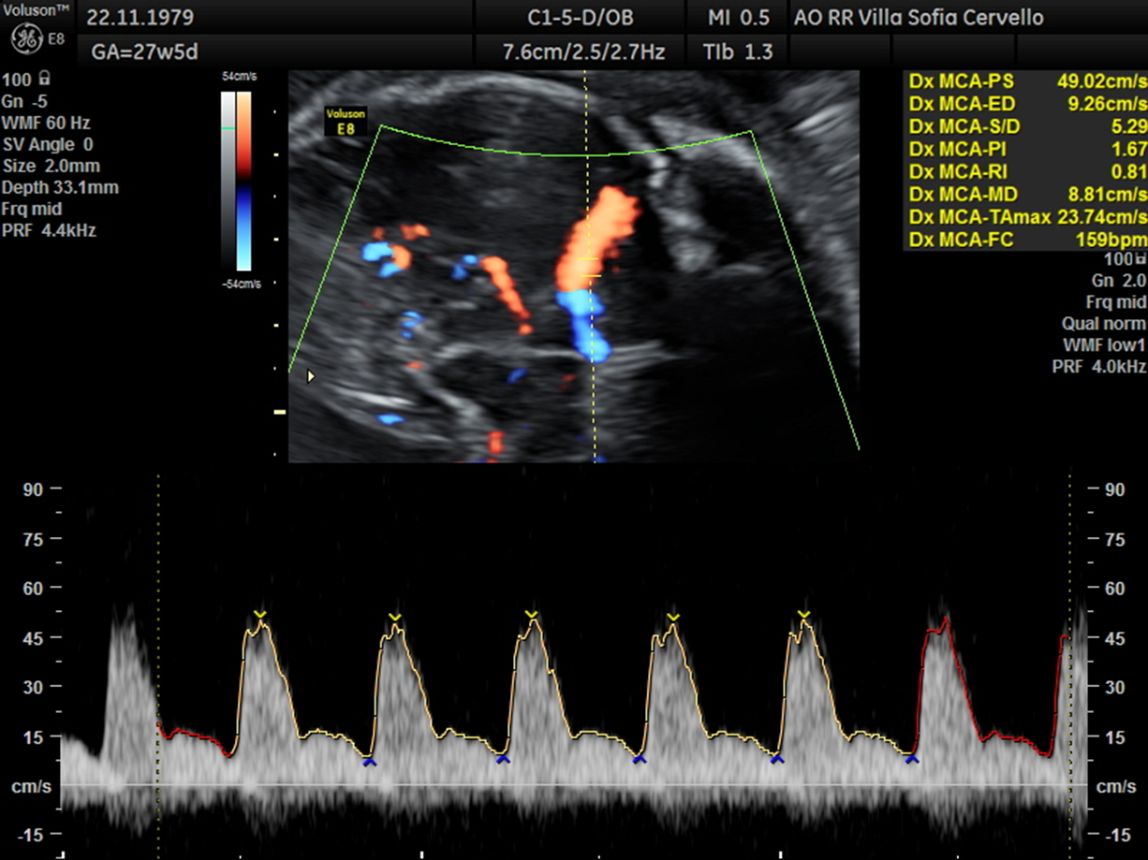
Figure 1 Diagnosis of fetal anemia. MCA-PSV ≥ 1.5 MoM for the gestational age as indirect sign of moderate to severe fetal anemia.
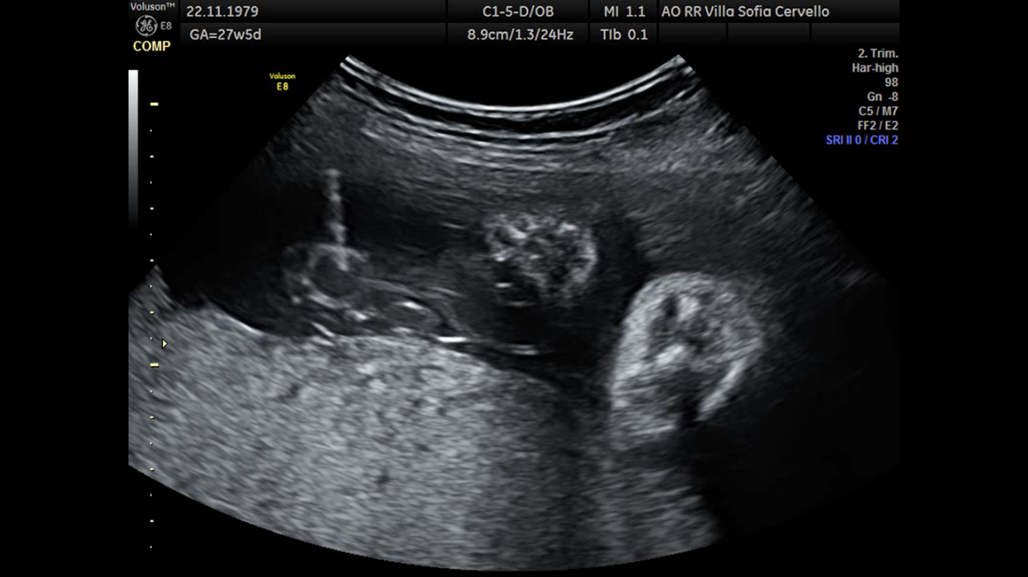
Figure 2 Treatment of fetal anemia. Fetal transfusion during cordocentesis.
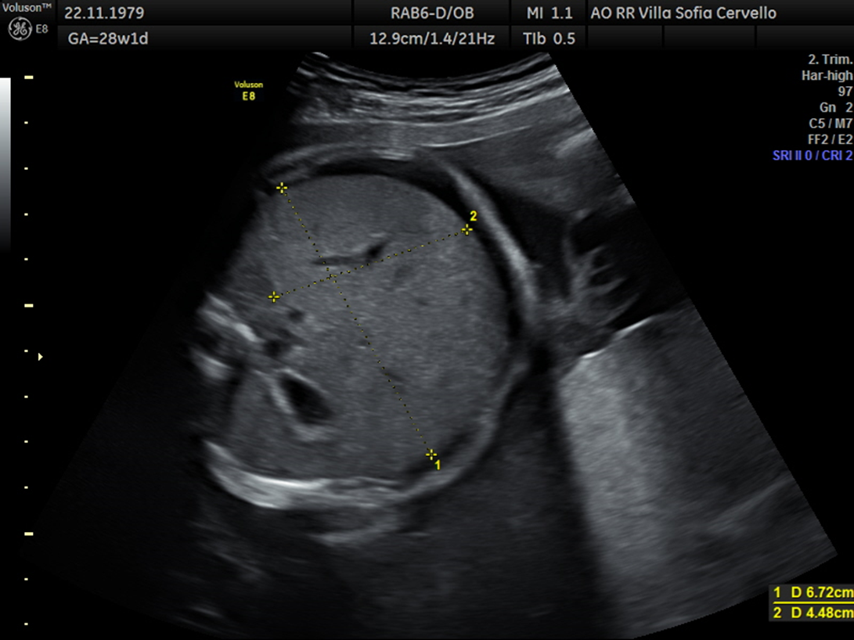
Figure 3 Hepatomegaly and decreasing ascites after fetal transfusion.

