Name of Journal: World Journal of Clinical Cases
Manuscript NO: 67475
Manuscript Type: ORIGINAL ARTICLE

Retrospective Study
diagnostic and prognostic value of secreted protein acidic and rich in cysteine in the diffuse large B-cell lymphoma

Pan PJ et al. SPARC as a biomarker for DLBCL

Peng-Ji Pan, Jun-Xia Liu

Peng-Ji Pan, Department of Hematology, Yongchuan Hospital of Chongqing Medical University, Chongqing 402160, China

Jun-Xia Liu, Department of Oncology, Yongchuan Hospital of Chongqing Medical University, Chongqing 402160, China

Author contributions: Pan PJ conducted the experimental analysis and wrote the manuscript; Liu JX performed the statistical analysis and revised the manuscript; all authors read and approved the final version of the manuscript.

Corresponding author: Jun-Xia Liu, MD, Chief Doctor, Department of Oncology, Yongchuan Hospital of Chongqing Medical University, No. 439 Xuanhua Road, Yongchuan District, Chongqing 402160, China. bepooo@aliyun.com

Received: April 25, 2021
Revised: May 29, 2021
Accepted: June 3, 2021
Published online: August 6, 2021

Abstract
BACKGROUND
Secreted protein acidic and rich in cysteine (SPARC) is an extracellular matrix-associated protein. Studies have revealed that SPARC is involved in the cell interaction and function including proliferation, differentiation, and apoptosis. However, the role of SPARC in cancer is controversial, as it was reported as the promoter or suppressor in different cancers. Further, the role of SPARC in lymphoma is unclear.

AIM
to identify the expression and significance of SPARC in lymphoma, especially in diffuse large B-cell lymphoma (DLBCL).

METHODS
The expression analysis of SPARC in different cancers was evaluated with Oncomine. The Brune, Eckerle, Piccaluga, Basso, Compagno, Alizadeh, and Rosenwald datasets were included to evaluate the mRNA expression of SPARC in lymphoma. The Cancer Genome Atlas (TCGA)-DLBCL was used to analyze the diagnostic value of SPARC in DLBCL. The Compagno and Brune DLBCL datasets were used for validation. Then, the diagnostic value was evaluated with the receiver operating characteristic (ROC) curve. The Kaplan-Meier plot was conducted with TCGA-DLBCL, and the ROC analysis was performed based on the survival time. Further, the overall survival analysis based on the level of SPARC expression was performed with the GSE4475 and E-TABM-346. The Gene Set Enrichment Analyses (GSEA) was performed to make the underlying mechanism-regulatory networks.

RESULTS
The pan-cancer analysis of SPARC showed that SPARC was highly expressed in the brain and central nervous system, breast, colon, esophagus, stomach, head and neck, pancreas, and sarcoma, especially in lymphoma. The overexpression of SPARC in lymphoma, especially DLBCL, was confirmed in several datasets. The ROC analysis revealed that SPARC was a valuable diagnostic biomarker. More importantly, compared with DLBCL patients with low SPARC expression, those with higher SPARC expression represented a higher overall survival rate. The ROC analysis showed that SPARC was a favorable prognostic biomarker for DLBCL. Results of the GSEA confirmed that the high expression of SPARC was closely associated with focal adhesion, extracellular matrix receptor interaction, and leukocyte transendothelial migration, which suggested that SPARC may be involved in the regulation of epithelial-mesenchymal transition, KRAS, and myogenesis in DLBCL.

CONCLUSION
SPARC was highly expressed in DLBCL, and the overexpression of SPARC showed sound diagnostic value. More interestingly, the overexpression of SPARC might be a favorable prognostic biomarker for DLBCL, suggesting that SPARC might be an inducible factor in the development of DLBCL, and inducible SPARC was negative in some oncogenic pathways. All the evidence suggested that inducible SPARC might be a good diagnostic and prognostic biomarker for DLBCL.

Key Words: Secreted protein acidic and rich in cysteine; Diffuse large B-cell lymphoma; Inducible expression; Diagnosis; Prognosis; Clinical application

©The Author(s) 2021. Published by Baishideng Publishing Group Inc. All rights reserved.

Citation: Pan PJ, Liu JX. Diagnostic and prognostic value of secreted protein acidic and rich in cysteine in the diffuse large B-cell lymphoma. World J Clin Cases 2021; 9(22): 6287-6299 URL: https://www.wjgnet.com/2307-8960/full/v9/i22/6287.htm DOI: https://dx.doi.org/10.12998/wjcc.v9.i22.6287

Core Tip: In this study, the expression and significance of secreted protein acidic and rich in cysteine (SPARC) in the diffuse large B-cell lymphoma (DLBCL) were evaluated. The overexpression of SPARC can be an efficient diagnostic and prognostic biomarker for DLBCL, suggesting that SPARC has a potential value in future clinical application.

INTRODUCTION
Secreted protein acidic and rich in cysteine (SPARC) is a secreted protein, which regulates various biological activities, including proliferation, migration, adhesion, differentiation, and apoptosis^{[1,2]}. Recently, it was reported that SPARC could control the extracellular matrix (ECM) turnover, which plays a significant role in the regulation of cell interactions^{[3,4]}.
The expression of SPARC in different cancers is ragged. According to the latest reports, the expression of SPARC could be controlled by many environmental factors. Studies showed that SPARC expression can be induced remarkably with the development of lung, esophageal, pancreatic, and prostate cancer, suggesting that SPARC could be a tumor promoter^{[5-9]}. In detail, mechanism studies revealed that SPARC regulated the tumor growth factor β (TGF-β) signaling and then promoted the epithelial-mesenchymal transition (EMT), which participates in the cancer metastasis^{[5,10,11]}. SPARC was a tumor promoter to activate the phosphatidylinositol 3-phosphate kinase (PI3K)/AKT pro-oncogenic pathway^{[12,13]}. Additionally, SPARC was an anti-apoptotic factor, inhibiting the caspase activity^{[14]}.
However, other reports revealed SPARC was a tumor suppressor. In the colon, prostate, ovarian, and cervical cancers, it was reported that the expression of SPARC was closely associated with negative regulation, indicating that SPARC was a favorable prognostic factor^{[15]}. Sailaja et al^{[16]} reported that SPARC could increase the PTEN expression, which was a negative molecule of AKT suppressor. Additionally, SPARC was reported to induce endoplasmic reticulum (ER) stress. Moreover, SPARC inhibited cell proliferation by inducing the G2/M cell cycle arrest^{[17]}. Taken together, the above evidence suggested that SPARC might play a dual role in different cancers. However, the role of SPARC is still unclear in some cancers, including diffuse large B-cell lymphoma (DLBCL), the most common clinical lymphoma. Thus, this study aimed to evaluate the significance of SPARC in the DLBCL.
In this study, we evaluated the pan-cancer expression of SPARC, and then confirmed the overexpression of SPARC in DLBCL. The receiver operating characteristic (ROC) analysis revealed a good diagnostic value of SPARC for DLBCL. Thus, we hypothesized that inducible SPARC was a favorable prognostic factor, as DLBCL patients with higher SPARC expression showed a higher survival rate. Furthermore, to validate the potential mechanism of SPARC in the DLBCL, the enrichment analysis confirmed that the overexpression of SPARC was negatively correlated with some pro-oncogenic pathways. This study confirmed inducible SPARC as a potential diagnostic and prognostic biomarker, which might function as the tumor suppressor in the DLBCL. Further, this study clarified the significance of SPARC in DLBCL and provided a reference for the future clinical transformation.

MATERIALS AND METHODS
The Oncomine gene expression analysis
The pan-cancer expression of SPARC was confirmed in the Oncomine database^{[18]}. The threshold for P value was set below 0.05, the fold change was over 2 times, and the top 1% gene rank was included in the results. The included datasets were shown in Table 1^{[19-26]}, including the detailed sample number and the reporter platform.

ROC evaluation based on different DLBCL datasets
The TCGA-DLBCL database was evaluated as the training dataset. Firstly, the difference of SPARC expression was confirmed, and the ROC analysis was conducted based on the expression results. The area under curve (AUC) was calculated to evaluate the diagnostic value, and an AUC value from 0.5 to 1 was considered to be statistically significant. The closer the AUC value was to 1, the better diagnostic effect^{[27,28]}. The Compagno and Brune DLBCL datasets were confirmed as validation datasets.

The survival analysis and the prognostic evaluation
The patients from TCGA-DLBCL with information on survival status were included in the overall survival analysis for the training test. The log-rank method was used to analyze the difference between SPARC high- and low-expression groups, and hazard ratio (HR) with 95% confidence interval (CI) was set to evaluate the prognostic value of SPARC. The value of HR was below 1.0, indicating that the high-expression group predicted a favorable prognosis^{[29,30]}. The ROC analysis based on the survival rate was conducted in 12, 36, and 60 mo, respectively. The AUC value was calculated to evaluate the statistical difference, with an AUC value over 0.5 considered significant in the prognostic prediction. The GSE4475^{[31]} and E-TABM-346^{[32]} datasets were included for validation tests to evaluate the prognoses of DLBCL patients. In the GSE4475 and E-TABM-346 datasets, the median expression value of SPARC was set as the cut-off, and the survival time of censored data was the time from the start event to the truncation point.

Gene Set Enrichment Analysis
The TCGA-DLBCL data was subjected to the Gene Set Enrichment Analysis (GSEA), and the KEGG and HALLMARK modules were adopted in the SangerBox tool (http://sangerbox.com/Index). The detailed setting was as follows: weighted manner enrichment statistic; Signal2Noise was subjected to the metric for ranking genes; the number of permutations was 1000; the number of markers was above 100; the minimum gene number sets was over 15.

Statistical analysis
Results were shown in mean ± SEM, and the data was processed with Graphpad Prism 8.0 software. The difference between two groups was analyzed with Student’s t test. The AUC value of ROC over 0.50 was considered statistically significant. The survival analysis was conducted with log-rank and Cox methods with CI, respectively. P < 0.05 was considered statistically significant.

RESULTS
SPARC is highly expressed in lymphoma
Previous studies showed that SPARC might play a dual role in some cancers^{[33]}. To further confirm the expression of SPARC in cancers, the Oncomine database with different expression datasets was used. As is shown in Figure 1A, the differences of SPARC expression between tumors and normal tissues were confirmed, and the results showed that SPARC was highly expressed in the brain and central nervous system cancer, breast cancer, cervical cancer, colon cancer, esophageal cancer, stomach cancer, head and neck cancer, pancreatic cancer, lymphoma, and sarcoma. The most significant overexpressing cancer was the lymphoma. Considering the expression of SPARC in lymphoma was controversial, this study focused on the potential role of SPARC in lymphoma. To fully understand the role of SPARC in the lymphoma, more lymphoma datasets were included to study the expression manners. As is shown in Figure 1B-D, three independent datasets revealed that SPARC was overexpressed in lymphoma cells compared with normal control cells. Further study is warranted to understand the significance of SPARC in lymphoma.

Specific overexpression of SPARC in DLBCL
Figure 1 shows the overexpression of SPARC in lymphoma. Due to the significant effect of tumor heterogeneity and molecular typing on the development of lymphoma, this study analyzed the SPARC expression in different types of lymphoma. As is shown in Figure 2A, there was no significant difference in the SPARC expression in Burkitt lymphoma and primary effusion lymphoma. However, we found a remarkable difference in DLBCL. Leukemia was included to test the SPARC expression as a blood tumor; however, no significant difference in the SPARC expression was found. These results suggest that SPARC was highly expressed in the lymphoma, mainly in DLBCL. The overexpression of SPARC in the DLBCL was confirmed with three independent datasets, including the Compagno dataset, Alizadeh dataset, and Rosenwald dataset (Figure 2B-D). Together, these data indicate the overexpression of SPARC in lymphoma was primarily in DLBCL, suggesting that SPARC might be closely associated with certain molecular types of lymphoma.

Diagnostic value of SPARC for DLBCL
Because SPARC was specifically overexpressed in DLBCL, we hypothesized that the overexpression of SPARC had diagnostic potential for DLBCL. To validate the hypothesis, tumor and normal control cells from DLBCL patients and healthy donors were included for the ROC analysis. Firstly, the overexpression of SPARC was reconfirmed in the TCGA-DLBCL database (Figure 3A). As is shown in Figure 3B, the ROC results of TCGA-DLBCL suggested high diagnostic potential, with the AUC value of up to 0.961 (P < 0.001). Furthermore, similar results were validated in Compagno and Brune DLBCL datasets, with the AUC value close to 1.0 (P < 0.001). These results indicate that SPARC is a diagnostic marker with a high true positive rate (TPR).

SPARC as a prognostic biomarker for the DLBCL
To elucidate the question of whether the overexpression of SPARC could be used as a potential diagnostic biomarker for DLBCL, the overall survival analysis was conducted. As is shown in Figure 4A, DLBCL patients with higher SPARC expression displayed longer survival time (median, 17.6 years), compared with lower SPARC levels (median, 3.4 years). The prognostic evaluation analysis was included with ROC analysis, which revealed that SPARC expression could act as a prognostic biomarker for the DLBCL patients, with the AUC value of 0.626, 0.569, and 0.577 for survival rate analysis at 1, 3, and 5 years, respectively (Figure 4B).

Validation of SPARC as a prognostic biomarker for DLBCL
Due to the small samples of DLBCL patients with detailed clinical information, other DLBCL datasets were included to validate the prognostic value of SPARC. The GSE4475 and E-TABM-346 datasets were included, and the detailed information is presented in Table 2. The overall survival analysis was conducted based on the SPARC expression. As is shown in Figure 5A, DLBCL patients with higher SPARC expression presented a higher survival rate than those with low SPARC levels [P = 0.0009, HR = 0.6 (0.45-0.8)]. Similar results were confirmed in the E-TABM-346 dataset [P = 0.001, HR = 0.54 (0.27-1.08), Figure 5B]. Furthermore, the Cox analysis was conducted in Table 2, and the Cox analysis of SPARC was confirmed in the GSE4475 as a prognostic biomarker. However, due to the small samples, the Cox analysis of the E-TABM-346 dataset showed no statistical significance (P = 0.08).

Potential pathways mediated by SPARC in DLBCL
The overexpression of SPARC might act as a favorable prognostic biomarker for DLBCL. To investigate the potential pathways mediated by SPARC in DLBCL, the GSEA analysis was performed and revealed that SPARC was implicated in focal adhesion (P = 0, FDR = 0, NES = -2.7), ECM receptor interaction (P = 0, FDR = 0, NES = -2.6), and leukocyte transendothelial migration (P = 0, FDR = 0, NES = -2.5). Furthermore, as is shown in Figure 6B, SPARC in DLBCL was enriched in EMT (P = 0, FDR = 0, NES = -2.7), KRAS signaling (P = 0, FDR = 0, NES = -2.6), and myogenesis (P = 0, FDR = 0, NES = -2.5). These negative correlation results with some pro-oncogenic pathways, combined with the prognostic analysis, suggest that SPARC might work as an onco-promoter in DLBCL.

DISCUSSION
DLBCL is the most common type of lymphoma. In clinical practice, the pathological characteristics of DLBCL were in a highly heterogeneous status^{[34,35]}. Thus, there was great variation in response to the treatment and prognoses of DLBCL patients. With the development of the next-generation sequencing, the discovery of novel prognosis biomarkers has achieved great progress. C-myc, Bcl-2, Ki-67, and CD5 were identified as independent prognostic markers for DLBCL, the overexpression of which predicts the poor prognosis of DLBCL^{[34,36]}. However, many factors can regulate the expressions of these genes, and the prognostic value is inaccurate^{[37,38]}. Thus, it is important to screen new biomarkers for DLBCL prognosis.
Interestingly, this study revealed that SPARC was specifically overexpressed in DLBCL, rather than other types of lymphomas (Figures 1 and 2). Previous studies showed that SPARC was overexpressed in some cancers, including melanoma, breast cancer, pancreatic cancer, lung cancer, and liver cancer, and the overexpression of SPARC might act as a tumor promoter^{[3,33]}. In glioma cells, SPARC could activate the PI3K/AKT pathway, and inhibit the apoptotic pathway^{[13]}. However, the molecular functions of SPARC in other cancers are completely the opposite. In neuroblastoma, SPARC induces ER stress and suppresses the AKT activity, suggesting that SPARC might play a dual role in different cancers^{[16]}. Additionally, SPARC was reported to be downregulated in T-cell lymphoma, and acted as a tumor suppressor through the inhibition of cell proliferation and metastasis^{[39]}. This study confirmed the overexpression and the diagnostic potential of SPARC in the DLBCL. The results showed an excellent TPR of SPARC as a diagnostic biomarker for the DLBCL (Figure 3). Considering the complex functions of SPARC in cancers, this study evaluated the significance of SPARC overexpression in the DLBCL. This study revealed that the overexpression of SPARC might represent a favorable prognosis for DLBCL patients (Figures 4 and 5), suggesting that SPARC might function as a tumor suppressor in DLBCL. Meyer et al^{[40]} reported the positive SPARC in stromal cells in DLBCL displayed a higher survival rate than those with negative SPARC. Our study further confirmed the clinical significance of SPARC in DLBCL. The survival rate analysis and the potential mechanism network were included in this study. The negative results were associated with the biological processes, including focal adhesion, ECM receptor interaction, and leukocyte transendothelial migration (Figure 6A). Focal adhesion and ECM receptor interaction were fully studied in the migration of cancer cells^{[41]}, and leukocyte transendothelial migration had a significant effect on the endothelial barrier function^{[42]}. The three biological processes were closely associated with the tumor development, and the negative association between SPARC and focal adhesion, ECM receptor interaction, and leukocyte transendothelial migration indicated the potential suppressing role of SPARC in DLBCL. Moreover, SPARC-associated pathways were enriched in EMT, KRAS, and myogenesis, which were implicated as tumor promoters in many cancers^{[43]}. Thus, the analysis of SPARC-associated pathways confirmed the negative regulation of SPARC on some pro-oncogenic pathways.

CONCLUSION
This study confirmed the overexpression of SPARC in lymphoma, and its overexpression is specific for DLBCL. More importantly, the overexpression of SPARC can be a diagnostic and prognostic biomarker for the DLBCL with high clinical potential.

ARTICLE HIGHLIGHTS
Research background
Secreted protein acidic and rich in cysteine (SPARC), is a protein related to the extracellular matrix. Studies have shown that SPARC regulate cell interactions and display multi-functions, including proliferation, differentiation and apoptosis. However, the role of SPARC in cancer is controversial because it is reported to be a promoter or inhibitor in different cancers. In addition, the role of SPARC in lymphoma is unclear.

Research motivation
The role of SPARC in different cancers is controversial, and the expression and clinical application of SPARC in lymphoma is unclear.

Research objectives
This study aimed to explore the expression and clinical value of SPARC in lymphoma, especially in the diffuse large B-cell lymphoma (DLBCL).

Research methods
The expression of SPARC in pan-cancer was conducted in Oncomine database. The Gene Expression Omnibus including Brune, Eckerle, Piccaluga, Basso, Compagno, Alizadeh, and Rosenwald datasets were subjected to confirm the expression of SPARC. The diagnostic value of SPARC was conducted in the Cancer Genome Atlas (TCGA)-DLBCL. The validated datasets were included with Compagno and Brune DLBCL datasets. Receiver operating characteristic (ROC) curve was applied to test the diagnostic value. The survival rate was conducted with Kaplan-Meier plot in TCGA-DLBCL database. The effect of SPARC on the overall survival was also confirmed in GSE4475 and E-TABM-346. The potential signaling pathways of SPARC in DLBCL was conducted with The Gene Set Enrichment Analyses (GSEA) software.

Research results
SPARC was highly expressed in pan-cancers, including brain and central nervous system cancer, breast cancer, colorectal cancer, esophageal cancer, gastric cancer, head and neck cancer, pancreatic cancer and sarcoma, most significantly in lymphoma. The overexpression of SPARC in lymphoma was confirmed by validated datasets. This study also identified that the overexpression of SPARC occurred significantly in DLBCL. And the overexpression of SPARC in DLBCL was tested in TCGA-DLBCL, and the ROC result showed a significant value of SPARC as a biomarker for DLBCL. Furthermore, the validation datasets including Compagno and Brune datasets confirmed the excellent diagnostic value of SPARC for DLBCL. In further prognostic analysis, DLBCL patients with high SPARC expression represented a favorable survival rate, and the ROC analysis of SPARC also demonstrated that SPARC as a favorable prognostic biomarker. The results of GSEA also revealed that SPARC was closely associated with focal adhesion, extracellular matrix receptor interaction and leukocyte transendothelial migration, which was involved in the regulation of epithelial-mesenchymal transition, KRAS and myogenesis signaling pathways in DLBCL.

Research conclusions
SPARC was overexpressed in DLBCL, showing an excellent diagnostic value. Furthermore, the overexpression of SPARC could be a favorable prognostic biomarker. The inducible SPARC was also negatively correlated with some oncogenic pathways. Overall, the inducible SPARC could serve as a good diagnostic and prognostic biomarker for DLBCL.

Research perspectives
This study identified that SPARC as a novel biomarker for the diagnosis and prognosis of DLBCL. Also, the inducible SPARC might be negatively correlated with some oncogenic pathways, suggesting that the inducible SPARC in the development of DLBCL could guide the clinical practice of DLBCL. However, this study was based on expression level, SPARC as a secreted protein, the serum level in DLBCL patients could be included in the further study.

REFERENCES
1 Brekken RA, Sage EH. SPARC, a matricellular protein: at the crossroads of cell-matrix communication. Matrix Biol 2001; 19: 816-827 [PMID: 11223341 DOI: 10.1016/s0945-053x(00)00133-5]
2 Wong SL, Sukkar MB. The SPARC protein: an overview of its role in lung cancer and pulmonary fibrosis and its potential role in chronic airways disease. Br J Pharmacol 2017; 174: 3-14 [PMID: 27759879 DOI: 10.1111/bph.13653]
3 Li L, Zhu Z, Zhao Y, Zhang Q, Wu X, Miao B, Cao J, Fei S. FN1, SPARC, and SERPINE1 are highly expressed and significantly related to a poor prognosis of gastric adenocarcinoma revealed by microarray and bioinformatics. Sci Rep 2019; 9: 7827 [PMID: 31127138 DOI: 10.1038/s41598-019-43924-x]
4 Melouane A, Carbonell A, Yoshioka M, Puymirat J, St-Amand J. Implication of SPARC in the modulation of the extracellular matrix and mitochondrial function in muscle cells. PLoS One 2018; 13: e0192714 [PMID: 29420632 DOI: 10.1371/journal.pone.0192714]
5 Sun W, Feng J, Yi Q, Xu X, Chen Y, Tang L. SPARC acts as a mediator of TGF-β1 in promoting epithelial-to-mesenchymal transition in A549 and H1299 lung cancer cells. Biofactors 2018; 44: 453-464 [PMID: 30346081 DOI: 10.1002/biof.1442]
6 Gong L, Mao W, Chen Q, Jiang Y, Fan Y. Analysis of SPARC and TUBB3 as predictors for prognosis in esophageal squamous cell carcinoma receiving nab-paclitaxel plus cisplatin neoadjuvant chemotherapy: a prospective study. Cancer Chemother Pharmacol 2019; 83: 639-647 [PMID: 30643929 DOI: 10.1007/s00280-019-03769-7]
7 Khetan K, Baloda V, Sahoo RK, Vishnubhathla S, Yadav R, Saraya A, Sharma A, Gupta SD, Das P. SPARC expression in desmoplastic and non desmoplastic pancreatic carcinoma and cholangiocarcinoma. Pathol Res Pract 2019; 215: 152685 [PMID: 31727501 DOI: 10.1016/j.prp.2019.152685]
8 Liu T, Qiu X, Zhao X, Yang R, Lian H, Qu F, Li X, Guo H. Hypermethylation of the SPARC promoter and its prognostic value for prostate cancer. Oncol Rep 2018; 39: 659-666 [PMID: 29207175 DOI: 10.3892/or.2017.6121]
9 López-Moncada F, Torres MJ, Castellón EA, Contreras HR. Secreted protein acidic and rich in cysteine (SPARC) induces epithelial-mesenchymal transition, enhancing migration and invasion, and is associated with high Gleason score in prostate cancer. Asian J Androl 2019; 21: 557-564 [PMID: 31031331 DOI: 10.4103/aja.aja_23_19]
10 Chang CH, Yen MC, Liao SH, Hsu YL, Lai CS, Chang KP, Hsu YL. Secreted Protein Acidic and Rich in Cysteine (SPARC) Enhances Cell Proliferation, Migration, and Epithelial Mesenchymal Transition, and SPARC Expression is Associated with Tumor Grade in Head and Neck Cancer. Int J Mol Sci 2017; 18 [PMID: 28718842 DOI: 10.3390/ijms18071556]
11 Aghamaliyev U, Gaitantzi H, Thomas M, Simon-Keller K, Gaiser T, Marx A, Yagublu V, Araos J, Cai C, Valous NA, Halama N, Kiesslich T, Ebert M, Grützmann R, Rückert F, Breitkopf-Heinlein K. Downregulation of SPARC Is Associated with Epithelial-Mesenchymal Transition and Low Differentiation State of Biliary Tract Cancer Cells. Eur Surg Res 2019; 60: 1-12 [PMID: 30650425 DOI: 10.1159/000494734]
12 Jing Y, Jin Y, Wang Y, Chen S, Zhang X, Song Y, Wang Z, Pu Y, Ni Y, Hu Q. SPARC promotes the proliferation and metastasis of oral squamous cell carcinoma by PI3K/AKT/PDGFB/PDGFRβ axis. J Cell Physiol 2019 [PMID: 30706473 DOI: 10.1002/jcp.28205]
13 Thomas SL, Alam R, Lemke N, Schultz LR, Gutiérrez JA, Rempel SA. PTEN augments SPARC suppression of proliferation and inhibits SPARC-induced migration by suppressing SHC-RAF-ERK and AKT signaling. Neuro Oncol 2010; 12: 941-955 [PMID: 20472716 DOI: 10.1093/neuonc/noq048]
14 Tang MJ, Tai IT. A novel interaction between procaspase 8 and SPARC enhances apoptosis and potentiates chemotherapy sensitivity in colorectal cancers. J Biol Chem 2007; 282: 34457-34467 [PMID: 17897953 DOI: 10.1074/jbc.M704459200]
15 Aoi W, Naito Y, Takagi T, Tanimura Y, Takanami Y, Kawai Y, Sakuma K, Hang LP, Mizushima K, Hirai Y, Koyama R, Wada S, Higashi A, Kokura S, Ichikawa H, Yoshikawa T. A novel myokine, secreted protein acidic and rich in cysteine (SPARC), suppresses colon tumorigenesis via regular exercise. Gut 2013; 62: 882-889 [PMID: 22851666 DOI: 10.1136/gutjnl-2011-300776]
16 Sailaja GS, Bhoopathi P, Gorantla B, Chetty C, Gogineni VR, Velpula KK, Gondi CS, Rao JS. The secreted protein acidic and rich in cysteine (SPARC) induces endoplasmic reticulum stress leading to autophagy-mediated apoptosis in neuroblastoma. Int J Oncol 2013; 42: 188-196 [PMID: 23123816 DOI: 10.3892/ijo.2012.1678]
17 Chetty C, Dontula R, Ganji PN, Gujrati M, Lakka SS. SPARC expression induces cell cycle arrest via STAT3 signaling pathway in medulloblastoma cells. Biochem Biophys Res Commun 2012; 417: 874-879 [PMID: 22206672 DOI: 10.1016/j.bbrc.2011.12.065]
18 Rhodes DR, Yu J, Shanker K, Deshpande N, Varambally R, Ghosh D, Barrette T, Pandey A, Chinnaiyan AM. ONCOMINE: a cancer microarray database and integrated data-mining platform. Neoplasia 2004; 6: 1-6 [PMID: 15068665 DOI: 10.1016/s1476-5586(04)80047-2]
19 Rosenwald A, Wright G, Chan WC, Connors JM, Campo E, Fisher RI, Gascoyne RD, Muller-Hermelink HK, Smeland EB, Giltnane JM, Hurt EM, Zhao H, Averett L, Yang L, Wilson WH, Jaffe ES, Simon R, Klausner RD, Powell J, Duffey PL, Longo DL, Greiner TC, Weisenburger DD, Sanger WG, Dave BJ, Lynch JC, Vose J, Armitage JO, Montserrat E, López-Guillermo A, Grogan TM, Miller TP, LeBlanc M, Ott G, Kvaloy S, Delabie J, Holte H, Krajci P, Stokke T, Staudt LM; Lymphoma/Leukemia Molecular Profiling Project. The use of molecular profiling to predict survival after chemotherapy for diffuse large-B-cell lymphoma. N Engl J Med 2002; 346: 1937-1947 [PMID: 12075054 DOI: 10.1056/NEJMoa012914]
20 Compagno M, Lim WK, Grunn A, Nandula SV, Brahmachary M, Shen Q, Bertoni F, Ponzoni M, Scandurra M, Califano A, Bhagat G, Chadburn A, Dalla-Favera R, Pasqualucci L. Mutations of multiple genes cause deregulation of NF-kappaB in diffuse large B-cell lymphoma. Nature 2009; 459: 717-721 [PMID: 19412164 DOI: 10.1038/nature07968]
21 Alizadeh AA, Eisen MB, Davis RE, Ma C, Lossos IS, Rosenwald A, Boldrick JC, Sabet H, Tran T, Yu X, Powell JI, Yang L, Marti GE, Moore T, Hudson J Jr, Lu L, Lewis DB, Tibshirani R, Sherlock G, Chan WC, Greiner TC, Weisenburger DD, Armitage JO, Warnke R, Levy R, Wilson W, Grever MR, Byrd JC, Botstein D, Brown PO, Staudt LM. Distinct types of diffuse large B-cell lymphoma identified by gene expression profiling. Nature 2000; 403: 503-511 [PMID: 10676951 DOI: 10.1038/35000501]
22 Rosenwald A, Alizadeh AA, Widhopf G, Simon R, Davis RE, Yu X, Yang L, Pickeral OK, Rassenti LZ, Powell J, Botstein D, Byrd JC, Grever MR, Cheson BD, Chiorazzi N, Wilson WH, Kipps TJ, Brown PO, Staudt LM. Relation of gene expression phenotype to immunoglobulin mutation genotype in B cell chronic lymphocytic leukemia. J Exp Med 2001; 194: 1639-1647 [PMID: 11733578 DOI: 10.1084/jem.194.11.1639]
23 Piccaluga PP, Agostinelli C, Califano A, Rossi M, Basso K, Zupo S, Went P, Klein U, Zinzani PL, Baccarani M, Dalla Favera R, Pileri SA. Gene expression analysis of peripheral T cell lymphoma, unspecified, reveals distinct profiles and new potential therapeutic targets. J Clin Invest 2007; 117: 823-834 [PMID: 17304354 DOI: 10.1172/jci26833]
24 Basso K, Margolin AA, Stolovitzky G, Klein U, Dalla-Favera R, Califano A. Reverse engineering of regulatory networks in human B cells. Nat Genet 2005; 37: 382-390 [PMID: 15778709 DOI: 10.1038/ng1532]
25 Brune V, Tiacci E, Pfeil I, Döring C, Eckerle S, van Noesel CJ, Klapper W, Falini B, von Heydebreck A, Metzler D, Bräuninger A, Hansmann ML, Küppers R. Origin and pathogenesis of nodular lymphocyte-predominant Hodgkin lymphoma as revealed by global gene expression analysis. J Exp Med 2008; 205: 2251-2268 [PMID: 18794340 DOI: 10.1084/jem.20080809]
26 Eckerle S, Brune V, Döring C, Tiacci E, Bohle V, Sundström C, Kodet R, Paulli M, Falini B, Klapper W, Chaubert AB, Willenbrock K, Metzler D, Bräuninger A, Küppers R, Hansmann ML. Gene expression profiling of isolated tumour cells from anaplastic large cell lymphomas: insights into its cellular origin, pathogenesis and relation to Hodgkin lymphoma. Leukemia 2009; 23: 2129-2138 [PMID: 19657361 DOI: 10.1038/leu.2009.161]
27 Cao L, Cheng H, Jiang Q, Li H, Wu Z. APEX1 is a novel diagnostic and prognostic biomarker for hepatocellular carcinoma. Aging (Albany NY) 2020; 12: 4573-4591 [PMID: 32167932 DOI: 10.18632/aging.102913]
28 Mo H, Guan J, Yuan ZC, Lin X, Wu ZJ, Liu B, He JL. Expression and predictive value of miR-489 and miR-21 in melanoma metastasis. World J Clin Cases 2019; 7: 2930-2941 [PMID: 31624741 DOI: 10.12998/wjcc.v7.i19.2930]
29 Rungsakulkij N, Suragul W, Mingphruedhi S, Tangtawee P, Muangkaew P, Aeesoa S. Prognostic role of alpha-fetoprotein response after hepatocellular carcinoma resection. World J Clin Cases 2018; 6: 110-120 [PMID: 29988930 DOI: 10.12998/wjcc.v6.i6.110]
30 Liu Y, Wu L, Ao H, Zhao M, Leng X, Liu M, Ma J, Zhu J. Prognostic implications of autophagy-associated gene signatures in non-small cell lung cancer. Aging (Albany NY) 2019; 11: 11440-11462 [PMID: 31811814 DOI: 10.18632/aging.102544]
31 Richter J, Schlesner M, Hoffmann S, Kreuz M, Leich E, Burkhardt B, Rosolowski M, Ammerpohl O, Wagener R, Bernhart SH, Lenze D, Szczepanowski M, Paulsen M, Lipinski S, Russell RB, Adam-Klages S, Apic G, Claviez A, Hasenclever D, Hovestadt V, Hornig N, Korbel JO, Kube D, Langenberger D, Lawerenz C, Lisfeld J, Meyer K, Picelli S, Pischimarov J, Radlwimmer B, Rausch T, Rohde M, Schilhabel M, Scholtysik R, Spang R, Trautmann H, Zenz T, Borkhardt A, Drexler HG, Möller P, MacLeod RA, Pott C, Schreiber S, Trümper L, Loeffler M, Stadler PF, Lichter P, Eils R, Küppers R, Hummel M, Klapper W, Rosenstiel P, Rosenwald A, Brors B, Siebert R; ICGC MMML-Seq Project. Recurrent mutation of the ID3 gene in Burkitt lymphoma identified by integrated genome, exome and transcriptome sequencing. Nat Genet 2012; 44: 1316-1320 [PMID: 23143595 DOI: 10.1038/ng.2469]
32 Jais JP, Haioun C, Molina TJ, Rickman DS, de Reynies A, Berger F, Gisselbrecht C, Brière J, Reyes F, Gaulard P, Feugier P, Labouyrie E, Tilly H, Bastard C, Coiffier B, Salles G, Leroy K; Groupe d'Etude des Lymphomes de l'Adulte. The expression of 16 genes related to the cell of origin and immune response predicts survival in elderly patients with diffuse large B-cell lymphoma treated with CHOP and rituximab. Leukemia 2008; 22: 1917-1924 [PMID: 18615101 DOI: 10.1038/leu.2008.188]
33 Camacho D, Jesus JP, Palma AM, Martins SA, Afonso A, Peixoto ML, Pelham CJ, Moreno E, Gogna R. SPARC-p53: The double agents of cancer. Adv Cancer Res 2020; 148: 171-199 [PMID: 32723563 DOI: 10.1016/bs.acr.2020.05.004]
34 Cucco F, Barrans S, Sha C, Clipson A, Crouch S, Dobson R, Chen Z, Thompson JS, Care MA, Cummin T, Caddy J, Liu H, Robinson A, Schuh A, Fitzgibbon J, Painter D, Smith A, Roman E, Tooze R, Burton C, Davies AJ, Westhead DR, Johnson PWM, Du MQ. Distinct genetic changes reveal evolutionary history and heterogeneous molecular grade of DLBCL with MYC/BCL2 double-hit. Leukemia 2020; 34: 1329-1341 [PMID: 31844144 DOI: 10.1038/s41375-019-0691-6]
35 Miao Y, Medeiros LJ, Li Y, Li J, Young KH. Genetic alterations and their clinical implications in DLBCL. Nat Rev Clin Oncol 2019; 16: 634-652 [PMID: 31127191 DOI: 10.1038/s41571-019-0225-1]
36 Huang H, Li Z, Huang C, Rao J, Xie Q, Cui W, Tou F, Zheng Z. CD5 and CD43 Expression are Associate with Poor Prognosis in DLBCL Patients. Open Med (Wars) 2018; 13: 605-609 [PMID: 30519638 DOI: 10.1515/med-2018-0089]
37 Abdulla M, Laszlo S, Triumf J, Hedström G, Berglund M, Enblad G, Amini RM. A population-based study of cellular markers in R-CHOP treated diffuse large B-cell lymphoma patients. Acta Oncol 2016; 55: 1126-1131 [PMID: 27549735 DOI: 10.1080/0284186X.2016.1189093]
38 McDermott MSJ, Sharko AC, Munie J, Kassler S, Melendez T, Lim CU, Broude EV. CDK7 Inhibition is Effective in all the Subtypes of Breast Cancer: Determinants of Response and Synergy with EGFR Inhibition. Cells 2020; 9 [PMID: 32155786 DOI: 10.3390/cells9030638]
39 Yan J, Zhang J, Zhang X, Li X, Li L, Li Z, Chen R, Zhang L, Wu J, Wang X, Sun Z, Fu X, Chang Y, Nan F, Yu H, Wu X, Feng X, Li W, Zhang M. SPARC is down-regulated by DNA methylation and functions as a tumor suppressor in T-cell lymphoma. Exp Cell Res 2018; 364: 125-132 [PMID: 29277504 DOI: 10.1016/j.yexcr.2017.12.022]
40 Meyer PN, Fu K, Greiner T, Smith L, Delabie J, Gascoyne R, Ott G, Rosenwald A, Braziel R, Campo E, Vose J, Lenz G, Staudt L, Chan W, Weisenburger DD. The stromal cell marker SPARC predicts for survival in patients with diffuse large B-cell lymphoma treated with rituximab. Am J Clin Pathol 2011; 135: 54-61 [PMID: 21173124 DOI: 10.1309/AJCPJX4BJV9NLQHY]
41 Namani A, Liu K, Wang S, Zhou X, Liao Y, Wang H, Wang XJ, Tang X. Genome-wide global identification of NRF2 binding sites in A549 non-small cell lung cancer cells by ChIP-Seq reveals NRF2 regulation of genes involved in focal adhesion pathways. Aging (Albany NY) 2019; 11: 12600-12623 [PMID: 31884422 DOI: 10.18632/aging.102590]
42 Schimmel L, Heemskerk N, van Buul JD. Leukocyte transendothelial migration: A local affair. Small GTPases 2017; 8: 1-15 [PMID: 27715453 DOI: 10.1080/21541248.2016.1197872]
43 Rizvi S, Gores GJ. Pathogenesis, diagnosis, and management of cholangiocarcinoma. Gastroenterology 2013; 145: 1215-1229 [PMID: 24140396 DOI: 10.1053/j.gastro.2013.10.013]

Footnotes
Institutional review board statement: This study was approved by the Ethics Committee of the Yongchuan Hospital of Chongqing Medical University.

Informed consent statement: Patients were not required to give informed consent to this study because the analysis used anonymous data from a database.

Conflict-of-interest statement: All authors have no conflict of interests to declare.

Data sharing statement: No additional data are available.

Open-Access: This article is an open-access article that was selected by an in-house editor and fully peer-reviewed by external reviewers. It is distributed in accordance with the Creative Commons Attribution NonCommercial (CC BY-NC 4.0) license, which permits others to distribute, remix, adapt, build upon this work non-commercially, and license their derivative works on different terms, provided the original work is properly cited and the use is non-commercial. See: http://creativecommons.org/Licenses/by-nc/4.0/

Manuscript source: Unsolicited manuscript

Peer-review started: April 25, 2021
First decision: May 24, 2021
Article in press: June 3, 2021

Specialty type: Hematology
Country/Territory of origin: China
Peer-review report’s scientific quality classification
Grade A (Excellent): 0
Grade B (Very good): B, B
Grade C (Good): 0
Grade D (Fair): 0
Grade E (Poor): 0

P-Reviewer: Shahjaman M, Sopo SM S-Editor: Gong ZM L-Editor: Filipodia P-Editor: Liu JH

Figure Legends
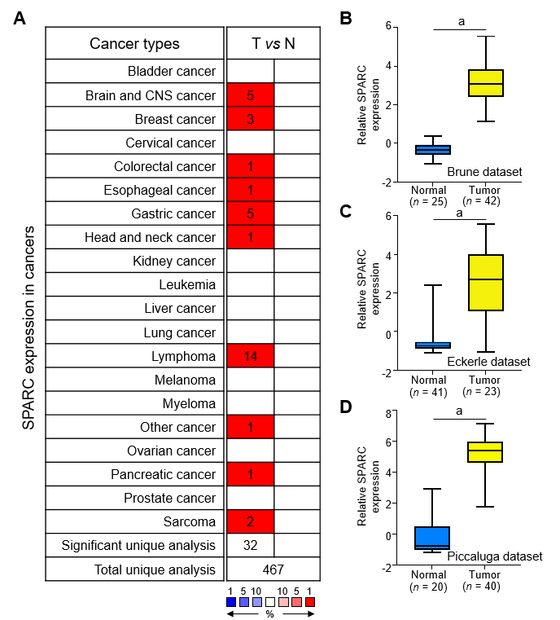
Figure 1 Significant expression of secreted protein acidic and rich in cysteine in diffuse large B-cell lymphoma. A: A total of 467 unique datasets were included to evaluate the expression difference of secreted protein acidic and rich in cysteine (SPARC) in pan-cancers. The top 1% ranking datasets were shown, and the fold change was set as over twice; B: The Brune dataset including different types of lymphoma was included to analyze the SPARC expression (ªP < 0.001 vs control group); C: The SPARC mRNA expression was evaluated in the Eckerle dataset of lymphoma (ªP < 0.001 vs control group); D: The SPARC mRNA level was confirmed with 200665_s_at in the lymphoma (ªP < 0.001 vs control group). ªP < 0.001 was considered statistical difference. T vs N: Tumor vs Normal.
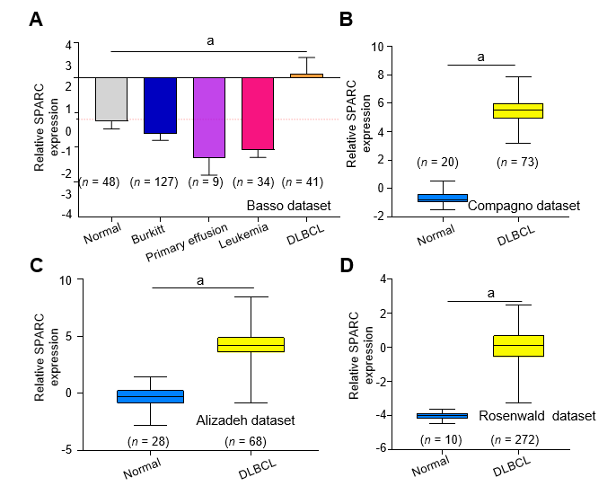
Figure 2 Specific overexpression of secreted protein acidic and rich in cysteine in diffuse large B-cell lymphoma. A: The Basso dataset including different types of lymphoma was included to evaluate the secreted protein acidic and rich in cysteine (SPARC) mRNA expression (ªP < 0.001 vs control group); B: The mRNA expression of SPARC in the diffuse large B-cell lymphoma (DLBCL) was confirmed in the Compagno lymphoma dataset (ªP < 0.001 vs control group); C: Alizadeh lymphoma dataset (ªP < 0.001 vs control group); D: Rosenwald dataset (ªP < 0.001 vs control group), and the normal lymphocytes were set as the normal control. ªP < 0.001 was considered statistical difference.
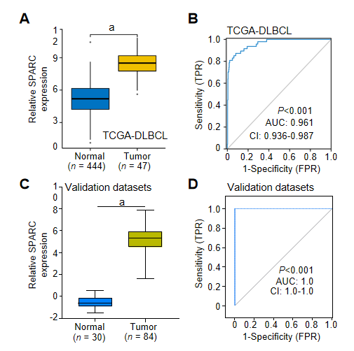
Figure 3 Diagnostic value of secreted protein acidic and rich in cysteine in diffuse large B-cell lymphoma. A: The mRNA level of secreted protein acidic and rich in cysteine (SPARC) was confirmed with The Cancer Genome Atlas (TCGA)-diffuse large B-cell lymphoma (DLBCL) database (ªP < 0.001 vs control group); B: The receiver operating characteristic (ROC) analysis was conducted with the TCGA-DLBCL database; C: The validation datasets including the Compagno and Brune DLBCL datasets were adopted to validate the SPARC expression (ªP < 0.001 vs control group); D: The ROC analysis was performed to evaluate the diagnostic value of SPARC for the DLBCL. ªP < 0.001 was considered statistical difference. AUC: Area under curve; CI: Confidence interval; TPR: True positive rate.
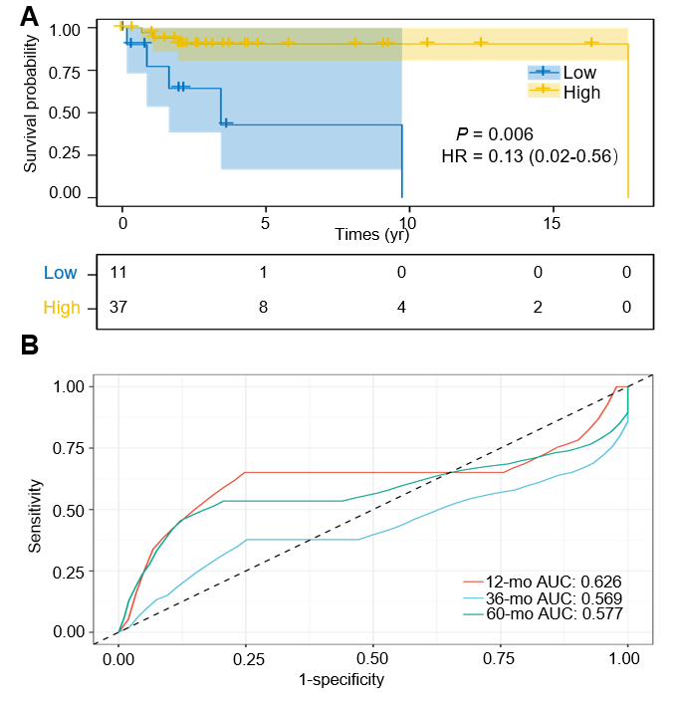
Figure 4 High expression of secreted protein acidic and rich in cysteine predicted a favorable prognostic biomarker for the diffuse large B-cell lymphoma. A: Patients from The Cancer Genome Atlas-diffuse large B-cell lymphoma (DLBCL) were included to evaluate the overall survival based on the secreted protein acidic and rich in cysteine (SPARC) expression; B: The receiver operating characteristic analysis of SPARC as a prognostic marker for the DLBCL in different time of follow-up. AUC: Area under curve; HR: Hazard ratio.
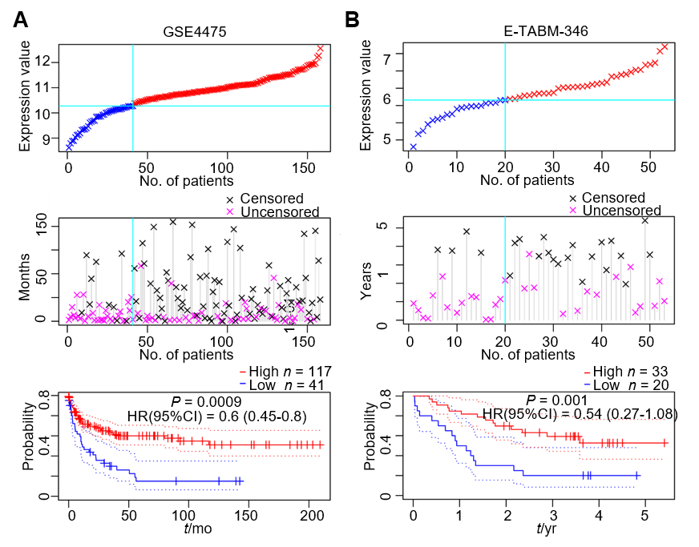
Figure 5 Validation of secreted protein acidic and rich in cysteine as a favorable prognostic biomarker for diffuse large B-cell lymphoma. A: The GSE4475; B: E-TABM-346 datasets were adopted to draw the overall survival curve, and high or low groups were defined based on the expression value of secreted protein acidic and rich in cysteine; the survival status is shown in the middle panel. The overall survival cure was drawn based on the expression value and survival status. CI: Confidence interval; HR: Hazard ratio.
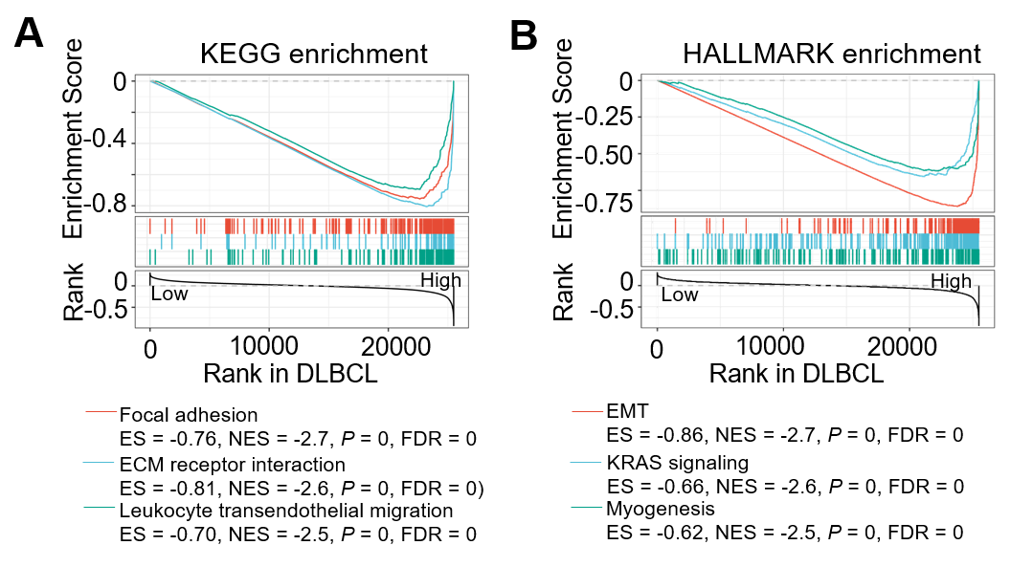
Figure 6 Gene Set Enrichment Analysis enrichment analysis based on secreted protein acidic and rich in cysteine of the diffuse large B-cell lymphoma. A, B: The Kyoto Encyclopedia of Genes and Genomes (KEGG) (A) and HALLMARK (B) enrichment modules were adopted to evaluate the enriched network. DLBCL: diffuse large B-cell lymphoma; ES: Enrichment score; FDR: False discovery rate; NES: Normalized enrichment score.
Table 1 Lymphoma datasets for secreted protein acidic and rich in cysteine analysis
Dataset | Sample size |  | Reporter | Ref.
 | Normal | Tumor
Rosenwald | 10 | 272 | AA045463 | [19]
Compagno | 20 | 111 | 200665_s_at | [20]
Alizadeh | 28 | 77 | IMAGE:324597 | [21]
Rosenwald Multi- | 14 | 46 | AA046533 | [22]
Piccaluga | 20 | 40 | 200665_s_at | [23]
Basso | 48 | 244 | 671_at | [24]
Brune | 25 | 42 | 200665_s_at | [25]
Eckerle | 41 | 23 | 200665_s_at | [26]

Table 2 Statistical prognostic analysis of secreted protein acidic and rich in cysteine in different datasets
Features | GSE4475 | E-TABM-346
Number | 158 | 53
P value | 0.000024 | 0.001367
Adj. P value | 0.000984 | 0.033088
Cox P value | 0.000532 | 0.082877
HR (95%CI) | 0.60 (0.45-0.80) | 0.54 (0.27-1.08)
Sex, n (%)
female | 68 (43.0) | 26 (49.1)
male | 90 (57.0) | 27 (50.9)
Event, n (%)
0 | 83 (52.5) | 23 (43.4)
1 | 75 (47.5) | 30 (56.6)
CI: Confidence interval; HR: Hazard ratio.

Published by Baishideng Publishing Group Inc
7041 Koll Center Parkway, Suite 160, Pleasanton, CA 94566, USA
Telephone: +1-925-3991568
E-mail: bpgoffice@wjgnet.com
Help Desk: https://www.f6publishing.com/helpdesk
https://www.wjgnet.com

© 2021 Baishideng Publishing Group Inc. All rights reserved.

