Name of Journal: World Journal of Gastroenterology
ESPS Manuscript NO: 25935
Manuscript Type: Review

Hepatitis E: Discovery, global impact, control and cure

Khuroo MS et al. Hepatitis E

Mohammad S Khuroo, Mehnaaz S Khuroo, Naira S Khuroo

Mohammad S Khuroo, Sher-I-Kashmir Institute of Medical Sciences, Srinagar, Kashmir 190010, India

Mehnaaz S Khuroo, Department of Pathology, Govt. Medical College, Srinagar, Kashmir 190001, India

Mohammad S Khuroo, Naira S Khuroo, Digestive Diseases Centre, Dr. Khuroo’s medical Clinic, Srinagar, Kashmir 190010, India

Author contributions: All three authors contributed equally; Khuroo MS and Khuroo NS conducted the literature search; Khuroo NS performed the thyroid ultrasound and provided the thyroid ultrasound images; Khuroo MS wrote the paper; All authors read the paper and made necessary corrections.

Conflict-of-interest statement: The authors report no conflict of interest.

Open-Access: This article is an open-access article which was selected by an in-house editor and fully peer-reviewed by external reviewers. It is distributed in accordance with the Creative Commons Attribution Non Commercial (CC BY-NC 4.0) license, which permits others to distribute, remix, adapt, build upon this work non-commercially, and license their derivative works on different terms, provided the original work is properly cited and the use is non-commercial. See: http://creativecommons.org/licenses/by-nc/4.0/

Manuscript source: Invited manuscript

Correspondence to: Mohammad S Khuroo, Director, Digestive Diseases Centre, Dr. Khuroo’s medical Clinic, Sector 1, SK Colony, Qamarwari, Srinagar, Kashmir 190010 India. khuroo@yahoo.com
Telephone: +91-194-2492398
Fax: +91-194-2491190

Received: March 26, 2016
Peer-review started: March 26, 2016
First decision: May 12, 2016
Revised: June 10, 2016
Accepted: July 6, 2016
Article in press:
Published online:

Abstract
Hepatitis E was identified as an epidemic of non-A, non-B hepatitis from Kashmir, India in 1978. Hepatitis E virus (HEV), the etiological agent is the sole member of family Hepeviridae. The virus has marked heterogeneity and infects many animals like bats, camel, chicken, deer, boar, mongoose, pigs, rats, rabbit and cutthroat trout. Hepatitis E is a disease with a major global impact and has two distinct epidemiological patterns. Hepatitis E is an imperative health issue in developing nations, transmitted through sullied water and happens most every now in young adults. The disease is particularly severe during pregnancy and in people with underlying liver cirrhosis. Autochthonous hepatitis E is increasingly recognized in developed countries. The virus infects domestic pigs, wild boar and Sika deer in these countries. HEV infections in humans occur by eating the undercooked game flesh, raw liver from supermarkets and Figureatelli sausages. Blood transfusion-associated HEV infections occur in many countries and screening of donors for HEV RNA is under consideration. Hepatitis E causes a number of extrahepatic diseases, including a wide spectrum of neurological syndromes. HEV genotype 3 causes prolonged viremia, chronic hepatitis, liver fibrosis and cirrhosis in organ transplant patients. The virus is amenable to ribavirin monotherapy and most patients clear the virus in a few weeks. Hepatitis E vaccine -239, marketed in China, has shown high efficacy with sustained protection for over four years.

Key words: Communicable diseases; Discovery; Hepatitis E; Hepatitis E virus; Vaccine; Zoonosis

© The Author(s) 2016. Published by Baishideng Publishing Group Inc. All rights reserved.

Core tip: Discovery of hepatitis E came to lime light when 1978-Kashmir epidemic of hepatitis was investigated. Hepatitis E is being recognized as a clinical entity of reemerging importance. Hepatitis E virus has marked heterogeneity and infects many animals like bats, camel, chicken, deer, boar, mongoose, pigs, rats, rabbit and cutthroat trout. Originally reported as a major health problem in poor-resource countries, hepatitis E is now recognized as an important clinical problem in the developed world. Zoonotic foodborne transmission of hepatitis E virus infections has relevance in solid organ transplant population. Major advances have been made in managing chronic hepatitis E. Hepatitis E causes a number of extrahepatic diseases, including a wide spectrum of neurological syndromes. Hepatitis E vaccine -239, marketed in China, has shown high efficacy with sustained protection for over four years.

Khuroo MS, Khuroo MS, Khuroo NS. Hepatitis E: Discovery, global impact, control and cure. World J Gastroenterol 2016; In press

Introduction
Hepatitis E was identified as an epidemic of non-A, non-B hepatitis (NANBH) from Kashmir, India in 1978^{[1]}. In the last 36 years since the discovery of the disease, major advances have occurred in relation to its causative agent, the host range in the animal kingdom, epidemiology and modes of spread^{[2]}. Hepatitis E virus (HEV) infections are ubiquitous in developing countries as a cause of epidemic and endemic acute hepatitis^{[3]}. However, the disease is now encountered in developed countries as well^{[4]}. Zoonotic foodborne transmission of HEV infection has a particular relevance to the organ transplant population^{[5]}. HEV infections cause a number of non-hepatic manifestations, which include a wide spectrum of neurological syndromes^{[6,7]}. Transfusion-associated HEV infections are reported with increasing frequencies and screening of donors for HEV RNA is being considered^{[8-10]}. Major advances have been made in understanding chronic hepatitis E^{[11]} and the commercial availability of hepatitis E vaccine (HEV-239) in China promises control of epidemic and sporadic hepatitis E^{[12]}. This article shall review the knowledge about the discovery, global impact, control and cure of hepatitis E.

Discovery
Discovery of hepatitis E came to lime light when 1978-Kashmir epidemic of hepatitis was investigated^{[1]}. This region where the disease occurred did suffer very hard weather conditions, lacked basic health care delivery system and the region was devoid of high tech cutting edge investigative facilities. Events leading to the discovery unravel a remarkable story of human interest, with its complexities, missteps, successes and failures (www.drkhuroo.com)^{[13]}. In November 1978, Dr. Mohammad S. Khuroo investigated an epidemic of jaundice in and around a town 50 km from Srinagar, Kashmir, India. The epidemic had hit two hundred villages with a population of 600000, caused around 52000 patients with icteric disease and 1700 fatalities^{[3]}. Pregnant women were more affected and many had been reported dead. An ingenious house-to-house investigation of this and subsequent epidemics and sporadic disease was performed over a 14-year period. This led us to the discovery of an enterically transmitted NANBH, which had triggered repeated epidemics in Kashmir^{[2,14]}. The disease affected young adults within the age group of 15 to 45 years. One remarkable discovery during this study was the relationship of this disease with pregnancy^{[15-17]}. The agent was transmitted vertically with high fetal and perinatal mortality^{[18,19]}. The disease was a self-limiting and did not cause chronic viremia, chronic hepatitis and cirrhosis^{[20]}. The loss of IgG antibodies occurred in over half of the population in a period of over 14 years^{[21]}. It was postulated that the disease was caused by yet unrecognized human hepatitis virus^{[1]}. Simultaneously, a sporadic disease identical in epidemiology and clinical features to epidemic disease and causing around half of acute hepatitis in the population was recognized^{[16,22]}.
An outbreak of NANBH was reported in Russian military personal posted in Afghanistan^{[23]}. The epidemic had similar epidemiological features as seen in the 1978-Kashmir epidemic. Dr. Mikhail S. Balayan, in a self-experimentation, ingested pooled stool extracts from 9 such patients^{[23]}. On 36th day after ingestion of the stool extracts, he developed severe acute hepatitis with jaundice and elevated liver tests. Stool samples of 28th day, 43th day and 45th day showed virus-like-particles (VLP) on immune electron microscopy. A number of primates were experimentally infected with the putative agent and the physicochemical properties of the agent were studied^{[24]}.
The virus could not be cloned for a number of years due to low yield of VLP in the infectious material. This was overcome by the basic perception that expansive amounts of VLP's were gotten from bile collected from infected primates. A partial cloning of the virus was done by Reyes et al^{[25]} (1990). Subsequent to this, Tam et al^{[26]} (1991) sequenced the full-length HEV genome of 7.2 kb and a diagnostic assay based on enzyme immunoassay was established.

HEV
Taxonomy and classification
HEV was originally thought to resemble HAV and included in Picornaviridae family^{[27]}. Once morphological features and genome organization of HEV were available, it is surmised that HEV is similar to noroviruses and placed in family Caliciviridae, under hepevirus genus. Before long it was built up that HEV has a significant sequence difference from caliciviruses and was removed from Caliciviridae and included in the “Hepatitis E-like viruses”^{[28]}. Subsequently, based on molecular analysis, all 4 recognized genotypes HEV-1 to HEV-4 were classified as sole agents of genus Hepevirus in the Hepeviridae family^{[29]}. Avian HEV was included in the unassigned genus. This classification received a setback as a number of hepatitis E viruses closely related to human HEV infecting rabbit and wild boar and those more divergent hepatitis E viruses infecting rats, ferrets, bats and cutthroat trout were identified. Recently, based on phylogenetical features and HEV hosts, the ICTV Hepeviridae study group gave a new classification for the family Hepeviridae^{[30,31]}. All HEV’s have been placed under Hepeviridae family and further classified under 2 genera namely Orthohepevirus, which included isolates from mammals and chicken and Piscihepevirus which included Cutthroat trout isolates. Orthohepevirus includes species A, B, C & D, while Piscihepevirus include species A only. Orthohepevirus A species included isolates from man, pigs, wild boar, rabbit, deer, mongoose and camel. This species encompassed several HEV genotypes infecting man alone (genotype HEV-1 and HEV-2); pigs and humans (genotype HEV-3 & HEV-4), wild boar (genotype HEV-5 & HEV-6) and dromedaries (genotype HEV-7). Orthohepevirus B contain viruses found in chickens and includes all three genotypes: avian HEV-1 (isolates from chicken in Australia), avian HEV-2 (isolates from chicken in United States and Canada) and avian HEV-3 (isolates from chicken in Europe and China). Orthohepevirus C includes 2 sequences namely HEV-C1 infecting rats and HEV-C2 infecting ferrets. Orthohepevirus D includes a single sequence infecting bat. Recently, partial sequences of other potential members of Hepeviridae family have been described^{[32-34]}. The moose virus has been assigned to Orthohepevirus A, mink HEV to HEV-C2 and rat HEV to HEV-C1. All known cutthroat trout virus isolates have been included in Piscihepevirus A species within the genus Piscihepevirus. As sequences studied from the vast majority of the cutthroat trout infection isolates are just 262 nucleotides long, there are insufficient data as of now to portray outline criteria for species inside this genus.

Physico-chemical properties
The virion is a naked particle, spherical in shape and has icosahedral symmetry. The virus shows surface spikes and indentations. The particle has diameter of 27-30 nm on immune electron microscopy, 32-34 nm after sucrose gradient centrifugation and 38.5-42 nm on cryo-EM analysis^{[23,35]}. Buoyant density of the particles in cesium chloride is around 1.35 g cm^{3[36]}. The virus is relatively stable in acid and mild alkaline conditions and unaffected by chloroform and ether treatment. HEV-infected pig liver homogenates maintain infectivity if incubated at 56⁰ for I hour, however boiling or frying for 5 minutes completely inactivates the virus. Treatment of liver suspensions with Tween-20 (0.05%) and formalin (0.05%) reduced infectivity by 1000-fold. HEV is susceptible to chlorine disinfection and chlorine disinfectant of water supplies is recommended during epidemics of disease^{[37-39]}.

Genetic organization
HEV genome consists of single-stranded RNA, has a molecular weight of approximately 7.2 kb with positive-sense polarity and is capped with 7-methylguanine at its 5’-end and poly (A) at its 3’-end (Figure 1). The genome has UTR’s at the 5’ end (27 nucleotides) and at the 3’ end (65 nucleotides) and a conserved stretch (58-nucleotides) near its 5’ end region within ORF1, which fold in to stem-loop and hairpin structures. HEV RNA replicates in to a genomic RNA of 7.2 kb and a bicistronic subgenomic RNA of 2.2 kb. There are 3 open reading frames in the genome namely ORF1, ORF2 and ORF3^{[40,41]}.
ORF1 of the well-characterized Burmese strain begins after 27 nucleotides of the 5’ end and extends across the 68 nucleotides of the conserved region for 5079 nucleotides before terminating at nucleotide position 5109^{[42]}. ORF1 translates in to a non-structural protein (pORF1) having 1693 amino acids (aa). ORF1 domains along with their aa boundaries based on Burmese isolate are methyltransferase from aa 56-240, a Y domain from aa 216-442, papain-like cysteine protease from aa 433-592, a proline-rich hinge domain V from aa 712-778, a X macrodomain from aa 785-942, an RNA helicase from aa 960-1204 and RNA-dependent RNA polymerase from aa 1207-1693. HEV methyltransferase catalyzes the capping of viral RNA. HEV papain till now has not been associated with any functional activity of the virus. ORF1 contains a functional protease, which may be involved in the polyprotein processing. HEV helicase and RNA-dependent RNA polymerase are needed to replicate the genomic RNA. Recombinant HEV polymerase bind to the genomic RNA at 3’ end. The virion binding is facilitated by stem-loop structures and poly (A) stretch.
ORF2 starts at nucleotide 5147 (38 nucleotides 3' at the end of ORF1) and develops roughly 1980 nucleotides till nucleotide 7127^{[43]}. ORF2 encodes pORF2, a polyprotein of 660 amino acids, which is involved in the virus assembly and binding and eliciting immune response to produce neutralizing antibodies. The pORF2 has three glycosylation sites at 137, 310 and 562 conserved asparaginase residues. HEV full-length and truncated ORF2 gene expression in baculovirus vectors generate capsid proteins with different molecular weights. Of these, two HEV capsid proteins (VLP/T=1 & VLP-T=3) form virus-like particles (VLP). While VLP/T=1 show no encapsulated RNA, VLP/T = 3 contained a about 2 kb RNA derived from the ORF2 gene. The buoyant densities of VLP/T=1 and VLP/T=3 are 1.285 g/cm³ and 1.31 g/cm³ in CsCl gradient, respectively, both smaller than the buoyant density of native HEV particles. ORF2 expression in Escherichia coli (E. coli) leads to the formation of three HEV capsid proteins, which are homodimers and include dominant antigenic sites of HEV. HEV p239 self-assemble to empty virus-like particle of 23 nm. Baculovirus/ and E. coli expressed VLP’s are strongly immunogenic and resemble the native virus in their three-dimensional structure. Two VLP’s namely p239 and recombinant Sar 56 kDa have been successfully tried as HEV vaccines. The p239 vaccine is marketed in China as Hecolin^{[12]}.
ORF3 is 345 nucleotides in length, begins 23 nucleotides 3’ of the termination of ORF1^{[40,41]}. ORF3 begins after nucleotide 5133 and terminates at nucleotide 5477 and translates in to a phosphoprotein (pORF3) of 114 aa. It has been suggested that pORF3 associates with the cytoskeleton and more specifically with microtubules. It is also implicated in HEV egress from hepatocytes^{[44]}. ORF3 overlaps ORF2 by 328 nucleotides at the 3’ end but does not overlap with ORF1.

HEV Replication
HEV lacks both a proper in vitro culture system and animal model^{[45]} and the life cycle of HEV remains poorly studied (Figure 2). It is assumed that HEV reaches the host through gut epithelial cells; attach to the surface of hepatocytes through heparin sulfate proteoglycans, binds to a receptor and enter the hepatocytes^{[46]}. Once internalized, the virus is uncoated, releases RNA and nonstructural proteins of the virus are translated. Positive sense viral RNA is replicated in to negative sense RNA with help of RNA-dependent RNA polymerase. Negative sense RNA become templates for 7.2 kb positive-sense RNA and 2.2 kb subgenocmic RNA. Subsequent to this, pORF2 & pORF3 are formed with the help of subgenocmic RNA as template. pORF2 protein along with genomic RNA assemble into the new virion while the pORF3 optimizes viral replication. The virion egressed from hepatocytes are coated with pORF3 and lipid layer. Both pORF3 and lipid layer are separated from virion after egress from hepatocytes^{[47]}.

HEV evolution
Hepatitis E is an ancient ailment. Epidemics of jaundice have been mentioned in medieval writing and in writings generated around 19th century. Till late it was surmised that these epidemics were caused by hepatitis A. Now we know that the disease in reality closely resembled hepatitis E^{[48]}. However, these have not been tested serologically because of non-availability of sera. The most recent epidemic confirmed to be caused by HEV, though retrospectively, was the Delhi epidemic 1955-56^{[49]}. Recently, the HEV evolutionary history was studied (Figure 3)^{[50]}. It was estimated that the tMRCAs (times-to the most-recent-common-ancestors) for mammalian HEV existed 536 to 1344 years ago. This progenitor develops in to two variants namely anthropotropic varaints, evloving in to HEV-1 & HEV-2 and enzootic variants evolving in to HEV-3 & HEV-4 respectively. The anthropotropic variant is around 367-656 years old and enzootic variant around 417 -656 years old. HEV genotypes existed at various periods namely HEV-1 (87-199 years), HEV-3 (256-342 years) and HEV-4 (131-266 years). HEV from chicken had existed for long in the evolutionary history.

Animal reservoirs
HEV was identified from pigs in the Unites States in 1997^{[51]} and presently known to exist in all the countries of the world^{[52,53]}. HEV infection develops very early and is ubiquitous in pigs from commercial farms. The infection is clinically silent, however, animals do show microscopic evidence of hepatitis. Pigs are infected by either genotype HEV-3 or HEV-4. Both have zoonotic potential and infect humans. HEV-3 has been detected in wild boar from Japan and many European countries^{[54-56]}. HEV prevalence in wild boar was between 12.0% to 42.7% (Ig anti-HEV) and 2.5% to 25% (HEV RNA). HEV-4 and two new HEV genotypes HEV-5 and HEV-6 have been recovered from wild boar. HEV-3 has also been found in the sika/Yezo deer (Cervus nippon) from Japan and red deer (Cervus elaphus) from the Netherlands^{[57-59]}. Mongoose has been observed to be infected with HEV and the full-length genomic arrangement of these confines have been shown to assemble with genotype HEV-3. HEV strains have been identified from rabbits from the United States and China^{[60,61]}, included as a distinct isolate of genotype HEV-3 and may be zoonotic. HEV has been discovered from dromedaries from the Middle East and the virus is named DcHEV^{[33]}. About 1.5% of the adult dromedary fecal samples showed presence of DcHEV RNA. A comparative genomic and phylogenetic analyses showed that DcHEV represents a previously unrecognized HEV genotype and designated as HEV-7. Recently, the zoonotic potential of DcHEV has been confirmed in a liver transplant patient from Middle East, who often eat camel meat and drank camel milk^{[62]}. Thus camel-derived food products may be a risk factor for post-transplant hepatitis E. Avian HEV causing BLSD (big liver and spleen disease) was identified in Australia in 1999^{[63]}. Subsequently, avian HEV was identified from chicken in the United States and Canada with HSS (hepatitis-splenomegaly syndrome)^{[64]}. Avian HEV shares approximately 50% to 60% nucleotide sequences with HEV from human and pigs. At present, avian HEV has three isolates namely from the United States, Europe and Australia^{[53]}. HEV infects rats (Rattus norvegicus, Rattus rattus and Sigmodon hispidus) and bandicoots^{[65,66]}. The rat HEV belongs to a separate species under Orthohepevirus C. Ferrets from a number of countries are infected with the virus^{[67]} and shared 72.3% identity with rodent HEV. The ferret HEV genome organization was found to be slightly different from other HEVs and included a putative ORF (ORF4) of 552 nucleotides that overlapped with ORF1. HEV has been detected in bats from Africa, Central America, and Europe^{[68]} and constitute a distinct genus. HEV from cutthroat trout (CTV) has sequence identity of 13% to 27% to human HEV and are classified in genus Piscihepevirus and species Piscihepevirus A in the Hepeviridae family^{[34]}.

Global distribution
Hepatitis E epidemiology is divided in to four distinct zones (Figures 4 and 5).

Hyperendemic zone
Hepatitis E is hyperendemic in many countries located in southern Asia (India, Bangladesh, Bhutan, Nepal, Pakistan and Sri Lanka) , southeast Asia (Burma, Cambodia, Indonesia, Thailand, Vietnam and Laos), central Asia (Kazakhstan, Tajikistan and Uzbekistan) ; north Africa (Algeria, Morocco, Sudan and Tunisia), east Africa (Kenya, Uganda and Burundi), west Africa (Ivory Coast, Liberia, Nigeria and Mali) and some countries in North America (Mexico)^{[2]}. In these countries, HEV infections present as epidemic and endemic disease. Hyperendemic disease is generally brought about by HEV-1. Be that as it may, the disease is brought on by HEV-2 in Mexico and some African countries.

Endemic zone
Hepatitis E is endemic in many countries of Middle East (Turkey, Saudi Arabia, Yemen, Libya, Oman, Bahrain, Iran, Kuwait and United Arab Emeritus), some regions of Southeast Asia (Singapore) and South America (Brazil Argentina, Ecuador and Uruguay). Hepatitis E is responsible for more than one-fourth of all cases of acute sporadic hepatitis and fulminant hepatitis. However, epidemics of jaundice caused by HEV infections do not occur in these countries^{[69]}.

Distinctive pattern zone
Hepatitis E epidemiology in Egypt is distinctive and different from other regions of the World^{[70,71]}. Disease occurs at young age and seroprevalence in this community resembles that of HAV. HEV infection in pregnant ladies is either asymptomatic or present as mild disease. HEV infecting Egyptian population is genotype HEV-1, with subtypes not seen in the Asian population.

Sporadic zone
Autochthonous hepatitis E is increasingly being recognized in developed countries^{[72]}. These infections are caused by HEV-3 and HEV-4^{[73-77]}. Around 50 to 100 cases of hepatitis E are reported each from France, Germany, UK and many other European countries per year. Seroprevalence data show that these reported numbers are grossly lower than the actual disease load. Most HEV infections are unrecognized as these may not be tested or may be asymptomatic or misdiagnosed as drug-induced liver injury (DILI)^{[78,79]}.

Disease spectrum
Hepatitis E is a major global health problem and has infected one-third of the world population. Hepatitis E is a puzzling double-faced disease, with contrasting epidemiological and disease patterns in developing and industrialized countries (Table 1)^{[80,81]}.

Developing countries
In 2005, HEV-1 and HEV-2 worldwide disease burden were computed in 9 of the 21 GBD regions of 2010, representing 71% world population. It was estimated that 20 million incident infections, 3.4 million cases, 70000 deaths and 3000 stillbirths had occurred in 2005^{[82]}. Several factors need to be considered while evaluating these numbers. Hepatitis E causes repeated epidemics. The disease frequency in these regions is in the range of 6%. The HEV antibodies show a dynamic response, with the loss of antibodies after some time in a sizeable proportion of the population. Recently, the HEV reinfections with altered immune response have been reported^{[14,21,83]}. Thus, these calculated numbers may grossly underestimate the disease load in such countries.
Hepatitis E in resource poor countries causes massive epidemics of jaundice^{[2,3,84]}. These regions have poor socio-economic conditions with drinking water sources which are polluted from sewage^{[85]}. HEV infections cause a huge number of cases and is the reason for significant number of deaths, and represents a health issue in endemic regions. Of major concern is the occurrence of these epidemics on repeated occasions^{[2]}. Over a 4-year period (1978-1982), four epidemics of hepatitis E were encountered in Kashmir, India^{[3]}. The disease affected 52000 people and caused 1700 fatalities. Hepatitis E constitutes around 30% to 70% of sporadic viral hepatitis in endemic areas^{[16,22]}. The disease incidence has been calculated to be around 45/1000 person per year^{[83]} and infects around 2.2 million people per year in India^{[2]}. HEV-related fulminant hepatic failure is a frequent occurrence and constitutes around 43% of all cases of fulminant hepatic failure^{[17,86]}. The mortality in HEV-related liver failure has been reported as 51.9%. One of the most distinctive features of the epidemic and endemic hepatitis E is higher occurrence and mortality of disease in pregnancy^{[15,16]}. Thus, the disease incidence was 8 times higher and acute liver failure occurred 13 times more often in pregnant women than age-matched men and non-pregnant women. The acute liver failure occurred in 44.4% in late pregnancy. Acute liver failure during pregnancy has limited pre-encephalopathy interval, rapid progression, high occurrence of brain edema and coning of the cerebellar tonsils. However, frequent occurrence of DIC (Disseminated intravascular coagulation) was distinct feature of this disease. Considering the association of DIC with HEV in pregnant women, it resembles a 'Schwartzman-like Phenomenon'. HEV in pregnant women causes substantial fetal and perinatal mortality. There are several studies reporting intrauterine transmission of HEV with high fetal and perinatal mortality^{[18,19,87]}. HEV infection in cirrhotic patients causes rapid deterioration of liver functions and results in high mortality^{[88-90]}. It is estimated that around 21% of cirrhotic patients in India contract HEV superinfection, develop rapidly progressive liver failure, with a 30-day mortality of around 34%^{[88,89]}.

Industrialized countries
Hepatitis E of indigenous origin in industrialized regions of the World is misdiagnosed as drug induced liver injury (DILI)^{[91]}. This has been because of the absence of attention to the disease by clinicians. Most autochthonous HEV disease occurs in older individuals. Such patients have more severe liver disease, with higher hepatic or non-hepatic complications (15%) and acute liver failure (8%-11%)^{[92]}. HEV superinfection in chronic alcoholics and alcoholic chronic liver disease has been reported, culminating in hepatic decompensation, progression of liver disease and death rate approaching to 70%^{[89,90,93]}. Autochthonous HEV infections in industrialized countries does not cause severe disease in pregnant women.
HEV-3 causes prolonged viremia, chronic hepatitis, liver fibrosis and cirrhosis in a subgroup of immunocompromised patients. These include people with solid organ transplant (SOT), subjects who are human immunodeficiency virus (HIV) positive and in those with hematological neoplasms^{[94,95]}. Viremia up to and beyond 3 mo suggests chronic hepatitis E. Patients with SOT in Europe have HEV RNA prevalence of 0.9% to 3.5%. Most of such patients are asymptomatic or have mild liver tests abnormalities and minimal constitutional symptoms. However, in a subgroup of patients, chronic hepatitis E leads to rapidly progressive liver fibrosis and cirrhosis over a period of 2–3 years. Of the 85 SOT patients with HEV-3 infection, 29 patients had self-limiting disease, 56 patients have chronic viremia with mild liver disease and 9 patients presented with liver fibrosis and cirrhosis. Several factors including use of tacrolimus as an immunosuppressant, thrombocytopenia, and low CD4 count as seen in HIV-infected patients were listed as high risk for progression of liver disease and development of liver fibrosis and cirrhosis^{[96]}.

Extrahepatic manifestations
Extrahepatic manifestations known to occur with hepatitis E include acute pancreatitis, thrombocytopenia, aplastic anemia, autoimmune thyroiditis, myositis, cryoglobulinemia with skin rashes and glomerulonephritis^{[97-99]}. In addition, neurological manifestations occur in 5% of HEV infections^{[7,100,101]}. The neurological manifestations include Bell’s palsy, encephalitis, brachial neuropathy, peripheral neuropathy and Guillain–Barre syndrome. HEV related neurological disease has been reported from developing and industrialized countries and occurs in both acute and chronic HEV infections. The long-term outcome of neurological syndromes is variable. Pathogenesis of extrahepatic HEV disease is not clear and might be multifactorial. It has been proposed that immune response to HEV may play a part in neurologic disease namely by antiganglioside antibodies through molecular mimicry^{[102]}. Although HEV is a primarily hepatotrophic virus, it has been shown to replicate in extrahepatic sites namely kidneys, small intestine, stomach, spleen, neurological tissues, and placenta^{[103,104]}.

Mode of transmission
There are several mechanisms of transmission of HEV infection.

Waterborne transmission
Hepatitis E in poor resource countries is spread through water contaminated by sewage^{[2,85]}. The way water gets contaminated is different from one epidemic to another; however, it follows the similar mechanism in repeat regional epidemics. Several environmental settings contribute to contamination. These include: (1) heavy monsoon rains; (2) floods causing stagnation and reversal of flow in waterways polluting drinking water sources; (3) seeping pipes supplying drinking water laid down through or crossing across the sewage channels; (4) overcrowding with polluted water sources as in refugee dwellings and fast growing slums; and (5) r aw sewage flowing in to open drinking water sources (rivers, streams, unprotected wells). It is imperative to find the mechanism of water contamination in each epidemic so that urgent measures can be taken to block contamination and control the epidemic.

Person-to-person transmission
Whether HEV infections are spread from one person to another is controversial?^{[105-107]}. It has been proposed that this form of transmission of HEV infection does not occur as there are no secondary waves of hepatitis following the epidemic^{[108]}. However, epidemics of hepatitis E occur due contamination of water supplies (common source infection) and whole community gets exposed to the virus at one time. In such a situation secondary waves of hepatitis cases caused by person-to-person transmission may not occur. In contrast, epidemics of hepatitis E which lack common source of infection are caused by person-to-person transmission^{[105]}. Sporadic infections are known to spread from one person to another^{[106]}. HEV infection occurred in 18 (29%) of the 62 household contacts to the 13 index cases of sporadic hepatitis E. However, other investigators found insignificant spread from one person to another during sporadic and epidemic hepatitis E^{[109]}.

Zoonotic transmission
HEV prevalence in several animals in India has been studied. In one such study, HEV infection was ubiquitous in several animals including domestic pig, goat, sheep and buffalo^{[110]}. In another study, 284 domestic pigs from Maharashtra, India were studied. 122 (42.6%) and 13 (4.6%) animals were reactive for IgG antibodies to HEV and HEV RNA respectively^{[111]}. All isolates from domestic pigs in India were of genotype HEV-4. As human HEV infections, both epidemic and sporadic in India are caused uniformly by genotype HEV-1, it is believed that human and pig HEV infections are unrelated and zoonotic transmission plays an insignificant role in human infections in India^{[111]}.
In industrialized countries, HEV-3 & HEV-4 is spread through foodborne zoonotic transmission^{[112,113]}. Wild boar, Sika deer and domestic pigs cross transmit HEV, and eating parboiled flesh or liver (a treat in such countries) could be responsible for the outbreaks of hepatitis E. A more common way of HEV spread is through consumption of raw livers from supermarkets or eating Corsican Figureatelli sausage. Such livers and sausages are often infected with live HEV. The waste water of domestic pig dung in such countries may pollute waterways and infect those who visit sea beaches or ingest infected mollusks.

Transfusion-associated HEV
In 2004, we reported on transfusion-associated hepatitis E from Kashmir, India^{[8]}. In a case-control study, we detected 13 HEV infections (IgM anti-HEV & HEV RNA) amongst 145 multiply transfused subjects and 2 infections amongst 250 subjects, not transfused. In another study, three post-transfusion HEV infections in 25 susceptible patients were detected and traced to 4 HEV RNA positive donor samples amongst a total of 107 samples. All the 4 donors were asymptomatic and all transfusion-associated infections in Kashmir were caused by genotype HEV-1. Subsequent to this report, a Japanese patient was found to have developed transfusion-associated HEV infection and authors reported a complete donor–patient sequence homology^{[114]}. Several cases and case series of transfusion-associated HEV infections were reported from several countries^{[115,116]}. In a recent study form United Kingdom, 18 (42%) of the 42 HEV-positive transfusion recipients had contracted HEV-3 infection. Of these, 3 had short lasting viremia, while 10 developed prolonged and persistent infection^{[117]}.
In developing countries, short lasting viremia often occurs in healthy donors^{[9,118,119]}. Presently, information on HEV RNA status in potential blood donors has been reported from many countries^{[79,120-122]}. Viremia was reported to occur in healthy donors in all countries and varied from 1 out of 672 donations (Germany) to 1 out of 8416 donations (Austria). Duration of viremia extends up to 45 d and the infectious dose of HEV is as low as its detection by RT-PCR. Based on these data, it was estimated that around 80000–100000 transfusion associated HEV infections had occurred in England in 2013. Of the 7.4 million blood products administered in Germany per year, 1600 to 5900 transfusion-associated HEV infections had occurred. Blood or blood products are often required for several clinical conditions in whom hepatitis E runs a more severe course or leads to chronic hepatitis and cirrhosis. These include pregnancy, liver disease, SOT, HIV positive and hematological neoplasm. In view of the above data there is need to conduct screening of blood donors in countries with high HEV prevalence.

Vertical transmission
HEV can be transmitted vertically to fetus and infant from the infected mothers. We studied 8 mothers who had HEV infection for evidence of vertical transmission. Six babies had contracted vertically transmitted HEV infection^{[18]}. In another study, 26 pregnant women with HEV infection were studied for pattern of vertically-transmitted HEV infection^{[19]}. Five mothers had died prior to delivery, 2 aborted the fetuses, 4 delivered premature babies and 15 had completed pregnancy with normal deliveries. Out of the 19 babies evaluated, 12 were reactive for IgM anti-HEV and 10 showed viremia. In all 15 (78.9%) had evidence of intrauterine HEV infection. HEV infection in babies presented as icteric hepatitis in 7, anicteric hepatitis in 5 and jaundice alone in 3. Six newborns died with liver failure and one due prematurity. Nine babies who survived had short-lasting viremia and none evidence of chronic hepatitis or cirrhosis. Subsequent to these reports, a number of reports have documented intrauterine transmission of HEV infection with high maternal and fetal mortality^{[87,123]}. Recently HEV replication in placenta was found to occur and correlated with fetal and maternal mortality in acute liver failure^{[103]}. We evaluated outcome of 36 pregnant women with hepatitis E and the occurrence and severity of vertically transmitted HEV infection in fetuses/neonates and found relationship between severity of disease in fetus with severity and outcome of disease in the mother and postulated that acute liver failure in pregnant women may be an example of mirror syndrome akin to acute fatty liver of pregnancy^{[124]}.

Diagnosis
Serological analysis for HEV infection has been problematic (Table 2)^{[125,126]}. Several issues need to be addressed while evaluating these tests. Some tests have problems while applying to different genotypes. Others perform poorly in immunocompromised persons. Cross reactions with other viral infections have been reported. Several assays available have been developed and evaluated by sera from patients with recent infections. These assays often have poor performance in sensitivity and specificity. Assays developed and evaluated against WHO reference reagents give more predictable results. Assays developed on either ‘indirect’ ELISA or class capture-ELISA technique also give better results^{[126]}. Amongst these, 2 assays for IgM anti-HEV marketed by the Beijing Wantai Biological Pharmacy (Wantai Rapid test) and Genelabs Diagnostics, Singapore (AssureTM) have high sensitivity and specificity. In routine clinical practice, acute HEV infection in immunocompetent patients can predictably be diagnosed by IgM anti-HEV. Around 90% patients are reactive for IgM anti-HEV at 2 wk of infection and stays so for up to 5 months^{[127]}. In patients with immune deficiency disease, additional testing for HEV RNA is recommended, in view of poor IgM response in this population.
IgG anti-HEV testing is useful in seroprevalence studies. Rising IgG titers may help in diagnosis of HEV infection in situations with poor IgM anti-HEV response^{[128]}. Testing for IgG anti-HEV titers is essential for determining effectiveness of HEV vaccine. Antibody titers of 2.5 WHO units/mL following vaccination or acute HEV infection are protective.
Testing for HEV RNA is useful in several situations which include: (1) donor screening; (2) diagnosis of HEV infections in patients with poor IgM response; (3) diagnosis of chronic HEV infection; and (4) evaluating response to antiviral drug therapy^{[129]}. In-house assays for HEV RNA detection may have limitations and needs to be standardized with WHO standard (genotype HEV-3a). Conventionally HEV RNA is detected in blood and other body fluids by RTPCR and using primers from conserved segments of HEV. Another assay, the loop-mediated isothermal amplification (LAMP) employs single-tube, one-step amplification of HEV RNA. The test quick, reliable and needs no special equipment^{[130]}.

Control and Cure
Prevention and control of epidemics of hepatitis E in poor resource countries is a challenging task^{[85]}. Management should be predominantly preventing and focusing on the supply of clean portable drinking water, adequate sanitation and proper sewage disposal and personal hygienic practices. During travel to countries with high prevalence of HEV infections, one should desist from use of contaminated drinks and beverages and eating of uncooked shellfish. “Clean India Campaign”, a Government of India Campaign 2014 is a US$ 10 billion project and is meant to clean the environs, construct toilets in homes, societies and schools and execute basic hygienic practices including proper hand hygiene. It is planned that around 1.2 billion Indians shall have access to public latrines in next 5 years^{[85]}. Numerous endemic areas lack proper healthcare amenities, disease surveillance means, health education and recognizing sick patients for referral and these activities need to be instituted^{[131]}. Chlorination of drinking water supplies is frequently being practiced to control epidemics and does help. Administration of immunoglobulins (IgG) from Indian source has not succeeded in control of epidemics^{[106]}. Availability of hyperimmune HEV globulin and a cheap, effective and safe HEV vaccine would help to prevent and help to arrest the spread of the epidemics^{[132]}.
Acute hepatitis E in immunocompetent individuals usually only need symptomatic treatment, due short lasting viremia. Ribavirin therapy for 3 wk in patients with severe hepatitis E causes rapid improvement of liver enzymes and functions^{[133]}. Despite the fact that ribavirin is a teratogenic drug, the dangers of untreated HEV to the mother and embryo are high, and trials of drug therapy may be advantageous in such patients. SOT patients should avoid eating uncooked game meat or domestic pig meat and liver and Figureatelli sausage. In contrast, all these food items need to be heated to inactivate the virus^{[38]}.
An algorithm for treatment of HEV-3 infection in SOT patients has been developed (Table 3)^{[134]}. Reduction in immunosuppression clears the virus in a significant proportion of patients. Calcineurin inhibitors (cyclosporine and tacrolimus) and mTOR inhibitors enhance HEV replication and may cause the increment and persistence of HEV RNA^{[135-138]}. In contrast, mycophenolic acid (including prodrug mycophenolate mofetil) inhibits HEV replication and may help with HEV clearance in chronic hepatitis E. Ribavirin is the drug of choice for patients with persistent viremia for 3 mo^{[138]}. PEGylated IFN can be used in patients who have had liver transplants and not in patients with other solid organ transplants^{[139]}. Sofosbuvir, a nucleotide analog inhibitor of hepatitis C infection polymerase, additionally hinders HEV replication in vitro by inhibiting the viral RNA-dependent RNA polymerase^{[140]}. The role of Sofosbuvir in acute and prolonged HEV infection needs closer examination. Some patients may develop liver fibrosis, cirrhosis and liver failure and are candidates for liver transplantation.

HEV vaccine
HEV-239 is made of VLP, expressed in E. coli (368–606 aa of ORF2) from HEV-1 Chinese strain and has 2 epitopes (533 to 552 aa) and incites an incredible T cell-dependent antibody response^{[12,141]}. The vaccine has effectively completed trials in China and is marketed (Hecolin) in 30-lg doses for 3 dose regimen (0, 1 and 6-month). At 4.5 years, vaccine offers efficacy was 86.8%. The vaccinated patients have protective antibody levels in 87% as against 9% in the control group^{[142]}. The vaccine has been shown to give cross-protective efficacy between genotype HEV-1 (the vaccine product) to HEV-4 (infection prevalent in area of study).
For the global launch of HEV-239 vaccine, we need safety data in children, elderly patients, patients with chronic liver disease, SOT, HIV and those with immune disorders^{[143]}. Data regarding safety of HEV-239 in pregnant women needs to be extended. Vaccine safety when used concomitantly with other vaccine needs consideration. Post-marketing and cost-effectively studies can be conducted once a vaccine is available in other countries. HEV-239 has been found highly effective in population where HEV-4 is prevalent with low endemicity at HEV attack rate of 0.03%. It is important to determine efficacy of vaccine in the Indian subcontinent where HEV-1 infection is prevalent with very high endemicity at an attack rate of 7.36%. Also vaccine efficacy studies in regions where genotype HEV-3 is prevalent need to be done^{[132]}.

References
1 Khuroo MS. Study of an epidemic of non-A, non-B hepatitis. Possibility of another human hepatitis virus distinct from post-transfusion non-A, non-B type. Am J Med 1980; 68: 818-824 [PMID: 6770682]
2 Khuroo MS. Discovery of hepatitis E: the epidemic non-A, non-B hepatitis 30 years down the memory lane. Virus Res 2011; 161: 3-14 [PMID: 21320558 DOI: 10.1016/j.virusres.2011.02.007]
3 Khuroo MS. Hepatitis E: the enterically transmitted non-A, non-B hepatitis. Indian J Gastroenterol 1991; 10: 96-100 [PMID: 1916971]
4 Purcell RH, Emerson SU. Hepatitis E: an emerging awareness of an old disease. J Hepatol 2008; 48: 494-503 [PMID: 18192058 DOI: 10.1016/j.jhep.2007.12.008]
5 Zhou X, de Man RA, de Knegt RJ, Metselaar HJ, Peppelenbosch MP, Pan Q. Epidemiology and management of chronic hepatitis E infection in solid organ transplantation: a comprehensive literature review. Rev Med Virol 2013; 23: 295-304 [PMID: 23813631 DOI: 10.1002/rmv.1751]
6 Pischke S, Behrendt P, Manns MP, Wedemeyer H. HEV-associated cryoglobulinaemia and extrahepatic manifestations of hepatitis E. Lancet Infect Dis 2014; 14: 678-679 [PMID: 25056019 DOI: 10.1016/S1473-3099(14)70823-0]
7 Deroux A, Brion JP, Hyerle L, Belbezier A, Vaillant M, Mosnier E, Larrat S, Morand P, Pavese P. Association between hepatitis E and neurological disorders: two case studies and literature review. J Clin Virol 2014; 60: 60-62 [PMID: 24583064 DOI: 10.1016/j.jcv.2014.01.026]
8 Khuroo MS, Kamili S, Yattoo GN. Hepatitis E virus infection may be transmitted through blood transfusions in an endemic area. J Gastroenterol Hepatol 2004; 19: 778-784 [PMID: 15209625 DOI: 10.1111/j.1440-1746.2004.03437.x]
9 Arankalle VA, Chobe LP. Hepatitis E virus: can it be transmitted parenterally? J Viral Hepat 1999; 6: 161-164 [PMID: 10607228]
10 Bajpai M, Gupta E. Transfusion-transmitted hepatitis E: is screening warranted? Indian J Med Microbiol 2011; 29: 353-358 [PMID: 22120793 DOI: 10.4103/0255-0857.90158]
11 Kamar N, Rostaing L, Izopet J. Hepatitis E virus infection in immunosuppressed patients: natural history and therapy. Semin Liver Dis 2013; 33: 62-70 [PMID: 23564390 DOI: 10.1055/s-0033-1338115]
12 Zhu FC, Zhang J, Zhang XF, Zhou C, Wang ZZ, Huang SJ, Wang H, Yang CL, Jiang HM, Cai JP, Wang YJ, Ai X, Hu YM, Tang Q, Yao X, Yan Q, Xian YL, Wu T, Li YM, Miao J, Ng MH, Shih JW, Xia NS. Efficacy and safety of a recombinant hepatitis E vaccine in healthy adults: a large-scale, randomised, double-blind placebo-controlled, phase 3 trial. Lancet 2010; 376: 895-902 [PMID: 20728932 DOI: 10.1016/S0140-6736(10)61030-6]
13 Khuroo MS. Discovery of hepatitis E virus-the untold story. JK-Practitioner 2004; 11: 291-294
14 Khuroo MS, Khuroo MS. Seroepidemiology of a second epidemic of hepatitis E in a population that had recorded first epidemic 30 years before and has been under surveillance since then. Hepatol Int 2010; 4: 494-499 [PMID: 20827406 DOI: 10.1007/s12072-009-9159-5]
15 Khuroo MS, Teli MR, Skidmore S, Sofi MA, Khuroo MI. Incidence and severity of viral hepatitis in pregnancy. Am J Med 1981; 70: 252-255 [PMID: 6781338]
16 Khuroo MS, Kamili S. Aetiology, clinical course and outcome of sporadic acute viral hepatitis in pregnancy. J Viral Hepat 2003; 10: 61-69 [PMID: 12558914]
17 Khuroo MS, Kamili S. Aetiology and prognostic factors in acute liver failure in India. J Viral Hepat 2003; 10: 224-231 [PMID: 12753342]
18 Khuroo MS, Kamili S, Jameel S. Vertical transmission of hepatitis E virus. Lancet 1995; 345: 1025-1026 [PMID: 7723501]
19 Khuroo MS, Kamili S, Khuroo MS. Clinical course and duration of viremia in vertically transmitted hepatitis E virus (HEV) infection in babies born to HEV-infected mothers. J Viral Hepat 2009; 16: 519-523 [PMID: 19228284 DOI: 10.1111/j.1365-2893.2009.01101.x]
20 Khuroo MS, Saleem M, Teli MR, Sofi MA. Failure to detect chronic liver disease after epidemic non-A, non-B hepatitis. Lancet 1980; 2: 97-98 [PMID: 6105287]
21 Khuroo MS, Kamili S, Dar MY, Moecklii R, Jameel S. Hepatitis E and long-term antibody status. Lancet 1993; 341: 1355 [PMID: 8098491]
22 Khuroo MS, Duermeyer W, Zargar SA, Ahanger MA, Shah MA. Acute sporadic non-A, non-B hepatitis in India. Am J Epidemiol 1983; 118: 360-364 [PMID: 6412542]
23 Balayan MS, Andjaparidze AG, Savinskaya SS, Ketiladze ES, Braginsky DM, Savinov AP, Poleschuk VF. Evidence for a virus in non-A, non-B hepatitis transmitted via the fecal-oral route. Intervirology 1983; 20: 23-31 [PMID: 6409836]
24 Bradley DW, Purdy MA, Reyes GR. Hepatitis E virus genome. Molecular features, expression of immunoreactive proteins and sequence divergence. J Hepatol 1991; 13 Suppl 4: S152-S154 [PMID: 1822509]
25 Reyes GR, Purdy MA, Kim JP, Luk KC, Young LM, Fry KE, Bradley DW. Isolation of a cDNA from the virus responsible for enterically transmitted non-A, non-B hepatitis. Science 1990; 247: 1335-1339 [PMID: 2107574]
26 Tam AW, Smith MM, Guerra ME, Huang CC, Bradley DW, Fry KE, Reyes GR. Hepatitis E virus (HEV): molecular cloning and sequencing of the full-length viral genome. Virology 1991; 185: 120-131 [PMID: 1926770]
27 Sreenivasan MA, Arankalle VA, Sehgal A, Pavri KM. Non-A, non-B epidemic hepatitis: visualization of virus-like particles in the stool by immune electron microscopy. J Gen Virol 1984; 65 ( Pt 5): 1005-1007 [PMID: 6427404 DOI: 10.1099/0022-1317-65-5-1005]
28 International Committee on Taxonomy of Viruses. Hepatitis E virus. 2004. Available from: URL: http://wwwictvonlineorg/
29 International Committee on Taxonomy of Viruses. Hepatitis E virus. 2009. Available from: URL: http://wwwictvonlineorg/
30 International Committee on Taxonomy of Viruses. Hepatitis E virus. 2015. Available from: URL: http://wwwictvonlineorg/
31 Smith DB, Simmonds P; International Committee on Taxonomy of Viruses Hepeviridae Study Group; Jameel S, Emerson SU, Harrison TJ, Meng XJ, Okamoto H, Van der Poel WH, Purdy MA. Consensus proposals for classification of the family Hepeviridae. J Gen Virol 2014; 95: 2223-2232 [PMID: 24989172 DOI: 10.1099/vir.0.068429-0]
32 Lin J, Norder H, Uhlhorn H, Belák S, Widén F. Novel hepatitis E like virus found in Swedish moose. J Gen Virol 2014; 95: 557-570 [PMID: 24296469 DOI: 10.1099/vir.0.059238-0]
33 Woo PC, Lau SK, Teng JL, Tsang AK, Joseph M, Wong EY, Tang Y, Sivakumar S, Xie J, Bai R, Wernery R, Wernery U, Yuen KY. New hepatitis E virus genotype in camels, the Middle East. Emerg Infect Dis 2014; 20: 1044-1048 [PMID: 24856611 DOI: 10.3201/eid2006.140140]
34 Batts W, Yun S, Hedrick R, Winton J. A novel member of the family Hepeviridae from cutthroat trout (Oncorhynchus clarkii). Virus Res 2011; 158: 116-123 [DOI: 10.1016/j.virusres.2011.03.019]
35 Bradley DW, Balayan MS. Virus of enterically transmitted non-A, non-B hepatitis. Lancet 1988; 1: 819 [PMID: 2895330]
36 Bradley DW. Hepatitis E virus: a brief review of the biology, molecular virology, and immunology of a novel virus. J Hepatol 1995; 22: 140-145 [PMID: 7602068]
37 Emerson SU, Arankalle VA, Purcell RH. Thermal stability of hepatitis E virus. J Infect Dis 2005; 192: 930-933 [PMID: 16088844 DOI: 10.1086/432488]
38 Girones R, Carratalà A, Calgua B, Calvo M, Rodriguez-Manzano J, Emerson S. Chlorine inactivation of hepatitis E virus and human adenovirus 2 in water. J Water Health 2014; 12: 436-442 [PMID: 25252347 DOI: 10.2166/wh.2014.027]
39 El-Senousy WM, El-Gamal MS, Mousa AAE, El-Hawary SE, Kamel MM, Fathi MN, El-Mahdy EM. Effect of Chlorine on Noroviruses, Rotaviruses and Hepatitis E Virus in Drinking Water. WASJ 2014; 32: 2206-2212 [DOI: 10.5829/idosi.wasj.2014.32.11.91114]
40 Panda SK, Thakral D, Rehman S. Hepatitis E virus. Rev Med Virol 2007; 17: 151-180 [PMID: 17051624 DOI: 10.1002/rmv.522]
41 Chandra V, Taneja S, Kalia M, Jameel S. Molecular biology and pathogenesis of hepatitis E virus. J Biosci 2008; 33: 451-464 [PMID: 19208971]
42 Ropp SL, Tam AW, Beames B, Purdy M, Frey TK. Expression of the hepatitis E virus ORF1. Arch Virol 2000; 145: 1321-1337 [PMID: 10963340]
43 Zhou YH, Purcell RH, Emerson SU. A truncated ORF2 protein contains the most immunogenic site on ORF2: antibody responses to non-vaccine sequences following challenge of vaccinated and non-vaccinated macaques with hepatitis E virus. Vaccine 2005; 23: 3157-3165 [PMID: 15837215 DOI: 10.1016/j.vaccine.2004.12.020]
44 Zafrullah M, Ozdener MH, Panda SK, Jameel S. The ORF3 protein of hepatitis E virus is a phosphoprotein that associates with the cytoskeleton. J Virol 1997; 71: 9045-9053 [PMID: 9371561]
45 Reyes GR, Huang CC, Tam AW, Purdy MA. Molecular organization and replication of hepatitis E virus (HEV). Arch Virol Suppl 1993; 7: 15-25 [PMID: 8219799]
46 Cao D, Meng XJ. Molecular biology and replication of hepatitis E virus. Emerg Microbes Infect 2012; 1: e17 [PMID: 26038426 DOI: 10.1038/emi.2012.7]
47 Yamada K, Takahashi M, Hoshino Y, Takahashi H, Ichiyama K, Tanaka T, Okamoto H. Construction of an infectious cDNA clone of hepatitis E virus strain JE03-1760F that can propagate efficiently in cultured cells. J Gen Virol 2009; 90: 457-462 [PMID: 19141456 DOI: 10.1099/vir.0.007559-0]
48 Lee CA, Thomas HC. Classic Papers in Viral Hepatitis London, England Science Press, 1988
49 Wong DC, Purcell RH, Sreenivasan MA, Prasad SR, Pavri KM. Epidemic and endemic hepatitis in India: evidence for a non-A, non-B hepatitis virus aetiology. Lancet 1980; 2: 876-879 [PMID: 6107544]
50 Purdy MA, Khudyakov YE. Evolutionary history and population dynamics of hepatitis E virus. PLoS One 2010; 5: e14376 [PMID: 21203540 DOI: 10.1371/journal.pone.0014376]
51 Meng XJ, Purcell RH, Halbur PG, Lehman JR, Webb DM, Tsareva TS, Haynes JS, Thacker BJ, Emerson SU. A novel virus in swine is closely related to the human hepatitis E virus. Proc Natl Acad Sci USA 1997; 94: 9860-9865 [PMID: 9275216]
52 Meng XJ. From barnyard to food table: the omnipresence of hepatitis E virus and risk for zoonotic infection and food safety. Virus Res 2011; 161: 23-30 [PMID: 21316404 DOI: 10.1016/j.virusres.2011.01.016]
53 Pavio N, Meng XJ, Renou C. Zoonotic hepatitis E: animal reservoirs and emerging risks. Vet Res 2010; 41: 46 [PMID: 20359452 DOI: 10.1051/vetres/2010018]
54 Takahashi M, Nishizawa T, Sato H, Sato Y, Jirintai S, Okamoto H. Analysis of the full-length genome of a hepatitis E virus isolate obtained from a wild boar in Japan that is classifiable into a novel genotype. J Gen Virol 2011; 92: 902-908 [PMID: 21228128 DOI: 10.1099/vir.0.029470-0]
55 Widén F, Sundqvist L, Matyi-Toth A, Metreveli G, Belák S, Hallgren G, Norder H. Molecular epidemiology of hepatitis E virus in humans, pigs and wild boars in Sweden. Epidemiol Infect 2011; 139: 361-371 [PMID: 20546635 DOI: 10.1017/S0950268810001342]
56 Wiratsudakul A, Sariya L, Prompiram P, Tantawet S, Suraruangchai D, Sedwisai P, Sangkachai N, Suksai P, Ratanakorn P. Detection and phylogenetic characterization of hepatitis E virus genotype 3 in a captive wild boar in Thailand. J Zoo Wildl Med 2012; 43: 640-644 [PMID: 23082533 DOI: 10.1638/2011-0217R1.1]
57 Yu C, Zimmerman C, Stone R, Engle RE, Elkins W, Nardone GA, Emerson SU, Purcell RH. Using improved technology for filter paper-based blood collection to survey wild Sika deer for antibodies to hepatitis E virus. J Virol Methods 2007; 142: 143-150 [PMID: 17336401 DOI: 10.1016/j.jviromet.2007.01.016]
58 Rutjes SA, Lodder-Verschoor F, Lodder WJ, van der Giessen J, Reesink H, Bouwknegt M, de Roda Husman AM. Seroprevalence and molecular detection of hepatitis E virus in wild boar and red deer in The Netherlands. J Virol Methods 2010; 168: 197-206 [PMID: 20510298 DOI: 10.1016/j.jviromet.2010.05.014]
59 Tomiyama D, Inoue E, Osawa Y, Okazaki K. Serological evidence of infection with hepatitis E virus among wild Yezo-deer, Cervus nippon yesoensis, in Hokkaido, Japan. J Viral Hepat 2009; 16: 524-528 [PMID: 19215576 DOI: 10.1111/j.1365-2893.2009.01107.x]
60 Zhao C, Ma Z, Harrison TJ, Feng R, Zhang C, Qiao Z, Fan J, Ma H, Li M, Song A, Wang Y. A novel genotype of hepatitis E virus prevalent among farmed rabbits in China. J Med Virol 2009; 81: 1371-1379 [PMID: 19551838 DOI: 10.1002/jmv.21536]
61 Lhomme S, Dubois M, Abravanel F, Top S, Bertagnoli S, Guerin JL, Izopet J. Risk of zoonotic transmission of HEV from rabbits. J Clin Virol 2013; 58: 357-362 [PMID: 23474012 DOI: 10.1016/j.jcv.2013.02.006]
62 Lee GH, Tan BH, Chi-Yuan Teo E, Lim SG, Dan YY, Wee A, Aw PP, Zhu Y, Hibberd ML, Tan CK, Purdy MA, Teo CG. Chronic Infection With Camelid Hepatitis E Virus in a Liver Transplant Recipient Who Regularly Consumes Camel Meat and Milk. Gastroenterology 2016; 150: 355-7.e3 [PMID: 26551551 DOI: 10.1053/j.gastro.2015.10.048]
63 Payne CJ, Ellis TM, Plant SL, Gregory AR, Wilcox GE. Sequence data suggests big liver and spleen disease virus (BLSV) is genetically related to hepatitis E virus. Vet Microbiol 1999; 68: 119-125 [PMID: 10501168]
64 Huang FF, Pierson FW, Toth TE, Meng XJ. Construction and characterization of infectious cDNA clones of a chicken strain of hepatitis E virus (HEV), avian HEV. J Gen Virol 2005; 86: 2585-2593 [PMID: 16099918 DOI: 10.1099/vir.0.81070-0]
65 Widén F, Ayral F, Artois M, Olofson AS, Lin J. PCR detection and analysis of potentially zoonotic Hepatitis E virus in French rats. Virol J 2014; 11: 90 [PMID: 24886183 DOI: 10.1186/1743-422X-11-90]
66 Purcell RH, Engle RE, Rood MP, Kabrane-Lazizi Y, Nguyen HT, Govindarajan S, St Claire M, Emerson SU. Hepatitis E virus in rats, Los Angeles, California, USA. Emerg Infect Dis 2011; 17: 2216-2222 [PMID: 22172320 DOI: 10.3201/eid1712.110482]
67 Raj VS, Smits SL, Pas SD, Provacia LB, Moorman-Roest H, Osterhaus AD, Haagmans BL. Novel hepatitis E virus in ferrets, the Netherlands. Emerg Infect Dis 2012; 18: 1369-1370 [PMID: 22840220 DOI: 10.3201/eid1808.111659]
68 Drexler JF, Seelen A, Corman VM, Fumie Tateno A, Cottontail V, Melim Zerbinati R, Gloza-Rausch F, Klose SM, Adu-Sarkodie Y, Oppong SK, Kalko EK, Osterman A, Rasche A, Adam A, Müller MA, Ulrich RG, Leroy EM, Lukashev AN, Drosten C. Bats worldwide carry hepatitis E virus-related viruses that form a putative novel genus within the family Hepeviridae. J Virol 2012; 86: 9134-9147 [PMID: 22696648 DOI: 10.1128/JVI.00800-12]
69 Ghabrah TM, Stickland GT, Tsarev S, Yarbough P, Farci P, Engle R, Emerson S, Purcell R. Acute viral hepatitis in Saudi Arabia: seroepidemiological analysis, risk factors, clinical manifestations, and evidence for a sixth hepatitis agent. Clin Infect Dis 1995; 21: 621-627 [PMID: 8527554]
70 Darwish MA, Faris R, Clemens JD, Rao MR, Edelman R. High seroprevalence of hepatitis A, B, C, and E viruses in residents in an Egyptian village in The Nile Delta: a pilot study. Am J Trop Med Hyg 1996; 54: 554-558 [PMID: 8686770]
71 Amer AF, Zaki SA, Nagati AM, Darwish MA. Hepatitis E antibodies in Egyptian adolescent females: their prevalence and possible relevance. J Egypt Public Health Assoc 1996; 71: 273-284 [PMID: 17217013]
72 Wedemeyer H, Pischke S, Manns MP. Pathogenesis and treatment of hepatitis e virus infection. Gastroenterology 2012; 142: 1388-1397.e1 [PMID: 22537448 DOI: 10.1053/j.gastro.2012.02.014]
73 Kamar N, Izopet J, Rostaing L. Hepatitis E virus infection. Curr Opin Gastroenterol 2013; 29: 271-278 [PMID: 23507918 DOI: 10.1097/MOG.0b013e32835ff238]
74 Dalton HR, Thurairajah PH, Fellows HJ, Hussaini HS, Mitchell J, Bendall R, Banks M, Ijaz S, Teo CG, Levine DF. Autochthonous hepatitis E in southwest England. J Viral Hepat 2007; 14: 304-309 [PMID: 17439519 DOI: 10.1111/j.1365-2893.2006.00800.x]
75 Wenzel JJ, Preiss J, Schemmerer M, Huber B, Plentz A, Jilg W. Detection of hepatitis E virus (HEV) from porcine livers in Southeastern Germany and high sequence homology to human HEV isolates. J Clin Virol 2011; 52: 50-54 [PMID: 21742549 DOI: 10.1016/j.jcv.2011.06.006]
76 Mansuy JM, Peron JM, Abravanel F, Poirson H, Dubois M, Miedouge M, Vischi F, Alric L, Vinel JP, Izopet J. Hepatitis E in the south west of France in individuals who have never visited an endemic area. J Med Virol 2004; 74: 419-424 [PMID: 15368508 DOI: 10.1002/jmv.20206]
77 Yatsuhashi H. Epidemiological and clinical features of hepatitis E in Japan. J Gastroenterol 2004; 39: 702-703 [PMID: 15293147 DOI: 10.1007/s00535-004-1392-z]
78 Kuniholm MH, Purcell RH, McQuillan GM, Engle RE, Wasley A, Nelson KE. Epidemiology of hepatitis E virus in the United States: results from the Third National Health and Nutrition Examination Survey, 1988-1994. J Infect Dis 2009; 200: 48-56 [PMID: 19473098 DOI: 10.1086/599319]
79 Juhl D, Baylis SA, Blümel J, Görg S, Hennig H. Seroprevalence and incidence of hepatitis E virus infection in German blood donors. Transfusion 2014; 54: 49-56 [PMID: 23441647 DOI: 10.1111/trf.12121]
80 Romanò L, Paladini S, Zanetti AR. Hepatitis E: a puzzling double-faced disease. Ann Ig 2013; 25: 169-180 [PMID: 23598800 DOI: 10.7416/ai.2013.1919]
81 Teshale EH, Hu DJ, Holmberg SD. The two faces of hepatitis E virus. Clin Infect Dis 2010; 51: 328-334 [PMID: 20572761 DOI: 10.1086/653943]
82 Rein DB, Stevens GA, Theaker J, Wittenborn JS, Wiersma ST. The global burden of hepatitis E virus genotypes 1 and 2 in 2005. Hepatology 2012; 55: 988-997 [PMID: 22121109 DOI: 10.1002/hep.25505]
83 Labrique AB, Zaman K, Hossain Z, Saha P, Yunus M, Hossain A, Ticehurst JR, Nelson KE. Epidemiology and risk factors of incident hepatitis E virus infections in rural Bangladesh. Am J Epidemiol 2010; 172: 952-961 [PMID: 20801864 DOI: 10.1093/aje/kwq225]
84 Khuroo MS. Hepatitis E virus: Another addition to the existing alphabet of human hepatitis viruses. Ann Saudi Med 1996; 16: 308-319 [PMID: 17372462]
85 Khuroo MS. Sanitation and sewage disposal in India. 2014. Available from: URL: http://www.researchgate.net/publication/269411584
86 Khuroo MS. Acute liver failure in India. Hepatology 1997; 26: 244-246 [PMID: 9214481 DOI: 10.1002/hep.510260138]
87 Kumar RM, Uduman S, Rana S, Kochiyil JK, Usmani A, Thomas L. Sero-prevalence and mother-to-infant transmission of hepatitis E virus among pregnant women in the United Arab Emirates. Eur J Obstet Gynecol Reprod Biol 2001; 100: 9-15 [PMID: 11728649]
88 Ramachandran J, Eapen CE, Kang G, Abraham P, Hubert DD, Kurian G, Hephzibah J, Mukhopadhya A, Chandy GM. Hepatitis E superinfection produces severe decompensation in patients with chronic liver disease. J Gastroenterol Hepatol 2004; 19: 134-138 [PMID: 14731121]
89 Kumar A, Aggarwal R, Naik SR, Saraswat V, Ghoshal UC, Naik S. Hepatitis E virus is responsible for decompensation of chronic liver disease in an endemic region. Indian J Gastroenterol 2004; 23: 59-62 [PMID: 15176538]
90 Hamid SS, Atiq M, Shehzad F, Yasmeen A, Nissa T, Salam A, Siddiqui A, Jafri W. Hepatitis E virus superinfection in patients with chronic liver disease. Hepatology 2002; 36: 474-478 [PMID: 12143058 DOI: 10.1053/jhep.2002.34856]
91 Dalton HR, Fellows HJ, Stableforth W, Joseph M, Thurairajah PH, Warshow U, Hazeldine S, Remnarace R, Ijaz S, Hussaini SH, Bendall RP. The role of hepatitis E virus testing in drug-induced liver injury. Aliment Pharmacol Ther 2007; 26: 1429-1435 [PMID: 17850420 DOI: 10.1111/j.1365-2036.2007.03504.x]
92 Péron JM, Bureau C, Poirson H, Mansuy JM, Alric L, Selves J, Dupuis E, Izopet J, Vinel JP. Fulminant liver failure from acute autochthonous hepatitis E in France: description of seven patients with acute hepatitis E and encephalopathy. J Viral Hepat 2007; 14: 298-303 [PMID: 17439518 DOI: 10.1111/j.1365-2893.2007.00858.x]
93 Radha Krishna Y, Saraswat VA, Das K, Himanshu G, Yachha SK, Aggarwal R, Choudhuri G. Clinical features and predictors of outcome in acute hepatitis A and hepatitis E virus hepatitis on cirrhosis. Liver Int 2009; 29: 392-398 [PMID: 19267864 DOI: 10.1111/j.1478-3231.2008.01887.x]
94 Kamar N, Selves J, Mansuy JM, Ouezzani L, Péron JM, Guitard J, Cointault O, Esposito L, Abravanel F, Danjoux M, Durand D, Vinel JP, Izopet J, Rostaing L. Hepatitis E virus and chronic hepatitis in organ-transplant recipients. N Engl J Med 2008; 358: 811-817 [PMID: 18287603 DOI: 10.1056/NEJMoa0706992]
95 Fujiwara S, Yokokawa Y, Morino K, Hayasaka K, Kawabata M, Shimizu T. Chronic hepatitis E: a review of the literature. J Viral Hepat 2014; 21: 78-89 [PMID: 24383921 DOI: 10.1111/jvh.12156]
96 Behrendt P, Steinmann E, Manns MP, Wedemeyer H. The impact of hepatitis E in the liver transplant setting. J Hepatol 2014; 61: 1418-1429 [PMID: 25195557 DOI: 10.1016/j.jhep.2014.08.047]
97 Haffar S, Bazerbachi F, Lake JR. HEV-associated cryoglobulinaemia and extrahepatic manifestations of hepatitis E. Lancet Infect Dis 2015; 15: 268 [PMID: 25749229 DOI: 10.1016/S1473-3099(15)70034-4]
98 Mishra A, Saigal S, Gupta R, Sarin SK. Acute pancreatitis associated with viral hepatitis: a report of six cases with review of literature. Am J Gastroenterol 1999; 94: 2292-2295 [PMID: 10445566 DOI: 10.1111/j.1572-0241.1999.01318.x]
99 Aggarwal R. Clinical presentation of hepatitis E. Virus Res 2011; 161: 15-22 [PMID: 21458513 DOI: 10.1016/j.virusres.2011.03.017]
100 Scharn N, Ganzenmueller T, Wenzel JJ, Dengler R, Heim A, Wegner F. Guillain-Barré syndrome associated with autochthonous infection by hepatitis E virus subgenotype 3c. Infection 2014; 42: 171-173 [PMID: 23512540 DOI: 10.1007/s15010-013-0448-5]
101 Kamar N, Abravanel F, Lhomme S, Rostaing L, Izopet J. Hepatitis E virus: chronic infection, extra-hepatic manifestations, and treatment. Clin Res Hepatol Gastroenterol 2015; 39: 20-27 [PMID: 25150374 DOI: 10.1016/j.clinre.2014.07.005]
102 Cheung MC, Maguire J, Carey I, Wendon J, Agarwal K. Review of the neurological manifestations of hepatitis E infection. Ann Hepatol 2012; 11: 618-622 [PMID: 22947521]
103 Bose PD, Das BC, Hazam RK, Kumar A, Medhi S, Kar P. Evidence of extrahepatic replication of hepatitis E virus in human placenta. J Gen Virol 2014; 95: 1266-1271 [PMID: 24622580 DOI: 10.1099/vir.0.063602-0]
104 Woolson KL, Forbes A, Vine L, Beynon L, McElhinney L, Panayi V, Hunter JG, Madden RG, Glasgow T, Kotecha A, Dalton HC, Mihailescu L, Warshow U, Hussaini HS, Palmer J, Mclean BN, Haywood B, Bendall RP, Dalton HR. Extra-hepatic manifestations of autochthonous hepatitis E infection. Aliment Pharmacol Ther 2014; 40: 1282-1291 [PMID: 25303615 DOI: 10.1111/apt.12986]
105 Teshale EH, Grytdal SP, Howard C, Barry V, Kamili S, Drobeniuc J, Hill VR, Okware S, Hu DJ, Holmberg SD. Evidence of person-to-person transmission of hepatitis E virus during a large outbreak in Northern Uganda. Clin Infect Dis 2010; 50: 1006-1010 [PMID: 20178415 DOI: 10.1086/651077]
106 Khuroo MS, Dar MY. Hepatitis E: evidence for person-to-person transmission and inability of low dose immune serum globulin from an Indian source to prevent it. Indian J Gastroenterol 1992; 11: 113-116 [PMID: 1506045]
107 Aggarwal R, Naik SR. Hepatitis E: does person-to-person spread occur? Indian J Gastroenterol 1992; 11: 109-112 [PMID: 1506044]
108 Naik SR, Aggarwal R, Salunke PN, Mehrotra NN. A large waterborne viral hepatitis E epidemic in Kanpur, India. Bull World Health Organ 1992; 70: 597-604 [PMID: 1464145]
109 Aggarwal R. Hepatitis E virus and person-to-person transmission. Clin Infect Dis 2010; 51: 477-48; author reply 477-48; [PMID: 20635871 DOI: 10.1086/655157]
110 Aggarwal R. Hepatitis E: Historical, contemporary and future perspectives. J Gastroenterol Hepatol 2011; 26 Suppl 1: 72-82 [PMID: 21199517 DOI: 10.1111/j.1440-1746.2010.06540.x]
111 Arankalle VA, Chobe LP, Joshi MV, Chadha MS, Kundu B, Walimbe AM. Human and swine hepatitis E viruses from Western India belong to different genotypes. J Hepatol 2002; 36: 417-425 [PMID: 11867187]
112 Yugo DM, Meng XJ. Hepatitis E virus: foodborne, waterborne and zoonotic transmission. Int J Environ Res Public Health 2013; 10: 4507-4533 [PMID: 24071919 DOI: 10.3390/ijerph10104507]
113 Izopet J, Kamar N. [Hepatitis E: from zoonotic transmission to chronic infection in immunosuppressed patients]. Med Sci (Paris) 2008; 24: 1023-1025 [PMID: 19116107 DOI: 10.1051/medsci/200824121023]
114 Matsubayashi K, Nagaoka Y, Sakata H, Sato S, Fukai K, Kato T, Takahashi K, Mishiro S, Imai M, Takeda N, Ikeda H. Transfusion-transmitted hepatitis E caused by apparently indigenous hepatitis E virus strain in Hokkaido, Japan. Transfusion 2004; 44: 934-940 [PMID: 15157263 DOI: 10.1111/j.1537-2995.2004.03300.x]
115 Yamamoto T, Suzuki H, Toyota T, Takahashi M, Okamoto H. Three male patients with sporadic acute hepatitis E in Sendai, Japan, who were domestically infected with hepatitis E virus of genotype III or IV. J Gastroenterol 2004; 39: 292-298 [PMID: 15065009 DOI: 10.1007/s00535-003-1292-7]
116 Matsubayashi K, Kang JH, Sakata H, Takahashi K, Shindo M, Kato M, Sato S, Kato T, Nishimori H, Tsuji K, Maguchi H, Yoshida J, Maekubo H, Mishiro S, Ikeda H. A case of transfusion-transmitted hepatitis E caused by blood from a donor infected with hepatitis E virus via zoonotic food-borne route. Transfusion 2008; 48: 1368-1375 [PMID: 18651907 DOI: 10.1111/j.1537-2995.2008.01722.x]
117 Hewitt PE, Ijaz S, Brailsford SR, Brett R, Dicks S, Haywood B, Kennedy IT, Kitchen A, Patel P, Poh J, Russell K, Tettmar KI, Tossell J, Ushiro-Lumb I, Tedder RS. Hepatitis E virus in blood components: a prevalence and transmission study in southeast England. Lancet 2014; 384: 1766-1773 [PMID: 25078306 DOI: 10.1016/S0140-6736(14)61034-5]
118 Aggarwal R. Hepatitis E: is it a blood-borne pathogen? J Gastroenterol Hepatol 2004; 19: 729-731 [PMID: 15209616 DOI: 10.1111/j.1440-1746.2004.03454.x]
119 Arankalle VA, Chobe LP. Retrospective analysis of blood transfusion recipients: evidence for post-transfusion hepatitis E. Vox Sang 2000; 79: 72-74 [PMID: 11054043]
120 Fukuda S, Sunaga J, Saito N, Fujimura K, Itoh Y, Sasaki M, Tsuda F, Takahashi M, Nishizawa T, Okamoto H. Prevalence of antibodies to hepatitis E virus among Japanese blood donors: identification of three blood donors infected with a genotype 3 hepatitis E virus. J Med Virol 2004; 73: 554-561 [PMID: 15221899 DOI: 10.1002/jmv.20125]
121 Vollmer T, Diekmann J, Johne R, Eberhardt M, Knabbe C, Dreier J. Novel approach for detection of hepatitis E virus infection in German blood donors. J Clin Microbiol 2012; 50: 2708-2713 [PMID: 22675127 DOI: 10.1128/JCM.01119-12]
122 Holm DK, Moessner BK, Engle RE, Zaaijer HL, Georgsen J, Purcell RH, Christensen PB. Declining prevalence of hepatitis E antibodies among Danish blood donors. Transfusion 2015; 55: 1662-1667 [PMID: 25819381 DOI: 10.1111/trf.13028]
123 Singh S, Mohanty A, Joshi YK, Deka D, Mohanty S, Panda SK. Mother-to-child transmission of hepatitis E virus infection. Indian J Pediatr 2003; 70: 37-39 [PMID: 12619951]
124 Khuroo MS. Association of severity of hepatitis E virus infection in the mother and vertically transmitted infection in the fetus. JK-Practitioner 2006; 13: 70-74
125 Khudyakov Y, Kamili S. Serological diagnostics of hepatitis E virus infection. Virus Res 2011; 161: 84-92 [PMID: 21704091 DOI: 10.1016/j.virusres.2011.06.006]
126 Zhou H, Jiang CW, Li LP, Zhao CY, Wang YC, Xu YW, Chen XF. [Comparison of the reliability of two ELISA kits for detecting IgM antibody against hepatitis E virus]. Zhonghua Yu Fang Yi Xue Za Zhi 2008; 42: 667-671 [PMID: 19175178]
127 Pas SD, Streefkerk RH, Pronk M, de Man RA, Beersma MF, Osterhaus AD, van der Eijk AA. Diagnostic performance of selected commercial HEV IgM and IgG ELISAs for immunocompromised and immunocompetent patients. J Clin Virol 2013; 58: 629-634 [PMID: 24210958 DOI: 10.1016/j.jcv.2013.10.010]
128 Aggarwal R. Diagnosis of hepatitis E. Nat Rev Gastroenterol Hepatol 2013; 10: 24-33 [PMID: 23026902 DOI: 10.1038/nrgastro.2012.187]
129 Zhao ZY, Ruan B, Shao H, Chen ZJ, Liu SL. Detection of hepatitis E virus RNA in sera of patients with hepatitis E by polymerase chain reaction. Hepatobiliary Pancreat Dis Int 2007; 6: 38-42 [PMID: 17287164]
130 Zhang LQ, Zhao FR, Liu ZG, Kong WL, Wang H, Ouyang Y, Liang HB, Zhang CY, Qi HT, Huang CL, Guo SH, Zhang GH. Simple and rapid detection of swine hepatitis E virus by reverse transcription loop-mediated isothermal amplification. Arch Virol 2012; 157: 2383-2388 [PMID: 22855125 DOI: 10.1007/s00705-012-1425-5]
131 World Health Organization. Hepatitis E: Fact sheet. 2015. Available from: URL: http://wwwwhoint/mediacentre/factsheets/fs280/en/
132 Hepatitis E vaccine: WHO position paper, May 2015. 2015; 90: 185-200 [PMID: 25935931]
133 Gerolami R, Borentain P, Raissouni F, Motte A, Solas C, Colson P. Treatment of severe acute hepatitis E by ribavirin. J Clin Virol 2011; 52: 60-62 [PMID: 21764632 DOI: 10.1016/j.jcv.2011.06.004]
134 Schildgen O, Müller A, Simon A. Chronic hepatitis E and organ transplants. N Engl J Med 2008; 358: 2521-252; author reply 2522 [PMID: 18525056 DOI: 10.1056/NEJMc080634]
135 Kamar N, Garrouste C, Haagsma EB, Garrigue V, Pischke S, Chauvet C, Dumortier J, Cannesson A, Cassuto-Viguier E, Thervet E, Conti F, Lebray P, Dalton HR, Santella R, Kanaan N, Essig M, Mousson C, Radenne S, Roque-Afonso AM, Izopet J, Rostaing L. Factors associated with chronic hepatitis in patients with hepatitis E virus infection who have received solid organ transplants. Gastroenterology 2011; 140: 1481-1489 [PMID: 21354150 DOI: 10.1053/j.gastro.2011.02.050]
136 Wang Y, Zhou X, Debing Y, Chen K, Van Der Laan LJ, Neyts J, Janssen HL, Metselaar HJ, Peppelenbosch MP, Pan Q. Calcineurin inhibitors stimulate and mycophenolic acid inhibits replication of hepatitis E virus. Gastroenterology 2014; 146: 1775-1783 [PMID: 24582714 DOI: 10.1053/j.gastro.2014.02.036]
137 Zhou X, Wang Y, Metselaar HJ, Janssen HL, Peppelenbosch MP, Pan Q. Rapamycin and everolimus facilitate hepatitis E virus replication: revealing a basal defense mechanism of PI3K-PKB-mTOR pathway. J Hepatol 2014; 61: 746-754 [PMID: 24859454 DOI: 10.1016/j.jhep.2014.05.026]
138 Pischke S, Hardtke S, Bode U, Birkner S, Chatzikyrkou C, Kauffmann W, Bara CL, Gottlieb J, Wenzel J, Manns MP, Wedemeyer H. Ribavirin treatment of acute and chronic hepatitis E: a single-centre experience. Liver Int 2013; 33: 722-726 [PMID: 23489973 DOI: 10.1111/liv.12114]
139 Kamar N, Rostaing L, Abravanel F, Garrouste C, Esposito L, Cardeau-Desangles I, Mansuy JM, Selves J, Peron JM, Otal P, Muscari F, Izopet J. Pegylated interferon-alpha for treating chronic hepatitis E virus infection after liver transplantation. Clin Infect Dis 2010; 50: e30-e33 [PMID: 20113176 DOI: 10.1086/650488]
140 Dao Thi VL, Debing Y, Wu X, Rice CM, Neyts J, Moradpour D, Gouttenoire J. Sofosbuvir Inhibits Hepatitis E Virus Replication In Vitro and Results in an Additive Effect When Combined With Ribavirin. Gastroenterology 2016; 150: 82-85.e4 [PMID: 26408347 DOI: 10.1053/j.gastro.2015.09.011]
141 Kamili S. Toward the development of a hepatitis E vaccine. Virus Res 2011; 161: 93-100 [PMID: 21620908 DOI: 10.1016/j.virusres.2011.05.008]
142 Zhang J, Zhang XF, Huang SJ, Wu T, Hu YM, Wang ZZ, Wang H, Jiang HM, Wang YJ, Yan Q, Guo M, Liu XH, Li JX, Yang CL, Tang Q, Jiang RJ, Pan HR, Li YM, Shih JW, Ng MH, Zhu FC, Xia NS. Long-term efficacy of a hepatitis E vaccine. N Engl J Med 2015; 372: 914-922 [PMID: 25738667 DOI: 10.1056/NEJMoa1406011]
143 Khuroo MS, Khuroo MS. Hepatitis E: an emerging global disease - from discovery towards control and cure. J Viral Hepat 2016; 23: 68-79 [PMID: 26344932 DOI: 10.1111/jvh.12445]

P-Reviewer: Chuang WL, Gallegos-Orozco JF, Kaplan DE S-Editor: Ma YJ L-Editor: E-Editor:

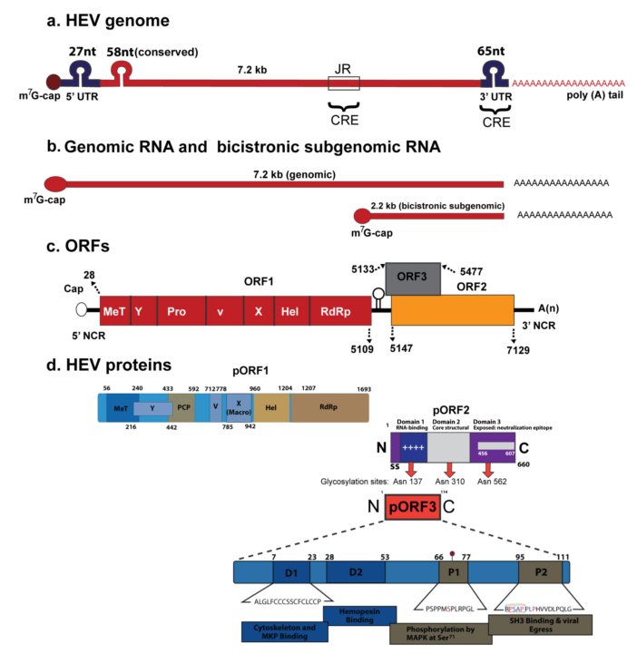
Figure 1 Hepatitis E virus. Genomic organization. a: The hepatitis E virus genome; b: genomic RNA and bicistronic subgenomic RNA; c: open reading frames (ORFs) and (d) 3 encoded proteins (pORF1, pORF2 and pORF3). For details, see text about hepatitis E virus. Adopted from Khuroo et al^{[143]}, 2016.

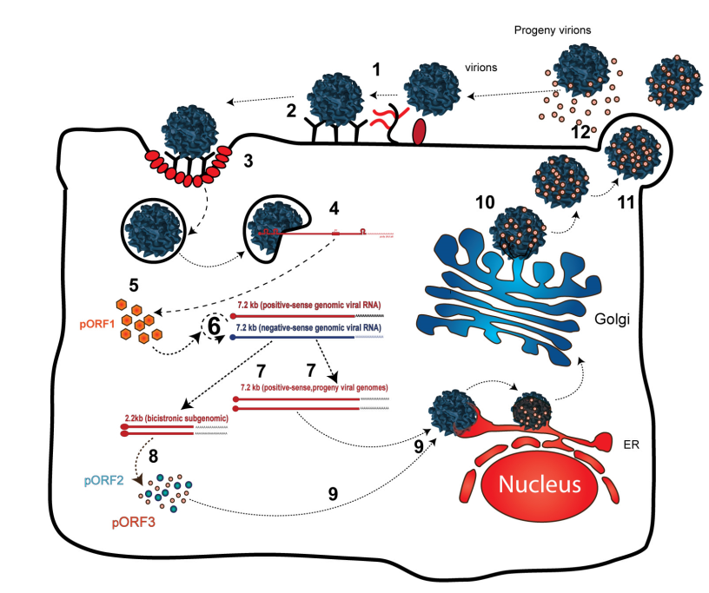
Figure 2 Proposed replication of hepatitis E virus. For details, see text about hepatitis E replication. Adopted from Khuroo et al^{[143]}, 2016.

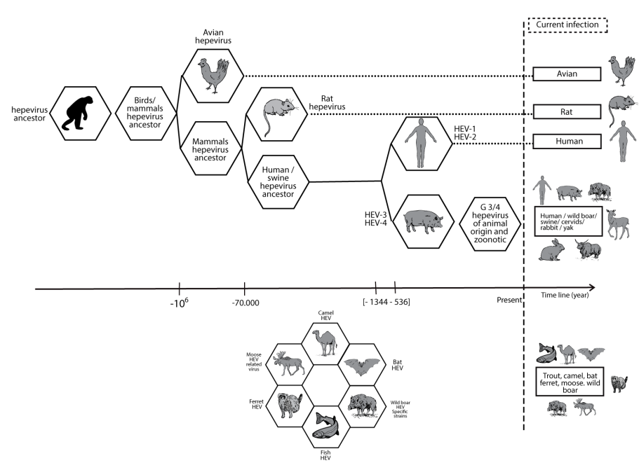
Figure 3 evolutionary history of hepatitis E virus. The times to the most recent common ancestors (tMRCAs) for all four genotypes of HEV were calculated using BEAST to conduct a Bayesian analysis of HEV. The population dynamics for genotypes 1, 3 and 4 were analyzed using skyline plots. For details see text on HEV evolution. Source of data Purdy et al^{[50]} 2010.

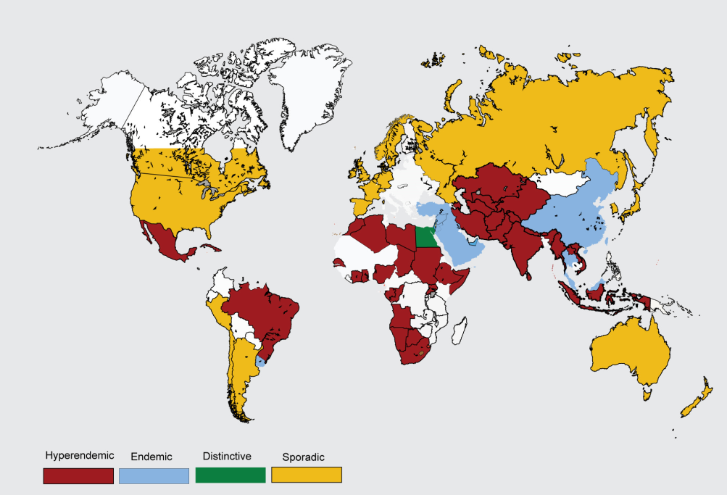
Figure 4 Global distribution of hepatitis E disease. See text under “global distribution” for explanation.

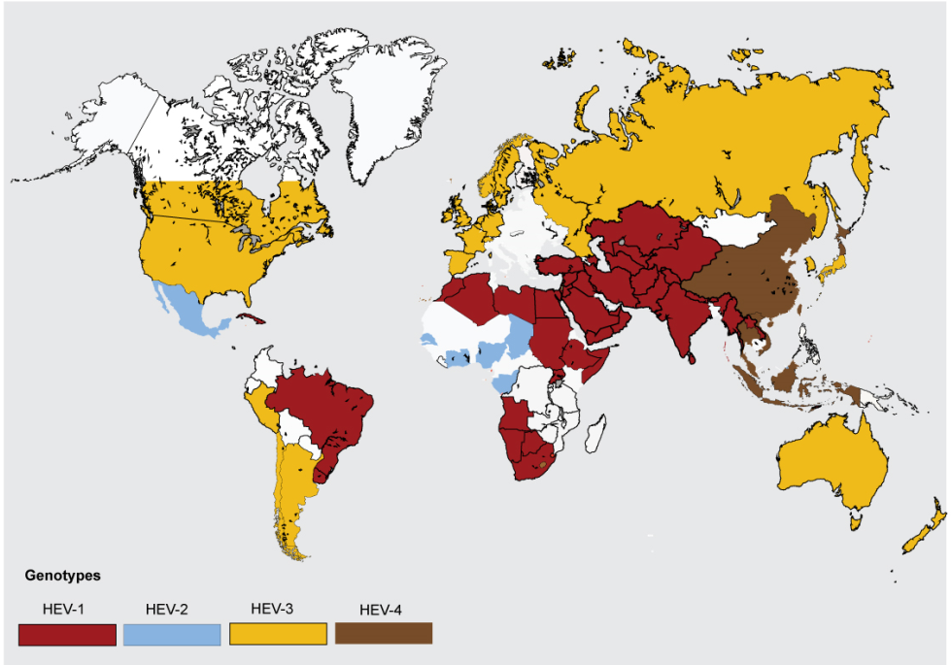
Figure 5 Global distribution of hepatitis E virus genotypes. See text under “global distribution” for explanation.

Table 1 Hepatitis E: Global epidemiology and clinical profile
 | Developing countries |  | Developed countries
Genotypes | HEV-1 | HEV-2 | HEV-3 | HEV-4
Distribution | Asia, Africa, Latin America | Mexico, West Africa | Worldwide | China, East Asia,  Central Europe
Disease pattern | Epidemic, Endemic |  | Autochthonous, sporadic, case-clusters
Attack rate | About 1 in 2 |  | 67%-98% asymptomatic
Seasonality | Yes |  | No
Reservoir | Human |  | Animals (pig, boar, deer)
Transmission | Water, person-to-person, vertical |  | Zoonotic-food-borne, vocational, infected water
Transfusion-associated | Reported |  | Yes (well-studied)
Seroprevalence | Low (< 15 yr), rapid increase  (15-30 yr), plateau at 30%-40% |  | Steady increase throughout age groups; varies 7% to 21%
Seroincidence | 64/1000-yr |  | 30 (south France), 2 (United Kingdom)  7 (United States)/1000-yr
Age (yr) | 15-40 |  | > 50
Sex | 2:1 |  | > 3:1
Clinical outcome | Self-limiting in most |  | Self-limiting in most
Risk factors | Pregnancy, Cirrhosis |  | Cirrhosis, LTx, HIV
Deaths in pregnancy | High (25%) |  | Not reported
HEV superinfections | Common, poor outcome |  | Reported, poor outcome
Extra-hepatic disease | Yes |  | Yes
Chronic infection | Not reported |  | HEV-3; SOT, HIV, hem NP
Burden | 3.4 million cases/year, 70000 deaths, 3000 still births |  | Unknown
HEV: Hepatitis E virus; HIV: human immunodeficiency virus. Adopted from Khuroo et al^{[143]} 2016.

Table 2 Diagnosis of hepatitis E virus infection
Test | Method | Uses | Comments
IgM anti-HEV | ELISA  ICT (POCT) | Acute infection | Assays vary in performance, issue of genotype applicability, poor performance in immune disorders, cross-reactive with other viral infections
IgG anti-HEV | ELISA  ICT (POCT) | Seroprevalence  Acute infection  Natural protection  Vaccine efficacy | Assays vary in performance
HEV RNA | NAT | Acute infection  Confirm chronicity  Anti-viral response  Donor screening | Viremia short-lasting, in-house assays vary in performance, advantage immune disorders
HEV antigen | EIA | Acute infection | 81% concordance with HEV RNA
HEV: Hepatitis E virus; ICT: Immunochromatographic test; POCT: Point of care test; NAT: Nucleic acid test; EIA: Enzyme immunoassay. Adopted from Khuroo et al^{[143]}, 2016.

Table 3 Effect of drugs on hepatitis E virus replication and their use and impact on immunosuppressant therapy during chronic hepatitis E virus infection in solid organ transplant patients
Class | Drug | Effect on HEV replication | Clinical use
Calcineurin inhibitors | Cyclosporine, Tacrolimus | Stimulates HEV replication with increase in HEV load and promotes HEV persistence | Reduce dose
mTOR inhibitors | Rapamycin, Everolimus | Stimulates HEV replication with increase in HEV load | Reduce dose
Antimetabolite immunosuppressant | Mycophenolate mofetil | Inhibits HEV replication and helps HEV clearance | Continue the drug
Guanosine analog | Ribavirin | Inhibits HEV replication and causes HEV clearance | Primary drug for therapy
Cytokines | Pegylated interferon α | Inhibits HEV replication and causes HEV clearance | Indicated if Ribavirin therapy fails
Nucleotide analog | Sofosbuvir | Inhibits HEV replication in vitro | Unclear, clinical trials indicated
HEV: Hepatitis E virus.

