Name of Journal: World Journal of Clinical Cases
Manuscript NO: 78877
Manuscript Type: CASE REPORT

Pacemaker electrode rupture causes recurrent syncope: A case report

Zhu XY et al. Pacemaker electrode rupture causes recurrent syncope

Xiao-Yong Zhu, Xin-Hu Tang, Wen-Yin Huang

Xiao-Yong Zhu, Xin-Hu Tang, Wen-Yin Huang, Department of Cardiology, Jiujiang University Affiliated Hospital, Jiujiang 332000, Jiangxi Province, China

Author contributions: Zhu XY reviewed the literature and contributed to manuscript drafting and revising; Zhu XY was the patient’s doctors and contributed to collecting the patient’s medical data and making a revision to the manuscript; Huang WY Completed surgery and recorded surgical images, Tang XH was responsible for the revision of the manuscript for important intellectual content; all authors issued final approval for the version to be submitted.

Corresponding author: xinhu tang, MD, Chief Physician, Doctor, Department of Cardiology, Jiujiang University Affiliated Hospital, No. 57 Road, Xunyang District, Jiujiang 332000, Jiangxi Province, China. 18879292198@163.com

Received: July 19, 2022
Revised: October 4, 2022
Accepted: October 19, 2022
Published online:

Abstract
BACKGROUND
Currently, the implantation of permanent cardiac pacemakers entails mostly subclavian vein puncture, which is relatively simpler and easier to master. However, due to individual differences, some patients carry a narrow space between the clavicle and the first rib. If the range of activity of the upper limb is increased, the friction between the electrode wire and the bone gap leads to the breakage of the electrode wire, which is manifested by poor pacemaker perception and pacing.

CASE SUMMARY
A 68-year-old woman underwent permanent pacemaker implantation in our hospital because of third-degree atrioventricular block 6 years ago. At that time, the patient was recommended to have a dual-chamber permanent pacemaker implantation, and finally chose a single-chamber permanent pacemaker because she could not afford the cost. The patient has repeatedly lost consciousness for no obvious reason in the past 3 d, and went to our hospital for treatment. The chest X-ray showed that the pacemaker electrode was broken. After the patient was given a pacemaker electrode replacement, the patient did not continue to lose consciousness.

CONCLUSION
Because the electrodes implanted in the subclavian approach are close to the clavicle and the first rib, the pacemaker electrodes may wear out. If the patient loses consciousness again after the pacemaker is implanted, we should consider whether there is a pacemaker. The possibility of electrode breakage, and timely help the patient to replace the new pacemaker electrodes.

Key Words: Syncope; Pacemaker; Lead fracture; Subclavian crush; Case report

Zhu XY, Tang XH, Huang WY. Pacemaker electrode rupture causes recurrent syncope: A case report. World J Clin Cases 2022; In press

Core Tip: We treated a patient who was implanted with a single-chamber pacemaker 6 years ago. The patient experienced repeated loss of consciousness 3 d ago without obvious incentives. The patient did not continue to lose consciousness after the pacemaker electrodes were replaced.

INTRODUCTION
Permanent pacemaker implantation is an effective treatment for bradyarrhythmia. This treatment method involves relatively simple surgery and is associated with minimal trauma. However, complications can still occur, including mainly hematoma, infection, hemopneumothorax, pacemaker syndrome, and electrode breakage and dislocation. The proportion of electrode fractures is about 1.2%^{[1]}. Early fracture is mostly caused by operator inefficiency, while the late fracture is mostly attributed to small subclavian space and long-term friction between the electrode and the clavicle or rib. We describe a case of abnormal perception and pacing triggered by the rupture of permanent pacemaker electrode, resulting in recurrent syncope. Ultimately, the patient did not experience any loss of consciousness after the pacemaker and electrodes were replaced.

CASE PRESENTATION
Chief complaints
A 68-year-old female, who suffered from repeated loss of consciousness for 3 d went to the Jiujiang University Affiliated Hospital on June 9, 2022.

History of present illness
The patient complained that there was no obvious cause for loss of consciousness 3 d ago, and the family members complained that the patient's consciousness recovered 10 s later, but he did not pay attention to it at that time and did not diagnose and treat it. The patient complained of repeated episodes of loss of consciousness, especially when turning sideways. He went to the emergency department of our hospital for treatment, and the electrocardiogram showed a pacemaker electrocardiogram (Figure 1A). Interestingly, when the patient was sitting on the bed and describing his medical history, she suddenly said that she had amaurosis symptoms, and the bedside electrocardiogram (ECG) monitor showed intermittent poor pacing, which was recorded in time by the ECG (Figure 1B). When the heart resumed full pacing, the patient complained of dizziness and amaurosis symptoms relieved, and the pacemaker programming indicated that the electrode impedance was 323 ohms, and the pacing threshold was 5v.

History of past illness
The patient had a history of hypertension for 10 years. She took amlodipine besylate 5 mg QD regularly to control her blood pressure, noting that the blood pressure level was controlled well. She did not take any other medications. The patient denied history of coronary heart disease, cerebral infarction, diabetes.

Personal and family history
The patient denied smoking, drinking history, and family disease history.

Physical examination
Body temperature, 36.3 ℃; breathing, 20 breaths/min; blood pressure, 114/70 mmHg; heart rate, 80 beats/min. Nerve examination and physical examination showed no abnormality

Laboratory examinations
No abnormality is found in blood routine test, liver function, kidney function, electrolyte, thyroid function, blood coagulation function and stool routine test.

Imaging examinations
Brain computed tomography showed no abnormality, Chest X-ray showed a broken electrode line at the junction of the left clavicle and the first rib (Figure 2A and B).

FINAL DIAGNOSIS
Fractured pacemaker electrodes resulted in poor pacing, and the patient experienced repeated loss of consciousness.

TREATMENT
Because the patient's pacemaker was implanted 6 years ago, the pacemaker and electrode replacement surgery were considered after full communication with the patient's family. The vascular puncture site was also adjusted from the subclavian vein to the axillary vein puncture, and the original electrodes were removed. And implanted new electrodes and pacemaker (Figure 2C and D).

OUTCOME AND FOLLOW-UP
The patient had good pacing after surgery, no further loss of consciousness, and was discharged from the hospital on July 7, 2022.

DISCUSSION
Permanent pacemaker plays an important role in the treatment of symptomatic bradyarrhythmia, Syncope can be induced by multiple factors. However, syncope triggered by cardiac causes often indicates poor prognosis and high mortality^{[2]}. The causes of syncope in patients with permanent cardiac pacemakers are mostly neurogenic, hemodynamic instability caused by ventricular tachycardia, pacemaker sensing and pacing dysfunction due to abnormalities associated with pacemaker and lead. Syncope caused by broken pacemaker leads accounts for the least proportion of these cases. Subclavian vein puncture is the preferred method for pacemaker electrode implantation, because of its high success rate, fewer complications, and relative simplicity and user-friendly features. The implantation of electrodes from the subclavian vein route is usually done through a narrow space consisting of the clavicle, ribs, muscles and ligaments^{[3]}. The sternoclavicular joint in this area is the joint between the sternal ribs and the scapula, which is involved in the movement of the thoracolumbar region^{[3]}. Because of the relative structural complexity, the pacemaker lead may be clamped, which leads to wear and tear of the pacemaker electrode during hand and shoulder movements, and breakage of the electrode. In some patients, this position can lead to subclavian crush syndrome, resulting in damaged wire. Magney et al^{[4]} reported anatomical studies involving cadavers that lead entrapment in the clavicle and first rib rather than friction resulted in lead damage.
In this case, subclavian vein puncture was used. Imaging revealed a medial puncture site and sub-clavicular electrode fracture site. Considering that the electrode fracture was related to the selection of puncture site, the reduced impedance suggested that the electrode insulation layer was damaged. The subsequent electrode fracture was related to pacemaker extrusion, traction and wear under the clavicle, which was also a disadvantage of subclavian puncture and electrode implantation. Axillary vein or cephalic vein pathway prevents electrode damage induced by subclavian puncture. Compared with the strong medial subclavian vein access, the cephalic or axillary vein puncture significantly reduced this complication^{[3,5]}. Implantation of pacemaker electrodes via axillary or cephalic vein incision can significantly reduce the risk of electrode wear^{[3]}. A meta-analysis showed that compared with subclavian puncture, the cephalic incision decreased the risk of electrode wear although the left and right implantations were associated with similar complications. Generally, we select the side toward the non-dominant hand for electrode implantation, that is, For right-handed patients, we place the pacemaker on the left^{[6]}. The annual incidence of pacemaker electrode breakage is about 1.2%^{[1]}, which is an underestimate, given the number of undetected and untreated cases. Pacemaker lead breakage is mostly seen in younger individuals (age less than 50 years)^{[7]}, patients engaged in intense sports activities, women, and patients with high left ventricular ejection fraction^{[8]}. Symptoms of pacemaker rupture depend on the patient’s dependance on pacemaker. These symptoms include dizziness, lethargy, syncope and a syndrome. In the absence of pacemaker dependence, it is hard to identify symptoms associated with a broken pacemaker electrode. ECG indicates poor pacing and it is not easy to detect images of pacemaker fracture. Occasionally, it is necessary to abduct the ipsilateral arm implanted with the pacemaker to detect the electrode fracture on an image. The pacemaker program control indicates a significant elevation in pacemaker electrode impedance (normal range, 300-1000 ohms). The treatment of broken pacemaker electrode is replacement with a new one, based on the advantages and disadvantages, and then decide whether or not to remove the broken pacemaker electrode^{[2]}. In the absence of trauma or intense physical activity, we believe that the broken pacemaker electrode in this patient was due to repeated friction between the electrode and the clavicle. This patient was fortunate in that the ECG revealed poor pacing after admission, indicating that the syncope was caused by the broken pacemaker wire, which prompted implantation of a new pacemaker electrode, avoiding any further adverse consequences.

CONCLUSION
Electrode breakage after permanent pacemaker implantation can be prevented by the following precautions: (1) The puncture point in subclavian vein puncture should be as close to the outside as possible to reduce the angle between the puncture needle and the skin, and avoid compression and friction of the locking rib triangle on the electrode line, or axillary vein or cephalic vein puncture may be used instead; (2) The range of motion of the upper limb on the operated side should be appropriate to avoid repeated twisting of electrode wires and prevent metal fatigue leading to fracture; and (3) The electrode wire should not be clamped with vascular forceps during the operation to prevent the risk of breakage of the electrode wire caused by human intervention.

REFERENCES
1 Alt E, Völker R, Blömer H. Lead fracture in pacemaker patients. Thorac Cardiovasc Surg 1987; 35: 101-104 [PMID: 2440129 DOI: 10.1055/s-2007-1020206]
2 Yasa E, Ricci F, Holm H, Persson T, Melander O, Sutton R, Hamrefors V, Fedorowski A. Pacing therapy in the management of unexplained syncope: a tertiary care centre prospective study. Open Heart 2019; 6: e001015 [PMID: 30997138 DOI: 10.1136/openhrt-2019-001015]
3 Chan NY, Kwong NP, Cheong AP. Venous access and long-term pacemaker lead failure: comparing contrast-guided axillary vein puncture with subclavian puncture and cephalic cutdown. Europace 2017; 19: 1193-1197 [PMID: 27733455 DOI: 10.1093/europace/euw147]
4 Magney JE, Flynn DM, Parsons JA, Staplin DH, Chin-Purcell MV, Milstein S, Hunter DW. Anatomical mechanisms explaining damage to pacemaker leads, defibrillator leads, and failure of central venous catheters adjacent to the sternoclavicular joint. Pacing Clin Electrophysiol 1993; 16: 445-457 [PMID: 7681196 DOI: 10.1111/j.1540-8159.1993.tb01607.x]
5 Atti V, Turagam MK, Garg J, Koerber S, Angirekula A, Gopinathannair R, Natale A, Lakkireddy D. Subclavian and Axillary Vein Access Versus Cephalic Vein Cutdown for Cardiac Implantable Electronic Device Implantation: A Meta-Analysis. JACC Clin Electrophysiol 2020; 6: 661-671 [PMID: 32553216 DOI: 10.1016/j.jacep.2020.01.006]
6 Benz AP, Vamos M, Erath JW, Hohnloser SH. Cephalic vs. subclavian lead implantation in cardiac implantable electronic devices: a systematic review and meta-analysis. Europace 2019; 21: 121-129 [PMID: 30020452 DOI: 10.1093/europace/euy165]
7 Morrison TB, Rea RF, Hodge DO, Crusan D, Koestler C, Asirvatham SJ, Bradley D, Shen WK, Munger TM, Hammill SC, Friedman PA. Risk factors for implantable defibrillator lead fracture in a recalled and a nonrecalled lead. J Cardiovasc Electrophysiol 2010; 21: 671-677 [PMID: 20082653 DOI: 10.1111/j.1540-8167.2009.01683.x]
8 Udo EO, Zuithoff NP, van Hemel NM, de Cock CC, Hendriks T, Doevendans PA, Moons KG. Incidence and predictors of short- and long-term complications in pacemaker therapy: the FOLLOWPACE study. Heart Rhythm 2012; 9: 728-735 [PMID: 22182495 DOI: 10.1016/j.hrthm.2011.12.014]

Footnotes
Informed consent statement: Informed written consent was obtained from the patient for publication of this report and any accompanying images.

Conflict-of-interest statement: All the authors declare that they have no conflict of interest to disclose.

CARE Checklist (2016) statement: The authors have read the CARE Checklist (2016), and the manuscript was prepared and revised according to the CARE Checklist (2016).

Open-Access: This article is an open-access article that was selected by an in-house editor and fully peer-reviewed by external reviewers. It is distributed in accordance with the Creative Commons Attribution NonCommercial (CC BY-NC 4.0) license, which permits others to distribute, remix, adapt, build upon this work non-commercially, and license their derivative works on different terms, provided the original work is properly cited and the use is non-commercial. See: https://creativecommons.org/Licenses/by-nc/4.0/

Provenance and peer review: Unsolicited article; Externally peer reviewed.
Peer-review model: Single blind

Peer-review started: July 19, 2022
First decision: September 25, 2022
Article in press:

Specialty type: Cardiac and cardiovascular systems
Country/Territory of origin: China
Peer-review report’s scientific quality classification
Grade A (Excellent): 0
Grade B (Very good): B
Grade C (Good): C, C
Grade D (Fair): 0
Grade E (Poor): E

P-Reviewer: Ghannam WM, Egypt; M.D. HA, Italy; Moussa BS; Salman I, Czech Republic S-Editor: Liu JH L-Editor: A P-Editor: Liu JH
Figure Legends
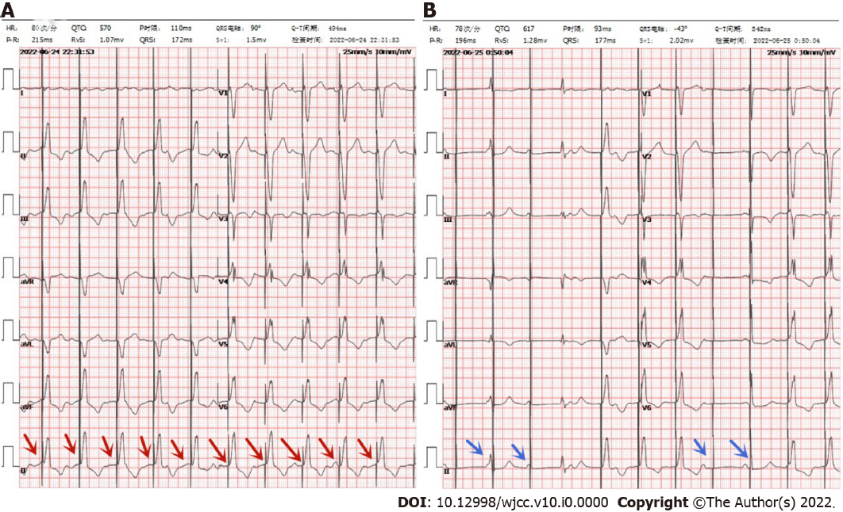
Figure 1 Electrocardiogram. A: Electrocardiogram (ECG) in emergency department: red arrow indicates normal pacing; B: ECG during amaurosis: Blue arrows indicate poor pacing.
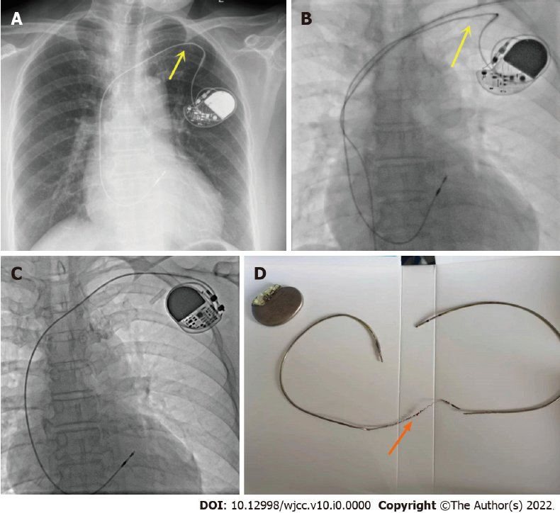
Figure 2 Brain computed tomography/electrodes and pacemaker. A and B: The fluoroscopic image shows the lead depression in the subclavian area (yellow arrows); C: Replaced pacemaker and pacemaker electrode; D: Extracted lead shows broken lead (orange arrow).

