Name of Journal: World Journal of Clinical Pediatrics
Manuscript NO: 66028
Manuscript Type: SCIENTOMETRICS

Global research production in neonatal abstinence syndrome: A bibliometric analysis

Zyoud SH et al. Neonatal abstinence syndrome

Sa'ed H Zyoud, Samah W Al-Jabi, Moyad Jamal Shahwan, Ammar Abdulrahman Jairoun

Sa'ed H Zyoud, Samah W Al-Jabi, Department of Clinical and Community Pharmacy, College of Medicine and Health Sciences, An-Najah National University, Nablus 44839, Palestine

Sa'ed H Zyoud, Poison Control and Drug Information Center, College of Medicine and Health Sciences, An-Najah National University, Nablus 44839, Palestine

Sa'ed H Zyoud, Clinical Research Centre, An-Najah National University Hospital, Nablus 44839, Palestine

Moyad Jamal Shahwan, Clinical Sciences, Ajman University, Ajman 2758, United Arab Emirates

Moyad Jamal Shahwan, Centre of Medical and Bio‑allied Health Sciences Research, Ajman University, Ajman 2758, United Arab Emirates

Ammar Abdulrahman Jairoun, Department of Health and Safety, Dubai Municipality, Dubai 67, United Arab Emirates

Author contributions: Zyoud SH designed the study, collected the data, analyzed the data, made major contributions to the manuscript’s existing literature search and interpretation, and drafted the manuscript; Al-Jabi SW, Jairoun AA, and Shahwan WM were involved in interpretation of the data, and made revisions to the initial draft; all authors provided a critical review and approved the final manuscript before submission.

Corresponding author: Sa'ed H Zyoud, PhD, Associate Professor, Department of Clinical and Community Pharmacy, College of Medicine and Health Sciences, An-Najah National University, Academic street, Nablus 44839, Palestine. saedzyoud@yahoo.com

Received: March 19, 2021
Revised: May 21, 2021
Accepted: March 16, 2022
Published online: May 9, 2022

Abstract
BACKGROUND
Recently, neonatal abstinence syndrome (NAS) emerged as a significant global concern with a dramatic increase in healthcare expenditures. The incidence of the NAS has increased notably in the past decade and emergence as a global public health problem.

AIM
To evaluate the development and trend of global NAS research from 1958 to 2019 by bibliometric analysis.

METHODS
Analyzed aspects included publication output per year, language, document types, journals, countries/territories, h-index, authors, and top research priorities. The VOSviewer was used to determine the top research priorities, and trends, and to present bibliometric networks concerning various dimensions, such as co-authorship, authors, and countries.

RESULTS
A total of 1738 articles were retrieved in the Scopus database from 1958 to 2019. It was found that the great majority of the total NAS documents (n = 1295) were original articles followed by reviews (n = 268) and letters (n = 48). The most productive countries in the NAS field were the United States (n = 833), Canada (n = 112), the United Kingdom (n = 111), and Germany (n = 77). Treatment and hospital outcomes in NAS, evidence-based nurse-driven interventions for the care of newborns with NAS, and a systematic reviews and network meta-analysis for therapeutic approaches of NAS were found in recent years (after 2010), compared with terms such as pathophysiology, mechanisms of NAS, and signs and symptoms in the early years.

CONCLUSION
Treatment and pediatric outcomes and the effectiveness of pharmacological treatment may be frontiers in the NAS field, and continued efforts from researchers are needed in those topics.

Key Words: Neonatal abstinence syndrome; Bibliometric; Scopus; VOSviewer; Visualization

©The Author(s) 2022. Published by Baishideng Publishing Group Inc. All rights reserved.

Citation: Zyoud SH, Al-Jabi SW, Shahwan MJ, Jairoun AA. Global research production in neonatal abstinence syndrome: A bibliometric analysis. World J Clin Pediatr 2022; 11(3): 307-320
URL: https://www.wjgnet.com/2219-2808/full/v11/i3/307.htm
DOI: https://dx.doi.org/10.5409/wjcp.v11.i3.307。

Core Tip: This bibliometric study extracts data on Neonatal abstinence syndrome (NAS) research at a global level, aiming to provide the top-cited articles and top research priorities in NAS and to determine the most prolific countries, journals, and authors. This would enable scientists and clinicians interested in the NAS field to identify the most prevalent topics that have been used for increasing our understanding of NAS and provide a basis for future research. Treatment and pediatric outcomes and the effectiveness of pharmacological treatment may be frontiers in the NAS field, and continued efforts from researchers are needed on these topics.
INTRODUCTION
Neonatal abstinence syndrome (NAS) is a group of signs and symptoms that occur due to the sudden discontinuation of infants shortly after the birth of certain substances that were abused or used during pregnancy^{[1,2]}. NAS can present with a broad range of signs and symptoms including restlessness, agitation, feeding intolerance, gastrointestinal disturbances, hypertonia, tremors, seizures, and respiratory distress^{[2-6]}.
Recently, NAS emerged as a significant global concern with a dramatic increase in healthcare expenditures^{[1,7-9]}. The incidence of NAS has increased notably in the past decade and emergence as a global public health problem. The reported rise in antidepressant therapy during pregnancy, or the use of narcotic analgesics for pain relief in pregnant women, or the illicit use of opioids such as heroin and oxycodone^{[10]} may play an important role in this aspect. The most clinically significant interventions in NAS management are appropriate to nonpharmacologic interventions^{[6,11]} including promoting breastfeeding of infants when not contraindicated, rooming-in, positioning of the infant, bed type, and non-insertive acupuncture. Opioids such as morphine or methadone or buprenorphine are usually the first-line agent to treat the symptoms of withdrawal when pharmacological treatment is indicated. Although phenobarbital has been recognized as a second-line agent to be used in infants when opioids fail, clonidine may be used as a nonopioid adjunctive NAS therapy with minimal adverse effects and reduced treatment time^{[5,6,12,13]}.
Although several bibliometric analyses have been carried out on several topics related to substance abuse such as illicit drug addiction^{[14]}, cocaine intoxication^{[15]}, substance use disorders^{[16]}, drug and alcohol^{[17]}, and drug abuse and dependence^{[18-23]}, an extensive literature search did not reveal any bibliometric analysis on NAS. Therefore, this bibliometric study extracts data on NAS research at a global level, aiming to provide the top-cited articles and top research priorities in NAS and to determine the most prolific countries, journals, and authors. This would enable scientists and clinicians interested in the NAS field to identify the most prevalent topics that have been used for increasing our understanding of NAS and provide a basis for future research.

MATERIALS AND METHODS
Database used
To achieve the objectives of the current bibliometric study, we performed a generalized search using the database of Scopus (Elsevier's citation database). The search was performed on July 17, 2020. Because the first publication related to NAS was published in 1958, the timespan was set from 1958 to 2019. The final year (2020) was omitted from the study as, at the time of data collection, certain publications from that year might not have been indexed in databases and this year's data does not represent a complete year of publication in the field.

Search strategy
The search was thus conducted using the following search string: (TITLE-ABS (neonat*) OR TITLE-ABS (newborn) OR TITLE-ABS (birth) OR TITLE-ABS (infant) AND TITLE-ABS ("Abstinence Syndrome") OR TITLE-ABS ("Abstinence Symptom*") OR TITLE-ABS ("Substance Withdrawal") OR TITLE-ABS ("narcotic syndrome") OR TITLE-ABS ("narcotic Symptom*") OR TITLE-ABS ("Withdrawal Symptom*") OR TITLE-ABS ("Withdrawal Syndrome") OR TITLE-ABS ("drug Withdrawal") OR TITLE-ABS ("Passive Addiction") OR TITLE-ABS("opioid withdrawal") OR TITLE-ABS ("opioid syndrome") AND EXCLUDE (DOCTYPE) AND [EXCLUDE (PUBYEAR, 2020). Neonatal abstinence syndrome-related terms were selected for this string based on those identified in previous literature reviews^{[6,10,24-27]}. The search strategy for the terms related to NAS was restricted to Title/Abstract to achieve greater accuracy in the results because many reported publications were not related to NAS (i.e., false-positive data) if applied to other search fields such as keywords. The use of title/abstract search is recommended in bibliometric studies^{[15,28,29]} in contrast to the title-abstract-keywords search query because it substantially increases specificity with minimum loss of sensitivity. The main explanation for the generation of false-positive results by keyword search is that Scopus considers keywords such as "Medline keywords", "EMTREE medical terms" and "EMTRE drug terms" as author and indexed keywords. In the absence of false-positive and false-negative findings, the method adopted in the current study was validated^{[30]}. No language restrictions were applied. Thus, both English and non-English documents were used.

Data analysis and visualization
The data was organized and analyzed using Microsoft Office Excel 2010. Descriptive statistics were used for data analysis, using frequencies and percentages. The downloaded document included the title, abstract, publication date, journal information, authors, country, collaboration patterns, and citations as indicators for quantity and qualitative analysis. These indicators were identified according to previous bibliometric literature^{[31-33]}. The VOSviewer version 1.6.14^{[34]}, a software package for analyzing and visualizing large bibliographic datasets, was used for content analysis to determine the top research priority topics, and trends, and to present bibliometric networks concerning various dimensions, such as co-authorship, authors, and countries. To map the network of terms co-occurrence in the title and abstract countries, collaboration co-authorship was extracted from downloaded bibliometric records. In terms with an occurrence frequency no less than 20 authors and countries who had at least five publications were chosen for visualisation. The number of publications related to a certain word is measured by the size of circles in VOSviewer maps and the distance between the two terms means the number of cooccurrences of the terms. Moreover, words that are similar to each other or have a certain color are more likely to deal with the same topic^{[34]}. In addition, the terms co-occurrences were analyzed to distinguish topics used by the authors’ overtime. Using the "link strength" indicator extracted from visualization maps, an international research collaboration among active countries was evaluated. The strength of the link is a measure of the strength of cooperation between any two countries in this field. The higher value of link strength means the thickness of the connecting line, which is considered the stronger research collaboration between certain countries in this field^{[34]}.

RESULTS
A total of 1738 articles were retrieved in the Scopus database from 1958 to 2019. It was found that the great majority of the total NAS documents (1295; 74.51%) were original articles followed by reviews (268; 15.42%) and letters (48; 2.76%). The yearly publication number of articles increased rapidly from 1958 to 2019 (Figure 1). Yearly articles increased from 2 in 1958 to 40 in 2007 and then to 177 in 2019. Twenty-three languages of publication were identified in the 1,738 articles retrieved. The four predominant languages were English (n = 1489; 85.67%), followed by German (n = 66; 3.80%), Spanish (n = 39; 2.24%), and French (n = 38; 2.13%).
There is a total of 111 countries/areas that make great contribution research publications in neonatal abstinence syndrome. Table 1 presents the 10 most productive countries in the NAS concerning total publications, h-index, as well as the collaboration pattern. The most productive countries in NAS field were the United States (n = 833; 47.93%), Canada (n = 112; 6.44%), the United Kingdom (n = 111; 6.39%) and Germany (n = 77; 4.43%). The h-index of the total retrieved articles was 87. Among the most productive countries, the United States achieved the highest h-index value with 71, followed by the United Kingdom with 29, and Canada with 29. A network visualization map for country collaboration is shown in Figure 2 and demonstrates that the United States is the most important collaboration country. Of the 111 countries, 33 had at least five publications; the largest set of connected countries consists of 28 countries in 8 clusters. For research collaboration, the strongest was in the United States (total link strength = 111), followed by the United Kingdom (total link strength = 72), and Netherlands (total link strength = 70). For most countries, the link strength was less than 20, suggesting insufficient international research collaboration in this field^{[34]}.
Table 2 shows the 11 journals with more than 17 published papers with their impact factors. The journals publishing most papers are Pediatrics (n = 43), Journal of Pediatrics (n = 34), and Journal of Perinatology (n = 33).
Among the top contributive authors (Table 3), Jones Hendrée (42 publications) from the University of North Carolina at Chapel Hill (United States) was ranked first, followed by Fischer, Gabriele (29 publications) from the Medical University Vienna (Austria). Of note, 8 and 3 authors are from the United States and Austria, respectively, suggesting an important contributing role to these countries. A network visualization map for the authors’ collaboration is shown in Figure 3. Of the 5305 authors, 118 had at least five publications; the largest set of connected authors consists of 70 authors in 11 clusters.
In VOSviewer, co-occurrence analysis for the title and abstract contents was used to produce the term co-occurrence network of NAS studies (Figure 4). In Figure 4, it can be seen that the top research priorities of NAS studies form five clusters, and the terms in the same cluster show superior connection in each of the research topics. These five clusters were as follows: Cluster 1 (blue) involved terms related to “treatment and hospital outcomes in NAS” such as “hospitalization, length, stay, hospital stay, discharge, neonate outcome”; Cluster 2 (yellow) involved terms related to “evidence-based nurse-driven interventions for the care of newborns with NAS” such as “nurse, intervention, guideline, barrier, challenge”; Cluster 3 (red) involved terms related to “pathophysiology and mechanisms of NAS” such as “brain, onset, alteration, activity, administration, tolerance, analgesia, sedation, animal, rat”; Cluster 4 (purple) involved terms related to “systematic review and network meta-analysis for therapeutic approaches of NAS” such as “systematic review, meta-analysis, Medline, trial, search”; and Cluster 5 (green) involved terms related to “signs and symptoms” such as “jitteriness in neonates, meconium, irritability, prematurity”. In the analysis of term co-occurrence (Figure 5), we also identified terms in the titles and abstracts related to NAS over time. Treatment and hospital outcomes in NAS, evidence-based nurse-driven interventions for the care of newborns with NAS, and a systematic reviews and network meta-analysis for therapeutic approaches of NAS were found in recent years (after 2010), compared with terms such as pathophysiology, mechanisms of NAS, and signs and symptoms in the early years (before 2010).
The top 20 cited publications in the field of NAS ranked by the total number of citations are shown in Table 4. The highest cited publication in the top 20 was cited 529 times and the lowest cited article 177 times^{[1,2,9,35-52]}. Table 5 includes the most frequently encountered agents related to NAS literature. “Methadone” (n = 629) was the most commonly occurred in NAS literature, followed by “morphine” (n = 378), “buprenorphine” (n = 313), and “phenobarbital” (n = 275).

DISCUSSION
This study is set out with the aim of investigating the current situation of NAS research at a global level by analysing the related literature bibliometrically. In 2015, member states of the United Nations had signed and adopted Sustainable Development Goals (SDGs) to be achieved in 2030^{[53]}. The third goal is dedicated to health and well-being. The fifth target of the third goal in the SDGs promotes the prevention and treatment of substance use disorders. Furthermore, the second target of the third goal promotes the health of the newborn and children by minimizing preventable deaths^{[54]}. The current study will endorse the attainment of 2030 goals by shedding light on an important problem related to maternal and newborn health within the context of substance use disorders.
The current study is novel in describing the characteristics of research publications related to NAS across time, via bibliometric analysis, and determining the top research priorities in this field during six decades (1958-2019). Advances in the knowledge of NAS by determining the top research priorities for this complex health issue will help to improve future research for maternal and neonatal care.
Overall, the current study demonstrated an increase in the number of publications involving NAS over the period 1958–2019. In another way, the total number of publications related to NAS increased more than twofold from 437 before 2000 to 971 during the last decade (2010–2019). This was possible because of different explanations. First, research concerning substance abuse, with a focus on prevention and policy issues has become a rapidly emerging area in medical sciences and is recently reaching maturity. Second, this progress can be attributed largely to the trend of increasing maternal opiates and illicit drug use across the world. Third, the development of neonatal opioid withdrawal scale to measure opioid withdrawal signs and symptoms in the neonate. Fourth, the rapid growth of the global economy with the development of information technology has contributed to the progress of research to keep up this increasing trend.
In this study, the United States was found to be the leader in NAS research. This result may be explained by the fact that the United States is the most prolific country for research in general by most bibliometric studies^{[31,55-57]}. Moreover, the United States is one of the countries that attributed largely to the trend of increasing maternal cocaine, illicit drugs, and opiate use, and subsequently escalating numbers of deaths^{[58]}. Additionally, the United States may be leading because of its size and economic strength and has a large research system including United States institutions, individual colleges, and hospitals^{[59]}. Seven newborns were diagnosed with NAS for every 1,000 hospital stays for newborns, according to 2016 statistics^{[60]}. This is around one baby in the United States diagnosed with NAS every 19 minutes, or almost 80 newborns diagnosed every day^{[60]}.
Clearly, the most commonly used keyword in NAS literature was “methadone,” followed by “morphine”, “buprenorphine”, and “phenobarbital”. It is interesting to note that three studies from the top 20 cited publications in the field of NAS were evaluating the efficacy and safety of methadone vs buprenorphine therapy for treating opioid-dependent pregnant patients^{[42-44]}.
The most cited publication in the field of NAS was published in 2012 in JAMA - Journal of the American Medical Association, conducted by Patrick et al^{[1]}, where the authors found an increase in maternal opiate use and incidence of NAS in the United States. The authors analyzed information on 7.4 million discharges from 4121 hospitals in 44 states, to measure the epidemiology and economic damage associated with NAS over the past decade. The authors reported that the number of mothers using opiates rose from 1.19 to 5.63 per 1000 hospital births per year between 2000 and 2009, and that it is estimated that aggregate hospital costs for NAS cases, adjusted for inflation, rose from $190 million to $720 million between 2000 and 2009. The second most cited publication was published in 2010 in New England Journal of Medicine, conducted by Jones et al^{[43]} resulting from the collaboration between several countries (United States, Canada, and Austria). This study considered the use of buprenorphine as the first-line treatment option instead of methadone for the treatment of opioid dependency during pregnancy. Methadone therapy for heroin addiction began in New York City in 1964^{[61]}, and then became the standard therapy for treating opioid-dependent pregnant patients in both the developed and developing worlds^{[62]}. Methadone therapy led to several adverse pregnancy events during withdrawal^{[63]}. After that, marked progress has been made in the area of buprenorphine research as an alternative treatment for opioid dependence^{[43]} which gives relative superiority for buprenorphine to be associated with a lower risk of NAS severity^{[64]}. This finding also accords with our observations, which showed that top research priorities including treatment and pediatric outcomes, and the effectiveness of pharmacological treatment were found in recent years. Furthermore, top research priorities in the field of NAS are consistent with the findings highlighted in the most highly cited publications, which provide substantial and valuable findings that open the door for new areas of research investigation.
Despite the importance of this topic, there remains a paucity of evidence on several issues related to NAS^{[65-68]}. The most significant knowledge gaps in NAS are the long-term outcomes and the international differences between treatments of drug-using mother/infant dyads. What happens to the children afterward? How have they looked after? Some of the medications used to treat NAS (e.g., methadone) are not sanctioned in countries outside the United States. Opioid-exposed infants are still at significantly higher risk of dying, of being abused, and of sliding towards an unpalatable life trajectory after discharge from the hospital. Further work is needed to highlight this missing information and note the urgent need to prioritize research and clinical care towards improving and ameliorating the impact of maternal drug use. More broadly, the emphasis on the need to conduct more research into pharmacological treatment neglects other aspects of care for infants, including rooming-in, breastfeeding, etc. The medications that are used to treat NAS are not innocuous, therefore, research is also needed to avoid pharmacological treatment, rather than to see which treatment is most effective in discharging the infants out of the hospital faster.

Strengths and limitations
This bibliometric study is the first comprehensive investigation to explore the distribution trends and top research priorities in the field of NAS. Additionally, another strength of the current study including a large literature database (i.e., Scopus), benefits from a higher coverage than other databases^{[69,70]}, spanning multiple years of analysis to identify relevant NAS literature. Several limitations matching those observed in earlier bibliometric studies^{[31,71,72]} should be noted. The main limitation of this study was the use of the Scopus database which expects that most perspectives of the publications in the field of NAS indexed in this database were analysed. Additionally, the current study used a comprehensive list of keywords based on those identified in previous literature reviews^{[6,10,24-27]}; however, there is a possible slight chance that some keywords have been missed which may lead to false-negative results.

CONCLUSION
In conclusion, this bibliometric review defined the scientific research output in the field of NAS using bibliometric methods over the past 60 years, including publication numbers, countries, organizations, journals, top research priorities, and emerging trends. The findings from this study make several contributions to the current literature. First, this study confirmed the increase in the number of publications involving NAS over the period 1958–2019. Second, the United States, Canada, and the United Kingdom had the leading position in global research productivity in this field. Third, it was found that the comparative studies related to the safety and efficacy of methadone and buprenorphine in NAS were the mainstay of the top-cited studies. In the last treatment and pediatric outcomes, and the effectiveness of pharmacological treatment may be frontiers in the NAS field, and continued efforts from researchers are needed on these topics. This bibliometric study offers an objective and quantitative summary of the progress of research in the NAS field, which can serve as a significant guide and entry point for more scientific research. This information can be used to develop targeted interventions aimed to improve international cooperation between organizations and countries by applying useful initiatives and policies.

ARTICLE HIGHLIGHTS
Research background
Neonatal abstinence syndrome (NAS) has recently become a major global issue, resulting in a substantial rise in healthcare costs. The NAS has become a global public health epidemic in the last decade, with a rise in incidence.

Research motivation
Despite the fact that bibliometric studies have been conducted on a variety of topics related to substance abuse, such as illegal drug addiction, a thorough search of the literature revealed no bibliometric research on NAS.

Research objectives
Bibliometric analysis was used to assess the evolution and pattern of the global NAS research from 1958 to 2019.

Research methods
Yearly publication production, language, document types, journals, countries/territories, h-index, authors, and top research priorities were among the indicators examined. The VOSviewer was used to assess the top research priorities and patterns, as well as to present bibliometric networks on a variety of dimensions, including co-authorship, authors, and countries.

Research results
The current study is novel in that it uses bibliometric analysis to describe the characteristics of research publications relevant to NAS over time and determine the top research priorities in this field over six decades (1958-2019). Advances in NAS awareness will help to enhance future maternal and neonatal care research by identifying the top research priorities for this complex health problem.

Research conclusions
Treatment and pediatric outcome, as well as the efficacy of pharmacological treatment, may be frontiers in the NAS area, and researchers must continue to work on these topics.

Research perspectives
This will allow scientists and clinicians interested in the field of NAS to recognise the most common topics that have been used to improve our understanding of the disease and serve as a foundation for future study.

REFERENCES
1 Patrick SW, Schumacher RE, Benneyworth BD, Krans EE, McAllister JM, Davis MM. Neonatal abstinence syndrome and associated health care expenditures: United States, 2000-2009. JAMA 2012; 307: 1934-1940 [PMID: 22546608 DOI: 10.1001/jama.2012.3951]
2 Kocherlakota P. Neonatal abstinence syndrome. Pediatrics 2014; 134: e547-e561 [PMID: 25070299 DOI: 10.1542/peds.2013-3524]
3 Sanlorenzo LA, Stark AR, Patrick SW. Neonatal abstinence syndrome: an update. Curr Opin Pediatr 2018; 30: 182-186 [PMID: 29346142 DOI: 10.1097/MOP.0000000000000589]
4 Grossman M, Seashore C, Holmes AV. Neonatal Abstinence Syndrome Management: A Review of Recent Evidence. Rev Recent Clin Trials 2017; 12: 226-232 [PMID: 28814260 DOI: 10.2174/1574887112666170816144818]
5 Raffaeli G, Cavallaro G, Allegaert K, Wildschut ED, Fumagalli M, Agosti M, Tibboel D, Mosca F. Neonatal Abstinence Syndrome: Update on Diagnostic and Therapeutic Strategies. Pharmacotherapy 2017; 37: 814-823 [PMID: 28519244 DOI: 10.1002/phar.1954]
6 Wachman EM, Schiff DM, Silverstein M. Neonatal Abstinence Syndrome: Advances in Diagnosis and Treatment. JAMA 2018; 319: 1362-1374 [PMID: 29614184 DOI: 10.1001/jama.2018.2640]
7 Corr TE, Hollenbeak CS. The economic burden of neonatal abstinence syndrome in the United States. Addiction 2017; 112: 1590-1599 [PMID: 28612362 DOI: 10.1111/add.13842]
8 Okoroh EM, Gee RE, Jiang B, McNeil MB, Hardy-Decuir BA, Zapata AL. Neonatal Abstinence Syndrome: Trend and Expenditure in Louisiana Medicaid, 2003-2013. Matern Child Health J 2017; 21: 1479-1487 [PMID: 28168591 DOI: 10.1007/s10995-017-2268-1]
9 Patrick SW, Davis MM, Lehmann CU, Cooper WO. Increasing incidence and geographic distribution of neonatal abstinence syndrome: United States 2009 to 2012. J Perinatol 2015; 35: 650-655 [PMID: 25927272 DOI: 10.1038/jp.2015.36]
10 McQueen K, Murphy-Oikonen J. Neonatal Abstinence Syndrome. N Engl J Med 2016; 375: 2468-2479 [PMID: 28002715 DOI: 10.1056/NEJMra1600879]
11 Bagley SM, Wachman EM, Holland E, Brogly SB. Review of the assessment and management of neonatal abstinence syndrome. Addict Sci Clin Pract 2014; 9: 19 [PMID: 25199822 DOI: 10.1186/1940-0640-9-19]
12 Streetz VN, Gildon BL, Thompson DF. Role of Clonidine in Neonatal Abstinence Syndrome: A Systematic Review. Ann Pharmacother 2016; 50: 301-310 [PMID: 26783353 DOI: 10.1177/1060028015626438]
13 McPherson C. Pharmacotherapy for Neonatal Abstinence Syndrome: Choosing the Right Opioid or No Opioid at All. Neonatal Netw 2016; 35: 314-320 [PMID: 27636696 DOI: 10.1891/0730-0832.35.5.314]
14 Khalili M, Rahimi-Movaghar A, Shadloo B, Mojtabai R, Mann K, Amin-Esmaeili M. Global Scientific Production on Illicit Drug Addiction: A Two-Decade Analysis. Eur Addict Res 2018; 24: 60-70 [PMID: 29627821 DOI: 10.1159/000487590]
15 Zyoud SH, Waring WS, Al-Jabi SW, Sweileh WM. Global cocaine intoxication research trends during 1975-2015: a bibliometric analysis of Web of Science publications. Subst Abuse Treat Prev Policy 2017; 12: 6 [PMID: 28153037 DOI: 10.1186/s13011-017-0090-9]
16 González-Alcaide G, Calafat A, Becoña E, Thijs B, Glänzel W. Co-Citation Analysis of Articles Published in Substance Abuse Journals: Intellectual Structure and Research Fields (2001-2012). J Stud Alcohol Drugs 2016; 77: 710-722 [PMID: 27588529 DOI: 10.15288/jsad.2016.77.710]
17 Clifford A, Shakeshaft A. A bibliometric review of drug and alcohol research focused on Indigenous peoples of Australia, New Zealand, Canada and the United States. Drug Alcohol Rev 2017; 36: 509-522 [PMID: 28334457 DOI: 10.1111/dar.12510]
18 Bramness JG, Henriksen B, Person O, Mann K. A bibliometric analysis of European versus USA research in the field of addiction. Research on alcohol, narcotics, prescription drug abuse, tobacco and steroids 2001-2011. Eur Addict Res 2014; 20: 16-22 [PMID: 23921359 DOI: 10.1159/000348260]
19 Condon TP. Reflecting on 30 years of research. A look at how NIDA has advanced the research, prevention, and treatment of drug abuse and addiction. Behav Healthc 2006; 26: 14, 16 [PMID: 16736912]
20 Rawson RA, Woody G, Kresina TF, Gust S. The globalization of addiction research: capacity-building mechanisms and selected examples. Harv Rev Psychiatry 2015; 23: 147-156 [PMID: 25747927 DOI: 10.1097/HRP.0000000000000067]
21 Blobaum PM. Mapping the literature of addictions treatment. J Med Libr Assoc 2013; 101: 101-109 [PMID: 23646025 DOI: 10.3163/1536-5050.101.2.005]
22 Rahimi-Movaghar A, Amin-Esmaeili M, Safarcherati A, Sarami H, Rafiey H. A Scientometric Study of Iranian Scientific Productions in the Field of Substance Use and Addiction Research in the Years 2008 to 2012. Addict Health 2015; 7: 99-108 [PMID: 26885346]
23 Valderrama Zurián JC, Aleixander R, Castellano M. Citation count analysis in addiction (2001). Addiction 2004; 99: 387-388 [PMID: 14982553 DOI: 10.1111/j.1360-0443.2004.00655.x]
24 Cleary BJ, Donnelly J, Strawbridge J, Gallagher PJ, Fahey T, Clarke M, Murphy DJ. Methadone dose and neonatal abstinence syndrome-systematic review and meta-analysis. Addiction 2010; 105: 2071-2084 [PMID: 20840198 DOI: 10.1111/j.1360-0443.2010.03120.x]
25 MacMillan KDL, Rendon CP, Verma K, Riblet N, Washer DB, Volpe Holmes A. Association of Rooming-in With Outcomes for Neonatal Abstinence Syndrome: A Systematic Review and Meta-analysis. JAMA Pediatr 2018; 172: 345-351 [PMID: 29404599 DOI: 10.1001/jamapediatrics.2017.5195]
26 Murphy-Oikonen J, McQueen K. Outpatient pharmacologic weaning for neonatal abstinence syndrome: a systematic review. Prim Health Care Res Dev 2018; 20: e76 [PMID: 29739484 DOI: 10.1017/S1463423618000270]
27 Rees P, Stilwell PA, Bolton C, Akillioglu M, Carter B, Gale C, Sutcliffe A. Childhood Health and Educational Outcomes After Neonatal Abstinence Syndrome: A Systematic Review and Meta-analysis. J Pediatr 2020; 226: 149-156.e16 [PMID: 32659230 DOI: 10.1016/j.jpeds.2020.07.013]
28 Olisah C, Okoh OO, Okoh AI. A bibliometric analysis of investigations of polybrominated diphenyl ethers (PBDEs) in biological and environmental matrices from 1992 - 2018. Heliyon 2018; 4: e00964 [PMID: 30533544 DOI: 10.1016/j.heliyon.2018.e00964]
29 Ekundayo TC, Okoh AI. A global bibliometric analysis of Plesiomonas-related research (1990 - 2017). PLoS One 2018; 13: e0207655 [PMID: 30496198 DOI: 10.1371/journal.pone.0207655]
30 Sweileh WM. Bibliometric analysis of global scientific literature on vaccine hesitancy in peer-reviewed journals (1990-2019). BMC Public Health 2020; 20: 1252 [PMID: 32807154 DOI: 10.1186/s12889-020-09368-z]
31 Zyoud SH, Waring WS, Al-Jabi SW, Sweileh WM. Bibliometric profile of global scientific research on digoxin toxicity (1849-2015). Drug Chem Toxicol 2020; 43: 553-559 [PMID: 30239237 DOI: 10.1080/01480545.2018.1518453]
32 Zhang TS, Qin HL, Wang T, Li HT, Li H, Xia SH, Xiang XH. Bibliometric analysis of top 100 cited articles in nonalcoholic fatty liver disease research. World J Hepatol 2016; 8: 1478-1488 [PMID: 27957247 DOI: 10.4254/wjh.v8.i33.1478]
33 Wang CY, Zhou SC, Li XW, Li BH, Zhang JJ, Ge Z, Zhang Q, Hu JH. Bibliometric analysis of randomized controlled trials of colorectal cancer over the last decade. World J Clin Cases 2020; 8: 3021-3030 [PMID: 32775383 DOI: 10.12998/wjcc.v8.i14.3021]
34 van Eck NJ, Waltman L. Software survey: VOSviewer, a computer program for bibliometric mapping. Scientometrics 2010; 84: 523-538 [PMID: 20585380 DOI: 10.1007/s11192-009-0146-3]
35 ACOG Committee on Health Care for Underserved Women; American Society of Addiction Medicine. ACOG Committee Opinion No. 524: Opioid abuse, dependence, and addiction in pregnancy. Obstet Gynecol 2012; 119: 1070-1076 [PMID: 22525931 DOI: 10.1097/AOG.0b013e318256496e]
36 Neonatal drug withdrawal. American Academy of Pediatrics Committee on Drugs. Pediatrics 1998; 101: 1079-1088 [PMID: 9614425]
37 Costei AM, Kozer E, Ho T, Ito S, Koren G. Perinatal outcome following third trimester exposure to paroxetine. Arch Pediatr Adolesc Med 2002; 156: 1129-1132 [PMID: 12413342 DOI: 10.1001/archpedi.156.11.1129]
38 Finnegan LP, Connaughton JF Jr, Kron RE, Emich JP. Neonatal abstinence syndrome: assessment and management. Addict Dis 1975; 2: 141-158 [PMID: 1163358]
39 Hadeed AJ, Siegel SR. Maternal cocaine use during pregnancy: effect on the newborn infant. Pediatrics 1989; 84: 205-210 [PMID: 2748245]
40 Hudak ML, Tan RC; COMMITTEE ON DRUGS; COMMITTEE ON FETUS AND NEWBORN; American Academy of Pediatrics. Neonatal drug withdrawal. Pediatrics 2012; 129: e540-e560 [PMID: 22291123 DOI: 10.1542/peds.2011-3212]
41 Hughes JR, Higgins ST, Bickel WK. Nicotine withdrawal versus other drug withdrawal syndromes: similarities and dissimilarities. Addiction 1994; 89: 1461-1470 [PMID: 7841857 DOI: 10.1111/j.1360-0443.1994.tb03744.x]
42 Jones HE, Johnson RE, Jasinski DR, O'Grady KE, Chisholm CA, Choo RE, Crocetti M, Dudas R, Harrow C, Huestis MA, Jansson LM, Lantz M, Lester BM, Milio L. Buprenorphine versus methadone in the treatment of pregnant opioid-dependent patients: effects on the neonatal abstinence syndrome. Drug Alcohol Depend 2005; 79: 1-10 [PMID: 15943939 DOI: 10.1016/j.drugalcdep.2004.11.013]
43 Jones HE, Kaltenbach K, Heil SH, Stine SM, Coyle MG, Arria AM, O'Grady KE, Selby P, Martin PR, Fischer G. Neonatal abstinence syndrome after methadone or buprenorphine exposure. N Engl J Med 2010; 363: 2320-2331 [PMID: 21142534 DOI: 10.1056/NEJMoa1005359]
44 Lejeune C, Simmat-Durand L, Gourarier L, Aubisson S; Groupe d'Etudes Grossesse et Addictions (GEGA). Prospective multicenter observational study of 260 infants born to 259 opiate-dependent mothers on methadone or high-dose buprenophine substitution. Drug Alcohol Depend 2006; 82: 250-257 [PMID: 16257138 DOI: 10.1016/j.drugalcdep.2005.10.001]
45 Levinson-Castiel R, Merlob P, Linder N, Sirota L, Klinger G. Neonatal abstinence syndrome after in utero exposure to selective serotonin reuptake inhibitors in term infants. Arch Pediatr Adolesc Med 2006; 160: 173-176 [PMID: 16461873 DOI: 10.1001/archpedi.160.2.173]
46 Nau H, Rating D, Koch S, Häuser I, Helge H. Valproic acid and its metabolites: placental transfer, neonatal pharmacokinetics, transfer via mother's milk and clinical status in neonates of epileptic mothers. J Pharmacol Exp Ther 1981; 219: 768-777 [PMID: 6795343]
47 Nordeng H, Lindemann R, Perminov KV, Reikvam A. Neonatal withdrawal syndrome after in utero exposure to selective serotonin reuptake inhibitors. Acta Paediatr 2001; 90: 288-291 [PMID: 11332169 DOI: 10.1111/j.1651-2227.2001.tb00306.x]
48 Ryan L, Ehrlich S, Finnegan L. Cocaine abuse in pregnancy: effects on the fetus and newborn. Neurotoxicol Teratol 1987; 9: 295-299 [PMID: 3683347 DOI: 10.1016/0892-0362(87)90018-3]
49 Sanz EJ, De-las-Cuevas C, Kiuru A, Bate A, Edwards R. Selective serotonin reuptake inhibitors in pregnant women and neonatal withdrawal syndrome: a database analysis. Lancet 2005; 365: 482-487 [PMID: 15705457 DOI: 10.1016/S0140-6736(05)17865-9]
50 Tolia VN, Patrick SW, Bennett MM, Murthy K, Sousa J, Smith PB, Clark RH, Spitzer AR. Increasing incidence of the neonatal abstinence syndrome in U.S. neonatal ICUs. N Engl J Med 2015; 372: 2118-2126 [PMID: 25913111 DOI: 10.1056/NEJMsa1500439]
51 Wisner KL, Gelenberg AJ, Leonard H, Zarin D, Frank E. Pharmacologic treatment of depression during pregnancy. JAMA 1999; 282: 1264-1269 [PMID: 10517430 DOI: 10.1001/jama.282.13.1264]
52 Zajecka J, Tracy KA, Mitchell S. Discontinuation symptoms after treatment with serotonin reuptake inhibitors: a literature review. J Clin Psychiatry 1997; 58: 291-297 [PMID: 9269249 DOI: 10.4088/jcp.v58n0702]
53 United Nations. Sustainable development goals. 2015. Vailable from: https://www.un.org/sustainabledevelopment/
54 Sweileh WM. Bibliometric analysis of scientific publications on "sustainable development goals" with emphasis on "good health and well-being" goal (2015-2019). Global Health 2020; 16: 68 [PMID: 32723366 DOI: 10.1186/s12992-020-00602-2]
55 Sweileh WM, Al-Jabi SW, Zyoud SH, Sawalha AF. Outdoor air pollution and respiratory health: a bibliometric analysis of publications in peer-reviewed journals (1900 - 2017). Multidiscip Respir Med 2018; 13: 15 [PMID: 29881545 DOI: 10.1186/s40248-018-0128-5]
56 Zyoud SH. Investigating global trends in paraquat intoxication research from 1962 to 2015 using bibliometric analysis. Am J Ind Med 2018; 61: 462-470 [PMID: 29537078 DOI: 10.1002/ajim.22835]
57 González-Alcaide G, Peris J, Ramos JM. Areas of research and clinical approaches to the study of liver abscess. World J Gastroenterol 2017; 23: 357-365 [PMID: 28127209 DOI: 10.3748/wjg.v23.i2.357]
58 Volkow ND. Medications for opioid use disorder: bridging the gap in care. Lancet 2018; 391: 285-287 [PMID: 29150199 DOI: 10.1016/S0140-6736(17)32893-3]
59 Chen RC, Chu D, Chiang CH, Chou CT. Bibliometric analysis of ultrasound research trends over the period of 1991 to 2006. J Clin Ultrasound 2009; 37: 319-323 [PMID: 19455690 DOI: 10.1002/jcu.20596]
60 Centers for Disease Control and Prevention. Data and Statistics About Opioid Use During Pregnancy. 2020. Available from: https://www.cdc.gov/pregnancy/opioids/data.html
61 Joseph H, Stancliff S, Langrod J. Methadone maintenance treatment (MMT): a review of historical and clinical issues. Mt Sinai J Med 2000; 67: 347-364 [PMID: 11064485 DOI: 10.1159/000054256]
62 Whelan PJ, Remski K. Buprenorphine vs methadone treatment: A review of evidence in both developed and developing worlds. J Neurosci Rural Pract 2012; 3: 45-50 [PMID: 22346191 DOI: 10.4103/0976-3147.91934]
63 Kuschel CA, Austerberry L, Cornwell M, Couch R, Rowley RS. Can methadone concentrations predict the severity of withdrawal in infants at risk of neonatal abstinence syndrome? Arch Dis Child Fetal Neonatal Ed 2004; 89: F390-F393 [PMID: 15321955 DOI: 10.1136/adc.2003.036863]
64 Siu A, Robinson CA. Neonatal abstinence syndrome: essentials for the practitioner. J Pediatr Pharmacol Ther 2014; 19: 147-155 [PMID: 25309144 DOI: 10.5863/1551-6776-19.3.147]
65 Uebel H, Wright IM, Burns L, Hilder L, Bajuk B, Breen C, Abdel-Latif ME, Feller JM, Falconer J, Clews S, Eastwood J, Oei JL. Reasons for Rehospitalization in Children Who Had Neonatal Abstinence Syndrome. Pediatrics 2015; 136: e811-e820 [PMID: 26371197 DOI: 10.1542/peds.2014-2767]
66 Uebel H, Wright IM, Burns L, Hilder L, Bajuk B, Breen C, Abdel-Latif ME, Falconer J, Clews S, Ward M, Eastwood J, Oei JL. Characteristics and causes of death in children with neonatal abstinence syndrome. J Paediatr Child Health 2020; 56: 1933-1940 [PMID: 32815631 DOI: 10.1111/jpc.15091]
67 Uebel H, Wright IM, Melhuish E, Eastwood J, Oei JL. Prenatal Opioid Exposure Research: Shortcomings and Solutions. J Addict Med 2020; 14: 355-356 [PMID: 31855920 DOI: 10.1097/ADM.0000000000000590]
68 Oei JL, Wouldes T. Will Simplifying the Finnegan Neonatal Abstinence Scoring Tool Improve Outcomes for Infants With Opioid Exposure? JAMA Netw Open 2020; 3: e202271 [PMID: 32267511 DOI: 10.1001/jamanetworkopen.2020.2271]
69 de Moya-Anegón F, Chinchilla-Rodríguez Z, Vargas-Quesada B, Corera-Álvarez E, Muñoz-Fernández FJ, González-Molina A, Herrero-Solana V. Coverage analysis of Scopus: A journal metric approach. Scientometrics 2007; 73: 53-78 [DOI: 10.1007/s11192-007-1681-4]
70 Mongeon P, Paul-Hus A. The journal coverage of Web of Science and Scopus: a comparative analysis. Scientometrics 2016; 106: 213-228 [DOI: 10.1007/s11192-015-1765-5]
71 Yue YY, Fan XY, Zhang Q, Lu YP, Wu S, Wang S, Yu M, Cui CW, Sun ZR. Bibliometric analysis of subject trends and knowledge structures of gut microbiota. World J Clin Cases 2020; 8: 2817-2832 [PMID: 32742991 DOI: 10.12998/wjcc.v8.i13.2817]
72 Brennan C, Laubscher M, Maqungo S, Graham SM. Bibliometric analysis of research on the effects of human immunodeficiency virus in orthopaedic and trauma surgery. World J Orthop 2021; 12: 169-177 [PMID: 33816143 DOI: 10.5312/wjo.v12.i3.169]

Footnotes
Conflict-of-interest statement: The authors have no financial disclosures or conflicts of interest to declare.

PRISMA 2009 Checklist statement: The authors have read the PRISMA 2009 Checklist, and the manuscript was prepared and revised according to the PRISMA 2009 Checklist.

Open-Access: This article is an open-access article that was selected by an in-house editor and fully peer-reviewed by external reviewers. It is distributed in accordance with the Creative Commons Attribution NonCommercial (CC BY-NC 4.0) license, which permits others to distribute, remix, adapt, build upon this work non-commercially, and license their derivative works on different terms, provided the original work is properly cited and the use is non-commercial. See: https://creativecommons.org/Licenses/by-nc/4.0/

Provenance and peer review: Invited article; Externally peer reviewed.
Peer-review model: Single blind

Peer-review started: March 19, 2021
First decision: May 6, 2021
Article in press: March 16, 2022

Specialty type: Substance abuse
Country/Territory of origin: Palestine
Peer-review report’s scientific quality classification
Grade A (Excellent): 0
Grade B (Very good): 0
Grade C (Good): C
Grade D (Fair): 0
Grade E (Poor): 0

P-Reviewer: Dong Y, China S-Editor: Ma YJ L-Editor: A P-Editor: Ma YJ
Figure Legends
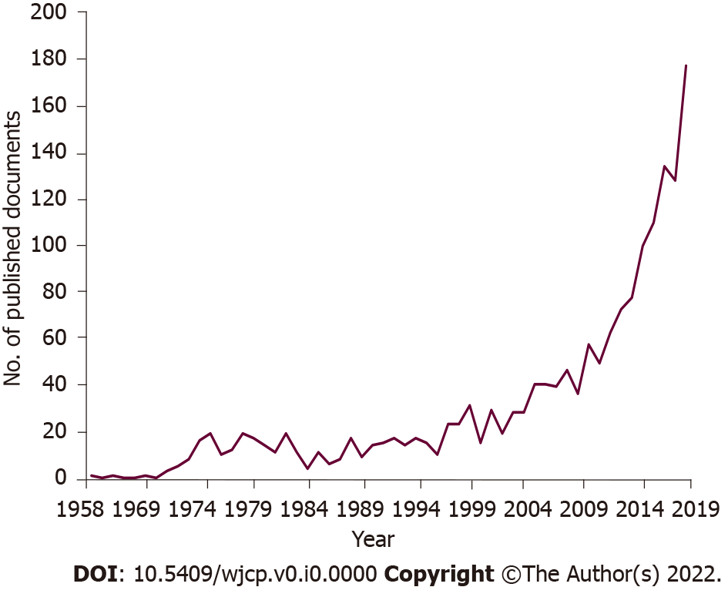
Figure 1 Annual number of articles published in neonatal abstinence syndrome.
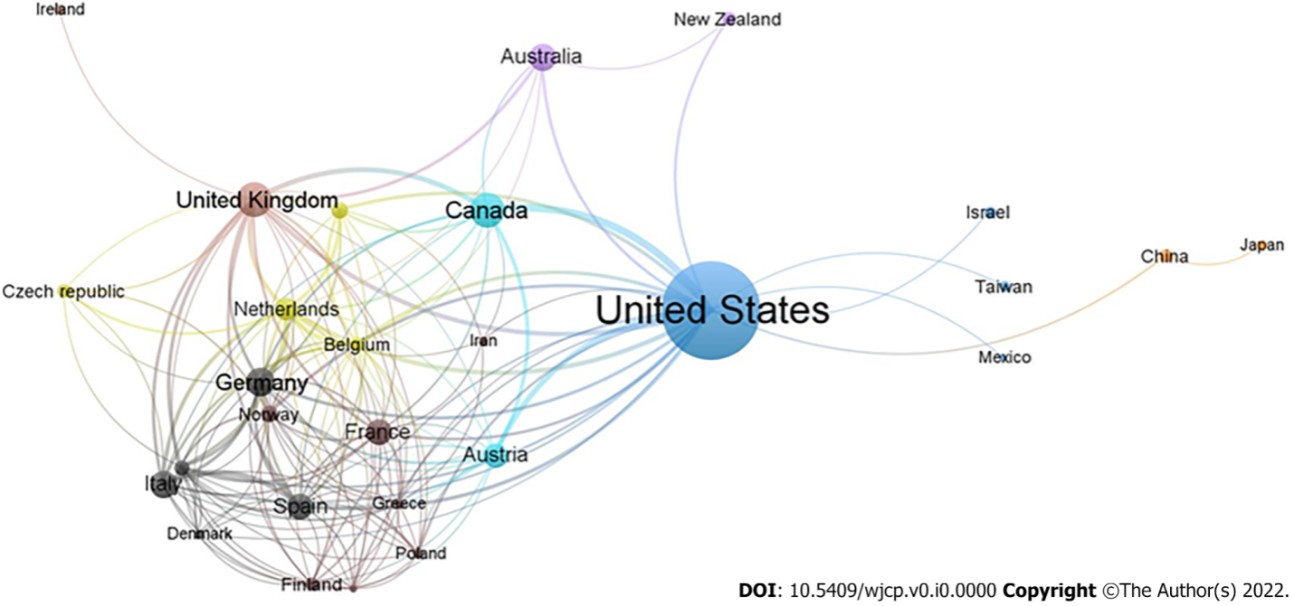
Figure 2 Network visualization map for countries collaboration among most productive countries. Of the 111 countries, 33 had at least five publications; the largest set of connected countries consists of 28 countries in 8 clusters.
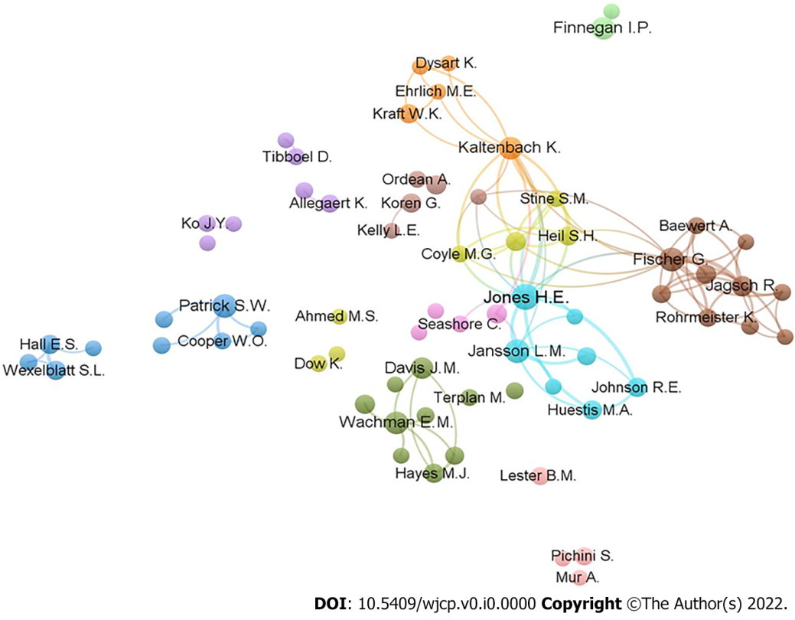
Figure 3 Co-authorship network among most productive authors with the threshold of minimum 5 publications. Of the 5305 authors, 118 had at least five publications; the largest set of connected authors consists of 70 authors in 11 clusters.

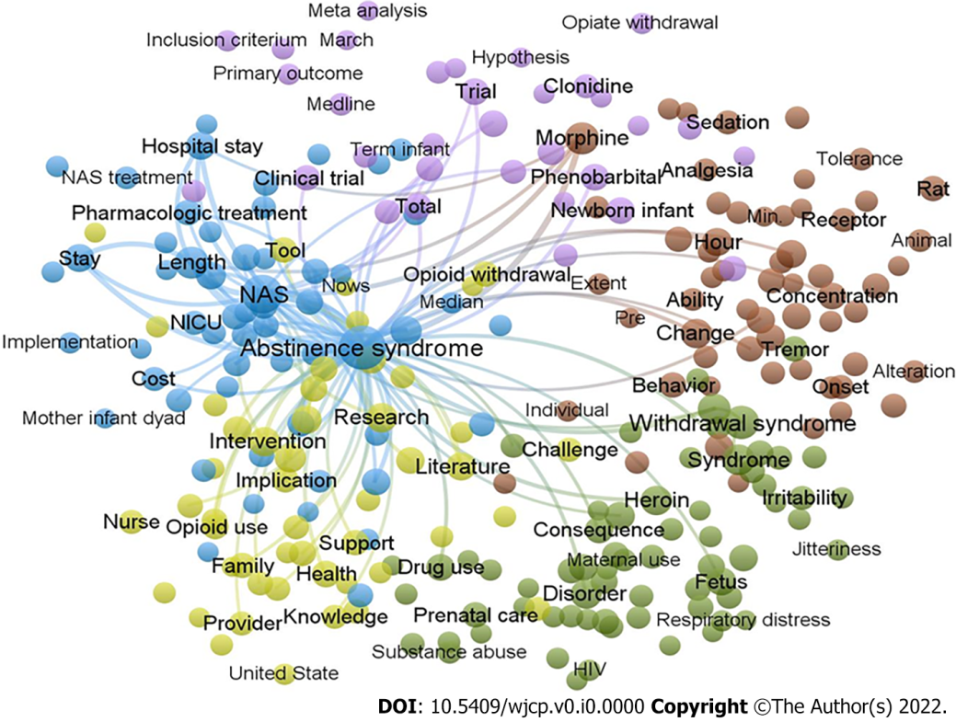
Figure 4 Terms co-occurrence network of neonatal abstinence syndrome studies. Of the 27233 terms, 436 terms occurred at least 20 times. For each of the 436 terms, a relevance score was calculated and used to select the 60% most relevant terms. The largest set of connected terms consists of 262 terms in five clusters.

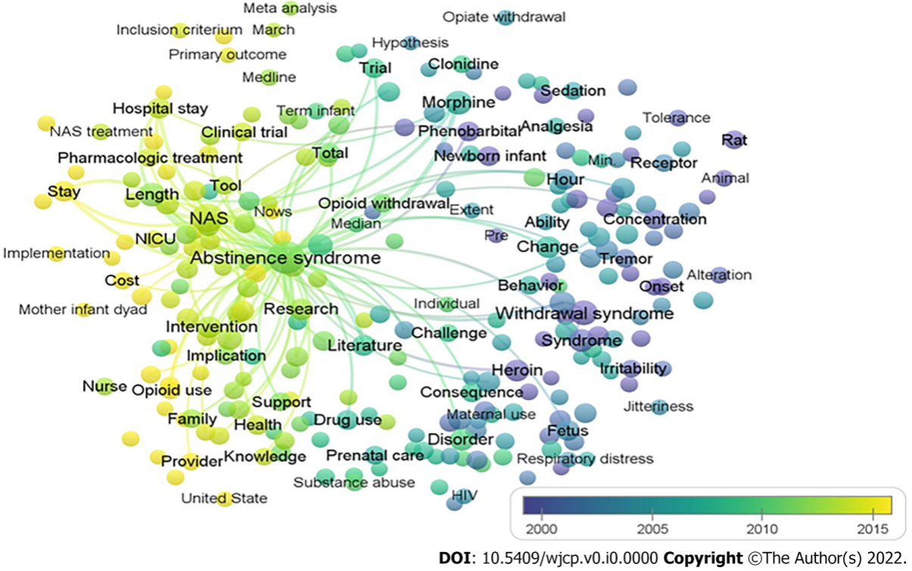
Figure 5 Distribution of terms according to their time of appearance. The blue colored terms mean early appearance and yellow colored terms appeared later.
Table 1 The top 10 countries contributed to publications in neonatal abstinence syndrome research (1958 to 2019)
SCR | Country | Number of documents (%) | h-index | No. of collaborated countries
1st | United States | 833 (47.93) | 71 | 38
2nd | Canada | 112 (6.44) | 29 | 14
3rd | United Kingdom | 111 (6.39) | 29 | 25
4th | Germany | 77 (4.43) | 17 | 23
5th | Italy | 65 (3.74) | 15 | 21
6th | Australia | 63 (3.62) | 26 | 7
7th | France | 62 (3.57) | 20 | 23
8th | Spain | 59 (3.39) | 18 | 22
9th | Austria | 52 (2.99) | 19 | 19
10th | the Netherlands | 45 (2.59) | 16 | 24

Table 2 The top 11 most productive journals on neonatal abstinence syndrome research from 1958 to 2019
SCR¹ | Journal | Frequency (%) | IF²
1st | Pediatrics | 43 (2.47) | 5.359
2nd | Journal of Pediatrics | 34 (1.96) | 3.700
3rd | Journal of Perinatology | 33 (1.90) | 1.967
4th | Drug and Alcohol Dependence | 31 (1.78) | 3.951
5th | Addiction | 27 (1.55) | 6.343
6th | Advances in Neonatal Care | 23 (1.32) | 1.405
6th | American Journal of Obstetrics and Gynecology | 23 (1.32) | 6.502
8th | Acta Paediatrica | 22 (1.27) | 2.111
9th | Archives of Disease in Childhood Fetal and Neonatal Edition | 19 (1.09) | 5.436
10th | Journal of Addiction Medicine | 18 (1.04) | 3.014
10th | Pediatric Research | 18 (1.04) | 2.747
¹If some journals receive the same ranking number, a gap is left in the next ranking numbers.
²Impact factors based on Journal Citation Reports 2019 adapted from Clarivate Analytics which was published in 2020.
IF: Impact factors.

Table 3 The first twelve authors by record count in neonatal abstinence syndrome research
SCR¹ | Author name | country | Number of documents (%)
1st | Jones HE | United States | 42 (2.42)
2nd | Fischer G | Austria | 29 (1.67)
3rd | Jansson LM | United States | 28 (1.61)
3rd | Patrick SW | United States | 28 (1.61)
5th | Finnegan LP | United States | 24 (1.38)
5th | Kaltenbach K | United States | 24 (1.38)
5th | Wachman EM | United States | 24 (1.38)
8th | Davis JM | United States | 17 (0.98)
9th | Jagsch R | Austria | 14 (0.81)
10th | Huestis MA | United States | 12 (0.69)
10th | Koren G | Israel | 12 (0.69)
10th | Raith W | Austria | 12 (0.69)
¹If some authors receive the same ranking number, a gap is left in the next ranking numbers.

Table 4 The 20 Most-cited articles in neonatal abstinence syndrome based on the citation count
SCR | Ref. | Title | Year | Source title | Cited by
1st | Patrick et al^{[1]} | Neonatal abstinence syndrome and associated health care expenditures: United States, 2000-2009 | 2012 | JAMA - Journal of the American Medical Association | 529
2nd | Jones et al^{[43]} | Neonatal abstinence syndrome after methadone or buprenorphine exposure | 2010 | New England Journal of Medicine | 526
3rd | Hudak et al^{[40]} | Neonatal drug withdrawal | 2012 | Pediatrics | 443
4th | Finnegan et al^{[38]} | Neonatal abstinence syndrome: assessment and management | 1975 | Addictive diseases | 435
5th | Sanz et al^{[49]} | Selective serotonin reuptake inhibitors in pregnant women and neonatal withdrawal syndrome: A database analysis | 2005 | Lancet | 318
6th | Hughes et al^{[41]} | Nicotine withdrawal vs other drug withdrawal syndromes: similarities and dissimilarities | 1994 | Addiction | 253
7th | Patrick et al^{[9]} | Increasing incidence and geographic distribution of neonatal abstinence syndrome: United States 2009 to 2012 | 2015 | Journal of Perinatology | 251
8th | Levinson-Castiel et al^{[45]} | Neonatal abstinence syndrome after in utero exposure to selective serotonin reuptake inhibitors in term infants | 2006 | Archives of Pediatrics and Adolescent Medicine | 238
9th | Costei et al^{[37]} | Perinatal outcome following third trimester exposure to paroxetine | 2002 | Archives of Pediatrics and Adolescent Medicine | 233
10th | Kocherlakota^{[2]} | Neonatal abstinence syndrome | 2014 | Pediatrics | 219
11th | Tolia et al^{[50]} | Increasing incidence of the neonatal abstinence syndrome in United States neonatal ICUs | 2015 | New England Journal of Medicine | 213
12th | American Academy of Pediatrics Committee on Drugs^{[36]} | Neonatal drug withdrawal | 1998 | Pediatrics | 212
13th | ACOG Committee on Health Care for Underserved Women and American Society of Addiction Medicine^{[35]} | Committee opinion no. 524: Opioid abuse, dependence, and addiction in pregnancy | 2012 | Obstetrics and Gynecology | 208
13th | Jones et al^{[42]} | Buprenorphine vs methadone in the treatment of pregnant opioid-dependent patients: Effects on the neonatal abstinence syndrome | 2005 | Drug and Alcohol Dependence | 208
15th | Wisner et al^{[51]} | Pharmacologic treatment of depression during pregnancy | 1999 | Journal of the American Medical Association | 200
16th | Zajecka et al^{[52]} | “Discontinuation symptoms after treatment with serotonin reuptake inhibitors: A literature review | 1997 | Journal of Clinical Psychiatry | 197
17th | Nau et al[46] | Valproic acid and its metabolites: Placental transfer, neonatal pharmacokinetics, transfer via mother's milk and clinical status in neonates of epileptic mothers | 1981 | Journal of Pharmacology and Experimental Therapeutics | 197
18th | Ryan et al^{[48]} | Cocaine abuse in pregnancy: Effects on the fetus and newborn | 1987 | Neurotoxicology and Teratology | 181
19th | Lejeune et al^{[44]} | Prospective multicenter observational study of 260 infants born to 259 opiate-dependent mothers on methadone or high-dose buprenophine substitution | 2006 | Drug and Alcohol Dependence | 180
20th | Hadeed and Siegel^{[39]} | Maternal cocaine use during pregnancy: Effect on the newborn infant | 1989 | Pediatrics | 177
21st | Nordeng et al^{[47]} | Neonatal withdrawal syndrome after in utero exposure to selective serotonin reuptake inhibitors | 2001 | Acta Paediatrica, | 175

Table 5 List of most frequent drugs occurrences in neonatal abstinence syndrome literature
Drug | Number of publications
Methadone | 629
Morphine | 378
Buprenorphine | 313
Phenobarbital | 275
Diamorphine | 212
Heroine | 138
Cocaine | 138
Clonidine | 130
Diazepam | 124
Alcohol | 80
Cannabis | 79
Chlorpromazine | 76
Naloxone | 62
Fentanyl | 56

Published by Baishideng Publishing Group Inc
7041 Koll Center Parkway, Suite 160, Pleasanton, CA 94566, USA
Telephone: +1-925-3991568
E-mail: bpgoffice@wjgnet.com
Help Desk: https://www.f6publishing.com/helpdesk
https://www.wjgnet.com

© 2022 Baishideng Publishing Group Inc. All rights reserved.

