Name of Journal: World Journal of Gastroenterology
Manuscript NO: 86696
Manuscript Type: SYSTEMATIC REVIEWS

Diagnostic role of transient elastography in patients with autoimmune liver diseases: A systematic review and meta-analysis

Chen H et al. Noninvasive diagnosis of fibrosis in AILD

Hong Chen, Yue Shen, Sheng-Di Wu, Qin Zhu, Cheng-Zhao Weng, Jun Zhang, Mei-Xia Wang, Wei Jiang

Hong Chen, Sheng-Di Wu, Cheng-Zhao Weng, Jun Zhang, Mei-Xia Wang, Wei Jiang, Department of Gastroenterology and Hepatology, Zhongshan Hospital (Xiamen), Fudan University, Xiamen 361015, Fujian Province, China

Hong Chen, Yue Shen, Sheng-Di Wu, Qin Zhu, Wei Jiang, Department of Gastroenterology and Hepatology, Zhongshan Hospital of Fudan University, Shanghai 200032, China

Hong Chen, Yue Shen, Sheng-Di Wu, Qin Zhu, Wei Jiang, Shanghai Institute of Liver Diseases, Fudan University Shanghai Medical College, Shanghai 200032, China

Author contributions: Jiang W conceived and designed the study; Chen H and Shen Y contributed to acquiring the data; Wang MX and Weng CZ contributed statistical analysis support; Chen H, Shen Y, Wu SD and Zhu Q contributed to analysis and interpretation of the data; Chen H wrote the manuscript; Wu SD and Zhang J contributed to manuscript revision; All authors read and approved the submitted version and are accountable for all aspects of the work.

Supported by Natural Science and Technology Major Project of Fujian Province, No. 2021D033; Natural Science Foundation of Shanghai, No. 20ZR1410900; Medical Innovation Project of Fujian Province, No. 2022CXB020; National Science and Technology Major Project, No. 2017ZX 10203202-003-002.

Corresponding author: Wei Jiang, MD, PhD, Academic Research, Chief Doctor, Professor, Department of Gastroenterology and Hepatology, Zhongshan Hospital (Xiamen), Fudan University, No. 666 Jinhu Road, Huli District, Xiamen 361015, Fujian Province, China. jiang.wei@zs-hospital.sh.cn

Received: July 2, 2023
Revised: September 9, 2023
Accepted: October 11, 2023
Published online:
Abstract
BACKGROUND
Noninvasive methods have been developed to detect fibrosis in many liver diseases due to the limits of liver biopsy. However, previous studies have focused primarily on chronic viral hepatitis and nonalcoholic fatty liver disease. The diagnostic value of transient elastography for autoimmune liver diseases (AILDs) is worth studying.

AIM
To compare the diagnostic accuracy of imaging techniques with serum biomarkers of fibrosis in AILD.

METHODS
The PubMed, Cochrane Library and EMBASE databases were searched. Studies evaluating the efficacy of noninvasive methods in the diagnosis of AILDs [autoimmune hepatitis (AIH), primary biliary cholangitis (PBC) and primary sclerosing cholangitis (PSC)] were included. The summary area under the receiver operating characteristic curve (AUROC), diagnostic odds ratio, sensitivity and specificity were used to assess the accuracy of these noninvasive methods for staging fibrosis.

RESULTS
A total of 60 articles were included in this study, and the number of patients with AIH, PBC and PSC was 1594, 3126 and 501, respectively. The summary AUROC of transient elastography in the diagnosis of significant fibrosis, advanced fibrosis and cirrhosis in patients with AIH were 0.84, 0.88 and 0.90, respectively, while those in patients with PBC were 0.93, 0.93 and 0.91, respectively. The AUROC of cirrhosis for patients with PSC was 0.95. However, other noninvasive indices (aspartate aminotransferase to platelet ratio index, aspartate aminotransferase/alanine aminotransferase ratio, fibrosis-4 index) had corresponding AUROCs less than 0.80.

CONCLUSION
Transient elastography exerts better diagnostic accuracy in AILD patients, especially in PBC patients. The appropriate cutoff values for staging advanced fibrosis and cirrhosis ranged from 9.6 to 10.7 and 14.4 to 16.9 KPa for PBC patients.

Key Words: Liver stiffness; Serum parameter; Liver fibrosis; Noninvasive diagnosis; Transient elastography; Autoimmune liver disease

Chen H, Shen Y, Wu SD, Zhu Q, Weng CZ, Zhang J, Wang MX, Jiang W. Diagnostic role of transient elastography in patients with autoimmune liver diseases: A systematic review and meta-analysis. World J Gastroenterol 2023; In press

Core Tip: Onset of autoimmune liver diseases (AILDs) is frequently insidious, and immune cell infiltration and continuous inflammation drive hepatic fibrosis, which gradually progresses to cirrhosis, causing poorer long-term outcomes. Liver biopsy as the reference standard is an invasive procedure. Thus, repeated biopsies are difficult to implement. Consequently, appropriate noninvasive methods are essential to dynamically monitor the degree of liver fibrosis. Our meta-analysis compared the diagnostic accuracy of imaging techniques with serum biomarkers of fibrosis in autoimmune liver diseases.

INTRODUCTION
The incidence of autoimmune liver diseases (AILDs), including autoimmune hepatitis (AIH), primary biliary cholangitis (PBC), primary sclerosing cholangitis (PSC), and multiple overlap syndromes, a group of autoimmune diseases associated with the liver and bile duct is increasing^{[1,2]}. Onset is frequently insidious, with nonspecific symptoms. Immune cell infiltration and continuous inflammation drive hepatic fibrosis, which gradually progresses to cirrhosis, causing poorer long-term outcomes in patients^{[3-5]}. Accordingly, accurate identification of high-risk patients for such conditions is essential in clinical care to guide timely treatment and delay disease progression.
For years, liver biopsy has been recognized as the reference standard for the assessment of liver fibrosis. However, biopsy area restrictions, sampling errors, and interobserver variability may affect the diagnostic accuracy^{[6,7]}. Moreover, because biopsy is an invasive procedure with potentially hazardous complications ranging from pain to more severe events and even death, many patients are reluctant to undergo repeat biopsies^{[8,9]}. Consequently, an increasing number of studies have focused on noninvasive methods to identify the ideal approach for dynamically monitoring the degree of liver fibrosis^{[10]}.
In recent years, some noninvasive methods, including biochemical tests and imaging techniques, have been widely developed, including the aspartate aminotransferase to platelet ratio index (APRI), aspartate aminotransferase/alanine aminotransferase (ALT) ratio (AAR), fibrosis-4 index (FIB-4), red cell distribution width to platelet ratio (RPR), Mac-2 binding protein (M2BP), platelet count to spleen diameter (PC/SD) ratio, transient elastography (TE), shear wave elastography (SWE), acoustic radiation force impulse (ARFI), magnetic resonance spectroscopy (MRS) and magnetic resonance elastography (MRE). Previous studies have validated that elastography is a reliable method with a diagnostic accuracy higher than that of blood tests for staging liver fibrosis in chronic viral hepatitis^{[11-13]}, nonalcoholic fatty liver disease^{[14]} and AIH^{[15]}; however, no studies have explored the diagnostic accuracy of noninvasive methods for the other two types of AILDs (PBC and PSC).
Therefore, the present meta-analysis aimed to compare the diagnostic accuracy of biochemical tests and imaging techniques for detecting liver fibrosis in patients with AILD, determine whether the same noninvasive methods show different diagnostic values in the three types of AILDs and recommend appropriate cutoff values for different fibrosis stages.

MATERIALS AND METHODS
Literature search strategy
Studies on the diagnosis of AILD published between January 2006 and December 2022 were searched in PubMed, Cochrane Library and EMBASE databases using the following keywords: AIH, PSC, PBC, liver fibrosis, TE, SWE, MRE, APRI, FIB-4 and AAR. The detailed search strategy is presented in Supplementary Table 1.

Study selection criteria
Original studies that fulfilled the following criteria were enrolled: (1) Studies with patient populations with AIH, PBC or PSC with discrete data that could be separately extracted from the mixed liver disease study cohort; (2) Studies in which liver biopsy was used as the gold standard to assess fibrosis based on the Metavir score or another score that could be converted to the Metavir score; (3) Studies assessing the performance and utility of APRI, AAR, FIB-4, RPR, M2BP, ARFI, PC/SD ratio, TE, SWE, MRE or MRS for staging liver fibrosis; and (4) Studies directly reporting the true-positive, false-positive, false-negative and true-negative values or provided data by which they could be calculated to allow the construction of a 2 × 2 table for each test.
The following studies were excluded: (1) Studies exploring the prognostic value of liver stiffness measurement (LSM) for patients with AILD; (2) Animal experiments, reviews, protocols, guidelines, case reports or meta-analyses; (3) Studies on liver fibrosis due to other etiologies, including nonalcoholic fatty liver disease, chronic hepatitis B, or chronic hepatitis C; and (4) Studies without sufficient data for further analysis or with the same or overlapping group of participants.

Data extraction and quality assessment
Two investigators (Chen H and Shen Y) independently evaluated the eligibility and quality of the included studies and extracted the data. Any disagreements were resolved by a senior researcher (Wu SD). We collated the following parameters in Microsoft Excel 2010: authors; year of publication; country; study period and design; pathological type; diagnostic methods; sample size; patient characteristics [age, sex, body mass index (BMI), ALT level, treatment condition]; quality of liver biopsy; and performance of the index test, including cutoff values, sensitivity, specificity, positive predictive value, negative predictive value, and area under the receiver operating characteristic curve (AUROC). Two reviewers (Chen H and Shen Y) independently assessed the risk of bias using the Quality Assessment of Diagnostic Accuracy Studies-2 tool^{[16]}.

Data synthesis and statistical analysis
According to the Metavir, Batts-Ludwig and Scheuer scores, liver fibrosis was classified into five stages (F0, F1, F2, F3 and F4), whereas there were seven stages according to the Ishak score. Given that Shiha et al^{[17]} proposed that an Ishak score of 3 corresponds to METAVIR score of F2, significant fibrosis (SF), advanced fibrosis (AF) and cirrhosis were defined as stages F2-F4, F3-F4, and F4, respectively. For the data analysis, we constructed 2 × 2 contingency tables with true-positive, false-positive, false-negative and true-negative values based on data directly extracted from the original studies or calculated from indirect variables (sensitivity, specificity and sample size). A bivariate random effects model was subsequently applied to calculate the diagnostic test accuracy variables, including summary sensitivity, summary specificity, positive likelihood ratio, negative likelihood ratio and diagnostic odds ratio (DOR) with their associated 95% confidence intervals (95%CIs). We also performed meta-analyses using hierarchical models to produce summary ROC curves, from which we obtained summary AUROC values to evaluate the diagnostic accuracy of the different noninvasive methods. The method was considered to have excellent accuracy if the summary AUROC value was above 0.90, moderate accuracy if it was greater than 0.80, and poor accuracy if it was less than 0.80^{[18]}.
The heterogeneity was assessed using multiple methods. Spearman’s correlation coefficient was calculated to evaluate the threshold heterogeneity of the included studies, whereas Cochran’s Q and I² values were used to assess nonthreshold heterogeneity. If an I² value > 50% or P < 0.05 indicated distinct statistical heterogeneity, a random effects model was used to combine the data. A fixed effect model was chosen when the I² value ≤ 50% or P ≤ 0.05. However, the number of original studies was sufficient to perform a meta-regression to explore the potential heterogeneity of certain index tests. In addition, we conducted a subgroup analysis according to the sample size, treatment conditions and cutoff value. Deeks’ funnel plots were used to evaluate the possible publication bias. The meta-analysis was performed using Stata 12.0, Reviewer Manager Version 5.3 and Meta-Disc Version 1.4.

RESULTS
Characteristics of the included studies and patients
The study selection process is illustrated in Figure 1. A total of 1386 studies were retrieved through our search strategy, of which 427 were excluded as duplicates and 602 were removed following the screening of titles, abstracts and reviews. The remaining 355 potentially eligible studies were selected for further evaluation. Of these, 60 articles were included in the evaluation and analysis. Among them, 22, 29 and 6 studies were regarding AIH, PBC and PSC, respectively (2 studies focused on both AIH and PBC^{[19,20]}, while 1 study focused on both PBC and PSC^{[21]}). In total, they included 11 noninvasive index tests. The basic characteristics of the included studies are presented in Table 1. We selected articles published between 2006 and 2022, of which 46 (76.7%) were published between 2016 and 2022. There were 31 (51.7%) retrospective studies, 17 (28.3%) prospective studies, 10 (16.7%) unknown studies and 2 studies with both designs. Most included studies were conducted in Asia (28 studies) or Europe (24 studies). A total of 27 studies utilized the Metavir score, 8 studies used the Batts-Ludwig score, 17 studies used the Scheuer score, 5 studies used the Ishak score, and 3 studies used the Ludwig-Scheuer score.
A total of 1594, 3126 and 501 patients with AIH, PBC, and PSC, respectively, were included to analyze the diagnostic performance of noninvasive methods in staging liver fibrosis. Most patients with AIH and PBC were female (72.4% and 87.6%, respectively). In contrast, patients with PSC were predominantly male (73.7%). The average ages of patients with AIH, PBC and PSC were 47.0, 55.2 and 41.5 years, respectively. Patients with AIH (160.29 IU/mL) had higher ALT levels than patients with PBC (69.81 IU/mL).

Quality assessment of the included studies
The results of the quality assessment based on the Quality Assessment of Diagnostic Accuracy Studies-2 scale for all 60 eligible studies are shown in Figure 2 and Supplementary Figure 1. Regarding patient selection, eight studies had an unclear risk of bias owing to the lack of information on whether patients were enrolled randomly or consecutively. Regarding the index test, four studies were determined to have an unclear risk of bias because the results of the index test were interpreted without blinded information on the results of the reference standard. Likewise, 22 studies were regarded as having an unclear risk of bias because the results of the reference standard were interpreted without blinded information regarding the results of the index test. In terms of flow and timing, two studies were considered high-risk because not every subject received a reference standard, while 19 studies were considered unclear risk because of an unknown time interval between the index and reference tests.

Performance of noninvasive methods in diagnosing SF (F ≥ 2)
Diagnosis of SF for AIH: Fifteen studies (n = 1001) evaluated eight noninvasive methods for detecting SF in patients with AIH. Of these, five (n = 459), two (n = 129), five (n = 459), nine (n = 523) and three (n = 234) studies focused on APRI, AAR, FIB-4, TE and SWE separately, whereas only one study each utilized the ARFI, PC/SD ratio and RPR.
The APRI had moderate summary sensitivity (exceeding 70%) with poor summary specificity (less than 50%), whereas the FIB-4 had the opposite result (Table 2). Interestingly, TE had a relatively greater diagnostic performance than the other laboratory tests, with summary sensitivity and specificity values of 0.82 and 0.73, respectively, and cutoff values ranging from 5.8–7.0 KPa. The summary sensitivity of SWE (0.89; 95%CI: 0.83–0.93) was significantly higher than that of the other six noninvasive methods and slightly greater than that of TE (0.83; 95%CI: 0.78–0.87).

Diagnosis of SF for PBC: Thirteen studies (n = 1389) evaluated nine noninvasive methods for diagnosing SF in patients with PBC. Among them, four (n = 584), three (n = 323), three (n = 462), two (n = 87), five (n = 446) and two (n = 210) studies focused on APRI, AAR, FIB-4, ARFI, TE and SWE, respectively; however, only one study each utilized the PC/SD ratio, MRE and M2BP.
As shown in Table 2, the APRI and FIB-4 index had relatively good summary sensitivities of 0.84 and 0.85, respectively, with mild summary specificities of 0.63 and 0.77, respectively. The corresponding values for sensitivity and specificity of the AAR were poor (0.69, 0.56). In contrast, both the summary sensitivity (0.81; 95%CI: 0.76–0.85) and specificity (0.95; 95%CI: 0.89–0.98) of TE were significantly higher than those of the other five noninvasive methods for predicting SF with cutoff values ranging from 5.9–8.8 KPa.
Furthermore, Table 3 shows that the summary DORs of APRI, FIB-4 and TE were 3.9 (95%CI: 2.1–7.3), 5.1 (95%CI: 3.1–8.5) and 16.8 (95%CI: 8.8–32.2), respectively, in patients with AIH, while the summary DORs of APRI and TE were 6.3 (95%CI: 3.5–11.2) and 74.5 (95%CI: 12.2–455.5), respectively, in patients with PBC. Additionally, the summary AUROC value of TE in patients with PBC (0.93, 95%CI: 0.91–0.95) was relatively higher than that of TE in patients with AIH (0.84, 95%CI: 0.80–0.87) but significantly higher than that of FIB-4 (0.74) and APRI (0.67) in patients with AIH and APRI (0.77) in patients with PBC (Table 3 and Figure 3).

Performance of noninvasive methods in diagnosing AF (F ≥ 3)
Diagnosis of AF for AIH: Twenty studies (n = 1435) evaluated 11 noninvasive methods for detecting AF in patients with AIH. Among them, 10 (n = 917), 7 (n = 532), 11 (n = 962), 7 (n = 460), 3 (n = 234) and 2 (n = 191) studies focused on APRI, AAR, FIB-4, TE, SWE and RPR, respectively; however, only one study each utilized the ARFI, MRS, PC/SD ratio, MRE and M2BP methods.
As shown in Table 2, with a cutoff value of 8.2–9.0 KPa, both the summary sensitivity and specificity exceeded 80% when TE was used for predicting AF, whereas with a cutoff value of 10.4–12.1 KPa, there was a better summary specificity (0.93; 95%CI: 0.86–0.97) with a mild summary sensitivity (0.73; 95%CI: 0.60–0.83). Regarding SWE, MRE and the PC/SD ratio, the summary sensitivity and specificity also exceeded 80%. The specificity of MRE was 1.00, but only one study assessed it^{[22]}. For AAR and FIB-4 index, there was a relatively modest summary specificity (< 0.80) and poor summary sensitivity (< 0.60).

Diagnosis of AF for PBC: Twenty-eight studies (n = 2737) evaluated 11 noninvasive methods for detecting AF in patients with PBC. Of these, 15 (n = 1589), 6 (n = 559), 13 (n = 1296), 2 (n = 97), 10 (n = 874), 5 (n = 362), 4 (n = 370) and 2 (n = 210) studies were focused on APRI, AAR, FIB-4, ARFI, TE, RPR, M2BP and SWE, respectively. Only one study each utilized the methods of MRE and RLR.
As shown in Table 2, TE had a good summary sensitivity and specificity (0.91, 0.82) with a cutoff value of 9.6–10.7 KPa, while RPR and M2BP had good summary specificity (0.89 and 0.80, respectively) with poor summary sensitivity (0.49 and 0.68, respectively). Regardless of the cutoff values, the summary sensitivities and specificities of the AAR, APRI and FIB-4 were less than 0.80.
Furthermore, Table 3 shows that the summary DORs of AAR, APRI, FIB-4 and TE were 4.9 (95%CI: 3.2–7.8), 3.9 (95%CI: 2.8–5.3), 4.0 (95%CI: 2.4–6.8) and 25.1 (95%CI: 9.7–65.3), respectively, in patients with AIH and 4.1 (95%CI: 2.0–8.6), 3.7 (95%CI: 2.3–6.0), 7.1 (95%CI: 4.0–12.8) and 41.8 (95%CI: 19.3–91.0), respectively, in patients with PBC. Moreover, the summary DORs of RPR and M2BP in patients with PBC were 8.0 (95%CI: 4.0–15.8) and 13.2 (95%CI: 4.1–42.4), respectively. As shown in Table 3 and Figure 3, the summary AUROC value of TE for detecting AF was 0.88 (95%CI: 0.85–0.90) and 0.93 (95%CI: 0.90–0.95) in patients with AIH and PBC, respectively. The value of M2BP was 0.86 (95%CI: 0.82–0.88) in patients with PBC, whereas the summary AUROC values for AAR, APRI and FIB-4 were less than 0.80 in both patients with AIH and PBC, and the value for RPR in patients with PBC was less than 0.60.

Performance of noninvasive methods in diagnosing cirrhosis (F = 4)
Diagnosis of cirrhosis for AIH: Sixteen studies (n = 1076) evaluated ten noninvasive methods for detecting cirrhosis in patients with AIH. Of these, six (n = 543), three (n = 213), six (n = 543), two (n = 82), seven (n = 415) and four (n = 297) studies focused on APRI, AAR, FIB-4, ARFI, TE and SWE, respectively. Only one study each utilized the PC/SD ratio, MRE, RPR and M2BP.
As shown in Table 2, the summary sensitivities and specificities of APRI and FIB-4 were less than 75%, and those of AAR were 0.61 and 0.83, respectively. Moreover, the summary sensitivity and specificity of TE (cutoff value ranging from 11.0–12.7 KPa) were significantly higher for predicting cirrhosis, with 0.89 (95%CI: 0.82–0.94) and 0.88 (95%CI: 0.81–0.93), respectively, while the summary sensitivity and specificity of SWE (0.83, 0.86) were close to those of TE. Surprisingly, the summary specificity dramatically rose to 0.97 (95%CI 0.92–0.99) with a cutoff value ranging from 16.0–19.0 KPa.

Diagnosis of cirrhosis for PBC: Sixteen studies (n = 1568) evaluated nine noninvasive methods for detecting cirrhosis in patients with PBC. Among them, six (n = 852), four (n = 407), six (n = 852), six (n = 483), two (n = 210) and two (n = 194) studies focused on APRI, AAR, FIB-4, TE, SWE and M2BP, respectively. However, only one study utilized the ARFI and MRE methods.
As listed in Table 2, the summary sensitivities of APRI, AAR and FIB-4 for predicting cirrhosis were 0.75, 0.81 and 0.87, respectively, and their corresponding summary specificities were 0.51, 0.77 and 0.61, respectively. In contrast, TE had higher summary sensitivity (0.90; 95%CI: 0.74–0.98) and specificity (0.93; 95%CI: 0.89–0.96) with a cutoff value ranging from 15.6–25.1 KPa.

Diagnosis of cirrhosis for PSC: Four studies (n = 207) evaluated TE as a predictor of cirrhosis in patients with PSC. Because the diagnosis of PSC does not rely on liver biopsy, few related studies have been conducted. As listed in Table 2, the summary sensitivity and specificity of TE were 0.82 (95%CI: 0.68–0.91) and 0.89 (95%CI: 0.83–0.94), respectively.
Furthermore, Table 3 shows that the summary DORs of APRI and FIB-4 were 3.8 (95%CI: 2.2–6.4) and 5.5 (95%CI: 2.4–12.6) in patients with AIH and 14.6 (95%CI: 1.9–113.8) and 29.8 (95%CI: 5.9–150.3) in patients with PBC. In addition, the summary DOR of TE was highest in patients with PBC, with values of 91.8 (95%CI: 40.1–201.2), 134.8 (95%CI: 33.0–551.8) and 70.6 (95%CI: 15.4–322.7) in patients with AIH, PBC and PSC, respectively. The summary AUROC values of TE for detecting cirrhosis in patients with AIH, PBC and PSC were 0.90 (95%CI: 0.87–0.92), 0.91 (95%CI: 0.88–0.93) and 0.95 (95%CI: 0.93–0.97), respectively, while the summary AUROC values for APRI and FIB-4 were less than 0.80 in patients with AIH and 0.90 in patients with PBC (Table 3 and Figure 3).

Methodological heterogeneity, subgroup analysis and publication bias
As shown in Table 4, threshold heterogeneity was observed only in APRI F2 in both patients with AIH and PBC, whereas nonthreshold heterogeneity was observed in most groups (Figure 4, Supplementary Figures 2 and 3). Because meta-regression to explore the source of heterogeneity requires the number of original studies to exceed 10, we only conducted a meta-regression for AF in patients with AIH and PBC. The heterogeneity of APRI, FIB-4 and TE accuracy was mainly affected by the cutoff value with regard to specificity, whereas FIB-4 and TE were affected by sample size with regard to sensitivity, according to the meta-regression analysis (Supplementary Figure 4).
Subgroup analyses of TE according to sample size, cutoff value and treatment status are shown in Table 5. Because of the limited data, we only conducted an analysis for posttreatment combined with original data for pretreatment (Supplementary Table 2).
Deeks’ funnel plot of these noninvasive methods was generated to assess publication bias. There was a publication bias for APRI in detecting SF (P = 0.06) and cirrhosis (P = 0.08) in patients with PBC but not in other methods for detecting SF, AF and cirrhosis (Figure 5, Supplementary Figure 5). Moreover, no publication bias was observed for any noninvasive method in patients with AIH (Figure 5, Supplementary Figure 6).

DISCUSSION
In our review, a total of 60 studies (including 1594, 3126 and 501 patients with AIH, PBC and PSC, respectively) were included to evaluate the diagnostic accuracy of noninvasive methods for predicting SF, AF and cirrhosis in patients with AILDs. TE had excellent accuracy with summary AUROC values of 0.93, 0.93 and 0.91 for SF, AF and cirrhosis, respectively, in patients with PBC, while TE had a moderate to excellent accuracy of 0.84, 0.88 and 0.90, respectively, in patients with AIH. Moreover, the summary AUROC was 0.95 for cirrhosis in patients with PSC. In contrast, other noninvasive methods, such as AAR, APRI, FIB-4 and RPR, had poor accuracy, with summary AUROC values of < 0.80. In addition, the pooled sensitivity and specificity of TE were higher than those of the other noninvasive methods. Our results indicated that LSM using TE had a better diagnostic performance for staging hepatic fibrosis in AILDs, especially in patients with PBC. Moreover, our results showed that TE had mostly higher specificity and relatively low sensitivity for the diagnosis of AILDs. Koizumi et al^{[23]} found that TE had high sensitivity and relatively low specificity for the diagnosis of PBC. However, the optimal cutoff values were higher and the range was wider than those in other studies, indicating that different optimal cutoff values may have an effect on diagnostic accuracy.
Meta-regression analysis is a reliable method for screening heterogeneity. In our study, the sample size, cutoff values, prevalence of SF and scoring system provided heterogeneity in summarizing the test results, consistent with previous studies^{[24,25]}. We conducted subgroup analyses based on the sample size and cutoff values. Our results revealed that TE had a better predictive effect in a larger sample of patients with PBC. LSM by TE is the best surrogate marker for staging in SF and AF with a cutoff ranging from 6.4–9.1 KPa and 9.0–11.0 KPa, respectively, in patients with AIH and staging in AF and cirrhosis with a cutoff ranging from 9.6–10.7 KPa and 14.4–16.9 KPa, respectively, in patients with PBC.
Several previous studies have demonstrated that inflammation in the liver (reflected by elevated ALT levels)^{[26]} and extrahepatic cholestasis (reflected by total bilirubin)^{[27]} may increase the stiffness value, causing a decrease in the diagnostic accuracy of TE, whereas ALT and bilirubin levels decline after treatment. Because a limited number of studies have reported results for the ALT subgroup, we only conducted a subgroup analysis of treatment conditions, which showed that the diagnostic accuracy for staging liver fibrosis was comparable between pretreatment and posttreatment in patients with both PBC and AIH. In other words, this may indicate that ALT levels have no significant effect on diagnostic accuracy. Meanwhile, two scoring systems [International Autoimmune Hepatitis Group (IAIHG) 1999 and IAIHG 2008] proposed by Granito et al^{[28]} for the diagnosis of AIH are not interchangeable. According to our subgroup analysis regarding diagnostic criteria, the IAIHG 2008 showed diagnostic accuracy comparable to that of the IAIHG 1999 in distinguishing patients with AIH (Supplementary Tables 3 and 4). However, due to the limited number of studies, further investigation is required to confirm these results.
In addition, some studies have shown that other imaging technologies, including two-dimensional-SWE (2D-SWE)^{[29-32]}, MRE^{[22,33]} and ARFI^{[19,34]}, also perform well in staging liver fibrosis (Supplementary Table 5). Further, 2D-SWE had excellent accuracy, with a summary AUROC of 0.91 for cirrhosis in patients with AIH (Table 3). In comparison, our findings indicated that 2D-SWE and ARFI had good accuracy with higher sensitivity, specificity and AUROC for AF and cirrhosis in patients with PBC, while the AUROC of MRE was higher in patients with AIH. Interestingly, compared with TE, 2D-SWE produces a two-dimensional grayscale image so that interference from the gallbladder, ascites and large tubular structures in the liver can be effectively avoided. However, the number of studies on 2D-SWE, MRE and ARFI included in our analysis was small. Indeed, the diagnostic accuracies of 2D-SWE and MRE require further studies with larger sample sizes to determine the best method for staging fibrosis in patients with AILDs.
However, the overlap syndrome, one of the AILDs, also deserves attention because it exhibits significantly higher rates of various complications, progresses to cirrhosis more rapidly and has a poor treatment response to ursodeoxycholic acid^{[35,36]}. Hence, the development of noninvasive methods is beneficial for this disease. Wu et al^{[37]} reported that the AUROCs of TE for SF, AF and cirrhosis were 0.837, 0.910 and 0.996, respectively. Yan et al^{[38]} reported that the AUROCs of SWE were 0.91, 0.97 and 0.96, respectively. These results show that noninvasive imaging techniques have excellent accuracy for overlap syndrome, although more studies are required for further validation.
Our study had some limitations. First, we only included studies published in the English language; therefore, a language bias may have influenced the results. Second, we did not consider the confounding factors such as obesity, whereas a previous study proposed that a high BMI may reduce the efficiency of ultrasound-based elastography techniques in detecting fibrosis^{[39]}. However, only a limited number of studies have provided sufficient data to conduct subgroup analyses to explore the potential impact of BMI on the diagnostic effects. Third, it is unknown whether ALT level is responsible for the difference in the diagnosis of TE between patients with AIH and PBC due to a lack of sufficient data. Moreover, the treatment conditions before inclusion in the study were unknown, and the lack of pretreatment studies made it impossible to compare the effects of treatment on outcomes. Finally, the number of studies on SWE, MRE and ARFI was inadequate to compare the effects of these imaging technologies and TE.

CONCLUSION
In conclusion, LSM using TE had better diagnostic performance for staging hepatic fibrosis in patients with AILDs compared to other serum biomarkers, especially in patients with PBC. The appropriate cutoff value for staging in AF and cirrhosis ranged from 9.6 to 10.7 KPa and 14.4 to 16.9 KPa, respectively, for patients with PBC. Additional recommended optimal cutoff values warrant further investigation to provide a better reference for clinical applications.

ARTICLE HIGHLIGHTS
Research background
Noninvasive criteria are needed for autoimmune liver diseases (AILDs) to assess liver fibrosis stage for prognosis and treatment decisions.

Research motivation
Results of individual diagnostic test accuracy studies assessing the diagnostic accuracy of transient elastography (TE) for the diagnosis of AILD appear promising. However, previous systematic review and meta-analyses have focused primarily on other liver diseases, which is still lacking in AILD.

Research objectives
To compare the diagnostic accuracy of imaging techniques with serum biomarkers of fibrosis in AILD.

Research methods
The PubMed, Cochrane and EMBASE databases were searched for literature. The Quality Assessment of Diagnostic Accuracy Studies-2 tool was used to evaluate the quality. Meta-Disc 1.4 and STATA 12.0 software were used to analyze the combined statistics: sensitivity; specificity; positive likelihood ratio; negative likelihood ratio; diagnostic odds ratio; and area under the curve fitted to the total receiver operating characteristic curve (AUROC).

Research results
A total of 60 studies were included in the meta-analysis. The AUROC curve values were 0.93, 0.93 and 0.91 for significant fibrosis, advanced fibrosis and cirrhosis, respectively, in primary biliary cholangitis patients, while the AUROC curve values were 0.84, 0.88 and 0.90, respectively, in autoimmune hepatitis patients.

Research conclusions
TE is a reliable method for diagnosis in AILD patients, especially in primary biliary cholangitis patients. The appropriate cutoff value for staging advanced fibrosis and cirrhosis ranged from 9.6 to 10.7 KPa and 14.4 to 16.9 KPa, respectively.

Research perspectives
We propose a suitable diagnostic threshold for TE in PBC patients. However, future prospective multicenter studies with TE and histopathology protocol are required to validate our results.

REFERENCES
1 Boonstra K, Beuers U, Ponsioen CY. Epidemiology of primary sclerosing cholangitis and primary biliary cirrhosis: a systematic review. J Hepatol 2012; 56: 1181-1188 [PMID: 22245904 DOI: 10.1016/j.jhep.2011.10.025]
2 Tanaka A, Ma X, Yokosuka O, Weltman M, You H, Amarapurkar DN, Kim YJ, Abbas Z, Payawal DA, Chang ML, Efe C, Ozaslan E, Abe M, Mitchell-Thain R, Zeniya M, Han KH, Vierling JM, Takikawa H. Autoimmune liver diseases in the Asia-Pacific region: Proceedings of APASL symposium on AIH and PBC 2016. Hepatol Int 2016; 10: 909-915 [PMID: 27649967 DOI: 10.1007/s12072-016-9767-9]
3 Manns MP, Czaja AJ, Gorham JD, Krawitt EL, Mieli-Vergani G, Vergani D, Vierling JM; American Association for the Study of Liver Diseases. Diagnosis and management of autoimmune hepatitis. Hepatology 2010; 51: 2193-2213 [PMID: 20513004 DOI: 10.1002/hep.23584]
4 Beringer A, Miossec P. IL-17 and IL-17-producing cells and liver diseases, with focus on autoimmune liver diseases. Autoimmun Rev 2018; 17: 1176-1185 [PMID: 30321671 DOI: 10.1016/j.autrev.2018.06.008]
5 Carbone M, Neuberger JM. Autoimmune liver disease, autoimmunity and liver transplantation. J Hepatol 2014; 60: 210-223 [PMID: 24084655 DOI: 10.1016/j.jhep.2013.09.020]
6 Poynard T, Halfon P, Castera L, Charlotte F, Le Bail B, Munteanu M, Messous D, Ratziu V, Benhamou Y, Bourlière M, De Ledinghen V; FibroPaca Group. Variability of the area under the receiver operating characteristic curves in the diagnostic evaluation of liver fibrosis markers: impact of biopsy length and fragmentation. Aliment Pharmacol Ther 2007; 25: 733-739 [PMID: 17311607 DOI: 10.1111/j.1365-2036.2007.03252.x]
7 Castera L, Forns X, Alberti A. Non-invasive evaluation of liver fibrosis using transient elastography. J Hepatol 2008; 48: 835-847 [PMID: 18334275 DOI: 10.1016/j.jhep.2008.02.008]
8 Piccinino F, Sagnelli E, Pasquale G, Giusti G. Complications following percutaneous liver biopsy. A multicentre retrospective study on 68,276 biopsies. J Hepatol 1986; 2: 165-173 [PMID: 3958472 DOI: 10.1016/s0168-8278(86)80075-7]
9 Zein CO, Angulo P, Lindor KD. When is liver biopsy needed in the diagnosis of primary biliary cirrhosis? Clin Gastroenterol Hepatol 2003; 1: 89-95 [PMID: 15017500 DOI: 10.1053/cgh.2003.50014]
10 Czaja AJ. Review article: The prevention and reversal of hepatic fibrosis in autoimmune hepatitis. Aliment Pharmacol Ther 2014; 39: 385-406 [PMID: 24387318 DOI: 10.1111/apt.12592]
11 Friedrich-Rust M, Ong MF, Herrmann E, Dries V, Samaras P, Zeuzem S, Sarrazin C. Real-time elastography for noninvasive assessment of liver fibrosis in chronic viral hepatitis. AJR Am J Roentgenol 2007; 188: 758-764 [PMID: 17312065 DOI: 10.2214/AJR.06.0322]
12 Li Y, Huang YS, Wang ZZ, Yang ZR, Sun F, Zhan SY, Liu XE, Zhuang H. Systematic review with meta-analysis: the diagnostic accuracy of transient elastography for the staging of liver fibrosis in patients with chronic hepatitis B. Aliment Pharmacol Ther 2016; 43: 458-469 [PMID: 26669632 DOI: 10.1111/apt.13488]
13 Johannessen A, Stockdale AJ, Henrion MYR, Okeke E, Seydi M, Wandeler G, Sonderup M, Spearman CW, Vinikoor M, Sinkala E, Desalegn H, Fall F, Riches N, Davwar P, Duguru M, Maponga T, Taljaard J, Matthews PC, Andersson M, Mboup S, Sombie R, Shimakawa Y, Lemoine M. Systematic review and individual-patient-data meta-analysis of non-invasive fibrosis markers for chronic hepatitis B in Africa. Nat Commun 2023; 14: 45 [PMID: 36596805 DOI: 10.1038/s41467-022-35729-w]
14 Xiao G, Zhu S, Xiao X, Yan L, Yang J, Wu G. Comparison of laboratory tests, ultrasound, or magnetic resonance elastography to detect fibrosis in patients with nonalcoholic fatty liver disease: A meta-analysis. Hepatology 2017; 66: 1486-1501 [PMID: 28586172 DOI: 10.1002/hep.29302]
15 Wu S, Yang Z, Zhou J, Zeng N, He Z, Zhan S, Jia J, You H. Systematic review: diagnostic accuracy of non-invasive tests for staging liver fibrosis in autoimmune hepatitis. Hepatol Int 2019; 13: 91-101 [PMID: 30443702 DOI: 10.1007/s12072-018-9907-5]
16 Whiting PF, Rutjes AW, Westwood ME, Mallett S, Deeks JJ, Reitsma JB, Leeflang MM, Sterne JA, Bossuyt PM; QUADAS-2 Group. QUADAS-2: a revised tool for the quality assessment of diagnostic accuracy studies. Ann Intern Med 2011; 155: 529-536 [PMID: 22007046 DOI: 10.7326/0003-4819-155-8-201110180-00009]
17 Shiha G, Zalata K. Ishak versus METAVIR: Terminology, Convertibility and Correlation with Laboratory Changes in Chronic Hepatitis C. Liver Biopsy 2011; 10: 155-170 [DOI:10.5772/20110]
18 Swets JA. Measuring the accuracy of diagnostic systems. Science 1988; 240: 1285-1293 [PMID: 3287615 DOI: 10.1126/science.3287615]
19 Park DW, Lee YJ, Chang W, Park JH, Lee KH, Kim YH, Kang NK, Chung JW, Jang HY, Ahn S, Kim H, Jeong SH, Kim JW, Jang ES. Diagnostic performance of a point shear wave elastography (pSWE) for hepatic fibrosis in patients with autoimmune liver disease. PLoS One 2019; 14: e0212771 [PMID: 30856201 DOI: 10.1371/journal.pone.0212771]
20 Zachou K, Lygoura V, Arvaniti P, Giannoulis G, Gatselis NK, Koukoulis GK, Dalekos GN. FibroMeter scores for the assessment of liver fibrosis in patients with autoimmune liver diseases. Ann Hepatol 2021; 22: 100285 [PMID: 33157268 DOI: 10.1016/j.aohep.2020.10.013]
21 Sheptulina A, Shirokova E, Ivashkin V. The diagnostic performance of non-invasive serum markers to identify significant liver fibrosis in patients with primary biliary cirrhosis and primary sclerosing cholangitis. In: UEG Week 2015 Poster Presentations. United European Gastroenterol J 2015; 3: 146-687 [DOI: 10.1177/2050640615601623]
22 Wang J, Malik N, Yin M, Smyrk TC, Czaja AJ, Ehman RL, Venkatesh SK. Magnetic resonance elastography is accurate in detecting advanced fibrosis in autoimmune hepatitis. World J Gastroenterol 2017; 23: 859-868 [PMID: 28223730 DOI: 10.3748/wjg.v23.i5.859]
23 Koizumi Y, Hirooka M, Abe M, Tokumoto Y, Yoshida O, Watanabe T, Nakamura Y, Imai Y, Yukimoto A, Kumagi T, Takeshita E, Ikeda Y, Hiasa Y. Comparison between real-time tissue elastography and vibration-controlled transient elastography for the assessment of liver fibrosis and disease progression in patients with primary biliary cholangitis. Hepatol Res 2017; 47: 1252-1259 [PMID: 28044427 DOI: 10.1111/hepr.12861]
24 Coco B, Oliveri F, Maina AM, Ciccorossi P, Sacco R, Colombatto P, Bonino F, Brunetto MR. Transient elastography: a new surrogate marker of liver fibrosis influenced by major changes of transaminases. J Viral Hepat 2007; 14: 360-369 [PMID: 17439526 DOI: 10.1111/j.1365-2893.2006.00811.x]
25 Xu X, Su Y, Song R, Sheng Y, Ai W, Wu X, Liu H. Performance of transient elastography assessing fibrosis of single hepatitis B virus infection: a systematic review and meta-analysis of a diagnostic test. Hepatol Int 2015; 9: 558-566 [PMID: 26187292 DOI: 10.1007/s12072-015-9643-z]
26 Xu XY, Kong H, Song RX, Zhai YH, Wu XF, Ai WS, Liu HB. The effectiveness of noninvasive biomarkers to predict hepatitis B-related significant fibrosis and cirrhosis: a systematic review and meta-analysis of diagnostic test accuracy. PLoS One 2014; 9: e100182 [PMID: 24964038 DOI: 10.1371/journal.pone.0100182]
27 Millonig G, Reimann FM, Friedrich S, Fonouni H, Mehrabi A, Büchler MW, Seitz HK, Mueller S. Extrahepatic cholestasis increases liver stiffness (FibroScan) irrespective of fibrosis. Hepatology 2008; 48: 1718-1723 [PMID: 18836992 DOI: 10.1002/hep.22577]
28 Granito A, Muratori P, Ferri S, Pappas G, Quarneti C, Lenzi M, Bianchi FB, Muratori L. Diagnosis and therapy of autoimmune hepatitis. Mini Rev Med Chem 2009; 9: 847-860 [PMID: 19519509 DOI: 10.2174/138955709788452676]
29 Guo L, Zheng L, Hu L, Zhou H, Yu L, Liang W. Transient Elastography (FibroScan) Performs Better Than Non-Invasive Markers in Assessing Liver Fibrosis and Cirrhosis in Autoimmune Hepatitis Patients. Med Sci Monit 2017; 23: 5106-5112 [PMID: 29073121 DOI: 10.12659/msm.907300]
30 Xing X, Yan Y, Shen Y, Xue M, Wang X, Luo X, Yang L. Liver fibrosis with two-dimensional shear-wave elastography in patients with autoimmune hepatitis. Expert Rev Gastroenterol Hepatol 2020; 14: 631-638 [PMID: 32510248 DOI: 10.1080/17474124.2020.1779589]
31 Janik MK, Kruk B, Szczepankiewicz B, Kostrzewa K, Raszeja-Wyszomirska J, Górnicka B, Lammert F, Milkiewicz P, Krawczyk M. Measurement of liver and spleen stiffness as complementary methods for assessment of liver fibrosis in autoimmune hepatitis. Liver Int 2021; 41: 348-356 [PMID: 33159831 DOI: 10.1111/liv.14726]
32 Yan Y, Xing X, Lu Q, Wang X, Luo X, Yang L. Assessment of biopsy proven liver fibrosis by two-dimensional shear wave elastography in patients with primary biliary cholangitis. Dig Liver Dis 2020; 52: 555-560 [PMID: 32111390 DOI: 10.1016/j.dld.2020.02.002]
33 Osman KT, Maselli DB, Idilman IS, Rowan DJ, Viehman JK, Harmsen WS, Harnois DM, Carey EJ, Gossard AA, LaRusso NF, Lindor KD, Venkatesh SK, Eaton JE. Liver Stiffness Measured by Either Magnetic Resonance or Transient Elastography Is Associated With Liver Fibrosis and Is an Independent Predictor of Outcomes Among Patients With Primary Biliary Cholangitis. J Clin Gastroenterol 2021; 55: 449-457 [PMID: 32976197 DOI: 10.1097/MCG.0000000000001433]
34 Zhang DK, Chen M, Liu Y, Wang RF, Liu LP, Li M. Acoustic radiation force impulse elastography for non-invasive assessment of disease stage in patients with primary biliary cirrhosis: A preliminary study. Clin Radiol 2014; 69: 836-840 [PMID: 24837697 DOI: 10.1016/j.crad.2014.03.019]
35 Park Y, Cho Y, Cho EJ, Kim YJ. Retrospective analysis of autoimmune hepatitis-primary biliary cirrhosis overlap syndrome in Korea: characteristics, treatments, and outcomes. Clin Mol Hepatol 2015; 21: 150-157 [PMID: 26157752 DOI: 10.3350/cmh.2015.21.2.150]
36 To U, Silveira M. Overlap Syndrome of Autoimmune Hepatitis and Primary Biliary Cholangitis. Clin Liver Dis 2018; 22: 603-611 [PMID: 30259856 DOI: 10.1016/j.cld.2018.03.010]
37 Wu HM, Sheng L, Wang Q, Bao H, Miao Q, Xiao X, Guo CJ, Li H, Ma X, Qiu DK, Hua J. Performance of transient elastography in assessing liver fibrosis in patients with autoimmune hepatitis-primary biliary cholangitis overlap syndrome. World J Gastroenterol 2018; 24: 737-743 [PMID: 29456412 DOI: 10.3748/wjg.v24.i6.737]
38 Yan YL, Xing X, Wang Y, Wang XZ, Wang Z, Yang L. Clinical utility of two-dimensional shear-wave elastography in monitoring disease course in autoimmune hepatitis-primary biliary cholangitis overlap syndrome. World J Gastroenterol 2022; 28: 2021-2033 [PMID: 35664960 DOI: 10.3748/wjg.v28.i18.2021]
39 Petitclerc L, Sebastiani G, Gilbert G, Cloutier G, Tang A. Liver fibrosis: Review of current imaging and MRI quantification techniques. J Magn Reson Imaging 2017; 45: 1276-1295 [PMID: 27981751 DOI: 10.1002/jmri.25550]
40 Youssef A, Abdel Ghaffar TY, Esmat G, Wanis AAA. Non invasive assessment of hepatic fibrosis in children: Performance of liver stiffness measurement and aspartate transaminase to platelet ratio. Hepatology 2013; 58: 815A [DOI: 10.1002/hep.26862]
41 Kim JK, Kim HW, Lee JI, Lee KS. Analysis of liver stiffness measured by transient elastography in autoimmune hepatitis. Hepatology 2014; 60: 364A-365A [DOI: 10.1002/hep.27496]
42 Abdollahi M, Pouri A, Ghojazadeh M, Estakhri R, Somi M. Non-invasive serum fibrosis markers: A study in chronic hepatitis. Bioimpacts 2015; 5: 17-23 [PMID: 25901293 DOI: 10.15171/bi.2015.05]
43 Harrison L, McFarlane E, Dube A, Gleeson D. Accuracy of transient elastography in predicting histological fibrosis severity in treated autoimmune hepatitis? Gut 2016; 65: A268-A269. [DOI: 10.1136/gutjnl-2016-312388.505]
44 Hartl J, Denzer U, Ehlken H, Zenouzi R, Peiseler M, Sebode M, Hübener S, Pannicke N, Weiler-Normann C, Quaas A, Lohse AW, Schramm C. Transient elastography in autoimmune hepatitis: Timing determines the impact of inflammation and fibrosis. J Hepatol 2016; 65: 769-775 [PMID: 27238753 DOI: 10.1016/j.jhep.2016.05.023]
45 Nishikawa H, Enomoto H, Iwata Y, Hasegawa K, Nakano C, Takata R, Nishimura T, Yoh K, Aizawa N, Sakai Y, Ikeda N, Takashima T, Iijima H, Nishiguchi S. Clinical significance of serum Wisteria floribunda agglutinin positive Mac-2-binding protein level and high-sensitivity C-reactive protein concentration in autoimmune hepatitis. Hepatol Res 2016; 46: 613-621 [PMID: 26406984 DOI: 10.1111/hepr.12596]
46 E Anastasiou O, Büchter M, A Baba H, Korth J, Canbay A, Gerken G, Kahraman A. Performance and Utility of Transient Elastography and Non-Invasive Markers of Liver Fiibrosis in Patients with Autoimmune Hepatitis: A Single Centre Experience. Hepat Mon 2016; 16: e40737 [PMID: 28070199 DOI: 10.5812/hepatmon.40737]
47 Piwczyńska K, Marek W, Maciej D, Małgorzata W. APRI as a fibrosis marker in children with autoimmune hepatitis(AIH). In: ESPGHAN 49th ANNUAL MEETING of the European Society for Paediatric Gastroenterology, Hepatology and Nutrition. Journal of Pediatric Gastroenterology and Nutrition 2016; 62: 1-890 [DOI: 10.1097/01.mpg.0000484500.48517.e7]
48 Sheptulina A, Shirokova E, Nekrasova T, Blum H, Ivashkin V. Platelet count to spleen diameter ratio non-invasively identifies severe fibrosis and cirrhosis in patients with autoimmune hepatitis. J Gastroenterol Hepatol 2016; 31: 1956-1962 [PMID: 27059170 DOI: 10.1111/jgh.13407]
49 Paranagua-Vezozzo D, Terrabuio DR, Moutinho RD, Ono S, Salas V, Carrilho F, Alves VF, Cancado EL. Transient elastography (TE) and acoustic radiation force impulse imaging (ARFI) can predict degree of advanced fibrosis for autoimmune hepatitis in biochemical remission. Hepatology 2017; 66:187A
50 Puustinen L, Hakkarainen A, Kivisaari R, Boyd S, Nieminen U, Färkkilä M, Lundbom N, Arkkila P. (31) Phosphorus magnetic resonance spectroscopy of the liver for evaluating inflammation and fibrosis in autoimmune hepatitis. Scand J Gastroenterol 2017; 52: 886-892 [PMID: 28415898 DOI: 10.1080/00365521.2017.1315738]
51 Xu Q, Sheng L, Bao H, Chen X, Guo C, Li H, Ma X, Qiu D, Hua J. Evaluation of transient elastography in assessing liver fibrosis in patients with autoimmune hepatitis. J Gastroenterol Hepatol 2017; 32: 639-644 [PMID: 27505153 DOI: 10.1111/jgh.13508]
52 Zeng J, Huang ZP, Zheng J, Wu T, Zheng RQ. Non-invasive assessment of liver fibrosis using two-dimensional shear wave elastography in patients with autoimmune liver diseases. World J Gastroenterol 2017; 23: 4839-4846 [PMID: 28765706 DOI: 10.3748/wjg.v23.i26.4839]
53 Liu L, Cao J, Zhong Z, Guo Z, Jiang Y, Bai Y, Xu J. Noninvasive indicators predict advanced liver fibrosis in autoimmune hepatitis patients. J Clin Lab Anal 2019; 33: e22922 [PMID: 31115929 DOI: 10.1002/jcla.22922]
54 Li X, Xu H, Gao P. Red Blood Cell Distribution Width-to-Platelet Ratio and Other Laboratory Indices Associated with Severity of Histological Hepatic Fibrosis in Patients with Autoimmune Hepatitis: A Retrospective Study at a Single Center. Med Sci Monit 2020; 26: e927946 [PMID: 33180750 DOI: 10.12659/MSM.927946]
55 Wang H, Wang J, Xia J, Yan X, Feng Y, Li L, Chen J, Liu D, Ding W, Yang Y, Huang R, Wu C. Red cell distribution width to platelet ratio predicts liver fibrosis in patients with autoimmune hepatitis. Medicine (Baltimore) 2020; 99: e21408 [PMID: 32846758 DOI: 10.1097/MD.0000000000021408]
56 Ferronato M, Lenzi M, Muratori P, Muratori L. Blood-Based Non-Invasive Tests of Hepatic Fibrosis in Autoimmune Hepatitis: Application among Selected Patients Leads to Higher Accuracy. Gastroenterology Insights 2022; 13: 286-295 [DOI: 10.3390/gastroent13030029]
57 Soh EG, Lee YH, Kim YR, Yoon KH, Choi KH. Usefulness of 2D shear wave elastography for the evaluation of hepatic fibrosis and treatment response in patients with autoimmune hepatitis. Ultrasonography 2022; 41: 740-749 [PMID: 36195317 DOI: 10.14366/usg.21266]
58 Nyblom H, Björnsson E, Simrén M, Aldenborg F, Almer S, Olsson R. The AST/ALT ratio as an indicator of cirrhosis in patients with PBC. Liver Int 2006; 26: 840-845 [PMID: 16911467 DOI: 10.1111/j.1478-3231.2006.01304.x]
59 Gómez-Dominguez E, Mendoza J, García-Buey L, Trapero M, Gisbert JP, Jones EA, Moreno-Otero R. Transient elastography to assess hepatic fibrosis in primary biliary cirrhosis. Aliment Pharmacol Ther 2008; 27: 441-447 [PMID: 18081731 DOI: 10.1111/j.1365-2036.2007.03585.x]
60 Alempijevic T, Krstic M, Jesic R, Jovanovic I, Sokic Milutinovic A, Kovacevic N, Krstic S, Popovic D. Biochemical markers for non-invasive assessment of disease stage in patients with primary biliary cirrhosis. World J Gastroenterol 2009; 15: 591-594 [PMID: 19195061 DOI: 10.3748/wjg.15.591]
61 Ferrara F, Caroli D, Antoniazzi S, Variola A, Cazzagon N, Baldo V, Floreani A. Performance of surrogate markers of hepatic fibrosis in primary biliary cirrhosis. J Hepatol 2009; 50: S243 [DOI: 10.1016/S1590-8658(09)60099-2]
62 Su CW, Chan CC, Hung HH, Huo TI, Huang YH, Li CP, Lin HC, Tsay SH, Lee PC, Lee SD, Wu JC. Predictive value of aspartate aminotransferase to alanine aminotransferase ratio for hepatic fibrosis and clinical adverse outcomes in patients with primary biliary cirrhosis. J Clin Gastroenterol 2009; 43: 876-883 [PMID: 19247208 DOI: 10.1097/MCG.0b013e31818980ac]
63 Floreani A, Cazzagon N, Martines D, Cavalletto L, Baldo V, Chemello L. Performance and utility of transient elastography and noninvasive markers of liver fibrosis in primary biliary cirrhosis. Dig Liver Dis 2011; 43: 887-892 [PMID: 21783442 DOI: 10.1016/j.dld.2011.06.011]
64 Corpechot C, Carrat F, Poujol-Robert A, Gaouar F, Wendum D, Chazouillères O, Poupon R. Noninvasive elastography-based assessment of liver fibrosis progression and prognosis in primary biliary cirrhosis. Hepatology 2012; 56: 198-208 [PMID: 22271046 DOI: 10.1002/hep.25599]
65 Umemura T, Joshita S, Sekiguchi T, Usami Y, Shibata S, Kimura T, Komatsu M, Matsumoto A, Ota M, Tanaka E. Serum Wisteria floribunda Agglutinin-Positive Mac-2-Binding Protein Level Predicts Liver Fibrosis and Prognosis in Primary Biliary Cirrhosis. Am J Gastroenterol 2015; 110: 857-864 [PMID: 25916223 DOI: 10.1038/ajg.2015.118]
66 Nishikawa H, Enomoto H, Iwata Y, Hasegawa K, Nakano C, Takata R, Nishimura T, Yoh K, Aizawa N, Sakai Y, Ikeda N, Takashima T, Ishii A, Iijima H, Nishiguchi S. Impact of serum Wisteria floribunda agglutinin positive Mac-2-binding protein and serum interferon-γ-inducible protein-10 in primary biliary cirrhosis. Hepatol Res 2016; 46: 575-583 [PMID: 26418076 DOI: 10.1111/hepr.12595]
67 Olmez S, Sayar S, Avcioglu U, Tenlik İ, Ozaslan E, Koseoglu HT, Altiparmak E. The relationship between liver histology and noninvasive markers in primary biliary cirrhosis. Eur J Gastroenterol Hepatol 2016; 28: 773-776 [PMID: 27092904 DOI: 10.1097/MEG.0000000000000637]
68 Wang H, Xu H, Wang X, Wu R, Gao X, Jin Q, Niu J. Red Blood Cell Distribution Width to Platelet Ratio is Related to Histologic Severity of Primary Biliary Cirrhosis. Medicine (Baltimore) 2016; 95: e3114 [PMID: 26986159 DOI: 10.1097/MD.0000000000003114]
69 Wang X, Han Z, Chen Y, Guo C, Han Y. Validity analysis based on non-invasive methods for the assessment of liver fibrosis in primary biliary cholangitis. In: Abstracts of the 26th Annual Conference of APASL. Hepatol Int 2017; 11: S590 [DOI: 10.1007/s12072-016-9783-9]
70 Jiang X, Wang Y, Su Z, Yang F, Lv H, Lin L, Sun C. Red blood cell distribution width to platelet ratio levels in assessment of histologic severity in patients with primary biliary cholangitis. Scand J Clin Lab Invest 2018; 78: 258-263 [PMID: 29533114 DOI: 10.1080/00365513.2018.1449011]
71 Kamal N, Surana P, Noureddin M, Kleiner D, Hoofnagle J, Heller T, Koh C. Bile Duct Damage and Cirrhosis in Primary Biliary Cholangitis: An Investigation of Non-Invasive Biomarkers. Gastroenterology 2018; 154: S1209 [DOI: 10.1016/s0016-5085(18)33995-7]
72 Meng J, Xu H, Liu X, Wu R, Niu J. Increased red cell width distribution to lymphocyte ratio is a predictor of histologic severity in primary biliary cholangitis. Medicine (Baltimore) 2018; 97: e13431 [PMID: 30508955 DOI: 10.1097/MD.0000000000013431]
73 Milovanović T, Copertino A, Boričić I, Miličić B, Marković AP, Krstić M, Matović V, Popović D. Transient elastography for noninvasive assessment of liver fibrosis in patients with primary biliary cirrhosis. Vojnosanitetski Pregled 2018; 75: 374-379 [DOI: 10.2298/VSP160409337A]
74 Wang Z, Liu X, Xu H, Qu L, Zhang D, Gao P. Platelet count to spleen thickness ratio is related to histologic severity of primary biliary cholangitis. Medicine (Baltimore) 2018; 97: e9843 [PMID: 29443746 DOI: 10.1097/MD.0000000000009843]
75 Jiang M, Yan X, Song X, Yan Q, Zhao Y, Wang L, Gao P. Total bile acid to platelet ratio: A noninvasive index for predicting liver fibrosis in primary biliary cholangitis. Medicine (Baltimore) 2020; 99: e20502 [PMID: 32481469 DOI: 10.1097/MD.0000000000020502]
76 Joshita S, Yamashita Y, Sugiura A, Uehara T, Usami Y, Yamazaki T, Fujimori N, Matsumoto A, Tanaka E, Umemura T. Clinical utility of FibroScan as a non-invasive diagnostic test for primary biliary cholangitis. J Gastroenterol Hepatol 2020; 35: 1208-1214 [PMID: 31724755 DOI: 10.1111/jgh.14929]
77 Rossi M, Alessi N, Cabibi A, Fichera A, Zarcone A, Bianco AL, Marco VD, Cammà C, Craxì A. High rate of misclassification of fibrosis stage using Transient Elastography in patients with Primary Biliary Cholangitis. Digestive and Liver Disease 2020; 52: e34 [DOI: 10.1016/j.dld.2019.12.122]
78 Cristoferi L, Calvaruso V, Overi D, Viganò M, Rigamonti C, Degasperi E, Cardinale V, Labanca S, Zucchini N, Fichera A, Di Marco V, Leutner M, Venere R, Picciotto A, Lucà M, Mulinacci G, Palermo A, Gerussi A, D'Amato D, Elisabeth O'Donnell S, Cerini F, De Benedittis C, Malinverno F, Ronca V, Mancuso C, Cazzagon N, Ciaccio A, Barisani D, Marzioni M, Floreani A, Alvaro D, Gaudio E, Invernizzi P, Carpino G, Nardi A, Carbone M; Italian PBC Registry. Accuracy of Transient Elastography in Assessing Fibrosis at Diagnosis in Naïve Patients With Primary Biliary Cholangitis: A Dual Cut-Off Approach. Hepatology 2021; 74: 1496-1508 [PMID: 33724515 DOI: 10.1002/hep.31810]
79 Fujinaga Y, Namisaki T, Takaya H, Tsuji Y, Suzuki J, Shibamoto A, Kubo T, Iwai S, Tomooka F, Takeda S, Fujimoto Y, Enomoto M, Murata K, Ishida K, Ogawa H, Takagi H, Ozutsumi T, Furukawa M, Nishimura N, Sawada Y, Kitagawa K, Sato S, Kaji K, Kawaratani H, Moriya K, Noguchi R, Akahane T, Mitoro A, Yoshiji H. Enhanced liver fibrosis score as a surrogate of liver-related complications and mortality in primary biliary cholangitis. Medicine (Baltimore) 2021; 100: e27403 [PMID: 34596167 DOI: 10.1097/MD.0000000000027403]
80 Manesis EK, Schina M, Vafiadis I, Gatos I, Theotokas J, Zoumpoulis P, Drazinos P, Ketikoglou J, Delladetsima IK, Tiniakos DG. Liver stiffness measurements by 2-dimensional shear wave elastography compared to histological and ultrasound parameters in primary biliary cholangitis. Scand J Gastroenterol 2021; 56: 1187-1193 [PMID: 34375562 DOI: 10.1080/00365521.2021.1928277]
81 Avcioğlu U, Eruzun H, Ustaoğlu M. The gamma-glutamyl transferase to platelet ratio for noninvasive evaluation of liver fibrosis in patients with primary biliary cholangitis. Medicine (Baltimore) 2022; 101: e30626 [PMID: 36221370 DOI: 10.1097/MD.0000000000030626]
82 Garrido I, Liberal R, Macedo G. Perfomance of vibrationcontrolled transient elastography in primary biliary cholangitis. Hepatology 2022; 76: S1483-S1483 [DOI: 10.1002/hep.32697]
83 Corpechot C, Gaouar F, El Naggar A, Kemgang A, Wendum D, Poupon R, Carrat F, Chazouillères O. Baseline values and changes in liver stiffness measured by transient elastography are associated with severity of fibrosis and outcomes of patients with primary sclerosing cholangitis. Gastroenterology 2014; 146: 970-9; quiz e15-6 [PMID: 24389304 DOI: 10.1053/j.gastro.2013.12.030]
84 Bowlus CL, Montano-Loza AJ, Invernizzi P, Chazouillères O, Hirschfield G, Metselaar HJ, Goodman Z, Myers RP, Aguilar R, Subramanian GM, McHutchison JG, Chapman R, Muir AJ, Eksteen B, Levy C. Liver stiffness measurement by transient elastography for the prediction of fibrosis in patients with primary sclerosing cholangitis in a randomized trial of simtuzumab. J Hepatol 2016; 64: S434
85 Eaton JE, Dzyubak B, Venkatesh SK, Smyrk TC, Gores GJ, Ehman RL, LaRusso NF, Gossard AA, Lazaridis KN. Performance of magnetic resonance elastography in primary sclerosing cholangitis. J Gastroenterol Hepatol 2016; 31: 1184-1190 [PMID: 26691631 DOI: 10.1111/jgh.13263]
86 Ehlken H, Wroblewski R, Corpechot C, Arrivé L, Rieger T, Hartl J, Lezius S, Hübener P, Schulze K, Zenouzi R, Sebode M, Peiseler M, Denzer UW, Quaas A, Weiler-Normann C, Lohse AW, Chazouilleres O, Schramm C. Validation of Transient Elastography and Comparison with Spleen Length Measurement for Staging of Fibrosis and Clinical Prognosis in Primary Sclerosing Cholangitis. PLoS One 2016; 11: e0164224 [PMID: 27723798 DOI: 10.1371/journal.pone.0164224]
87 Krawczyk M, Ligocka J, Ligocki M, Raszeja-Wyszomirska J, Milkiewicz M, Szparecki G, Ilczuk T, Górnicka B, Zieniewicz K, Krawczyk M, Lammert F, Milkiewicz P. Does transient elastography correlate with liver fibrosis in patients with PSC? Laennec score-based analysis of explanted livers. Scand J Gastroenterol 2017; 52: 1407-1412 [PMID: 28851259 DOI: 10.1080/00365521.2017.1370009]
88 Umetsu S, Inui A, Sogo T, Komatsu H, Fujisawa T. Usefulness of serum Wisteria floribunda agglutinin-positive Mac-2 binding protein in children with primary sclerosing cholangitis. Hepatol Res 2018; 48: 355-363 [PMID: 29168311 DOI: 10.1111/hepr.13004]

Footnotes
Conflict-of-interest statement: The authors declare that the research was conducted in the absence of any commercial or financial relationships that could be construed as a potential conflict of interest.

PRISMA 2009 Checklist statement: The authors have read the PRISMA 2009 Checklist, and the manuscript was prepared and revised according to the PRISMA 2009 Checklist.

Open-Access: This article is an open-access article that was selected by an in-house editor and fully peer-reviewed by external reviewers. It is distributed in accordance with the Creative Commons Attribution NonCommercial (CC BY-NC 4.0) license, which permits others to distribute, remix, adapt, build upon this work non-commercially, and license their derivative works on different terms, provided the original work is properly cited and the use is non-commercial. See: https://creativecommons.org/Licenses/by-nc/4.0/

Provenance and peer review: Invited article; Externally peer reviewed.

Peer-review model: Single blind

Peer-review started: July 2, 2023
First decision: August 30, 2023
Article in press:

Specialty type: Gastroenterology and Hepatology
Country/Territory of origin: China
Peer-review report’s scientific quality classification
Grade A (Excellent): 0
Grade B (Very good): B, B
Grade C (Good): C, C, C
Grade D (Fair): 0
Grade E (Poor): 0

P-Reviewer: Granito A, Italy; Tai DI, Taiwan; Yoshioka K, Japan; Jian-Gao Fan, China
S-Editor: Lin C L-Editor: Filipodia P-Editor:

Figure Legends
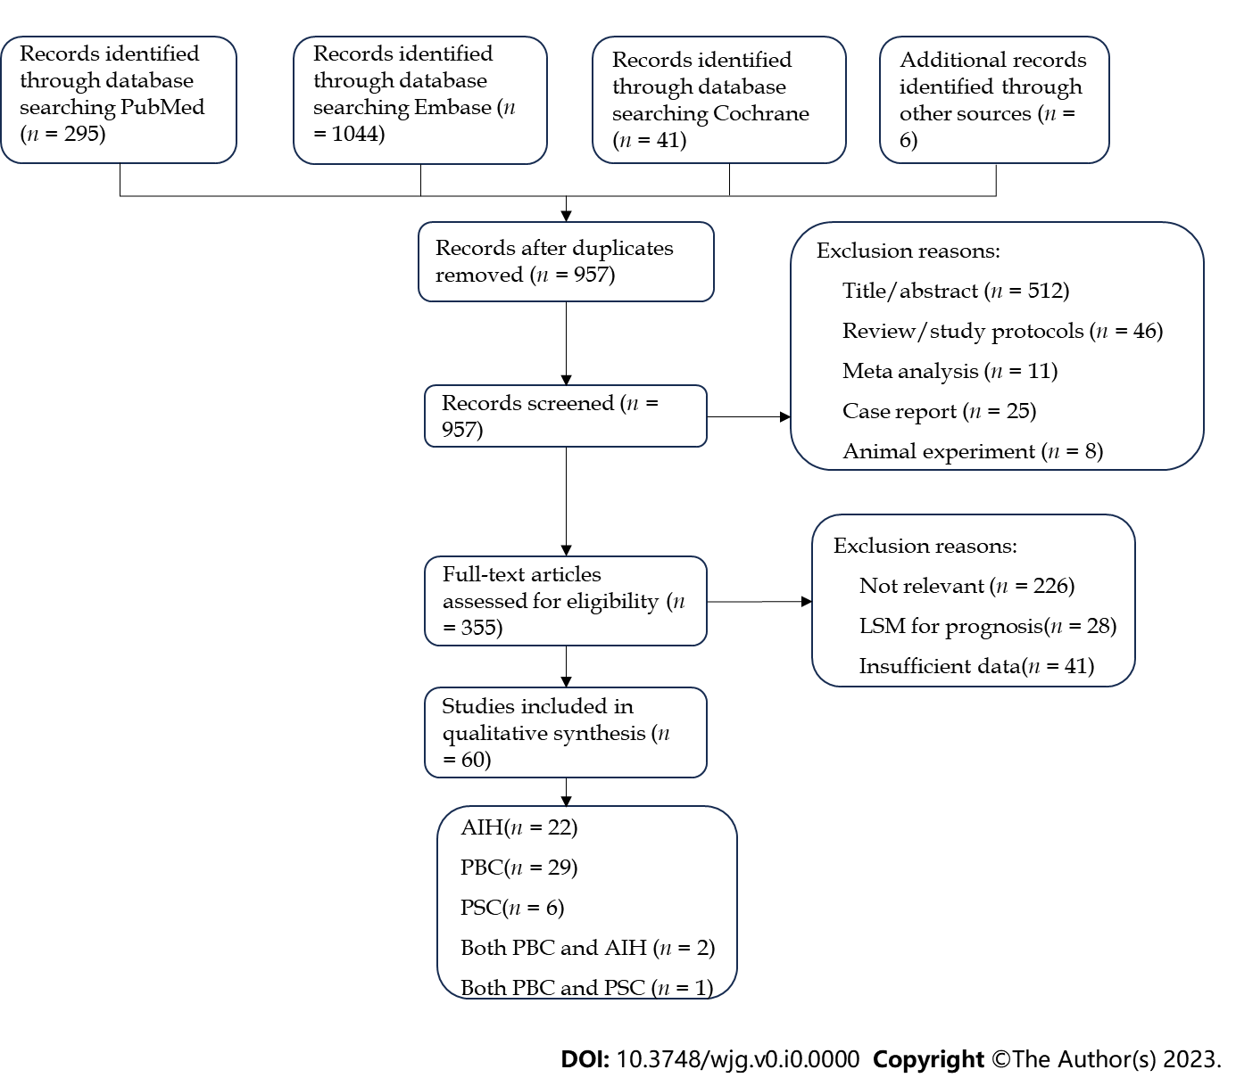
Figure 1 Flowchart of study identification and selection process. AIH: Autoimmune hepatitis; LSM: Liver stiffness measurement; PBC: Primary biliary cholangitis; PSC: Primary sclerosing cholangitis.

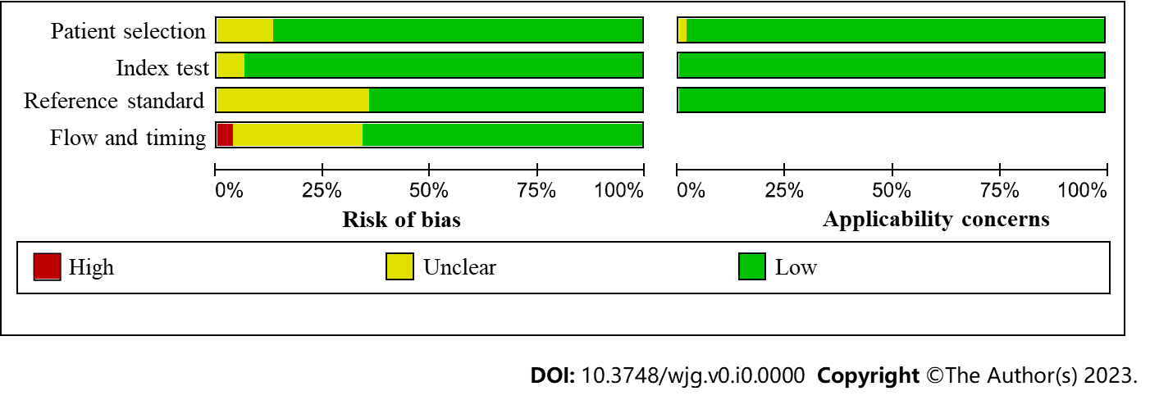
Figure 2 Quality assessment of included studies by Quality Assessment of Diagnostic Accuracy Studies-2. Risk of bias and applicability concerns graph.

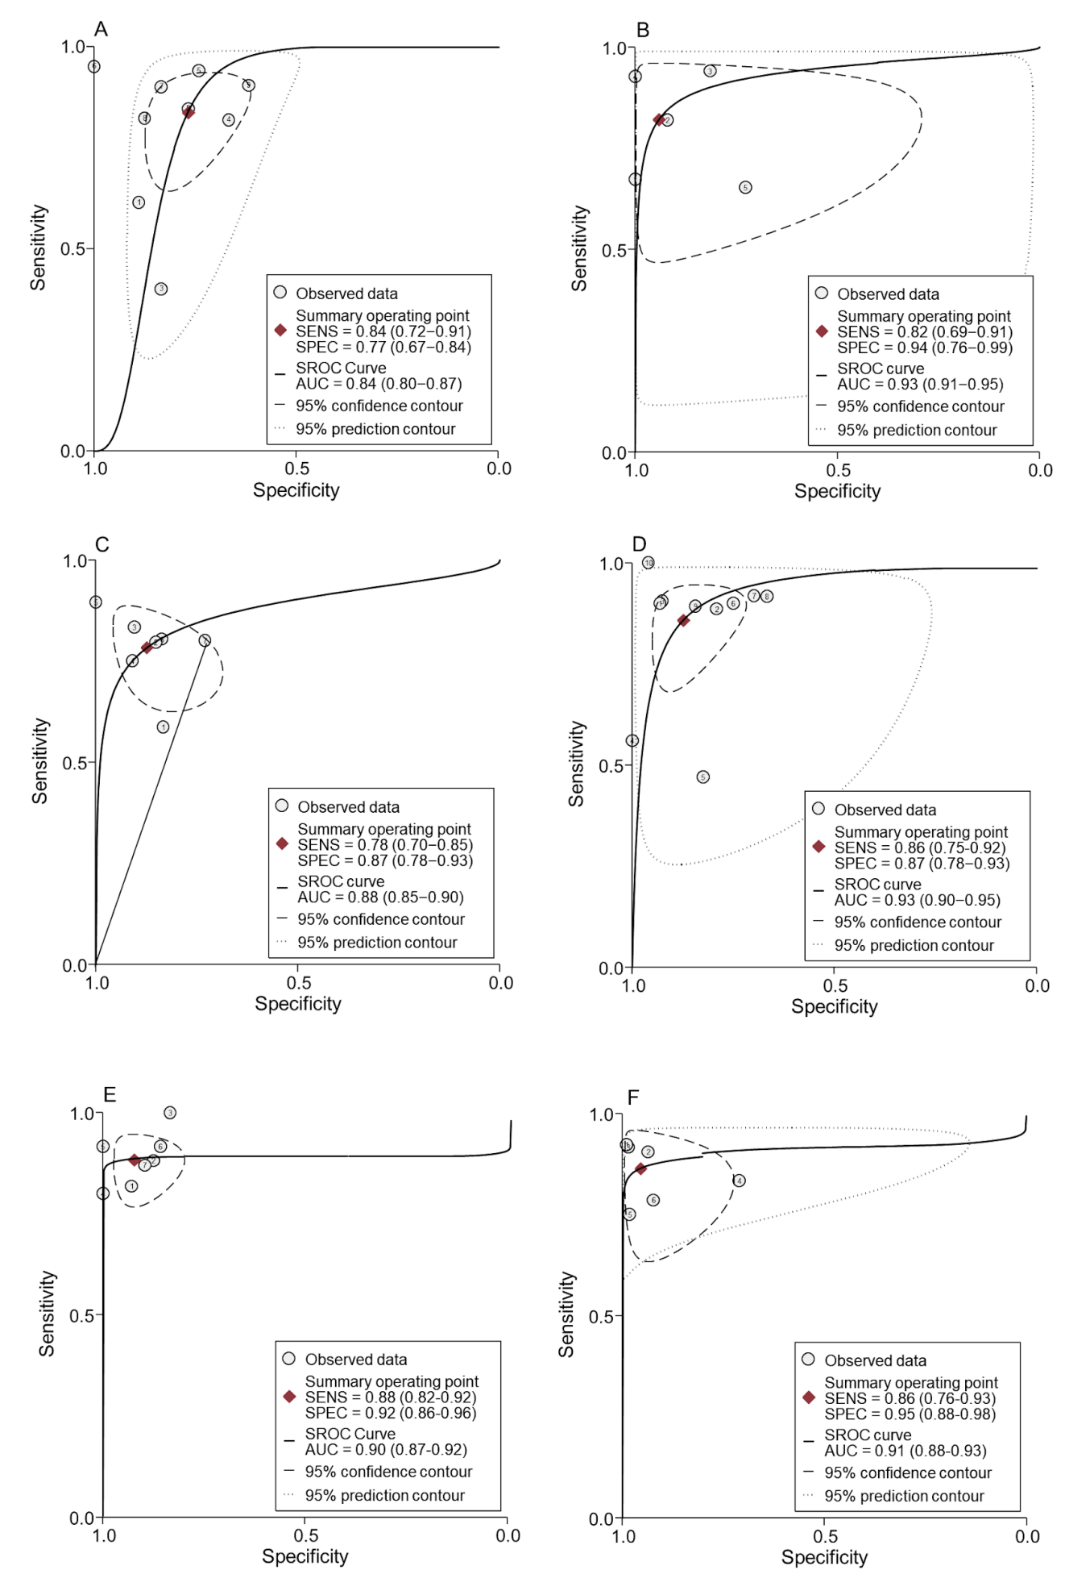
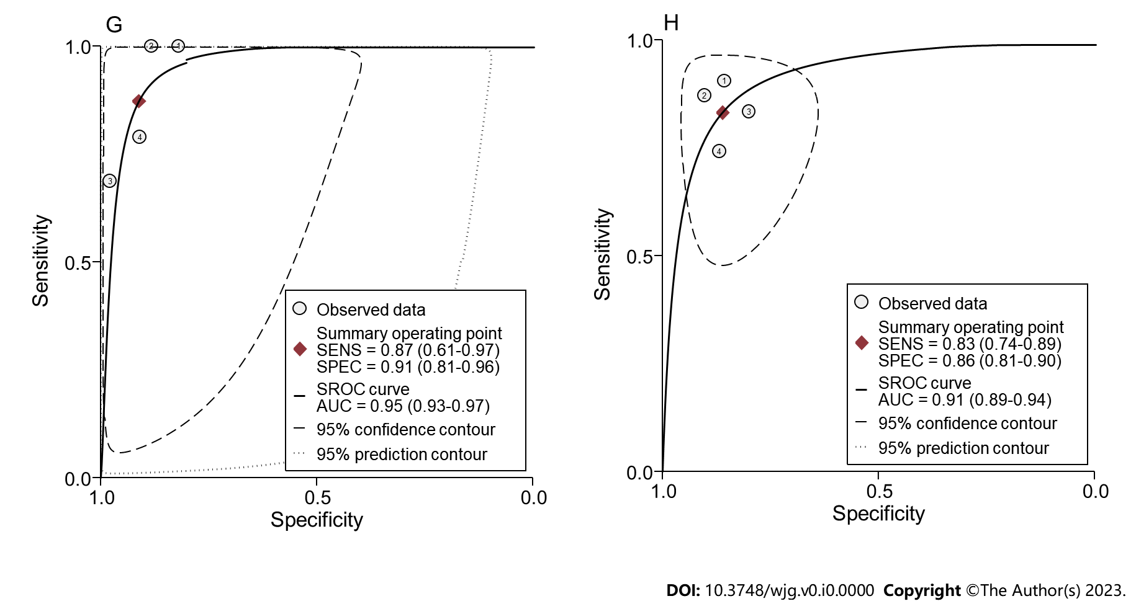
Figure 3 The summary receiver operating characteristic curve plots of transient elastography in autoimmune liver disease patients. A and B: Transient elastography (TE) for detecting significant fibrosis in autoimmune hepatitis (AIH, A) and primary biliary cholangitis (PBC, B) patients; C and D: TE for detecting advanced fibrosis in AIH (C) and PBC (D) patients; E-G: TE for detecting cirrhosis in AIH (E), PBC (F) and primary sclerosing cholangitis (G) patients; H: Shear wave elastography for detecting cirrhosis in AIH patients. AUC: Area under the curve; SENS: Sensitivity; SPEC: Specificity; SROC: Summary receiver operating characteristic.

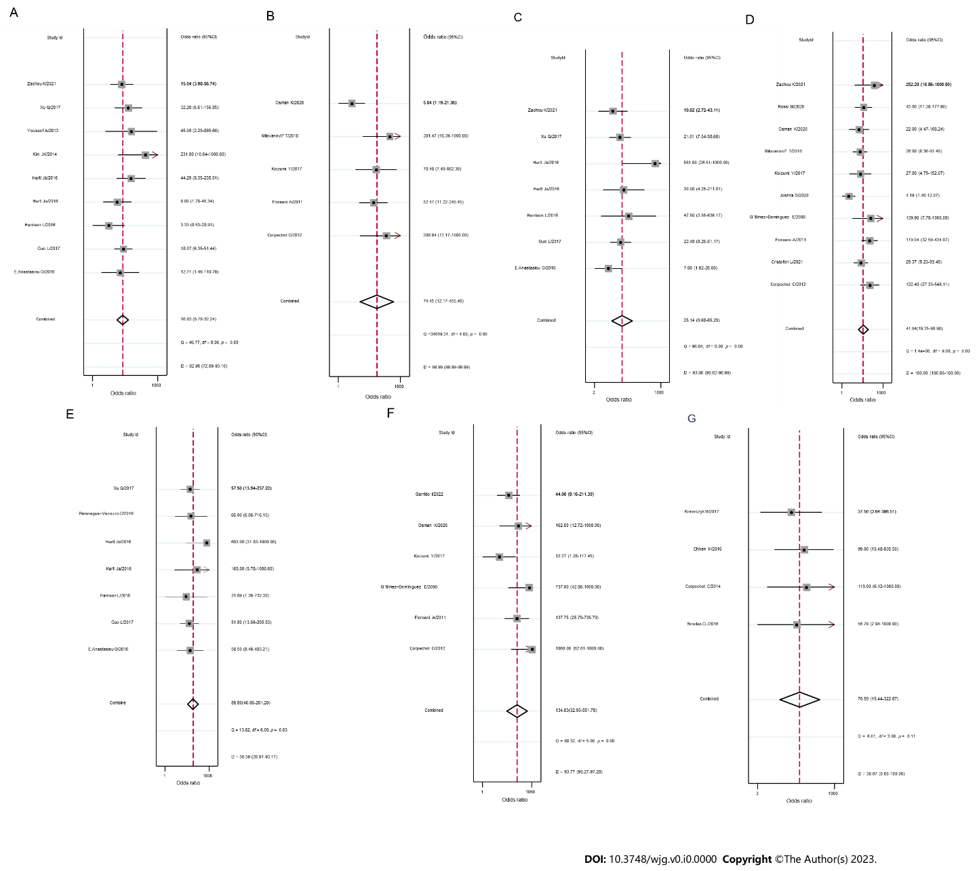
Figure 4 Forest plots of diagnostic odds ratio of transient elastography in autoimmune liver disease patients. A and B: Transient elastography (TE) for detecting significant fibrosis in autoimmune hepatitis (AIH, A) and primary biliary cholangitis (PBC, B) patients, respectively; C and D: TE for detecting advanced fibrosis in AIH (C) and PBC (D) patients; E-G: TE for detecting cirrhosis in AIH (E), PBC (F) and primary sclerosing cholangitis (G) patients. 95%CI: 95% confidence interval.

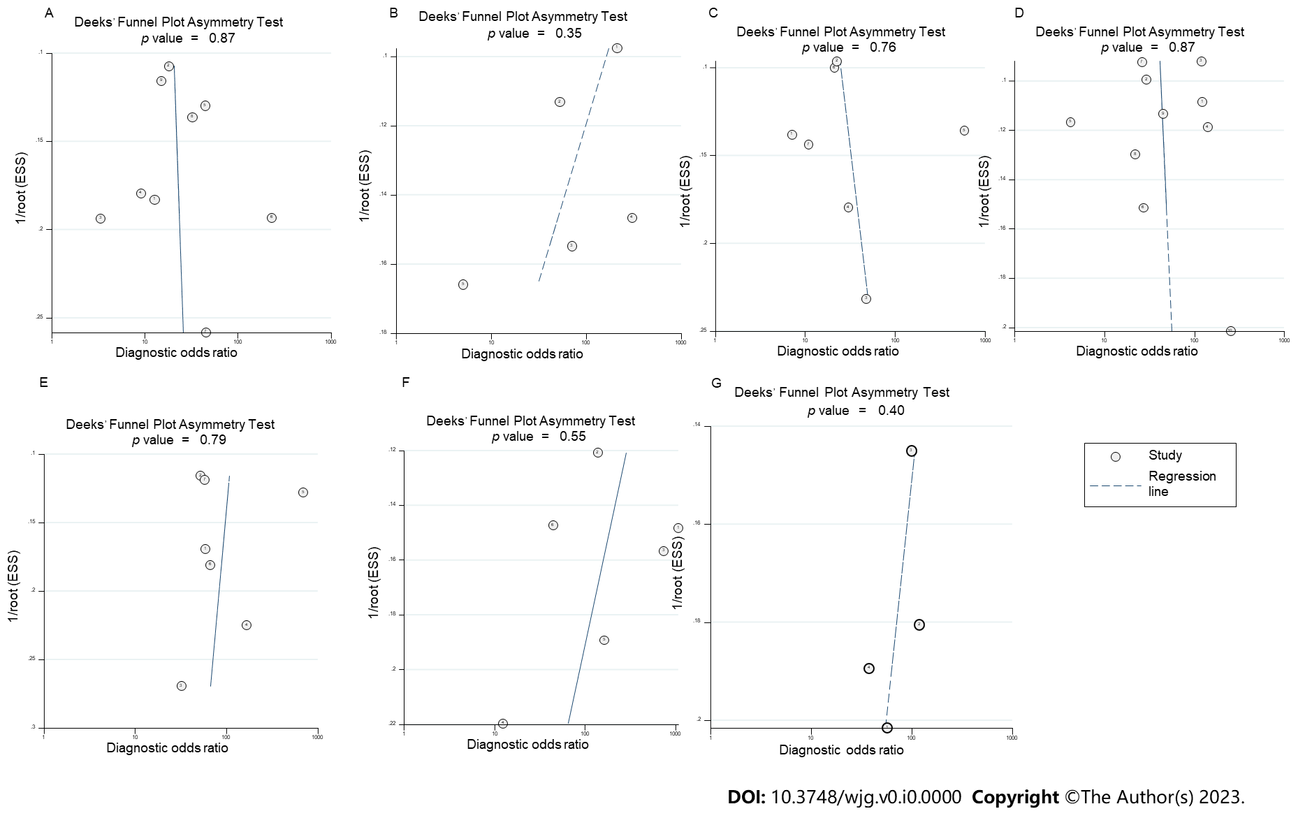
Figure 5 Deeks’ funnel plot asymmetry test for publication bias of transient elastography in autoimmune liver disease patients. A and B: Transient elastography (TE) for detecting significant fibrosis in autoimmune hepatitis (AIH, A) and primary biliary cholangitis (PBC, B) patients; C and D: TE for detecting advanced fibrosis in AIH (C) and PBC (D) patients; E-G: TE for detecting cirrhosis in AIH (E), PBC (F) and primary sclerosing cholangitis (G) patients.
Table 1 Characteristics of studies included in this study
No. | Ref., Yr of publication, Country | Disease | Study time | Study design | Diagnostic model¹ | Sample size | Mean age in yr | Sex, F/M | Mean BMI in kg/m² | Mean  ALT in IU/mL | Treatment condition | Scoring system | Interval
1 | Youssef et al^{[40]}, 2013, Egypt | AIH | NA | Retrospective | 5 | 16 | NA | NA | NA | NA | NA | Metavir | NA
2 | Kim et al^{[41]}, 2014, Korea | AIH | 2008-2014 | Retrospective | 5 | 47 | NA | 41/6 | NA | NA | NA | Metavir | NA
3 | Abdollahi et al^{[42]}, 2015, Iran | AIH | 2011-2013 | NA | 1, 2, 3 | 80 | 34.75 | 51/29 | NA | 106.49 | NA | Ishak | NA
4 | Harrison et al^{[43]}, 2016, United Kingdom | AIH | 2013-2015 | Prospective | 5 | 27 | 56 | 25/2 | NA | 21 | Post | Ishak | The same day
5 | Hartl et al^{[44]}, 2016, Germany | AIH | 2007-2010 | Prospective | 5 | 34 | 53 | 28/6 | NA | 48.5 | Post | Scheuer | Within 3 mo
 | Hartl et al^{[44]}, 2016, Germany | AIH | 2008-2015 | Retrospective | 5 | 60 | 52 | 50/10 | NA | 35 | Post | Scheuer | Within 4 mo
6 | Nishikawa et al^{45]}, 2016, Japan | AIH | 2005-2015 | Prospective | 1, 2, 3, 11 | 84 | 64 | 69/15 | NA | 57.5 | Pre | Scheuer | NA
7 | E Anastasiou et al^{[46]}, 2016, Germany | AIH | 2008-2013 | Retrospective | 1, 2, 3, 5 | 53 | 47.3 | 31/22 | NA | 606.42 | Pre 35 + post 18 | Metavir | Within 3 wk
8 | Piwczyńska et al^{[47]}, 2016, Poland | AIH | NA | Prospective | 4 | 46 | 14.5 | 33/13 | NA | NA | NA | Batts-Ludwig | NA
9 | Sheptulina et al^{[48]}, 2016, Russian | AIH | 2008-2014 | Prospective | 1, 2, 3, 9 | 76 | 40 | 65/11 | 25 | 54.4 | Pre 22 + post 54 | Metavir | Within 7 d
10 | Guo et al^{[29]}, 2017, China | AIH | 2012-2017 | Retrospective | 1, 3, 5 | 108 | 46.54 | 88/20 | 23.52 | 146.51 | NA | Metavir | Within 3 d
11 | Paranagua-Vezozzo et al^{[49]}, 2016, Brazil | AIH | 2012-2015 | Prospective | 4, 5 | 33 | NA | 28/5 | 28.6 | NA | Post | Metavir | The same day
12 | Puustinen et al^{[50]}, 2017, Finland | AIH | NA | Prospective | 8 | 12 | 42.8 | 10/2 | NA | 28.5 | NA | Metavir | Within 1 mo
13 | Wang et al^{[22]}, 2017, China | AIH | 2007-2015 | Retrospective | 1, 2, 3, 7 | 36 | 51.6 | NA | 27.7 | 217.4 | Pre 17 + post 19 | Metavir | Within 3 mo
14 | Xu et al^{[51]}, 2017, China | AIH | 2014-2016 | Prospective | 1, 3, 5 | 100 | 45 | 81/19 | NA | 131.5 | Pre | Metavir | The same day
15 | Zeng et al^{[52]}, 2017, China | AIH | 2011-2016 | Prospective | 6 | 62 | 45.6 | NA | 21.6 | 78.5 | Pre | Metavir | 3 d
16 | Liu et al^{[53]}, 2019, China | AIH | 2008-2018 | Retrospective | 2, 3 | 45 | 54.29 | 37/8 | NA | NA | NA | Metavir | The same day
17 | Park et al^{[19]}, 2019, South Korea | AIH | 2014-2017 | NA | 4 | 49 | 56 | 42/7 | 23.7 | 163 | NA | Metavir | The same day
 |  | PBC |  |  |  | 41 | 55.3 | 35/6 | 25.5 | 45 | NA
18 | Li et al^{[54]}, 2020, China | AIH | 2010-2019 | Retrospective | 1, 2, 3, 10 | 72 | 54 | 64/8 | NA | 137.55 | Post | Metavir | NA
19 | Wang et al^{[55]}, 2020, China | AIH | 2016-2019 | Retrospective | 1, 3, 10 | 119 | 52.5 | 99/20 | NA | 81.6 | Pre | Scheuer | Within 7 d
20 | Xing et al^{[30]}, 2020, China | AIH | 2016-2019 | Retrospective | 1, 3, 6 | 103 | 54 | 81/22 | 22.5 | 163 | NA | Scheuer | Within 7 d
21 | Janik et al^{[31]}, 2021, Poland | AIH | 2015-2020 | Prospective | 6 | 63 | 37 | 15/48 | 23.9 | 130 | Post | Batts-Ludwig | Within 3 mo
22 | Zachou et al^{[20]}, 2021, Greece | AIH | 2009-2016 | Retrospective | 5 | 78 | 57 | 54/24 | NA | 68 | Pre 47 + post 31 | Metavir | The same day
 |  | PBC |  |  |  | 56 | 52 | 48/8 | NA | 47 | Pre 37 + post 19
23 | Ferronato et al^{[56]}, 2022, Italy | AIH | NA | Retrospective | 1, 2, 3 | 122 | 59 | 90/32 | NA | 481.8 | Pre | Ishak | Within 23 d
24 | Soh et al^{[57]}, 2022, Korea | AIH | 2014-2021 | Retrospective | 6 | 69 | 59.7 | 60/9 | NA | 187.1 | Pre 44 + post 25 | Metavir | The same day
25 | Nyblom et al^{[58]}, 2006, Sweden | PBC | 1976-2000 | Retrospective | 2 | 121 | 54 | NA | NA | 189.9 | NA | Metavir | NA
26 | Gómez-Dominguez et al^{[59]}, 2008, Spain | PBC | NA | Prospective | 5 | 80 | 54 | 64/16 | NA | NA | Post | Metavir | Within 9 mo
27 | Alempijevic et al^{[60]}, 2009, Serbia | PBC | 2006 | NA | 1, 2 | 112 | 53.88 | 104/8 | NA | NA | Post | Scheuer | Within 1 wk
28 | Ferrara et al^{[61]}, 2009, Italy | PBC | NA | NA | 1, 3 | 248 | 52 | 233/15 | NA | NA | NA | Scheuer | The same day
29 | Su et al^{[62]}, 2009, China | PBC | 1985-2006 | Retrospective | 2 | 46 | 53.3 | 34/12 | NA | 140.6 | NA | Scheuer | Within 1 mo
30 | Floreani et al^{[63]}, 2011, Italy | PBC | 2009 | NA | 5 | 114 | 58 | 96/24 | 24 | 44 | NA | Metavir | Within 6 mo
31 | Corpechot et al^{[64]}, 2012, France | PBC | 2004-2010 | Prospective | 5 | 103 | 56 | 87/16 | 23.9 | 76 | Post | Metavir | Within 9 mo
32 | Zhang et al^{[34]}, 2014, China | PBC | 2011-2013 | NA | 4 | 56 | 45 | 46/10 | NA | NA | NA | Batts-Ludwig | Within 3 d
33 | Sheptulina et al^{[21]}, 2015, Russian | PBC | 2008-2014 | Retrospective | 9 | 82 | 54.5 | 78/4 | NA | NA | NA | Metavir | NA
 |  | PSC |  |  | 3 | 22 | 38 | 6/16 | NA | NA | NA |  | NA
34 | Umemura et al^{[65]}, 2015, Japan | PBC | 1981-2014 | Retrospective | 11 | 137 | 57 | 111/26 | NA | 41 | Post | Metavir | The same day
35 | Nishikawa et al^{[66]}, 2016, Japan | PBC | 2005-2014 | Prospective | 1, 3, 11 | 57 | 59 | 49/8 | NA | 35 | Pre | Scheuer | NA
36 | Olmez et al^{[67]}, 2016, Turkey | PBC | 1995-2013 | Retrospective | 1, 3 | 40 | 49.6 | 40/0 | NA | 54.5 | NA | Scheuer | Within 1 wk
37 | Wang et al^{[68]}, 2016, China | PBC | 2010-2015 | Retrospective | 1, 3, 10 | 73 | 52.4 | 62/11 | NA | 89.3 | Pre | Ludwing and Scheuer | The day before
38 | Koizumi et al^{[23]}, 2017, Japan | PBC | 2012-2015 | Prospective | 1, 2, 3, 5 | 44 | 60.5 | 41/3 | NA | 65.9 | Post | Metavir | Within 1 wk
39 | Wang et al^{[69]}, 2017, China | PBC | 2009-2016 | Retrospective | 1, 3 | 261 | 52 | 230/31 | NA | NA | NA | Metavir | NA
40 | Jiang et al^{[70]}, 2018, China | PBC | 2009-2015 | Retrospective | 3, 10 | 77 | 62.4 | 64/13 | NA | 81.2 | Pre | Scheuer | NA
41 | Kamal et al^{[71]}, 2018, Netherlands | PBC | 1979-2010 | Retrospective | 1, 2, 3 | 85 | 50 | 75/10 | NA | NA | NA | Ishak | NA
42 | Meng et al^{[72]}, 2018, China | PBC | 2013-2017 | Retrospective | 1, 3, 10 | 94 | 51.02 | NA | NA | 116.58 | Pre | Ludwing and Scheuer | Within 1 wk
43 | Milovanović et al^{[73]}, 2018, Serbia | PBC | 2009-2011 | Prospective | 1, 2, 5 | 122 | 57.4 | NA | NA | 50.8 | Post | Metavir | Within 1 mo
44 | Wang et al^{[74]}, 2018, China | PBC | 2010-2016 | Retrospective | 1, 3, 10 | 58 | 53.3 | 51/7 | NA | 90.4 | Pre | Ludwing and Scheuer | Within 1 wk
45 | Jiang et al^{[75]}, 2020, China a | PBC | 2008-2018 | Prospective | 1, 2, 3, 10 | 78 | 52 | 71/7 | NA | NA | Pre 39 + post 39 | Scheuer | Within 2 wk
 | Jiang et al^{[75]}, 2020, China b | PBC | 2008-2018 | Retrospective | 1, 3, 10 | 40 | 51 | 35/5 | NA | NA | Pre 20 + post 20 | Scheuer | Within 2 wk
46 | Joshita et al^{[76]}, 2020, Japan | PBC | 2015-2019 | NA | 5, 11 | 74 | 64 | 62/12 | NA | 48 | Pre | Scheuer | The same day
47 | Rossi et al^{[77]}, 2020, Italy | PBC | NA | NA | 5 | 92 | NA | NA | NA | NA | NA | Scheuer | Within 1 mo
48 | Yan et al^{[32]}, 2020, China | PBC | 2016-2019 | Retrospective | 1, 2, 3, 6 | 157 | 53 | 136/21 | 22.2 | 72 | NA | Scheuer | NA
49 | Cristoferi et al^{[78]}, 2021, Italy | PBC | 2006-2019 | Prospective | 1, 5 | 126 | 52 | 114/12 | 22.3 | 52.8 | Pre | Batts-Ludwig | Within 12 wk
50 | Fujinaga et al^{79]}, 2021, Japan | PBC | 2000-2019 | Retrospective | 1, 3, 11 | 102 | 61 | 89/13 | NA | 68.4 | Pre | Scheuer | NA
51 | Manesis et al^{[80]}, 2021, Greece | PBC | 2010-2018 | Retrospective | 6 | 53 | 62.6 | 46/7 | 25.7 | 30 | Pre 30 + post 23 | Scheuer | Within 3 mo
52 | Osman et al^{[33]}, 2021, United States | PBC | 2007-2019 | Retrospective | 5 | 63 | 60.95 | NA | NA | 31.2 | NA | Batts-Ludwig | Within 1 yr
 |  |  |  |  | 7 | 98 | 60.21 | NA | NA | 36.4 | NA
53 | Avcioğlu et al^{[81]}, 2022, Turkey | PBC | 2008-2020 | Retrospective | 1, 3 | 35 | 49.6 | 33/2 | NA | 50.6 | Pre | Scheuer | Within 1 wk
54 | Garrido et al^{[82]}, 2022, Portugal | PBC | 2010-2021 | NA | 5 | 79 | 52 | NA | NA | NA | Pre 40 + post 39 | Batts-Ludwig | Within 2 mo
55 | Corpechot et al^{[83]}, 2014, France | PSC | 2005-2010 | Prospective | 5 | 59 | 40.7 | 24/35 | NA | 145.7 | Post | Metavir | Within 6 mo
56 | Bowlus et al^{[84]}, 2016, France | PSC | NA | NA | 5 | 56 | 43 | 22/34 | NA | 255 | NA | Ishak | NA
57 | Eaton et al^{[85]}, 2016, United States | PSC | 2007-2013 | Retrospective | 1, 7 | 266 | 46.12 | 81/185 | 26 | 48 | Pre | Batts-Ludwig | Within 1 yr
58 | Ehlken et al^{[86]}, 2016, Germany | PSC | 2006-2014 | Retrospective | 5 | 62 | 38 | 63/77 | NA | 38 | NA | Scheuer | NA
59 | Krawczyk et al^{[87]}, 2017, Poland | PSC | 2014-2016 | Prospective | 5 | 30 | 33 | 12/18 | NA | 50 | NA | Metavir | NA
60 | Umetsu et al^{[88]}, 2018, Japan | PSC | 2007-2016 | Retrospective | 1, 2, 3, 11 | 28 | 14 | 8/20 | NA | 56.5 | NA | Batts-Ludwig | The same day
¹Diagnostic models are represented by the following numbers: 1 = Aspartate aminotransferase to platelet ratio index; 2 = caspartate aminotransferase to alanine aminotransferase ratio; 3 = Fibrosis-4 index; 4 = Acoustic radiation force impulse; 5 = Transient elastography; 6 = Shear wave elastography; 7 = Magnetic resonance elastography; 8 = Magnetic resonance spectroscopy; 9 = Platelet count to spleen diameter ratio; 10 = Red cell distribution width to platelet ratio ; 11 = Mac-2-binding protein. AIH: Autoimmune hepatitis; ALT: Alanine aminotransferase; BMI: Body mass index; F: Female; M: Male; NA: Not available; PBC: Primary biliary cholangitis; PSC: Primary sclerosing cholangitis.

Table 2 Summary sensitivities, specificities, positive likelihood ratio and negative likelihood ratio of noninvasive methods at various diagnostic thresholds for prediction of significant fibrosis, advanced fibrosis and cirrhosis in autoimmune liver diseases patients
Disease | Diagnostic model/Stage | Cutoff values | No. of patients (n) | Summary sensitivity | Summary specificity | Summary PLR | Summary NLR
AIH | APRI
 | SF | 0.27-0.70 | 2 (195) | 0.80 (0.72-0.86) | 0.35 (0.23-0.48) | 1.46 (0.55-3.89) | 0.36 (0.061-2.09)
 |  | 0.88-1.55 | 3 (264) | 0.74 (0.68-0.80) | 0.51 (0.38-0.63) | 1.52 (1.18-1.96) | 0.50 (0.36-0.69)
 | AF | 0.38-0.90 | 4 (379) | 0.86 (0.81-0.90) | 0.48 (0.41-0.56) | 1.60 (1.18-2.15) | 0.33 (0.24-0.47)
 |  | 1.12-3.40 | 6 (538) | 0.80 (0.72-0.86) | 0.35 (0.23-0.48) | 0.57 (0.51-0.64) | 0.68 (0.62-0.73)
 | Cirrhosis | 0.55-1.81 | 3 (330) | 0.65 (0.56-0.74) | 0.47 (0.40-0.54) | 1.49 (0.93-2.39) | 0.62 (0.46-0.83)
 |  | 1.85-2.00 | 3 (213) | 0.70 (0.57-0.81) | 0.73 (0.65-0.79) | 2.48 (1.75-3.52) | 0.42 (0.28-0.62)
 | AAR
 | SF | 0.72-0.93 | 2 (129) | 0.67 (0.57-0.77) | 0.68 (0.49-0.83) | 2.22 (1.32-3.72) | 0.46 (0.23-0.90)
 | AF | 0.76-1.18 | 7 (532) | 0.61 (0.54-0.68) | 0.72 (0.66-0.77) | 2.01 (1.59-2.53) | 0.58 (0.46-0.73)
 | Cirrhosis | 0.94-1.40 | 3 (213) | 0.61 (0.47-0.74) | 0.83 (0.76-0.88) | 3.31 (1.96-5.59) | 0.49 (0.36-0.69)
 | FIB-4
 | SF | 1.95-2.90 | 3 (303) | 0.64 (0.58-0.71) | 0.71 (0.61-0.81) | 2.20 (1.48-3.27) | 0.50 (0.38-0.65)
 |  | 3.20-5.07 | 2 (156) | 0.60 (0.51-0.69) | 0.77 (0.60-0.90) | 2.66 (1.44-4.92) | 0.52 (0.39-0.69)
 | AF | 1.75-2.37 | 6 (476) | 0.66 (0.59-0.72) | 0.63 (0.57-0.69) | 2.05 (1.56-2.70) | 0.40 (0.20-0.81)
 |  | 3.21-5.60 | 5 (486) | 0.47 (0.41-0.54) | 0.73 (0.67-0.79) | 1.83 (1.24-2.71) | 0.68 (0.50-0.92)
 | Cirrhosis | 2.21-3.40 | 5 (440) | 0.75 (0.67-0.82) | 0.56 (0.50-0.62) | 2.06 (1.53-2.77) | 0.37 (0.19-0.71)
 |  | 6.44 | 1 (103) | 0.68 | 0.64 | 1.88 | 0.51
 | TE
 | SF | 5.80-7.00 | 7 (423) | 0.83 (0.78-0.87) | 0.73 (0.65-0.80) | 2.89 (2.23-3.76) | 0.23 (0.12-0.42)
 |  | 9.10-10.05 | 2 (100) | 0.77 (0.67-0.86) | 0.94 (0.70-1.00) | 7.65 (1.66-35.32) | 0.18 (0.02-1.47)
 | AF | 8.18-9.00 | 3 (286) | 0.80 (0.72-0.87) | 0.80 (0.73-0.86) | 4.09 (2.64-6.33) | 0.24 (0.17-0.35)
 |  | 10.40-12.10 | 4 (174) | 0.73 (0.60-0.83) | 0.93 (0.86-0.97) | 7.67 (2.89-20.31) | 0.27 (0.12-0.61)
 | Cirrhosis | 11.00-12.67 | 4 (213) | 0.89 (0.82-0.94) | 0.88 (0.81-0.93) | 6.89 (4.38-10.85) | 0.14 (0.09-0.23)
 |  | 16.00-19.00 | 3 (147) | 0.88 (0.74-0.96) | 0.97 (0.92-0.99) | 22.08 (5.35-91.22) | 0.16 (0.08-0.33)
 | 2D-SWE
 | SF | 8.20-10.00 | 3 (234) | 0.89 (0.83-0.93) | 0.72 (0.59-0.83) | 3.25 (1.67-6.32) | 0.17 (0.11-0.28)
 | AF | 12.20-15.80 | 3 (234) | 0.82 (0.73-0.89) | 0.79 (0.72-0.86) | 3.92 (2.79-5.52) | 0.24 (0.13-0.44)
 | Cirrhosis | 14.30-19.30 | 4 (297) | 0.83 (0.74-0.90) | 0.86 (0.81-0.91) | 5.85 (4.09-8.37) | 0.21 (0.13-0.34)
PBC | APRI
 | SF | 0.26-1.20 | 4 (584) | 0.84 (0.80-0.87) | 0.63 (0.56-0.70) | 1.98 (1.54-2.55) | 0.34 (0.23-0.51)
 | AF | 0.3.0-0.75 | 8 (858) | 0.62 (0.57-0.68) | 0.54 (0.50-0.58) | 1.39 (1.09-1.79) | 0.68 (0.48-0.98)
 |  | 0.93-2.00 | 7 (731) | 0.73 (0.68-0.78) | 0.68 (0.64-0.72) | 2.68 (1.80-3.97) | 0.46 (0.36-0.58)
 | Cirrhosis | 0.65-1.39 | 6 (852) | 0.75 (0.67-0.83) | 0.51 (0.48-0.55) | 2.19 (1.38-3.50) | 0.31 (0.10-0.99)
 | AAR
 | SF | 0.92-1.00 | 3 (323) | 0.69 (0.61-0.76) | 0.56 (0.48-0.63) | 1.61 (1.33-1.95) | 0.52 (0.31-0.87)
 | AF | 0.81-1.01 | 5 (559) | 0.54 (0.47-0.62) | 0.73 (0.68-0.77) | 2.15 (1.52-3.03) | 0.63 (0.44-0.91)
 | Cirrhosis | 1.00-1.10 | 4 (407) | 0.81 (0.70-0.90) | 0.77 (0.72-0.82) | 4.55 (1.98-10.49) | 0.28 (0.10-0.79)
 | FIB-4
 | SF | 1.39-3.90 | 3 (462) | 0.85 (0.81-0.89) | 0.77 (0.69-0.83) | 2.89 (2.10-3.98) | 0.26 (0.10-0.66)
 | AF | 2.05-2.63 | 7 (865) | 0.77 (0.72-0.81) | 0.57 (0.53-0.61) | 1.95 (1.51-2.52) | 0.31 (0.16-0.61)
 |  | 2.81-4.60 | 6 (431) | 0.63 (0.55-0.71) | 0.80 (0.75-0.85) | 3.25 (1.78-5.94) | 0.49 (0.30-0.81)
 | Cirrhosis | 2.05-4.60 | 6 (852) | 0.87 (0.80-0.93) | 0.61 (0.58-0.65) | 2.79 (1.92-4.07) | 0.16 (0.05-0.52)
 | TE
 | SF | 5.90-8.80 | 4 (402) | 0.81 (0.76-0.85) | 0.95 (0.89-0.98) | 10.51 (2.03-54.36) | 0.23 (0.12-0.44)
 |  | 16.00 | 1 (44) | 0.94 | 0.81 | 4.90 | 0.07
 | AF | 6.75-7.60 | 4 (377) | 0.80 (0.73-0.86) | 0.81 (0.76-0.86) | 4.19 (2.35-7.46) | 0.19 (0.05-0.79)
 |  | 9.60-10.70 | 3 (317) | 0.91 (0.84-0.95) | 0.82 (0.77-0.87) | 5.68 (2.55-12.69) | 0.12 (0.07-0.21)
 |  | 11.90-17.90 | 3 (180) | 0.75 (0.60-0.86) | 0.94 (0.88-0.97) | 11.76 (2.29-60.48) | 0.22 (0.06-0.80)
 | Cirrhosis | 11.40-14.40 | 3 (256) | 0.84 (0.69-0.93) | 0.94 (0.90-0.97) | 13.46 (7.66-23.65) | 0.19 (0.10-0.38)
 |  | 15.60-25.10 | 3 (227) | 0.90 (0.74-0.98) | 0.93 (0.89-0.96) | 22.8 (0.81-639.69) | 0.12 (0.04-0.34)
 | RPR
 | AF | 0.10-0.14 | 4 (362) | 0.49 (0.40-0.58) | 0.89 (0.84-0.92) | 4.27 (2.22-8.22) | 0.59 (0.47-0.74)
 | M2BP
 | AF | 1.00-1.40 | 4 (370) | 0.68 (0.59-0.77) | 0.80 (0.75-0.85) | 4.26 (1.82-9.96) | 0.32 (0.14-0.75)
PSC | TE
 | SF | 8.80 | 2 (121) | 0.76 (0.62-0.87) | 0.88 (0.79-0.95) | 6.34 (3.25-12.37) | 0.29 (0.18-0.46)
 | AF | 9.60 | 3 (177) | 0.82 (0.70-0.91) | 0.83 (0.75-0.89) | 4.75 (2.21-10.19) | 0.15 (0.02-1.04)
 | Cirrhosis | 13.70-14.40 | 4 (207) | 0.82 (0.68-0.91) | 0.89 (0.83-0.94) | 7.46 (3.74-14.88) | 0.25 (0.15-0.43)
2D-SWE: Two-dimensional shear wave elastography; AAR: Aspartate aminotransferase to alanine aminotransferase ratio; AF: Advanced fibrosis; AIH: Autoimmune hepatitis; APRI: Aspartate aminotransferase to platelet ratio index; FIB-4: Fibrosis-4 index; M2BP: Mac-2-binding protein; NLR: Negative likelihood ratio; PLR: Positive likelihood ratio; PBC: Primary biliary cholangitis; PSC: Primary sclerosing cholangitis; RPR: Red cell distribution width to platelet ratio; SF: Significant fibrosis; TE: Transient elastography.

Table 3 Summary area under the receiver operator curve and diagnostic odds ratio of noninvasive methods for prediction of significant fibrosis, advanced fibrosis and cirrhosis in autoimmune liver diseases patients
Disease | Diagnostic model/Stage | Fibrosis stage | Threshold heterogeneity |  | Non-threshold heterogeneity
 |  |  | r | P value | I² (%) | P value
AIH | TE | SF | 0.176 | 0.651 | 82.90 | 0
 |  | AF | -0.429 | 0.337 | 93.80 | 0
 |  | Cirrhosis | 0.321 | 0.482 | 56.59 | 0.030
 | APRI | SF | 1.000 | 0 | 62.34 | 0.050
 |  | AF | 0.717 | 0.020 | 71.94 | 0
 |  | Cirrhosis | 0.714 | 0.111 | 90.93 | 0
 | FIB-4 | SF | 0.700 | 0.188 | 46.81 | 0.110
 |  | AF | 0.627 | 0.039 | 98.29 | 0
 |  | Cirrhosis | -0.029 | 0.957 | 88.98 | 0
 | AAR | AF | 0.857 | 0.014 | 36.46 | 0.160
 | SWE | Cirrhosis | 0 | 1.000 | 61.97 | 0.050
PBC | TE | SF | -0.100 | 0.873 | 99.99 | 0
 |  | AF | 0.195 | 0.590 | 100 | 0
 |  | Cirrhosis | -0.726 | 0.027 | 93.77 | 0
 | APRI | SF | 1.000 | 0 | 99.90 | 0
 |  | AF | 0.209 | 0.454 | 100 | 0
 |  | Cirrhosis | -0.657 | 0.156 | 100 | 0
 | FIB-4 | AF | 0.418 | 0.156 | 100 | 0
 |  | Cirrhosis | 0.029 | 0.957 | 100 | 0
 | AAR | AF | 0.600 | 0.208 | 96.05 | 0
 |  | Cirrhosis | 0.400 | 0.600 | 95.37 | 0
 | M2BP | AF | 0 | 1.000 | 99.24 | 0
 | RPR | AF | 0 | 1.000 | 94.49 | 0
PSC | TE | Cirrhosis | 0.800 | 0.200 | 50.07 | 0.110
AAR: Aspartate aminotransferase to alanine aminotransferase ratio; AF: Advanced fibrosis; AIH: Autoimmune hepatitis; APRI: Aspartate aminotransferase to platelet ratio index; FIB-4: Fibrosis-4 index; M2BP: Mac-2-binding protein; PBC: Primary biliary cholangitis; PSC: Primary sclerosing cholangitis; RPR: Red cell distribution width to platelet ratio; SF: Significant fibrosis; SWE: Shear wave elastography; TE: Transient elastography.

Table 5 Subgroup analysis of sample size and treatment status in prediction of significant fibrosis, advanced fibrosis and cirrhosis in autoimmune hepatitis and primary biliary cholangitis patients
Disease | Parameter | Stage | Subgroup | Sensitivity (95%CI) | Specificity (95%CI) | AUROC (95%CI)
AIH | Sample size | SF | n < 50 | 0.83 (0.55-0.95) | 0.82 (0.65-0.92) | 0.85 (0.82-0.88)
 |  |  | n > 50 | 0.84 (0.73-0.91) | 0.77 (0.63-0.87) | 0.87 (0.84-0.90)
 |  | AF | n < 50 | 0.78 (0.54-0.91) | 0.91 (0.78-0.96) | 0.92 (0.89-0.94)
 |  |  | n > 50 | 0.78 (0.68-0.86) | 0.87 (0.73-0.94) | 0.88 (0.84-0.90)
 |  | Cirrhosis | n < 50 | 0.90 (0.65-0.98) | 0.92 (0.74-0.98) | 0.96 (0.94-0.97)
 |  |  | n > 50 | 0.88 (0.82-0.93) | 0.93 (0.86-0.96) | 0.92 (0.89-0.94)
 | Treatment status | SF | Post | 0.78 (0.44-0.94) | 0.76 (0.60-0.86) | 0.79 (0.75-0.82)
 |  | AF | Post | 0.83 (0.66-0.93) | 0.96 (0.84-0.99) | 0.93 (0.91-0.95)
 |  | Cirrhosis | Post | 0.91(0.77-0.97) | 0.97 (0.73-1.00) | 0.94 (0.91-0.95)
 | Cutoff value | SF | 5.80-6.27 | 0.87 (0.81-0.92) | 0.69 (0.60-0.77) | 0.86 (0.83-0.89)
 |  |  | 6.40-9.10 | 0.82 (0.75-0.88) | 0.89 (0.74-0.96) | 0.92 (0.89-0.94)
 |  | AF | 9.00-11.00 | 0.83 (0.69-0.91) | 0.92 (0.73-0.98) | 0.88 (0.85-0.91)
 |  |  | 8.18-12.10 | 0.77 (0.71-0.83) | 0.85 (0.80-0.89) | 0.88 (0.85-0.90)
 |  | Cirrhosis | 11.00-12.67 | 0.89 (0.82-0.94) | 0.88 (0.81-0.93) | 0.92 (0.94-0.96)
 |  |  | 11.00-19.00 | 0.88 (0.82-0.93) | 0.92 (0.88-0.95) | 0.90 (0.87-0.92)
PBC | Sample size | SF | n < 100 | 0.81 (0.48-0.95) | 0.78 (0.60-0.89) | 0.82 (0.79-0.86)
 |  |  | n > 100 | 0.83 (0.68-0.92) | 0.98 (0.74-1.00) | 0.97 (0.95-0.98)
 |  | AF | n < 100 | 0.90 (0.85-0.94) | 0.88 (0.78-0.94) | 0.91 (0.88-0.93)
 |  |  | n > 100 | 0.81 (0.64-0.91) | 0.88 (0.75-0.94) | 0.91 (0.88-0.93)
 |  | Cirrhosis | n < 100 | 0.82 (0.67-0.91) | 0.94 (0.80-0.99) | 0.86 (0.82-0.89)
 |  |  | n > 100 | 0.91 (0.76-0.97) | 0.97 (0.90-0.99) | 0.94 (0.92-0.96)
 | Treatment status | SF | Post | 0.89 (0.70-0.97) | 0.98 (0.41-1.00) | 0.97 (0.95-0.98)
 |  | AF | Post | 0.85 (0.68-0.94) | 0.92 (0.63-0.99) | 0.93 (0.91-0.95)
 |  | Cirrhosis | Post | 0.90 (0.71-0.97) | 0.96 (0.74-1.00) | 0.94 (0.92-0.96)
 | Cutoff value | AF | 6.75-7.60 | 0.80 (0.73-0.86) | 0.81 (0.76-0.86) | 0.88 (0.85-0.91)
 |  |  | 9.60-10.70 | 0.91 (0.84-0.95) | 0.82 (0.77-0.87) | 0.92 (0.89-0.94)
 |  |  | 11.90-17.90 | 0.75 (0.60-0.86) | 0.94 (0.88-0.97) | 0.93 (0.91-0.95)
 |  | Cirrhosis | 11.40-14.40 | 0.84 (0.69-0.93) | 0.94 (0.90-0.97) | 0.96 (0.94-0.97)
 |  |  | 14.40-16.90 | 0.88 (0.72-0.97) | 0.99 (0.96-1.00) | 0.99 (0.98-1.00)
95%CI: 95% confidence interval; AF: Advanced fibrosis; AIH: Autoimmune hepatitis; AUROC: Area under the receiver operator curve; PBC: Primary biliary cholangitis; SF: Significant fibrosis.

