Name of Journal: World Journal of Clinical Cases
Manuscript NO: 69556
Manuscript Type: META-ANALYSIS

Melatonin intervention to prevent delirium in hospitalized patients: A meta-analysis

You W et al. Melatonin prevents delirium in hospitalized patients

Wei You, Xiao-Yu Fan, Cheng Lei, Chen-Cong Nie, Yao Chen, Xue-Lian Wang

Wei You, Yao Chen, Xue-Lian Wang, Emergency Department Intensive Care Unit, Zigong Fourth People's Hospital, Zigong 643000, Sichuan Province, China

Xiao-Yu Fan, Department of General Surgery, Zigong Fourth People's Hospital, Zigong 643000, Sichuan Province, China

Cheng Lei, School of Public Health and Management, Chongqing Medical University, Chongqing 400000, Chongqing, China

Chen-Cong Nie, Department of Nursing, Zigong Fourth People's Hospital, Zigong 643000, Sichuan Province, China

Author contributions: You W and Fan XY contributed equally to this work; You W and Cheng L contributed to the design and provided the analysis; You W and Fan XY completed the data collection and provided statistical support; Nie CC, Chen Y, and Wang XL contributed to the manuscript preparation.

Supported by the Scientific Research Project of Sichuan Provincial Health Commission, No. 19PJ045.

Corresponding author: Xiao-Yu Fan, BSc, Chief Nurse, Department of General Surgery, Zigong Fourth People's Hospital, No. 2 Tanmulin Street, Ziliujing District, Zigong 643000, Sichuan Province, China. 453611550@qq.com

Received: July 5, 2021
Revised: July 26, 2021
Accepted: April 3, 2022
Published online:

Abstract
BACKGROUND
Evaluation of the effectiveness of melatonin is necessary to prevent the development of delirium in hospitalized patients. Melatonin (N-acetyl-5-methoxytryptamine) is a hormone produced by the pineal gland of the brain from the amino acid tryptophan. Synthetic melatonin supplements have been used for various medical conditions, especially sleep-related diseases, and have proved to be successful.

AIM
To determine the effect of melatonin on the prevention of delirium in hospitalized patients.

METHODS
A literature search of the CNKI, Wanfang Database, VIP Database, China Biomedical Literature Database, PubMed, Embase, Cochrane Library, Web of Science, and other databases was conducted. The CNKI, Wanfang Database, VIP Database (VIP), and China Biomedical Literature Database were searched for Chinese studies, and PubMed, Embase, Cochrane Library, Web of Science and other databases were searched for international studies. It will be established in June 2021 in a randomized controlled trial (RCT) whether melatonin treatment for 6 mo prevents delirium in hospitalized patients. Literature screening, quality review, and data extraction were carried out using the Cochrane Manual 5.1.0 systematic evaluation method, and Stata 15.0 software and Review Manager 5.3 were used for meta-analysis and processing.

RESULTS
A total of 18 new RCT articles and 18 experimental subjects were identified. The results of the meta-analysis showed that following the occurrence of delirium, melatonin reduced the incidence of delirium in patients (RR = 0.69, 95%CI: 0.60-0.80), which is of significance, but heterogeneity was significant I² = 62%. Subgroup analysis was performed to examine the source of heterogeneity, and it was found that different patient types were the source of heterogeneity; the research on subgroup analysis was of high quality and homogeneous. To determine the reliability and robustness of the research results, a sensitivity analysis was carried out. The results showed that after excluding individual studies one by one, the effect size was still within 95%CI, which strengthened the reliability of the original meta-analysis results. Melatonin has a significant preventive effect on delirium in hospitalized medical patients [RR = 0.60, 95%CI: 0.47-0.76), P < 0.001].

CONCLUSION
Melatonin can reduce the rate of delirium in medical patients, and the role of melatonin in reducing the incidence of delirium in surgical patients and critical care unit patients requires further study.

Key Words: Melatonin; Delirium; Prevention; Meta-analysis; Randomized controlled trial

You W, Fan XY, Lei C, Nie CC, Chen Y, Wang XL. Melatonin intervention to prevent delirium in hospitalized patients: A meta-analysis. World J Clin Cases 2021; In press

Core Tip: Melatonin was shown to be effective in preventing delirium in hospitalized patients in this meta-analysis. Eighteen studies were reviewed involving 2137 patients and it was found that melatonin significantly reduced the incidence of delirium in hospitalized medical patients, but the effectiveness of melatonin in reducing the incidence of delirium in hospitalized surgical patients and intensive care unit patients requires further research.

INTRODUCTION
Delirium, also known as the state of conscious confusion, is a disorder of consciousness (which is the clarity of perceiving the environment), changes in consciousness (including changes in thinking), cognitive disorders, mental illness, and sleep-wake movements. The delirium is a recognized Complications of medical diseases, especially elderly patients, which is related to the mortality rate, and increase in Hospital costs^{[1,2]}. In the palliative care setting, it is reported that the prevalence of delirium on admission is 20%-42%, and as high as 88% in the last few hours or days of life. Delirium is an acute neurocognitive disorder, in which a person's awareness of the surrounding environment is reduced, and attention disorder is its core feature; other mental deficits and perceptual abnormalities may also occur^{[3]}. The collective symptoms of delirium can affect patients due to these characteristics and accompanying changes in psychomotor dysfunction or attention deficit hyperactivity disorder. Delirium is a symptomatic disorder, and its clinical management is challenging, especially when psychomotor agitation is present. This is especially true in the case of advanced disease and hospice care, where the patient's physical and functional decline can lead to a high degree of vulnerability to delirium (such as infections and adverse drug reactions)^{[5-6]}. When delirium appears, it is associated with a mortality rate of 10% to 75%, although death may be more related to both advanced age and delirium. It is estimated that drug-induced delirium accounts for 22% to 39% of all cases. A study involving elderly hospitalized patients found that in their study population, the most likely cause of delirium was drug use^{[7-10]}. Antipsychotics and anti-anxiety agents are FDA-approved therapies for the treatment or prevention of delirium; however, data have revealed their lack of efficacy and the risk of serious side effects^{[11]}.
Melatonin (N-acetyl-5-methoxytryptamine) is a hormone produced by the pineal gland in the brain from the amino acid tryptophan. Synthetic melatonin supplements have been used for various medical conditions, especially sleep-related diseases, and have proved to be successful^{[12]}. Delirium is characterized by a disturbance in the circadian sleep-wake cycle, which leads to the hypothesis that the neurotransmitter melatonin and associated metabolic changes are involved in the pathogenesis of delirium. After admission, especially after admission to the intensive care unit (ICU), the metabolism of melatonin is disturbed, all of which are factors that cause delirium. These characteristics suggest an association between melatonin abnormalities and delirium. Although there is still a lack of evidence of causality^{[2]}, melatonin regulates the body’s sleep-wake cycle, season, and circadian rhythm^{[13]}. It is a sleep-improving substance. Oral melatonin has been widely used nationally and internationally. Although melatonin depletion is considered to be one of the mechanisms of delirium, there have been some studies on the effect of melatonin on the prevention of delirium; however, there are differences in the various research results. Therefore, this study analyzed randomized controlled trials (RCTs) of melatonin interventions to prevent delirium using a meta-analysis, aiming to quantitatively synthesize the results of multiple studies to provide more reliable quantitative results and to target patients in different situations. The best intervention measures to prevent delirium in hospitalized patients are recommended to provide evidence-based data and serve as a basis for the prevention and clinical treatment of delirium in hospitalized patients.

MATERIALS AND METHODS
Document retrieval
The search was conducted using operating system principles (P: PIC, which stands for the research object; I: Search strategy, which stands for the search object); C: Comparison strategy, realization; O: Search research design, research design. The databases PubMed, Web of Science, Cochrane Library, Embase, and Chinese databases, including China Biomedical Literature Database, Wanfang Data Medical Journal Library, Weipu Database, CNKI, etc. were searched. The search period was from establishment of the database through June 2021. Chinese database search terms were: (Melatonin) and (OR delirium neurocognitive impairment) and (randomized controlled trial or randomized controlled or randomized) and English database search terms were "melatonin" and "Delirium" and 'randomized controlled trials' or 'randomized controlled trials' or 'randomized'.

Search strategy
The following search terms were used: ("Delirium" [Mesh]) OR (title) (acute subdelirium [title/abstract]) OR (delirium, sub [title/abstract]) OR (delirium, acute sub [title/abstract] OR (Sub-Delirium [title/abstract]) or (Mixed Origin Delirium [abstract]) OR (Mixed Origin Delirium [title/abstract]) OR (Mixed Origin Delirium [title/abstract]) AND (Melatonin [title/abstract]) AND (Randomized Controlled Trial [Publication Type] OR (Randomized [title/abstract] AND Control [title/abstract] AND Trial [title/abstract]). This study has been registered on the PROSPERO website (No. CRD42021264902).

Inclusion and exclusion criteria
Inclusion criteria were: (1) Research subjects: clinically hospitalized patients, including patients in surgery, internal medicine, and ICU, the criteria for diagnosing delirium were determined by the CAM = Delirium Confusion Assessment (CAM) criteria^{[14,15]}; (2) Intervention measures: The selected study was an RCT, and there were no significant differences between the experimental group and the control group before the experiment; and (3) Outcome indicators: the main observation indicator was RR (Relative risk).
The exclusion criteria included: reviews, conference papers, systematic reviews, dissertations, animal experiments, repeat publications, unavailable full text or incomplete data extraction, low quality of the literature or obvious research flaws; already suffering from mental illness before admission, patients with abnormalities, severe sensory disturbances, history of depression or delirium, or long-term use of antipsychotic drugs.

Study selection and data extraction
Two researchers who had received systematic evidence-based training performed the literature assessment and data extraction. They independently read, screened, and retrieved relevant content based on the inclusion and exclusion criteria. Excel entry was used to extract data, the first author Wei You completed the literature screening, and data extraction was completed by author Xiaoyu Fan. After completion, cross-checking was carried out. If there was disagreement, this was resolved by discussion or joint negotiation with the third author Cheng Lei. The relevant data extracted from the included studies were the title, first author, publication time, research country (region), sample size, intervention time, evaluation indicators, and other information.

Quality assessment and publication bias
Two researchers who had undergone rigorous evidence-based training assessed the quality of the literature. The quality of the included studies was assessed using the bias risk assessment approach provided by the Cochrane Handbook 5.1.0, and discrepancies were addressed through discussion or by third-party researchers. The evaluated items included: (1) The generation of a random allocation plan; (2) Whether to carry out the allocation plan; (3) Whether to blind the subjects and researchers; (4) Whether to blind the evaluators; (5) Incomplete results; (6) Selectively reported research results; and (7) Other sources of bias. The evaluation result of "yes" indicated that the risk of bias was low; the result of "no" indicated that the risk of bias in the study was higher; "unclear" indicated that the study did not mention or did not have sufficient information to evaluate whether bias was present. Publication bias was tested using Egger's Funnel plots.

Statistical analysis
Review Manager 5.3 and Stata 15.0 software were used to conduct a meta-analysis on the extracted data. Subgroup analysis was conducted to analyze the heterogeneity of the included study results, and the corresponding effect model was selected based on the results: if P ≥ 0.1 and I² < 50%, this indicated that the statistical heterogeneity between the studies was acceptable. A fixed-effects model was chosen for data merging; if P < 0.1 and I² ≥ 50%, this indicated that the clinical heterogeneity between studies was large, and the source of heterogeneity was assessed or a random-effects model was chosen for data merging. Two categories of delirium incidence and relative risk (RR) were selected for analysis, and the 95%CI was calculated. When necessary, a sub-analysis of potential heterogeneity factors was performed, as well as an analysis to test the data.

RESULTS
Characteristics of the included studies
The flowchart of the research selection process is shown in Figure 1. The literature search retrieved 217 related documents from the Chinese and English databases. The document management software deleted 173 duplicate documents, read the titles and abstracts, and eliminated a total of 63 articles including reviews, systematic reviews, reviews, and animal experiments. Further research included reading the full text, deleting contents with inconsistent research data or inconsistent intervention measures/control measures (90 documents), excluding non-RCT literature (1), and one study with inconsistent outcome indicators was excluded. A total of 18 articles were finally re-analyzed, and the functions of the re-study are shown in Table 1. The basic characteristics of the literature in 18 articles were reviewed^{[16-33]} and published in 2010-2021. The languages of the included literature are English and Chinese, and the study included 16 English articles and 2 Chinese articles. A total of 521 studies were involved. All included studies were divided into the control group and experimental group. The intervention in the experimental group was melatonin, and the intervention in the control group was a placebo (Table 1).
The experimental group was given melatonin to prevent delirium, and the control group was given placebo to prevent delirium.

Learning quality assessment
This study included 18 RCTs, 18 of which were of high quality, 6 of which scored 6 points, 7 of which described the method of random allocation sequence in full, and 18 assessed subjects using a blind approach. All trials provided complete data and no other potential risk of bias. The risk of bias in selective reporting was low. As shown in Figure 2, the standard was "+" and the standard "-" was not met. Figure 3 shows a statistical chart of the proportion of each item in the literature quality evaluation. See Figure 2 and Figure 3 for details.

Meta-analysis results
The overall effect of melatonin in all selected samples showed that it prevented delirium in hospitalized patients. Overall homogeneity (I² = 62%, P < 0.0003) indicated multiple studies, and there was heterogeneity between the data; therefore, the random-effects model was used for analysis, but subgroup analysis was needed to determine the heterogeneity between multiple sets of data in this meta-analysis, as shown in Table 2 and Figure 4 (Forest map).

Heterogeneity test
The 18 documents in this study were tested for heterogeneity, and it was found that I² = 62% > 50%, and the Q test showed P = 0.0003 < 0.1, suggesting that the documents selected in this study were heterogeneous. Further investigation using Rabe diagrams and star diagrams indicated that there was a strong possibility of heterogeneity in the literature with regard to different patient types (Figures 5 and 6). Therefore, heterogeneity testing was required.

Sensitivity analysis
Sensitivity analysis is a method of testing the stability of results obtained under certain assumptions by changing some important factors that affect the combined results, such as inclusion criteria, literature evaluation, loss to follow-up, and different effect sizes, and then re-analyzing the data. The results before and after changing the conditions were compared, to judge the stability of the meta-analysis conclusions. A sensitivity analysis of the 18 articles found that different types of hospitalized patients had a greater impact on the heterogeneity, and it was necessary to further determine the source of heterogeneity (Figure 7).

Subgroup analysis
Subgroup analysis is also a commonly used method to identify heterogeneity in a meta-analysis. It investigates the source of heterogeneity from the perspectives of clinical and methodological heterogeneity, and it can incorporate the issue of effect size by referring to homogeneity research. According to the characteristics that may cause heterogeneity, the different types of experimental patients were analyzed in subgroups. In terms of the grouping of patients, the patients were divided into three subgroups: inpatient surgical patients, inpatient medical patients, and inpatient ICU patients. This is shown in the Forest diagram. Both the surgical group and the internal medicine group demonstrated statistical significance (P < 0.05), but not the ICU group (P > 0.05). Sensitivity analysis was performed on the analysis results. Two effect models (fixed and random) were used. After each study was eliminated one by one, the meta-analysis was performed again. The results found that the surgical group had high heterogeneity, indicating that the source of heterogeneity was not the research literature. Considering that many factors cause delirium, it is not possible to blindly adopt the random effect model to merge the effect size; following exclusion of the article by Stuti^{[27]} in the internal medicine group, the combined effect size of the meta-analysis changed markedly, indicating that the source of heterogeneity in the internal medicine group was due to Stuti J, suggesting that the results of this study were robust. Individual studies were excluded one by one following subgroup analysis, and the sensitivity analysis approach of analyzing the difference between the combined effect size and the total effect size of the remaining studies, also known as impact analysis, was used. Among hospitalized patients in internal medicine, the effect sizes after excluding studies one by one were all within the 95%CI value of the total effect size. Therefore, they had little effect on the total combined effect size and were acceptable. The original meta-analysis results were strengthened to make them more convincing.
In the groups of patient (surgery, internal medicine, ICU), their I² were 75%, 45%, and 36%, respectively, indicating that there was no obvious heterogeneity in internal medicine patients in the subgroups; but if the three subgroups were combined, I² was 61% indicating that there was heterogeneity, the intervention effect of melatonin in preventing delirium in different hospitalized patients was inconsistent, and the different types of hospitalized patients were the source of the heterogeneity. Melatonin had a stronger effect in reducing the incidence of delirium in hospitalized medical patients, according to subgroup analysis (P < 0.01) as shown in Figure 8. Therefore, Stuti's^{[27]} article was eliminated. Following removal of this study, the heterogeneity test was performed again. The results showed that the remaining 6 documents did not demonstrate heterogeneity (I² = 45% < 50%, P = 0.1). After elimination of this study, the fixed-effects model was used to combine the effect size.

Bias test
To determine whether there was publication bias in this study, a funnel chart was developed. The funnel chart for this study is shown in Figure 9. The funnel chart results of hospitalized patients in internal medicine showed a symmetrical distribution, suggesting that the publication bias of the included literature was small.

DISCUSSION
Delirium is characterized by dramatic changes in cognition, which are accompanied by changes in consciousness and in mental state, and these changes will fluctuate over time^{[34]}. The incidence of delirium on admission is 11%-33%. The number of elderly patients in the emergency department, internal medicine, and surgery wards of general hospitals has increased by 6%^{[35-37]}.
In palliative care, the clinical management strategy for delirium episodes is to identify and treat correctable precipitating factors if they are consistent with the patient's desired treatment objectives; when the desired care goals are completely focused on comfort or delirium, the clinical management method is to identify and treat correctable precipitating factors. When episodes are difficult to treat, the therapeutic intervention must focus on symptomatic management of painful symptoms, such as perceptual disturbance or agitation. Antipsychotic drugs have been advocated for the first-line pharmacological treatment of painful delirium symptoms^{[38,39]}. However, there is evidence that antipsychotic drugs have no preventive effect on delirium in hospitalized adults, and their therapeutic effects are limited^{[12,40,41]}; in a recent trial of palliative care patients, antipsychotic drugs were less effective than placebo. Exacerbation of mild to moderate delirium can occur^{[42]}. The proposed overall management approach is shifting to larger preventive measures, especially non-pharmacological interventions, and minimizing the use of antipsychotic drugs^{[43]}. Multi-component non-pharmacological interventions, including maintenance of sleep hygiene, have significant effects in preventing delirium in the elderly^{[44,45]}, but in studies of palliative care populations, similar interventions plus suppressive therapy have not been effective in preventing delirium. Sleep-wake cycle disorder is not the core diagnostic criterion for the diagnosis of delirium, but it is reported that the prevalence of delirium in cancer patients is between 75% and 100%^{[46,47]}. Although the pathophysiology of delirium is complex and not fully understood, melatonin disorders and related sleep-wake cycle disturbances are thought to be contributing factors to delirium. This is consistent with the initiation and maintenance of sleep; it plays an important role in the regulation and synchronization of the sleep-wake cycle and circadian rhythm^{[48]}. According to reports, melatonin circadian rhythm disorders are found in postoperative patients and critically ill patients, especially in sepsis patients^{[49-51]}. Melatonin disorders have therefore been confirmed in the majority of clinical patients with the highest risk of delirium, and this is the main hypothetical basis for the exogenous use of melatonin to prevent delirium. Postoperative delirium is closely related to postoperative cognitive dysfunction. In addition, postoperative delirium is considered to be a predictor of postoperative cognitive decline^{[52]}.
Although there is increasing attention on the effects of melatonin and melatonin receptor agonists in promoting sleep and preventing delirium in critically ill patients and other high-risk populations^{[53]}, the heterogeneity of melatonin supplementation to prevent delirium has ruled out broad concluding recommendations^{[54]}.
A total of 18 studies and 2137 patients were included in this systematic review and meta-analysis. The results of the study suggest that melatonin has a more significant effect in preventing delirium in hospitalized patients (P < 0.01), but no outstanding advantages have been observed in surgery and ICU patients, especially in surgical patients, although the effect was significant (P < 0.01). However, the heterogeneity in each study was strong. Melatonin cannot yet be considered effective in preventing delirium in surgical (post-surgery) patients; in ICU patients, the effectiveness of melatonin in preventing delirium in patients was not significant (P > 0.01), and there are currently few RCT-based studies on the effect of melatonin in the prevention of delirium in ICU patients. Multi-center, large-sample randomized controlled experimental data are still required to support these findings. Melatonin can be used to prevent delirium in hospitalized patients. However, it is unknown whether it is worthy of clinical recommendation, and the results of this study should be treated with caution.
This systematic study only retrieved publically available Chinese and English publications, and there are limitations in the retrieval of other languages and grey literature, which may cause certain publication bias. However, many predisposing factors of delirium were taken into account (for example, higher age, cognitive impairment, and dementia) and predisposing factors (for example, infections, drugs, and electrolyte disorders). Future studies should consider different subgroups of medical, surgical, and trauma patients, and patients with a higher incidence of delirium, such as the elderly, to evaluate which subgroup benefits most from exogenous melatonin supplementation. Larger RCTs should assess the possible differential melatonin effects in different patient subtypes to determine which subgroups of patients can benefit from melatonin to prevent delirium and which dose and duration of melatonin management are the most effective.

CONCLUSION
Melatonin may reduce the incidence of delirium in medical patients, but did not significantly reduce the occurrence of delirium in surgical and ICU patients.

ARTICLE HIGHLIGHTS
Research background
From an evidence-based perspective, this study examined the influence of melatonin on the prevention of delirium in hospitalized patients. The results suggest that in patients with delusional behavior and dermatology ward (ICU) patients, the effect of melatonin on delirium was confirmed. Thus, melatonin may be a treatment option for delirium with careful design for different types of respondents, and more standardized options.

Research motivation
Recently, research on the effect of melatonin on the occurrence of delirium in hospitalized patients has attracted more and more attention. However, it is unknown whether melatonin can play a role in different types of hospitalized patients. The use of melatonin to prevent delirium has aroused increasing interest in doctors. However, whether melatonin can play a role in different types of hospitalized patients needs further research.

Research objectives
We conducted a meta-analysis, mainly for one purpose. It was based on high-quality studies with a large enough sample size to calculate a reliable estimate of the incidence of melatonin in preventing delirium in hospitalized patients, and to evaluate the role of melatonin in reducing the incidence of delirium in different types of patients.

Research methods
Various databases were searched and relevant studies on the incidence of delirium treated with melatonin in hospitalized patients were retrieved. In our meta-analysis, fixed-effects and random-effects models were used to estimate the incidence of delirium in hospitalized patients. Publication and sensitivity bias analysis was used to test the robustness of the data.

Research results
A total of 18 studies involving 2137 patients were eligible for this review. Melatonin was shown to be more effective in reducing the incidence of delirium in hospitalized medical patients, and the findings were statistically significant (P < 0.01).

Research conclusions
Melatonin can reduce the incidence of delirium in medical patients, but its impact on reducing the incidence of delirium in patients with behavioral disorders and ICU patients is unclear.

Research perspectives
Our meta-analysis showed that melatonin can reduce the incidence of delirium in hospitalized medical patients. Unfortunately, limited research has shown that the benefit is not seen in surgical patients or ICU patients. Further study to determine the role of melatonin in reducing the incidence of delirium in surgical and ICU patients is required.

ACKNOWLEDGEMENTS
We would like to thank the doctors from the School of Public Health and Management and the Department of Biosensing, Chongqing Medical University for their help.

REFERENCES
1 Gray SL, Lai KV, Larson EB. Drug-induced cognition disorders in the elderly: incidence, prevention and management. Drug Saf 1999; 21: 101-122 [PMID: 10456379 DOI: 10.2165/00002018-199921020-00004]
2 Witlox J, Eurelings LS, de Jonghe JF, Kalisvaart KJ, Eikelenboom P, van Gool WA. Delirium in elderly patients and the risk of postdischarge mortality, institutionalization, and dementia: a meta-analysis. JAMA 2010; 304: 443-451 [PMID: 20664045 DOI: 10.1001/jama.2010.1013]
3 Baker KG. Evaluation of DSM-5 and IWG-2 criteria for the diagnosis of Alzheimer's disease and dementia with Lewy bodies. Diagnosis (Berl) 2016; 3: 9-12 [PMID: 29540044 DOI: 10.1515/dx-2015-0031]
4 Breitbart W, Gibson C, Tremblay A. The delirium experience: delirium recall and delirium-related distress in hospitalized patients with cancer, their spouses/caregivers, and their nurses. Psychosomatics 2002; 43: 183-194 [PMID: 12075033 DOI: 10.1176/appi.psy.43.3.183]
5 Gagnon B, Lawlor PG, Mancini IL, Pereira JL, Hanson J, Bruera ED. The impact of delirium on the circadian distribution of breakthrough analgesia in advanced cancer patients. J Pain Symptom Manage 2001; 22: 826-833 [PMID: 11576799 DOI: 10.1016/s0885-3924(01)00339-6]
6 Lawlor PG, Bush SH. Delirium in patients with cancer: assessment, impact, mechanisms and management. Nat Rev Clin Oncol 2015; 12: 77-92 [PMID: 25178632 DOI: 10.1038/nrclinonc.2014.147]
7Espino DV, Jules-Bradley AC, Johnston CL, Mouton CP. Diagnostic approach to the confused elderly patient. Am Fam Physician 1998; 57: 1358-1366 [PMID: 9531917]
8Parikh SS, Chung F. Postoperative delirium in the elderly. Anesth Analg 1995; 80: 1223-1232 [DOI: 10.1097/00132586-199602000-00021]
9Carter GL, Dawson AH, Lopert R. Drug-induced delirium. Incidence, management and prevention. Drug Saf 1996; 15: 291-301 [PMID: 8905254 DOI: 10.2165/00002018-199615040-00007]
10Inouye SK. The dilemma of delirium: clinical and research controversies regarding diagnosis and evaluation of delirium in hospitalized elderly medical patients. Am J Med 1994; 97: 278-288 [PMID: 8092177 DOI: 10.1016/0002-9343(94)90011-6]
11Neufeld KJ, Yue J, Robinson TN, Inouye SK, Needham DM. Antipsychotic Medication for Prevention and Treatment of Delirium in Hospitalized Adults: A Systematic Review and Meta-Analysis. J Am Geriatr Soc 2016; 64: 705-714 [PMID: 27004732 DOI: 10.1111/jgs.14076]
12Caumo W, Torres F, Moreira NL Jr, Auzani JA, Monteiro CA, Londero G, Ribeiro DF, Hidalgo MP. The clinical impact of preoperative melatonin on postoperative outcomes in patients undergoing abdominal hysterectomy. Anesth Analg 2007; 105: 1263-1271, table of contents [PMID: 17959953 DOI: 10.1213/01.ane.0000282834.78456.90]
13Tordjman S, Chokron S, Delorme R, Charrier A, Bellissant E, Jaafari N, Fougerou C. Melatonin: Pharmacology, Functions and Therapeutic Benefits. Curr Neuropharmacol 2017; 15: 434-443 [PMID: 28503116 DOI: 10.2174/1570159X14666161228122115]
14Inouye SK, van Dyck CH, Alessi CA, Balkin S, Siegal AP, Horwitz RI. Clarifying confusion: the confusion assessment method. A new method for detection of delirium. Ann Intern Med 1990; 113: 941-948 [PMID: 2240918 DOI: 10.7326/0003-4819-113-12-941]
15Ryan K, Leonard M, Guerin S, Donnelly S, Conroy M, Meagher D. Validation of the confusion assessment method in the palliative care setting. Palliat Med 2009; 23: 40-45 [PMID: 19010967 DOI: 10.1177/0269216308099210]
16Sultan SS. Assessment of role of perioperative melatonin in prevention and treatment of postoperative delirium after hip arthroplasty under spinal anesthesia in the elderly. Saudi J Anaesth 2010; 4: 169-173 [PMID: 21189854 DOI: 10.4103/1658-354X.71132]
17de Jonghe A, van Munster BC, Goslings JC, Kloen P, van Rees C, Wolvius R, van Velde R, Levi M, de Haan RJ, de Rooij SE; Amsterdam Delirium Study Group. Effect of melatonin on incidence of delirium among patients with hip fracture: a multicentre, double-blind randomized controlled trial. CMAJ 2014; 186: E547-E556 [PMID: 25183726 DOI: 10.1503/cmaj.140495]
18Wang YH. Effect of exogenous melatonin intervention on postoperative delirium and serum S100 in elderly patients β The impact of. Dalian Yike Daxue Zazhi 2018; 6: 533-536 [DOI: 10.11724/jdmu.2018.06.12]
19Prabhat K. The Effect of Ramelteon on Postoperative Delirium in Elderly Patients: A Randomised Double-Blind Study. J Clin Diag Res 2019; 12: 17-20 [DOI: 10.7860/jcdr/2019/42635.13384]
20Ford AH,Flicker L,Passage J,Wibrow B,Anstey M,Edwards M,Almeida OP. The Healthy Heart-Mind trial: melatonin for prevention of delirium following cardiac surgery: study protocol for a randomized controlled trial. Trials 2016; 17: 55 [PMID: 26822209 DOI: 10.1186/s13063-016-1163-1]
21Chen M. Effect of melatonin on prevention of postoperative delirium in elderly patients with major abdominal surgery. Guangdong Yike Daxue Xuebao 2020; 2: 230-233
22Javaherforoosh Zadeh F, Janatmakan F, Shafaeebejestan E, Jorairahmadi S. Effect of Melatonin on Delirium After on-Pump Coronary Artery Bypass Graft Surgery: A Randomized Clinical Trial. Iran J Med Sci 2021; 46: 120-127 [PMID: 33753956DOI: 10.30476/ijms.2020.82860.1146]
23Oh ES, Leoutsakos JM, Rosenberg PB, Pletnikova AM, Khanuja HS, Sterling RS, Oni JK, Sieber FE, Fedarko NS, Akhlaghi N, Neufeld KJ. Effects of Ramelteon on the Prevention of Postoperative Delirium in Older Patients Undergoing Orthopedic Surgery: The RECOVER Randomized Controlled Trial. Am J Geriatr Psychiatry 2021; 29: 90-100 [PMID: 32532654 DOI: 10.1016/j.jagp.2020.05.006]
24Al-Aama T, Brymer C, Gutmanis I, Woolmore-Goodwin SM, Esbaugh J, Dasgupta M. Melatonin decreases delirium in elderly patients: a randomized, placebo-controlled trial. Int J Geriatr Psychiatry 2011; 26: 687-694 [PMID: 20845391 DOI: 10.1002/gps.2582]
25Hatta K, Kishi Y, Wada K, Takeuchi T, Odawara T, Usui C, Nakamura H; DELIRIA-J Group. Preventive effects of ramelteon on delirium: a randomized placebo-controlled trial. JAMA Psychiatry 2014; 71: 397-403 [PMID: 24554232 DOI: 10.1001/jamapsychiatry.2013.3320]
26Agar M. Randomised double blind placebo controlled phase ii trial of prolonged release melatonin for prevention of delirium in inpatients with advancedcancer. Palliativemedicine 2016; 6: NP20160611-NP20160612 [DOI: 10.1177/0269216316646056]
27 Jaiswal SJ, McCarthy TJ, Wineinger NE, Kang DY, Song J, Garcia S, van Niekerk CJ, Lu CY, Loeks M, Owens RL. Melatonin and Sleep in Preventing Hospitalized Delirium: A Randomized Clinical Trial. Am J Med 2018; 131: 1110-1117 [PMID: 29729237 DOI: 10.1016/j.amjmed.2018.04.009]
28Lawlor PG, McNamara-Kilian MT, MacDonald AR, Momoli F, Tierney S, Lacaze-Masmonteil N, Dasgupta M, Agar M, Pereira JL, Currow DC, Bush SH. Melatonin to prevent delirium in patients with advanced cancer: a double blind, parallel, randomized, controlled, feasibility trial. BMC Palliat Care 2020; 19: 163 [PMID: 33087111 DOI: 10.1186/s12904-020-00669-z]
29Mengel A, Zurloh J, Boßelmann C, Brendel B, Stadler V, Sartor-Pfeiffer J, Meisel A, Fleischmann R, Ziemann U, Poli S, Stefanou MI. Delirium REduction after administration of melatonin in acute ischemic stroke (DREAMS): A propensity score-matched analysis. Eur J Neurol 2021; 28: 1958-1966 [PMID: 33657679 DOI: 10.1111/ene.14792]
30Vijayakumar HN, Ramya K, Duggappa DR, Gowda KV, Sudheesh K, Nethra SS, Raghavendra Rao RS. Effect of melatonin on duration of delirium in organophosphorus compound poisoning patients: A double-blind randomised placebo controlled trial. Indian J Anaesth 2016; 60: 814-820 [PMID: 27942054 DOI: 10.4103/0019-5049.193664]
31Nishikimi M, Numaguchi A, Takahashi K, Miyagawa Y, Matsui K, Higashi M, Makishi G, Matsui S, Matsuda N. Effect of Administration of Ramelteon, a Melatonin Receptor Agonist, on the Duration of Stay in the ICU: A Single-Center Randomized Placebo-Controlled Trial. Crit Care Med 2018; 46: 1099-1105 [PMID: 29595562 DOI: 10.1097/CCM.0000000000003132]
32Abbasi S, Farsaei S, Ghasemi D, Mansourian M. Potential Role of Exogenous Melatonin Supplement in Delirium Prevention in Critically Ill Patients: A Double-Blind Randomized Pilot Study. Iran J Pharm Res 2018; 17: 1571-1580 [PMID: 30568713]
33Jaiswal SJ, Vyas AD, Heisel AJ, Ackula H, Aggarwal A, Kim NH, Kerr KM, Madani M, Pretorius V, Auger WR, Fernandes TM, Malhotra A, Owens RL. Ramelteon for Prevention of Postoperative Delirium: A Randomized Controlled Trial in Patients Undergoing Elective Pulmonary Thromboendarterectomy. Crit Care Med 2019; 47: 1751-1758 [PMID: 31567351 DOI: 10.1097/CCM.0000000000004004]
34Trull TJ, Vergés A, Wood PK, Jahng S, Sher KJ. The structure of Diagnostic and Statistical Manual of Mental Disorders (4th edition, text revision) personality disorder symptoms in a large national sample. Personal Disord 2012; 3: 355-369 [PMID: 22506626 DOI: 10.1037/a0027766]
35Bucht G, Gustafson Y, Sandberg O. Epidemiology of delirium. Dement Geriatr Cogn Disord 1999; 10: 315-318 [PMID: 10473930 DOI: 10.1159/000017161]
36Inouye SK. Deliriuminolder persons. N Engl J Med 2006; 354: 1157-1165 [DOI: 10.1056/nejmx060018]
37 Michaud L, Büla C, Berney A. Delirium Guidelines Development Group. Delirium: guidelines for general hospitals. J Psychosom Res 2007; 62: 371-383 [DOI：10.1016/j.jpsychores.2004.04.043]
38 Breitbart W, Alici Y. Evidence-based treatment of delirium in patients with cancer. J Clin Oncol 2012; 30: 1206-1214 [PMID: 22412123 DOI: 10.1200/JCO.2011.39.8784]
39 Irwin SA, Pirrello RD, Hirst JM, Buckholz GT, Ferris FD. Clarifying delirium management: practical, evidenced-based, expert recommendations for clinical practice. J Palliat Med 2013; 16: 423-435 [PMID: 23480299 DOI: 10.1089/jpm.2012.0319]
40 Burry L, Mehta S, Perreault MM, Luxenberg JS, Siddiqi N, Hutton B, Fergusson DA, Bell C, Rose L. Antipsychotics for treatment of delirium in hospitalised non-ICU patients. Cochrane Database Syst Rev 2018; 6: CD005594 [PMID: 29920656DOI: 10.1002/14651858.CD005594.pub3]
41 Finucane AM, Jones L, Leurent B, Sampson EL, Stone P, Tookman A, Candy B. Drug therapy for delirium in terminally ill adults. Cochrane Database Syst Rev 2020; 1: CD004770 [PMID: 31960954 DOI: 10.1002/14651858.CD004770.pub3]
42 Agar MR, Lawlor PG, Quinn S, Draper B, Caplan GA, Rowett D, Sanderson C, Hardy J, Le B, Eckermann S, McCaffrey N, Devilee L, Fazekas B, Hill M, Currow DC. Efficacy of Oral Risperidone, Haloperidol, or Placebo for Symptoms of Delirium Among Patients in Palliative Care: A Randomized Clinical Trial. JAMA Intern Med 2017; 177: 34-42 [PMID: 27918778 DOI: 10.1001/jamainternmed.2016.7491]
43 Bush SH, Lawlor PG, Ryan K, Centeno C, Lucchesi M, Kanji S, Siddiqi N, Morandi A, Davis DHJ, Laurent M, Schofield N, Barallat E, Ripamonti CI; ESMO Guidelines Committee. Delirium in adult cancer patients: ESMO Clinical Practice Guidelines. Ann Oncol 2018; 29 Suppl 4: iv143-iv165 [PMID: 32169223 DOI: 10.1093/annonc/mdy147]
44 Martinez F, Tobar C, Hill N. Preventing delirium: should non-pharmacological, multicomponent interventions be used? A systematic review and meta-analysis of the literature. Age Ageing 2015; 44: 196-204 [PMID: 25424450 DOI: 10.1093/ageing/afu173]
45 Gagnon P, Allard P, Gagnon B, Mérette C, Tardif F. Delirium prevention in terminal cancer: assessment of a multicomponent intervention. Psychooncology 2012; 21: 187-194 [PMID: 22271539 DOI: 10.1002/pon.1881]
46 Bosisio M, Caraceni A, Grassi L; Italian Delirium Study Group. Phenomenology of delirium in cancer patients, as described by the Memorial Delirium Assessment Scale (MDAS) and the Delirium Rating Scale (DRS). Psychosomatics 2006; 47: 471-478 [PMID: 17116947 DOI: 10.1176/appi.psy.47.6.471]
47 Meagher DJ, Moran M, Raju B, Gibbons D, Donnelly S, Saunders J, Trzepacz PT. Phenomenology of delirium. Assessment of 100 adult cases using standardised measures. Br J Psychiatry 2007; 190: 135-141 [PMID: 17267930 DOI: 10.1192/bjp.bp.106.023911]
48 Cipolla-Neto J, Amaral FGD. Melatonin as a Hormone: New Physiological and Clinical Insights. Endocr Rev 2018; 39: 990-1028 [PMID: 30215696 DOI: 10.1210/er.2018-00084]
49 Perras B, Kurowski V, Dodt C. Nocturnal melatonin concentration is correlated with illness severity in patients with septic disease. Intensive Care Med 2006; 32: 624-625 [PMID: 16477409 DOI: 10.1007/s00134-006-0069-x]
50 Seifman MA, Gomes K, Nguyen PN, Bailey M, Rosenfeld JV, Cooper DJ, Morganti-Kossmann MC. Measurement of serum melatonin in intensive care unit patients: changes in traumatic brain injury, trauma, and medical conditions. Front Neurol 2014; 5: 237 [PMID: 25477861 DOI: 10.3389/fneur.2014.00237]
51 Yoshitaka S, Egi M, Morimatsu H, Kanazawa T, Toda Y, Morita K.Perioperative plasma melatonin concentration in postoperative critically ill patients: its association with delirium. J Crit Care 2013; 28: 236-242 [PMID: 23312124 DOI: 10.1016/j.jcrc.2012.11.004]
52 Glumac S, Kardum G, Karanovic N. Postoperative Cognitive Decline After Cardiac Surgery: A Narrative Review of Current Knowledge in 2019. Med Sci Monit 2019; 25: 3262-3270 [PMID: 31048667 DOI: 10.12659/MSM.914435]
53 Mo Y, Scheer CE, Abdallah GT. Emerging Role of Melatonin and Melatonin Receptor Agonists in Sleep and Delirium in Intensive Care Unit Patients. J Intensive Care Med 2016; 31: 451-455 [PMID: 26092575 DOI: 10.1177/0885066615592348]
54 Choy SW, Yeoh AC, Lee ZZ, Srikanth V, Moran C. Melatonin and the Prevention and Management of Delirium: A Scoping Study. Front Med (Lausanne) 2017; 4: 242 [PMID: 29376051 DOI: 10.3389/fmed.2017.00242]

Footnotes
Conflict-of-interest statement: The authors declare no conflicts of interest.

PRISMA 2009 Checklist statement: The authors have read the PRISMA 2009 Checklist and the manuscript was prepared and revised according to the PRISMA 2009 Checklist.

Open-Access: This article is an open-access article that was selected by an in-house editor and fully peer-reviewed by external reviewers. It is distributed following the Creative Commons Attribution-Non Commercial (CC BY-NC 4.0) license, which permits others to distribute, remix, adapt, build upon this work non-commercially, and license their derivative works on different terms, provided the original work is properly cited and the use is non-commercial. See: http://creativecommons.org/Licenses/by-nc/4.0/

Provenance and peer review: Unsolicited article; Externally peer reviewed.
Peer-review model: Single blind

Peer-review started: July 5, 2021
First decision: July 26, 2021
Article in press:

Specialty type: Medicine, research, and experimental
Country/Territory of origin: China
Peer-review report’s scientific quality classification
Grade A (Excellent): 0
Grade B (Very good): B, B
Grade C (Good): 0
Grade D (Fair): 0
Grade E (Poor): 0

P-Reviewer: Byeon H, South Korea; Glumac S, Croatia S-Editor: Wu YXJ L-Editor: Webster JR P-Editor: Wu YXJ

Figure Legends:
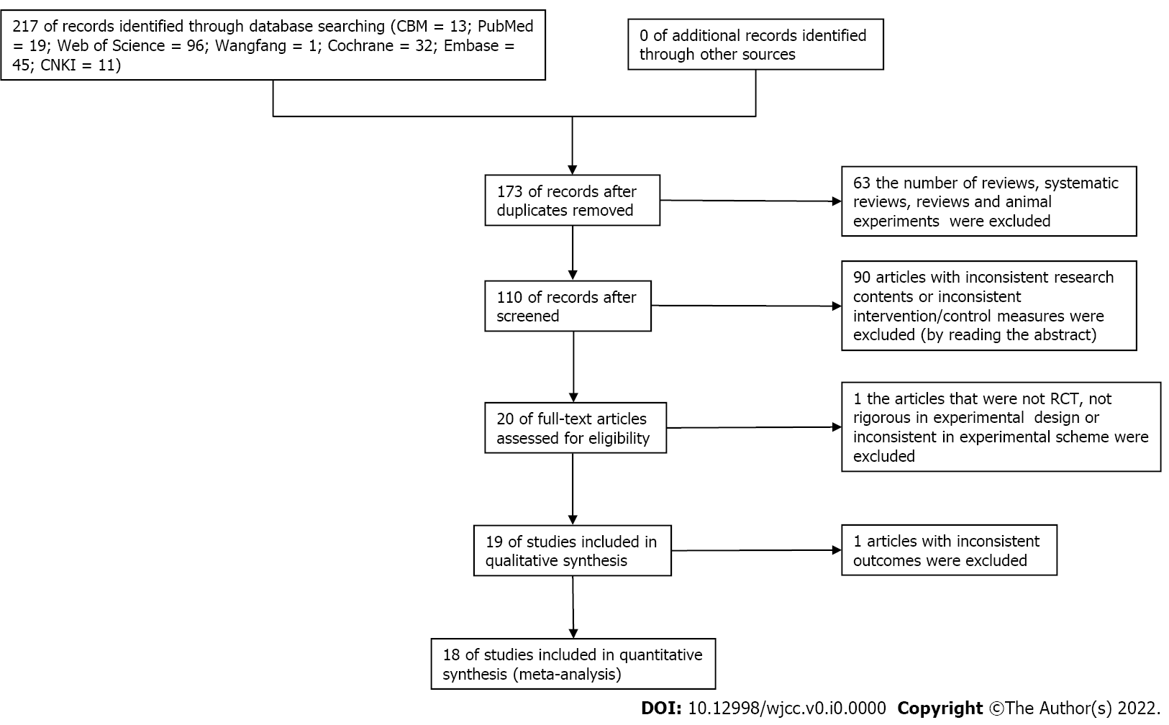
Figure 1 Flow diagram of study selection (up to June 2021). CBM: Chinese Biological Medical database; CNKI: China National Knowledge Infrastructure; VIP: China Science and Technology Journal database; WF: Wanfang database and foreign language databases including PubMed, Embase, Cochrane Library, Web of Science, etc.

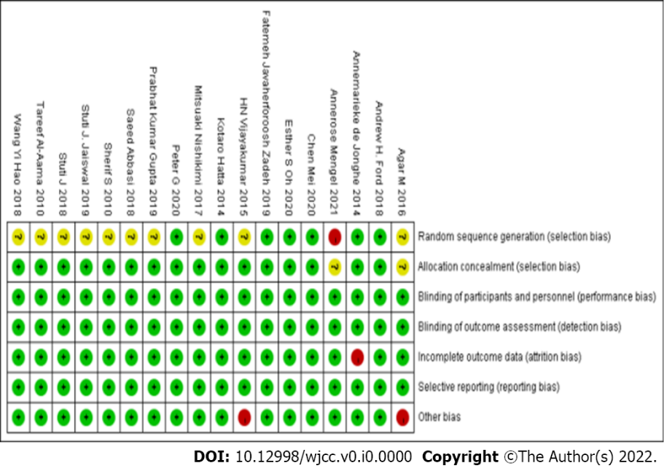
Figure 2 Methodological quality of the included studies. Category: "+" up to standard, "-" not up to standard.

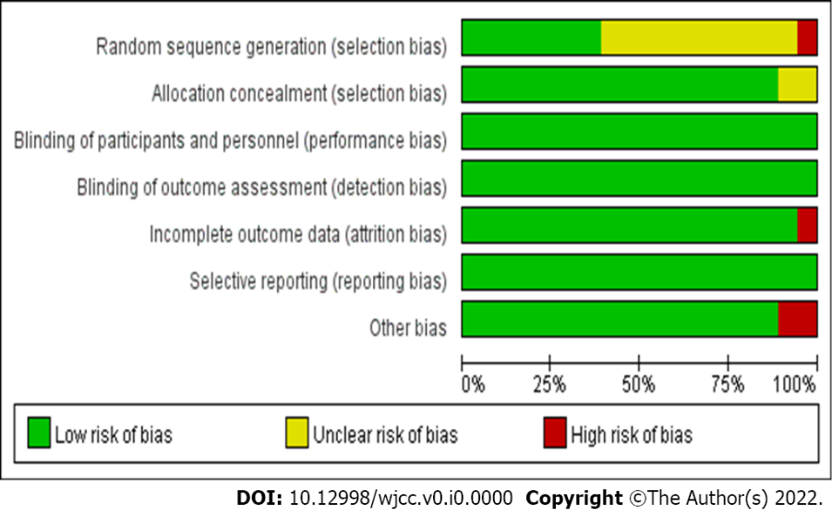
Figure 3 Distribution of the methodological quality of the included studies.

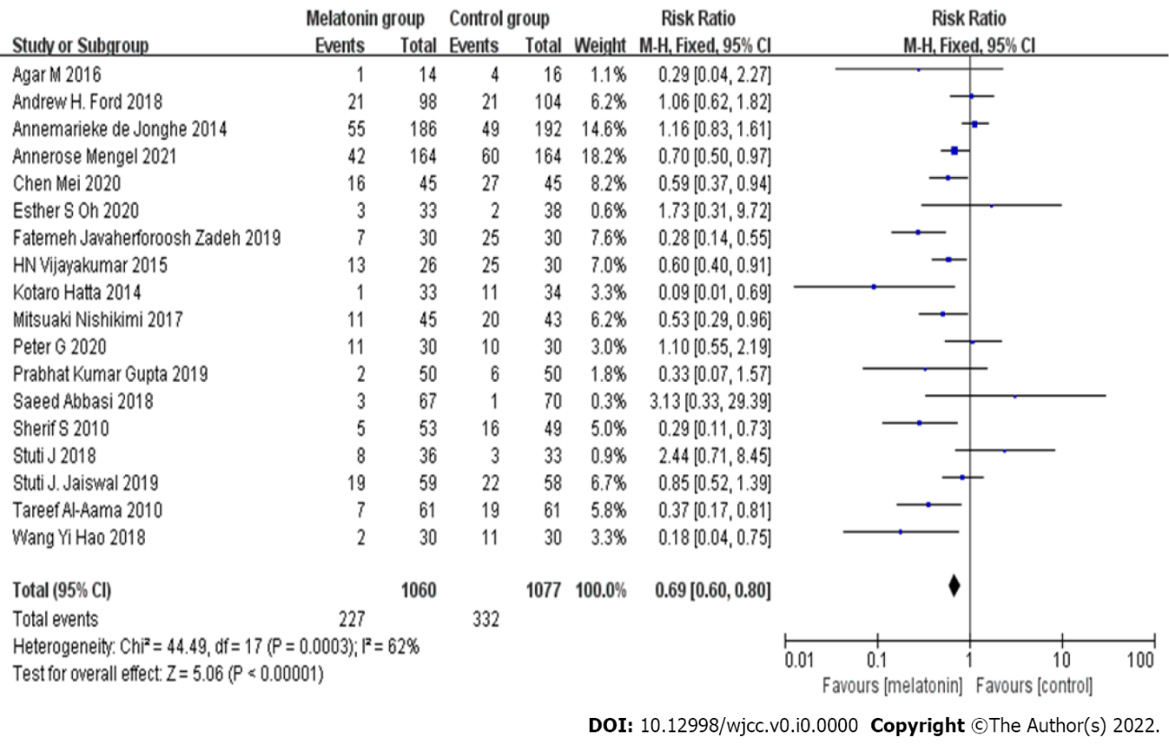
Figure 4 Meta-analysis forest diagram of melatonin in the prevention of delirium in hospitalized patients in this study. CI: Confidence interval.

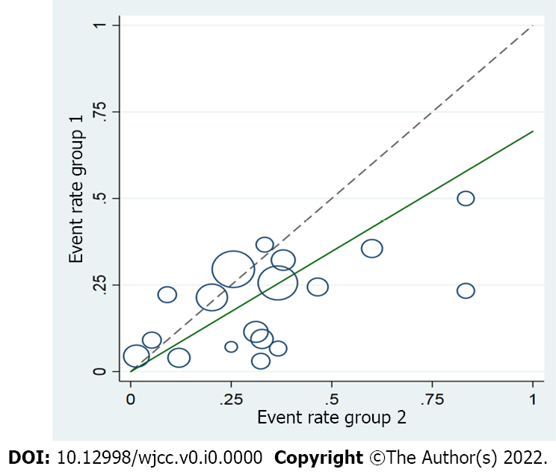
Figure 5 Diagram of melatonin in the prevention of delirium in hospitalized patients in this study. It can see that the small circles and the middle circles are distributed on both sides of the oblique line in the figure, indicating that the heterogeneity is small, the large circles are not aligned, and the heterogeneity is strong.

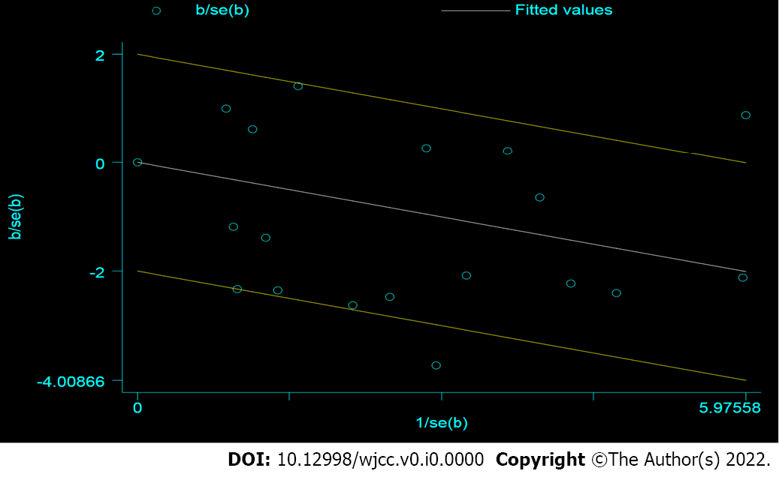
Figure 6 Galbraith diagram of melatonin in the prevention of delirium in hospitalized patients in this study (star chart).

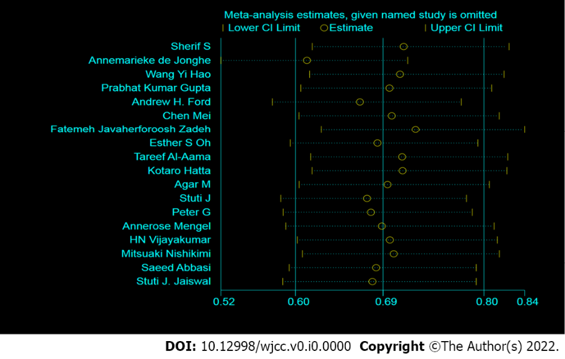
Figure 7 Sensitivity analysis of melatonin in the prevention of delirium in hospitalized patients.

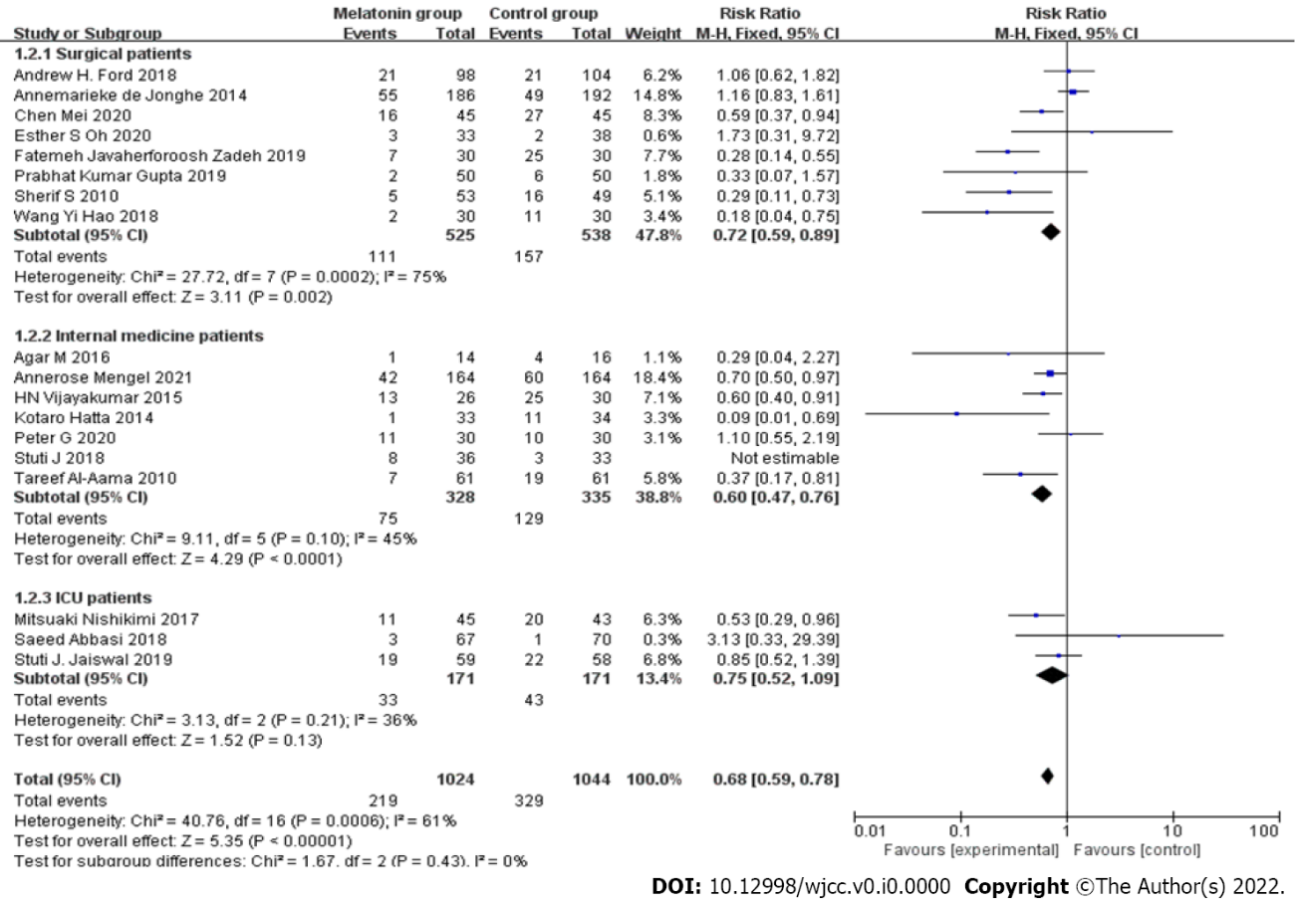
Figure 8 Forest diagram of subgroup analysis according to the type of inpatients (surgery, internal medicine, and intensive care unit).

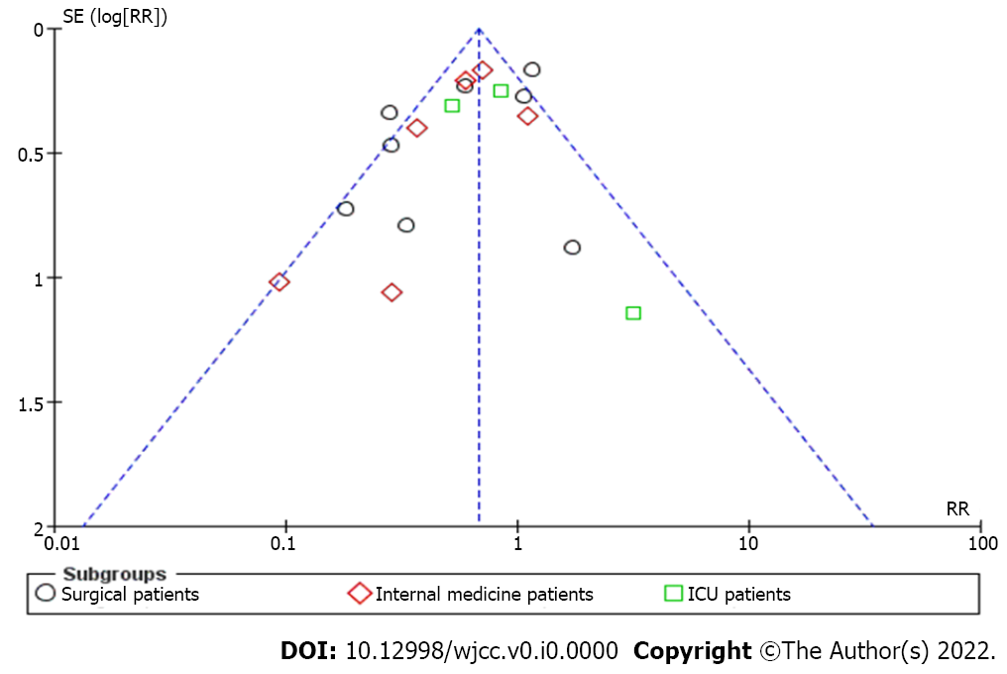
Figure 9 Funnel chart of subgroup analysis according to the type of hospitalized patients (surgery, internal medicine, and intensive care unit).

Table 1 Characteristics and details of the included studies.
Ref. | Sample size (example) |  | Intervention |  | Age |  | Diagnostic criteria
 | T | C | T | C | T | C
Sultan et al^{[16]}, 2010 | 53 | 49 | Melatonin | Placebo | 70.4 ± 7.1 | 72.3 ± 6.4 | CAM
de Jonghe et al^{[17]}, 2014 | 186 | 192 | Melatonin | Placebo | 84.1 ± 8.0 | 83.4 ± 7.5 | CAM
Wang et al^{[18]}, 2018 | 30 | 30 | Melatonin | Placebo | 70.7 ± 4.3 | 69.9 ± 4.5 | CAM
Prabhat et al^{[19]}, 2019 | 50 | 50 | Melatonin | Placebo | 69.30 ± 4.05 | 70.64 ± 3.76 | CAM
Ford et al^{[20]}, 2018 | 98 | 104 | Melatonin | Placebo | 69 ± 8.3 | 67.6 ± 8.0 | CAM
Chen et al^{[21]}, 2020 | 45 | 45 | Melatonin | Placebo | 71.36 ± 7.12 | 73.56 ± 6.65 | CAM
Javaherforoosh Zadeh et al^{[22]}, 2019 | 30 | 30 | Melatonin | Placebo | 60.26 ± 9.50 | 62.9 ± 8.08 | CAM
Oh et al^{[23]}, 2020 | 33 | 38 | Melatonin | Placebo | 71.3 ± 5.1 | 71.6 ± 5.2 | CAM
Al-Aama et al^{[24]}, 2010 | 61 | 61 | Melatonin | Placebo | 84.3 ± 5.9 | 84.6 ± 6.2 | CAM
Hatta et al^{[25]}, 2014 | 33 | 34 | Melatonin | Placebo | 78.2 ± 6.6 | 78.3 ± 6.8 | CAM
Agar et al^{[26]}, 2016 | 14 | 16 | Melatonin | Placebo | 76.3 ± 5.6 | 76.0 ± 5.3 | CAM
Jaiswal et al^{[27]}, 2018 | 36 | 33 | Melatonin | Placebo | 75.3 ± 5.3 | 75.6 ± 5.7 | CAM
Lawlor et al^{[28]}, 2020 | 30 | 30 | Melatonin | Placebo | 67 ± 5.9 | 67 ± 6.0 | CAM
Mengel et al^{[29]}, 2021 | 164 | 164 | Melatonin | Placebo | 74 ± 1.3 | 73 ± 1.5 | CAM
Vijayakumar et al^{[30]}, 2015 | 26 | 30 | Melatonin | Placebo | 36.9 ± 10.3 | 38 ± 14.4 | CAM
Nishikimi et al^{[31]}, 2017 | 45 | 43 | Melatonin | Placebo | 68.0 ± 5.1 | 68.0 ± 5.3 | CAM
Abbasi et al^{[32]}, 2018 | 67 | 70 | Melatonin | Placebo | 52.5 ± 18.4 | 49.9 ± 19 | CAM
Jaiswa et al^{[33]}, 2019 | 59 | 58 | Melatonin | Placebo | 58.1 ± 14.1 | 56.1 ± 15.8 | CAM
T: Experimental group; C: Control group; CAM: Delirium confusion assessment method standard determination.

Table 2 Meta-analysis of the prevention of delirium by melatonin in the studied hospitalized patients
 | Independent sample | Homogeneity test |  |  | Two-tailed test |  | Effect size and 95% confidence interval
 |  | χ² | P | I² | Z | P
Random effects model | 2137 | 44.49 | P < 0.0003 | 62% | 5.06 | P < 0.00001 | 0.69 (0.60, 0.80)

