Name of Journal: World Journal of Clinical Cases
Manuscript NO: 63621
Manuscript Type: CASE REPORT

Perianal superficial CD34-positive fibroblastic tumor: A case report

Long CY et al. Perianal SCPFT

Chen-Yan Long, Tao-Li Wang

Chen-Yan Long, The Second Department of General Surgery, Zhuzhou Hospital Affiliated to Xiangya School of Medicine, Central South University, Zhuzhou 412007, Hunan Province, China

Tao-Li Wang, Department of Pathology, Zhuzhou Hospital Affiliated to Xiangya School of Medicine, Central South University, Zhuzhou 412007, Hunan Province, China

Author contributions: Long CY collected the data of the case and drafted the manuscript; Wang TL reviewed the manuscript and provided constructive input; both authors read and approved the final manuscript.

Corresponding author: Tao-Li Wang, MD, Doctor, Department of Pathology, Zhuzhou Hospital Affiliated to Xiangya School of Medicine, Central South University, No. 116 Changjiang South Road, Zhuzhou 412007, Hunan Province, China. wtl820419@sina.cn

Received: February 9, 2021
Revised: April 1, 2021
Accepted: May 15, 2021
Published online: July 16, 2021
Abstract
BACKGROUND
Superficial CD34-positive fibroblast tumors (SCPFTs) are newly recognized fibroblast and myofibroblast tumors representing intermediate tumors. To the best of our knowledge, fewer than 50 cases have been reported. Perianal SCPFT has not been previously reported.

CASE SUMMARY
A 55-year-old man was hospitalized upon discovering a painless perianal lump 10 d prior. Physical examination showed a lump of approximately 3 cm × 4 cm in the 7 to 8 o’clock direction in the perianal area. Perianal abscess was considered the primary diagnosis. Lump removal surgery was performed under epidural anesthesia. Postoperative pathology showed a well-circumscribed, soft tissue-derived, spindle-cell tumor with strong CD34 positivity by immunohistochemistry. The final diagnosis was perianal SCPFT. There were no complications, and the patient was followed for more than 8 mo without recurrence or metastasis.

CONCLUSION
We report a case of perianal superficial CD34-positive fibroblast tumor. This rare mesenchymal neoplasm has distinctive histomorphology, which is important for diagnosis. Comprehensive consideration of clinical information, imaging, histology, and immunohistochemistry is important for diagnosis.

Key Words: Superficiality; CD34-positive; Fibroblast tumor; Perianal; Diagnosis; Case report

©The Author(s) 2021. Published by Baishideng Publishing Group Inc. All rights reserved.

Citation: Long CY, Wang TL. Perianal superficial CD34-positive fibroblastic tumor: A case report. World J Clin Cases 2021; 9(20): 5605-5610
URL: https://www.wjgnet.com/2307-8960/full/v9/i20/5605.htm
DOI: https://dx.doi.org/10.12998/wjcc.v9.i20.5605

Core Tip: We present a new case of perianal superficial CD34-positive fibroblast tumor. Surgery is the main treatment for superficial painless slowly growing masses. Postoperative immunohistochemical examination showed that strong positivity for CD34 and good prognosis were the characteristics of the case.

INTRODUCTION
Superficial CD34-positive fibroblast tumors (SCPFTs) are newly recognized fibroblast and myofibroblast tumors representing intermediate tumors. SCPFT was first reported in 2014^{[1]}. To date, less than 50 cases have been reported. Perianal SCPFT has not been previously reported^{[2]}. Here, we report a case that was misdiagnosed as a perianal abscess before surgery. Informed consent for the publication of these data was obtained from the patient.

CASE PRESENTATION
Chief complaints
A 55-year-old man was hospitalized after he discovered a painless perianal mass.

History of present illness
The patient’s symptoms started 10 d prior to presentation.

History of past illness
The patient had no relevant previous medical history.

Personal and family history
The patient’s family history was unremarkable.

Physical examination
A lump approximately 3 cm × 4 cm could be felt in the 7 to 8 o’clock direction of the perianal area.

Laboratory examinations
After admission to the inpatient ward, laboratory examinations were carried out, which included routine blood tests (Table 1), routine tests for stool plus occult blood, and tests for liver and kidney function, electrolytes, blood coagulation function, and tumor biomarkers. Preoperative examinations ruled out hepatitis B, hepatitis C, syphilis, and human immunodeficiency virus. All results were within normal ranges.
Postoperative pathology showed that a lump approximately 8 cm × 6.5 cm × 5 cm with a clear boundary, regional capsule, surface color of gray or taupe, interior color of gray, likely nodules, and mucoid changes in some areas was observed (Figures 1-3).
Immunohistochemistry showed that the tumor cells were diffusely and strongly positive for CD34 and vimentin, but negative for CD31, S100, desmin, EMA, SMA, CD117, Dog-1, CK-P, INI1, CD68, CD99, STAT6, β-catenin, HMB45, and ALK (D5F3) (Figure 4). The Ki-67 index was < 1%.

Imaging examinations
Ultrasound showed a 7.9 cm × 7.6 cm cystic mass in the 1 to 5 o’clock direction in the knee-chest position. The border was clear with poor entrant sound and rear echo enhancement. Many vascular signals could be detected around the mass (Figure 5).

FINAL DIAGNOSIS
SCPFT.

TREATMENT
Lump removal surgery was performed under epidural anesthesia.

OUTCOME AND FOLLOW-UP
There were no complications, and the patient was followed for more than 8 mo without recurrence or metastasis.

DISCUSSION
SCPFTs are mostly slow-growing, painless lumps, occurring in patients with a median age of 35 years (age range, 20-76 years) with a slight male preponderance^{[3-8]}. It most commonly occurs in the lower limb, thigh, buttock, shoulder, and upper arm. The location in the perianal region was not previously reported. Our patient had a small red mass but had no fever before surgery and no fever or pain, and routine blood examination was normal. It was misdiagnosed as a perianal abscess due to the unusual disease location combined with B ultrasound results. Perianal abscess often manifests as an inflammatory mass with obvious pain. The total number of leukocytes and proportion of neutrophils can be increased on routine blood examinations. CD34 expression status on immunohistochemistry is the most important discriminatory factor.
Histologically, SCPFT can vary and has many forms without unique histological morphological characteristics, and the disease can be easily misdiagnosed as other mesenchymal tumors. The features of SCPFT include the following: (1) It is a slow-growing, painless lump; (2) the tumor is confined to the deep dermis or superficial fibroadipose tissue; (3) tumor cells are composed of plump spindle to epithelioid cells^{[9]}; and (4) CD34 is strongly positive on immunohistochemistry, with partial cellular expression of keratin, no INI1 expression, and a low Ki67 proliferative index^{[10]}.
To date, surgical resection has been used to treat SCPFT. Only one patient had lymph node metastasis after the operation^{[3]}. No recurrence or metastasis was reported.

CONCLUSION
This is the first reported case of perianal SCPFT. Due to the novelty of this tumor, the long-term prognosis is not clear. Therefore, it is necessary to accumulate more cases and conduct long-term follow-up.

REFERENCES
1 Carter JM, Weiss SW, Linos K, DiCaudo DJ, Folpe AL. Superficial CD34-positive fibroblastic tumor: report of 18 cases of a distinctive low-grade mesenchymal neoplasm of intermediate (borderline) malignancy. Mod Pathol 2014; 27: 294-302 [PMID: 23887307 DOI: 10.1038/modpathol.2013.139]
2 Lin TL, Yang CS, Juan CK, Weng YC, Chen YJ. Superficial CD34-Positive Fibroblastic Tumor: A Case Report and Review of the Literature. Am J Dermatopathol 2020; 42: 68-71 [PMID: 30702454 DOI: 10.1097/DAD.0000000000001355]
3 Lao IW, Yu L, Wang J. Superficial CD34-positive fibroblastic tumour: a clinicopathological and immunohistochemical study of an additional series. Histopathology 2017; 70: 394-401 [PMID: 27636918 DOI: 10.1111/his.13088]
4 Hendry SA, Wong DD, Papadimitriou J, Robbins P, Wood BA. Superficial CD34-positive fibroblastic tumour: report of two new cases. Pathology 2015; 47: 479-482 [PMID: 26126039 DOI: 10.1097/PAT.0000000000000281]
5 Wada N, Ito T, Uchi H, Nakahara T, Tsuji G, Yamada Y, Oda Y, Furue M. Superficial CD34-positive fibroblastic tumor: A new case from Japan. J Dermatol 2016; 43: 934-936 [PMID: 26946226 DOI: 10.1111/1346-8138.13327]
6 Li W, Molnar SL, Mott M, White E, De Las Casas LE. Superficial CD34-positive fibroblastic tumor: Cytologic features, tissue correlation, ancillary studies, and differential diagnosis of a recently described soft tissue neoplasm. Diagn Cytopathol 2016; 44: 926-930 [PMID: 27432164 DOI: 10.1002/dc.23529]
7 Donaldson MR, Weber LA. Superficial CD34-Positive Fibroblastic Tumor Treated With Mohs Micrographic Surgery. Dermatol Surg 2017; 43: 1489-1491 [PMID: 28263196 DOI: 10.1097/DSS.0000000000001073]
8 Sood N, Khandelia BK. Superficial CD34-positive fibroblastic tumor: A new entity; case report and review of literature. Indian J Pathol Microbiol 2017; 60: 377-380 [PMID: 28937375 DOI: 10.4103/IJPM.IJPM_589_16]
9 Zemheri E, Karadag AS, Yılmaz İ. Superficial CD34-Positive Fibroblastic Tumor: Report of an Extremely Rare Entity. Indian J Dermatol 2020; 65: 526-529 [PMID: 33487713 DOI: 10.4103/ijd.IJD_585_18]
10 Yu L, Wang J. [Updates on pathology of soft tissue tumors]. Zhonghua Bing Li Xue Za Zhi 2013; 42: 145-146 [PMID: 23769430 DOI: 10.3760/cma.j.issn.0529-5807.2013.03.001]

Footnotes
Informed consent statement: Informed written consent was obtained from the patient for publication of this report and any accompanying images.

Conflict-of-interest statement: The authors declare that they have no conflict of interest to report.

CARE Checklist (2016) statement: The authors have read the CARE Checklist (2016), and the manuscript was prepared and revised according to the CARE Checklist (2016).

Open-Access: This article is an open-access article that was selected by an in-house editor and fully peer-reviewed by external reviewers. It is distributed in accordance with the Creative Commons Attribution NonCommercial (CC BY-NC 4.0) license, which permits others to distribute, remix, adapt, build upon this work non-commercially, and license their derivative works on different terms, provided the original work is properly cited and the use is non-commercial. See: http://creativecommons.org/Licenses/by-nc/4.0/

Manuscript source: Unsolicited manuscript

Peer-review started: February 9, 2021
First decision: March 25, 2021
Article in press: May 15, 2021

Specialty type: Surgery
Country/Territory of origin: China
Peer-review report’s scientific quality classification
Grade A (Excellent): 0
Grade B (Very good): B
Grade C (Good): C, C
Grade D (Fair): 0
Grade E (Poor): 0

P-Reviewer: Barosi G, Enomoto H S-Editor: Yan JP L-Editor: Wang TQ P-Editor: Li JH
Figure Legends

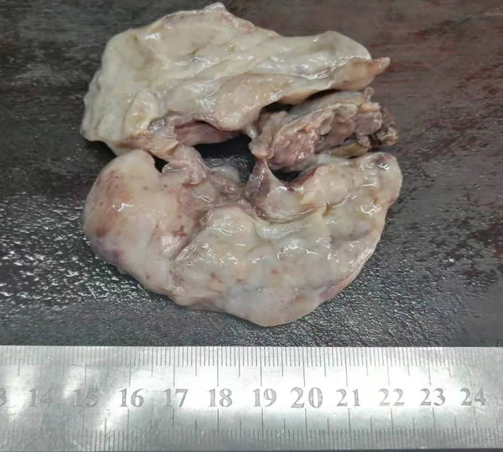
Figure 1 Postoperative gross pathology. A subcutaneous tumor approximately 8 cm in diameter was observed in the perianal area.

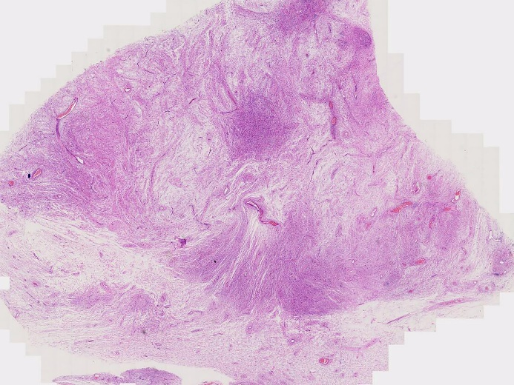
Figure 2 Histopathological examination by hematoxylin-eosin staining (0.45 ×). A tumor with a clear boundary was located in the upper dermis.

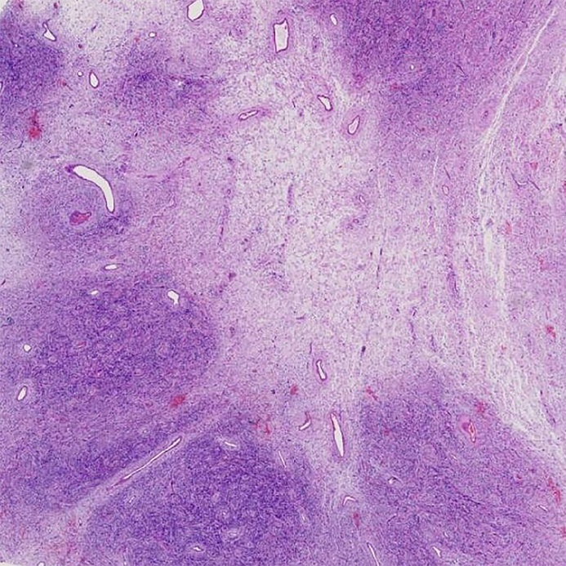
Figure 3 Histopathological examination by hematoxylin-eosin staining (20 ×). The tumor cells grew as mixed nodules in dense areas and sparse areas.

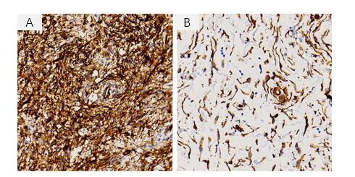

Figure 4 Immunohistochemical examination by the EnVision method (400 ×). A: Diffuse and strong expression of CD34 in the dense area; B: The expression of CD34 was positive in the sparse area.

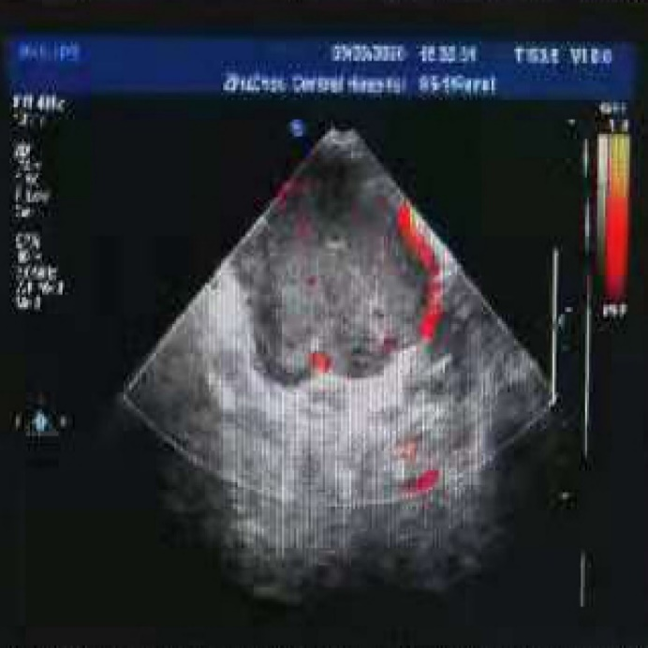
Figure 5 Ultrasound image. A perianal cystic mass, which was initially considered as a perianal abscess, was observed.

Table 1 Inflammatory factors and tumor biomarkers of this patient
Inflammatory factor |  | Tumor biomark
White blood cell count | 7.55 × 10⁹/L | AFP | 4.08 ng/mL
Neutrophil count | 4.28 × 10⁹/L | CA19-9 | 11.51 U/mL
Neutrophil percentage | 56.6% | CA125 | 7.6 U/mL
High-sensitivity C-reactive protein | 0.46 mg/L | CEA | 1.97 ng/mL

Published by Baishideng Publishing Group Inc
7041 Koll Center Parkway, Suite 160, Pleasanton, CA 94566, USA
Telephone: +1-925-3991568
E-mail: bpgoffice@wjgnet.com
Help Desk: https://www.f6publishing.com/helpdesk
https://www.wjgnet.com

© 2021 Baishideng Publishing Group Inc. All rights reserved.

