Name of Journal: World Journal of Diabetes
Manuscript NO: 89542
Manuscript Type: EDITORIAL

Potential therapeutic targets for the prevention of diabetic nephropathy: Glycyrrhetinic acid

Cai L et al. Preventive effect of GA on diabetic nephropathy

Lu Cai, Michael Horowitz, Md Shahidul Islam

Lu Cai, Pediatric Research Institute, Department of Pediatrics, University of Louisville, Louisville, KY 40202, United States

Michael Horowitz, Department of Medicine, University of Adelaide, Adelaide 5005, Australia

Md Shahidul Islam, Department of Biochemistry, School of Life Sciences, University of KwaZulu-Natal, Durban 4000, KwaZulu-Natal, South Africa

Author contributions: Cai L conceptualized and drafted the first draft of the editorial; Islam MS and Horowitz M did further revisions and editorial corrections before submission; All authors have read and approve the final manuscript.

Corresponding author: Lu Cai, MD, PhD, Director, Professor, Pediatric Research Institute, Department of Pediatrics, University of Louisville, 570 S. Preston Street, Baxter I, Rm: 304F, Louisville, KY 40202, United States. lu.cai@louisville.edu

Received: November 5, 2023
Revised: November 29, 2023
Accepted: December 6, 2023
Published online:

Abstract
Uncontrolled hyperglycemia or poorly managed disease increases the propensity for a number of diabetes-related complications targeting major organs including the heart, eyes, and kidney. Although the mechanisms by which diabetes induces cardiovascular diseases include oxidative stress and inflammation, when insulin resistance remains the key to the pathogenesis, as implicated in the two reviews in this issue. This editorial mainly comments on the potential preventive application of glycyrrhetinic acid (or 18β-GA) in relation to diabetic nephropathy. The therapeutic or preventive effects of 18β-GA, as a hydrolytic product of glycyrrhizic acid that is a component of licorice, have been appreciated in other disorders, but have received much less attention in relation to diabetic complications. A study in this issue has identified 18β-GA as a therapeutic for preventing diabetic nephropathy and provides evidence to support efficacy in cultured human renal tubule cells in vitro. Although it represents a pilot study, the observations support a new therapeutic approach that warrants further exploration.

Key Words: Insulin resistance; Diabetic cardiomyopathy; Diabetic nephropathy; Glycyrrhetinic acid; Licorice; Chinese herbal remedy

Cai L, Horowitz M, Islam MS. Potential therapeutic targets for the prevention of diabetic nephropathy: Glycyrrhetinic acid. World J Diabetes 2023; In press

Core Tip: Uncontrolled hyperglycemia or poorly managed disease increases the propensity for a number of diabetes-related complications targeting major organs including the heart, eyes, and kidney. Although the mechanisms by which diabetes induces cardiovascular diseases include oxidative stress and inflammation, when insulin resistance remains the key to the pathogenesis, as implicated in the two reviews in this issue. This editorial mainly comments on the potential preventive application of glycyrrhetinic acid (or 18β-GA) in relation to diabetic nephropathy (DN). The therapeutic or preventive effects of 18β-GA, as a hydrolytic product of glycyrrhizic acid that is a component of licorice, have been appreciated in other disorders, but have received much less attention in relation to diabetic complications. A study in this issue has identified 18β-GA as a therapeutic for preventing DN and provides evidence to support efficacy in cultured human renal tubule cells in vitro. Although it represents a pilot study, the observations support a new therapeutic approach that warrants further exploration.

INTRODUCTION
Diabetes is well known as a chronic, metabolic disease that over time often leads to serious damage to the heart, blood vessels, eyes, kidneys and nerves. More than 95% of people with diabetes have type 2 diabetes mellitus (T2DM). T2DM occurs when the body becomes resistant to insulin or doesn't make sufficient insulin due to partial pancreatic b-cell damage. T2DM usually occurs in adults but a number of recent studies have demonstrated its disturbing increasing prevalence in children and adolescents^{[1,2]}. Uncontrolled hyperglycemia or poorly managed diabetes leads to a number of diabetes-related complications targeting major organs, including heart, kidney, brain and eyes. Although these potentially life-threatening complications can be reduced or delayed by following healthy lifestyle, awareness of warning signs, regular visits to a health care provider, and effective therapeutic interventions are urgently needed, as discussed in two reviews in this or recent issue^{[3,4]}. The mechanisms by which diabetes induces cardiovascular diseases include oxidative stress and inflammation^{[1-4]}. However, insulin resistance remains key to the pathogenesis, underpinning the increases in oxidative stress and inflammation, particularly in individuals with T2DM^{[1-4]}. Insulin resistance is often accompanied by hyperlipidemia, therefore, atorvastatin as one of the statins, HMG-CoA reductase inhibitors, are used widely as a class of lipid-lowering medications. Song et al^{[5]} reported their efficacy in preventing diabetic cardiomyopathy in db/db T2DM mice, which may also be associated with anti-oxidative and anti-inflammatory effects through modulating the polarization of macrophages. This information provides an additional rationale for statins in the management of diabetic complications. However, these drugs may also exhibit adverse effects on other organs. Accordingly, the importance of natural compounds for the management of diabetic complications cannot be underestimated due to their minimal adverse effects. These natural compounds include, but not limited to, polyphenols, flavonoids, phenolic acids and zinc that have been shown to have substantial beneficial effects in the management of hyperglycemia, diabetes and its associated complications^{[6]}. In line of this notion, a study by Meng et al^{[7]} in a recent issue proposed the potential preventive effect of glycyrrhetinic acid (also called 18β-Glycyrrhetinic acid, 18β-GA) for the management of diabetic nephropathy (DN).
18β-GA, as a hydrolytic product of glycyrrhizic acid, is a component of licorice. Licorice (sometimes spelled liquorice) has been used as an herbal remedy and sweetening agent across cultures for centuries. Chinese licorice (or liquorice) root is the rhizome (the underground stem) of the plant Glycyrrhiza glabra, which is native to Asia, Turkey, and Greece. Glycyrrhizic acid is structurally composed of two molecules of glucuronic acid and 18β-GA. Glycyrrhizic acid is metabolized by gut bacteria to 18β-GA^{[8-10]}. Therefore, 18β-GA is an in vivo metabolic component of glycyrrhizic acid. It is considered widely as one of the main active substances of licorice. Although a number of recent studies have focused on the biological activities of 18β-GA, this has related primarily to its anti-inflammatory, immunoregulatory, anti-tumor, anti-injury, and antioxidative properties. A number of comprehensive reviews have summarized the protective effects of licorice-derived 18β-GA against liver injury^{[8]} and its potential immunomodulatory and anti-inflammatory properties^{[9]}, and efficacy in cancer therapy^{[10]}, as summarized in Figure 1. However, less work has been done in relation to its potential in the management of diabetic complications.
Although many studies have shown the beneficial effects of 18β-GA on other conditions, its application, and associated mechanisms for the preventive and therapeutic effects on diabetic complications are poorly understood^{[11,12]}. The study by Meng et al^{[7]} in this issue, explored the therapeutic targets and molecular mechanisms of 18β-GA against DN based on network pharmacology and molecular docking, and found that 18β-GA has a therapeutic effect on DN with a potential 186 targets. Molecular docking studies demonstrated strong binding of 18β-GA to mitogen-activated protein kinase (MAPK)-1, SRC, PIK3R1, HSP90AA1, CASPASE9, HARS, KRAS, and MAPK14. It was revealed that 18β-GA inhibits HK-2 cell viability, induces cell cycle arrest at the G2/M phase, and reduces apoptosis with 18β-GA in a dose-dependent manner after the treatment of an immortalized proximal tubule epithelial cell line from normal adult human kidney cells or HK-2 cells with high level of glucose with and without 18β-GA. Further analysis showed that 18β-GA differentially up-regulated key insulin signaling pathway members including PI3K, AKT and GSK3. These innovative and important observations have provided the evidence to support the concept of therapeutic efficacy as published previously^{[11,12]}.

CONCLUSION
In conclusion, as a main component of licorice, 18β-GA-mediated beneficial effects in several pathogenic conditions have been widely appreciated; however, its application to the management of diabetes and diabetic complications remains elusive. Although the outcomes of this pilot study have raised many questions that should be further addressed, as the authors propose, it also provides a new direction in relation to its potential clinical application for the prevention and management of DN, which is likely to be safe, inexpensive and with no or lower adverse effects.

REFERENCES
1 Tan Y, Zhang Z, Zheng C, Wintergerst KA, Keller BB, Cai L. Mechanisms of diabetic cardiomyopathy and potential therapeutic strategies: preclinical and clinical evidence. Nat Rev Cardiol 2020; 17: 585-607 [PMID: 32080423 DOI: 10.1038/s41569-020-0339-2]
2 Cai L, Tan Y, Watson S, Wintergerst K. Diabetic cardiomyopathy - Zinc preventive and therapeutic potentials by its anti-oxidative stress and sensitizing insulin signaling pathways. Toxicol Appl Pharmacol 2023; 477: 116694 [PMID: 37739320 DOI: 10.1016/j.taap.2023.116694]
3 Sun HY, Lin XY. Analysis of the management and therapeutic performance of diabetes mellitus employing special target. World J Diabetes 2023; In press
4 Wang T, Wang YY, Shi MY, Liu L. Mechanisms of action of natural products on type 2 diabetes. World J Diabetes 2023; 14: 1603-1620 [DOI: 10.4239/wjd.v14.i11.1603]
5 Song XM, Zhao MN, Li GZ, Li N, Wang T, Zhou H. Atorvastatin ameliorated myocardial fibrosis in db/db mice by inhibiting oxidative stress and modulating macrophage polarization. World J Diabetes 2023; In press
6 Islam MS, Cai L, Horowitz M. Recent therapeutic targets for the prevention and management of diabetic complications. World J Diabetes 2023; 14: 1330-1333 [PMID: 37771330 DOI: 10.4239/wjd.v14.i9.1330]
7 Meng FD, Yuan L, Xu DJ, Che MY, Hou SZ, Lu DD, Liu WJ, Nan Y. Exploring the targets and molecular mechanism of glycyrrhetinic acid against diabetic nephropathy based on network pharmacology and molecular docking. World J Diabetes 2023; 14: 1672-1692 [DOI: 10.4239/wjd.v14.i11.1672]
8 Wu SY, Wang WJ, Dou JH, Gong LK. Research progress on the protective effects of licorice-derived 18β-glycyrrhetinic acid against liver injury. Acta Pharmacol Sin 2021; 42: 18-26 [PMID: 32144337 DOI: 10.1038/s41401-020-0383-9]
9 Richard SA. Exploring the Pivotal Immunomodulatory and Anti-Inflammatory Potentials of Glycyrrhizic and Glycyrrhetinic Acids. Mediators Inflamm 2021; 2021: 6699560 [PMID: 33505216 DOI: 10.1155/2021/6699560]
10 Speciale A, Muscarà C, Molonia MS, Cristani M, Cimino F, Saija A. Recent Advances in Glycyrrhetinic Acid-Functionalized Biomaterials for Liver Cancer-Targeting Therapy. Molecules 2022; 27 [PMID: 35335138 DOI: 10.3390/molecules27061775]
11 Alqahtani A, Hamid K, Kam A, Wong KH, Abdelhak Z, Razmovski-Naumovski V, Chan K, Li KM, Groundwater PW, Li GQ. The pentacyclic triterpenoids in herbal medicines and their pharmacological activities in diabetes and diabetic complications. Curr Med Chem 2013; 20: 908-931 [PMID: 23210780]
12 Yang L, Jiang Y, Zhang Z, Hou J, Tian S, Liu Y. The anti-diabetic activity of licorice, a widely used Chinese herb. J Ethnopharmacol 2020; 263: 113216 [PMID: 32763420 DOI: 10.1016/j.jep.2020.113216]

Footnotes
Conflict-of-interest statement: Cai L, Horowitz M, and Islam MS have no conflict of interest within this article.

Open-Access: This article is an open-access article that was selected by an in-house editor and fully peer-reviewed by external reviewers. It is distributed in accordance with the Creative Commons Attribution NonCommercial (CC BY-NC 4.0) license, which permits others to distribute, remix, adapt, build upon this work non-commercially, and license their derivative works on different terms, provided the original work is properly cited and the use is non-commercial. See: https://creativecommons.org/Licenses/by-nc/4.0/

Provenance and peer review: Invited article; Externally peer reviewed.

Peer-review model: Single blind

Peer-review started: November 5, 2023
First decision: November 23, 2023
Article in press:

Specialty type: Endocrinology and metabolism
Country/Territory of origin: United States
Peer-review report’s scientific quality classification
Grade A (Excellent): 0
Grade B (Very good): B
Grade C (Good): C
Grade D (Fair): 0
Grade E (Poor): 0

P-Reviewer: Feng J, China; Guerrero-Castillo AP, Iran S-Editor: Fan JR L-Editor: A P-Editor:

Figure Legends
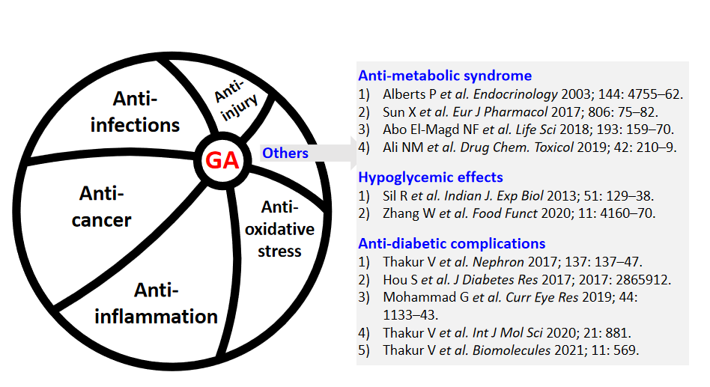
Figure 1 Summary of the beneficial effects of glycyrrhetinic acid family members. The left panel summarizes the well-known beneficial effects based on several reviews cited in this editorial publication^{[8–10]}. The right panel of this figure as a small part of total research on provides the limited publications that showed the certain protective effects on metabolic syndrome, hyperglycemia, and potential diabetic complications. GA: Glycyrrhetinic acid.

