Name of Journal: World Journal of Clinical Infectious Diseases
Manuscript NO: 65056
Manuscript Type: META-ANALYSIS

Lymphocyte count predicts the severity of COVID-19: Evidence from a meta-analysis

Zhao YS et al. Lymphocyte count and COVID-19

Yi-Si Zhao, Ying-Xi Yu

Yi-Si Zhao, Ying-Xi Yu, Department of Critical Care Medicine, The First Affiliated Hospital of Chongqing Medical University, Chongqing 400016, China

Author contributions: Zhao YS wrote and revised this manuscript; Zhao YS and Yu YX participated in discussion the research; Zhao YS searched and collected bibliography.

Corresponding author: Yi-Si Zhao, MM, Doctor, Department of Critical Care Medicine, The First Affiliated Hospital of Chongqing Medical University, No. 1 Youyi road, Yuzhong District, Chongqing 400016, China. 476663973@qq.com

Received: February 27, 2021
Revised: April 3, 2021
Accepted: September 10, 2021
Published online:

Abstract
BACKGROUND
In December 2019, the coronavirus disease 2019 (COVID-19) was reported firstly in Wuhan, China. To date, COVID-19 already is a global pandemic worldwide.

AIM
The aim of this study was to assess the suitability of lymphocyte count as a biomarker of COVID-19 severity.

METHODS
Five literature databases (PubMed/Medline, Web of Science, Google Scholar, Embase, and Scopus) were searched to identify eligible articles. A meta-analysis was performed to calculate the standard mean difference (SMD) and 95% confidence interval (95%CI) of lymphocyte counts in coronaviral pneumonia cases.

RESULTS
Eight studies, including 1057 patients, were integrated in the meta-analysis. Lymphocyte counts were associated with severe coronavirus infection (SMD = -1.35, 95%CI: -1.97, -0.37, P < 0.001, I² = 92.6%). In the subgroup analysis stratified by prognosis, lymphocytes were associated with coronavirus infection mortality (n = 2, SMD = -0.42, 95%CI: -0.66, -0.19, P < 0.001, I² = 0.0%), severity (n = 2, SMD = -0.93, 95%CI: -1.20, -0.67, P < 0.001, I² = 0.0%), and diagnostic rate (n = 4, SMD = -2.32, 95%CI: -3.60, -1.04, P < 0.001, I² = 91.2%).

CONCLUSION
Lymphocyte count may represent a simple, rapid, and commonly available laboratory index with which to diagnosis infection and predict the severity of coronavirus infections, including COVID-19. However, additional research studies, such as case-control or cohort studies, are required for detailed analyses of COVID-19.

Key Words: COVID-19; Lymphocyte count; Coronavirus; Severe of disease; Meta-analysis

Zhao YS, Yu YX. Lymphocyte count predicts the severity of COVID-19: Evidence from a meta-analysis. World J Clin Infect Dis 2021; In press

Core Tip: Lymphocyte count reflects immune function and inflammatory state of body with infectious disease. Severe acute respiratory syndrome coronavirus 2 spreads and invades through respiratory mucosa, triggers a series of immune responses and induces cytokine storm in vivo, resulting in changes in immune components such as lymphocytes. Previous studies have shown that the decrease in lymphocyte count can be used as an indicator of severity for both severe acute respiratory syndrome and Middle East respiratory syndrome, both of which are coronavirus infections. Therefore, this paper systematically reviews and meta-analysis the literature evaluating the diagnostic and prognostic utility of the lymphocyte count in patients with viral pneumonia by coronavirus infections.

INTRODUCTION
In December 2019, in Wuhan, China, a novel coronavirus was identified as the causative agent of a novel pneumonia. The disease and the virus were subsequently termed coronavirus disease 2019 (COVID-19) and severe acute respiratory syndrome coronavirus 2 (SARS-CoV-2), respectively, by the World Health Organization (WHO)^{[1,2]}. To date, COVID-19 has infected over 465000 people in 199 countries, with nearly 21000 deaths^{[3]}. These numbers continue to increase. As a coronavirus (CoV) hypotype, SARS-CoV-2 is similar to the coronaviruses causing severe acute respiratory syndrome (SARS) and Middle East respiratory syndrome (MERS)^{[4,5]}. Both SARS and MERS spread rapidly worldwide, and have led to more than 10000 human infections and 1000 deaths^{[4,6]}. The largest epidemiological study of COVID-19 performed by the Chinese CDC showed that 13.8% of all COVID-19 cases were severe, and 4.7% were critical^{[7]}. Critical patients, with a 49% case fatality rate, are at the most risk of death from COVID-19^{[7]}. Therefore, it is important to develop a rapid, simple clinical method to identify severe COVID-19 cases.
Lymphocytes play a decisive role in the maintenance of immune homeostasis and the inflammatory response in the body^{[8]}. During the progression of an infectious disease, lymphocyte count reflects immune function and inflammatory state. SARS-CoV-2 invades via the respiratory mucosa, triggering a series of immune responses in vivo, including a cytokine storm, and affecting immune components, such as peripheral blood leukocytes and lymphocytes^{[9]}. Consistent with this, studies have shown that lymphopenia, particularly the depletion of CD4 and CD8 Lymphocytes, is a clinical characteristic of COVID-19 patients, especially those with severe infections^{[10-12]}. Indeed, previous studies have shown that the decrease in lymphocyte count can be used to indicate the severity of SARS and MERS, both of which are coronavirus infections^{[13,14]}. However, due to the lack of analytical data, as might be provided by case-control or cohort studies, it is unclear whether lymphocyte count can also be used to reflect COVID-19 severity. Although Tan et al^{[15]} had reported that lymphocyte count predicted the severity of COVID-19, this study had too few samples. However, relying on the association of CoVs infection, we could find some evidence in a small number of observational studies of COVID-19. Here, we performed a systematic review and meta-analysis of the literature to evaluate the diagnostic and prognostic utility of lymphocyte count in patients with viral pneumonia caused by coronavirus infections. Our aim was to explore the possibility that lymphocyte counts predicted COVID-19 severity and provide associated evidence.

MATERIALS AND METHODS
Search strategy and selection criteria
This protocol was registered with the PROSPERO international prospective register of systematic reviews (CRD42020177132, available from: https://www.crd.york.ac.uk/prospero/display_record.php?RecordID=177132) and followed the recommendations established by the Preferred Reporting Items for Systematic Reviews and Meta-Analyses (PRISMA) statement^{[16]}. We conducted a systematic review across five literature databases: PubMed/Medline, Web of Science, Google Scholar, Embase, and Scopus. The search terms used were as follows: “lymphocyte count,” and “pneumonia, viral” or “SARS” or “MERS” or “COVID-19”. All of the searches were concluded by March 21, 2020, and two researchers independently evaluated the search results.

Eligibility criteria
We included published peer-reviewed articles describing case-control, cohort, or cross-sectional studies, where lymphocyte counts were measured in peripheral blood samples from humans of any age with coronavirus infections. Case reports, conference abstracts, and review articles were excluded.
COVID-19 infections were diagnosed using next-generation sequencing or real-time reverse transcription polymerase chain reactions (RT-PCRs)^{[17]}. MERS-CoV was diagnosed according to the WHO criteria: a confirmed case was defined as a suspected case that was positive for MERS-CoV based on RT-PCR results^{[18]}. SARS infections were confirmed based on a definite exposure history, as well as either a positive RT-PCR test during acute infection or detectable coronavirus-specific antibodies during convalescence^{[19]}. We excluded studies conducted exclusively in patients with active cancer, chronic liver disease, human immunodeficiency virus, or immunosuppression. When an article reported duplicate information from the same patient, the reports were combined to obtain complete data, but the case was only counted once.

Study selection
All of the titles and abstracts returned by the database search (Figure 1) were reviewed by First author (Zhao YS) independently to assess the need for a full-text review. Any disagreements were resolved through discussion between the same author and another author (Yu YX). Reasons for exclusion were recorded.
Assessment of risk of bias
Publication bias was assessed using a funnel-plot, Begg’s test, and Egger’s test.

Statistical analysis
According to study by Hozo et al^{[20]}, we estimating the mean and standard deviation from the median, range, and the size of a sample as data extrapolation. When sample size was small (n < 25), we use a simple formula: x = (a + 2m + b)/4 to estimate the mean (x) using the values of the median (m), low and high end of the range (a and b, respectively). As soon as sample size exceeds 25, the median itself is the best estimator. When sample size was small (n < 15), we use the formula: S² = 1/12 × (((a - 2m + b)2)/4 + (b – a) 2) to estimate the standard deviation (S²). When the sample size increases (15 < n < 70), Range/4 is the best estimator for the S². For large samples (n > 70) Range/6 is actually the best estimator for the S^{2[20]}. To indicate the severity of the coronavirus infection, we designed a cohort that combined three different measures of prognosis with respect to the control group: diagnosed vs non-diagnosed, severe vs non-severe, and death vs survival. The control group included non-diagnosed group, non-severe group and survival group. And the case group was relative severe including diagnosed group, severe group and death group.
We used the random-effects model to calculate the standard mean difference (SMD) and the 95% confidence interval (95%CI) for lymphocyte count in the coronavirus-infection patients and to draw a forest plot. Subgroup analysis was performed based on the study definition of severity. Heterogeneity between pairs of studies was quantified using the I-squared (I²) statistic. We investigated potential sources of heterogeneity, including prognosis and data source (original data vs extrapolated data), by performing subgroup analyses. One is prognosis subgroup which divided into mortality subgroup, severity subgroup and diagnostic rate subgroup according to different prognosis investigating in included studies. One is data source subgroup which divided into original data subgroup and extrapolated data subgroup. The criteria is whether the data having extrapolated according study by Hozo et al^{[20]}. All of the analyses were performed using Stata (V.14, Stata Corp, College Station, TX, USA).

RESULTS
Results of the electronic search
We identified 609 articles using database searches. After screening, 16 articles remained. After examination of the full-text articles, we excluded eight of these articles: three contained duplicate information from same patient; four articles had insufficient data on lymphocyte count; and one article chose a patient with community-acquired pneumonia as a control group. Therefore, eight studies were included in our meta-analysis^{[10,13,14,19,21-24]}.

Characteristics of the included studies
The characteristics of the eight included studies are summarized in Table 1. All of the studies included in the meta-analysis were prospective or retrospective case-control studies, cohort studies, or cross-sectional studies. The patient population in each study ranged from 30 to 346 (1057 patients in total). The earliest publications were from 2003^{[22,24]}, and the most recent article was published in 2020^{[10,21,23]}.
Most studies were based in China (n = 7), including Taiwan (n = 3)^{[13,19,24]}, Wuhan (n = 2)^{[10]}, Beijing (n = 1)^{[22]}, and Shanghai (n = 1)^{[23]}. One study was based in Saudi Arabia^{[14]}. The coronaviruses studied were COVID-19 (n = 3; 37.5%)^{[10,21,23]}, MERS (n = 1; 12.5%)^{[14]}, and SARS (n = 4; 50%)^{[13,19,22,24]}. Four studies (50%) investigated prognosis with respect to diagnostic rate (diagnosed vs non-diagnosed)^{[19,22-24]}, two studies (25%) investigated prognosis with respect to severity (severe vs non-severe)^{[10,21]}, and two studies (25%) investigated prognosis with respect to mortality (death vs survival)^{[13,14]}.

Characteristics of lymphocyte count
The means and standard deviations of lymphocyte counts from four studies^{[10,14,21,23]} were extrapolated from sample size, median, and IQR (Table 1). In the forest plot, if the SMD (95%CI) < 0. It showed that the mean and standard deviation of lymphocyte counts in case group were less than control group. That meant lymphocyte counts were less in severe coronavirus infection. Analysis showed that lymphocyte counts were associated with severe coronavirus infection (SMD = -1.35, 95%CI: -1.97, -0.37, P < 0.001, I² = 92.6%) (Figure 2). There was heterogeneity among studies. Therefore, subgroup analysis, stratified by prognosis and data source, was performed. In the subgroup analysis stratified by prognosis, lymphocytes were associated with mortality due to coronavirus infection (n = 2, SMD = -0.42, 95%CI: -0.66, -0.19, P < 0.001, I² = 0.0%), with severity of coronavirus infection (n = 2, SMD = -0.93, 95%CI: -1.20, -0.67, P < 0.001, I² = 0.0%), and with the diagnostic rate of coronavirus infection (n = 4, SMD = -2.32, 95%CI: -3.60, -1.04, P < 0.001, I² = 91.2%) (Figure 3). In the subgroup analysis stratified by data source, lymphocytes were associated with both the extrapolated data (n = 4, SMD = -0.92, 95%CI: -1.33, -0.51, P < 0.001, I² = 64.0%) and the original data (n = 4, SMD = -1.97, 95%CI: -3.35, -0.60, P < 0.001, I² = 96.5%) (see Supplementary Figure 1, which illustrates the forest plot of subgroup analysis stratified by data source), explaining the observed overall heterogeneity among studies. In addition, because few studies were included in our analysis, it was unclear whether the funnel plot was symmetrical (Figure 4), but Begg’s test and Egger’s test showed that publication bias had no significant effects on the results of the meta-analysis (P = 0.174).

DISCUSSION
COVID-19 is rapidly infectious and highly severe, with a high mortality rate ^{[3]}. Patients with COVID-19 exhibit a wide range of variability in disease severity. In clinical practice, we believe that low levels of lymphocytes are disadvantageous for COVID-19 patients. Because lymphocyte count reflects disease characteristics, this count might potentially help in the evaluation of COVID-19 severity. Usefully, this measure is easily available in laboratory tests.
Lymphocytes are vital cells that maintain immune function and execute the immune response in the body^{[8]}. In the best-case scenario, the cellular immune response rapidly clears CoV with little or no clinical signs of infection. Alternatively, the virus causes a state of immunosuppression, which debilitates and sometimes overwhelms the host’s defenses^{[25]}. Currently, no detailed study of the immunological response to SARS-CoV-2 is available. Thus, we must rely on previous studies of other CoVs, especially SARS-CoV and MERS-CoV^{[26]}. Based on other CoVs, SARS-CoV-2 might induce a T-lymphocyte-mediated protective immune response^{[25]}. However, lymphopenia is associated with many types of infections, including coronavirus^{[14,27]}. Studies have shown that lymphopenia is related to cell apoptosis in SARS patients^{[19,28]}. In addition, hospitalized patients infected with SARS-CoV-2 frequently manifest lymphopenia, suggesting that cellular immune responses may be suppressed^{[10,21]}. However, lymphopenia in MERS but not SARS cases could be a result of direct infection of T cells and infection-induced apoptosis^{[29]}. Although the lymphopenia in patients with SARS and those with MERS may have different mechanism, they forecast similar outcome. Furthermore, lymphocyte count as a biomarker to predicting severity in other non-corona-virus-diseases (such as measles, herpes and vaccinia) is effective^{[19]}. Therefore, the hypothesis which predictive role of lymphopenia in COVID-19 is reasonable, and some recently study also provide some evidence to prove this hypothesis^{[15]}. However, studies of the role of lymphocytes in COVID-19 are rare.
In this study, we designed a meta-analysis to explore the feasibility of using lymphocyte count to predict COVID-19 severity. All of the eight studies included in our meta-analysis involved SARS, MERS, or COVID-19, and were prospective or retrospective case-control, cohort, or cross-sectional studies (Table 1). Existing research results do not always rank the severity of COVID-19 infections using the same criteria. Even during the earliest part of the Chinese outbreak, the guidelines for COVID-19 diagnosis and treatment issued by the Chinese National Health Commission were revised seven times based on clinical experiences^{[30]}. Therefore, we roughly evaluated disease severity using paired concepts: “diagnosed vs non-diagnosed"^{[19,22-24]}; “severe vs non-severe"^{[10]}, and “death vs survival"^{[13,14]}.
We found that lymphocyte count was associated with severe CoV infection (SMD = -1.35, 95%CI: -1.97, -0.37, P < 0.001, I² = 92.6%) (Figure 2). Lymphocytes were also associated with CoV mortality, severity, and diagnostic rate (Figure 3). Thus, lymphocyte count may represent a simple, rapid, and commonly available diagnostic and severity-prediction tool for CoV infections, including COVID-19. Because we included studies of SARS-CoV-2 infections, our results indicate the value of lymphocyte count for the assessment of COVID-19 severity. A recent related study suggested that lymphocyte percentage (LYM%) might a reliable indicator of moderate, severe, or critical infections, independent of auxiliary indicators^{[15]}. However, this study included relatively few severe (n = 39) and critical (n = 28) cases^{[15]}. In combination, our analysis and the most recent research results suggested that lymphocyte counts potentially reflect COVID-19 severity. Meanwhile, some research showed that the viral load of SARS-CoV-2 is associated with the lymphocyte count: A study of interleukin (IL)-3 (a cytokine produced by T lymphocytes) discovered that patients with high viral load presented had lower plasma IL-3 Levels than low viral load^{[31]}. What’s more, CD4:CD8 ratio and Treg significantly decrease in mice with high viral load^{[32]}. Not only T cells, but also B cells and natural killer cells in patients with severe COVID-19 were significantly lower than those in patients with the mild form^{[33,34]}. Lymphopenia in COVID-19 may have several underlying causes, including the destruction of lymphatic organs, the direct attack on lymphocytes by SARS-CoV-2^{[35]}, lymphocyte apoptosis due to the continual release of inflammatory cytokines, or, in severe cases, the inhibition of lymphocytes by hyperlactacidemia^{[36]}. It is clear that hyperlacticacidemia- and cytokine storm-related acute respiratory distress syndrome is the primary presentation of patients with critical COVID-19 infections^{[30]}. Thus, lymphocyte count is an important indicator of severe or critical COVID-19 infection.
For the acute outbreak of COVID-19, the meta-analysis has limitations either. One hand, we faced the shortage of data sources during the research. Even now, the data with COVID-19 is insufficient at present. The research results in the previous response to coronavirus should be used for reference. The most mainstream of these were SARS and MERS. As other important subgroups in coronavirus, they have similarities to COVID-19. And from the perspective of the important characteristics of respiratory infections, SARS and MERS could be included in the reference category. The prevent and treatment methods of COVID-19 all often refer to methods of SARS and MERS. A meta-analysis about prevent person-to-person transmission of COVID-19 also included SARS, MERS coincidentally^{[37]}. Studies showed that lymphopenia is related to apoptosis, in SRAS^{[28]}. And lymphopenia is the result of direct T cell infection and infection-induced apoptosis in MERS^{[29]}. We also think that the deficiencies of such inclusion exist. Because, some differences have been found in clinical treatment (for example: Hormone use, antibody titer, etc.). However, from the current situation of prevalence, spread, and treatment, it is of reference value. On the other hand, in studies which were included in the meta-analysis, five studies referred to lymphocyte counts were obtained on the day of hospital admission, and two studies did not descript the relative time that lymphocyte counts were obtained clearly. In clinical research, because it is difficult to make a complete review to the course of disease admission, it is generally considered that it is to choose the day/time of hospital admission as the sampling point^{[10]}. Study showed that the degree of lymphopenia was steady in the first week^{[38]}. And lymphocyte counts progressive decrease and reached its lowest point in the day 14 in most cases^{[38]}. Therefore, our analysis did not divide these studies by relative time of lymphocyte counts were obtained. "One week" of hospital admission could be recognized as a stable value interval for lymphocyte counts. Of course, in recently study showed that the varied lymphocyte count in varied time of hospitalized should was obtained^{[39]}. Thus, the further study which analysis lymphocyte counts in varied time could increase the predicted efficiency in COVID-19.

CONCLUSION
Our meta-analysis provides the available information on three simple and common interventions to combat the immediate threat of COVID-19, while new evidence on pharmacological treatments, vaccines, hematology monitoring and other personal protective strategies is being generated^{[37]}. It showed that lymphocyte count may represent a simple, rapid, and commonly available laboratory index with which to diagnosis infection and predict the severity of coronavirus infections, including COVID-19. However, our study was limited by the lack of COVID-19 studies, especially those with homogeneous or uniform standards. Therefore, it was necessary to include SARS and MERS in our study, both of which can lead to coronaviral pneumonia. Thus, these diseases might represent a reference for COVID-19. During the current severe COVID-19 outbreak and pandemic, we hope to provide a framework for the future predictions of COVID-19 severity. Indeed, if critical infections could be predicted and treated earlier, mortality would be lower. Lymphocyte count is a potential indicator of COVID-19 severity and deserves further examination. However, the high heterogeneity among studies suggests that additional research, including case-control and cohort studies, is required for detailed analyses of the relationship between lymphocyte count and COVID-19 severity.

ARTICLE HIGHLIGHTS
Research background
In December 2019, the Coronavirus Disease 2019 (COVID-19) was reported firstly in Wuhan, China. To date, COVID-19 already is a global pandemic worldwide.

Research motivation
The COVID-19 with high morbidity threatens the life of global people. It is important to develop a rapid, simple clinical method to identify severe COVID-19 cases.

Research objectives
The aim of this study was to assess the suitability of lymphocyte count as a biomarker of COVID-19 severity.

Research methods
We searched Five literature databases (PubMed/Medline, Web of Science, Google Scholar, Embase, and Scopus) to identify eligible articles. A meta-analysis was performed to calculate the standard mean difference (SMD) and 95% confidence interval (95%CI) of lymphocyte counts in coronaviral pneumonia cases.

Research results
Our research integrated eight studies, including 1057 patients. Lymphocyte counts were associated with severe coronavirus infection (SMD = -1.35, 95%CI: -1.97, -0.37, P < 0.001, I² = 92.6%). In the subgroup analysis stratified by prognosis, lymphocytes were associated with coronavirus infection mortality (n = 2, SMD = -0.42, 95%CI: -0.66, -0.19, P < 0.001, I² = 0.0%), severity (n = 2, SMD = -0.93, 95%CI: -1.20, -0.67, P < 0.001, I² = 0.0%), and diagnostic rate (n = 4, SMD = -2.32, 95%CI: -3.60, -1.04, P < 0.001, I² = 91.2%).

Research conclusions
Lymphocyte count may represent a simple, rapid, and commonly available laboratory index with which to diagnosis infection and predict the severity of coronavirus infections, including COVID-19.

Research perspectives
As a coronavirus hypotype, severe acute respiratory syndrome (SARS) coronavirus 2 is similar to the coronaviruses causing SARS and Middle East respiratory syndrome. Hence, we performed a systematic review and meta-analysis of the literature to evaluate the diagnostic and prognostic utility of lymphocyte count in patients with viral pneumonia caused by coronavirus infections. Our aim was to explore the possibility that lymphocyte counts predicted COVID-19 severity and provide associated evidence.

ACKNOWLEDGEMENTS
This article also commemorates the Chinese medical staffs who gave their lives in the fight of COVID-19.

REFERENCES
1 Zhu N, Zhang D, Wang W, Li X, Yang B, Song J, Zhao X, Huang B, Shi W, Lu R, Niu P, Zhan F, Ma X, Wang D, Xu W, Wu G, Gao GF, Tan W; China Novel Coronavirus Investigating and Research Team. A Novel Coronavirus from Patients with Pneumonia in China, 2019. N Engl J Med 2020; 382: 727-733 [PMID: 31978945 DOI: 10.1056/NEJMoa2001017]
2 Sohrabi C, Alsafi Z, O'Neill N, Khan M, Kerwan A, Al-Jabir A, Iosifidis C, Agha R. World Health Organization declares global emergency: A review of the 2019 novel coronavirus (COVID-19). Int J Surg 2020; 76: 71-76 [PMID: 32112977 DOI: 10.1016/j.ijsu.2020.02.034]
3 World Health Organization. Coronavirus disease 2019 (COVID-19) Situation Report –66. 2020 [cited 20 December 2020]. Available from: https://www.who.int/docs/default-source/coronaviruse/situation-reports/20200326-sitrep-66-covid-19.pdf?sfvrsn=81b94e61_2
4 Peiris JS, Guan Y, Yuen KY. Severe acute respiratory syndrome. Nat Med 2004; 10: S88-S97 [PMID: 15577937 DOI: 10.1038/nm1143]
5 Zaki AM, van Boheemen S, Bestebroer TM, Osterhaus AD, Fouchier RA. Isolation of a novel coronavirus from a man with pneumonia in Saudi Arabia. N Engl J Med 2012; 367: 1814-1820 [PMID: 23075143 DOI: 10.1056/NEJMoa1211721]
6 Badawi A, Ryoo SG. Prevalence of Diabetes in the 2009 Influenza A (H1N1) and the Middle East Respiratory Syndrome Coronavirus: A Systematic Review and Meta-Analysis. J Public Health Res 2016; 5: 733 [PMID: 28083520 DOI: 10.4081/jphr.2016.733]
7 Epidemiology Working Group for NCIP Epidemic Response, Chinese Center for Disease Control and Prevention. The epidemiological characteristics of an outbreak of 2019 novel coronavirus diseases (COVID-19) in China. Zhonghua Liu Xing Bing Xue Za Zhi 2020; 41: 145-151 [PMID: 32064853 DOI: 10.3760/cma.j.issn.0254-6450.2020.02.003]
8 Jalkanen S, Salmi M. Lymphatic endothelial cells of the lymph node. Nat Rev Immunol 2020; 20: 566-578 [PMID: 32094869 DOI: 10.1038/s41577-020-0281-x]
9 Wu J, Liu J, Zhao X, Liu C, Wang W, Wang D, Xu W, Zhang C, Yu J, Jiang B, Cao H, Li L. Clinical Characteristics of Imported Cases of Coronavirus Disease 2019 (COVID-19) in Jiangsu Province: A Multicenter Descriptive Study. Clin Infect Dis 2020; 71: 706-712 [PMID: 32109279 DOI: 10.1093/cid/ciaa199]
10 Wang D, Hu B, Hu C, Zhu F, Liu X, Zhang J, Wang B, Xiang H, Cheng Z, Xiong Y, Zhao Y, Li Y, Wang X, Peng Z. Clinical Characteristics of 138 Hospitalized Patients With 2019 Novel Coronavirus-Infected Pneumonia in Wuhan, China. JAMA 2020; 323: 1061-1069 [PMID: 32031570 DOI: 10.1001/jama.2020.1585]
11 Chen N, Zhou M, Dong X, Qu J, Gong F, Han Y, Qiu Y, Wang J, Liu Y, Wei Y, Xia J, Yu T, Zhang X, Zhang L. Epidemiological and clinical characteristics of 99 cases of 2019 novel coronavirus pneumonia in Wuhan, China: a descriptive study. Lancet 2020; 395: 507-513 [PMID: 32007143 DOI: 10.1016/S0140-6736(20)30211-7]
12 Rodriguez-Morales AJ, Cardona-Ospina JA, Gutiérrez-Ocampo E, Villamizar-Peña R, Holguin-Rivera Y, Escalera-Antezana JP, Alvarado-Arnez LE, Bonilla-Aldana DK, Franco-Paredes C, Henao-Martinez AF, Paniz-Mondolfi A, Lagos-Grisales GJ, Ramírez-Vallejo E, Suárez JA, Zambrano LI, Villamil-Gómez WE, Balbin-Ramon GJ, Rabaan AA, Harapan H, Dhama K, Nishiura H, Kataoka H, Ahmad T, Sah R; Latin American Network of Coronavirus Disease 2019-COVID-19 Research (LANCOVID-19). Clinical, laboratory and imaging features of COVID-19: A systematic review and meta-analysis. Travel Med Infect Dis 2020; 34: 101623 [PMID: 32179124 DOI: 10.1016/j.tmaid.2020.101623]
13 Chang HL, Chen KT, Lai SK, Kuo HW, Su IJ, Lin RS, Sung FC. Hematological and biochemical factors predicting SARS fatality in Taiwan. J Formos Med Assoc 2006; 105: 439-450 [PMID: 16801031 DOI: 10.1016/S0929-6646(09)60183-2]
14 Das KM, Lee EY, Al Jawder SE, Enani MA, Singh R, Skakni L, Al-Nakshabandi N, AlDossari K, Larsson SG. Acute Middle East Respiratory Syndrome Coronavirus: Temporal Lung Changes Observed on the Chest Radiographs of 55 Patients. AJR Am J Roentgenol 2015; 205: W267-W274 [PMID: 26102309 DOI: 10.2214/AJR.15.14445]
15 Tan L, Wang Q, Zhang D, Ding J, Huang Q, Tang YQ, Wang Q, Miao H. Lymphopenia predicts disease severity of COVID-19: a descriptive and predictive study. Signal Transduct Target Ther 2020; 5: 33 [PMID: 32296069 DOI: 10.1038/s41392-020-0148-4]
16 Moher D, Liberati A, Tetzlaff J, Altman DG; PRISMA Group. Preferred reporting items for systematic reviews and meta-analyses: the PRISMA statement. Int J Surg 2010; 8: 336-341 [PMID: 20171303 DOI: 10.1016/j.ijsu.2010.02.007]
17 Huang C, Wang Y, Li X, Ren L, Zhao J, Hu Y, Zhang L, Fan G, Xu J, Gu X, Cheng Z, Yu T, Xia J, Wei Y, Wu W, Xie X, Yin W, Li H, Liu M, Xiao Y, Gao H, Guo L, Xie J, Wang G, Jiang R, Gao Z, Jin Q, Wang J, Cao B. Clinical features of patients infected with 2019 novel coronavirus in Wuhan, China. Lancet 2020; 395: 497-506 [PMID: 31986264 DOI: 10.1016/S0140-6736(20)30183-5]
18 Who Mers-Cov Research Group. State of Knowledge and Data Gaps of Middle East Respiratory Syndrome Coronavirus (MERS-CoV) in Humans. PLoS Curr 2013; 5 [PMID: 24270606 DOI: 10.1371/currents.outbreaks.0bf719e352e7478f8ad85fa30127ddb8]
19 Chen RF, Chang JC, Yeh WT, Lee CH, Liu JW, Eng HL, Yang KD. Role of vascular cell adhesion molecules and leukocyte apoptosis in the lymphopenia and thrombocytopenia of patients with severe acute respiratory syndrome (SARS). Microbes Infect 2006; 8: 122-127 [PMID: 16182592 DOI: 10.1016/j.micinf.2005.06.007]
20 Hozo SP, Djulbegovic B, Hozo I. Estimating the mean and variance from the median, range, and the size of a sample. BMC Med Res Methodol 2005; 5: 13 [PMID: 15840177 DOI: 10.1186/1471-2288-5-13]
21 Zhang JJ, Dong X, Cao YY, Yuan YD, Yang YB, Yan YQ, Akdis CA, Gao YD. Clinical characteristics of 140 patients infected with SARS-CoV-2 in Wuhan, China. Allergy 2020; 75: 1730-1741 [PMID: 32077115 DOI: 10.1111/all.14238]
22 Cui W, Fan Y, Wu W, Zhang F, Wang JY, Ni AP. Expression of lymphocytes and lymphocyte subsets in patients with severe acute respiratory syndrome. Clin Infect Dis 2003; 37: 857-859 [PMID: 12955652 DOI: 10.1086/378587]
23 Li YX, Wu W, Yang T, Zhou W, Fu YM, Feng QM, Ye JM. [Characteristics of peripheral blood leukocyte differential counts in patients with COVID-19]. Zhonghua Nei Ke Za Zhi 2020; 59: 372-374 [PMID: 32370466 DOI: 10.3760/cma.j.cn112138-20200221-00114]
24 Chen SY, Su CP, Ma MH, Chiang WC, Hsu CY, Ko PC, Tsai KC, Yen ZS, Shih FY, Chen SC, Chen WJ. Predictive model of diagnosing probable cases of severe acute respiratory syndrome in febrile patients with exposure risk. Ann Emerg Med 2004; 43: 1-5 [PMID: 14707932 DOI: 10.1016/s0196-0644(03)00817-5]
25 Jin W, Zhu X, Yao F, Xu X, Chen X, Luo Z, Zhao D, Li X, Leng X, Sun L. Corrigendum to "Cytoprotective effect of Fufang Lurong Jiangu capsule against hydrogen peroxide-induced oxidative stress in bone marrow stromal cell-derived osteoblasts through the Nrf2/HO-1 signaling pathway" [Biomed. Pharmacother. 121 (2020) 109676]. Biomed Pharmacother 2020; 122: 109808 [PMID: 31902541 DOI: 10.1016/j.biopha.2019.109808]
26 Hu H, Tao L, Wang Y, Chen L, Yang J, Wang H. Enhancing immune responses against SARS-CoV nucleocapsid DNA vaccine by co-inoculating interleukin-2 expressing vector in mice. Biotechnol Lett 2009; 31: 1685-1693 [PMID: 19579009 DOI: 10.1007/s10529-009-0061-y]
27 Chan MH, Wong VW, Wong CK, Chan PK, Chu CM, Hui DS, Suen MW, Sung JJ, Chung SS, Lam CW. Serum LD1 isoenzyme and blood lymphocyte subsets as prognostic indicators for severe acute respiratory syndrome. J Intern Med 2004; 255: 512-518 [PMID: 15049886 DOI: 10.1111/j.1365-2796.2004.01323.x]
28 O'Donnell R, Tasker RC, Roe MF. SARS: understanding the coronavirus: apoptosis may explain lymphopenia of SARS. BMJ 2003; 327: 620 [PMID: 12969939 DOI: 10.1136/bmj.327.7415.620-b]
29 Chu H, Zhou J, Wong BH, Li C, Chan JF, Cheng ZS, Yang D, Wang D, Lee AC, Li C, Yeung ML, Cai JP, Chan IH, Ho WK, To KK, Zheng BJ, Yao Y, Qin C, Yuen KY. Middle East Respiratory Syndrome Coronavirus Efficiently Infects Human Primary T Lymphocytes and Activates the Extrinsic and Intrinsic Apoptosis Pathways. J Infect Dis 2016; 213: 904-914 [PMID: 26203058 DOI: 10.1093/infdis/jiv380]
30 National Health Commission of China. The guidelines for diagnosis and treatment of novel coronavirus (2019-nCoV) infected pneumonia (the seventh edition draft). [cited 20 December 2020]. Available from: http://www.gov.cn/zhengce/zhengceku/2020-03/04/5486705/files/ae61004f930d47598711a0d4cbf874a9.pdf
31 Bénard A, Jacobsen A, Brunner M, Krautz C, Klösch B, Swierzy I, Naschberger E, Podolska MJ, Kouhestani D, David P, Birkholz T, Castellanos I, Trufa D, Sirbu H, Vetter M, Kremer AE, Hildner K, Hecker A, Edinger F, Tenbusch M, Mühl-Zürbes P, Steinkasserer A, Richter E, Streeck H, Berger MM, Brenner T, Weigand MA, Swirski FK, Schett G, Grützmann R, Weber GF. Interleukin-3 is a predictive marker for severity and outcome during SARS-CoV-2 infections. Nat Commun 2021; 12: 1112 [PMID: 33602937 DOI: 10.1038/s41467-021-21310-4]
32 Graham JB, Swarts JL, Leist SR, Schäfer A, Menachery VD, Gralinski LE, Jeng S, Miller DR, Mooney MA, McWeeney SK, Ferris MT, Pardo-Manuel de Villena F, Heise MT, Baric RS, Lund JM. Baseline T cell immune phenotypes predict virologic and disease control upon SARS-CoV infection in Collaborative Cross mice. PLoS Pathog 2021; 17: e1009287 [PMID: 33513210 DOI: 10.1371/journal.ppat.1009287]
33 Corrao S, Gervasi F, Di Bernardo F, Natoli G, Raspanti M, Catalano N, Argano C. Immunological Characteristics of Non-Intensive Care Hospitalized COVID-19 Patients: A Preliminary Report. J Clin Med 2021; 10: 849 [PMID: 33669527 DOI: 10.3390/jcm10040849]
34 Gao Y, Chen L, Chi J, Zeng S, Feng X, Li H, Liu D, Feng X, Wang S, Wang Y, Yu R, Yuan Y, Xu S, Li C, Zhang W, Li S, Gao Q. Development and validation of an online model to predict critical COVID-19 with immune-inflammatory parameters. J Intensive Care 2021; 9: 19 [PMID: 33602326 DOI: 10.1186/s40560-021-00531-1]
35 Xu H, Zhong L, Deng J, Peng J, Dan H, Zeng X, Li T, Chen Q. High expression of ACE2 receptor of 2019-nCoV on the epithelial cells of oral mucosa. Int J Oral Sci 2020; 12: 8 [PMID: 32094336 DOI: 10.1038/s41368-020-0074-x]
36 Fischer K, Hoffmann P, Voelkl S, Meidenbauer N, Ammer J, Edinger M, Gottfried E, Schwarz S, Rothe G, Hoves S, Renner K, Timischl B, Mackensen A, Kunz-Schughart L, Andreesen R, Krause SW, Kreutz M. Inhibitory effect of tumor cell-derived lactic acid on human T cells. Blood 2007; 109: 3812-3819 [PMID: 17255361 DOI: 10.1182/blood-2006-07-035972]
37 Chu DK, Akl EA, Duda S, Solo K, Yaacoub S, Schünemann HJ; COVID-19 Systematic Urgent Review Group Effort (SURGE) study authors. Physical distancing, face masks, and eye protection to prevent person-to-person transmission of SARS-CoV-2 and COVID-19: a systematic review and meta-analysis. Lancet 2020; 395: 1973-1987 [PMID: 32497510 DOI: 10.1016/S0140-6736(20)31142-9]
38 Wong RS, Wu A, To KF, Lee N, Lam CW, Wong CK, Chan PK, Ng MH, Yu LM, Hui DS, Tam JS, Cheng G, Sung JJ. Haematological manifestations in patients with severe acute respiratory syndrome: retrospective analysis. BMJ 2003; 326: 1358-1362 [PMID: 12816821 DOI: 10.1136/bmj.326.7403.1358]
39 Petrilli CM, Jones SA, Yang J, Rajagopalan H, O'Donnell L, Chernyak Y, Tobin KA, Cerfolio RJ, Francois F, Horwitz LI. Factors associated with hospital admission and critical illness among 5279 people with coronavirus disease 2019 in New York City: prospective cohort study. BMJ 2020; 369: m1966 [PMID: 32444366 DOI: 10.1136/bmj.m1966]

Footnotes
Conflict-of-interest statement: We not received any fees for serving as a speaker. We not received any research funding from.

PRISMA 2009 Checklist statement: The authors have read the PRISMA 2009 Checklist, and the manuscript was prepared and revised according to the PRISMA 2009 Checklist.

Open-Access: This article is an open-access article that was selected by an in-house editor and fully peer-reviewed by external reviewers. It is distributed in accordance with the Creative Commons Attribution NonCommercial (CC BY-NC 4.0) license, which permits others to distribute, remix, adapt, build upon this work non-commercially, and license their derivative works on different terms, provided the original work is properly cited and the use is non-commercial. See: http://creativecommons.org/Licenses/by-nc/4.0/

Manuscript source: Unsolicited manuscript

Peer-review started: February 27, 2021
First decision: March 31, 2021
Article in press:

Specialty type: Infectious diseases
Country/Territory of origin: China
Peer-review report’s scientific quality classification
Grade A (Excellent): 0
Grade B (Very good): B, B
Grade C (Good): 0
Grade D (Fair): 0
Grade E (Poor): 0

P-Reviewer: Shimizu Y S-Editor: Liu M L-Editor: P-Editor:

Figure Legends
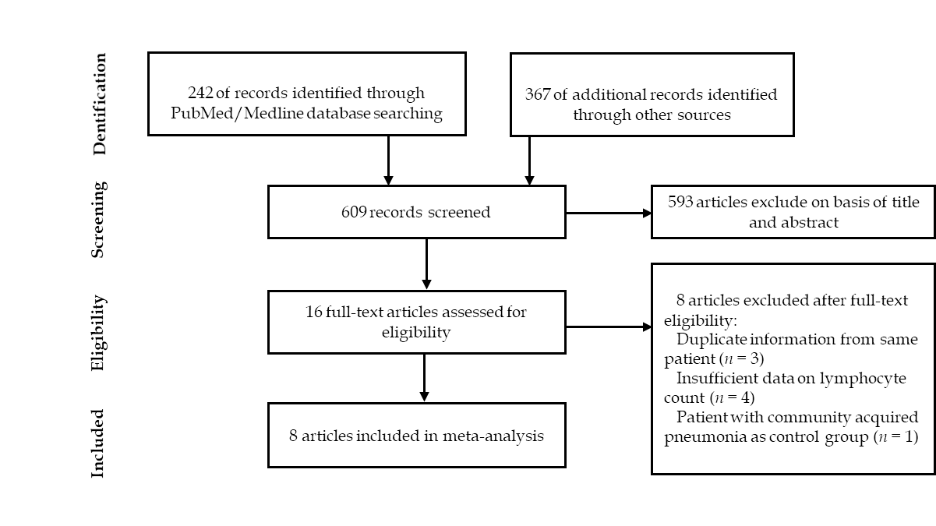
Figure 1 Article selection process.

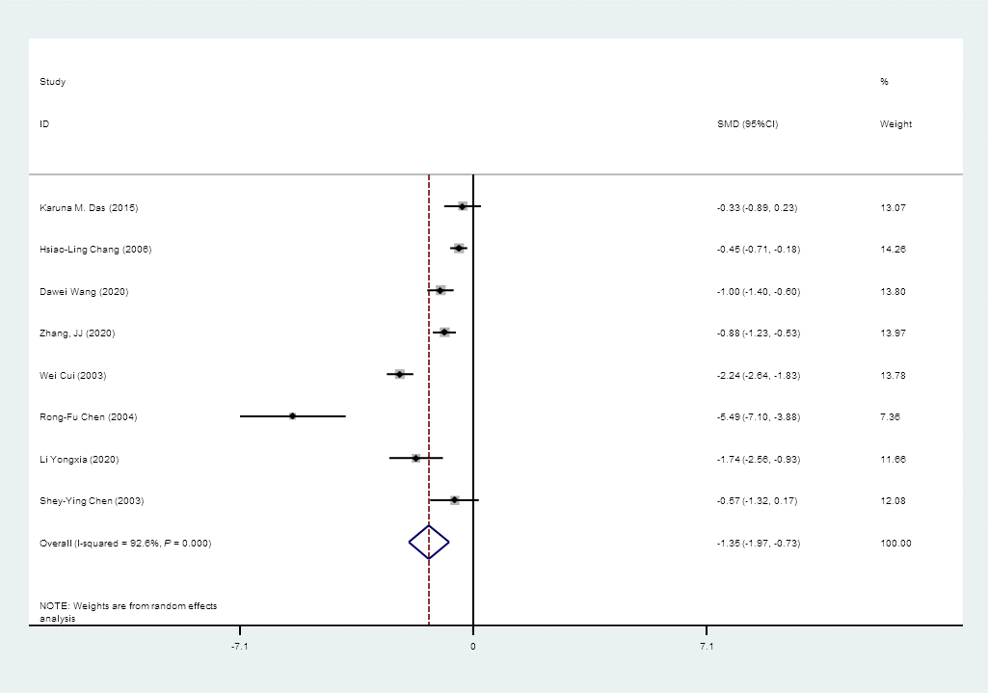
Figure 2 Forest plot: Overall identification of lymphocyte count in patients with coronaviral pneumonia. P = 0.000 means P < 0.001. CI: Confidence interval.

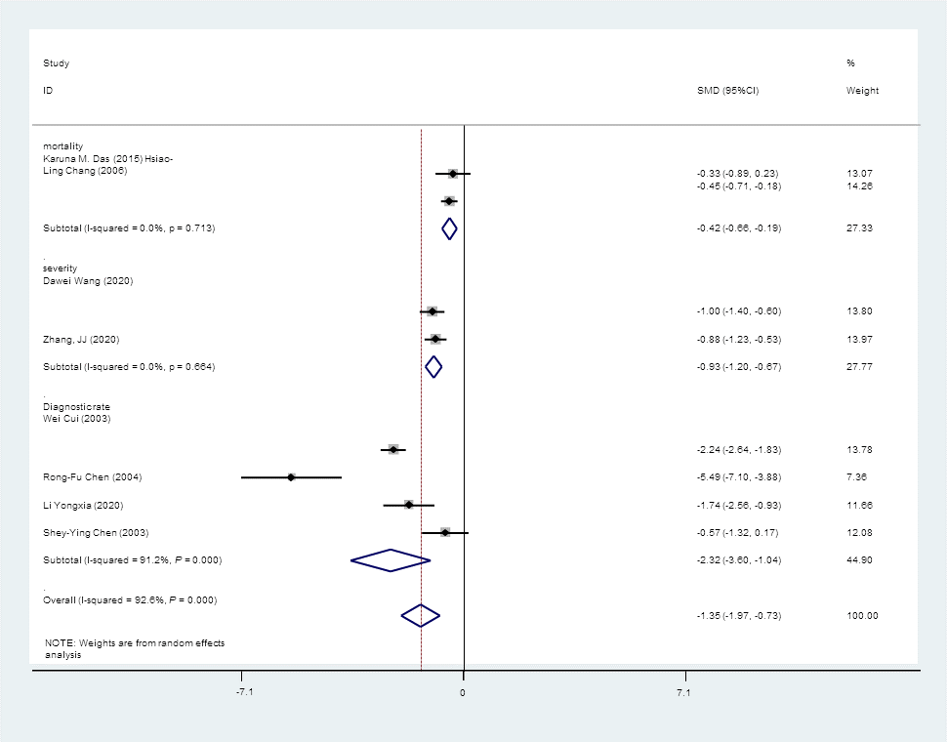
Figure 3 Forest plot: Overall identification of lymphocyte count in patients with coronaviral pneumonia, subgroup analysis stratified by prognosis. P = 0.000 means P < 0.001. CI: Confidence interval.

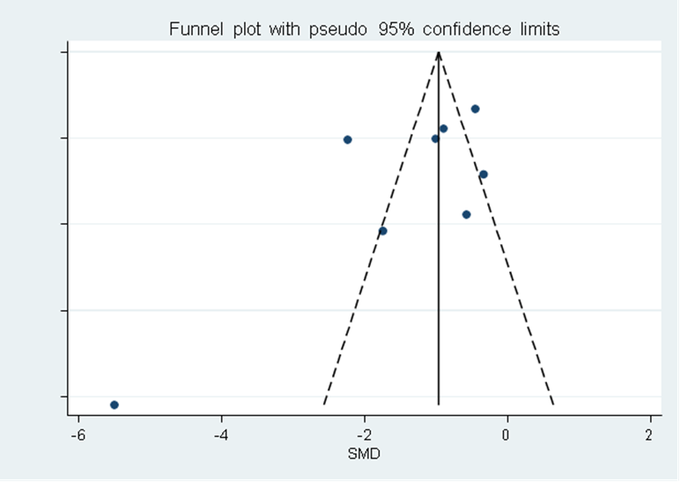
Figure 4 Funnel plot: Publication bias of eight studies included.

Table 1 Characteristics of the included studies
Ref. | City, country | Type of coronavirus | Outcome | n (case) | Lymphocyte count of case, mean ± SD (*10⁹/L) | n (control) | Lymphocyte count of control, mean ± SD (× 10⁹/L)
Das et al^{[14]}, 2015 | Saudi Arabia | MERS | Mortality | 19 | 18.25 ± 11.75 | 36 | 24.00 ± 19.75
Chang et al^{[13]}, 2006 | Taiwan, China | SARS | Mortality | 73 | 0.81 ± 0.38 | 273 | 1.02 ± 0.48
Wang et al^{[10]}, 2020 | Wuhan, China | COVID-19 | Severity | 36 | 0.80 ± 0.10 | 102 | 0.90 ± 0.10
Zhang et al^{[21]}, 2020 | Wuhan, China | COVID-19 | Severity | 58 | 0.70 ± 0.13 | 82 | 0.80 ± 0.10
Cui et al^{[22]}, 2003 | Beijing, China | SARS | Diagnostic rate | 38 | 0.91 ± 0.44 | 200 | 3.00 ± 1.00
Chen et al^{[19]}, 2006 | Taiwan, China | SARS | Diagnostic rate | 15 | 0.60 ± 0.30 | 15 | 2.00 ± 0.20
Li et al^{[23]}, 2020 | Shanghai, China | COVID-19 | Diagnostic rate | 10 | 1.22 ± 0.20 | 30 | 1.75 ± 0.33
Chen et al^{[24]}, 2004 | Taiwan, China | SARS | Diagnostic rate | 8 | 0.90 ± 0.30 | 62 | 1.50 ± 1.10
COVID-19: Coronavirus disease 2019; SARS: Severe acute respiratory syndrome.

