Supplementary Table I. PCR Primers for detection of HBV DNA
HBV genomic regions | Nucleotide position | Product size
S region
S1-F : 5'-CATCAGGATTCCTAGGACCCCT-3’  S2-R : 5'-AGGACAAACGGGCAACATAC-3'  S3-F : 5'-CTTGTTGACAAGAATCCTCACA-3'  S4-R : 5'-CCAACAAGAAGATGAGGCATA-3' | 168-189  478-458  214-235  442-420 | 311bp  229bp
Pre-core / Core region
C5-F : 5'-TCACCTCTGCCTAATCATC-3'  C6-R : 5'-GAGGGAGTTCTTCTTCTAGG-3'  C7-F : 5'-TTCAAGCCTCCAAGCTGTGCC-3'  C8-R : 5-AGGAGTGCGAATCCACACTCC-3' | 1825-1843  2391-2371  1862-1882  2277-2267 | 546bp  406bp
Pol region
P9-F : 5'-CGTCGCAGAAGATCTCAATC-3'  P10-R : 5'-TCTTGTTCCCAAGAATATGGT-3'  P11-F : 5'-CCTTGGACTCATAAGGT-3'  P12-R : 5'-TCCCAAGAATATGGTGACCC-3' | 2420-2439  2845-2825  2463-2479  2839-2820 | 406bp  358bp
X region
X13-F : 5'-CGCCAACTTACAAGGCCTTTC-3'  X14-R : 5'-GGCGTTCACGGTGGTCTCCAT-3'  X15-F : 5'-CCATACTGCGGAACTCCTAG-3'  X16-R : 5'-CGTAAAGAGAGGTGCGCCCC-3' | 1100-1120  1628-1608  1266-1685  1540-1521 | 509bp  256bp
HBV: Hepatitis B virus.

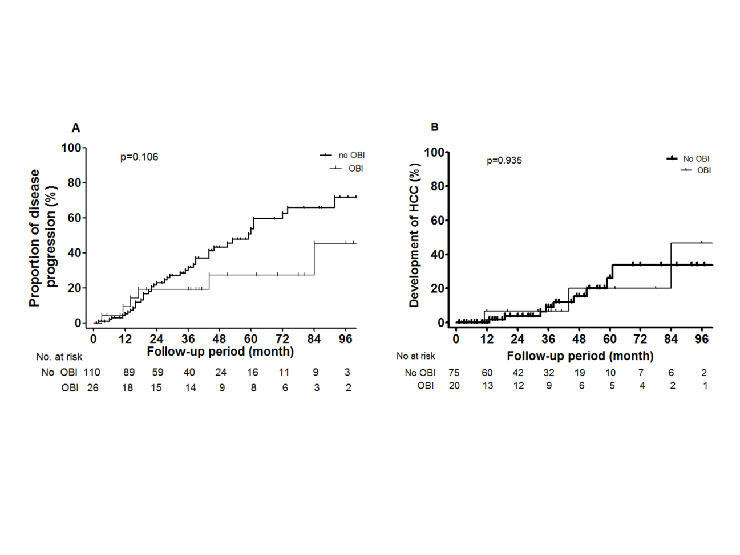Supplementary Figure 1 Cumulative incidence of disease progression defined as development of liver cirrhosis or hepatocellular carcinoma, worsening of Child Pugh class, or mortality according to the presence of occult hepatitis B virus infection (OBI) (A) and development of hepatocellular carcinoma (B) in 134 patients who were not in sustained virologic response state during study period. HCC; Hepatocellular carcinoma, OBI; occult hepatitis B virus infection.

