Clinical Trial registration statement:

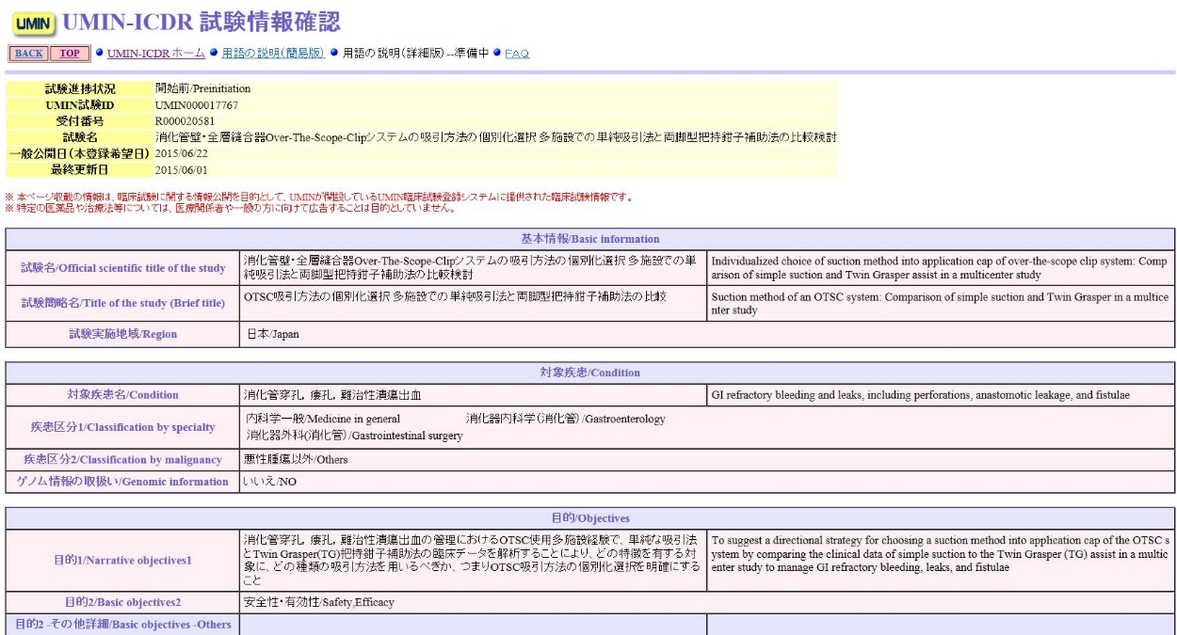
This study was registered under UMIN no. 000017767 as follows.

