Name of Journal: World Journal of Clinical Cases
Manuscript NO: 73534
Manuscript Type: CASE REPORT

Hepatopulmonary metastases from papillary thyroid microcarcinoma: A case report

Yang CY et al. Papillary thyroid microcarcinoma metastasized to liver and lung

Chuan-Yu Yang, Xuan-Wu Chen, Dong Tang, Wen-Jun Yang, Xiao-Xiao Mi, Jun-Ping Shi, Wei-Dong Du

Chuan-Yu Yang, Xuan-Wu Chen, Wei-Dong Du, Department of Hepatobiliary Surgery, The First Clinical Medical College of Zhejiang Chinese Medical University, Hangzhou 310003, Zhejiang Province, China

Dong Tang, Department of Medical Imaging, The Affiliated Hospital of Hangzhou Normal University, Hangzhou 310015, Zhejiang Province, China

Wen-Jun Yang, Department of Pathology, The Affiliated Hospital of Hangzhou Normal University, Hangzhou 310015, Zhejiang Province, China

Xiao-Xiao Mi, Jun-Ping Shi, Institute of Translational Medicine, The Affiliated Hospital of Hangzhou Normal University, Hangzhou 310015, Zhejiang Province, China

Author contributions: Yang CY and Chen XW provided the case; Tang D performed radiological imaging analysis; Yang WJ performed pathological imaging analysis; Yang CY was involved in the biomedical analysis; Yang CY and Mi XX wrote the manuscript with input from Chen XW, Tang D and Yang WJ; Du WD and Shi JP revised the manuscript; all authors have contributed significantly.

Supported by the Joint Funds of the Zhejiang Provincial Natural Science Foundation of China, No. LBY21H030001; and the Science and Technology Planning Project of Zhejiang Province, No. 2020KY708.

Corresponding author: Wei-Dong Du, MD, Chief Physician, Department of Hepatobiliary Surgery, The First Clinical Medical College of Zhejiang Chinese Medical University, No. 54 Youdian Road, Shangcheng District, Hangzhou 310003, Zhejiang Province, China. hzadu@163.com

Received: December 1, 2021
Revised: January 18, 2022
Accepted: March 16, 2022
Published online:

Abstract
BACKGROUND
Papillary thyroid carcinoma (PTC) is the most common endocrine malignancy. Papillary thyroid microcarcinoma (PTMC) accounts for the majority of PTC cases. However, concurrent pulmonary and hepatic metastases of PTMC are rarely seen. Here, we present a patient with coexisting liver and lung metastases from PTMC.

CASE SUMMARY
We describe a 26-year-old woman with PTMC with multiple concurrent metastases. After 3 d of unexplained fever, she was admitted to our hospital. Her thyroid functional tests were abnormal. Her positron emission tomography (PET)/magnetic resonance imaging (MRI) examination showed increased fluorodeoxyglucose (FDG) metabolism and space-occupying lesions in the left lobe of the thyroid. Additionally, PET/MRI images revealed multiple nodules in the lung and liver with increased FDG metabolism. Chest computer tomography (CT) showed multiple pulmonary metastases. Abdominal ultrasound and liver MRI showed multiple space-occupying lesions in the liver. The patient underwent total thyroidectomy and central lymph node dissection. Postoperative pathological analysis showed a papillary microcarcinoma multiplex in the left lobe of the thyroid. A diagnosis of hepatopulmonary metastases from papillary thyroid microcarcinoma was made. The patient was given iodine-131 treatment one year after the surgery. She recovered well after the operation, and the incision healed well. After discharge, she was treated with oral levothyroxine sodium tablets, and symptomatic and supportive treatments were also given to promote radioactive excretion and prevent bone marrow suppression by iodine-131 treatment.

CONCLUSION
Since patients with thyroid cancer concurrent with hepatopulmonary metastases have rarely been reported, our case will highlight the clinical and pathological profiles of these patients.

Key Words: Papillary thyroid microcarcinoma; Distant metastasis; Liver; Lung; Case report

Yang CY, Chen XW, Tang D, Yang WJ, Mi XX, Shi JP, Du WD. Hepatopulmonary metastases from papillary thyroid microcarcinoma: A case report. World J Clin Cases 2022; In press

Core Tip: Concurrent pulmonary and hepatic metastases of papillary thyroid microcarcinoma are not often seen due to their rarity and nonspecific presentations. Herein, we provided a successful example of the diagnosis and treatment of pulmonary and hepatic metastases of papillary thyroid microcarcinoma in a young female patient. Our case emphasizes that distant metastases of papillary thyroid carcinoma can occur in young patients.

INTRODUCTION
Thyroid cancer is the most common endocrine tumor with a strong female preponderance (3:1)^{[1]}. Papillary thyroid carcinoma (PTC) is a well-differentiated endocrine malignancy. Papillary thyroid microcarcinoma (PTMC) is defined by the World Health Organization as PTC with a maximum diameter ≤ 10 mm. Papillary thyroid microcarcinoma increases the incidence of thyroid cancer by 50%^{[2]}. The main manifestations of PTCs are neck masses and thyroid nodules. However, distant metastasis of PTMC is rare, affecting bone, lung and chest lymph nodes, although local regional metastases in neck lymph nodes are commonly seen^{[3-5]}. PTMC simultaneously metastasized to the liver and lung is very rare. Here, we report a case of PTMC concurrent with liver and pulmonary metastases.

CASE PRESENTATION
Chief complaints
A 26-year-old woman who presented with unexplained fever was admitted to our hospital for further examination.

History of present illness
The patient showed a clear mind and no significant weight loss in the past three months.

History of past illness
She had no smoking or drinking history and no family history of tumors. She had no cough or expectoration. Ethical approval for publishing this case was obtained from the First Medical College of Zhejiang Chinese Medical University Research Ethics Committee.

Personal and family history
She denied a family history of hereditary disease.

Physical examination
Her physical examination showed nothing abnormal

Laboratory examinations
Her thyroid function tests showed elevated levels of thyroid-stimulating hormone and antithyroglobulin antibody, with a decreased level of thyroglobulin. Her biochemical tests showed elevated levels of triglycerides and cholesterol. Routine blood tests showed neutrophilia and lymphocytosis. Humoral tumor screening presented an elevated level of CA50. Her blood coagulation function was normal.

Imaging examinations
She underwent a positron emission tomography/magnetic resonance imaging (PET/MRI) examination in our hospital. The PET/MRI images showed a space-occupying lesion in the left thyroid with increased fluorodeoxyglucose (FDG) metabolism (Figure 1A), and a Computer tomography (CT) scan revealed that the lesions in the left lobe of the thyroid showed low-density nodular changes involving the thyroid capsule (Figure 1B). The PET/MRI images also showed multiple diffuse nodules (maximum 0.8 cm) in the lung with increased FDG metabolism and multiple nodules (maximum 2.0 cm) in the liver with increased FDG metabolism (Figure 1). Chest CT showed multiple metastases in both lungs, multiple low-density shadows in the liver, and small calcifications in the left breast (Figure 2). Abdominal ultrasound showed a fatty liver and multiple liver nodules (Figure 3A). MRI showed multiple space-occupying lesions in the liver (Figure 3B-D). Whole-body bone imaging and organ tomography showed a metabolically active left tibia and unevenly increased local bone density (Figure 4).

FINAL DIAGNOSIS
Collectively, based on the medical imaging results and pathological features, a diagnosis of hepatopulmonary metastasis from papillary thyroid microcarcinoma was made.

TREATMENT
The patient underwent thyroidectomy and central node dissection. Postoperative pathology revealed multiple papillary microcarcinomas in the left thyroid and one foci with the follicular subtype (Figure 5). The carcinomas had invaded the capsule and presented no lymph node metastasis. The immunohistochemical results showed positive signals for CK-19, Gal-3, TTF, and Ki-67 (3%) (Figure 6).

OUTCOME AND FOLLOW-UP
One year after thyroid cancer surgery, the patient was given iodine-131 treatment in our hospital. As shown in Figure 7, iodine imaging in the thyroid area was considered to be residual thyroid tissue. Multiple small nodules were found in both lungs, with no significant iodine uptake. A small amount of pleural effusion was observed on both sides of the lung. Multiple lymph nodes were present in the bilateral neck and supraclavicular areas without iodine intake. Physiological iodine intake was observed in the nasopharynx, oral cavity, salivary glands, gastrointestinal tract, and bladder (Figure 7). The patient had recovered well after the operation, and the incision had healed well. The patient was treated after the iodine therapy with daily oral levothyroxine sodium administration.

DISCUSSION
PTC accounts for approximately 85% of all follicular-derived well-differentiated thyroid cancers^{[6]}. The 10-year survival rate is more than 80%, and these tumors are considered to be indolent^{[7,8]}. PTMC is a subtype of PTC with a foci diameter ≤ 10 mm. PTMC accounts for the majority of PTC cases. Distant metastasis of PTMC is rare. The most common metastatic sites include the bone and lung, while brain, eye, breast, liver, kidney, muscle, and skin metastases are not commonly seen and only appear in patients with advanced tumor diseases. Here, we present a patient with PTMC who had simultaneous metastases to the lung and liver. Coexisting lung and liver metastases in PTC patients are not commonly seen.
Predictive factors for PTC metastasis included age, sex, thyroid function, Hashimoto's thyroiditis, multifocal tumor, tumor size, capsular invasion, and extrathyroidal extensions. The histopathological characteristics of tumors, such as their bilaterality, multifocality, extrathyroidal extension, capsular invasion, and lymph node metastasis, are important indicators of their invasiveness and they affect the prognosis^{[9,10]}.
Liver metastasis from PTMC is a rare event with a reported frequency of only 0.5%^{[11]}. Liver masses can be detected by various imaging modalities, such as ultrasonography, computed tomography, and magnetic resonance imaging. Liver masses are usually ¹³¹I-negative in PTMC patients with liver metastasis^{[12]}, which is consistent with the observations in our patient. PTC liver metastasis has a poor prognosis. Surgical resection of liver lesions has been reported to offer the best chance for prolonged survival^{[13]}. An increased age in cases of thyroid cancer with lung metastasis increases the mortality risk. In a study performed by Huang, the mortality rates of thyroid cancer with lung metastasis were 32.78% (118/360), 46.71% (156/334), 53.93% (199/369), 58.96% (158/268) and 82.76% (72/87) in patients aged ≤ 55 years, > 55 ≤ 65 years, > 65 ≤ 75 years, > 75 ≤ 85 years and > 85 years^{[14]}. Since our patient was a young mother of a young child, we suggested routine follow-up liver function tests to monitor the pathophysiology of the liver.
PTMC has no early typical symptoms due to its anatomic location. Therefore, a delay in clinical diagnosis is inevitable, which leads to its diagnosis in the advanced stage. Thus, a primary tumor in the thyroid is usually not diagnosed until the symptoms of a secondary metastatic tumor appear^{[15]}. In this case, the patient did not exhibit clinical manifestations of the disease at the initial stage, and no corresponding clinical symptoms were found even after metastasis occurred. Multiple metastases of thyroid cancer were incidentally found during the patient’s examination for unexplained fever, indicating that the disease is easily missed. Therefore, a better clinical index or screening method is needed.
Male patients with distant metastases from PTMC have a high risk of death^{[8,15]}. However, PTC patients with distant metastases have lower levels of dedifferentiation than differentiated thyroid carcinoma patients with distant metastases. Therefore, PTC exhibits more indolent behaviors than differentiated thyroid carcinoma, even with distant metastases. PTC nevertheless has a generally favorable prognosis for long-term survival, even with distant metastases. The clinical manifestations vary from the early to late stages of the disease^{[6]}. The maximal PTMC foci is 1 cm or less^{[16]}. In our patient, postoperative pathology revealed one PCT foci with a diameter of 0.8 cm. Total thyroidectomy with central node dissection is an effective treatment for PTC patients^{[17]}. Long-term follow-up of PTMC patients is needed after surgical treatment^{[18,19]}. Periodic thyroglobulin and thyroglobulin autoantibody measurements are recommended for PTMC patients^{[20]}. An active surveillance approach is recommended by the American Thyroid Association guidelines as an alternative option for patients with low-risk PTMC^{[18]}. Our patient was a 26-year-old woman with PTMC with multiple metastases. She was recommended to take levothyroxine sodium tablets and consume a low iodine diet after her surgery. We also suggested routine thyroid function test and liver imaging during follow-up. She is still alive and actively engaging in daily life.
Our patient's diagnosis of hepatopulmonary metastasis from papillary thyroid carcinoma was based on imaging findings and pathological results. PET/MRI, ultrasonography, CT, and MRI revealed multiple nodules in the liver and lung. Our case will provide a valuable reference for the diagnosis and treatment of papillary thyroid microcarcinoma patients in the future.

CONCLUSION
In conclusion, we present the case of a young woman with PTMC metastasis to her liver and lung. Since patients with thyroid cancer concurrent with hepatopulmonary metastases have rarely been reported, our case highlights the clinical and pathological profiles of these patients.

ACKNOWLEDGEMENTS
The authors would like to thank colleagues from the Institute of Translational Medicine of the Affiliated Hospital of Hangzhou Normal University and colleagues from the Department of Hepatobiliary Surgery of the First Clinical Medical College of Zhejiang Chinese Medical University for their support and collaboration.

REFERENCES
1 Stewart LA, Kuo JH. Advancements in the treatment of differentiated thyroid cancer. Ther Adv Endocrinol Metab 2021; 12: 20420188211000251 [PMID: 33796254 DOI: 10.1177/20420188211000251]
2 Kitahara CM, Sosa JA. The changing incidence of thyroid cancer. Nat Rev Endocrinol 2016; 12: 646-653 [PMID: 27418023 DOI: 10.1038/nrendo.2016.110]
3 Mazzaferri EL, Jhiang SM. Long-term impact of initial surgical and medical therapy on papillary and follicular thyroid cancer. Am J Med 1994; 97: 418-428 [PMID: 7977430 DOI: 10.1016/0002-9343(94)90321-2]
4 Sampson E, Brierley JD, Le LW, Rotstein L, Tsang RW. Clinical management and outcome of papillary and follicular (differentiated) thyroid cancer presenting with distant metastasis at diagnosis. Cancer 2007; 110: 1451-1456 [PMID: 17705176 DOI: 10.1002/cncr.22956]
5 Carmel Neiderman NN, Duek I, Ravia A, Yaka R, Warshavsky A, Ringel B, Muhanna N, Horowitz G, Ziv Baran T, Fliss DM. The incidence of postoperative re-stratification for recurrence in well-differentiated thyroid cancer-a retrospective cohort study. Gland Surg 2021; 10: 2354-2367 [PMID: 34527547 DOI: 10.21037/gs-21-105]
6 Lim H, Devesa SS, Sosa JA, Check D, Kitahara CM. Trends in Thyroid Cancer Incidence and Mortality in the United States, 1974-2013. JAMA 2017; 317: 1338-1348 [PMID: 28362912 DOI: 10.1001/jama.2017.2719]
7 Yu XM, Wan Y, Sippel RS, Chen H. Should all papillary thyroid microcarcinomas be aggressively treated? An analysis of 18,445 cases. Ann Surg 2011; 254: 653-660 [PMID: 21876434 DOI: 10.1097/SLA.0b013e318230036d]
8 Weng HY, Yan T, Qiu WW, Xi C, Hou LY, Yang ZL, Qiu ZL. Long-term outcomes and prognostic factors in papillary thyroid microcarcinoma patients with distant metastases. Endocrine 2021 [PMID: 34699028 DOI: 10.1007/s12020-021-02906-8]
9 Zhao L, Sun X, Luo Y, Wang F, Lyu Z. Clinical and pathologic predictors of lymph node metastasis in papillary thyroid microcarcinomas. Ann Diagn Pathol 2020; 49: 151647 [PMID: 33126150 DOI: 10.1016/j.anndiagpath.2020.151647]
10 Jeon MJ, Kim WG, Choi YM, Kwon H, Lee YM, Sung TY, Yoon JH, Chung KW, Hong SJ, Kim TY, Shong YK, Song DE, Kim WB. Features Predictive of Distant Metastasis in Papillary Thyroid Microcarcinomas. Thyroid 2016; 26: 161-168 [PMID: 26563473 DOI: 10.1089/thy.2015.0375]
11 Salvatori M, Perotti G, Rufini V, Maussier ML, Summaria V, Fadda G, Troncone L. Solitary liver metastasis from Hürthle cell thyroid cancer: a case report and review of the literature. J Endocrinol Invest 2004; 27: 52-56 [PMID: 15053244 DOI: 10.1007/BF03350911]
12 Song HJ, Xue YL, Xu YH, Qiu ZL, Luo QY. Rare metastases of differentiated thyroid carcinoma: pictorial review. Endocr Relat Cancer 2011; 18: R165-R174 [PMID: 21632805 DOI: 10.1530/ERC-11-0068]
13 Kuo CS, Tang KT, Lin JD, Yang AH, Lee CH, Lin HD. Diffuse sclerosing variant of papillary thyroid carcinoma with multiple metastases and elevated serum carcinoembryonic antigen level. Thyroid 2012; 22: 1187-1190 [PMID: 23050785 DOI: 10.1089/thy.2011.0361]
14 Huang X, Xia Q, Huang Y, Peng A, Yang J. Age increased the cancer-specific mortality risk of thyroid cancer with lung metastasis. Clin Endocrinol (Oxf) 2022 [PMID: 34990026 DOI: 10.1111/cen.14675]
15 Nunes KS, Matos LL, Cavalheiro BG, Magnabosco FF, Tavares MR, Kulcsar MA, Hoff AO, Kowalski LP, Leite AK. Risk factors associated with disease-specific mortality in papillary thyroid cancer patients with distant metastases. Endocrine 2021 [PMID: 34665427 DOI: 10.1007/s12020-021-02901-z]
16 Pu W, Shi X, Yu P, Zhang M, Liu Z, Tan L, Han P, Wang Y, Ji D, Gan H, Wei W, Lu Z, Qu N, Hu J, Hu X, Luo Z, Li H, Ji Q, Wang J, Zhang X, Wang YL. Single-cell transcriptomic analysis of the tumor ecosystems underlying initiation and progression of papillary thyroid carcinoma. Nat Commun 2021; 12: 6058 [PMID: 34663816 DOI: 10.1038/s41467-021-26343-3]
17 Pastorčić Grgić M, Stubljar B, Perše P, Zekan Vučetić M, Šitić S. Total Thyroidectomy with Central Node Dissection is a Valuable Option in Papillary Thyroid Cancer Treatment. Acta Clin Croat 2020; 59: 102-107 [PMID: 34219891 DOI: 10.20471/acc.2020.59.s1.13]
18 Haugen BR, Alexander EK, Bible KC, Doherty GM, Mandel SJ, Nikiforov YE, Pacini F, Randolph GW, Sawka AM, Schlumberger M, Schuff KG, Sherman SI, Sosa JA, Steward DL, Tuttle RM, Wartofsky L. 2015 American Thyroid Association Management Guidelines for Adult Patients with Thyroid Nodules and Differentiated Thyroid Cancer: The American Thyroid Association Guidelines Task Force on Thyroid Nodules and Differentiated Thyroid Cancer. Thyroid 2016; 26: 1-133 [PMID: 26462967 DOI: 10.1089/thy.2015.0020]
19 Gao M, Ge M, Ji Q, Cheng R, Lu H, Guan H. 2016 Chinese expert consensus and guidelines for the diagnosis and treatment of papillary thyroid microcarcinoma. Cancer Biol Med 2017; 14: 203-211 [PMID: 28948061 DOI:10.20892/j.issn.2095-3941.2017.0051]
20 Knappe L, Giovanella L. Life after thyroid cancer: the role of thyroglobulin and thyroglobulin antibodies for postoperative follow-up. Expert Rev Endocrinol Metab 2021; 16: 273-279 [PMID: 34693849 DOI: 10.1080/17446651.2021.1993060]

Footnotes
Informed consent statement: Written informed consent was obtained from the patient for publication of this case report and any accompanying images.

Conflict-of-interest statement: The authors declare that they have no competing interests.

CARE Checklist (2016) statement: Our case report is written according to CARE Checklist (2016).

Open-Access: This article is an open-access article that was selected by an in-house editor and fully peer-reviewed by external reviewers. It is distributed in accordance with the Creative Commons Attribution NonCommercial (CC BY-NC 4.0) license, which permits others to distribute, remix, adapt, build upon this work non-commercially, and license their derivative works on different terms, provided the original work is properly cited and the use is non-commercial. See: https://creativecommons.org/Licenses/by-nc/4.0/

Provenance and peer review: Unsolicited article; Externally peer reviewed.
Peer-review model: Single blind

Peer-review started: December 1, 2021
First decision: January 12, 2022
Article in press:

Specialty type: Oncology
Country/Territory of origin: China
Peer-review report’s scientific quality classification
Grade A (Excellent): 0
Grade B (Very good): 0
Grade C (Good): C, C
Grade D (Fair): 0
Grade E (Poor): 0

P-Reviewer: Cainap C, Romania; Pop TL, Romania S-Editor: Xing YX L-Editor: A P-Editor: Xing YX
Figure Legends
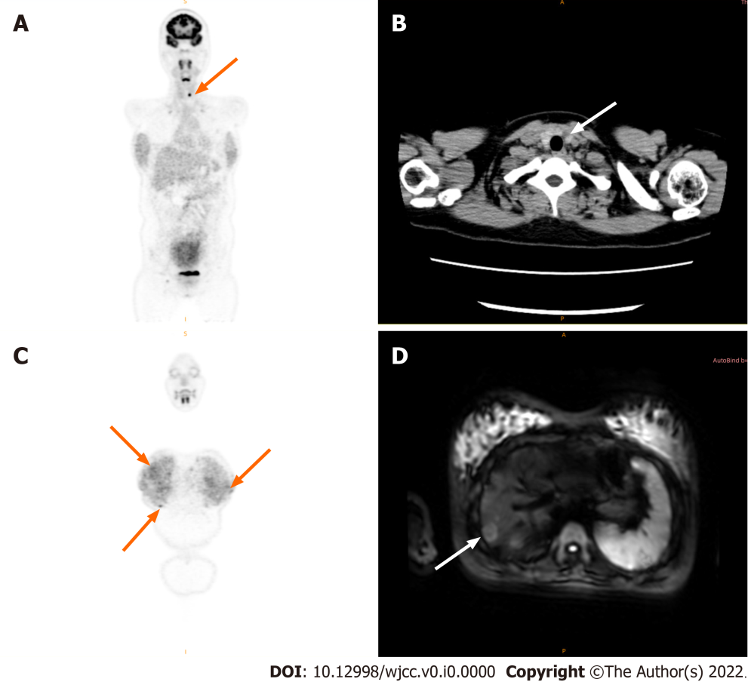
Figure 1 Positron emission tomography/magnetic resonance imaging images. A: High concentration iodine uptake in the left lobe of the thyroid (arrow); B: Plain computer tomography scan showing the lesions in the left lobe of the thyroid have low-density nodular changes (arrow) involving the thyroid capsule; C: Positron emission tomography (PET)/magnetic resonance imaging (MRI) images showing multiple diffuse nodules in the lung (arrow); D: PET-MRI showing a high concentration of iodide uptake in the liver metastases (arrow).
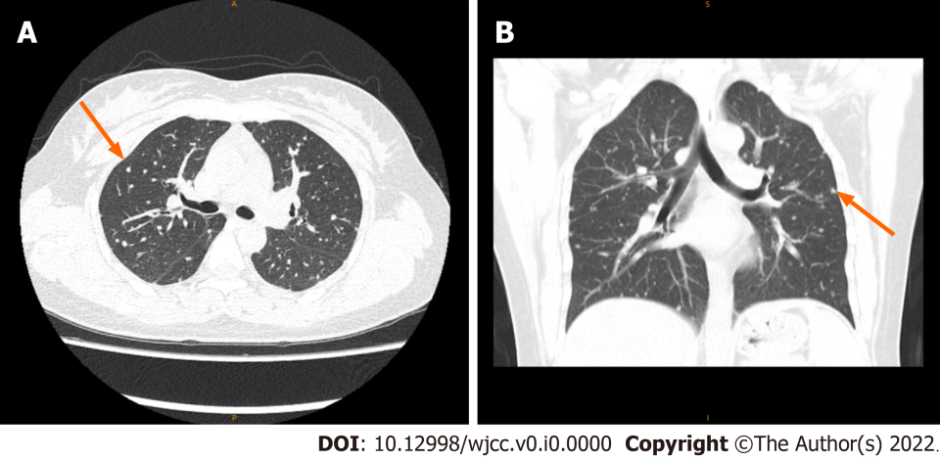
Figure 2 Chest computer tomography. A-B: Multiple nodules in both lungs suggest metastasis (arrow).
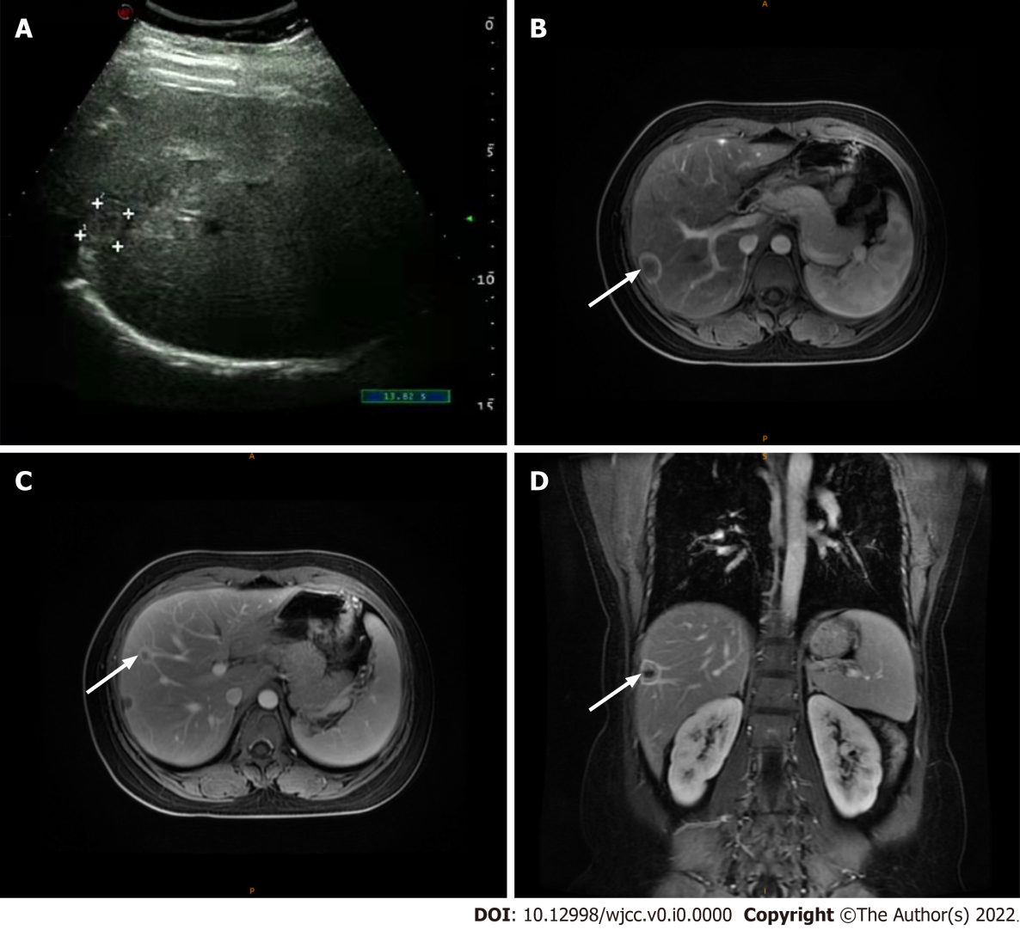
Figure 3 Liver metastasis. A: Abdominal ultrasound showing mixed medium echo nodules near the hepatic capsule in the right lobe of the liver, suggesting metastasis; B-D: Liver magnetic resonance imaging showing multiple liver metastases (arrow).
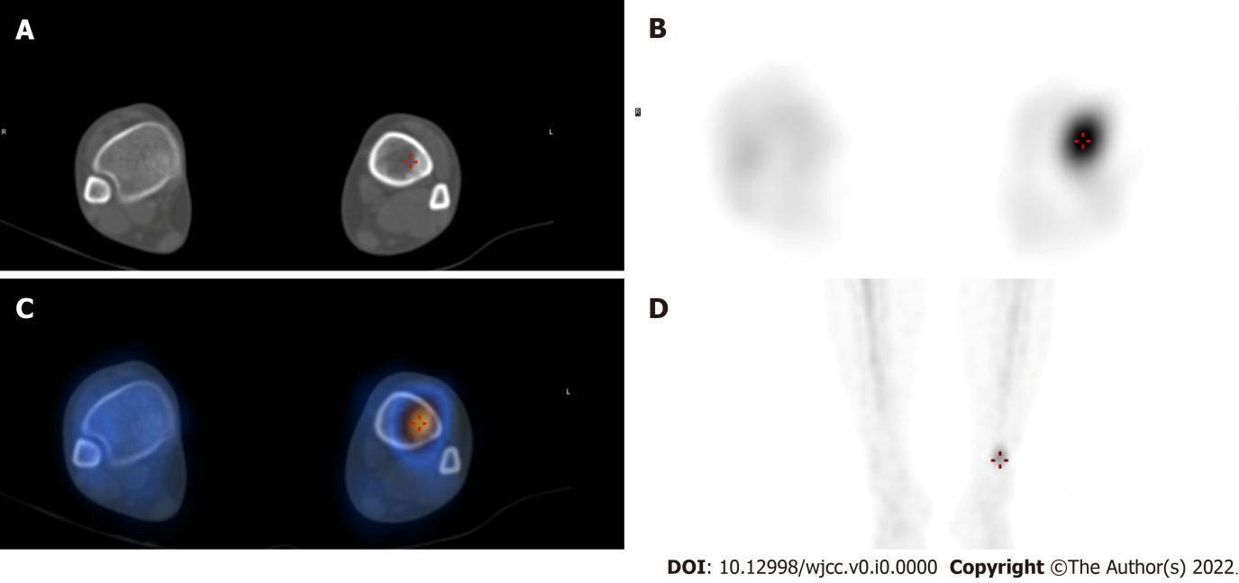
Figure 4 Whole-body bone imaging and organ tomography. A: Tibial computer tomography; B-D: Radionuclide imaging; C: Radionuclide color imaging.
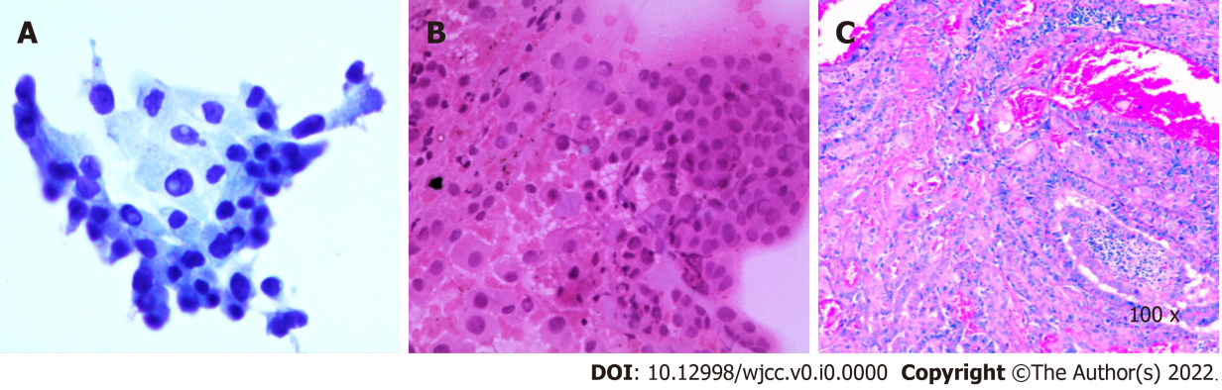
Figure 5 Postoperative pathology in the left thyroid. A: Liquid-based cytology of fine-needle aspiration; B: Smear staining of fine-needle puncture. C: HE staining.
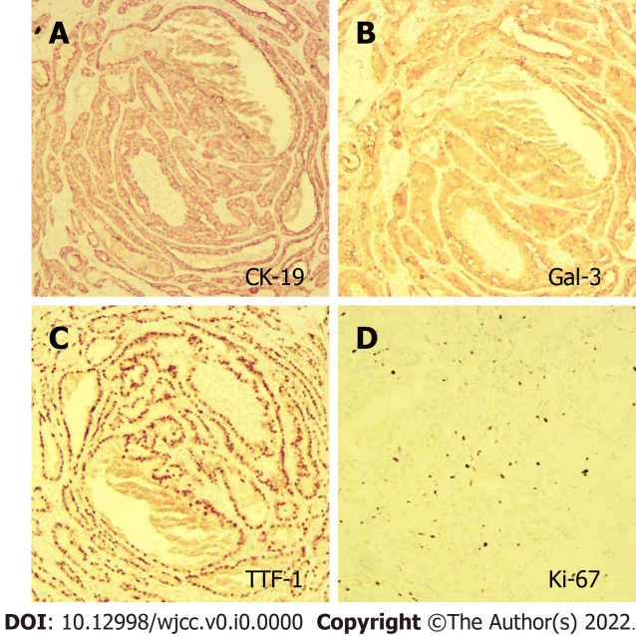
Figure 6 Immunohistochemical staining. A: CK-19 staining; B: Gal-3 staining; C: TTF-1 staining; D: Ki-67 staining.
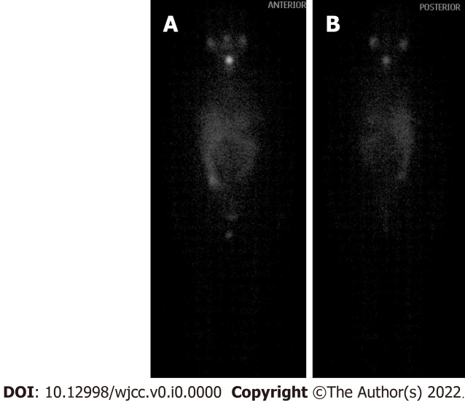
Figure 7 Iodine scan after iodine-131 treatment. A: Anterior; B: Posterior.

