Name of journal: World Journal of Gastroenterology
ESPS Manuscript NO: 15442
Columns: ORIGINAL ARTICLE

Basic Study
Effect of resveratrol on the regulation of Treg/Th17 signaling and thetreatment of ulcerative colitis in mice

Yao J et al. Effect resveratrol on regulation of Treg/Th17

Jun Yao, Cheng Wei, Jian-Yao Wang, Ru Zhang, Ying-Xue Li, Li-Sheng Wang

Jun Yao, Cheng Wei, Ru Zhang, Ying-Xue Li, Li-sheng Wang, Department of Gastroenterology, Jinan University of Medical Sciences, Shenzhen Municipal People’s Hospital, Shenzhen 518020, Guangdong Province, China

Jian-Yao Wang, Department of General Surgery, Shenzhen Children’s Hospital, Shenzhen 518026, Guangdong Province, China

Author contributions: Yao J, Wei C and Wang JY contributed equally to this work; Yao J, Wei C and Wang JY performed the majority of experiments; Zhang R, Li YX provided vital reagents and analytical tools and were also involved in editing the manuscript; Wang LS and Yao J designed the study and wrote the manuscript.

Supported by Outstanding Doctoral Thesis Support Project of Guangdong Province, No. 85514045; the Technical Research and Development Project of Shenzhen, No. JCYJ20130402092657774; and the Medical Research Foundation of Guangdong Province, No.B2013347.

Ethics approval: All experimental procedures were conducted in conformity with institutional guidelines for the care and use of laboratory animals in Southern Medical University, Guangdong, China, and conformed to the National Institutes of Health Guide for Care and Use of Laboratory Animals (Publication No. 85-23, revised 1985).

Institutional animal care and use committee: All animal experiments were reviewed and approved by the Guangdong Animal Medical Ethics Committee, China.

Conflict-of-interest: The authors declared that they have no conflicts of interest to this work.

Data sharing: No additional data are available.

Open-Access: This article is an open-access article which was selected by an in-house editor and fully peer-reviewed by external reviewers. It is distributed in accordance with the Creative Commons Attribution Non Commercial (CC BY-NC 4.0) license, which permits others to distribute, remix, adapt, build upon this work non-commercially, and license their derivative works on different terms, provided the original work is properly cited and the use is non-commercial. See: http://creativecommons.org/licenses/by-nc/4.0/

Correspondence to: Dr. Li-Sheng Wang, Department of Gastroenterology, Jinan University of Medical Sciences, Shenzhen Municipal People’s Hospital, 1017 East Gate Road, Shenzhen, 518020, Guangdong Province, China. wangls168@163.com
Telephone: +86-755-25533018
Fax: +86-755-25533497

Received: November 26, 2014
Peer-review started: November 27, 2014
First decision: December 11, 2014
Revised: January 23, 2015
Accepted: March 12, 2015

Article in press:
Published online:
Abstract
AIM：To determine the therapeutic efficacy of resveratrol on ulcerative colitis (UC) and its underlying mechanisms.

METHODS：The mouse UC model was developed using 5% dextran sulfate sodium. Mice were randomly divided into four groups: normal control, UC model group, resveratrol low dose group (50 mg/kg per day, RLD) and resveratrol high dose group (100 mg/kg per day, RHD).

RESULTS: The results showed that RLD regulates Treg/Th17 balance mainly through reducing the number of Th17 cells, while RHD regulates Treg/Th17 balance through both down-regulating the number of Th17 cells and up-regulating the number of Treg cells. Resveratrol can also regulate the level of plasma and intestinal mucosal cytokines including IL-10, TGF-β1, IL-6 and IL-17. The expression of HIF-1α, mTOR and STAT3 was significantly decreased in the intestinal tissues of mice treated by resveratrol.

CONCLUSION: The therapeutic efficacy of resveratrol in IBD is dose-dependent and closely associated with the regulation of Treg/Th17 balance and the HIF-1α/mTOR signaling pathway.

Key words: Ulcerative colitis; Resveratrol; Th17 cells; Treg cells; HIF-α; mTOR

© The Author(s) 2015. Published by Baishideng Publishing Group Inc. All rights reserved.

Core tip: Ulcerative colitis (UC) is an inflammatory bowel disease (IBD) manifested by diarrhea, bloody and mucus stools, abdominal pain, and recurrent chronic process. The etiology and pathogenesis are not clear. Resveratrol is a natural and biologically active polyphenols with a variety of anti-inflammatory and anti-oxidant functions, which are beneficial to human health. The purpose of this study was to determine the therapeutic efficacy of resveratrol on UC and its underlying mechanisms. Our results demonstrated that the therapeutic efficacy of resveratrol in IBD is dose-dependent and closely associated with the regulation of Treg/Th17 balance and the HIF-1α/mTOR signaling pathway.

Yao J, Wei C, Wang JY, Zhang R, Li YX, Wang LS. Effect of resveratrol on the regulation of Treg/Th17 signaling and thetreatment of ulcerative colitis in mice. World J Gastroenterol 2015; In press
INTRODUCTION
Ulcerative colitis (UC) is a chronic non-specific inflammatory disease involving the rectum and colon with unknown causes. It was hypothesized that UC is associated with genetic, infectious, immune, environmental factors and intestinal dysbiosis^{[1]}. In the early stage of UC, colonic mucosa lesions with visible diffuse inflammation, mucosal congestion and edema can be observed. In severe cases, there are visible focal hemorrhages, and the tissues become brittle and easy to bleeding. In the acute phase of UC, there are infiltration of lymphocytes, eosinophils and neutrophils^{[2]}. UC animal model can be developed by feeding the mice with 5% DSS for a consecutive 7 d. After 4-7 d of DSS feeding, mice develop loose stools, bloody diarrhea, and weight loss with histological changes similar to UC^{[3]}.
Previous studies have shown that abnormal intestinal mucosal immune response and inflammation disorders are present in UC and are closely associated with the imbalance Treg and Th17 cells and disorders of cytokine levels^{[4]}. Th17 cells affect the innate and acquired immune responses through the release of IL-17 and other inflammatory cytokines that are involved in the immune pathogenesis and prognosis of inflammatory bowel disease (IBD)^{[5]}. Imbalance Treg/Th17 and their secreted cytokines, e.g., IL-10, TGF-β1, IL-17 and IL-6 play an important role in the development of IBD^{[4]}. In the past 10-15 years, it was generally believed that Crohn's disease (CD) is a Th1 cell-mediated intestinal inflammation, while UC is a Th2 cell-mediated inflammatory response^{[6]}. Recently, Th17 cells are recognized as a new subset of helper T cells, and are closely associated with autoimmune diseases and inflammatory bowel disease. Discovery of Th17 cells helps to explain some unusual phenomenon in Th1/Th2 responses in IBD^{[7]}. Current evidence suggests that IBD is closely associated with Treg/Th17 imbalance^{[8,9]}. Hypoxia-mTOR-HIF-1α-Th17 and IL-6-STAT3-HIF-1α-Th17 pathways play an important role in Th17 development and the activation of IL-17 production. In addition, HIF-1α can bind Foxp3, leading to the accelerated degradation Foxp3 and thus affecting Treg development and function^{[10]}. Previous studies demonstrated that Treg/Th17 imbalance is present in many inflammatory and autoimmune diseases, e.g., rheumatoid arthritis and SLE^{[11-13]}.
Resveratrol is a naturally active ingredient widely present in grapes, peanuts and other plants. Resveratrol contains a variety of biological activities including immune regulation, anti-inflammation, antioxidation, anti-angiogenesis and reducing tissue damages^{[14,15]}. Our previous studies have demonstrated that resveratrol exhibits anti-inflammatory effects on colitis in mice via the antioxidant activities^{[14]}. Recently, it has been shown that resveratrol has excellent therapeutic efficacy on UC by reducing neutrophilic exudate, inhibiting adhesion molecules and regulating cytokine levels^{[16,17]}. Clinical studies have shown that anti-inflammatory treatment has a very good therapeutic effect on UC patients. Salazosulfapyridine and 5-aminosalicyclic acid have recently been used in the treatment of colitis^{[18,19]}. These drugs can effectively relieve intestinal inflammation, but have some adverse effects. Recent studies suggest that UC patients can be benefited from anti-inflammatory treatments, e.g., the use of infliximab to inhibit TNF-α or anti-IL-6 based therapy^{[20-22]}. Adverse effects of biological agents include increased antibody reaction, increased risk of infection and hypersensitivity, and an unknown risk of mutagenesis^{[23,24]}. Numerous studies reported that resveratrol had good biological activities that can be used for the treatment of rheumatoid arthritis and pancreatitis^{[25,26]}. Resveratrol is a natural biological extracts with little toxic side effects and its multiple therapeutic effects have been demonstrated. In this study, we demonstrated that colitis mice had severe Treg/Th17 imbalance, decreases of anti-inflammatory factor (e.g., TGF-β1, IL-10), increased proinflammatory cytokines (e.g., IL-6, IL-17) and elevation of nuclear protein HIF-1ɑ and cytoplasm protein mTOR and STAT3. Our results also showed that resveratrol can regulate the rebalancing of Treg/Th17, increase the TGF-β1 and IL-10 levels, decrease the IL-6 and IL-17 levels and inhibit hypoxia-mTOR-HIF-1ɑ-Th17 and IL-6-STAT3-HIF-1α-Th17 pathways. Regulation of immune disorder in mice with colitis further demonstrated that resveratrol had excellent therapeutic effect on UC, which provided a potential new treatment of UC.

MATERIALS AND METHOD
Animal care and use
SPF level BALB/c mice (male, 6-7-wk-old, weight: 22-26 g, n = 40) (Experimental Animal Center of Southern Medical University, Certificate number: SCXK Guangdong 2011-0015) were maintained in a clean animal room with a temperature of 22-25 ℃ and relative humidity of about 55%. The mice were given 12 h of light and 12 h dark light control environment. Mice were also given controlled access to water and free access to food. Dextran sulfate sodium (DSS, MW: 5000) was purchased from Woka company (Japan), and dissolved in sterile distilled water to make a 5% solution. Flow cytometry reagents for analysis of Th17/Treg were purchased from BD Biosciences. ELISA detection kits for IL-17, IL-10, IL-6, and TGF-β1 were purchased from Beijing Dakota for Biotechnology Co., Ltd. Anti-mouse antibodies against STAT3 and HIF-1ɑ were purchased from Cell Signaling Technology, and anti-mouse antibody against mTOR was purchased from Santa Cruz, (United States). Resveratrol (purity ≥ 99%) was purchased from Guangzhou Qiyunsheng Biotechnology Co., Ltd. and was dissolved in ethanol to make 0.5% solution as required.

Experimental design
After adaptive feeding for one week, 40 mice were randomly divided into four groups (with 10 mice in each group): normal controls (NC), model (MD) group, resveratrol 50 mg/kg.d treatment group (RLD) and resveratrol 100 mg/kg.d treatment group (RHD). NC group was given free access to sterile distilled water for 14 d; MD group and the treatment group were given 5% DSS for the first 7 d and distilled water for subsequent 7 d. Starting from the 7th d, mice in the NC and MD groups weregiven 0.5% ethanol (0.2 mL) daily via gavage for 7 d, while mice in the RLD and RHD groups were given the same amount of ethanol containing 50 mg/kg per day and 100 mg/kg per day resveratrol, respectively. After 14 d, blood samples were collected from eye and subsequently mice were sacrificed by cervical dislocation. The plasma, spleen, and colon tissue samples were collected from the sacrificed mice.

Mice disease activity index and spleen index
Daily DAI was recorded by the Murthy scoring system^{[27]}. The scoring criteria were shown in Table 1. Disease activity index (DAI) was calculated as the total scores of weight loss rate, feces viscosity and occult/visible bloody stools divided by 3. After the mice were sacrificed, spleen was dissected, and the blood on the surface of spleen was washed with physiological saline. The spleen was dried and weighed. spleen index (SI) was calculated as spleen weight (mg) divided by the body weight (g)^{[28]}.

Pathological assessment of colonic tissues in mice
Fresh colon tissues obtained from each experimental group were immediately placed in 10% formalin solution at room temperature and fixed for 48 h in the dark environment. Tissue dehydration and embedding were performed subsequently. Tissue sections were stained with hematoxylin-eosin (HE). Colonic tissue were observed and assessed according to the histological scoring criteria^{[29]}. The average score of colonic tissue of mice were shown in Table 2.

Flow cytometry analysis of mouse spleen Treg/Th17 cells.
After blood was collected from the eyeball, the mice were sacrificed by cervical dislocation. Appropriate amount of spleen tissues were placed in 5 mL lymphocyte separation solution and ground for 2 min on 200 mesh nylon using 5 mL syringe piston. Spleen tissue homogenate was centrifuged at 800 g for 30 min and the lymphocyte layer was aspirated. After washing with 10 m l1640 solution, single lymphocyte cell suspension was obtained. The single cell suspension was resuspended in RPMI1640 medium containing 10% serum, 50 ng/mL of PMA (Sigma), 1 μg/mL of Ionomycin (Sigma) and 2 μg/mL of Monensin (BD, United States), and incubated for 5 h at 37 ℃. The cell number was adjusted to 2 × 10⁶/mL, and centrifuged at 300 g for 5min. The collected cells were added with 20 μL pre-chilled 1 × BD Mouse Foxp3 Fixation Buffer (BD, United States), and fixed at 4 ℃ in darkroom for 30 min. The fixative was then washed and the cells were collected. Subsequently, 200 μl preheated 1 × BD Mouse Foxp3 Permeabilization Buffer (BD, United States) was added and the cells were incubated at 37 ℃ in the darkroom for 30 min. The Permeabilization Buffer was washed away and the cells were added with 20 μL of mouse Treg/Th17 phenotype antibody reagents (BD, United States) or isotype control antibody and incubated at room temperature for 30 min. The antibody was then washed away and resuspended in 200 μL FBS for flow cytometry analysis.

Cytokine analysis by ELISA
Eyeball blood was added with heparin for anticoagulation. The plasma samples were obtained by centrifugation at 4 ℃ for 20 min (3000 rpm) and stored at -80 ℃ for subsequent analysis. Colon tissue (50 mg) was added with 2ml cold saline and homogenized using a glass homogenizer. The homogenates were centrifuged at low temperature for 20 min at 3000 rpm. The protein concentration in the supernatant was quantified by Nanodrop 2000 (Thermo Scientific United States). The concentration of IL-6, IL-10, IL-17 and TGF-β1 was determined according to the manufacturer’s instruction.

Western blot analysis
Nucleus and cytoplasm protein were obtained from 100 mg of colon tissue according to the manufacturer’s instruction. Protein samples were quantified by Nanodrop 2000 and added with the appropriate amount of protein 6×loading buffer, phosphatase and protease inhibitors. Protein samples were separated by 10% SDS-PAGE electrophoresis and transferred to a membrane. Following blocking, primary antibodies including STAT3 (1: 500), HIF-1α (1: 200), mTOR (1: 200), Lamin, andβ-actin were added. After extensive washing, second antibodies were added and ECL developing was performed.

Statistical analysis
The experimental data were expressed as mean ± SD. Statistical analysis was performed using SPSS13.0 statistical software. Difference between groups was analyzed using single-factor analysis of variance and P < 0.05 was considered statistically significance. The statistical methods of this study were reviewed by Wei-Seng Zeng from Southern Medical University in China.

RESULTS
Assessment of mice DAI and SI
DAI of mice in the NC group was 0. In the first 7 d, mice in the MD, RLD and RHD groups had bloody stool, weight loss, and decreased activities. Starting from the 10th d, visible bloody stool was not observed in the RLD and RHD groups. Furthermore, the RLD and RHD groups had less body weight loss. From day 10 to day 14, DAI score in RHD group was significantly lower than that in the MD group and RLD group. The mice in the MD group had significantly enlarged spleen. The SI in the RLD and RHD groups was lower than that in the MD group. Compared to RLD group, RHD group had more significant reduction of SI. These results indicated that resveratrol reduces both DAI and SI in the colitis mice in a dose-dependent manner.

Pathological assessment of colon tissues
Compared to the NC group (Figure 2A-1), mice in the MD group (Figure 2A-2) exhibited acute inflammation, accompanied by mucosal erosions, edema, reduction of crypts and presence of neutrophils and other inflammatory cells in the mucosa, submucosa and lamina propria. Compared with the MD group, mice in the RLD group (Figure 2A-3) and RHD group (Figure 2A-4) exhibited relieved colonic inflammatory cell infiltration, erosion and edema. These results indicated that resveratrol reduces the pathological alteration in colitis mice.

Effect of resveratrol on Treg/Th17
Compared with the NC group, MD group showed significantly increased ratio of CD4+IL-17+(Th17)/CD4+ lymphocytes and decreased CD4+Foxp3 + (Treg)/CD4+ lymphocytes (Figure 3). Compared with the MD group, RHD group had significantly reduced Th17 lymphocytes and increased Treg lymphocytes. Th17 cells were significantly decreased, but Treg was not changed in RLD group compared with the MD group. These results indicated that high dose of resveratrol can both reduce Th17 cells and increase Treg cells, while low dose of resveratrol only reduces Th17, but has not effect on Treg cells.

Effect of resveratrol on cytokines in the plasma and colon tissue
Compared with the NC group, MD group showed significantly increased level of proinflammatory cytokines (IL-6, IL-17) and decreased level of anti-inflammatory cytokines (IL -10, TGF-β1) (Figure 4). IL-6 and IL-17 in RLD and RHD groups were significantly lower than those in the MD group, while IL-10 and TGF-β1 in the RLD and RHD groups were significantly lower than those in the MD group. Furthermore, more dramatic decreases of IL-6 and IL-17 and increases of IL-10 and TGF-β1 were observed in RHD group compared to those in the RLD group. These results indicated that resveratrol can downregulate the expression of proinflammatory cytokines and upregulate the expression of anti-inflammatory cytokines in colitis mice in a dose-dependent manner.

Effect of resveratrol on the expression of HIF-1α, mTOR and STAT3
Nuclear protein HIF-1α and cytoplasmic proteins mTOR and STAT3 in MD group were significantly increased in comparison with those in the NC group. HIF-1α, mTOR and STAT3 in RLD and RHD groups were lower than those in the MD group. Furthermore, the reduction of HIF-1α, mTOR and STAT3 in RHD groups was more significant than that in the RLD group, suggesting that resveratrol downregulate the expression of HIF-1α, mTOR and STAT3 in colitis mice in a dose-dependent manner.

DISCUSSION
The molecular mechanisms of IBD pathogenesis are not fully understood. Studies have suggested that the environmental factors act on genetically susceptible populations, resulting in excessive immune response disorders, intestinal inflammation, and ultimately the intestinal injury^{[28,30]}. It was previously believed that Thl/Th2 imbalance plays a dominant role in the pathogenesis of UC. The discovery of Th17 cells explained the unusual phenomenon of Th1/Th2 imbalance in UC^{[6,31]}. In this study, we successfully developed UC mouse model using 5% DSS. The colitis mice experienced bloody stools, loss of body weight and decreased activities. DAI and SI of the colitis mice were significantly increased and the histological alterations were similar to those observed in human UC. Treatment of colitis mice with resveratrol significantly reduced DAI and SI and improved histological alterations. Furthermore, high dose of resveratrol appears to have better efficacy than low dose of resveratrol. Resveratrol also improved the systemic symptoms and intestinal inflammation by improving the DAI and intestinal pathology in colitis mice. The observation that resveratrol affects the spleen function promotes us to further investigate the effect of resveratrol on immune responses.
Our results showed that spleen in colitis mice was significantly enlarged, while treatment of the colitis mice with resveratrol significantly reduced the spleen. It was thus confirmed that as an important immune organ, spleen exhibited compensatory increases after DSS stimulation. Flow cytometry analysis showed that colitis mice had a significant decrease of Treg and increase of Th17 cells, suggesting that DSS-induced systemic and intestinal immune disorder is a key factor for the formation and progression of colitis. Previous studies have demonstrated that Th17 cells affect the innate and acquired immune responses and are involved in the pathogenesis of IBD's immunity and prognosis through the release of cytokines, e.g., IL-17^{[5]}. Treg/Th17 imbalance is frequently observed in a variety of autoimmune diseases. Extensive literature has reported that human IBD is closely correlated with the alteration of Treg and Th17 cells and their secreted cytokines. Therefore, Treg/Th17 imbalance is potentially one of the possible targets for the treatment of IBD^{[4,11,32]}.
Therapeutic efficacy of resveratrol on colitis mice can be achieved by the following mechanisms. First, anti-inflammatory cytokines were increased, while the proinflammatory cytokines were decreased after resveratrol treatment. Maintaining the balance of cytokines may play an important role in the treatment of UC. Cytokines can promote interaction between immune cells, stimulate proliferation of antigen-specific effector cells, and cause local or systemic inflammatory response, which may lead to the development of UC^{[33,34]}. IL-10 can downregulate T cell- and macrophage-secreted IL-1β, IL-6 and TNF-α by inhibiting antigen-presenting, which ultimately inhibits T cell-mediated immune response and improves intestinal inflammation in UC^{[33]}. Resveratrol achieves its central role in inhibiting proinflammatory cytokines and anti-inflammatory effect by increasing IL-10 level. Second, our results demonstrated that resveratrol regulates Treg/Th17 in a dose-dependent manner. RHD regulates the balance of Treg/Th17 by both downregulating Th17 cells and upregulating Treg cells, while RLD regulates the balance of Treg/Th17 mainly through downregulating Th17 cells. Furthermore, Treg/Th17 ratio achieved by RHD is closer to the physiological level. Th17 cells belong to CD4+ T cell subsets and are characterized by secreting IL-17. Th17 plays an important role in the intestinal mucosal immune response and inflammatory process^{[35]}. Treg can suppress the inflammatory response cascade and maintain the balance of the intestinal immune response by secreting and regulating anti-inflammatory cytokines, e.g., IL-10 and TGF-β^{[36,37]}. Our results showed that Treg/Th17 ratio was decreased in colitis mice, which is consistent with human IBD^{[4]}. Our results further demonstrated that resveratrol inhibits the expression of HIF-1α, mTOR and STAT3, suggesting that resveratrol regulates Treg/Th17 balance mainly through inhibiting "hypoxia-mTOR-HIF-1α-Th17" and "IL-6-STAT3-HIF-1α-Th17" pathways. Studies have suggested that local intestinal tissue hypoxia in colitis activates mTOR and promotes translocation of HIF-1ɑ into the nucleus, leading to the activation of Th17, degradation of Foxp3 degradation and inhibition of Treg^{[10,38]}. It was also shown that inflammation leads to increased IL-6 through IL-6/STAT3 signaling pathway, which results in the activation of HIF-1α and influences the Treg/Th17 balance^{[39-41]}. Our studies suggest that HIF-1α plays a central role in these two pathways involved in the regulation of Treg/Th17 balance. HIF-1ɑ-Th17 pathway is closely correlated with Th17 development, activation and production of inflammatory cytokines IL-17. HIF-1α also leads to accelerated degradation of Foxp3 and downregulation of Treg. Hypoxia directly upregulates the expression of mTOR and mTOR promotes translocation of HIF-1α into the nucleus to activate Th17. Third, resveratrol itself has anti-inflammatory and antioxidant function. Resveratrol promotes the rebalance of Treg/Th17 by inhibiting the production of leukocyte eicosanoid and inflammatory cytokines, which prevents further inflammatory cascade and plays a very important role in the recovery of UC. At the same time, resveratrol can reduce and inhibit neutrophil and macrophage exudation, regulate intestinal immune disorders, relieve intestinal endothelial cell swelling and increased permeability, which further reduces intestinal inflammation^{[42,43]}.
In conclusion, resveratrol can decrease DAI and SI, improve histological alteration and achieve therapeutic efficacy in colitis mice. Mechanistically, therapeutic effect of resveratrol is achieved by reducing proinflammatory cytokines and increasing the anti-inflammatory cytokines, which ultimately leads to the rebalance of Treg/Th17 via inhibiting the HIF-1α-Th17 pathway. Our results also demonstrated that resveratrol inhibits inflammatory response in a dose-dependent manner. These results suggest that resveratrol could be a potential new therapeutics for the treatment of UC.

COMMENTS
Background
Ulcerative colitis (UC) is an inflammatory bowel disease (IBD) manifested by diarrhea, bloody and mucus stools, abdominal pain, and recurrent chronic process. Resveratrol is a natural and biologically active polyphenols with a variety of anti-inflammatory and anti-oxidant functions, which are beneficial to human health.

Research frontiers
The etiology and pathogenesis of UC are not clear. This study declare the mechanism of Resveratrol’s therapeutic effect in UC.

Innovations and breakthroughs
The results demonstrated that the therapeutic efficacy of resveratrol in IBD is dose-dependent and closely associated with the regulation of Treg/Th17 balance and the HIF-1ɑ/mTOR signaling pathway.

Applications
Regulation of immune disorder in mice with colitis further demonstrated that resveratrol had excellent therapeutic effect on UC, which provided a potential new treatment of UC.

Terminology
Resveratrol could be a potential new therapeutics for the treatment of UC.

Peer-review
The manuscript by Yao et al reports on the effects of resveratrol, a naturally occurring polyphenolic compound found in the skin of various berries, on signaling in cells of the immune system in the gut during UC. More specifically, they have studied the therapeutic effects of resveratrol using a well-established UC model, mice exposed to dextran sodium sulphate. They observed that resveratrol affected the Treg/Th17-balance of immune cells and regulated a number of cytokines and intracellular signal transducers. They concluded that resveratrol exerts an anti-ulcerative effect by reducing pro-inflammatory cytokines and increasing anti-inflammatory cytokines.
REFERENCES
1 Sartor RB. Therapeutic manipulation of the enteric microflora in inflammatory bowel diseases: antibiotics, probiotics, and prebiotics. Gastroenterology 2004; 126: 1620-1633 [PMID: 15168372 DOI: 10.1053/j.gastro.2004.03.024]
2 Lichtenstein GR, Rutgeerts P. Importance of mucosal healing in ulcerative colitis. Inflamm Bowel Dis 2010; 16: 338-346 [PMID: 19637362 DOI: 10.1002/ibd.20997]
3 Yao J, Wang JY, Lai MG, Li YX, Zhu HM, Shi RY, Mo J, Xun AY, Jia CH, Feng JL, Wang LS, Zeng WS, Liu L. Treatment of mice with dextran sulfate sodium-induced colitis with human interleukin 10 secreted by transformed Bifidobacterium longum. Mol Pharm 2011; 8: 488-497 [PMID: 21271712 DOI: 10.1021/mp100331r]
4 Eastaff-Leung N, Mabarrack N, Barbour A, Cummins A, Barry S. Foxp3+ regulatory T cells, Th17 effector cells, and cytokine environment in inflammatory bowel disease. J Clin Immunol 2010; 30: 80-89 [PMID: 19936899 DOI: 10.1007/s10875-009-9345-1]
5 Raza A, Yousaf W, Giannella R, Shata MT. Th17 cells: interactions with predisposing factors in the immunopathogenesis of inflammatory bowel disease. Expert Rev Clin Immunol 2012; 8: 161-168 [PMID: 22288454 DOI: 10.1586/eci.11.96]
6 Fuss IJ. Is the Th1/Th2 paradigm of immune regulation applicable to IBD? Inflamm Bowel Dis 2008; 14 Suppl 2: S110-S112 [PMID: 18816734 DOI: 10.1002/ibd.20683]
7 Liu ZJ, Yadav PK, Shu JL, Wang JS, Fei K. Potential role of Th17 cells in the pathogenesis of inflammatory bowel disease. World J Gastroenterol 2009; 15: 5784-5788 [PMID: 19998498 DOI: 10.3748/wjg.15.5784]
8 Ogino H, Nakamura K, Ihara E, Akiho H, Takayanagi R. CD4( )CD25( ) Regulatory T Cells Suppress Th17-Responses in an Experimental Colitis Model. Digest Dis Sci 2011; 56: 376-386 [PMID: 20521112 DOI: 10.1007/s10620-010-1286-2]
9 Abraham C, Cho J. Interleukin-23/Th17 pathways and inflammatory bowel disease. Inflamm Bowel Dis 2009; 15: 1090-1100 [PMID: 19253307 DOI: 10.1002/ibd.20894]
10 Nutsch K, Hsieh C. When T cells run out of breath: the HIF-1α story. Cell 2011; 146: 673-674 [PMID: 21884928 DOI: 10.1016/j.cell.2011.08.018]
11 Awasthi A, Murugaiyan G, Kuchroo VK. Interplay between effector Th17 and regulatory T cells. J Clin Immunol 2008; 28: 660-670 [PMID: 18810613 DOI: 10.1007/s10875-008-9239-7]
12 Kleczynska W, Jakiela B, Plutecka H, Milewski M, Sanak M, Musial J. Imbalance between Th17 and regulatory T-cells in systemic lupus erythematosus. Folia Histochem Cytobiol 2011; 49: 646-653 [PMID: 22252759]
13 Nistala K, Wedderburn LR. Th17 and regulatory T cells: rebalancing pro- and anti-inflammatory forces in autoimmune arthritis. Rheumatology (Oxford) 2009; 48: 602-606 [PMID: 19269955 DOI: 10.1093/rheumatology/kep028]
14 Yao J, Wang JY, Liu L, Li YX, Xun AY, Zeng WS, Jia CH, Wei XX, Feng JL, Zhao L, Wang LS. Anti-oxidant effects of resveratrol on mice with DSS-induced ulcerative colitis. Arch Med Res 2010; 41: 288-294 [PMID: 20637373 DOI: 10.1016/j.arcmed.2010.05.002]
15 Trapp V, Parmakhtiar B, Papazian V, Willmott L, Fruehauf JP. Anti-angiogenic effects of resveratrol mediated by decreased VEGF and increased TSP1 expression in melanoma-endothelial cell co-culture. Angiogenesis 2010; 13: 305-315 [PMID: 20927579 DOI: 10.1007/s10456-010-9187-8]
16 Singh UP, Singh NP, Singh B, Hofseth LJ, Taub DD, Price RL, Nagarkatti M, Nagarkatti PS. Role of resveratrol-induced CD11b(+) Gr-1(+) myeloid derived suppressor cells (MDSCs) in the reduction of CXCR3(+) T cells and amelioration of chronic colitis in IL-10(-/-) mice. Brain Behav Immun 2012; 26: 72-82 [PMID: 21807089 DOI: 10.1016/j.bbi.2011.07.236]
17 Abdallah DM, Ismael NR. Resveratrol abrogates adhesion molecules and protects against TNBS-induced ulcerative colitis in rats. Can J Physiol Pharmacol 2011; 89: 811-818 [PMID: 22029500 DOI: 10.1139/Y11-080]
18 Sands BE. Therapy of inflammatory bowel disease. Gastroenterology 2000; 118: 68-82 [PMID: 10868899 DOI: 10.1016/S0016-5085(00)70007-2]
19 Katz JA. Advances in the medical therapy of inflammatory bowel disease. Curr Opin Gastroenterol 2002; 18: 435-440 [PMID: 17033318]
20 Aberra FN, Lichtenstein GR. Infliximab in ulcerative colitis. Gastroenterol Clin North Am 2006; 35: 821-836 [PMID: 17129815 DOI: 10.2147/BTT.S2249]
21 Feagan BG, Reinisch W, Rutgeerts P, Sandborn WJ, Yan S, Eisenberg D, Bala M, Johanns J, Olson A, Hanauer SB. The effects of infliximab therapy on health-related quality of life in ulcerative colitis patients. Am J Gastroenterol 2007; 102: 794-802 [PMID: 17324131 DOI: 10.1111/j.1572-0241.2007.01094.x]
22 Nishimoto N, Nakahara H, Yoshio-Hoshino N, Mima T. Successful treatment of a patient with Takayasu arteritis using a humanized anti-interleukin-6 receptor antibody. Arthritis Rheum 2008; 58: 1197-1200 [PMID: 18383395 DOI: 10.1002/art.23373]
23 Ardizzone S, Bianchi Porro G. Biologic therapy for inflammatory bowel disease. Drugs 2005; 65: 2253-2286 [PMID: 16266194 DOI: 10.1053/gast.2002.33426]
24 Reddy JG, Loftus EV. Safety of infliximab and other biologic agents in the inflammatory bowel diseases. Gastroenterol Clin North Am 2006; 35: 837-855 [PMID: 17129816 DOI: 10.1016/j.gtc.2006.09.008]
25 Elmali N, Baysal O, Harma A, Esenkaya I, Mizrak B. Effects of resveratrol in inflammatory arthritis. Inflammation 2007; 30: 1-6 [PMID: 17115116 DOI: 10.1007/s10753-006-9012-0]
26 Ma ZH, Ma QY, Wang LC, Sha HC, Wu SL, Zhang M. Effect of resveratrol on peritoneal macrophages in rats with severe acute pancreatitis. Inflamm Res 2005; 54: 522-527 [PMID: 16389574 DOI: 10.1007/s00011-005-1388-z]
27 Sun L, Nava GM, Stappenbeck TS. Host genetic susceptibility, dysbiosis, and viral triggers in inflammatory bowel disease. Curr Opin Gastroenterol 2011; 27: 321-327 [PMID: 21483258 DOI: 10.1097/MOG.0b013e32834661b4]
28 Wang Y, Zhao Y. Influence of Zuoguiyin on Antioxidation in Blood Thymus And Spleen Index of Senile Mice. Zhongguo Shiyan Fangjixue Zazhi 2007; 13: 67-68
29 Hirata I, Yasumoto S, Toshina K, Inoue T, Nishikawa T, Murano N, Murano M, Wang FY, Katsu K. Evaluation of the effect of pyrrolidine dithiocarbamate in suppressing inflammation in mice with dextran sodium sulfate-induced colitis. World J Gastroenterol 2007; 13: 1666-1671 [PMID: 17461468]
30 Scharl M, Rogler G. Inflammatory bowel disease pathogenesis: what is new? Curr Opin Gastroenterol 2012; 28: 301-309 [PMID: 22573190 DOI: 10.1097/MOG.0b013e328353e61e]
31 Stephani J, Radulovic K, Niess JH. Gut microbiota, probiotics and inflammatory bowel disease. Arch Immunol Ther Exp (Warsz) 2011; 59: 161-177 [PMID: 21445715 DOI: 10.1007/s00005-011-0122-5]
32 Hundorfean G, Neurath MF, Mudter J. Functional relevance of T helper 17 (Th17) cells and the IL-17 cytokine family in inflammatory bowel disease. Inflamm Bowel Dis 2012; 18: 180-186 [PMID: 21381156 DOI: 10.1002/ibd.21677]
33 Ko JK, Auyeung KK. Inflammatory bowel disease: etiology, pathogenesis and current therapy. Curr Pharm Des 2014; 20: 1082-1096 [PMID: 23782147 DOI: 10.1016/S0016-5085(98)70381-6]
34 Szkaradkiewicz A, Marciniak R, Chudzicka-Strugała I, Wasilewska A, Drews M, Majewski P, Karpiński T, Zwoździak B. Proinflammatory cytokines and IL-10 in inflammatory bowel disease and colorectal cancer patients. Arch Immunol Ther Exp (Warsz) ; 57: 291-294 [PMID: 19578817 DOI: 10.1007/s00005-009-0031-z]
35 Lohr J, Knoechel B, Caretto D, Abbas AK. Balance of Th1 and Th17 effector and peripheral regulatory T cells. Microbes Infect 2009; 11: 589-593 [PMID: 19376259 DOI: 10.1016/j.micinf.2009.04.012]
36 Gupta S. Immune homeostasis: regulatory T cells (Treg) and molecules. J Clin Immunol 2008; 28: 617-618 [PMID: 18982430 DOI: 10.1007/s10875-008-9259-3]
37 Unutmaz D, Pulendran B. The gut feeling of Treg cells: IL-10 is the silver lining during colitis. Nat Immunol 2009; 10: 1141-1143 [PMID: 19841645 DOI: 10.1038/ni1109-1141]
38 Tseng WP, Yang SN, Lai CH, Tang CH. Hypoxia induces BMP-2 expression via ILK, Akt, mTOR, and HIF-1 pathways in osteoblasts. J Cell Physiol 2010; 223: 810-818 [PMID: 20232298 DOI: 10.1002/jcp.22104]
39 Mitsuyama K, Matsumoto S, Masuda J, Yamasakii H, Kuwaki K, Takedatsu H, Sata M. Therapeutic strategies for targeting the IL-6/STAT3 cytokine signaling pathway in inflammatory bowel disease. Anticancer Res 2007; 27: 3749-3756 [PMID: 17970038 DOI: 10.1002/ibd.20342]
40 Carey R, Jurickova I, Ballard E, Bonkowski E, Han XN, Xu H, Denson LA. Activation of an IL-6: STAT3-dependent transcriptome in pediatric-onset inflammatory bowel disease. Inflamm Bowel Dis 2008; 14: 446-457 [PMID: 18069684]
41 Jung JE, Kim HS, Lee CS, Shin YJ, Kim YN, Kang GH, Kim TY, Juhnn YS, Kim SJ, Park JW, Ye SK, Chung MH. STAT3 inhibits the degradation of HIF-1alpha by pVHL-mediated ubiquitination. Exp Mol Med 2008; 40: 479-485 [PMID: 18985005 DOI: 10.3858/emm.2008.40.5.479]
42 Martín AR, Villegas I, Sánchez-Hidalgo M, de la Lastra CA. The effects of resveratrol, a phytoalexin derived from red wines, on chronic inflammation induced in an experimentally induced colitis model. Br J Pharmacol 2006; 147: 873-885 [PMID: 16474422 DOI: 10.1038/sj.bjp.0706469]
43 Mahal HS, Mukherjee T. Scavenging of reactive oxygen radicals by resveratrol: antioxidant effect. Res Chem Intermediat 2006; 32: 59-71 [DOI: 10.1163/156856706775012941]

P-Reviewer: Danielsen EM, Goetze TO S-Editor: Qi Y
L-Editor: E-Editor:
Table 1 Murthy scoring system
Scores | Rate of body weight loss | Viscosity of the stools | Occult and visible bloody stools
0  1  2  3  4 | (-)  1%-5%  6%-10%  11%-15%  > 15% | Normal (Particles)  Soft (Paste, do not adhere to the anus)  Diarrhea (Water, adhere to the anus) | Normal  Occult blood (+)  Bloody stools

Table 2 Histological scoring system
Scores | Histological features
0 | Normal intestinal mucosa
1 | 1/3 crypts missing
2 | 2/3 crypts missing
3 | Lamina propria contains infiltration of mild inflammatory cells
4 | Significant inflammatory cell infiltration

Figure 1 Effect of resveratrol on mice DAI and SI. A: DAI in the normal group is 0. The letters a and b represent statistical significant [P < 0.05 vs model (MD) and resveratrol low dose (RLD) groups], respectively. B: Spleens from (1) normal mice, (2) mice with colitis; (3) mice in the RLD group; and (4) mice in the resveratrol high dose group. C: SI in each group. The letters a, b and c represent statistical significant (P < 0.05 vs normal controls, MD and RLD groups), respectively.

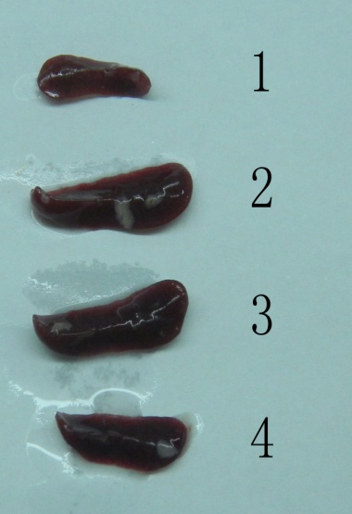
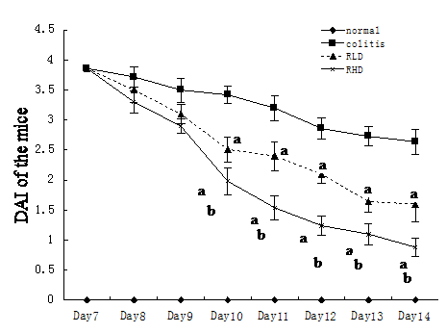
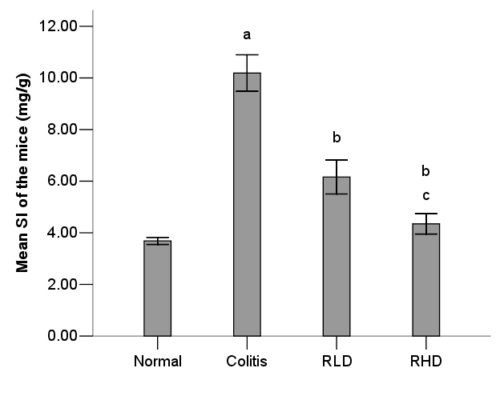
Figure 2 Effect of resveratrol on the histology of mice colon tissues. A: HE staining for (1) normal mice; (2) mice with colitis; (3) mice with colitis treated with resveratrol low dose (RLD); (4) mice with colitis treated with resveratrol high dose. B: Histological score. The letters a, b and c represent statistical significant (P < 0.05 vs normal controls, model and RLD groups), respectively.
A
B
C

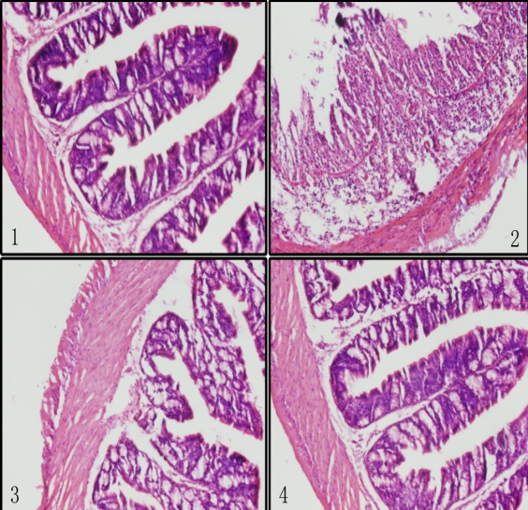
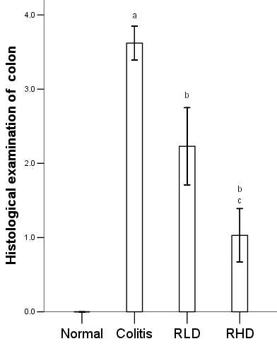
Figure 3 Effect of resveratrol on the spleen Treg and Th17 cells. A: The letters a, b and c represent statistical significant (P < 0.05 vs normal controls, model and resveratrol low dose groups) respectively.
A
B

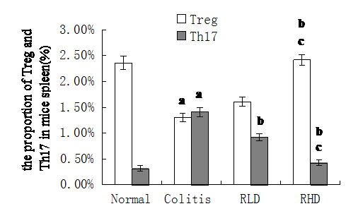
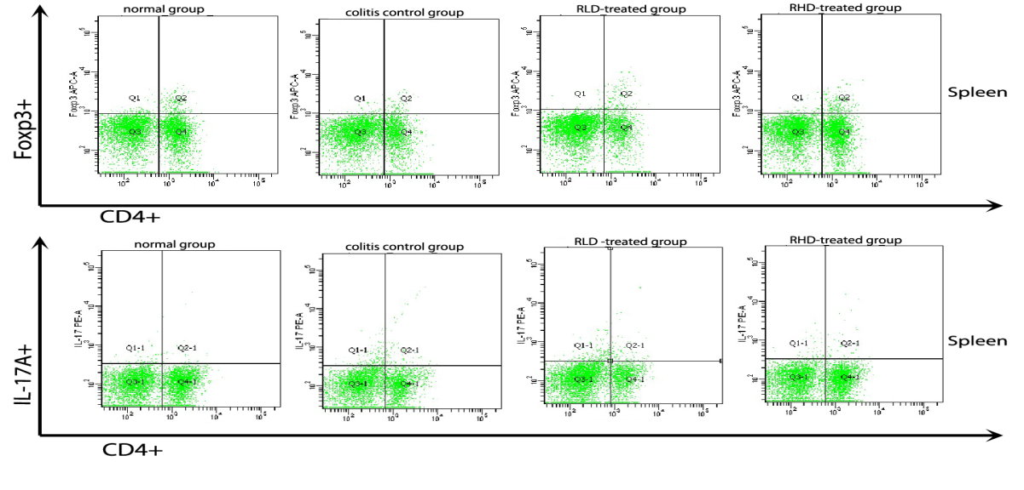
Figure 4 Effect of resveratrol on the cytokines in the plasma and colonic tissues. A: The effect of resveratrol on the level of plasma TGF-β1 and IL-6. B, C: The effect of resveratrol on the level of IL-10, TGF-β1, IL-6 and IL-17 in the colonic tissues. The letters a, b and c represent statistical significant (P < 0.05 vs normal controls, model and resveratrol low dose groups), respectively.
B
A
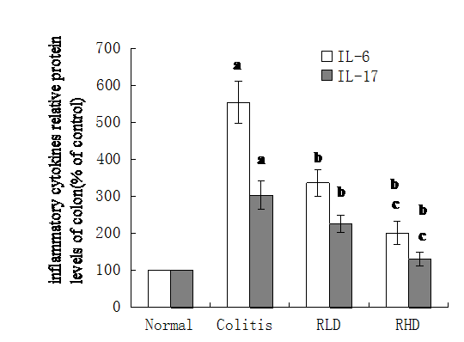
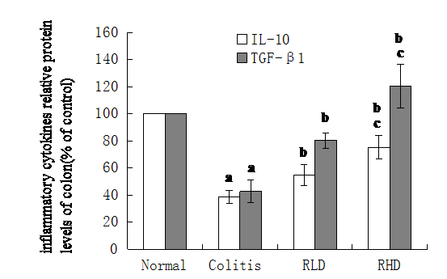
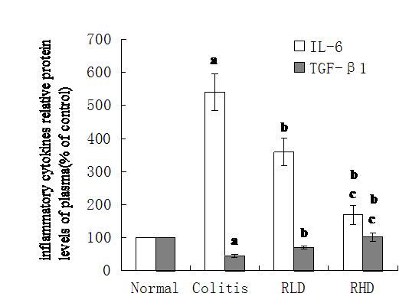
A
B
C
Figure 5 Effect of resveratrol on the expression of HIF-1α、mTOR、STAT3. A: lane (1) normal mice; (2) mice with colitis; (3) mice with colitis treated with resveratrol low dose (RLD); (4) mice with colitis treated with resveratrol high dose (RHD); B and C: Lane (1) normal mice; (2) mice with colitis; (3) mice with colitis treated with RHD; (4) mice with colitis treated with RLD.

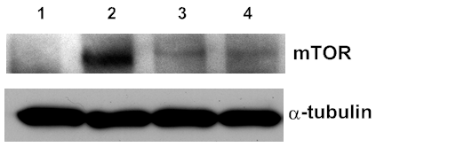
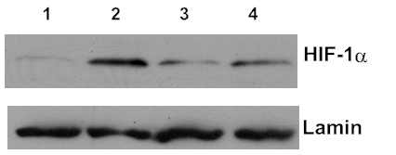
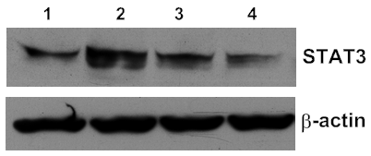
C
A
B

