Name of Journal: World Journal of Clinical Cases
Manuscript NO: 65889
Manuscript Type: CASE REPORT

Subsequent placenta accreta after previous mifepristone-induced abortion: a case report

Zhao P et al. Placenta accreta after previous mifepristone-induced abortion

Peng Zhao, Ying Zhao, Jing He, Xiao-xia Bai, Jian Chen

Peng Zhao, Ying Zhao, Department of Obstetrics, the Fourth Affiliated Hospital, Zhejiang University School of Medicine, Yiwu 322000, Zhejiang Province, China

Jing He, Xiao-xia Bai, Department of Obstetrics, Women’s Hospital, Zhejiang University School of Medicine, Hangzhou 310006, Zhejiang Province, China

Jian Chen, Department of Ultrasonography, the Fourth Affiliated Hospital Zhejiang University School of Medicine, Yiwu 322000, Zhejiang Province, China

Author contributions: Zhao P and He J designed the research study; Zhao P and Zhao Y performed the literature research; Zhao P, Zhao Y, Chen J and Bai XX contributed data acquisition and data analysis; Zhao P and Zhao Y wrote the manuscript; He J, Bai XX and Chen J critically revised the manuscript; All authors have read and approved the final manuscript.

Corresponding author: Jian Chen, MD, Chief Physician, Department of Ultrasonography, the Fourth Affiliated Hospital Zhejiang University School of Medicine, No. N1 Shangcheng dadao, Yiwu 322000, Zhejiang Province, China. chenjianzuj4h@zju.edu.cn

Received: March 17, 2021
Revised: September 22, 2021
Accepted: October 14, 2021
Published online: December 26, 2021

Abstract
BACKGROUND
Mifepristone-induced abortion (MIA) has been used worldwide to terminate pregnancies. However, the association between placenta accrete (PA) and MIA has seldom been reported.

CASE SUMMARY
A 26-year-old pregnant woman presented with painless vaginal bleeding at 35 wk of gestation. She had a medical abortion (mifepristone followed by misoprostol) 1 year ago at the sixth week of gestation. Her personal history for previous surgery was negative. Abdominal ultrasonography showed a normal foetus with complete placenta previa. The foetal membrane ruptured with massive vaginal bleeding and severe abdominal pain. An emergency Caesarean section was performed, and the newborn was delivered. The placenta failed to expel and manual extraction was carried out. A large defect was noted in the uterine fundus and repair of the uterine rupture was conducted immediately. The postoperative pathology report showed placenta accreta.

CONCLUSION
The evidence suggests a possible etiologic role of MIA in PA, as the incidence of PA after MIA is much higher than general population. Millions of pregnancies are complicated by PA each year, some of which result in fatality. To prevent subsequent placental complications after MIA, hormonal supplementation might be a promising therapeutic options. However, further studies are needed to identify the high-risk factors and to confirm the effectiveness of estrogen supplement therapy.

Key Words: Mifepristone-induced abortion; Placenta accreta; Uterine rupture; Placental complications; Hormonal supplementation; case report

©The Author(s) 2021. Published by Baishideng Publishing Group Inc. All rights reserved.

Citation: Zhao P, Zhao Y, He J, Bai XX, Chen J. Subsequent placenta accreta after previous mifepristone-induced abortion: a case report. World J Clin Cases 2021; 9(33): 10244-10248
URL: https://www.wjgnet.com/2307-8960/full/v9/i33/10244.htm
DOI: https://dx.doi.org/10.12998/wjcc.v9.i33.10244

Core Tip: The main findings of the current study are (1) a potential association between placenta accrete (PA) and mifepristone-induced abortion (MIA); and (2) the prevalence of PA after MIA has been neglected and underestimated for a long time. Millions of pregnancies are complicated by PA each year, some of which result in fatality. To prevent subsequent placental complications after MIA, hormonal supplementation might be a promising therapeutic option. However, further study is needed to identify risk factors and to confirm the effectiveness of estrogen supplement therapy.

INTRODUCTION
Considered as the most popular abortion choice, mifepristone-induced abortion (MIA) has been used to terminate unwanted pregnancies. It has been estimated that 3 million women received mifepristone in combination with misoprostol in France, Sweden, the United Kingdom, and China in 2000^{[1]}. Since then, the worldwide use of MIA has expanded. By 2003, the estimated number of induced abortions has reached 46 million^{[2]}. The immediate side effects of MIA have been well studied and the long term outcomes still need full evaluation. There have been published findings of placental complications, such as retained placenta^{[3]}, placental abruption^{[4]}, and placenta previa^{[5]} associated with MIA. However, placenta accreta (PA) has been seldom reported. The aim of this study was to (1) report a case of PA after a previous MIA; (2) review the literature; and (3) evaluate the risk factors and therapeutic strategies for preventing placental complications.

CASE PRESENTATION
Chief complaints
A 26-year-old (gravida 2, parity woman presented at our emergency department at 33 wk of gestation with a chief complaint of painless vaginal bleeding for 5 h.

History of present illness
There was no fever, vaginal bleeding, vaginal discharge, or any other symptoms.

History of past illness
She had a medical abortion (mifepristone followed by misoprostol) 1 year ago at the sixth week of gestation. Her personal history for previous surgery, including cervical and uterine surgery, was negative.

Personal and family history
No significant personal history or hereditary family history was noted.

Physical examination
The patient’s vital signs were normal on admission. Vaginal spotting was noted. No abdominal sharp tenderness or rebound pain were present. Vaginal examination revealed that the cervix was closed and its length was in the normal range. There was no vaginal fluid.

Laboratory examination
She was hemodynamically stable with normal liver function tests, normal coagulation profile and a haemoglobin level of 10.8 mg/dL. Cardiotocography, C-reaction protein, and fetal non-stress test results were normal.

Imaging examination
Abdominal ultrasonography showed a normal foetus with the placenta located in the anterior uterine wall. The fundus and the lower margin of the placenta completely covered the internal orifice of the cervix (complete placenta previa). No fluid was detected in the pouch of Douglas.

FINAL DIAGNOSIS
The patient was diagnosed with complete placenta previa at week 33 of gestation.

TREATMENT
Dexamethasone was administered instantly to the mother to promote foetal lung maturation. The patient stayed hospitalized for recurrent vaginal bleeding and tocolytics were given accordingly. 12 d later at 35 wk of gestation, the foetal membranes ruptured with massive vaginal bleeding and severe abdominal pain. An emergency Caesarean section was performed and a newborn was delivered with a birth weight of 2500 g and an Apgar score of 9 at 5 min and 10 at 10 min. The placenta failed to expel and manual extraction was carried out. The placenta was tightly attached and was difficult to remove. A large 5 cm × 3 cm defect was noted in the uterine fundus after manual removal of the placenta (Figure 1). Repair of the uterine defect was conducted immediately. The surgery went well with an estimated blood loss of 1000 mL.

OUTCOME AND FOLLOW-UP
The pathology report showed placenta accreta. The patient was discharged 6 d after surgery and recovered uneventfully during follow-up.

DISCUSSION
This preliminary study showed that there was a potential association between PA and MIA. In theory, the use of mifepristone to induce abortion is associated with endometrial haemorrhage and extracellular matrix degradation, which may cause irreversible injury to the endometrium^{[6]}. If the severity of injury exceeds the self-repair capacity of the uterus, long term adverse effects are likely to occur. PA, defined as the invasion of chorionic villi into the myometrium, is one of the clinical manifestations of such a condition. This study also demonstrated that the prevalence of PA after MIA has been neglected and underestimated for a long time. It has been reported that the incidence of PA after MIA was 0.5%^{[7]}, which is twelve-fold higher than the 0.04% estimated in pregnant women in the general population^{[8]}. Between 2010 and 2014, an estimated 55.9 million induced abortions were performed worldwide^{[9]}, with 65.1% of the women having subsequent pregnancies^{[10]}. To put the above estimates into real-world terms, there would be 0.2 million pregnancies complicated by PA. Moreover, the misuse of over the counter or black market mifepristone by self-administration potentially poses a serious danger. For example, in India, 5 million unsafe abortions are performed each year, and 31.25% of the patients had a history of self-administration of abortion pills^{[11]}. Therefore, the actual number of pregnancies complicated by PA after MIA can be assumed to be much higher than the estimated number.
The prevention of PA after MIA is a major concern of physicians during clinical practice. Sporadic studies have shown hormonal supplementation to be one of the promising options to prevent endometrial injury after MIA^{[12-16]}. Administration of estrogen before or after MIA increases endometrial proliferation and reduces the risk of endometrial injury. The details of studies of post-^{[12-16]} and pre-MIA hormonal supplementation^{[17]} are shown in Table 1. However, the previously described effectiveness of estrogen supplementation needs to be verified by a larger and more suitable clinical trial. Additionally, prescribing estrogen for every patient would lead to a significant financial burden and consumption of precious resources. Therefore, it is important to identify the risk factors that increase the risk of PA associated with MIA. Several observational studies^{[7,18,19]} showed that multiple MIAs, prolonged duration of vaginal bleeding after MIA, gestational age more than 6 wk at MIA, and an interpregnancy interval longer than 18 mo might be associated with placental complications. In this report, the patient had one clinical feature that could be identified as a risk factor, and that was a gestational age of more than 6 wk at MIA. Further study should be conducted to confirm the risk factors.

CONCLUSION
In conclusion, there is evidence of a possible etiologic role of MIA in PA, as the incidence of PA after MIA is much higher than it is in the general population. Millions of pregnancies are complicated by PA each year, some of which result in fatality. Hormonal supplementation might effective for preventing placental complication subsequent to MIA. However, further studies needed to identify risk factors and to confirm the effectiveness of estrogen supplementation therapy.

ACKNOWLEDGMENTS
We would like to thank Dr. Joynauth Jyotsnav for his critical review and language editing of this study.

REFERENCES
1 Virk J, Zhang J, Olsen J. Medical abortion and the risk of subsequent adverse pregnancy outcomes. N Engl J Med 2007; 357: 648-653 [PMID: 17699814 DOI: 10.1056/NEJMoa070445]
2 Liao H, Wei Q, Duan L, Ge J, Zhou Y, Zeng W. Repeated medical abortions and the risk of preterm birth in the subsequent pregnancy. Arch Gynecol Obstet 2011; 284: 579-586 [PMID: 20978775 DOI: 10.1007/s00404-010-1723-7]
3 Zhou W, Nielsen GL, Larsen H, Olsen J. Induced abortion and placenta complications in the subsequent pregnancy. Acta Obstet Gynecol Scand 2001; 80: 1115-1120 [PMID: 11846708 DOI: 10.1034/j.1600-0412.2001.801207.x]
4 Lin TB, Hsieh MF, Hou YC, Hsueh YL, Chang HP, Tseng YT. Long-term physical health consequences of abortion in Taiwan, 2000 to 2013: A nationwide retrospective cohort study. Medicine (Baltimore) 2018; 97: e11785 [PMID: 30075608 DOI: 10.1097/MD.0000000000011785]
5 Johnson LG, Mueller BA, Daling JR. The relationship of placenta previa and history of induced abortion. Int J Gynaecol Obstet 2003; 81: 191-198 [PMID: 12706277 DOI: 10.1016/s0020-7292(03)00004-3]
6 Männistö J, Mentula M, Bloigu A, Hemminki E, Gissler M, Heikinheimo O, Niinimäki M. Medical versus surgical termination of pregnancy in primigravid women--is the next delivery differently at risk? A population-based register study. BJOG 2013; 120: 331-337 [PMID: 23126244 DOI: 10.1111/1471-0528.12034]
7 Zhu QX, Gao ES, Chen AM, Luo L, Cheng YM, Yuan W. Mifepristone-induced abortion and placental complications in subsequent pregnancy. Hum Reprod 2009; 24: 315-319 [PMID: 19054774 DOI: 10.1093/humrep/den426]
8 ACOG Committee on Obstetric Practice. ACOG Committee opinion. Number 266, January 2002: placenta accreta. Obstet Gynecol 2002; 99: 169-170 [PMID: 11777527 DOI: 10.1097/00006250-200201000-00029]
9 Sedgh G, Bearak J, Singh S, Bankole A, Popinchalk A, Ganatra B, Rossier C, Gerdts C, Tunçalp Ö, Johnson BR Jr, Johnston HB, Alkema L. Abortion incidence between 1990 and 2014: global, regional, and subregional levels and trends. Lancet 2016; 388: 258-267 [PMID: 27179755 DOI: 10.1016/S0140-6736(16)30380-4]
10 Yan M, Shen J, Su S, Wang Y. The correlation between pregnancy and delivery history and abortion effect in women with medical abortion. Zhongguo Fuyou Baojian 2004; 19: 1970-1971 [DOI: 10.3969/j.issn.1001-4411.2004.05.041]
11 Nivedita K, Shanthini F. Is It Safe to Provide Abortion Pills over the Counter? A Study on Outcome Following Self-Medication with Abortion Pills. J Clin Diagn Res 2015; 9: QC01-QC04 [PMID: 25738038 DOI: 10.7860/JCDR/2015/11626.5388]
12 Martin CW, Brown AH, Baird DT. A pilot study of the effect of methotrexate or combined oral contraceptive on bleeding patterns after induction of abortion with mifepristone and a prostaglandin pessary. Contraception 1998; 58: 99-103 [PMID: 9773264 DOI: 10.1016/s0010-7824(98)00072-9]
13 Tang OS, Xu J, Cheng L, Lee SW, Ho PC. The effect of contraceptive pills on the measured blood loss in medical termination of pregnancy by mifepristone and misoprostol: a randomized placebo controlled trial. Hum Reprod 2002; 17: 99-102 [PMID: 11756369 DOI: 10.1093/humrep/17.1.99]
14 Liu C, Guan J, Shen H, Feng Y, Zhang D, Hu M, Fang H. Estrogen Promoting Endometrium Regeneration after Medical Abortion. Zhongguo Jihua Shengyu Zazhi 2006; 125: 165-166
15 Wang C, Huang Z, Li X. Effects of taking estrogen and progestogen after medical abortionon reducing vaginal hemorrhage time: a randomized-controlled trial. Zhonghua Yi Xue Za Zhi 2011; 91: 3179-3181 [DOI: 10.1631/jzus.B1000197]
16 Farhi J, Bar-Hava I, Homburg R, Dicker D, Ben-Rafael Z. Induced regeneration of endometrium following curettage for abortion: a comparative study. Hum Reprod 1993; 8: 1143-1144 [PMID: 8408501 DOI: 10.1093/oxfordjournals.humrep.a138208]
17 Luo F. Clinical Application of Estradiol Valerate Combined with Anti-pregnancy Pills in Missed Abortion. Shiyong Linchuang Yixue 2012; 13: 66-68
18 Chen AQ, Fang H. The effect on susequent pregnancies after induced abortion or medical abortion. Zhongguo Fuyou Baojian 2006; 21: 3235-3236 [DOI: 10.3969/j.issn.1001-4411.2006.23.016]
19 Lopes A, King PA, Duthie SJ, To WK, Ma HK. The impact of multiple induced abortions on the outcome of subsequent pregnancy. Aust N Z J Obstet Gynaecol 1991; 31: 41-43 [PMID: 1872772 DOI: 10.1111/j.1479-828X.1991.tb02762.x]

Footnotes
Informed consent statement: Written informed consent for publication was obtained from the patient.

Conflict-of-interest statement: The authors declared no conflict of interest with respect to the research, authorship, and publication of this article.

CARE Checklist (2016) statement: The authors have read the CARE Checklist (2016), and the manuscript was prepared and revised according to the CARE Checklist (2016).

Open-Access: This article is an open-access article that was selected by an in-house editor and fully peer-reviewed by external reviewers. It is distributed in accordance with the Creative Commons Attribution NonCommercial (CC BY-NC 4.0) license, which permits others to distribute, remix, adapt, build upon this work non-commercially, and license their derivative works on different terms, provided the original work is properly cited and the use is non-commercial. See: http://creativecommons.org/Licenses/by-nc/4.0/

Provenance and peer review: Unsolicited article; Externally peer reviewed.

Peer-review started: March 17, 2021
First decision: April 13, 2021
Article in press: October 14, 2021

Specialty type: Obstetrics and gynecology
Country/Territory of origin: China
Peer-review report’s scientific quality classification
Grade A (Excellent): 0
Grade B (Very good): B
Grade C (Good): C, C
Grade D (Fair): 0
Grade E (Poor): 0

P-Reviewer: Levine E, Omar NS S-Editor: Gong ZM L-Editor: Filipodia P-Editor: Gong ZM
Figure Legends
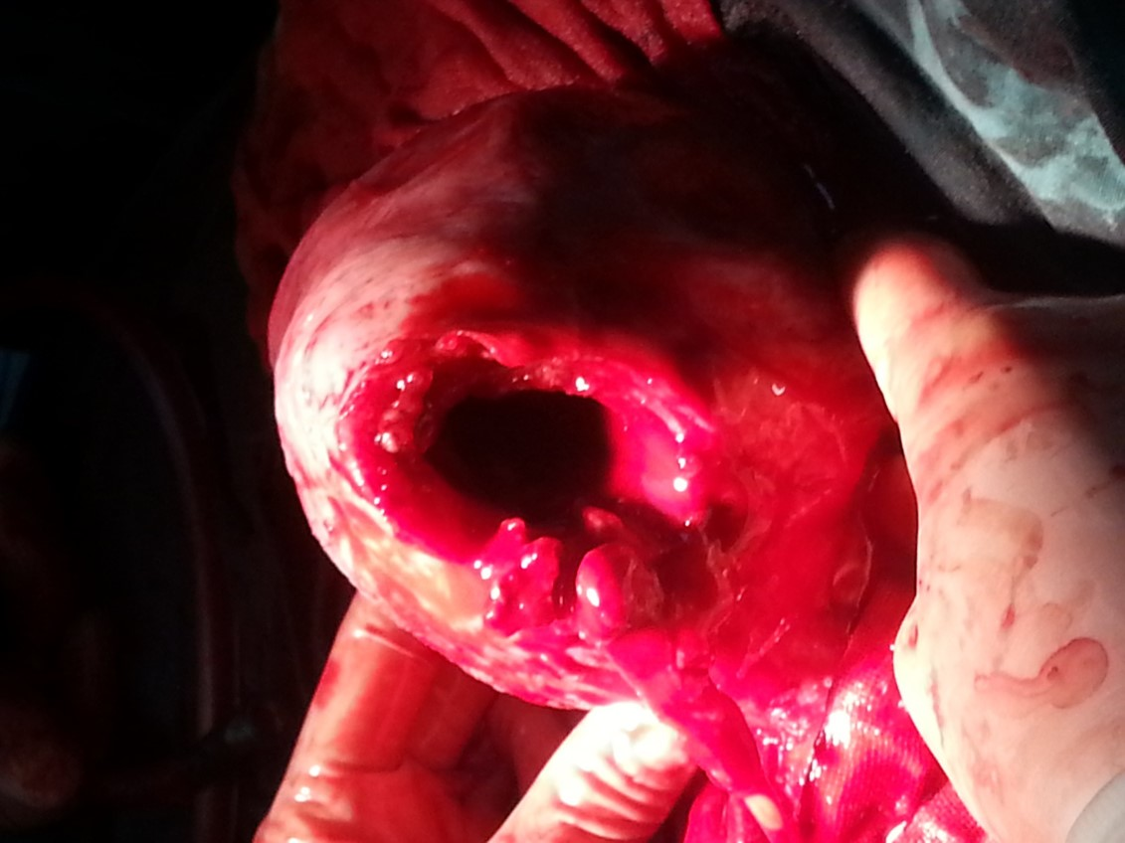
Figure 1 A large uterine defect was noted in the fundus after manual removal of the placenta.

Table 1 Studies of estrogen administration following mifepristone-induced abortion
Ref. | Hormone regimen | Dose | Duration
Martin et al^{[12]}, 1988 | Post-operation, oral contraceptive | Ethinyl oestradiol 30 µg; levonorgestrel 150 µg | Start on the day of abortion, daily for 21 d
Tang et al^{[13]}, 2002 | Post-operation, oral contraceptive | Ethinyl oestradiol 30 µg; levonorgestrel 150 µg | Start 1 d after the administration of misoprostol, daily for 21 d
Liu et al^{[14]}, 2006 | Post-operation, estrogenic supplementation | Oestradiol valerate 1mg | Start 1 d after abortion, daily for 14-18 d
Wang et al^{[15]}, 2011 | Post-operation, oestrogenic-progesterone sequential administration | Oestradiol valerate 2 mg; Medroxyprogesterone 10 mg | Oestradiol valerate, start 1 d after abortion, daily for 21 d; Medroxyprogesterone, daily for the last 5 d
Farhi et al^{[16]}, 1993 | Post-operation, oestrogenic-progesterone sequential administration | Oestradiol valerate 2 mg; Norgestrel 0.5 mg | Oestradiol valerate, start 1 d after abortion, daily for 21 d; Norgestrel, daily for the last 10 d
Luo et al^{[17]}, 2012 | Pre-operation, oestrogen supplementation | Oestradiol valerate 5 mg | Oestradiol valerate, daily for 3 d before abortion

Published by Baishideng Publishing Group Inc
7041 Koll Center Parkway, Suite 160, Pleasanton, CA 94566, USA
Telephone: +1-925-3991568
E-mail: bpgoffice@wjgnet.com
Help Desk: https://www.f6publishing.com/helpdesk
https://www.wjgnet.com

© 2021 Baishideng Publishing Group Inc. All rights reserved.

