Name of Journal: World Journal of Gastroenterology
Manuscript NO: 56807
Manuscript Type: ORIGINAL ARTICLE

Observational Study
Comparison of bowel ultrasound and magnetic resonance enterography in Egyptian patients with inflammatory bowel disease

Kamel S et al. Bowel ultrasound vs MRE in IBD

Shimaa Kamel, Mohamed Sakr, Waleed Hamed, Mohamed Eltabbakh, Safaa Askar, Ahmed Bassuny, Rasha Hussein, Ahmed Elbaz

Shimaa Kamel, Mohamed Sakr, Waleed Hamed, Mohamed Eltabbakh, Safaa Askar, Ahmed Bassuny, Ahmed Elbaz, Department of Tropical Medicine, Gastroenterology and Hepatology, Ain Shams University, Cairo 11566, Egypt

Rasha Hussein, Department of Radiology, Ain Shams University and MR Unit of Misr Radiology Center, Cairo 11566, Egypt

Author contributions: Kamel S completed the study design, bowel ultrasound examination, data collection and data analysis; Sakr M, Hamed W, Eltabbakh M and Askar S reviewed the manuscript for important scientific content; Bassuny A finished data collection; Hussein R reviewed the magnetic resonance imaging scans as an expert radiologist with significant experience in inflammatory bowel disease, reviewed and edited the radiological section of the manuscript; ElBaz A completed the literature search, data analysis and writing the manuscript; all authors have read and approved the final manuscript.

Corresponding author: Ahmed Elbaz, MD, Assistant Professor, Department of Tropical Medicine, Gastroenterology and Hepatology, Ain Shams University, Abbasia, Cairo 11566, Egypt. ahmedelbaz75@gmail.com

Received: May 28, 2020
Revised: August 11, 2020
Accepted: September 11, 2020
Published online:

Abstract
BACKGROUND
Bowel ultrasound and magnetic resonance enterography (MRE) are decisive medical imaging modalities for diagnosing and locating bowel lesions, their extramural extent and complications. These modalities assess the degree of activity, help clinicians to identify patients in need of surgery, and can be used for patient follow-up.

AIM
To compare the role of MRE and bowel ultrasound in the diagnosis and follow-up of inflammatory bowel disease (IBD) patients in Egypt.

METHODS
The study included 40 patients with IBD. All patients underwent clinical assessment, laboratory investigations, bowel ultrasound, MRE, and colonoscopy up to the terminal ileum with biopsies for histopathological examination.

RESULTS
This study included 14 patients (35%) with ulcerative colitis and 26 patients (65%) with Crohn's disease; 34 (85%) of these patients had active disease. Bowel ultrasound detected different bowel lesions with the following accuracies: ileum (85%), large bowel (70%), fistula (95%), stricture and proximal dilatation (95%) and abscesses (100%). It also showed a statistically significant difference for bowel ultrasound in the differentiation between remission and activity of IBD in comparison to MRE and colonoscopy.

CONCLUSION
In comparison to MRE, bowel ultrasound is a useful, non-invasive, and feasible bedside imaging tool for the detection of inflammation and complications, and in the follow-up of IBD patients when performed by the attending physician.

Key Words: Bowel ultrasound; Colonoscopy; Crohn's disease; Magnetic resonance enterography; Ulcerative colitis; Inflammatory bowel disease

Kamel S, Sakr M, Hamed W, Eltabbakh M, Askar S, Bassuny A, Hussein R, Elbaz A. Comparison of bowel ultrasound and magnetic resonance enterography in Egyptian patients with inflammatory bowel disease. World J Gastroenterol 2020; In press

Core Tip: Crohn’s disease and ulcerative colitis are chronic, relapsing inflammatory bowel diseases (IBDs). Medical imaging is decisive for the diagnosis of bowel lesions and their complications. Magnetic resonance enterography (MRE) is one of these imaging techniques. In addition, bowel ultrasound is becoming progressively important in the management of IBD. The aim of this study was to compare the role of MRE and bowel ultrasound in the diagnosis and follow-up of Egyptian IBD patients.
INTRODUCTION
Crohn’s disease and ulcerative colitis are chronic, relapsing inflammatory bowel diseases (IBDx). Medical imaging is decisive for diagnosing and locating bowel lesions, their extramural extent and complications. Imaging determines the degree of activity, assigns patients in need of surgery and can be used for their follow-up.
Magnetic resonance enterography (MRE) is one specific imaging technique for these diseases^{[1]}. T2W and T1W images after intravenous gadolinium administration have high accuracy for the diagnosis and assessment of disease activity^{[2]}.
Bowel ultrasound is also becoming progressively important in IBD management. Ultrasonography is a noninvasive, non-radiating, inexpensive, and readily available technique that is acceptable and tolerated by patients and can be used repeatedly for follow-up examinations. Ultrasonography in these patients requires higher frequency linear array probes (5-15 MHz) for assessment of the five-layer bowel wall^{[3]}.
To date, no published studies have compared bowel ultrasound and MRE in Egyptian patients who suffered/are suffering from IBD, either ulcerative colitis or Crohn’s disease.

MATERIALS AND METHODS
Study population
Our study enrolled 40 patients who presented to our IBD center at Ain Shams University Hospital during the period from September 2017 to September 2018.
The study was approved by the medical ethics committee of Ain Shams University. The study population included adolescents who were over 18 years old. All patients provided written informed consent before enrollment. Patients were excluded if they had severe or uncontrolled comorbidities, such as cardio-respiratory, neurological, metabolic, liver or kidney diseases, claustrophobia, a cardiac pacemaker, or implanted metal objects that prohibited the use of MRE.
All patients had a complete medical history, and underwent thorough clinical examinations and laboratory investigations, including complete blood count, liver profile tests, renal profile tests, C-reactive protein, erythrocyte sedimentation rate, MRE, bowel ultrasound, and colonoscopy up to the terminal ileum with biopsies for histopathological examination.
Clinical activity score for Crohn's disease was assessed by The Crohn’s Disease Activity Index (CDAI). Clinical remission was determined if CDAI was < 150 points or no fistula drainage was found as assessed by the Fistula Drainage Assessment Index^{[4]}. Ulcerative colitis activity was assessed using the Truelove and Witts classification based on clinical and laboratory parameters, such as fever, frequency of bowel movements, rectal bleeding, tachycardia, anemia, and elevated erythrocyte sedimentation rate^{[5]}.
Colonoscopies were performed with a videoscope system from Olympus Exera II CV-180 after colonic preparation and fasting for six hours.

Bowel ultrasound
Bowel ultrasound was carried out by one examiner who had performed several previous general ultrasound examinations. This examiner was trained to carry out several bowel ultrasound exams under the supervision of an ultrasound gastroenterologist specialist at Sacco Hospital, Italy. Bowel ultrasound assessment was reviewed blindly compared to MRE and colonoscopy.
Patients were examined by ultrasound after a six hour fasting period to minimize intestinal air contents. The examination was carried out using an ultrasound machine (Toshiba Xario, Japan) with a low frequency curved-array transducer (2.5-4.5 MHz) to determine any pathological bowel motility or distension and any para-intestinal structures, such as abscesses, in all abdominal quadrants. Examination with a high-frequency linear-array transducer (6.0-8.4 MHz) was used for bowel wall examination starting with examination of the proximal colon followed with the distal colon and then the small bowel^{[3]}. This examination assessed inflammation criteria such as thickness of the bowel wall, inflammatory mesenteric fat and lymph nodes, hyperemia on color Doppler flow, and complications, such as stenosis, fistulas or inflammatory masses.
In the longitudinal direction, the bowel wall was measured for bowel thickness at its anterior wall or in an area in which it was more visible in order to avoid mucosal folds and haustrations. The cursor was placed at the end of the interface echo between the serosa and proper muscle to the start of the interface echo between the lumen and the mucosa^{[6,7]}.
Several criteria for stenosis diagnosis via ultrasound have been reported, such as thickened bowel wall, narrowing of the diameter of the lumen < 1 cm, hyperperistalsis of the pre-stenotic bowel, and proximal dilatation > 25-30 mm^{[8–10]}.
An abscess was indicated by bowel ultrasound as an irregular, avascular hypoechoic area with a small amount of internal echoes or air in the form of hyperechoic streaks^{[9]}.

MRE
The patient was instructed to have a low residue diet the day before the examination and was asked to fast at least 6 to 8 h before the procedure. Ingestion of 1 to 2 L of hyperosmolar oral contrast was performed about 45 min before the magnetic resonance (MR) exam started. After full distension of the bowel, a spasmolytic medication was given to decrease bowel peristalsis to provide better bowel visualization. The examination was performed on 1.5-T MR machine, Achieva, Philips Medical System, Best, Netherlands in the MRI Unit, Ain Shams University Hospital. The patient was placed in the supine position using a multi-element phased array Torso coil (16 channels). A dedicated MR study was then performed as described in Table 1. Pixel-based apparent diffusion coefficient maps were generated on the off-line workstation (extended workspace ‘‘EWS’’), Pride software (Philips Medical Systems). Intravenous gadolinium contrast was given (0.2 mmol/kg body weight) in a dynamic fashion obtaining three-dimensional enhanced T1 isotropic volume excitation (3D-eTHRIVE) coronal scans at 10 s, 20 s, 60 s, 70 s, and 90 s. The total MRE procedure took approximately 30 to 45 min.
The images were interpreted by a radiologist with 12 years of experience in abdominal imaging and who was blinded to the clinical and colonoscopy examination results.
The MRE evaluated bowel wall thickening, mural edema, enlarged mesenteric lymph nodes, restricted diffusion, peri-enteric vascularization (comb sign), peri-enteric fluid, and the presence of complications, such as abscesses or fistulas.

Statistical analysis
Statistical analysis was performed using the SPSS software (22.0 version: SPSS Inc., Chicago, IL, United States). The description of quantitative variables was expressed in the form of mean ± standard deviation (mean ± SD) or median and inter-quartile range. A description of qualitative variables was expressed by frequency and percentage. A comparison of qualitative variables was carried out using the chi-square test. P < 0.05 was taken as significant. The sensitivity, specificity, overall correctness of prediction, and positive and negative predictive values were calculated. Correlations were calculated using Pearson’s correlation coefficient. The receiver operating characteristic (ROC) curves and areas under the ROC (AUROC) curves were used to evaluate the prognostic values (specificity and sensitivity).

RESULTS
The demographic profile, clinical and laboratory parameters are shown in Table 2. Most of the patients were middle-age females who presented with abdominal pain and diarrhea. The results indicated that 14 (35%) of our patients had ulcerative colitis, and 26 (65%) had Crohn's disease while 34 (85%) of them had inactive disease. Four (4%) of the studied patients had pancolitis, and 18 (45%) had ileal lesions.
The results in Table 3 indicate that bowel ultrasound appears to detect ileal disease with a sensitivity, specificity, and diagnostic accuracy of 93.8%, 50%, and 85%, respectively. With respect to the large bowel, bowel ultrasound detected large bowel disease with a sensitivity, specificity, and accuracy of 37.5%, 91.7%, and 70%, respectively. Also, bowel ultrasound detected the thickness of the affected segment with a sensitivity, specificity, and accuracy of 83.3%, 50%, and 60%, respectively. Bowel ultrasound detected a fistulous track with a sensitivity, specificity, and accuracy of 85.7%, 100%, and 95%, respectively, and detected stricture and proximal dilatation with a sensitivity, specificity, and accuracy of 100%, 94.4%, and 95%, respectively. Abscess was detected by bowel ultrasound in six patients with high specificity, sensitivity, and accuracy (100%). In addition, there were no statistically significant differences between bowel ultrasound findings and disease activity index, which indicate that bowel ultrasound can differentiate between remission and active disease.
Table 4 demonstrates that there were no statistically significant differences between bowel ultrasound, MRE, and colonoscopy in the detection of disease activity, indicating that bowel ultrasound and MRE can differentiate between remission and active IBD.
Table 5 compares the clinical symptoms and bowel ultrasound and MRE findings. It can be seen that bleeding per rectum was statistically significant in patients with strictures and proximal dilatation during assessment by bowel ultrasound, while diarrhea was statistically significantly related to the extent of the lesions when assessed by MRE.

DISCUSSION
Endoscopy is still the most important diagnostic procedure as it permits biopsies for histological examination^{[11]}. European guidelines have recommended imaging techniques, such as bowel ultrasound, computed tomography enterography, and MRE as complementary tools for IBD diagnosis that can help define lesion location, extension, and complications^{[12]}.
MRE is a cross-sectional non-ionizing imaging technique that can be used for IBD diagnosis and extra-intestinal assessment of disease activity and follow-up of patients. However, MRE is available at certain centers only and it takes a long time during scanning with sedation in some cases such as children to avoid motion artefacts in addition to non-compliance to contrast intake and the breath-hold technique^{[13]}.
Assessment of the gastrointestinal tract in IBD patients by intestinal ultrasound has evolved due to the development of ultrasound devices and increased skill of the examiners such as radiologists and gastroenterologists. Major parts of the small and large intestine can be easily examined by bowel ultrasound while the proximal part of the jejunum and the rectum may be difficult to assess due to overlying structures. Despite the various advantages of bowel ultrasound as a rapid bedside, inexpensive, non-radiating and tolerable test, the results are subjective to the examiner's expertise^{[14]}.
Our results showed similar sensitivity for the detection of ileal IBD compared with a previous study (92.7%), but with lower specificity than this study (88.2%). With regard to colonic IBD, our results showed lower sensitivity than that observed in the previous study (81.8%) but with similar specificity (95.3%), a finding which may be explained by interobserver variability between examiners^{[13]}. This variability can explain why one study concluded that bowel ultrasound is more accurate in the assessment of IBD patients if combined with colonoscopy^{[16]}.
A bowel wall thickness cutoff value of 3 mm in our study showed a sensitivity (83.3%), specificity (50%), and accuracy (60%) compared with other studies, which showed sensitivities of 88% to 94%; however, specificity (93%-97%) and diagnostic accuracy (94%) were higher in previous studies than in our study^{[9,15]}. This finding can be explained by the lack of international agreement regarding standardized measurement parameters, which leads to interobserver variability between examiners^{[18]}.
Mesenteric lymph nodes detected by bowel ultrasound in our study were non-sensitive and non-specific (16.7% and 71.4%, respectively) and subsided during remission; therefore, lymph node detection is not a good parameter of disease activity, which in agreement with previous studies^{[19,20]}.
Our results were in agreement with those from different trials and showed that the detection rate of fistulas, depending on their localization, resulted in a sensitivity between 67% and 82% and specificity between 90% and 100%^{[8,9,21–23]}.
The detection of strictures in our study by bowel ultrasound showed a sensitivity, specificity, and accuracy of 100%, 94.4%, and 95%, respectively, and were similar to those in other studies^{[15,24–26]}.
The sensitivity for detecting abscesses in different studies varied between 80% and 100%, and the specificity varied between 92% and 94%, which were similar to our results^{[27–29]}.
The findings in this study agreed with those from various trials in which it was shown that the diagnosis of IBD and assessment of disease activity cannot be dependent on clinical evaluation alone but should be combined with other investigations such as biomarkers, endoscopy, and imaging techniques such as bowel ultrasound and MRE^{[25,30]}.
Our results showed that aphthous ulcers at endoscopy, stricture and mesenteric lymphadenopathy at bowel ultrasound, thickness of bowel wall and proximal dilatation at MRE were significantly correlated with disease activity. Other studies showed that other bowel ultrasound parameters such as bowel wall thickening and its extent showed a significant correlation with disease activity^{[26,31,32]}. With regard to the MRE results in our study these agreed with the findings from other studies^{[33,34]} and disagreed with those in another study^{[35]}.
This indicates that there is no clear gold standard imaging technique for the diagnosis of IBD including MRE and bowel ultrasound which could be used in addition to clinical history, biomarkers, and endoscopy for the diagnosis of IBD as shown in previous studies^{[25,30,36]}.
Bowel ultrasound may be more helpful in the follow-up of IBD patients and monitoring their response to treatment aside from its role in diagnosis by ultrasound- guided biopsy.
In Egypt, both MRE and colonoscopy are available with an estimated total cost of 93 dollars and 125 dollars, respectively. Bowel ultrasound costs only 18 dollars which is considered a low cost alternative and has prospects for widespread clinical use.
The limitations of our study included the relatively small number of patients, and comparative assessments of clinical decisions with and without bowel ultrasound were not available.

CONCLUSION
In comparison to MRE and colonoscopy, bowel ultrasound is a useful non-invasive and feasible bedside imaging tool for the detection of inflammation and complications, and as screening tool and for follow-up of IBD patients when performed by the attending physician.

ARTICLE HIGHLIGHTS
Research background
Bowel ultrasound is a new tool for the evaluation of inflammatory bowel disease.

Research motivation
To date, no previously published studies have compared bowel ultrasound and magnetic resonance enterography (MRE) in Egyptian inflammatory bowel disease (IBD) patients.

Research objectives
Compare the role of bowel ultrasound and MRE in Egyptian IBD patients.

Research methods
The study included 40 patients who presented to the IBD center of Ain Shams University Hospital. The patients were subjected to clinical, laboratory, colonoscopic and radiological assessments including bowel ultrasound and MRE.

Research results
Bowel ultrasound was a good predictor of disease activity, fistula, stricture, and abscess formation with high sensitivity in the ileum and greater specificity in the large bowel.

Research conclusions
Bowel ultrasound is a useful inexpensive bedside imaging tool in the diagnosis and follow-up of IBD patients.

Research perspectives
Further studies are necessary to compare clinical decisions with and without bowel ultrasound.

REFERENCES
1 Lunder AK, Bakstad LT, Jahnsen J, Borthne A, Hov JR, Vatn M, Negård A. Assessment of Bowel Inflammation and Strictures by Magnetic Resonance Enterography in Long-term Crohn's Disease. J Crohns Colitis 2019; 13: 607-614 [PMID: 30541145 DOI: 10.1093/ecco-jcc/jjy208]
2 Maccioni F, Bruni A, Viscido A, Colaiacomo MC, Cocco A, Montesani C, Caprilli R, Marini M. MR imaging in patients with Crohn disease: value of T2- vs T1-weighted gadolinium-enhanced MR sequences with use of an oral superparamagnetic contrast agent. Radiology 2006; 238: 517-530 [PMID: 16371574 DOI: 10.1148/radiol.2381040244]
3 Strobel D, Goertz RS, Bernatik T. Diagnostics in inflammatory bowel disease: ultrasound. World J Gastroenterol 2011; 17: 3192-3197 [PMID: 21912467 DOI: 10.3748/wjg.v17.i27.3192]
4 Best WR, Becktel JM, Singleton JW. Rederived values of the eight coefficients of the Crohn's Disease Activity Index (CDAI). Gastroenterology 1979; 77: 843-846 [PMID: 467941]
5 TRUELOVE SC, WITTS LJ. Cortisone in ulcerative colitis; final report on a therapeutic trial. Br Med J 1955; 2: 1041-1048 [PMID: 13260656 DOI: 10.1136/bmj.2.4947.1041]
6 Nylund K, Hausken T, Ødegaard S, Eide GE, Gilja OH. Gastrointestinal wall thickness measured with transabdominal ultrasonography and its relationship to demographic factors in healthy subjects. Ultraschall Med 2012; 33: E225-E232 [PMID: 22504939 DOI: 10.1055/s-0031-1299329]
7 Nylund K, Maconi G, Hollerweger A, Ripolles T, Pallotta N, Higginson A, Serra C, Dietrich CF, Sporea I, Saftoiu A, Dirks K, Hausken T, Calabrese E, Romanini L, Maaser C, Nuernberg D, Gilja OH. EFSUMB Recommendations and Guidelines for Gastrointestinal Ultrasound. Ultraschall Med 2017; 38: e1-e15 [PMID: 27604052 DOI: 10.1055/s-0042-115853]
8 Calabrese E, Zorzi F, Onali S, Stasi E, Fiori R, Prencipe S, Bella A, Petruzziello C, Condino G, Lolli E, Simonetti G, Biancone L, Pallone F. Accuracy of small-intestine contrast ultrasonography, compared with computed tomography enteroclysis, in characterizing lesions in patients with Crohn's disease. Clin Gastroenterol Hepatol 2013; 11: 950-955 [PMID: 23375998 DOI: 10.1016/j.cgh.2013.01.015]
9 Castiglione F, Mainenti PP, De Palma GD, Testa A, Bucci L, Pesce G, Camera L, Diaferia M, Rea M, Caporaso N, Salvatore M, Rispo A. Noninvasive diagnosis of small bowel Crohn's disease: direct comparison of bowel sonography and magnetic resonance enterography. Inflamm Bowel Dis 2013; 19: 991-998 [PMID: 23429465 DOI: 10.1097/MIB.0b013e3182802b87]
10 Coelho R, Ribeiro H, Maconi G. Bowel Thickening in Crohn's Disease: Fibrosis or Inflammation? Diagnostic Ultrasound Imaging Tools. Inflamm Bowel Dis 2017; 23: 23-34 [PMID: 28002125 DOI: 10.1097/MIB.0000000000000997]
11 Annese V, Daperno M, Rutter MD, Amiot A, Bossuyt P, East J, Ferrante M, Götz M, Katsanos KH, Kießlich R, Ordás I, Repici A, Rosa B, Sebastian S, Kucharzik T, Eliakim R; European Crohn's and Colitis Organisation. European evidence based consensus for endoscopy in inflammatory bowel disease. J Crohns Colitis 2013; 7: 982-1018 [PMID: 24184171 DOI: 10.1016/j.crohns.2013.09.016]
12 Gomollón F, Dignass A, Annese V, Tilg H, Van Assche G, Lindsay JO, Peyrin-Biroulet L, Cullen GJ, Daperno M, Kucharzik T, Rieder F, Almer S, Armuzzi A, Harbord M, Langhorst J, Sans M, Chowers Y, Fiorino G, Juillerat P, Mantzaris GJ, Rizzello F, Vavricka S, Gionchetti P; ECCO. 3rd European Evidence-based Consensus on the Diagnosis and Management of Crohn's Disease 2016: Part 1: Diagnosis and Medical Management. J Crohns Colitis 2017; 11: 3-25 [PMID: 27660341 DOI: 10.1093/ecco-jcc/jjw168]
13 Ramos López L, Hernández Camba A, Rodríguez-Lago I, Carrillo Palau M, Cejas Dorta L, Elorza A, Alonso Abreu I, Vela M, Hidalgo A, Hernández Álvarez-Builla N, Rodríguez GE, Rodríguez Y, Tardillo C, Díaz-Flórez L, Eiroa D, Aduna M, Garrido MS, Larena JA, Cabriada JL, Quintero Carrion E. Usefulness of magnetic resonance enterography in the clinical decision-making process for patients with inflammatory bowel disease. Gastroenterol Hepatol 2020; Online ahead of print [PMID: 32349904 DOI: 10.1016/j.gastrohep.2020.03.007]
14 Rajagopalan A, Sathananthan D, An YK, Van De Ven L, Martin S, Fon J, Costello SP, Begun J, Bryant RV. Gastrointestinal ultrasound in inflammatory bowel disease care: Patient perceptions and impact on disease-related knowledge. JGH Open 2020; 4: 267-272 [PMID: 32280776 DOI: 10.1002/jgh3.12268]
15 Calabrese E, Maaser C, Zorzi F, Kannengiesser K, Hanauer SB, Bruining DH, Iacucci M, Maconi G, Novak KL, Panaccione R, Strobel D, Wilson SR, Watanabe M, Pallone F, Ghosh S. Bowel Ultrasonography in the Management of Crohn's Disease. A Review with Recommendations of an International Panel of Experts. Inflamm Bowel Dis 2016; 22: 1168-1183 [PMID: 26958988 DOI: 10.1097/MIB.0000000000000706]
16 Maconi G, Bolzoni E, Giussani A, Friedman AB, Duca P. Accuracy and cost of diagnostic strategies for patients with suspected Crohn's disease. J Crohns Colitis 2014; 8: 1684-1692 [PMID: 25179579 DOI: 10.1016/j.crohns.2014.08.005]
17 Fraquelli M, Colli A, Casazza G, Paggi S, Colucci A, Massironi S, Duca P, Conte D. Role of US in detection of Crohn disease: meta-analysis. Radiology 2005; 236: 95-101 [PMID: 15987966 DOI: 10.1148/radiol.2361040799]
18 Calabrese E, Kucharzik T, Maaser C, Maconi G, Strobel D, Wilson SR, Zorzi F, Novak KL, Bruining DH, Iacucci M, Watanabe M, Lolli E, Chiaramonte C, Hanauer SB, Panaccione R, Pallone F, Ghosh S, Monteleone G. Real-time Interobserver Agreement in Bowel Ultrasonography for Diagnostic Assessment in Patients With Crohn's Disease: An International Multicenter Study. Inflamm Bowel Dis 2018; 24: 2001-2006 [PMID: 29718450 DOI: 10.1093/ibd/izy091]
19 Kucharzik T, Wittig BM, Helwig U, Börner N, Rössler A, Rath S, Maaser C; TRUST study group. Use of Intestinal Ultrasound to Monitor Crohn's Disease Activity. Clin Gastroenterol Hepatol 2017; 15: 535-542.e2 [PMID: 27856365 DOI: 10.1016/j.cgh.2016.10.040]
20 Maconi G, Di Sabatino A, Ardizzone S, Greco S, Colombo E, Russo A, Cassinotti A, Casini V, Corazza GR, Bianchi Porro G. Prevalence and clinical significance of sonographic detection of enlarged regional lymph nodes in Crohn's disease. Scand J Gastroenterol 2005; 40: 1328-1333 [PMID: 16243717 DOI: 10.1080/00365510510025746]
21 Onali S, Calabrese E, Petruzziello C, Zorzi F, Sica G, Fiori R, Ascolani M, Lolli E, Condino G, Palmieri G, Simonetti G, Pallone F, Biancone L. Small intestine contrast ultrasonography vs computed tomography enteroclysis for assessing ileal Crohn's disease. World J Gastroenterol 2012; 18: 6088-6095 [PMID: 23155337 DOI: 10.3748/wjg.v18.i42.6088]
22 Pallotta N, Vincoli G, Montesani C, Chirletti P, Pronio A, Caronna R, Ciccantelli B, Romeo E, Marcheggiano A, Corazziari E. Small intestine contrast ultrasonography (SICUS) for the detection of small bowel complications in crohn's disease: a prospective comparative study vs intraoperative findings. Inflamm Bowel Dis 2012; 18: 74-84 [PMID: 21438095 DOI: 10.1002/ibd.21678]
23 Kumar S, Hakim A, Alexakis C, Chhaya V, Tzias D, Pilcher J, Vlahos J, Pollok R. Small intestinal contrast ultrasonography for the detection of small bowel complications in Crohn's disease: correlation with intraoperative findings and magnetic resonance enterography. J Gastroenterol Hepatol 2015; 30: 86-91 [PMID: 25168482 DOI: 10.1111/jgh.12724]
24 Parente F, Maconi G, Bollani S, Anderloni A, Sampietro G, Cristaldi M, Franceschelli N, Bianco R, Taschieri AM, Bianchi Porro G. Bowel ultrasound in assessment of Crohn's disease and detection of related small bowel strictures: a prospective comparative study versus X ray and intraoperative findings. Gut 2002; 50: 490-495 [PMID: 11889068 DOI: 10.1136/gut.50.4.490]
25 Panes J, Bouhnik Y, Reinisch W, Stoker J, Taylor SA, Baumgart DC, Danese S, Halligan S, Marincek B, Matos C, Peyrin-Biroulet L, Rimola J, Rogler G, van Assche G, Ardizzone S, Ba-Ssalamah A, Bali MA, Bellini D, Biancone L, Castiglione F, Ehehalt R, Grassi R, Kucharzik T, Maccioni F, Maconi G, Magro F, Martín-Comín J, Morana G, Pendsé D, Sebastian S, Signore A, Tolan D, Tielbeek JA, Weishaupt D, Wiarda B, Laghi A. Imaging techniques for assessment of inflammatory bowel disease: joint ECCO and ESGAR evidence-based consensus guidelines. J Crohns Colitis 2013; 7: 556-585 [PMID: 23583097 DOI: 10.1016/j.crohns.2013.02.020]
26 Dong J, Wang H, Zhao J, Zhu W, Zhang L, Gong J, Li Y, Gu L, Li J. Ultrasound as a diagnostic tool in detecting active Crohn's disease: a meta-analysis of prospective studies. Eur Radiol 2014; 24: 26-33 [PMID: 23921767 DOI: 10.1007/s00330-013-2973-0]
27 Gasche C, Moser G, Turetschek K, Schober E, Moeschl P, Oberhuber G. Transabdominal bowel sonography for the detection of intestinal complications in Crohn's disease. Gut 1999; 44: 112-117 [PMID: 9862836 DOI: 10.1136/gut.44.1.112]
28 Kohn A, Cerro P, Milite G, De Angelis E, Prantera C. Prospective evaluation of transabdominal bowel sonography in the diagnosis of intestinal obstruction in Crohn's disease: comparison with plain abdominal film and small bowel enteroclysis. Inflamm Bowel Dis 1999; 5: 153-157 [PMID: 10453369 DOI: 10.1097/00054725-199908000-00001]
29 Maconi G, Sampietro GM, Parente F, Pompili G, Russo A, Cristaldi M, Arborio G, Ardizzone S, Matacena G, Taschieri AM, Bianchi Porro G. Contrast radiology, computed tomography and ultrasonography in detecting internal fistulas and intra-abdominal abscesses in Crohn's disease: a prospective comparative study. Am J Gastroenterol 2003; 98: 1545-1555 [PMID: 12873576 DOI: 10.1111/j.1572-0241.2003.07521.x]
30 Kucharzik T, Petersen F, Maaser C. Bowel Ultrasonography in Inflammatory Bowel Disease. Dig Dis 2015; 33 Suppl 1: 17-25 [PMID: 26366707 DOI: 10.1159/000437035]
31 Ripollés T, Paredes Arquiola JM, Moreno-Osset E. Ultrasonography and Transmural Healing in Crohn's Disease. Clin Gastroenterol Hepatol 2015; 13: 1549-1551 [PMID: 25724705 DOI: 10.1016/j.cgh.2015.02.026]
32 Parente F, Molteni M, Marino B, Colli A, Ardizzone S, Greco S, Sampietro G, Foschi D, Gallus S. Are colonoscopy and bowel ultrasound useful for assessing response to short-term therapy and predicting disease outcome of moderate-to-severe forms of ulcerative colitis?: a prospective study. Am J Gastroenterol 2010; 105: 1150-1157 [PMID: 19997096 DOI: 10.1038/ajg.2009.672]
33 Martínez MJ, Ripollés T, Paredes JM, Blanc E, Martí-Bonmatí L. Assessment of the extension and the inflammatory activity in Crohn's disease: comparison of ultrasound and MRI. Abdom Imaging 2009; 34: 141-148 [PMID: 18214582 DOI: 10.1007/s00261-008-9365-y]
34 Rimola J, Ordás I, Rodriguez S, García-Bosch O, Aceituno M, Llach J, Ayuso C, Ricart E, Panés J. Magnetic resonance imaging for evaluation of Crohn's disease: validation of parameters of severity and quantitative index of activity. Inflamm Bowel Dis 2011; 17: 1759-1768 [PMID: 21744431 DOI: 10.1002/ibd.21551]
35 Ordás I, Rimola J, Rodríguez S, Paredes JM, Martínez-Pérez MJ, Blanc E, Arévalo JA, Aduna M, Andreu M, Radosevic A, Ramírez-Morros AM, Pinó S, Gallego M, Jauregui-Amezaga A, Ricart E, Panés J. Accuracy of magnetic resonance enterography in assessing response to therapy and mucosal healing in patients with Crohn's disease. Gastroenterology 2014; 146: 374-82.e1 [PMID: 24177375 DOI: 10.1053/j.gastro.2013.10.055]
36 Schreiber-Dietrich D, Chiorean L, Cui XW, Braden B, Kucharzik T, Jüngert J, Kosiak W, Stenzel M, Dietrich CF. Particularities of Crohn's disease in pediatric patients: current status and perspectives regarding imaging modalities. Expert Rev Gastroenterol Hepatol 2015; 9: 1313-1325 [PMID: 26377445 DOI: 10.1586/17474124.2015.1083420]

Footnotes
Institutional review board statement: The study was reviewed and approved by the Ain Shams University, Faculty of Medicine, Research Ethics Committee Institutional Review Board, No. FWA000017585.

Informed consent statement: All study participants, or their legal guardian, provided informed written consent prior to study enrollment.

Conflict-of-interest statement: None to declare.

Data sharing statement: Technical appendix, statistical code, and dataset available from the corresponding author at ahmedelbaz75@gmail.com. Participants gave informed consent for publication of data. No additional data are available.

STROBE statement: The authors have read the STROBE Statement-checklist of items, and the manuscript was prepared and revised according to the STROBE Statement-checklist of items.

Open-Access: This article is an open-access article that was selected by an in-house editor and fully peer-reviewed by external reviewers. It is distributed in accordance with the Creative Commons Attribution NonCommercial (CC BY-NC 4.0) license, which permits others to distribute, remix, adapt, build upon this work non-commercially, and license their derivative works on different terms, provided the original work is properly cited and the use is non-commercial. See: http://creativecommons.org/Licenses/by-nc/4.0/

Manuscript source: Unsolicited manuscript

Peer-review started: May 28, 2020
First decision: July 29, 2020
Article in press:

Specialty type: Gastroenterology and hepatology
Country/Territory of origin: Egypt
Peer-review report’s scientific quality classification
Grade A (Excellent): 0
Grade B (Very good): B
Grade C (Good): C, C, C
Grade D (Fair): D
Grade E (Poor): 0

P-Reviewer: Huang Z, Koga H, Sang LX, Zhuo ZQ S-Editor: Gao CC L-Editor: Webster JR P-Editor:

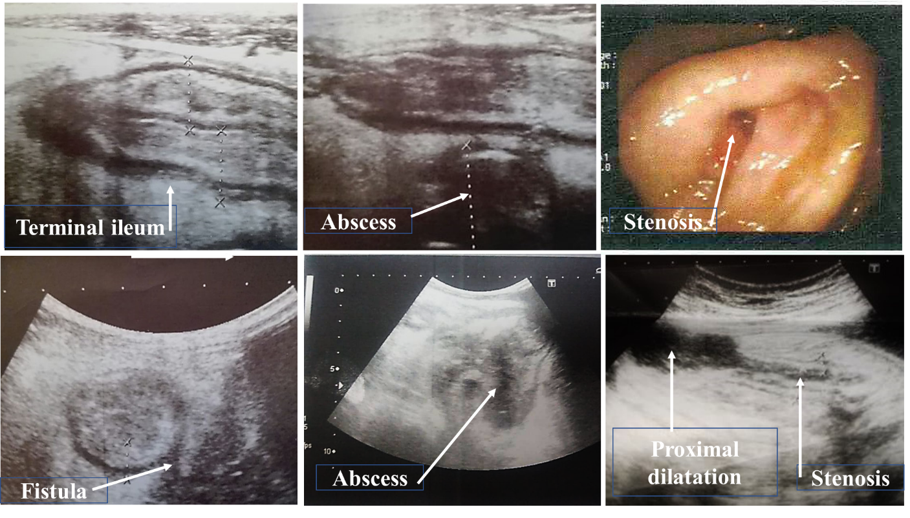
Figure 1 Bowel ultrasound and colonoscopy images. Bowel ultrasound demonstrates diffuse terminal ileal wall thickening likely inflammatory in nature with sonographic evidence of fistulization with mesenteric abscess formation. Stenosis which was detected during colonoscopy was detected by bowel ultrasound with proximal dilatation.

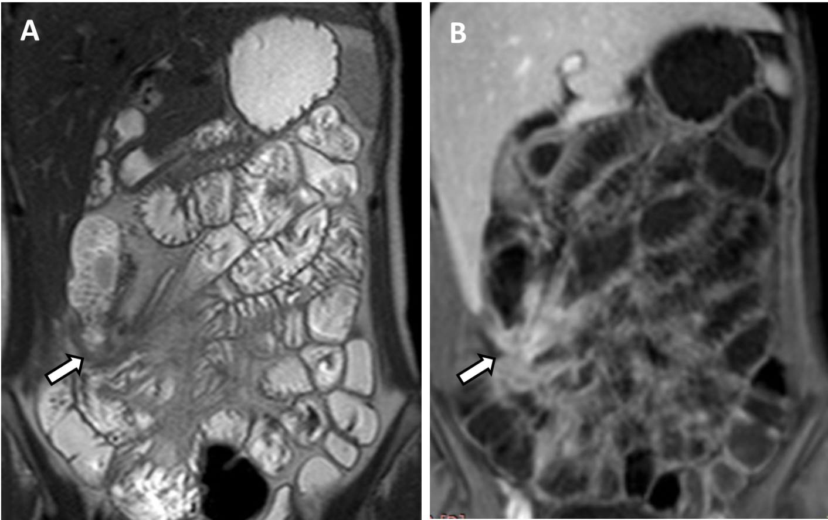
Figure 2 Magnetic resonance enterography. A: Coronal T2WI shows enteroenteric fistula at the right iliac fossa with stellate appearance of the thickened ileal loops (white arrow); B: Coronal fat-suppressed three-dimensional gradient echo postcontrast T1WI shows accentuated star-like enhancement at the right iliac fossa denoting fistulizing Crohn’s disease.

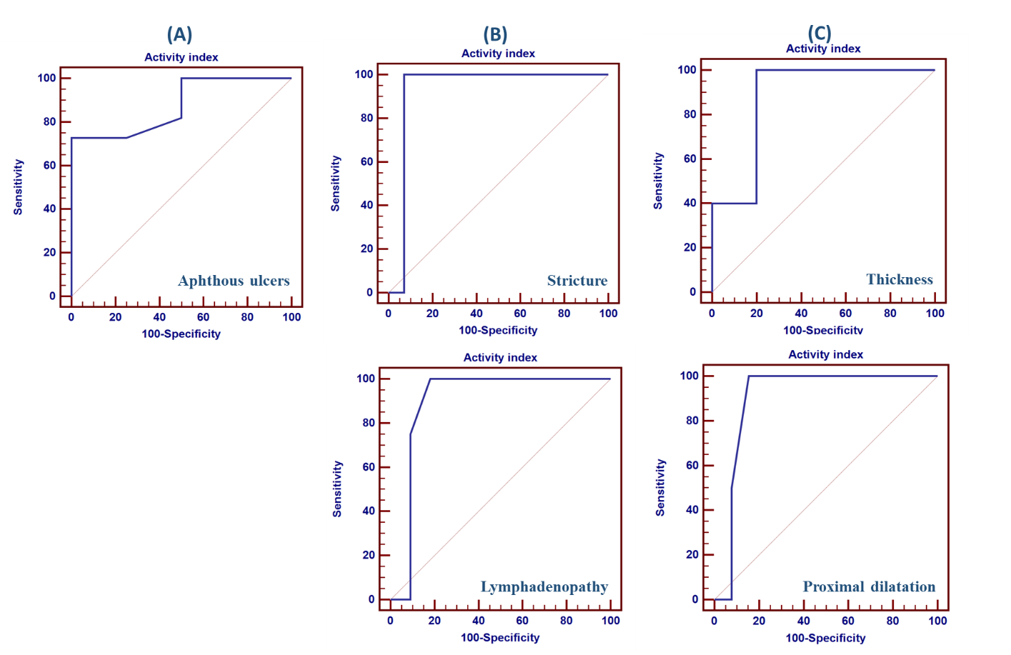
Figure 3 Receiver operating characteristic curve for prediction of active disease. A: At endoscopy, aphthous ulcers mean area under the receiver operating characteristic (ROC) curve was 0.875 (P < 0.001), positive likelihood ratio infinity, and negative likelihood ratio 0.28; B: Bowel ultrasound showed that stricture and lymphadenopathy mean area under the ROC curve were 0.929 (P = 0.036) and 0.898 (P = 0.01), respectively, positive likelihood ratio infinity for both, and negative likelihood ratio of 0.94 and 0.71, respectively; C: Magnetic resonance enterography showed that the thickness and proximal dilatation mean area under the ROC curve were 0.880 (P < 0.001) and 0.904 (P = 0.033), respectively, positive likelihood ratio was 1.06 and infinity, respectively, and negative likelihood ratio was 0.88 for both.
Table 1 Magnetic resonance enterography imaging protocol
Imaging sequence and plane | TR/TE | Slice thickness (mm) | Gap | Field of view (mm) | Matrix
Coronal T2 SSFSE | 1200/115 | 6 | 1 | 375 × 375 | 268 × 234
Coronal SSFP | 3.2/1.56 | 6 | 0 | 375 × 375 | 252 × 233
Axial T2WI | 1200/115 | 7 | 1 | 375 × 336 | 268 × 208
Axial DWI | 2743/65 | 7 | 1 | 375 × 302 | 124 × 100
3D-THRIVE | 4/1.9 | - | 0 | 410 × 377 | 196 × 178
Axial post contrast fat-suppressed gradient-echo T1WI | 3.8/1.8 | - | 0 | 375 × 314 | 196 × 157
Coronal post contrast fat-suppressed gradient-echo T1WI | 4/1.9 | - | 0 | 410 × 314 | 196 × 178
TR: Repetition time; TE: Echo time; SSFSE: Single-shot fast spin-echo; SSFP: Single-shot free precision; 3D: Three dimensional.
Table 2 Demographic characteristics, laboratory and colonoscopic findings of the 40 cases studied
Demographic characteristics, laboratory and colonoscopic findings | Value
Age (yr) | 33.50 ± 8.19
Gender (male/female) | 16/24
Symptoms
Diarrhea | 14 (35%)
Diarrhea and bleeding | 10 (25%)
Bleeding | 4 (10%)
Abdominal pain | 36 (90%)
Total leukocyte count (10³/cm³) | 7.32 ± 2.22
Hemoglobin (g/dL) | 11.22 ± 1.86
Total bilirubin (mg/dL) | 0.97 ± 0.14
Alanine aminotransferase (IU/L) | 25.75 ± 10.49
Total protein (g/dL) | 7.16 ± 0.73
Albumin (g/dL) | 3.76 ± 0.44
Blood urea nitrogen (mg/dL) | 22.10 ± 9.86
Creatinine (mg/dL) | 0.87 ± 0.22
Serum sodium (mmol/L) | 136.65 ± 6.19
Serum potassium (mmol/L) | 3.96 ± 0.55
C-reactive protein (mg/L) | 28 (6–55)
Erythrocyte sedimentation rate (mm/h) | 45 (31.5–60)
Colonoscopic findings
Opacity of mucosa | 28 (70%)
Excess exudate | 24 (60%)
Cobble stone | 26 (65%)
Bleeding on touch | 20 (50%)
Aphthous ulcers | 30 (75%)
Diffuse ulceration | 20 (50%)
Pseudopolyps | 20 (50%)
Polyps | 30 (75%)
Site of involvement
Rectum | 4 (10%)
Pancolitis | 4 (10%)
Descending colon | 4 (10%)
Rectum and sigmoid colon | 10 (25%)
Ileum | 18 (45%)
Type of disease
Ulcerative colitis | 14 (35%)
Crohn's disease | 26 (65%)
Activity
Remission | 6 (15%)
Activity | 34 (85%)
Data are mean ± standard deviation, n (%) and median (inter-quartile range).
Table 3 The diagnostic characteristics of the bowel ultrasound in the detection of small intestinal and large bowel disease and its correlation with the disease activity index
 | Bowel ultrasound |  |  |  |  | Disease activity index
 | Sensitivity | Specificity | PPV | NPV | Accuracy | Remission | Activity | P value
Large bowel | 37.5% | 91.7% | 75% | 68.8% | 0.700 | 0 (0) | 8 (23.5%) | 0.184
Ileum | 93.8% | 50% | 88.2% | 66.7% | 0.850 | 6 (100%) | 28 (82.4%) | 0.264
Thickness (> 3 mm) | 83.3% | 50% | 41.7% | 87.5% | 0.600 | 4 (66.7%) | 20 (58.8%) | 0.718
Extent | 33.3% | 85.7% | 50% | 75% | 0.700 | 0 (0) | 8 (23.5%) | 0.184
Mesenteric lymphadenopathy | 16.7% | 71.4% | 20% | 66.7% | 0.550 | 0 (0) | 10 (29.4%) | 0.125
Fistula | 85.7% | 100% | 100% | 92.9% | 0.950 | 0 (0) | 12 (35.3%) | 0.082
Stricture and proximal dilatation | 100% | 94.4% | 66.7% | 100% | 0.950 | 0 (0) | 6 (17.6%) | 0.264
Abscess | 100% | 100% | 100% | 100% | 0.1 | 0 (0) | 6 (17.6%) | 0.264
Data are n (%). PPV: Positive predictive value; NPV: Negative predictive value.
Table 4 Comparison between bowel ultrasound, magnetic resonance enterography and colonoscopy with regard to the detection of disease activity and remission
Activity | Colonoscopy | Bowel ultrasound | MRE | P value
Remission | 6 (15%) | 6 (15%) | 6 (15%) | 1.000
Activity | 34 (85%) | 34 (85%) | 34 (85%) | 1.000
Data are n (%). MRE: Magnetic resonance enterography.
Table 5 Comparison between clinical symptoms and imaging techniques; bowel ultrasound and magnetic resonance enterography
 | Abdominal pain |  | P value | Bleeding per rectum |  | P value | Diarrhea |  | P value
 | No, n (%) | Yes, n (%) |  | No, n (%) | Yes, n (%) |  | No, n (%) | Yes, n (%)
Bowel ultrasound
Large bowel | 0 (0) | 8 (22.2) | 0.292 | 8 (25.0) | 0 (0) | 0.114 | 2 (10.0) | 6 (30.0) | 0.114
Ileum | 4 (100.0) | 30 (83.3) | 0.376 | 26 (81.2) | 8 (100.0) | 0.184 | 18 (90.0) | 16 (80.0) | 0.376
Thickness (> 3 mm) | 4 (100.0) | 20 (55.6) | 0.085 | 18 (56.2) | 6 (75.0) | 0.333 | 14 (70.0) | 10 (50.0) | 0.197
Extent | 0 (0) | 8 (22.2) | 0.292 | 8 (25.0) | 0 (0) | 0.114 | 2 (10.0) | 6 (30.0) | 0.114
Lymphadenopathy | 0 (0) | 10 (27.8) | 0.224 | 8 (25.0) | 2 (25.0) | 1.000 | 4 (20.0) | 6 (30.0) | 0.465
Fistula | 0 (0) | 12 (33.3) | 0.168 | 8 (25.0) | 4 (50.0) | 0.168 | 4 (20.0) | 8 (40.0) | 0.168
Stricture and proximal dilatation | 0 (0) | 2 (5.6) | 0.629 | 0 (0) | 2 (25.0) | 0.004 | 0 (0) | 2 (10.0) | 0.147
Abscess | 2 (50.0) | 6 (16.7) | 0.114 | 6 (18.8) | 2 (25.0) | 0.693 | 6 (30.0) | 2 (10.0) | 0.114
MRE
Large bowel | 0 (0) | 16 (44.4) | 0.085 | 14 (43.8) | 2 (25.0) | 0.333 | 6 (30.0) | 10 (50.0) | 0.197
Ileum | 4 (100.0) | 28 (77.8) | 0.292 | 24 (75.0) | 8 (100.0) | 0.114 | 16 (80.0) | 16 (80.0) | 1.000
Thickness (> 3 mm) | 2 (50.0) | 10 (27.8) | 0.358 | 10 (31.2) | 2 (25.0) | 0.730 | 6 (30.0) | 6 (30.0) | 1.000
Extent | 0 (0) | 12 (33.3) | 0.168 | 10 (31.2) | 2 (25.0) | 0.730 | 2 (10.0) | 10 (50.0) | 0.006
Lymphadenopathy | 0 (0) | 12 (33.3) | 0.168 | 8 (25.0) | 4 (50.0) | 0.168 | 8 (40.0) | 4 (20.0) | 0.168
Fistula | 0 (0) | 14 (38.9) | 0.122 | 10 (31.2) | 4 (50.0) | 0.320 | 6 (30.0) | 8 (40.0) | 0.507
Stricture and proximal dilatation | 0 (0) | 4 (11.1) | 0.482 | 4 (12.5) | 0 (0) | 0.292 | 2 (10.0) | 2 (10.0) | 1.000
Abscess | 0 (0) | 6 (16.7) | 0.376 | 6 (18.8) | 0 (0) | 0.184 | 2 (10.0) | 4 (20.0) | 0.376
MRE: Magnetic resonance enterography.

