SUPPLEMENTARY MATERIALS

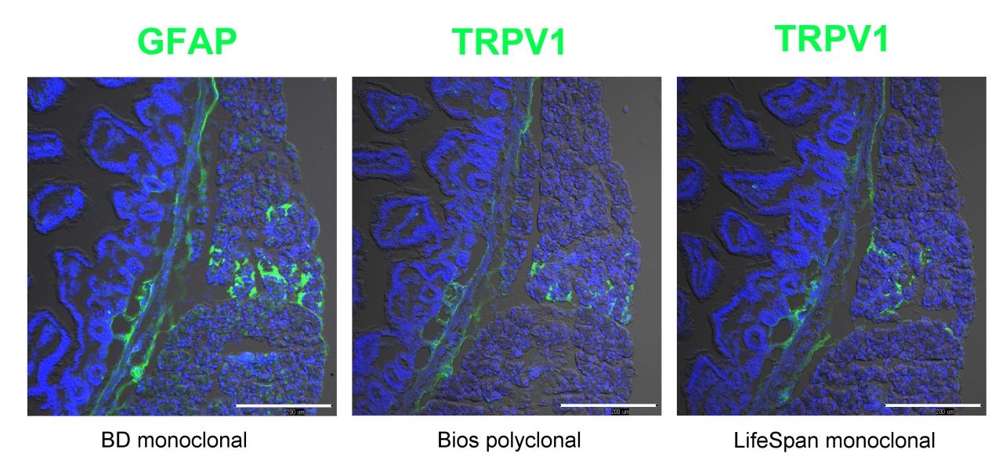
Supplementary Figure S1
Specificity of anti-TRPV1 antibodies used in the present study. Immunostaining with GFAP and 2 TRPV1 antibodies in serial sections prepared from the jejunum of WT mice. These antibodies gave essentially the same immunostaining pattern. Scale bar represented 200 μm.

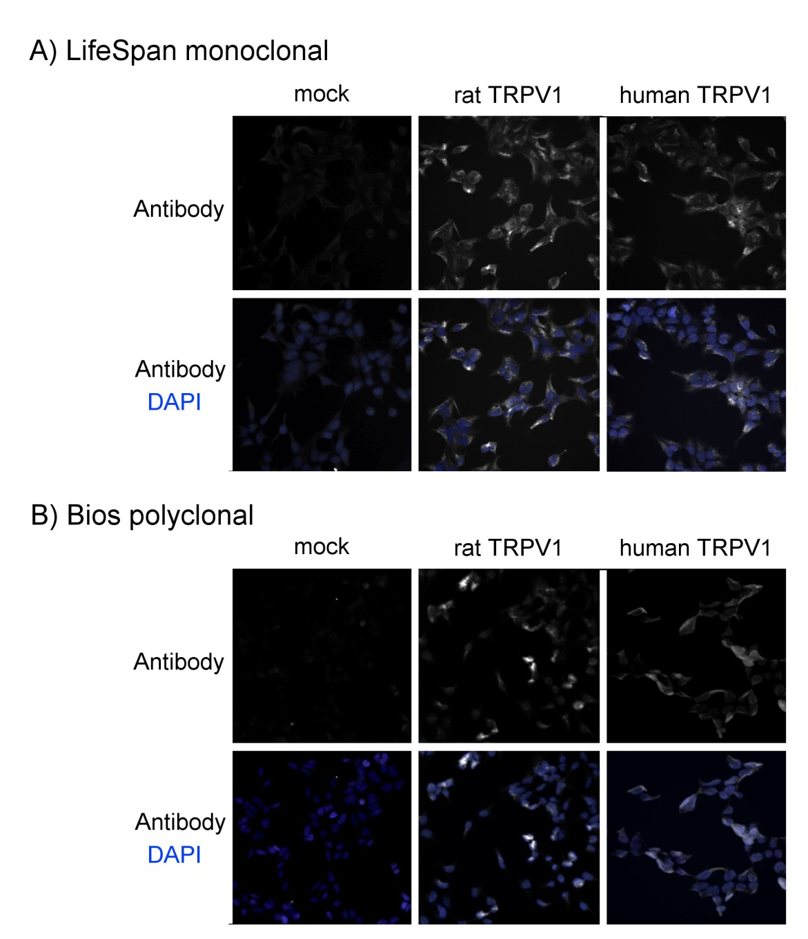
Supplementary Figure S2
Immunocytochemistry with two anti-TRPV1 antibodies in TRPV1-expressing and control cells. Recombinant rat (middle) and rat TRPV1 (right) were stably expressed in Rex293 cells. Mock-transfected control cells (left) had no TRPV1-IR signals. Nuclei were stained with DAPI. The generation and activity of the recombinant TRPV1 cells were described in our previous paper (Kubota K. et al, Am J Phsyiol. 2015; 308: G579–G590).

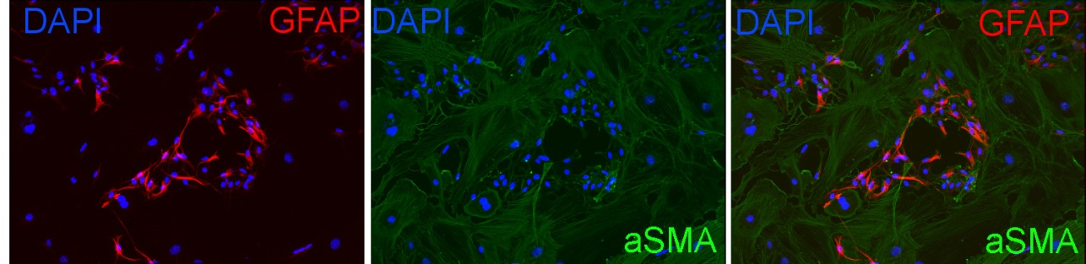
Supplementary Figure S3
Immunostaining with αSMA and GFAP in a co-culture system of MPC and SMC. The cells in the co-culture system are predominantly SMC with a small number of EGC. SMC are stained with αSMA. Nuclei were stained with DAPI. Portions of EGC are stained with GFAP. Scale bar represents 20 μm.

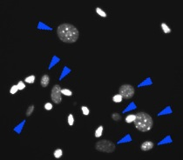
Supplementary Figure S4
DAPI staining in a co-culture system of MPC and SMC. Nuclei of SMC are indicated by blue arrows. Nuclei of MPC (virtually EGC) were unmarked. SMC nuclei are generally larger and dimmer than EGC nuclei. Some SMC nuclei are similar in size to EGC nuclei but still fainter. Co-gating by size and fluorescence intensity using imaging analysis software can easily discriminate between SMC and EGC. Scale bar represents 20 μm.

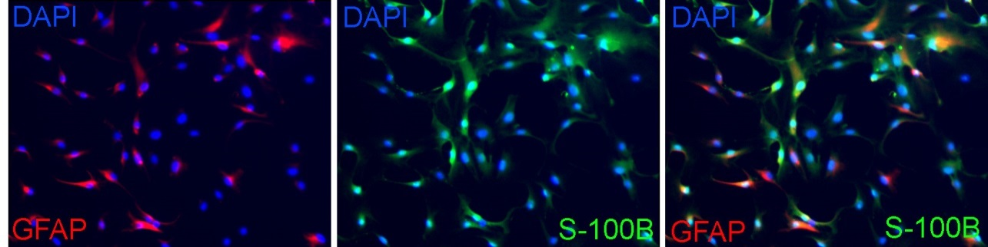
Supplementary Figure S5
Immunostaining with αSMA and S-100B in enriched EGC culture. The enriched EGC culture consists mainly of EGC. Most cells were S100B⁺, GFAP⁺ or S100B⁺GFAP⁺. Nuclei were stained with DAPI. Scale bar represents 20 μm.

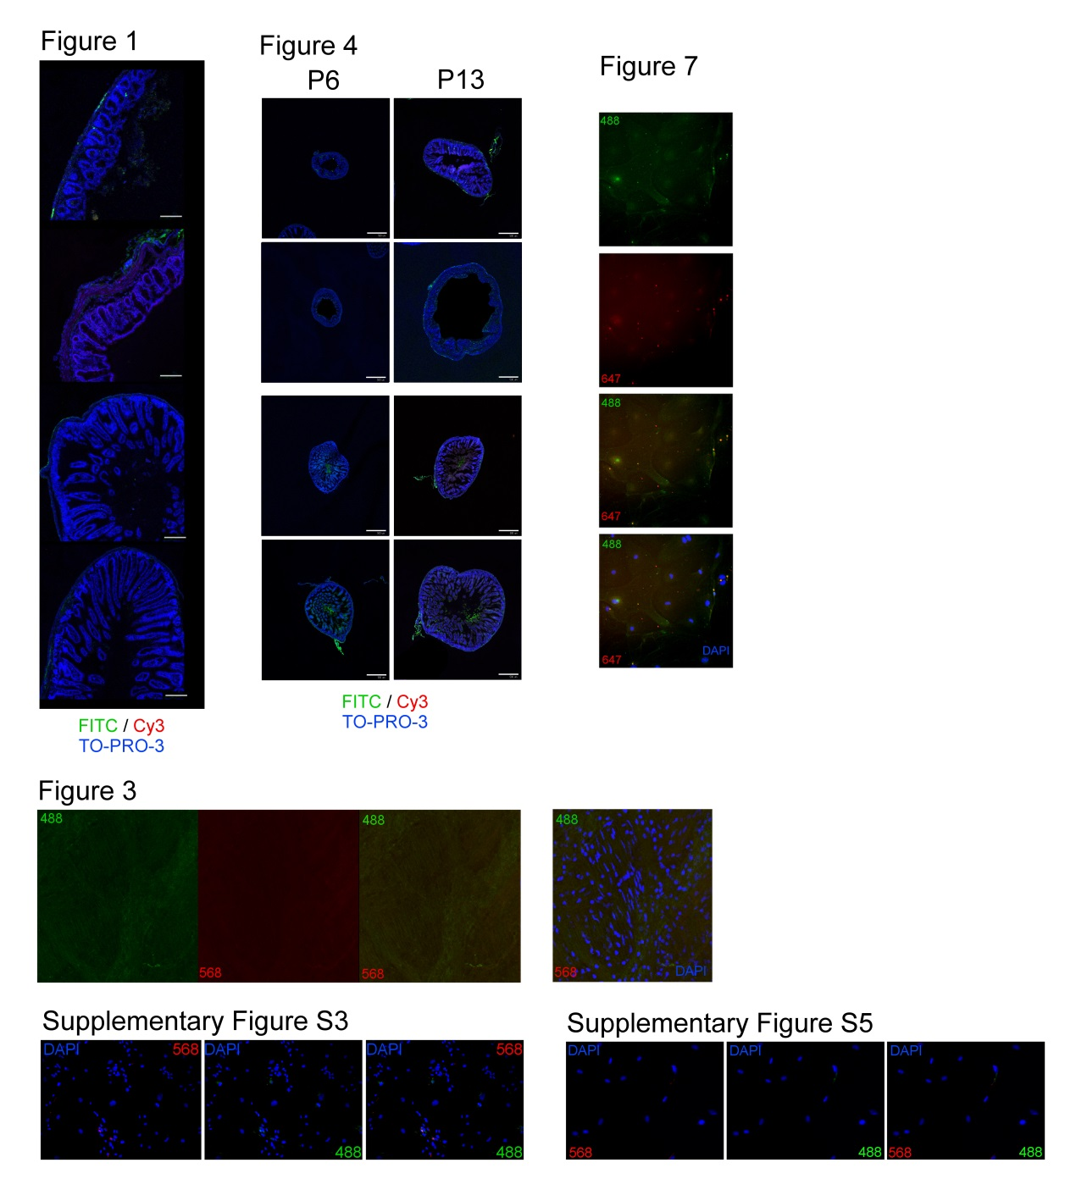
Supplementary Figure S6
Negative controls of immunostaining performed in this study. For Figure 3, DAPI image was added to show the presence of the cells.

