Name of Journal: World Journal of Clinical Cases
Manuscript NO: 78093
Manuscript Type: CASE REPORT

Surgical excision of a large retroperitoneal lymphangioma: A case report

Park JH et al. Tx of large retroperitoneal lymphangioma

John Hee Park, Donghyoun Lee, Young Hee Maeng, Won-Bae Chang

John Hee Park, Department of Surgery, Samsung Medical Center, Seoul 06351, South Korea

Donghyoun Lee, Department of Surgery, Jeju National University Hospital, Jeju-si 63241, Jeju-do, South Korea

Young Hee Maeng, Department of Pathology, Jeju National University Medical Center, Jeju-si 63241, Jeju-do, South Korea

Won-Bae Chang, Department of Surgery, Jeju National University Medical Center, Jeju-si 63241, Jeju-do, South Korea

Author contributions: Park JH and Lee D contributed equally to this work. Chang WB, Lee D involved in the conceptualization; Lee D and Park JH contributed to the formal analysis; Park JH involved in visualization; Park JH and Lee D wrote the original draft; Chang WB reviewed and edited the manuscript.

Corresponding author: Won-Bae Chang, MD, Assistant Professor, Department of Surgery, Jeju National University Medical Center, 15, Aran 13-gil, Jeju-si 63241, Jeju-do, South Korea. wbchangmd@gmail.com

Received: June 29, 2022
Revised: August 23, 2022
Accepted: October 9, 2022
Published online: November 6, 2022

Abstract
BACKGROUND
Lymphangiomas are rare benign tumors most commonly found in children under 2 years of age; adult cases are extremely rare. Retroperitoneal lymphangiomas represent less than 1% of all lymphangiomas. Because of their benign nature and possibility of spontaneous resolution, lymphangiomas are sometimes left untreated for long periods of time. However, if they grow large enough to compress surrounding structures, retroperitoneal lymphangiomas may cause symptoms such as abdominal pain, nausea or vomiting. We report a case of a rapidly growing retroperitoneal lymphangioma in an adult, treated with complete surgical excision.

CASE SUMMARY
A 60-year-old female who was diagnosed with an intra-abdominal cystic mass (11 cm × 9.5 cm) seven years ago presented to our hospital with symptoms of early satiety, nausea, and intermittent abdominal pain. Computed tomography (CT) scan confirmed interval enlargement to a 24 cm × 22 cm-sized huge left retroperitoneal mass, causing left hydronephrosis by external compression. Laparotomy was done via long midline incision. Due to severe adhesion between the aorta and the medial border of the mass, the cyst was intentionally opened for fluid aspiration and size reduction. After suture closure of the opening, we proceeded carefully with dissection. Aspiration showed light yellowish serous fluid. The mass was excised completely, and the pathology was consistent with cystic lymphangioma. The post-operative period was uneventful, and the patient was discharged without complications. Follow-up CT scan one month after surgery confirmed complete removal of the mass and decreased left hydronephrosis.

CONCLUSION
Excision of the huge retroperitoneal cystic mass resulted in relief of the patient’s symptoms, originally caused by external compression, and also ruled out the possibility of malignancy.

Key Words: Retroperitoneum; Lymphangioma; Hydronephrosis; Case report

©The Author(s) 2022. Published by Baishideng Publishing Group Inc. All rights reserved.

Citation: Park JH, Lee D, Maeng YH, Chang WB. Surgical excision of a large retroperitoneal lymphangioma: A case report. World J Clin Cases 2022; 10(31): 11561-11566
URL: https://www.wjgnet.com/2307-8960/full/v10/i31/11561.htm
DOI: https://dx.doi.org/10.12998/wjcc.v10.i31.11561

Core Tip: This is a rare clinical case which is related to the surgical excision of giant retroperitoneal lymphangioma. This mass which grew up to 24 cm diameter to compress surrounding structure caused symptoms such as abdominal pain, nausea, vomiting, and left hydronephrosis by compressing the left ureter and pelvis. We also could rule out the possibility of malignancy by pathologic study of excised specimen. This article presents the largest retroperitoneal lymphangioma treated with complete surgical excision in South Korea, compared to previous literature.

INTRODUCTION
Lymphangiomas are rare benign tumors most commonly found in children under 2 years of age. Adult cases are extremely rare^{[1]}. Frequently found in the head and neck region, retroperitoneal lymphangiomas represent less than 1% of all lymphangiomas, and are usually discovered incidentally on surgery or imaging studies^{[2]}. Because of their benign nature and possibility of spontaneous resolution, lymphangiomas are sometimes left untreated for long periods of time^{[3]}. However, if they grow large enough to compress surrounding structures, retroperitoneal lymphangiomas may cause symptoms such as abdominal pain, nausea or vomiting^{[4]}. Occasionally, complication by infection, intracystic hemorrhage, or cyst rupture may occur^{[2]}. Preoperative diagnosis is challenging, as imaging findings may be suggestive of lymphangioma but are often inconclusive^{[5]}. Pathological examination is required for final diagnosis^{[6]}. Surgery is the primary management option for all lymphangiomas, providing both diagnostic specimen and symptom relief^{[3]}. Here, we report a case of a rapidly growing retroperitoneal lymphangioma in an adult, treated with complete surgical excision. Initially asymptomatic, the mass eventually caused mass effect symptoms, leading the patient to opt for surgical treatment. This article presents the largest retroperitoneal lymphangioma treated with complete surgical excision in South Korea, compared to previous literature^{[7]}.

CASE PRESENTATION
Chief complaints
Known retroperitoneal cystic mass with early satiety, loss of appetite, nausea, and intermittent abdominal pain.

History of present illness
A 60-year-old female patient was referred to our outpatient clinic for evaluation of an intra-abdominal large cystic mass (11 cm × 6 cm × 9.5 cm) found incidentally upon abdominal ultrasound examination in 2015 during a routine medical check-up with worsened symptoms such as early satiety, loss of appetite, nausea, and intermittent abdominal pain.

History of past illness
Computed tomography (CT) scan showed a retroperitoneal cystic mass without mural nodules, septation, or enhancing portions, correlating with an impression of retroperitoneal lymphangioma (Figure 1A). Surgical excision was recommended, but the patient chose to seek a second opinion from another medical center.

Personal and family history
The patient decided not to undergo surgery based on the absence of symptoms and benign-like features of the mass on imaging studies. Follow-up was lost until the patient revisited our medical center for check-up seven years later.

Physical examination
Abdomen was distended without tenderness or rebound tenderness.

Laboratory examinations
It was unremarkable.

Imaging examinations
Upon follow-up, imaging study showed significant increase in mass size (from 11 cm to over 20 cm) and left hydronephrosis on ultrasound, suggesting possibility of malignant transformation. CT scan confirmed interval enlargement to a 24 cm × 22 cm-sized huge left retroperitoneal mass, causing mass effect on retroperitoneal organs to the pancreas and aorta, and left hydronephrosis (Figures 1B and 1C).

FINAL DIAGNOSIS
Retroperitoneal cystic lymphangioma.

TREATMENT
Laparotomy was done via long midline incision. After exposure of the retroperitoneal mass (Figure 2A), there was some difficulty dissecting the mass from the aorta due to severe adhesion with the medial border of the mass. There was also adhesion with the pancreas, increasing difficulty dissecting the mass. Hence, the cyst was intentionally opened during dissection of the medial mass area for fluid aspiration and size reduction. After suture closure of the opening, we proceeded carefully with dissection. Aspiration showed serous fluid with multiple yellowish patches. The mass was excised completely without significant complications (Figure 2B), and the pathology was consistent with cystic lymphangioma (Figure 2C). The post-operative period initially involved paralytic ileus but was otherwise uneventful, and the patient was discharged on post-operative day 15 with satisfactory relief of previous symptoms.

OUTCOME AND FOLLOW-UP
Upon outpatient clinic follow-up, laboratory values were non-remarkable and follow-up CT scan showed complete removal of mass, decreased left hydronephrosis, and no postoperative complications (Figure 1D).

DISCUSSION
The etiology of lymphangiomas remains uncertain, but congenital lymphatic malformations leading to sequestration of lymphatic tissue appear to be the primary cause^{[8]}. Most commonly found in children under 2 years of age, incidence rates are reported to be roughly 1.2-2.8 per 100000^{[1]}; adult cases are extremely rare. Lymphangiomas may be classified as capillary, cystic, or cavernous depending on their histologic characteristics^{[8]}, and frequently present as benign masses in the head and neck region. Other regions of incidence include the axilla (20%) and intra-abdomen (less than 5%), with retroperitoneal lymphangiomas representing less than 1% of all lymphangiomas^{[2]}. Retroperitoneal lymphangiomas are almost always cystic^{[9]}.
Because lymphangiomas are mostly asymptomatic until they grow into considerable size, they pose a difficult challenge in terms of pre-operative diagnosis^{[6]}. Differential diagnosis for retroperitoneal cystic lymphangioma is diverse, ranging from benign tumors from the pancreas or kidney to malignant tumors including teratoma, undifferentiated sarcoma, and cystic metastases from stomach or ovary; peri-pancreatic cysts must also be differentiated^{[8]}. Often, the only symptom of a retroperitoneal lymphangioma will be a slowly growing, palpable abdominal mass. If mass effect occurs, the patient may experience abdominal pain, nausea/vomiting, loss of appetite, fever, and hematuria, among other symptoms^{[4]}.
Imaging studies such as CT scan and magnetic resonance imaging (MRI) are useful to observe tumor characteristics and help diagnosis^{[5]}. Ultrasound may show cystic mass nature with sharp margins, while CT/MRI findings may include uni- or multi-locular cysts with characteristic ‘water density’ fluid^{[2]}. Percutaneous biopsy is usually not recommended^{[5]}. Pathologic examination is the only definitive diagnostic measure^{[10]}. Large, cystic lymphangiomas may compress and surround other organs, making surgical excision difficult^{[5]}. Regardless, the literature regards complete surgical excision as the only definitive treatment for lymphangiomas, if possible without major complications to surrounding structures^{[9]}. This provides surgical specimen for pathological diagnosis, ameliorates symptoms caused by the tumor mass effect, and generally results in excellent outcomes. Alternative therapies such as sclerotherapy, aspiration, or observation have been associated with tumor growth or recurrence^{[11]}. When cystic lymphangioma is not completely excised, recurrence rates are reported to be around 10%-15%^{[1,4]}.
In our patient, the rapid growth of the mass (more than 10 cm over the years) also raised the possibility of malignant transformation, causing concern to both the physician and, above all, the patient. To date, the literature does not confirm malignant transformation of lymphangiomas^{[5]}. However, reports are not non-existent. A case has been reported of a lymphangioma transforming into a malignant lymphangiosarcoma^{[12]}. Further studies are required but are probably limited due to the rarity of lymphangiomas, especially in adults. Therefore, we abide by the literature and recommend complete surgical excision as the only definitive treatment, especially when the mass effect symptoms are present.
To our knowledge, this was the largest retroperitoneal lymphangioma successfully treated with surgical excision to date in South Korea. A previous review based on intra-abdominal cystic lymphangiomas in Korea published in 2010 reported cases of intra-abdominal lymphangioma with the largest retroperitoneal cyst sized at 10 cm; the largest intra-abdominal cystic lymphangioma reported was 20 cm, originating in the pancreas tail^{[7]}.

CONCLUSION
In conclusion, retroperitoneal lymphangiomas are very rare in adults, and huge masses may be daunting for the surgeon who must decide whether ‘to excise or not’. The choice for observation is tempting given the benign nature of lymphangiomas, especially when the patient presents no symptoms. However, observation is associated with growth of mass which may lead to the development of symptoms, as in our patient. This results in decreased quality of life and health concern for the patient. Complete surgical excision is the only definitive treatment for lymphangioma and results in excellent outcomes. Despite drastic growth upon observation, however, malignant change was not observed in our case, supporting conventional literature describing lymphangiomas as benign. Hence, such tumors can be observed before compression symptoms appear, and surgical excision should be considered if symptoms occur. Whether the tumor is observed or surgically excised, regular follow-up is mandatory to check tumor growth or recurrence.

REFERENCES
1 Colangeli W, Facchini V, Kapitonov A, Zappalà M, Bozza F, Becelli R. Cystic lymphangioma in adult: a case report and a review of the literature. J Surg Case Rep 2020; 2020: rjaa179 [PMID: 32760485 DOI: 10.1093/jscr/rjaa179]
2 Bhavsar T, Saeed-Vafa D, Harbison S, Inniss S. Retroperitoneal cystic lymphangioma in an adult: A case report and review of the literature. World J Gastrointest Pathophysiol 2010; 1: 171-176 [PMID: 21607159 DOI: 10.4291/wjgp.v1.i5.171]
3 Kennedy TL, Whitaker M, Pellitteri P, Wood WE. Cystic hygroma/lymphangioma: a rational approach to management. Laryngoscope 2001; 111: 1929-1937 [PMID: 11801972 DOI: 10.1097/00005537-200111000-00011]
4 Gachabayov M, Kubachev K, Abdullaev E, Babyshin V, Neronov D, Abdullaev A. A Huge Cystic Retroperitoneal Lymphangioma Presenting with Back Pain. Case Rep Med 2016; 2016: 1618393 [PMID: 27843456 DOI: 10.1155/2016/1618393]
5 Improta L, Tzanis D, Bouhadiba T, Abdelhafidh K, Bonvalot S. Overview of primary adult retroperitoneal tumours. Eur J Surg Oncol 2020; 46: 1573-1579 [PMID: 32600897 DOI: 10.1016/j.ejso.2020.04.054]
6 Gümüştaş OG, Sanal M, Güner O, Tümay V. Retroperitoneal cystic lymphangioma: a diagnostic and surgical challenge. Case Rep Pediatr 2013; 2013: 292053 [PMID: 23533897 DOI: 10.1155/2013/292053]
7 Na WT, Lee TH, Lee BS, Kim SH, Chae HB, Kim SB, Kim YS, Kim SM, Im EH, Huh KC, Choi YW, Kang YW. [Clinical aspects of intraabdominal cystic lymphangioma in Korea]. Korean J Gastroenterol 2010; 56: 353-358 [PMID: 21173558 DOI: 10.4166/kjg.2010.56.6.353]
8 Suhani, Aggarwal L, Ali S, Thomas S. Giant Retroperitoneal Lymphangioma: a Rare Entity. Indian J Surg 2014; 76: 402-404 [PMID: 26396474 DOI: 10.1007/s12262-013-0989-y]
9 Wilson SR, Bohrer S, Losada R, Price AP. Retroperitoneal lymphangioma: an unusual location and presentation. J Pediatr Surg 2006; 41: 603-605 [PMID: 16516648 DOI: 10.1016/j.jpedsurg.2005.11.057]
10 Mota MMDS, Bezerra ROF, Garcia MRT. Practical approach to primary retroperitoneal masses in adults. Radiol Bras 2018; 51: 391-400 [PMID: 30559557 DOI: 10.1590/0100-3984.2017.0179]
11 Hubli P, Rohith M, Sachin BM. A Giant Retroperitoneal Lymphangioma: A Case Report. J Clin Diagn Res 2016; 10: PD14-PD15 [PMID: 27630902 DOI: 10.7860/JCDR/2016/19989.8142]
12 Yu H, Mao Q, Zhou L, Li J, Xu X. Rare Case of Cystic Lymphangioma Transforming Into Lymphangiosarcoma: A Case Report. Front Oncol 2022; 12: 814023 [PMID: 35251984 DOI: 10.3389/fonc.2022.814023]

Footnotes
Informed consent statement: Written informed consent was obtained from the patient for the publication of this case and accompanying images.

Conflict-of-interest statement: All the authors report no relevant conflicts of interest for this article.

CARE Checklist (2016) statement: The authors have read the CARE Checklist (2016), and the manuscript was prepared and revised according to the CARE Checklist (2016).

Open-Access: This article is an open-access article that was selected by an in-house editor and fully peer-reviewed by external reviewers. It is distributed in accordance with the Creative Commons Attribution NonCommercial (CC BY-NC 4.0) license, which permits others to distribute, remix, adapt, build upon this work non-commercially, and license their derivative works on different terms, provided the original work is properly cited and the use is non-commercial. See: https://creativecommons.org/Licenses/by-nc/4.0/

Provenance and peer review: Unsolicited article; Externally peer reviewed
Peer-review model: Single blind

Peer-review started: June 29, 2022
First decision: August 1, 2022
Article in press: October 9, 2022

Specialty type: Medicine, research and experimental
Country/Territory of origin: South Korea
Peer-review report’s scientific quality classification
Grade A (Excellent): 0
Grade B (Very good): 0
Grade C (Good): C, C
Grade D (Fair): D
Grade E (Poor): 0

P-Reviewer: Liang P, China; Zhang JW, China S-Editor: Wang JJ L-Editor: A P-Editor: Wang JJ

Figure Legends
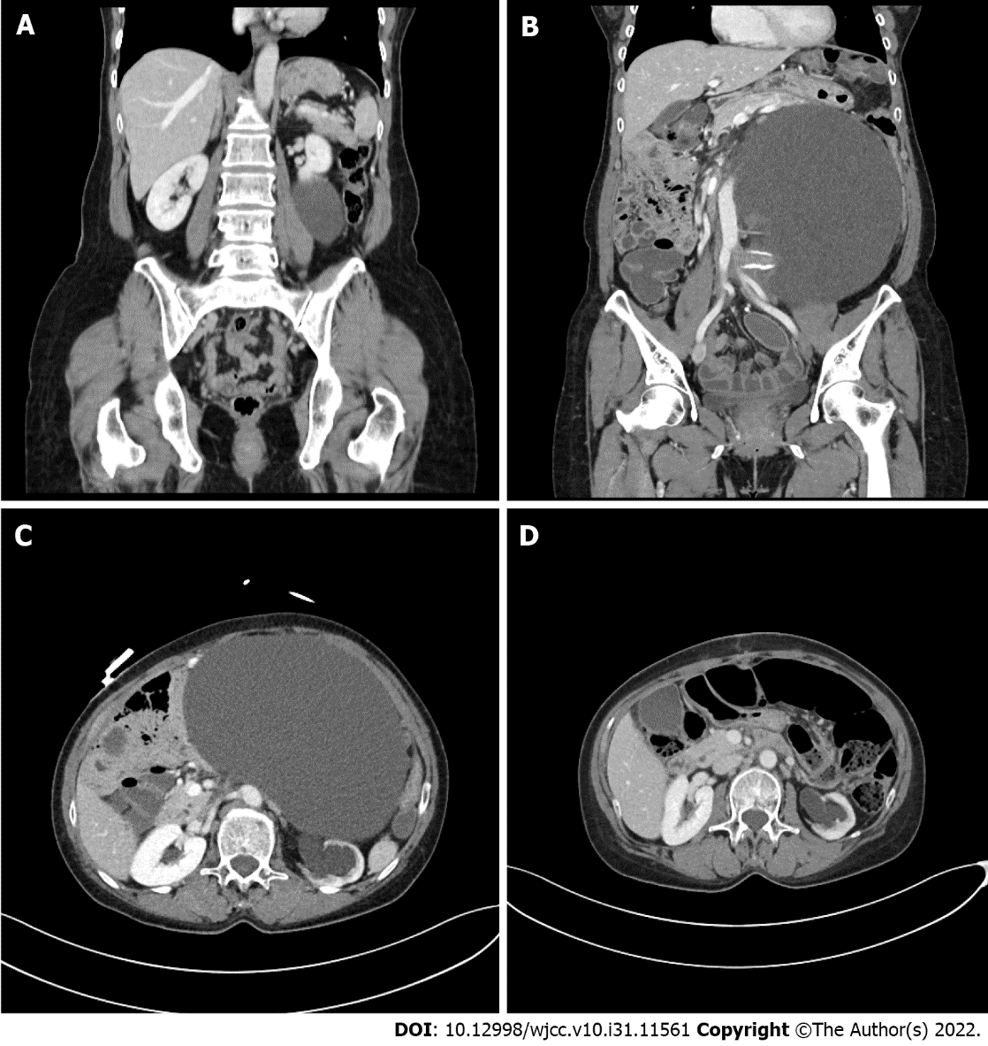
Figure 1 The pre- and post-operative computed tomography scan of the patient. A: A retroperitoneal cystic mass on abdominal computed tomography (CT) scan; B and C: Follow-up CT scan in seven years from initial diagnosis showed significant increase in mass size (from 11 cm to 24 cm) with left hydronephrosis caused by external compression of cystic mass; D: Follow-up CT scan in one month after surgical excision showed complete removal of mass and decreased left hydronephrosis.

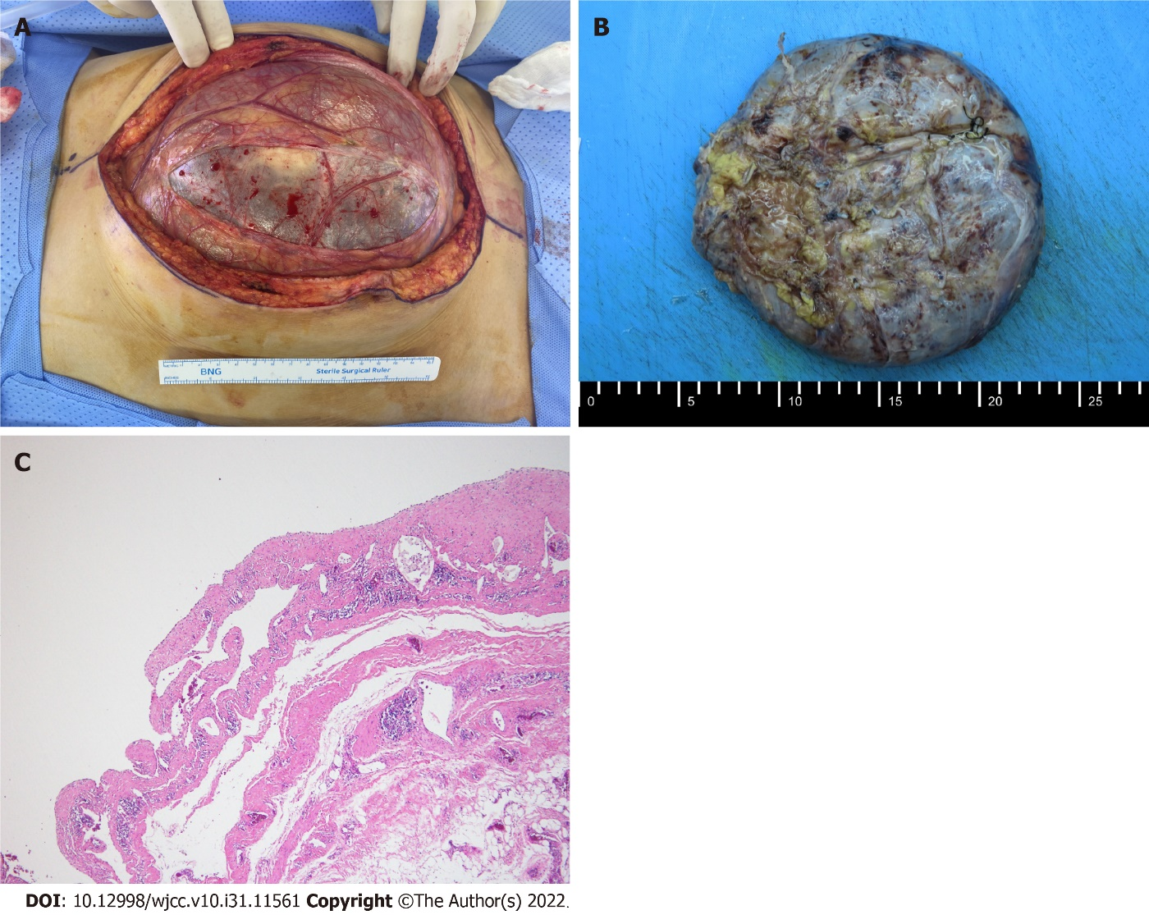
Figure 2 The gross and microscopic findings of the mass. A: Huge cystic mass before excision; B: The mass after excision; C: The microscopic feature which shows the cystic space and dilated lymphatic vessels lined by flattened endothelium consistent with lymphangioma.

Published by Baishideng Publishing Group Inc
7041 Koll Center Parkway, Suite 160, Pleasanton, CA 94566, USA
Telephone: +1-925-3991568
E-mail: bpgoffice@wjgnet.com
Help Desk: https://www.f6publishing.com/helpdesk
https://www.wjgnet.com

© 2022 Baishideng Publishing Group Inc. All rights reserved.

