Name of Journal: World Journal of Gastroenterology
Manuscript NO: 47309
Manuscript Type: REVIEW

Diagnosis and therapeutic strategies for small bowel vascular lesions

Sakai E et al. Diagnosis and treatment for SBVLs

Eiji Sakai, Ken Ohata, Atsushi Nakajima, Nobuyuki Matsuhashi

Eiji Sakai, Ken Ohata, Nobuyuki Matsuhashi, Department of Gastroenterology, NTT Medical Center Tokyo, Tokyo 141-8625, Japan

Eiji Sakai, Atsushi Nakajima, Division of Gastroenterology and Hepatology, Yokohama City University School of Medicine, Yokohama 236-0004, Japan

ORCID number: Eiji Sakai (0000-0002-3357-7901); Ken Ohata (0000-0003-0288-0366); Atsushi Nakajima (0000-0003-3811-9704); Nobuyuki Matsuhashi (0000-0002-0139-430X).

Author contributions: All the authors helped to perform the research; Sakai E drafted the article; Nakajima A participated in the study’s conception and design; Ohata K and Matsuhashi N approved the final manuscript.

Conflict-of-interest statement: None of the authors have any potential conflicts of interest to declare.

Open-Access: This article is an open-access article which was selected byan in-house editor and fully peer-reviewed by external reviewers. It is distributed in accordance with the Creative Commons Attribution Non Commercial (CC BY-NC 4.0) license, which permits others to distribute, remix, adapt, build upon this work non-commercially, and license their derivative works on different terms, provided the original work is properly cited and the use is non-commercial. See: http://creativecommons.org/licenses/by-nc/4.0/

Manuscript source: Invited manuscript

Corresponding author: Atsushi Nakajima, MD, PhD, Professor, Division of Gastroenterology and Hepatology, Yokohama City University School of Medicine, 3-9 Fuku-ura, Kanazawa-ku, Yokohama 236-0004, Japan. nakajima-tky@umin.ac.jp
Telephone: +81-45-7872640
Fax: +81-45-7843546

Received: March 12, 2019
Peer-review started: March 13, 2019
First decision: April 11, 2019
Revised: April 21, 2019
Accepted: May 3, 2019
Article in press:
Published online:

Abstract
Small bowel vascular lesions, including angioectasia (AE), Dieulafoy’s lesion (DL) and arteriovenous malformation (AVM), are the most common causes of obscure gastrointestinal bleeding. Since AE are considered to be venous lesions, they usually manifest as a chronic, well-compensated condition. Subsequent to video capsule endoscopy, deep enteroscopy can be applied to control active bleeding or to improve anemia necessitating blood transfusion. Despite the initial treatment efficacy of argon plasma coagulation (APC), many patients experience re-bleeding, probably because of recurrent or missed AEs. Pharmacological treatments can be considered for patients who have not responded well to other types of treatment or in whom endoscopy is contraindicated. Meanwhile, a conservative approach with iron supplementation remains an option for patients with mild anemia. DL and AVM are considered to be arterial lesions; therefore, these lesions frequently cause acute life-threatening hemorrhage. Mechanical hemostasis using endoclips is recommended to treat DLs, considering the high re-bleeding rate after primary APC cauterization. Meanwhile, most small bowel AVMs are large and susceptible to re-bleeding therefore, they usually require surgical resection. To achieve optimal diagnostic and therapeutic approaches for each type of small bowel lesion, the differences in their epidemiology, pathology and clinical presentation must be understood.

Key words: Angiodysplasia; Angioectasia; Dieulafoy’s lesion; Arteriovenous malformation; Obscure gastrointestinal bleeding; Video capsule endoscopy; Deep enteroscopy; Argon plasm coagulation

© The Author(s) 2019. Published by Baishideng Publishing Group Inc. All rights reserved.

Core tip: Angiodysplasia includes a variety of synonymous disease concepts such as angioectasia, Dieulafoy’s lesion and arteriovenous malformation. Although these lesions are the most common causes of small bowel bleeding, optimal management strategies have not been established. We propose that these lesions should be addressed separately when determining diagnostic and therapeutic plans because of their clinical heterogeneity. In this review, we focused on differences in their epidemiology, pathology and clinical presentation and discussed the currently available diagnostic and therapeutic options that may be used to control small bowel bleeding, which consequently improve patient quality of life.

Sakai E, Ohata K, Nakajima A, Matsuhashi N. Diagnosis and therapeutic strategies for small bowel vascular lesions. World J Gastroenterol 2019; In press

INTRODUCTION

Obscure gastrointestinal bleeding (OGIB) has been defined as gastrointestinal (GI) bleeding from an unidentified origin that persists despite a comprehensive upper and lower GI evaluation^{[1]}. Although missed lesions during an esophagogastroduodenoscopy or colonoscopy should be considered, most bleeding sources are reportedly identified within the small bowel^{[2]}, accounting for approximately 5% of all cases of GI bleeding^{[3]}. Small bowel bleeding can present as overt bleeding, can manifest as clinically evident melena or hematochezia or occult bleeding, and can be associated with iron-deficiency anemia, with or without a positive fecal occult blood test. Additionally, overt bleeding is sometimes further categorized into ongoing and previous. Despite recent developments in endoscopic and radiologic modalities, small bowel bleeding remains a diagnostic and therapeutic challenge because of the difficulty in accessing and performing optimal treatments within the small bowel.

Several types of vascular abnormalities have been identified in the GI tract. Angiodysplasia (AD) is characterized by the focal accumulation of abnormal, dilated and tortuous blood vessels visualized within the mucosal and submucosal layers of the gut and is reportedly the most common cause of small bowel bleeding^{[4,5]}. AD can usually be found in patients with OGIB, and the severity of bleeding may range widely from chronic, well-compensated conditions to acute life-threatening conditions^{[6]}. Since the term AD sometimes includes a variety of synonymous disease concepts, such as angioectasia (AE), Dieulafoy’s lesion (DL) and arteriovenous malformation (AVM), careful attention is needed when interpreting epidemiological and clinical data concerning ADs, because several clinical heterogeneities (e.g., the incidence, pathogenesis and distribution of the lesion; bleeding pattern; and patient prognosis) underlie, these vascular abnormalities. However, these differences have not been fully addressed in previous reports. Moreover, the optimal approach to treating these lesions remains unclear because of a lack of large clinical trials. This review will focus on small bowel abnormalities, including AE, DL and AVM, and will assess the differences in their epidemiology, pathology, clinical presentation and management, which may help to establish diagnostic and therapeutic strategies.

METHODS

A comprehensive literature search was conducted using PubMed database. The MeSH terms used were “angiodysplasis” or “angioectasia” or “vascular ectasia” or “vascular lesions” or “Dieulafoy’s lesion” or “arteriovenous malformation”. The search was limited to manuscripts published in English language only. Subsequently, we manually selected manuscripts regarding lesions located at small bowel.

CLASSIFICATION OF SMALL BOWEL VASCULAR LESIONS
Small bowel vascular lesions can be endoscopically classified into four categories based on the Yano-Yamamoto classification^{[7]}. AEs are generally found during endoscopy as small erythemas and are classified as Type 1a: punctuate (< 1 mm) or Type 1b: Patchy (a few mm). Histopathologically, they consist of thin, dilated and tortuous veins that lack a smooth muscle layer, explaining their weakness and tendency to bleed. DLs consist of histologically normal but abnormally large arteries that typically protrude through a small mucosal defect and are classified as Type 2a: Punctuate lesions with pulsatile bleeding or Type 2b: Pulsatile red protrusions without surrounding venous dilatation^{[8]}. AVMs are histopathologically diagnosed as aberrant vessels with thickened, hypertrophic walls that vary in thickness greatly and are characterized by the direct connections of arteries and veins without a capillary bed^{[9]}. Some intestinal AVMs are classified as Type 3: Pulsatile red protrusions with surrounding venous dilatation. Meanwhile, congenital intestinal AVMs are relatively large and sometimes appear as a mass or polypoid lesion^{[10,11]}, which can be classified as Type 4: Lesions not classified into any of the above categories.
During real-time endoscopic observations, the presence of pulsation can be evaluated, enabling venous and arterial lesions to be distinguished from each other. The presence or absence of arterial components provides important information because it helps in the selection of an optimal treatment approach and can affect a patient’s prognosis. However, this endoscopic classification doses not necessarily reflect the histopathologic findings. Distinguishing small bowel vascular lesion can be difficult, and an accurate diagnosis can only be achieved after a post-operative histopathological evaluation. The representative images of each type of small bowel vascular lesion were shown in Figures 1 to 3, respectively.

ETIOLOGY AND PATHOGENISIS
Because of the high incidence of AE in the GI tract, the etiology and pathology of this condition must be addressed. Although the pathogenesis of AE is not fully understood, two developmental mechanisms, termed the “mechanical theory” and the “angiogenic theory”, have been proposed. Boley et al^{[12]} suggested that increased bowel wall pressures and chronic hypoxia can induce the partial obstruction of submucosal veins, leading to capillary congestion, failure of the pre-capillary sphincters, and eventually the formation of permanent AE. This hypothesis is supported by the fact that AE is frequently identified in the right colon of elderly patients, where the bowel tension is relatively high^{[13-15]}. On the other hand, Junquera et al^{[16]} reported the importance of angiogenic factors in the formation of AE. They revealed that the expression of vascular endothelial growth factor (VEGF); a central mediator in the early phases of angiogenesis, was significantly increased in patients with colonic AEs. Mucosal ischemia from chronic hypoxia, which can be due in part to cardiac or renal diseases, reportedly impairs the balance between pro-angiogenic and anti-angiogenic factors, resulting in pathological neovascularization^{[17,18]}. Recently, Randi et al^{[19]} reported a close association between von Willebrand factor dysfunction and vascular malformation, suggesting that replacement therapy could be a novel therapeutic approach to controlling refractory bleeding from small bowel AE. Meanwhile, the etiology and pathology of DL is poorly understood. However, the consensus is that ischemic injury, probably related to co-morbidities (e.g., cardiovascular disease) or drugs (e.g., non-steroidal anti-inflammatory drugs and anti-thrombotic drugs), leads to the disruption of the overlying epithelium, then massive bleeding occurred from a large submucosal vessel^{[20]}.
The etiology and pathology of AVMs are also not fully understood. According to Moore’s classification^{[21]}, intestinal AVMs can be classified into three categories. Type 1 AVMs are an acquired disease, occurring mainly in elderly patients and frequently appearing in the right colon. Type 2 AVMs are considered to be a congenital disease, occurring in younger patients and typically appearing in the small bowel. Type 3 AVMs present as GI involvement in patients with hereditary hemorrhagic telangiectasia. Type 1 AVMs, which are considered to be an acquired disease, are predominantly located in the right colon, where the bowel tension is relatively high, suggesting that AVMs might also develop through “mechanical theory”, similar to AEs.

DIAGNOSIS
A variety of diagnostic modalities are available to reveal the cause of OGIB. The choice of investigation is strongly affected by the clinical status of the patient. For example, endoscopic investigation is not recommended for patients with hemodynamic instability. In contrast, radiographic examinations are especially useful for patients with ongoing overt bleeding, but for patients with occult bleeding, because the bleeding rate threshold is relatively high. It is important to understand the characteristics of each diagnostic modalities and adequate timing for clinical application.

Endoscopy
Video capsule endoscopy (VCE) and deep enteroscopy (DE) play important roles in the diagnosis and treatment of small bowel ADs. While the indications for the use of these modalities are the same, their characteristics are different. VCE enables the visualization of the entire small bowel in approximately 90% of patients^{[22]}, and this success rate can be further improved through the use of real-time viewing or an increased battery capacity^{[23]}. A large systematic review that included 227 studies revealed that the diagnostic yield of VCE for OGIB was 59.4% and that more than 50% of the patients had ADs, with a pooled retention rate of 1.4%^{[22]}. The diagnostic yield of VCE was highest when it was performed during ongoing overt bleeding^{[24]}, which demonstrating the usefulness of emergent VCE. To note, emergent VCE is useful not only for identifying cause of bleeding, but also for determining subsequent management plan. The detection of ADs using VCE is reportedly higher than that for other diagnostic modalities, such as computed tomography (CT) enterography, mesenteric angiography and DE^{[25]}. Therefore, VCE is currently recommended by GI societies as a first-line test for evaluating the presence of small bowel bleeding^{[2,26]}. However, some limitations of VCE remain to be resolved. The most important limitation is its inability to obtain biopsy samples or to provide endoscopic treatments. Additionally, it is sometimes difficult to distinguish highly relevant lesions from less relevant lesions, even though less relevant lesions, such as tiny red spot or erosion, are considered to be a negative finding^{[27]}. Moreover, the diagnostic yield of capsule endoscopy can be reduced when the visibility of the mucosa is impaired by the presence of air bubbles, food residue, or bile pigments. To overcome these disadvantages, we previously revealed that flexible spectral imaging color enhancement can reduce the effects of bile -pigments and improve the detectability of small bowel AE^{[28]}. Recently, the efficacy of computer-assisted automatic diagnosis using a convolutional neural network has also been reported to increase the detection of small bowel AE^{[29]}.
DE enables pathological diagnosis and therapeutic intervention within the small bowel. DE includes single-balloon enteroscopy and double-balloon enteroscopy (DBE), which function using a push-and-pull technique, and spiral enteroscopy (SE), which functions using a rotate-to-advance technique. Of the three types of DE, DBE has been established as the most viable option for the management of small bowel abnormalities. Although no significant differences in the diagnostic yields of the three modalities have been reported, the total enteroscopy rate and the maximum insertion depth of DBE were significantly higher than those of other modalities^{[30-32]}. The diagnostic yield of DBE was lower than that of VCE using a single insertion approach, but the results became comparable when both anterograde and retrograde approaches were used^{[33]}. DBE appears to be an effective and safe endoscopic technique, with a reported pooled complication rate (including pancreatitis and perforation) of 1.2%^{[34]}. However, DBE is an invasive and time-consuming procedure that usually requires sedation; consequently, it can be intolerable for elderly patients with severe co-morbidities.
Overall, CE can be used as a first-line investigation for small bowel ADs because of its usefulness in evaluating the localization, size and number of ADs, providing information on the best insertion route for DE. Since the re-bleeding rate was reportedly high in patients with positive VCE^{[35]}, subsequent interventional DE should be conducted even if the overt bleeding is temporarily relieved. On the other hand, there are no clear guidelines for patients with negative findings after an initial VCE examination. Teshima et al^{[36]} conducted a meta-analysis and revealed that the diagnostic yield of DBE after a previous negative VCE was only 27.5%. Taken together with the lower re-bleeding rate after a negative VCE result^{[37]}, some patients with a stable general condition can probably be managed safely with observation only.

Radiographic examination
Radiographic examinations include multiphase CT angiography, radionuclide scanning and mesenteric angiography; these modalities are useful for detecting the bleeding source in patients with active overt GI bleeding. When interpreting the results of radiographic examinations, the bleeding rate threshold and the intermittent nature of bleeding from small bowel ADs should be considered.
In patients with overt GI bleeding, multi-phase CT angiography can accurately localize the bleeding area as an extravasation when the bleeding rate is over 0.3 mL/min^{[38]}. A recent meta-analysis revealed that CT angiography had a pooled sensitivity of 89% and specificity of 85% for the detection of active bleeding^{[39]}. Meanwhile, CT enterography has been developed to identify the specific cause of small bowel bleeding, although large volumes of a neutral enteric contrast material are needed to distend the intestine. Using a modified, multiphase CT enterography technique, Huprich et al^{[40]} found that small bowel vascular lesions can be classified into several categories. Interestingly, the morphology and enhancement pattern seen on CT enterography are well correlated with the aforementioned endoscopic classification^{[7]}. AE can be detected as a focal enhancement that is brightest during the enteric phase and gradually fades during the delayed phase. Arterial lesions, including DL and AVM, are enhanced most brightly during the arterial phase and become invisible during the enteric and delayed phases. Most small bowel AVMs are congenital, appear as relatively large lesions, and sometimes harbor an early draining vein during the arterial phase. VCE reportedly had a significantly higher pooled OGIB diagnostic yield than CT enterography (53% vs 34%), mainly because of the higher detection rate for vascular lesions^{[41]}. In contrast, CT enterography was superior to VCE for the detection of small bowel tumors^{[42]}. Although there are concerns regarding radiation exposure and nephrotoxicity from the intravenous contrast agents, CT enterography can be used as a complemental modality to small bowel VCE, possibly enabling the identification of missed small bowel lesions.
Radionuclide scanning using technetium-99m-labeled red blood cells can be used to localize the bleeding source when the bleeding rate is over 0.1 mL/min. The accuracy of a positive test result is reportedly as high as 66%^{[43]}. Despite its sensitivity at detecting bleeding and its noninvasive nature, radionuclide scanning includes difficulty in accurate localization of the bleeding site. Additionally, this technique can only be used for diagnostic purposes; thus, a subsequent endoscopic or angiographic examination is required.
The sensitivity of mesenteric angiography is relatively low^{[44]}, because it requires an active bleeding rate of over 0.5 mL/min at the time of the examination to enable diagnosis and treatment. Nevertheless, this technique allows accurate localization and subsequent selective embolization during the same examination. The successful localization of bleeding is highly dependent on the rate of bleeding, which may be especially useful for patients with hemodynamic instability requiring a large blood transfusions^{[45]}.

TREATMENT
Endoscopic treatment
Since the intestinal wall of the small bowel is thin, endoscopists should be cautious of the possibility of perforation. Argon plasma coagulation (APC) involves the use of a jet of ionized argon gas that is directed through a probe that in turn passes through the endoscope, allowing the transmission of the gas to the target lesion without any direct contact with the mucosa^{[46]}. The depth of coagulation is limited to the superficial mucosa and can be controlled using the power setting, gas flow and the duration of coagulation. Optionally, the submucosal injection of a saline and adrenaline solution can be applied for the treatment of Type 1b lesions to avoid muscular damage caused by the long duration of coagulation^{[47]}. Because of its lower incidence of complications^{[48]}, APC has become the most widely used method for treating small bowel AEs. APC has enabled favorable outcomes for the treatment of colonic AE, with re-bleeding rates of only 2% and 10% at 1- and 2-year follow-ups, respectively^{[49]}. Meanwhile, its efficacy for small bowel AE is controversial, since the pooled re-bleeding rate estimated by a recent meta-analysis was 43% in patients with small bowel AEs after endoscopic treatment^{[50]}. Instead, there is a consensus that endoscopic treatment can stabilize the blood hemoglobin level and reduce the need for transfusion, thereby improving the patient’s quality of life^{[51]}.
Other endoscopic modalities that can be applied in the management of small bowel ADs include endoclips and injection with sclerotherapy. Mechanical hemostasis using endoclips can be attempted for the management of large AEs or arterial lesions such as DL and AVM. Meanwhile, Igawa et al^{[52]} reported that a combination of APC and endoscopic injection sclerotherapy with polidocanol was useful for achieving the successful hemostasis of large AEs in the small bowel. Because of the limited clinical data that is currently available, whether coaptive and noncontact cauterizing therapies differ in efficacy or whether mechanical hemostasis is better for selected lesions remains uncertain.

Radiological embolization
Radiological embolization is generally considered for patients with active GI bleeding in whom endoscopic therapy has failed or is contraindicated because of hemodynamic instability. Subsequent to the detection of the bleeding vessel by mesenteric angiography, superselective transcatheter embolization is performed using microcoils, which have been recommended for small bowel bleeding^{[53]}. Importantly, microcoils can also be used as a radiographic marker to indicate the localization of the bleeding source during surgery^{[54]}. Although the rate of successful immediate hemostasis achieved by embolization is reportedly high (96%), early recurrent bleeding can occur in approximately 20% of patients with lower GI bleeding^{[43,55]}. The reported incidence of severe complications, including arterial dissection and bowel infarction, was 17%, and this high incidence is a major limitation of angiographic embolization^{[43]}. Since mesenteric angiography requires a higher bleeding rate for detection, the benefits of this technique are more notable for DL or AVM, and less so for AE.

Surgical treatment
Now that endoscopic or angiographic treatment has become widely available, surgery is expected to play a minor role and is often the final therapeutic option for uncontrollable bleeding after other treatments, including endoscopic hemostasis or angiographic embolization, have failed. The preoperative or intraoperative localization of the target lesion is necessary to achieve successful surgical resection.

Pharmacological treatment
Even after invasive therapeutic interventions for patients with small bowel ADs, recurrent bleeding can occur since it is usually difficult to determine the locations of all lesions and to detect the true bleeding origin^{[56]}. Pharmacological treatment can be considered as an alternative strategy for such patients.
At present, hormonal therapy is not recommended for patients with ADs, since the results of a large prospective, double-blind randomized trial showed no clinical benefits in terms of reducing the number of bleeding episodes or blood transfusions between patients treated with a combination of ethinyl estradiol and norethisterone and a placebo group^{[57]}. Instead, the efficacy and safety of thalidomide and somatostatin analogs have been investigated in patients with refractory anemia after failed endoscopic treatment for intestinal ADs.
Thalidomide has been shown to reduce bleeding from ADs by suppressing the expression of VEGF^{[58]}. Subsequent to the favorable clinical outcomes that were confirmed in several case reports^{[59-61]}, Ge et al^{[58]} conducted a randomized open-label trial that included 55 patients with recurrent bleeding from ADs. They found a significant reduction in bleeding episodes in the thalidomide group, compared with the control group after a mean follow-up period of 39 months. Similarly, Chen et al^{[62]} reported that a significant reduction in bleeding episodes was confirmed in approximately 80% of the patients who received a course of 100 mg/d of thalidomide for 4 mo during a follow-up period of at least one year. However, previous clinical trials reported high rates of adverse events including fatigue, constipation, peripheral neuropathy, leukopenia and liver toxicity^{[62,63]}. Together with the risk of birth defects associated with the use of thalidomide, these findings suggest that the clinical usefulness of thalidomide is likely to be limited to a small number of patients.
Somatostatin analogs can reduce bleeding from ADs, probably because of a combination of improved platelet aggregation, decreased splanchnic blood flow, increased vascular resistance and the inhibition of angiogenesis^{[64]}. Although several prospective cohort studies have shown the efficacy of somatostatin analogs for the management of recurrent bleeding from ADs^{[65,66]}, differences in study design, patient characteristics, therapeutic schedule and follow-up periods complicate assessments of these results. In a recent meta-analysis, a significant effect of somatostatin analogs on bleeding cessation was confirmed, with a pooled odds ratio of 14.5 (95% confidence interval, 5.9-36)^{[67]}. Long-acting release octreotide (OCT-LAR) harbors a significant advantage in reducing the burden of treatment and thus may improve patient compliance. Nardone et al^{[68]} showed that the number of bleeding episodes was significantly reduced and that 73.4% of patients with recurrent bleeding from AD achieved a stable hemoglobin level without requiring a blood transfusion after one to three cycles of intramuscular OCT-LAR administration. As for cost-effectiveness, Klímová et al. confirmed a reduction in costs of 61.5% before and after the start of OCT-LAR administration^{[69]}. Although the rate of serious adverse events was reportedly low^{[68]}, Holleran et al^{[70]} expressed some concern regarding the safety of OCT-LAR, since treatment was discontinued in 30% of the participants. Despite the promising utility of somatostatin analogs, prolonged use is potentially associated with an increased risk of adverse events. Consequently, the efficacy of lanreotide, which is thought to be less toxic and better tolerated, has been recently evaluated for the management of bleeding from intestinal ADs^{[71]}.
Overall, pharmacological therapy can be considered as a therapeutic option in patients who have failed or who are not candidates for other invasive therapies. However, most previous studies were performed using retrospective cohorts, included relatively small sample sizes, had short follow-up periods, and were not focused only on small bowel ADs. Multicenter randomized controlled trials are therefore needed to confirm the utility and safety of pharmacological therapy for the management of bleeding from small bowel ADs.

DIAGNOSTIC AND MANAGEMNET STRATEGIES FOR EACH TYPE OF SMALL BOWEL VASCULAR LESION
The choice of examination and treatment method depends on the epidemiology, pathology, and clinical presentation, which should be determined considering the aforementioned differences among each type of small bowel vascular lesion. Proposed diagnostic and therapeutic algorithms are presented in Figures 4 and 5, respectively.

AE
AE is the most common causes of small bowel bleeding and is frequently seen in elderly patients with multiple comorbidities^{[72]}. They are considered to be venous lesions, and they usually manifest as a chronic, well-compensated condition. When OGIB occurs in such patients, VCE should be conducted to confirm the presence of lesions in the small bowel. Prior CT examination may be useful for detecting arterial bleeding caused by DLs or AVMs. Since multiple lesions are reportedly identified in up to 63% of patients^{[25]}, observation of the entire small bowel is desirable to determine a suitable insertion route for subsequent DE. For patients with positive VCE, endoscopic intervention is usually conducted to treat target lesions, considering the higher rate of re-bleeding after a positive VCE result^{[35]}. Meanwhile, watchful observation can be applied to patients with a negative VCE result. However, a repeat VCE should be considered if the disease presentation changes from occult to overt or if a rapid decrease in the serum hemoglobin level is confirmed, providing an opportunity to identify missed lesions and to initiate changes in patient management^{[73,74]}. Mesenteric angiography remains as an alternative diagnostic and therapeutic tool, especially for patients with hemodynamic instability.
Endoscopic treatment can be applied to control active bleeding or to stabilize the blood hemoglobin level and reduce transfusion requirements. The decision to proceed with interventional treatment depends on the size, distribution and number of AEs as well as the severity of bleeding. Since it can be difficult to distinguish true bleeding origins from other incidentally identified lesions, the therapeutic target may consist of multiple lesions. Additionally, tiny AEs can also cause active bleeding and anemia requiring transfusions^{[75]}. According to previous reports, initial APC, sometimes in combination with the injection of a saline and adrenaline solution, was successful for hemostasis in most cases^{[76-79]}. Nevertheless, small bowel AEs were prone to recurrent bleeding in up to 43% of cases, even after successful endoscopic treatment^{[50]}, with the incidence of recurrent bleeding reportedly increasing to 63% at 5 years^{[80]}. These recurrences may arise from the re-occurrence of AEs, driven by persistent underlying comorbidities, or missed AEs that were beyond the reach of DE. Therefore, small bowel AE remains a diagnostic and therapeutic challenge for gastroenterologists. Meanwhile, endoscopic treatment can be avoided in elderly patients with severe comorbidities, since bleeding from small bowel AEs can stop spontaneously. A conservative approach with iron supplementation remains an option for such patients with mild anemia.
When repeat endoscopic treatments were conducted to manage re-bleeding, special caution is needed for patients with multiple lesions, chronic kidney disease, valvular heart disease, and a history of anticoagulant use, since these factors are closely associated with re-bleeding from small bowel AEs^{[51,81]}. Pharmacological treatments can be considered for patients who have not responded well to other types of treatments including APC or in whom endoscopy is contraindicated. Somatostatin analogs are promising drugs for the management of bleeding from small bowel AEs; however, these drugs are still being introduced as salvage therapy^{[82]}. Recently, additional benefits of somatostatin analogs were confirmed in patients who received endoscopic treatment for small bowel AEs^{[83]}, and somatostatin analogs may be useful as an adjunct therapy, especially for patients with a high risk of re-bleeding.

DL
Although DL is frequently found in the proximal stomach on the lesser curvature, especially within 6 cm of the gastroesophageal junction^{[84]}, advances in endoscopic modalities have increased the identification of DL in the small bowel. Using DBE, Dulic-Lakovic et al^{[85]} revealed that DL in the small bowel was identified as the source of OGIB in 3.5% of patients, with most of these lesions located in the jejunum. Of note, almost all the patients with small bowel DLs presented with overt bleeding and severe, transfusion-dependent anemia. Similar results have also been confirmed in other previous reports^{[86-89]}. These results suggest that most cases of bleeding from small bowel DL require therapeutic intervention. Nevertheless, bleeding from DL can be easily overlooked despite careful endoscopic examination because of the intermittent nature of bleeding; therefore, a mean of 1.3 to 1.9 endoscopic sessions were reportedly required to reach an exact diagnosis^{[90,91]}. Therefore, VCE should be performed during ongoing overt bleeding. Importantly, the re-bleeding rate from overlooked DL is reportedly high^{[92]}. Although repeated EDG or VCE examinations can be performed to reveal obscure bleeding sources, an urgent anterograde DE may be useful for identifying small bowel DLs, since they are predominantly located in the proximal small bowel. When endoscopic examination fails to localize the bleeding source, a radiographic examination should be considered as a subsequent diagnostic or therapeutic approach^{[93]}.
Although the optimal therapeutic approach for small bowel DL has not been evaluated in any large clinical trial, endoscopic intervention has been recommended as the treatment of first choice. Since DL can cause arterial bleeding, mechanical hemostasis should be applied. Dulic-Lakovic et al^{[85]} reported that re-bleeding episodes occur in 20% (2/10) of patients with small bowel DL after epinephrine injection therapy and/or APC cauterization^{[85]}. To achieve successful hemostasis for small bowel DLs, they recommended combining two endoscopic techniques, one of which should be a clip application. Similarly, Lipka et al^{[94]} showed the efficacy of bipolar electrocoagulation combined with additional clips for the treatment of small bowel DLs. Multiple lesions are rarely reported in small bowel DL^{[85,94]}, suggesting that initial endoscopic treatment is important for reducing the re-bleeding rate and improving patient prognosis. Meanwhile, the efficacy of pharmacologic treatment has not been confirmed in patients with small bowel DLs. Surgical intervention can be considered after other treatment approaches, including radiographic embolization, have failed.

AVM
Similar to DLs, intestinal AVMs can also cause life-threatening bleeding^{[10,11,54,95]}. Although the incidence of small bowel AVMs is quite low, such lesions can be identified as the bleeding source in patients with overt OGIB harboring severe, transfusion-dependent anemia. Since most causes of AVM are congenital, special caution is needed for younger patients. VCE is useful diagnostic modality for detecting small bowel AVMs. Considering the high detection rate, CT enterography is also recommended for detecting small bowel AVMs^{[42]}. Similar to DLs, small AVMs that present endoscopically as flat or mildly elevated hemorrhagic spots can be treated using mechanical hemostasis with endoclips during subsequent DE examinations^{[7]}. However, most small bowel AVMs require surgical resection because of their relatively large size and tendency to re-bleed. In patients requiring surgical interventions for small bowel AVMs, identifying the location of the lesion can be difficult during surgery^{[95]}. Mesenteric angiography and subsequent microcoil embolization are reportedly effective for primary hemostasis and preoperative localization^{[95]}. Additionally, endoscopic tattooing^{[10]} or marking clips^{[96]} and intraoperative indocyanine green injections^{[54]} are reportedly useful for localizing the target lesion.

CONCLUSION
Advances in endoscopic modalities have increased the identification of small bowel abnormalities. Small bowel vascular lesions are the most common causes of small bowel bleeding. The term “AD” is usually used to describe vascular abnormalities including AE, DL and AVM. As shown in this review, the epidemiology, pathology, clinical presentation and optimal management approaches differ widely according to lesion type, and the diagnosis and treatment of these lesions should thus be considered separately. Since the choice of diagnostic and therapeutic investigation is strongly affected by the clinical presentation of the patient, clinicians should understand the characteristics of each modality and select adequate method and timing for clinical application. Yano-Yamamoto classification enables real-time endoscopic diagnosis of small bowel vascular lesions and helps in the selection of an optimal treatment approach. Although pharmacological treatments have been applied to manage bleeding from small bowel vascular lesions, multicenter randomized controlled trials are needed to confirm the utility and safety of them.

REFERENCES
1 ASGE Standards of Practice Committee, Gurudu SR, Bruining DH, Acosta RD, Eloubeidi MA, Faulx AL, Khashab MA, Kothari S, Lightdale JR, Muthusamy VR, Yang J, DeWitt JM. The role of endoscopy in the management of suspected small-bowel bleeding. Gastrointest Endosc 2017; 85: 22-31 [PMID: 27374798 DOI: 10.1016/j.gie.2016.06.013]
2 Gerson LB, Fidler JL, Cave DR, Leighton JA. ACG Clinical Guideline: Diagnosis and Management of Small Bowel Bleeding. Am J Gastroenterol 2015; 110: 1265-87; quiz 1288 [PMID: 26303132 DOI: 10.1038/ajg.2015.246]
3 Lewis BS. Small intestinal bleeding. Gastroenterol Clin North Am 1994; 23: 67-91 [PMID: 8132301 DOI: 10.1016/S0889-8553(05)70108-4]
4 Li F, Leighton JA, Sharma VK. Capsule endoscopy in the evaluation of obscure gastrointestinal bleeding: A comprehensive review. Gastroenterol Hepatol (N Y) 2007; 3: 777-785 [PMID: 21960786]
5 Sakai E, Endo H, Taniguchi L, Hata Y, Ezuka A, Nagase H, Yamada E, Ohkubo H, Higurashi T, Sekino Y, Koide T, Iida H, Hosono K, Nonaka T, Takahashi H, Inamori M, Maeda S, Nakajima A. Factors predicting the presence of small bowel lesions in patients with obscure gastrointestinal bleeding. Dig Endosc 2013; 25: 412-420 [PMID: 23368528 DOI: 10.1111/den.12002]
6 Almeida N, Figueiredo P, Lopes S, Freire P, Lérias C, Gouveia H, Leitão MC. Urgent capsule endoscopy is useful in severe obscure-overt gastrointestinal bleeding. Dig Endosc 2009; 21: 87-92 [PMID: 19691780 DOI: 10.1111/j.1443-1661.2009.00838.x]
7 Yano T, Yamamoto H, Sunada K, Miyata T, Iwamoto M, Hayashi Y, Arashiro M, Sugano K. Endoscopic classification of vascular lesions of the small intestine (with videos). Gastrointest Endosc 2008; 67: 169-172 [PMID: 18155439 DOI: 10.1016/j.gie.2007.08.005]
8 Morowitz MJ, Markowitz R, Kamath BM, von Allmen D. Dieulafoy's lesion and segmental dilatation of the small bowel: An uncommon cause of gastrointestinal bleeding. J Pediatr Surg 2004; 39: 1726-1728 [PMID: 15547843 DOI: 10.1016/j.jpedsurg.2004.07.027]
9 Eastman J, Nazek M, Mangels D. Localized arteriovenous malformation of the jejunum. Arch Pathol Lab Med 1994; 118: 181-183 [PMID: 8311661 DOI: 10.1002/sim.4780130310]
10 Chung CS, Chen KC, Chou YH, Chen KH. Emergent single-balloon enteroscopy for overt bleeding of small intestinal vascular malformation. World J Gastroenterol 2018; 24: 157-160 [PMID: 29358892 DOI: 10.3748/wjg.v24.i1.157]
11 Molina AL, Jester T, Nogueira J, CaJacob N. Small intestine polypoid arteriovenous malformation: A stepwise approach to diagnosis in a paediatric case. BMJ Case Rep 2018; 2018: pii: bcr-2018-224536 [PMID: 30042105 DOI: 10.1136/bcr-2018-224536]
12 Boley SJ, Sammartano R, Adams A, DiBiase A, Kleinhaus S, Sprayregen S. On the nature and etiology of vascular ectasias of the colon. Degenerative lesions of aging. Gastroenterology 1977; 72: 650-660 [PMID: 300063]
13 Danesh BJ, Spiliadis C, Williams CB, Zambartas CM. Angiodysplasia--an uncommon cause of colonic bleeding: Colonoscopic evaluation of 1,050 patients with rectal bleeding and anaemia. Int J Colorectal Dis 1987; 2: 218-222 [PMID: 3500991 DOI: 10.1007/BF01649509]
14 Foutch PG, Rex DK, Lieberman DA. Prevalence and natural history of colonic angiodysplasia among healthy asymptomatic people. Am J Gastroenterol 1995; 90: 564-567 [PMID: 7717311]
15 Höchter W, Weingart J, Kühner W, Frimberger E, Ottenjann R. Angiodysplasia in the colon and rectum. Endoscopic morphology, localisation and frequency. Endoscopy 1985; 17: 182-185 [PMID: 3876926 DOI: 10.1055/s-2007-1018495]
16 Junquera F, Saperas E, de Torres I, Vidal MT, Malagelada JR. Increased expression of angiogenic factors in human colonic angiodysplasia. Am J Gastroenterol 1999; 94: 1070-1076 [PMID: 10201485 DOI: 10.1111/j.1572-0241.1999.01017.x]
17 Galanopoulos G. Angiodysplastic lesions as a cause of colonic bleeding in patients with chronic renal disease: Is there an association? Saudi J Kidney Dis Transpl 2012; 23: 925-928 [PMID: 22982901 DOI: 10.4103/1319-2442.100858]
18 Pate GE, Mulligan A. An epidemiological study of Heyde's syndrome: An association between aortic stenosis and gastrointestinal bleeding. J Heart Valve Dis 2004; 13: 713-716 [PMID: 15473467]
19 Randi AM, Laffan MA. Von Willebrand factor and angiogenesis: Basic and applied issues. J Thromb Haemost 2017; 15: 13-20 [PMID: 27778439 DOI: 10.1111/jth.13551]
20 Baxter M, Aly EH. Dieulafoy's lesion: Current trends in diagnosis and management. Ann R Coll Surg Engl 2010; 92: 548-554 [PMID: 20883603 DOI: 10.1308/003588410X12699663905311]
21 Moore JD, Thompson NW, Appelman HD, Foley D. Arteriovenous malformations of the gastrointestinal tract. Arch Surg 1976; 111: 381-389 [PMID: 1083228 DOI: 10.1001/archsurg.1976.01360220077013]
22 Liao Z, Gao R, Xu C, Li ZS. Indications and detection, completion, and retention rates of small-bowel capsule endoscopy: A systematic review. Gastrointest Endosc 2010; 71: 280-286 [PMID: 20152309 DOI: 10.1016/j.gie.2009.09.031]
23 Cotter J, de Castro FD, Magalhães J, Moreira MJ, Rosa B. Finding the solution for incomplete small bowel capsule endoscopy. World J Gastrointest Endosc 2013; 5: 595-599 [PMID: 24368935 DOI: 10.4253/wjge.v5.i12.595]
24 Pennazio M, Santucci R, Rondonotti E, Abbiati C, Beccari G, Rossini FP, De Franchis R. Outcome of patients with obscure gastrointestinal bleeding after capsule endoscopy: Report of 100 consecutive cases. Gastroenterology 2004; 126: 643-653 [PMID: 14988816 DOI: 10.1053/j.gastro.2003.11.057]
25 Hadithi M, Heine GD, Jacobs MA, van Bodegraven AA, Mulder CJ. A prospective study comparing video capsule endoscopy with double-balloon enteroscopy in patients with obscure gastrointestinal bleeding. Am J Gastroenterol 2006; 101: 52-57 [PMID: 16405533 DOI: 10.1111/j.1572-0241.2005.00346.x]
26 Pennazio M, Spada C, Eliakim R, Keuchel M, May A, Mulder CJ, Rondonotti E, Adler SN, Albert J, Baltes P, Barbaro F, Cellier C, Charton JP, Delvaux M, Despott EJ, Domagk D, Klein A, McAlindon M, Rosa B, Rowse G, Sanders DS, Saurin JC, Sidhu R, Dumonceau JM, Hassan C, Gralnek IM. Small-bowel capsule endoscopy and device-assisted enteroscopy for diagnosis and treatment of small-bowel disorders: European Society of Gastrointestinal Endoscopy (ESGE) Clinical Guideline. Endoscopy 2015; 47: 352-376 [PMID: 25826168 DOI: 10.1055/s-0034-1391855]
27 Saurin JC, Delvaux M, Gaudin JL, Fassler I, Villarejo J, Vahedi K, Bitoun A, Canard JM, Souquet JC, Ponchon T, Florent C, Gay G. Diagnostic value of endoscopic capsule in patients with obscure digestive bleeding: Blinded comparison with video push-enteroscopy. Endoscopy 2003; 35: 576-584 [PMID: 12822092 DOI: 10.1055/s-2003-40244]
28 Sakai E, Endo H, Kato S, Matsuura T, Tomeno W, Taniguchi L, Uchiyama T, Hata Y, Yamada E, Ohkubo H, Higrashi T, Hosono K, Takahashi H, Nakajima A. Capsule endoscopy with flexible spectral imaging color enhancement reduces the bile pigment effect and improves the detectability of small bowel lesions. BMC Gastroenterol 2012; 12: 83 [PMID: 22748141 DOI: 10.1186/1471-230X-12-83]
29 Leenhardt R, Vasseur P, Li C, Saurin JC, Rahmi G, Cholet F, Becq A, Marteau P, Histace A, Dray X; CAD-CAP Database Working Group. A neural network algorithm for detection of GI angiectasia during small-bowel capsule endoscopy. Gastrointest Endosc 2019; 89: 189-194 [PMID: 30017868 DOI: 10.1016/j.gie.2018.06.036]
30 May A, Färber M, Aschmoneit I, Pohl J, Manner H, Lotterer E, Möschler O, Kunz J, Gossner L, Mönkemüller K, Ell C. Prospective multicenter trial comparing push-and-pull enteroscopy with the single- and double-balloon techniques in patients with small-bowel disorders. Am J Gastroenterol 2010; 105: 575-581 [PMID: 20051942 DOI: 10.1038/ajg.2009.712]
31 May A, Manner H, Aschmoneit I, Ell C. Prospective, cross-over, single-center trial comparing oral double-balloon enteroscopy and oral spiral enteroscopy in patients with suspected small-bowel vascular malformations. Endoscopy 2011; 43: 477-483 [PMID: 21437852 DOI: 10.1055/s-0030-1256340]
32 Takano N, Yamada A, Watabe H, Togo G, Yamaji Y, Yoshida H, Kawabe T, Omata M, Koike K. Single-balloon versus double-balloon endoscopy for achieving total enteroscopy: A randomized, controlled trial. Gastrointest Endosc 2011; 73: 734-739 [PMID: 21272875 DOI: 10.1016/j.gie.2010.10.047]
33 Chen X, Ran ZH, Tong JL. A meta-analysis of the yield of capsule endoscopy compared to double-balloon enteroscopy in patients with small bowel diseases. World J Gastroenterol 2007; 13: 4372-4378 [PMID: 17708614 DOI: 10.3748/wjg.v13.i32.4372]
34 Möschler O, May A, Müller MK, Ell C; German DBE Study Group. Complications in and performance of double-balloon enteroscopy (DBE): Results from a large prospective DBE database in Germany. Endoscopy 2011; 43: 484-489 [PMID: 21370220 DOI: 10.1055/s-0030-1256249]
35 Tziatzios G, Gkolfakis P, Dimitriadis GD, Triantafyllou K. Long-term effects of video capsule endoscopy in the management of obscure gastrointestinal bleeding. Ann Transl Med 2017; 5: 196 [PMID: 28567376 DOI: 10.21037/atm.2017.03.80]
36 Teshima CW, Kuipers EJ, van Zanten SV, Mensink PB. Double balloon enteroscopy and capsule endoscopy for obscure gastrointestinal bleeding: An updated meta-analysis. J Gastroenterol Hepatol 2011; 26: 796-801 [PMID: 21155884 DOI: 10.1111/j.1440-1746.2010.06530.x]
37 Yung DE, Koulaouzidis A, Avni T, Kopylov U, Giannakou A, Rondonotti E, Pennazio M, Eliakim R, Toth E, Plevris JN. Clinical outcomes of negative small-bowel capsule endoscopy for small-bowel bleeding: A systematic review and meta-analysis. Gastrointest Endosc 2017; 85: 305-317.e2 [PMID: 27594338 DOI: 10.1016/j.gie.2016.08.027]
38 Ren JZ, Zhang MF, Rong AM, Fang XJ, Zhang K, Huang GH, Chen PF, Wang ZY, Duan XH, Han XW, Liu YJ. Lower gastrointestinal bleeding: Role of 64-row computed tomographic angiography in diagnosis and therapeutic planning. World J Gastroenterol 2015; 21: 4030-4037 [PMID: 25852291 DOI: 10.3748/wjg.v21.i13.4030]
39 Wu LM, Xu JR, Yin Y, Qu XH. Usefulness of CT angiography in diagnosing acute gastrointestinal bleeding: A meta-analysis. World J Gastroenterol 2010; 16: 3957-3963 [PMID: 20712058 DOI: 10.3748/wjg.v16.i31.3957]
40 Huprich JE, Barlow JM, Hansel SL, Alexander JA, Fidler JL. Multiphase CT enterography evaluation of small-bowel vascular lesions. AJR Am J Roentgenol 2013; 201: 65-72 [PMID: 23789659 DOI: 10.2214/AJR.12.10414]
41 Wang Z, Chen JQ, Liu JL, Qin XG, Huang Y. CT enterography in obscure gastrointestinal bleeding: A systematic review and meta-analysis. J Med Imaging Radiat Oncol 2013; 57: 263-273 [PMID: 23721134 DOI: 10.1111/1754-9485.12035]
42 Huprich JE, Fletcher JG, Fidler JL, Alexander JA, Guimarães LS, Siddiki HA, McCollough CH. Prospective blinded comparison of wireless capsule endoscopy and multiphase CT enterography in obscure gastrointestinal bleeding. Radiology 2011; 260: 744-751 [PMID: 21642417 DOI: 10.1148/radiol.11110143]
43 Strate LL, Naumann CR. The role of colonoscopy and radiological procedures in the management of acute lower intestinal bleeding. Clin Gastroenterol Hepatol 2010; 8: 333-43; quiz e44 [PMID: 20036757 DOI: 10.1016/j.cgh.2009.12.017]
44 Leung WK, Ho SS, Suen BY, Lai LH, Yu S, Ng EK, Ng SS, Chiu PW, Sung JJ, Chan FK, Lau JY. Capsule endoscopy or angiography in patients with acute overt obscure gastrointestinal bleeding: A prospective randomized study with long-term follow-up. Am J Gastroenterol 2012; 107: 1370-1376 [PMID: 22825363 DOI: 10.1038/ajg.2012.212]
45 Abbas SM, Bissett IP, Holden A, Woodfield JC, Parry BR, Duncan D. Clinical variables associated with positive angiographic localization of lower gastrointestinal bleeding. ANZ J Surg 2005; 75: 953-957 [PMID: 16336385 DOI: 10.1111/j.1445-2197.2005.03582.x]
46 Vargo JJ. Clinical applications of the argon plasma coagulator. Gastrointest Endosc 2004; 59: 81-88 [PMID: 14722558 DOI: 10.1016/S0016-5107(03)02296-X]
47 Suzuki N, Arebi N, Saunders BP. A novel method of treating colonic angiodysplasia. Gastrointest Endosc 2006; 64: 424-427 [PMID: 16923494 DOI: 10.1016/j.gie.2006.04.032]
48 Möschler O, May AD, Müller MK, Ell C; DBE-Studiengruppe Deutschland. [Complications in double-balloon-enteroscopy: Results of the German DBE register]. Z Gastroenterol 2008; 46: 266-270 [PMID: 18322881 DOI: 10.1055/s-2007-963719]
49 Olmos JA, Marcolongo M, Pogorelsky V, Herrera L, Tobal F, Dávolos JR. Long-term outcome of argon plasma ablation therapy for bleeding in 100 consecutive patients with colonic angiodysplasia. Dis Colon Rectum 2006; 49: 1507-1516 [PMID: 17024322 DOI: 10.1007/s10350-006-0684-1]
50 Romagnuolo J, Brock AS, Ranney N. Is Endoscopic Therapy Effective for Angioectasia in Obscure Gastrointestinal Bleeding?: A Systematic Review of the Literature. J Clin Gastroenterol 2015; 49: 823-830 [PMID: 25518005 DOI: 10.1097/MCG.0000000000000266]
51 May A, Friesing-Sosnik T, Manner H, Pohl J, Ell C. Long-term outcome after argon plasma coagulation of small-bowel lesions using double-balloon enteroscopy in patients with mid-gastrointestinal bleeding. Endoscopy 2011; 43: 759-765 [PMID: 21544778 DOI: 10.1055/s-0030-1256388]
52 Igawa A, Oka S, Tanaka S, Kunihara S, Nakano M, Aoyama T, Chayama K. Major predictors and management of small-bowel angioectasia. BMC Gastroenterol 2015; 15: 108 [PMID: 26302944 DOI: 10.1186/s12876-015-0337-8]
53 Zahid A, Young CJ. Making decisions using radiology in lower GI hemorrhage. Int J Surg 2016; 31: 100-103 [PMID: 27233375 DOI: 10.1016/j.ijsu.2016.05.043]
54 Ono H, Kusano M, Kawamata F, Danjo Y, Kawakami M, Nagashima K, Nishihara H. Intraoperative localization of arteriovenous malformation of a jejunum with combined use of angiographic methods and indocyanine green injection: Report of a new technique. Int J Surg Case Rep 2016; 29: 137-140 [PMID: 27846454 DOI: 10.1016/j.ijscr.2016.10.030]
55 Gillespie CJ, Sutherland AD, Mossop PJ, Woods RJ, Keck JO, Heriot AG. Mesenteric embolization for lower gastrointestinal bleeding. Dis Colon Rectum 2010; 53: 1258-1264 [PMID: 20706068 DOI: 10.1007/DCR.0b013e3181e10e90]
56 Jarbandhan S, van der Veer WM, Mulder CJ. Double-balloon endoscopy in the diagnosis and treatment of hemorrhage from retrovalvular angiodysplasias. J Gastrointestin Liver Dis 2008; 17: 333-334 [PMID: 18836630]
57 Junquera F, Feu F, Papo M, Videla S, Armengol JR, Bordas JM, Saperas E, Piqué JM, Malagelada JR. A multicenter, randomized, clinical trial of hormonal therapy in the prevention of rebleeding from gastrointestinal angiodysplasia. Gastroenterology 2001; 121: 1073-1079 [PMID: 11677198 DOI: 10.1053/gast.2001.28650]
58 Ge ZZ, Chen HM, Gao YJ, Liu WZ, Xu CH, Tan HH, Chen HY, Wei W, Fang JY, Xiao SD. Efficacy of thalidomide for refractory gastrointestinal bleeding from vascular malformation. Gastroenterology 2011; 141: 1629-37.e1-4 [PMID: 21784047 DOI: 10.1053/j.gastro.2011.07.018]
59 Bauditz J, Lochs H, Voderholzer W. Macroscopic appearance of intestinal angiodysplasias under antiangiogenic treatment with thalidomide. Endoscopy 2006; 38: 1036-1039 [PMID: 17058171 DOI: 10.1055/s-2006-944829]
60 Kamalaporn P, Saravanan R, Cirocco M, May G, Kortan P, Kandel G, Marcon N. Thalidomide for the treatment of chronic gastrointestinal bleeding from angiodysplasias: A case series. Eur J Gastroenterol Hepatol 2009; 21: 1347-1350 [PMID: 19730385 DOI: 10.1097/MEG.0b013e32832c9346]
61 Shurafa M, Kamboj G. Thalidomide for the treatment of bleeding angiodysplasias. Am J Gastroenterol 2003; 98: 221-222 [PMID: 12526972 DOI: 10.1111/j.1572-0241.2003.07201.x]
62 Chen H, Fu S, Feng N, Chen H, Gao Y, Zhao Y, Xue H, Zhang Y, Li X, Dai J, Fang J, Ge Z. Bleeding recurrence in patients with gastrointestinal vascular malformation after thalidomide. Medicine (Baltimore) 2016; 95: e4606 [PMID: 27537596 DOI: 10.1097/MD.0000000000004606]
63 Garrido A, Sayago M, López J, León R, Bellido F, Márquez JL. Thalidomide in refractory bleeding due to gastrointestinal angiodysplasias. Rev Esp Enferm Dig 2012; 104: 69-71 [PMID: 22372800 DOI: 10.4321/S1130-01082012000200005]
64 Brown C, Subramanian V, Wilcox CM, Peter S. Somatostatin analogues in the treatment of recurrent bleeding from gastrointestinal vascular malformations: An overview and systematic review of prospective observational studies. Dig Dis Sci 2010; 55: 2129-2134 [PMID: 20393879 DOI: 10.1007/s10620-010-1193-6]
65 Junquera F, Saperas E, Videla S, Feu F, Vilaseca J, Armengol JR, Bordas JM, Piqué JM, Malagelada JR. Long-term efficacy of octreotide in the prevention of recurrent bleeding from gastrointestinal angiodysplasia. Am J Gastroenterol 2007; 102: 254-260 [PMID: 17311647 DOI: 10.1111/j.1572-0241.2007.01053.x]
66 Nardone G, Rocco A, Balzano T, Budillon G. The efficacy of octreotide therapy in chronic bleeding due to vascular abnormalities of the gastrointestinal tract. Aliment Pharmacol Ther 1999; 13: 1429-1436 [PMID: 10571598 DOI: 10.1046/j.1365-2036.1999.00647.x]
67 Jackson CS, Gerson LB. Management of gastrointestinal angiodysplastic lesions (GIADs): A systematic review and meta-analysis. Am J Gastroenterol 2014; 109: 474-83; quiz 484 [PMID: 24642577 DOI: 10.1038/ajg.2014.19]
68 Nardone G, Compare D, Scarpignato C, Rocco A. Long acting release-octreotide as "rescue" therapy to control angiodysplasia bleeding: A retrospective study of 98 cases. Dig Liver Dis 2014; 46: 688-694 [PMID: 24893688 DOI: 10.1016/j.dld.2014.04.011]
69 Klímová K, Padilla-Suárez C, Giménez-Manzorro Á, Pajares-Díaz JA, Clemente-Ricote G, Hernando-Alonso A. Octreotide long-active release in the treatment of gastrointestinal bleeding due to vascular malformations: Cost-effectiveness study. Rev Esp Enferm Dig 2015; 107: 79-88 [PMID: 25659389 DOI: 10.1136/gutjnl-2015-309861.470]
70 Holleran G, Hall B, Breslin N, McNamara D. Long-acting somatostatin analogues provide significant beneficial effect in patients with refractory small bowel angiodysplasia: Results from a proof of concept open label mono-centre trial. United European Gastroenterol J 2016; 4: 70-76 [PMID: 26966525 DOI: 10.1177/2050640614559121]
71 Chetcuti Zammit S, Sanders DS, Sidhu R. Lanreotide in the management of small bowel angioectasias: Seven-year data from a tertiary centre. Scand J Gastroenterol 2017; 52: 962-968 [PMID: 28506132 DOI: 10.1080/00365521.2017.1325929]
72 Holleran G, Hall B, Hussey M, McNamara D. Small bowel angiodysplasia and novel disease associations: A cohort study. Scand J Gastroenterol 2013; 48: 433-438 [PMID: 23356721 DOI: 10.3109/00365521.2012.763178]
73 Bar-Meir S, Eliakim R, Nadler M, Barkay O, Fireman Z, Scapa E, Chowers Y, Bardan E. Second capsule endoscopy for patients with severe iron deficiency anemia. Gastrointest Endosc 2004; 60: 711-713 [PMID: 15557946 DOI: 10.1016/S0016-5107(04)02051-6]
74 Jones BH, Fleischer DE, Sharma VK, Heigh RI, Shiff AD, Hernandez JL, Leighton JA. Yield of repeat wireless video capsule endoscopy in patients with obscure gastrointestinal bleeding. Am J Gastroenterol 2005; 100: 1058-1064 [PMID: 15842579 DOI: 10.1111/j.1572-0241.2005.40722.x]
75 Shinozaki S, Yamamoto H, Yano T, Sunada K, Miyata T, Hayashi Y, Arashiro M, Sugano K. Long-term outcome of patients with obscure gastrointestinal bleeding investigated by double-balloon endoscopy. Clin Gastroenterol Hepatol 2010; 8: 151-158 [PMID: 19879968 DOI: 10.1016/j.cgh.2009.10.023]
76 Gerson LB, Batenic MA, Newsom SL, Ross A, Semrad CE. Long-term outcomes after double-balloon enteroscopy for obscure gastrointestinal bleeding. Clin Gastroenterol Hepatol 2009; 7: 664-669 [PMID: 19514115 DOI: 10.1016/j.cgh.2009.01.021]
77 Kushnir VM, Tang M, Goodwin J, Hollander TG, Hovis CE, Murad FM, Mullady DK, Azar RR, Jonnalagadda SS, Early DS, Edmundowiz SA, Chen CH. Long-term outcomes after single-balloon enteroscopy in patients with obscure gastrointestinal bleeding. Dig Dis Sci 2013; 58: 2572-2579 [PMID: 23430372 DOI: 10.1007/s10620-013-2588-y]
78 Sakai E, Endo H, Taguri M, Kawamura H, Taniguchi L, Hata Y, Ezuka A, Nagase H, Kessoku T, Ishii K, Arimoto J, Yamada E, Ohkubo H, Higurashi T, Koide T, Nonaka T, Takahashi H, Nakajima A. Frequency and risk factors for rebleeding events in patients with small bowel angioectasia. BMC Gastroenterol 2014; 14: 200 [PMID: 25430814 DOI: 10.1186/s12876-014-0200-3]
79 Samaha E, Rahmi G, Landi B, Lorenceau-Savale C, Malamut G, Canard JM, Bloch F, Jian R, Chatellier G, Cellier C. Long-term outcome of patients treated with double balloon enteroscopy for small bowel vascular lesions. Am J Gastroenterol 2012; 107: 240-246 [PMID: 21946281 DOI: 10.1038/ajg.2011.325]
80 Pinho R, Ponte A, Rodrigues A, Pinto-Pais T, Fernandes C, Ribeiro I, Silva J, Rodrigues J, Mascarenhas-Saraiva M, Carvalho J. Long-term rebleeding risk following endoscopic therapy of small-bowel vascular lesions with device-assisted enteroscopy. Eur J Gastroenterol Hepatol 2016; 28: 479-485 [PMID: 26808473 DOI: 10.1097/MEG.0000000000000552]
81 Holleran G, Hall B, Zgaga L, Breslin N, McNamara D. The natural history of small bowel angiodysplasia. Scand J Gastroenterol 2016; 51: 393-399 [PMID: 26540240 DOI: 10.3109/00365521.2015.1102317]
82 Nardone G, Compare D, Martino A, Rocco A. Pharmacological treatment of gastrointestinal bleeding due to angiodysplasias: A position paper of the Italian Society of Gastroenterology (SIGE). Dig Liver Dis 2018; 50: 542-548 [PMID: 29610020 DOI: 10.1016/j.dld.2018.02.004]
83 Chetcuti Zammit S, Sidhu R, Sanders D. Refractory Anaemia Secondary to Small Bowel Angioectasias - Comparison between Endotherapy Alone versus Combination with Somatostatin Analogues. J Gastrointestin Liver Dis 2017; 26: 369-374 [PMID: 29253051 DOI: 10.15403/jgld.2014.1121.264.zam]
84 Veldhuyzen van Zanten SJ, Bartelsman JF, Schipper ME, Tytgat GN. Recurrent massive haematemesis from Dieulafoy vascular malformations--a review of 101 cases. Gut 1986; 27: 213-222 [PMID: 3485070 DOI: 10.1136/gut.27.2.213]
85 Dulic-Lakovic E, Dulic M, Hubner D, Fuchssteiner H, Pachofszky T, Stadler B, Maieron A, Schwaighofer H, Püspök A, Haas T, Gahbauer G, Datz C, Ordubadi P, Holzäpfel A, Gschwantler M; Austrian Dieulafoy-bleeding Study Group. Bleeding Dieulafoy lesions of the small bowel: A systematic study on the epidemiology and efficacy of enteroscopic treatment. Gastrointest Endosc 2011; 74: 573-580 [PMID: 21802676 DOI: 10.1016/j.gie.2011.05.027]
86 Blecker D, Bansal M, Zimmerman RL, Fogt F, Lewis J, Stein R, Kochman ML. Dieulafoy's lesion of the small bowel causing massive gastrointestinal bleeding: Two case reports and literature review. Am J Gastroenterol 2001; 96: 902-905 [PMID: 11280574 DOI: 10.1111/j.1572-0241.2001.03641.x]
87 Marangoni G, Cresswell AB, Faraj W, Shaikh H, Bowles MJ. An uncommon cause of life-threatening gastrointestinal bleeding: 2 synchronous Dieulafoy lesions. J Pediatr Surg 2009; 44: 441-443 [PMID: 19231553 DOI: 10.1016/j.jpedsurg.2008.09.033]
88 Mino A, Ogawa Y, Ishikawa T, Uchima Y, Yamazaki M, Nakamura S, Yukawa T, Matsumoto T, Arakawa T, Hirakawa K. Dieulafoy's vascular malformation of the jejunum: First case report of laparoscopic treatment. J Gastroenterol 2004; 39: 375-378 [PMID: 15168250 DOI: 10.1007/s00535-003-1305-6]
89 Ueno N, Tada S, Nakamura T, Gohda K, Uehara M, Ohwan T, Suko H, Kamio T, Matsumoto T. Bleeding jejunal Dieulafoy lesion. Gastrointest Endosc 2002; 55: 558 [PMID: 11923772 DOI: 10.1067/mge.2002.121795]
90 Kasapidis P, Georgopoulos P, Delis V, Balatsos V, Konstantinidis A, Skandalis N. Endoscopic management and long-term follow-up of Dieulafoy's lesions in the upper GI tract. Gastrointest Endosc 2002; 55: 527-531 [PMID: 11923766 DOI: 10.1067/mge.2002.122652]
91 Norton ID, Petersen BT, Sorbi D, Balm RK, Alexander GL, Gostout CJ. Management and long-term prognosis of Dieulafoy lesion. Gastrointest Endosc 1999; 50: 762-767 [PMID: 10570333 DOI: 10.1016/S0016-5107(99)70155-0]
92 Ciobanu L, Pascu O, Diaconu B, Matei D, Pojoga C, Tanţău M. Bleeding Dieulafoy's-like lesions of the gut identified by capsule endoscopy. World J Gastroenterol 2013; 19: 4823-4826 [PMID: 23922483 DOI: 10.3748/wjg.v19.i29.4823]
93 Patel P, Tobi M. Dieulafoy-like lesion bleeding: In the loop. Gastroenterol Hepatol (N Y) 2011; 7: 271-274 [PMID: 21857828]
94 Lipka S, Rabbanifard R, Kumar A, Brady P. A single-center United States experience with bleeding Dieulafoy lesions of the small bowel: Diagnosis and treatment with single-balloon enteroscopy. Endosc Int Open 2015; 3: E339-E345 [PMID: 26356602 DOI: 10.1055/s-0034-1391901]
95 So M, Itatani Y, Obama K, Tsunoda S, Hisamori S, Hashimoto K, Sakai Y. Laparoscopic resection of idiopathic jejunal arteriovenous malformation after metallic coil embolization. Surg Case Rep 2018; 4: 78 [PMID: 30022275 DOI: 10.1186/s40792-018-0486-4]
96 Fujikawa T, Maekawa H, Shiraishi K, Tanaka A. Successful resection of complicated bleeding arteriovenous malformation of the jejunum in patients starting dual-antiplatelet therapy just after implanting a drug-eluting coronary stent. BMJ Case Rep 2012; 2012: pii: bcr2012006779 [PMID: 23008375 DOI: 10.1136/bcr-2012-006779]
P-Reviewer: Gavriilidis P, Maric I, Sharma V S-Editor: Yan JP
L-Editor: E-Editor:
Specialty type: Gastroenterology and hepatology
Country of origin: Japan
Peer-review report classification
Grade A (Excellent): 0
Grade B (Very good): B, B
Grade C (Good): C
Grade D (Fair): 0
Grade E (Poor): 0

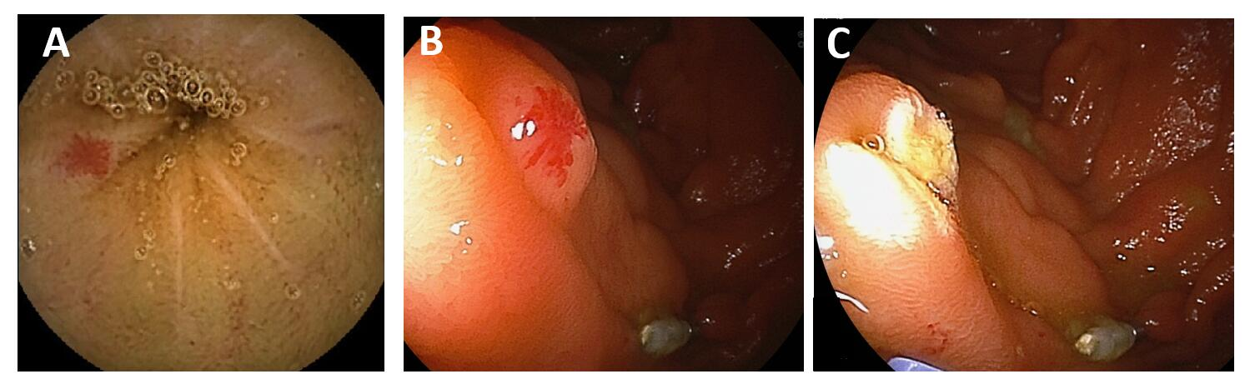

Figure 1 Representative images of angioectasia. A: Video capsule endoscopy confirmed multifocal jejunal angioectasias in patients with chronic anemia; B: Double balloon endoscopy identified an angioectasia classified into Yano-Yamamoto classification Type 1b; C: Argon plasm coagulation cauterization was successfully performed.

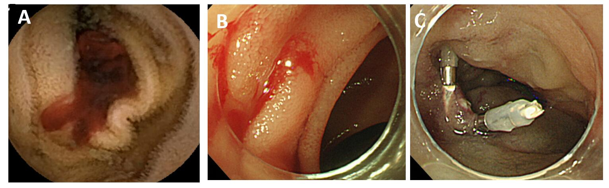

Figure 2 Representative images of Dieulafoy’s lesion. A: Video capsule endoscopy confirmed active bleeding from unknown origin in patient with ongoing overt obscure gastrointestinal bleeding; B: Arterial bleeding occurred from a jejunal punctuate lesion classified into Yano-Yamamoto classification Type 2a; C: Successful hemostasis was achieved by combination of argon plasm coagulation cauterization and endoclips.

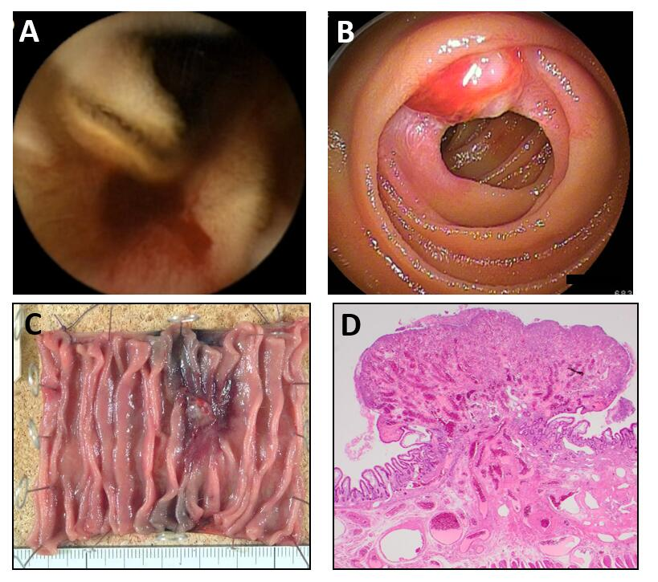

Figure 3 Representative images of arteriovenous malformation. A: Video capsule endoscopy confirmed active bleeding from jejunum in young patient with ongoing overt obscure gastrointestinal bleeding; B: Double balloon endoscopy identified pulsating subepithelial tumor classified into Yano-Yamamoto classification Type 4; C: Subsequent to endoscopic tattooing, surgical resection was performed; D: Pathological examination revealed a vascular malformation in the submucosa.

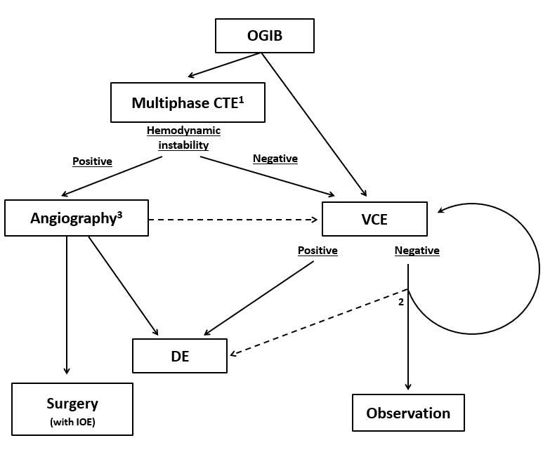

Figure 4 Diagnostic algorithm for small bowel vascular lesions. Note: ¹Computed tomography (CT) scan is especially recommended for patients with ongoing overt obscure gastrointestinal bleeding (OGIB). CT enterography can be replaced to multiphase CT or radionuclide scanning, considering patients general condition; ²Repeated video capsule endoscopy is recommended if the disease presentation changes from occult to overt or if a rapid decrease in the serum hemoglobin level is confirmed. Urgent deep enteroscopy may be useful to reveal the bleeding source in patients with recurrent overt OGIB; ³Surgical intervention with intra-operative endoscopy will be conducted when superselective transcatheter embolization was failed. Meanwhile subsequent endoscopic examination is recommended to reveal bleeding origin, even if hemodynamic instability was relieved. OGIB: Obscure gastrointestinal bleeding; CTE: Computed tomography enteroscopy; VCE: Video capsule endoscopy; DE: Deep enteroscopy; IOE: Intra-operative endoscopy; CT: Computed tomography.

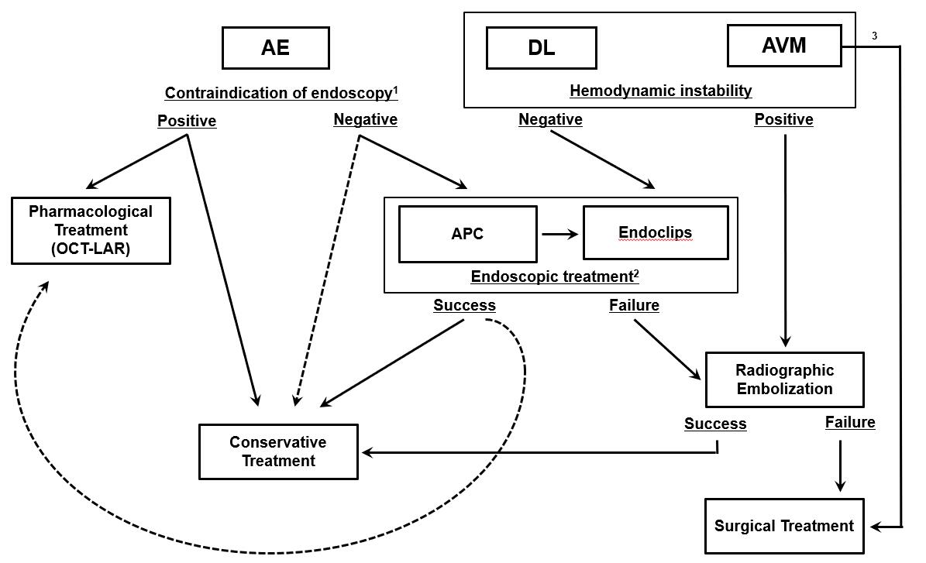

Figure 5 Therapeutic algorithm for small bowel vascular lesions. Note: ¹Pharmacological treatment is recommended for patients whom endoscopy is contraindicated. Meanwhile conservative approach with iron supplementation remains an option for patients with mild anemia; ²Subsequent pharmacological treatment after successful endoscopic treatment may be useful as an adjunct therapy, especially for patients with a high risk of re-bleeding; ³Arteriovenous malformation usually requires surgical resection because of their relatively large size and tendency to re-bleed. AE: Angioectasia; DL: Dieulafoy’s lesion; AVM: Arteriovenous malformation; APC: Argon plasm coagulation; OCT-LAR: Long-acting release octreotide.

