Name of Journal: World Journal of Diabetes
Manuscript NO: 87777
Manuscript Type: MINIREVIEWS

Management of monogenic diabetes in pregnancy: A narrative review

Jeeyavudeen MS et al. Monogenic diabetes in pregnancy

Mohammad Sadiq Jeeyavudeen, Sarah R Murray, Mark W J Strachan

Mohammad Sadiq Jeeyavudeen, Mark W J Strachan, Metabolic Unit, Western General Hospital, Edinburgh EH4 2XU, United Kingdom

Sarah R Murray, MRC Centre for Reproductive Health, University of Edinburgh Queen’s Medical Research Institute, Edinburgh EH16 4TJ, United Kingdom

Author contributions: Jeeyavudeen MS performed the literature search, interpreted the relevant literature and drafted the initial manuscript, conceived the idea and designed the paper, prepared the figures and supervised the revision of the article critically for important intellectual content; Strachan MWJ and Murray SR contributed to the manuscript drafting and the idea of this manuscript; and all authors have read and approved the final version of the manuscript.

Corresponding author: Mohammad Sadiq Jeeyavudeen, MD, Doctor, Metabolic Unit, Western General Hospital, Crewe Road South, Edinburgh EH4 2XU, United Kingdom. mohammadsadiqj@gmail.com

Received: August 29, 2023
Revised: November 13, 2023
Accepted: December 8, 2023
Published online: January 15, 2024

Abstract
Pregnancy in women with monogenic diabetes is potentially complex, with significant implications for both maternal and fetal health. Among these, maturity-onset diabetes of the young (MODY) stands out as a prevalent monogenic diabetes subtype frequently encountered in clinical practice. Each subtype of MODY requires a distinct approach tailored to the pregnancy, diverging from management strategies in non-pregnant individuals. Glucokinase MODY (GCK-MODY) typically does not require treatment outside of pregnancy, but special considerations arise when a woman with GCK-MODY becomes pregnant. The glycemic targets in GCK-MODY pregnancies are not exclusively dictated by the maternal/paternal MODY genotype but are also influenced by the genotype of the developing fetus. During pregnancy, the choice between sulfonylurea or insulin for treating hepatocyte nuclear factor 1-alpha (HNF1A)-MODY and HNF4A-MODY depends on the mother’s specific circumstances and the available expertise. Management of other rarer MODY subtypes is individualized, with decisions made on a case-by-case basis. Therefore, a collaborative approach involving expert diabetes and obstetric teams is crucial for the comprehensive management of MODY pregnancies.

Key Words: Diabetes; Pregnancy; Maturity-onset diabetes of the young; Insulin; Sulphonylurea; Glucokinase; Hepatocyte nuclear factor 1-alpha, hepatocyte nuclear factor 1-beta, and hepatocyte nuclear factor 4-alpha

©The Author(s) 2024. Published by Baishideng Publishing Group Inc. All rights reserved.

Citation: Jeeyavudeen MS, Murray SR, Strachan MWJ. Management of monogenic diabetes in pregnancy: A narrative review. World J Diabetes 2024; 15(1): 15-23
URL: https://www.wjgnet.com/1948-9358/full/v15/i1/15.htm
DOI: https://dx.doi.org/10.4239/wjd.v15.i1.15

Core Tip: Management of monogenic diabetes in pregnancy, particularly maturity-onset diabetes of the young (MODY), requires tailored approaches due to the unique challenges encountered in pregnancy. While glucokinase MODY often doesn’t require treatment outside pregnancy, managing it during pregnancy is complex due to its impact on fetal growth. Monitoring fetal genotype and growth patterns is essential for adjusting treatment. Non-invasive methods for fetal genotype determination, such as cell-free DNA analysis, hold promise but require further research.

INTRODUCTION
Monogenic diabetes is an umbrella term encompassing all diabetes forms caused by pathogenic mutations in a single gene^{[1]}. Maturity-onset diabetes of the young (MODY) is the most common monogenic diabetes, and generally presents in later childhood or early adulthood. Other specific gene abnormalities can give rise to neonatal diabetes, which as its name suggests causes diabetes in early life. This review will focus on the management of the most common forms of MODY in pregnancy.
Autosomal dominant mutations in genes affecting pancreatic β cell function are responsible for the development of MODY^{[2,3]}. A total of 1%-5% of all cases of diabetes and, in particular, 1%-2% of all cases of diabetes in the white European population have MODY^{[3]}. Since MODY is a rare form of diabetes, and because of variable access to diagnostic genetic testing, it is often mis-classified as one of the more common forms of diabetes - type 1 or type 2 diabetes mellitus. The distinguishing features between MODY and type 1 or type 2 diabetes are early onset fasting hyperglycemia, lean body habitus, absence of pancreatic islet autoantibodies and a family history of diabetes with autosomal dominant inheritance^{[4]}.

Classification of MODY
MODY is classified into 14 subtypes based on the gene involved (Table 1)^{[5,6]}. Mutations in the hepatocyte nuclear factor 1-alpha (HNF1A), HNF4A, and glucokinase (GCK) genes account for > 95% of all MODY cases^{[7]}.

Prevalence
The prevalence of MODY has been extensively studied in European, North American, and Australian populations, while data on its prevalence in other regions are limited^{[3,8]}. The prevalence of MODY is 1:10000 in adults and 1:23000 in children in the European population^{[9]}. HNF1A-MODY is the most common MODY subtype, followed by GCK-MODY, HNF4A-MODY and HNF1B-MODY in European cohorts^{[10]}. In a United States based study focused on GCK-, HNF1A- and HNF4A-MODY genes, the prevalence was estimated to be 1.2% in children with diabetes^{[8]}. In contrast, prevalence data from other ethnic groups and regions, including Asia, Africa, and South America, remain scarce^{[8]}. The lack of data in these populations may be attributed to limited access to genetic testing, the diverse genetic background of different ethnic groups and different testing strategies.
GCK-MODY is estimated to account for approximately 1% of all cases of gestational diabetes mellitus (GDM), with a majority of affected individuals remaining asymptomatic and undiagnosed outside of pregnancy^{[3,11]}. In the population-based Atlantic Diabetes in Pregnancy study involving 5500 participants, the population prevalence of GCK-MODY was found to be 1.1 in 1000 [95% confidence interval (CI): 0.3-2.9 in 1000]^{[3]}. Within women with GDM in this study, the prevalence of GCK-MODY was 0.9% (95%CI: 0.3-2.3). The combined criteria of having a body mass index < 25 kg/m² and fasting glucose ≥ 5.5 mmol/L demonstrated a sensitivity of 68%, specificity of 96% for the detection of GCK-MODY. The number of women with GDM to test to identify one case of GCK-MODY was 2.7^{[3]}.

Testing for MODY in pregnancy
MODY screening is not routinely performed in pregnant women due to its low prevalence in the general population. Any woman who is diagnosed with GDM at < 35 years of age and with a lean body mass index should be screened for MODY if auto-antibodies for type 1 diabetes mellitus are negative^{[10,12-14]}. In the context of MODY testing during pregnancy, two key sequencing methods have been utilised: Sanger sequencing and next-generation sequencing (NGS)^{[15]}. Sanger sequencing, also known as chain termination sequencing, has been a fundamental technique in genetic testing for several decades. It allows for the identification of specific DNA sequences by synthesising new DNA strands complementary to the target region. While Sanger sequencing is accurate and reliable, it is best suited for examining individual genes or specific genomic regions^{[16]}. Due to its relatively lower throughput and higher cost per sample, Sanger sequencing is often employed when targeting a particular known mutation or a limited set of candidate genes associated with MODY. On the other hand, NGS has revolutionised the field of genetic testing by enabling high-throughput sequencing of millions of DNA fragments simultaneously^{[17]}. NGS platforms can process large-scale genomic data rapidly, making it a more efficient approach for detecting mutations in multiple genes concurrently. This technology is particularly valuable in the context of MODY testing during pregnancy since it allows for comprehensive screening of a wide range of MODY-associated genes, facilitating a more accurate and comprehensive diagnosis^{[18]}. Hence awareness of the testing type available locally will be useful to guide the diagnosis and treatment strategies.
Direct mutation assessment of the foetus to identify whether the foetus has inherited the given mutation is challenging. Chorionic villi sampling or amniocentesis testing are available for predicting foetus genotype and consequently, the likelihood of developing MODY^{[19]}. However, these invasive methods are not recommended solely for detecting MODY genotyping purposes, as they carry a risk of miscarriage^{[14]}. The emergence of cell-free circulating DNA has shown promise as a non-invasive method for determining fetal genotype^{[20]}. Nonetheless, extensive studies in this area are currently lacking, and it is not ready yet for routine clinical use. Therefore, the importance of evaluating fetal growth through ultrasound remains a crucial tool in assessing the impact of maternal hyperglycemia on the fetus^{[21]}. Additionally, ultrasound can aid in identifying structural anomalies associated with specific genotypes. Nevertheless, it is important to note that these indicators are not definitive and cannot conclusively determine the fetal genotype. Until more robust diagnostic tools become available, monitoring fetal growth by ultrasound after 26 wk of gestation using ethnicity-specific growth charts may offer insights into the fetal genotype and guide the initiation of appropriate therapeutic interventions for optimal fetal growth and maternal glycemic control.

GCK-MODY
GCK-MODY results from a loss of function mutation in the GCK gene^{[22]}. GCK codes for the enzyme GCK that converts glucose to glucose-6-phosphate during the first stage of glycolysis. In the pancreatic beta-cells, GCK acts as the glucose sensor facilitating insulin release in response to rising blood glucose levels (Figure 1)^{[23]}. The inactivating heterozygous mutation in GCK reduces the insulin secreting function of β-cells and causes mild stable hyperglycemia in the prediabetic range starting from birth. Affected individuals respond to glucose-stimulated insulin release, but at a higher set-point than those with normal GCK function^{[24]}. As the hyperglycemia is mild in GCK-MODY, affected individuals do not develop major microvascular or macrovascular complication of diabetes.

Complications associated with GCK-MODY pregnancy
An increase in miscarriage rate of up to 33% has been reported with GCK-MODY pregnancies in some cohorts, but not all^{[13]}. Caudal regression syndrome in offspring of mothers carrying the mutant allele has recently been reported^{[25]}. Furthermore, despite the increase in birth weight, there is no long-term effect of maternal hyperglycemia on the offspring’s glucose tolerance (Table 2)^{[26]}. There are some reported cases of homozygous deletion of the GCK gene leading to intrauterine or neonatal death due to fetal growth retardation^{[29]}. Maternal hyperglycemia in GCK-MODY pregnant mothers causes an increase in fetal insulin production and in fetuses with no GCK-MODY mutation this leads to accelerated fetal growth (and potentially macrosomia) due to the anabolic effect of insulin. Macrosomia is well known to be associated with an increased risk of shoulder dystocia and an increased likelihood of cesarean birth. Furthermore, neonates carrying the wild-type GCK gene born to GCK-MODY mother are faced with an increased vulnerability to postnatal hypoglycemia. Having been exposed to a glucose-rich environment in utero accompanied by hyperinsulinemia, the abrupt cessation of maternal glucose supply postnatally can result in some neonates experiencing hypoglycemia, persisting until the neonate’s glucose-insulin equilibrium is reestablished.

Management of GCK-MODY during pregnancy
The impact of maternal GCK-MODY on the fetus is closely linked to the fetal genotype, i.e. whether or not the fetus has inherited the abnormal maternal GCK gene. This is summarised in Figure 2. A fetus with wild-type GCK is at risk of accelerated growth, diabetic fetopathy and increased birth weight. This is due to enhanced fetal insulin secretion in response to maternal hyperglycemia^{[23]}, as is seen in conventional GDM. If the fetus has inherited the abnormal GCK gene from the mother, the fetus does not develop hyperinsulinaemia in response to maternal hyperglycaemia and birthweight is not increased^{[30]}. For completeness, Figure 2 also shows that if the fetus has an abnormal GCK, which has been inherited from the father, then the fetus will produce lower insulin levels than normal in the face of maternal normoglycaemia, resulting in reduced birthweight^{[3]}.
Chorionic villus sampling or amniocentesis are available for determining fetal genotype^{[19]}. However, these invasive methods are not recommended solely for MODY genotyping purposes, as they carry a risk of miscarriage of around 1%-2%^{[14]}. The emergence of circulating cell-free fetal DNA has shown promise as a non-invasive method for determining fetal genotype^{[20]}. Nonetheless, extensive studies in this area are currently lacking, and it is not yet available for routine clinical use.
Most women with GCK-MODY do not require anti-diabetic therapy out with pregnancy. It is generally recommended that anti-diabetic therapy should not be commenced as a matter of routine during the first and second trimesters of pregnancy, even though maternal blood glucose levels are likely to be above typical pregnancy targets. Thereafter, the requirement for treatment should be determined by looking at the trajectory of fetal growth. Pregnant woman with GCK-MODY are recommended to undergo ultrasound scanning every two weeks from 26 wk of gestation^{[22]}. Accelerated fetal growth in pregnancy (implying that the fetus has not inherited the abnormal GCK gene) should lead to the commencement of maternal insulin therapy^{[7,9,19,24,27]}. Pregnant women with GCK-MODY generally require higher insulin doses (0.6 to 1 U/kg) to lower maternal glucose levels and it is often difficult to achieve standard pregnancy glucose targets. If the fetus shows a normal growth pattern from 26 wk (implying that the fetus has inherited the abnormal GCK gene), maternal insulin may not be required and if treated may cause growth restriction.

HNF1A MODY
The gene responsible for developing HNF1A MODY is HNF1A. HNF-1A MODY, also known as MODY 3, manifests with hyperglycemia in adolescence or during early adulthood^{[31]}.

Management during HNF1A-MODY pregnancy
The first line of treatment for HNF1A-MODY in non-pregnant individuals is a low dose of a sulphonylurea. DPP-IV inhibitors and GLP1 receptor agonist are the second line available options^{[14]}. However, data related to management during pregnancy in HNF1A-MODY is limiting. Some reports suggest that offspring inheriting the mutant allele do not show an increase in birthweight or neonatal hypoglycemia. However, the usage of sulphonylurea and insulin therapy need to be carefully decided in pregnant women as sulphonylurea’s have been shown to cross the placenta^{[32]}. Glyburide, the only sulphonylurea approved in pregnancy, might cause an increased risk of neonatal hypoglycemia and macrosomia when administered during pregnancy as compared to insulin therapy^{[33,34]}. In a meta-analysis conducted in 2014 of women with gestational diabetes, macrosomia (risk ratio = 3.07) and neonatal hypoglycemia (risk ratio = 2.30) were more common in those treated with glyburide compared with insulin therapy^{[33]}. These data are leading to a shift towards insulin therapy as opposed to sulphonylurea therapy during HNF1A-MODY pregnancy^{[33]}. Fetal monitoring at an early gestational stage, with fetal echocardiography to identify birth defects followed by growth ultrasound scanning at periodic intervals after 26 wk of pregnancy are recommended^{[4]}. Post-partum mothers can restart glybruide and it is safe to continue during breastfeeding as a low dose of glyburide is neither excreted in breast milk nor leads to neonatal hypoglycemia^{[14]}.

HNF4A MODY
HNF4A-MODY arises from genetic mutations within the HNF4A gene. The clinical attributes of HNF4A-MODY parallel those observed in HNF1A-MODY, as both are marked by a progressive decline in insulin secretion^{[22]}. Furthermore, this gene is recognized as an upstream regulator of the HNF1A transcription factor.

Management during HNF4A-MODY pregnancy
Babies carrying the mutation are macrosomic in approximately half of the cases, along with an elevated risk of transient neonatal hypoglycemia^{[31]}. Both of these outcomes are linked to fetal hyperinsulinism^{[35]}. In a non-pregnant state, low-dose sulfonylureas prove effective in achieving glycemic control. Given the significant risks associated with macrosomia and hypoglycemia, maintaining a tight maternal glycemic control during pregnancy is of paramount importance. Currently, no validated interventions exist to enhance fetal outcomes or manage macrosomia in HNF4A-MODY pregnancies. The therapeutic approach mirrors that employed for HNF1A-MODY pregnancies, necessitating the discontinuation of sulfonylureas before pregnancy and a transition to insulin therapy, accompanied by periodic fetal growth surveillance from 26 wk^{[31]}. The occurrence of macrosomia is significantly higher in offsprings carrying HNF4A mutations (56% vs 13%) when compared to the offsprings carrying no mutuation^{[35]}. Additionally, neonatal hyperinsulinemic hypoglycemia has been observed in 15% of infants with HNF4A mutations, compared to those without the mutation^{[26,35]}.

HNF1B-MODY
HNF1B-MODY, also known as MODY5, occurs due to a mutation in HNF1B, which is involved in embryonic development of pancreas, kidney, liver and genitourinary tract^{[36,37]}. The clinical manifestations are not limited to insulin secretion resulting in hyperglycemia, but individuals may also develop genital tract malformation, cystic renal disease, hypomagnesaemia, abnormal liver function, gout and hyperuricemia. The mean age of diabetes onset is 24 years^{[38]}. However, the age of onset can range from the neonatal period to middle age^{[39,40]}. Diabetes is managed with insulin and during pregnancy management is along the same lines as for type 1 diabetes^{[22]}. Taken together, the major complications associated with HNF1B-MODY are the variable age of onset and the variable clinical phenotypes that progress with age. Moreover, the dependency on insulin therapy is the only way to manage the disease. These clinical phenotypes and available treatment strategies raise concern for the identification of the causative disease mutation in the family at an early age and also identification of better and novel treatment drugs for this MODY.

Management during HNF1B-MODY pregnancy
There is a paucity of evidence with regards to management of MODY5 in pregnancy compared to the other MODY sub-types. Fetus’ carrying the mutant allele from a normal mother show reduced birthweight and increased risk of being small for gestational age. On the other hand, if both the fetus and the mother carry the mutant allele then the baby tends to grow larger for their gestational age. The fetal growth should be regularly monitored during pregnancy and the offspring should be subjected to genetic screening with renal abnormalities monitored in carriers as renal abnormalities are more common than diabetes in MODY 5^{[22]}.

CONCLUSION
Managing MODY pregnancy remains an area of ongoing investigation, and current protocols are based on expert judgement, small studies rather than large clinical trial data. Each form of MODY needs an individualised approach to management. Improving the early detection of MODY during the initial stages of pregnancy requires several key changes: Better implementation of MODY guidelines in general diabetes clinics for pre-pregnancy diagnosis, raising awareness among the treating medical team, ensuring accessibility to genetic testing facilities, and fostering familiarity with appropriate treatment strategies. Once pregnancy is confirmed, establishing a well-structured and comprehensive care plan is vital to avoid unnecessary interventions for the pregnant mother and ensures the optimal well-being of the fetus. Advancements in non-invasive pre-natal testing methods, such as cell-free fetal DNA analysis, hold promise for the identification of fetal genotypes.

REFERENCES
1 Bonnefond A, Unnikrishnan R, Doria A, Vaxillaire M, Kulkarni RN, Mohan V, Trischitta V, Froguel P. Monogenic diabetes. Nat Rev Dis Primers 2023; 9: 12 [PMID: 36894549 DOI: 10.1038/s41572-023-00421-w]
2 Bishay RH, Greenfield JR. A review of maturity onset diabetes of the young (MODY) and challenges in the management of glucokinase-MODY. Med J Aust 2016; 205: 480-485 [PMID: 27852188 DOI: 10.5694/mja16.00458]
3 Chakera AJ, Spyer G, Vincent N, Ellard S, Hattersley AT, Dunne FP. The 0.1% of the population with glucokinase monogenic diabetes can be recognized by clinical characteristics in pregnancy: the Atlantic Diabetes in Pregnancy cohort. Diabetes Care 2014; 37: 1230-1236 [PMID: 24550216 DOI: 10.2337/dc13-2248]
4 Naylor R, Knight Johnson A, del Gaudio D. Maturity-Onset Diabetes of the Young Overview. 2018 May 24. In: GeneReviews® [Internet]. Seattle (WA): University of Washington, Seattle; 1993 [PMID: 29792621]
5 Schwitzgebel VM. Many faces of monogenic diabetes. J Diabetes Investig 2014; 5: 121-133 [PMID: 24843749 DOI: 10.1111/jdi.12197]
6 Oliveira SC, Neves JS, Pérez A, Carvalho D. Maturity-onset diabetes of the young: From a molecular basis perspective toward the clinical phenotype and proper management. Endocrinol Diabetes Nutr (Engl Ed) 2020; 67: 137-147 [PMID: 31718996 DOI: 10.1016/j.endinu.2019.07.012]
7 Delvecchio M, Pastore C, Giordano P. Treatment Options for MODY Patients: A Systematic Review of Literature. Diabetes Ther 2020; 11: 1667-1685 [PMID: 32583173 DOI: 10.1007/s13300-020-00864-4]
8 Pihoker C, Gilliam LK, Ellard S, Dabelea D, Davis C, Dolan LM, Greenbaum CJ, Imperatore G, Lawrence JM, Marcovina SM, Mayer-Davis E, Rodriguez BL, Steck AK, Williams DE, Hattersley AT; SEARCH for Diabetes in Youth Study Group. Prevalence, characteristics and clinical diagnosis of maturity onset diabetes of the young due to mutations in HNF1A, HNF4A, and glucokinase: results from the SEARCH for Diabetes in Youth. J Clin Endocrinol Metab 2013; 98: 4055-4062 [PMID: 23771925 DOI: 10.1210/jc.2013-1279]
9 Nkonge KM, Nkonge DK, Nkonge TN. The epidemiology, molecular pathogenesis, diagnosis, and treatment of maturity-onset diabetes of the young (MODY). Clin Diabetes Endocrinol 2020; 6: 20 [PMID: 33292863 DOI: 10.1186/s40842-020-00112-5]
10 Skoczek D, Dulak J, Kachamakova-Trojanowska N. Maturity Onset Diabetes of the Young-New Approaches for Disease Modelling. Int J Mol Sci 2021; 22 [PMID: 34299172 DOI: 10.3390/ijms22147553]
11 Rudland VL, Hinchcliffe M, Pinner J, Cole S, Mercorella B, Molyneaux L, Constantino M, Yue DK, Ross GP, Wong J. Identifying Glucokinase Monogenic Diabetes in a Multiethnic Gestational Diabetes Mellitus Cohort: New Pregnancy Screening Criteria and Utility of HbA1c. Diabetes Care 2016; 39: 50-52 [PMID: 26109503 DOI: 10.2337/dc15-1001]
12 Shields BM, Hicks S, Shepherd MH, Colclough K, Hattersley AT, Ellard S. Maturity-onset diabetes of the young (MODY): how many cases are we missing? Diabetologia 2010; 53: 2504-2508 [PMID: 20499044 DOI: 10.1007/s00125-010-1799-4]
13 Bacon S, Schmid J, McCarthy A, Edwards J, Fleming A, Kinsley B, Firth R, Byrne B, Gavin C, Byrne MM. The clinical management of hyperglycemia in pregnancy complicated by maturity-onset diabetes of the young. Am J Obstet Gynecol 2015; 213: 236.e1-236.e7 [PMID: 25935773 DOI: 10.1016/j.ajog.2015.04.037]
14 Colom C, Corcoy R. Maturity onset diabetes of the young and pregnancy. Best Pract Res Clin Endocrinol Metab 2010; 24: 605-615 [PMID: 20832739 DOI: 10.1016/j.beem.2010.05.008]
15 Johansson S, Irgens H, Chudasama KK, Molnes J, Aerts J, Roque FS, Jonassen I, Levy S, Lima K, Knappskog PM, Bell GI, Molven A, Njølstad PR. Exome sequencing and genetic testing for MODY. PLoS One 2012; 7: e38050 [PMID: 22662265 DOI: 10.1371/journal.pone.0038050]
16 Stranneheim H, Lundeberg J. Stepping stones in DNA sequencing. Biotechnol J 2012; 7: 1063-1073 [PMID: 22887891 DOI: 10.1002/biot.201200153]
17 Slatko BE, Gardner AF, Ausubel FM. Overview of Next-Generation Sequencing Technologies. Curr Protoc Mol Biol 2018; 122: e59 [PMID: 29851291 DOI: 10.1002/cpmb.59]
18 Rizzo JM, Buck MJ. Key principles and clinical applications of "next-generation" DNA sequencing. Cancer Prev Res (Phila) 2012; 5: 887-900 [PMID: 22617168 DOI: 10.1158/1940-6207.CAPR-11-0432]
19 Chakera AJ, Steele AM, Gloyn AL, Shepherd MH, Shields B, Ellard S, Hattersley AT. Recognition and Management of Individuals With Hyperglycemia Because of a Heterozygous Glucokinase Mutation. Diabetes Care 2015; 38: 1383-1392 [PMID: 26106223 DOI: 10.2337/dc14-2769]
20 De Franco E, Caswell R, Houghton JA, Iotova V, Hattersley AT, Ellard S. Analysis of cell-free fetal DNA for non-invasive prenatal diagnosis in a family with neonatal diabetes. Diabet Med 2017; 34: 582-585 [PMID: 27477181 DOI: 10.1111/dme.13180]
21 Dickens LT, Letourneau LR, Philipson LH, Greeley SAW, Naylor RN. Management of GCK-MODY in Pregnancy-Does Clinical Practice Follow Current Recommendations? Diabetes 2018; 67: 1453-P [DOI: 10.2337/db18-1453-P]
22 Dickens LT, Naylor RN. Clinical Management of Women with Monogenic Diabetes During Pregnancy. Curr Diab Rep 2018; 18: 12 [PMID: 29450745 DOI: 10.1007/s11892-018-0982-8]
23 Ren Q, Wang Z, Yang W, Han X, Ji L. Maternal and Infant Outcomes in GCK-MODY Complicated by Pregnancy. J Clin Endocrinol Metab 2023; 108: 2739-2746 [PMID: 37011183 DOI: 10.1210/clinem/dgad188]
24 Rudland VL. Diagnosis and management of glucokinase monogenic diabetes in pregnancy: current perspectives. Diabetes Metab Syndr Obes 2019; 12: 1081-1089 [PMID: 31372018 DOI: 10.2147/DMSO.S186610]
25 Taylor RAM, Mackie A, Mogra R, Pinner J, Rajendran S, Ross GP. Caudal regression syndrome in a fetus of a glucokinase-maturity-onset diabetes of the young pregnancy. Diabet Med 2019; 36: 252-255 [PMID: 30362177 DOI: 10.1111/dme.13844]
26 Singh R, Pearson ER, Clark PM, Hattersley AT. The long-term impact on offspring of exposure to hyperglycaemia in utero due to maternal glucokinase gene mutations. Diabetologia 2007; 50: 620-624 [PMID: 17216282 DOI: 10.1007/s00125-006-0541-8]
27 Dickens LT, Letourneau LR, Sanyoura M, Greeley SAW, Philipson LH, Naylor RN. Management and pregnancy outcomes of women with GCK-MODY enrolled in the US Monogenic Diabetes Registry. Acta Diabetol 2019; 56: 405-411 [PMID: 30535721 DOI: 10.1007/s00592-018-1267-z]
28 Fu J, Wang T, Liu J, Wang X, Li M, Xiao X. Birthweight correlates with later metabolic abnormalities in Chinese patients with maturity-onset diabetes of the young type 2. Endocrine 2019; 65: 53-60 [PMID: 31028668 DOI: 10.1007/s12020-019-01929-6]
29 Gloyn AL, Ellard S, Shield JP, Temple IK, Mackay DJ, Polak M, Barrett T, Hattersley AT. Complete glucokinase deficiency is not a common cause of permanent neonatal diabetes. Diabetologia 2002; 45: 290 [PMID: 11942315 DOI: 10.1007/s00125-001-0746-9]
30 Hulín J, Škopková M, Valkovičová T, Mikulajová S, Rosoľanková M, Papcun P, Gašperíková D, Staník J. Clinical implications of the glucokinase impaired function - GCK MODY today. Physiol Res 2020; 69: 995-1011 [PMID: 33129248 DOI: 10.33549/physiolres.934487]
31 Colclough K, Bellanne-Chantelot C, Saint-Martin C, Flanagan SE, Ellard S. Mutations in the genes encoding the transcription factors hepatocyte nuclear factor 1 alpha and 4 alpha in maturity-onset diabetes of the young and hyperinsulinemic hypoglycemia. Hum Mutat 2013; 34: 669-685 [PMID: 23348805 DOI: 10.1002/humu.22279]
32 Schwartz RA, Rosenn B, Aleksa K, Koren G. Glyburide transport across the human placenta. Obstet Gynecol 2015; 125: 583-588 [PMID: 25730219 DOI: 10.1097/AOG.0000000000000672]
33 Poolsup N, Suksomboon N, Amin M. Efficacy and safety of oral antidiabetic drugs in comparison to insulin in treating gestational diabetes mellitus: a meta-analysis. PLoS One 2014; 9: e109985 [PMID: 25302493 DOI: 10.1371/journal.pone.0109985]
34 Hebert MF, Ma X, Naraharisetti SB, Krudys KM, Umans JG, Hankins GD, Caritis SN, Miodovnik M, Mattison DR, Unadkat JD, Kelly EJ, Blough D, Cobelli C, Ahmed MS, Snodgrass WR, Carr DB, Easterling TR, Vicini P; Obstetric-Fetal Pharmacology Research Unit Network. Are we optimizing gestational diabetes treatment with glyburide? The pharmacologic basis for better clinical practice. Clin Pharmacol Ther 2009; 85: 607-614 [PMID: 19295505 DOI: 10.1038/clpt.2009.5]
35 Pearson ER, Boj SF, Steele AM, Barrett T, Stals K, Shield JP, Ellard S, Ferrer J, Hattersley AT. Macrosomia and hyperinsulinaemic hypoglycaemia in patients with heterozygous mutations in the HNF4A gene. PLoS Med 2007; 4: e118 [PMID: 17407387 DOI: 10.1371/journal.pmed.0040118]
36 Bellanné-Chantelot C, Clauin S, Chauveau D, Collin P, Daumont M, Douillard C, Dubois-Laforgue D, Dusselier L, Gautier JF, Jadoul M, Laloi-Michelin M, Jacquesson L, Larger E, Louis J, Nicolino M, Subra JF, Wilhem JM, Young J, Velho G, Timsit J. Large genomic rearrangements in the hepatocyte nuclear factor-1beta (TCF2) gene are the most frequent cause of maturity-onset diabetes of the young type 5. Diabetes 2005; 54: 3126-3132 [PMID: 16249435 DOI: 10.2337/diabetes.54.11.3126]
37 Lim SH, Kim JH, Han KH, Ahn YH, Kang HG, Ha IS, Cheong HI. Genotype and Phenotype Analyses in Pediatric Patients with HNF1B Mutations. J Clin Med 2020; 9 [PMID: 32708349 DOI: 10.3390/jcm9072320]
38 Chen YZ, Gao Q, Zhao XZ, Chen YZ, Bennett CL, Xiong XS, Mei CL, Shi YQ, Chen XM. Systematic review of TCF2 anomalies in renal cysts and diabetes syndrome/maturity onset diabetes of the young type 5. Chin Med J (Engl) 2010; 123: 3326-3333 [PMID: 21163139]
39 Edghill EL, Bingham C, Ellard S, Hattersley AT. Mutations in hepatocyte nuclear factor-1beta and their related phenotypes. J Med Genet 2006; 43: 84-90 [PMID: 15930087 DOI: 10.1136/jmg.2005.032854]
40 Edghill EL, Bingham C, Slingerland AS, Minton JA, Noordam C, Ellard S, Hattersley AT. Hepatocyte nuclear factor-1 beta mutations cause neonatal diabetes and intrauterine growth retardation: support for a critical role of HNF-1beta in human pancreatic development. Diabet Med 2006; 23: 1301-1306 [PMID: 17116179 DOI: 10.1111/j.1464-5491.2006.01999.x]

Footnotes
Conflict-of-interest statement: All the authors report no relevant conflicts of interest for this article.

Open-Access: This article is an open-access article that was selected by an in-house editor and fully peer-reviewed by external reviewers. It is distributed in accordance with the Creative Commons Attribution NonCommercial (CC BY-NC 4.0) license, which permits others to distribute, remix, adapt, build upon this work non-commercially, and license their derivative works on different terms, provided the original work is properly cited and the use is non-commercial. See: https://creativecommons.org/Licenses/by-nc/4.0/

Provenance and peer review: Invited article; Externally peer reviewed.
Peer-review model: Single blind

Peer-review started: August 29, 2023
First decision: October 24, 2023
Article in press: December 8, 2023

Specialty type: Endocrinology and metabolism
Country/Territory of origin: United Kingdom
Peer-review report’s scientific quality classification
Grade A (Excellent): 0
Grade B (Very good): 0
Grade C (Good): C, C, C, C
Grade D (Fair): 0
Grade E (Poor): 0

P-Reviewer: Cen LS, China; Zhao CF, China; Horowitz M, Australia S-Editor: Wang JJ L-Editor: A P-Editor: Chen YX

Figure Legends
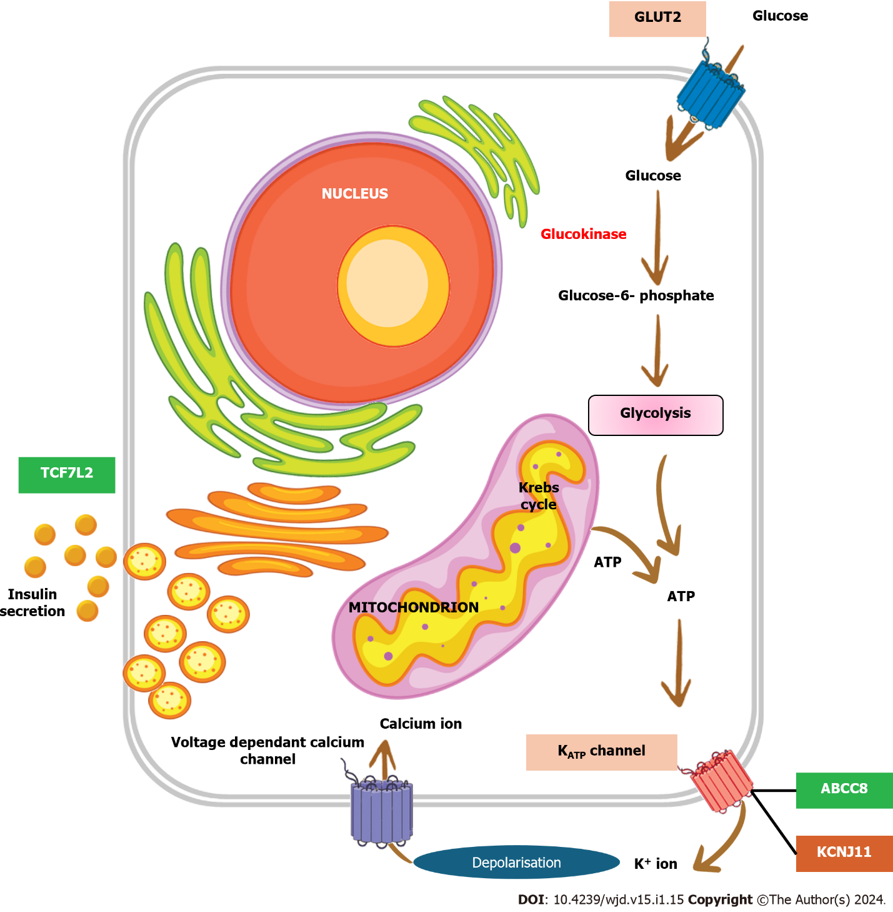
Figure 1 The key process of glucose mediated insulin secretion in the pancreas. Glucose enters the cell through GLUT2 transported and gets phosphorylated to glucose-6-phosphate by glucokinase, a rate limiting step in the process.

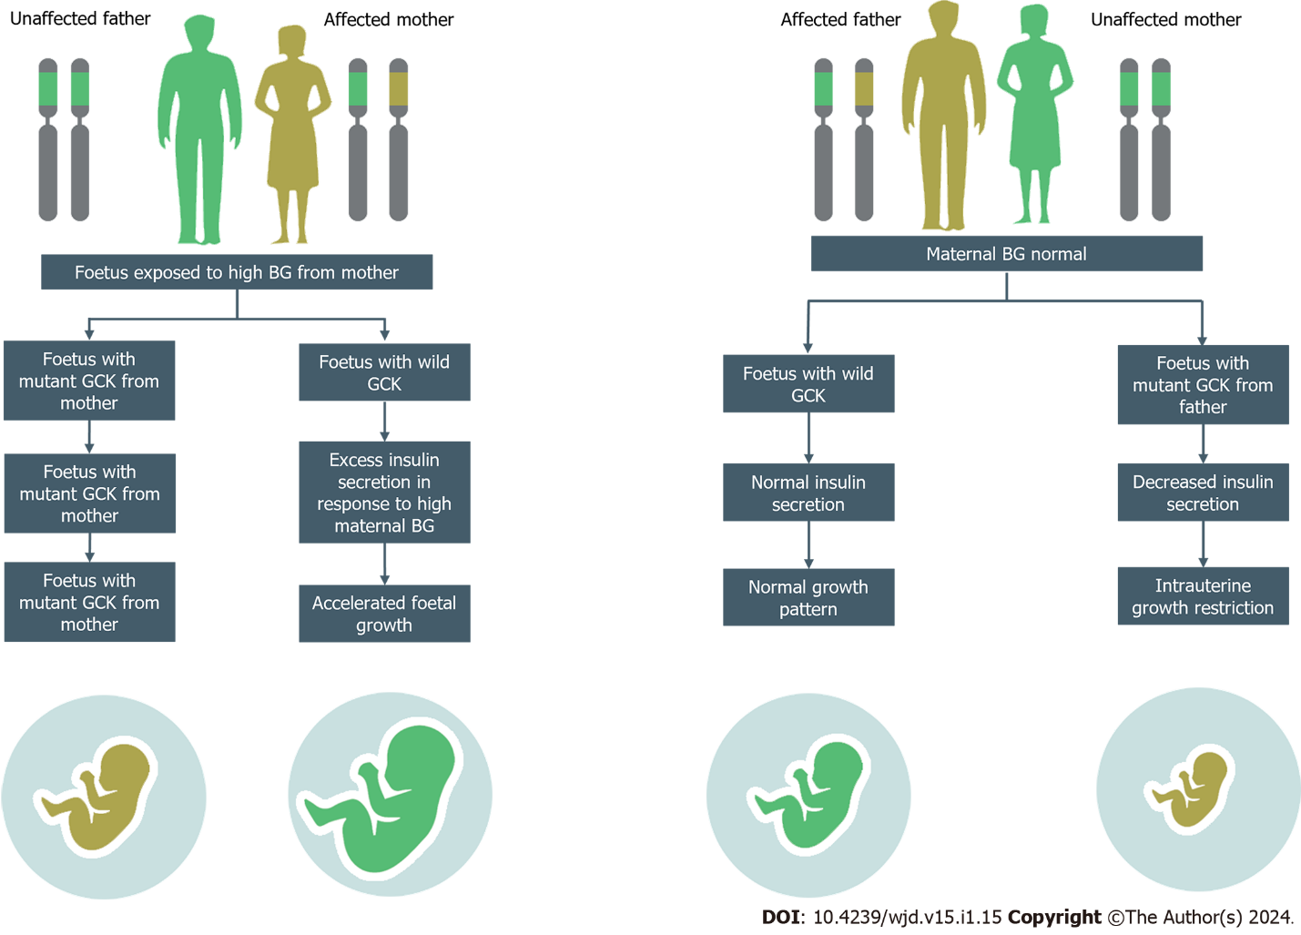
Figure 2 Management of glucokinase maturity-onset diabetes of the young in pregnancy. GCK: Glucokinase; BG: Blood glucose.

Table 1 Classification of maturity-onset diabetes of the young
MODY type | MODY sub-type | Genes affected | Characteristics features
HNF4A-MODY | MODY 1 | HNF4A | Young-onset hyperglycemia, pancreatic beta cell dysfunction, sensitive to sulfonylurea treatment, macrosomia, transient neonatal hyperinsulinism
GCK-MODY | MODY 2 | GCK | Mild fasting hyperglycemia, stable glucose levels, lack of complications
HNF1A-MODY | MODY 3 | TCF1 | Young-onset hyperglycemia, sensitive to sulfonylurea treatment, renal cysts, genital tract anamolies
PDX1-MODY | MODY 4 | PDX1 | Young-onset hyperglycemia, pancreatic agenesis, hypopituitarism, growth retardation
HNF1B-MODY | MODY 5 | HNF1B | Young-onset hyperglycemia, renal abnormalities, genital tract malformations, gout
NEUROD1-MODY | MODY 6 | NEUROD1 | Young-onset hyperglycemia, retinal dystrophy, cerebellar ataxia, epilepsy, intellectual disability, sensorineural hearing loss
KLF11-MODY | MODY 7 | KLF11 | Young-onset hyperglycemia, hepatic steatosis
CEL-MODY | MODY 8 | CEL | Neonatal diabetes, pancreatic atrophy, exocrine pancreatic insufficiency, transient neonatal hyperinsulinism
PAX4-MODY | MODY 9 | PAX4 | Adult onset diabetes, multisystem disorder, mutation inhibits beta-cell proliferation, ketosis prone
INS-MODY | MODY 10 | INS | Neonatal diabetes, insulin gene mutation, requires lifelong insulin treatment
BLK-MODY | MODY 11 | BLK | Young-onset hyperglycemia, reduced beta-cell mass
ABCC8-MODY | MODY 12 | ABCC8 | Neonatal diabetes, potassium channel gene mutation, responsive to high-dose sulfonylurea
KCNJ11-MODY | MODY 13 | KCNJ11 | Neonatal diabetes, potassium channel gene mutation, responsive to high-dose sulfonylurea
APPL1-MODY | MODY 14 | APPL1 | Young-onset diabetes and decreased glucose mediated insulin release, dysmorphic features and developmental delay in animal models
HNF4A: Hepatocyte nuclear factor 4 alpha; GCK: Glucokinase; TCF1: Transcription factor 1 (also known as HNF1A); PDX1: Pancreatic and Duodenal Homeobox 1; HNF1B: Hepatocyte nuclear factor 1 beta (also known as TCF2); NEUROD1: Neurogenic differentiation 1; KLF11: Krüppel-like factor 11; CEL: Carboxyl ester lipase; PAX4: Paired box 4; BLC2L1: B-cell CLL/lymphoma 2 like 1; INS: Insulin; BLK: B-lymphocyte kinase; APPL1: Adaptor protein, phosphotyrosine interaction, PH domain, and leucine zipper containing 1; ABCC8: ATP-binding cassette subfamily c member 8 (also known as SUR1); KCNJ11: potassium voltage-gated channel subfamily J member 11 (also known as Kir6.2).

Table 2 Complications of glucokinase maturity-onset diabetes of the young in pregnancy
Outcome feature | Percentage | Ref.
Miscarriage | 15%-33% | [9,27]
Preterm birth | 12% | [27]
Low birth weight | 6% | [28]
Macrosomia | 3% | [23]
Neonatal hypoglycemia | 10% | [23]
Congenital malformations | 2%-3% | [23]

Published by Baishideng Publishing Group Inc
7041 Koll Center Parkway, Suite 160, Pleasanton, CA 94566, USA
Telephone: +19253991568
Email: office@baishideng.com
Help Desk: https://www.f6publishing.com/helpdesk
https://www.wjgnet.com

© 2024 Baishideng Publishing Group Inc. All rights reserved.

