Name of Journal: World Journal of Gastroenterology
Manuscript NO: 84213
Manuscript Type: CASE REPORT

Value of contrast-enhanced ultrasound in deep angiomyxoma using a biplane transrectal probe: A case report

Zhang Q et al. Value of CEUS in DAM

Qiong Zhang, Hua-Lin Yan, Qiang Lu, Yan Luo

Qiong Zhang, Hua-Lin Yan, Qiang Lu, Yan Luo, Department of Medical Ultrasound, West China Hospital, Sichuan University, Chengdu 610041, Sichuan Province, China

Author contributions: Zhang Q and Luo Y contributed to the study conceptualization; Luo Y and Lu Q supervised the study; Zhang Q and Yan HL contributed to data collection and manuscript drafting; Yan HL and Lu Q contributed to manuscript revision; and all authors have approved the final manuscript.

Corresponding author: Yan Luo, Doctor, Professor, Department of Medical Ultrasound, West China Hospital, Sichuan University, No. 37 Guo Xue Xiang, Chengdu 610041, Sichuan Province, China. yanluo@scu.edu.cn

Received: March 2, 2023
Revised: May 23, 2023
Accepted: June 13, 2023
Published online: July 14, 2023

Abstract
BACKGROUND
Deep angiomyxoma (DAM) is a very rare tumor type. Magnetic resonance imaging (MRI) is considered the best imaging modality for diagnosing DAM. Computed tomography (CT) is used mainly to assess the invasion range of DAM. The value of ultrasonography in the diagnosis of DAM is still controversial. Through a literature review, we summarized the current state of ultrasonic examination for DAM and reported for the first time the contrast-enhanced ultrasound (CEUS) features of DAM seen using a biplane transrectal probe.

CASE SUMMARY
A 37-year-old woman presented with a sacrococcygeal mass that had gradually increased in size over the previous 6 mo. MRI and CT examinations failed to allow a definite diagnosis to be made. Transperineal core needle biopsy (CNB) guided by transrectal ultrasound and CEUS was suggested after a multidisciplinary discussion. Grayscale ultrasound of the lesion showed a layered appearance with alternating hyperechoic and hypoechoic patterns. Transrectal CEUS showed a laminated distribution of the contrast agent that was consistent with the layered appearance of the tumor on grayscale ultrasound. We performed transperineal CNB of the enhanced area inside the tumor under transrectal CEUS guidance and finally made a definitive diagnosis of DAM through histopathology. The patient underwent laparoscopic-assisted transabdominal surgery combined with transperineal surgery for large pelvic tumor resection and pelvic floor peritoneal reconstruction. No recurrence or metastasis was found at the nine-month follow-up.

CONCLUSION
Transrectal CEUS can show the layered perfusion characteristics of the contrast agent, guiding subsequent transperineal CNB of the enhanced area within the DAM.

Key Words: Contrast-enhanced ultrasound; Transrectal ultrasound; Transperineal core needle biopsy; Deep angiomyxoma; Pelvic tumor; Case report

©The Author(s) 2023. Published by Baishideng Publishing Group Inc. All rights reserved.

Citation: Zhang Q, Yan HL, Lu Q, Luo Y. Value of contrast-enhanced ultrasound in deep angiomyxoma using a biplane transrectal probe: A case report. World J Gastroenterol 2023; 29(26): 4214-4221
URL: https://www.wjgnet.com/1007-9327/full/v29/i26/4214.htm
DOI: https://dx.doi.org/10.3748/wjg.v29.i26.4214

Core Tip: Deep angiomyxoma (DAM) is a very rare tumor. Imaging examinations play an important role in the diagnosis of DAM. Magnetic resonance imaging is considered the best imaging modality for diagnosing DAM. Computed tomography is used mainly to assess the invasion range of DAM. The value of ultrasonography in the diagnosis of DAM is still controversial. We reported for the first time the contrast-enhanced ultrasound (CEUS) features of DAM seen using a biplane transrectal probe. Transrectal CEUS can provide more abundant diagnostic information in terms of the blood perfusion characteristics of DAM, guiding subsequent transperineal puncture of the enhanced area within the tumor.
INTRODUCTION
Deep angiomyxoma (DAM) is a very rare tumor that mainly occurs in the pelvis and perineum of women of reproductive age^{[1]}. DAM is classified as a "tumor of uncertain differentiation" in the World Health Organization classification. Since it was first described in 1983, DAM has been described in multiple single case reports and some case series reports^{[1-3]}. Imaging examinations play an important role in the diagnosis of DAM and in evaluating the scope of lesion invasion. Magnetic resonance imaging (MRI) is considered the best imaging modality for the diagnosis of DAM; computed tomography (CT) is mainly used to evaluate the invasion range of DAM, and the value of ultrasound in the diagnosis of DAM is still controversial. This article reports for the first time the contrast-enhanced ultrasound (CEUS) features of DAM seen using a biplane transrectal probe and reviews the imaging features of DAM in the literature.

CASE PRESENTATION
Chief complaints
A 37-year-old woman presented with a sacrococcygeal mass that had been increasing in size over the previous 6 mo.

History of present illness
The patient inadvertently found a sacrococcygeal mass 6 mo prior, which was approximately the size of a pigeon egg at first, without pain or other discomfort. The mass gradually increased in size, accompanied by lumbosacral distension. No definite diagnosis was made after an examination at the local hospital; thus, the patient was transferred to our hospital for further diagnosis and treatment.

History of past illness
The patient had no previous medical history.

Personal and family history
The patient and family histories were negative.

Physical examination
A digital rectal examination revealed a large solid mass in the anterior rectal wall, with a hard texture and fixed position. The mass boundary could not be palpated.

Laboratory examinations
The results of laboratory examinations were normal, including routine blood analysis, carcinoembryonic antigen (CEA), alpha-fetoprotein (AFP), carbohydrate antigen (CA) 19-9, and CA125 results.

Imaging examinations
Preoperative MRI showed a paracervical mass in the pelvis, measuring approximately 9.5 cm × 8.1 cm in size (Figure 1A). T2-weighted imaging (T2WI) presented stratification changes with alternating high and low signals that were clearly demarcated from the surrounding tissue, and the uterus was pushed and displaced cephalad. Preoperative contrast-enhanced CT (CECT) demonstrated a pelvic mass between the cervix and rectum with nonenhanced areas (Figure 1B). The mass pushed against and displaced the anterior vagina and the right posterior rectum.
Preoperative transrectal ultrasound (TRUS) was performed with the MyLab Twice ultrasound system (Esaote, Genoa, Italy) equipped with a biplane endoscopic probe (TRT33, linear frequency of 4-13 MHz, convex frequency of 3-9 MHz). Grayscale ultrasound showed that the left pelvic mass had an irregular shape (Figure 2A). The internal echo of the mass presented a layered appearance with alternating hyperechoic and hypoechoic patterns, and the boundary between the mass and rectum wall was clear. Color Doppler flow imaging (CDFI) showed some blood vessels scattered in the tumor (Figure 2B), and the dispersed intratumoral blood vessels were consistent with the layered appearance of the tumor on grayscale ultrasound. Then, transrectal CEUS was performed with a bolus injection of 2.4 mL of SonoVue (Bracco, Milan, Italy) through the elbow vein (Figure 2C). A laminated distribution of the contrast agent was observed within the mass, which was also consistent with the layered appearance of the tumor on grayscale ultrasound.

Further diagnostic work-up
Transperineal core needle (16G) biopsy (CNB) was performed under the guidance of TRUS (Figure 2D). The probe was switched to linear mode, and puncture sampling was performed under real-time monitoring by TRUS, avoiding the nonenhanced areas of the tumor. No complications occurred during the biopsy.

FINAL DIAGNOSIS
Postoperative immunohistochemical staining showed the following results: CD34 (vascular +), CK (pan) (-), ER (+), PR (+), Desmin (+), S-100 (-), SMA (+), CDK4 (-), and MDM2 (±). FISH revealed an unbalanced translocation of the HMGA2 gene. The final diagnosis was a DAM in the deep pelvis (Figure 3).

TREATMENT
A preoperative examination was completed. The patient underwent laparoscopic-assisted transabdominal surgery combined with transperineal surgery for large pelvic tumor resection and pelvic floor peritoneal reconstruction on February 10, 2022.
During surgery, the tumor was found to be located below the pelvic peritoneal reflex plane, behind the cervix, and in front of the left side of the rectum. It was irregular in shape, with a smooth capsule, and contained both cystic and solid components. The postoperative pathological report was consistent with DAM.

OUTCOME AND FOLLOW-UP
The patient recovered well after surgery and underwent regular outpatient follow-up examinations. CECT of the pelvic cavity was performed on August 12, 2022 (Figure 1C), six months after resection, and indicated no obvious signs of tumor recurrence. No recurrence or metastasis was found by the last follow-up on November 9, 2022.

DISCUSSION
DAM is a very rare type of tumor that most commonly occurs in the pelvis and perineum of women of reproductive age^{[1]}. Histologically, the typical morphology of DAM is an infiltrating, uniformly hypocellular tumor, consisting of small-sized spindled or stellate cells scattered randomly in the myxoid stroma and containing many small to medium/Large blood vessels, without nuclear atypia^{[1]} (Figure 3). Clinically, DAM presents as a slowly growing painless mass. DAM is characterized by locally aggressive growth, with recurrence and metastasis occurring in some cases^{[2,3]}. Accurate preoperative diagnosis and complete resection of the lesion are key to the treatment and prevention of recurrence^{[4]}. Imaging examinations play an important role in the diagnosis of DAM and in assessing the extent of lesion invasion^{[5]}. Commonly used imaging examinations include MRI, CT, and ultrasound^{[6]}.
CT is mainly used to evaluate the invasion range of DAM and perform follow-up observations, but its value in displaying typical signs such as a laminated or swirled appearance of the DAM tissue is limited^{[5-7]}. MRI is considered the best imaging modality for the diagnosis of DAM^{[6,8-10]}. T2WI can reveal the swirled or layered appearance of the mass, which has been reported in at least 83% of cases^{[6]}. MRI is also critical to determining the range of tumor extension into the surrounding space and the mode of tumor invasion into surrounding organs^{[6,9]}. Retrospective analysis of the T2WI MRI data in our case showed a typical laminated and swirled appearance consistent with the reports in the literature^{[8-10]} (Figure 1A). However, we failed to make a definitive diagnosis, mainly because DAM is rare; we had insufficient experience in diagnosing this tumor. Some experts believe that it is difficult to accurately diagnose DAM before surgery, and these tumors are often misdiagnosed as other soft tissue tumors^{[11-13]}, such as Bartholin cyst, lipoma, and cellular angiofibroma. The misdiagnosis rate is as high as 82%^{[11]}.
Although MRI has many advantages in the diagnosis of DAM, the cost of MRI is relatively high, and patients with metal in the body cannot be examined by MRI. Similar to MRI, ultrasound can also be applied to avoid radiation exposure. Because of its low cost, convenient operation, and noninvasiveness, ultrasound can be used for multiple examinations in cases of DAM and follow-up examinations after surgery. In addition, ultrasound is not limited by the presence of metal objects such as heart stents and is also the preferred choice for patients with claustrophobia.
However, the literature related to ultrasound for DAM is scarce^{[14]}, and the value and role of ultrasound have not been systematically summarized. Through a literature review, we found that the previous ultrasonography methods related to DAM mainly consisted of examinations with transabdominal convex array probes^{[10,15]}, intracavity convex array probes^{[9,14,16,17]}, and transperineal linear array probes^{[18,19]}. Among the 53 reports related to DAM, only 2^{[9,15]} reported a typical laminated or swirled appearance on grayscale ultrasound. In all reports, CDFI did not show swirled or layered blood vessel distribution characteristics corresponding to the grayscale ultrasound findings, and CEUS examination was not performed in any of the previous reports, as shown in Table 1.
We report for the first time the CEUS features of DAM in the pelvic cavity seen using a biplane transrectal probe. In this case, transrectal grayscale ultrasound showed a laminated appearance with alternating hyperechoic and hypoechoic patterns inside the mass (Figure 2A), demonstrating the same details as MRI and excellent resolution, which confirms the high sensitivity of transrectal high-frequency ultrasound in detecting the characteristic histological structure of DAM. We also observed that the distribution of scattered blood vessels within the tumor on CDFI was consistent with the layered appearance of the tumor on grayscale ultrasound (Figure 2B). This layered distribution of vascular features has not been previously reported in the literature^{[9-11,15,18,19]}, which may be related to the fact that more anatomical details of the tumor can be displayed by high-frequency ultrasound with a biplane transrectal probe^{[9,20,21]}; however, this is yet to be verified by subsequent cases. Reportedly, CEUS may be of great value in the diagnosis of DAM^{[15]}, as this modality can better show the characteristics of DAM and help to determine the role of ultrasound in tumor treatment. However, to our knowledge, the diagnosis of DAM by CEUS has not been reported. In our case, the mass was examined by transrectal CEUS (Figure 2C). The characteristic laminated perfusion of the contrast agent was observed within the mass, which was also consistent with the layered appearance of the tumor on grayscale ultrasound.
We believe that the advantages of ultrasound with a biplane transrectal probe and CEUS in the diagnosis of DAM in the deep pelvic cavity are as follows:
First, the biplane transrectal high-frequency probe can enter the pelvic cavity along the anal canal and rectum and clearly display the laminated or swirled appearance of DAM, as well as the boundary of the mass and its relationships with adjacent structures, allowing this modality to be comparable to MRI. Typically, transperineal ultrasound and transabdominal ultrasound cannot simultaneously meet the requirements of satisfactory detection depth and high resolution of images when examining deep pelvic lesions. Additionally, the biplane transrectal probe effectively overcomes the obvious limitation of the observation angle of the convex end-fire probe.
Second, the laminated perfusion characteristics inside the mass can be displayed in real time by CEUS, which is helpful for the diagnosis and differential diagnosis of DAM.
Third, the gold standard for the diagnosis of DAM depends on histopathology and immunohistochemistry^{[18]}. However, the proportion of cystic components in DAM is as high as 75%^{[10]}, and these components appeared as unenhanced areas on transrectal CEUS, which were easy to distinguish from enhanced areas of the mass, guiding subsequent precise and effective puncture of the enhanced area (Figure 2D). After transrectal CEUS, our patient immediately underwent transperineal CNB^{[22,23]} guided by TRUS at the examination bed, and a clear pathological diagnosis was obtained, which provided a basis for formulating the surgical plan and reducing the patient's waiting time before surgery.
Fourth, compared with MRI and CT, TRUS is convenient, rapid, radiation-free, and economical. TRUS can dynamically display the internal and adjacent structures of the lesion in real time and can be used for repeated monitoring of the lesion before surgery.
Fifth, for patients with cardiac pacemakers, internal metal stents, or claustrophobia, ultrasound with a biplane transrectal probe and CEUS can be used instead of MRI.
Sixth, long-term follow-up is necessary due to the high recurrence rate of DAM^{[24]}. Due to the above advantages, ultrasound with a biplane transrectal probe and CEUS are ideal tools for the postoperative follow-up of pelvic DAM patients. In summary, ultrasound with a biplane transrectal probe and CEUS can be one of the first choices for the diagnosis and follow-up of DAM patients.

CONCLUSION
In conclusion, pelvic DAM is a rare tumor. In our case, the typical laminated appearance of DAM could be observed by ultrasound with a biplane transrectal probe and CEUS. Moreover, CNB of the enhanced area inside the tumor could be accurately guided by transrectal CEUS, enabling the pathological gold standard for the diagnosis of DAM; thus, this modality is expected to be one of the preferred methods for the diagnosis of DAM in the pelvic cavity.

ACKNOWLEDGEMENTS
The authors thank Dr. Wang WY (Department of Pathology, West China Hospital, Sichuan University) for providing the pathological data.

REFERENCES
1 Steeper TA, Rosai J. Aggressive angiomyxoma of the female pelvis and perineum. Report of nine cases of a distinctive type of gynecologic soft-tissue neoplasm. Am J Surg Pathol 1983; 7: 463-475 [PMID: 6684403 DOI: 10.1097/00000478-198307000-00009]
2 Gay F, Champigneulle J, Tortuyaux JM, Cuny T, Régent D, Laurent-Croisé V. Aggressive angiomyxoma. Diagn Interv Imaging 2013; 94: 657-661 [PMID: 23453353 DOI: 10.1016/j.diii.2013.01.009]
3 Giraudmaillet T, Mokrane FZ, Delchier-Bellec MC, Motton S, Cron C, Rousseau H. Aggressive angiomyxoma of the pelvis with inferior vena cava involvement: MR imaging features. Diagn Interv Imaging 2015; 96: 111-114 [PMID: 25533499 DOI: 10.1016/j.diii.2014.03.006]
4 Song M, Glasgow M, Murugan P, Rivard C. Aggressive Angiomyxoma of the Vulva and Bladder. Obstet Gynecol 2017; 130: 885-888 [PMID: 28885430 DOI: 10.1097/AOG.0000000000002254]
5 Outwater EK, Marchetto BE, Wagner BJ, Siegelman ES. Aggressive angiomyxoma: findings on CT and MR imaging. AJR Am J Roentgenol 1999; 172: 435-438 [PMID: 9930798 DOI: 10.2214/ajr.172.2.9930798]
6 Surabhi VR, Garg N, Frumovitz M, Bhosale P, Prasad SR, Meis JM. Aggressive angiomyxomas: a comprehensive imaging review with clinical and histopathologic correlation. AJR Am J Roentgenol 2014; 202: 1171-1178 [PMID: 24848813 DOI: 10.2214/AJR.13.11668]
7 Jeyadevan NN, Sohaib SA, Thomas JM, Jeyarajah A, Shepherd JH, Fisher C. Imaging features of aggressive angiomyxoma. Clin Radiol 2003; 58: 157-162 [PMID: 12623047 DOI: 10.1053/crad.2002.1127]
8 Srinivasan S, Krishnan V, Ali SZ, Chidambaranathan N. "Swirl sign" of aggressive angiomyxoma-a lesser known diagnostic sign. Clin Imaging 2014; 38: 751-754 [PMID: 24852676 DOI: 10.1016/j.clinimag.2014.04.001]
9 Tariq R, Hasnain S, Siddiqui MT, Ahmed R. Aggressive angiomyxoma: swirled configuration on ultrasound and MR imaging. J Pak Med Assoc 2014; 64: 345-348 [PMID: 24864615]
10 Kumar N, Goyal A, Manchanda S, Sharma R, Kumar A, Bansal VK. Aggressive pelvic angiomyxoma and its mimics: can imaging be the guiding light? Br J Radiol 2020; 93: 20200255 [PMID: 32401545 DOI: 10.1259/bjr.20200255]
11 Bai HM, Yang JX, Huang HF, Cao DY, Chen J, Yang N, Lang JH, Shen K. Individualized managing strategies of aggressive angiomyxoma of female genital tract and pelvis. Eur J Surg Oncol 2013; 39: 1101-1108 [PMID: 23899874 DOI: 10.1016/j.ejso.2013.06.013]
12 Smith HO, Worrell RV, Smith AY, Dorin MH, Rosenberg RD, Bartow SA. Aggressive angiomyxoma of the female pelvis and perineum: review of the literature. Gynecol Oncol 1991; 42: 79-85 [PMID: 1916515 DOI: 10.1016/0090-8258(91)90235-w]
13 Zou R, Xu H, Shi Y, Wang J, Wang S, Zhu L. Retrospective analysis of clinicopathological features and prognosis for aggressive angiomyxoma of 27 cases in a tertiary center: a 14-year survey and related literature review. Arch Gynecol Obstet 2020; 302: 219-229 [PMID: 32430760 DOI: 10.1007/s00404-020-05592-5]
14 Yang X, Zhang L, Zhao W, Zhang Y, Yu J. Invasive angiomyxoma diagnosed by transvaginal ultrasound: a case report. Ann Palliat Med 2021; 10: 5870-5874 [PMID: 33040540 DOI: 10.21037/apm-20-321]
15 Zhao CY, Su N, Jiang YX, Yang M. Application of ultrasound in aggressive angiomyxoma: Eight case reports and review of literature. World J Clin Cases 2018; 6: 811-819 [PMID: 30510948 DOI: 10.12998/wjcc.v6.i14.811]
16 Hajjar R, Alharthi M, Richard C, Gougeon F, Loungnarath R. Pelvic Aggressive Angiomyxoma: Major Challenges in Diagnosis and Treatment. Cureus 2019; 11: e4419 [PMID: 31245206 DOI: 10.7759/cureus.4419]
17 Huang CC, Sheu CY, Chen TY, Yang YC. Aggressive angiomyxoma: a small palpable vulvar lesion with a huge mass in the pelvis. J Low Genit Tract Dis 2013; 17: 75-78 [PMID: 23222052 DOI: 10.1097/LGT.0b013e3182507df8]
18 Sun J, Lian PH, Ye ZX, Dong X, Ji ZG, Wen J, Li HZ. Aggressive Angiomyxoma in the Scrotum: A Case Series and Literature Review. Front Surg 2022; 9: 762212 [PMID: 35310439 DOI: 10.3389/fsurg.2022.762212]
19 Ota H, Otsuki K, Ichihara M, Ishikawa T, Okai T. A case of aggressive angiomyxoma of the vulva. J Med Ultrason (2001) 2013; 40: 283-287 [PMID: 27277251 DOI: 10.1007/s10396-012-0427-y]
20 Wenig BM, Vinh TN, Smirniotopoulos JG, Fowler CB, Houston GD, Heffner DK. Aggressive psammomatoid ossifying fibromas of the sinonasal region: a clinicopathologic study of a distinct group of fibro-osseous lesions. Cancer 1995; 76: 1155-1165 [PMID: 8630892 DOI: 10.1002/1097-0142(19951001)76:7<1155::aid-cncr2820760710>3.0.co;2-p]
21 Granter SR, Nucci MR, Fletcher CD. Aggressive angiomyxoma: reappraisal of its relationship to angiomyofibroblastoma in a series of 16 cases. Histopathology 1997; 30: 3-10 [PMID: 9023551 DOI: 10.1046/j.1365-2559.1997.d01-556.x]
22 Zhang Q, Zhao JY, Zhuang H, Lu CY, Yao J, Luo Y, Yu YY. Transperineal core-needle biopsy of a rectal subepithelial lesion guided by endorectal ultrasound after contrast-enhanced ultrasound: A case report. World J Gastroenterol 2021; 27: 1354-1361 [PMID: 33833488 DOI: 10.3748/wjg.v27.i13.1354]
23 Nuernberg D, Saftoiu A, Barreiros AP, Burmester E, Ivan ET, Clevert DA, Dietrich CF, Gilja OH, Lorentzen T, Maconi G, Mihmanli I, Nolsoe CP, Pfeffer F, Rafaelsen SR, Sparchez Z, Vilmann P, Waage JER. EFSUMB Recommendations for Gastrointestinal Ultrasound Part 3: Endorectal, Endoanal and Perineal Ultrasound. Ultrasound Int Open 2019; 5: E34-E51 [PMID: 30729231 DOI: 10.1055/a-0825-6708]
24 Draeger DL, Protzel C, Hakenberg OW. Aggressive Angiomyxoma as a Rare Differential Diagnosis of Enlargement of the Scrotum. Clin Genitourin Cancer 2016; 14: e237-e239 [PMID: 26774350 DOI: 10.1016/j.clgc.2015.12.022]

Footnotes
Informed consent statement: Informed written consent was obtained from the patient for publication of this report and any accompanying images.

Conflict-of-interest statement: All the authors report no relevant conflicts of interest for this article.

CARE Checklist (2016) statement: The authors have read the CARE Checklist (2016), and the manuscript was prepared and revised according to the CARE Checklist (2016).

Open-Access: This article is an open-access article that was selected by an in-house editor and fully peer-reviewed by external reviewers. It is distributed in accordance with the Creative Commons Attribution NonCommercial (CC BY-NC 4.0) license, which permits others to distribute, remix, adapt, build upon this work non-commercially, and license their derivative works on different terms, provided the original work is properly cited and the use is non-commercial. See: https://creativecommons.org/Licenses/by-nc/4.0/

Provenance and peer review: Unsolicited article; Externally peer reviewed.
Peer-review model: Single blind

Peer-review started: March 2, 2023
First decision: May 16, 2023
Article in press: June 13, 2023

Specialty type: Gastroenterology and hepatology
Country/Territory of origin: China
Peer-review report’s scientific quality classification
Grade A (Excellent): 0
Grade B (Very good): B
Grade C (Good): C
Grade D (Fair): 0
Grade E (Poor): 0

P-Reviewer: Martino A, Italy; Naganuma H, Japan S-Editor: Yan JP L-Editor: A P-Editor: Yan JP

Figure Legends
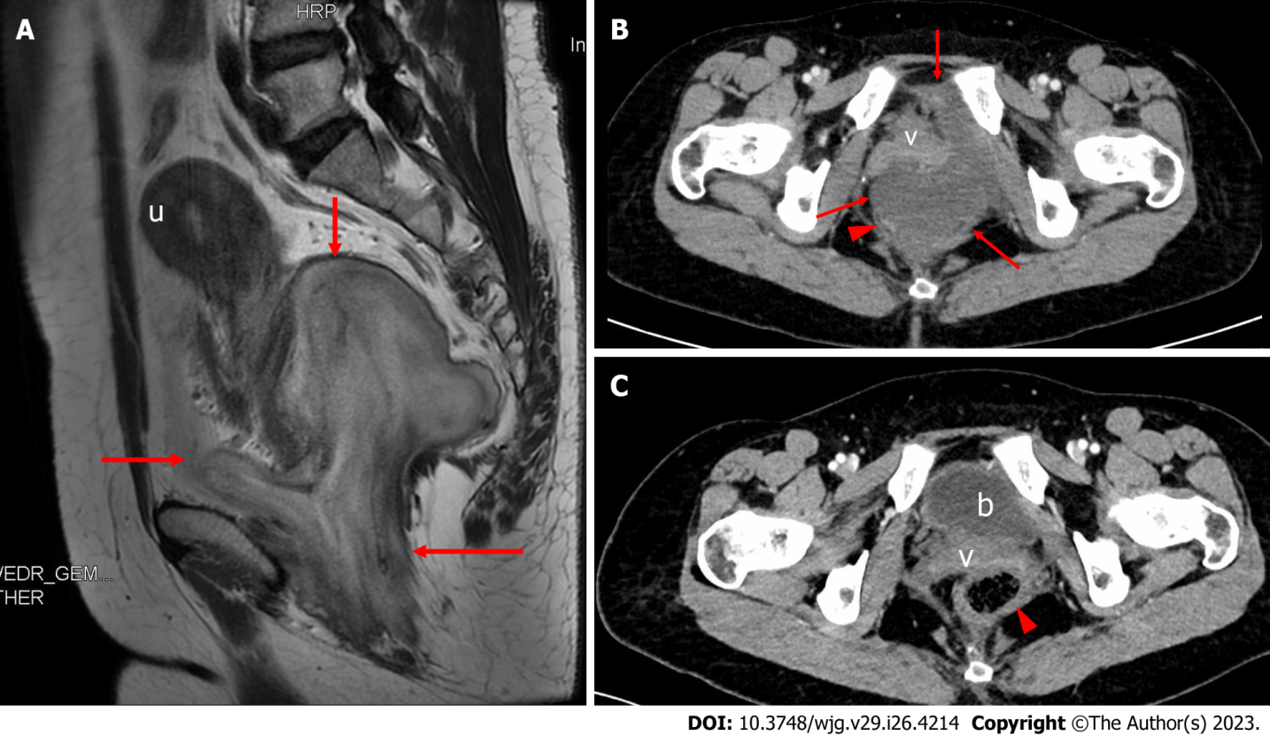
Figure 1 Magnetic resonance imaging and contrast-enhanced computed tomography images in our case. A: Preoperative sagittal T2-weighted imaging. The mass (arrows) was 9.5 cm × 8.1 cm in size, showing a layered appearance with alternating high and low signals and a clearly demarcated boundary with respect to surrounding tissue, and the uterus was pushed and displaced cephalad; B: Preoperative transverse contrast-enhanced computed tomography (CECT) showed that the anterior vagina and the right posterior rectum (arrowhead) were pushed by the mass (arrows); C: Six months after surgery, transverse CECT showed that the filled bladder, vagina, and rectum (arrowhead) were in normal positions, with no evidence of tumor recurrence. u: Uterus; v: Vagina; b: Bladder.

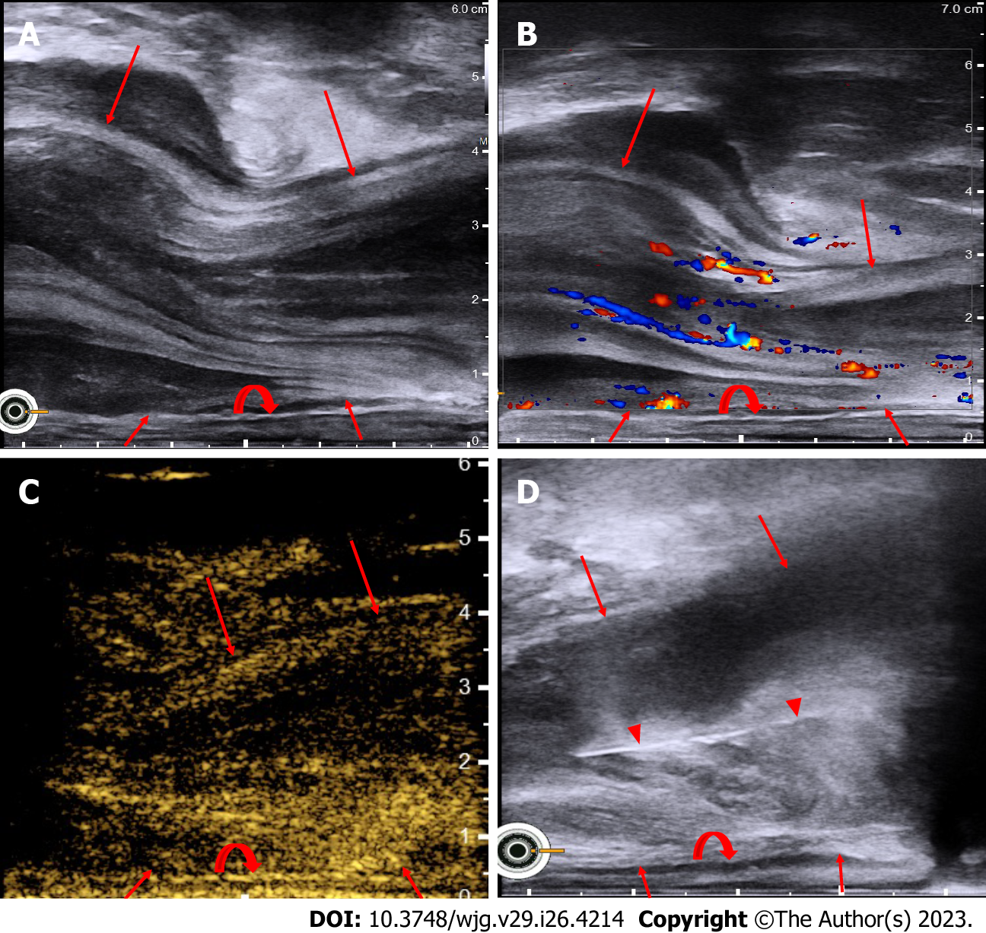
Figure 2 Scanning with a TRT33 biplane transrectal probe linear array. A: Grayscale ultrasound showed that the mass (arrows) was irregular in shape, with a layered appearance of alternating hyperechoic and hypoechoic areas inside and a clearly demarcated boundary with respect to the rectal wall (curved arrow); B: Color Doppler flow imaging showed that the dispersed intratumoral blood vessels were consistent with the layered appearance of the mass (arrows) on grayscale ultrasound; C: Transrectal contrast-enhanced ultrasound showed a laminated distribution of the contrast agent in the mass (arrows), also consistent with the layered appearance of the tumor on grayscale ultrasound; D: Transperineal core needle (arrowheads) biopsy was performed under the guidance of transrectal ultrasound.

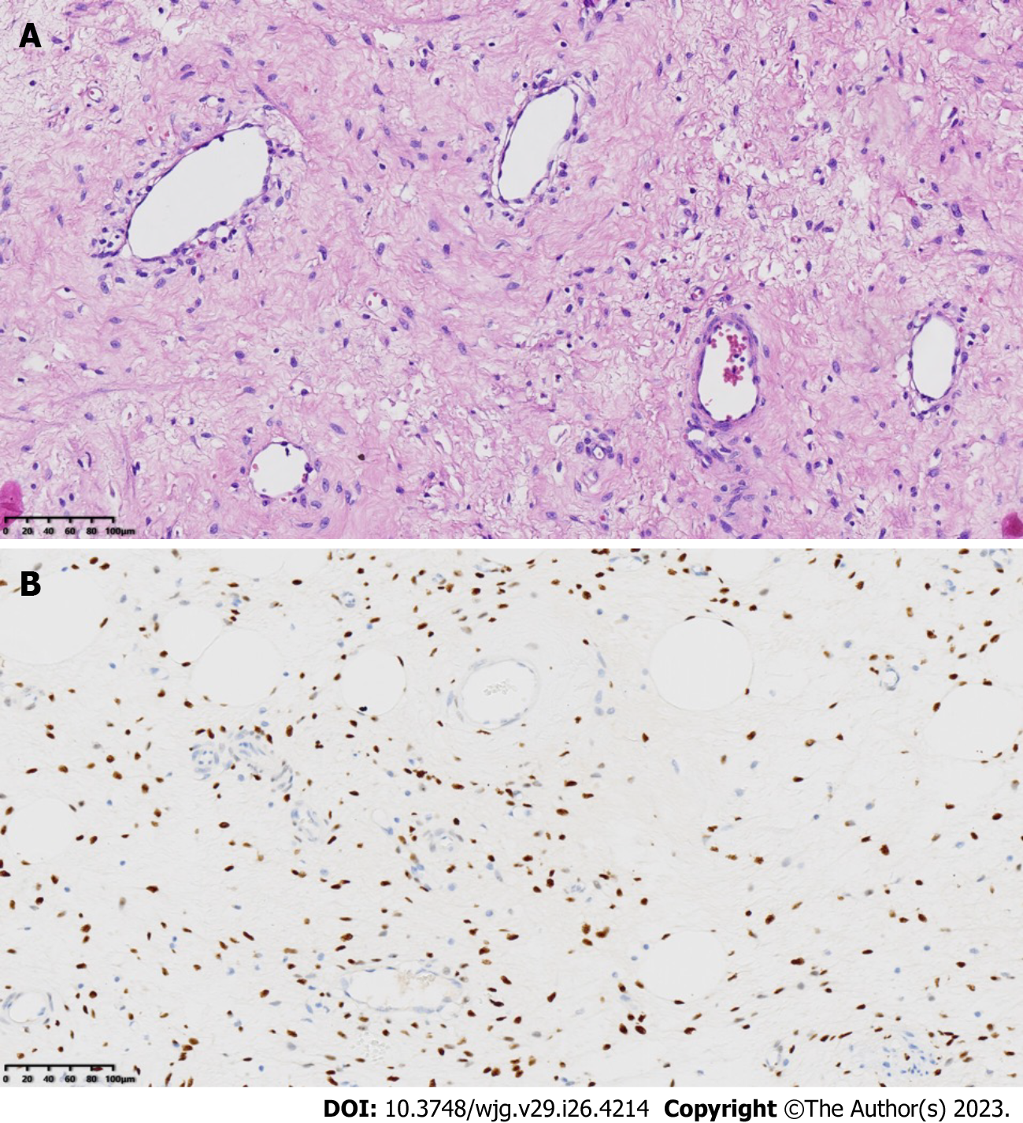
Figure 3 Pathological results of the deep angiomyxoma puncture sample. A: Small-sized spindled or stellate cells scattered in the myxoid stroma containing many blood vessels of varying caliber, without cellular atypia or mitotic activity (HE × 200); B: Immunohistochemistry showed positive expression of estrogen receptors in the tumor cells (× 200).

Table 1 Summary of sonographic features of deep angiomyxoma from the literature
No. | Ultrasonographic approach and probe | No. of tumors | Sex | Age (yr) | Location | Maximal diameter (cm) | Internal echogenicity | No. of cystic component | Laminated/swirled pattern in 2D
1 | Transabdominal convex array probe | 4 | F | 18-50 | Pelvis | 3-38.8 (mean: 16.2 ± 9.4) | Hypoechoic or isoechoic internal components | 3 | No
2 | Transabdominal convex array probe | 8 | 7F; 1M | 35-64 (median 39) | Vulva, pelvis, perineal region, spermatic cord, and scrotum | 7-21 | Heterogeneous, isoechoic internal components | 2 | Yes
3 | Transvaginal end-fire probe | 1 | F | 40 | Pelvis extending to the perineum | 11.8 | Mixed echogenicity | 0 | Yes
4 | Transvaginal end-fire probe | 1 | F | 54 | Behind the uterus | 18 | Heterogeneous hypoechoic internal components | 1 | No
5 | Transvaginal end-fire probe | 1 | F | 44 | Left pelvis | 12 | Hypoechoic to isoechoic internal components | 0 | No
6 | Transrectal radial probe | 1 | F | 61 | Left perirectal mass | 10.7 | Hypoechoic to isoechoic internal components | NA | No
7 | Transperineal linear probe | 36 | M | 1-81 (mean 48.3 ± 20.6) | Epididymis, testes, spermatic cord, scrotum | 1.6-25 (mean: 8.36) | Heterogeneous hypoechoic internal components | NA | No
8 | Transperineal linear probe | 1 | F | 28 | Vulva | 4.8 | Heterogeneous hypoechoic internal components | 0 | No
F: Female; M: Male; NA: Not available.

Published by Baishideng Publishing Group Inc
7041 Koll Center Parkway, Suite 160, Pleasanton, CA 94566, USA
Telephone: +1-925-3991568
E-mail: bpgoffice@wjgnet.com
Help Desk: https://www.f6publishing.com/helpdesk
https://www.wjgnet.com

© 2023 Baishideng Publishing Group Inc. All rights reserved.

