Name of journal: World Journal of Stomatology
ESPS Manuscript NO: 2548
Columns: BRIEF ARTICLE

Management of missile injuries to the maxillofacial region: A case series

Ebrahimi A et al. Management of missile injuries

Ali Ebrahimi, Mohammad Hosein Kalantar Motamedi, Nasrin Nejadsarvari, Hossein Mohammad Kazemi,

Ali Ebrahimi, Plastic Surgery, Trauma Research Center, Baqiyatallah University of Medical Sciences, 14366-14313 Tehran, Iran

Mohammad Hosein Kalantar Motamedi, Oral and Maxillofacial Surgery, Trauma Research Center, Baqiyatallah University of Medical Sciences, 14366-14313 Tehran, Iran

Nasrin Nejadsarvari, Plastic Surgery, Tehran University of Medical Sciences, 14366-14313 Tehran, Iran

Hossein Mohammad Kazemi, Trauma Research Center, Baqiyatallah University of Medical Sciences, 14366-14313 Tehran, Iran

Author contributions: All the authors contributed equally to this manuscript.

Correspondence to: Mohammad Hosein Kalantar Motamedi, Professor, Oral and Maxillofacial Surgery, Trauma Research Center, Baqiyatallah University of Medical Sciences, 14366-14313 Tehran, Iran. motamedical@yahoo.com

Telephone: +98-21-88053766 Fax: +98-21-88053766
Received: February 27, 2013 Revised: March 24, 2013
Accepted: April 18, 2013
Published online:

Abstract
AIM: To assess our management of patients suffering from missile injuries to the maxillofacial region.

METHODS: From December 2009 to September 2012, 40 patients with missile injuries (high-velocity gunshot and bullet wounds, explosive injuries and shrapnels etc.) affecting the maxillofacial region were treated. All except two patients were males. All had soft tissue injuries with or without bone injuries. These patients were referred to the plastic and maxillofacial surgery ward of our hospital. The patients were 19 to 65 years of age (mean 45 years). In 19 cases, there were missile injuries to other parts of the body especially the lower extremities. All of the patients were managed by early soft-tissue debridement, comprehensive reconstruction and antibiotics. This retrospective study was approved by the IRB and ethical committees.

RESULTS: The majority of injuries were caused by high velocity projectiles (88%) and the remaining by car explosions or dynamite blasts (12%). 40 patients were treated surgically. Thirty patients had soft-tissue loss (75%) and 20 patients (50%) had bone loss, there were combined soft tissue and bone loss in 10 (25%) patients. Facial fractures were in the orbital bones in 10 cases, maxillary in 7 cases, nasal in 5 cases and the mandible in three cases. We used primary repair in the majority of soft-tissue defects (25 of 40 cases). Bone repair was done primarily at the same stage using miniplates, titanium screws or wires. In some cases with bone defect iliac bone grafts were used simultaneously or in the later stages (mandibular defects). There was no failure of bone reconstruction, in our cases. Infections occurred in two cases and were treated with systemic antibiotic and dressing changes without any long term sequelae.

CONCLUSION: Our principles for soft tissue reconstructions were according to the reconstructive ladder, including primary repair, local flaps, skin grafts, regional flaps depending on the extent of damage. Primary repair in facial missile defects was not associated with increased morbidity or complications in this series. We recommend this approach when feasible.

© 2013 Baishideng. All rights reserved.

Key words: Missle; Maxillofacial; Management; Primary; Surgery

Core tip: Exposure to missile injuries may result in unique and complex injury patterns from projectiles or fragments. Injuries to the face due to firearms are either high velocity or low energy; high-velocity velocity projectiles can result in devastating functional and aesthetic consequences shattering the hard tissues. Early intervention in facial firearm injuries resulted in restoration of occlusion and continuity of the jaw, fixation of luxated or extruded teeth, early return of function, prevention of segment displacement and tissue contracture, less scaring and decreased need for major bone graft reconstruction later on.

Ebrahimi A, Motamedi MHK, Nejadsarvari N, Kazemi HM. Management of missile injuries to the maxillofacial region: A case series.
World J Stomatol 2013;
Available from:
DOI:

INTRODUCTION
Missile injuries to the maxillofacial region are important health issues both in the military and civilian population. The range of damage of these injuries represents a continuum of severity from minor injuries to those resulting in lost workdays, long-term disability and fatalities ^{[1]}.
We managed such patients after primary urgent management at our hospital. The principles of treating blunt trauma to the face is well established; however, missile injuries in this region have special features that provide the surgeon with multiple medical and surgical challenges when dealing with these injuries^{[2]}.

Severity
The severity of these injuries depends upon many factors, including type of the missile and type and site of the injury, damage to the tissue is much more a function of the velocity of missile than of its mass^{[2]}.

Assessment and resuscitation
The most important factor in the care of patients with missile injury is the initial assessment and resuscitation performed at the emergency department.

Management
The management of missile injuries of the maxillofacial region can be divided into three phases: immediate, intermediate and late^{[3]}. Indeed most plastic and maxillofacial surgeons manage patients in intermediate and late phases but for optimal management require cooperation between the emergency physician and maxillofacial surgeon and early management.
Controversy exists regarding early aggressive intervention or a more conservative approach^{[2]}. In this article, we review facial reconstruction after missile injuries with early surgical intervention.

MATERIALS AND METHODS
Forty patients with missile injuries (high-velocity gunshot wounds, explosive injuries) affecting the maxillofacial region were included in this retrospective study within the period from December 2009 to September 2012 consecutively. These patients were referred to the plastic and maxillofacial surgery ward of our hospital; 38 patients were men and two were women. The patients aged from 19 to 65 years (mean 45 years). All patients had combined soft tissue with or without bone injuries in the facial region (Figure 1). In 19 cases, there were missile injuries to other parts of the body especially the lower extremities. We managed all patients with early soft-tissue debridement and reconstruction and placed them on antibiotics for one week after primary surgery. This study was approved by the IRB and ethical committee.

Soft tissue management
Our principles of reconstruction of the facial soft tissues were by primary intention including: primary repair, local flaps, regional flaps such as cervicofacial flaps. In periorbital wounds, the orbit and globe were examined carefully for detection of injuries, and we requested ophthalmologist consultation for such patients (Figures 2 and 3). In three cases of gunshot injury with unilateral blindness globe enucleation was done.

Shell fragments
Shell fragments, bullets and shrapnels were removed if they were in the field of operation otherwise they were left to remain.

Bone management
For bone reconstruction, we restored shape, contour rigidity and stability to the facial skeleton with different devices such as titanium screw and plate, wire, arch bar immobilization with or without bone grafts (Figure 1). Our method for bone grafting was in the early phase from the iliac crest .

Mandible
For treatment of gunshot wounds of the mandible we used intraoral or extraoral approach and open reduction and internal fixation with miniplates or reconstruction plates with or without intermaxillary fixation. In one case we used a reconstruction plate (Figure 1) and in a later stage iliac bone grafting was done.

Maxilla
For treatment of gunshot wounds of the maxilla we used intraoral incision and open reduction and internal fixation with miniplates with or without intermaxillary fixation .

Frontal bone
For treatment of gunshot wounds of the frontal bone we used an open approach from laceration site or coronal incision and after reduction internal fixation with miniplates with or without bone graft was done.

Periorbital fractures
All periorbital fractures were operated during the first week after injury. Upon admission of injured patients examinations were done as indicated (radiography, axial and coronal facial CT-scans, Doppler ultrasound for carotid arteries damage).

Orbital fractures
For treatment of gunshot wounds of the orbit we used an open approach with reduction and internal fixation with miniplates and screws with or without an implant.

Scars
All deformities, and scar contractures were corrected after maturation of scars. Ophthalmic injuries were diagnosed in ten patients (globe, eyelid, and eyebrow). Enucleation of the unilateral eye was done in three cases by the ophthalmologist for severely damaged and complete blindness of the unilateral eye.
We used primary repair in the majority of soft-tissue defects (25 of 40 cases). Bone repair was done primarily at the same stage using miniplates, titanium screws or wires. In some cases with bone defect iliac bone grafts were used simultaneously or in the later stages (mandibular defects).

RESULTS
A total of 40 patients were treated and followed from five months to three years. There were 38 male and two female patients with an average age of 37 years (range 19-65 years). Most injuries were caused by high velocity projectiles (88%) and remaining by car explosions or dynamite (12%). Thirty patients had soft-tissue loss (75%) and twenty patients (50%) had bone loss, there were combined soft tissue and bone loss in ten (25%) patients. Facial fractures were in the orbital bones in ten cases, maxillary in seven cases, nasal in 5 cases and the mandible in three cases (Table 1).
There was no failure of bone reconstruction, in our cases. Infections occurred in two cases and were treated with systemic antibiotic and dressing changes without any long term sequelae.

DISCUSSION
Exposure to missile injuries may result in unique and complex injury pattern and surviving casualties usually from fragments or bullet wounds, which are often fatal if they involve the head. Blast overpressure is the abrupt, rapid rise in atmospheric pressure resulting from explosive detonation, firing of large caliber weapons and accident occupational explosion^{[4,5]}. There are two schools of thought for management of such patients subjected to missile injuries: early intervention and nonaggressive conservative intervention^{[2]}. Injuries to the face due to firearms are either high velocity or low energy; high-velocity velocity projectiles can result in devastating functional and aesthetic consequences shattering the hard tissues^{[6]}.
Our principles for soft tissue reconstructions were according to the reconstructive ladder, including primary repair, local flaps, skin grafts, regional flaps depending to extension of damages (Figure 3). We used primary repair in the majority of soft-tissue defects (25 of 30 cases) and recommended this approach for these injuries.
We used surgical intervention in all cases. Early intervention in facial firearm injuries resulted in restoration of occlusion and continuity of the jaw, fixation of luxated or extruded teeth, early return of function, prevention of segment displacement and tissue contracture, less scaring and decreased need for major bone graft reconstruction later in one study^{[6]}. In this case series study, we had no major complications after early surgical interventions.
All facial wounds were under systemic antibiotic therapy for one week and local antibiotic ointment to prevent secondary infections. There was no failure of bone reconstruction, in our cases maxillary defects were reconstructed with bicortical bone grafts in the same operation. We had facial wound infections postoperatively in two cases and we treated them with systemic antibiotics and dressing changes without any long term sequel (these two patients had mandible fracture with through and through wound of the oral cavity without any medical immunocompromising factors).
The issue of when to treat maxillofacial firearm injuries remain controversial (early or delayed), although not all maxillofacial projectile injuries can be comprehensively treated at the onset, many indeed may^{[7]}. Although all missile wounds are contaminated, the general consensus in medical literature and textbooks consider these infections to be mostly of odontogenic origin^{[8]}. In composite defects (soft tissue and bone), we used bone graft and soft-tissue flaps simultaneously for coverage of bone, and our results were free of any significant resorption or flap necrosis after early operative intervention.
In our study, the most common site of entrance and exit wounds were in the cheek (67%). In another study in Iraq by Kummona, the most common site was also in the cheek (54.8%). According to our results the midface is a common site for gunshot injuries and a safe coverage for protection of cheek in military and civilian people must be designed for combat. The face is the part of the body most subjected to injuries either by road traffic accidents or by missile war injuries^{[9]}. In our experience gunshot injuries of the craniofacial region are not a single site injury and often have associated injuries; thus, a complete evaluation of soft tissue and bones must be done for all patients. We used free bone grafting for four patients in our cases and the preferred site for bone graft harvesting was the iliac crest because of combined corticocancellous block of bone. For delayed reconstruction of the frontal cranium, we used titanium mesh and soft-tissue flap with acceptable results (Figure 3) without any complication. In our series, the most commons associated injuries were ophthalmic injuries (Table 2) seen in ten patients with unilateral blindness. In another study, the most common injured facial structure was the facial nerve and the second most common was ophthalmic injuries. An important problem in patients with gunshot injuries or blast damage are facial burn-blast tattoos that must be managed in the early post damage by operative intervention. Application of silver sulfadiazine before operative intervention helps to better remove embedded particles and decrease traumatic tattoos^{[10]}. This procedure is also better done early. Advocates of primary management have supported this viewpoint^{[11-14]}.
In high-velocity gunshot injuries and blast injuries with facial damage to soft tissue and bone, early surgical intervention is beneficial and good results without significant complications can be obtained; we recommend this approach in these types of facial injuries.

COMMENTS
Background
Firearm projectiles can result in devastating functional and aesthetic consequences shattering the hard tissues. Early intervention in facial firearm injuries is still in debate.

Research frontiers
Experience has shown early management resulted in restoration of occlusion and continuity of the jaw, fixation of luxated or extruded teeth, early return of function, prevention of segment displacement and tissue contracture, less scaring and decreased need for major bone graft reconstruction later on.

Innovations and breakthroughs
Innovations in surgical instruments and hardware, plates and screws have enabled rigid fixation of fractures.

Applications
These advancements have enabled surgeons to better manage gunshot injuries.

Peer review
The manuscript is a result of good effort in the part of the authors which may be useful to determine management of maxillofacial injuries secondary to missiles and gun shot wounds.

REFERENCES
1 Helmkamp JC, Kennedy RD. Causes of death among U.S. military personnel: a 14-year summary, 1980-1993. Mil Med 1996; 161: 311-317 [PMID: 8700323]
2 Kummoona R, Muna AM. Evaluation of immediate phase of management of missile injuries affecting maxillofacial region in iraq. J Craniofac Surg 2006; 17: 217-223 [PMID: 16633165 DOI: 10.1097/00001665-200603000-00003]
3 Banks P, Mellor S, Haywood IR, et al. Gunshot wounds. In: Williams JLT, ed. Rowe and Williams Maxillofacial Injuries,2nd edition. London, England: Churchill Livingstone, 1994: 665
4 Nelson TJ, Wall DB, Stedje-Larsen ET, Clark RT, Chambers LW, Bohman HR. Predictors of mortality in close proximity blast injuries during Operation Iraqi Freedom. J Am Coll Surg 2006; 202: 418-422 [PMID: 16500245 DOI: 10.1016/j.jamcollsurg.2005.11.011]
5 Bird SM. UK statistical indifference to its military casualties in Iraq. Lancet 2006; 367: 713-715 [PMID: 16517258 DOI: 10.1016/S0140-6736(06)68281-0]
6 Motamedi MH. Management of firearm injuries to the facial skeleton: Outcomes from early primary intervention. J Emerg Trauma Shock 2011; 4: 212-216 [PMID: 21769208 DOI: 10.4103/0974-2700.82208]
7 Motamedi MH, Behnia H. Experience with regional flaps in the comprehensive treatment of maxillofacial soft-tissue injuries in war victims. J Craniomaxillofac Surg 1999; 27: 256-265 [PMID: 10626260 DOI: 10.1016/S1010-5182(99)80038-9]
8 Green AW, Flower EA, New NE. Mortality associated with odontogenic infection! Br Dent J 2001; 190: 529-530 [PMID: 11411886]
9 Kummoona RK. Missile war injuries of the face. J Craniofac Surg 2011; 22: 2017-2021 [PMID: 22067852 DOI: 10.1097/SCS.0b013e318231978a]
10 Ebrahimi A, Motamedi MHK. Application of silver sulfadiazine cream with early surgical intervention in patients suffering from combined burn-blast injury facial tattoos. Trauma Monthly 2012; 17: 255-258 doi: 10.5812/traumamon.3935
11 Motamedi MH. Primary treatment of penetrating injuries to the face. J Oral Maxillofac Surg 2007; 65: 1215-1218 [PMID: 17517308 DOI: 10.1016/j.joms.2007.03.001]
12 Motamedi MH. Primary management of maxillofacial hard and soft tissue gunshot and shrapnel injuries. J Oral Maxillofac Surg 2003; 61: 1390-1398 [PMID: 14663802 DOI: 10.1016/j.joms.2003.07.001]
13 Motamedi MH, Hashemi HM, Shams MG, Nejad AN. Rehabilitation of war-injured patients with implants: analysis of 442 implants placed during a 6-year period. J Oral Maxillofac Surg 1999; 57: 907-13; discussion 914-5 [PMID: 10437717 DOI: 10.1016/S0278-2391(99)90005-8]
14 Behnia H, Motamedi MH. Reconstruction and rehabilitation of short-range, high-velocity gunshot injury to the lower face: a case report. J Craniomaxillofac Surg 1997; 25: 220-227 [PMID: 9268901 DOI: 10.1016/S1010-5182(97)80079-0]

P-Reviewers Lee J, Gokul S, Lopez-Jornet P S-Editor Gou SX L-Editor E-Editor

1A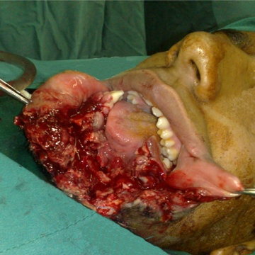 1B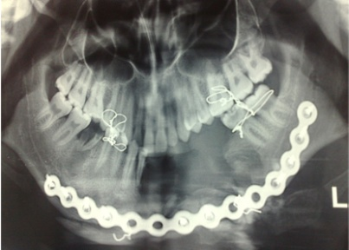1C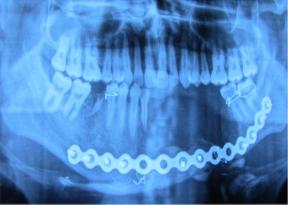
1D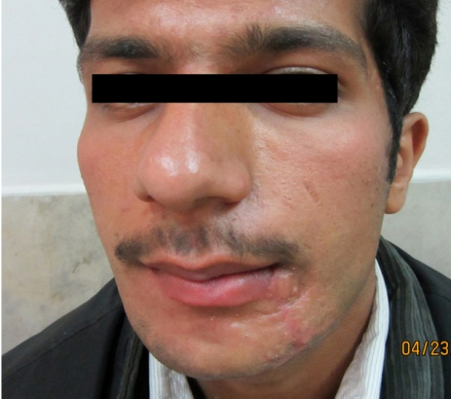

Figure 1 A 20 year-old man with gunshot wound to lower face with disruption of soft tissue and mandible bone in body with bone defect. A: Before operation; B: Computed tomography scan before operation; C: Reconstruction with reconstructive plate; D: Three month post operation.

2A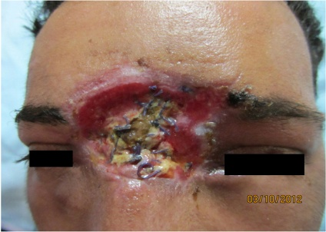
2B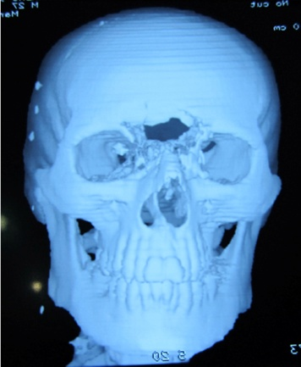 2C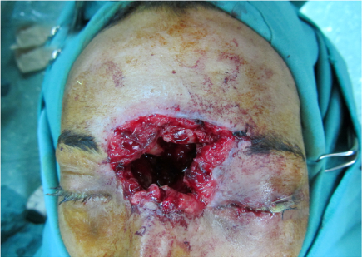 2D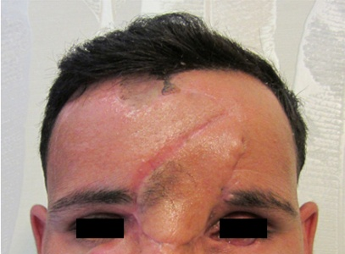

Figure 2 A 30 year-old man with gunshot wound to upper face with disruption of forehead and frontal and ethmoid sinus and left eye to the base of the skull. A: Before operation; B: The patient was treated with abdominal fat to obliterate the frontal sinus elsewhere before referral. Computed tomography scan before reconstruction; C: Intra operative view; D: Reconstruction with forehead flap and iliac bone graft (one month post operation).

3A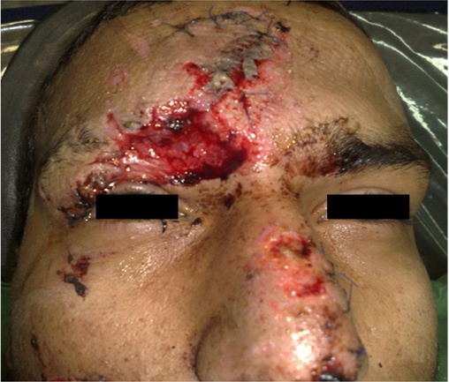 3B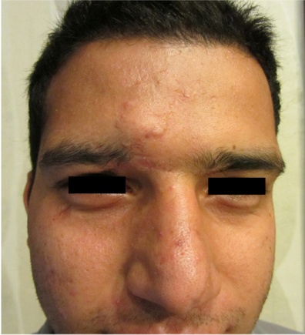
1C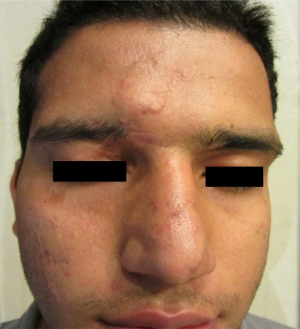

Figure 3 A 23 year-old man with gunshot wound defect of the eyebrow. A: Before operation; B: Early post operation; C: One year post operation.

Table 1 Distribution of facial soft tissue and bone damage in 40 gunshots and blast injured person
 | Site of injury | n | Bone | Soft tissue defect | Combined soft tissue-bone
1 | Periorbital | 12 | 10 | 6 | 4
2 | Maxillary | 17 | 7 | 16 | 6
3 | Mandible | 4 | 3 | 2 | 1
4 | Nasal | 5 | 3 | 4 | 3
5 | Frontal | 2 | 2 | 2 | 2
Total |  | 40 | 25 | 30 | 16

Table 2 Associated injures in the face n (%)
Associated injures
Facial nerve | 2 (5)
Parotid duct | 4 (10)
Globe | 3 (7.5)
Oral mucosa | 3 (7.5)
Lacrimal duct | 2 (5)
Total | 14 (35)

