Name of Journal: World Journal of Gastroenterology
Manuscript NO: 64837
Manuscript Type: META-ANALYSIS

Endoscopic submucosal dissection vs endoscopic mucosal resection for colorectal polyps: A meta-analysis and meta-regression with single arm analysis

Lim XC et al. ESD and EMR for colorectal polyps

Xiong Chang Lim, Kameswara Rishi Yeshayahu Nistala, Cheng Han Ng, Snow Yunni Lin, Darren Jun Hao Tan, Khek-Yu Ho, Choon-Seng Chong, Mark Muthiah

Xiong Chang Lim, Kameswara Rishi Yeshayahu Nistala, Cheng Han Ng, Snow Yunni Lin, Darren Jun Hao Tan, Yong Loo Lin School of Medicine, National University of Singapore, Singapore 117597, Singapore

Khek-Yu Ho, Mark Muthiah, Department of Medicine, National University Hospital, Singapore 119074, Singapore

Choon-Seng Chong, Department of Surgery, National University Hospital, Singapore 119074, Singapore

Author contributions: Lim XC, Nistala KRY, Ng CH, Ho KY, Muthiah M and Chong CS were involved in the conceptualization of the paper; Lim XC and Nistala KRY were involved in the acquisition of data; Lim XC, Nistala KRY, Ng CH, Lin SY, Tan DJH, Ho KY, Muthiah M and Chong CS were involved in the data analysis and interpretation; Lim XC, Nistala KRY and Ng CH were involved in writing of first draft; Ho KY, Muthiah M, Chong CS were involved in the reviewing of the drafts; all eight authors approved the final manuscript.

Corresponding author: Mark Muthiah, MBBS, MRCP, MMed, Assistant Professor, Department of Medicine, National University Hospital, 5 Lower Kent Ridge Road, Singapore 119074, Singapore. mdcmdm@nus.edu.sg

Received: February 24, 2021
Revised: April 21, 2021
Accepted: June 1, 2021
Published online: July 7, 2021

Abstract
BACKGROUND
Endoscopic submucosal dissection (ESD) has shown to be effective in management of colorectal neoplasm in the Asian countries, while its implementation in Western countries where endoscopic mucosal resection (EMR) is preferred is still debatable.

AIM
To compare the surgical, histological, and oncological outcomes between ESD and EMR in the treatment of colorectal polyps, with subgroup analysis comparing the efficacy of ESD and EMR between Japan and the rest of the world.

METHODS
Embase and Medline databases were searched from inception to October 2020 in accordance with PRISMA guidelines for studies comparing en bloc, complete resection, margin involvement, resection time, need for additional surgery, complications, and recurrence rate of ESD with EMR.

RESULTS
Of 281344 colorectal polyps from 21 studies were included. When compared to EMR, the pooled analysis revealed ESD was associated with higher en bloc and complete resection rate, and lower lateral margin involvement and recurrence. ESD led to increased procedural time, need for additional surgery, and perforation risk. No significant difference in bleeding risk was found between the two groups. Meta-regression analysis suggested only right colonic polyps correlated with an increased perforation risk in ESD. Confounders including polyp size and invasion depth did not significantly influence the en bloc and complete resection rate, bleeding risk and recurrence. In subgroup analysis, Japan performed better than the rest of the world in both ESD and EMR with perforation risk of 4% and 0.0002%, respectively, as compared to perforation risk of 8% and 1%, respectively, in reports coming from rest of the world.

CONCLUSION
ESD resulted in better resection outcomes and lower recurrence compared to EMR. With appropriate training, ESD is preferred over EMR as the first-line therapy for resection of colorectal polyps, without restricting to lesions greater than 20 mm and those with high suspicion of submucosal invasion.

Key Words: Endoscopic mucosal resection; Endoscopy; Colonic polyps; Colorectal neoplasm; Colonoscopy

©The Author(s) 2021. Published by Baishideng Publishing Group Inc. All rights reserved.

Citation: Lim XC, Nistala KRY, Ng CH, Lin SY, Tan DJH, Ho KY, Chong CS, Muthiah M. Endoscopic submucosal dissection vs endoscopic mucosal resection for colorectal polyps: A meta-analysis and meta-regression with single arm analysis. World J Gastroenterol 2021; 27(25): 3925-3939
URL: https://www.wjgnet.com/1007-9327/full/v27/i25/3925.htm
DOI: https://dx.doi.org/10.3748/wjg.v27.i25.3925

Core Tip: The present study is the most extensive meta-analysis evaluating the surgical, histological, and oncological outcomes of endoscopic submucosal dissection (ESD) in comparison to endoscopic mucosal resection (EMR) in the treatment of colorectal polyps. Our analysis also showed the increased proficiency in performing ESD and EMR in Japan as compared to the rest of the world.

INTRODUCTION
In recent years, the incidence of colorectal polyps has increased drastically with the widespread implementation of national colorectal cancer (CRC) screening programs. CRC screening with colonoscopy provides the opportunity to identify and remove any precursor lesions^{[1]} and polypectomy has been shown to reduce the incidence and mortality of CRC^{[1-3]}. Currently, 2 major forms of polypectomy are performed, namely endoscopic submucosal dissection (ESD) and endoscopic mucosal resection (EMR) with the latter procedure favored by western countries.
ESD was first proposed in 1999 as an endoscopic resection technique for safe en bloc removal of superficial lesions in the upper gastrointestinal tract^{[4]}. Although colorectal ESD is widely practiced in the Asian countries, the implementation of ESD in Western countries where endoscopic mucosal resection is preferred is still debatable. According to the 2015 European Society of Gastrointestinal Endoscopy (ESGE), ESD is strongly recommended when there is high suspicion of submucosal invasion as determined by morphologic factors and advanced surface pattern, especially in lesions greater than 20 mm^{[5]}. Despite the technical difficulties faced, ESD is designed for en bloc resection of lesions in an attempt to achieve complete resection, reliable histopathological analysis, and reduced recurrence rate.
Previous meta-analyses and systematic reviews comparing ESD with EMR mainly focused on data reported from Asian countries with limited data coming from outside of Japan, without controlling for confounders or lesions < 20 mm^{[6,7]}. Since then, numerous studies comparing between ESD and EMR have been reported from the West and other countries^{[8-16]}. We sought to perform an expanded meta-analysis to include lesions ≤ 20 mm, and incorporate regression analysis to control for confounders.

MATERIALS AND METHODS
Search strategy and inclusion criteria
A search was conducted with reference to the PRISMA methodology on October 4, 2020 in Medline and Embase^{[17]}. Keywords and Mesh terms were employed in the search strategy relating to the ‘Colorectal’, ‘ESD’ and ‘EMR’, the full list of terms included in the search can be found in the Supplementary Material 1. References were managed with Endnote X9. Two authors (XCL, KRYN) were involved in the sieving of the abstracts. Articles that compared between EMR and ESD for colorectal polyps were included in the search. Study designs included both retrospective and prospective cohorts, and case-controlled studies. Editorials, conferences abstracts, and commentaries were excluded in the review.

Data extraction
Based on the pre-determined inclusion criterion, article selection was performed by two authors with consensus from an independent third author should discrepancies arise. Information pertaining to the demographics (country, sample size, age, gender, polyp location, polyp size, polyp macroscopic type and depth of cancer invasion) and outcomes were extracted. Outcomes were limited to en bloc resection, complete resection, lateral and vertical margin involvement, lymphovascular invasion, mean operation time, additional surgery required, perforation, bleeding, and recurrence. En bloc resection was defined as the resection of the lesion in a single specimen, and complete resection was defined as the resection of the lesion with no marginal involvement of neoplastic tissue, as assessed by the pathologist. Additional surgical operations performed were considered in cases with intra-operative complications as a result of ESD or EMR or those with technical difficulties. Bleeding was considered both intra-operative and post-operative, and perforation was considered when diagnosed endoscopically during resection or radiologically by the presence of free air. Recurrence was defined as the detection of local or secondary primary tumors on interval colonoscopy. When estimates of mean and standard deviation (SD) were not available for continuous data, well established formulae were used to estimate mean and SD from median and range^{[18]}.

Statistical analysis and quality assessment
Three type of analysis were performed in this review. Firstly, a meta-analysis of proportions was used to pool results from the individual arms (ESD and EMR) using a freeman turkey double arsine transformation^{[19]}. The freeman turkey double arsine transformation is recommended for single arm meta-analysis and necessary to stabilize the variance^{[20]}. Next, comparative meta-analysis after a 0.5 continuity correction was to compare the difference in ESD and EMR, using risk ratios (RR) as the outcome of interest for dichotomous variables and weighted mean differences for continuous variables^{[21]}. A 0.5 continuity correction was considered appropriate to incorporate 0 events into the meta-analysis. Regardless of heterogeneity measures (I², tau, Cochran Q test), all analysis was performed in random effects with the Dersimonian and Laird model^{[22,23]}. Region (Japan vs rest of the world) was defined with refences to the manuscript country of origin. Publication bias was assessed with harbord test and egger regression for dichotomous and continuous variables respectively when > 10 studies were available. A univariate meta regression was also conducted with in random effects using the restricted maximum likelihood model with Kapp variance estimator to adjust for confounders in the outcomes^{[24]}. A subgroup analysis was considered to compare between the articles originating from Japan and outside of Japan and a sensitivity analysis was performed to only include studies that have polyps size of ≥ 20 mm. All articles were graded with the Newcastle Ottawa scale for cohort studies, grading articles on the domains of study group selection, study group comparability, and ascertainment of outcomes of interest^{[25]}. The statistical methods of this study were reviewed by Cheng Han Ng (ORCID ID: 0000-0002-8297-1569) from Yong Loo Lin School of Medicine, National University of Singapore.

RESULTS
Study selection
A systematic search of the literature using our search strategy yielded 1180 articles. After removal of duplicates, 895 were excluded based on study title and abstract, and 212 underwent full text review, of which 21 articles comparing ESD with EMR in resection of colorectal polyps were subsequently included in the meta-analysis (Figure 1)^{[8-16,26-37]}. In total, 12 originated from Japan^{[26-37]}, five from European^{[10-13,16]}, three from South Korea^{[8,9,14]} and one from China^{[15]}. Of the 21 studies, there were 17 retrospective cohort studies, two prospective cohort studies and two retrospective case-control studies. In total, 281344 colorectal polyps were resected, of which 19573 underwent ESD while 261771 underwent EMR. Quality assessment of those included studies mostly scored 6-7. A summary of the study characteristics of the included articles can be found in the Supplementary Table 1.

Overall results
The summary of the results is found in Table 1. The pooled analysis showed a higher rate of en bloc resection (RR = 1.837; 95%CI: 1.464 to 2.305; P < 0.001), and a lower frequency of positive lateral margin involvement (RR = 0.292; 95%CI: 0.089 to 0.995; P = 0.042) in the ESD group than the EMR group. Publication bias was significant for en bloc resection rate (P = 0.0025). No significant difference in the rates of positive vertical margin involvement was observed between ESD and EMR groups (RR = 4.368; 95%CI: 0.409 to 46.710; P = 0.223). However, the rate of complete resection was higher in the ESD compared to EMR groups (RR = 1.504; 95%CI: 1.041 to 2.174; P < 0.03). Significantly, the time taken for ESD was longer than EMR (RR = 72.709; 95%CI: 54.487 to 90.931; P < 0.001). ESD group required more additional surgical operations relative to that of EMR group (RR = 3.139; 95%CI: 1.360 to 7.243; P = 0.007).
Compared to EMR, ESD shows a significant increased risk of perforation (RR = 7.597; 95%CI: 4.281 to 13.479; P < 0.001) (Figure 2), but no significant difference in the bleeding risk was observed between the two groups (RR = 1.277; 95%CI: 0.896 to 1.820; P = 0.175) (Figure 3). The rate of recurrence in the ESD group was lower than that of the EMR group (RR = 0.269; 95%CI: 0.112 to 0.648; P = 0.003) (Figure 4).

Meta regression
The influence of the included covariates on en bloc resection, complete resection, risk of perforation and bleeding, and rate of recurrence evaluated by meta-regression are summarized in Table 2. Meta-regression analysis for risk of perforation suggested that right colonic polyps (β = 7.731; 95%CI: 4.965 to 10.497; P < 0.001) correlated with an increased risk in perforation in ESD (Figure 5). Other factors including polyp size and depth of invasion, did not influence the en bloc resection rate, complete resection rate, the risk of bleeding, and recurrence rate.

Sensitivity analysis for articles ≥ 20 mm
The results of the sensitivity analysis are summarized in Supplementary Table 2 and results were largely unchanged after a sensitivity analysis. When a sensitivity analysis was performed to include ≥ 20 mm colorectal polyps only, the pooled analysis revealed higher rate of en bloc resection (RR = 1.932; 95%CI: 1.389 to 2.688; P < 0.001), longer operation time (RR = 3.247; 95%CI: 59.249 to 87.245; P < 0.001), higher risk of perforation (RR = 4.513; 95%CI: 2.531 to 8.046; P < 0.001) and lower recurrence rate (RR = 0.191; 95%CI: 0.085 to 0.431; P < 0.001) in ESD compared to EMR groups. Furthermore, in the two studies included, more additional surgical operations were required (RR = 3.139; 95%CI: 1.360 to 7.243; P = 0.007) in the ESD than in the EMR groups.

Subgroup analysis by region
The results of the subgroup analysis comparing outcomes of ESD with EMR in Japan vs the rest of the world are presented in Table 3.
ESD in Japan had an en bloc resection rate of 89% (95%CI: 0.77 to 0.97), perforation risk of 4% (95%CI: 0.01 to 0.07), bleeding risk of 2.4% (95%CI: 0.01 to 0.04) and recurrence rate of 1% (95%CI: 0.01 to 0.02) while its EMR had an en bloc resection rate of 53% (95%CI: 0.38 to 0.67), perforation risk of 0.0002% (95%CI: 0.00 to 0.00081), bleeding risk of 2.1% (95%CI: 0.01 to 0.03) and recurrence rate of 7% (95%CI: 0.02 to 0.15). Comparing between the two techniques in Japan, ESD had higher en bloc resection rate (RR = 1.658, 95%CI: 1.270 to 2.165, P < 0.001), perforation risk (RR = 9.586, 95%CI: 4.425 to 20.768, P < 0.001) and bleeding risk (RR = 1.267, 95%CI: 1.174 to 1.367, P < 0.001) than EMR. Following sensitivity analysis, similar results were obtained, except ESD had lower recurrence rate than EMR (RR = 0.204, 95%CI: 0.097 to 0.429, P < 0.001), and there was no difference in bleeding risk (RR = 0.895, 95%CI: 0.438 to 1.829, P = 0.762) between the two techniques.
With regards to studies from the rest of the world, ESD had an en bloc resection rate of 90% (95%CI: 0.85 to 0.94), perforation risk of 8% (95%CI: 0.05 to 0.12), bleeding risk of 5% (95%CI: 0.02 to 0.11) and recurrence rate of 3% (95%CI: 0.00 to 0.08) while EMR had an en bloc resection rate of 41% (95%CI: 0.22 to 0.61), perforation risk of 1% (95%CI: 0.00 to 0.02), bleeding risk of 3% (95%CI: 0.01 to 0.06) and recurrence rate of 16% (95%CI: 0.04 to 0.32). Comparing between the two techniques, ESD had higher en bloc resection rate (RR = 2.201, 95%CI: 1.411 to 3.433, P = 0.001), perforation rate (RR = 4.602, 95%CI: 2.729 to 7.759, P < 0.001) and lower recurrence rate (RR = 0.245, 95%CI: 0.073 to 0.819, P = 0.022) than EMR. Following sensitivity analysis, similar results were obtained.

DISCUSSION
The advancements in endoscopic resection techniques have resulted in the shift from radical surgery to minimally invasive and organ-sparing endoscopic resection techniques, such as ESD and EMR, for the treatment of colorectal lesions. With reference to 2015 ESGE guidelines, ESD should be considered for colorectal lesions larger than 20 mm, with high suspicion of submucosal invasion, or those where en bloc resection by EMR are not feasible^{[5]}. Previous meta-analyses comparing ESD and EMR for colorectal polyps primarily reported data from Asian countries, with 72.7% of the published studies from Japan^{[6]}. Since then, several retrospective and prospective studies comparing ESD and EMR for the treatment of colorectal polyps have been published outside of Japan. The present study is the most extensive meta-analysis evaluating the surgical, histological, and oncological outcomes of ESD in comparison to EMR in the treatment of colorectal polyps. Nine out of 21 studies (42.9%) on colorectal polyps included in this meta-analysis were conducted in countries outside of Japan. While ESD has been known to provide significantly better resection outcomes and lower recurrence rate, our analysis found that polyp size and depth of invasion did not significantly influence the en bloc and complete resection rate, bleeding and perforation risk, and recurrence rate in colorectal polyps that was not previously reported. Additionally, previous reviews were confined only to sessile lesions larger than 20 mm^{[6,7]}. Our analysis also showed the increased proficiency in performing ESD and EMR in Japan as compared to the rest of the world.
Consistent with previous studies, ESD showed benefits in the technical, histological, and oncological outcomes. Pooled analysis showed higher rates of en bloc resection and complete resection in ESD than in EMR albeit significant publication bias (P = 0.0025). En bloc resection offers the technical advantage of removing the entire pathologic specimen, thus allowing for detailed histologic evaluation. This results in an increase in the complete resection rate which in turn reduces the recurrence rate. Therefore, en bloc resection with ESD is favored as it provides curative treatment without the need for surgery for lesions with significant likelihood of submucosal invasion^{[38]}. However, the advantages of ESD come at the expense of longer procedural time, additional surgical operations, and increased perforation risk compared to EMR^{[6]}. The high rate of additional surgical operations for ESD is presumed to be due to the aggressive selection of ESD for T1 Lesions. Although the perforation risk was higher with ESD, most perforations in the studies included were treated conservatively or endoscopically using endoclips^{[9,12,31,33,34,37]}.
Meta-regression was performed to assess the risk factors that affect surgical, histological, and oncological outcomes. Our present analysis showed that polyp size did not affect the risk of perforation, which was reported otherwise in studies by Kim et al^{[39]} and Hong et al^{[40]} Polyp size and depth of invasion were also not associated with significant change in en bloc and complete resection rate, risk of bleeding, and recurrence between ESD and EMR. Furthermore, the en bloc resection rate (before RR = 1.837, 95%CI: 1.464 to 2.305, P < 0.001; after RR = 1.932, 95%CI: 1.389 to 2.688, P < 0.001) and recurrence rate (before RR = 0.269, 95%CI: 0.112 to 0.648, P = 0.003; after RR = 0.191, 95%CI: 0.085 to 0.431; P < 0.001) appeared comparable before and after the sensitivity analysis to ≥ 20 mm polyps. Instead, the risk of perforation was increased in patients with right colonic polyps and this was consistent with previous study which identified the technical difficulty and proficient endoscopic skills required to remove polyps from right colon safely^{[41]}. As such, training should ensure endoscopists achieve procedural proficiency in left sided lesions before proceeding to attempt right sided lesions. Other factors including polyp size and depth of invasion are less important criteria when deciding between EMR and ESD in skilled tertiary centers.
Despite the advantages of ESD, the data regarding the efficacy of colorectal ESD have been inconsistent and vary between Japan and the rest of the world. One of the reasons is the limitations to the implementation of ESD in other countries, which are in part due to the lack of expertise and training centers. To date, no meta-analysis comparing ESD and EMR between Japan and the rest of the world have been performed. Our single arm meta-analysis found that Japan performed better than the rest of the world in ESD and EMR. Significantly, perforation is a major concern in ESD. The perforation risk of ESD and EMR was 4% and 0.0002%, respectively in Japan, and 8% and 1%, respectively in the rest of the world. While there is an observed increase risk of perforation from Japan only studies (RR = 9.586) compared to the rest of the world (RR = 4.602), even after sensitivity analysis, the risk of perforation for ESD was only statistically higher in Japan only studies due to the very low risk of perforation in EMR in Japan. In addition, the challenges of doing ESD in difficult could have resulted in the higher perforation rate in ESD compared with EMR in Japan. Another important factor to consider is the recurrence rate of ESD and EMR which was 1% and 7%, respectively in Japan and 3% and 27%, respectively in the rest of the world following sensitivity analysis. The observed increase in recurrence rate from Japan only studies (RR = 0.204) compared to the rest of the world (RR = 0.179) was due to the much lower recurrence rate of EMR in Japan as compared to the rest of the world. Overall, our results seem to favor studies from Japan and are in tandem with a single arm analysis of ESD only procedures with subgroup on region efficacy^{[42]}. However, most of the studies originating from the rest of the world should be interpreted with the understanding that these studies are mainly from tertiary centers and the results may not be generalized to non-tertiary centers.
The potential of ESD resection is limited by the difficulty in conducting the procedure as the length of procedure for ESD even when performed by experienced endoscopists can be three times longer than that for EMR^{[43]}. However, the advancement in endoscopic resection equipment has been shown to shorten the procedure time despite a relatively short training duration^{[44]}. Using the cumulative sum method, Miyakawa et al^{[44]} recently reported the use of Stag-Beetle Knife Jr for ESD in a Japan single-center study generated good learning curve to achieve satisfactory resection speed (min/cm²), which allowed the acquisition of proficient and safe skills within 120 cases^{[44]}. Other alternatives to ESD do exist, such as hybrid ESD and pre-cut EMR. This hybrid approach has been shown to have lower en bloc resection rate (68.4% vs 91.0%) and complete resection rate (60.6% vs 82.9%) than conventional ESD^{[42]}. Currently, underwater EMR has been thought to be a safe and effective method with higher rate of en bloc resection and lower rate of recurrence^{[45]}, but no head-to-head comparisons have been done between UMER and ESD.
The inclusion of 21 studies with a total of 281344 polyps based on our search strategy and inclusion criteria represents the most extensive meta-analysis on this issue. However, as no randomized controlled trials comparing the performance between EMR and ESD have yet been conducted, this highlights the need for a randomized study to better understand the efficacy and safety of these techniques in the management of colorectal polyps. The evaluation of heterogeneity allowed us to compare the significant differences in the performance of ESD and EMR between Japan and the rest of the world.
Our meta-analysis has some limitations. While we aimed to decrease heterogeneity, the included articles used a variety of EMR techniques including standard EMR, piecemeal EMR, EMR with small incision, EMR-precutting and EMR-circumferential incision. This, however, was an acceptable confounding factor in previous meta-analysis analysis. Also, a major factor that we were unable to regress for was the procedural skills of each centers. ESD and EMR are largely operator dependent and we were only able to account for it in a subgroup analysis comparing between studies conducted in Japan and the rest of the world.

CONCLUSION
Evidence from this meta-analysis suggests that with appropriate training, ESD is preferred over EMR as the first-line therapy for resection of colorectal polyps, without restricting to lesions greater than 20 mm and those with high suspicion of submucosal invasion. Our overall findings are consistent with previous meta-analyses showing ESD is associated with higher rate of en bloc and complete resection, and lower recurrence compared to EMR, but at the cost of increased procedural time, need for additional surgical operations and perforation risk. This is coupled with the new finding that confounders including polyp size and invasion depth did not influence the rates of en bloc and complete resection, bleeding risk, and recurrence.

ARTICLE HIGHLIGHTS
Research background
Endoscopic submucosal dissection (ESD) has shown to be effective in management of colorectal neoplasm in the Asian countries, while its implementation in Western countries where endoscopic mucosal resection (EMR) is preferred is still debatable.

Research motivation
Previous meta-analyses and systematic reviews comparing ESD with EMR included studies mainly conducted in Asia, with limited data coming from outside of Japan and did not control for confounders or lesions smaller than 20 mm.

Research objectives
To compare the outcomes of ESD and EMR in the treatment of colorectal polyps, with subgroup analysis comparing the efficacy of these two techniques between Japan and the rest of the world.

Research methods
Embase and Medline databases were searched in accordance with PRISMA guidelines for studies comparing en bloc, complete resection, margin involvement, resection time, need for additional surgery, complications, and recurrence rate of ESD with EMR in patients with colorectal lesions.

Research results
ESD was associated with better resection outcomes and lower recurrence rate when compared to EMR. Meta-regression analysis suggested only right colonic polyps correlated with an increased perforation risk in ESD, while confounders including polyp size and invasion depth did not significantly influence the resection outcomes, bleeding risk and recurrence. Subgroup analysis showed that Japan performed better than the rest of the world in both ESD and EMR with lower perforation risk.

Research conclusions
This meta-analysis suggests that with appropriate training, ESD is preferred over EMR as the first-line therapy for resection of colorectal polyps, without restricting to lesions greater than 20 mm and those with high suspicion of submucosal invasion. Increased proficiency in performing ESD and EMR was shown in Japan as compared with the rest of the world.

Research perspectives
This highlights the need to establish adequate training programs for colorectal ESD to be performed effectively. A randomized controlled trial is necessary to better understand the efficacy and safety of these techniques in the management of colorectal polyps.

ACKNOWLEDGEMENTS
We would like to thank Dr. Hiroaki Ikematsu of the Division of Science and Technology for Endoscopy, Exploratory Oncology Research & Clinical Trial Center, National Cancer Center for his advice on the writing of the manuscript.

REFERENCES
1 Winawer SJ, Zauber AG, Ho MN, O'Brien MJ, Gottlieb LS, Sternberg SS, Waye JD, Schapiro M, Bond JH, Panish JF. Prevention of colorectal cancer by colonoscopic polypectomy. The National Polyp Study Workgroup. N Engl J Med 1993; 329: 1977-1981 [PMID: 8247072 DOI: 10.1056/NEJM199312303292701]
2 Zauber AG, Winawer SJ, O'Brien MJ, Lansdorp-Vogelaar I, van Ballegooijen M, Hankey BF, Shi W, Bond JH, Schapiro M, Panish JF, Stewart ET, Waye JD. Colonoscopic polypectomy and long-term prevention of colorectal-cancer deaths. N Engl J Med 2012; 366: 687-696 [PMID: 22356322 DOI: 10.1056/NEJMoa1100370]
3 Siegel RL, Miller KD, Goding Sauer A, Fedewa SA, Butterly LF, Anderson JC, Cercek A, Smith RA, Jemal A. Colorectal cancer statistics, 2020. CA Cancer J Clin 2020; 70: 145-164 [PMID: 32133645 DOI: 10.3322/caac.21601]
4 Yamamoto H, Yube T, Isoda N, Sato Y, Sekine Y, Higashizawa T, Ido K, Kimura K, Kanai N. A novel method of endoscopic mucosal resection using sodium hyaluronate. Gastrointest Endosc 1999; 50: 251-256 [PMID: 10425422 DOI: 10.1016/s0016-5107(99)70234-8]
5 Pimentel-Nunes P, Dinis-Ribeiro M, Ponchon T, Repici A, Vieth M, De Ceglie A, Amato A, Berr F, Bhandari P, Bialek A, Conio M, Haringsma J, Langner C, Meisner S, Messmann H, Morino M, Neuhaus H, Piessevaux H, Rugge M, Saunders BP, Robaszkiewicz M, Seewald S, Kashin S, Dumonceau JM, Hassan C, Deprez PH. Endoscopic submucosal dissection: European Society of Gastrointestinal Endoscopy (ESGE) Guideline. Endoscopy 2015; 47: 829-854 [PMID: 26317585 DOI: 10.1055/s-0034-1392882]
6 Arezzo A, Passera R, Marchese N, Galloro G, Manta R, Cirocchi R. Systematic review and meta-analysis of endoscopic submucosal dissection vs endoscopic mucosal resection for colorectal lesions. United European Gastroenterol J 2016; 4: 18-29 [PMID: 26966519 DOI: 10.1177/2050640615585470]
7 De Ceglie A, Hassan C, Mangiavillano B, Matsuda T, Saito Y, Ridola L, Bhandari P, Boeri F, Conio M. Endoscopic mucosal resection and endoscopic submucosal dissection for colorectal lesions: A systematic review. Crit Rev Oncol Hematol 2016; 104: 138-155 [PMID: 27370173 DOI: 10.1016/j.critrevonc.2016.06.008]
8 Lee EJ, Lee JB, Lee SH, Youk EG. Endoscopic treatment of large colorectal tumors: comparison of endoscopic mucosal resection, endoscopic mucosal resection-precutting, and endoscopic submucosal dissection. Surg Endosc 2012; 26: 2220-2230 [PMID: 22278105 DOI: 10.1007/s00464-012-2164-0]
9 Kim YJ, Kim ES, Cho KB, Park KS, Jang BK, Chung WJ, Hwang JS. Comparison of clinical outcomes among different endoscopic resection methods for treating colorectal neoplasia. Dig Dis Sci 2013; 58: 1727-1736 [PMID: 23385636 DOI: 10.1007/s10620-013-2560-x]
10 Acquistapace F, Maternini F, Snider L, Bellini O, Moglia P, Capretti P. Endoscopic treatment of superficial colorectal neoplasms. Retrospective analysis of a single center technique and results. G Chir 2015; 36: 247-250 [PMID: 26888699 DOI: 10.11138/gchir/2015.36.6.247]
11 Emmanuel A, Gulati S, Burt M, Hayee B, Haji A. Combining eastern and western practices for safe and effective endoscopic resection of large complex colorectal lesions. Eur J Gastroenterol Hepatol 2018; 30: 506-513 [PMID: 29406437 DOI: 10.1097/MEG.0000000000001086]
12 Soliman H, Brieau B, Guillaumot MA, Leblanc S, Barret M, Camus M, Dior M, Terris B, Coriat R, Prat F, Chaussade S. Invasive pit pattern, macronodule and depression are predictive factors of submucosal invasion in colorectal laterally spreading tumours from a Western population. United European Gastroenterol J 2018; 6: 1569-1577 [PMID: 30574328 DOI: 10.1177/2050640618804713]
13 Urban O, Falt P, Fojtik P, Andelova R. Comparison of endoscopic mucosal resection and endoscopic submucosal dissection in the treatment of flat neoplastic lesions in the rectum. Gastroenterol Hepatol 2018; 72: 193-198 [DOI: 10.14735/amgh2018193]
14 Jung JS, Hong JY, Oh HH, Kweon SS, Lee J, Kim SW, Seo GS, Kim HS, Joo YE. Clinical outcomes of endoscopic resection for colorectal laterally spreading tumors with advanced histology. Surg Endosc 2019; 33: 2562-2571 [PMID: 30350100 DOI: 10.1007/s00464-018-6550-0]
15 Liu C, Wu R, Sun X, Tao C, Liu Z. Risk factors for delayed hemorrhage after colonoscopic postpolypectomy: Polyp size and operative modality. JGH Open 2019; 3: 61-64 [PMID: 30834342 DOI: 10.1002/jgh3.12106]
16 Benites Goñi H, Palacios Salas F, Marin Calderón L, Bardalez Cruz P, Vásquez Quiroga J, Alva Alva E, Calixto Aguilar L, Alférez Andía J, Dávalos Moscol M. Closure of colonic deep mural injury and perforation with endoclips. Rev Esp Enferm Dig 2020; 112: 772-777 [PMID: 32954773 DOI: 10.17235/reed.2020.6880/2020]
17 Moher D, Liberati A, Tetzlaff J, Altman DG; PRISMA Group. Preferred reporting items for systematic reviews and meta-analyses: the PRISMA statement. PLoS Med 2009; 6: e1000097 [PMID: 19621072 DOI: 10.1371/journal.pmed.1000097]
18 Wan X, Wang W, Liu J, Tong T. Estimating the sample mean and standard deviation from the sample size, median, range and/or interquartile range. BMC Med Res Methodol 2014; 14: 135 [PMID: 25524443 DOI: 10.1186/1471-2288-14-135]
19 Nyaga VN, Arbyn M, Aerts M. Metaprop: a Stata command to perform meta-analysis of binomial data. Arch Public Health 2014; 72: 39 [PMID: 25810908 DOI: 10.1186/2049-3258-72-39]
20 Rousseau MJ, Evans JC. Key statistical assumptions and methods in one-arm meta-analyses with binary endpoints and low event rates, including a real-life example in the area of endoscopic colonic stenting. Cogent Med 2017; 4: 1334318 [DOI: 10.1080/2331205X.2017.1334318]
21 Harris R, Bradburn M, Deeks J, Harbord R, Altman D, Sterne J. Metan: Fixed- and random-effects meta-analysis. Stata J 2008; 8: 3-28 [DOI: 10.1177/1536867X0800800102]
22 DerSimonian R, Laird N. Meta-analysis in clinical trials. Control Clin Trials 1986; 7: 177-188 [PMID: 3802833 DOI: 10.1016/0197-2456(86)90046-2]
23 Egger M, Davey Smith G, Schneider M, Minder C. Bias in meta-analysis detected by a simple, graphical test. BMJ 1997; 315: 629-634 [PMID: 9310563 DOI: 10.1136/bmj.315.7109.629]
24 Harbord RM, Higgins JPT. Meta-regression in stata. Stata J 2008; 8: 493-519 [DOI: 10.1177/1536867X0800800403]
25 Wells G, Shea B, O'Connell D, Peterson J, Welch V, Losos M, Tugwell P. The Newcastle-Ottawa Scale (NOS) for assessing the quality of nonrandomised studies in meta-analyses, 2012. [cited 10 January 2021]. Available from: http://www.ohri.ca/Programs/clinical_epidemiology/oxford.asp
26 Taku K, Sano Y, Fu KI, Saito Y, Matsuda T, Uraoka T, Yoshino T, Yamaguchi Y, Fujita M, Hattori S, Ishikawa T, Saito D, Fujii T, Kaneko E, Yoshida S. Iatrogenic perforation associated with therapeutic colonoscopy: a multicenter study in Japan. J Gastroenterol Hepatol 2007; 22: 1409-1414 [PMID: 17593224 DOI: 10.1111/j.1440-1746.2007.05022.x]
27 Tamegai Y, Saito Y, Masaki N, Hinohara C, Oshima T, Kogure E, Liu Y, Uemura N, Saito K. Endoscopic submucosal dissection: a safe technique for colorectal tumors. Endoscopy 2007; 39: 418-422 [PMID: 17516348 DOI: 10.1055/s-2007-966427]
28 Iizuka H, Okamura S, Onozato Y, Ishihara H, Kakizaki S, Mori M. Endoscopic submucosal dissection for colorectal tumors. Gastroenterol Clin Biol 2009; 33: 1004-1011 [PMID: 19762190 DOI: 10.1016/j.gcb.2009.02.039]
29 Toyonaga T, Man-I M, Morita Y, Sanuki T, Yoshida M, Kutsumi H, Inokuchi H, Azuma T. The new resources of treatment for early stage colorectal tumors: EMR with small incision and simplified endoscopic submucosal dissection. Dig Endosc 2009; 21 Suppl 1: S31-S37 [PMID: 19691730 DOI: 10.1111/j.1443-1661.2009.00872.x]
30 Oka S, Tanaka S, Kanao H, Ishikawa H, Watanabe T, Igarashi M, Saito Y, Ikematsu H, Kobayashi K, Inoue Y, Yahagi N, Tsuda S, Simizu S, Iishi H, Yamano H, Kudo SE, Tsuruta O, Tamura S, Saito Y, Cho E, Fujii T, Sano Y, Nakamura H, Sugihara K, Muto T. Current status in the occurrence of postoperative bleeding, perforation and residual/local recurrence during colonoscopic treatment in Japan. Dig Endosc 2010; 22: 376-380 [PMID: 21175503 DOI: 10.1111/j.1443-1661.2010.01016.x]
31 Saito Y, Fukuzawa M, Matsuda T, Fukunaga S, Sakamoto T, Uraoka T, Nakajima T, Ikehara H, Fu KI, Itoi T, Fujii T. Clinical outcome of endoscopic submucosal dissection vs endoscopic mucosal resection of large colorectal tumors as determined by curative resection. Surg Endosc 2010; 24: 343-352 [PMID: 19517168 DOI: 10.1007/s00464-009-0562-8]
32 Tajika M, Niwa Y, Bhatia V, Kondo S, Tanaka T, Mizuno N, Hara K, Hijioka S, Imaoka H, Ogura T, Haba S, Yamao K. Comparison of endoscopic submucosal dissection and endoscopic mucosal resection for large colorectal tumors. Eur J Gastroenterol Hepatol 2011; 23: 1042-1049 [PMID: 21869682 DOI: 10.1097/MEG.0b013e32834aa47b]
33 Kobayashi N, Yoshitake N, Hirahara Y, Konishi J, Saito Y, Matsuda T, Ishikawa T, Sekiguchi R, Fujimori T. Matched case-control study comparing endoscopic submucosal dissection and endoscopic mucosal resection for colorectal tumors. J Gastroenterol Hepatol 2012; 27: 728-733 [PMID: 22004124 DOI: 10.1111/j.1440-1746.2011.06942.x]
34 Sagawa T, Kakizaki S, Iizuka H, Onozato Y, Sohara N, Okamura S, Mori M. Analysis of colonoscopic perforations at a local clinic and a tertiary hospital. World J Gastroenterol 2012; 18: 4898-4904 [PMID: 23002362 DOI: 10.3748/wjg.v18.i35.4898]
35 Terasaki M, Tanaka S, Oka S, Nakadoi K, Takata S, Kanao H, Yoshida S, Chayama K. Clinical outcomes of endoscopic submucosal dissection and endoscopic mucosal resection for laterally spreading tumors larger than 20 mm. J Gastroenterol Hepatol 2012; 27: 734-740 [PMID: 22098630 DOI: 10.1111/j.1440-1746.2011.06977.x]
36 Niikura R, Yasunaga H, Yamada A, Matsui H, Fushimi K, Hirata Y, Koike K. Factors predicting adverse events associated with therapeutic colonoscopy for colorectal neoplasia: a retrospective nationwide study in Japan. Gastrointest Endosc 2016; 84: 971-982.e6 [PMID: 27189658 DOI: 10.1016/j.gie.2016.05.013]
37 Sato T, Fukuzawa M, Gotoda T, Moriyasu F. Comparison of clinical outcomes between colorectal EMR and ESD. J Tokyo Med Univer 2016; 74: 154-162
38 Tanaka S, Kashida H, Saito Y, Yahagi N, Yamano H, Saito S, Hisabe T, Yao T, Watanabe M, Yoshida M, Kudo SE, Tsuruta O, Sugihara KI, Watanabe T, Saitoh Y, Igarashi M, Toyonaga T, Ajioka Y, Ichinose M, Matsui T, Sugita A, Sugano K, Fujimoto K, Tajiri H. JGES guidelines for colorectal endoscopic submucosal dissection/endoscopic mucosal resection. Dig Endosc 2015; 27: 417-434 [PMID: 25652022 DOI: 10.1111/den.12456]
39 Kim ES, Cho KB, Park KS, Lee KI, Jang BK, Chung WJ, Hwang JS. Factors predictive of perforation during endoscopic submucosal dissection for the treatment of colorectal tumors. Endoscopy 2011; 43: 573-578 [PMID: 21448852 DOI: 10.1055/s-0030-1256339]
40 Hong SN, Byeon JS, Lee BI, Yang DH, Kim J, Cho KB, Cho JW, Jang HJ, Jeon SW, Jung SA, Chang DK. Prediction model and risk score for perforation in patients undergoing colorectal endoscopic submucosal dissection. Gastrointest Endosc 2016; 84: 98-108 [PMID: 26708921 DOI: 10.1016/j.gie.2015.12.011]
41 Nishiyama H, Isomoto H, Yamaguchi N, Fukuda E, Ikeda K, Ohnita K, Mizuta Y, Nakamura T, Nakao K, Kohno S, Shikuwa S. Endoscopic submucosal dissection for colorectal epithelial neoplasms. Dis Colon Rectum 2010; 53: 161-168 [PMID: 20087091 DOI: 10.1007/DCR.0b013e3181b78cb6]
42 Fuccio L, Hassan C, Ponchon T, Mandolesi D, Farioli A, Cucchetti A, Frazzoni L, Bhandari P, Bellisario C, Bazzoli F, Repici A. Clinical outcomes after endoscopic submucosal dissection for colorectal neoplasia: a systematic review and meta-analysis. Gastrointest Endosc 2017; 86: 74-86.e17 [PMID: 28254526 DOI: 10.1016/j.gie.2017.02.024]
43 Fujiya M, Tanaka K, Dokoshi T, Tominaga M, Ueno N, Inaba Y, Ito T, Moriichi K, Kohgo Y. Efficacy and adverse events of EMR and endoscopic submucosal dissection for the treatment of colon neoplasms: a meta-analysis of studies comparing EMR and endoscopic submucosal dissection. Gastrointest Endosc 2015; 81: 583-595 [PMID: 25592748 DOI: 10.1016/j.gie.2014.07.034]
44 Miyakawa A, Kuwai T, Sakuma Y, Kubota M, Nakamura A, Itobayashi E, Shimura H, Suzuki Y, Shimura K. Learning curve for endoscopic submucosal dissection of early colorectal neoplasms with a monopolar scissor-type knife: use of the cumulative sum method. Scand J Gastroenterol 2020; 55: 1234-1242 [PMID: 32853052 DOI: 10.1080/00365521.2020.1807597]
45 Choi AY, Moosvi Z, Shah S, Roccato MK, Wang AY, Hamerski CM, Samarasena JB. Underwater vs conventional EMR for colorectal polyps: systematic review and meta-analysis. Gastrointest Endosc 2021; 93: 378-389 [PMID: 33068608 DOI: 10.1016/j.gie.2020.10.009]

Footnotes
Conflict-of-interest statement: The authors deny any conflict of interest.

PRISMA 2009 Checklist statement: The authors have read the PRISMA 2009 Checklist, and the manuscript was prepared and revised according to the PRISMA 2009 Checklist.

Open-Access: This article is an open-access article that was selected by an in-house editor and fully peer-reviewed by external reviewers. It is distributed in accordance with the Creative Commons Attribution NonCommercial (CC BY-NC 4.0) license, which permits others to distribute, remix, adapt, build upon this work non-commercially, and license their derivative works on different terms, provided the original work is properly cited and the use is non-commercial. See: http://creativecommons.org/Licenses/by-nc/4.0/

Manuscript source: Unsolicited manuscript

Peer-review started: February 24, 2021
First decision: April 18, 2021
Article in press: June 1, 2021

Specialty type: Gastroenterology and hepatology
Country/Territory of origin: Singapore
Peer-review report’s scientific quality classification
Grade A (Excellent): A
Grade B (Very good): 0
Grade C (Good): 0
Grade D (Fair): 0
Grade E (Poor): 0

P-Reviewer: Protopapas AA S-Editor: Fan JR L-Editor: A P-Editor: Wang LL
Figure Legends
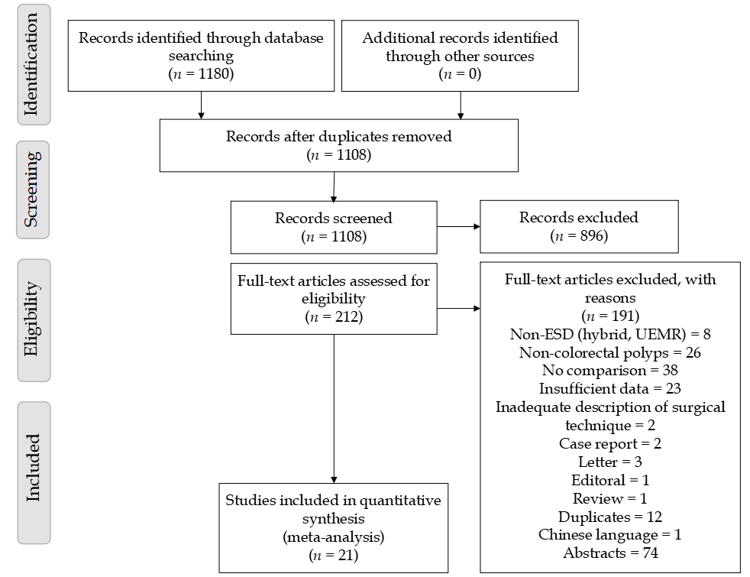
Figure 1 PRISMA flow diagram of included articles. ESD: Endoscopic submucosal dissection; EMR: Endoscopic mucosal resection.
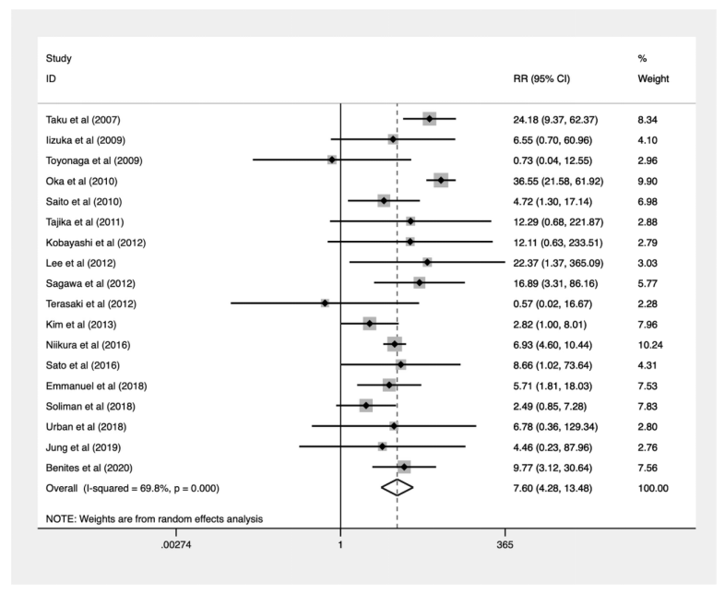
Figure 2 Forest plot for risk of perforation. RR: Relative risk; CI: Confidence interval.
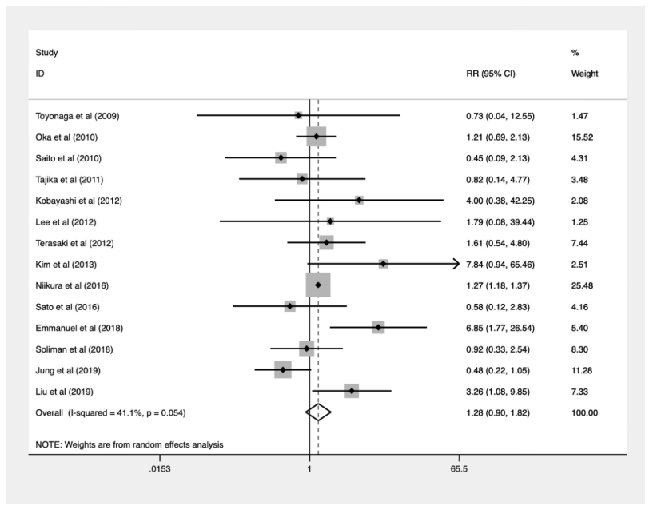
Figure 3 Forest plot for risk of bleeding. RR: Relative risk; CI: Confidence interval.
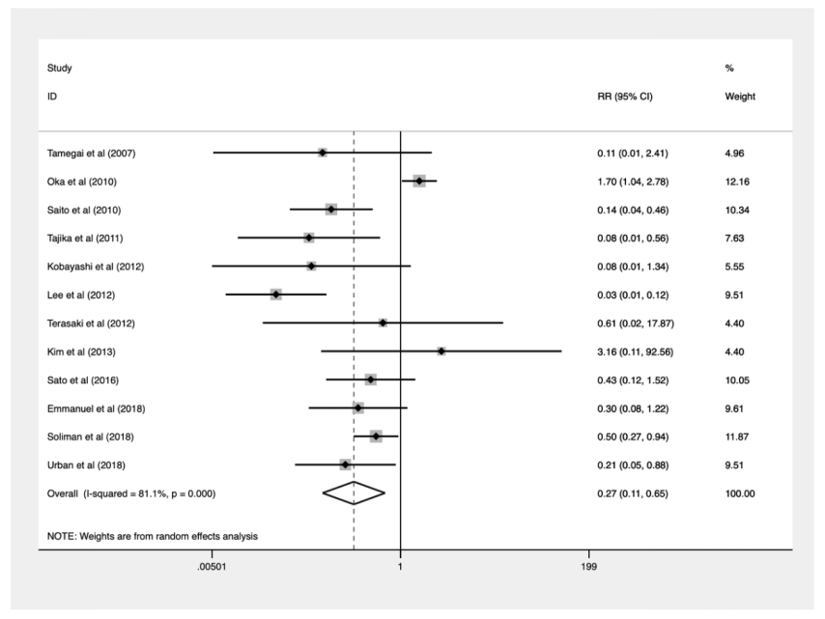
Figure 4 Forest plot for recurrence rate. RR: Relative risk; CI: Confidence interval.
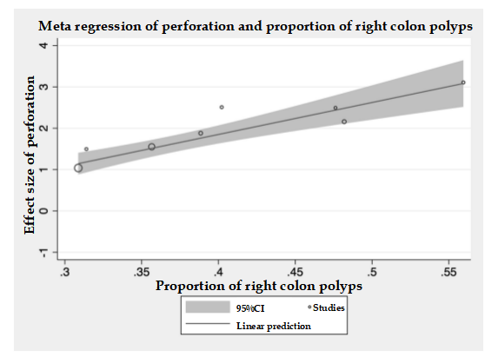
Figure 5 Meta regression of perforation and proportion of right colon polyps. CI: Confidence interval.

Table 1 Pooled proportions and comparative meta-analysis of endoscopic submucosal dissection and endoscopic mucosal resection
 | Total papers | Sample size (ESD) | Pooled proportions | Sample size (EMR) | Pooled proportions | RR (CI) | P value | Publication bias
En bloc resection | 11 | 1641 | 89% (0.83-0.94) | 1411 | 47% (0.36-0.59) | 1.837 (1.464-2.305) | < 0.001 | 0.0025
Positive lateral margin | 2 | 123 | 3% (0.01-0.06) | 187 | 14% (0.09-0.19) | 0.292 (0.089-0.995) | 0.042 | -
Positive vertical margin | 1 | 38 | 5% (0.00-0.17) | 83 | 1% (0.00-0.07) | 4.368 (0.409-46.710) | 0.223 | -
Complete resection | 8 | 918 | 82% (0.74-0.88) | 1012 | 56% (0.34-0.77) | 1.504 (1.041-2.174) | 0.03 | -
Lymphovsacular  invasion | 1 | 54 | 6% (0.03-0.13) | 23 | 0% (0.00-0.04) | 4.352 (0.248-76.483) | 0.315 | -
Mean procedural time | 8 | 1087 | - | 838 | - | 72.709 (54.487-90.931) | < 0.001 | -
Additional surgery | 2 | 99 | 13% (0.07-0.21) | 153 | 5% (0.02-0.09) | 3.139 (1.360-7.243) | 0.007 | -
Perforation | 18 | 19470 | 5% (0.03-0.09) | 260901 | 0% (0.00-0.01) | 7.597 (4.281-13.479) | < 0.001 | 0.301
Bleeding | 14 | 20048 | 3% (0.02-0.05) | 257065 | 3% (0.02-0.04) | 1.277 (0.896-1.820) | 0.175 | 0.139
Recurrences | 12 | 1822 | 2% (0.01-0.03) | 37721 | 10% (0.04-0.17) | 0.269 (0.112-0.648) | 0.003 | 0.725
ESD: Endoscopic submucosal dissection; EMR: Endoscopic mucosal resection; CI: Confidence interval.

Table 2 Meta-regression
 | En bloc resection |  |  | Complete resection |  |  | Perforation |  |  | Bleeding |  |  | Recurrence
 | n | Beta (CI) | P value | n | Beta (CI) | P value | n | Beta (CI) | P value | n | Beta (CI) | P value | n | Beta (CI) | P value
Age | 8 | -0.017 (-0.168-0.133) | 0.785 | 5 | -0.010 (-0.426-0.406) | 0.944 | 9 | 0.073 (-0.191-0.336) | 0.535 | 8 | -0.201 (-0.540-0.138) | 0.197 | 8 | 0.254 (-0.039-0.547) | 0.078
Gender | 6 | -6.023 (-23.152-11.106) | 0.384 | 4 | -20.662 (-108.758-67.434) | 0.419 | 8 | -7.868 (-22.078–6.342) | 0.224 | 7 | -4.446 (-27.915-19.022) | 0.647 | 6 | -9.096 (-62.174-43.982) | 0.659
Polyp size | 10 | 0.242 (-0.037-0.086) | 0.390 | 6 | -0.034 (-0.098-0.030) | 0.217 | 10 | -0.034 (-0.117-0.049) | 0.378 | 9 | -0.041 (-0.177-0.095) | 0.498 | 8 | 0.077 (-0.118-0.272) | 0.369
Lateral spreading tumor | 10 | 1.262 (-1.072-3.596) | 0.248 | 7 | -0.481 (-4.655-3.693) | 0.779 | 11 | -2.324 (-5.536-0.888) | 0.136 | 9 | -0.680 (-5.586-4.226) | 0.753 | 9 | 3.827 (-2.323-9.977) | 0.185
Right colon | 8 | 1.247 (-2.024-4.517) | 0.387 | 5 | 2.373 (-0.881-5.626) | 0.103 | 8 | 7.731 (4.965-10.497) | < 0.001 | 7 | 1.688 (-12.442-15.817) | 0.771 | 6 | -8.739 (-26.616-9.139) | 0.246
Colon | 7 | -1.803 (-4.486-0.880) | 0.145 | 4 | -1.914 (-7.213-3.385) | 0.26 | 8 | 0.759 (-3.184-4.701) | 0.654 | 6 | 6.649 (-5.182-18.480) | 0.194 | 7 | -1.102 (-4.754-2.551) | 0.473
Rectum | 7 | 1.803 (-0.880-4.486) | 0.145 | 4 | 1.914 (-3.385-7.213) | 0.26 | 8 | -0.759 (-4.701-3.184) | 0.654 | 6 | -6.649 (-18.480-5.182) | 0.194 | 7 | 1.102 (-2.551-4.754) | 0.473
Submucosal invasion | 8 | -0.004 (-0.014-0.007) | 0.431 | 5 | -0.006 (-0.020-0.008) | 0.253 | 9 | 0.001 (-0.049-0.051) | 0.956 | 8 | -0.016 (-0.033-0.001) | 0.061 | 7 | -6.508 (-27.976-14.960) | 0.471
Muscularis propria invasion | 8 | -5.870 (-17.738-5.998) | 0.272 | 5 | -0.157 (-21.715-21.401) | 0.983 | 9 | 6.731 (-33.772-47.234) | 0.706 | 8 | -109.836 (-1040.943-821.272) | 0.783 | - | - | -
CI: Confidence interval.

Table 3 Subgroup analysis (Japan and rest of the world) of pooled proportions and comparative meta-analysis of endoscopic submucosal dissection and endoscopic mucosal resection
 | Japan papers | Pooled proportions (ESD) | Pooled proportions (EMR) | RR (CI) | P value | Rest of the world papers | Pooled proportions (ESD) | Pooled proportions (EMR) | RR (CI) | P value
Overall results
En bloc resection | 6 | 89% (0.77-0.97) | 53% (0.38-0.67) | 1.658 (1.270-2.165) | < 0.001 | 5 | 90% (0.85-0.94) | 41% (0.22-0.61) | 2.201 (1.411-3.433) | 0.001
Positive lateral margin | 2 | 3% (0.00-0.06) | 14% (0.09-0.19) | 0.292 (0.089-0.955) | 0.042 | - | - | - | - | -
Positive vertical margin | 1 | 5% (0.01-0.17) | 1% (0.00-0.05) | 4.368 (0.409-46.710) | 0.223 | - | - | - | - | -
Complete resection | 2 | 79% (0.73-0.84) | 53% (0.48-0.58) | 1.452 (1.303-1.618) | < 0.001 | 6 | 85% (0.78-0.91) | 59% (0.27-0.88) | 1.562 (0.921-2.650) | 0.098
Lymphovsacular  invasion | 1 | 6% (0.03-0.13) | 0% (0.00-0.04) | 4.352 (0.248-76.483) | 0.315 | - | - | - | - | -
Mean procedural time | 4 | - | - | 72.106 (48.831-95.382) | < 0.001 | 4 | - | - | 73.916 (36.075-111.757) | < 0.001
Additional surgery | 2 | 13% (0.07-0.21) | 5% (0.02-0.09) | 3.139 (1.360-7.243) | 0.007 | - | - | - | - | -
Perforation | 11 | 4% (0.01-0.07) | 0.0002% (0.00-0.00081) | 9.586 (4.425-20.768) | < 0.001 | 7 | 8% (0.05-0.12) | 1% (0.00-0.02) | 4.602 (2.729-7.759) | < 0.001
Bleeding | 8 | 2.4% (0.01-0.04) | 2.1% (0.01-0.03) | 1.267 (1.174-1.367) | < 0.001 | 6 | 5% (0.02- 0.11) | 3% (0.01-0.06) | 1.986 (0.716-5.508) | 0.188
Recurrences | 7 | 1% (0.01-0.02) | 7% (0.02-0.15) | 0.274 (0.071-1.054) | 0.06 | 5 | 3% (0.00-0.08) | 16% (0.04-0.32) | 0.245 (0.073-0.819) | 0.022
Sensitivity analysis (≥ 20 mm only)
En bloc resection | 4 | 82% (0.72-0.91) | 50% (0.33-0.67) | 1.645 (1.174-2.306) | 0.004 | 2 | 91% (0.88-0.93) | 33% (0.28-0.37) | 2.668 (1.752-4.063) | < 0.001
Positive lateral margin | 2 | 3% (0.00-0.06) | 14% (0.09-0.19) | 0.292 (0.089-0.955) | 0.042 | - | - | - | - | -
Positive vertical margin | 1 | 5% (0.01-0.17) | 1% (0.00-0.07) | 4.368 (0.409-46.710) | 0.223 | - | - | - | - | -
Complete resection | 2 | 79% (0.73-0.84) | 53% (0.48-0.58) | 1.452 (1.303-1.618) | < 0.001 | 2 | 90% (0.87-0.93) | 77% (0.73-0.82) | 1.613 (0.209-12.452) | 0.647
Lymphovsacular  invasion | 2 | 6% (0.03-0.13) | 0% (0.00-0.04) | 4.352 (0.248-76.483) | 0.315 | - | - | - | - | -
Mean procedural time | 2 | - | - | 69.167 (48.446-89.888) | < 0.001 | 1 | - | - | 82.700 (67.578-97.822) | < 0.001
Additional surgery | 2 | 13% (0.07-0.21) | 5% (0.02-0.09) | 3.139 (1.360-7.243) | 0.007 | - | - | - | - | -
Perforation | 5 | 4% (0.01-0.07) | 0% (0.00-0.01) | 5.235 (2.123-12.910) | < 0.001 | 3 | 7% (0.05-0.10) | 1% (0.00-0.03) | 4.546 (1.674-12.346) | 0.003
Bleeding | 4 | 3% (0.00-0.07) | 3% (0.01-0.05) | 0.895 (0.438-1.829) | 0.762 | 3 | 3% (0.00-0.08) | 1% (0.00-0.04) | 2.233 (0.489-10.197) | 0.300
Recurrences | 5 | 1% (0.00-0.02) | 7% (0.02-0.15) | 0.204 (0.097-0.429) | < 0.001 | 3 | 3% (0.00-0.10) | 27% (0.10-0.20) | 0.179 (0.032-0.990) | 0.049
ESD: Endoscopic submucosal dissection; EMR: Endoscopic mucosal resection; RR: Relative risk; CI: Confidence interval.

Published by Baishideng Publishing Group Inc
7041 Koll Center Parkway, Suite 160, Pleasanton, CA 94566, USA
Telephone: +1-925-3991568
E-mail: bpgoffice@wjgnet.com
Help Desk: https://www.f6publishing.com/helpdesk
https://www.wjgnet.com

© 2021 Baishideng Publishing Group Inc. All rights reserved.

