Name of Journal: World Journal of Gastrointestinal Oncology
Manuscript NO: 75851
Manuscript Type: ORIGINAL ARTICLE

Case Control Study
Oxidative imbalance increases the risk for colonic polyp and colorectal cancer development

Tsounis D et al. Oxidative imbalance in CRC development

Dimitrios Tsounis, Vassiliki Villiotou, Angeliki Melpidou, Chara Pantsiou, Alexandra Argyrou, Charis Giannopoulou, Adriani Grigoratou, Dimitra Rontogianni, Gerassimos J Mantzaris, George Papatheodoridis

Dimitrios Tsounis, Alexandra Argyrou, Department of Gastroenterology, 251 General Hospital of Hellenic Air Force, Athens 11525, Greece

Vassiliki Villiotou, Department of Biochemistry, Metaxa Anticancer Hospital, Piraeus 18537, Greece

Angeliki Melpidou, Chara Pantsiou, Adriani Grigoratou, Department of Biochemistry, Evangelismos Hospital, Athens 10676, Greece

Charis Giannopoulou, Department of Nuclear Medicine and Positron Emission Tomography Computed Tomography, Evangelismos Hospital, Athens 10676, Greece

Dimitra Rontogianni, Department of Pathology, Evangelismos Hospital, Athens 10676, Greece

Gerassimos J Mantzaris, Department of Gastroenterology, Evangelismos, Ophthalmiatreion Athinon and Polyclinic Hospitals, Athens 10676, Greece

George Papatheodoridis, Academic Department of Gastroenterology, Athens University Medical School, Laikon General Hospital, Athens 11527, Greece

Author contributions: All authors equally contributed to this paper with the conception and design of the study, literature review and analysis, drafting and critical revision and editing, and final approval of the final version.

Corresponding author: Dimitrios Tsounis, FEBG, MD, MSc, Chief Doctor, Consultant Physician-Scientist, Department of Gastroenterology, 251 General Hospital of Hellenic Air Force, P. Kanellopoulou Avenue 3, Athens 11525, Greece. dim.tsoun69@gmail.com

Received: May 4, 2022
Revised: August 19, 2022
Accepted: September 21, 2022
Published online:

Abstract
BACKGROUND
The role of oxidative stress in the pathogenesis of colorectal carcinoma (CRC) has garnered considerable interest recently. Specific oxidative factors have been implicated in the pathogenesis of adenomatous polyps and ultimately adenocarcinoma.

AIM
To evaluate the effect of oxidative imbalance as quantified by specific serological markers in the development of sporadic colon adenocarcinoma.

METHODS
A total of 170 patients that underwent endoscopy of the lower gastrointestinal tract in a tertiary center within 3 years were included in the study. They were allocated in three groups; those with sporadic colon adenocarcinoma (n = 56, 32.9%), those with colonic polyps (n = 33, 19.4%) and healthy controls (n = 81, 47.7%). All patients were evaluated for oxidant activity and antioxidant capacity with serum measurements of specific markers such as vitamins A, 25(OH) D3, E, C, B12, folic acid, glutathione, selenium (Se), zinc (Zn), free iron (Fe²⁺), and malondialdehyde and results were compared between groups.

RESULTS
Serum levels of vitamins C, E, D, Se, Zn, vitamin B12 and total antioxidant capacity were significantly lower in the combined neoplasia/polyp group than in the control group (P = 0.002, P = 0.009, P < 0.001, P < 0.001, P < 0.001, P = 0.020 and P < 0.001, correspondingly). Increased levels of vitamin E (P = 0.004), vitamin D (P < 0.001), Se (P < 0.001) and Zn (P < 0.001) seem to bestow a protective effect on the development of CRC. For vitamin D (P < 0.001) and Zn (P = 0.036), this effect seems to extend to the development of colon polyps as well. On the other hand, elevated serum levels of malondialdehyde are associated with a higher risk of CRC (OR = 2.09 compared to controls, P = 0.004). Regarding colonic polyp development, increased concentrations of vitamin Α and Fe²⁺ are associated with a higher risk, whereas lower levels of malondialdehyde with a lower risk.

CONCLUSION
Increased oxidative stress may play an important role in the pathogenesis and progression of CRC. Antioxidants’ presence may exert a protective effect in the very early stages of colon carcinogenesis.

Key Words: Oxidative imbalance; Reactive oxygen species; Colorectal adenocarcinoma; Colonic polyps; Antioxidant capacity

Tsounis D, Villiotou V, Melpidou A, Pantsiou C, Argyrou A, Giannopoulou C, Grigoratou A, Rontogianni D, Mantzaris GJ, Papatheodoridis G. Oxidative imbalance increases the risk for colonic polyp and colorectal cancer development. World J Gastrointest Oncol 2022; In press

Core Tip: The role of oxidative stress in the pathogenesis of colorectal carcinoma (CRC) has garnered considerable interest recently. Here, we evaluated oxidant activity and antioxidant capacity of the patients with serum measurements of specific markers. Increased levels of vitamin E, vitamin D, selenium and zinc seem to bestow a protective effect regarding the development of CRC, whereas elevated serum levels of malondialdehyde are associated with a higher risk of CRC. Increased oxidative stress may play an important role in the pathogenesis and progression of CRC. Antioxidants’ presence may exert a protective effect in the very early stages of colon carcinogenesis.
INTRODUCTION
The term oxidative stress or oxidative imbalance refers to a series of intracellular complex metabolic processes that lead to overproduction and accumulation of oxidative products, otherwise called free radicals or reactive oxygen species (ROS), including hydrogen peroxide, hydroxyl radical, superoxide anion and peroxynitrite^{[1]}. These, in turn, collaborate to overcome the protective action of existing intracellular antioxidant mechanisms. The overproduction of ROS has been shown to ultimately result in toxicity inimical practically to every cellular macromolecule including all intracellular organelles with a special emphasis on membranes and mitochondria. The net effect of this process is local and eventually generalized impairment of human organ system function, either in the form of inflammation or carcinogenesis^{[1]}.
The pathogenesis of sporadic adenocarcinoma (adenoCa) of the large intestine is a complex process involving both genetic and epigenetic factors^{[2-4]}. The genetic component refers to the gradual accumulation of multiple genetic mutations in key growth regulatory genes^{[5]}, leading to two main types of gene instability (chromosome and microsatellite) which characterize sporadic adenoCa and define its biological behavior^{[4]}. Furthermore, multiple other conditions have been identified as implicated in the pathogenesis of large bowel adenoCa, possibly through chemical modification of DNA bases during the replication process, especially in the stage of aberrant crypt foci (ACF) formation^{[5,6]}. ACF represents the earliest histological alterations in the formation of colorectal neoplasia^{[6]}. Risk factors associated with colorectal cancer include inflammatory bowel disease, nutrition habits (western type of diet), type II diabetes mellitus, sedentary (e.g., low exercise) lifestyle, professional exposure to specific irritants (e.g., mutagenic chemicals such as asbestos), previous medical procedures (e.g., cholecystectomy, radiotherapy of the pelvis, ureterocolic anastomosis), as well as smoking and obesity.
Among the aforementioned risk factors, nutritional habits and their potential influence in particular on the equilibrium between oxidative and antioxidative substances have garnered a significant amount of interest recently. Epidemiological studies indicate that colon adenocarcinoma is observed more frequently among individuals with a diet characterized by a low intake of fiber and calcium and a higher consumption of saturated fatty acids and proteins, especially of bovine origin (red meat)^{[7-10]}. This dietary profile has been associated with increased production of potentially carcinogenic substances such as toxic bile acids and free iron^{[11]}. Furthermore, the resulting positive energy balance (due to the high accumulation of calories when following the western type of diet) and subsequent obesity have been suggested to lead to metabolic stress including overproduction of ROS or other organic compounds, such as malondialdehyde (MDA)^{[12]}. Contrariwise, antioxidant substances including polyphenols, tocopherols, carotenoids, curcumin, vitamin A, vitamin C and vitamin D seem to obtain a protective role against colorectal cancer^{[1]}. It is intriguing to ascertain the exact role of oxidative imbalance in the pathogenesis of initially precancerous lesions such as colonic polyps and ultimately colon cancer. To our knowledge, there are only a few studies that have tried to detect a pattern of total oxidant activity and antioxidant capacity among patients with established sporadic adenocarcinoma of the large intestine, as this may be assessed through the measurement of specific serum compounds and these studies have produced conflicting results^{[13,14]}. Thus, we designed a prospective, case-control, single-center study aiming to evaluate the role of oxidative imbalance and its effect as a possible primary agent in the development of sporadic adenocarcinoma of the large intestine. We tried to achieve this by determining serum levels of specific markers that reflect oxidant capacity in patients with established colorectal carcinoma in comparison to patients with colonic polyps and healthy controls.

MATERIALS AND METHODS
Study population
A total of 6500 patients that were over 50-years-old and successfully underwent colonoscopy within 3 years in a major tertiary Greek hospital were screened for participation in the study. A set of specific exclusion criteria were used to curtail the influence of confounding risk factors in data analysis (Table 1). Ultimately 170 patients were included in our study. Among them, three specific groups were defined, those with a histologically confirmed sporadic adenoCa of the colon, those with a diagnosis of colonic polyps and a healthy control group consisting of patients with no significant findings or findings irrelevant to the development of colorectal carcinoma (CRC) (e.g., diverticula).

Study protocol
All patients gave informed consent for their participation in the study and were interviewed by a gastroenterologist not involved in their endoscopic management. Relevant demographic, epidemiological and clinical characteristics were recorded. Full colonoscopy was performed on all patients following the established sedation, preparation and safety protocols in our Centre following international guidelines. All procedures were performed by the same experienced gastroenterologist (with more than 2000 colonoscopies/year and a rate of over 98% for successful completion of the procedure). When endoscopic findings, suggestive of adenocarcinoma or polyps of the large intestine were identified, single or multiple biopsy samples were obtained and sent to the Pathology department of our hospital. Biopsy specimens were assessed by two independent and experienced pathologists, unaware of the endoscopic findings, with a high inter-observer agreement (> 90%). Sporadic adenocarcinoma was evaluated for the following parameters: (1) Staging according to the Astler-Coller system of classification^{[15]}; (2) Grading according to a three-degree system of differentiation based on the architectural model of development of sporadic adenoCa defined by the presence of adenoCa blasts, as follows: poorly differentiated (0%-49% adenoCa blasts), moderately differentiated (50%-95% adenoCa blasts), well-differentiated (> 95% adenoCa blasts); (3) Size of adenoCa (< 1 cm, 1 cm, > 1 cm); (4) The number of adenoCa (1, > 1–synchronous adenoCa); (5) Pathologic classification as ulcerative, fungating and polyp-shaped (either with a stalk or not); and (6) Location in the colon. Colonic polyps were evaluated for the following parameters: (1) Histological classification of adenoma according to World Health Organization (WHO) classification as tubular, villous, tubulovillous^{[16]}; (2) Grading of adenoma's dysplasia (mild, moderate and severe according to WHO criteria); (3) Size of polyp (< 0.5 cm, > 0.5 cm); (4) Number of polyps (1, > 1); (5) Presence of stalk or not; and (6) Location in the colon.
The definite diagnosis of either sporadic adenocarcinoma or colonic polyp was made within a maximum of 2 d from endoscopy. Until definite pathological diagnosis, patients underwent fasting (nil per os), after which blood samples were obtained.
The study protocol was approved by the Ethics Board of our Hospital.

Measurement of serum markers
Calculation of oxidative agents’ levels took place as follows: Oxidant activity was measured by using a colorimetric test system for the quantitative determination of total lipid peroxides in serum (PerOx Assay, Immundiagnostik AG, Bensheim, Germany). Malondialdehyde was quantitatively measured using the reverse-phase high-performance liquid chromatography method (HPLC-Analytik, Immundiagnostik AG, Bensheim, Germany) and the Vp Series HPLC System (Series LC-10 ADVp Gradient pump, Series RF-10AXL Fluorescence detector, Series SPD-10ADVp UV detector, Shimadzu, Germany). Ferrum (Fe²⁺) levels were calculated using a colorimetric assay [FerroZine, Roche Diagnostics GmbH (COBAS), Mannheim, Germany]. Triglycerides were quantitatively calculated by using a colorimetric enzymatic test [Trinder endpoint reaction, Roche Diagnostics GmbH (COBAS), Mannheim, Germany].
Calculation of antioxidative agents’ concentrations took place as follows: Total antioxidant capacity was measured by using a colorimetric test system (Imanox Assay) for the quantitative determination of the residual exogenous provided hydrogen peroxide that could not be eliminated from the total antioxidants in serum, after having completed an eliminating reaction with a certain amount of exogenously provided hydrogen peroxide (Immundiagnostik AG, Bensheim, Germany). Fat-soluble vitamins A (retinol) and E (α-tocopherol) levels were determined simultaneously in human serum using the reverse-phase HPLC method with the 22000 ClinRep Kit (Recipe Chemicals + Instruments GmbH & Co KG Labortechnik, Munich, Germany). Retinol was monitored at 325 nm and α-tocopherol at 295 nm with the Up series HPLC System (Series LC-10ADVp Gradient pump, Series RF-10AXL Fluorescence detector, Series SPD-10ADVp UV detector, Shimadzu, Germany). Fat-soluble vitamin D (25-OH vitamin D) was measured using a chemiluminescent immunoassay method (DiaSorin LIAISON 25 OH Vitamin D Total Assay, DiaSorin S.p.A, Italy). Water soluble vitamin C was quantitatively measured using the reverse-phase HPLC method (Immundiagnostik AG, Bensheim, Germany). Glutathione (GSH) levels were calculated as the ratio between GSH reduced/GSH total using the reverse-phase HPLC method (Immundiagnostik AG, Bensheim, Germany). Cobalamin/vitamin B12 and folate acid concentrations were calculated using a radioimmunoassay method from MP Biomedicals Inc., New York, United States, with the Packard cobra autogamma g counter from Packard, United States. Selenium (Se) and zinc (Zn) serum levels were determined using a graphite furnace atomic absorption spectrophotometry method with the AA spectrophotometer model 2100 (Perkin Elmer, Norwalk CT, United States).

Statistical analysis
Statistical analyses were conducted using the SPSS statistical package (IBM Statistical Package for Social Sciences v. 19.0, Chicago, Illinois, United States). At first, cases were distributed according to demographic characteristics and smoking habits as well as levels of the studied compounds (median, 25th and 75th percentile for each compound and each patient category). As most variables measured followed a skewed distribution (with the notable exception of triglyceride levels), non-parametric tests (Mann-Whitney and Kruskal-Wallis) were used to compare means between different groups. In order to minimize the effect of possible confounding factors in our results, we then used multiple regression to compare log-transformed serum compound levels between patients with diagnosed pathology (either adenocarcinoma or polyp) vs controls (using two dummy variables for pathology diagnoses correspondingly), controlling for age (as a continuous variable), sex (male vs female), blood triglyceride (as a continuous variable) and smoking habits (as smokers vs non-smokers). Finally, we applied multiple logistic regression models to investigate the association between levels of the measured compounds and either risk of adenocarcinoma or risk of polyp development, controlling for the same variables as in the log-linear models. A two-tailed P value of < 0.05 was considered statistically significant for all comparisons.

RESULTS
The patients' main characteristics are summarized in Table 1. Briefly, our study included 56 patients with adenocarcinoma, 33 patients with colonic polyps and 81 patients in the control group (colonoscopy negative for cancer or precancerous lesions). Patients with adenocarcinoma tended to be relatively older (71.5 ± 6.6 years, mean ± SD), compared to those with colon polyps (66.1 ± 9.4 years) or with the control group (68.4 ± 8.5 years). Among patients with adenocarcinoma or polyps, men presented a clear majority (62.5% and 63.6% respectively) compared to women. In the adenocarcinoma subgroup, 89.3% of patients were smokers (from which 72% with a high rate of use, e.g., more than 20 cigarettes per day) compared to 51.5% of patients who were smokers in the polyp group, whereas smoking habits in the control subgroup bore a close resemblance to those of the adenocarcinoma subgroup (84% smokers from which 70.6% smoked more than 20 cigarettes/day).
When comparing patients with adenocarcinoma or polyp(s) with the control group there were notable differences in practically all antioxidant markers (Table 2). Thus, serum levels of vitamins C, E, D, as well as Se, Zn and B12 and total antioxidant capacity were significantly lower in the combined neoplasia/polyp group than in the control group (P = 0.002, P = 0.009, P < 0.001, P < 0.001, P < 0.001, P = 0.02 and P < 0.001, correspondingly). For the antioxidant capacity, in particular, there is a clear picture of higher measurements in the control group when compared to a patient with neoplastic lesions (Figure 1). On the other hand, serum levels of oxidant activity presented the opposite pattern (P < 0.001 for the difference among the three groups) (Figure 2). In summary, all antioxidant substances were statistically significantly lower among patients with adenocarcinoma compared to controls, except vitamin Α which did not present any differentiation (Table 3). Vitamin D presented the greatest difference since it was lower by 56.8% (95%CI: 50.2% to 62.6%). Although no statistically significant differences regarding the levels of each measured oxidant substance in isolation were observed, total oxidant activity was statistically significantly increased among adenocarcinoma patients.
In the group of patients with colonic polyps, most anti-oxidants did not present significant differences in serum concentration when compared to controls. Notable exceptions included, vitamin D which exhibited significantly lower levels by 46% (95%CI: 35.4% to 54.9%) (Figure 3) and total antioxidant capacity which was reduced by 40.1% (95%CI: 38.5% to 41.6%). Interestingly, vitamin A though nominally an anti-oxidant displayed significantly higher levels compared to controls. Finally, patients with colonic polyps, presented lower levels of malondialdehyde by 31.6% (95%CI: 22.3% to 39.8%), but higher Fe²⁺ concentrations by 43.5% (95%CI: 22.2% to 68.5%) (Figure 4), as well as total oxidant activity levels (95%CI: 111.7% to 128.9%).
Next, multivariate analyses were conducted to ascertain which variables presented a true correlation with the neoplastic process. Results were similar between univariate and multivariate analyses regarding the risk of adenoCa (Table 4, which presents the risk of adenocarcinoma in comparison to controls for change in the levels of the measured compounds equal to one standard deviation of its distribution). A significant protective effect was shown especially for vitamin D (OR = 0.04, 95%CI: 0.02 to 0.12) and Zn (OR = 0.16, 95%CI: 0.09 to 0.31) (Figure 5) but also for vitamin E (OR = 0.57, 95%CI: 0.39 to 0.84) and Se (OR = 0.35, 95%CI: 0.22 to 0.55). An increase of the levels of the abovementioned substances equal to one standard deviation reduced the risk of colon adenocarcinoma to about 50%. The relation between low levels of the aforementioned antioxidants and increased risk of adenocarcinoma remained significant after mutual adjustment, e.g., OR for Se becomes 0.34 (95%CI: 0.13 to 0.88 P = 0.027). As far as the oxidant substances are concerned, the solitary finding was that a doubling of malondialdehyde serum concentration is associated with an approximately twofold increase in the risk for development of colon adenocarcinoma (OR = 2.09 95%CI: 1.27 to 3.45 P = 0.004).
Due to the small number of patients in the colon polyp subgroup, fewer associations retained their significance for the development of colon polyps (Table 5). Nevertheless, similarly to results from the CRC group increased levels of vitamin D (OR = 0.27, 95%CI: 0.15 to 0.48, P < 0.001) and Zn (OR = 0.39, 95%CI: 0.16 to 0.94, P = 0.036) exhibited an association with a reduced risk for colon polyp development, whereas it is worthy of note that increased levels of vitamin A were associated with almost 9 times higher risk of colon polyps compared to controls (OR = 8.84, 95%CI: 3.76 to 20.74, P < 0.001). Moreover, regarding the oxidant group, elevated serum levels of Fe²⁺ seem to double the risk for the development of colon polyps, (OR = 2.58 95%CI: 1.53 to 4.33, P < 0.001). Interestingly, in contrast to results from the CRC group, higher malondialdehyde levels seem to exert a protective role (OR = 0.35 95%CI: 0.2 to 0.6 P < 0.001). These results remain stable after the mutual adjustment of the measured compounds.

DISCUSSION
CRC is the third cause of cancer-related mortality in both men and women worldwide^{[1,2]}. Current therapeutic options including surgery, chemotherapy, radiotherapy and molecular-targeted therapy are still limited for advanced tumors. Thus, identifying new strategies that will increase the probability of early detection of this clinical modality while keeping the public health costs reasonable (as endoscopy confers a significant financial burden on health budgets) remains an important challenge.
Comparative international epidemiological data indicate that the difference between the highest and lowest sporadic colon cancer incidence is approximately 10-fold, suggesting that environmental factors in the pathogenesis of colon cancer occupy a more prominent role than their genetic counterparts. The dominant environmental factor identified so far is the low-fiber, high-fat diet of Western industrialized countries^{[17,18]}.
Although numerous studies dedicated to elucidating the exact role of dietary factors in CRC pathogenesis, and research conducted in a variety of in vitro and in vivo animal models strongly hint in favor of a protective effect of antioxidants regarding CRC development, even in the stage of ACF formation, results derived from human populations are not as clear-cut in their results and are in fact at times conflicting^{[11,12,19,20]}.
In our study, a basic assumption was made that serum levels of oxidant/antioxidant compounds may accurately reflect the dietary intake habits of individuals and thus could be used to evaluate oxidative imbalance^{[12]}. Over fifty natural and synthetic compounds have been shown to exert a relevant chemotherapeutic effect, but since for the majority of these agents, the literature concerning their role is comparatively scarce, we opted to focus on a variety of compounds with a reasonably established place in the management of the oxidative/anti-oxidative equilibrium^{[1]}.
Regarding the oxidant markers, MDA is an endogenous genotoxic end product of lipid peroxidation by ROS and has been utilized in vivo as a bio-marker of oxidative stress (peroxidability index)^{[21]}. It is thought to participate in harmful processes that lead to DNA damage and mutation mainly through the formation of DNA adducts^{[22]}. MDA-induced DNA lesions, called DNA interstrand cross-link seems to be implicated in the gene-toxic effects associated with lipid peroxidation and oxidative stress^{[21]}. Therefore, MDA has been suggested to be strongly associated with CRC pathogenesis, a suggestion that the results of our study strongly endorse. However, the results from the polyp subgroup present a different picture as MDA levels were significantly lower than those in the control group. This latter finding seems odd, considering the fact that colonic adenomas are established precursors of sporadic CRC, but firstly the small number of cases in this subgroup may skew the results in an unexpected direction, and secondly, this finding may account for a more prominent role of MDA in the second part of the neoplastic process that leads to the evolution of precancerous lesions such as polyps to adenoCa.
On the other hand, elevated levels of free iron (labile iron), another recognized strong oxidant, actually doubled the risk of colon polyp development in our cohort whereas no similar correlation was observed for the adenocarcinoma group of patients. Dietary iron can be consumed in the form of heme iron (Fe²⁺) and nonheme iron (Fe³⁺)^{[23]}. Heme iron contributes to colorectal cancer via the Fenton reaction. Hydroxyl radicals produced by the Fenton reaction can alter DNA leading to oxidative base damage^{[24]}. Furthermore, heme iron contributes to cancer development by inducing colonic hyperproliferation through modulation of the intestinal microbiota and inducing mutations through DNA adducts or by increasing the formation of lipid peroxyl radicals (ferroptosis), such as malondialdehyde and 4-hydroxynonenal which are potent carcinogens^{[24-26]}. These findings provide a strong association between excessive intestinal heme iron and colorectal cancer. However, no sufficient evidence is available to our knowledge that links a mechanism of nonheme iron and colorectal cancer^{[25]}. However, emerging evidence suggests that reduced iron intake and low systemic iron levels are also associated with the pathogenesis of colorectal cancer^{[25]}. This is important because patients with colorectal cancer often present with iron deficiency. The mechanism supporting iron deficiency and colorectal cancer development is not fully understood; it may involve cellular functions’ requirement for iron, which, when deficient, may hinder immune cells’ ability to protect against cancer, providing the potential for a suppressed immunosurveillance response, affecting growth and differentiation of immune cells, as well as influencing cell-mediated immune response and cytokines activities which may contribute to tumor immune-cell evasion and inadequate tumor cell destruction^{[27]}. On the contrary, the association between high iron concentration and the risk of formation of adenomatous (colonic) polyps is ambiguous^{[28]}. Several studies suggest that the presence of high levels of Fe²⁺ may induce the formation of colonic polyps, suggesting a potent involvement in the early rather than later steps of colorectal carcinogenesis^{[1,28,29]}.
Regarding the antioxidant markers, Vitamin A (retinol) did not exhibit any protective role in our study population. Elevated vitamin A concentrations were associated with almost 9 times higher risk of colon polyps compared to controls with no significant effect observed in the adenoCa subgroup. This is not as confusing as it may seem as results regarding the role of vitamin A in the prevention or recurrence of adenomas have been conflicting so far. Several studies^{[30-32]} suggested a protective effect of vitamin A and its derivatives (retinoids) against CRC, whereas Andersen et al^{[33]} failed to establish a beneficial role for vitamin A in CRC. On the contrary, recent studies on the metabolism of vitamin A in CRC imply that despite the presence of high concentrations of retinol or all-trans-retinoic acid (ATRA), CRC has been promoted instead of obtaining decreasing cancer cell proliferation^{[34-36]}. The growth and differentiation of the colonic epithelial cells are strongly controlled by retinoid-activated genes which contain retinoic acid receptors (RARs) in their promoter regions. RARs bind to ATRA to induce the transcription of these genes. In many epithelial-derived adenomas and carcinomas, the expression of one or more RAR is lost and the cell loses its ability to regulate normal growth, a phenomenon called “ATRA-resistance”. In addition, as CRC progresses, colorectal tumor cells lose the ability to produce ATRA^{[34].} Kropotova et al^{[37]} claimed that these dysregulated pathways were more observed in adenomas rather than in more advanced carcinomas^{[37]}. Consequently, the high levels of vitamin A in the polyp group in our study might reveal the inadequate protective mechanism of retinol, possibly due to decreased ATRA production and the loss of RAR in the colonic epithelial cells.
On the other hand, Vitamin D was by far the compound with the most significant decrease in concentration among patients with adenocarcinoma or colorectal polyps when compared to controls in our analysis. It should be noted that we assessed vitamin D levels by measuring circulating 25(OH)D3 (calcidiol) levels, thus providing an overall estimate of vitamin D status, as described elsewhere^{[38]}. Since 1980, a large number of epidemiological and experimental studies support the association of vitamin D deficiency with a large variety of human diseases, including an increased incidence of colorectal cancer^{[39]}. The most active metabolite of vitamin D which is 1a,25-dihydroxy vitamin D3 [1,25(OH)2D3, (calcitriol)], is synthesized in a highly regulated multi-step process by mitochondrial 25(OH)D3-1a-hydroxylase^{[38]}. Several cell types, including colon cells have been described to contain vitamin D receptors (VDRs)^{[38]}. When these receptors are activated by calcitriol, they are thought to induce differentiation, regulate detoxification metabolism, sensitize cells to apoptosis and inhibit proliferation, invasiveness, angiogenesis and metastatic potential^{[39].} In general, according to epidemiological studies, vitamin D deficiency may be linked to a higher risk for neoplasia. A recent meta-analysis of case-control and cohort demonstrated a consistent inverse relationship between serum 25(OH)D3 levels and CRC risk^{[40]}. Another systematic review of studies evaluating the association of vitamin D intake or serum levels of 25(OH)D3 and the risk of CRC suggests as well an inverse correlation between CRC risk and both serum 25(OH)D3 and vitamin D intake^{[41]}. This mostly positive observational data have failed to be confirmed by human intervention studies in which supplemental vitamin D administration was found to be ineffective in reducing colon cancer risk in contrast with dietary sources of vitamin D. These disappointing results may be explained by the timing of administration indicating that colon lesions may progress to a stage where they become unresponsive to vitamin D, bearing, therefore, the hallmarks of an epigenetic change^{[42]}. Moreover, gene expression and activity controlled by VDRs have been described as up-regulated at the early stages of colorectal tumorigenesis with a subsequent sharp decline in advanced CRC^{[43]}. Further investigations of VDR expression at different stages of colon cancer development have come to a consensus that VDR expression is frequently increased at the pre-neoplastic ACF and the early stages before being lost in more advanced lesions, suggesting a possible role for vitamin D supplementation in early stages with no benefit conferred in advanced cases of this neoplasia^{[44,45]}.
Vitamin E is a generic term that describes a group of lipid-soluble chain-breaking antioxidants that exist in nature as eight structurally related forms with α-tocopherol as the isomer found in the highest concentrations in serum and dietary supplements^{[1]}. The results of our study show a potent protective effect for vitamin E in the adenocarcinoma group of patients compared to controls, although studies focusing on vitamin E have produced conflicting results so far^{[46,47]}. Non-significant trends toward reduced blood concentrations of α–tocopherol have been observed in subjects subsequently developing colorectal cancer when compared with controls^{[47]}. Conversely, intakes of other forms of vitamin E (γ-tocopherol, δ-tocopherol, γ-tocotrienol and δ-tocotrienol) suggest a highly significant inverse trend between serum concentration of vitamin E and cancer risk (P < 0.001)^{[30,47]}. In a recent interventional study, the administration of a combination of resveratrol and vitamin E to prevent the development of colonic adenomas exhibited clear benefits^{[48]}. Therefore, our findings, though interesting, must be further evaluated within larger sample size studies.
Se, an essential trace element, is one of the most extensively studied anti-oxidant compounds^{[8]}. A protective effect of Se for the prevention of colorectal adenomas development has been convincingly described^{[49-52]}. Data from the European Prospective Investigation into Cancer and Nutrition cohort that evaluated the effect of Se supplementation according to the dose supplied, demonstrated a statistically significant decrease in the incidence of CRC, although only for a subgroup of subjects with baseline Se concentration < 100 μg/L^{[52]}. These reports are in agreement with our results of a protective effect of higher Se levels regarding CRC risk. In summary, it can be concluded that an inverse dose-response correlation between the level of Se in serum and the risk of colorectal cancer may exist, albeit this association may be stronger in particular subgroups of patients.
Zn is another potent compound that has been found to play a crucial role mainly in antioxidant defense systems, as a specific activator of many enzymatic reactions (e.g., CuZn Superoxide dismutases), in DNA synthesis as well as in immune functions^{[53]}. Zn has also been shown to inhibit chemically induced neoplastic progression in the colon and to promote the cell cycle arrest of colon cancer cells in animal models^{[53,54]}. Reports regarding Zn levels in biological fluids from CRC patients have been limited but encouraging^{[54]}. In a large Mendelian randomization study, the analysis suggested that increased dietary Zn intake may be associated with a decreased risk of both proximal and distal colon cancer^{[55]}. Similar findings were reported by a recent meta-analysis of nineteen studies that suggested a statistically significant inverse dose-response association of Zn intake with CRC risk^{[54]}. The aforementioned findings are in agreement with our results that hint at a protective role for elevated serum levels of Zn in regards to CRC pathogenesis both in the early and later steps of this process.
There are several limitations to this study. From the antioxidant compounds analyzed in our study, we observed that vitamin D provided the strongest argument in favor of a protective role in the prevention of CRC. An important issue though, that should be taken into account concerning vitamin D assessment is the age of the participants as a potential confounder since it is known that vitamin D insufficiency is strongly associated with increasing age^{[56-59]}. Of particular interest is also the finding that elevated serum levels of Fe²⁺ were associated with a twofold increase in the risk of colon polyp development suggesting a possible role in the formation of colonic polyps and more specifically involvement in early rather than late stages of colorectal carcinogenesis. To our knowledge, there are not many studies in the literature in favor of this association, probably because in most of them, bound -and not free- iron was under scrutiny^{[29]}. In our analysis, we also noticed a trend for certain antioxidant substances to be associated with a lower risk of colonic polyp rather than CRC subgroups of patients. This possibly could be explained by a more prominent role in the protective effect of these antioxidants in the early stages of CRC pathogenesis, i.e. before the formation of precancerous cells. This effect, when overcome by the sum of tumorigenic factors will then be attenuated when the adenoma stage is reached rendering interventions such as nutritional antioxidant supplementation incapable of stabilizing or reversing the neoplastic phenotype. This is an attractive theory, especially considering the often inconsistent and even negative results from intervention trials with antioxidant supplementation^{[1,60,61]}. It is known that selecting the exact timing and duration of the intervention (e.g., the age of the patient at enrollment and the supplementation period) is challenging^{[62,63]}. It remains unclear if interventions given for a relatively short period, as in most of the trials due to practical reasons, have the potential to interrupt the tumorigenic sequence. Furthermore, it is difficult to ascertain the optimal follow-up duration for such a trial to detect an effect on the incidence of a disease such as CRC with a time-extensive pathogenetic process. Apart from that, clinical trials cannot provide evidence concerning the exact point at which chemoprevention begins to take effect concerning the start of treatment or concerning the precise nature of this effect (whether this is gradual or constant)^{[61,63-65]}. In most studies, the relative risk predicted for the incidence of colonic polyp formation or CRC is assumed to be constant because of a lack of data to the contrary, thus suggesting that chemoprevention does not offer any cumulative protection^{[64,65]}. Our study followed the "top-down" approach to studying the exosomal risk factors for CRC onset^{[2,66]}. Thus, it suffers from the known limitations of this approach which we mentioned earlier, mainly that the time-points for specific marker measurements were limited and that the crucial pathophysiological effects regarding CRC pathogenesis may have already taken place. On the other hand, it presents a clear and unbiased approach to the biochemical serum profile of several factors important to the oxidative balance in a sizeable CRC cohort. Thus, while a causal effect can by no means be proven for these compounds, intriguing correlations emerge from our analysis that may be the trigger for further research and new insights.

CONCLUSION
In summary, we describe a possible protective effect for Se, Zn, vitamin E and vitamin D regarding CRC pathogenesis, while elevated levels of MDA were associated with a two-fold increase in the risk for CRC. Regarding the development of colonic polyps, higher serum levels of vitamin D and Zn correlated with a decreased risk of adenoma, whereas elevated levels of vitamin Α and Fe²⁺ bestowed a higher risk. Interestingly, lower levels of MDA were found in patients with polyps when compared to controls. Our findings indicate that increased oxidative stress and a reduced antioxidant defense mechanism as assessed by a variety of serum compounds may participate in CRC pathogenesis and progression. Moreover, the possible protective effect of antioxidants may be more important in the very early stages of colon carcinogenesis, probably through an interactive mechanism in the early stages of ACF formation^{[1,6]}. Total antioxidant intake may represent a better predictor of colorectal cancer risk as opposed to specific foods and nutrients^{[12]}. Further trials are needed that should focus on the effect of total antioxidant intake in high-risk for CRC populations but prevention of CRC through manipulation of the oxidative balance in the human body via nutritional supplementation may represent a worthwhile future research target.

ARTICLE HIGHLIGHTS
Research background
The role of oxidative stress in the pathogenesis of colorectal cancer (CRC) has recently attracted considerable interest. Specific oxidative factors have been implicated in the pathogenesis of adenomatous polyps and ultimately adenocarcinoma.

Research motivation
Several studies have evaluated the association between oxidative imbalance and the development of colorectal adenocarcinoma although the results are conflicting. Thus, the study was designed to assess the correlation between the dietary intake habits of individuals with either colonic polyps or CRC through measurements of oxidant/antioxidant serological markers aiming to introduce novel serum indicators of colonic cancer even in the stage of aberrant crypt foci.

Research objectives
The main objective of the study was to evaluate the effect of total oxidant activity and antioxidant capacity in the development of sporadic colon adenocarcinoma.

Research methods
A total of 170 patients that underwent endoscopy of the lower gastrointestinal tract in a tertiary center within 3 years were included in the study. They were allocated in three groups; those with sporadic colon adenocarcinoma (n = 56, 32.9%), those with colonic polyps (n = 33, 19.4%) and healthy controls (n = 81, 47.7%). All patients were evaluated for oxidant activity and antioxidant capacity with serum measurements of specific markers such as vitamins A, 25(OH) D3, E, C, B12, folic acid, glutathione, selenium (Se), zinc (Zn), free iron (Fe²⁺) and malondialdehyde and results were compared between groups.

Research results
Serum levels of vitamins C, E, D, Se, Zn, vitamin B12 and total antioxidant capacity were significantly lower in the combined neoplasia/polyp group than in the control group (P = 0.002, P = 0.009, P < 0.001, P < 0.001, P < 0.001, P = 0.020 and P < 0.001, correspondingly). Increased levels of vitamin E (P = 0.004), vitamin D (P < 0.001), Se (P < 0.001) and Zn (P < 0.001) seem to bestow a protective effect on the development of CRC. For vitamin D (P < 0.001) and Zn (P = 0.036), this effect seems to extend to the development of colon polyps as well. On the other hand, elevated serum levels of malondialdehyde are associated with a higher risk of CRC (OR = 2.09 compared to controls, P = 0.004). Regarding colonic polyp development, increased concentrations of vitamin Α and Fe²⁺ are associated with a higher risk whereas lower levels of malondialdehyde with a lower risk.

Research conclusions
In conclusion, increased oxidative stress may play an essential role in the pathogenesis and progression of CRC. Antioxidants’ presence may exert a protective effect in the early stages of colon carcinogenesis.

Research perspectives
Further research in high-risk CRC populations is needed in order to assess the role of oxidative imbalance in the development of CRC and the potential for colonic cancer by dietary modifications regarding specific oxidative serum markers.

REFERENCES
1 Carini F, Mazzola M, Rappa F, Jurjus A, Geagea AG, Al Kattar S, Bou-Assi T, Jurjus R, Damiani P, Leone A, Tomasello G. Colorectal Carcinogenesis: Role of Oxidative Stress and Antioxidants. Anticancer Res 2017; 37: 4759-4766 [PMID: 28870894 DOI: 10.21873/anticanres.11882]
2 Burnett-Hartman AN, Lee JK, Demb J, Gupta S. An Update on the Epidemiology, Molecular Characterization, Diagnosis, and Screening Strategies for Early-Onset Colorectal Cancer. Gastroenterology 2021; 160: 1041-1049 [PMID: 33417940 DOI: 10.1053/j.gastro.2020.12.068]
3 Nguyen LH, Goel A, Chung DC. Pathways of Colorectal Carcinogenesis. Gastroenterology 2020; 158: 291-302 [PMID: 31622622 DOI: 10.1053/j.gastro.2019.08.059]
4 Pandurangan AK, Divya T, Kumar K, Dineshbabu V, Velavan B, Sudhandiran G. Colorectal carcinogenesis: Insights into the cell death and signal transduction pathways: A review. World J Gastrointest Oncol 2018; 10: 244-259 [PMID: 30254720 DOI: 10.4251/wjgo.v10.i9.244]
5 Tiwari A, Saraf S, Verma A, Panda PK, Jain SK. Novel targeting approaches and signaling pathways of colorectal cancer: An insight. World J Gastroenterol 2018; 24: 4428-4435 [PMID: 30357011 DOI: 10.3748/wjg.v24.i39.4428]
6 Clapper ML, Chang WL, Cooper HS. Dysplastic Aberrant Crypt Foci: Biomarkers of Early Colorectal Neoplasia and Response to Preventive Intervention. Cancer Prev Res (Phila) 2020; 13: 229-240 [PMID: 32132117 DOI: 10.1158/1940-6207.CAPR-19-0316]
7 Ma H, Brosens LAA, Offerhaus GJA, Giardiello FM, de Leng WWJ, Montgomery EA. Pathology and genetics of hereditary colorectal cancer. Pathology 2018; 50: 49-59 [PMID: 29169633 DOI: 10.1016/j.pathol.2017.09.004]
8 Cornish AJ, Law PJ, Timofeeva M, Palin K, Farrington SM, Palles C, Jenkins MA, Casey G, Brenner H, Chang-Claude J, Hoffmeister M, Kirac I, Maughan T, Brezina S, Gsur A, Cheadle JP, Aaltonen LA, Tomlinson I, Dunlop MG, Houlston RS. Modifiable pathways for colorectal cancer: a mendelian randomisation analysis. Lancet Gastroenterol Hepatol 2020; 5: 55-62 [PMID: 31668584 DOI: 10.1016/S2468-1253(19)30294-8]
9 Gupta R, Sinha S, Paul RN. The impact of microsatellite stability status in colorectal cancer. Curr Probl Cancer 2018; 42: 548-559 [PMID: 30119911 DOI: 10.1016/j.currproblcancer.2018.06.010]
10 Jung G, Hernández-Illán E, Moreira L, Balaguer F, Goel A. Epigenetics of colorectal cancer: biomarker and therapeutic potential. Nat Rev Gastroenterol Hepatol 2020; 17: 111-130 [PMID: 31900466 DOI: 10.1038/s41575-019-0230-y]
11 Clinton SK, Giovannucci EL, Hursting SD. The World Cancer Research Fund/American Institute for Cancer Research Third Expert Report on Diet, Nutrition, Physical Activity, and Cancer: Impact and Future Directions. J Nutr 2020; 150: 663-671 [PMID: 31758189 DOI: 10.1093/jn/nxz268]
12 Rafiee P, Jafari Nasab S, Bahrami A, Rezaeimanesh N, Jalali S, Hekmatdoost A, Sadeghi A, Naja F, Houshyari M, Hejazi E. Dietary total antioxidant capacity and colorectal cancer and colorectal adenomatous polyps: a case-control study. Eur J Cancer Prev 2021; 30: 40-45 [PMID: 32079892 DOI: 10.1097/CEJ.0000000000000577]
13 Port J, Muthalagu N, Raja M, Ceteci F, Monteverde T, Kruspig B, Hedley A, Kalna G, Lilla S, Neilson L, Brucoli M, Gyuraszova K, Tait-Mulder J, Mezna M, Svambaryte S, Bryson A, Sumpton D, McVie A, Nixon C, Drysdale M, Esumi H, Murray GI, Sansom OJ, Zanivan SR, Murphy DJ. Colorectal Tumors Require NUAK1 for Protection from Oxidative Stress. Cancer Discov 2018; 8: 632-647 [PMID: 29500295 DOI: 10.1158/2159-8290.CD-17-0533]
14 Taheri Z, Asadzadeh Aghdaei H, Irani S, Modarressi MH, Zahra N. Evaluation of the Epigenetic Demethylation of NRF2, a Master Transcription Factor for Antioxidant Enzymes, in Colorectal Cancer. Rep Biochem Mol Biol 2020; 9: 33-39 [PMID: 32821749 DOI: 10.29252/rbmb.9.1.33]
15 Li Destri G, Rinzivillo C, Vasquez E, Di Cataldo A, Puleo S, Licata A. Evaluation of the prognostic accuracy of Astler-Coller's and Jass' classifications of colorectal cancer. Tumori 2001; 87: 127-129 [PMID: 11504364]
16 Nagtegaal ID, Odze RD, Klimstra D, Paradis V, Rugge M, Schirmacher P, Washington KM, Carneiro F, Cree IA; WHO Classification of Tumours Editorial Board. The 2019 WHO classification of tumours of the digestive system. Histopathology 2020; 76: 182-188 [PMID: 31433515 DOI: 10.1111/his.13975]
17 Bénard F, Barkun AN, Martel M, von Renteln D. Systematic review of colorectal cancer screening guidelines for average-risk adults: Summarizing the current global recommendations. World J Gastroenterol 2018; 24: 124-138 [PMID: 29358889 DOI: 10.3748/wjg.v24.i1.124]
18 Costea T, Hudiță A, Ciolac OA, Gălățeanu B, Ginghină O, Costache M, Ganea C, Mocanu MM. Chemoprevention of Colorectal Cancer by Dietary Compounds. Int J Mol Sci 2018; 19 [PMID: 30487390 DOI: 10.3390/ijms19123787]
19 Roshani M, Jafari A, Loghman A, Sheida AH, Taghavi T, Tamehri Zadeh SS, Hamblin MR, Homayounfal M, Mirzaei H. Applications of resveratrol in the treatment of gastrointestinal cancer. Biomed Pharmacother 2022; 153: 113274 [PMID: 35724505 DOI: 10.1016/j.biopha.2022.113274]
20 Guertin KA, Li XS, Graubard BI, Albanes D, Weinstein SJ, Goedert JJ, Wang Z, Hazen SL, Sinha R. Serum Trimethylamine N-oxide, Carnitine, Choline, and Betaine in Relation to Colorectal Cancer Risk in the Alpha Tocopherol, Beta Carotene Cancer Prevention Study. Cancer Epidemiol Biomarkers Prev 2017; 26: 945-952 [PMID: 28077427 DOI: 10.1158/1055-9965.EPI-16-0948]
21 Tsikas D. Assessment of lipid peroxidation by measuring malondialdehyde (MDA) and relatives in biological samples: Analytical and biological challenges. Anal Biochem 2017; 524: 13-30 [PMID: 27789233 DOI: 10.1016/j.ab.2016.10.021]
22 Ay A, Gulyasar T, Alkanli N, Sipahi T, Cicin I, Kocak Z, Sut N. Investigation of the relationship between GSTM1 gene variations and serum trace elements, plasma malondialdehyde levels in patients with colorectal cancer. Mol Biol Rep 2021; 48: 6911-6921 [PMID: 34498162 DOI: 10.1007/s11033-021-06694-2]
23 Padmanabhan H, Brookes MJ, Iqbal T. Iron and colorectal cancer: evidence from in vitro and animal studies. Nutr Rev 2015; 73: 308-317 [PMID: 26011904 DOI: 10.1093/nutrit/nuu015]
24 Xu C, Liu Z, Xiao J. Ferroptosis: A Double-Edged Sword in Gastrointestinal Disease. Int J Mol Sci 2021; 22 [PMID: 34830285 DOI: 10.3390/ijms222212403]
25 Phipps O, Brookes MJ, Al-Hassi HO. Iron deficiency, immunology, and colorectal cancer. Nutr Rev 2021; 79: 88-97 [PMID: 32679587 DOI: 10.1093/nutrit/nuaa040]
26 Martin OCB, Olier M, Ellero-Simatos S, Naud N, Dupuy J, Huc L, Taché S, Graillot V, Levêque M, Bézirard V, Héliès-Toussaint C, Estrada FBY, Tondereau V, Lippi Y, Naylies C, Peyriga L, Canlet C, Davila AM, Blachier F, Ferrier L, Boutet-Robinet E, Guéraud F, Théodorou V, Pierre FHF. Haem iron reshapes colonic luminal environment: impact on mucosal homeostasis and microbiome through aldehyde formation. Microbiome 2019; 7: 72 [PMID: 31060614 DOI: 10.1186/s40168-019-0685-7]
27 Ploug M, Kroijer R, Qvist N, Lindahl CH, Knudsen T. Iron deficiency in colorectal cancer patients: a cohort study on prevalence and associations. Colorectal Dis 2021; 23: 853-859 [PMID: 33253490 DOI: 10.1111/codi.15467]
28 Bastide N, Morois S, Cadeau C, Kangas S, Serafini M, Gusto G, Dossus L, Pierre FH, Clavel-Chapelon F, Boutron-Ruault MC. Heme Iron Intake, Dietary Antioxidant Capacity, and Risk of Colorectal Adenomas in a Large Cohort Study of French Women. Cancer Epidemiol Biomarkers Prev 2016; 25: 640-647 [PMID: 26823477 DOI: 10.1158/1055-9965.EPI-15-0724]
29 Constante M, Fragoso G, Calvé A, Samba-Mondonga M, Santos MM. Dietary Heme Induces Gut Dysbiosis, Aggravates Colitis, and Potentiates the Development of Adenomas in Mice. Front Microbiol 2017; 8: 1809 [PMID: 28983289 DOI: 10.3389/fmicb.2017.01809]
30 Luo H, Fang YJ, Lu MS, Pan ZZ, Huang J, Chen YM, Zhang CX. Dietary and serum vitamins A and E and colorectal cancer risk in Chinese population: a case-control study. Eur J Cancer Prev 2019; 28: 268-277 [PMID: 29846268 DOI: 10.1097/CEJ.0000000000000452]
31 Hunsu VO, Facey COB, Fields JZ, Boman BM. Retinoids as Chemo-Preventive and Molecular-Targeted Anti-Cancer Therapies. Int J Mol Sci 2021; 22 [PMID: 34299349 DOI: 10.3390/ijms22147731]
32 Zamzami MA, Nasrullah M, Choudhry H, Khan MI. A Study on the Effect of Vitamins A and C to Modulate the Expression of NKG2D Ligands in Hepatic and Colon Cancer Cells. Nutr Cancer 2021; 73: 2751-2762 [PMID: 33349056 DOI: 10.1080/01635581.2020.1860240]
33 Andersen V, Halekoh U, Bohn T, Tjønneland A, Vogel U, Kopp TI. No Interaction between Polymorphisms Related to Vitamin A Metabolism and Vitamin A Intake in Relation to Colorectal Cancer in a Prospective Danish Cohort. Nutrients 2019; 11 [PMID: 31242605 DOI: 10.3390/nu11061428]
34 Applegate CC, Lane MA. Role of retinoids in the prevention and treatment of colorectal cancer. World J Gastrointest Oncol 2015; 7: 184-203 [PMID: 26483874 DOI: 10.4251/wjgo.v7.i10.184]
35 Jin Y, Teh SS, Lau HLN, Xiao J, Mah SH. Retinoids as anti-cancer agents and their mechanisms of action. Am J Cancer Res 2022; 12: 938-960 [PMID: 35411232]
36 Bauzone M, Souidi M, Dessein AF, Wisztorski M, Vincent A, Gimeno JP, Monté D, Van Seuningen I, Gespach C, Huet G. Cross-talk between YAP and RAR-RXR Drives Expression of Stemness Genes to Promote 5-FU Resistance and Self-Renewal in Colorectal Cancer Cells. Mol Cancer Res 2021; 19: 612-622 [PMID: 33472949 DOI: 10.1158/1541-7786.MCR-20-0462]
37 Kropotova ES, Zinovieva OL, Zyryanova AF, Dybovaya VI, Prasolov VS, Beresten SF, Oparina NY, Mashkova TD. Altered expression of multiple genes involved in retinoic acid biosynthesis in human colorectal cancer. Pathol Oncol Res 2014; 20: 707-717 [PMID: 24599561 DOI: 10.1007/s12253-014-9751-4]
38 Yuan C, Sato K, Hollis BW, Zhang S, Niedzwiecki D, Ou FS, Chang IW, O'Neil BH, Innocenti F, Lenz HJ, Blanke CD, Goldberg RM, Venook AP, Mayer RJ, Fuchs CS, Meyerhardt JA, Ng K. Plasma 25-Hydroxyvitamin D Levels and Survival in Patients with Advanced or Metastatic Colorectal Cancer: Findings from CALGB/SWOG 80405 (Alliance). Clin Cancer Res 2019; 25: 7497-7505 [PMID: 31548349 DOI: 10.1158/1078-0432.CCR-19-0877]
39 Carlberg C, Muñoz A. An update on vitamin D signaling and cancer. Semin Cancer Biol 2022; 79: 217-230 [PMID: 32485310 DOI: 10.1016/j.semcancer.2020.05.018]
40 Boughanem H, Canudas S, Hernandez-Alonso P, Becerra-Tomás N, Babio N, Salas-Salvadó J, Macias-Gonzalez M. Vitamin D Intake and the Risk of Colorectal Cancer: An Updated Meta-Analysis and Systematic Review of Case-Control and Prospective Cohort Studies. Cancers (Basel) 2021; 13 [PMID: 34200111 DOI: 10.3390/cancers13112814]
41 Vaughan-Shaw PG, Buijs LF, Blackmur JP, Theodoratou E, Zgaga L, Din FVN, Farrington SM, Dunlop MG. The effect of vitamin D supplementation on survival in patients with colorectal cancer: systematic review and meta-analysis of randomised controlled trials. Br J Cancer 2020; 123: 1705-1712 [PMID: 32929196 DOI: 10.1038/s41416-020-01060-8]
42 Kim H, Lipsyc-Sharf M, Zong X, Wang X, Hur J, Song M, Wang M, Smith-Warner SA, Fuchs C, Ogino S, Wu K, Chan AT, Cao Y, Ng K, Giovannucci EL. Total Vitamin D Intake and Risks of Early-Onset Colorectal Cancer and Precursors. Gastroenterology 2021; 161: 1208-1217.e9 [PMID: 34245763 DOI: 10.1053/j.gastro.2021.07.002]
43 El-Sharkawy A, Malki A. Vitamin D Signaling in Inflammation and Cancer: Molecular Mechanisms and Therapeutic Implications. Molecules 2020; 25 [PMID: 32679655 DOI: 10.3390/molecules25143219]
44 He L, Liu T, Shi Y, Tian F, Hu H, Deb DK, Chen Y, Bissonnette M, Li YC. Gut Epithelial Vitamin D Receptor Regulates Microbiota-Dependent Mucosal Inflammation by Suppressing Intestinal Epithelial Cell Apoptosis. Endocrinology 2018; 159: 967-979 [PMID: 29228157 DOI: 10.1210/en.2017-00748]
45 Fang Y, Song H, Huang J, Zhou J, Ding X. The clinical significance of vitamin D levels and vitamin D receptor mRNA expression in colorectal neoplasms. J Clin Lab Anal 2021; 35: e23988 [PMID: 34651346 DOI: 10.1002/jcla.23988]
46 Cheng WW, Wang ZK, Shangguan HF, Zhu Q, Zhang HY. Are vitamins relevant to cancer risks? A Mendelian randomization investigation. Nutrition 2020; 78: 110870 [PMID: 32659681 DOI: 10.1016/j.nut.2020.110870]
47 Jiang Q. Natural Forms of Vitamin E as Effective Agents for Cancer Prevention and Therapy. Adv Nutr 2017; 8: 850-867 [PMID: 29141970 DOI: 10.3945/an.117.016329]
48 Wang C, Wang N, Li N, Yu Q, Wang F. Combined Effects of Resveratrol and Vitamin E From Peanut Seeds and Sprouts on Colorectal Cancer Cells. Front Pharmacol 2021; 12: 760919 [PMID: 34803703 DOI: 10.3389/fphar.2021.760919]
49 Ullah H, Liu G, Yousaf B, Ali MU, Abbas Q, Munir MAM, Mian MM. Developmental selenium exposure and health risk in daily foodstuffs: A systematic review and meta-analysis. Ecotoxicol Environ Saf 2018; 149: 291-306 [PMID: 29268101 DOI: 10.1016/j.ecoenv.2017.11.056]
50 Ala M, Kheyri Z. The rationale for selenium supplementation in inflammatory bowel disease: A mechanism-based point of view. Nutrition 2021; 85: 111153 [PMID: 33578241 DOI: 10.1016/j.nut.2021.111153]
51 Hughes DJ, Fedirko V, Jenab M, Schomburg L, Méplan C, Freisling H, Bueno-de-Mesquita HB, Hybsier S, Becker NP, Czuban M, Tjønneland A, Outzen M, Boutron-Ruault MC, Racine A, Bastide N, Kühn T, Kaaks R, Trichopoulos D, Trichopoulou A, Lagiou P, Panico S, Peeters PH, Weiderpass E, Skeie G, Dagrun E, Chirlaque MD, Sánchez MJ, Ardanaz E, Ljuslinder I, Wennberg M, Bradbury KE, Vineis P, Naccarati A, Palli D, Boeing H, Overvad K, Dorronsoro M, Jakszyn P, Cross AJ, Quirós JR, Stepien M, Kong SY, Duarte-Salles T, Riboli E, Hesketh JE. Selenium status is associated with colorectal cancer risk in the European prospective investigation of cancer and nutrition cohort. Int J Cancer 2015; 136: 1149-1161 [PMID: 25042282 DOI: 10.1002/ijc.29071]
52 Baker JR, Umesh S, Jenab M, Schomburg L, Tjønneland A, Olsen A, Boutron-Ruault MC, Rothwell JA, Severi G, Katzke V, Johnson T, Schulze MB, Masala G, Agnoli C, Simeon V, Tumino R, Bueno-de-Mesquita HB, Gram IT, Skeie G, Bonet C, Rodriguez-Barranco M, Houerta JM, Gylling B, Van Guelpen B, Perez-Cornago A, Aglago E, Freisling H, Weiderpass E, Cross AJ, Heath AK, Hughes DJ, Fedirko V. Prediagnostic Blood Selenium Status and Mortality among Patients with Colorectal Cancer in Western European Populations. Biomedicines 2021; 9 [PMID: 34829750 DOI: 10.3390/biomedicines9111521]
53 Luo H, Fang YJ, Zhang X, Feng XL, Zhang NQ, Abulimiti A, Huang CY, Zhang CX. Association between Dietary Zinc and Selenium Intake, Oxidative Stress-Related Gene Polymorphism, and Colorectal Cancer Risk in Chinese Population - A Case-Control Study. Nutr Cancer 2021; 73: 1621-1630 [PMID: 32777945 DOI: 10.1080/01635581.2020.1804950]
54 Li P, Xu J, Shi Y, Ye Y, Chen K, Yang J, Wu Y. Association between zinc intake and risk of digestive tract cancers: a systematic review and meta-analysis. Clin Nutr 2014; 33: 415-420 [PMID: 24148607 DOI: 10.1016/j.clnu.2013.10.001]
55 Tsilidis KK, Papadimitriou N, Dimou N, Gill D, Lewis SJ, Martin RM, Murphy N, Markozannes G, Zuber V, Cross AJ, Burrows K, Lopez DS, Key TJ, Travis RC, Perez-Cornago A, Hunter DJ, van Duijnhoven FJB, Albanes D, Arndt V, Berndt SI, Bézieau S, Bishop DT, Boehm J, Brenner H, Burnett-Hartman A, Campbell PT, Casey G, Castellví-Bel S, Chan AT, Chang-Claude J, de la Chapelle A, Figueiredo JC, Gallinger SJ, Giles GG, Goodman PJ, Gsur A, Hampe J, Hampel H, Hoffmeister M, Jenkins MA, Keku TO, Kweon SS, Larsson SC, Le Marchand L, Li CI, Li L, Lindblom A, Martín V, Milne RL, Moreno V, Nan H, Nassir R, Newcomb PA, Offit K, Pharoah PDP, Platz EA, Potter JD, Qi L, Rennert G, Sakoda LC, Schafmayer C, Slattery ML, Snetselaar L, Schenk J, Thibodeau SN, Ulrich CM, Van Guelpen B, Harlid S, Visvanathan K, Vodickova L, Wang H, White E, Wolk A, Woods MO, Wu AH, Zheng W, Bueno-de-Mesquita B, Boutron-Ruault MC, Hughes DJ, Jakszyn P, Kühn T, Palli D, Riboli E, Giovannucci EL, Banbury BL, Gruber SB, Peters U, Gunter MJ. Genetically predicted circulating concentrations of micronutrients and risk of colorectal cancer among individuals of European descent: a Mendelian randomization study. Am J Clin Nutr 2021; 113: 1490-1502 [PMID: 33740060 DOI: 10.1093/ajcn/nqab003]
56 Ferrari D, Lombardi G, Strollo M, Pontillo M, Motta A, Locatelli M. Association between solar ultraviolet doses and vitamin D clinical routine data in European mid-latitude population between 2006 and 2018. Photochem Photobiol Sci 2019; 18: 2696-2706 [PMID: 31556901 DOI: 10.1039/c9pp00372j]
57 McCullough ML, Zoltick ES, Weinstein SJ, Fedirko V, Wang M, Cook NR, Eliassen AH, Zeleniuch-Jacquotte A, Agnoli C, Albanes D, Barnett MJ, Buring JE, Campbell PT, Clendenen TV, Freedman ND, Gapstur SM, Giovannucci EL, Goodman GG, Haiman CA, Ho GYF, Horst RL, Hou T, Huang WY, Jenab M, Jones ME, Joshu CE, Krogh V, Lee IM, Lee JE, Männistö S, Le Marchand L, Mondul AM, Neuhouser ML, Platz EA, Purdue MP, Riboli E, Robsahm TE, Rohan TE, Sasazuki S, Schoemaker MJ, Sieri S, Stampfer MJ, Swerdlow AJ, Thomson CA, Tretli S, Tsugane S, Ursin G, Visvanathan K, White KK, Wu K, Yaun SS, Zhang X, Willett WC, Gail MH, Ziegler RG, Smith-Warner SA. Circulating Vitamin D and Colorectal Cancer Risk: An International Pooling Project of 17 Cohorts. J Natl Cancer Inst 2019; 111: 158-169 [PMID: 29912394 DOI: 10.1093/jnci/djy087]
58 Kweder H, Eidi H. Vitamin D deficiency in elderly: Risk factors and drugs impact on vitamin D status. Avicenna J Med 2018; 8: 139-146 [PMID: 30319955 DOI: 10.4103/ajm.AJM_20_18]
59 Keum N, Lee DH, Greenwood DC, Manson JE, Giovannucci E. Vitamin D supplementation and total cancer incidence and mortality: a meta-analysis of randomized controlled trials. Ann Oncol 2019; 30: 733-743 [PMID: 30796437 DOI: 10.1093/annonc/mdz059]
60 Zhang C, Cheng R, Ding J, Li X, Niu H, Li X. Serum Copper and Zinc Levels and Colorectal Cancer in Adults: Findings from the National Health and Nutrition Examination 2011-2016. Biol Trace Elem Res 2022; 200: 2033-2039 [PMID: 34283364 DOI: 10.1007/s12011-021-02826-8]
61 Song M, Lee IM, Manson JE, Buring JE, Dushkes R, Gordon D, Walter J, Wu K, Chan AT, Ogino S, Fuchs CS, Meyerhardt JA, Giovannucci EL. No Association Between Vitamin D Supplementation and Risk of Colorectal Adenomas or Serrated Polyps in a Randomized Trial. Clin Gastroenterol Hepatol 2021; 19: 128-135.e6 [PMID: 32062040 DOI: 10.1016/j.cgh.2020.02.013]
62 Umezawa S, Higurashi T, Komiya Y, Arimoto J, Horita N, Kaneko T, Iwasaki M, Nakagama H, Nakajima A. Chemoprevention of colorectal cancer: Past, present, and future. Cancer Sci 2019; 110: 3018-3026 [PMID: 31361372 DOI: 10.1111/cas.14149]
63 Katona BW, Weiss JM. Chemoprevention of Colorectal Cancer. Gastroenterology 2020; 158: 368-388 [PMID: 31563626 DOI: 10.1053/j.gastro.2019.06.047]
64 Crockett SD, Barry EL, Mott LA, Ahnen DJ, Robertson DJ, Anderson JC, Wallace K, Burke CA, Bresalier RS, Figueiredo JC, Snover DC, Baron JA. Calcium and vitamin D supplementation and increased risk of serrated polyps: results from a randomised clinical trial. Gut 2019; 68: 475-486 [PMID: 29496722 DOI: 10.1136/gutjnl-2017-315242]
65 Frugé AD, Smith KS, Riviere AJ, Tenpenny-Chigas R, Demark-Wahnefried W, Arthur AE, Murrah WM, van der Pol WJ, Jasper SL, Morrow CD, Arnold RD, Braxton-Lloyd K. A Dietary Intervention High in Green Leafy Vegetables Reduces Oxidative DNA Damage in Adults at Increased Risk of Colorectal Cancer: Biological Outcomes of the Randomized Controlled Meat and Three Greens (M3G) Feasibility Trial. Nutrients 2021; 13 [PMID: 33917165 DOI: 10.3390/nu13041220]
66 Vernia F, Longo S, Stefanelli G, Viscido A, Latella G. Dietary Factors Modulating Colorectal Carcinogenesis. Nutrients 2021; 13 [PMID: 33401525 DOI: 10.3390/nu13010143]

Footnotes
Institutional review board statement: The study was approved by the ethics committee of Evangelismos Hospital (Athens, Greece).

Informed consent statement: All patients gave informed consent.

Conflict-of-interest statement: No benefits in any form have been received or will be received from a commercial party related directly or indirectly to the subject of this article.

Data sharing statement: Technical appendix, statistical code and dataset available from the corresponding author at dim.tsoun69@gmail.com.

STROBE statement: The authors have read the STROBE Statement and the manuscript was prepared and revised according to the STROBE Statement.

Open-Access: This article is an open-access article that was selected by an in-house editor and fully peer-reviewed by external reviewers. It is distributed in accordance with the Creative Commons Attribution NonCommercial (CC BY-NC 4.0) license, which permits others to distribute, remix, adapt, build upon this work non-commercially, and license their derivative works on different terms, provided the original work is properly cited and the use is non-commercial. See: https://creativecommons.org/Licenses/by-nc/4.0/

Provenance and peer review: Unsolicited article; Externally peer reviewed.
Peer-review model: Single blind
Corresponding Author's Membership in Professional Societies: Hellenic Society of Gastroenterology; European Society of Gastrointestinal Endoscopy, No. 45909945; European Crohn's and Colitis Organization, No. 10007.

Peer-review started: May 4, 2022
First decision: July 13, 2022
Article in press:

Specialty type: Gastroenterology and hepatology
Country/Territory of origin: Greece
Peer-review report’s scientific quality classification
Grade A (Excellent): 0
Grade B (Very good): B
Grade C (Good): 0
Grade D (Fair): D
Grade E (Poor): 0

P-Reviewer: Jabbarpour Z, Iran; Jin CH, China S-Editor: Zhang H L-Editor: Filipodia P-Editor: Zhang H

Figure Legends
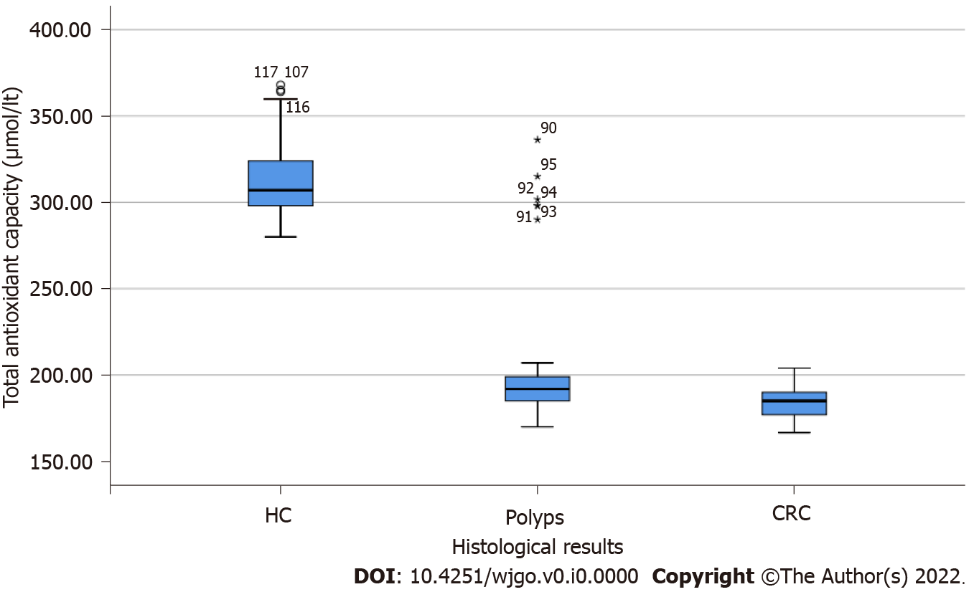
Figure 1 Antioxidant capacity among control group, group of patients with colonic polyps and group of patients with neoplasia. HC: Healthy controls; CRC: Colorectal cancer.

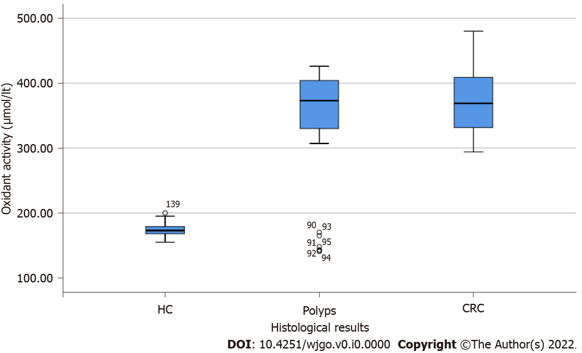
Figure 2 Oxidant activity among the control group, group of patients with colonic polyps and group of patients with neoplasia. HC: Healthy controls; CRC: Colorectal cancer.

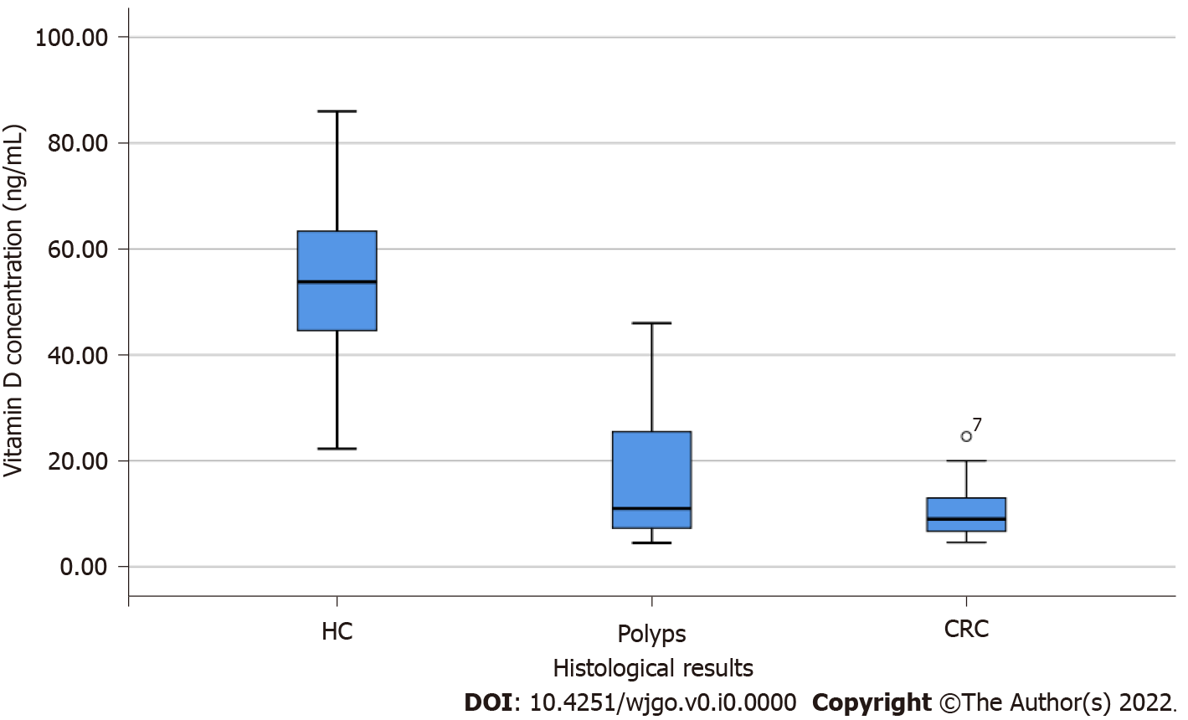
Figure 3 Vitamin D concentration among control group and group of patients with either colonic polyps or neoplasia. HC: Healthy controls; CRC: Colorectal cancer.

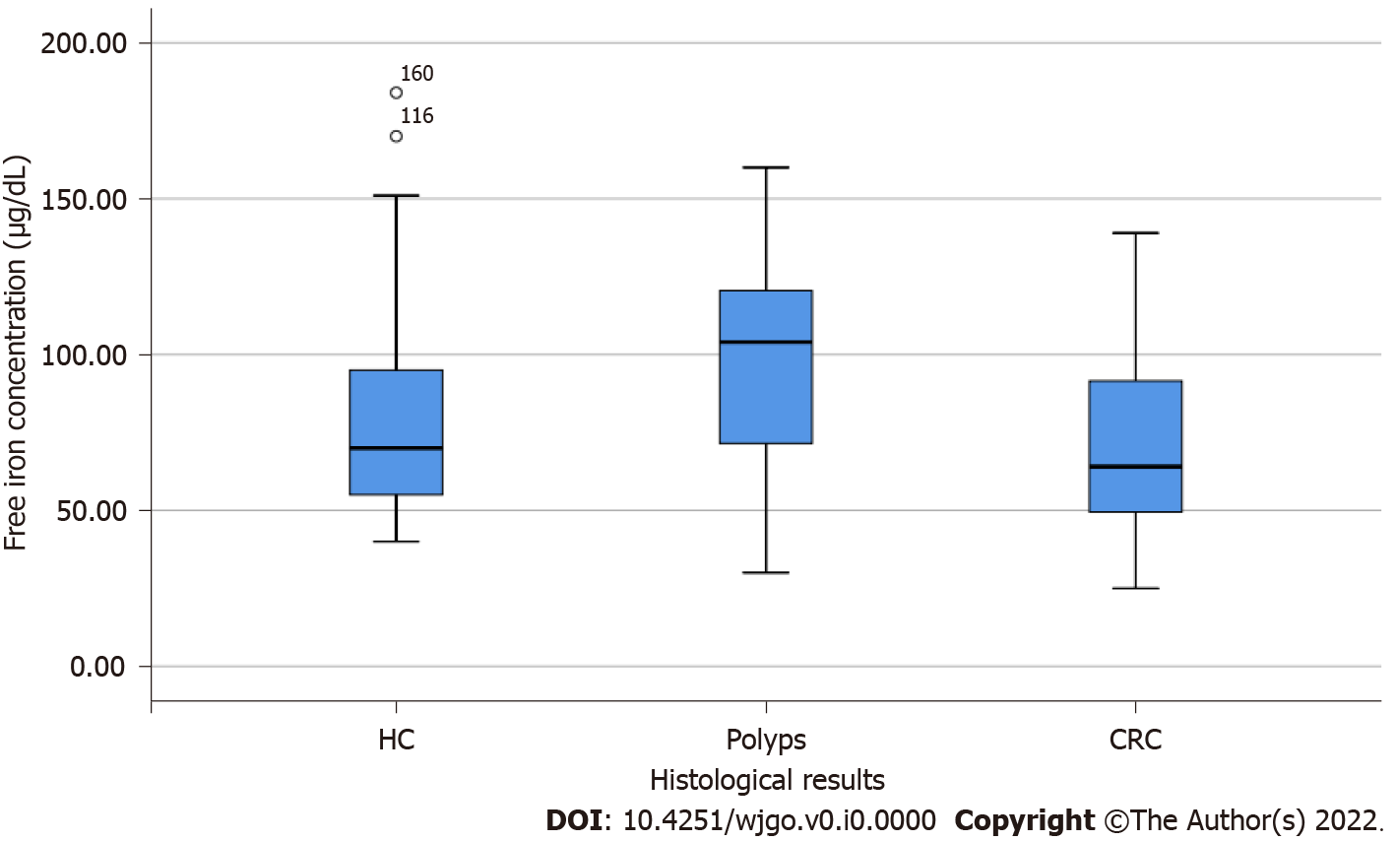
Figure 4 Free iron concentration among control group, group of patients with colonic polyps and group of patients with neoplasia. HC: Healthy controls; CRC: Colorectal cancer.

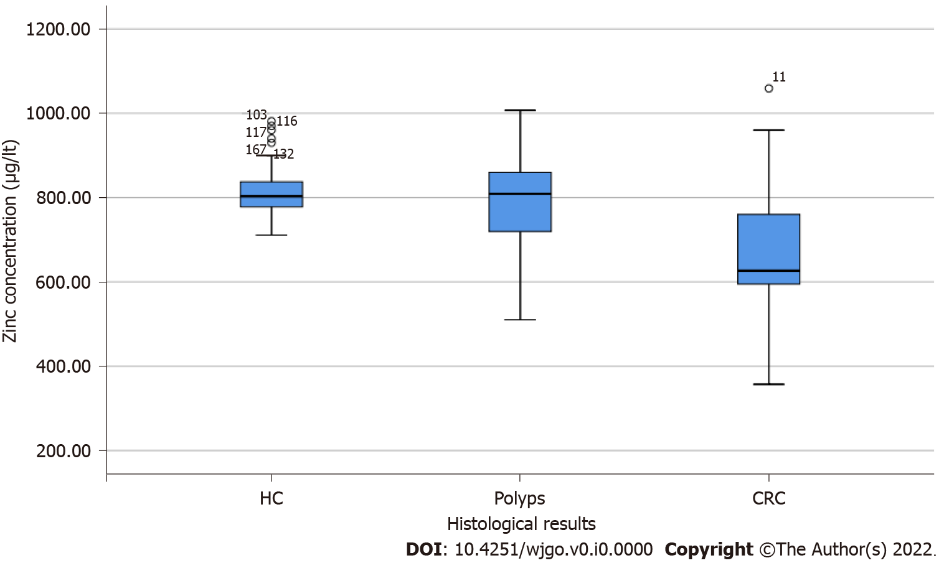
Figure 5 Zinc concentration among control group, group of patients with colonic polyps and group of patients with neoplasia. HC: Healthy controls; CRC: Colorectal cancer.
Table 1 Patients’ main characteristics
 | Αdenocarcinoma, n = 56 | Colon polyps, n = 33 | Controls, n = 81
Age in yr, n (%)
50-59 | 1 (1.8) | 8 (24.2) | 9 (11.1)
60-69 | 20 (35.7) | 12 (36.4) | 44 (54.3)
70-79 | 28 (50.0) | 11 (33.3) | 16 (19.8)
80-94 | 7 (12.5) | 2 (6.1) | 12 (14.8)
Sex
Men | 35 (62.5) | 21 (63.6) | 44 (54.3)
Women | 21 (37.5) | 12 (36.4) | 37 (45.7)
Smoking
Yes | 50 (89.3) | 17 (51.5) | 68 (84.0)
No | 6 (10.7) | 16 (48.5) | 13 (16.0)
Number of cigarettes/d
< 20 | 4 ± 8.0 | 3 ± 17.6 | 0 ± 0.0
20 | 10 ± 20.0 | 6 ± 35.3 | 20 ± 29.4
> 20 | 36 ± 72.0 | 8 ± 47.1 | 48 ± 70.6
Smoking duration in yr (mean ± SD) | 37.7 ± 10.0 | 33.5 ± 9.1 | 40.3 ± 6.2
Values are presented as n (%) or mean ± SD.
Table 2 Distribution (median 25-75 percentile) of antioxidants and oxidants compounds in the plasma by group
 | Αdenocarcinoma, n = 56 | Colon polyps, n = 33 | Controls, n = 81
Αntioxidants
Αntioxidant capacity in μmol/L | 185.0 (177.0-190.0) | 190.0 (182.0-196.2) | 305.0 (298.0-324.0)
Vitamin Α in μg/L | 391.5 (288.3-493.8) | 572.0 (480.0-609.0) | 380.0 (350.0-416.0)
Vitamin C in μg/L | 4.7 (3.9-6.5) | 6.0 (4.7-10.0) | 6.0 (4.5-9.0)
Vitamin E in mg/L | 3.5 (2.4-3.9) | 3.8 (3.5-4.2) | 3.7 (3.2-4.0)
Vitamin D in ng/mL | 9.0 (6.7-13.0) | 9.0 (6.8-20.5) | 24.0 (20.0-26.0)
Se in μg/L | 62.0 (45.5-78.8) | 78.0 (72.0-80.0) | 76.0 (69.5-80.0)
Zn in μg/L | 626.5 (594.5-782.5) | 800.0 (711.0-840.0) | 809.0 (780.5-842.5)
B12 in pg/L | 211.0 (159.3-297.0) | 250.0 (220.0-355.0) | 289.0 (200.0-340.0)
Folic acid in ng/L | 4.3 (3.3-4.6) | 4.2 (3.9-4.6) | 4.0 (3.8-4.4)
Οxidants
Οxidant activity in μmol/L | 368.8 (330.8-409.0) | 378.0 (348.5-409.1) | 172.0.0 (167.5-178.5)
Μalondialdehyde in μmol/L | 1.9 (1.6-2.4) | 1.2 (0.9-2.0) | 1.8 (1.7-1.9)
Fe²⁺ in μg/dL | 64.0 (49.3-92.3) | 110.0 (90.0-127.0) | 68.0 (51.0-95.0)
Se: Selenium; Zn: Zinc; B12: Vitamin B12/cobalamin; Fe²⁺: Ferum.
Table 3 Percent change (and 95%CIs respectively) in the levels of serum antioxidant and oxidant substances compared to the control group
 | Colon polyps | Colon adenocarcinoma
 | % Change (95%CI) | % Change (95%CI)
Antioxidants
Antioxidant capacity | -40.1 (-41.6 to -38.5) | -40.7 (-41.8 to -39.5)
Vitamin Α | 32.2 (20.8 to 44.7) | 0.1 (-6.9 to 7.6)
Vitamin C | -3.1 (-15.8 to 11.6) | -12.7 (-21.9 to -2.4)
Vitamin E | 4.2 (-5.0 to 14.2) | -12.3 (-18.4 to -5.7)
Vitamin D | -46.0 (-54.9 to -35.4) | -56.8 (-62.6 to -50.2)
Se | 1.7 (-6.3 to 10.4) | -19.4 (-24.5 to -14.0)
Zn | -6.7 (-12.9 to 0.0) | -20.2 (-24.5 to -15.7)
B12 | 6.0 (-11.7 to 27.2) | -15.0 (-26.5 to -1.8)
Folic acid | 2.1 (-6.9 to 12.0) | -8.2 (-14.7 to -1.3)
Oxidants
Oxidant activity | 120.1 (111.7 to 128.9) | 113.4 (106.8 to 120.2)
Malondialdehyde | -31.6 (-39.8 to -22.3) | 10.1 (-0.6 to 21.9)
Fe²⁺ | 43.5 (22.2 to 68.5) | -8.9 (-19.8 to 3.5)
Results from multiple log-linear regression models controlling for age, sex, serum triglycerides, and smoking habits.
Table 4 Results from multiple logistic regression models (odds ratios and 95%CIs) for the risk of colon adenocarcinoma in comparison to the control group¹
 | Odds ratio | 95%CI | P value
Antioxidants
Vitamin Α, per 99.6 μg/L | 1.20 | 0.77-1.88 | 0.430
Vitamin C, per 2.8 μg/L | 0.71 | 0.44-1.15 | 0.168
Vitamin E, per 0.7 mg/L | 0.57 | 0.39-0.84 | 0.004
Vitamin D, per 8.2 ng/mL | 0.04 | 0.02-0.12 | < 0.001
Se, per 13.6 μg/L | 0.35 | 0.22-0.55 | < 0.001
Zn, per 128.5 μg/L | 0.16 | 0.09-0.31 | < 0.001
B12, per 157.1 pg/L | 0.80 | 0.51-1.26 | 0.337
Folic acid, per 38.1 ng/L | 0.77 | 0.54-1.11 | 0.170
Oxidants
Malondialdehyde, per 0.5 μmol/L | 2.09 | 1.27-3.45 | 0.004
Fe²⁺, per 33.9 μg/dL | 0.73 | 0.47-1.13 | 0.154
¹Controlling for age, sex, serum triglycerides, and smoking habits. Se: Selenium; Zn: Zinc; B12: Vitamin B12/cobalamin; Fe²⁺: Ferum.
Table 5 Multiple logistic regression results (odds ratios and 95%CIs) for the risk of colon polyp development in comparison to the control group¹
 | Odds ratio | 95%CI | P value
Antioxidants
Vitamin Α, per 99.6 μg/L | 8.84 | 3.76-20.74 | < 0.001
Vitamin C, per 2.8 μg/L | 0.99 | 0.58-1.70 | 0.982
Vitamin E, per 0.7 mg/L | 1.51 | 0.87-2.63 | 0.141
Vitamin D, per 8.2 ng/mL | 0.27 | 0.15-0.48 | < 0.001
Se, per 13.6 μg/L | 1.68 | 0.82-3.42 | 0.157
Zn, per 128.5 μg/L | 0.39 | 0.16-0.94 | 0.036
B12, per 157.1 pg/L | 1.51 | 0.92-2.46 | 0.103
Folic acid, per 38.1 ng/L | 1.42 | 0.74-2.72 | 0.299
Οxidants
Malondialdehyde, per 0.5 μmol/L | 0.35 | 0.20-0.60 | < 0.001
Fe²⁺, per 33.9 μg/dL | 2.58 | 1.53-4.33 | < 0.001
¹Controlling for age, sex, serum triglycerides, and smoking habits. Se: Selenium; Zn: Zinc; B12: Vitamin B12/cobalamin; Fe²⁺: Ferum.

