Name of Journal: World Journal of Gastrointestinal Oncology
Manuscript NO: 88927
Manuscript Type: ORIGINAL ARTICLE

Retrospective Cohort Study
Combining systemic inflammatory response index and albumin fibrinogen ratio to predict early serious complications and prognosis after resectable gastric cancer

Ren JY et al. SIRI and AFR to gastric cancer

Jing-Yao Ren, Da Wang, Li-Hui Zhu, Shuo Liu, Miao Yu, Hui Cai

Jing-Yao Ren, Li-Hui Zhu, Hui Cai, School of Clinical Medicine, Ningxia Medical University, Yinchuan 750000, Ningxia Hui Autonomous Region, China

Jing-Yao Ren, Da Wang, Li-Hui Zhu, Shuo Liu, Miao Yu, Hui Cai, General Surgery Clinical Medical Center, Gansu Provincial Hospital, Lanzhou 730000, Gansu Province, China

Jing-Yao Ren, Da Wang, Li-Hui Zhu, Shuo Liu, Miao Yu, Hui Cai, Key Laboratory of Molecular Diagnostics and Precision Medicine for Surgical Oncology in Gansu Province, Gansu Provincial Hospital, Lanzhou 730000, Gansu Province, China

Jing-Yao Ren, Da Wang, Li-Hui Zhu, Shuo Liu, Miao Yu, Hui Cai, NHC Key Laboratory of Diagnosis and Therapy of Gastrointestinal Tumor, Gansu Provincial Hospital, Lanzhou 730000, Gansu Province, China

Da Wang, Medical College of Jiangsu University, Jiangsu University, Zhenjiang 212013, Jiangsu Province, China

Shuo Liu, The First Clinical Medical College of Lanzhou University, Lanzhou University, Lanzhou 730000, Gansu Province, China

Hui Cai, The First Clinical Medical School, Lanzhou University, Lanzhou 730000, Gansu Province, China

Co-first authors: Jing-Yao Ren and Da Wang.

Author contributions: Ren JY conceived and designed the study and wrote the manuscript; Ren JY, Wang D, Zhu LH, Liu S, and Yu M conducted all data collection and analysis and compiled charts; Cai H reviewed and revised the manuscript; All authors read and approved the final manuscript.

Supported by the National Natural Science Foundation of China, No. 8236110677; Central to guide local scientific and Technological Development, No. ZYYDDFFZZJ-1; Natural Science Foundation of Gansu Province, China, No. 18JR2RA033; and Gansu Da Vinci Robot High-End Diagnosis and Treatment Team Construction Project, National Key Research and Development Program, No. 2020RCXM076.

Corresponding author: Hui Cai, Doctor, PhD, Chief Doctor, Dean, Doctor, General Surgery Clinical Medical Center, Gansu Provincial Hospital, No. 204 Donggang West Road, Chengguan District, Lanzhou 730000, Gansu Province, China. caialonteam@163.com

Received: October 15, 2023
Revised: December 9, 2023
Accepted: January 9, 2024
Published online:

Abstract
BACKGROUND
Gastric cancer has a high incidence and fatality rate, and surgery is the preferred course of treatment. Nonetheless, patient survival rates are still low, and the incidence of major postoperative complications cannot be disregarded. The systemic inflammatory response, nutritional level, and coagulation status are key factors affecting the postoperative recovery and prognosis of gastric cancer patients. The systemic inflammatory response index (SIRI) and the albumin fibrinogen ratio (AFR) are two valuable comprehensive indicators of the severity and prognosis of systemic inflammation in various medical conditions.

AIM
To assess the clinical importance and prognostic significance of the SIRI scores and the AFR on early postoperative outcomes in patients undergoing radical gastric cancer surgery.

METHODS
We conducted a retrospective analysis of the clinicopathological characteristics and relevant laboratory indices of 568 gastric cancer patients from January 2018 to December 2019. We calculated and compared two indicators of inflammation and then examined the diagnostic ability of combined SIRI and AFR values for serious early postoperative complications. We scored the patients and categorized them into three groups based on their SIRI and AFR levels. COX analysis was used to compare the three groups of patients the prognostic value of various preoperative SIRI-AFR scores for 5-year overall survival (OS) and disease-free survival (DFS).

RESULTS
SIRI-AFR scores were an independent risk factor for prognosis [OS: P = 0.004; hazards ratio (HR) = 3.134; DFS: P < 0.001; HR = 3.543] and had the highest diagnostic power (area under the curve: 0.779; 95% confidence interval: 0.737-0.820) for early serious complications in patients with gastric cancer. The tumor-node-metastasis stage (P = 0.001), perioperative transfusion (P = 0.044), positive carcinoembryonic antigen (P = 0.014) findings, and major postoperative complications (P = 0.011) were factors associated with prognosis.

CONCLUSION
Preoperative SIRI and AFR values were significantly associated with early postoperative survival and the occurrence of severe complications in gastric cancer patients.

Key Words: Inflammation; Albumin fibrinogen ratio; Gastric cancer; Complications; Prognosis

Ren JY, Wang D, Zhu LH, Liu S, Yu M, Cai H. Combining systemic inflammatory response index and albumin fibrinogen ratio to predict early serious complications and prognosis after resectable gastric cancer. World J Gastrointest Oncol 2024; In press

Core Tip: We conducted a retrospective analysis of the clinicopathological characteristics and relevant laboratory indices of 568 gastric cancer patients. The aim of this study was to assess the clinical importance and prognostic significance of systemic inflammatory response index (SIRI) combined with the albumin fibrinogen ratio (AFR) on early postoperative outcomes in patients who underwent radical gastrectomy. The results demonstrated that preoperative SIRI and AFR were significantly associated with 5-year survival and the occurrence of major complications in gastric cancer patients. We created novel markers in the current study to aid in the early identification and therapy of gastric cancer.

INTRODUCTION
Gastric cancer ranks fifth for morbidity and fourth for fatality for all malignancies and is one of the most prominent diseases worldwide^{[1]}. Similarly, gastric cancer has made a great contribution to the cancer burden in China. Gastric cancer is the second most diagnosed cancer and the third leading cause of cancer-related deaths in China. As a transitioning country, China bears a greater morbidity/mortality and 5-year prevalence rate for gastric cancer compared to most developed countries^{[2]}. Surgery-based multidisciplinary comprehensive treatment remains the main approach to treating gastric cancer^{[3]}. An essential course of treatment for non-metastatic gastric cancer is gastroplasty with lymph node dissection^{[4]}.
Despite significant improvements in surgery and anesthetic procedures, postoperative care, and interventional radiology related to stomach cancer gastrectomy has a substantial risk of postoperative complications, such as wound infection, leakage, bleeding, and intestinal obstruction^{[5]}. Recurrences are common. The rate of postoperative complications following gastric surgery was reported to be 46%^{[6]}. Thus, these complications may reduce the quality of life, postpone the start of adjuvant treatment, and impede recovery^{[7]}. Patients with complications are at greater risk of disease recurrence^{[8]}. Relevant evidence revealed that more than 70% of recurrences and cancer-related mortalities develop within 2 years of surgery, and gastric cancer recurrence and metastasis can significantly decrease patient survival rates^{[9]}.
Chronic and sustained inflammation associated with gastric cancer not only promotes gastric cancer occurrence and advancement^{[10]}, but the inflammatory response stimulates and releases systemic cytokines, which attract the growth of remaining cancer cells and promote postoperative recurrence and metastasis^{[8]}. Studies revealed that several newly established inflammation-based indicators, including the neutrophil-to-lymphocyte ratio, lymphocyte-to-monocyte ratio, lymphocyte-to-C reactive protein ratio^{[11]}, fibrinogen-to-albumin ratio (FAR)^{[12]}, and systemic inflammatory response index (SIRI)^{[13]}, play an instrumental part in the diagnosis, staging, and prediction of gastric cancer. For example, fibrinogen-neutrophil-to-lymphocyte has served as a prognostic marker for patients with esophageal-gastric junction and superior gastric cancer after gastrectomy and has shown favorable predictive effects^{[14]}. Among the above indicators, SIRI, an indicator for assessing a patient’s inflammatory status by integrating multiple inflammatory cells into the assessment, has certain advantages and prospects for application. A significant variety of studies have increasingly reported that SIRI values were strongly associated with the prognosis of patients with many different types of tumors^{[15-17]}. Patients with nasopharyngeal cancer and higher SIRI values had considerably shorter overall survival (OS) compared to those with lower SIRI values^{[18]}. SIRI values were also found to be a standalone risk prognostic factor in postmenopausal women with breast cancer^{[19]}. In some solid tumors, such as pancreatic, gastric, and esophageal malignancies, SIRI values have strong predictive performance^{[20,21]}. The albumin fibrinogen ratio (AFR) is widely used due to its simplicity of measurement, inexpensive nature, and relatively high accuracy^{[22]}. According to a large retrospective research study of 1196 gastric cancer patients, serum fibrinogen levels were positively correlated with advanced tumor stage and poor prognosis in patients undergoing gastrectomy^{[23]}. Several studies reported that the FAR or AFR could serve as a point for the clinical prognosis of gastric cancer patients undergoing first-line chemotherapy^{[24]}, elderly gastric cancer patients^{[25]}, and in patients with resectable stage II or III gastric cancer^{[26-28]}.
Therefore, to further explore preoperative indicators that can easily and accurately identify the risk of complications in the early post-operative period and prognosis for patients undergoing radical gastrectomy, we propose using both SIRI and AFR values, with the aim of improving the sensitivity of assessing inflammation, nutritional levels and coagulation status and the accuracy and specificity of predicting postoperative outcomes in the short and long-term for gastric cancer patients.

MATERIALS AND METHODS
Patients and follow-up
This was a retrospective research study on patients at the Gansu Provincial Hospital (Lanzhou, China) with histologically verified gastric cancer from January 2018 to December 2019. A total of 568 patients met the inclusion criteria. The average age of the study cohort was 60.29 ± 9.79 years and included 442 (77.8%) men and 126 (22.1%) women. The research protocols for the current investigation, which conformed to the principles of the Declaration of Helsinki, received approval from Gansu Provincial Hospital Medical Ethics Committee (Ethical Consent: 21/10/2022-410). Information was gathered from medical records on sex, age, tumor dimensions, tumor localization, metastatic rate of lymph nodes rate, degree of tumor differentiation, immunohistochemistry results (Ki67, p53, and Her2). The process of immunohistochemistry involved staining tissue sections with an antibody specific to the protein of interest, followed by visualization using a chromogenic or fluorescent label^{[29]}. p53 expression was defined as positive (mutant) when more than 10% of cancer cell nuclei stained positive^{[30]}. The percentage of cells with Ki67 expression (0%-49%, 50%-74%, 75%-100%) was calculated from the number of malignant cells in the highest labelled field under high magnification (400 ×)^{[31]}. HER2 expression was evaluated as membrane staining of invasive tumor cells and scored into four classes (0/1+/2+/3+), the expression of grade 3+ or 2+ was defined as positive^{[32]}. Tumor-node-metastasis (TNM) stage [referring to the American Joint Commission on Cancer (AJCC) gastric cancer TNM staging criteria (eighth edition)], American Society of Anesthesiologists score, surgical approach, extent of resection, duration of surgery, blood loss, periprocedural blood transfusion, length of hospitalization, and duration of postoperative enteral nutrition.
The inclusion criteria for patients were as follows: (1) Between 18 years and 80 years of age with a clinical diagnosis of preoperative gastric malignancy; (2) Postoperative pathological results confirming primary gastric cancer; and (3) Undergoing D1/D1+/D2 lymph node dissection with radical R0 resection for the first time for radical gastric cancer. The exclusion criteria for patients were as follows: (1) Distant tumor metastasis; (2) Combined hematological diseases, autoimmune diseases, infectious diseases, chronic inflammatory diseases, or liver dysfunction that may affect white blood cells; (3) Preoperative neoadjuvant therapy (radiotherapy or chemotherapy); (4) Presence of other malignant tumors; and (5) Incomplete data.
The participants in the included studies were followed up by telephone contact, outpatient review, hospitalization, and other methods. The patients were carefully followed up every 3 mo to 6 mo after surgery. Annual follow-up was implemented after 2 years. The follow-up outcomes were OS and disease-free survival (DFS) at 5 years postoperatively. The definition of DFS is the period from diagnosis to any locally recurring disease, distant metastasis, or the last follow-up. OS was defined as the duration between diagnosis and disease-related mortality or the end of the study. The last follow-up was in December 2022.

Laboratory variables and definition of AFR and SIRI index
Relevant indicator levels were assessed in blood samples drawn within a week prior to surgery. Retrospective analysis and data collection from the electronic medical records included additional parameters. SIRI values and AFRs were calculated as the follows: SIRI = neutrophil count × monocyte count/lymphocyte count; AFR = albumin fibrinogen ratio. Complications occurring in-hospital or within 30 d were categorized as early postoperative complications, and all complications were graded for severity according to the Clavien-Dindo complication grading system^{[33]}, with grade I or II complications categorized as minor complications, and grade III and higher characterized as major complications. The general post-operative pathology specimen’s greatest diameter was used to calculate the tumor size. The primary tumor locations were classified as upper, middle, and lower stomach accordingly. Differentiation levels were categorized as poorly differentiated and moderately/well differentiated.

Statistical analysis
All the statistical analyses were completed utilizing IBM SPSS for Windows, version 26.0 (IBM Statistics for Windows, version 26, IBM Corporation, Armonk, NY, United States). Categorized data are presented as number (n) and percentage (%). For normally distributed measures, the information is described as the mean ± SD, and for non-normally distributed continuous variables, it is expressed as the median (interquartile range). Paired groups were compared using either the Mann-Whitney U test or the Student’s t-test, depending on the normality of the data distribution. The χ² test was used to evaluate categorical group differences. Logistic regression models were employed to identify factors affecting postoperative complications. Receiver operating characteristic (ROC) curves with Youden indices were employed to establish the most favorable cut-off values for each outcome. Youden’s index is a global measure of overall diagnostic accuracy and can be used to choose the best cut-point. Its definition is the maximum vertical distance between the ROC curve and the diagonal line^{[34]}. The area under the curve (AUC) values are supplied with a 95% confidence interval (CI). The hazard ratios (HRs) for disease recurrence or metastasis were calculated applying Cox proportional hazards models. P < 0.05 was designated as statistical significance.

RESULTS
Patient characteristics
The flowchart for patient screening is displayed in Figure 1. A total of 568 patients fit the inclusion criteria. No chemotherapy or radiotherapy was administered to any of the patients prior to surgery, and there was no perioperative mortality. This study included 442 men and 126 women with an average age of 60.29 ± 9.79 years (25-87 years). The average body mass index (BMI) ratio prior to surgery for all patients was 22.20 ± 3.37 kg/m². Of the patients, 31.7% (n = 180) underwent open surgery, 40.0% (n = 227) had a laparoscopic approach, and 28.3% (n = 161) underwent robot-assisted surgery. Based on AJCC staging standards, 119 (21.0%) patients were categorized as stage I, 178 (31.3%) were stage II, and 271 (47.7%) were stage III. A mean follow-up time of 45 mo was established for all patients, ranging from 12 to 61 mo. All patients underwent a follow-up assessment.

Postoperative complications
Eighty-nine (15.7%) patients in our study experienced serious complications. The occurrence of early postoperative complications in individuals experiencing radical gastrectomy is shown in Table 1. The complications included a duration of enteral nutrition longer than 2 wk in 26 patients, infection-related complications (incision infection, abdominal infection, pulmonary infection) in 234 patients, an anastomotic fistula in 6 patients, pyloric or intestinal obstruction in 14 patients, thrombosis or embolism in 15 patients, and postoperative shock in 7 patients. All resolved after treatment.
The clinical characteristics of the study population are shown in Table 2, along with a comparison of the characteristics and clinical aspects of the two groups of patients who had no complications (no) and/or experienced minor complications and those who had major complications. Age (P = 0.046), BMI (P = 0.003), tumor size (< 3/≥ 3 cm) (P = 0.014), resection range (P = 0.019), perioperative transfusion (P < 0.001), and hospital stay (P < 0.001) were significantly different between the two groups (Table 2). For laboratory parameters, lymphocytes (P < 0.001), neutrophils (P < 0.001), platelets (P = 0.013), monocytes (P = 0.032), albumin (P < 0.001), fibrinogen (P < 0.001), carcinoembryonic antigen (CEA) (P = 0.011), SIRI (P < 0.001), and AFR values (P < 0.001) also significantly differed between groups.

Correlations between SIRI, AFR and the clinicopathological characteristics of gastric cancer
Preoperative SIRI scores were related to sex (P = 0.002) and resection range (P = 0.008) among gastric cancer patients, as shown in Table 3. AFR was associated with the degree of tumor differentiation (P = 0.002) and the duration of enteral nutrition (P = 0.01). Both preoperative conditions were related to age, tumor size (< 3/≥ 3 cm), TNM stage, perioperative transfusion, carbohydrate antigen 199 (CA199), CEA, amount of bleeding, locoregional recurrence or metastasis (P < 0.05). Upon further analysis, SIRI levels were lower and AFR levels were higher in patients under 60 years of age compared to patients older than 60 years (SIRI, P = 0.038; AFR, P < 0.001), and SIRI levels were higher and AFR levels were lower in individuals with a maximum tumor diameter > 3 cm compared to individuals with tumor diameter of 3 cm or less (SIRI, P < 0.001; AFR, P < 0.001). SIRI values were the highest and AFRs were the lowest in patients with stage III disease (SIRI, P < 0.001; AFR, P < 0.001). SIRI levels were higher and AFRs were lower in perioperative blood transfusion patients (SIRI, P < 0.001; AFR, P < 0.001). SIRI scores were higher and AFRs were lower in CA199 and CEA-positive patients (SIRI, P = 0.023, P < 0.001; AFR, P = 0.001, P < 0.001). The highest SIRI levels and lowest AFRs levels were observed in patients with > 400 mL intraoperative blood loss (SIRI, P < 0.001; AFR, P < 0.001). The SIRI levels of patients with gastric cancer with locoregional recurrence or metastasis was noticeably increased (P < 0.001) and the AFRs were reduced (P < 0.001).

The significance of preoperative SIRI and AFR levels for early serious postoperative complications in resectable gastric cancer
Table 4 lists the outcomes of the univariate and multivariate regression analyses that were executed to establish the odds ratio (OR) values for the complication estimation. The results suggest that high preoperative SIRI values were substantially related to early serious postoperative complications (P < 0.001; OR = 1.429; 95%CI: 1.175-1.738), and elevated preoperative AFRs levels were a protective factor against postoperative complications (P < 0.001; OR = 0.729; 95%CI: 0.665-0.799). Additionally, the SIRI and AFR components, such as neutrophil count, monocyte count, lymphocyte count, serum albumin, and fibrinogen serum levels, age, BMI, tumor size (< 3/≥ 3 cm), resection range, perioperative transfusion, and CEA status (< 5/≥ 5 ng/mL) were also related to early serious postoperative complications revealed by univariate analysis (P < 0.05). Preoperative SIRI values and AFRs remained independent indicators for postoperative complications in multivariable analysis (SIRI: P = 0.018; OR = 1.221; 95%CI: 1.031-1.446; AFR: P < 0.001; OR = 0.761; 95%CI: 0.693-0.843). Perioperative transfusion (P = 0.012; OR = 2.095; 95%CI: 1.179-3.722) was another contributing factor.

Predictive abilities of SIRI and AFR values for postoperative complications
Previous statistical findings concluded that high AFR levels were a protective parameter for postoperative complications, but a high SIRI value was a risk factor. Thus, to facilitate the calculation of the predictive power of SIRI combined with AFR, we used the FAR in the calculation. ROC curve generation and AUC calculations were used to determine the predictive capability of SIRI and AFR values. The AUC values for SIRI, AFR, and SIRI combined with AFR levels are summarized in Figure 2. The AUC value computed for SIRI was 0.765 (95%CI: 0.714-0.815), 0.743 for AFR (95%CI: 0.689-0.797), and 0.779 for SIRI-AFR (95%CI: 0.737-0.820).

Establishment of SIRI-AFR scores
The patients were grouped based on the appropriate cut-off values for each determinant, established using ROC curves with Youden’s index (SIRI: cut-off value: 1.007, sensitivity: 0.966, specificity: 0.532, AFR: cut-off value: 9.849, sensitivity: 0.770, specificity: 0.582). A scoring system was developed according to the SIRI and AFR cut-off values. Patients with a SIRI score of ≥ 1.007 and an AFR of ≤ 9.849 were assigned a SIRI-AFR score of 2, patients with a SIRI score < 1.007 and an AFR > 9.849 were assigned a SIRI-AFR score of 0, and those with a SIRI score of ≥ 1.007 or an AFR of ≤ 9.849 were assigned a SIRI-AFR score of 1. According to the SIRI-AFR system, 219 (38.6%), 224 (39.4%), and 125 (22.0%) patients had scores of 0, 1, and 2, respectively.

Univariate and multivariate Cox regression analyses for OS and DFS
We conducted a COX analysis to investigate the primary variables influencing the prognosis of patients with postoperative gastric cancer. Among gastric cancer patients, univariate analysis revealed that a worse prognosis was profoundly associated with older age (OS: P = 0.013; DFS: P = 0.003 ), large tumor size (OS: P < 0.001; DFS: P < 0.001 ), later clinical stage (OS: P < 0.001; DFS: P < 0.001 ), perioperative transfusion (OS: P < 0.001; DFS: P < 0.001 ), positive CA199 (OS: P = 0.001; DFS: P = 0.001), positive CEA (OS: P < 0.001; DFS: P = 0.001), major postoperative complications (OS: P < 0.001; DFS: P < 0.001), no postoperative adjuvant chemotherapy (OS: P = 0.003; DFS: P = 0.002), higher SIRI values (OS: P < 0.001; DFS: P < 0.001), lower AFR values (OS: P < 0.001; DFS: P < 0.001), and high SIRI-AFR scores (OS: P < 0.001; DFS: P < 0.001). Multivariate analysis revealed that TNM stage (P = 0.001; HR = 5.464, 95%CI: 1.948-15.327), perioperative transfusion (P = 0.044; HR = 1.517, 95%CI: 1.011-2.277), positive CEA (P = 0.014; HR = 1.605; 95%CI: 1.101-2.338), fibrinogen levels (P = 0.005; HR = 1.415, 95%CI: 1.111-1.803), and SIRI-AFR scores (P = 0.004; HR = 3.134, 95%CI: 1.445-6.797) were independently determined prognostic variables for OS (Table 5). Similarly, Cox survival multivariable analysis indicated that TNM stage (P = 0.001; HR = 4.071, 95%CI: 1.757-9.435), major postoperative complications (P = 0.011; HR = 1.604, 95%CI: 1.115-2.307), albumin levels (P = 0.044; HR = 0.959, 95%CI: 0.920-0.999), fibrinogen levels (P = 0.003; HR = 1.407, 95%CI: 1.126-1.759), and SIRI-AFR scores (P < 0.001; HR = 3.543, 95%CI: 1.844-6.809) were individual prognostic elements for DFS (Table 6). We also found that SIRI-AFR scores could effectively differentiate patients into three distinct risk groups for OS and DFS (Figure 3).
According to the Cox regression model analysis, we performed further subgroup analyses targeting TNM stage, perioperative transfusion, positive CEA, and major postoperative complications, which were several important factors affecting prognosis. The findings demonstrated longer survival in the low SIRI-AFR subgroups with TNM I-II and TNM III (Figure 4A-D). In the subgroups without or with perioperative blood transfusion, patients with low SIRI-AFR levels also had relatively better prognostic ability (Figure 4E-H). Alternatively, patients with lower SIRI-AFR scores exhibited longer survival in the CEA-negative and positive subgroups (Figure 4I-L). Not surprisingly, prognoses were better in the lower SIRI-AFR group than in the high SIRI-AFR group in subgroups with or without postoperative major complications (Figure 4M-P).

DISCUSSION
Gastric cancer is a serious public health issue^{[35]}, and the occurrence of serious complications and recurrence and metastasis after surgery remain difficult problems for clinicians. The development of gastric cancer is a multi-gene, multi-step process and certain key factors may participate in the development of gastric cancer and even infiltration and metastasis at some stages. The systemic inflammatory response and nutritional situation are two considerable contributing factors^{[36]}. SIRI and AFR values are a valuable novel way to evaluate the inflammatory and nutritional conditions of patients. To our knowledge, no studies have examined how SIRI and AFR values in patients who received radical gastric cancer surgery relate to early postoperative serious complications and postoperative survival outcomes. In the current study, we created novel markers and evaluated their diagnostic and predictive potential to aid in the early identification and treatment of gastric cancer.
Tumorigenesis involves the establishment of a preneoplastic inflammatory environment^{[37]}. The Correa sequence, the canonical theory of cancer development in the stomach, indicated that the inflammatory response was an indispensable component of tumor progression^{[36]}. The epidemiological and clinical investigations provided substantial evidence that inflammation is associated with supporting tumor cell growth and dissemination^{[38]}.
SIRI is unique in reflecting the sophisticated interactions and complementary activity of the major immune cells in the cancer microenvironment. This new metric reflects the state of equilibrium between the immune and inflammatory systems of the host. As essential elements of the tumor microenvironment, neutrophils participate in tumor progression via multiple mechanisms, and pathological neutrophil activation may symbolize the beginning of comprehending the processes behind the reactivation of dormant tumor cells^{[39]}. Neutrophils produce substances, such as chemokines, cytokines, stromal degrading proteases, and reactive oxygen species, that can alter tumor growth and invasiveness^{[40]}. Thus, neutrophil physiology at the cellular and molecular levels seems to indicate that their primary function is to facilitate transferential seeding. Neutrophil extracellular traps, shaped by molecularly released DNA, are intended to capture circulating tumor cells^{[41]}. Such an entanglement of circulating tumor cells may be beneficial to intraluminal survival, adhesion to the endothelium, and extravasation. Monocytes serve as cells bridging innate and adaptive immunity and can promote cancer immune escape by differentiation into immunomodulatory cells^{[42]}. They can be involved in the promotion, support, and maintenance of tumor growth by affecting the tumor microenvironment through multiple mechanisms that produce tolerance, angiogenesis, and accelerated tumor cell proliferation^{[43]}. Lymphocytes play a role in immunologic surveillance and contribute to the identification and destruction of abnormal cells^{[44]}. Importantly, biochemical alterations of T cells can modulate cellular activities and promote tumor progression^{[45]}. Evidence suggests that the magnitude and composition of tumor-infiltrating lymphocytes can affect the survival of esophageal adenocarcinoma^{[46]}.
With a combination of multiple metrics, AFR can more accurately assess a patient’s inflammatory status, coagulation, and nutritional conditions. Unlike other indicators of inflammation, fibrinogen and albumin levels in the blood are not disturbed by chemotherapy and more accurately reflect the true inflammatory state of the patient after chemotherapy^{[47,48]}. Abnormal fibrinogen levels can lead to disturbances in the control of normal homeostasis during coagulation. The sedimentation of fibrinogen on cancer cells can form a physical shield to protect cancer cells from recognition and lysis by natural killer cells^{[49]}. Albumin levels are influenced by nutritional status and metabolism. Hypoalbuminemia can generate immunodeficiency in tumor patients, reducing treatment effectiveness and increasing mortality^{[50]}. Thus, albumin levels are a recognized prognostic factor for several malignancies^{[51,52]}. Similarly, some research suggested that albumin levels affect the likelihood of postoperative complications^{[53]} and cancer recurrence^{[54]}.
Mounting data have pointed to the usefulness of SIRI values as a predictor of adverse survival in patients with a range of malignancies, including gastric cancer^{[55-57]}. In our findings, SIRI values constituted an independently attributable risk for severe postoperative complications in patients with radical gastrectomy. Recently, Schietroma et al^{[58]} confirmed that SIRI could predict anastomotic fistulas after total gastrectomy. Similarly, related research has demonstrated that AFR can predict the prognoses of patients with pancreatic cancer^{[51]}, gallbladder cancer^{[59]}, and colorectal cancer^{[60]}. Chen et al^{[61]} reported that AFR was a distinct risk factor for postoperative delirium in senior gastric cancer patients who underwent laparoscopic gastrectomy, with a cut-off value of 9.95 and an AUC area of 0.614. You et al^{[25]} found that major postoperative complications in senior gastric cancer patients after laparoscopic radical gastrectomy were predicted by the preoperative AFR. The ROC curve’s results revealed a cut-off value of 8.49 and an AUC of 0.841. The discrepancy between our cut-off value and the results for the AUC may be due to variations in the data samples and methodological models. Our findings suggested that the AFR was a worthwhile parameter for predicting serious complications and prognosis in patients receiving radical gastrectomy in the early postoperative period. The predictive value of combining SIRI and AFR values for early postoperative serious complications and prognosis of patients undergoing radical gastrectomy was first identified through our study and suggest that it could be used as a tool to guide cancer treatment strategy decisions.
SIRI and AFR values reflect the complex interactions and synergistic promotion between major immune cells and components of the cancer microenvironment. By integrating risks related to inflammation, coagulation, and nutrition, SIRI and AFR values can deliver a more comprehensive assessment of a patient’s overall condition and provide more accurate predictive outcomes. SIRI and AFR values are suitable for frequent testing during follow-up because they have the advantages of easy accessibility, low cost, and good reproducibility. Both the values and the dynamics of SIRI and AFR have the potential to contribute to assessing the efficacy of adjuvant radiotherapy, the selection of suitable patients for specific targeted therapies and immunotherapies, and the monitoring of possible recurrences. In addition, SIRI and AFR values can improve the accuracy and reliability of predictions by continuously learning and updating the models. With the continuous development of medical technology and the accumulation of clinical data, SIRI values and AFRs can be used to constantly optimize the models to provide more accurate prediction results and better support for patient treatment and rehabilitation.
This investigation had a few limitations. Firstly, the retrospective nature of the study at a single institution restricts its statistical power. Subsequently, we lacked an evaluation of postoperative SIRI and AFR dynamic changes in a relatively large cohort of gastric cancer patients. Therefore, larger multicenter prospective randomized controlled trials are needed to verify our conclusions. Finally, even though SIRI and AFR values are worthwhile and easily attainable routine blood parameters, the underlying biological and molecular mechanisms that account for their prognostic and predictive nature remain unclear.

CONCLUSION
Overall, the findings of this investigation indicate a significant association between preoperative SIRI and AFR values in gastric cancer patients and the occurrence of severe complications, as well as early postoperative survival outcomes. These results may aid surgeons and oncologists in conducting more effective preoperative evaluations and management and developing postoperative monitoring plans for gastric cancer patients.

ARTICLE HIGHLIGHTS
Research background
Gastric cancer is a serious public health issue, and the occurrence of serious complications and recurrence and metastasis after surgery remain difficult problems for clinicians. Patient survival rates are still low and the incidence of major postoperative complications cannot be disregarded. The systemic inflammatory response, nutritional level, and coagulation status are key factors affecting postoperative recovery and prognosis of gastric cancer patients. The systemic inflammatory response index (SIRI) and the albumin fibrinogen ratio (AFR) are two valuable comprehensive indicators of the severity and prognosis of systemic inflammation in various medical conditions.

Research motivation
The aim of this study was to assess the clinical importance and prognostic significance of the SIRI scores and AFR on early postoperative outcomes in patients undergoing radical gastric cancer surgery. These results may aid surgeons and oncologists in conducting more effective preoperative evaluations and management and developing postoperative monitoring plans for gastric cancer patients.

Research objectives
The objective of this study is to assess the clinical importance and prognostic significance of the SIRI scores and the AFR on early postoperative outcomes in patients undergoing radical gastric cancer surgery.

Research methods
We conducted an analysis of the clinicopathological characteristics and relevant laboratory indices of 568 gastric cancer patients from January 2018 to December 2019. We calculated and compared two indicators of inflammation and then examined the diagnostic ability of combined SIRI and AFR values for early postoperative serious complications. We scored the patients and categorized them into three groups based on their SIRI and AFR levels.

Research results
SIRI-AFR scores had the highest diagnostic power for early serious complications and were an independent risk factor for prognosis in gastric cancer patients. Furthermore, the tumor-node-metastasis stage, perioperative transfusion, positive carcinoembryonic antigen findings, and major postoperative complications were factors associated with prognosis. The significant value of the SIRI and AFR for the early severe postoperative complications and prognosis in gastric cancer patients can provide important insights for the future prevention and treatment of patients. However, we lacked an evaluation of postoperative SIRI and AFR dynamic changes in a relatively large cohort of gastric cancer patients. Therefore, larger multicenter prospective randomized controlled trials are needed to verify our conclusions. Even though SIRI and AFR values are worthwhile and easily attainable routine blood parameters, the underlying biological and molecular mechanisms that account for their prognostic and predictive nature remain unclear.

Research conclusions
In this study, we created novel markers and evaluated their diagnostic and predictive potential to aid in the early identification and treatment of gastric cancer.

Research perspectives
Larger multicenter prospective randomized controlled trials are needed to verify our conclusions. Additionally, the underlying biological and molecular mechanisms that account for the prognostic and predictive nature of SIRI and AFR values remain unclear. Further research is needed to elucidate the specific pathways and interactions through which these indicators impact the postoperative outcomes in gastric cancer patients.

REFERENCES
1 Sung H, Ferlay J, Siegel RL, Laversanne M, Soerjomataram I, Jemal A, Bray F. Global Cancer Statistics 2020: GLOBOCAN Estimates of Incidence and Mortality Worldwide for 36 Cancers in 185 Countries. CA Cancer J Clin 2021; 71: 209-249 [PMID: 33538338 DOI: 10.3322/caac.21660]
2 Cao W, Chen HD, Yu YW, Li N, Chen WQ. Changing profiles of cancer burden worldwide and in China: a secondary analysis of the global cancer statistics 2020. Chin Med J (Engl) 2021; 134: 783-791 [PMID: 33734139 DOI: 10.1097/CM9.0000000000001474]
3 Joshi SS, Badgwell BD. Current treatment and recent progress in gastric cancer. CA Cancer J Clin 2021; 71: 264-279 [PMID: 33592120 DOI: 10.3322/caac.21657]
4 Cravo M, Fidalgo C, Garrido R, Rodrigues T, Luz G, Palmela C, Santos M, Lopes F, Maio R. Towards curative therapy in gastric cancer: Faraway, so close!. World J Gastroenterol 2015; 21: 11609-11620 [PMID: 26556990 DOI: 10.3748/wjg.v21.i41.11609]
5 Kanda M, Ito S, Mochizuki Y, Teramoto H, Ishigure K, Murai T, Asada T, Ishiyama A, Matsushita H, Tanaka C, Kobayashi D, Fujiwara M, Murotani K, Kodera Y. Multi-institutional analysis of the prognostic significance of postoperative complications after curative resection for gastric cancer. Cancer Med 2019; 8: 5194-5201 [PMID: 31353821 DOI: 10.1002/cam4.2439]
6 Kim KM, An JY, Kim HI, Cheong JH, Hyung WJ, Noh SH. Major early complications following open, laparoscopic and robotic gastrectomy. Br J Surg 2012; 99: 1681-1687 [PMID: 23034831 DOI: 10.1002/bjs.8924]
7 Kanda M. Preoperative predictors of postoperative complications after gastric cancer resection. Surg Today 2020; 50: 3-11 [PMID: 31535226 DOI: 10.1007/s00595-019-01877-8]
8 Eto K, Hiki N, Kumagai K, Shoji Y, Tsuda Y, Kano Y, Yasufuku I, Okumura Y, Tsujiura M, Ida S, Nunobe S, Ohashi M, Sano T, Yamaguchi T. Prophylactic effect of neoadjuvant chemotherapy in gastric cancer patients with postoperative complications. Gastric Cancer 2018; 21: 703-709 [PMID: 29188456 DOI: 10.1007/s10120-017-0781-y]
9 Shiraishi N, Inomata M, Osawa N, Yasuda K, Adachi Y, Kitano S. Early and late recurrence after gastrectomy for gastric carcinoma. Univariate and multivariate analyses. Cancer 2000; 89: 255-261 [PMID: 10918153 DOI: 10.1002/1097-0142(20000715)89:2<255::aid-cncr8>3.0.co;2-n]
10 Zavros Y, Merchant JL. The immune microenvironment in gastric adenocarcinoma. Nat Rev Gastroenterol Hepatol 2022; 19: 451-467 [PMID: 35288702 DOI: 10.1038/s41575-022-00591-0]
11 Çağlar R. The relationship of different preoperative inflammatory markers with the prognosis of gastric carcinoma. Asian J Surg 2023; 46: 360-365 [PMID: 35589478 DOI: 10.1016/j.asjsur.2022.04.075]
12 Lin GT, Chen QY, Zhong Q, Huang ZN, Huang CM. ASO Author Reflections: Fibrinogen-Albumin Ratio as New Promising Biochemical Marker for Predicting Oncological Outcomes in Gastric Cancer Compared with the Combination of Other Inflammation-Related Factors. Ann Surg Oncol 2021; 28: 7074-7075 [PMID: 33907923 DOI: 10.1245/s10434-021-10042-w]
13 Liu Z, Ge H, Miao Z, Shao S, Shi H, Dong C. Dynamic Changes in the Systemic Inflammation Response Index Predict the Outcome of Resectable Gastric Cancer Patients. Front Oncol 2021; 11: 577043 [PMID: 33718137 DOI: 10.3389/fonc.2021.577043]
14 Cong X, Li S, Zhang Y, Zhu Z, Wang Y, Song S, Ma Y, Xie R, Xue Y. The combination of preoperative fibrinogen and neutrophil-lymphocyte ratio is a predictive prognostic factor in esophagogastric junction and upper gastric cancer. J Cancer 2019; 10: 5518-5526 [PMID: 31632495 DOI: 10.7150/jca.31162]
15 Cui S, Cao S, Chen Q, He Q, Lang R. Preoperative systemic inflammatory response index predicts the prognosis of patients with hepatocellular carcinoma after liver transplantation. Front Immunol 2023; 14: 1118053 [PMID: 37051235 DOI: 10.3389/fimmu.2023.1118053]
16 Hudson MR, Jones NC. Deciphering the code: Identifying true gamma neural oscillations. Exp Neurol 2022; 357: 114205 [PMID: 35985554 DOI: 10.1016/j.expneurol.2022.114205]
17 Ye K, Xiao M, Li Z, He K, Wang J, Zhu L, Xiong W, Zhong Z, Tang Y. Preoperative systemic inflammation response index is an independent prognostic marker for BCG immunotherapy in patients with non-muscle-invasive bladder cancer. Cancer Med 2023; 12: 4206-4217 [PMID: 36214475 DOI: 10.1002/cam4.5284]
18 Chen Y, Jiang W, Xi D, Chen J, Xu G, Yin W, Chen J, Gu W. Development and validation of nomogram based on SIRI for predicting the clinical outcome in patients with nasopharyngeal carcinomas. J Investig Med 2019; 67: 691-698 [PMID: 30127099 DOI: 10.1136/jim-2018-000801]
19 Hua X, Long ZQ, Huang X, Deng JP, Wen W, He ZY, Guo L, Zhang WW, Lin HX. The preoperative systemic inflammation response index (SIRI) independently predicts survival in postmenopausal women with breast cancer. Curr Probl Cancer 2020; 44: 100560 [PMID: 32122667 DOI: 10.1016/j.currproblcancer.2020.100560]
20 Li S, Lan X, Gao H, Li Z, Chen L, Wang W, Song S, Wang Y, Li C, Zhang H, Xue Y. Systemic Inflammation Response Index (SIRI), cancer stem cells and survival of localised gastric adenocarcinoma after curative resection. J Cancer Res Clin Oncol 2017; 143: 2455-2468 [PMID: 28828692 DOI: 10.1007/s00432-017-2506-3]
21 Geng Y, Zhu D, Wu C, Wu J, Wang Q, Li R, Jiang J, Wu C. A novel systemic inflammation response index (SIRI) for predicting postoperative survival of patients with esophageal squamous cell carcinoma. Int Immunopharmacol 2018; 65: 503-510 [PMID: 30408627 DOI: 10.1016/j.intimp.2018.10.002]
22 Lu S, Liu Z, Zhou X, Wang B, Li F, Ma Y, Wang W, Ma J, Wang Y, Wang H, Fu W. Preoperative Fibrinogen-Albumin Ratio Index (FARI) is a Reliable Prognosis and Chemoradiotherapy Sensitivity Predictor in Locally Advanced Rectal Cancer Patients Undergoing Radical Surgery Following Neoadjuvant Chemoradiotherapy. Cancer Manag Res 2020; 12: 8555-8568 [PMID: 32982448 DOI: 10.2147/CMAR.S273065]
23 Yu X, Hu F, Yao Q, Li C, Zhang H, Xue Y. Serum fibrinogen levels are positively correlated with advanced tumor stage and poor survival in patients with gastric cancer undergoing gastrectomy: a large cohort retrospective study. BMC Cancer 2016; 16: 480 [PMID: 27418164 DOI: 10.1186/s12885-016-2510-z]
24 Zhang L, Wang Z, Xiao J, Zhang Z, Li H, Wang Y, Dong Q, Piao H, Wang Q, Bi F, Li F, Zhang J. Prognostic value of fibrinogen-to-albumin ratio in patients with gastric cancer receiving first-line chemotherapy. Oncol Lett 2020; 20: 10 [PMID: 32774483 DOI: 10.3892/ol.2020.11871]
25 You X, Zhou Q, Song J, Gan L, Chen J, Shen H. Preoperative albumin-to-fibrinogen ratio predicts severe postoperative complications in elderly gastric cancer subjects after radical laparoscopic gastrectomy. BMC Cancer 2019; 19: 931 [PMID: 31533682 DOI: 10.1186/s12885-019-6143-x]
26 Zhang J, Ruan J, Wang W, Lu Y, Wang H, Yu X, Wang H, Teng L. Prognostic Value of the Combination of CEA and Fibrinogen/Albumin Ratio in Resectable Gastric Cancer. Cancer Manag Res 2020; 12: 2767-2775 [PMID: 32368151 DOI: 10.2147/CMAR.S246566]
27 Zhang J, Li SQ, Liao ZH, Jiang YH, Chen QG, Huang B, Liu J, Xu YM, Lin J, Ying HQ, Wang XZ. Prognostic value of a novel FPR biomarker in patients with surgical stage II and III gastric cancer. Oncotarget 2017; 8: 75195-75205 [PMID: 29088857 DOI: 10.18632/oncotarget.20661]
28 Feng LW, Li J, Liang LF, Guo QQ, Li J, Wu J, Zhang PH, Qin YR. A Predictive Scoring System Based on Inflammatory and Tumor Markers for Gastric Cancer Patients Undergoing Curative Resection. Cancer Manag Res 2020; 12: 3937-3948 [PMID: 32547229 DOI: 10.2147/CMAR.S250408]
29 Zhang X, Wang M, Wang Y, Cheng X, Jiang Y, Xiao H. Clinicopathologic significance of Her-2 and P(53) expressions in gastric cancer. Asian J Surg 2023; 46: 526-531 [PMID: 35760678 DOI: 10.1016/j.asjsur.2022.06.039]
30 Liu F, Wu X, Wang W, Chang J. A novel immunohistochemical score predicts the postoperative prognosis of gastric cancer patients. World J Surg Oncol 2023; 21: 220 [PMID: 37491274 DOI: 10.1186/s12957-023-03113-7]
31 Qiu Z, Qin R, Zhang Z, Zhang T, Zhang Z, Qiao C, Xi Y, Tian G, Wang Y. Expression of p53 as a biomarker in determining response to apatinib for advanced gastric cancer. Front Oncol 2023; 13: 1203980 [PMID: 37655112 DOI: 10.3389/fonc.2023.1203980]
32 Rüschoff J, Hanna W, Bilous M, Hofmann M, Osamura RY, Penault-Llorca F, van de Vijver M, Viale G. HER2 testing in gastric cancer: a practical approach. Mod Pathol 2012; 25: 637-650 [PMID: 22222640 DOI: 10.1038/modpathol.2011.198]
33 Dindo D, Demartines N, Clavien PA. Classification of surgical complications: a new proposal with evaluation in a cohort of 6336 patients and results of a survey. Ann Surg 2004; 240: 205-213 [PMID: 15273542 DOI: 10.1097/01.sla.0000133083.54934.ae]
34 Lai CY, Tian L, Schisterman EF. Exact confidence interval estimation for the Youden index and its corresponding optimal cut-point. Comput Stat Data Anal 2012; 56: 1103-1114 [PMID: 27099407 DOI: 10.1016/j.csda.2010.11.023]
35 Mihmanli M, Ilhan E, Idiz UO, Alemdar A, Demir U. Recent developments and innovations in gastric cancer. World J Gastroenterol 2016; 22: 4307-4320 [PMID: 27158199 DOI: 10.3748/wjg.v22.i17.4307]
36 Banks M, Graham D, Jansen M, Gotoda T, Coda S, di Pietro M, Uedo N, Bhandari P, Pritchard DM, Kuipers EJ, Rodriguez-Justo M, Novelli MR, Ragunath K, Shepherd N, Dinis-Ribeiro M. British Society of Gastroenterology guidelines on the diagnosis and management of patients at risk of gastric adenocarcinoma. Gut 2019; 68: 1545-1575 [PMID: 31278206 DOI: 10.1136/gutjnl-2018-318126]
37 Coussens LM, Werb Z. Inflammation and cancer. Nature 2002; 420: 860-867 [PMID: 12490959 DOI: 10.1038/nature01322]
38 Qian BZ. Inflammation fires up cancer metastasis. Semin Cancer Biol 2017; 47: 170-176 [PMID: 28838845 DOI: 10.1016/j.semcancer.2017.08.006]
39 Perego M, Tyurin VA, Tyurina YY, Yellets J, Nacarelli T, Lin C, Nefedova Y, Kossenkov A, Liu Q, Sreedhar S, Pass H, Roth J, Vogl T, Feldser D, Zhang R, Kagan VE, Gabrilovich DI. Reactivation of dormant tumor cells by modified lipids derived from stress-activated neutrophils. Sci Transl Med 2020; 12 [PMID: 33268511 DOI: 10.1126/scitranslmed.abb5817]
40 Galdiero MR, Marone G, Mantovani A. Cancer Inflammation and Cytokines. Cold Spring Harb Perspect Biol 2018; 10 [PMID: 28778871 DOI: 10.1101/cshperspect.a028662]
41 Cools-Lartigue J, Spicer J, McDonald B, Gowing S, Chow S, Giannias B, Bourdeau F, Kubes P, Ferri L. Neutrophil extracellular traps sequester circulating tumor cells and promote metastasis. J Clin Invest 2013; 123: 3446-3458 [PMID: 23863628 DOI: 10.1172/JCI67484]
42 Gabrilovich DI, Ostrand-Rosenberg S, Bronte V. Coordinated regulation of myeloid cells by tumours. Nat Rev Immunol 2012; 12: 253-268 [PMID: 22437938 DOI: 10.1038/nri3175]
43 Kim IS, Gao Y, Welte T, Wang H, Liu J, Janghorban M, Sheng K, Niu Y, Goldstein A, Zhao N, Bado I, Lo HC, Toneff MJ, Nguyen T, Bu W, Jiang W, Arnold J, Gu F, He J, Jebakumar D, Walker K, Li Y, Mo Q, Westbrook TF, Zong C, Rao A, Sreekumar A, Rosen JM, Zhang XH. Immuno-subtyping of breast cancer reveals distinct myeloid cell profiles and immunotherapy resistance mechanisms. Nat Cell Biol 2019; 21: 1113-1126 [PMID: 31451770 DOI: 10.1038/s41556-019-0373-7]
44 Farag CM, Antar R, Akosman S, Ng M, Whalen MJ. What is hemoglobin, albumin, lymphocyte, platelet (HALP) score? A comprehensive literature review of HALP's prognostic ability in different cancer types. Oncotarget 2023; 14: 153-172 [PMID: 36848404 DOI: 10.18632/oncotarget.28367]
45 Jiang S, Yan W. T-cell immunometabolism against cancer. Cancer Lett 2016; 382: 255-258 [PMID: 27664755 DOI: 10.1016/j.canlet.2016.09.003]
46 Noble F, Mellows T, McCormick Matthews LH, Bateman AC, Harris S, Underwood TJ, Byrne JP, Bailey IS, Sharland DM, Kelly JJ, Primrose JN, Sahota SS, Bateman AR, Thomas GJ, Ottensmeier CH. Tumour infiltrating lymphocytes correlate with improved survival in patients with oesophageal adenocarcinoma. Cancer Immunol Immunother 2016; 65: 651-662 [PMID: 27020682 DOI: 10.1007/s00262-016-1826-5]
47 Cho IR, Park JC, Park CH, Jo JH, Lee HJ, Kim S, Shim CN, Lee H, Shin SK, Lee SK, Lee YC. Pre-treatment neutrophil to lymphocyte ratio as a prognostic marker to predict chemotherapeutic response and survival outcomes in metastatic advanced gastric cancer. Gastric Cancer 2014; 17: 703-710 [PMID: 24442663 DOI: 10.1007/s10120-013-0330-2]
48 Zhao G. Albumin/fibrinogen ratio, a predictor of chemotherapy resistance and prognostic factor for advanced gastric cancer patients following radical gastrectomy. BMC Surg 2022; 22: 207 [PMID: 35643493 DOI: 10.1186/s12893-022-01657-1]
49 Palumbo JS, Talmage KE, Massari JV, La Jeunesse CM, Flick MJ, Kombrinck KW, Jirousková M, Degen JL. Platelets and fibrin(ogen) increase metastatic potential by impeding natural killer cell-mediated elimination of tumor cells. Blood 2005; 105: 178-185 [PMID: 15367435 DOI: 10.1182/blood-2004-06-2272]
50 Cham S, Chen L, St Clair CM, Hou JY, Tergas AI, Melamed A, Ananth CV, Neugut AI, Hershman DL, Wright JD. Development and validation of a risk-calculator for adverse perioperative outcomes for women with ovarian cancer. Am J Obstet Gynecol 2019; 220: 571.e1-571.e8 [PMID: 30771346 DOI: 10.1016/j.ajog.2019.02.019]
51 Fang L, Yan FH, Liu C, Chen J, Wang D, Zhang CH, Lou CJ, Lian J, Yao Y, Wang BJ, Li RY, Han SL, Bai YB, Yang JN, Li ZW, Zhang YQ. Systemic Inflammatory Biomarkers, Especially Fibrinogen to Albumin Ratio, Predict Prognosis in Patients with Pancreatic Cancer. Cancer Res Treat 2021; 53: 131-139 [PMID: 32854494 DOI: 10.4143/crt.2020.330]
52 Liao CK, Yu YL, Lin YC, Hsu YJ, Chern YJ, Chiang JM, You JF. Prognostic value of the C-reactive protein to albumin ratio in colorectal cancer: an updated systematic review and meta-analysis. World J Surg Oncol 2021; 19: 139 [PMID: 33933070 DOI: 10.1186/s12957-021-02253-y]
53 Bullock AF, Greenley SL, McKenzie GAG, Paton LW, Johnson MJ. Relationship between markers of malnutrition and clinical outcomes in older adults with cancer: systematic review, narrative synthesis and meta-analysis. Eur J Clin Nutr 2020; 74: 1519-1535 [PMID: 32366995 DOI: 10.1038/s41430-020-0629-0]
54 Coskun AK, Coskun ZY. A commentary on "bedside ultrasonography for acute appendicitis: An updated diagnostic meta-analysis" (Int J Surg 2019 Aug 9;70:1-9. doi: 10.1016/j.ijsu.2019.08.009. [Epub ahead of print]). Int J Surg 2019; 71: 84 [PMID: 31561007 DOI: 10.1016/j.ijsu.2019.09.023]
55 Qi Q, Zhuang L, Shen Y, Geng Y, Yu S, Chen H, Liu L, Meng Z, Wang P, Chen Z. A novel systemic inflammation response index (SIRI) for predicting the survival of patients with pancreatic cancer after chemotherapy. Cancer 2016; 122: 2158-2167 [PMID: 27152949 DOI: 10.1002/cncr.30057]
56 Sun L, Hu W, Liu M, Chen Y, Jin B, Xu H, Du S, Xu Y, Zhao H, Lu X, Sang X, Zhong S, Yang H, Mao Y. High Systemic Inflammation Response Index (SIRI) Indicates Poor Outcome in Gallbladder Cancer Patients with Surgical Resection: A Single Institution Experience in China. Cancer Res Treat 2020; 52: 1199-1210 [PMID: 32718144 DOI: 10.4143/crt.2020.303]
57 Xu L, Yu S, Zhuang L, Wang P, Shen Y, Lin J, Meng Z. Systemic inflammation response index (SIRI) predicts prognosis in hepatocellular carcinoma patients. Oncotarget 2017; 8: 34954-34960 [PMID: 28430597 DOI: 10.18632/oncotarget.16865]
58 Schietroma M, Romano L, Schiavi D, Pessia B, Mattei A, Fiasca F, Carlei F, Giuliani A. Systemic inflammation response index (SIRI) as predictor of anastomotic leakage after total gastrectomy for gastric cancer. Surg Oncol 2022; 43: 101791 [PMID: 35716547 DOI: 10.1016/j.suronc.2022.101791]
59 Xu WY, Zhang HH, Xiong JP, Yang XB, Bai Y, Lin JZ, Long JY, Zheng YC, Zhao HT, Sang XT. Prognostic significance of the fibrinogen-to-albumin ratio in gallbladder cancer patients. World J Gastroenterol 2018; 24: 3281-3292 [PMID: 30090008 DOI: 10.3748/wjg.v24.i29.3281]
60 Sun F, Tan YA, Gao QF, Li SQ, Zhang J, Chen QG, Jiang YH, Zhang L, Ying HQ, Wang XZ. Circulating fibrinogen to pre-albumin ratio is a promising biomarker for diagnosis of colorectal cancer. J Clin Lab Anal 2019; 33: e22635 [PMID: 30047185 DOI: 10.1002/jcla.22635]
61 Chen J, Ji X, Xing H. Risk factors and a nomogram model for postoperative delirium in elderly gastric cancer patients after laparoscopic gastrectomy. World J Surg Oncol 2022; 20: 319 [PMID: 36171580 DOI: 10.1186/s12957-022-02793-x]

Footnotes
Institutional review board statement: The research protocol was approved by the Gansu Provincial Hospital Medical Ethics Committee in accordance with the principles of the Declaration of Helsinki.

Informed consent statement: Participants were exempted from informed consent.

Conflict-of-interest statement: The authors report no relevant conflicts of interest for this article.

Data sharing statement: The datasets used and/or analyzed during the current study are available from the corresponding author on reasonable request.

STROBE statement: The authors have read the STROBE Statement-checklist of items, and the manuscript was prepared and revised according to the STROBE Statement-checklist of items.

Open-Access: This article is an open-access article that was selected by an in-house editor and fully peer-reviewed by external reviewers. It is distributed in accordance with the Creative Commons Attribution Non-Commercial (CC BY-NC 4.0) license, which permits others to distribute, remix, adapt, build upon this work non-commercially, and license their derivative works on different terms, provided the original work is properly cited and the use is non-commercial. See: https://creativecommons.org/Licenses/by-nc/4.0/

Provenance and peer review: Unsolicited article; Externally peer reviewed.
Peer-review model: Single blind

Peer-review started: October 15, 2023
First decision: November 22, 2023
Article in press:

Specialty type: Oncology
Country/Territory of origin: China
Peer-review report’s scientific quality classification
Grade A (Excellent): 0
Grade B (Very good): 0
Grade C (Good): C, C
Grade D (Fair): D
Grade E (Poor): 0

P-Reviewer: Gutiérrez-Cuevas J, Mexico; Mohammadianpanah M, Iran S-Editor: Wang JJ L-Editor: Filipodia P-Editor:

Figure Legends
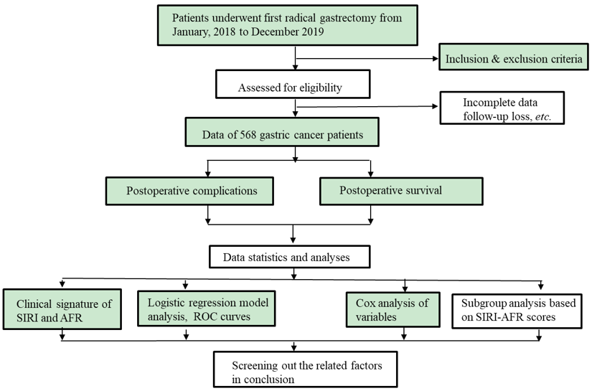
Figure 1 Patient selection flowchart of the present study. AFR: Albumin fibrinogen ratio; ROC: Receiver operating characteristic; SIRI: Systemic inflammatory response index.

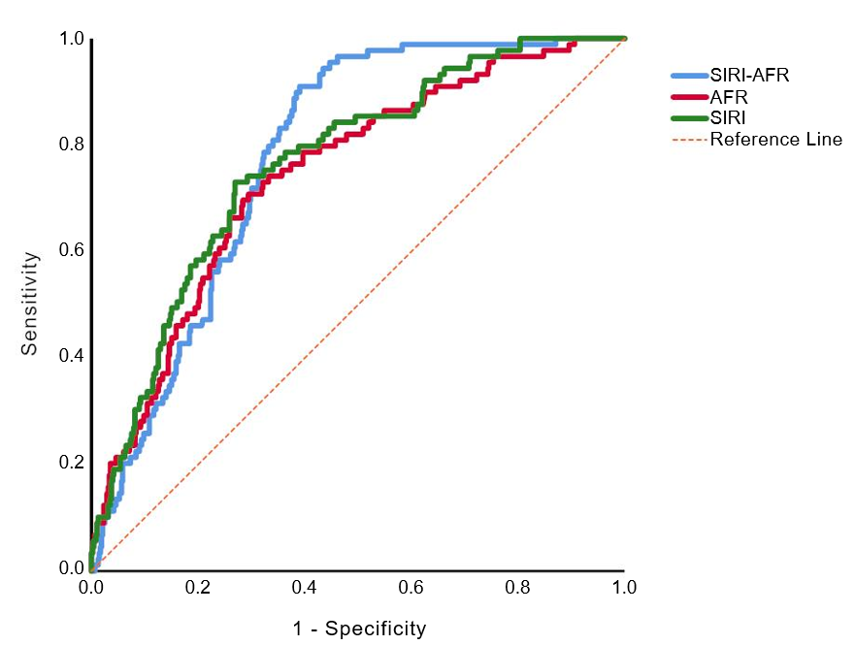
Figure 2 Receiver operating characteristic curve analysis of systemic inflammatory response index, albumin fibrinogen ratio and systemic inflammatory response index combined albumin fibrinogen ratio for early severe postoperative complications in gastric cancer. Systemic inflammatory response index (SIRI): Area under the curve (AUC) = 0.765, 95% confidence interval (CI): 0.714-0.815; albumin fibrinogen ratio (AFR): AUC = 0.743, 95%CI: 0.689-0.797; SIRI-AFR: AUC = 0.779, 95%CI: 0.737-0.820.

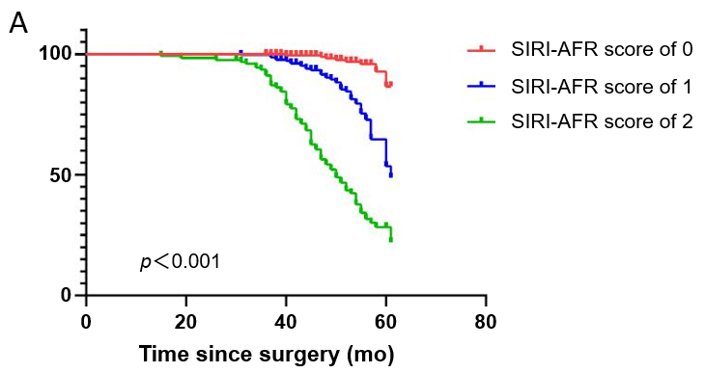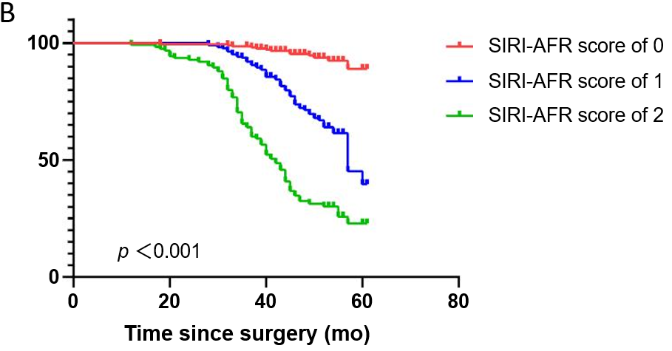
Figure 3 Kaplan-Meier analysis of overall survival and disease-free survival based on the systemic inflammatory response index-albumin fibrinogen ratio score in gastric cancer patients. P value was calculated by the log-rank test. A: Overall survival; B: Disease-free survival. AFR: Albumin fibrinogen ratio; SIRI: Systemic inflammatory response index.
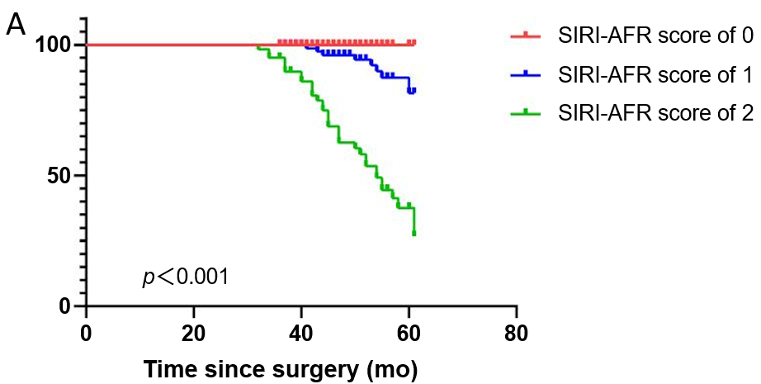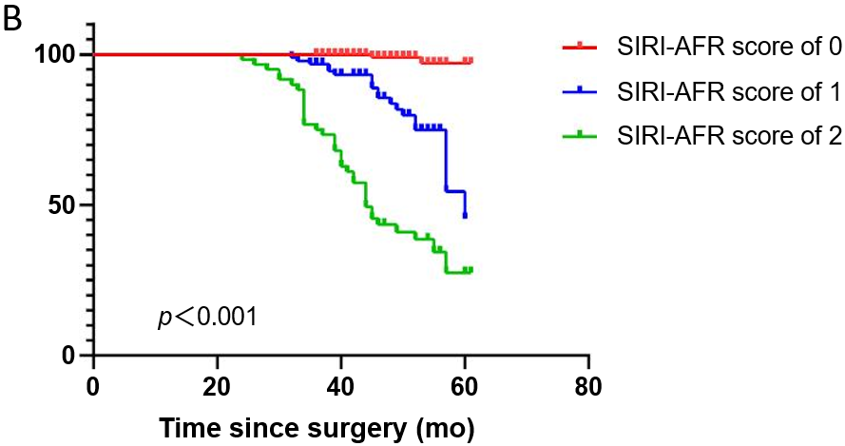
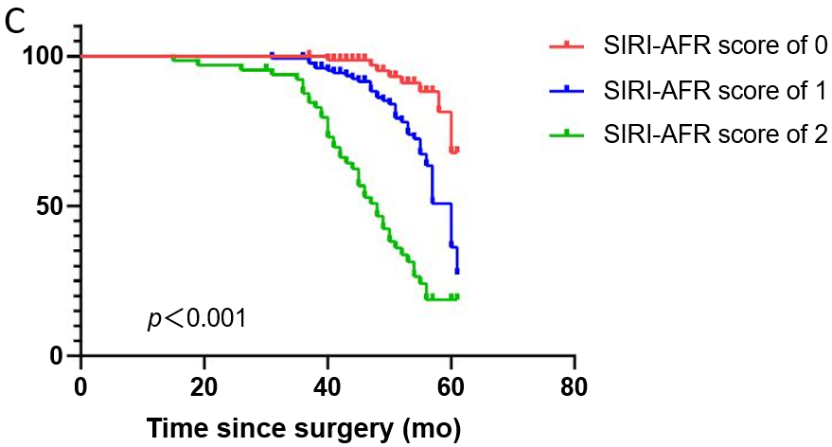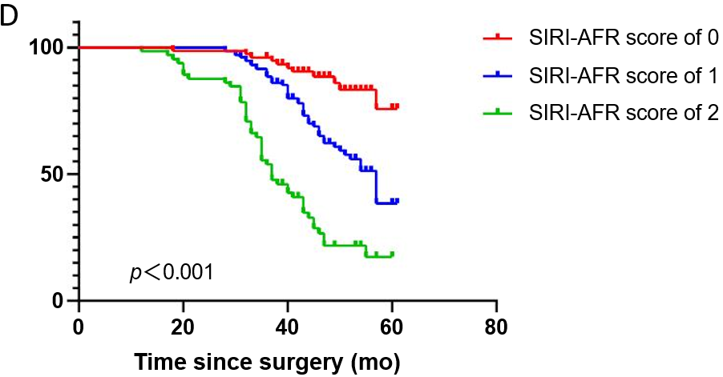
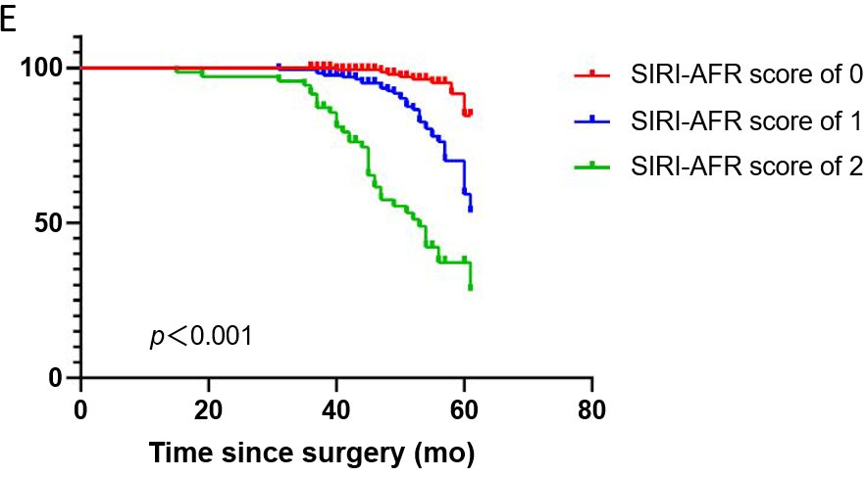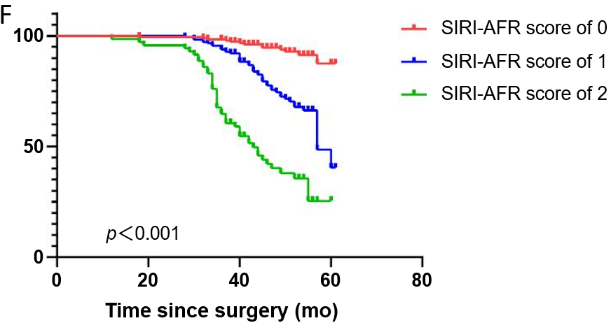
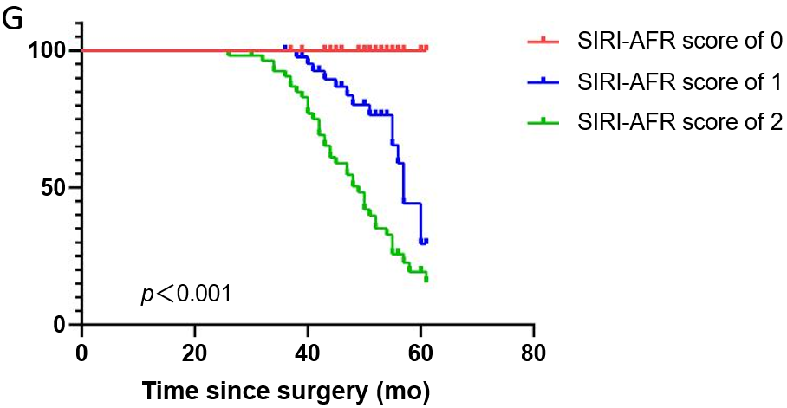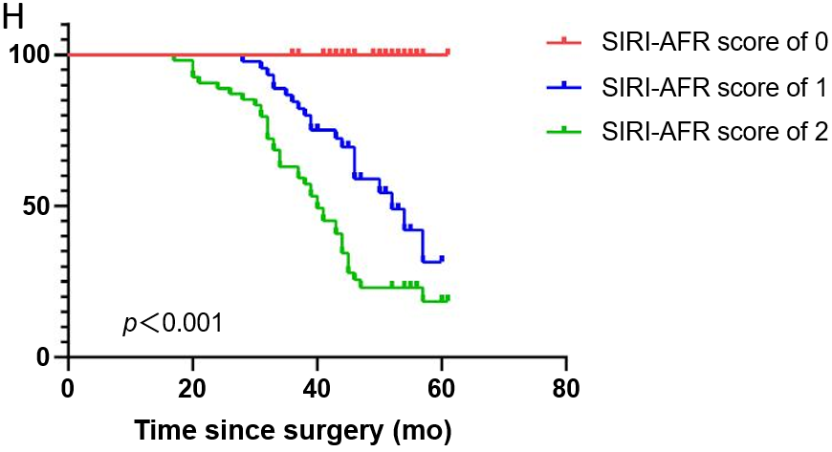
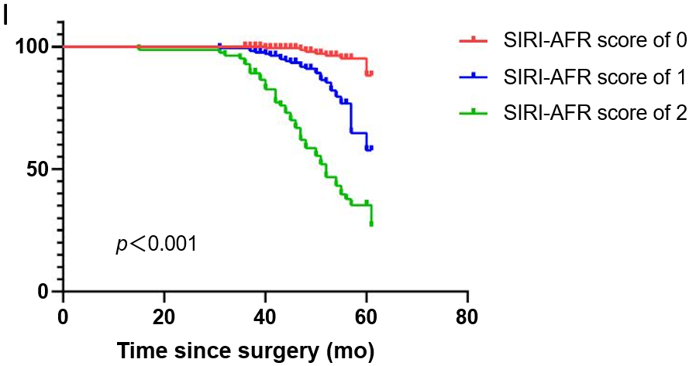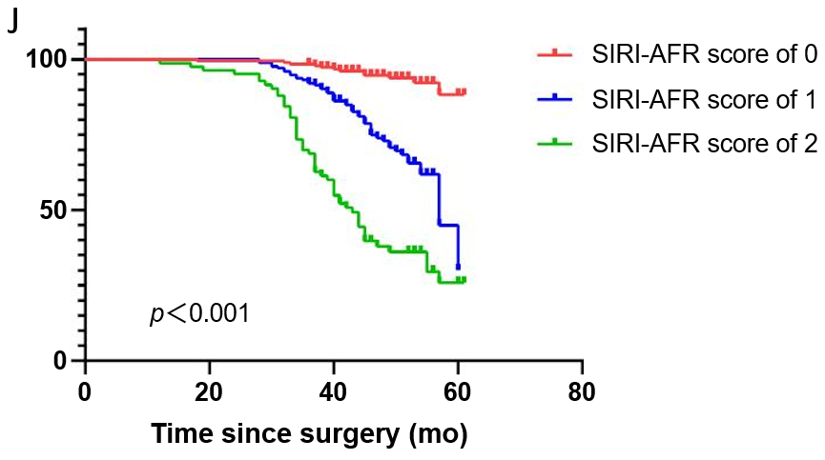
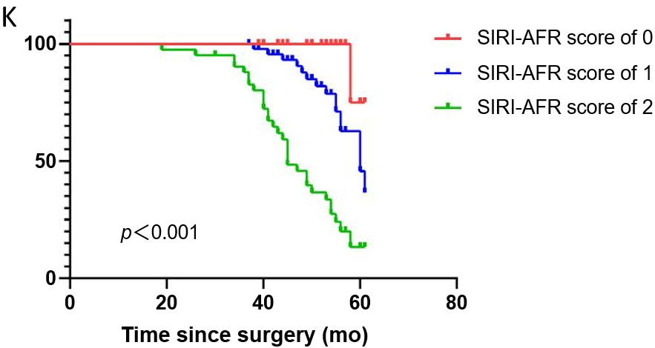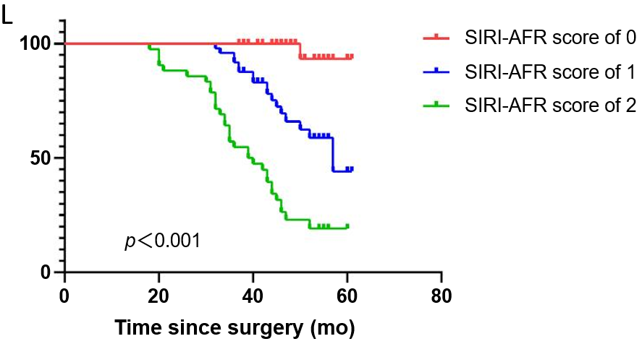
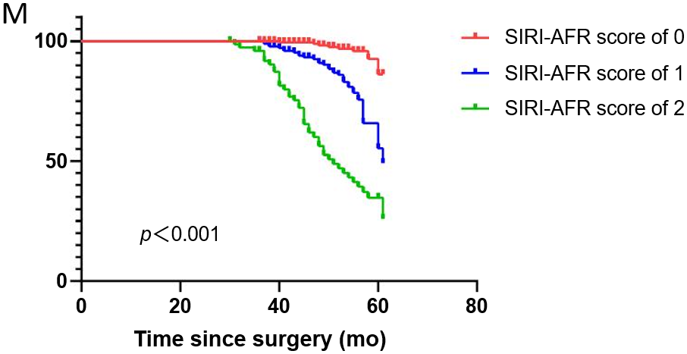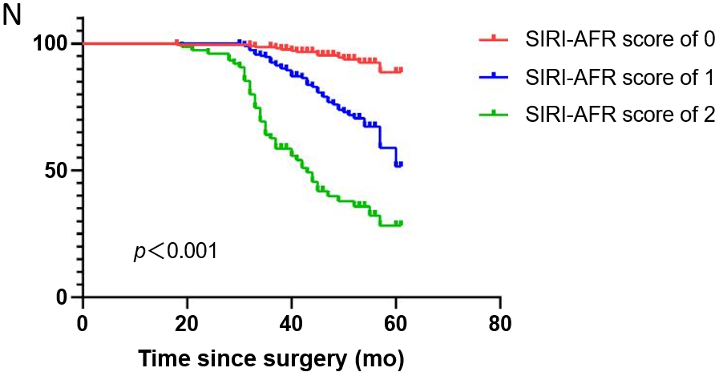
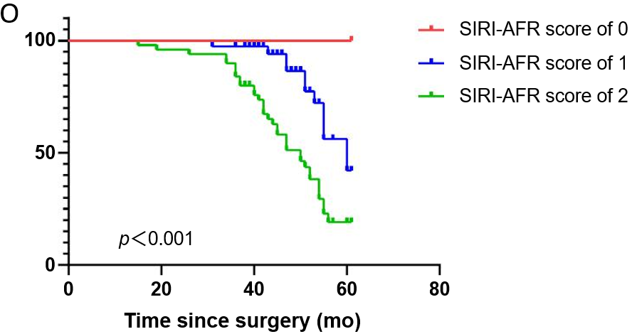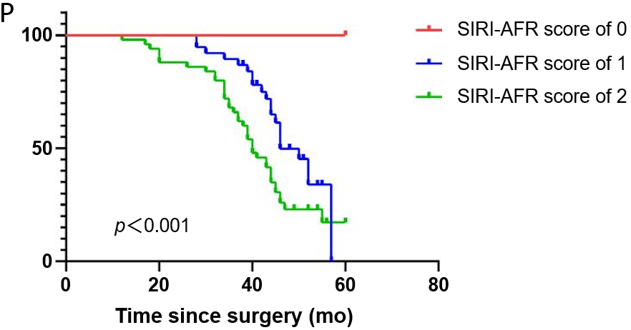
Figure 4 Kaplan-Meier analysis of overall survival and disease-free survival based on the systemic inflammatory response index-albumin fibrinogen ratio score of gastric cancer patients in the subgroup. A and B: Patients with tumor-node-metastasis (TNM) I-II; C and D: Patients with TNM III; E and F: Patient received no perioperative transfusion; G and H: Patient received perioperative transfusion; I and J: Patient negative for carcinoembryonic antigen (CEA); K and L: Patient positive for CEA; M and N: Patient without postoperative major complications; O and P: Patient with postoperative major complications. P value was calculated by the log-rank test. SIRI: Systemic inflammatory response index; AFR: Albumin fibrinogen ratio.

Table 1 Occurrence of short-term postoperative complications in patients after radical gastrectomy
Postoperative complications | n (%)
Enteral nutrition time > 2 wk | 26 (4.58)
Incision infection | 4 (0.70)
Abdominal infection | 160 (28.17)
Pulmonary infection | 70 (12.32)
Pelvic effusion | 6 (1.06)
Abdominal bleeding | 9 (1.58)
Anastomotic fistula | 6 (1.06)
Pyloric or intestinal obstruction | 14 (2.46)
Deep venous thrombosis | 10 (1.76)
Splenic embolism | 1 (0.18)
Pulmonary embolism | 4 (0.70)
Shock | 7 (1.23)

Table 2 Patient baseline characteristics and differences in each variable across subgroups of postoperative complications after respectable gastric cancer
Variables |  | Minor/no complication, n = 479 (84.3%) | Major complication, n = 89 (15.7%) | P value
Sex | Male | 378 (78.9) | 64 (71.9) | 0.144¹
 | Female | 101 (21.1) | 25 (28.1)
Age in yr |  | 59.93 ± 9.66 | 62.19 ± 10.33 | 0.046^{2,a}
Underlying disease | No | 382 (79.7) | 75 (84.3) | 0.323¹
 | Yes | 97 (20.3) | 14 (15.7)
BMI |  | 22.37 ± 3.36 | 21.23 ± 3.28 | 0.003^{2,a}
Tumor location | Upper third | 56 (11.7) | 15 (16.9) | 0.537¹
 | Middle third | 44 (9.2) | 8 (9.0)
 | Lower third | 377 (78.7) | 66 (74.2)
Tumor dimensions in cm | < 3 | 148 (30.9) | 16 (18.0) | 0.014^{1,a}
 | ≥ 3 | 331 (69.1) | 73 (82.0)
Differentiation | Moderate and poor | 460 (96.0) | 86 (96.6) | 1¹
 | Well | 19 (4.0) | 3 (3.4)
TNM stage | I | 106 (22.1) | 13 (14.6) | 0.236¹
 | II | 150 (31.3) | 28 (31.5)
 | III | 223 (46.6) | 48 (53.9)
Surgical approach | Open | 149 (31.1) | 31 (34.8) | 0.539¹
 | Laparoscopic | 190 (39.7) | 37 (41.6)
 | Robot-assisted | 140 (29.2) | 21 (23.6)
Operation | Subtotal gastrectomy | 248 (51.8) | 34 (38.2) | 0.019^{1,a}
 | Total gastrectomy | 231 (48.2) | 55 (61.8)
ASA | I-II | 433 (90.4) | 76 (85.4) | 0.155¹
 | III-IV | 46 (9.6) | 13 (14.6)
Blood loss in mL |  | 100 (100) | 150 (200) | 0.089³
Duration of surgery in min |  | 240 (90) | 250 (85) | 0.079³
Perioperative transfusion | No | 389 (81.2) | 50 (56.2) | < 0.001^{1,a}
 | Yes | 90 (18.8) | 39 (43.8)
Length of hospitalization in d |  | 17.00 (5.00) | 21.00 (8.00) | < 0.001^{3,a}
Lymph node metastasis rate, % |  | 4.02% ± 15.17% | 4.52% ± 14.72% | 0.264²
Lymphocytes as × 10⁹/L |  | 1.44 (0.72) | 1.18 (0.59) | < 0.001^{3,a}
Neutrophils as × 10⁹/L |  | 3.52 (1.76) | 5.03 (1.56) | < 0.001^{3,a}
Platelet as × 10⁹/L |  | 213 (86) | 234 (107) | 0.013^{3,a}
Monocyte as × 10⁹/L |  | 0.39 (0.16) | 0.42 (0.17) | 0.032^{3,a}
Albumin in g/L |  | 39.40 ± 4.36 | 36.60 ± 4.50 | < 0.001^{2,a}
Fibrinogen in g/L |  | 3.39 ± 0.79 | 4.08 ± 1.04 | < 0.001^{2,a}
SIRI |  | 0.95 (0.82) | 1.54 (0.97) | < 0.001^{3,a}
AFR |  | 12.32 ± 3.46 | 9.54 ± 2.68 | < 0.001^{3,a}
CA199 in ng/mL | Negative | 406 (84.8) | 69 (77.5) | 0.090¹
 | Positive | 73 (15.2) | 20 (22.5)
CEA in ng/mL | Negative | 386 (80.6) | 61 (68.5) | 0.011^{1,a}
 | Positive | 93 (19.4) | 28 (31.5)
ªP < 0.05. ¹χ² test; ²Student’s t-test with mean ± standard deviation; ³Mann-Whitney U test with median (interquartile range). AFR: Albumin fibrinogen ratio; ASA: American Society of Anesthesiology; BMI: Body mass index; CA199: Carbohydrate antigen 199; CEA: Carcinoembryonic antigen; SIRI: Systemic inflammation response index; TNM: Tumor-node-metastasis.

Table 3 Differences in preoperative systemic inflammation response index and albumin fibrinogen ratio at varying levels of clinicopathological variables in gastric cancer patients
Variables |  | Preoperative SIRI, median (IQR) | ¹P value | Preoperative AFR, mean ± SD | ²P value
Sex | Male | 1.11 (0.89) | 0.002ª | 11.96 ± 3.68 | 0.252
 | Female | 0.91 (0.87) |  | 11.62 ± 2.77
Age in yr | < 60 | 1.03 (0.86) | 0.038ª | 12.58 ± 3.83 | < 0.001ª
 | ≥ 60 | 1.14 (0.96) |  | 11.26 ± 3.04
Underlying disease | No | 1.07 (0.90) | 0.187 | 11.88 ± 3.55 | 0.989
 | Yes | 1.14 (0.91) |  | 11.89 ± 3.31
BMI | < 24 | 1.06 (0.89) | 0.29 | 11.82 ± 3.60 | 0.464
 | ≥ 24 | 1.15 (0.85) |  | 12.06 ± 3.23
Tumor location | Upper third | 1.17 (1.09) | 0.164 | 11.63 ± 3.09 | 0.695
 | Middle third | 1.00 (0.80) |  | 12.36 ± 3.14
 | Lower third | 1.07 (0.88) |  | 11.88 ± 3.61
Tumor dimensions in cm | < 3 | 0.89 (0.69) | < 0.001ª | 13.44 ± 3.86 | < 0.001ª
 | ≥ 3 | 1.17 (0.92) |  | 11.26 ± 3.13
Differentiation | Moderate and poor | 1.08 (0.90) | 0.235 | 11.80 ± 3.46 | 0.002
 | Well | 0.91 (0.71) |  | 14.11 ± 3.90
TNM stage | I | 0.78 (0.58) | < 0.001ª | 13.70 ± 4.20 | < 0.001ª
 | II | 1.08 (0.93) |  | 11.66 ± 3.41
 | III | 1.20 (0.92) |  | 11.24 ± 2.90
Surgical approach | Open | 1.16 (0.89) | 0.261 | 12.05 ± 3.97 | 0.617
 | Laparoscopic | 1.05 (0.87) |  | 11.90 ± 3.29
 | Robot-assisted | 1.08 (0.97) |  | 11.68 ± 3.22
Operation | Subtotal gastrectomy | 0.97 (0.84) | 0.008ª | 12.10 ± 3.41 | 0.169
 | Total gastrectomy | 1.15 (0.94) |  | 11.67 ± 3.58
ASA | I-II | 1.07 (0.90) | 0.458 | 11.89 ± 3.53 | 0.906
 | III-IV | 1.23 (0.85) |  | 11.83 ± 3.24
Perioperative transfusion | No | 1.02 (0.81) | < 0.001ª | 12.37 ± 3.50 | < 0.001ª
 | Yes | 1.44 (1.20) |  | 10.25 ± 3.00
CA199 in ng/mL | Negative | 1.06 (0.86) | 0.023ª | 12.14 ± 3.16 | 0.001ª
 | Positive | 1.23 (1.17) |  | 10.57 ± 2.83
CEA in ng/mL | Negative | 1.03 (0.83) | < 0.001ª | 12.24 ± 3.59 | < 0.001ª
 | Positive | 1.29 (1.30) |  | 10.58 ± 2.81
Blood loss in mL | < 200 | 1.02 (0.77) | 0.011ª | 12.24 ± 3.63 | 0.013ª
 | 200 ≤ X ≤ 400 | 1.16 (1.02) |  | 11.49 ± 3.32
 | > 400 | 1.25 (0.95) |  | 11.00 ± 3.00
Relapse or metastasis | No | 0.93 (0.82) | < 0.001ª | 12.65 ± 3.35 | < 0.001ª
 | Yes | 1.48 (1.07) |  | 9.40 ± 2.77
P53 | Wild | 1.14 (0.94) | 0.372 | 11.89 ± 3.40 | 0.997
 | Mutant | 1.06 (0.82) |  | 11.89 ± 3.56
Ki-67 | 0%-49% | 0.92 (0.79) | 0.183 | 12.58 ± 3.16 | 0.249
 | 50%-74% | 1.14 (0.79) |  | 11.87 ± 3.30
 | 75%-100% | 1.07 (0.95) |  | 11.76 ± 3.66
Her-2 | Negative | 1.08 (0.91) | 0.795 | 11.88 ± 3.53 | 0.891
 | Positive | 0.98 (0.75) |  | 11.95 ± 3.19
Lymph node metastasis rate, % | < 4.60% | 1.07 (0.90) | 0.471 | 11.95 ± 3.55 | 0.112
 | ≥ 4.60% | 1.20 (0.83) |  | 11.10 ± 2.81
Enteral nutrition time | ≤ 7 d | 1.06 (0.91) | 0.087 | 12.18 ± 3.62 | 0.01ª
 | > 7 d | 1.15 (0.88) |  | 11.40 ± 3.23
ªP < 0.05. ¹P value using Mann-Whitney U test with median (interquartile range). ²P value using Student’s t-test with mean ± standard deviation. AFR: Albumin fibrinogen ratio; ASA: American Society of Anesthesiology; BMI: Body mass index; CA199: Carbohydrate antigen 199; CEA: Carcinoembryonic antigen; IQR: Interquartile range; SD: Standard deviation; SIRI: Systemic inflammation response index; TNM: Tumor-node-metastasis.
Table 4 Univariate and multivariate analyses of the logistic regression model for postoperative complications in patients with gastric cancer
Variables | Univariate analysis |  |  | Multivariate analysis
 | OR | 95%CI | P value | OR | 95%CI | P value
Age in yr | 1.025 | 1.000-1.049 | 0.046ª | 1.011 | 0.984-1.040 | 0.427
BMI | 0.896 | 0.832-0.964 | 0.003ª | 0.939 | 0.864-1.020 | 0.135
Tumor dimensions in cm | 2.04 | 1.148-3.624 | 0.015ª | 0.869 | 0.443-1.706 | 0.684
Operation | 1.737 | 1.092-2.761 | 0.02ª | 1.619 | 0.944-2.777 | 0.080
Perioperative transfusion | 3.371 | 2.091-5.434 | < 0.001ª | 2.095 | 1.179-3.722 | 0.012
CEA in ng/mL | 1.905 | 1.154-3.146 | 0.012ª | 1.268 | 0.711-2.262 | 0.421
Neutrophil count | 1.413 | 1.240-1.609 | < 0.001ª | 2.036 | 1.240-1.609 | < 0.001ª
Monocyte count | 4.092 | 1.005-16.663 | 0.049ª | 10.259 | 0.672-16.609 | 0.086
Lymphocyte count | 0.381 | 0.232-0.626 | < 0.001ª | 0.161 | 0.053-0.493 | 0.001ª
Albumin | 0.876 | 0.833-0.921 | < 0.001ª | 0.956 | 0.898-1.017 | 0.152
Fibrinogen | 2.328 | 0.833-0.921 | < 0.001ª | 1.808 | 1.341-2.439 | < 0.001ª
SIRI | 1.429 | 1.790-3.027 | < 0.001ª | 1.221 | 1.031-1.446 | 0.018ª
AFR | 0.729 | 0.665-0.799 | < 0.001ª | 0.761 | 0.693-0.843 | < 0.001ª
ªP < 0.05. AFR: Albumin fibrinogen ratio; BMI: Body mass index; CEA: Carcinoembryonic antigen; CI: Confidence interval; OR: Odds ratio; SIRI: Systemic inflammation response index.

Table 5 Univariate and multivariate Cox regression analysis for overall survival in gastric cancer patients
Variables |  | Univariate analysis |  |  | Multivariate analysis
 |  | OR | 95%CI | P value | OR | 95%CI | P value
Age in yr |  | 1.024 | 1.005-1.043 | 0.013ª | 1.000 | 0.981-1.020 | 0.964
Tumor dimensions in cm
 | < 3/≥ 3 | 3.143 | 1.932-5.112 | < 0.001ª | 1.335 | 0.778-2.290 | 0.294
Differentiation
 | Moderate and poor/well | 0.144 | 0.020-1.029 | 0.053 | 0.605 | 0.073-5.026 | 0.641
Her-2 | Negative/positive | 0.504 | 0.206-1.231 | 0.133 | 0.583 | 0.230-1.479 | 0.256
TNM stage |  |  |  | < 0.001ª |  |  | < 0.001ª
 | I | Ref |  |  | Ref
 | II | 3.550 | 1.570-8.027 | 0.002ª | 1.777 | 0.665-4.748 | 0.479
 | III | 7.097 | 3.290-15.306 | < 0.001ª | 5.464 | 1.948-15.327 | 0.001ª
Operation time in min |  | 1.003 | 1.001-1.006 | 0.003ª | 1.003 | 1.000-1.005 | 0.055
Perioperative transfusion | No/yes | 2.564 | 1.811-3.629 | < 0.001ª | 1.517 | 1.011-2.277 | 0.044ª
CA199 in ng/mL | Negative/positive | 1.990 | 1.347-2.940 | 0.001ª | 1.184 | 0.776-1.807 | 0.433
CEA in ng/mL | Negative/positive | 2.126 | 1.490-3.034 | < 0.001ª | 1.605 | 1.101-2.338 | 0.014ª
Lymph node metastasis rate, % |  | 1.001 | 0.991-1.012 | 0.790 | 0.990 | 0.979-1.002 | 0.110
Postoperative complication | No or minor/major | 3.498 | 2.434-5.029 | < 0.001ª | 1.450 | 0.956-2.200 | 0.080
Postoperative chemotherapy | No/yes | 1.916 | 1.239-2.963 | 0.003ª | 0.628 | 0.357-1.104 | 0.106
Lymphocytes as × 10⁹/L |  | 0.490 | 0.347-0.692 | < 0.001ª | 0.840 | 0.553-1.1275 | 0.413
Neutrophils as × 10⁹/L |  | 1.240 | 1.152-1.335 | < 0.001ª | 1.075 | 0.357-1.104 | 0.106
Monocyte as × 10⁹/L |  | 7.393 | 2.685-20.351 | < 0.001ª | 0.762 | 0.188-3.086 | 0.703
Albumin in g/L |  | 0.880 | 0.850-0.911 | < 0.001ª | 0.969 | 0.927-1.013 | 0.164
Fibrinogen in g/L |  | 2.063 | 1.792-2.375 | < 0.001ª | 1.415 | 1.111-1.803 | 0.005ª
SIRI |  | 1.190 | 1.117-1.267 | < 0.001ª | 1.036 | 0.764-1.404 | 0.820
AFR |  | 0.727 | 0.681-0.776 | < 0.001ª | 1.059 | 0.858-1.308 | 0.592
SIRI-AFR score |  |  |  |  |  |  | < 0.001ª
 | 0 | Ref |  |  | Ref
 | 1 | 6.034 | 2.964-12.285 | < 0.001ª | 3.134 | 1.445-6.797 | 0.004ª
 | 2 | 20.555 | 10.287-41.071 | < 0.001ª | 5.239 | 2.122-12.935 | < 0.001ª
ªP < 0.05.
AFR: Albumin fibrinogen ratio; CA199: Carbohydrate antigen 199; CEA: Carcinoembryonic antigen; CI: Confidence interval; OR: Odds ratio; SIRI: Systemic inflammation response index; TNM: Tumor-node-metastasis.

Table 6 Univariate and multivariate Cox regression analysis for disease-free survival in gastric cancer patients
Variables |  | Univariate analysis |  |  | Multivariate analysis
 |  | OR | 95%CI | P value | OR | 95%CI | P value
Age in yr |  | 1.026 | 1.009-1.043 | 0.003ª | 1.005 | 0.988-1.022 | 0.589
Tumor dimensions in cm | < 3/≥ 3 | 2.679 | 1.772-4.051 | < 0.001ª | 1.165 | 0.736-1.844 | 0.514
Differentiation | Moderate and poor/well | 0.241 | 0.060-0.974 | 0.046ª | 0.674 | 0.48-3.056 | 0.609
Her-2 | Negative/positive | 2.151 | 0.247-1.123 | 0.097 | 0.563 | 0.258-1.229 | 0.149
TNM stage |  |  |  | < 0.001ª |  |  | < 0.001ª
 | I | Ref |  |  | Ref
 | II | 2.920 | 1.546-5.512 | 0.001ª | 1.726 | 0.774-3.850 | 0.182
 | III | 5.167 | 2.844-9.387 | < 0.001ª | 4.071 | 1.757-9.435 | 0.001ª
Operation time in min |  | 1.003 | 1.001-1.005 | 0.014ª | 1.002 | 0.999-1.004 | 0.201
Perioperative transfusion | No/yes | 2.288 | 1.666-3.141 | < 0.001ª | 1.377 | 0.954-1.989 | 0.088
CA199 in ng/mL | Negative/positive | 1.852 | 1.292-2.653 | 0.001ª | 1.251 | 0.851-1.838 | 0.255
CEA in ng/mL | Negative/positive | 1.780 | 1.280-2.476 | 0.001ª | 1.234 | 0.875-1.741 | 0.231
Lymph node metastasis rate, % |  | 0.998 | 0.988-1.008 | 0.698 | 0.993 | 0.982-1.005 | 0.238
Postoperative complication | No or minor/major | 3.980 | 2.895-5.470 | < 0.001ª | 1.604 | 1.115-2.307 | 0.011ª
Postoperative chemotherapy | No/yes | 1.836 | 1.248-2.702 | 0.002ª | 0.609 | 0.365-1.018 | 0.059
Lymphocytes as × 10⁹/L |  | 0.515 | 0.378-0.703 | < 0.001ª | 0.954 | 0.669-1.359 | 0.792
Neutrophils as × 10⁹/L |  | 1.192 | 1.119-1.269 | < 0.001ª | 1.036 | 0.938-1.144 | 0.484
Monocyte as × 10⁹/L |  | 5.946 | 2.457-14.387 | < 0.001ª | 0.980 | 0.301-3.188 | 0.973
Albumin in g/L |  | 0.884 | 0.857-0.912 | < 0.001ª | 0.959 | 0.920-0.999 | 0.044ª
Fibrinogen in g/L |  | 2.141 | 1.867-2.456 | < 0.001ª | 1.407 | 1.126-1.759 | 0.003ª
SIRI |  | 1.142 | 1.080-1.207 | < 0.001ª | 1.076 | 0.913-1.268 | 0.380
AFR |  | 0.735 | 0.692-0.780 | < 0.001ª | 0.931 | 0.700-1.239 | 0.625
SIRI-AFR score |  |  |  |  |  |  | < 0.001ª
 | 0 | Ref |  |  | Ref
 | 1 | 6.042 | 3.339-10.931 | < 0.001ª | 3.543 | 1.844-6.809 | < 0.001ª
 | 2 | 18.207 | 10.138-32.699 | < 0.001ª | 5.005 | 2.256-11.107 | < 0.001ª
ªP < 0.05. AFR: Albumin fibrinogen ratio; CA199: Carbohydrate antigen 199; CEA: Carcinoembryonic antigen; CI: Confidence interval; OR: Odds ratio; SIRI: Systemic inflammation response index; TNM: Tumor-node-metastasis.

