Name of Journal: World Journal of Gastroenterology
Manuscript NO: 67601
Manuscript Type: MINIREVIEWS

COVID-19 status quo: Emphasis on gastrointestinal and liver manifestations

Bhurwal A et al. GI and liver COVID-19 status quo

Abhishek Bhurwal, Carlos D Minacapelli, Evan Orosz, Kapil Gupta, Christopher Tait, Ishita Dalal, Clark Zhang, Eric Zhao, Vinod K Rustgi

Abhishek Bhurwal, Carlos D Minacapelli, Evan Orosz, Kapil Gupta, Christopher Tait, Ishita Dalal, Vinod K Rustgi, Department of Medicine, Division of Gastroenterology and Hepatology, Rutgers Robert Wood Johnson Medical School, New Brunswick, NJ 08901, United States

Abhishek Bhurwal, Carlos D Minacapelli, Evan Orosz, Kapil Gupta, Christopher Tait, Ishita Dalal, Vinod K Rustgi, Center for Liver Diseases and Masses, Rutgers Robert Wood Johnson School of Medicine, New Brunswick, NJ 08901, United States

Clark Zhang, Eric Zhao, Department of Internal Medicine, Rutgers Robert Wood Johnson Medical School, New Brunswick, NJ 08901, United States

Author contributions: Bhurwal A, Minacapelli CD, Orosz E, Gupta K, Tait C, Dalal I, Zhang C, Zhao E and Rustgi VK were involved in data collection, writing the manuscript, and editing the manuscript.

Corresponding author: Vinod K Rustgi, MD, Professor, Department of Medicine, Division of Gastroenterology and Hepatology, Rutgers Robert Wood Johnson Medical School, 1 Robert Wood Johnson Place Medical Education Building Rm No. 466, New Brunswick, NJ 08901, United States. vr262@rwjms.rutgers.edu

Received: April 28, 2021
Revised: July 23, 2021
Accepted: November 25, 2021
Published online: December 14, 2021

Abstract
The coronavirus disease 2019 (COVID-19) has caused one of the worst public health crises in modern history. Even though severe acute respiratory syndrome coronavirus 2 primarily affects the respiratory tract, gastrointestinal manifestations are well described in literature. This review will discuss the epidemiology, virology, manifestations, immunosuppressant states, and lessons learned from COVID-19. Observations: At the time of writing, COVID-19 had infected more than 111 million people and caused over 2.5 million deaths worldwide. Multiple medical comorbidities including obesity, pre-existing liver condition and the use of proton pump inhibitor have been described as risk factor for severe COVID-19. COVID-19 most frequently causes diarrhea (12.4%), nausea/vomiting (9%) and elevation in liver enzymes (15%-20%). The current data does not suggest that patients on immunomodulators have a significantly increased risk of mortality from COVID-19. The current guidelines from American Gastroenterological Association and American Association for the Study of Liver Diseases do not recommend pre-emptive changes in patients on immunosuppression if the patients have not been infected with COVID-19. Conclusions and relevance: The COVID-19 pandemic has prompted a change in structure and shape of gastroenterology departmental activities. Endoscopy should be performed only when necessary and with strict protective measures. Online consultations in the form of telehealth services and home drug deliveries have revolutionized the field.

Key Words: COVID-19; Status quo; Epidemiology; Virology; Gastrointestinal manifestations; Liver manifestations; Immunosuppressed states

©The Author(s) 2021. Published by Baishideng Publishing Group Inc. All rights reserved.

Citation: Bhurwal A, Minacapelli CD, Orosz E, Gupta K, Tait C, Dalal I, Zhang C, Zhao E, Rustgi VK. COVID-19 status quo: Emphasis on gastrointestinal and liver manifestations. World J Gastroenterol 2021; 27(46): 7969-7981
URL: https://www.wjgnet.com/1007-9327/full/v27/i46/7969.htm
DOI: https://dx.doi.org/10.3748/wjg.v27.i46.7969

Core Tip: The coronavirus disease 2019 (COVID-19) has caused one of the worst public health crises in modern history. Even though severe acute respiratory syndrome coronavirus 2 primarily affects the respiratory tract, gastrointestinal manifestations are well described in literature. This review will discuss the epidemiology, virology, manifestations, immunosuppressant states, and lessons learned from COVID-19.

INTRODUCTION
Coronavirus disease 2019 (COVID-19) is considered one of the fastest expanding pandemics since the Spanish flu of 1918, and one of the most impactful public health crises in modern history. As of February 2021, the coronavirus causing COVID-19, also known as severe acute respiratory syndrome coronavirus 2 (SARS-CoV-2), had infected more than 111 million people and caused over 2.5 million deaths worldwide, including 500000 in the United States^{[1]}.
It is hypothesized that SARS-CoV-2 originated from animal reservoirs and adapted to human-to-human transmission^{[2,3]}. The first cases of severe pneumonia-like conditions were diagnosed in Wuhan, China at the end of 2019^{[4]}. In February 2020, the international virus classification commission termed the novel coronavirus SARS-CoV-2, and its clinical disease was termed COVID-19 by the World Health Organization (WHO) ^{[5,6]}. The case fatality ratio (CFR), defined as the proportion of individuals dying of a disease, was estimated to be up to 3%^{[7]}. Till date, CFR remains the best tool to express the severity of COVID-19 infection among confirmed cases (Table 1). In addition to CFR, many other COVID-19 risk assessment tools have been developed that try to gauge the severity of the novel disease^{[8]} within ethnically diverse populations^{[9]}.
SARS-CoV-2 pathogenesis manifests primarily as a respiratory viral syndrome causing symptoms such as cough, fever, general malaise, dyspnea, and respiratory distress, and in a proportion of cases causes severe pulmonary manifestations with respiratory failure and death^{[10]}. SARS-CoV-2 propagates from the respiratory tract to other organs such as the gastrointestinal (GI) tract and liver^{[10-12]}.
Due to the availability of the genomic sequence of the viral RNA, scientists and researchers have been able to understand the SARS-CoV-2 virus and develop treatment strategies. This review will discuss the epidemiology, virology, manifestations, immunosuppressant states, and lessons learned from COVID-19.

EPIDEMIOLOGY
The high degree of infectivity of the COVID-19 virus is attributed to its novelty in the human host. It can be can be measured by the basic reproduction number or R0, which is a statistical tool used to describe the contagiousness of a virus. It is estimated that the SARS-CoV-2 R0 is between 2 and 3, signifying that each infected person is likely to spread the infection to 2 to 3 additional people^{[13,14]}. The secondary attack rate characterizes the contagiousness of a virus in the close contact setting, which considers how social behaviors may influence transmissibility^{[15,16]}. Jing et al^{[17]} estimated the secondary attack rate of COVID-19 to be 12.4% amongst close relatives and 17.1% amongst those who share the same residential address.
There are many medical comorbidities identified as risk factors for increased COVID-19 severity and mortality. In a summary report from China, pre-existing comorbid conditions increase fatality rate by 10.5% for cardiovascular disease, 7.3% for diabetes, 6.3% for chronic respiratory disease, 6.0% for hypertension, and 5.6% for cancer^{[18]}. In a retrospective cohort study of 403 COVID-19 patients from a racially diverse, urban hospital, Rustgi et al^{[9]} identified chronic kidney disease, hypertension, congestive heart failure, coronary artery disease, malignancy, dementia, cerebrovascular disease, seizures, and COPD to be associated with increased mortality. The centers for disease control (CDC) lists diabetes and BMI as conditions associated with increased risk of severe illness^{[19]}. In an analysis of nearly 300000 COVID-19 cases in the United States, the mortality rate was 12 times as high among patients with reported comorbidities compared to those with none^{[20]}. Understanding the significance of these risk factors can be vital when triaging and treating patients with COVID-19.
Few GI and liver-specific risk factors have also been identified. In a retrospective study of 2780 COVID-19 patients, Galiero et al^{[21]} examined the effect of pre-existing liver disease (including NAFLD, NASH, and cirrhosis) on mortality. Patients with liver disease had a significantly higher risk of mortality. Another gastroenterology-specific risk factor identified is the use of proton pump inhibitors (PPIs). Luxenburger et al^{[22]} reported that in hospitalized patients with COVID-19, the use of a PPI significantly increased the risk of developing secondary infection (48.4% vs 20.0%, P ≤ 0.001), ARDS (27.4% vs 12.2%, P = 0.02), and mortality (19.4% vs 5.6%, P = 0.01)^{[22]}. One proposed mechanism is that PPI use suppresses gastric acid production leading to increased gastric microbiota which, in turn, can lead to micro-aspiration and subsequent bacterial colonization of the lung^{[23]}. In addition, there is growing evidence that PPIs can also modulate immune responses by inhibiting neutrophil function with anti-inflammatory activity^{[24]}.
Age is another notable variable that affects mortality rates with older patients at much higher risk of death. One study in China showed that the mortality rate could be up to 3 times higher in patients who are 80 years or older^{[18]}. Race and ethnicity have also been shown to affect mortality rates, though there is limited literature. Rustgi et al^{[9]} showed that White, Blacks, Asians, and Hispanics all have significantly different mortality rates^{[9]}. In a meta-analysis of more than 3 million reported global cases, male patients compared to females had increased odds of ICU admission (OR, 2.84; 95%CI: 2.06-3.92) and mortality (OR,1.39; 95%CI: 1.31-1.47)^{[25]}. COVID-19 mortality rates also vary significantly by country. For example, France had a CFR of 15.2% whereas Korea had a CFR of 2.1%^{[26]}. Unique delivery systems and healthcare infrastructure in these countries play a major role in influencing COVID-19 mortality.

VIROLOGY
SARS-CoV-2 is an enveloped, positive-sense, single-stranded RNA virus of the Coronaviridae family^{[2]}. The coronaviruses can infect a wide range of vertebrates, including snakes, bats, pangolins, and humans. Sequence similarities with the bat and pangolin coronavirus virus RaTG13 strains suggest that the SARS-CoV-2 has a zoonotic origin^{[2,3,27]}.
Human infection happens by aerosol droplets or carried on fomites. Upon inhalation, the SARS-CoV-2 enters host respiratory cells via the angiotensin-converting enzyme 2 (ACE2) receptor and activating receptors such as the transmembrane protease serine 2 or cathepsin (Figure 1)^{[27,28]}. Viral replication in the infected cells causes immune cells to proliferate and produce large amounts of cytokines and chemokines such as TNF-alpha, interferon-gamma, interleukin 6 (IL-6), IL-8, and IL-10 (Figure 1)^{[28,29]}. This process causes a cascade of inflammatory reactions with toxic damage to the lungs (Figure 2). These mechanisms have also been utilized as targets for therapy. After the initial focus on hydroxychloroquine, emphasis has more recently been on polymerase inhibitors (Remdesivir), binding agents such as convalescent plasma therapy and IL-6 inhibitors such as Tocilizumab^{[30,31]}. Vaccines, such as mRNA-based (Pfizer-BioNTech, Moderna), adenovirus-based (AstraZeneca, Sputnik V, Convidicea, ZF2001), inactivated viral particles (CoronaVac, BBIBP-CorV, Covaxin, CoviVac), non-replicating viral vector (Janssen), and peptide (EpiVacCorona) (Figure 3) are areas of active evolution^{[30-33]}. Adenovirus based intra-nasal COVID vaccines are currently undergoing evaluation via clinical trials. These vaccines with different mechanisms of action trigger immune responses and are of great benefit to systematically stop the COVID-19 pandemic^{[34]}.
GI symptoms such as diarrhea, nausea, vomiting, or abdominal pain have been reported in approximately 10%-15% of COVID-19 patients before, during or after clinical disease^{[28,35]}. Stool samples from infected patients may test positive for the presence of SARS-CoV-2^{[36]}. In vitro studies have demonstrated that enterocyte organoids may harbor and be capable of supporting SARS-CoV-2 replication^{[37]}. In addition, in-vivo reports indicate that viral RNA is detectable by RT-PCR in biopsies from the esophagus, stomach, duodenum, and rectum^{[35]}. These limited studies suggest that the SARS-CoV-2 virus can actively infect and replicate in the GI tract causing direct organ dysfunction.
The liver may suffer injury in 35%-56% of COVID-19 patients as shown by elevated aspartate aminotransferase (AST), alanine aminotransferase (ALT), gamma-glutamyl transpeptidase and/or bilirubin levels^{[12,38,39]}. Interestingly, SARS-CoV-2 RNA sequences have been detected by RT-PCR in liver tissues of infected individuals, suggesting that hepatic injury may be related to direct viral infection^{[40]}. Biopsy findings have demonstrated non-specific inflammatory changes such as hepatocyte swelling and steatosis, mild proliferation of hepatic sinusoid cells, hyperplasia of Kupffer cells and infiltration of lymphocytes^{[41-43]}. SARS-CoV-2 injury in the liver may be mediated by high ACE-2 expression in liver cholangiocytes as well as TROP-2 Liver progenitor cells^{[41]}.
Ischemia-perfusion injury has been reported as a complication of COVID-19 in both the GI and liver and has been more frequently observed in those COVID-19 patients admitted to intensive care units^{[44-46]}. This injury may be due to coagulopathy, vasculopathy, hypoxia and shock caused by COVID-19 and thromboembolic events^{[47-49]}. Under these conditions, there is an increase in reactive oxygen species which, in turn, activate transcription factors and initiate the release of various pro-inflammatory factors that lead to tissue damage (Figure 2)^{[49,50]}.

GI MANIFESTATIONS
GI symptoms are common in COVID-19^{[51]}. The most commonly reported GI manifestations are diarrhea, nausea, vomiting, and abdominal pain^{[52]}. Loss of appetite and dysgeusia have also been described^{[53]}. Viral particles have been isolated in fecal samples suggesting the possibility of fecal transmission of the virus^{[54]}. A minority of patients with positive stool testing lacked GI symptoms suggesting asymptomatic carriage of disease^{[55]}. These findings highlight the importance of fecal-aerosol-mucosal transmission among individuals exposed to contaminated feces, including public toilets or areas with poor sanitation. This provides a concerning avenue for infectious spread in under-developed regions of the globe, including many regions in Africa and South Asia which lack comprehensive wastewater treatment facilities. Disease control guidelines have emphasized effective management and disinfection of potentially contaminated feces in COVID19 patients, and aggressive vaccination programs in areas at higher risk for fecal-oral spread^{[43]}.
Initial case series from China revealed diarrhea as the most prevalent GI symptom, occurring in 2%-36% of cases, followed by nausea (1%-17%), vomiting (1%-6%), and abdominal pain (2%-6%)^{[56]}. As the pandemic has spread, additional reviews and meta-analyses have confirmed the prevalence of GI symptoms in other population groups, although much of the reported data remains from cohorts of Chinese patients. A large meta-analysis of 59254 patients predominantly from the Hubei province (75.8), showed that 9% of all patients experience GI symptoms (Table 2)^{[57]}. A more recent meta-analysis by Tariq et al^{[52]} focused specifically on GI manifestations of disease, including 12797 patients from 11 countries. Of the patients included, 12.4% reported diarrhea and 9% nausea and/or vomiting. Abdominal pain was also reported in 6.2% of patients. Comparative analysis by patient location revealed a significantly higher proportion of symptoms of diarrhea and nausea/vomiting in the non-China subgroup while loss of appetite was similar between groups.
Anosmia and ageusia are frequently reported with important implications. Ageusia was reported in 20% of patients in one recent review while the rates of anosmia varied greatly across studies from 22%-68%^{[53]}. Anosmia and dysgeusia were more likely to be associated with concurrent nausea or loss of appetite (16.9 vs 6.5%, P = 0.006).
GI symptoms generally occur with modest frequency compared with respiratory symptoms and fever; however, there are a small number of patients who present with GI symptoms as the only manifestation of disease^{[58]}. Among these patients with isolated symptoms, there is frequently a more delayed hospital presentation compared to respiratory symptoms (9.0 d vs 7.3 d)^{[59]}. The American Gastroenterological Association (AGA) has recommended COVID-19 testing in patients with new onset GI symptoms as these may precede pulmonary symptoms^{[60]}. Several studies have attempted to correlate GI symptoms with severity of disease and mortality with mixed results. A recent United States-based case-control series of 150 patients with GI symptoms did not demonstrate increased mortality, intubation, or hospital length of stay compared with controls who lacked GI symptoms^{[61]}. This is in contrast to some initial series from China which linked digestive symptoms to longer length of stay^{[62]}. Further investigation into this area is needed.
While critically ill patients still experience many of the same GI symptoms including diarrhea and vomiting, more severe complications noted have included bowel ischemia (3.8%), ileus (55.8%), and Ogilvie-like syndrome (1.9%), as demonstrated in one series of 141 COVID ICU patients(44). A recent review compared GI complications between critically ill patients with COVID and those with non-COVID ARDS and found that the COVID cohort developed more GI complications (74% vs 37%, P < 0.001)^{[63]}. While many symptoms have been identified, data describing the significance of the GI symptoms in predicting disease course and outcomes has been limited, variable, and sometimes contradictory.

COVID-19 AND LIVER MANIFESTATIONS
COVID-19 infection has been shown to directly affect the liver and cause laboratory abnormalities via previously described mechanisms based on abundant ACE2 receptors found on hepatocytes and cholangiocytes to directly enter cells and cause significant liver dysfunction and injury^{[55,63]}. Hospitals in China reported abnormal liver enzymes in approximately 14%-76% of cases hospitalized for COVID-19^{[64,65]}. According to a systematic review and meta-analysis of 47 studies with 10890 total patients with COVID-19, approximately 15% to 20% were identified to have abnormal liver enzymes with a higher prevalence identified in studies performed outside of China (Table 3)^{[60]}.
Hospitalized patients found to have abnormal liver enzymes, may have also shown a higher likelihood of developing severe disease, as well as increased risk of intensive care admission and death^{[57]}. This lack of data has recently prompted the AGA to recommend obtaining baseline liver enzymes and consider monitoring liver enzymes in patients throughout the course of their infection^{[60]}.
Treatments for COVID-19 have been associated with elevated liver enzymes and subsequent injury, most notably with remdesivir use. Remdesivir use in early trials and series was associated with 10%-50% of patients developing transient, mild to moderate (< 5 times upper limit or normal) elevations in AST and ALT within 5 da of therapy. Nine percent of patients in reported trials showed at least moderate elevations, but resolved with discontinuation and were not associated with clinically significant injury. Pharmacology guidelines recommend close monitoring of liver enzymes and early discontinuation of infusions if elevations rise > 10 times the upper limit of normal^{[66,67]}. Dexamethasone remains a treatment for severe COVID-19 infection. It should be acknowledged that prolonged use of corticosteroid therapy can cause hepatic steatosis as well as increase the risk of developing reactivation of latent infections, such as viral hepatitis B.

COVID-19 AND IMMUNOSUPPRESSED STATES
Corticosteroids, immunomodulators (thiopurines, methotrexate) and biologic therapies (such as anti-TNF agents) are frequently used to manage inflammatory bowel disease (IBD), liver transplant recipients and patients with autoimmune hepatitis^{[68]}. These medications block the intracellular signals necessary for host immunity and are associated with high rates of viral and bacterial infections including pneumonia^{[69,70]}. Therefore, it is plausible that immunosuppressed patients would increase the risk of infection with SARS-CoV-2. However, it is also plausible that these medications reduce mortality in COVID-19 by blocking the cytokine storm of SARS-CoV-2^{[71]}. Hence, how a gastroenterologist should handle immunosuppressive therapies in patients with suspected or confirmed COVID-19 is a challenging clinical question.
The SECURE-IBD (Surveillance Epidemiology of Coronavirus Under Research Exclusion – IBD) database consists of reported cases of COVID-19 in IBD patients^{[72]}. The data suggests that the prevalence of severe COVID-19 is low in patients on immunomodulator therapy and biologic therapy; 25% needed hospitalization on immunomodulator monotherapy whereas 19% needed hospitalization while on anti-TNF agents^{[73]}. Fortunately, mortality rates were low with 2% in the immunomodulator monotherapy group and 1% in the anti-TNF cohort^{[72]}. Thus, the AGA recommends that IBD therapies be continued with a goal of maintaining remission and adjustment being made as necessary^{[74]}.
Similar to SECURE-IBD, SECURE-Cirrhosis (Surveillance Epidemiology of Coronavirus Under Research Exclusion - Cirrhosis) is a registry for all COVID-19 cases in patients with chronic liver disease as well as liver transplant recipients^{[75]}. The data from this registry suggests that patients with chronic liver disease but without cirrhosis have a similar risk of mortality from COVID-19 as patients without liver disease. However, patients with cirrhosis have an increased risk with mortality of 32%^{[75,76]}. The data from the registry also suggests that liver transplantation was not associated with an increase in mortality with SARS-CoV-2 infection^{[77]}. The American Association For The Study Of Liver Diseases (AASLD) recommends that anticipatory changes in immunosuppressive regimen should not be made for post-transplant patients and autoimmune patients without COVID-19^{[78]}. In patients on immunosuppression, AASLD recommends lowering the dosages based on the general principles to manage infections in these patients^{[78]}.
In summary, the current data does not suggest that patients on immunomodulators have an increased risk of mortality from COVID-19. The current guidelines from AGA and AASLD do not recommend pre-emptive changes in patients on immunosuppression if the patients have not been infected with COVID-19. However, the dosages may be adjusted in patients with COVID-19 on the basis of general principles^{[74,78]}.

CONCLUSION
The WHO and CDC have developed ongoing recommendations to be followed during the COVID-19 pandemic. The mechanism of injury and cascade of events due to COVID-19 (Figure 2) have been studied in great detail. These have helped develop targets for therapy and vaccines. The current literature does not reveal that immunosuppressed patients are at higher risk of COVID-19 infection^{[74,78]}. However, the impact of the COVID-19 vaccine on specific organs such as liver and GI tract are still uncertain. Further research is necessary to evaluate the long-term effects of the vaccine in relation to GI tract. Despite lack of long-term data, patients and physicians are encouraged to get vaccinated as universal vaccination is of great societal and global benefit.
The pandemic has prompted a change in structure and shape of gastroenterology departmental activities. 27% of the centers in the United States and Canada had implemented routine endotracheal intubation for upper endoscopic procedures^{[79]}. The reshaping has been aimed to address urgent and emergent needs of the community and decreasing patient exposures in the hospital. Most of the practices had altered coverage schedule for the physicians. Strict protective measures during endoscopic procedures such as gowns, gloves, face shields, N95 masks, hairnets, double gloves, shoe covers, have also been implemented^{[79]}. The patients are screened at arrival for symptoms and exposures. During the pandemic, only highly urgent endoscopic procedures are being performed on COVID-19 patients^{[80]}. Endoscopy should be performed only when necessary and in a negative pressure flow room for COVID-19 patients if such a room is available. Where a negative pressure flow room for COVID-19 is not possible, strict sanitation measures are recommended^{[80]}.
Online consultations in the form of telehealth services and home drug deliveries have been important. Virtual clinics have been started by majority of the institutions as chronic digestive diseases can be managed via online consultations. Approximately 96% (70/73) of the practices had adopted telehealth as revealed in the survey of 62 U.S and 11 Canadian Centers in May 2020^{[80]}.
The evaluation of inpatients should be judicious to prevent unnecessary exposure of patients, hospital personnel to COVID-19. Clearly, society as well as healthcare delivery will continue to evolve and adapt for this and future crisis.

REFERENCES
1 World Health Organization. Dashboard WCD. [cited 10 March 2014]. Available from: https://covid19.who.int
2 Andersen KG, Rambaut A, Lipkin WI, Holmes EC, Garry RF. The proximal origin of SARS-CoV-2. Nat Med 2020; 26: 450-452 [PMID: 32284615 DOI: 10.1038/s41591-020-0820-9]
3 Rasmussen AL. On the origins of SARS-CoV-2. Nat Med 2021; 27: 9 [PMID: 33442004 DOI: 10.1038/s41591-020-01205-5]
4 Zhou P, Yang XL, Wang XG, Hu B, Zhang L, Zhang W, Si HR, Zhu Y, Li B, Huang CL, Chen HD, Chen J, Luo Y, Guo H, Jiang RD, Liu MQ, Chen Y, Shen XR, Wang X, Zheng XS, Zhao K, Chen QJ, Deng F, Liu LL, Yan B, Zhan FX, Wang YY, Xiao GF, Shi ZL. A pneumonia outbreak associated with a new coronavirus of probable bat origin. Nature 2020; 579: 270-273 [PMID: 32015507 DOI: 10.1038/s41586-020-2012-7]
5 Zhu N, Zhang D, Wang W, Li X, Yang B, Song J, Zhao X, Huang B, Shi W, Lu R, Niu P, Zhan F, Ma X, Wang D, Xu W, Wu G, Gao GF, Tan W; China Novel Coronavirus Investigating and Research Team. A Novel Coronavirus from Patients with Pneumonia in China, 2019. N Engl J Med 2020; 382: 727-733 [PMID: 31978945 DOI: 10.1056/NEJMoa2001017]
6 Coronaviridae Study Group of the International Committee on Taxonomy of Viruses. The species Severe acute respiratory syndrome-related coronavirus: classifying 2019-nCoV and naming it SARS-CoV-2. Nat Microbiol 2020; 5: 536-544 [PMID: 32123347 DOI: 10.1038/s41564-020-0695-z]
7 Spychalski P, Błażyńska-Spychalska A, Kobiela J. Estimating case fatality rates of COVID-19. Lancet Infect Dis 2020; 20: 774-775 [PMID: 32243815 DOI: 10.1016/S1473-3099(20)30246-2]
8 Liang W, Liang H, Ou L, Chen B, Chen A, Li C, Li Y, Guan W, Sang L, Lu J, Xu Y, Chen G, Guo H, Guo J, Chen Z, Zhao Y, Li S, Zhang N, Zhong N, He J; China Medical Treatment Expert Group for COVID-19. Development and Validation of a Clinical Risk Score to Predict the Occurrence of Critical Illness in Hospitalized Patients With COVID-19. JAMA Intern Med 2020; 180: 1081-1089 [PMID: 32396163 DOI: 10.1001/jamainternmed.2020.2033]
9 Rustgi V, Makar M, Minacapelli CD, Gupta K, Bhurwal A, Li Y, Catalano C, Panettieri R. In-Hospital Mortality and Prediction in an Urban U.S. Population With COVID-19. Cureus 2020; 12: e11786 [PMID: 33409033 DOI: 10.7759/cureus.11786]
10 Lai CC, Ko WC, Lee PI, Jean SS, Hsueh PR. Extra-respiratory manifestations of COVID-19. Int J Antimicrob Agents 2020; 56: 106024 [PMID: 32450197 DOI: 10.1016/j.ijantimicag.2020.106024]
11 Gulati A, Pomeranz C, Qamar Z, Thomas S, Frisch D, George G, Summer R, DeSimone J, Sundaram B. A Comprehensive Review of Manifestations of Novel Coronaviruses in the Context of Deadly COVID-19 Global Pandemic. Am J Med Sci 2020; 360: 5-34 [PMID: 32620220 DOI: 10.1016/j.amjms.2020.05.006]
12 Makar M, John Pisano T, Minacapelli CD, Rustgi V. Gastrointestinal Findings in a Patient With COVID-19. ACG Case Rep J 2020; 7: e00392 [PMID: 32637437 DOI: 10.14309/crj.0000000000000392]
13 Delamater PL, Street EJ, Leslie TF, Yang YT, Jacobsen KH. Complexity of the Basic Reproduction Number (R₀). Emerg Infect Dis 2019; 25: 1-4 [PMID: 30560777 DOI: 10.3201/eid2501.171901]
14 Sharma V DU. Epidemiology of COVID-19: Implications for a Gastroenterologist. J Digest Endosc 2020; 11: 8-12 [DOI: 10.1055/s-0040-1712549]
15 Dhar Chowdhury S, Oommen AM. Epidemiology of COVID-19. J Digest Endosc 2020; 11: 3-7 [DOI: 10.1055/s-0040-1712187]
16 Center of Diease Control and Prevention. An Introduction to Applied Epidemiology and Biostatistics. Lesson 3: Measures of Risk. In: Principles of Epidemiology in Public Health Practice. 3th ed. U.S. Department of Health & Human Services, 2012
17 Jing QL, Liu MJ, Zhang ZB, Fang LQ, Yuan J, Zhang AR, Dean NE, Luo L, Ma MM, Longini I, Kenah E, Lu Y, Ma Y, Jalali N, Yang ZC, Yang Y. Household secondary attack rate of COVID-19 and associated determinants in Guangzhou, China: a retrospective cohort study. Lancet Infect Dis 2020; 20: 1141-1150 [PMID: 32562601 DOI: 10.1016/S1473-3099(20)30471-0]
18 Wu Z, McGoogan JM. Characteristics of and Important Lessons From the Coronavirus Disease 2019 (COVID-19) Outbreak in China: Summary of a Report of 72 314 Cases From the Chinese Center for Disease Control and Prevention. JAMA 2020; 323: 1239-1242 [PMID: 32091533 DOI: 10.1001/jama.2020.2648]
19 Centers for Disease Control and Prevention. COVID-19. Your Health. People with Certain Medical Conditions. [cited 10 March 2014]. Available from: https://www.cdc.gov/coronavirus/2019-ncov/need-extra-precautions/people-with-medical-conditions.html
20 Stokes EK, Zambrano LD, Anderson KN, Marder EP, Raz KM, El Burai Felix S, Tie Y, Fullerton KE. Coronavirus Disease 2019 Case Surveillance - United States, January 22-May 30, 2020. MMWR Morb Mortal Wkly Rep 2020; 69: 759-765 [PMID: 32555134 DOI: 10.15585/mmwr.mm6924e2]
21 Galiero R, Pafundi PC, Simeon V, Rinaldi L, Perrella A, Vetrano E, Caturano A, Alfano M, Beccia D, Nevola R, Marfella R, Sardu C, Coppola C, Scarano F, Maggi P, De Lucia Sposito P, Vocciante L, Rescigno C, Sbreglia C, Fraganza F, Parrella R, Romano A, Calabria G, Polverino B, Pagano A, Bologna C, Amitrano M, Esposito V, Coppola N, Maturo N, Adinolfi LE, Chiodini P, Sasso FC; COVOCA Study Group. Impact of chronic liver disease upon admission on COVID-19 in-hospital mortality: Findings from COVOCA study. PLoS One 2020; 15: e0243700 [PMID: 33301529 DOI: 10.1371/journal.pone.0243700]
22 Luxenburger H, Sturm L, Biever P, Rieg S, Duerschmied D, Schultheiss M, Neumann-Haefelin C, Thimme R, Bettinger D. Treatment with proton pump inhibitors increases the risk of secondary infections and ARDS in hospitalized patients with COVID-19: coincidence or underestimated risk factor? J Intern Med 2021; 289: 121-124 [PMID: 32608546 DOI: 10.1111/joim.13121]
23 Corsonello A, Lattanzio F, Bustacchini S, Garasto S, Cozza A, Schepisi R, Lenci F, Luciani F, Maggio MG, Ticinesi A, Butto V, Tagliaferri S, Corica F. Adverse Events of Proton Pump Inhibitors: Potential Mechanisms. Curr Drug Metab 2018; 19: 142-154 [PMID: 29219052 DOI: 10.2174/1389200219666171207125351]
24 Namazi MR, Jowkar F. A succinct review of the general and immunological pharmacologic effects of proton pump inhibitors. J Clin Pharm Ther 2008; 33: 215-217 [PMID: 18452407 DOI: 10.1111/j.1365-2710.2008.00907.x]
25 Peckham H, de Gruijter NM, Raine C, Radziszewska A, Ciurtin C, Wedderburn LR, Rosser EC, Webb K, Deakin CT. Male sex identified by global COVID-19 meta-analysis as a risk factor for death and ITU admission. Nat Commun 2020; 11: 6317 [PMID: 33298944 DOI: 10.1038/s41467-020-19741-6]
26 Bulut C, Kato Y. Epidemiology of COVID-19. Turk J Med Sci 2020; 50: 563-570 [PMID: 32299206 DOI: 10.3906/sag-2004-172]
27 Wrobel AG, Benton DJ, Xu P, Roustan C, Martin SR, Rosenthal PB, Skehel JJ, Gamblin SJ. SARS-CoV-2 and bat RaTG13 spike glycoprotein structures inform on virus evolution and furin-cleavage effects. Nat Struct Mol Biol 2020; 27: 763-767 [PMID: 32647346 DOI: 10.1038/s41594-020-0468-7]
28 Trypsteen W, Van Cleemput J, Snippenberg WV, Gerlo S, Vandekerckhove L. On the whereabouts of SARS-CoV-2 in the human body: A systematic review. PLoS Pathog 2020; 16: e1009037 [PMID: 33125439 DOI: 10.1371/journal.ppat.1009037]
29 Xu ZS, Shu T, Kang L, Wu D, Zhou X, Liao BW, Sun XL, Zhou X, Wang YY. Temporal profiling of plasma cytokines, chemokines and growth factors from mild, severe and fatal COVID-19 patients. Signal Transduct Target Ther 2020; 5: 100 [PMID: 32561706 DOI: 10.1038/s41392-020-0211-1]
30 Bansal V, Mahapure KS, Bhurwal A, Gupta I, Hassanain S, Makadia J, Madas N, Armaly P, Singh R, Mehra I, O'Horo JC, Kashyap R. Mortality Benefit of Remdesivir in COVID-19: A Systematic Review and Meta-Analysis. Front Med (Lausanne) 2020; 7: 606429 [PMID: 33585508 DOI: 10.3389/fmed.2020.606429]
31 Janiaud P, Axfors C, Schmitt AM, Gloy V, Ebrahimi F, Hepprich M, Smith ER, Haber NA, Khanna N, Moher D, Goodman SN, Ioannidis JPA, Hemkens LG. Association of Convalescent Plasma Treatment With Clinical Outcomes in Patients With COVID-19: A Systematic Review and Meta-analysis. JAMA 2021; 325: 1185-1195 [PMID: 33635310 DOI: 10.1001/jama.2021.2747]
32 Ghazy RM, Almaghraby A, Shaaban R, Kamal A, Beshir H, Moursi A, Ramadan A, Taha SHN. A systematic review and meta-analysis on chloroquine and hydroxychloroquine as monotherapy or combined with azithromycin in COVID-19 treatment. Sci Rep 2020; 10: 22139 [PMID: 33335141 DOI: 10.1038/s41598-020-77748-x]
33 Forni G, Mantovani A; COVID-19 Commission of Accademia Nazionale dei Lincei, Rome. COVID-19 vaccines: where we stand and challenges ahead. Cell Death Differ 2021; 28: 626-639 [PMID: 33479399 DOI: 10.1038/s41418-020-00720-9]
34 Deplanque D, Launay O. Efficacy of COVID-19 vaccines: From clinical trials to real life. Therapie 2021; 76: 277-283 [PMID: 34049688 DOI: 10.1016/j.therap.2021.05.004]
35 Lin L, Jiang X, Zhang Z, Huang S, Zhang Z, Fang Z, Gu Z, Gao L, Shi H, Mai L, Liu Y, Lin X, Lai R, Yan Z, Li X, Shan H. Gastrointestinal symptoms of 95 cases with SARS-CoV-2 infection. Gut 2020; 69: 997-1001 [PMID: 32241899 DOI: 10.1136/gutjnl-2020-321013]
36 Han C, Duan C, Zhang S, Spiegel B, Shi H, Wang W, Zhang L, Lin R, Liu J, Ding Z, Hou X. Digestive Symptoms in COVID-19 Patients With Mild Disease Severity: Clinical Presentation, Stool Viral RNA Testing, and Outcomes. Am J Gastroenterol 2020; 115: 916-923 [PMID: 32301761 DOI: 10.14309/ajg.0000000000000664]
37 Lamers MM, Beumer J, van der Vaart J, Knoops K, Puschhof J, Breugem TI, Ravelli RBG, Paul van Schayck J, Mykytyn AZ, Duimel HQ, van Donselaar E, Riesebosch S, Kuijpers HJH, Schipper D, van de Wetering WJ, de Graaf M, Koopmans M, Cuppen E, Peters PJ, Haagmans BL, Clevers H. SARS-CoV-2 productively infects human gut enterocytes. Science 2020; 369: 50-54 [PMID: 32358202 DOI: 10.1126/science.abc1669]
38 Wang Q, Zhao H, Liu LG, Wang YB, Zhang T, Li MH, Xu YL, Gao GJ, Xiong HF, Fan Y, Cao Y, Ding R, Wang JJ, Cheng C, Xie W. Pattern of liver injury in adult patients with COVID-19: a retrospective analysis of 105 patients. Mil Med Res 2020; 7: 28 [PMID: 32507110 DOI: 10.1186/s40779-020-00256-6]
39 Fan Z, Chen L, Li J, Cheng X, Yang J, Tian C, Zhang Y, Huang S, Liu Z, Cheng J. Clinical Features of COVID-19-Related Liver Functional Abnormality. Clin Gastroenterol Hepatol 2020; 18: 1561-1566 [PMID: 32283325 DOI: 10.1016/j.cgh.2020.04.002]
40 Cheung CCL, Goh D, Lim X, Tien TZ, Lim JCT, Lee JN, Tan B, Tay ZEA, Wan WY, Chen EX, Nerurkar SN, Loong S, Cheow PC, Chan CY, Koh YX, Tan TT, Kalimuddin S, Tai WMD, Ng JL, Low JG, Yeong J, Lim KH. Residual SARS-CoV-2 viral antigens detected in GI and hepatic tissues from five recovered patients with COVID-19. Gut 2021 [PMID: 34083386 DOI: 10.1136/gutjnl-2021-324280]
41 Tian D, Ye Q. Hepatic complications of COVID-19 and its treatment. J Med Virol 2020; 92: 1818-1824 [PMID: 32437004 DOI: 10.1002/jmv.26036]
42 Xu Z, Shi L, Wang Y, Zhang J, Huang L, Zhang C, Liu S, Zhao P, Liu H, Zhu L, Tai Y, Bai C, Gao T, Song J, Xia P, Dong J, Zhao J, Wang FS. Pathological findings of COVID-19 associated with acute respiratory distress syndrome. Lancet Respir Med 2020; 8: 420-422 [PMID: 32085846 DOI: 10.1016/S2213-2600(20)30076-X]
43 Song M, Li ZL, Zhou YJ, Tian G, Ye T, Zeng ZR, Deng J, Wan H, Li Q, Liu JB. Gastrointestinal involvement of COVID-19 and potential faecal transmission of SARS-CoV-2. J Zhejiang Univ Sci B 2020; 21: 749-751 [PMID: 32893532 DOI: 10.1631/jzus.B2000253]
44 Kaafarani HMA, El Moheb M, Hwabejire JO, Naar L, Christensen MA, Breen K, Gaitanidis A, Alser O, Mashbari H, Bankhead-Kendall B, Mokhtari A, Maurer L, Kapoen C, Langeveld K, El Hechi MW, Lee J, Mendoza AE, Saillant NN, Parks J, Fawley J, King DR, Fagenholz PJ, Velmahos GC. Gastrointestinal Complications in Critically Ill Patients With COVID-19. Ann Surg 2020; 272: e61-e62 [PMID: 32675498 DOI: 10.1097/SLA.0000000000004004]
45 Hu LL, Wang WJ, Zhu QJ, Yang L. [Novel coronavirus pneumonia-related liver injury: etiological analysis and treatment strategy]. Zhonghua Gan Zang Bing Za Zhi 2020; 28: 97-99 [PMID: 32075364 DOI: 10.3760/cma.j.issn.1007-3418.2020.02.001]
46 Yang L, Wang W, Wang X, Zhao J, Xiao L, Gui W, Fan H, Xia J, Li Z, Yan J, Alasbahi A, Zhu Q, Hou X. Creg in Hepatocytes Ameliorates Liver Ischemia/Reperfusion Injury in a TAK1-Dependent Manner in Mice. Hepatology 2019; 69: 294-313 [PMID: 30076625 DOI: 10.1002/hep.30203]
47 Keshavarz P, Rafiee F, Kavandi H, Goudarzi S, Heidari F, Gholamrezanezhad A. Ischemic gastrointestinal complications of COVID-19: a systematic review on imaging presentation. Clin Imaging 2021; 73: 86-95 [PMID: 33341452 DOI: 10.1016/j.clinimag.2020.11.054]
48 Connors JM, Levy JH. COVID-19 and its implications for thrombosis and anticoagulation. Blood 2020; 135: 2033-2040 [PMID: 32339221 DOI: 10.1182/blood.2020006000]
49 Zhao JN, Fan Y, Wu SD. Liver injury in COVID-19: A minireview. World J Clin Cases 2020; 8: 4303-4310 [PMID: 33083389 DOI: 10.12998/wjcc.v8.i19.4303]
50 Zhang XJ, Cheng X, Yan ZZ, Fang J, Wang X, Wang W, Liu ZY, Shen LJ, Zhang P, Wang PX, Liao R, Ji YX, Wang JY, Tian S, Zhu XY, Zhang Y, Tian RF, Wang L, Ma XL, Huang Z, She ZG, Li H. An ALOX12-12-HETE-GPR31 signaling axis is a key mediator of hepatic ischemia-reperfusion injury. Nat Med 2018; 24: 73-83 [PMID: 29227475 DOI: 10.1038/nm.4451]
51 Cha MH, Regueiro M, Sandhu DS. Gastrointestinal and hepatic manifestations of COVID-19: A comprehensive review. World J Gastroenterol 2020; 26: 2323-2332 [PMID: 32476796 DOI: 10.3748/wjg.v26.i19.2323]
52 Tariq R, Saha S, Furqan F, Hassett L, Pardi D, Khanna S. Prevalence and Mortality of COVID-19 Patients With Gastrointestinal Symptoms: A Systematic Review and Meta-analysis. Mayo Clin Proc 2020; 95: 1632-1648 [PMID: 32753138 DOI: 10.1016/j.mayocp.2020.06.003]
53 Carrillo-Larco RM, Altez-Fernandez C. Anosmia and dysgeusia in COVID-19: A systematic review. Wellcome Open Res 2020; 5: 94 [PMID: 32587902 DOI: 10.12688/wellcomeopenres.15917.1]
54 Tian Y, Rong L, Nian W, He Y. Review article: gastrointestinal features in COVID-19 and the possibility of faecal transmission. Aliment Pharmacol Ther 2020; 51: 843-851 [PMID: 32222988 DOI: 10.1111/apt.15731]
55 Zhang J, Wang S, Xue Y. Fecal specimen diagnosis 2019 novel coronavirus-infected pneumonia. J Med Virol 2020; 92: 680-682 [PMID: 32124995 DOI: 10.1002/jmv.25742]
56 Wong SH, Lui RN, Sung JJ. Covid-19 and the digestive system. J Gastroenterol Hepatol 2020; 35: 744-748 [PMID: 32215956 DOI: 10.1111/jgh.15047]
57 Borges do Nascimento IJ, Cacic N, Abdulazeem HM, von Groote TC, Jayarajah U, Weerasekara I, Esfahani MA, Civile VT, Marusic A, Jeroncic A, Carvas Junior N, Pericic TP, Zakarija-Grkovic I, Meirelles Guimarães SM, Luigi Bragazzi N, Bjorklund M, Sofi-Mahmudi A, Altujjar M, Tian M, Arcani DMC, O'Mathúna DP, Marcolino MS. Novel Coronavirus Infection (COVID-19) in Humans: A Scoping Review and Meta-Analysis. J Clin Med 2020; 9: 941 [PMID: 32235486 DOI: 10.3390/jcm9040941]
58 Liang W, Feng Z, Rao S, Xiao C, Xue X, Lin Z, Zhang Q, Qi W. Diarrhoea may be underestimated: a missing link in 2019 novel coronavirus. Gut 2020; 69: 1141-1143 [PMID: 32102928 DOI: 10.1136/gutjnl-2020-320832]
59 Patel KP, Patel PA, Vunnam RR, Hewlett AT, Jain R, Jing R, Vunnam SR. Gastrointestinal, hepatobiliary, and pancreatic manifestations of COVID-19. J Clin Virol 2020; 128: 104386 [PMID: 32388469 DOI: 10.1016/j.jcv.2020.104386]
60 Sultan S, Altayar O, Siddique SM, Davitkov P, Feuerstein JD, Lim JK, Falck-Ytter Y, El-Serag HB; AGA Institute. Electronic address: ewilson@gastro.org. AGA Institute Rapid Review of the Gastrointestinal and Liver Manifestations of COVID-19, Meta-Analysis of International Data, and Recommendations for the Consultative Management of Patients with COVID-19. Gastroenterology 2020; 159: 320-334.e27 [PMID: 32407808 DOI: 10.1053/j.gastro.2020.05.001]
61 Ramachandran P, Onukogu I, Ghanta S, Gajendran M, Perisetti A, Goyal H, Aggarwal A. Gastrointestinal Symptoms and Outcomes in Hospitalized Coronavirus Disease 2019 Patients. Dig Dis 2020; 38: 373-379 [PMID: 32599601 DOI: 10.1159/000509774]
62 El Moheb M, Naar L, Christensen MA, Kapoen C, Maurer LR, Farhat M, Kaafarani HMA. Gastrointestinal Complications in Critically Ill Patients With and Without COVID-19. JAMA 2020; 324: 1899-1901 [PMID: 32970139 DOI: 10.1001/jama.2020.19400]
63 Zhang C, Shi L, Wang FS. Liver injury in COVID-19: management and challenges. Lancet Gastroenterol Hepatol 2020; 5: 428-430 [PMID: 32145190 DOI: 10.1016/S2468-1253(20)30057-1]
64 Xu L, Liu J, Lu M, Yang D, Zheng X. Liver injury during highly pathogenic human coronavirus infections. Liver Int 2020; 40: 998-1004 [PMID: 32170806 DOI: 10.1111/liv.14435]
65 Cai Q, Huang D, Yu H, Zhu Z, Xia Z, Su Y, Li Z, Zhou G, Gou J, Qu J, Sun Y, Liu Y, He Q, Chen J, Liu L, Xu L. COVID-19: Abnormal liver function tests. J Hepatol 2020; 73: 566-574 [PMID: 32298767 DOI: 10.1016/j.jhep.2020.04.006]
66 Agarwal A, Chen A, Ravindran N, To C, Thuluvath PJ. Gastrointestinal and Liver Manifestations of COVID-19. J Clin Exp Hepatol 2020; 10: 263-265 [PMID: 32405183 DOI: 10.1016/j.jceh.2020.03.001]
67 LiverTox: Clinical and Research Information on Drug-Induced Liver Injury. Bethesda (MD): National Institute of Diabetes and Digestive and Kidney Diseases, 2012 [PMID: 31643176]
68 Torres J, Mehandru S, Colombel JF, Peyrin-Biroulet L. Crohn's disease. Lancet 2017; 389: 1741-1755 [PMID: 27914655 DOI: 10.1016/S0140-6736(16)31711-1]
69 Lichtenstein GR, Loftus EV, Isaacs KL, Regueiro MD, Gerson LB, Sands BE. ACG Clinical Guideline: Management of Crohn's Disease in Adults. Am J Gastroenterol 2018; 113: 481-517 [PMID: 29610508 DOI: 10.1038/ajg.2018.27]
70 Kirchgesner J, Lemaitre M, Carrat F, Zureik M, Carbonnel F, Dray-Spira R. Risk of Serious and Opportunistic Infections Associated With Treatment of Inflammatory Bowel Diseases. Gastroenterology 2018; 155: 337-346.e10 [PMID: 29655835 DOI: 10.1053/j.gastro.2018.04.012]
71 Long MD, Martin C, Sandler RS, Kappelman MD. Increased risk of pneumonia among patients with inflammatory bowel disease. Am J Gastroenterol 2013; 108: 240-248 [PMID: 23295276 DOI: 10.1038/ajg.2012.406]
72 Current Data. Secure-IBD database. [cited 10 January 2021]. Available from: https://covidibd.org/current-data/
73 Maude SL, Barrett D, Teachey DT, Grupp SA. Managing cytokine release syndrome associated with novel T cell-engaging therapies. Cancer J 2014; 20: 119-122 [PMID: 24667956 DOI: 10.1097/PPO.0000000000000035]
74 Rubin DT, Feuerstein JD, Wang AY, Cohen RD. AGA Clinical Practice Update on Management of Inflammatory Bowel Disease During the COVID-19 Pandemic: Expert Commentary. Gastroenterology 2020; 159: 350-357 [PMID: 32283100 DOI: 10.1053/j.gastro.2020.04.012]
75 SECURE-Liver Registry. SECURE-Cirrhosis. [cited 10 January 2021]. Available from: https://covidcirrhosis.web.unc.edu/
76 Marjot T, Moon AM, Cook JA, Abd-Elsalam S, Aloman C, Armstrong MJ, Pose E, Brenner EJ, Cargill T, Catana MA, Dhanasekaran R, Eshraghian A, García-Juárez I, Gill US, Jones PD, Kennedy J, Marshall A, Matthews C, Mells G, Mercer C, Perumalswami PV, Avitabile E, Qi X, Su F, Ufere NN, Wong YJ, Zheng MH, Barnes E, Barritt AS 4th, Webb GJ. Outcomes following SARS-CoV-2 infection in patients with chronic liver disease: An international registry study. J Hepatol 2021; 74: 567-577 [PMID: 33035628 DOI: 10.1016/j.jhep.2020.09.024]
77 Webb GJ, Marjot T, Cook JA, Aloman C, Armstrong MJ, Brenner EJ, Catana MA, Cargill T, Dhanasekaran R, García-Juárez I, Hagström H, Kennedy JM, Marshall A, Masson S, Mercer CJ, Perumalswami PV, Ruiz I, Thaker S, Ufere NN, Barnes E, Barritt AS 4th, Moon AM. Outcomes following SARS-CoV-2 infection in liver transplant recipients: an international registry study. Lancet Gastroenterol Hepatol 2020; 5: 1008-1016 [PMID: 32866433 DOI: 10.1016/S2468-1253(20)30271-5]
78 Fix OK, Hameed B, Fontana RJ, Kwok RM, McGuire BM, Mulligan DC, Pratt DS, Russo MW, Schilsky ML, Verna EC, Loomba R, Cohen DE, Bezerra JA, Reddy KR, Chung RT. Clinical Best Practice Advice for Hepatology and Liver Transplant Providers During the COVID-19 Pandemic: AASLD Expert Panel Consensus Statement. Hepatology 2020; 72: 287-304 [PMID: 32298473 DOI: 10.1002/hep.31281]
79 Forbes N, Smith ZL, Spitzer RL, Keswani RN, Wani SB, Elmunzer BJ; North American Alliance for the Study of Digestive Manifestations of COVID-19. Changes in Gastroenterology and Endoscopy Practices in Response to the Coronavirus Disease 2019 Pandemic: Results From a North American Survey. Gastroenterology 2020; 159: 772-774.e13 [PMID: 32376410 DOI: 10.1053/j.gastro.2020.04.071]
80 Paramasivan P. Infection Control Practices in Endoscopy Room in COVID-19 Era. J Digest Endosc 2020; 11: 67-68 [DOI: 10.1055/s-0040-1712599]

Footnotes
Conflict-of-interest statement: There is no conflict of interest.

Open-Access: This article is an open-access article that was selected by an in-house editor and fully peer-reviewed by external reviewers. It is distributed in accordance with the Creative Commons Attribution NonCommercial (CC BY-NC 4.0) license, which permits others to distribute, remix, adapt, build upon this work non-commercially, and license their derivative works on different terms, provided the original work is properly cited and the use is non-commercial. See: https://creativecommons.org/Licenses/by-nc/4.0/

Provenance and peer review: Invited article; Externally peer reviewed
Peer-review model: Single blind

Peer-review started: April 28, 2021
First decision: June 13, 2021
Article in press: November 25, 2021

Specialty type: Gastroenterology and hepatology
Country/Territory of origin: United States
Peer-review report’s scientific quality classification
Grade A (Excellent): 0
Grade B (Very good): B, B, B
Grade C (Good): 0
Grade D (Fair): 0
Grade E (Poor): 0

P-Reviewer: Amir M, Goenka MK, Xie M S-Editor: Liu M L-Editor: A P-Editor: Liu M
Figure Legends
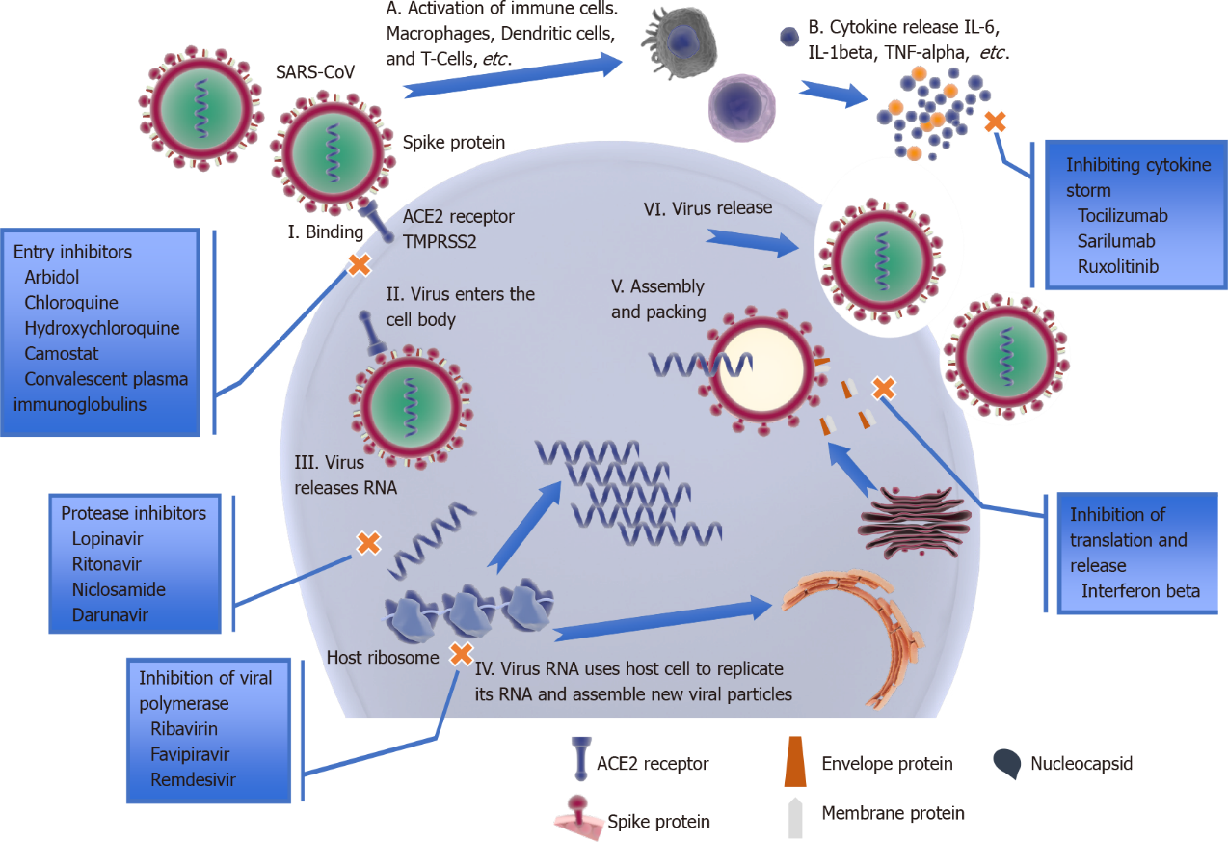
Figure 1 Schematic representation of severe acute respiratory syndrome coronavirus 2 life cycle causing coronavirus disease 2019. Angiotensin-converting enzyme 2 receptors located on the cell surface of ciliated epithelial cells in the respiratory airways, and in type II pneumocytes in the alveoli, bind to virus spike proteins (I). The virus enters the cell body (II) and releases its RNA (III) using host cells to create new virus particles by replication of RNA and translation of polyproteins (IV). New viral particles are assembled (V) and released by exocytosis (VI). Library of Science & Medical Illustrations were utilized in part to create this figure. https://creativecommons.org/licenses/by-nc-sa/4.0/
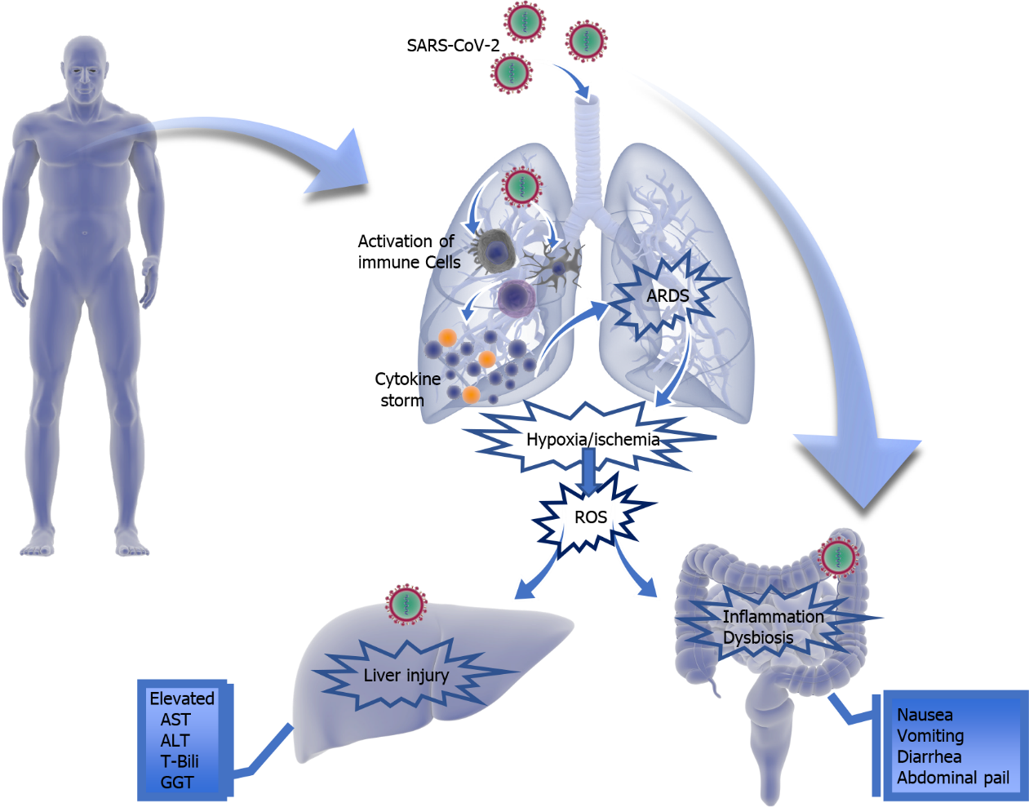
Figure 2 Overview of severe acute respiratory syndrome coronavirus 2 affecting multiple body systems directly or indirectly. Library of Science & Medical Illustrations were utilized in part to create BioNTech this figure. https://creativecommons.org/licenses/by-nc-sa/4.0/

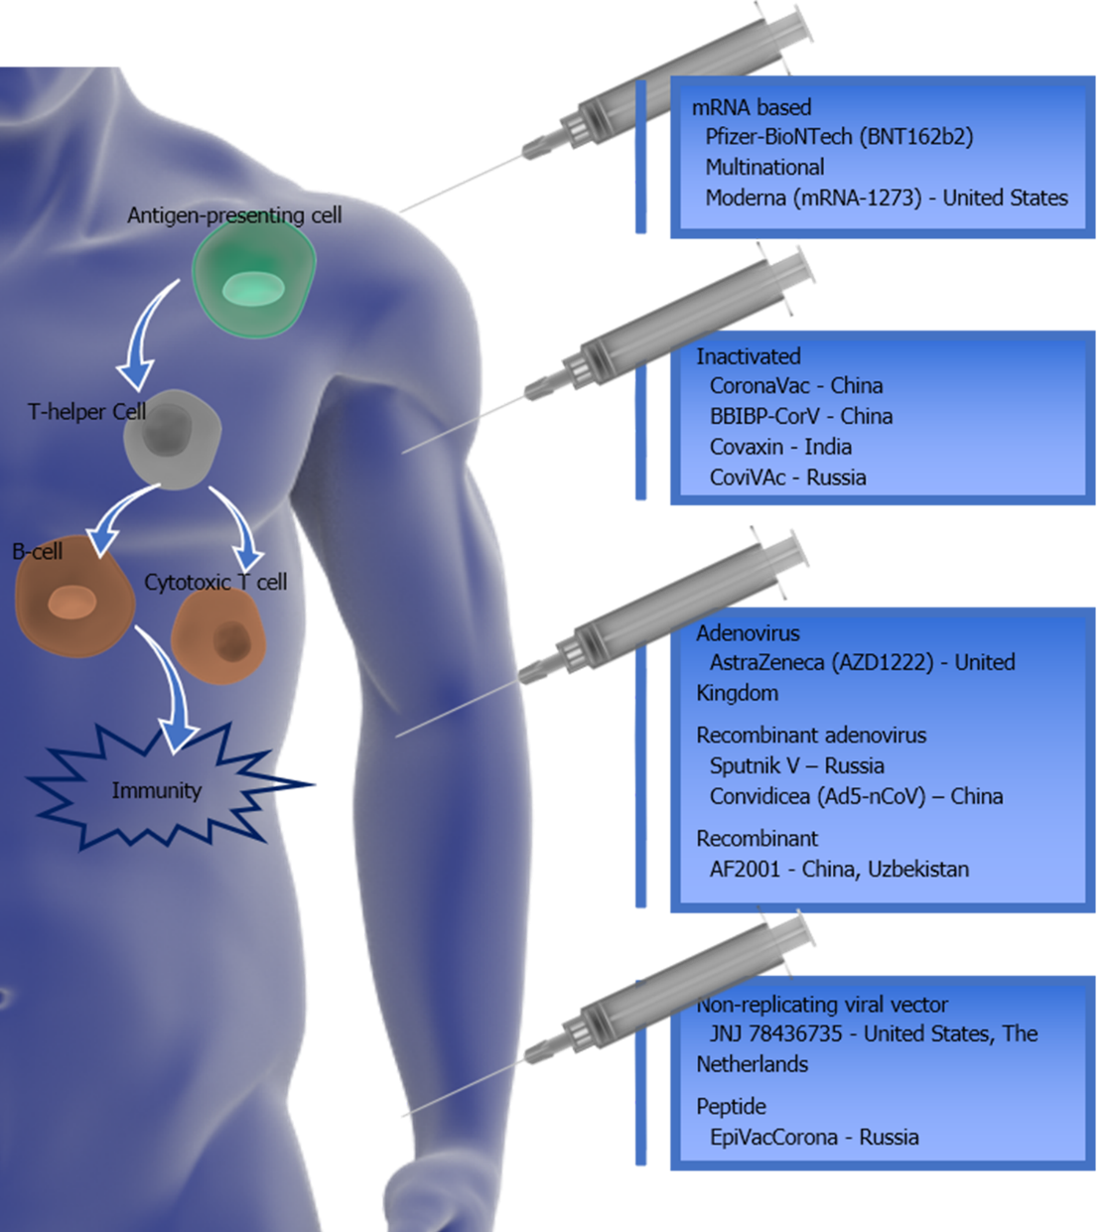
Figure 3 Summary of authorized/approved coronavirus disease 2019 vaccines around the world and their mechanism. The immune response starts by antigen-presenting cells engulfing the virus and activating T-helper cells. These T-helper cells enable an immune response via B cells (antibodies) and Cytotoxic T cells to destroy virus-infected cells. Library of Science & Medical Illustrations were utilized in part to create this figure. https://creativecommons.org/licenses/by-nc-sa/4.0/
Table 1 Calculated case fatality rate globally and regional according to World Health Organization reports
Region | Cumulative confirmed cases | Cumulative death cases | CFR
Global | 111762965 | 2479678 | 2.22%
Americas | 49700102 | 1182591 | 2.38%
Europa | 37974729 | 848644 | 2.23%
South East Asia | 13415064 | 205814 | 1.53%
Eastern Mediterranean | 6266689 | 142986 | 2.28%
Africa | 2811106 | 71159 | 2.53%
Western Pacific | 1594530 | 28471 | 1.79%
Estimated calculation with January 24, 2021 Data - World Health Organization Coronavirus (COVID-19) Dashboard, Available from: https://covid19.who.int/. CFR: Case fatality ratio.
Table 2 Gastrointestinal manifestations in coronavirus disease 2019
Ref. | Number of subjects | Diarrhea | Nausea | Vomiting¹ | Abdominal pain
Lin et al^{[35]}, 2020 | 95 | 24% | 18% | 4% | 2%
Wong et al^{[56]}, 2020 | 2230 | 2%-36% | 1%-17% | 1%-6% | 2%-6%
Tariq et al^{[52]}, 2020 | 12797 | 12% | 9%¹ | 9%¹ | 6%
¹Study presented "nausea and/or vomiting" as one statistic.
Table 3 Liver manifestations in coronavirus disease 2019
Ref. | Number of subjects | Abnormal LFTs (any) | ALT | AST | Tbili
Lin et al^{[35]}, 2020 | 95 | - | 5% | 4% | 23%
Wang et al^{[38]}, 2020 | 105 | 56% | 16% | 9% | 2%
Fan et al^{[39]}, 2020 | 148 | 37% | 18% | 22% | 6%
Zhang et al^{[63]}, 2020 | 1628 | 14%-53% | - | - | -
Cai et al^{[65]}, 2020 | 417 | 76% | - | - | -
Sultan et al^{[60]}, 2020 | 10890 | - | 15% | 15% | 17%
AST: Aspartate aminotransferase; ALT: Alanine aminotransferase.

Published by Baishideng Publishing Group Inc
7041 Koll Center Parkway, Suite 160, Pleasanton, CA 94566, USA
Telephone: +1-925-3991568
E-mail: bpgoffice@wjgnet.com
Help Desk: https://www.f6publishing.com/helpdesk
https://www.wjgnet.com

© 2021 Baishideng Publishing Group Inc. All rights reserved.

