Name of Journal: World Journal of Gastroenterology
Manuscript NO: 83404
Manuscript Type: ORIGINAL ARTICLE

Basic Study
Metronomic capecitabine inhibits liver transplant rejection in rats by triggering recipients’ T cell ferroptosis

Wang H et al. The antirejection effect of metronomic CAP

Hao Wang, Zheng-Lu Wang, Sai Zhang, De-Jun Kong, Rui-Ning Yang, Lei Cao, Jian-Xi Wang, Sei Yoshida, Zhuo-Lun Song, Tao Liu, Shun-Li Fan, Jia-Shu Ren, Jiang-Hong Li, Zhong-Yang Shen, Hong Zheng

Hao Wang, Rui-Ning Yang, Jia-Shu Ren, Jiang-Hong Li, The First Central Clinical School, Tianjin Medical University, Tianjin 300190, China

Zheng-Lu Wang, Zhuo-Lun Song, Shun-Li Fan, Zhong-Yang Shen, Hong Zheng, Department of Organ Transplant, Tianjin First Central Hospital, School of Medicine, Nankai University, Tianjin 300190, China

Zheng-Lu Wang, Zhong-Yang Shen, Hong Zheng, Key Laboratory of Transplant Medicine, Chinese Academy of Medical Sciences, Tianjin 300190, China

Sai Zhang, De-Jun Kong, School of Medicine, Nankai University, Tianjin 300190, China

Lei Cao, Jian-Xi Wang, Sei Yoshida, Zhong-Yang Shen, Hong Zheng, Research Institute of Transplant Medicine, Nankai University, Tianjin 300071, China

Lei Cao, Jian-Xi Wang, Zhong-Yang Shen, Hong Zheng, Tianjin Key Laboratory for Organ Transplantation, Tianjin First Central Hospital, School of Medicine, Nankai University, Tianjin 300071, China

Tao Liu, Zhong-Yang Shen, Hong Zheng, National Health Commission’s Key Laboratory for Critical Care Medicine, Tianjin First Central Hospital, Tianjin 300071, China

Author contributions: Wang H conceived the study, performed the experiments, analyzed the data, generated the figures, and wrote the manuscript; Wang ZL, Zhang S, and Kong DJ provided technical help and assisted with the experiments; Zhang S, Kong DJ, Yang RN, Cao L, and Wang JX helped with the data analyses; Wang ZL, Yoshida S, Zhang S, Liu T, Shen ZY, and Zheng H performed critical reading of the manuscript; Fan SL, Ren JS, Li JH, and Zheng H assisted with the editing and writing of the manuscript; Zheng H supervised the study and edited the manuscript.

Supported by National Key Research and Development Program of China, No. 2020YFA0710802; The Youth Science Fund of the Nature Science Foundation of Tianjin, No. 20JCQNJC01370; The Key Projects of Tianjin Science and Technology Project, No. 21JCZDJC00160; and The Science Foundation of Tianjin Health Commission, No. ZC20065 and No. ZC20089.

Corresponding author: Hong Zheng, PhD, Professor, Department of Organ Transplant, Tianjin First Central Hospital, School of Medicine, Nankai University, No. 24 Fukang Road, Nankai District, Tianjin 300190, China. zhenghongyx@139.com

Received: January 21, 2023
Revised: February 19, 2023
Accepted: April 28, 2023
Published online: May 28, 2023

Abstract
BACKGROUND
Capecitabine (CAP) is a classic antimetabolic drug and has shown potential antirejection effects after liver transplantation (LT) in clinical studies. Our previous study showed that metronomic CAP can cause the programmed death of T cells by inducing oxidative stress in healthy mice. Ferroptosis, a newly defined non-apoptotic cell death that occurs in response to iron overload and lethal levels of lipid peroxidation, is an important mechanism by which CAP induces cell death. Therefore, ferroptosis may also play an important role in CAP-induced T cell death and play an immunosuppressive role in acute rejection after transplantation.

AIM
To investigate the functions and underlying mechanisms of antirejection effects of metronomic CAP.

METHODS
A rat LT model of acute rejection was established, and the effect of metronomic CAP on splenic hematopoietic function and acute graft rejection was evaluated 7 d after LT. In vitro, primary CD3⁺ T cells were sorted from rat spleens and human peripheral blood, and co-cultured with or without 5-fluorouracil (5-FU) (active agent of CAP). The levels of ferroptosis-related proteins, ferrous ion concentration, and oxidative stress-related indicators were observed. The changes in mitochondrial structure were observed using electron microscopy.

RESULTS
With no significant myelotoxicity, metronomic CAP alleviated graft injury (Banff score 9 vs 7.333, P < 0.001), prolonged the survival time of the recipient rats (11.5 d vs 16 d, P < 0.01), and reduced the infiltration rate of CD3⁺ T cells in peripheral blood (6.859 vs 3.735, P < 0.001), liver graft (7.459 vs 3.432, P < 0.001), and spleen (26.92 vs 12.9, P < 0.001), thereby inhibiting acute rejection after LT. In vitro, 5-FU, an end product of CAP metabolism, induced the degradation of the ferritin heavy chain by upregulating nuclear receptor coactivator 4, which caused the accumulation of ferrous ions. It also inhibited nuclear erythroid 2 p45-related factor 2, heme oxygenase-1, and glutathione peroxidase 4, eventually leading to oxidative damage and ferroptosis of T cells.

CONCLUSION
Metronomic CAP can suppress acute allograft rejection in rats by triggering CD3⁺ T cell ferroptosis, which makes it an effective immunosuppressive agent after LT.

Key Words: Capecitabine; Ferroptosis; T Lymphocytes, Immunosuppressive agents; Graft rejection; Liver transplantation

©The Author(s) 2023. Published by Baishideng Publishing Group Inc. All rights reserved.

Citation: Wang H, Wang ZL, Zhang S, Kong DJ, Yang RN, Cao L, Wang JX, Yoshida S, Song ZL, Liu T, Fan SL, Ren JS, Li JH, Shen ZY, Zheng H. Metronomic capecitabine inhibits liver transplant rejection in rats by triggering recipients’ T cell ferroptosis. World J Gastroenterol
2023; 29(20): 3084-3102
URL: https://www.wjgnet.com/1007-9327/full/v29/i20/3084.htm
DOI: https://dx.doi.org/10.3748/wjg.v29.i20.3084

Core Tip: Our studies proved that metronomic capecitabine (CAP) alleviated the acute rejection after transplantation in rats without the common side effect of myelosuppression. T cell ferroptosis is the underlying mechanism behind the antirejection effect of CAP, which can induce cell ferrous ions overload and suppress the nuclear erythroid 2 p45-related factor 2, heme oxygenase-1/glutathione peroxidase 4 antioxidant systems, thereby directly increasing the levels of intracellular reactive oxygen species, and leading to severe oxidative damage in T cells. These results revealed a new mechanism of CAP-induced T cell programmed death and suggested the possibility of using CAP as an immunosuppressant after transplantation.

INTRODUCTION
Recurrence of hepatocellular carcinoma (HCC) represents a serious issue after liver transplantation (LT), and is closely related to the usage of immunosuppressant drugs^{[1-3]}. As a classic antimetabolic chemotherapeutic agent, capecitabine (CAP) is widely used in the treatment of cancers and has also shown good effects on HCC^{[4,5]}. Metronomic CAP is suitable for long-term oral administration with low adverse effects and without sacrificing treatment efficacy^{[6,7]}. In patients with recurrent liver cancer after LT, Ravaioli et al^{[8]} showed that metronomic CAP achieved similar efficacy to sorafenib, a protein kinase inhibitor approved for HCC but with a high incidence of adverse effects^{[9]}. Interestingly, no acute rejection was seen, suggesting that CAP may have both immunosuppressive and anticarcinogenic effects. CAP is a fluoropyrimidine prodrug that is metabolized in a three-step process to 5-fluorouracil (5-FU)^{[10]}. The last step requires thymidine phosphorylase (TP), the distribution of which determines CAP distribution. This partially explains its different pharmacological characteristics compared to 5-FU. Because TP is highly expressed in cancer cells and lymphocytes^{[11,12]}, the administration of CAP to LT patients with HCC may increase tumor killing while preventing graft rejection. In preliminary work, we found that the differential expression of TP avoided CAP’s side effects of myelosuppression and suppressed normal mouse immune responses by inducing T cell apoptosis^{[13]}. However, it is not clear what effect CAP has during the immune activation that follows transplantation, which is key to its use as an immunosuppressant.
Ferroptosis is a newly defined nonapoptotic cell death that occurs with iron overload and lethal levels of lipid peroxidation^{[14-16]}. Ferroptosis is tightly regulated by iron metabolism, while ferritin is the major intracellular iron storage protein complex. Ferritinophagy activation depends on nuclear receptor coactivator 4 (NCOA4) to transport ferritin to the autophagosome and degrade ferritin to increase intracellular iron levels^{[17,18]}. Subsequently, free ferrous ions overload results in oxidative injury by the Fenton reaction. Although the regulatory mechanisms of ferroptosis are poorly understood, some molecules with antioxidant effects may be implicated, such as nuclear erythroid 2 p45-related factor 2 (Nrf2)^{[19,20]}, heme oxygenase-1 (HO-1)^{[21]}, and glutathione peroxidase 4 (GPX4)^{[22]}. Overall, free ferrous ions result in reactive oxygen species (ROS) generation and oxidative injury, whereas the Nrf2-HO-1/GPX4 antioxidative system protects cells from oxidative damage induced by ferroptosis^{[23]}. In mouse models and in vitro, 5-FU mediates injuries in intestinal mucosal cells, such as those occurring during chemotherapy, by reducing Nrf2 expression and increasing ferroptosis^{[24]}. 5-FU also leads to ROS and iron homeostasis-dependent ferroptosis in myocardial cells by reducing the expression of GPX4 and ferritin heavy chain (FTH1) but enhancing the expression of transferrin receptor 1^{[25]}. Thus, mechanistically, ferroptosis plays an important role in the cell-killing effect of 5-FU.
Our previous study indicated that metronomic CAP can increase ROS levels and reduce mitochondrial membrane potential (MMP), thus affecting the immune system of mice^{[13]}. Those results prompted us to further explore whether ferroptosis plays a significant role in 5-FU-induced immunosuppression. In this study, we investigated the effect of metronomic CAP on acute rejection in a rat model of LT, and determined how ferroptosis affects 5-FU-induced immunosuppression. Elucidating the possible mechanism of CAP as an immunosuppressant with anticancer effects is of great relevance to optimize drug regimens for HCC patients after LT in the future.

MATERIALS AND METHODS
Animals
Specific-pathogen-free male Lewis rats (donors) and male Brown Norway rats (recipients) aged 8–10 wk and weighing 250–300 g were obtained from Beijing Vital River Laboratory Animal Technology Co. Ltd. (Beijing, China). The rats were housed in a standard room, and fed filtered clean water and standard laboratory food. To acclimatize, the rats were housed 1 wk before transplantation. According to different postoperative medication regimens, the rats were randomized to untreated control group (CON) (0.9% saline, ig) and metronomic capecitabine-treated (MET) groups (CAP 100 mg/kg/d, ig). A total of 12 recipients (6 rats/group) were used for postoperative specimen collection at 7 d after transplantation, and another 12 recipients (6 rats/group) were used to observe survival. All invasive procedures and specimen collection were performed under isoflurane anesthesia to minimize pain or discomfort.

Orthotopic LT in rats
Anesthesia was induced with isoflurane and orthotopic LT was performed based on Kamada’s two-cuff method. The anhepatic phase was controlled within 26 min^{[26,27]}. After transplantation, the rats received 2 mL Ringer’s lactate to replenish blood volume and were rewarmed in an incubator at 37 ℃ for 30 min. On day 7 after LT, an overdose of pentobarbital (150 mg/kg) was injected intraperitoneally for euthanasia. Femur, blood, spleen, and the transplanted liver were collected for further examination.

Routine blood tests
Whole blood was used for blood routine tests 7 d after LT. These were performed with an automatic hematology analyzer (BC-2800Vet; Mindray, Shenzhen, China).

Peripheral blood lymphocyte CD3⁺ T cell count
Peripheral blood lymphocyte CD3⁺ T cell count was obtained based on peripheral blood lymphocyte count and flow cytometric analysis of the CD3⁺ T cell ratio.

Liver function assay
Serum levels of aspartate aminotransferase (AST), alanine aminotransferase (ALT), total bilirubin (TBIL), and direct bilirubin (DBIL) were measured using kits (Mindray, Shenzhen, China) and read with an automatic biochemical analyzer (BS-240VET; Mindray, Shenzhen, China).

Flow cytometric analysis
Rat peripheral blood mononuclear cells were isolated by gradient centrifugation with a rat peripheral blood mononuclear cell separation solution (Solarbio, Beijing, China). Anti-CD3 antibodies (APC anti-rat CD3 Antibody, Cat# 201414; RRID: AB_2563366 BioLegend, San Diego, CA, United States) were used for extracellular staining to identify CD3-positive lymphocytes. Flow cytometry was performed using the Accuri C6 Plus flow cytometry (BD Biosciences, Palo Alto, CA, United States), and FlowJo software (TreeStar, Woodburn, OR, United States) was used for data analysis.
The ferrous levels in T cells were measured using FerroOrange (Cat# MX4559, Maokang Biotechnology, Shanghai, China). Cells were incubated with FerroOrange (37 ℃, 20 min) for fluorescence detection. To measure intracellular ROS, cells were resuspended in phosphate-buffered saline (PBS) containing DCFH-DA (Cat# CA1410, Solarbio, Beijing, China) at 37 ℃ for 30 min and washed twice with PBS for fluorescence detection. To measure the lipid ROS of T cells, C11-BODIPY 581/591 (Cat# MX5211, Maokang Biotechnology, Shanghai, China) was added and incubated at 37 ℃ with 5% CO₂ for 30 min. Cells were then washed twice before fluorescence detection. The MMP Assay Kit (Cat# M8650, Solarbio, Beijing, China) was used to measure the MMP in T cells. Cells were incubated with JC-1 working solution at 37 ℃ for 20 min, then washed twice with JC-1 buffer for fluorescence detection. BODIPY emission was recorded on an oxidized C11 signal (FITC channel).

Luminex assay
The rat sera were analyzed for cytokine concentrations [interleukin (IL)-10, IL-2, IL-1α, IL-4, interferon gamma (IFN-γ), tumor necrosis factor alpha (TNF-α), IL-5, IL-6, growth-regulated oncogene (GRO)/keratinocyte chemoattractant (KC), IL-12p70] using the Millipore Luminex 200 instrument (Luminex Corporation, Austin, TX, United States), after incubation of the samples with beads according to the manufacturer’s instructions. The quantification was performed with Luminex xPonent version 3.1 software.

Cell culture
Healthy mononuclear cells from the spleen of rats and peripheral blood of humans were collected by gradient centrifugation with respectively, rat tissue mononuclear cell separation solution (Solarbio, Beijing, China) and human peripheral blood mononuclear cell separation solution (Solarbio, Beijing, China). T cells were purified through positive magnetic selection using microbeads (Miltenyi Biotec, Bergisch Gladbac, Germany) and cultivated at 2.0 × 10⁶ cells/well in 6-well plates with RPMI-1640 with 5% fetal bovine serum and 100 IU/mL IL-2. Within the first 72 h, the anti-CD3/CD28 antibody (Cat# 201401, RRID: AB_893302; 2 μg/mL and Cat# 200902, RRID: AB_313891; 1 μg/mL) were used to stimulate the T cells.

Cell proliferation assay
The Cell Counting Kit-8 (CCK-8) assay (Boster, Hubei, China) was used to evaluate T cell proliferation in vitro. The CON group (n = 3), 5-FU group (5-FU 15 μmol/L, MCE, Shanghai, China; n = 3); ferrostatin-1 (Fer-1) group (Fer-1 2 μmol/L, MCE, Shanghai, China; n = 3); 5-FU+fer-1 group (5-FU 15 μmol/L + fer-1 2 μmol/L) were included. After 72 h of culture, CCK-8 solution was added to each well of the 96-well plates and allowed to incubate for 2 h at 37 ℃, and the optical density value at 450 nm was recorded.

Histopathology
The femurs and grafts (n = 6 for each group) were removed on postoperative day 7. The femurs were decalcified with EDTA decalcifying solution (Solarbio, Beijing, China). Then both femurs and grafts were fixed in 10% paraformaldehyde, dehydrated, paraffin-embedded, cut into 4 μm slides, and stained with hematoxylin and eosin (H&E; G1120; Solarbio, Beijing, China).

Immunohistochemistry
CD3⁺ cell infiltration was assessed on spleen and liver graft sections as follows: Tissue sections were heated for 15 min in EDTA (pH 8.0) in a microwave for antigen retrieval, incubated in 3% hydrogen peroxide for 30 min to eliminate endogenous peroxidase activity, and blocked in normal goat serum. Then the sections were incubated overnight at 4 ℃ with a rat anti-CD3 antibody (CD3-12, Cat# ab11089, RRID: AB_2889189; Abcam, Cambridge, MA, United States) and incubated with a secondary antibody (Goat Anti-Rat IgG H&L, Cat# ab97057, RRID: AB_10680316; Abcam, Cambridge, MA, United States) or 30 min at room temperature the next day. Finally, the sections were stained with freshly prepared diaminobenzidine solution and counterstained with hematoxylin. ImageJ software was applied to 200 × images to quantify the CD3-positive fields.

Transmission electron microscopy
Cells were collected after centrifugation and fixed in 2.5% glutaraldehyde. After dehydration through graded ethanol, the cells were embedded in epoxy resins and cut into ultrathin sections. The morphologic changes in mitochondrial ultrastructure were observed using a transmission electron microscope (HT7800; Hitachi, Tokyo, Japan).

Western blot analysis
Total protein was extracted using RIPA buffer containing protease and phosphatase inhibitors. The mixture was placed on ice for 30 min for cell lysis, and then centrifuged at 12000 g for 15 min at 4 ℃ to discard the cell debris. Total protein concentration was quantified by the BCA Protein Assay Kit (Beyotime Biotechnology, Beijing, China). The proteins were resolved by sodium dodecyl sulfate-polyacrylamide gel electrophoresis, electrotransferred to polyvinylidene fluoride membranes, and blocked in 5% skimmed milk for 1 h. Then the membranes were incubated overnight at 4 ℃ with primary antibodies against FTH1 (EPR18878, Cat# ab183781; Abcam, Cambridge, MA, United States), NCOA4 (Cat# PA5-96398, RRID: AB_2808200; Thermo Fisher Scientific, Waltham, MA, United States), Nrf2 (E5F1A, Cat# 20733S, Cell Signaling Technology, Danvers, MA, United States), HO-1 (EPR1390Y, Cat# ab68477, RRID: AB_11156457; Abcam, Cambridge, MA, United States), and GPX4 (EPNCIR144, Cat# ab125066, RRID: AB_10973901; Abcam, Cambridge, MA, United States). β-actin (SP124, Cat# ab115777, RRID: AB_10899528; Abcam, Cambridge, MA, United States) antibody served as the internal control. The membranes were washed and then incubated with a secondary antibody (Goat anti-Rabbit IgG H+L, Cat# A16110; Thermo Fisher Scientific, Shanghai, China) for 1 h at RT. Proteins were detected with an imaging system (Bio-Rad, Hercules, CA, United States), and band intensities were analyzed with ImageJ software (National Institutes of Health, Bethesda, MD, United States).

Statistical analyses
The statistical analyses were performed with SPSS 23.0 (IBM Analytics) and GraphPad 8.0 (GraphPad Software). The statistical methods of this study were reviewed by Yuan Wang from the Department of Biostatistics and Epidemiology, The First Central Clinical School, Tianjin Medical University. Data are presented as the mean ± standard error of the mean. The unpaired t-test was used to assess the differences between the two groups, and a one-way analysis of variance was used to assess the differences among three or more groups. P < 0.05 was considered statistically significant.

RESULTS
Metronomic CAP exerts a marginal myelosuppressive effect, compatible with continuous administration
5-FU, the end product of CAP, may induce myelotoxicity. Thus, we first evaluated metronomic CAP’s myelotoxicity on peripheral blood hemoglobin (HGB), platelets (PLTs), and leukocytes in a rat model of orthotopic LT, where recipient Brown-Norway rats received the livers from Lewis rats. Seven days after LT, there was no significant difference in the index of HGB and PLTs between the CON group and the MET group (Figure 1A and B). However, leukopenia with a reduced number of lymphocytes was found in the MET group, while the number of other leukocyte subsets (granulocytes and mononuclear cells) was not significantly different (Figure 1C–F). These results suggest that CAP had a relatively targeted killing effect on lymphocytes, but no obvious effect on PLTs, erythrocytes, monocytes, or granulocytes. In the bone marrow, the rats in the MET group had no pathological manifestation of myelosuppression (Figure 1G), suggesting that the lymphocytopenia caused by CAP did not result from myelosuppression.

Metronomic CAP reduces acute rejection and alleviates graft injury
To evaluate the effect of metronomic CAP during acute rejection, the grafted livers were harvested on day 7 after LT for histopathological examination. As shown in Figure 2A, prominent acute rejection with severe bile duct damage, endothelitis, and hepatocyte vacuolation occurred in the grafts of the CON group. Portal areas were infiltrated by inflammatory cells, hepatic sinusoids were greatly expanded, and the sinusoidal endothelial cells were markedly swollen. Compared with the CON group, acute rejection in the MET group was ameliorated, as evidenced by inflammatory cell infiltration being confined to only some of the portal areas and the degeneration of a few bile duct epithelia. The Banff scores^{[28]} decreased in the MET group compared with the CON group (Figure 2B). On day 7 after LT, liver damage was assessed by measuring serum levels of AST and ALT (Figure 2C and D). Compared with the CON group, CAP significantly decreased the serum levels of ALT and AST. However, TBIL and DBIL in both groups showed an increasing trend after the operation, but there was no significant difference between the two groups (Figure 2E and F). In the survival analysis, a log-rank (Mantel Cox) test was conducted. Rats in the MET group had a longer survival time compared with the CON group (Figure 2G, median survival time: 16.5 and 11.5 d; P < 0.01).

Metronomic CAP reduces the number of CD3⁺ T cells in graft recipients
Next, to investigate whether the inhibition of acute rejection by metronomic CAP involved an effect on T cells, CD3⁺ T cells in the peripheral blood, grafts, and spleens were analyzed. Compared to the CON group, the CD3⁺ T cells in the peripheral blood were significantly lower in the MET group (Figure 3A and B). In addition, a large number of CD3⁺ T cells was localized in the portal canal area of the CON group. Infiltrated CD3⁺ T cells in both the liver and spleen were significantly reduced in the MET group (Figure 3C and D). These results indicate that metronomic CAP can decrease the number of CD3⁺ T cells in the peripheral blood, liver, and spleen of the recipient rats.

Metronomic CAP regulates serum cytokine levels
Cytokines are an important reflection of immune cell function and immune status. Thus, the levels of IFN-γ, TNF-α, human GRO/KC, IL-1β, IL-2, IL-4, IL-5, IL-6, IL-10, and IL-12p70 in peripheral blood and graft were quantified by Luminex assay. As shown in Figure 4, the levels of pro-inflammatory IFN-γ, TNF-α, IL-2, and IL-12p70 in the MET group were significantly lower than those in the CON group. Other cytokines (IL-1β, IL-5, IL-6, IL-4, IL-10, and GRO/KC) did not show significant changes (Supplementary Figure 1). The results showed that metronomic CAP plays an immunosuppressive role by downregulating the concentration of pro-inflammatory cytokines.

Metronomic CAP increases T cell free ferrous ions and induces lipid peroxidation in vivo
The immune activation of T cells is particularly important in the acute rejection of organ transplants. Similar to many commonly used immunosuppressants, the killing effect of CAP on T cells is also key to its immunosuppressive activity^{[13]}. Therefore, we further explored the mechanism of T cell killing by metronomic CAP. Ferroptosis is a new form of ROS-dependent programmed cell death that may plays an important role in CAP-mediated cytotoxicity. Thus, we measured by flow cytometry the concentration of free ferrous ions, ROS level, and lipid ROS level in peripheral blood CD3⁺ T cells from transplanted rats of both groups at day 7. Compared with the CON group, free ferrous ion concentration (Figure 5A), total ROS (Figure 5B), and lipid ROS (Figure 5C) levels were increased in the MET group. At the same time, the detection of the MMP showed a decreasing trend in the MET group (Figure 5D). These results indicated that metronomic CAP leads to the generation of ferrous ions and results in lipid peroxidation, which conforms to the typical characteristics of ferroptosis.

5-FU triggers ferritinophagy and ferroptosis in T cells in vitro
To further explore in vitro the mechanism underlying the CAP-mediated ferroptosis linked to immunosuppression observed in vivo, primary CD3⁺ T cells were sorted from rat spleens and human peripheral blood (Supplementary Figure 2). Both primary CD3⁺ T cells were treated with 5-FU in vitro (Supplementary Figure 3). This treatment significantly inhibited cell viability, which was attenuated by the ferroptosis inhibitor Fer-1 (Figure 6A). Transmission electron microscopy revealed typical characteristics of ferroptosis in 5-FU-treated group, namely, smaller mitochondria with increased membrane density, and diminished mitochondrial cristae (Figure 6B). Free ferrous ions concentration was increased in the 5-FU-treated group, whereas Fer-1 partially reversed the increase of ferrous ions induced by 5-FU (Figure 6C). As a selective cargo receptor, NCOA4 mediates the transport of ferritin into lysosomes, inducing ferroptosis. Western blot analysis revealed that 5-FU treatment induced FTH1 decrease, but a tendency toward increasing NCOA4 expression was observed (Figure 6D), consistent with the in vivo studies (Supplementary Figure 4). These results confirmed that the cytotoxicity of 5-FU is at least partly related to the induction of T cell ferroptosis, in which the increase of free ferrous ions caused by NCOA4-mediated ferritinophagy plays an important role.

5-FU-triggered ferroptosis is associated with the inhibition of the Nrf2-HO-1/GPX4 antioxidative pathway
To evaluate the effect of 5-FU on the antioxidant system, antioxidant-related proteins were measured in rat and human primary CD3⁺ T cells treated with 5-FU. The expression of Nrf-2, HO-1, and GPX4 was evaluated in both groups and compared, and treatment with 5-FU was found to be associated with a marked decrease (Figure 7A), consistent with the in vivo studies (Supplementary Figure 4). The results showed that 5-FU treatment increased total ROS and lipid ROS levels and decreased MMP (Figure 7B–D). It also decreased glutathione (GSH) levels and increased the oxidative stress biomarker malondialdehyde (MDA) (Figure 7E and F). Fer-1 inhibits ferroptosis partly by activating Nrf2^{[29]}. Accordingly, it reversed 5-FU-mediated inhibition of Nrf-2, HO-1, and GPX4, increased GSH level, and decreased MDA content, thereby alleviating cell peroxidation induced by 5-FU (Figure 7A–D). These results suggest that 5-FU inhibits the antioxidant system of T cells, inducing the T cells damaged by lipid peroxidation, which results in ferroptosis.

DISCUSSION
The conflict between the risk of tumor formation and immune rejection after transplantation has always been a concern. Therefore, it is of great clinical value to identify a drug with both immunosuppressive and anticancer effects. CAP is a classic chemotherapy drug for HCC^{[4,6]}, which has been shown to have immunosuppressive effects in a previous study^{[8]}, suggesting that metronomic CAP can be used as an immunosuppressant after transplantation and bring long-term benefits to LT patients with HCC. In our previous study, we found that metronomic CAP exerts immunosuppressive effects on normal mice by inducing T cell apoptosis^{[13]}; however, the effect of CAP on the immune system in the context of organ transplantation was unclear. Therefore, we explored the safety, availability, and mechanism of metronomic CAP as an immunosuppressant in a model of rat orthotopic LT. Our results suggest that metronomic CAP can inhibit the acute rejection of LT by inhibiting T cells while avoiding the main side effects of 5-FU. Its mechanism is related to the induction of ferritin degradation and the inhibition of antioxidant-related proteins, which ultimately leads to the death of T cells (Figure 8).
The main effects of 5-FU are on rapidly proliferating tissues, specifically bone marrow. 5-FU suppressed bone marrow hematopoiesis including a significant decrease in the number of erythrocytes, platelet, and leukocyte in the peripheral blood^{[30,31]}. As the prodrug of 5-FU, it is of high clinical relevance to show the safety of the medication of CAP. Overall, metronomic CAP is considered safe, with fewer side effects than traditional chemotherapy regimens. Metronomic CAP is well tolerated and safe in clinical practice, including for patients with HCC or patients after LT^{[8,32-34]}. In mice, there was also no obvious myelosuppression in the MET group 7 d after taking CAP, though the related studies showed that 5-FU could cause severe myelosuppression after 7 d of administration^{[35]}. TP is a key enzyme in the metabolism of CAP^{[36]}. The lack of TP in bone marrow may explain the lack of bone marrow suppression of CAP^{[11,13]}. In a past study, we established the safety of CAP in CAP-fed mice, which did not cause significant myelosuppression after 21 d of administration^{[13]}. However, the depletion of lymphocytes is not related to bone marrow suppression, and the high expression of TP in lymphocytes directly leads to the killing effect of CAP^{[11]}. CAP is safe for long-term use because it can circumvent the inhibitory effect of 5-FU on bone marrow hematopoietic function.
When acute rejection occurs, immune cells mainly infiltrate the hilar region of the grafted liver, inducing pericentral inflammation, damaging the vascular and bile duct endothelium, damaging hepatocytes, and destroying the lobular structure^{[37,38]}. CAP can preserve the function and structure of the transplanted liver by inhibiting acute rejection. Compared with the CON group, the Banff score was significantly lower in the MET group at 7 d after transplantation while the elevation of ALT and AST in the MET group was significantly less pronounced than that in the CON group. ALT and AST are primarily expressed in liver cells, and liver allograft destruction caused by rejection is positively associated with ALT and AST expression^{[39,40]}. However, TBIL and DBIL in both groups showed an increasing trend after surgery with no significant difference between the two groups. It may be related to biliary tract injury and bilirubin stasis caused by the lack of hepatic artery reconstruction and the use of cannula reconstruction of the bile duct in the traditional rat “two-cuff method” orthotopic LT^{[41]}.
Antigen presentation and T cell activation are key steps in rejection. Donor-derived antigen-presenting cells provide immune stimulation to recipient naive CD4⁺ T cells, known as the direct antigen presentation pathway, which is the main mode of activation in acute rejection^{[42,43]}. Once rejection is initiated, CD8⁺ T cells mainly differentiate into cytotoxic T cells, which directly cause graft injury. CD4⁺ T cells can differentiate into many subtypes, mainly helper T cells (Th1, Th2, and Th17) and regulatory T cells (Treg). In acute rejection, T cells differentiate mainly to Th1, driven by pro-inflammatory cytokines such as IL-12 and IFN-γ. Th1 cells secrete IL-2 and IFN-γ, providing a positive feedback loop to stimulate Th1 cells to proliferate further. IFN-γ is usually associated with proinflammatory and immune activation processes while IL-2 is necessary for survival and effects of activated T cells. T cell activation, proliferation, differentiation, and migration are the immune basis of acute rejection after organ transplantation, and are often used as the targets of clinical immunosuppression^{[42,44,45]}. The results of our study showed that IL-2 and IFN-γ were decreased in CAP treated rats. The changes in cytokines suggest that in addition to decreasing the number of T cells, CAP may also target Th0 cells’ differentiation. Since IFN-γ has a stimulatory effect on the secretion of TNF-α by M1 macrophages^{[46]}, the decrease in TNF-α may be related to the inhibition of IL-2 secretion in T cells by CAP. By inducing the programmed death of T cells, CAP mitigates transplant rejection and protects graft function. Moreover, cytokines associated with rejection were also affected by CAP treatment. Metronomic CAP significantly reduced the levels of pro-inflammatory cytokines (IFN-γ, TNF-α, IL-2, and IL-12p70), which are mainly secreted by immune cells and contributing to rejection^{[47-50]}.
The data from our study demonstrated that the selective cytotoxic effect of the T cells of metronomic CAP is crucial for the prevention of acute organ transplant rejection. Next, we further explored the mechanism underlying the immunosuppressive effect of metronomic CAP by studying CD3⁺ T cells in more details. Mitochondria is a main source of ROS and mitochondria ROS is a critical component of T cell activation, proliferation, and effector function of T cells^{[51-53]}. However, excessive ROS production, inducible by a high level of iron, leads to ROS-mediated membrane phospholipid peroxidation and T cell death upon activation^{[54]}. Thus, we investigated the effect of CAP on the level of CD3⁺ T cell ferrous ions with a ferrous probe and found that CAP treatment induced ferrous ion accumulation, accompanied by increased ROS and lipid ROS and decreased MMP. Mitochondrial ROS production and MMP reduction are two important parameters of mitochondrial damage, and lipid peroxidation following ROS generation plays an important role in ROS-induced cellular damage^{[55-57]}. These results indicate that metronomic CAP increased ferrous ion accumulation and oxidative damage in the CD3⁺ T cells of rats after transplantation, which may be the mechanism behind CAP-induced T cell reduction. Next, we used rat and human primary CD3⁺ T cells to further explore the role of ferroptosis in CAP-induced immunosuppression in vitro. Free ferrous iron overload, lipid peroxide accumulation, and specific mitochondrial morphological changes are three key characteristics that distinguish ferroptosis from other programmed cell deaths^{[14]}. In this study, typical mitochondrial changes were observed in T cells of the 5-FU group under transmission electron microscopy. Ferrous ion in rat primary CD3⁺ T cells of the 5-FU group was increased with the downregulation of FTH1 and upregulation of NCOA4, revealing the occurrence of ferritinophagy. That is, the autophagic degradation of ferritin, contributed to rat T cell ferrous overload, excessive lipid peroxidation, and eventually ferroptosis in the 5-FU group. Nrf2 is a core player in the regulation of antioxidant molecules in cells, which can induce the synthesis of HO-1 and GPX4^{[20,58]}. The Nrf2-HO-1/GPX4 antioxidative system, which participates in the regulation of oxidative damage and inhibits erastin-induced ferroptosis^{[59]}, was suppressed by 5-FU in vitro. It also reduced GSH levels, indicative of impairment of antioxidant capacity, and improved the levels of MDA, an end-product of lipid peroxidation.
In this study, we showed that metronomic CAP alleviated rat LT rejection without the common side effect (myelosuppression) of antitumor drugs. T cell ferroptosis plays an important role in the antirejection effect of CAP, which can induce cell iron overload and suppress the Nrf2-HO-1/GPX4 antioxidant systems, directly increasing the levels of intracellular ROS, leading to severe mitochondrial damage in T cells. These results revealed a new mechanism of CAP-induced T cell programmed death and suggested the possibility of using CAP as an immunosuppressant after transplantation. As a traditional antitumor drug, CAP has immunosuppressive effects, that may kill tumor cells and induce T cell death at the same time. CAP may have both antirejection and antitumor effects on patients with HCC after LT, thereby having broad clinical application prospects. In light of our findings, CAP alone as an immunosuppressive agent does not achieve satisfactory therapeutic effects. Therefore, the combination and interaction of CAP with other immunosuppressive agents is an important research direction in the future. In addition, we observed interesting effects of CAP on different cytokines, but further observations were lacking. The effects of CAP on T cell subsets and other immune cells are worth further attention. In the future, we plan to establish tumor-bearing animal models for allotransplantation, to clarify the dual antirejection and antitumor effects of CAP. In conclusion, the immunosuppressive effect of CAP should be further explored to optimize the drug treatment regimen for LT patients with liver cancer.

CONCLUSION
Metronomic CAP can alleviate liver graft injury and reduce the proliferation and infiltration of CD3⁺ T cells in peripheral blood, graft, and spleen, thereby inhibiting acute rejection after LT. T cell ferroptosis plays an important role in the antirejection effect of CAP, which can induce cell iron overload and suppress the Nrf2-HO-1/GPX4 antioxidant systems, thereby directly increasing the levels of intracellular ROS and leading to severe oxidative damage in T cells.

ARTICLE HIGHLIGHTS
Research background
As a classical antimetabolite, capecitabine (CAP) has shown potential antirejection effects after liver transplantation (LT) in clinical trials. Our previous study showed that metronomic CAP can cause programmed T cell death in healthy mice by inducing oxidative stress, which is also the key step in ferroptosis. Thus, ferroptosis may play an important role in CAP-induced T cell death and an immunosuppressive role in acute rejection after transplantation.

Research motivation
This study investigated the immunosuppressive effect of metronomic CAP in rat LT and its mechanism, which may be used as an immunosuppressive agent after LT to improve the prognosis of liver transplant patients with hepatocellular carcinoma.

Research objectives
The objective of this study was to investigate the possibility of using CAP as an anti-rejection agent after transplantation. The results showed that metronomic CAP could exert an immunosuppressive effect by inducing T cell ferroptosis, which provided a basis for investigating CAP as part of an immunosuppressive regimen.

Research methods
A rat LT model of acute rejection was established, and the effect of metronomic CAP on splenic hematopoietic function and acute graft rejection was evaluated 7 d after transplantation. In vitro, primary CD3⁺ T cells were sorted and co-cultured with or without 5-fluorouracil (5-FU) (active agent of CAP). The levels of ferroptosis-related proteins, ferrous ion concentration, and oxidative stress-related indicators were observed. The changes in mitochondrial structure were observed using electron microscopy.

Research results
With no significant myelotoxicity, metronomic CAP alleviated graft injury, prolonged the survival time of the recipient rats, and reduced the infiltration rate of CD3⁺ T cells in peripheral blood, liver graft, and spleen, thereby inhibiting acute rejection after LT. In vitro, 5-FU, an end product of CAP metabolism, induced the degradation of the ferritin heavy chain by upregulating nuclear receptor coactivator 4, which caused the accumulation of ferrous ions. It also inhibited nuclear erythroid 2 p45-related factor 2, heme oxygenase-1, and glutathione peroxidase 4, eventually leading to oxidative damage and ferroptosis of T cells.

Research conclusions
Metronomic CAP can alleviate liver graft injury and reduce the proliferation and infiltration of CD3⁺ T cells in peripheral blood, graft, and spleen by inducing T cell oxidative damage and ferroptosis, thereby inhibiting acute rejection after LT.

Research perspectives
The combination and interaction of CAP with other immunosuppressive agents is an important research direction in the future. In addition, the effects of CAP on T cell subsets and other immune cells are worth further attention. Besides, we plan to establish tumor-bearing animal models for allotransplantation, to clarify the dual antirejection and antitumor effects of CAP.

REFERENCES
1 Vivarelli M, Cucchetti A, La Barba G, Ravaioli M, Del Gaudio M, Lauro A, Grazi GL, Pinna AD. Liver transplantation for hepatocellular carcinoma under calcineurin inhibitors: reassessment of risk factors for tumor recurrence. Ann Surg 2008; 248: 857-862 [PMID: 18948815 DOI: 10.1097/SLA.0b013e3181896278]
2 Gish RG. Hepatocellular carcinoma: overcoming challenges in disease management. Clin Gastroenterol Hepatol 2006; 4: 252-261 [PMID: 16527686 DOI: 10.1016/j.cgh.2006.01.001]
3 Kawahara T, Asthana S, Kneteman NM. m-TOR inhibitors: what role in liver transplantation? J Hepatol 2011; 55: 1441-1451 [PMID: 21781947 DOI: 10.1016/j.jhep.2011.06.015]
4 Pelizzaro F, Sammarco A, Dadduzio V, Pastorelli D, Giovanis P, Soldà C, Rizzato MD, Lombardi G, Lonardi S, Peserico G, Imondi A, Sartori A, Maddalo G, Farinati F. Capecitabine in advanced hepatocellular carcinoma: A multicenter experience. Dig Liver Dis 2019; 51: 1713-1719 [PMID: 31320302 DOI: 10.1016/j.dld.2019.06.015]
5 Changou CA, Shiah HS, Chen LT, Liu S, Luh F, Liu SH, Cheng YC, Yen Y. A Phase II Clinical Trial on the Combination Therapy of PHY906 Plus Capecitabine in Hepatocellular Carcinoma. Oncologist 2021; 26: e367-e373 [PMID: 33140457 DOI: 10.1002/onco.13582]
6 Bocci G, Kerbel RS. Pharmacokinetics of metronomic chemotherapy: a neglected but crucial aspect. Nat Rev Clin Oncol 2016; 13: 659-673 [PMID: 27184418 DOI: 10.1038/nrclinonc.2016.64]
7 Kerbel RS, Shaked Y. The potential clinical promise of 'multimodality' metronomic chemotherapy revealed by preclinical studies of metastatic disease. Cancer Lett 2017; 400: 293-304 [PMID: 28202353 DOI: 10.1016/j.canlet.2017.02.005]
8 Ravaioli M, Cucchetti A, Pinna AD, De Pace V, Neri F, Barbera MA, Maroni L, Frega G, Palloni A, De Lorenzo S, Ripoli MC, Pantaleo MA, Cescon M, Del Gaudio M, Brandi G. The role of metronomic capecitabine for treatment of recurrent hepatocellular carcinoma after liver transplantation. Sci Rep 2017; 7: 11305 [PMID: 28900245 DOI: 10.1038/s41598-017-11810-z]
9 Keating GM, Santoro A. Sorafenib: a review of its use in advanced hepatocellular carcinoma. Drugs 2009; 69: 223-240 [PMID: 19228077 DOI: 10.2165/00003495-200969020-00006]
10 Ishikawa T, Utoh M, Sawada N, Nishida M, Fukase Y, Sekiguchi F, Ishitsuka H. Tumor selective delivery of 5-fluorouracil by capecitabine, a new oral fluoropyrimidine carbamate, in human cancer xenografts. Biochem Pharmacol 1998; 55: 1091-1097 [PMID: 9605432 DOI: 10.1016/s0006-2952(97)00682-5]
11 Yoshimura A, Kuwazuru Y, Furukawa T, Yoshida H, Yamada K, Akiyama S. Purification and tissue distribution of human thymidine phosphorylase; high expression in lymphocytes, reticulocytes and tumors. Biochim Biophys Acta 1990; 1034: 107-113 [PMID: 2328255 DOI: 10.1016/0304-4165(90)90160-x]
12 Schüller J, Cassidy J, Dumont E, Roos B, Durston S, Banken L, Utoh M, Mori K, Weidekamm E, Reigner B. Preferential activation of capecitabine in tumor following oral administration to colorectal cancer patients. Cancer Chemother Pharmacol 2000; 45: 291-297 [PMID: 10755317 DOI: 10.1007/s002800050043]
13 Zhang S, Wang Z, Fan S, Liu T, Yoshida S, Yang S, Liu L, Hou W, Cao L, Wang J, Song Z, Li S, Zhang S, Wang H, Li J, Zheng H, Shen Z. Capecitabine Can Induce T Cell Apoptosis: A Potential Immunosuppressive Agent With Anti-Cancer Effect. Front Immunol 2021; 12: 737849 [PMID: 34557199 DOI: 10.3389/fimmu.2021.737849]
14 Dixon SJ, Lemberg KM, Lamprecht MR, Skouta R, Zaitsev EM, Gleason CE, Patel DN, Bauer AJ, Cantley AM, Yang WS, Morrison B 3rd, Stockwell BR. Ferroptosis: an iron-dependent form of nonapoptotic cell death. Cell 2012; 149: 1060-1072 [PMID: 22632970 DOI: 10.1016/j.cell.2012.03.042]
15 Xie Y, Hou W, Song X, Yu Y, Huang J, Sun X, Kang R, Tang D. Ferroptosis: process and function. Cell Death Differ 2016; 23: 369-379 [PMID: 26794443 DOI: 10.1038/cdd.2015.158]
16 Li J, Cao F, Yin HL, Huang ZJ, Lin ZT, Mao N, Sun B, Wang G. Ferroptosis: past, present and future. Cell Death Dis 2020; 11: 88 [PMID: 32015325 DOI: 10.1038/s41419-020-2298-2]
17 Truman-Rosentsvit M, Berenbaum D, Spektor L, Cohen LA, Belizowsky-Moshe S, Lifshitz L, Ma J, Li W, Kesselman E, Abutbul-Ionita I, Danino D, Gutierrez L, Li H, Li K, Lou H, Regoni M, Poli M, Glaser F, Rouault TA, Meyron-Holtz EG. Ferritin is secreted via 2 distinct nonclassical vesicular pathways. Blood 2018; 131: 342-352 [PMID: 29074498 DOI: 10.1182/blood-2017-02-768580]
18 Fuhrmann DC, Mondorf A, Beifuß J, Jung M, Brüne B. Hypoxia inhibits ferritinophagy, increases mitochondrial ferritin, and protects from ferroptosis. Redox Biol 2020; 36: 101670 [PMID: 32810738 DOI: 10.1016/j.redox.2020.101670]
19 Dodson M, Castro-Portuguez R, Zhang DD. NRF2 plays a critical role in mitigating lipid peroxidation and ferroptosis. Redox Biol 2019; 23: 101107 [PMID: 30692038 DOI: 10.1016/j.redox.2019.101107]
20 Song X, Long D. Nrf2 and Ferroptosis: A New Research Direction for Neurodegenerative Diseases. Front Neurosci 2020; 14: 267 [PMID: 32372896 DOI: 10.3389/fnins.2020.00267]
21 Kwon MY, Park E, Lee SJ, Chung SW. Heme oxygenase-1 accelerates erastin-induced ferroptotic cell death. Oncotarget 2015; 6: 24393-24403 [PMID: 26405158 DOI: 10.18632/oncotarget.5162]
22 Seibt TM, Proneth B, Conrad M. Role of GPX4 in ferroptosis and its pharmacological implication. Free Radic Biol Med 2019; 133: 144-152 [PMID: 30219704 DOI: 10.1016/j.freeradbiomed.2018.09.014]
23 Deng HF, Yue LX, Wang NN, Zhou YQ, Zhou W, Liu X, Ni YH, Huang CS, Qiu LZ, Liu H, Tan HL, Tang XL, Wang YG, Ma ZC, Gao Y. Mitochondrial Iron Overload-Mediated Inhibition of Nrf2-HO-1/GPX4 Assisted ALI-Induced Nephrotoxicity. Front Pharmacol 2020; 11: 624529 [PMID: 33584308 DOI: 10.3389/fphar.2020.624529]
24 Deng S, Wu D, Li L, Li J, Xu Y. TBHQ attenuates ferroptosis against 5-fluorouracil-induced intestinal epithelial cell injury and intestinal mucositis via activation of Nrf2. Cell Mol Biol Lett 2021; 26: 48 [PMID: 34794379 DOI: 10.1186/s11658-021-00294-5]
25 Li D, Song C, Zhang J, Zhao X. ROS and iron homeostasis dependent ferroptosis play a vital role in 5-Fluorouracil induced cardiotoxicity in vitro and in vivo. Toxicology 2022; 468: 153113 [PMID: 35101590 DOI: 10.1016/j.tox.2022.153113]
26 Xu HS, Rosenlof LK, Pruett TL, Jones RS. Prostaglandin E1 increases survival with extended anhepatic phase during liver transplantation. Ann Surg 1994; 220: 53-58 [PMID: 8024359 DOI: 10.1097/00000658-199407000-00009]
27 Kamada N, Calne RY. Orthotopic liver transplantation in the rat. Technique using cuff for portal vein anastomosis and biliary drainage. Transplantation 1979; 28: 47-50 [PMID: 377595]
28 Banff schema for grading liver allograft rejection: an international consensus document. Hepatology 1997; 25: 658-663 [PMID: 9049215 DOI: 10.1002/hep.510250328]
29 Li X, Chen J, Yuan S, Zhuang X, Qiao T. Activation of the P62-Keap1-NRF2 Pathway Protects against Ferroptosis in Radiation-Induced Lung Injury. Oxid Med Cell Longev 2022; 2022: 8973509 [PMID: 35847598 DOI: 10.1155/2022/8973509]
30 Ishibashi M, Ishii M, Yamamoto S, Mori Y, Shimizu S. Possible involvement of TRPM2 activation in 5-fluorouracil-induced myelosuppression in mice. Eur J Pharmacol 2021; 891: 173671 [PMID: 33131720 DOI: 10.1016/j.ejphar.2020.173671]
31 Numazawa S, Sugihara K, Miyake S, Tomiyama H, Hida A, Hatsuno M, Yamamoto M, Yoshida T. Possible involvement of oxidative stress in 5-fluorouracil-mediated myelosuppression in mice. Basic Clin Pharmacol Toxicol 2011; 108: 40-45 [PMID: 20722640 DOI: 10.1111/j.1742-7843.2010.00621.x]
32 Brandi G, de Rosa F, Agostini V, di Girolamo S, Andreone P, Bolondi L, Serra C, Sama C, Golfieri R, Gramenzi A, Cucchetti A, Pinna AD, Trevisani F, Biasco G; Italian Liver Cancer (ITA.LI.CA) Group. Metronomic capecitabine in advanced hepatocellular carcinoma patients: a phase II study. Oncologist 2013; 18: 1256-1257 [PMID: 24232581 DOI: 10.1634/theoncologist.2013-0093]
33 Granito A, Marinelli S, Terzi E, Piscaglia F, Renzulli M, Venerandi L, Benevento F, Bolondi L. Metronomic capecitabine as second-line treatment in hepatocellular carcinoma after sorafenib failure. Dig Liver Dis 2015; 47: 518-522 [PMID: 25861840 DOI: 10.1016/j.dld.2015.03.010]
34 Casadei Gardini A, Foca F, Scartozzi M, Silvestris N, Tamburini E, Faloppi L, Brunetti O, Rudnas B, Pisconti S, Valgiusti M, Marisi G, Foschi FG, Ercolani G, Tassinari D, Cascinu S, Frassineti GL. Metronomic capecitabine versus best supportive care as second-line treatment in hepatocellular carcinoma: a retrospective study. Sci Rep 2017; 7: 42499 [PMID: 28211921 DOI: 10.1038/srep42499]
35 Kojima S, Takaba K, Kimoto N, Takeda T, Kakuni M, Mizutani M, Suzuki K, Sato H, Hara T. Protective effects of glutathione on 5-fluorouracil-induced myelosuppression in mice. Arch Toxicol 2003; 77: 285-290 [PMID: 12734643 DOI: 10.1007/s00204-003-0448-9]
36 Lam SW, Guchelaar HJ, Boven E. The role of pharmacogenetics in capecitabine efficacy and toxicity. Cancer Treat Rev 2016; 50: 9-22 [PMID: 27569869 DOI: 10.1016/j.ctrv.2016.08.001]
37 Fels Elliott DR, Tavakol M, Lucas CH, Sheahon K, Kakar S, Hameed B, Ferrell LD, Gill RM. Clinicopathological features and outcomes of parenchymal rejection in liver transplant biopsies. Histopathology 2020; 76: 822-831 [PMID: 31894595 DOI: 10.1111/his.14058]
38 Demirhan B, Bilezikçi B, Haberal AN, Sevmiş S, Arat Z, Haberal M. Hepatic parenchymal changes and histologic eosinophilia as predictors of subsequent acute liver allograft rejection. Liver Transpl 2008; 14: 214-219 [PMID: 18236397 DOI: 10.1002/lt.21360]
39 De Lorenzo S, Tovoli F, Barbera MA, Garuti F, Palloni A, Frega G, Garajovà I, Rizzo A, Trevisani F, Brandi G. Metronomic capecitabine vs. best supportive care in Child-Pugh B hepatocellular carcinoma: a proof of concept. Sci Rep 2018; 8: 9997 [PMID: 29968763 DOI: 10.1038/s41598-018-28337-6]
40 Vionnet J, Miquel R, Abraldes JG, Wall J, Kodela E, Lozano JJ, Ruiz P, Navasa M, Marshall A, Nevens F, Gelson W, Leithead J, Masson S, Jaeckel E, Taubert R, Tachtatzis P, Eurich D, Simpson KJ, Bonaccorsi-Riani E, Feng S, Bucuvalas J, Ferguson J, Quaglia A, Sidorova J, Elstad M, Douiri A, Sánchez-Fueyo A. Non-invasive alloimmune risk stratification of long-term liver transplant recipients. J Hepatol 2021; 75: 1409-1419 [PMID: 34437910 DOI: 10.1016/j.jhep.2021.08.007]
41 Li GL, Lin HM, Long TZ, Lv LH, Yu JD, Huang YH, Min J, Wan YL. High incidence of biliary complications in rat liver transplantation: can we avoid it? World J Gastroenterol 2011; 17: 3140-3144 [PMID: 21912457 DOI: 10.3748/wjg.v17.i26.3140]
42 Ronca V, Wootton G, Milani C, Cain O. The Immunological Basis of Liver Allograft Rejection. Front Immunol 2020; 11: 2155 [PMID: 32983177 DOI: 10.3389/fimmu.2020.02155]
43 Safinia N, Vaikunthanathan T, Lechler RI, Sanchez-Fueyo A, Lombardi G. Advances in Liver Transplantation: where are we in the pursuit of transplantation tolerance? Eur J Immunol 2021; 51: 2373-2386 [PMID: 34375446 DOI: 10.1002/eji.202048875]
44 Kumar BV, Connors TJ, Farber DL. Human T Cell Development, Localization, and Function throughout Life. Immunity 2018; 48: 202-213 [PMID: 29466753 DOI: 10.1016/j.immuni.2018.01.007]
45 Wong TC, Lo CM, Fung JY. Emerging drugs for prevention of T-cell mediated rejection in liver and kidney transplantation. Expert Opin Emerg Drugs 2017; 22: 123-136 [PMID: 28503959 DOI: 10.1080/14728214.2017.1330884]
46 Sun G, Yang S, Cao G, Wang Q, Hao J, Wen Q, Li Z, So KF, Liu Z, Zhou S, Zhao Y, Yang H, Zhou L, Yin Z. γδ T cells provide the early source of IFN-γ to aggravate lesions in spinal cord injury. J Exp Med 2018; 215: 521-535 [PMID: 29282251 DOI: 10.1084/jem.20170686]
47 Li S, Yu J, Guo C, Jie Y, Pan Z. The Balance of Th1/Th2 and LAP+Tregs/Th17 Cells Is Crucial for Graft Survival in Allogeneic Corneal Transplantation. J Ophthalmol 2018; 2018: 5404989 [PMID: 29576879 DOI: 10.1155/2018/5404989]
48 Newstead CG, Lamb WR, Brenchley PE, Short CD. Serum and urine IL-6 and TNF-alpha in renal transplant recipients with graft dysfunction. Transplantation 1993; 56: 831-835 [PMID: 8212202 DOI: 10.1097/00007890-199310000-00010]
49 Ma L, Zhang H, Hu K, Lv G, Fu Y, Ayana DA, Zhao P, Jiang Y. The imbalance between Tregs, Th17 cells and inflammatory cytokines among renal transplant recipients. BMC Immunol 2015; 16: 56 [PMID: 26400627 DOI: 10.1186/s12865-015-0118-8]
50 Assadiasl S, Mooney N, Nicknam MH. Cytokines in Liver Transplantation. Cytokine 2021; 148: 155705 [PMID: 34564024 DOI: 10.1016/j.cyto.2021.155705]
51 Sena LA, Li S, Jairaman A, Prakriya M, Ezponda T, Hildeman DA, Wang CR, Schumacker PT, Licht JD, Perlman H, Bryce PJ, Chandel NS. Mitochondria are required for antigen-specific T cell activation through reactive oxygen species signaling. Immunity 2013; 38: 225-236 [PMID: 23415911 DOI: 10.1016/j.immuni.2012.10.020]
52 Pearce EL, Poffenberger MC, Chang CH, Jones RG. Fueling immunity: insights into metabolism and lymphocyte function. Science 2013; 342: 1242454 [PMID: 24115444 DOI: 10.1126/science.1242454]
53 Gerriets VA, Kishton RJ, Nichols AG, Macintyre AN, Inoue M, Ilkayeva O, Winter PS, Liu X, Priyadharshini B, Slawinska ME, Haeberli L, Huck C, Turka LA, Wood KC, Hale LP, Smith PA, Schneider MA, MacIver NJ, Locasale JW, Newgard CB, Shinohara ML, Rathmell JC. Metabolic programming and PDHK1 control CD4+ T cell subsets and inflammation. J Clin Invest 2015; 125: 194-207 [PMID: 25437876 DOI: 10.1172/JCI76012]
54 Matsushita M, Freigang S, Schneider C, Conrad M, Bornkamm GW, Kopf M. T cell lipid peroxidation induces ferroptosis and prevents immunity to infection. J Exp Med 2015; 212: 555-568 [PMID: 25824823 DOI: 10.1084/jem.20140857]
55 Ogando DG, Choi M, Shyam R, Li S, Bonanno JA. Ammonia sensitive SLC4A11 mitochondrial uncoupling reduces glutamine induced oxidative stress. Redox Biol 2019; 26: 101260 [PMID: 31254733 DOI: 10.1016/j.redox.2019.101260]
56 Zhang J, Wang X, Vikash V, Ye Q, Wu D, Liu Y, Dong W. ROS and ROS-Mediated Cellular Signaling. Oxid Med Cell Longev 2016; 2016: 4350965 [PMID: 26998193 DOI: 10.1155/2016/4350965]
57 Zorov DB, Juhaszova M, Sollott SJ. Mitochondrial reactive oxygen species (ROS) and ROS-induced ROS release. Physiol Rev 2014; 94: 909-950 [PMID: 24987008 DOI: 10.1152/physrev.00026.2013]
58 Kerins MJ, Milligan J, Wohlschlegel JA, Ooi A. Fumarate hydratase inactivation in hereditary leiomyomatosis and renal cell cancer is synthetic lethal with ferroptosis induction. Cancer Sci 2018; 109: 2757-2766 [PMID: 29917289 DOI: 10.1111/cas.13701]
59 Xu C, Sun S, Johnson T, Qi R, Zhang S, Zhang J, Yang K. The glutathione peroxidase Gpx4 prevents lipid peroxidation and ferroptosis to sustain Treg cell activation and suppression of antitumor immunity. Cell Rep 2021; 35: 109235 [PMID: 34133924 DOI: 10.1016/j.celrep.2021.109235]

Footnotes
Institutional review board statement: The studies involving human participants were conducted in accordance with the Declaration of Helsinki (1964) and were reviewed and approved by the Tianjin First Hospital clinical research ethics committee, No. 2022N150KY. The participants provided written informed consent to participate in this study.

Institutional animal care and use committee statement: The animal study was reviewed and approved by the ethics committee of the Institute of Radiation Medicine of the Chinese Academy of Medical Sciences, No. IRM-DWLL-2021184.

Informed consent statement: All study participants or their legal guardian provided informed written consent about personal and medical data collection prior to study enrolment.

Conflict-of-interest statement: All the authors report no relevant conflicts of interest for this article.

Data sharing statement: No additional data are available.

ARRIVE guidelines statement: The authors have read the ARRIVE guidelines, and the manuscript was prepared and revised according to the ARRIVE guidelines.

Open-Access: This article is an open-access article that was selected by an in-house editor and fully peer-reviewed by external reviewers. It is distributed in accordance with the Creative Commons Attribution NonCommercial (CC BY-NC 4.0) license, which permits others to distribute, remix, adapt, build upon this work non-commercially, and license their derivative works on different terms, provided the original work is properly cited and the use is non-commercial. See: https://creativecommons.org/Licenses/by-nc/4.0/

Provenance and peer review: Unsolicited article; Externally peer reviewed.

Peer-review model: Single blind

Peer-review started: January 21, 2023
First decision: February 7, 2023
Article in press: April 28, 2023

Specialty type: Gastroenterology and hepatology
Country/Territory of origin: China
Peer-review report’s scientific quality classification
Grade A (Excellent): 0
Grade B (Very good): B
Grade C (Good): C, C
Grade D (Fair): 0
Grade E (Poor): 0

P-Reviewer: Boteon YL, Brazil; Chun JW, Korea S-Editor: Fan JR L-Editor: A P-Editor: Liu JH

Figure Legends
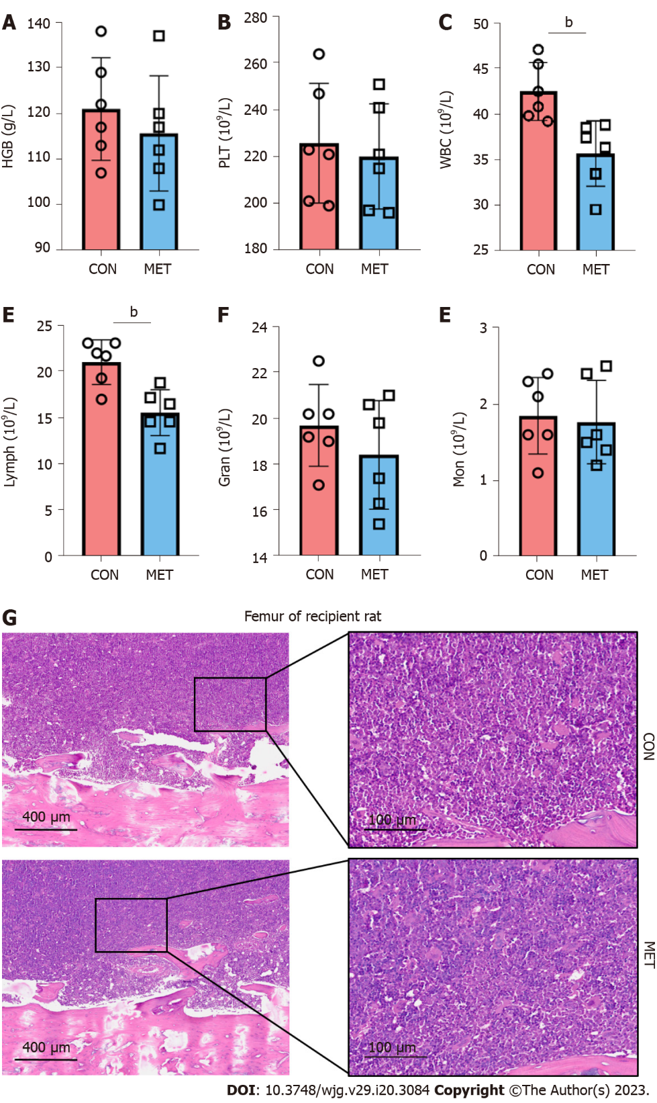
Figure 1 Metronomic capecitabine showed no significant myelosuppression. A and B: Hemoglobin level and platelets count in the peripheral blood; C-F: White blood cells, lymphocytes, granulocytes, and monocytes counts in the peripheral blood; G: Bone marrow tissue was stained with hematoxylin and eosin (50 × and 200 ×). Statistical analysis was done by unpaired t-test, n = 6. Data are shown as mean ± SD; ^{b}P < 0.01 vs the control group. CON: Untreated control groups, rats received 0.9% normal saline for 7 d; MET: Metronomic capecitabine (CAP)-treated groups, rats received metronomic CAP (100 mg/kg/d) treated for 7 d; HGB: Hemoglobin; PLT: Platelets; WBC: White blood cells; lymph: Lymphocytes; Gran: Granulocytes; Mon: Monocytes.

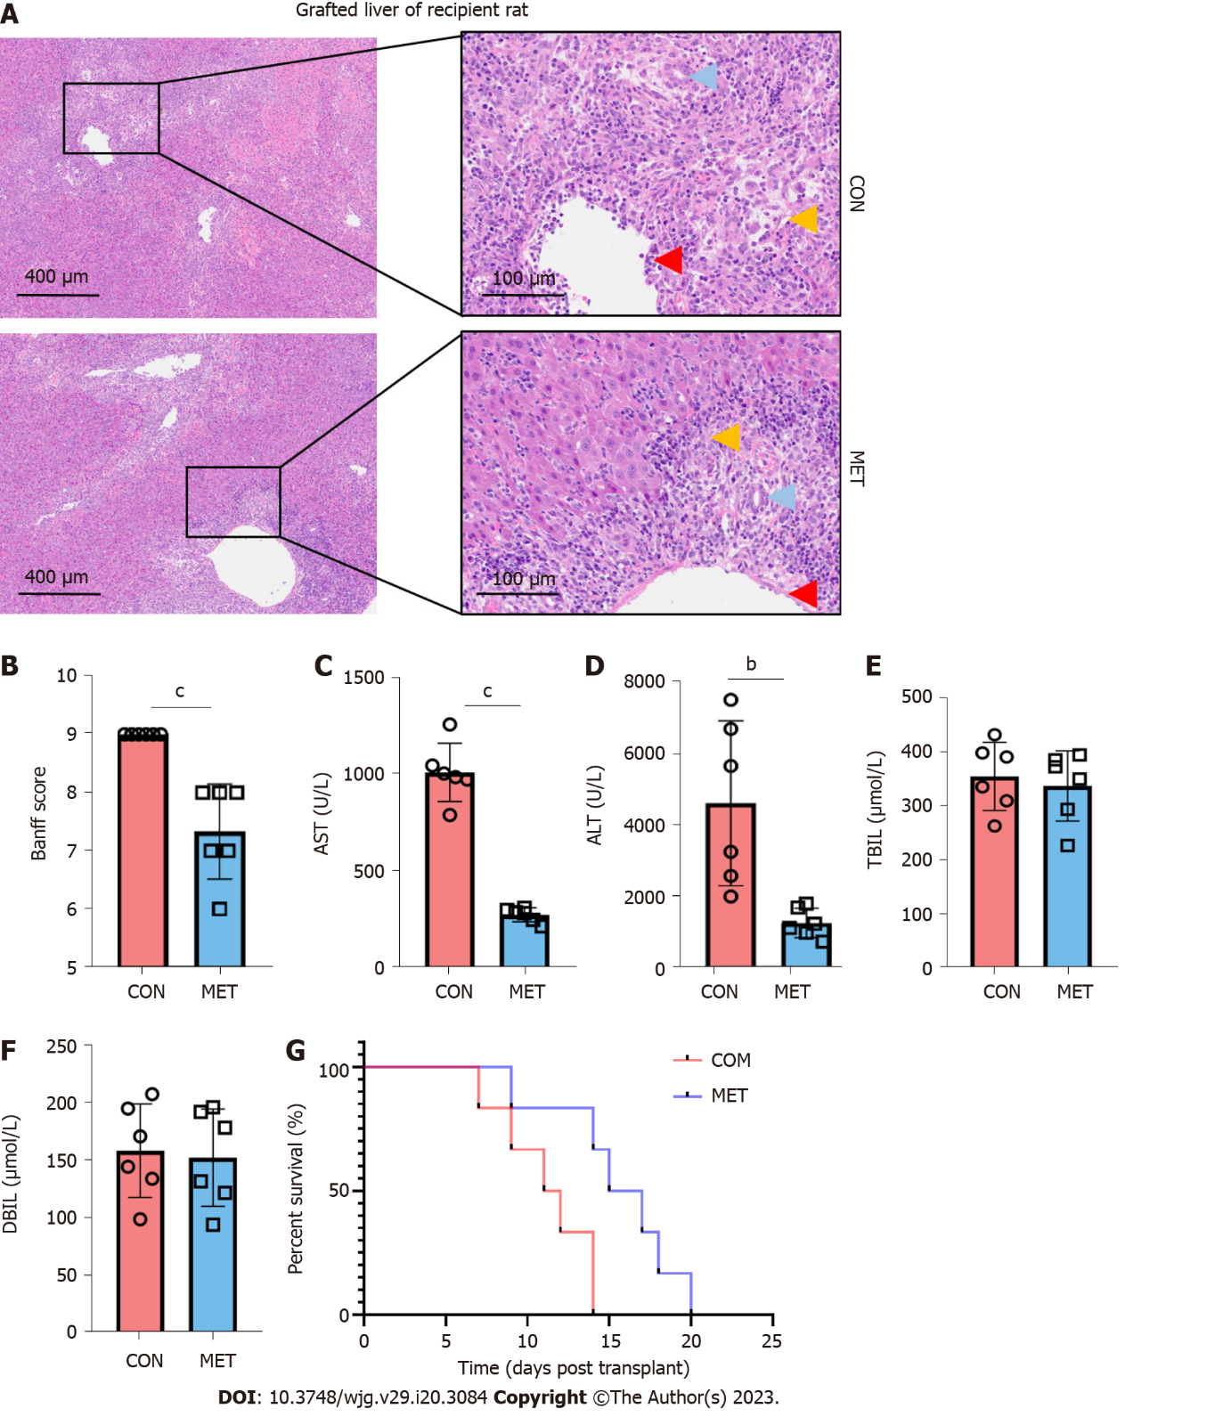
Figure 2 Metronomic capecitabine improves liver function and ameliorates liver allograft rejection. A: Liver allograft tissue was stained with hematoxylin and eosin (50 × and 200 ×). Liver tissue, portal vein, and bile duct were significantly injured in the untreated control group (CON), with a large number of inflammatory cells infiltrated. In the metronomic capecitabine-treated groups (MET), liver tissue destruction was relatively mild, with limited infiltration of inflammatory cells (yellow arrows), relatively little degeneration of portal vein endothelium (red arrows), and bile duct epithelium (blue arrows); B: The severity of acute rejection was graded according to the Banff liver rejection criteria; C-F: Alanine transaminase, aspartate transaminase, total bilirubin, and direct bilirubin levels in the peripheral blood; G: Survival analysis of rats after liver transplantation. The median survival time of the CON and MET groups were 11.5 d and 16 d, respectively (P < 0.01). The survival analysis was done by log-rank (Mantel Cox) test, n = 6. Statistical analysis was done by unpaired t-test, n = 6. Data are shown as mean ± SD; ^{b}P < 0.01 vs the control group, ^{c}P < 0.001 vs the control group. CON: Untreated control groups, rats received 0.9% normal saline for 7 d; MET: Metronomic capecitabine (CAP)-treated groups, rats received metronomic CAP (100 mg/kg/d) treated for 7 d; ALT: Alanine transaminase; AST: Aspartate transaminase; TBIL: Total bilirubin; DBIL: Direct bilirubin.

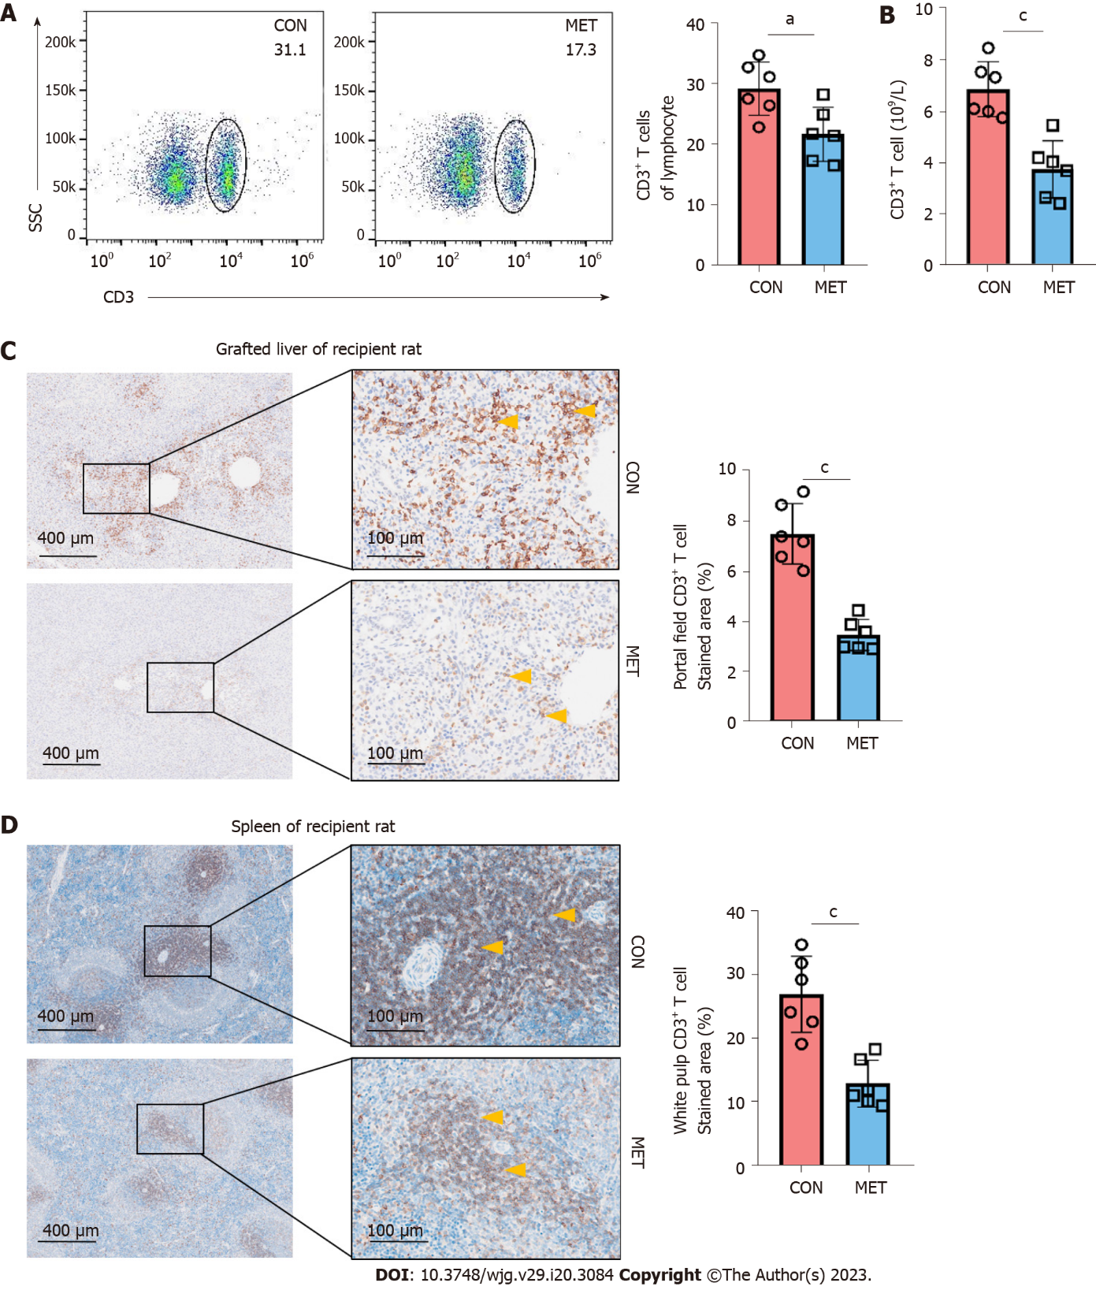
Figure 3 Metronomic capecitabine decreased the infiltration of CD3⁺ T cells in peripheral blood, liver allografts, and spleen. A: The percentage of CD3⁺ T cells among lymphocytes in the peripheral blood at postoperative day 7; B: The number of CD3⁺ T cells in the peripheral blood at postoperative day 7; C and D: Grafted liver (C) and spleen (D) sections were stained for CD3. The samples from each group were collected on postoperative day 7. The arrows show positive staining (50 × and 200 ×). Quantification of the proportion of CD3⁺ positive area within a given section (%). Statistical analysis was done by unpaired t-test, n = 6. Data are shown as mean ± SD; ªP < 0.05 vs the control group, ^{c}P < 0.001 vs the control group. CON: Untreated control groups, rats received 0.9% normal saline for 7 d; MET: Metronomic capecitabine (CAP)-treated groups, rats received metronomic CAP (100 mg/kg/d) treated for 7 d.

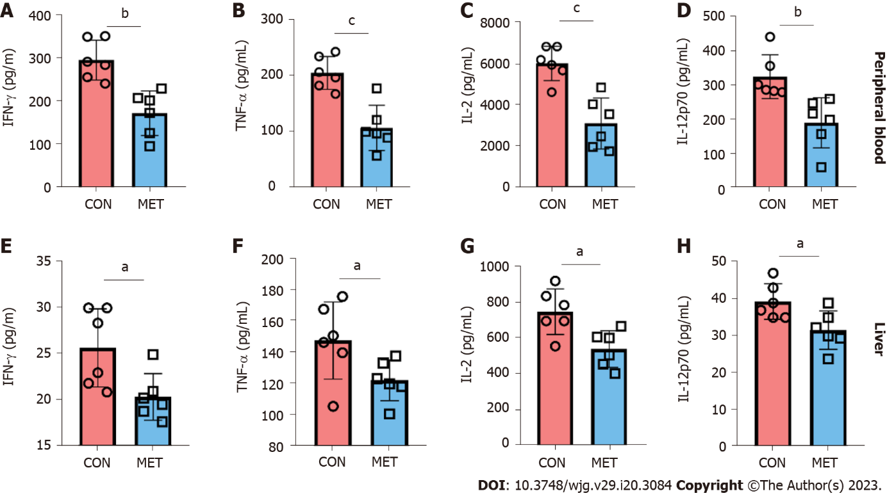Figure 4 Cytokine concentrations of peripheral blood and liver graft in transplanted rats. Use Luminex assay to detect the concentrations of interferon gamma (IFN-γ), tumor necrosis factor alpha (TNF-α), interleukin (IL)-2 and IL-12 in peripheral blood and graft. A and E: IFN-γ; B and F: TNF-α; C and G: IL-2; D and H: IL-12. Statistical analysis was done by unpaired Students t-test, n = 6. Data are shown as mean ± SD; ªP < 0.05 vs the control group, ^{b}P < 0.01 vs the control group, ^{c}P < 0.001 vs the control group. CON: Untreated control groups, rats received 0.9% normal saline for 7 d; MET: Metronomic capecitabine (CAP)-treated groups, rats received metronomic CAP (100 mg/kg/d) treated for 7 d; IFN-γ: Interferon gamma; TNF-α: Tumor necrosis factor alpha; IL: Interleukin.
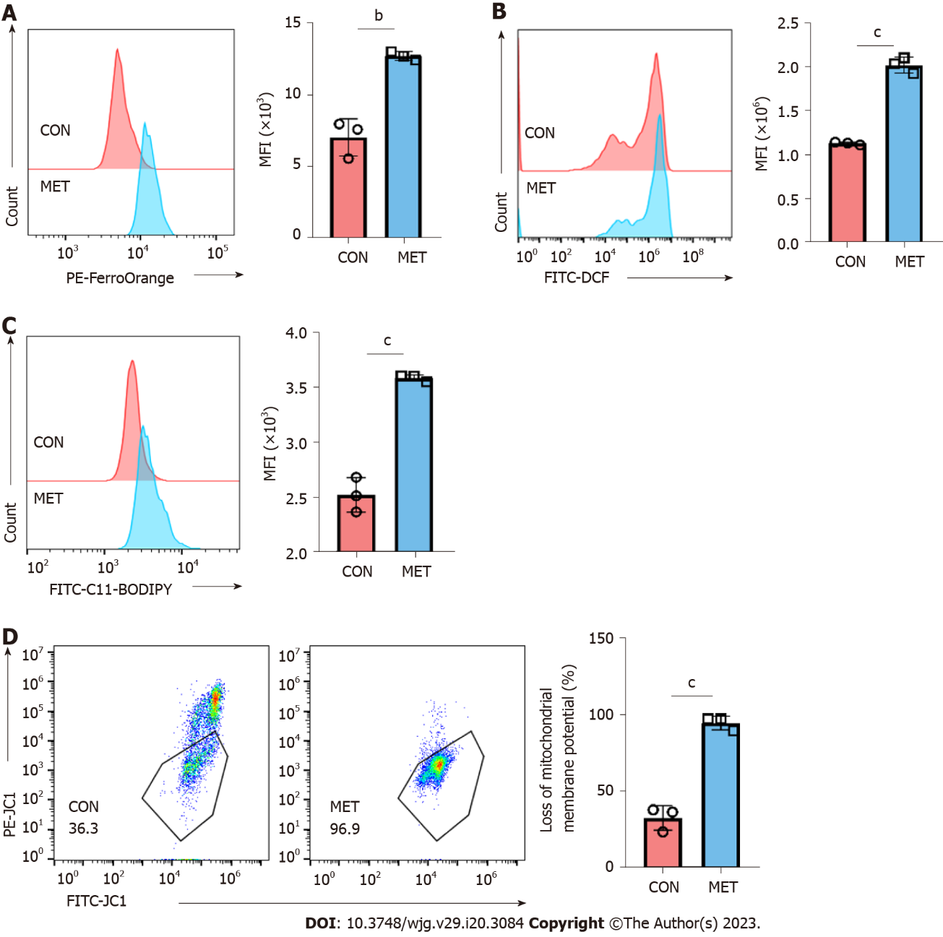
Figure 5 Metronomic capecitabine caused the increase of free ferrous ions and oxidative stress in peripheral blood CD3⁺ T cells of transplanted rats. A: Representative FACS data showing differential FerroOrange staining reflecting different cytoplasmic labile iron concentrations in control groups and metronomic capecitabine-treated rats, followed by statistical analysis of mean fluorescence intensity (MFI); B and C: Reactive oxygen species (ROS) and lipid ROS detected by FACS using DCFH-DA and C11-BODIPY respectively, BODIPY emission was recorded on oxidized C11 (FITC channel) signal. The graph shows the statistical analysis of differential MFIs in the two groups; D: The proportion of cells with reduced mitochondrial membrane potential was assessed by flow cytometry. Statistical analysis was done by unpaired t-test, n = 3. Data are shown as mean ± SD; ^{b}P < 0.01 vs the control group, ^{c}P < 0.001 vs the control group. CON: Untreated control groups, rats received 0.9% normal saline for 7 d; MET: Metronomic capecitabine (CAP)-treated groups, rats received metronomic CAP (100 mg/kg/d) treated for 7 d; MFI: Mean fluorescence intensity.
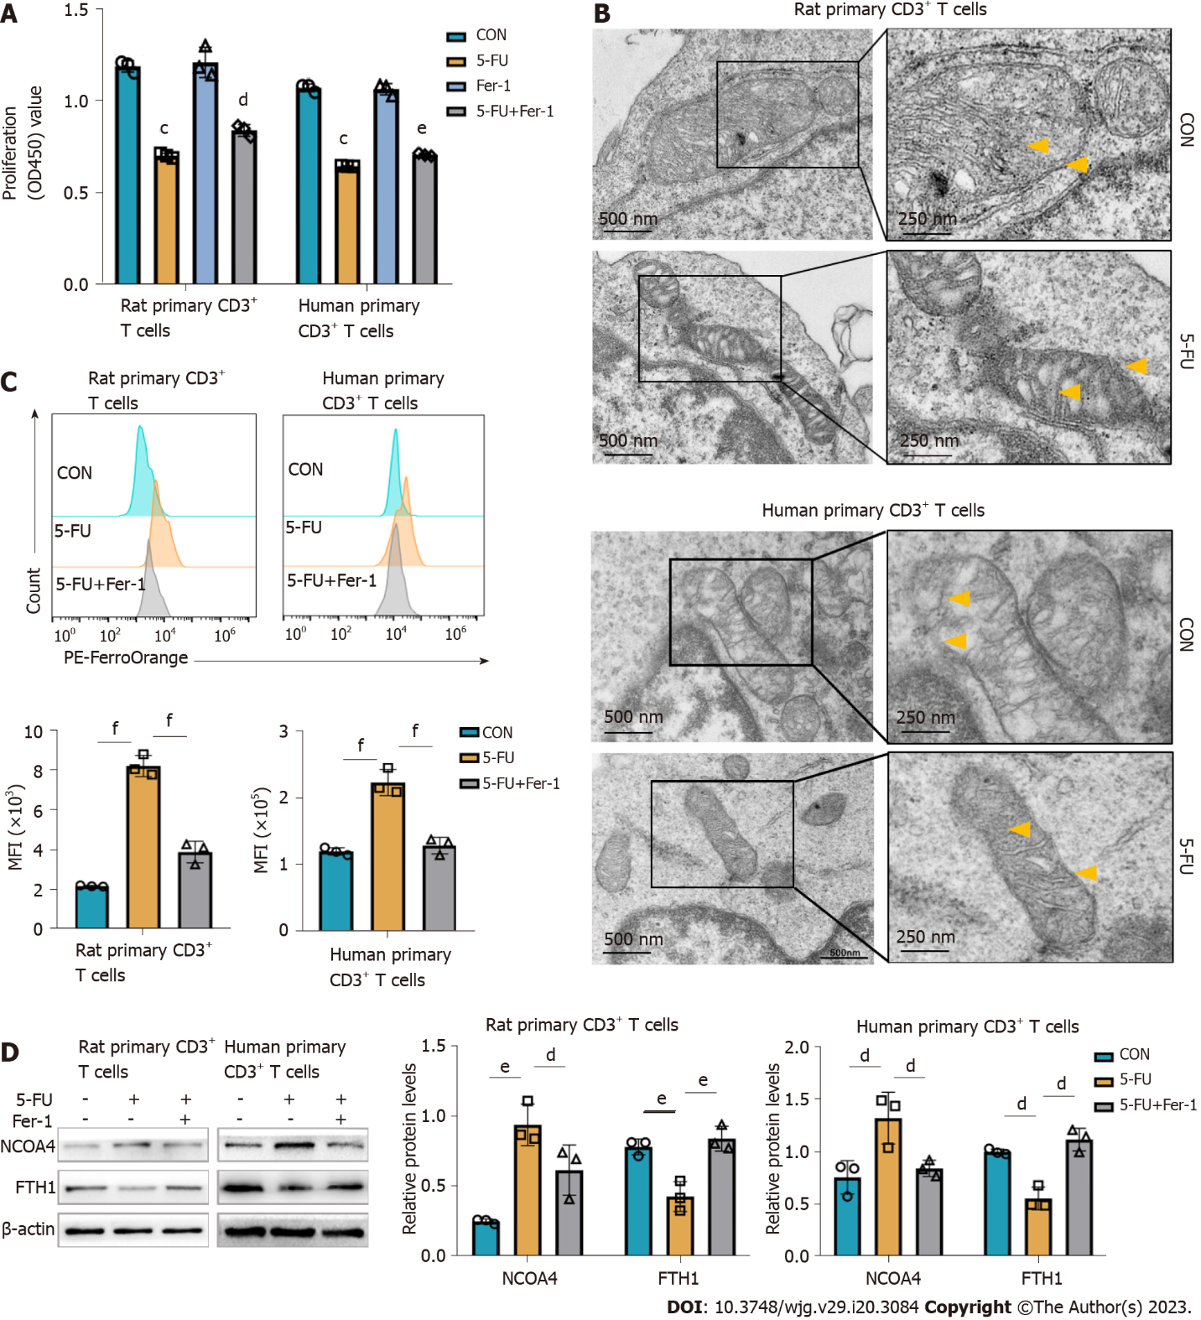
Figure 6 5-fluorouracil increases the pool of labile iron and contributes to ferroptosis in CD3⁺ T cells. Vitro experiments were conducted on rat splenic and human peripheral blood CD3⁺ T cells, which were sorted by immunomagnetic beads. According to predetermined IC50, the rat, and human primary CD3⁺ T cells were treated with 5-fluorouracil (5-FU) (15 μmol/L) and ferrostatin-1 (Fer-1) (2 μmol/L) for 48 h. A: Cell viability was assessed with a Cell Counting Kit-8 kit; the results are expressed as optical density read at 450 nm; B: Transmission electron microscopy images of mitochondria in T cells show increased membrane density (yellow arrows) and a shrunk morphology (Scale bar, 500 nm, and 250 nm); C: Representative FACS data showing FerroOrange staining as the measurement of the level of cytoplasmic labile iron in primary CD3⁺ T cells. The graph shows the statistical analysis of mean fluorescence intensity in the different groups; D: Levels of ferritinophagy-related proteins nuclear receptor coactivator 4 and ferritin heavy chain 1 were assessed by western blot. CON groups: T cells were treated with DMSO for 48 h; 5-FU groups: T cells were treated with 5-FU (15 μmol/L) for 48 h; 5-FU+ Fer-1 groups: T cells were treated with 5-FU (15 μmol/L) and Fer-1 (2 μmol/L) for 48 h. Statistical analysis was done by one-way ANOVA, n = 3. Data are shown as mean ± SD. Data are shown as mean ± SD. ^{c}P < 0.001 vs the control group, ^{d}P < 0.05 vs the 5-FU group, ^{e}P < 0.01 vs the 5-FU group, ^{f}P < 0.001 vs the 5-FU group. CON: Untreated control groups; 5-FU: 5-fluorouracil; NCOA4: Nuclear receptor coactivator 4; FTH1: Ferritin heavy chain 1; Fer-1: Ferrostatin-1.

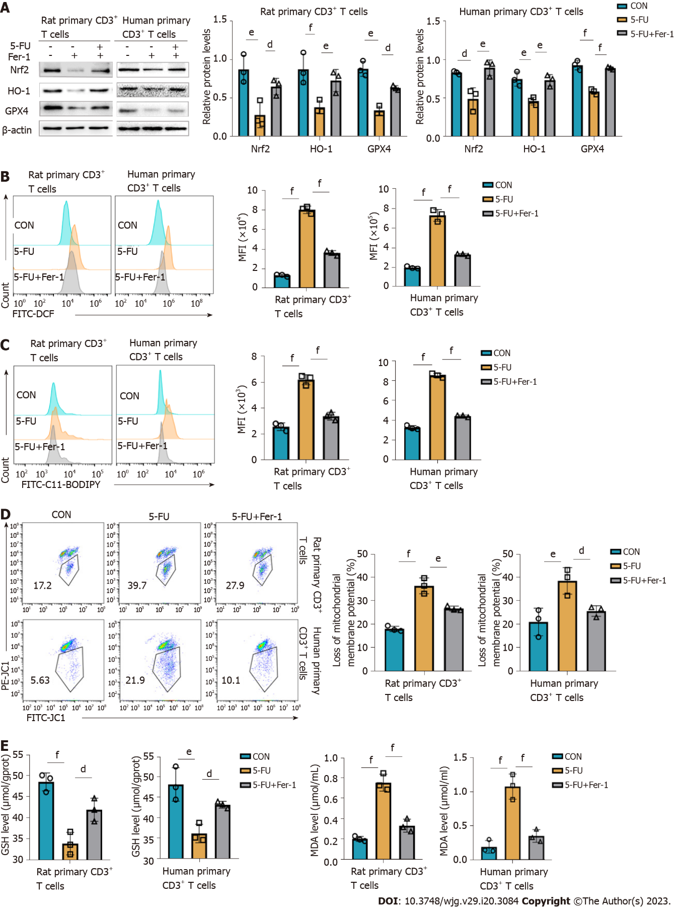
Figure 7 5-fluorouracil disturbs the antioxidative/oxidative balance, resulting in CD3⁺ T cells ferroptosis. A: Levels of antioxidant proteins nuclear erythroid 2 p45-related factor 2, heme oxygenase-1, and glutathione peroxidase 4 assessed by western blot, and corresponding graphs showing the statistical comparison between groups; B and C: Reactive oxygen species (ROS) and lipid ROS of rat and human CD3⁺ T cells were detected by FACS using DCFH-DA and C11-BODIPY fluorescent conjugates, BODIPY emission was recorded on oxidized C11 (FITC channel) signal; the graphs display the comparison of mean fluorescence intensity levels in the different groups; D: Proportion of cells with reduced mitochondrial membrane potential assessed by flow cytometry; E and F: Glutathione and malondialdehyde content T cells after treatment for 48 h. CON groups: T cells were treated with DMSO for 48 h; 5-fluorouracil (5-FU) groups: T cells were treated with 5-FU (15 μmol/L) for 48 h; 5-FU+ferrostatin-1 (Fer-1) groups: T cells were treated with 5-FU (15 μmol/L) and Fer-1 (2 μmol/L) for 48 h. Statistical analysis was done by one-way ANOVA, n = 3. ^{d}P < 0.05 vs the 5-FU group, ^{e}P < 0.01 vs the 5-FU group, ^{f}P < 0.001 vs the 5-FU group. Nrf2: Nuclear erythroid 2 p45-related factor 2; HO-1: Heme oxygenase-1; GPX4: Glutathione peroxidase 4; GSH: Glutathione; MDA: Malondialdehyde; CON: Untreated control groups; 5-FU: 5-fluorouracil; Fer-1: Ferrostatin-1; MFI: Mean fluorescence intensity.
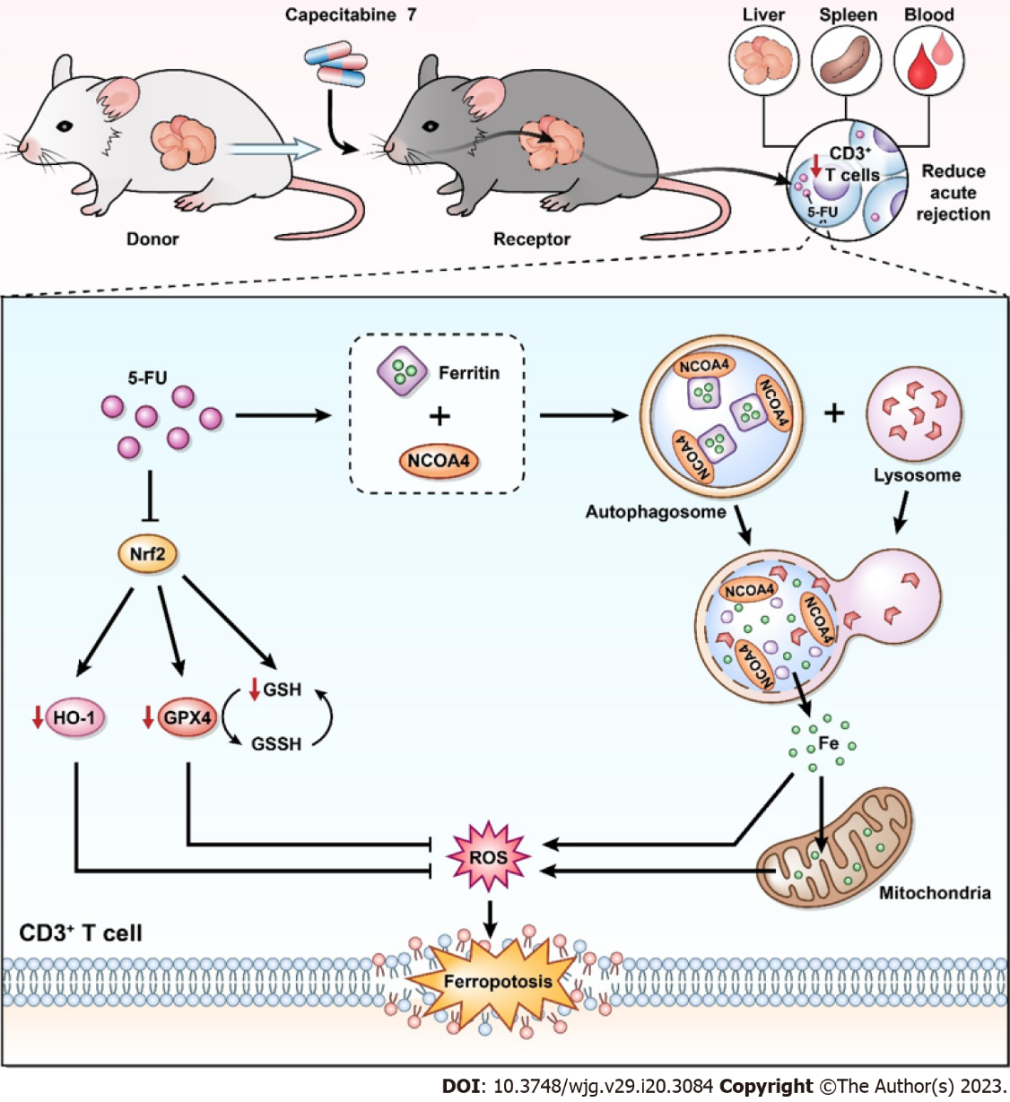
Figure 8 Possible immunosuppressive mechanisms of metronomic capecitabine on T cells by ferroptosis induction. In the rat model of acute rejection after liver transplantation, metronomic capecitabine (CAP) exerts an immunosuppressive effect by decreasing T cell numbers in peripheral blood, liver graft, and spleen. Metronomic CAP increases the concentration of free ferrous ions by inducing ferritin degradation while inhibiting the expression of antioxidant proteins. Eventually, these effects lead to peroxidation damage and iron toxicity, which induce T cell death. 5-FU: 5-fluorouracil; Nrf2: Nuclear erythroid 2 p45-related factor 2; NCOA4: Nuclear receptor coactivator 4; HO-1: Heme oxygenase-1; GPX4: Glutathione peroxidase 4; GSH: Glutathione; GSSH: Oxidized glutathione; ROS: Reactive oxygen species.

Published by Baishideng Publishing Group Inc
7041 Koll Center Parkway, Suite 160, Pleasanton, CA 94566, USA
Telephone: +19253991568
Email: bpgoffice@wjgnet.com
Help Desk: https://www.f6publishing.com/helpdesk
https://www.wjgnet.com

© 2023 Baishideng Publishing Group Inc. All rights reserved.

