Name of journal: World Journal of Gastroenterology
ESPS Manuscript NO: 27544
Manuscript Type: ORIGINAL ARTICLE

Retrospective Cohort Study
Effect of airplane transport of donor livers on post-liver transplantation survival

Huang Y et al. Airplane transported liver and outcomes

Yi Huang, Gerry MacQuillan, Leon A Adams, George Garas, Megan Collins, Albert Nwaba, Linjun Mou, Max K Bulsara, Luc Delriviere, Gary P Jeffrey

Yi Huang, Gerry MacQuillan, Leon A Adams, George Garas, Gary P Jeffrey, School of Medicine and Pharmacology, University of Western Australia, Nedlands, WA 6009, Australia

Gerry MacQuillan, Leon A Adams, George Garas, Megan Collins, Albert Nwaba, Linjun Mou, Luc Delriviere, Gary P Jeffrey, Western Australian Liver Transplantation Service, Sir Charles Gairdner Hospital, Nedlands, WA 6009, Australia

Max K Bulsara, Institute of Health Research, University of Notre Dame, Fremantle, WA 6160, Australia

Author contributions: Huang Y and Jeffrey GP were responsible for study design, data collection and data analysis; Huang Y and Bulsara MK were responsible for statistical analysis of the date; all authors took part in data interpretation, review of the draft report, and content development.

Institutional review board statement: This study was reviewed and approved by the Institutional Review Board of Sir Charles Gairdner Hospital Human Research Ethics Committee.

Conﬂict-of-interest statement: None of the authors has a conﬂict of interest.

Informed consent statement: Due to the nature of the study design, no direct contact of participants was required. The informed consent was waived by Sir Charles Gairdner Hospital Human Research Ethics Committee.

Data sharing statement: Additional data are available from the corresponding author at gary.jeffrey@uwa.edu.au.

Open-Access: This article is an open-access article which was selected by an in-house editor and fully peer-reviewed by external reviewers. It is distributed in accordance with the Creative Commons Attribution Non Commercial (CC BY-NC 4.0) license, which permits others to distribute, remix, adapt, build upon this work non-commercially, and license their derivative works on different terms, provided the original work is properly cited and the use is non-commercial. See: http://creativecommons.org/licenses/by-nc/4.0/

Manuscript source: Unsolicited manuscript

Correspondence to: Gary P Jeffrey, MB, BS, MD, FRACP, FRCP, Professor, School of Medicine and Pharmacology, University of Western Australia, 5th Floor, Harry Perkins Institute of Medical Research, 6 Verdun Street, Nedlands, WA 6009, Australia. gary.jeffrey@uwa.edu.au
Telephone: +61-8-93462098
Fax: +61-8-93463098

Received: June 3, 2016
Peer-review started: June 4, 2016
First decision: July 12, 2016
Revised: July 26, 2016
Accepted: August 23, 2016
Article in press:
Published online:

Abstract:
AIM: To evaluate the effect of long haul airplane transport of donor livers on post-transplant outcomes.

METHODS: A retrospective cohort study of patients who received a liver transplantation was performed in Perth, Australia from 1992 to 2012. Donor and recipient characteristics information were extracted from Western Australian liver transplantation service database. Patients were followed up for a mean of six years. Patient and graft survival were evaluated and compared between patients who received a local donor liver and those who received an airplane transported donor liver. Predictors of survival were determined by univariate and multivariate analysis using cox regression.

RESULTS: 193 patients received a local donor liver and 93 patients received an airplane transported donor liver. Airplane transported livers had a significantly lower alanine transaminase (mean: 45 μ/L vs 84 μ/L, P = 0.035), higher donor risk index (mean: 1.88 vs 1.42, P < 0.001) and longer cold ischemic time (CIT) (mean: 10.1 hours vs 6.4 h, P < 0.001). There was a weak correlation between CIT and transport distance (r² = 0.29, P < 0.001). Mean follow up was six years and 93 patients had graft failure. Multivariate analysis found only airplane transport retained significance for graft loss (HR = 1.92, 95%CI: 1.16-3.17). One year graft survival was 0.88 for those with a local liver and was 0.71 for those with an airplane transported liver. One year graft loss was due to primary graft non-function or associated with preservation injury in 20.8% of recipients of an airplane transported liver compared with 4.6% in those with a local liver (P = 0.027).

CONCLUSION: Airplane transport of donor livers was independently associated with reduced graft survival following liver transplantation.

Key words: Airplane transportation; Cold ischemic time; Graft survival; Donor location; Organ damage

© The Author(s) 2016. Published by Baishideng Publishing Group Inc. All rights reserved.

Core tip: This study demonstrated a significantly decreased graft and patient survival for patients who received an airplane transported donor liver compared to a local donor liver not requiring airplane transport. The hazard ratio for airplane transported donor livers compared to local donor livers was 1.98 for graft survival and 1.86 for patient survival. The effect of airplane transportation was independent of cold ischemic time.

Huang Y, MacQuillan G, Adams LA, Garas G, Collins M, Nwaba A, Mou L, Bulsara MK, Delriviere L, Jeffrey GP. Effect of airplane transport of donor livers on post-liver transplantation survival. World J Gastroenterol 2016; In press

INTRODUCTION
The combination of the large geographic area of Western Australia and relatively small and centralised population has resulted in the need for donor livers to be transported by airplane over long distances. Australian donor allocation policy is based on a regional (state) and national model. Sharing between regions is mandatory for urgent patients and for non-urgent patients sharing occurs when there is no suitable local recipient. As a result a significant number of patients in Perth have received a long distance airplane transported donor liver from other states in Australia and New Zealand. The shortest transport distance was from Adelaide (2140 km) and the longest was from Auckland (5364 km) and this is similar to that between Dallas and Los Angeles and Nuuk (Greenland) and Los Angeles respectively.
It is well established that the cold ischemic time (CIT) has a major effect on donor organ quality and graft survival following liver transplantation and most transplant centres attempt to maintain the CIT less than12 hours^{[1]}. One study found that air transport of donor livers for more than 322 km increased CIT and decreased graft survival and it was recommended that long distance transport be avoided if other adverse donor risk factors were present^{[2]}. The donor risk index and other donor risk models that have been developed to predict short term graft survival have used a variety of donor factors that include donor age, Body Mass Index (BMI), time in Intensive Care Unit, use of inotropes, hypernatremia, cause of death, liver function tests, pre-existing donor liver disease, warm ischaemic time, CIT, MELD score and location of donor^{[3-7]}. Interestingly, none have analysed if the type of transport used to transfer the organ could add to the utility of the model. Airplane transport is commonly used for long distance donor liver transportation, but its unique conditions such as low cabin pressure (0.7 Atm), reduced partial pressure of oxygen, acceleration and deceleration forces and engine vibrations have the potential to cause damage to donor organs.
The geographic isolation of Perth allows a unique opportunity to evaluate the effect of long distance airplane transport of donor livers on graft and patient survival. The aim of this study was firstly to evaluate the association between airplane donor liver transport distance and CIT and secondarily determine the effects of liver transport type on graft and patient survival.

MATERIALS AND METHODS
286 patients who had a liver transplant (LT) performed by the Western Australian liver transplant service, Sir Charles Gairdner Hospital from 1992 to 2012 were included. All patients received a donation after brain death donor liver. Exclusion criteria included living donor liver transplantation.

Donor organ retrieval
Donor livers were preserved in cold (4 °C) UW solution, sealed in two plastic bags and placed in an insulated cooler that contained a slurry of iced water (Figure 1). All Western Australian donor liver retrievals were performed in Perth. Ventilated patients in regional areas of Western Australia are transferred by the Royal Flying Doctor Service to Perth and only Perth based intensive care units will declare brain death. Interstate donor liver retrieval is performed by the regional donor team. The cold stored donor livers are transported by commercial flights (passenger or freight) in the cabin. Charter jets are rarely used due to the expense.

Data source
Clinical data were prospectively recorded and retrospectively extracted from the Western Australian liver transplantation service database. Donor factors collected were regional area of donation, history of airplane travel, age, gender, weight, height, liver function test (alanine transaminase (ALT), aspartate transaminase (AST), bilirubin and alkaline phosphatase(ALP)), blood type, CIT, cause of death, past cytomegalovirus (CMV) infection, smoking/drinking history. The donor risk index (age, cause of death, race, partial/split liver, height, CIT, regional/national share and donation after cardiac death) was also calculated^{[3]} Recipient factors collected were age, gender, race, weight, height, blood type, MELD score, LT indication, past CMV infection. Follow-up was performed at Sir Charles Gairdner Hospital on all patients till death, re-transplantation or December 2012. The study was approved by the Sir Charles Gairdner Hospital Human Research Ethics Committee.

Endpoints and statistical analysis
The primary endpoints were graft and patient survival. Primary graft non-function was defined as severe and immediate liver dysfunction that lead to death of the patient or re-transplantation during the first seven postoperative days^{[8]}. Primary graft dysfunction was defined as transaminases > 2000 μ/L immediately post-LT^{[9]}. Early graft failure was associated with primary graft dysfunction or progressive deterioration of liver function tests from the time of transplantation. Continuous variables were expressed as mean and standard deviation. Mean values between groups were compared using the t test. Categorical variables were expressed as count and percentages. Percentages were compared using the Chi-square test. The correlation between transport distance and CIT was assessed using linear regression analysis. Survival was assessed using Kaplan Meier curves and significance determined by the log rank test. Predictors of survival were determined by univariate and multivariate analysis using cox regression. Two sided P values of < 0.05 were considered significant.

RESULTS
Two hundred and eighty-six patients were included: 193 (67%) patients received a local donor liver and 93 (33%) patients received a donor liver airplane transported from other states in Australia or New Zealand. Donor and recipients characteristics are shown in Table 1. Local and airplane transported donor livers were well matched for factors that are known to affect graft and patient survival following liver transplantation. Airplane transported donor livers had a lower mean ALT level (45 μ/L vs 84 μ/L, P = 0.035) and a higher mean donor risk index (1.88 vs 1.42, P < 0.001). There was a trend for less alcohol use in airplane transported donor livers but this was non-significant. Recipients who received an airplane transported donor liver were significantly younger than those who received a local donor liver (50 year vs 47 year, P = 0.019), had a higher mean MELD score (18.2 vs 14.5, P = 0.0007) and more often had acute liver failure (16.1% vs 2.6%, P < 0.001).
Local donor livers had a significantly shorter mean CIT of 6.4 h vs 10.1 h for airplane transported livers (P < 0.001). Only 4% of local donor livers had a CIT ≥ 12 h compared to 24% of airplane transported livers. Livers transported from the central states (South Australia, Northern Territory) had a mean CIT of 9.0 h and those from the eastern states (Queensland, New South Wales, Victoria, Tasmania) had a significantly longer mean CIT of 10.7 h (P = 0.01). Linear regression analysis found that CIT significantly increased with transport distance with a coefficient of 1.3 (95%CI: 1.1-1.6) per 1000 km, P < 0.001 (Figure 2). However the correlation was poor with a model fit (R square value) of 0.295, indicating that other factors apart from transport distance affected CIT. Some of these included availability of commercial flights, flight delays and flight diversions.
Recipients were followed after LT for a mean of six years (range: 0.1-19 years). 93 (33%) developed graft failure, 15 (5%) had a repeat LT and 78 (27%) died. The one and five year graft survival was 83% and 73% and patient survival was 86% and 76% respectively. Univariate analysis found that airplane donor transport and long CIT were significantly associated with worse graft survival and patient survival (Table 2). After adjusting for potential confounders (donor and recipient age, donor and recipient gender, CIT, transplant indication), multivariate analysis found that only airplane donor transport was significantly associated with decreased graft and patient survival (Table 2). The hazard ratio for airplane transported donor livers compared to local donor livers was 1.98 (95%CI: 1.20-3.27) for graft survival and 1.86 (95%CI: 1.07-3.22) for patient survival. Recipients with airplane transported livers had significantly worse graft survival (P = 0.0005) and patient survival (P = 0.003) than those who received a local liver (Figure 3). One year and five year graft survival was 0.88 and 0.79 for those with a local liver and was 0.71 and 0.61 for those with an airplane transported liver. One year and five year patient survival was 0.91 and 0.81 for those with a local donor liver and was 0.76 and 0.66 for those with an airplane transported liver. The significant reduction in graft survival for recipients with an airplane transported liver was observed immediately after liver transplantation with graft loss within seven days of 8.6% (8/93) compared to 1% (2/193) for those with local livers (P = 0.02). This difference in graft survival increased until one year post-transplant (28% vs 11.4% respectively, P = 0.001) and then was maintained until the end of follow up. Primary graft non-function and early graft failure associated with preservation injury accounted for 20.8% of graft loss within the first year in those with an airplane transported liver and only for 4.6% for those with a local liver (P = 0.027) (Table 3). The primary graft dysfunction rate was also significantly higher in recipients with an airplane transported liver than those with a local liver (38.5% vs 4.6%, P = 0.006) (Table 3).
Analysis of survival stratified by CIT (CIT ≥ 12 h, CIT < 12 h) found that airplane donor liver transport was significantly associated with decreased graft survival in both groups (P = 0.032 and P = 0.004 respectively) (Figure 4). Stratification by cause of liver failure found a significant reduction of graft survival for airplane transported livers in recipients with chronic liver disease (P = 0.002) but not for recipients with acute liver failure (P = 0.243) (Figure 4). The non-significant difference for acute liver failure was possibly due to small numbers (n = 20) and lack of statistical power. For those patients transplanted for chronic liver disease, further stratification analysis by MELD score (MELD ≥ 20, MELD < 20) found a significant correlation between airplane transported liver and graft survival in both groups (P = 0.013 and P = 0.019 respectively). Finally there was no significant difference in graft or patient survival when comparing recipients who received an airplane transported liver from the central states compared with the eastern states, P = 0.88 and 0.93 respectively.

DISCUSSION
In this longitudinal study, we found that airplane transport of donor liver organs was associated with significantly reduced patient and graft survival independently of CIT and donor and recipient characteristics. Donor characteristics were well matched in local and airplane transported liver groups apart from a lower mean ALT level and the expected longer CIT in the airplane transported liver group. The lower ALT level in this group is likely due to a better quality donor liver being accepted because of the added risk of interstate airplane transport. Recipient characteristics differed in that there were an increased proportion of acute liver failure recipients and a higher MELD score in those that received an airplane transported liver. National mandatory donor sharing accounted for 75% of all donor livers being transported by airplane for this urgent indication.
There was a weak but significant correlation between donor transport distance and CIT. CIT increased by 1.3 h for each additional 1000 km of flight distance. Clearly other transport related factors apart from transport distance influenced CIT and these included delays in ground transport to and from airports, delayed airplane departures and increased flight times. On one occasion Perth airports closed due to adverse weather conditions and caused a flight diversion. These delays become more significant in that surgery may be commenced prior to arrival of the donor organ in an attempt to reduce CIT.
Overall graft and patient survival were excellent and not different from those reported by the Transplantation Society of Australia and New Zealand for transplantation during this period^{[10]}. There was however a significantly reduced graft and patient survival in recipients that received an airplane transported donor liver. For those who received a local donor the one year graft and patient survival was 88% and 91% respectively compared to 71% and 76% respectively for those with an airplane transported liver. The increased graft loss in airplane transported livers was evident early within seven days after LT with the maximum difference observed after one year. Moreover, primary graft non-function and early graft failure accounted for 28% of all graft loss in the first year for recipients with an airplane transported liver compared with 4.6% in those with a local liver. This suggested a role of graft damage during transportation for recipients with an airplane transported liver.
Airplane transport was the only factor that was independently associated with either graft survival or patient survival. Univariate analysis found CIT was associated with both end-points but this did not maintain significance in multivariate analysis. After stratifying graft survival results for livers that had CIT ≥ 12 h or < 12 h; for recipients with a MELD ≥ 20 or < 20 and for recipients transplanted for chronic liver disease, there remained a significant difference between airplane transported and local donor livers. This further confirmed the independent effect of airplane transportation on graft survival. Other donor risk factors such as pre-existing liver disease, the use of inotropes, hypernatremia and warm ischemia time were not available for analysis in this study. It is unlikely that these factors varied between groups. It is also unlikely that donor organ retrieval by the other states contributed to the worse graft survival as all donor procurement surgery was performed by experienced surgical teams that also perform the service for each of the home states. Others have shown that non-local organ procurement had no effect on graft survival^{[11]}. Future studies that include these clinical factors are of great interest.
Up to date, this is the only study that has evaluated the effect of airplane transport on post-transplantation survival. Two large studies from the US and European found that distant donor location (local vs reginal vs national) was independently associated with decreased survival after adjusting for CIT^{[3,7]}. This decreased graft survival was potentially due to damage of the donor liver caused by airplane transport. In the current environment where donor sharing across a large geographical area is increasing, further clinical and laboratory investigation is needed to determine the potential mechanism of the damage caused by airplane transport and search for possible solutions. Airplane transport has a number of well documented environmental effects that have the potential to cause damage to cold stored donor livers. Cabin pressure is routinely maintained at approximately 8000 ft which is equivalent to approximately 0.7 Atm. The direct and indirect effects of this pressure change on the isolated organ with tissue swelling and bubble expansion in preservation fluid both have the potential to adversely affect graft quality^{[12]}. The decreased partial pressure of oxygen to 108 mmHg is less likely to affect the donor liver because cellular metabolism at 4 °C is negligible. Direct trauma from the walls of the container and acceleration and de-acceleration forces could also damage the isolated liver. Finally airplane engine and other vibrations are well known to cause tissue damage particularly in the resonance frequency range for organs of 4-5 Hz.
In summary, this “proof of concept” study demonstrated the significant effect of airplane transportation of donor livers on post-liver transplantation survival. Further investigation is required to determine the mechanism of organ damage in airplane transported livers. However in the meantime it would seem prudent to minimise donor liver trauma and atmospheric pressure change effects by transporting isolated organs in a pressure sealed cooler that has an appropriate organ harness and that is isolated from floor vibrations. Clearly these observations have similar and important implications for other donor organs that are transported by airplane.

ACKNOWLEDGEMENTS
We thank all Australian and New Zealand liver transplantation centres and donor co-ordinators.

COMMENTS
Background
In the current environment of donor scarcity donor sharing between large geographical areas is increasing. Airplane transportation is commonly used for long distance donor transportation. However, no studies have evaluated the potential effect of airplane transportation on post liver transplantation survivals.

Research Frontiers
The geographic isolation of Perth allows a unique opportunity to evaluate the effect of long distance airplane transport of donor livers on post liver transplantation outcomes.

Innovations and breakthroughs
This study demonstrates for the first time a significantly decreased graft and patient survival for patients who received an airplane transported donor liver compared to a local donor liver not requiring airplane transport. This effect was independent of the cold ischaemic time.

Applications
This study raised an interesting clinical question and leads to further investigations to determine the mechanism of organ damage in airplane transported livers. In the meantime, transporting isolated organs in a pressure sealed cooler that has an appropriate organ harness and that is isolated from floor vibrations should be considered to minimise the potential damage caused by airplane transportation.

Terminology
All terms used in this study are easily understandable.

Peer-review
This manuscript compared survival of liver transplant recipients that received a local organ donor versus an airplane transported donor liver in Australia. This is an interesting exploratory and novel study that has not been reported previously. The study finding is very topical in an era of increasing transport of donor livers that aims to redistribute organs in a fair way.
REFERENCES
1 Adam R, Cailliez V, Majno P, Karam V, McMaster P, Caine RY, O'Grady J, Pichlmayr R, Neuhaus P, Otte JB, Hoeckerstedt K, Bismuth H. Normalised intrinsic mortality risk in liver transplantation: European Liver Transplant Registry study. Lancet 2000; 356: 621-627 [PMID: 10968434 DOI: 10.1016/S0140-6736(00)02603-9]
2 Totsuka E, Fung JJ, Lee MC, Ishii T, Umehara M, Makino Y, Chang TH, Toyoki Y, Narumi S, Hakamada K, Sasaki M. Influence of cold ischemia time and graft transport distance on postoperative outcome in human liver transplantation. Surg Today 2002; 32: 792-799 [PMID: 12203057 DOI: 10.1007/s005950200152]
3 Feng S, Goodrich NP, Bragg-Gresham JL, Dykstra DM, Punch JD, DebRoy MA, Greenstein SM, Merion RM. Characteristics associated with liver graft failure: the concept of a donor risk index. Am J Transplant 2006; 6: 783-790 [PMID: 16539636 DOI: 10.1111/j.1600-6143.2006.01242.x]
4 Cameron AM, Ghobrial RM, Yersiz H, Farmer DG, Lipshutz GS, Gordon SA, Zimmerman M, Hong J, Collins TE, Gornbein J, Amersi F, Weaver M, Cao C, Chen T, Hiatt JR, Busuttil RW. Optimal utilization of donor grafts with extended criteria: a single-center experience in over 1000 liver transplants. Ann Surg 2006; 243: 748-753; discussion 753-755 [PMID: 16772778 DOI: 10.1097/01.sla.0000219669.84192.b3]
5 Rana A, Hardy MA, Halazun KJ, Woodland DC, Ratner LE, Samstein B, Guarrera JV, Brown RS, Emond JC. Survival outcomes following liver transplantation (SOFT) score: a novel method to predict patient survival following liver transplantation. Am J Transplant 2008; 8: 2537-2546 [PMID: 18945283 DOI: 10.1111/j.1600-6143.2008.02400.x]
6 Halldorson JB, Bakthavatsalam R, Fix O, Reyes JD, Perkins JD. D-MELD, a simple predictor of post liver transplant mortality for optimization of donor/recipient matching. Am J Transplant 2009; 9: 318-326 [PMID: 19120079 DOI: 10.1111/j.1600-6143.2008.02491.x]
7 Braat AE, Blok JJ, Putter H, Adam R, Burroughs AK, Rahmel AO, Porte RJ, Rogiers X, Ringers J. The Eurotransplant donor risk index in liver transplantation: ET-DRI. Am J Transplant 2012; 12: 2789-2796 [PMID: 22823098 DOI: 10.1111/j.1600-6143.2012.04195.x]
8 Moreno R, Berenguer M. Post-liver transplantation medical complications. Ann Hepatol 2006; 5: 77-85 [PMID: 16807513]
9 Chui AK, Shi LW, Rao AR, Anasuya A, Hagl C, Pillay P, Verran D, McCaughan GW, Sheil AG. Primary graft dysfunction after liver transplantation. Transplant Proc 2000; 32: 2219-2220 [PMID: 11120140 DOI: 10.1016/S0041-1345(00)01642-0]
10 Australia and New Zealand Live Transplant Registry. Available from: URL: http://www.anzltr.org/Reports/24thANZLTRReport.pdf
11 Salvalaggio PR, Ferraz-Neto BH. Liver grafts procured by other transplant teams do not affect posttransplantation outcomes. Transplant Proc 2012; 44: 2293-2296 [PMID: 23026577 DOI: 10.1016/j.transproceed.2012.07.043]
12 Rainford DJ. Gradwell DP. Ernsings Aviation Medicine. 4th ed. Hodder Arnold, 2006.

P-Reviewer: Fulop T, Hardinger KL, Therapondos G, Rydzewski A S-Editor: Qi Y L-Editor: E-Editor:

Specialty type: Gastroenterology and hepatology
Country of origin: Australia
Peer-review report classification
Grade A (Excellent): A
Grade B (Very good): B, B
Grade C (Good): C
Grade D (Fair): 0
Grade E (Poor): 0
Table 1 Patient characteristics n (%)
Characteristics | Local liver transport (n = 193) | Airplane liver transport (n = 93) | P value
Donor characteristics
Age (yr) | 41 (16.8) | 44 (14.8) | 0.23
Gender-male/female | 55%/45% | 56%/44% | 0.87
Height (cm) | 171 (11.5) | 172 (9.3) | 0.74
Weight (kg) | 77 (17.4) | 77 (13.4) | 0.96
BMI | 26 (7.5) | 26 (4.2) | 0.66
Bilirubin (µmol/L) | 15 (8.1) | 14 (9.0) | 0.38
ALP (U/L) | 78 (35.4) | 80 (35.8) | 0.73
AST (U/L) | 70 (84.9) | 62 (69.2) | 0.52
ALT (U/L) | 84(167.6) | 45 (45.8) | 0.035
Smoker | 63% | 64% | 0.94
Etoh drinker | 82% | 69% | 0.07
CMV positive | 57% | 63% | 0.421
Cause of Death – trauma/CVA/anoxia/other, (%) | 37/52/9/2 | 25/67/7/1 | 0.129
Donor risk index | 1.42 (0.35) | 1.88 (0.43) | < 0.0001
Recipient characteristics
Age (yr) | 50 (10.8) | 47 (13.4) | 0.019
Gender-male/female | 72%/28% | 63%/37% | 0.175
Non-Caucasian | 36 (19) | 20 (22) | 0.53
MELD score | 14·5 (7.7) | 18.2 (10.2) | 0.0007
Height (cm) | 171 (9.7) | 171 (8.2) | 0.65
Weight (kg) | 78 (15.7) | 75 (16.2) | 0.08
BMI | 27 (4.5) | 26 (4.7) | 0.21
CMV positive | 61% | 65% | 0.58
Transplant indication  Acute liver failure/ chronic liver disease | 2.6/97.4% | 16.1%/83.9% | < 0.001
Transplant factors
CIT (hours) | 6.4 (2.8) | 10.1 (2.9) | < 0.001
ABO incompatible | 6 (3.4) | 3 (3.8) | 1.00
Age, height, weight, BMI, bilirubin, ALP, AST, ALT, MELD score, cold ischemia time and donor risk index were expressed as mean (standard deviation). Donor allocation, gender, recipient age, gender, transplant indication was available in all patients, Missing data count: donor factors: age:1; BMI: 50; Bilirubin: 51; ALP: 58; AST:110; ALT: 54; smoking history: 113; drinking history: 107; CMV infection: 19; cause of death: 24; donor risk index: 54; recipient factors: race: 6; MELD score: 5; BMI: 28; CMV infection: 20; Transplantation factors: CIT: 3; blood type: 27.

Table 2 Predictors for patient survival and graft survival
Factors | HR, 95%CI, P value
 | Patient death |  | Graft loss
 | Univariate | Multivariate | Univariate | multivariate
Cold ischemic time | 1.07 (1.002-1.14)  P = 0.041 | 1.04 (0.96-1.13)  P = 0.300 | 1.07 (1.01-1.14)  P = 0.018 | 1.04 (0.96-1.11)  P = 0.348
Airplane transport liver vs local liver | 1.95 (1.25-3.04)  P = 0.003 | 1.86 (1.07-3.22)  P = 0.027 | 2.03 (1.35-3.05)  P = 0.001 | 1.98 (1.20-3.27)  P = 0.008
Donor age, donor gender, recipient age, recipient gender, cold ischemic time, transplant indication and donor liver transport were included in multivariate analysis.

Table 3 Cause of graft loss within one year and primary graft dysfunction rate n (%)

 |  | Local liver transport (n = 22) | Airplane liver transport (n = 26) | P value
Cause of graft loss |  |  |  | 0.027
 | Primary graft non-function | 1 (4.6) | 3 (11.5)
 | Early graft failure | 0 (0) | 5 (19.3)
 | MOF due to sepsis | 5 (22.7) | 9 (34.6)
 | others | 16 (72.7) | 9 (34.6)
Primary graft dysfunction |  | 1 (4.6) | 10 (38.5) | 0.006
MOF: Multi-organ failure.

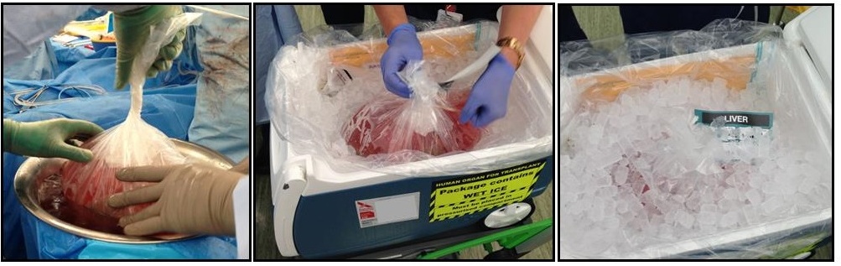Figure 1 Donor liver preservation for airplane transport.

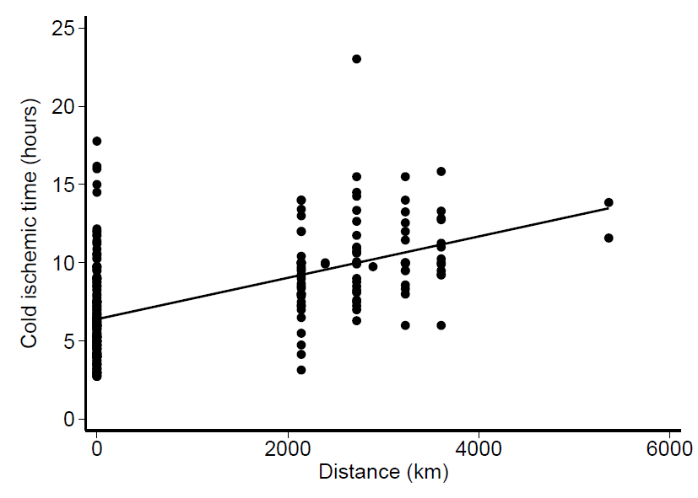
Figure 2 Correlation between cold ischemic time and liver transport distance.

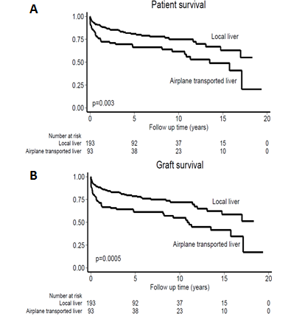
Figure 3 Post-transplantation outcome for recipient with local liver and those with airplane transported liver. A: Patient survival; B: Graft survival.

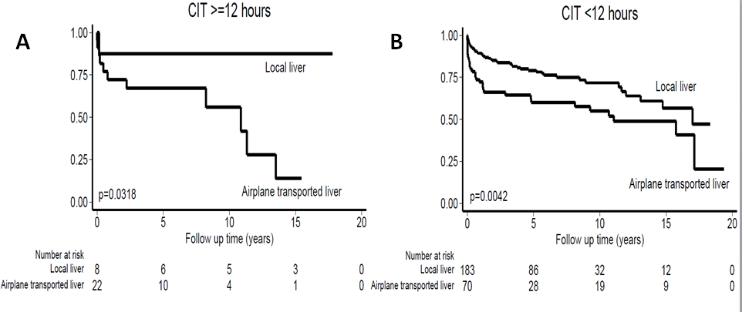 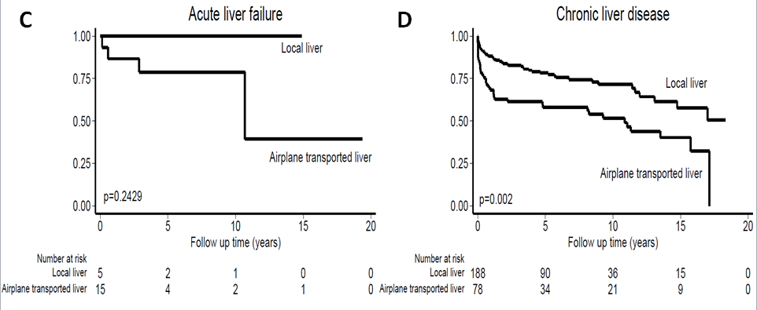 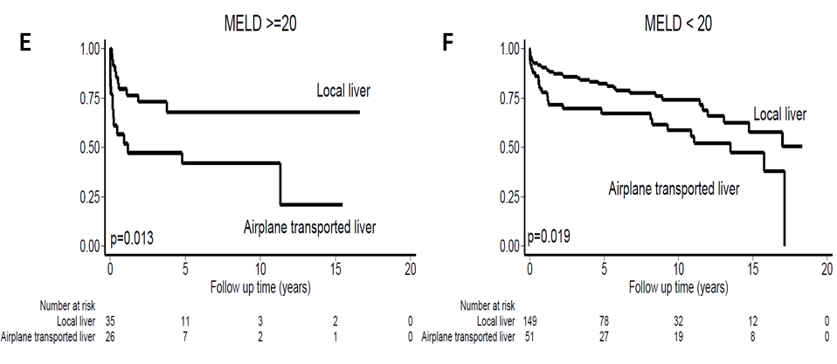 Figure 4 Graft survival curves after stratification. A: Recipients with cold ischemic time (CIT) ≥ 12 h; B: Recipients with CIT < 12 h; C: Recipients transplanted for acute liver failure; D: Recipients transplanted for chronic liver disease; E: Recipients transplanted for chronic liver disease and with MELD score ≥ 20; F: Recipients transplanted for chronic liver disease and with MELD score < 20.

