Name of Journal: World Journal of Radiology
Manuscript NO: 63506
Manuscript Type: SYSTEMATIC REVIEWS

Differential diagnosis of COVID-19 at the chest computed tomography scan: A review with special focus on cancer patients

Perrone F et al. Radiological differential diagnosis of COVID-19

Fabiana Perrone, Maurizio Balbi, Chiara Casartelli, Sebastiano Buti, Gianluca Milanese, Nicola Sverzellati, Melissa Bersanelli

Fabiana Perrone, Chiara Casartelli, Sebastiano Buti, Melissa Bersanelli, Medical Oncology Unit, University Hospital of Parma, Parma 43126, Italy

Fabiana Perrone, Chiara Casartelli, Melissa Bersanelli, Department of Medicine and Surgery, University of Parma, Parma 43126, Italy

Maurizio Balbi, Gianluca Milanese, Nicola Sverzellati, Department of Surgical Sciences, Institute of Diagnostic and Interventional Radiology, University of Parma, Parma 43126, Italy

Author contributions: Bersanelli M, Perrone F, and Casartelli C designed the work, planned the literature review according to PRISMA methods, and identified the areas of interest to discuss; Perrone F and Casartelli C collected the data; Balbi M prepared the figures; Perrone F and Balbi M wrote the first draft of the manuscript; Bersanelli M revised the manuscript for relevant scientific content and copyediting; Buti S, Milanese G, and Sverzellati N revised the manuscript for relevant scientific content; All authors have read and approved the final version of the manuscript.

Corresponding author: Melissa Bersanelli, MD, Adjunct Professor, Chief Doctor, Medical Oncology Unit, University Hospital of Parma, Via Gramsci 14, Parma 43126, Italy. bersamel@libero.it

Received: January 28, 2021
Revised: May 18, 2021
Accepted: August 2, 2021
Published online: August 28, 2021
Abstract
BACKGROUND
Given the several radiological features shared by coronavirus disease 2019 pneumonia and other infective or non-infective diseases with lung involvement, the differential diagnosis is often tricky, and no unequivocal tool exists to help the radiologist in the proper diagnosis. Computed tomography is considered the gold standard in detecting pulmonary illness caused by severe acute respiratory syndrome coronavirus 2.

AIM
To conduct a systematic review including the available studies evaluating computed tomography similarities and discrepancies between coronavirus disease 2019 pneumonia and other pulmonary illness, then providing a discussion focus on cancer patients.

METHODS
Using pertinent keywords, we performed a systematic review using PubMed to select relevant studies published until October 30, 2020.

RESULTS
Of the identified 133 studies, 18 were eligible and included in this review.

CONCLUSION
Ground-glass opacity and consolidations are the most common computed tomography lesions in coronavirus disease 2019 pneumonia and other respiratory diseases. Only two studies included cancer patients, and the differential diagnosis with early lung cancer and radiation pneumonitis was performed. A single lesion associated with pleural effusion and lymphadenopathies in lung cancer and the onset of the lesions in the radiation field in the case of radiation pneumonitis allowed the differential diagnosis. Nevertheless, the studies were heterogeneous, and the type and prevalence of lesions, distributions, morphology, evolution, and additional signs, together with epidemiological, clinical, and laboratory findings, are crucial to help in the differential diagnosis.

Key Words: COVID-19; Computed tomography; Differential diagnosis; Cancer; Pneumonia; Radiological findings

©The Author(s) 2021. Published by Baishideng Publishing Group Inc. All rights reserved.

Citation: Perrone F, Balbi M, Casartelli C, Buti S, Milanese G, Sverzellati N, Bersanelli M. Differential diagnosis of COVID-19 at the chest computed tomography scan: A review with special focus on cancer patients. World J Radiol 2021; 13(8): 243-257
URL: https://www.wjgnet.com/1949-8470/full/v13/i8/243.htm
DOI: https://dx.doi.org/10.4329/wjr.v13.i8.243

Core Tip: In the coronavirus disease 2019 era, the differential diagnosis of pneumonitis, already challenging in patients with multiple comorbidities and polypharmacological therapy, has become even more challenging. The gold-standard technique for diagnosing coronavirus disease 2019-related pneumonia is still not established. Still, a computed tomography scan is essential for the differential diagnosis of drug-induced pneumonitis, infectious pneumonia, and other conditions such as cancer progression. With this review, we have dealt with frequent radiological diatribes in the radiological diagnosis of coronavirus disease 2019 pneumonitis, with a special focus on cancer patients, for whom clinical elements can be more confounding than helpful as a compendium to the correct diagnostic conclusion.

INTRODUCTION
The coronavirus disease 2019 (COVID-19) outbreak began in Wuhan, China, in late 2019 and rapidly spread worldwide at the beginning of 2020, when it was declared a global pandemic by the World Health Organization^{[1,2]}. Many jurisdictions in several states carried out public health interventions to contain the transmission of severe acute respiratory syndrome coronavirus 2 (SARS-CoV-2)^{[3]}. Europe is now experiencing a second wave of contagion^{[4]}.
The virus has a specific tropism for the lower respiratory tract, and it is the cause of mild to severe respiratory infection^{[5]}.
Imaging has been widely employed to triage the massive load of acute respiratory referral due to COVID-19 by complementing the nucleic acid testing (i.e., the diagnostic reference standard). Typical manifestations of COVID-19 pneumonia on computed tomography (CT) have become known since the early phase of the pandemic: bilateral peripheral opacities with a lower lung distribution, usually consisting of nodular or mass-like ground-glass opacities (GGO) variably associated with areas of consolidation^{[6,7]}. CT abnormalities may be absent in the earliest disease phases and become more extensive in the peak stage (i.e., around day 9 to 13) before resolve or evolve to a more organized phase, possibly leading to fibrotic-like changes^{[8,9]}.
Many of the hallmark CT findings are apparent on chest X-ray, which is prone to miss subtle GGO, even if relatively diffuse in extent. Nevertheless, chest X-ray has shown the potential to predict outcomes in relatively advanced disease stages, assess supervening complications, and monitor the disease course^{[10]}. Lung ultrasound was suggested as a fast and feasible approach for triaging COVID-19 patients by identifying peripheral lung abnormalities such as confluent artifactual signs, small hyperechoic lung regions, thickened pleural lines, and consolidation^{[11,12]}. Though highly sensitive, lung ultrasound is operator-dependent, challenging to perform in obese patients, and has lower specificity than CT^{[13]}.
It is worth emphasizing that the imaging appearance of COVID-19 is non-specific, and the performance of different modalities dramatically relies on the disease prevalence. The typical manifestations may mimic or overlap with other infective and non-infectious diseases, including influenza and acute lung injuries from drug reactions and connective tissue diseases^{[14]}. Identifying findings uncommonly seen in COVID-19 pneumonia such as cavitation, tree-in-bud, and pleural effusion may help suggest an alternative diagnosis, which cannot be prescinded from clinical evaluation.
In the present article, we performed a systematic review of the literature focusing on differential radiological diagnosis between COVID-19 pneumonia and other infective and non-infective lung diseases, then discussing possibly helpful clinical elements and finally focusing on this issue in cancer patients.

MATERIALS AND METHODS
We conducted this systematic review according to the Preferred Reporting Items guidelines for Systematic Reviews and Meta-Analysis (PRISMA) Statement^{[15]}. The primary aim was to collect, describe, and discuss all the clinical studies evaluating the different CT findings between COVID-19 infection and other infective or non-infective lung diseases.

Search strategy
Two authors (CC and FP) carried out a comprehensive systematic search for published articles on the MEDLINE/PubMed library until October 31, 2020. Given the absence of articles on this topic before December 2019, when the first COVID-19 outbreak started, no upper limit for the search was chosen.
The following search keywords were used: “COVID-19” AND “computed tomography” AND “differential diagnosis.” The reference lists of the included articles and reviews/meta-analyses on our research topic were also reviewed to identify additional relevant papers.

Study selection and eligibility criteria
Retrospective studies, prospective studies, and case reports describing the difference between CT signs caused by SARS-CoV2 infection and other respiratory and non-respiratory diseases were included. Only English-language articles were considered eligible. Studies with insufficient radiological data or focused on non-CT radiological findings (i.e., ultrasound or radiography) were excluded. We planned qualitative analysis only, forecasting a high heterogeneity between the eligible studies, likely preventing quantitative analyses.
Narrative papers, such as commentaries and editorials, were excluded from the formal qualitative analysis, but the most relevant articles discussing the issue were considered in the discussion.

Data extraction and synthesis
The study characteristics (first author, year of publication, type of study, number of patients included, disease of comparison assessed, and main radiological similarities and discrepancies, laboratory findings) were extracted from the included articles by a single author (FP). Two reviewers (FP and CC) initially performed the data extraction, and then it was independently reviewed by an additional reviewer (MB).
Any doubt or disagreement was discussed with a fourth investigator (SB) and resolved with all investigators’ consensus.

RESULTS
Literature search
Of the 133 studies found in the search, 104 were initially excluded by title and abstract reading. After reading the full text of the remaining 29 articles, 11 were excluded because they missed relevant radiological information or comparison between different imaging patterns. Overall, 18 studies satisfied the prespecified criteria and were selected for the qualitative analysis. The outline of the search is reported in Figure 1.

Characteristics of the included studies
Trial characteristics and the main results of the studies included are reported in Table 1. Among the 18 studies included, 5 were case report/case series^{[16-20]}, and 13 were retrospective^{[21-33]}. All the studies described the typical radiological characteristics of COVID-19 pneumonia and addressed the radiological differential diagnosis issue. The difference between COVID-19 and non-infective respiratory diseases, namely: Systemic sclerosis and granulomatosis with polyangiitis (n = 2)^{[30,31]}, fat embolism (n = 1)^{[32]}, pulmonary contusion (n = 1)^{[33]} were evaluated in 5 out of 18 studies. One study evaluated both heart failure-induced pulmonary edema and rheumatic pneumonia (n = 1)^{[16]}.
On the other hand, 11 studies explored the CT imaging differences between COVID-19 disease and other infective pneumonia. In particular, the differential diagnosis was performed with influenza pneumonia (n = 3)^{[23,30,33]}, community-acquired pneumonia (CAP) (n = 3)^{[24,25,31]}, and other non- specified viral or bacterial pneumonia (n = 5)^{[21,22,26,27,32]}.
Only two studies included cancer patients. One assessed the radiological discrepancies between COVID-19 disease with lung involvement and radiation pneumonitis^{[28]}. In the other study, the differential diagnosis regarded early lung cancer^{[29]}.
In the majority of studies, detection of SARS-CoV-2 was performed by RT-PCR on throat/nasopharyngeal swab. The laboratory test was lacking in only one study, in which the final diagnosis was carried out based on clinical and epidemiological findings^{[20]}.
In the following paragraphs, the findings of the included studies are reported by topic.

Differential diagnosis between COVID-19 pneumonia and other non-infective respiratory diseases
The radiological difference between COVID-19 pneumonia and heart failure-induced pulmonary edema was evaluated by Dai et al^{[16]}.
Although GGOs and interlobular septal thickening were CT manifestations shared by both diseases, butterfly signs (patchy high attenuation patterns and large patchy high attenuation patterns in both lungs), peribronchial cuffing, and redistribution of blood flow in both lungs were typical in heart failure pulmonary edema.
Three rheumatologic diseases, namely systemic sclerosis, granulomatosis with polyangiitis, and rheumatic disease, often caused lung involvement with GGOs. Predominant lower lobe distribution associated with reticulations and honeycombing in advanced cases distinguished systemic sclerosis-related interstitial lung disease from interstitial pneumonia, as reported by Orlandi et al^{[17]}.
According to Shenavandeh et al^{[18]}, pulmonary nodules, mass lesions, and consolidation caused by lung hemorrhage and infarction due to small vessel vasculitis were typical for granulomatosis with polyangiitis.
Finally, extensive patchy exudates and consolidations in both lungs, faint GGOs on edge, and interlobular septal thickening were characteristic features for rheumatic pneumonia observed by Dai et al^{[16]}.
Although GGOs and consolidation characterized pulmonary contusion (usually caused by traffic accidents, falls, bumps, and crashes), a higher proportion of consolidations often associated with bilateral pleural effusion and subpleural atelectasis was observed when compared to COVID-19 disease. In addition, the radiological evolution was different in the two illnesses. No signs or few sheet shadows may be observed in pulmonary contusion 4-6 h after injury. The lung returned to normal after 7-10 d. Otherwise, in the case of COVID-19, the radiological pattern was long-lasting^{[20]}.
As in COVID-19 disease, bilateral GGOs with multilobe central and peripheral involvement were observed by Mazouz et al^{[19]} in the case of fat embolism.

Differential diagnosis between COVID-19 pneumonia and cancer-related lung lesions
One out of two studies including cancer patients investigated the difference between COVID-19 disease and pulmonary toxicities caused by radiotherapy. GGOs with partial consolidation, lung fibrosis characterized by linear scarring, air bronchograms, irregular intralobular or interlobular septal thickening were typical radiation pneumonitis features. With the onset within 6 mo after completing radiotherapy and limited distribution to the irradiation field, CT lesions were distinguished from COVID-19 pneumonia by Zeng et al^{[28]}.
The study on cancer patients conducted by Zhang et al^{[29]} focused on the similarities and discrepancies between COVID-19 pneumonia and early lung cancer. Although GGOs, air bronchogram, and cystic changes were present in both diseases, some differences were observed. Pure and mixed GGOs were most frequent in lung cancer, while COVID-19 patients tended to have more than one type of lung lesion. Contrary to COVID-19 pneumonia, characterized by patchy and bilateral lesions, unilateral and oval lesions were predominant in lung cancer patients. Air bronchogram was prevalent in COVID-19 patients, in contrast with cystic changes in lung cancer patients. Some radiological features were present only in COVID-19 pneumonia, such as reticular pattern, subpleural linear opacity, bronchial dilatation, centrilobular nodule, and the tree-in-bud sign. On the other hand, lobulated signs, pleural retraction, and vessel convergence signs were present in lung cancer patients but absent in those with COVID-19. More lobes and segments were involved in COVID-19 pneumonia compared to early lung cancer.

Differential diagnosis between COVID-19 pneumonia and another infective pneumonitis
In a retrospective study, Himoto et al^{[27]} used five chest CT criteria to distinguish COVID-19 pneumonia from other infective respiratory diseases, such as Pneumococcal pneumonia, Moraxella pneumonia, Legionella pneumonia, not-specified bacterial or viral pneumonia, Pneumocystis pneumonia, and non-specific interstitial pneumonia. The differential patterns evaluated were: (1) GGO-predominant lesions; (2) GGO- and peripheral-predominant lesions; (3) bilateral GGO-predominant lesions; (4) bilateral GGO- and peripheral-predominant lesions; and (5) bilateral GGO- and predominant peripheral lesions without nodules, airway abnormalities, pleural effusion, and mediastinal lymphadenopathy. Compared to other infective respiratory diseases analyzed, COVID-19 pneumonia had bilateral GGO- and peripheral-predominant lesions without airway abnormalities, mediastinal lymphadenopathy, and pleural effusion^{[27]}.
Luo et al^{[22]} developed an imaging score to distinguish COVID-19 pneumonia and non-COVID-19 pneumonia (Influenza pneumonia, Pneumocystis carinii pneumonia, Mycoplasma pneumonia, and CAP). Seven positive signs were identified: posterior part/lower lobe predilection, bilateral involvement, rounded GGO, subpleural bandlike GGO, crazy-paving pattern, peripheral distribution, and GGO with or without consolidation. Only one-lobe involvement, only central distribution, the tree-in-bud sign, and bronchial wall thickening were considered negative signs. The score ranged from -4 to 7 and was significantly higher in the COVID-19 group than in the non-COVID-19 group. Both diseases shared GGOs with or without consolidation. The tree-in-bud sign was observed in non-COVID-19 patients only. Rounded and subpleural bandlike GGO were more common in COVID-19 patients.
Similarly, other authors found that pure/mixed GGOs, interlobular septal thickening, crazy-paving patterns, halo signs, and consolidation were common both in COVID-19-positive and negative patients. The unique CT finding, potentially typical of COVID-19 disease, was a peripheral distribution of the pulmonary lesions^{[26]} and a high proportion of rounded opacities. Bronchial wall thickening was a characteristic sign of Mycoplasma pneumonia^{[32]}.
Although GGOs and consolidations were present in both other viral pneumonia (adenovirus, influenza, parainfluenza, rhinovirus, and others) and COVID-19, central plus peripherical distribution, air bronchogram, pleural thickening, pleural effusion, and lymphadenopathy were more frequent in viral pneumonia^{[21]}.
Two studies investigated the differential radiological manifestations of COVID-19 lung disease and CAP. By using a new radiological model, Li et al^{[24]} observed that CAP was characterized more often by nodular or consolidation shadows with or without patchy GGOs and more rarely by subtle mesh changes, dilatated small vessels, bronchiectasis, and lesion with the long axis parallel to the pleura compared to COVID-19 pneumonia. Moreover, lymphadenopathy, pleural effusion, pleural and bronchial wall thickening, fibrous tissue, lung cavity, and bullae were detected by other authors in CT scans of CAP affected patients, while these findings were absent or more rarely in COVID-19 patients^{[25]}. Similar radiological signs were observed by Zhou et al^{[31]} in Streptococcus pneumoniae CAP.
Consolidation, nodules, pleural effusion, and tree-in-bud signs were the radiological manifestation in influenza pneumonia in the analysis by Liu et al^{[23]} and Zhao et al^{[33]}. The distribution of the lesions (bilateral lobe vs inferior lobe), their margin (clear vs vague), and the GGO lesion involvement pattern (patchy or GGO associated with consolidation vs cluster-like involvement) distinguished COVID-19 from influenza pneumonia, according to Wang et al^{[30]}.

DISCUSSION
The current review focuses on the differential diagnosis between COVID-19 disease and other respiratory and non-respiratory disorders.
Since the early phase of the pandemic, radiological imaging has been employed to assess the suspicion of COVID-19 pneumonia in patients selected by clinical triage, demonstrating the potential for a standardized assessment of the degree of pulmonary involvement and prognostication purposes. Moreover, it has been used as a tool capable of complementing the limited sensitivity and time-consuming laboratory testing process for the SARS-CoV-2 infection detection^{[34-37]}.
Such a practical approach has found application in an unprecedented pandemic scenario, where the prevalence of the disease was extraordinarily high, with the awareness that the imaging findings of COVID-19 pneumonia were non-specific as reflecting the diffuse alveolar damage and organizing pneumonia with features shared by a broad spectrum of disorders^{[38,39]}. Despite the increasing knowledge about radiological imaging’s role in the pandemic, the actual diagnostic performance of different imaging modalities is still unclear, with reported specificities and sensitivities depending on several factors, from the duration of symptoms to the pre-test probability of the disease. Without articulating the relative merit of X-ray or lung ultrasound vs CT, the latter is generally recognized as more sensitive for early parenchymal disease, disease progression, and differential diagnoses, including acute heart failure and pneumonia caused by other pathogens^{[40]}. Remarkably, caution is warranted when analyzing data about the specificity and sensitivity of CT in detecting COVID-19 pneumonia, as some of the most cited studies from the radiology literature seem to suffer from limitations that may lead to overreaching conclusions^{[16,41-43]}. Among the studies included in the present analysis, Bai et al^{[21]} recruited the most extensive study population in which differences between COVID-19 and viral pneumonia were evaluated^{[21]}. Though these authors concluded that radiologists are likely to distinguish COVID-19 from viral pneumonia on chest CT with high specificity (i.e., up to 94%), the lack of training information or specific diagnostic criteria in their study suggests that such results could have been overestimated.
Similarly, other studies included in the present analyses should be interpreted with caution due to limitations such as selection bias or the relatively limited number of patients. Given this awareness, it is noticeable how some CT imaging findings, namely mucoid impactions, centrilobular nodules, lobar consolidation, and significant pleural effusion, have been consistently found to be less frequent in COVID-19 than in other types of pneumonia (Figures 2-4). Thus, they are potentially helpful in everyday practice to complement clinical data in triaging acute respiratory patients^{[22,23,25,31,44]}. Notably, radiologists need to have consciousness of ancillary findings that can be encountered in association with typical pulmonary features of COVID-19 pneumonia, possibly mimicking diseases other than COVID-19 (e.g., centrilobular solid nodules: polyhedral in shape and close to enlarged vessels within ground-glass opacities in COVID-19 pneumonia, while rounded or branching in minor airway diseases)^{[45]}.
Imaging findings typical of interstitial pneumonia may be found in asymptomatic COVID-19 patients^{[46]}. Interestingly, incidental GGO showing accumulation of fluorine-18 fluorodeoxyglucose at the positron-emission tomography scan has been described in cancer patients with SARS-CoV-2 infection, raising the suspicion of tumor progression in cases of a false-negative RT-PCR result^{[47-49]}. In those situations, an approach that includes a comparison with recent chest CT findings, as well as a close follow-up, would be appropriate.
When dealing with cancer patients, COVID-19 needs to be considered among diseases that may confound staging or treatment response assessment^{[50]}. For obvious reasons, special attention will need to be given to patients being screened or treated for lung cancer. In our experience, different etiopathogenetic factors can coexist, and their respective inflammatory phenomena can be overlapped in the same patient, as shown in Figure 5, collecting the different CT patterns of five cancer patients who underwent differential diagnosis for pneumonitis.
Besides cancer progression, COVID-19 pneumonia has been investigated as a mimicker of early lung cancer, both potentially displaying as single or multifocal GGOs^{[29]}. Unsurprisingly, in their retrospective study, Zhang et al^{[29]} found a single location and nodular morphology as significantly more frequent in lung cancer than in COVID-19^{[29]}. Although the authors are alert about the consequences of an inappropriate surgical approach in these patients, it is reasonable to assume that evaluating the temporal evolution of CT findings, symptoms, and molecular test results would allow avoiding such a diagnostic and therapeutic pitfall in most cases.
Radiotherapy and oncologic treatment, such as target therapy and immunotherapy, may induce lung toxicity, mimicking COVID-19 illness. Zeng et al^{[28]} recruited suspected COVID-19 patients diagnosed with cancer and treated with radiation to explore the differential diagnosis between COVID-19 pneumonia and radiation pneumonitis. The location, extent, and distribution of the lung CT abnormalities were considered useful to differentiate these two entities, with acute radiation-induced pneumonitis usually displaying GGOs or consolidation in the irradiated lung in contrast to the predominantly peripheral, subpleural opacities described in COVID-19 pneumonia. Otherwise, the differential diagnosis between COVID-19 and immuno-related pneumonia is likely to be less straightforward. The issue is highly relevant, especially considering the expanding immune checkpoint inhibitor indications and their potential to induce unique pulmonary toxicities^{[51,52]}. Pneumonitis is a rare but potentially severe side effect of immune checkpoint inhibitors, involving 2.7% of the patients treated with anti-programmed cell death 1 and anti-programmed death-ligand 1 monotherapy and 6.6% of the patients receiving the combination of anti-programmed cell death 1 and anti-cytotoxic T-lymphocyte antigen 4^{[53]}. Several clinical and radiological presentations have been described. Dyspnea and cough are the most frequent symptoms, while fever occurs in 12% of cases^{[54]}. These clinical manifestations could be further confounding for the differential diagnosis. From a radiology perspective, COVID-19 and immune-related pneumonia have a range of imaging manifestations that can substantially overlap, particularly in cases of organizing pneumonia pattern (i.e., the most common pattern seen across all tumor treatments and regimens) and when leading to diffuse GGO and consolidation as a result of diffuse alveolar damage^{[51,52]}. The varying sensitivity of molecular confirmation of SARS-CoV-2 infection and the low specificity of both entities’ clinical manifestation renders even more complicated the correct diagnosis, mostly requiring a multidisciplinary discussion before deciding on patient management^{[55]}. However, the simultaneous presence of other immune-related adverse events, such as diarrhea, skin toxicities, and thyroid alterations, with or without a high level of inflammatory factors (i.e., interleukin-6, C-reactive protein) involved in the cytokine storm (the latter also shared with COVID-19), could lead to the hypothesis of pneumonitis most likely due to immunotherapy.
In addition to immune checkpoint inhibitors, other anticancer drugs such as tyrosine kinase inhibitors (i.e., gefitinib, erlotinib, crizotinib, osimertinib, panitumumab, cetuximab, and others), mTOR inhibitors (everolimus, temsirolimus), and chemotherapy (topotecan, bleomycin, gemcitabine, and others) can induce an interstitial pneumonitis^{[56]}. To date, neither radiological nor clinical features can help the physician in the differential diagnosis. The rapid development of cardiovascular complications, such as acute pericarditis, left ventricular dysfunction, acute myocardial injury, embolic complications due to coagulopathy, such as disseminated intravascular coagulation, venous thromboembolism, or massive pulmonary embolism, with or without detection of the virus, can address the diagnosis of COVID-19^{[57]}.
Although lymphopenia and a high level of D-dimer and C-reactive protein are often identified in COVID-19 patients, these laboratory findings are not unique and are inadequate to address the proper diagnosis, especially in cancer patients.
Our systematic review has several limitations, including the mostly retrospective nature and the heterogeneity of the included studies.

CONCLUSION
The patient’s global view of epidemiological, clinical, radiological, and laboratory elements could help the physician overcome the diagnostic difficulties in the COVID-19 era.

ARTICLE HIGHLIGHTS
Research background
Several radiological features are shared by coronavirus disease 19 (COVID-19) pneumonia and other infective or non-infective pulmonary diseases.

Research motivation
The differential diagnosis of COVID-19 pneumonia is a radiological challenge.

Research objectives
To identify crucial radiological features of COVID-19 pneumonia reported by the literature and their differential diagnosis.

Research methods
We performed a systematic review with a descriptive aim.

Research results
Ground-glass opacity and consolidations are the most common computed tomography lesions in COVID-19 pneumonia and other respiratory diseases. Of the identified 133 studies, 18 were eligible and included in this review. Single lesion associated with pleural effusion and lymphadenopathies distinguishes COVID-19 pneumonia from early lung cancer. Only two studies included cancer patients, and the differential diagnosis with early lung cancer and radiation pneumonitis was performed. The onset of the lesions in the radiation fields only allows the differential diagnosis between COVID-19 pneumonia and radiation pneumonitis.

Research conclusions
Computed tomography scan is essential for the differential diagnosis of drug-induced pneumonitis, infectious pneumonia, and other conditions such as cancer progression.

Research perspectives
The focus on patients with cancer evidenced a wide lack of data in this field, suggesting at least retrospective collection of data in this population.

REFERENCES
1 Xu S, Li Y. Beware of the second wave of COVID-19. Lancet 2020; 395: 1321-1322 [PMID: 32277876 DOI: 10.1016/S0140-6736(20)30845-X]
2 World Health Organization. Rolling updates on coronavirus disease (COVID-19): WHO characterizes COVID-19 as a pandemic. Available from: https://www.who.int/emergencies/diseases/novel-coronavirus-2019/events-as-they-happen
3 Sebhatu A, Wennberg K, Arora-Jonsson S, Lindberg SI. Explaining the homogeneous diffusion of COVID-19 nonpharmaceutical interventions across heterogeneous countries. Proc Natl Acad Sci USA 2020; 117: 21201-21208 [PMID: 32788356 DOI: 10.1073/pnas.2010625117]
4 Looi MK. Covid-19: Is a second wave hitting Europe? BMJ 2020; 371: m4113 [PMID: 33115704 DOI: 10.1136/bmj.m4113]
5 Ragnoli B, Malerba M. Focus on the Potential Role of Lung Ultrasound in COVID-19 Pandemic: What More to Do? Int J Environ Res Public Health 2020; 17 [PMID: 33202769 DOI: 10.3390/ijerph17228398]
6 Chung M, Bernheim A, Mei X, Zhang N, Huang M, Zeng X, Cui J, Xu W, Yang Y, Fayad ZA, Jacobi A, Li K, Li S, Shan H. CT Imaging Features of 2019 Novel Coronavirus (2019-nCoV). Radiology 2020; 295: 202-207 [PMID: 32017661 DOI: 10.1148/radiol.2020200230]
7 Simpson S, Kay FU, Abbara S, Bhalla S, Chung JH, Chung M, Henry TS, Kanne JP, Kligerman S, Ko JP, Litt H. Radiological Society of North America Expert Consensus Statement on Reporting Chest CT Findings Related to COVID-19. Endorsed by the Society of Thoracic Radiology, the American College of Radiology, and RSNA - Secondary Publication. J Thorac Imaging 2020; 35: 219-227 [PMID: 32324653 DOI: 10.1097/RTI.0000000000000524]
8 Pan F, Ye T, Sun P, Gui S, Liang B, Li L, Zheng D, Wang J, Hesketh RL, Yang L, Zheng C. Time Course of Lung Changes at Chest CT during Recovery from Coronavirus Disease 2019 (COVID-19). Radiology 2020; 295: 715-721 [PMID: 32053470 DOI: 10.1148/radiol.2020200370]
9 Han X, Fan Y, Alwalid O, Li N, Jia X, Yuan M, Li Y, Cao Y, Gu J, Wu H, Shi H. Six-month Follow-up Chest CT Findings after Severe COVID-19 Pneumonia. Radiology 2021; 299: E177-E186 [PMID: 33497317 DOI: 10.1148/radiol.2021203153]
10 Toussie D, Voutsinas N, Finkelstein M, Cedillo MA, Manna S, Maron SZ, Jacobi A, Chung M, Bernheim A, Eber C, Concepcion J, Fayad ZA, Gupta YS. Clinical and Chest Radiography Features Determine Patient Outcomes in Young and Middle-aged Adults with COVID-19. Radiology 2020; 297: E197-E206 [PMID: 32407255 DOI: 10.1148/radiol.2020201754]
11 Peng QY, Wang XT, Zhang LN; Chinese Critical Care Ultrasound Study Group (CCUSG). Findings of lung ultrasonography of novel corona virus pneumonia during the 2019-2020 epidemic. Intensive Care Med 2020; 46: 849-850 [PMID: 32166346 DOI: 10.1007/s00134-020-05996-6]
12 Poggiali E, Dacrema A, Bastoni D, Tinelli V, Demichele E, Mateo Ramos P, Marcianò T, Silva M, Vercelli A, Magnacavallo A. Can Lung US Help Critical Care Clinicians in the Early Diagnosis of Novel Coronavirus (COVID-19) Pneumonia? Radiology 2020; 295: E6 [PMID: 32167853 DOI: 10.1148/radiol.2020200847]
13 Colombi D, Petrini M, Maffi G, Villani GD, Bodini FC, Morelli N, Milanese G, Silva M, Sverzellati N, Michieletti E. Comparison of admission chest computed tomography and lung ultrasound performance for diagnosis of COVID-19 pneumonia in populations with different disease prevalence. Eur J Radiol 2020; 133: 109344 [PMID: 33091835 DOI: 10.1016/j.ejrad.2020.109344]
14 Goyal N, Chung M, Bernheim A, Keir G, Mei X, Huang M, Li S, Kanne JP. Computed Tomography Features of Coronavirus Disease 2019 (COVID-19): A Review for Radiologists. J Thorac Imaging 2020; 35: 211-218 [PMID: 32427651 DOI: 10.1097/RTI.0000000000000527]
15 Kristjansson M, Bieluch VM, Byeff PD. Mycobacterium haemophilum infection in immunocompromised patients: case report and review of the literature. Rev Infect Dis 1991; 13: 906-910 [PMID: 1962107 DOI: 10.1371/journal.pmed.1000097]
16 Dai WC, Zhang HW, Yu J, Xu HJ, Chen H, Luo SP, Zhang H, Liang LH, Wu XL, Lei Y, Lin F. CT Imaging and Differential Diagnosis of COVID-19. Can Assoc Radiol J 2020; 71: 195-200 [PMID: 32129670 DOI: 10.1177/0846537120913033]
17 Orlandi M, Lepri G, Bruni C, Wang Y, Bartoloni A, Zammarchi L, Cometi L, Guiducci S, Matucci-Cerinic M, Bellando-Randone S. The systemic sclerosis patient in the COVID-19 era: the challenging crossroad between immunosuppression, differential diagnosis and long-term psychological distress. Clin Rheumatol 2020; 39: 2043-2047 [PMID: 32514674 DOI: 10.1007/s10067-020-05193-2]
18 Shenavandeh S, Sefidbakht S, Iranpour P, Teimouri A, Hooshmandi S, Hooshmandi E, Athari M. COVID-19 and granulomatosis with polyangiitis (GPA): a diagnostic challenge. Rheumatology (Oxford) 2020; 59: 2170-2171 [PMID: 32556292 DOI: 10.1093/rheumatology/keaa326]
19 Mazouz S, Aissaoui O, Fehdi MA, Nsiri A, AlHarrar R. COVID-19 suspicion revealed to be fat embolism syndrome. Pan Afr Med J 2020; 36: 104 [PMID: 32821315 DOI: 10.11604/pamj.2020.36.104.23631]
20 Chen LR, Chen ZX, Liu YC, Peng L, Zhang Y, Xu Q, Lin Q, Tao YM, Wu H, Yin S, Hu YJ. Pulmonary contusion mimicking COVID-19: A case report. World J Clin Cases 2020; 8: 1554-1560 [PMID: 32368550 DOI: 10.12998/wjcc.v8.i8.1554]
21 Bai HX, Hsieh B, Xiong Z, Halsey K, Choi JW, Tran TML, Pan I, Shi LB, Wang DC, Mei J, Jiang XL, Zeng QH, Egglin TK, Hu PF, Agarwal S, Xie FF, Li S, Healey T, Atalay MK, Liao WH. Performance of Radiologists in Differentiating COVID-19 from Non-COVID-19 Viral Pneumonia at Chest CT. Radiology 2020; 296: E46-E54 [PMID: 32155105 DOI: 10.1148/radiol.2020200823]
22 Luo L, Luo Z, Jia Y, Zhou C, He J, Lyu J, Shen X. CT differential diagnosis of COVID-19 and non-COVID-19 in symptomatic suspects: a practical scoring method. BMC Pulm Med 2020; 20: 129 [PMID: 32381057 DOI: 10.1186/s12890-020-1170-6]
23 Liu M, Zeng W, Wen Y, Zheng Y, Lv F, Xiao K. COVID-19 pneumonia: CT findings of 122 patients and differentiation from influenza pneumonia. Eur Radiol 2020; 30: 5463-5469 [PMID: 32399710 DOI: 10.1007/s00330-020-06928-0]
24 Li Z, Zeng B, Lei P, Liu J, Fan B, Shen Q, Pang P, Xu R. Differentiating pneumonia with and without COVID-19 using chest CT images: from qualitative to quantitative. J Xray Sci Technol 2020; 28: 583-589 [PMID: 32568167 DOI: 10.3233/XST-200689]
25 Liu KC, Xu P, Lv WF, Chen L, Qiu XH, Yao JL, Gu JF, Hu B, Wei W. Differential diagnosis of coronavirus disease 2019 from community-acquired-pneumonia by computed tomography scan and follow-up. Infect Dis Poverty 2020; 9: 118 [PMID: 32843064 DOI: 10.1186/s40249-020-00737-9]
26 Xie S, Lei Z, Chen X, Liu W, Wang X, Dong Y, Guo Y, Duan Y, Cao H, Qin J, Lin B. Chest CT-based differential diagnosis of 28 patients with suspected corona virus disease 2019 (COVID-19). Br J Radiol 2020; 93: 20200243 [PMID: 32450727 DOI: 10.1259/bjr.20200243]
27 Himoto Y, Sakata A, Kirita M, Hiroi T, Kobayashi KI, Kubo K, Kim H, Nishimoto A, Maeda C, Kawamura A, Komiya N, Umeoka S. Diagnostic performance of chest CT to differentiate COVID-19 pneumonia in non-high-epidemic area in Japan. Jpn J Radiol 2020; 38: 400-406 [PMID: 32232648 DOI: 10.1007/s11604-020-00958-w]
28 Zeng Q, Tang C, Deng L, Li S, Liu J, Wang S, Shan H. Differential Diagnosis of COVID-19 Pneumonia in Cancer Patients Received Radiotherapy. Int J Med Sci 2020; 17: 2561-2569 [PMID: 33029098 DOI: 10.7150/ijms.46133]
29 Zhang YJ, Yang WJ, Liu D, Cao YQ, Zheng YY, Han YC, Jin RS, Han Y, Wang XY, Pan AS, Dai JY, Sun QF, Zhao FQ, Yang QY, Zhang JH, Liu SJ, Da Q, Guo W, Li CQ, Zhang WT, Wu H, Chen XS, Ji AQ, Xiang J, Chen K, Feng XJ, Zhang XF, Cao QQ, Qin L, Li J, Zhou M, Lu Y, Wang CF, Yan FH, Li HC, Qu JM. COVID-19 and early-stage lung cancer both featuring ground-glass opacities: a propensity score-matched study. Transl Lung Cancer Res 2020; 9: 1516-1527 [PMID: 32953523 DOI: 10.21037/tlcr-20-892]
30 Wang H, Wei R, Rao G, Zhu J, Song B. Characteristic CT findings distinguishing 2019 novel coronavirus disease (COVID-19) from influenza pneumonia. Eur Radiol 2020; 30: 4910-4917 [PMID: 32323011 DOI: 10.1007/s00330-020-06880-z]
31 Zhou J, Liao X, Cao J, Ling G, Ding X, Long Q. Differential diagnosis between the coronavirus disease 2019 and Streptococcus pneumoniae pneumonia by thin-slice CT features. Clin Imaging 2021; 69: 318-323 [PMID: 33045476 DOI: 10.1016/j.clinimag.2020.09.012]
32 Chi Q, Dai X, Jiang X, Zhu L, Du J, Chen Y, Zheng J, Huang J. Differential diagnosis for suspected cases of coronavirus disease 2019: a retrospective study. BMC Infect Dis 2020; 20: 679 [PMID: 32948121 DOI: 10.1186/s12879-020-05383-y]
33 Zhao W, Xie X, Liu J. The importance of distinguishing COVID-19 from more common respiratory illnesses. Epidemiol Infect 2020; 148: e195 [PMID: 32873360 DOI: 10.1017/S0950268820001971]
34 Sverzellati N, Milanese G, Milone F, Balbi M, Ledda RE, Silva M. Integrated Radiologic Algorithm for COVID-19 Pandemic. J Thorac Imaging 2020; 35: 228-233 [PMID: 32271278 DOI: 10.1097/RTI.0000000000000516]
35 Rubin GD, Ryerson CJ, Haramati LB, Sverzellati N, Kanne JP, Raoof S, Schluger NW, Volpi A, Yim JJ, Martin IBK, Anderson DJ, Kong C, Altes T, Bush A, Desai SR, Goldin O, Goo JM, Humbert M, Inoue Y, Kauczor HU, Luo F, Mazzone PJ, Prokop M, Remy-Jardin M, Richeldi L, Schaefer-Prokop CM, Tomiyama N, Wells AU, Leung AN. The Role of Chest Imaging in Patient Management during the COVID-19 Pandemic: A Multinational Consensus Statement from the Fleischner Society. Radiology 2020; 296: 172-180 [PMID: 32255413 DOI: 10.1148/radiol.2020201365]
36 Prokop M, van Everdingen W, van Rees Vellinga T, Quarles van Ufford H, Stöger L, Beenen L, Geurts B, Gietema H, Krdzalic J, Schaefer-Prokop C, van Ginneken B, Brink M; COVID-19 Standardized Reporting Working Group of the Dutch Radiological Society. CO-RADS: A Categorical CT Assessment Scheme for Patients Suspected of Having COVID-19-Definition and Evaluation. Radiology 2020; 296: E97-E104 [PMID: 32339082 DOI: 10.1148/radiol.2020201473]
37 Feng Z, Yu Q, Yao S, Luo L, Zhou W, Mao X, Li J, Duan J, Yan Z, Yang M, Tan H, Ma M, Li T, Yi D, Mi Z, Zhao H, Jiang Y, He Z, Li H, Nie W, Liu Y, Zhao J, Luo M, Liu X, Rong P, Wang W. Early prediction of disease progression in COVID-19 pneumonia patients with chest CT and clinical characteristics. Nat Commun 2020; 11: 4968 [PMID: 33009413 DOI: 10.1038/s41467-020-18786-x]
38 Tian S, Hu W, Niu L, Liu H, Xu H, Xiao SY. Pulmonary Pathology of Early-Phase 2019 Novel Coronavirus (COVID-19) Pneumonia in Two Patients With Lung Cancer. J Thorac Oncol 2020; 15: 700-704 [PMID: 32114094 DOI: 10.1016/j.jtho.2020.02.010]
39 Carsana L, Sonzogni A, Nasr A, Rossi RS, Pellegrinelli A, Zerbi P, Rech R, Colombo R, Antinori S, Corbellino M, Galli M, Catena E, Tosoni A, Gianatti A, Nebuloni M. Pulmonary post-mortem findings in a series of COVID-19 cases from northern Italy: a two-centre descriptive study. Lancet Infect Dis 2020; 20: 1135-1140 [PMID: 32526193 DOI: 10.1016/S1473-3099(20)30434-5]
40 Driggin E, Madhavan MV, Bikdeli B, Chuich T, Laracy J, Biondi-Zoccai G, Brown TS, Der Nigoghossian C, Zidar DA, Haythe J, Brodie D, Beckman JA, Kirtane AJ, Stone GW, Krumholz HM, Parikh SA. Cardiovascular Considerations for Patients, Health Care Workers, and Health Systems During the COVID-19 Pandemic. J Am Coll Cardiol 2020; 75: 2352-2371 [PMID: 32201335 DOI: 10.1016/j.jacc.2020.03.031]
41 Fang Y, Zhang H, Xie J, Lin M, Ying L, Pang P, Ji W. Sensitivity of Chest CT for COVID-19: Comparison to RT-PCR. Radiology 2020; 296: E115-E117 [PMID: 32073353 DOI: 10.1148/radiol.2020200432]
42 Ai T, Yang Z, Hou H, Zhan C, Chen C, Lv W, Tao Q, Sun Z, Xia L. Correlation of Chest CT and RT-PCR Testing for Coronavirus Disease 2019 (COVID-19) in China: A Report of 1014 Cases. Radiology 2020; 296: E32-E40 [PMID: 32101510 DOI: 10.1148/radiol.2020200642]
43 Raptis CA, Hammer MM, Short RG, Shah A, Bhalla S, Bierhals AJ, Filev PD, Hope MD, Jeudy J, Kligerman SJ, Henry TS. Chest CT and Coronavirus Disease (COVID-19): A Critical Review of the Literature to Date. AJR Am J Roentgenol 2020; 215: 839-842 [PMID: 32298149 DOI: 10.2214/AJR.20.23202]
44 Revel MP, Parkar AP, Prosch H, Silva M, Sverzellati N, Gleeson F, Brady A; European Society of Radiology (ESR) and the European Society of Thoracic Imaging (ESTI). COVID-19 patients and the radiology department - advice from the European Society of Radiology (ESR) and the European Society of Thoracic Imaging (ESTI). Eur Radiol 2020; 30: 4903-4909 [PMID: 32314058 DOI: 10.1007/s00330-020-06865-y]
45 Silva M, Ledda RE, Schiebler M, Balbi M, Sironi S, Milone F, Affanni P, Milanese G, Sverzellati N. Frequency and characterization of ancillary chest CT findings in COVID-19 pneumonia. Br J Radiol 2021; 94: 20200716 [PMID: 33471553 DOI: 10.1259/bjr.20200716]
46 Varble N, Blain M, Kassin M, Xu S, Turkbey EB, Amalou A, Long D, Harmon S, Sanford T, Yang D, Xu Z, Xu D, Flores M, An P, Carrafiello G, Obinata H, Mori H, Tamura K, Malayeri AA, Holland SM, Palmore T, Sun K, Turkbey B, Wood BJ. CT and clinical assessment in asymptomatic and pre-symptomatic patients with early SARS-CoV-2 in outbreak settings. Eur Radiol 2021; 31: 3165-3176 [PMID: 33146796 DOI: 10.1007/s00330-020-07401-8]
47 Polverari G, Arena V, Ceci F, Pelosi E, Ianniello A, Poli E, Sandri A, Penna D. ¹⁸F-Fluorodeoxyglucose Uptake in Patient With Asymptomatic Severe Acute Respiratory Syndrome Coronavirus 2 (Coronavirus Disease 2019) Referred to Positron Emission Tomography/Computed Tomography for NSCLC Restaging. J Thorac Oncol 2020; 15: 1078-1080 [PMID: 32243920 DOI: 10.1016/j.jtho.2020.03.022]
48 Zou S, Zhu X. FDG PET/CT of COVID-19. Radiology 2020; 296: E118 [PMID: 32142399 DOI: 10.1148/radiol.2020200770]
49 Liu C, Zhou J, Xia L, Cheng X, Lu D. 18F-FDG PET/CT and Serial Chest CT Findings in a COVID-19 Patient With Dynamic Clinical Characteristics in Different Period. Clin Nucl Med 2020; 45: 495-496 [PMID: 32332319 DOI: 10.1097/RLU.0000000000003068]
50 Boettcher AN, Hammoud DA, Weinberg JB, Agarwal P, Mendiratta-Lala M, Luker GD. Cancer Imaging and Patient Care during the COVID-19 Pandemic. Radiol Imaging Cancer 2020; 2: e200058 [PMID: 33778750 DOI: 10.1148/rycan.2020200058]
51 Nishino M, Hatabu H, Hodi FS. Imaging of Cancer Immunotherapy: Current Approaches and Future Directions. Radiology 2019; 290: 9-22 [PMID: 30457485 DOI: 10.1148/radiol.2018181349]
52 Kalisz KR, Ramaiya NH, Laukamp KR, Gupta A. Immune Checkpoint Inhibitor Therapy-related Pneumonitis: Patterns and Management. Radiographics 2019; 39: 1923-1937 [PMID: 31584861 DOI: 10.1148/rg.2019190036]
53 Nishino M, Giobbie-Hurder A, Hatabu H, Ramaiya NH, Hodi FS. Incidence of Programmed Cell Death 1 Inhibitor-Related Pneumonitis in Patients With Advanced Cancer: A Systematic Review and Meta-analysis. JAMA Oncol 2016; 2: 1607-1616 [PMID: 27540850 DOI: 10.1001/jamaoncol.2016.2453]
54 Naidoo J, Wang X, Woo KM, Iyriboz T, Halpenny D, Cunningham J, Chaft JE, Segal NH, Callahan MK, Lesokhin AM, Rosenberg J, Voss MH, Rudin CM, Rizvi H, Hou X, Rodriguez K, Albano M, Gordon RA, Leduc C, Rekhtman N, Harris B, Menzies AM, Guminski AD, Carlino MS, Kong BY, Wolchok JD, Postow MA, Long GV, Hellmann MD. Pneumonitis in Patients Treated With Anti-Programmed Death-1/Programmed Death Ligand 1 Therapy. J Clin Oncol 2017; 35: 709-717 [PMID: 27646942 DOI: 10.1200/JCO.2016.68.2005]
55 Naidoo J, Reuss JE, Suresh K, Feller-Kopman D, Forde PM, Mehta Steinke S, Rock C, Johnson DB, Nishino M, Brahmer JR. Immune-related (IR)-pneumonitis during the COVID-19 pandemic: multidisciplinary recommendations for diagnosis and management. J Immunother Cancer 2020; 8 [PMID: 32554619 DOI: 10.1136/jitc-2020-000984]
56 Sakai F, Johkoh T, Kusumoto M, Arakawa H, Takahashi M. Drug-induced interstitial lung disease in molecular targeted therapies: high-resolution CT findings. Int J Clin Oncol 2012; 17: 542-550 [PMID: 23138271 DOI: 10.1007/s10147-012-0489-2]
57 Azer SA. COVID-19: pathophysiology, diagnosis, complications and investigational therapeutics. New Microbes New Infect 2020; 37: 100738 [PMID: 32834902 DOI: 10.1016/j.nmni.2020.100738]
Footnotes
Conflict-of-interest statement: Melissa Bersanelli received honoraria as a speaker at scientific events by Bristol-Myers Squibb (BMS), Novartis, Astra Zeneca, Pierre Fabre, and Pfizer and as a consultant for advisory role by Novartis, BMS, IPSEN, and Pfizer; she also received fees for copyright transfer by Sciclone Pharmaceuticals and research funding by Roche S.p.A., Seqirus UK, Pfizer, Novartis, BMS, Astra Zeneca, and Sanofi Genzyme. Sebastiano Buti received honoraria as a speaker at scientific events and advisory role by Bristol-Myers Squibb (BMS), Pfizer; MSD, Ipsen, Roche, Eli-Lilly, AstraZeneca and Novartis; he also received research funding from Novartis. All the other authors declare they have no conflicts of interest to disclose.

PRISMA 2009 Checklist statement: The authors have read the PRISMA 2009 Checklist, and the manuscript was prepared and revised according to the PRISMA 2009 Checklist.

Open-Access: This article is an open-access article that was selected by an in-house editor and fully peer-reviewed by external reviewers. It is distributed in accordance with the Creative Commons Attribution NonCommercial (CC BY-NC 4.0) license, which permits others to distribute, remix, adapt, build upon this work non-commercially, and license their derivative works on different terms, provided the original work is properly cited and the use is non-commercial. See: http://creativecommons.org/Licenses/by-nc/4.0/

Manuscript source: Invited manuscript

Peer-review started: January 28, 2021
First decision: May 6, 2021
Article in press: August 2, 2021

Specialty type: Radiology, nuclear medicine and medical imaging
Country/Territory of origin: Italy
Peer-review report’s scientific quality classification
Grade A (Excellent): 0
Grade B (Very good): B
Grade C (Good): C
Grade D (Fair): 0
Grade E (Poor): 0

P-Reviewer: Fei C, Patel L S-Editor: Ma YJ L-Editor: Filipodia P-Editor: Yuan YY

Figure Legends
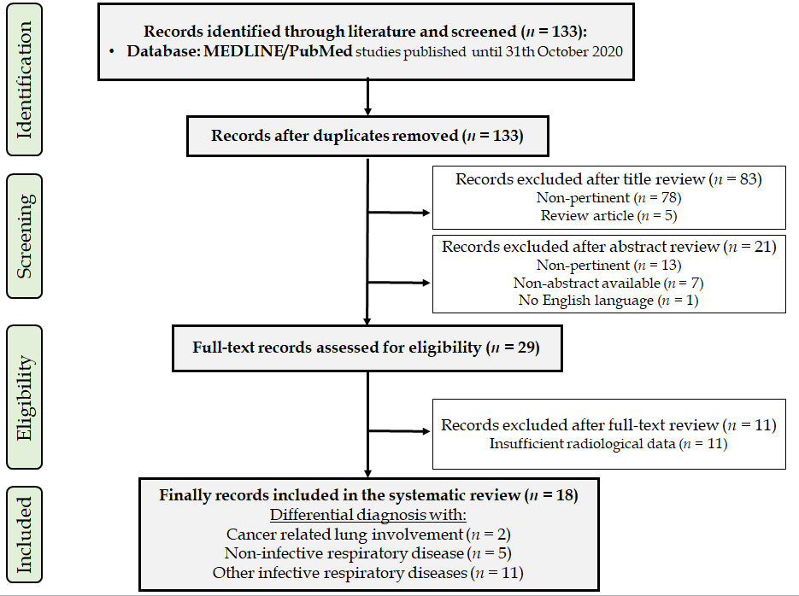
Figure 1 PRISMA flow diagram.
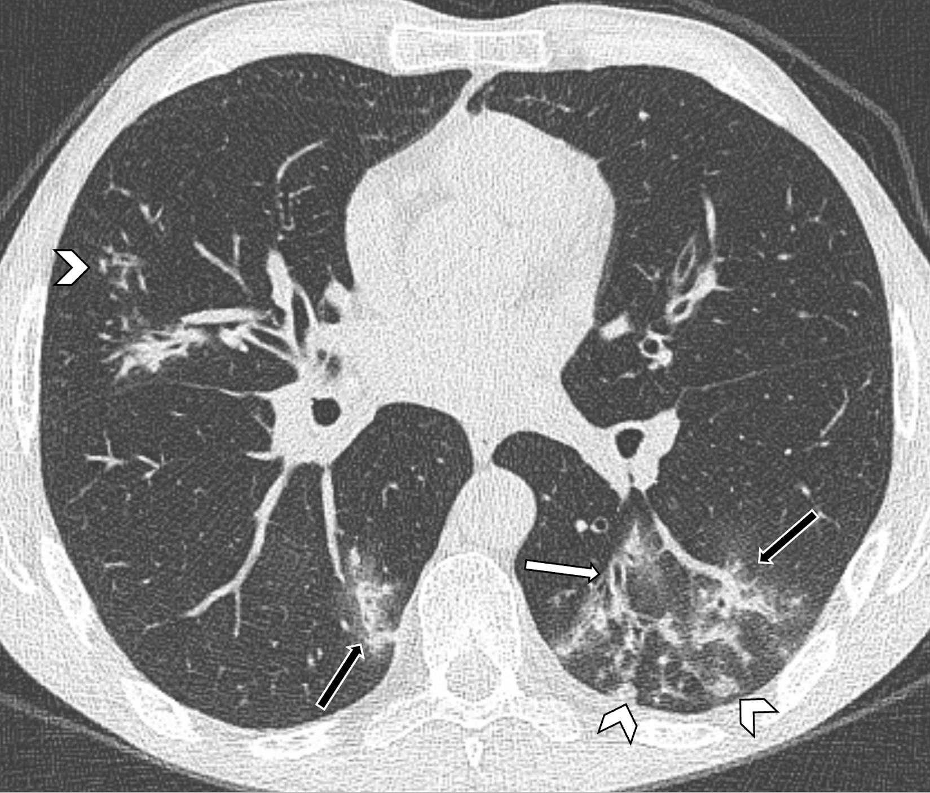
Figure 2 Axial computed tomography image of a 36-year-old man shows nodular (arrowheads) and peribronchovascular branching (orange arrows) opacities along with bronchial wall thickening (white arrow), which suggest a diagnosis other than coronavirus disease 2019 pneumonia. The patient was diagnosed with Mycoplasma pneumoniae pneumonia.
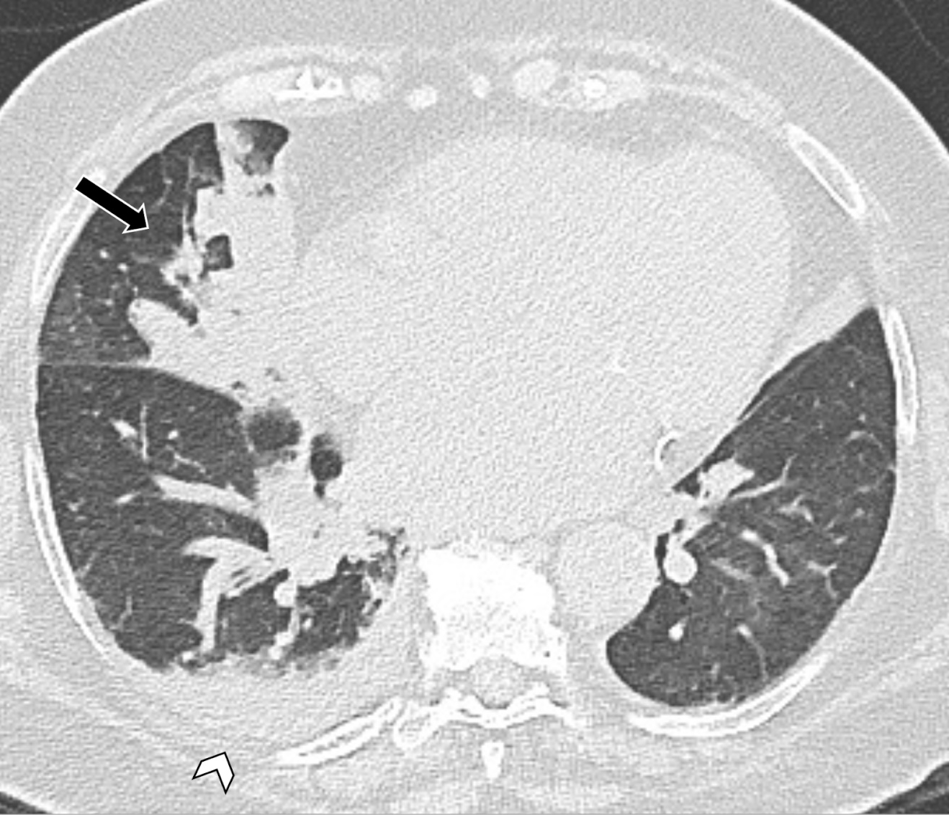
Figure 3 Axial computed tomography image shows right lung consolidation (arrow) and unilateral pleural effusion (arrowhead) in a 64-year-old man with bacterial pneumonia.
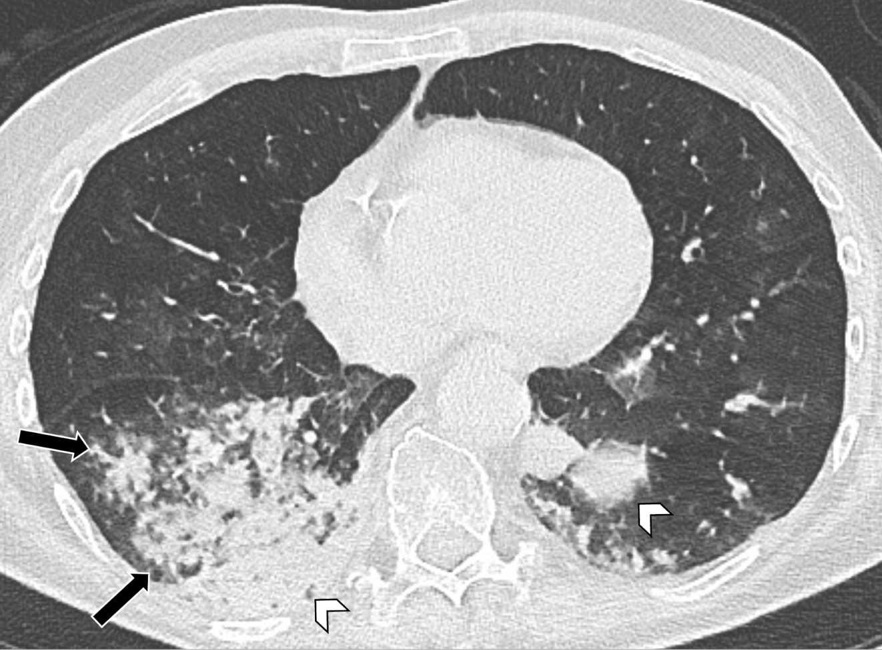
Figure 4 Axial computed tomography image in a 50-year-old woman diagnosed with bronchopneumonia shows confluent centrilobular nodules (arrows) and consolidation (arrowheads) mostly located in the lower lobes.
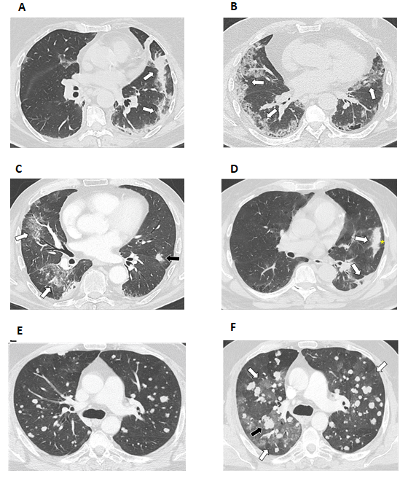
Figure 5 Axial computed tomography image. A: Axial computed tomography (CT) image of a 45-year-old patient with coronavirus disease 2019 showing left peripheral consolidation with perilobular distribution (arrows) suggesting organizing pneumonia; B: Axial CT image showing bilateral ground-glass opacities distributed in the subpleural regions (arrows) in a renal cancer patient confirmed with coronavirus disease 2019 pneumonia; C: Axial CT image showing multifocal ground-glass opacities in the right lung (orange arrows) and nodular consolidation (black arrow) in a renal cancer patient diagnosed with immune-related pneumonitis after treatment with nivolumab; D: Axial CT image of a patient suffering from immune-related pneumonitis showing multifocal, bandlike consolidation in the left lower lobe (arrows) with peripheral sparing (asterisk) suggesting organizing pneumonia; E and F: The last is a case of immune-related pneumonitis in a patient undergoing ipilimumab plus nivolumab for metastatic soft tissue sarcoma, whose baseline axial CT image (E) shows bilateral solid metastatic nodules; the axial CT image obtained after starting immunotherapy (F) shows new multifocal ground-glass opacities (orange arrows) with interval enlargement and an increasing number of pulmonary nodules (black arrow).

Table 1 Summary of the studies included in the systematic review
Ref. | Yr | Type of study | Patients, n | Disease in differential diagnosis | Radiological similarities with COVID-19 disease | Radiological discrepancy with COVID-19 disease | Laboratory findings
Dai et al^{[16]} | 2020 | Case series | 4 pts COVID-19 positive.  1 pts heart failure induced pulmonary edema.  1 pts rheumatic pneumonia. | Heart failure induced pulmonary edema.  Rheumatic pneumonia. | Local or multiple GGOs.  Patchy high-attenuation patterns.  Sporadic or local interlobular septal thickening.  Patchy GGOs and consolidations; interlobular septal thickening. | Butterfly sign.  Peribronchial cuffing.  Redistribution of blood flow in both lungs. | Normal WBC count, D-dimer, hs-CRP. RT-PCR for SARS-CoV-2 negative.  Normal WBC and lymphocyte count, high hs-CRP, D-dimer, rheumatoid factor. RT-PCR for SARS-CoV-2 negative.
Orlandi et al^{[17]} | 2020 | Case report | - | Systemic sclerosis ILD | Bilateral GGOs with or without consolidations.  Reticulations. | Limited to lower lobes.  Honeycombing pattern. | RT-PCR for SARS-CoV-2 negative
Shenavandeh et al^{[18]} | 2020 | Case report | 1 | Granulomatosis with polyangiitis | GGOs and consolidation | Nodules and mass lesions | -
Chen et al^{[20]} | 2020 | Case report | 1 | Pulmonary contusion | GGOs and consolidation | More consolidations.  Less combined with pleural effusion and subpleural atelectasis.  Different time evolution of lesions. | High WBC count and mild decreased of lymphocyte count
Mazouz et al^{[19]} | 2020 | Case report | 1 | Fat embolism | Bilateral GGOs | Central and peripherical involvement | High CRP, alkalosis with hypoxemia, normal lymphocyte count. RT-PCR for SARS-CoV-2 negative.
Zhang et al^{[29]} | 2020 | Retrospective | 157 pts COVID-19.  374 pts with early lung cancer. | Early lung cancer | Air bronchogram.  Cystic change. | Less lobes and segments involved.  Unilateral oval lesions.  Pure or mixed GGOs.  Lobulated sign, pleural retraction and vessel convergence sign.  Less lymphadenopathies and pleural effusion. | Higher WBC and lymphocyte count, lower D-dimer level.
Zeng et al^{[28]} | 2020 | Retrospective | 112 pts COVID-19 positive or suspected.  4 pts with radiation pneumonitis. | Radiation pneumonitis | GGOs with consolidation.  Air bronchogram.  Irregular intralobular or interlobular septal thickening.  Fibrosis in late stage. | Onset within 6 mo after radiation.  Slow evolution.  Lesions confined to radiation fields. | High WBC count, D-Dimer, CRP and PCT, marked lymphopenia. RT-PCR for SARS-CoV-2 negative.
Himoto et al^{[27]} | 2020 | Retrospective | 21 pts COVID-19 positive.  15 pts with viral or bacterial pneumonia. | Pneumococcal pneumonia, Moraxella pneumonia, Legionella pneumonia, not-specified bacterial or viral pneumonia. Pneumocystis pneumonia and interstitial pneumonia. | Bilateral peripherical GGOs.  No cavitation, airway abnormalities, pleural effusion, and mediastinal lymphadenopathy. | Less lobes involved.  No rounded morphology lesions. | RT-PCR for SARS-CoV-2 negative
Luo et al^{[22]} | 2020 | Retrospective | 30 pts COVID-19 positive.  43 pts with viral or bacterial pneumonia. | Influenza pneumonia, Pneumocystis carinii pneumonia, Mycoplasma pneumonia and CAP. | GGOs with or without consolidation | Less lobes involved.  Peribronchovascular distribution.  Centrilobular nodules.  Bronchial wall thickening. | WBC and lymphocyte count normal, but lower in COVID-19 positive patients.  RT-PCR.
Xie et al^{[26]} | 2020 | Retrospective | 12 pts COVID-19 positive.  16 pts COVID-19 negative. | COVID-19 negative | Bilateral multiple lung involvement, large irregular/patchy opacities, rounded opacities and linear opacities, crazy-paving patterns, interlobular septal, pleural and peribronchovascular interstitial thickening, air bronchograms, tree-in-bud patterns. | More central distribution of lesions.  Less frequent rounded opacities. | Higher level of neutrophil count in COVID-19 negative.  RT-PCR.
Bai et al^{[21]} | 2020 | Retrospective | 219 pts COVID-19 positive.  205 pts with viral pneumonia. | Viral pneumonia | Bilateral, multiple GGOs, consolidation, nodules.  Septal thickening. | More central + peripheral distribution.  More air bronchogram, pleural thickening, pleural effusion and lymphadenopathy. | Higher WBC and lymphocyte count in patients with viral pneumonia.  RT-PCR.
Chi et al^{[32]} | 2020 | Retrospective | 17 pts COVID-19 positive.  51 pts with viral or bacterial pneumonia. | Influenza A and B.  Adenovirus.  Chlamydia pneumonia.  Mycoplasma pneumonia. | - | INFLUENZA A: scattered and patchy shadows and nodular shadows in both lungs.  INFLUENZA B: subpleural patchy shadows.  ADENOVIRUS: consolidation near the pleura.  CHLAMYDIA PNEUMONIAE: multiple GGOs and consolidations in both lungs.  MYCOPLASMA PNEUMONIAE: bronchial wall thickening, centrilobular nodules, GGOs and consolidation. | Higher WBC count, RT-PCR
Li et al^{[24]} | 2020 | Retrospective | 43 pts COVID-19 positive.  49 pts with CAP. | CAP | - | More nodular or consolidation shadows with or without patchy GGOs.  Less fine mesh changes, small vessels dilatated, bronchiectasis and lesion with long axis parallel to the pleura. | RT-PCR
Liu et al^{[25]} | 2020 | Retrospective | 165 pts COVID-19 positive.  118 pts with CAP. | CAP | - | More central distribution.  More frequent single lesion.  GGOs rapid changes in consolidation.  Fibrous cord and bronchial wall thickening. | Normal WBC count, higher lymphocyte count and CRP.  RT-PCR.
Zhou et al^{[31]} | 2020 | Retrospective | 149 pts COVID-19 positive.  97 pts with CAP. | CAP (Streptococcus. pneumoniae) | - | More consolidation lesions, bronchial wall thickening, centrolobular nodules and pleural effusion.  Less GGOs, crazy paving sign and abnormally thickened interlobular septa. | High WBC count, neutrophils count and CRP.  Rt-PCR.
Liu et al^{[23]} | 2020 | Retrospective | 122 pts COVID-19 positive.  48 pts with influenza pneumonia. | Influenza pneumonia | GGOs with consolidation.  Nodules.  Linear opacities.  Interlobular septal thickening tree-in-bud sign. | More nodules, pleural effusions and tree-in-bud sign.  Central + peripheral distribution. | RT-PCR for influenza or SARS-CoV-2.
Zhao et al^{[33]} | 2020 | Retrospective | 31 pts COVID-19 positive.  18 pts with influenza pneumonia. | Influenza pneumonia | - | More consolidations and pleural effusions. | RT-PCR
Wang et al^{[30]} | 2020 | Retrospective | 13 pts COVID-19 positive.  92 pts with influenza pneumonia. | Influenza pneumonia | GGOs and GGOs with consolidation | Inferior lobe involved.  Cluster-like GGOs.  Lesion with vague margin.  Bronchial wall thickening. | Normal WBC count.  Low lymphocyte count in Influenza B.  No significative difference between two groups.  RT-PCR.
pts: Patients; GGO: Ground-glass opacity; ILD: Interstitial lung disease; CAP: Community acquired pneumonia; WBC: White blood count; hs-CRP: High sensitivity C-reactive protein; RT-PCR: Reverse transcriptase polymerase chain reaction; SARS-CoV-2: Severe acute respiratory syndrome coronavirus 2; PCT: Procalcitonin; COVID-19: Coronavirus disease 2019; CRP: C-reactive protein.

Published by Baishideng Publishing Group Inc
7041 Koll Center Parkway, Suite 160, Pleasanton, CA 94566, USA
Telephone: +1-925-3991568
E-mail: bpgoffice@wjgnet.com
Help Desk: https://www.f6publishing.com/helpdesk
https://www.wjgnet.com

© 2021 Baishideng Publishing Group Inc. All rights reserved.

