Name of Journal: World Journal of Gastrointestinal Surgery
Manuscript NO: 83092
Manuscript Type: CASE REPORT

Massive bleeding from a gastric artery pseudoaneurysm in hepatocellular carcinoma treated with atezolizumab plus bevacizumab: A case report

Pang FW et al. Pseudoaneurysm bleeding after ATZ–BVZ

Fu-Wen Pang, Bin Chen, De-Ti Peng, Jian He, Wei-Cheng Zhao, Tuan-Tuan Chen, Zong-Gui Xie, Hai-Hui Deng

Fu-Wen Pang, Bin Chen, Jian He, Wei-Cheng Zhao, Tuan-Tuan Chen, Zong-Gui Xie, Hai-Hui Deng, Department of Interventional Radiology, Shenzhen Traditional Chinese Medicine Hospital, Shenzhen 518033, Guangdong Province, China

De-Ti Peng, Department of Hepatology, Shenzhen Traditional Chinese Medicine Hospital, Shenzhen 518033, Guangdong Province, China

Author contributions: Pang FW and Chen B contributed equally to this work; the treatment plan was designed by Xie ZG and Deng HH; treatment was performed by Pang FW and Deng HH; Pang FW and Chen B wrote the manuscript; Pang FW, Chen B, He J, Zhao WC, and Chen TT participated in data acquisition and manuscript revision; Xie ZG, Peng DT, and Deng HH supervised the study; all authors approved the final manuscript.

Corresponding author: Hai-Hui Deng, MD, Doctor, Department of Interventional Radiology, Shenzhen Traditional Chinese Medicine Hospital, No. 1 Fuhua Road, Futian District, Shenzhen 518033, Guangdong Province, China. dhaihui@163.com

Received: January 12, 2023
Revised: January 30, 2023
Accepted: April 19, 2023
Published online:

Abstract
BACKGROUND
The combination of atezolizumab (ATZ) and bevacizumab (BVZ) was approved as first-line systemic therapy for advanced hepatocellular carcinoma (HCC) owing to its superior rates of response and patient survival. However, ATZ + BVZ is associated with increased risk of upper gastrointestinal (GI) bleeding, including arterial bleeding, which is rare and potentially fatal. We present a case of massive upper GI bleeding from a gastric pseudoaneurysm in a patient with advanced HCC who had been treated with ATZ + BVZ.

CASE SUMMARY
A 67-year-old man presented with severe upper GI bleeding after atezolizumab (ATZ) + bevacizumab (BVZ) therapy for HCC. Endoscopy failed to detect the bleeding site. Digital subtraction angiography revealed a gastric artery pseudoaneurysm and contrast extravasation from the inferior splenic artery and a branch of the left gastric artery. Successful hemostasis was achieved with embolization.

CONCLUSION
HCC patients who have been treated with ATZ + BVZ should be followed for 3 to 6 mo to monitor for development of massive GI bleeding. Diagnosis may require angiography. Embolization is an effective treatment.

Key Words: Atezolizumab; Bevacizumab; Hepatocellular carcinoma; Gastric artery pseudoaneurysm; Gastrointestinal bleeding; Case report

Pang FW, Chen B, Peng DT, He J, Zhao WC, Chen TT, Xie ZG, Deng HH. Massive bleeding from a gastric artery pseudoaneurysm in hepatocellular carcinoma treated with atezolizumab plus bevacizumab: A case report. World J Gastrointest Surg 2023; In press

Core Tip: Atezolizumab (ATZ) + bevacizumab (BVZ) treatment increases the risk of bleeding in hepatocellular carcinoma (HCC) patients. Gastrointestinal (GI) bleeding is most common and usually arises from esophageal varices. We report a patient with advanced HCC who presented with massive upper GI bleeding from a gastric artery pseudoaneurysm after three cycles of ATZ + BVZ. Gastric artery pseudoaneurysm is rare and often asymptomatic. Mortality is high and emergency endovascular embolization is required. Patients receiving ATZ + BVZ treatment should be followed closely for GI bleeding. Arterial bleeding should be considered when massive GI bleeding occurs. Angiography may be required for diagnosis. Embolization has a role in treatment.

INTRODUCTION
Primary liver cancer is the fourth leading cause of cancer-related death worldwide^{[1]} and hepatocellular carcinoma (HCC) is the most common type of primary liver cancer^{[2]}. Curative treatment options for early-stage HCC include resection, liver transplantation, and ablation. However, most HCC patients are diagnosed in an advanced stage^{[2]}. In these patients, current guidelines recommend systemic therapy^{[3]}.
The multikinase inhibitor sorafenib is an effective first-line systemic agent for treating advanced HCC^{[4,5]}. Lenvatinib, another multikinase inhibitor, is an accepted alternative^{[6]}. Previous studies have shown that both provide modest improvement in survival^{[6,7]}. However, multikinase inhibitors are associated with considerable toxicities which can impair quality of life. The IMbrave 150 trial showed that atezolizumab (ATZ), a programmed cell death ligand 1 antibody and immune checkpoint inhibitor, combined with bevacizumab (BVZ), a vascular endothelial growth factor (VEGF) antibody, achieved a better response rate and rates of progression-free and overall survival than sorafenib in patients with advanced metastatic or unresectable HCC^{[8]}. Based on the trial’s results, ATZ + BVZ was approved as first-line systemic therapy for advanced HCC in May 2020. However, compared with sorafenib, ATZ + BVZ was associated with a higher rate of bleeding overall (25.2% vs 17.3%) and higher rate of upper gastrointestinal (GI) bleeding (7% vs 4.5%). According to previous studies, variceal bleeding accounts for approximately 70% of all upper GI bleeding in HCC patients receiving BVZ or ATZ + BVZ; arterial GI bleeding is rare^{[9,10]}. Here, we report an HCC patient who developed massive GI bleeding from a gastric artery pseudoaneurysm after treatment with ATZ + BVZ.

CASE PRESENTATION
Chief complaints
A 67-year-old man with advanced HCC was admitted to our hospital for massive upper GI bleeding after three cycles of ATZ+BVZ treatment.

History of present illness
The patient had been treated with transcatheter arterial chemoembolization (TACE) twice and surgical resection. Owing to HCC progression, he had more recently been treated with sorafenib and four radiofrequency ablation procedures. He was referred to our hospital for evaluation of right upper quadrant abdominal pain in January 2021. Contrast-enhanced abdominal magnetic resonance imaging (MRI) showed multiple enhancing nodules in all segments of the liver (Figure 1A). He underwent TACE twice as well as lenvatinib treatment. Nonetheless, his HCC progressed (Figure 1B). Combination of ATZ (1200 mg) and BVZ (15 mg/kg) every 3 wk was therefore initiated. Blood testing revealed a white blood cell count of 2.83 × 10⁹/L, hemoglobin concentration of 127 g/L, and platelet count of 149 × 10⁹/L. Child–Pugh score was 6 (Class A), indicating preserved liver function. Prothrombin time was 2 s longer than normal. Concentrations of the tumor markers des-gamma-carboxyprothrombin and alpha fetoprotein were elevated (29787 mAU/mL and 0.8 ng/mL, respectively). After three cycles, MRI showed continued progression but no remarkable gastroesophageal varices (Figure 1C and D). The patient then underwent another TACE procedure which showed no contrast extravasation in the gastric area (Figure 2). He was discharged without complications. Ten days later, he was admitted to the hospital because of massive hematochezia and melanemesis. The patient’s clinical course is shown in Figure 3.

History of past illness
The patient had a history of hepatitis C, cirrhosis, and HCC diagnosed 3 years ago. He also had a remote history of gastric carcinoma treated with partial gastrectomy 30 years previously.

Personal and family history
No specific personal and family history.

Physical examination
On admission, he exhibited signs of hypovolemic shock: Paleness, sweating and low blood pressure (64/38 mm Hg).

Laboratory examinations
Hemoglobin concentration and platelet count were 59 g/L and 98 × 10⁹/L, respectively. Prothrombin time was 5 s longer than normal.

Imaging examinations
His condition did not improve despite infusion of intravenous fluids and a transfusion of packed red blood cells. Because acute upper GI bleeding was suspected, GI endoscopy was performed, which revealed fresh blood and blood clots within the stomach (Figure 4). The blood could not be removed with repeated washings. Esophageal varices and red wale signs were not observed; however, visualization was limited. Because hemostasis could not be achieved, he underwent emergency digital subtraction angiography (DSA), which showed contrast extravasation from a gastric artery pseudoaneurysm, the inferior splenic artery, and a branch of the left gastric artery (Figure 5A).

FINAL DIAGNOSIS
The final diagnosis was acute massive upper GI bleeding from a gastric pseudoaneurysm.

TREATMENT
The pseudoaneurysm was successfully embolized with a mixture of lipiodol (2 mL) and liquid glue (0.5 mL) (Figure 5B-D).

OUTCOME AND FOLLOW-UP
Although embolization resulted in hemostasis and marked improvement in general condition, the patient later developed liver failure and hepatic encephalopathy. Further treatment was discontinued at the family’s request. Unfortunately, he died because of disease deterioration 6 d later.

DISCUSSION
We report a patient who presented with massive bleeding after receiving ATZ + BVZ treatment for progressive HCC. Although endoscopy failed to detect a bleeding source, DSA revealed a gastric artery pseudoaneurysm and contrast extravasation from the inferior splenic artery and a branch of the left gastric artery. Hemostasis was achieved after successful embolization.
ATZ is a humanized immunoglobulin G1 monoclonal antibody which selectively targets programmed cell death ligand 1 on tumor-infiltrating immune cells or tumor cells and prevents ligand interactions with programmed cell death protein 1 and the costimulatory molecule B7-1 on activated T-cells. This enables inhibition of effector T-cells and induces tumor cell death^{[11,12]}. ATZ is associated with a wide range of immune-related adverse events that can involve almost any organ^{[13]}. In the IMbrave150 study^{[8]}, the most common ones were hepatitis (53%), rash (22%), and hypothyroidism (14%); incidence of GI bleeding was relatively low.
BVZ is a recombinant humanized monoclonal immunoglobulin G antibody which binds VEGF and blocks its interaction with receptors on endothelial cells to inhibit tumor angiogenesis and growth^{[14]}. VEGF-A is an important growth factor which induces vascular permeability, stimulates extracellular matrix remodeling, and creates new blood vessels^{[15]}. BVZ inhibits normal and pathological angiogenesis via targeting VEGF-A. In the IMbrave150 study^{[8]}, GI bleeding (3%), pulmonary hemorrhage (0.3%), and subarachnoid hemorrhage (0.3%) were adverse events which led to withdrawal of treatment. The cause of the gastric pseudoaneurysm in our patient remains unclear; however, based on the inhibitory effect of BVZ on VEGF and angiogenesis, BVZ may have been involved. Gastric artery pseudoaneurysms are rare and usually cause no symptoms; they are typically found after rupture^{[16]}. Causes include pancreatitis, trauma, peptic ulcer, atherosclerosis, iatrogenic, and connective tissue disorders^{[17]}. Computed tomography angiography is the most sensitive noninvasive diagnostic modality for detecting pseudoaneurysms^{[18]}. The early diagnosis of gastric pseudoaneurysm by computed tomography angiography was unavailable because the patient had no related symptom or laboratory abnormalities until he suffered from massive upper GI bleeding. Shord et al^{[19]} reported pseudoaneurysms of the left internal iliac artery and superior rectal artery, respectively, in two patients who received BVZ therapy for metastatic colorectal cancer. Our patient had no history of anticoagulant use or cardiovascular or other diseases associated with increased risk of bleeding. As a result, BVZ may have been the cause of his gastric artery pseudoaneurysm and bleeding. Moreover, deterioration of HCC can also be the cause of bleeding.
Because the patient had a remote history of gastric carcinoma and partial gastrectomy and the site of bleeding was in the stomach, recurrence of gastric carcinoma and anastomotic bleeding should be taken into consideration. Unfortunately, we did not perform endoscopy before ATZ + BVZ was administered or before bleeding began. GI endoscopy at the time of bleeding failed to detect the bleeding site because of limited visualization. However, the gastrectomy was performed approximately 30 years prior and the recurrence rate more than 10 years after curative gastrectomy is lower than 0.2%^{[20]}. In addition, DSA performed before the massive bleeding occurred showed no pseudoaneurysm in the gastric area. Therefore, these possibilities are unlikely. In a meta-analysis of the risk of high-grade bleeding in patients with various cancers treated with BVZ, the risk was significantly higher in those who received 5 mg/kg per wk than those who received 2.5 mg/kg per wk^{[21]}. However, none of the studies included in the meta-analysis examined patients with HCC. HCC patients typically receive doses of BVZ (15 mg/kg) and ATZ (1200 mg) on the same day administered every 3 wk^{[8]}. BVZ dosing adjustments have not been established at present. Our patient received the standard recommended BVZ dose; therefore, it is not likely to have been the cause of bleeding.
Acute GI bleeding from varices or nonvariceal lesions can be fatal in patients with cirrhosis or HCC. Careful monitoring and appropriate intervention are important. Visceral artery pseudoaneurysms require immediate treatment because their rupture rate is high^{[22]} and endovascular embolization using coils and/or liquid glue is effective. In our patient, owing to his poor physical condition and the massive degree of bleeding, embolization was successfully performed using a mixture of liquid glue and lipiodol.
In HCC patients undergoing treatment with ATZ + BVZ, we recommend GI endoscopy before and after therapy. Patients with a high risk of bleeding should be followed for 3 to 6 mo^{[23]}. Any pseudoaneurysms identified should be embolized under DSA guidance.

CONCLUSION
In this study, we report a case of massive GI bleeding from a gastric pseudoaneurysm in patient after ATZ + BVZ treatment for HCC. Awareness of this rare and life-threatening complication allows specific diagnostic evaluation and timely intervention. Angioembolization of the pseudoaneurysm guided by DSA is preferred whenever a pseudoaneurysm becomes apparent.

ACKNOWLEDGEMENTS
The authors thank the patient and his family for their involvement.

REFERENCES
1 European Association for the Study of the Liver. EASL Clinical Practice Guidelines: Management of hepatocellular carcinoma. J Hepatol 2018; 69: 182-236 [PMID: 29628281 DOI: 10.1016/j.jhep.2018.03.019]
2 Bray F, Ferlay J, Soerjomataram I, Siegel RL, Torre LA, Jemal A. Global cancer statistics 2018: GLOBOCAN estimates of incidence and mortality worldwide for 36 cancers in 185 countries. CA Cancer J Clin 2018; 68: 394-424 [PMID: 30207593 DOI: 10.3322/caac.21492]
3 D'Alessio A, Cammarota A, Zanuso V, Pressiani T, Personeni N, Rimassa L. Atezolizumab plus bevacizumab for unresectable or metastatic hepatocellular carcinoma. Expert Rev Anticancer Ther 2021; 21: 927-939 [PMID: 34167423 DOI: 10.1080/14737140.2021.1948329]
4 Fang P, Hu JH, Cheng ZG, Liu ZF, Wang JL, Jiao SC. Efficacy and safety of bevacizumab for the treatment of advanced hepatocellular carcinoma: a systematic review of phase II trials. PLoS One 2012; 7: e49717 [PMID: 23284624 DOI: 10.1371/journal.pone.0049717]
5 Finn RS, Qin S, Ikeda M, Galle PR, Ducreux M, Kim TY, Kudo M, Breder V, Merle P, Kaseb AO, Li D, Verret W, Xu DZ, Hernandez S, Liu J, Huang C, Mulla S, Wang Y, Lim HY, Zhu AX, Cheng AL; IMbrave150 Investigators. Atezolizumab plus Bevacizumab in Unresectable Hepatocellular Carcinoma. N Engl J Med 2020; 382: 1894-1905 [PMID: 32402160 DOI: 10.1056/NEJMoa1915745]
6 Forner A, Reig M, Bruix J. Hepatocellular carcinoma. Lancet 2018; 391: 1301-1314 [PMID: 29307467 DOI: 10.1016/S0140-6736(18)30010-2]
7 Hang XF, Xu WS, Wang JX, Wang L, Xin HG, Zhang RQ, Ni W. Risk of high-grade bleeding in patients with cancer treated with bevacizumab: a meta-analysis of randomized controlled trials. Eur J Clin Pharmacol 2011; 67: 613-623 [PMID: 21243343 DOI: 10.1007/s00228-010-0988-x]
8 Hsu C, Rimassa L, Sun HC, Vogel A, Kaseb AO. Immunotherapy in hepatocellular carcinoma: evaluation and management of adverse events associated with atezolizumab plus bevacizumab. Ther Adv Med Oncol 2021; 13: 17588359211031141 [PMID: 34377156 DOI: 10.1177/17588359211031141]
9 Huppert LA, Gordan JD, Kelley RK. Checkpoint Inhibitors for the Treatment of Advanced Hepatocellular Carcinoma. Clin Liver Dis (Hoboken) 2020; 15: 53-58 [PMID: 32226615 DOI: 10.1002/cld.879]
10 Kudo M, Finn RS, Qin S, Han KH, Ikeda K, Piscaglia F, Baron A, Park JW, Han G, Jassem J, Blanc JF, Vogel A, Komov D, Evans TRJ, Lopez C, Dutcus C, Guo M, Saito K, Kraljevic S, Tamai T, Ren M, Cheng AL. Lenvatinib versus sorafenib in first-line treatment of patients with unresectable hepatocellular carcinoma: a randomised phase 3 non-inferiority trial. Lancet 2018; 391: 1163-1173 [PMID: 29433850 DOI: 10.1016/S0140-6736(18)30207-1]
11 Li CC, Tsai HL, Huang CW, Yeh YS, Tsai TH, Wang JY. Iatrogenic pseudoaneurysm after bevacizumab therapy in patients with metastatic colorectal cancer: Two case reports. Mol Clin Oncol 2018; 9: 499-503 [PMID: 30345042 DOI: 10.3892/mco.2018.1712]
12 Llovet JM, Ricci S, Mazzaferro V, Hilgard P, Gane E, Blanc JF, de Oliveira AC, Santoro A, Raoul JL, Forner A, Schwartz M, Porta C, Zeuzem S, Bolondi L, Greten TF, Galle PR, Seitz JF, Borbath I, Häussinger D, Giannaris T, Shan M, Moscovici M, Voliotis D, Bruix J; SHARP Investigators Study Group. Sorafenib in advanced hepatocellular carcinoma. N Engl J Med 2008; 359: 378-390 [PMID: 18650514 DOI: 10.1056/NEJMoa0708857]
13 Nagarajan K, Sunilkumar D, Ramakrishnaiah VPN, Amuthabarathi M. Left Gastric Pseudoaneurysm in a Case of Chronic Pancreatitis: A Case Report With Review of Literature. Vasc Endovascular Surg 2021; 55: 73-76 [PMID: 32869730 DOI: 10.1177/1538574420954309]
14 Petrick JL, Braunlin M, Laversanne M, Valery PC, Bray F, McGlynn KA. International trends in liver cancer incidence, overall and by histologic subtype, 1978-2007. Int J Cancer 2016; 139: 1534-1545 [PMID: 27244487 DOI: 10.1002/ijc.30211]
15 Pitton MB, Dappa E, Jungmann F, Kloeckner R, Schotten S, Wirth GM, Mittler J, Lang H, Mildenberger P, Kreitner KF, Oberholzer K, Dueber C. Visceral artery aneurysms: Incidence, management, and outcome analysis in a tertiary care center over one decade. Eur Radiol 2015; 25: 2004-2014 [PMID: 25693662 DOI: 10.1007/s00330-015-3599-1]
16 Roviello G, Bachelot T, Hudis CA, Curigliano G, Reynolds AR, Petrioli R, Generali D. The role of bevacizumab in solid tumours: A literature based meta-analysis of randomised trials. Eur J Cancer 2017; 75: 245-258 [PMID: 28242502 DOI: 10.1016/j.ejca.2017.01.026]
17 Sangro B, Chan SL, Meyer T, Reig M, El-Khoueiry A, Galle PR. Diagnosis and management of toxicities of immune checkpoint inhibitors in hepatocellular carcinoma. J Hepatol 2020; 72: 320-341 [PMID: 31954495 DOI: 10.1016/j.jhep.2019.10.021]
18 Shin CH, Lee WY, Hong SW, Chang YG. Characteristics of gastric cancer recurrence five or more years after curative gastrectomy. Chin J Cancer Res 2016; 28: 503-510 [PMID: 27877009 DOI: 10.21147/j.issn.1000-9604.2016.05.05]
19 Shord SS, Bressler LR, Tierney LA, Cuellar S, George A. Understanding and managing the possible adverse effects associated with bevacizumab. Am J Health Syst Pharm 2009; 66: 999-1013 [PMID: 19451611 DOI: 10.2146/ajhp080455]
20 Sudo G, Tanuma T, Nakase H. Gastric Ulcer Bleeding Due to Left Gastric Artery Pseudoaneurysm. Am J Gastroenterol 2018; 113: 1281 [PMID: 29899435 DOI: 10.1038/s41395-018-0126-4]
21 Suzuki H, Iwamoto H, Shimose S, Niizeki T, Shirono T, Noda Y, Kamachi N, Yamaguchi T, Nakano M, Kuromatsu R, Koga H, Kawaguchi T. Case Report: Exacerbation of varices following atezolizumab plus bevacizumab treatment of hepatocellular carcinoma: A case series and literature review. Front Oncol 2022; 12: 948293 [PMID: 35936693 DOI: 10.3389/fonc.2022.948293]
22 Tang A, Hallouch O, Chernyak V, Kamaya A, Sirlin CB. Epidemiology of hepatocellular carcinoma: target population for surveillance and diagnosis. Abdom Radiol (NY) 2018; 43: 13-25 [PMID: 28647765 DOI: 10.1007/s00261-017-1209-1]
23 Valluru B, Yang B, Sharma K, Adam AA, Wei D, Zhou Z, Ali MO. Significance of radiology in the diagnosis and management of ruptured left gastric artery aneurysm associated with acute pancreatitis: Case report. Medicine (Baltimore) 2019; 98: e14824 [PMID: 30855508 DOI: 10.1097/MD.0000000000014824]

Footnotes
Informed consent statement: Informed written consent was obtained from the patient for publication of this report and any accompanying images.

Conflict-of-interest statement: All the authors report no relevant conflicts of interest for this article.

CARE Checklist (2016) statement: The authors have read the CARE Checklist (2016), and the manuscript was prepared and revised according to the CARE Checklist (2016).

Open-Access: This article is an open-access article that was selected by an in-house editor and fully peer-reviewed by external reviewers. It is distributed in accordance with the Creative Commons Attribution NonCommercial (CC BY-NC 4.0) license, which permits others to distribute, remix, adapt, build upon this work non-commercially, and license their derivative works on different terms, provided the original work is properly cited and the use is non-commercial. See: https://creativecommons.org/Licenses/by-nc/4.0/

Provenance and peer review: Unsolicited article; Externally peer reviewed.
Peer-review model: Single blind

Peer-review started: January 12, 2023
First decision: January 21, 2023
Article in press:

Specialty type: Gastroenterology and hepatology
Country/Territory of origin: China
Peer-review report’s scientific quality classification
Grade A (Excellent): 0
Grade B (Very good): B
Grade C (Good): C, C
Grade D (Fair): 0
Grade E (Poor): 0

P-Reviewer: Huang CF, Taiwan; Tanabe H, Japan S-Editor: Liu JH L-Editor: A P-Editor:
Figure Legends
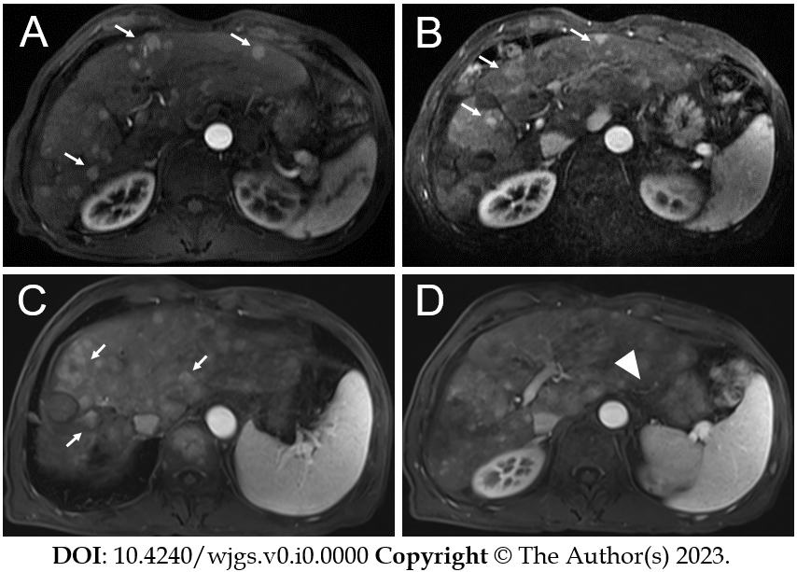
Figure 1 Pseudoaneurysm bleeding after atezolizumab–bevacizumab treatment. A: Magnetic resonance imaging (MRI) of the abdomen revealed multifocal enhancing hepatocellular carcinoma lesions in the liver (white arrows); B: After transcatheter arterial chemoembolization and lenvatinib treatment, MRI showed disease progression (white arrows); C and D: After three cycles of atezolizumab plus bevacizumab, MRI showed progressive disease (white arrows) but no remarkable gastroesophageal varices (white arrowhead).

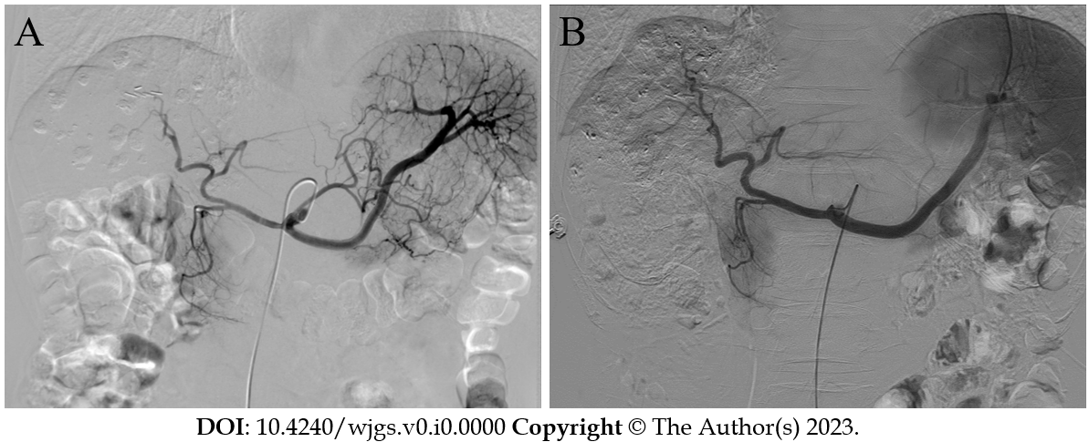
Figure 2 Selective digital subtraction angiography showed no extravasation of contrast medium in the gastric area. A: Digital subtraction angiography in March 2021; B: Digital subtraction angiography in September 2021.

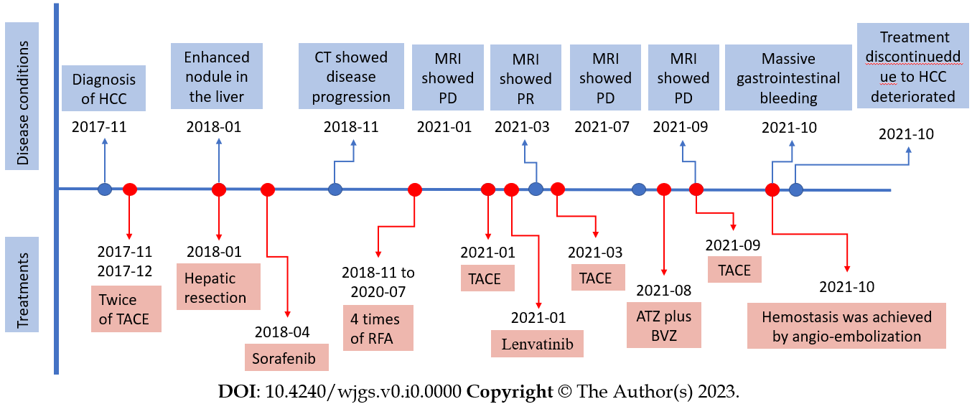
Figure 3 Treatment and disease status timeline. HCC: Hepatocellular carcinoma; TACE: Transcatheter arterial chemoembolization; CT: Computed tomography; RFA: Radiofrequency ablation; MRI: Magnetic resonance imaging; PD: Progressive disease; PR: Partial response; ATZ: Atezolizumab; BVZ: Bevacizumab.

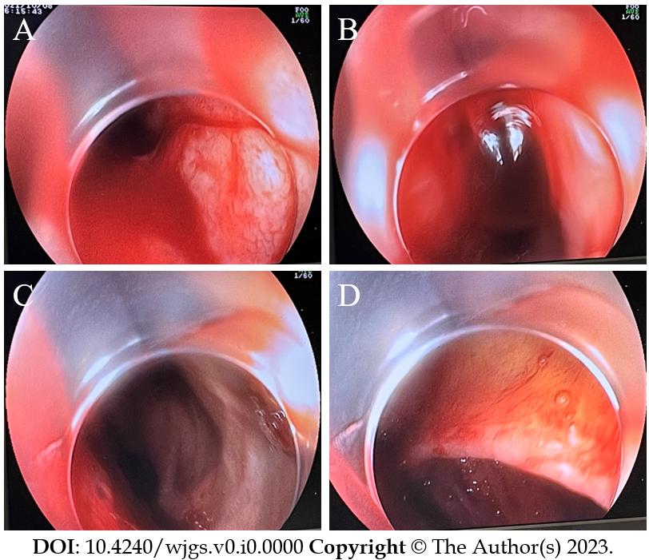
Figure 4 The findings of gastrointestinal endoscopy performed by the time of massive upper gastrointestinal bleeding. Visualization was limited because of massive fresh blood and blood clots within the stomach. A-C: No remarkable esophageal varices or red wale signs were observed in esophagus and fundus of stomach; D: No recurrence of gastric carcinoma or anastomotic bleeding was detected.

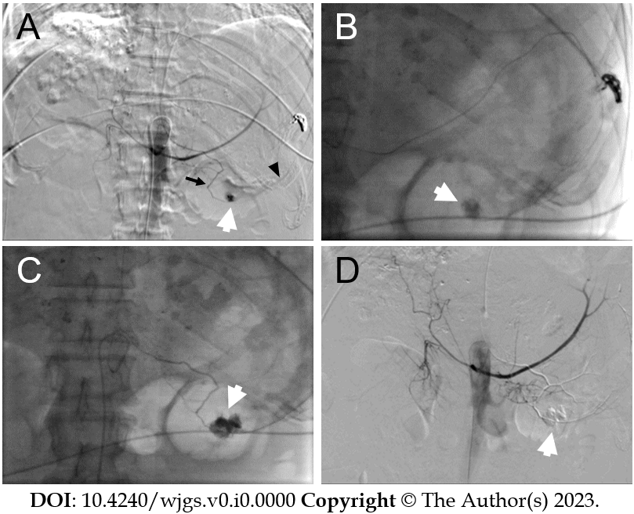
Figure 5 Emergency angiography. A: Selective digital subtraction angiography of the celiac trunk showed extravasation of contrast medium (white arrow) from the inferior splenic artery (black arrow), a branch of the left gastric artery (black arrow head), and a pseudoaneurysm of the gastric artery; B and C: The pseudoaneurysm (white arrow) was embolized using liquid glue and lipiodol; D: After embolization, the pseudoaneurysm (white arrow) and active bleeding were no longer visible.

