Name of Journal: World Journal of Clinical Cases
Manuscript NO: 74467
Manuscript Type: CASE REPORT

Ovarian growing teratoma syndrome with multiple metastases in the abdominal cavity and liver: A case report

Hu X et al. Ovarian GTS with multiple metastases in the abdominal cavity and liver

Xu Hu, Zhong Jia, Li-Xin Zhou, Nisile Kakongoma

Xu Hu, The Fourth Clinical Medical College, Zhejiang Chinese Medical University, Hangzhou 310011, Zhejiang Province, China

Zhong Jia, Li-Xin Zhou, Department of Hepatobiliary Surgery, The First People's Hospital, Zhejiang University School of Medicine, Hangzhou 310006, Zhejiang Province, China

Nisile Kakongoma, Hangzhou Women’s Hospital, Zhejiang Chinese Medical University, Hangzhou 310008, Zhejiang Province, China

Author contributions: Jia Z and Hu X analyzed the case and drafted the manuscript; Hu X also helped prepare the images; Zhou LX took part in the operation and perioperative management of the patient; Kakongoma N helped modify the language; all authors read and approved the final manuscript.

Corresponding author: Zhong Jia, Doctor, Department of Hepatobiliary Surgery, The First People's Hospital, Zhejiang University School of Medicine, No. 261 Huang Sha, Shangcheng District, Hangzhou 310006, Zhejiang Province, China. jiazhong664181@163.com

Received: December 24, 2021
Revised: February 6, 2022
Accepted: March 26, 2022
Published online:

Abstract
BACKGROUND
Growing teratoma syndrome (GTS) is an unusual presentation of an amazing transformation of teratoma from malignant to benign on pathology during or after systemic or intraperitoneal chemotherapy. The definitive pathogenesis is still not fully understood due to the lack of large-sample studies.

CASE SUMMARY
A 53-year-old woman underwent radical surgery and postoperative intraperitoneal chemotherapy due to immature teratoma of the right ovary at the age of 28. She remained well during a 25-year follow-up period after surgery. Multiple asymptomatic solid masses were found in the liver on ultrasonography a month ago. Enhanced computed tomography (CT) of the abdomen revealed multiple masses in the abdominal cavity. The largest one was located in the posterior peritoneum next to the sixth segment of the right liver, about 7.9 cm × 7.5 cm in size. Three masses were present inside the liver, and one mass was in the right pelvic floor. Multiple lumps in the abdominal cavity were completely removed by surgery. During the operation, multiple space-occupying lesions were seen, ranging in size from 0.5 to 3 cm, and grayish white in color and hard in texture. Ovarian GTS was finally diagnosed based on postoperative pathology. After surgery, she recovered uneventfully. During a 3-year follow-up, the patient remained free of the disease without any recurrence on CT scan.

CONCLUSION
GTS is a rare phenomenon characterized by conversion of immature teratoma to mature one during or after chemotherapy and presents as growing and metastasizing masses. The pathogenesis of GTS is unclear, and the prognosis is good after surgical resection.

Key Words: Hepatic mass; Hypothesis of tumoral competitive inhibition and dormancy; Ovarian growing teratoma syndrome; Treatment; Case report

Hu X, Jia Z, Zhou LX, Kakongoma N. Ovarian growing teratoma syndrome with multiple metastases in the abdominal cavity and liver: A case report. World J Clin Cases 2022; In press

Core Tip: Growing teratoma syndrome (GTS) is a rare complication characterized by normal tumor markers during or after chemotherapy, but the size or number of tumor increases or both increases. At present, the mechanism has not yet been explained. In this regard, we propose a new hypothesis of tumor competitive inhibition and dormancy. It is recommended that clinicians should know the characteristics of the course of the disease, closely follow up the patients, diagnose and treat the disease timely, and avoid unnecessary chemotherapy. Surgical resection is the key to ensure a good prognosis of ovarian GTS.

INTRODUCTION
Growing tumor syndrome (GTS) is a rare entity that refers to an amazing phenomenon characterized by complete conversion of the primary malignant tissues to benign components on pathology during or after systemic or intraperitoneal chemotherapy, leaving the benign acquiring a regrowing performance and tolerance to radiotherapy or chemotherapy^{[1]}. It was first reported in 1982^{[2]} However, its definitive pathogenesis is still not fully understood due to lack of large sample studies. In addition, GTS in the liver is often misdiagnosed as multiple primary or metastatic masses^{[3]}. Herein, we describe a middle-aged woman who was finally diagnosed with an ovarian growing teratoma syndrome (OGTS) that mimicked multiple metastatic hepatic masses at first, aiming to investigate its diagnosis, treatment, and possible pathogenesis.

CASE PRESENTATION
Chief complaints
A 53-year-old woman underwent radical surgery and postoperative intraperitoneal chemotherapy due to immature teratoma of the right ovary at the age of 28. She remained well during a 25-year follow-up period after surgery. Multiple asymptomatic solid masses were found in the liver on ultrasonography a month ago and she was then hospitalized in the Hangzhou First People's Hospital.

History of present illness
The patient was accidentally found to have multiple asymptomatic solid masses in the liver during an ultrasound examination at a local community clinic a month ago, and a palpable mass in the abdomen, but no tenderness. She visited our hospital for relevant examinations and further treatment. The patient underwent pathological examination of liver tumor guided by B-ultrasound before operation, which suggested mature teratoma. Finally, the patient decided to undergo surgery.

History of past illness
The patient underwent bilateral appendage + total hysterectomy + omentectomy + appendectomy + lymph node dissection 25 years ago due to immature solid teratoma of the right ovary. Postoperative pathological diagnosis was immature solid teratoma of the right ovary, involving the omentum and appendix, with lymph node metastasis (4/21). From the 3rd day after surgery, she received intraperitoneal chemotherapy of cisplatin 6 times. The patient had no history of hepatitis and gastrointestinal malignancies.

Personal and family history
The patient did not smoke or drink, and had no relevant family history.

Physical examination
A non-tender hard mass on the right upper abdomen with clear boundary and smooth surface, about 7 cm × 6 cm in size, was noted. In the middle and lower abdomen, incision scar was observed.

Laboratory examinations
Carbohydrate antigen (CA) 242 was 23.7 ku/L and carbohydrate antigen 19-9 (CA 19-9) was 93.6 ku/L. Alpha-fetoprotein and lactate dehydrogenase were within the normal range.

Imaging examinations
Abdominal computed tomography (CT) showed multiple masses in the abdominal cavity. The largest one was located in the posterior peritoneum next to the sixth segment of the right liver, about 7.9 cm × 7.5 cm in size, with uneven internal density, calcification and adipose tissue. Three masses were present inside the liver, the largest was about 3 cm × 2 cm, and one mass was in the right pelvic floor, which was about 2 cm × 2 cm (Figure 1).

FINAL DIAGNOSIS
Based on the patient’s medical history and related examinations, the patient was diagnosed with OGTS (Figure 2).

TREATMENT
The patient underwent liver mass resection + laparoscopic-assisted pelvic nodule resection + retroperitoneal mass resection.

OUTCOME AND FOLLOW-UP
The patient recovered uneventfully after surgery and was discharged after 8 d, and has returned to the hospital for review every 3 mo. On a 3-year follow-up, the patient remained free of the tumor without recurrence on CT scan.

Discussion
OGTS refers to selective extinction of ovary-origin immature teratoma acquiring tolerance to radiochemotherapy^{[1]}. It often occurs in young women, the youngest patient is 4 years old^{[4]}. And 2%-7% of GTS occur in non-spermatogonia reproductive tumors, the main modes of metastasis are transperitoneal dissemination, lymph node metastasis and hematological dissemination, and the most common metastatic site is retroperitoneum, but also in the liver, kidney and mediastinum, with a median growth rate of 0.5 cm/mo^{[5]}. So far, there are no standardized criteria for GTS diagnosis and treatment^{[6]}. The mainstream of hypothesis concerning its pathogenesis hold that extinction of immature teratomatous cells or benign lesion transformation might be a genetic mutation triggered by sensitive chemotherapy, leaving mature teratomatous cells regrowing behind^{[7]}. However, the hypothesis seemed to be difficult to explain the OGTS presenting as multiple foci with different growing pace just like this case. For this reason, we proposed a new hypothesis of tumoral competitive inhibition and dormancy. We supposed that immature and mature teratomatous cells most likely co-existed in the primary malignant ovarian teratoma and its metastatic foci, but the benign growth arrested due to the malignant aggressive behavior. When encountering sensitive chemotherapeutic drugs such as cisplatin, immature teratomatous cells were selectively killed, while mature teratomatous cells were completely inhibited to an occult status that refers to dormancy stage until they might be awakened at an uncertain time. The key to successful diagnosis includes four tips: (1) Serum tumor markers are normal or tending to be normal; (2) During or after systemic chemotherapy or thoracic or abdominal chemotherapy, the recurring tumor has growth characteristics and is resistant to radiotherapy or chemotherapy; (3) The postoperative pathology of the tumor specimen suggests a benign tumor (mature teratoma); and (4) Preoperative pathological examination or imaging examination of the mass has no evidence of malignancy, but shows teratoma characteristics. In this case, the elevated serum CA 19-9 was thought to be most likely associated with these metastatic masses involving the liver and pelvic peritoneum because the abnormal CA 19-9 was back to normal after removal of these metastatic foci. Complications of OGTS include focal carcinoma transformation, spontaneous rupture, and symptoms of compressing adjacent viscus^{[8,9]}. Additionally, the incomplete resection might lead to a higher recurrence rate (72%-83%) compared to complete resection (< 4%)^{[10]}. Therefore, thorough surgical removal of all newly emerged masses should be the only curative management.

CONCLUSION
OGTS presenting as multiple hepatic masses might be misdiagnosed as metastatic or primary liver lesions, or result in disastrous consequence due to invalid radio-chemotherapy. Therefore, early recognition of this disease and complete removal of all the masses are crucial in the treatment of this disease, and long-term follow-up should be carried out after the operation. Hypothesis of tumoral competitive inhibition and dormancy could better explain its occurrence.

REFERENCES
1 Kataria SP, Varshney AN, Nagar M, Mandal AK, Jha V. Growing Teratoma Syndrome. Indian J Surg Oncol 2017; 8: 46-50 [PMID: 28127182 DOI: 10.1007/s13193-016-0568-3]
2 Logothetis CJ, Samuels ML, Trindade A, Johnson DE. The growing teratoma syndrome. Cancer 1982; 50: 1629-1635 [PMID: 6288220 DOI: 10.1002/1097-0142(19821015)50:8<1629::aid-cncr2820500828>3.0.co;2-1]
3 Li X, Zhu D, Lv LI, Yu J. An uncommon recurrence of an immature teratoma: A case report. Oncol Lett 2016; 11: 2453-2456 [PMID: 27073497 DOI: 10.3892/ol.2016.4254]
4 Daher P, Riachy E, Khoury A, Raffoul L, Ghorra C, Rehayem C. Growing teratoma syndrome: first case report in a 4-year-old girl. J Pediatr Adolesc Gynecol 2015; 28: e5-e7 [PMID: 25256881 DOI: 10.1016/j.jpag.2014.03.003]
5 Krainev AA, Mathavan VK, Klink D, Fuentes RC, Birhiray R. Resection of a mature cystic teratoma of the liver harboring a carcinoid tumor. J Surg Case Rep 2018; 2018: rjy279 [PMID: 30397434 DOI: 10.1093/jscr/rjy279]
6 Li S, Liu Z, Dong C, Long F, Liu Q, Sun D, Gao Z, Wang L. Growing Teratoma Syndrome Secondary to Ovarian Giant Immature Teratoma in an Adolescent Girl: A Case Report and Literature Review. Medicine (Baltimore) 2016; 95: e2647 [PMID: 26886604 DOI: 10.1097/MD.0000000000002647]
7 Scavuzzo A, Santana Ríos ZA, Noverón NR, Jimenez Ríos MA. Growing teratoma syndrome. Case Rep Urol 2014; 2014: 139425 [PMID: 25197607 DOI: 10.1155/2014/139425]
8 Wang D, Zhu S, Jia C, Cao D, Wu M, Shen K, Yang J, Pan L, Cheng N, Xiang Y. Diagnosis and management of growing teratoma syndrome after ovarian immature teratoma: A single center experience. Gynecol Oncol 2020; 157: 94-100 [PMID: 31954532 DOI: 10.1016/j.ygyno.2019.12.042]
9 Gorbatiy V, Spiess PE, Pisters LL. The growing teratoma syndrome: Current review of the literature. Indian J Urol 2009; 25: 186-189 [PMID: 19672343 DOI: 10.4103/0970-1591.52910]
10 André F, Fizazi K, Culine S, Droz J, Taupin P, Lhommé C, Terrier-Lacombe M, Théodore C. The growing teratoma syndrome: results of therapy and long-term follow-up of 33 patients. Eur J Cancer 2000; 36: 1389-1394 [PMID: 10899652 DOI: 10.1016/s0959-8049(00)00137-4]

Footnotes
Informed consent statement: Informed written consent was obtained from the patient for publication of this report and any accompanying images.

Conflict-of-interest statement: The authors declare that they have no conflict of interest.

CARE Checklist (2016) statement: The authors have read the CARE Checklist (2016), and the manuscript was prepared and revised according to the CARE Checklist-2016.

Open-Access: This article is an open-access article that was selected by an in-house editor and fully peer-reviewed by external reviewers. It is distributed in accordance with the Creative Commons Attribution NonCommercial (CC BY-NC 4.0) license, which permits others to distribute, remix, adapt, build upon this work non-commercially, and license their derivative works on different terms, provided the original work is properly cited and the use is non-commercial. See: https://creativecommons.org/Licenses/by-nc/4.0/

Provenance and peer review: Unsolicited article; Externally peer reviewed.
Peer-review model: Single blind

Peer-review started: December 24, 2021
First decision: January 25, 2022
Article in press:

Specialty type: Obstetrics and gynecology
Country/Territory of origin: China
Peer-review report’s scientific quality classification
Grade A (Excellent): 0
Grade B (Very good): B, B
Grade C (Good): 0
Grade D (Fair): D
Grade E (Poor): 0

P-Reviewer: Li WJ, United States; Shelat VG, Singapore S-Editor: Liu JH L-Editor: A P-Editor: Liu JH

Figure Legends
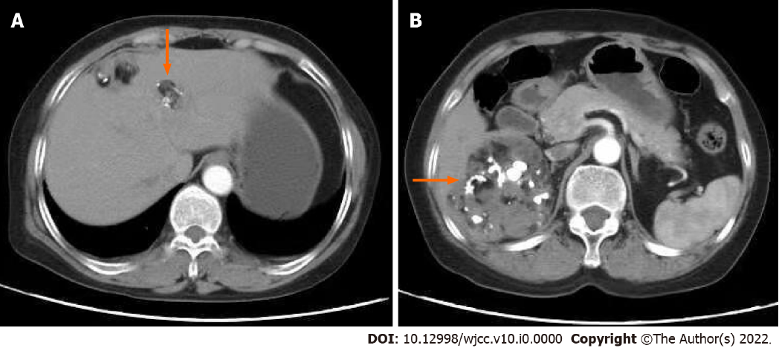
Figure 1 Abdominal computed tomography showed multiple masses in the abdominal cavity. A: Showing three small masses in the liver; B: Showed the largest one was located in the posterior peritoneum next to the sixth segment of the right liver. The largest one was located in the posterior peritoneum next to the sixth segment of the right liver, three masses were present inside of liver and one mass was in the right pelvic floor.

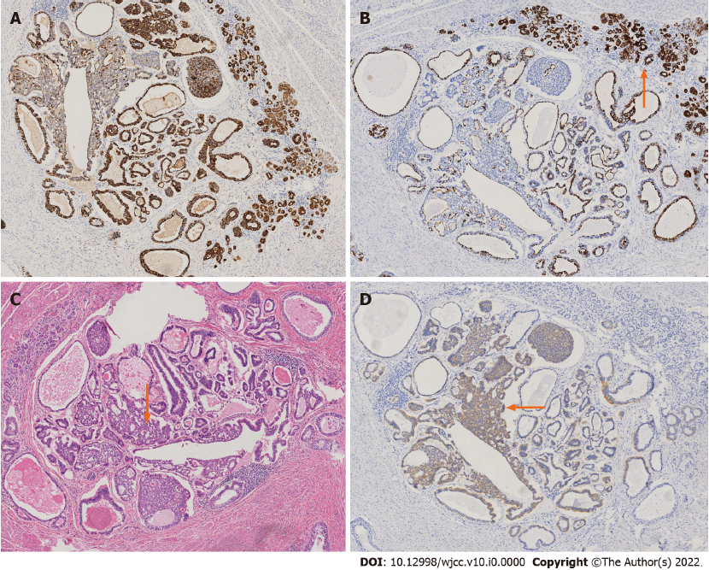
Figure 2 Postoperative histopathology combined with immunohistochemistry analysis demonstrated purely mature teratomatous tissues. A: Shows that the pathological immunohistochemical results are positive for cytokeratin; B: Shows that the pathological immunohistochemical results are negative for cytokeratin 7; C: Shows that the pathological immunohistochemical results are is HE staining; D: Shows that the pathological immunohistochemical results are positive for cluster of differentiation 56. The pathological results were obtained under a microscope with a magnification of 40 times, in which figure A is cytokeratin (+), figure B is cytokeratin 7 (-), figure C is HE staining, figure D is cluster of differentiation 56 (+), and orange arrows mark a large number of nerves endocrine cell aggregation, and all pathological results showed no immature neural tube, suggesting a mature teratoma.

