Name of Journal: World Journal of Gastrointestinal Surgery
Manuscript NO: 88203
Manuscript Type: ORIGINAL ARTICLE

Retrospective Study
Predictive value of machine learning models for lymph node metastasis in gastric cancer: A two-center study

Lu T et al. ML-based prediction of lymph node metastasis

Tong Lu, Miao Lu, Dong Wu, Yuan-Yuan Ding, Hao-Nan Liu, Tao-Tao Li, Da-Qing Song

Tong Lu, Dong Wu, Tao-Tao Li, Da-Qing Song, Department of Emergency Medicine, Jining No. 1 People’s Hospital, Jining 272000, Shandong Province, China

Miao Lu, Wuxi Mental Health Center, Wuxi 214000, Jiangsu Province, China

Yuan-Yuan Ding, Department of Gastroenterology, Jining No. 1 People’s Hospital, Jining 272000, Shandong Province, China

Hao-Nan Liu, Department of Oncology, The Affiliated Hospital of Xuzhou Medical University, Xuzhou 221002, Jiangsu Province, China

Co-first authors: Tong Lu and Miao Lu.

Author contributions: Lu T and Wu D designed the study and wrote the manuscript; Li TT and Ding YY analyzed the data; Liu HN collected the data; Lu M and Song DQ revised the manuscript; Lu T and Lu M designed the study and wrote the article; Wu D and Ding YY analyzed the data; Li T and Song DQ revised the article; Lu M is one of the co-first authors of this paper. Lu T and Lu M contributed equally to this work as co-first authors. The research was performed as a collaborative effort, and the designation of co-first authors authorship accurately reflects the distribution of responsibilities and burdens associated with the time and effort required to complete the study and the resultant paper. This also ensures effective communication and management of post-submission matters, ultimately enhancing the paper's quality and reliability. Lu T and Lu M contributed efforts of equal substance throughout the research process. The choice of these researchers as co-first authors acknowledges and respects this equal contribution, while recognizing the spirit of teamwork and collaboration of this study.

Corresponding author: Da-Qing Song, Doctor, Additional Professor, Department of Emergency Medicine, Jining No. 1 People’s Hospital, No. 6 Jiankang Road, Rencheng District, Jining 272000, Shandong Province, China. 19552153365@163.com

Received: September 14, 2023
Revised: November 24, 2023
Accepted: December 21, 2023
Published online: January 27, 2024

Abstract
BACKGROUND
Gastric cancer is one of the most common malignant tumors in the digestive system, ranking sixth in incidence and fourth in mortality worldwide. Since 42.5% of metastatic lymph nodes in gastric cancer belong to nodule type and peripheral type, the application of imaging diagnosis is restricted.

AIM
To establish models for predicting the risk of lymph node metastasis in gastric cancer patients using machine learning (ML) algorithms and to evaluate their predictive performance in clinical practice.

METHODS
Data of a total of 369 patients who underwent radical gastrectomy at the Department of General Surgery of Affiliated Hospital of Xuzhou Medical University (Xuzhou, China) from March 2016 to November 2019 were collected and retrospectively analyzed as the training group. In addition, data of 123 patients who underwent radical gastrectomy at the Department of General Surgery of Jining First People’s Hospital (Jining, China) were collected and analyzed as the verification group. Seven ML models, including decision tree, random forest, support vector machine (SVM), gradient boosting machine, naive Bayes, neural network, and logistic regression, were developed to evaluate the occurrence of lymph node metastasis in patients with gastric cancer. The ML models were established following ten cross-validation iterations using the training dataset, and subsequently, each model was assessed using the test dataset. The models’ performance was evaluated by comparing the area under the receiver operating characteristic curve of each model.

RESULTS
Among the seven ML models, except for SVM, the other ones exhibited higher accuracy and reliability, and the influences of various risk factors on the models are intuitive.

CONCLUSION
The ML models developed exhibit strong predictive capabilities for lymph node metastasis in gastric cancer, which can aid in personalized clinical diagnosis and treatment.

Key Words: Machine learning; Prediction model; Gastric cancer; Lymph node metastasis

©The Author(s) 2024. Published by Baishideng Publishing Group Inc. All rights reserved.

Citation: Lu T, Lu M, Wu D, Ding YY, Liu HN, Li TT, Song DQ. Predictive value of machine learning models for lymph node metastasis in gastric cancer: A two-center study. World J Gastrointest Surg 2024; 16(1): 85-94
URL: https://www.wjgnet.com/1948-9366/full/v16/i1/85.htm
DOI: https://dx.doi.org/10.4240/wjgs.v16.i1.85

Core Tip: The purpose of this study was to explore the performance of machine learning based models for the risk assessment of lymph node metastasis in patients with gastric cancer. We used seven different methods to analyze our data. After training, the algorithm with the highest average area under the receiver operating characteristic curve was selected as the optimal algorithm.

INTRODUCTION
Gastric cancer is one of the most common malignant tumors in the digestive system, ranking sixth in the world in incidence and fourth in mortality^{[1]}. At present, gastric cancer typically is managed with comprehensive treatment that includes surgery. However, the overall 5-year survival rate remains below 50%^{[2]}. In the Tumor-Node-Metastasis staging system of the American Joint Committee on Cancer, N represents the number of lymph node metastases, which is itself an independent factor in predicting the overall survival rate of gastric cancer patients^{[3]}. However, there are some difficulties in the exploration of lymph nodes in patients with gastric cancer, such as multiple regional lymph nodes located in the abdominal cavity, which are not easy to explore preoperatively. In addition, 42.5% of metastatic lymph nodes in gastric cancer belong to nodule type and peripheral type, restricting the application of imaging diagnosis^{[4,5]}.
Artificial intelligence refers to the ability of machines to independently replicate typical human intellectual processes^{[6]}. Artificial intelligence has various applications in the medical field, encompassing image processing, computer vision, machine learning (ML), artificial neural networks (ANNs), and convolutional neural networks (CNNs). ML can assist physicians in interpreting clinical data through the computer-aided diagnostic (CAD) system. The CAD can be categorized into three stages: Feature recognition, feature extraction, and clinical reasoning. It is feasible to feed variables related to gastric cancer lymph node metastasis into the system and develop a risk model for lymph node metastasis of gastric cancer using a more advanced ML-based algorithm^{[7,8]}. ML algorithms play crucial roles in assisting diagnosis and predicting prognosis by processing a large amount of complex medical data^{[9,10]}. A clinical prediction model can be proposed and optimized through the training dataset, and subsequently examined through the external validation dataset to determine its external validity and adaptability to other patients^{[11,12]}. The clinical utility of ML within the realm of artificial intelligence is increasingly attracting clinicians’ attention, and it is also applied to help diagnose and treat various clinical diseases, including gastric cancer.

MATERIALS AND METHODS
Study subjects
A total of 369 patients who underwent radical gastrectomy at the Department of General Surgery of the Affiliated Hospital of Xuzhou Medical University (Xuzhou, China) from March 2016 to November 2019 were enrolled as the training group, and 123 patients who underwent radical gastrectomy at the Department of General Surgery of Jining First People’s Hospital (Jining, China) were enrolled as the verification group. The inclusion criteria were as follows: (1) Newly diagnosed gastric cancer patients with complete medical records; (2) radical resection for primary gastric cancer was performed in either of the two hospitals, and lymph node metastasis was confirmed by imaging and pathology; and (3) no anti-tumor therapy, such as radiotherapy or chemotherapy, was performed preoperatively. The exclusion criteria were: (1) Combination with other malignant tumors; (2) preoperative complications of other infectious diseases, blood system diseases, autoimmune diseases, and other diseases that could affect inflammatory indicators; (3) recently or currently receiving anti-inflammatory or immunosuppressive therapy; (4) preoperative blood transfusion treatment; (5) severe liver and kidney dysfunction; and (6) incomplete clinical data (Figure 1).

Observational indicators
Clinical data, such as patient name, age, gender, and other clinicopathological data, including routine blood parameters, tumor location, maximum tumor diameter, depth of invasion, and the presence or absence of lymph node metastasis, were collected from all patients. Blood samples were collected in the morning on an empty stomach on the day after admission to determine neutrophil count, platelet count, monocyte count, and lymphocyte count using the Sysmex XE-2100 Automatic Blood Analyzer. Carcinoembryonic antigen (CEA) level in the blood was also measured. The pan-immune-inflammation value (PIV) and CEA level were utilized to establish clinical prediction models. PIV was calculated as (neutrophil count × platelet count × monocyte count)/lymphocyte count.

Statistical analysis
Continuous variables are expressed as the mean ± SD, and categorical variables are presented as percentages. LR was employed to identify the independent risk factors associated with lymph node metastasis in gastric cancer patients. This analysis allowed for the calculation of odds ratios (ORs) and their corresponding 95% confidence intervals. An OR greater than 1 indicated that the variable was a positive risk factor affecting the outcome, while an OR less than 1 suggested that the variable was a negative risk factor influencing the outcome. Statistical significance was defined as a P value of less than 0.05. The statistical analyses and modeling procedures were carried out using SPSS 20.0 software (IBM, Armonk, NY, United States) and R-Studio 25.0 software (R Foundation for Statistical Computing, Vienna, Austria). Several packages were utilized to train models and draw relevant graphs, with the caret package applied for training and validating ML models. In addition to the fundamental linear model (linear LR), seven ML models were fitted, including LR, random forest (RF), gradient boosting machine (GBM), decision tree (DT), support vector machine (SVM), naive Bayes (NB), and multi-layer perceptron (MLP), as illustrated in Figure 2.
The training dataset was combined with the validation dataset, and seven ML algorithms were employed to establish prediction models. LR is a classification algorithm designed to establish a relationship between a feature and the probability of a specific outcome. Rather than using LR for estimating class probability, it employs S-shaped functions for modeling^{[13,14]}. DT is primarily utilized for classification tasks. It begins at the root node to split the dataset based on the most informative feature, creating decision points that segment the data into distinct classes^{[15]}. RF is an extension of the DT method and functions as an ensemble approach. It generates multiple DTs, with the majority vote from these trees determining the final class prediction of the model^{[16,17]}. MLP is an ML algorithm inspired by biological neural networks. ANNs consist of interconnected nodes that communicate through connections^{[18,19]}. SVM classifies data by defining boundaries that separate classes. The optimization process aims to maximize the margin between these class boundaries. While SVM generally outperforms LR, its computational complexity may lead to longer training time during model development^{[20,21]}. GBM is a boosting technique that serves as a numerical optimization algorithm for constructing additive models that minimize loss functions^{[22,23]}. NB is a straightforward classification algorithm that calculates the probability of each category’s occurrence given the item to be classified. The item is assigned to the category with the highest probability^{[24,25]}.
Performance evaluation of the models involved various metrics, including accuracy, recall, and other indicators. The primary indicator for predicting binary classification results was the area under the receiver operating characteristic curve (AUC). This metric varies from 0 to 1, with higher values signifying a superior performance. Additionally, for models with two outcomes, the area under the accuracy-recall curve was utilized, illustrating the trade-off between true accuracy and positive predictive value, and the F1 score, defined as the harmonic mean of recall and accuracy. The models underwent 10-fold cross-validation on the training dataset and then assessed for their performance on the test dataset. According to the optimal model, a network estimator was developed to facilitate disease prediction using patient data. This estimator enables surgeons to assess the risk of lymph node metastasis in gastric cancer patients.

RESULTS
Baseline clinical data in the training group and verification group
The comparison of clinical data between the two groups is presented in Table 1. Gender, age, tumor location, and surgical method exhibited no significant differences between the two groups (P > 0.05). In the training dataset, the proportion of patients with total gastrectomy, neurovascular invasion, and maximum tumor diameter > 5 cm was significantly higher in patients with lymph node metastasis than in those without (P < 0.05). In the verification dataset, the number of patients who were aged > 60 years old and had neurovascular invasion and maximum tumor diameter > 5 cm was significantly greater in patients with lymph node metastasis than in those without (P < 0.05).
The results of Mann-Whitney U test revealed that there were no statistically significant differences in the depth of infiltration, PIV, or CEA level between the two groups (P > 0.05). It was found that the depth of infiltration and CEA level in patients with lymph node metastasis were significantly higher than those in patients without (P < 0.05). In the training dataset, the infiltration depth, PIV, and CEA level in patients with lymph node metastasis were significantly greater than those in patients without (P < 0.05).

Evaluation of predictive performance of each model
In order to compare the predictive performance of the seven ML-based models, this study employed ten-fold cross-validation and utilized the AUC value, validated on the test dataset, as the primary metric for assessing their performance. As shown in Table 2 and Figure 2, the GBM model exhibited the best performance in predicting the occurrence of lymph node metastasis in gastric cancer patients, with an average AUC of 0.927. In this study, a web-based online estimator, along with feature importance (Figure 3) and Shapley Additive Explanations (SHAP) summary plot (Figure 4), was developed based on the GBM model. Feature importance enables the visualization of the model’s internal results, highlighting the significance of specific variables within the model. Utilizing the optimal GBM model, we have developed a web-based risk calculator (https://gastric.shinyapps.io/gbm4Lymph). By entering the clinical characteristics of patients with gastric cancer and lymph node metastasis, healthcare professionals can predict the risk of lymph node development in these patients (Figure 5).

DISCUSSION
As a result of the limited early detection of gastric cancer, over 50% of patients are diagnosed at advanced stages or with metastasis. At present, surgery is the main method for the treatment of gastric cancer, and lymph node metastasis is regarded as the main factor affecting the stage, grade, and survival rate of gastric cancer^{[26,27]}. Therefore, early prediction of the occurrence of lymph node metastasis is vital. To date, several scholars have concentrated on lymph node metastasis in gastric cancer, while few studies have developed tools to provide accurate predictions. Therefore, the development of precise predictive models is essential to facilitate collaborative decision-making for clinicians and patients. The continuous advancement of artificial intelligence in the field of clinical research has led to the introduction of innovative approaches.
ML represents an evolving frontier in the field of medicine, drawing substantial resources to connect computer science and statistical analysis with medical challenges. ML has the capacity to effectively handle extensive, diverse, and intricate medical data. Consequently, the implementation of ML techniques in medicine is widely regarded as the cornerstone of future endeavors in biomedical research, personalized medicine, and computer-aided diagnosis^{[28,29]}. Specifically, the operational framework of ML involves development of algorithms to execute numerous tasks, refining the algorithms iteratively to optimize performance. Ultimately, this process yields a model that establishes connections between multiple variables and target outcomes. In the present study, clinical data were collected, and ML algorithms were employed to develop a model for assessing the risk of lymph node metastasis in gastric cancer. By leveraging multiple variables, clinicians can employ this AI-driven approach to select more efficacious treatment strategies^{[30-33]}.
In this study, in addition to some clinicopathological data, hematological indicators, namely, immunoinflammatory factors (PIV and CEA), were utilized to develop the prediction models. PIV is a novel blood-based biomarker that integrates different subsets of peripheral blood immune cells, neutrophils, platelets, monocytes, and lymphocytes. As PIV has the potential to comprehensively represent patients’ immunity and systemic inflammation, it may potentially serve as a robust predictor in advanced cancer patients undergoing cytotoxic chemotherapy, immunotherapy, and targeted therapy. It has been previously demonstrated that PIV is mainly dependent on neutrophil-to-lymphocyte ratio, platelet-to-lymphocyte ratio, lymphocyte-to-monocyte ratio, and other indicators in predicting cancer prognosis^{[34,35]}. CEA is a widely used serum tumor marker in clinical practice, particularly in the early screening of various types of cancer, and elevation of its elevation is also regarded as an independent risk factor for poor prognosis of gastric cancer^{[36]}. Development of a model based on combination of clinicopathological data with hematological suggestions can better reflect the physiological and pathological changes of patients with gastric cancer during the disease, making the model more representative.
Using ML, seven models were established for comparative analysis, utilizing the AUC as the benchmark for assessment. The outcomes are summarized as follows: The AUC for the DT model was 0.824, the RF model yielded an AUC of 0.923, the AUC for SVM was 0.721, and the GBM model demonstrated an AUC of 0.927. The NB model’s AUC stood at 0.914, while the NNET model’s AUC reached 0.907. The results of the seven models indicated that the GBM model displayed the most reliable performance, while SVM exhibited the least promising results. Furthermore, a feature importance table was developed based on the highly effective GBM model, which highlighted that factors, such as nerve or vascular invasion, CEA level, maximum tumor diameter, PIV, age, and tumor site, were significant contributors to the occurrence of lymph node metastasis.
Using the best-performing GBM model, feature importance assessment was conducted. This analysis highlighted the significance of specific indicators within the model, providing new insights into the model’s structure. To understand the relationship between the direction of lymph node metastasis in gastric cancer and the importance of its main predictors, a SHAP summary plot was drawn. This method was utilized to explain the predictions of ML models. SHAP-Beeswarm diagrams, a common visualization tool in SHAP method, display the effect of each feature on the predicted results. The horizontal axis of the plot represents the SHAP value, indicating the contribution of each feature to the predicted result, while the vertical axis represents the feature name. Each data point in the diagram represents a sample, with its horizontal position indicating the sample’s influence on the prediction result. Data points closer to the left side of the graph negatively impact the result, while those closer to the right side positively impact the result. The vertical position of the data point represents the feature name, with each feature having a corresponding vertical position.
According to the optimal GBM model, a web-based risk calculator was developed. By inputting patients’ clinical characteristics, it can directly predict the probability of lymph node metastasis in patients with gastric cancer. This tool is user-friendly and straightforward, making it accessible for healthcare practitioners. It serves as a valuable resource in diagnosis and treatment, providing significant support for clinicians.

CONCLUSION
In summary, based on the clinicopathological data of 492 gastric cancer patients in two centers, ML algorithms were utilized to establish clinical models and conduct cross-validation, and AUC values were finally compared to draw conclusions. In addition to SVM, other ML models have exhibited promising accuracy and reliability, as well as better predictive value for gastric cancer lymph node metastasis. Among them, GBM outperformed the others, with the highest predictive value and accuracy. This study demonstrated that ML could reveal the potential of clinical data to reflect disease conditions, thereby assisting clinicians in evaluating patients’ conditions and making more informed treatment decisions.

ARTICLE HIGHLIGHTS
Research background
Gastric cancer is one of the most common malignant tumors of the digestive system, ranking sixth in incidence and fourth in mortality worldwide. Machine learning (ML) represents an evolving frontier in the field of medicine, drawing substantial resources to connect computer science and statistical analysis with medical challenges. ML has the capacity to effectively handle extensive, diverse, and intricate medical data. Consequently, the implementation of ML techniques in medicine is widely regarded as the cornerstone of future endeavors in biomedical research, personalized medicine, and computer-aided diagnosis.

Research motivation
Using machine learning-based models to predict lymph node metastasis of gastric cancer is helpful to individualized diagnosis and treatment of gastric cancer patients.

Research objectives
Based on the clinicopathological data of 492 gastric cancer patients in two centers, we used ML algorithms to establish clinical models and conduct cross-validation, and finally compared the area under the receiver operating characteristic curve to draw conclusions. In addition to support vector machine, other ML models have good accuracy and reliability, and have better predictive value for gastric cancer lymph node metastasis. Among them, gradient boosting machine (GBM) has the best performance and the highest predictive value and accuracy. Through this study, ML can dig out the ability of clinical data to reflect disease, which can help clinicians evaluate patients' conditions and make better treatment decisions.

Research methods
Seven machine algorithm models were built with data from two centers, and then their performance was evaluated. Based on GBM model, a web-based online estimator and Shapley Additive Explanations summary plot were established.

Research results
ML can tap into the ability of clinical data to reflect disease, which can help clinicians assess patients' conditions and make better treatment decisions.

Research conclusions
ML algorithms have been used to establish an optimal prediction model for lymph node metastasis in gastric cancer, which is helpful for clinical risk stratification and individualized diagnosis and treatment of gastric cancer patients.

Research perspectives
In the future, multi-center data are needed to verify the external applicability of our model.

REFERENCES
1 Salvatori S, Marafini I, Laudisi F, Monteleone G, Stolfi C. Helicobacter pylori and Gastric Cancer: Pathogenetic Mechanisms. Int J Mol Sci 2023; 24 [PMID: 36769214 DOI: 10.3390/ijms24032895]
2 National Health Commission Of The People's Republic Of China. Chinese guidelines for diagnosis and treatment of gastric cancer 2018 (English version). Chin J Cancer Res 2019; 31: 707-737 [PMID: 31814675 DOI: 10.21147/j.issn.1000-9604.2019.05.01]
3 Jin C, Jiang Y, Yu H, Wang W, Li B, Chen C, Yuan Q, Hu Y, Xu Y, Zhou Z, Li G, Li R. Deep learning analysis of the primary tumour and the prediction of lymph node metastases in gastric cancer. Br J Surg 2021; 108: 542-549 [PMID: 34043780 DOI: 10.1002/bjs.11928]
4 Wang H, Gong H, Tang A, Cui Y. Neutrophil/lymphocyte ratio predicts lymph node metastasis in patients with gastric cancer. Am J Transl Res 2023; 15: 1412-1420 [PMID: 36915778]
5 Li C, Tian XJ, Qu GT, Teng YX, Li ZF, Nie XY, Liu DJ, Liu T, Li WD. Clinical value of regional lymph node sorting in gastric cancer. World J Gastrointest Oncol 2022; 14: 2393-2403 [PMID: 36568948 DOI: 10.4251/wjgo.v14.i12.2393]
6 Topol EJ. High-performance medicine: the convergence of human and artificial intelligence. Nat Med 2019; 25: 44-56 [PMID: 30617339 DOI: 10.1038/s41591-018-0300-7]
7 Li Y, Xie F, Xiong Q, Lei H, Feng P. Machine learning for lymph node metastasis prediction of in patients with gastric cancer: A systematic review and meta-analysis. Front Oncol 2022; 12: 946038 [PMID: 36059703 DOI: 10.3389/fonc.2022.946038]
8 Bhinder B, Gilvary C, Madhukar NS, Elemento O. Artificial Intelligence in Cancer Research and Precision Medicine. Cancer Discov 2021; 11: 900-915 [PMID: 33811123 DOI: 10.1158/2159-8290.CD-21-0090]
9 Mainali G. Artificial Intelligence in Medical Science: Perspective from a Medical Student. JNMA J Nepal Med Assoc 2020; 58: 709-711 [PMID: 33068098 DOI: 10.31729/jnma.5257]
10 Seifert R, Weber M, Kocakavuk E, Rischpler C, Kersting D. Artificial Intelligence and Machine Learning in Nuclear Medicine: Future Perspectives. Semin Nucl Med 2021; 51: 170-177 [PMID: 33509373 DOI: 10.1053/j.semnuclmed.2020.08.003]
11 Luo R, Gao J, Gan W, Xie WB. Clinical-radiomics nomogram for predicting esophagogastric variceal bleeding risk noninvasively in patients with cirrhosis. World J Gastroenterol 2023; 29: 1076-1089 [PMID: 36844133 DOI: 10.3748/wjg.v29.i6.1076]
12 Ma Y, Lu Q, Yuan F, Chen H. Comparison of the effectiveness of different machine learning algorithms in predicting new fractures after PKP for osteoporotic vertebral compression fractures. J Orthop Surg Res 2023; 18: 62 [PMID: 36683045 DOI: 10.1186/s13018-023-03551-9]
13 Collins GS, Reitsma JB, Altman DG, Moons KG. Transparent reporting of a multivariable prediction model for individual prognosis or diagnosis (TRIPOD): the TRIPOD statement. BMJ 2015; 350: g7594 [PMID: 25569120 DOI: 10.1136/bmj.g7594]
14 Zhou CM, Wang Y, Yang JJ, Zhu Y. Predicting postoperative gastric cancer prognosis based on inflammatory factors and machine learning technology. BMC Med Inform Decis Mak 2023; 23: 53 [PMID: 37004065 DOI: 10.1186/s12911-023-02150-2]
15 Song X, Liu X, Liu F, Wang C. Comparison of machine learning and logistic regression models in predicting acute kidney injury: A systematic review and meta-analysis. Int J Med Inform 2021; 151: 104484 [PMID: 33991886 DOI: 10.1016/j.ijmedinf.2021.104484]
16 Koga S, Zhou X, Dickson DW. Machine learning-based decision tree classifier for the diagnosis of progressive supranuclear palsy and corticobasal degeneration. Neuropathol Appl Neurobiol 2021; 47: 931-941 [PMID: 33763863 DOI: 10.1111/nan.12710]
17 Collin FD, Durif G, Raynal L, Lombaert E, Gautier M, Vitalis R, Marin JM, Estoup A. Extending approximate Bayesian computation with supervised machine learning to infer demographic history from genetic polymorphisms using DIYABC Random Forest. Mol Ecol Resour 2021; 21: 2598-2613 [PMID: 33950563 DOI: 10.1111/1755-0998.13413]
18 Choi RY, Coyner AS, Kalpathy-Cramer J, Chiang MF, Campbell JP. Introduction to Machine Learning, Neural Networks, and Deep Learning. Transl Vis Sci Technol 2020; 9: 14 [PMID: 32704420 DOI: 10.1167/tvst.9.2.14]
19 Citko W, Sienko W. Inpainted Image Reconstruction Using an Extended Hopfield Neural Network Based Machine Learning System. Sensors (Basel) 2022; 22 [PMID: 35161559 DOI: 10.3390/s22030813]
20 Dinh A, Miertschin S, Young A, Mohanty SD. A data-driven approach to predicting diabetes and cardiovascular disease with machine learning. BMC Med Inform Decis Mak 2019; 19: 211 [PMID: 31694707 DOI: 10.1186/s12911-019-0918-5]
21 Wu Y, Fang Y. Stroke Prediction with Machine Learning Methods among Older Chinese. Int J Environ Res Public Health 2020; 17 [PMID: 32178250 DOI: 10.3390/ijerph17061828]
22 Cha GW, Moon HJ, Kim YC. Comparison of Random Forest and Gradient Boosting Machine Models for Predicting Demolition Waste Based on Small Datasets and Categorical Variables. Int J Environ Res Public Health 2021; 18 [PMID: 34444277 DOI: 10.3390/ijerph18168530]
23 Senders JT, Staples P, Mehrtash A, Cote DJ, Taphoorn MJB, Reardon DA, Gormley WB, Smith TR, Broekman ML, Arnaout O. An Online Calculator for the Prediction of Survival in Glioblastoma Patients Using Classical Statistics and Machine Learning. Neurosurgery 2020; 86: E184-E192 [PMID: 31586211 DOI: 10.1093/neuros/nyz403]
24 Chang CH, Lin CH, Lane HY. Machine Learning and Novel Biomarkers for the Diagnosis of Alzheimer's Disease. Int J Mol Sci 2021; 22 [PMID: 33803217 DOI: 10.3390/ijms22052761]
25 Peiffer-Smadja N, Rawson TM, Ahmad R, Buchard A, Georgiou P, Lescure FX, Birgand G, Holmes AH. Machine learning for clinical decision support in infectious diseases: a narrative review of current applications. Clin Microbiol Infect 2020; 26: 584-595 [PMID: 31539636 DOI: 10.1016/j.cmi.2019.09.009]
26 Ma D, Zhang Y, Shao X, Wu C, Wu J. PET/CT for Predicting Occult Lymph Node Metastasis in Gastric Cancer. Curr Oncol 2022; 29: 6523-6539 [PMID: 36135082 DOI: 10.3390/curroncol29090513]
27 Li X, Zhou H, Zhao X, Peng H, Luo S, Feng J, Heng J, Liu H, Ge J. Establishment and Validation for Predicting the Lymph Node Metastasis in Early Gastric Adenocarcinoma. J Healthc Eng 2022; 2022: 8399822 [PMID: 35812896 DOI: 10.1155/2022/8399822]
28 Obermeyer Z, Emanuel EJ. Predicting the Future - Big Data, Machine Learning, and Clinical Medicine. N Engl J Med 2016; 375: 1216-1219 [PMID: 27682033 DOI: 10.1056/NEJMp1606181]
29 Bayliss L, Jones LD. The role of artificial intelligence and machine learning in predicting orthopaedic outcomes. Bone Joint J 2019; 101-B: 1476-1478 [PMID: 31786999 DOI: 10.1302/0301-620X.101B12.BJJ-2019-0850.R1]
30 DeVries Z, Hoda M, Rivers CS, Maher A, Wai E, Moravek D, Stratton A, Kingwell S, Fallah N, Paquet J, Phan P; RHSCIR Network. Development of an unsupervised machine learning algorithm for the prognostication of walking ability in spinal cord injury patients. Spine J 2020; 20: 213-224 [PMID: 31525468 DOI: 10.1016/j.spinee.2019.09.007]
31 Bien N, Rajpurkar P, Ball RL, Irvin J, Park A, Jones E, Bereket M, Patel BN, Yeom KW, Shpanskaya K, Halabi S, Zucker E, Fanton G, Amanatullah DF, Beaulieu CF, Riley GM, Stewart RJ, Blankenberg FG, Larson DB, Jones RH, Langlotz CP, Ng AY, Lungren MP. Deep-learning-assisted diagnosis for knee magnetic resonance imaging: Development and retrospective validation of MRNet. PLoS Med 2018; 15: e1002699 [PMID: 30481176 DOI: 10.1371/journal.pmed.1002699]
32 Craik A, He Y, Contreras-Vidal JL. Deep learning for electroencephalogram (EEG) classification tasks: a review. J Neural Eng 2019; 16: 031001 [PMID: 30808014 DOI: 10.1088/1741-2552/ab0ab5]
33 MacEachern SJ, Forkert ND. Machine learning for precision medicine. Genome 2021; 64: 416-425 [PMID: 33091314 DOI: 10.1139/gen-2020-0131]
34 Handelman GS, Kok HK, Chandra RV, Razavi AH, Lee MJ, Asadi H. eDoctor: machine learning and the future of medicine. J Intern Med 2018; 284: 603-619 [PMID: 30102808 DOI: 10.1111/joim.12822]
35 Seligman B, Tuljapurkar S, Rehkopf D. Machine learning approaches to the social determinants of health in the health and retirement study. SSM Popul Health 2018; 4: 95-99 [PMID: 29349278 DOI: 10.1016/j.ssmph.2017.11.008]
36 Feng F, Tian Y, Xu G, Liu Z, Liu S, Zheng G, Guo M, Lian X, Fan D, Zhang H. Diagnostic and prognostic value of CEA, CA19-9, AFP and CA125 for early gastric cancer. BMC Cancer 2017; 17: 737 [PMID: 29121872 DOI: 10.1186/s12885-017-3738-y]

Footnotes
Institutional review board statement: This study was reviewed and approved by the Ethics Committee of the Affiliated Hospital of Xuzhou Medical University and Jining First People’s Hospital.

Informed consent statement: All study participants or their legal guardian provided informed written consent about personal and medical data collection prior to study enrolment.

Conflict-of-interest statement: We have no financial relationships to disclose.

Data sharing statement: No additional data are available.

Open-Access: This article is an open-access article that was selected by an in-house editor and fully peer-reviewed by external reviewers. It is distributed in accordance with the Creative Commons Attribution NonCommercial (CC BY-NC 4.0) license, which permits others to distribute, remix, adapt, build upon this work non-commercially, and license their derivative works on different terms, provided the original work is properly cited and the use is non-commercial. See: https://creativecommons.org/Licenses/by-nc/4.0/

Provenance and peer review: Unsolicited article; Externally peer reviewed.

Peer-review model: Single blind

Peer-review started: September 14, 2023
First decision: November 17, 2023
Article in press: December 21, 2023

Specialty type: Gastroenterology and hepatology
Country/Territory of origin: China
Peer-review report’s scientific quality classification
Grade A (Excellent): 0
Grade B (Very good): B
Grade C (Good): C
Grade D (Fair): 0
Grade E (Poor): 0

P-Reviewer: Cheng C, China; Lee KS, South Korea S-Editor: Qu XL L-Editor: Wang TQ P-Editor: Xu ZH
Figure Legends
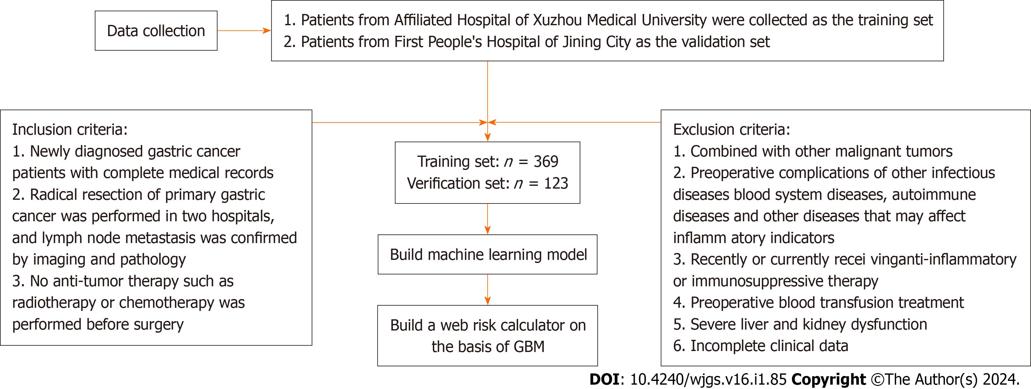
Figure 1 Flow chart. GBM: Gradient boosting machine.
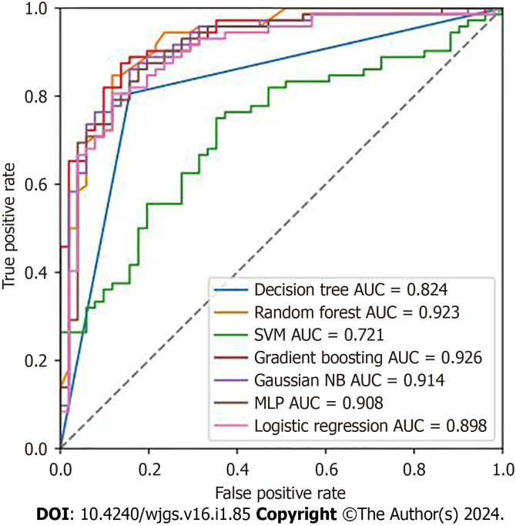
Figure 2 Prediction performance evaluation of each model. SVM: Support vector machine; AUC: Area under the receiver operating characteristic curve; MLP: Multi-layer perceptron.
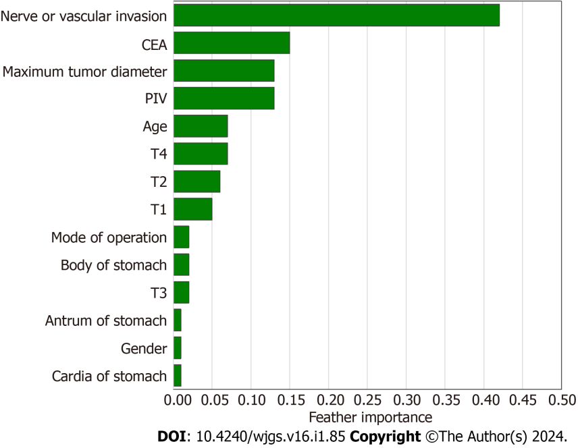
Figure 3 Feature importance. SHAP: Shapley Additive Explanations; CEA: Carcinoembryonic antigen; PIV: Pan-immune-inflammation value.

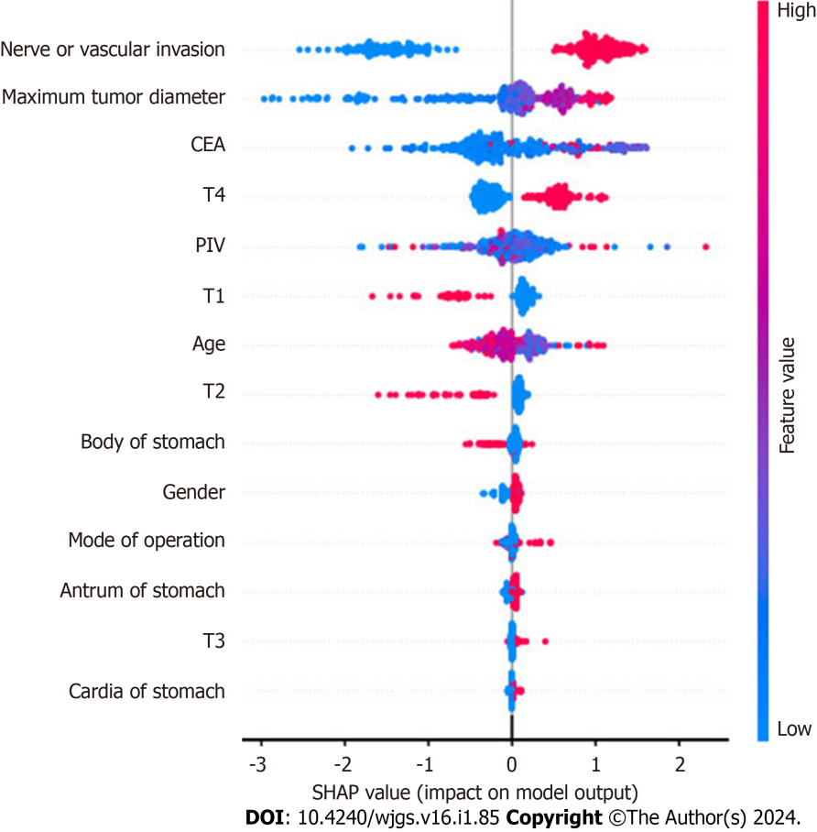
Figure 4 Shapley Additive Explanations summary plot. SHAP: Shapley Additive Explanations; CEA: Carcinoembryonic antigen; PIV: Pan-immune-inflammation value.

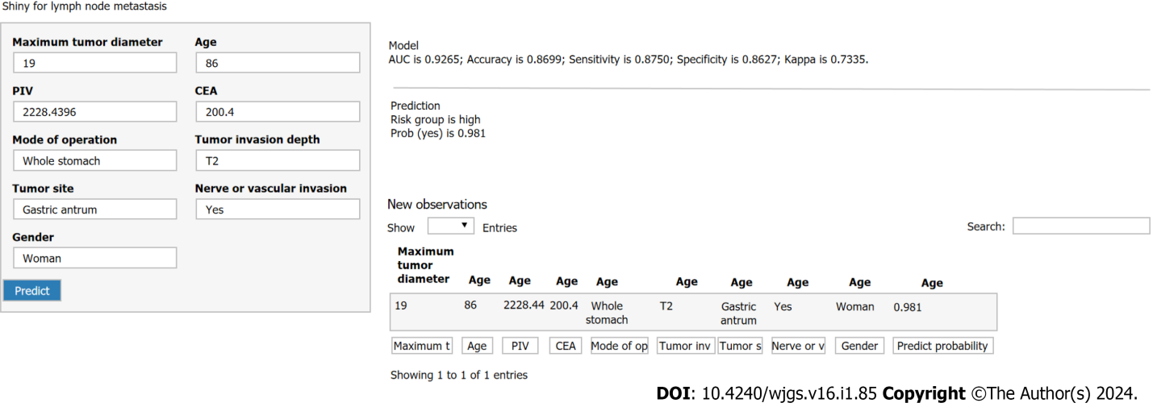
Figure 5 Web risk calculator. SHAP: Shapley Additive Explanations; CEA: Carcinoembryonic antigen; PIV: Pan-immune-inflammation value.
Table 1 Comparison of clinical data between the two groups
Clinical data | Training set | Lymph node metastasis (n = 228) | t/Z/χ² | P value | Validation set | Lymph node metastasis (n = 72) | t/Z/χ² | P value
 | No lymph node metastasis (n = 141) |  |  |  | No lymph node metastasis (n = 51)
Gender |  |  | 1.017 | 0.313 |  |  | 1.126 | 0.289
Male | 99 (70.2) | 171 (75.0) |  |  | 33 (64.7) | 53 (73.6)
Female | 42 (29.8) | 57 (25.0) | 0 |  | 18 (35.3) | 19 (26.4)
Age (yr) |  |  | 0.015 | 0.901 |  |  | 4.729 | 0.030
≤ 60 | 64 (45.4) | 105 (46.1) |  |  | 27 (52.9) | 24 (33.3)
> 60 | 77 (54.6) | 123 (53.9) |  |  | 24 (47.1) | 48 (66.7)
Mode of operation |  |  | 7.816 | 0.005 |  |  | 3.578 | 0.059
Partial gastrectomy | 113 (80.1) | 152 (66.7) |  |  | 43 (84.3) | 50 (69.4)
Total gastrectomy | 28 (19.9) | 76 (33.3) |  |  | 8 (15.7) | 22 (30.6)
Tumor invasion depth |  |  | -11.022 | < 0.001 |  |  | -7.114 | < 0.001
T1 | 61 (43.3) | 13 (5.7) |  |  | 30 (58.8) | 4 (5.6)
T2 | 42 (29.8) | 22 (9.6) |  |  | 13 (25.5) | 13 (18.1)
T3 | 21 (14.9) | 64 (28.1) |  |  | 6 (11.8) | 27 (37.5)
T4 | 17 (12.1) | 129 (56.6) |  |  | 2 (3.9) | 28 (38.9)
Tumor site |  |  | 0.716 | 0.699 |  |  | 0.392 | 0.822
Gastric body | 24 (17.0) | 32 (14.0) |  |  | 18 (35.3) | 22 (30.6)
Gastric antrum | 73 (51.8) | 126 (55.3) |  |  | 26 (51.0) | 38 (52.8)
Gastric cardia | 44 (31.2) | 70 (30.7) |  |  | 7 (13.7) | 12 (16.7)
Nerve or vascular invasion |  |  | 128.649 | < 0.001 |  |  | 54.772 | < 0.001
No | 108 (76.6) | 39 (17.1) |  |  | 42 (82.4) | 11 (15.3)
Yes | 33 (23.4) | 189 (82.9) |  |  | 9 (17.6) | 61 (84.7)
Maximum tumor diameter |  |  | 38.634 | < 0.001 |  |  | 8.323 | 0.004
≤ 5 cm | 122 (86.5) | 126 (55.3) |  |  | 46 (90.2) | 49 (68.1)
> 5 cm | 19 (13.5) | 102 (44.7) |  |  | 5 (9.8) | 23 (31.9)
PIV | 132.00 (80.73, 226.80) | 190.72 (106.49, 311.44) | -3.606 | < 0.001 | 149.43 (91.73, 217.49) | 173.59 (102.20, 274.73) | -1.586 | 0.113
CEA | 2.47 (1.53, 3.58) | 2.90 (1.82, 6.87) | -3.189 | 0.001 | 2.65 (1.47, 3.95) | 4.91 (1.97, 9.02) | -2.331 | 0.020
PIV: Pan-immune-inflammation value; CEA: Carcinoembryonic antigen.
Table 2 Prediction performance evaluation of each model
Model | AUC | Accuracy | Kappa | Sensitivity (recall rates) | Specificity
DT | 0.824 | 0.821 | 0.638 | 0.806 | 0.843
RF | 0.923 | 0.854 | 0.702 | 0.847 | 0.882
SVM | 0.721 | 0.585 | 0.000 | 0.750 | 0.547
GBM | 0.927 | 0.870 | 0.734 | 0.875 | 0.863
NB | 0.914 | 0.821 | 0.640 | 0.861 | 0.843
MLP | 0.907 | 0.837 | 0.665 | 0.882 | 0.824
LR | 0.898 | 0.821 | 0.636 | 0.806 | 0.882
AUC: Area under the receiver operating characteristic curve; DT: Decision tree; RF: Random forest; SVM: Support vector machine; GBM: Gradient boosting machine; NB: Naive bayes; LR: Logistic regression; MLP: Multi-layer perceptron.

Published by Baishideng Publishing Group Inc
7041 Koll Center Parkway, Suite 160, Pleasanton, CA 94566, USA
Telephone: +1-925-3991568
E-mail: office@baishideng.com
Help Desk: https://www.f6publishing.com/helpdesk
https://www.wjgnet.com

© 2024 Baishideng Publishing Group Inc. All rights reserved.

