Name of Journal: World Journal of Clinical Cases
Manuscript NO: 79828
Manuscript Type: CASE REPORT

Phlegmonous gastritis after biloma drainage: A case report and review of the literature

Yang KC et al. Phlegmonous gastritis after biloma drainage

Kai-Chun Yang, Hsin-Yu Kuo, Jui-Wen Kang

Kai-Chun Yang, Hsin-Yu Kuo, Jui-Wen Kang, Department of Internal Medicine, National Cheng Kung University Hospital, Tainan 704, Taiwan

Author contributions: Yang KC contributed to manuscript writing and editing, and data collection and analyses; Kuo HY and Kang JW supervised the study; Kang JW conceived the study; all authors have read and approved the final manuscript.

Corresponding author: Jui-Wen Kang, MD, Attending Doctor, Department of Internal Medicine, National Cheng Kung University Hospital, No. 138 Sheng Li Road, Tainan 704, Taiwan. kang1594@gmail.com

Received: September 10, 2022
Revised: September 28, 2022
Accepted: October 31, 2022
Published online: November 26, 2022

Abstract
BACKGROUND
Phlegmonous gastritis (PG) is a rare bacterial infection of the gastric submucosa and is related to septicemia, direct gastric mucosal injury, or the direct influence of infection or inflammation in neighboring organs. Here, we present a patient who had spontaneous biloma caused by choledocholithiasis and then PG resulting from bile leakage after biloma drainage.

CASE SUMMARY
A 79-year-old man with a medical history of hypertension had persistent diffuse abdominal pain for 4 d. Physical examination showed stable vital signs, icteric sclera, diffuse abdominal tenderness, and muscle guarding. Laboratory tests showed hyperbilirubinemia and bandemia. Contrast computed tomography (CT) of the abdomen showed a dilated common bile duct and left subphrenic abscess. Left subphrenic abscess drainage revealed bilious fluid, and infected biloma was confirmed. Repeated abdominal CT for persistent epigastralgia after drainage showed gastric wall thickening. Esophagogastroduodenoscopy (EGD) showed an edematous, hyperemic gastric mucosa with poor distensibility. The gastric mucosal culture yielded Enterococcus faecalis. PG was diagnosed based on imaging, EGD findings, and gastric mucosal culture. The patient recovered successfully with antibiotic treatment.

CONCLUSION
PG should be considered in patients with intraabdominal infection, especially from infected organs adjacent to the stomach.

Key Words: Phlegmonous gastritis; Epigastric pain; Choledocholithiasis; Bile leakage; Antibiotics; Case report

©The Author(s) 2022. Published by Baishideng Publishing Group Inc. All rights reserved.

Citation: Yang KC, Kuo HY, Kang JW. Phlegmonous gastritis after biloma drainage: A case report and review of the literature. World J Clin Cases 2022; 10(33): 12430-12439
URL: https://www.wjgnet.com/2307-8960/full/v10/i33/12430.htm
DOI: https://dx.doi.org/10.12998/wjcc.v10.i33.12430

Core Tip: We report a case of spontaneous biloma caused by choledocholithiasis followed by phlegmonous gastritis (PG) resulting from biloma rupture after biloma drainage. Additionally, we analyzed 44 PG cases reported from 2012 to 2022. The etiology of PG is mainly direct microbial invasion from gastric mucosa injury or hematogenous/lymphogenous spread and the most important risk factor for PG is an immunocompromised state. In our case, the patient was immunocompetent and PG was caused by bile leakage after biloma drainage rather than the direct influence of infected biloma.

INTRODUCTION
Phlegmonous gastritis (PG) is a rare bacterial infection of the gastric submucosa and is related to septicemia, direct gastric mucosal injury, or direct influence of infection or inflammation in neighboring organs. It is fatal if not diagnosed and treated immediately. An immunocompromised state associated with malignancy, chemotherapy-induced neutropenia, acquired immunodeficiency syndrome, alcoholism, and immunosuppressive drugs is considered the main risk factor^{[1,2]}.
Here, we present a patient with spontaneous biloma caused by choledocholithiasis followed by PG induced by bile leakage after biloma drainage.

CASE PRESENTATION
Chief complaints
A 79-year-old male complained of persistent diffuse abdominal pain for 4 d.

History of present illness
Initially, the abdominal pain occurred abruptly after eating a big meal, 4 d prior to admission. The initial abdominal pain was mainly located in the right upper quarter abdominal area and then migrated to the whole abdomen. Additionally, the patient experienced nausea, vomiting, constipation, and fever. Recurrent abdominal pain was noted for the 4 d as well. Sonography-guided percutaneous catheter drainage of the left subphrenic abscess, as shown by contrast computed tomography (CT) of the abdomen, was performed. The bilirubin level was 76.0 mg/dL and volume of abscess drainage was around 600 mL. The abscess culture yielded Enterococcus faecalis and Enterobacter cloacae complex. The blood culture yielded no pathogen isolates. Biloma was confirmed. However, the patient still complained of epigastric pain after drainage.

History of past illness
The patient had a medical history of hypertension and had taken an antihypertensive drug regularly.

Personal and family history
The patient’s personal and family histories were unremarkable.

Physical examination
Initial vital signs were a temperature of 37.8 °C, heart rate of 126 beats/min, blood pressure of 163/93 mmHg, and respiratory rate of 32 breaths/min. There was no apparent loss of consciousness. Physical examination showed icteric sclera, abdominal fullness, diffuse tenderness, and muscle guarding. Follow-up vital signs before repeat abdominal CT for persistent abdominal pain were a temperature of 37.5 °C, heart rate of 116 beats/min, blood pressure of 162/84 mmHg, and respiratory rate of 20 breaths/min. Severe muscle guarding and diffuse tenderness were observed.

Laboratory examinations
Abnormal laboratory findings included hyperbilirubinemia (total bilirubin: 3.0 mg/dL; reference range: ≤ 1.2 mg/dL), mildly elevated alkaline phosphatase (138 U/L; reference range: 40-129 U/L), hyponatremia (sodium: 127 mmol/L; reference range: 136-145 mmol/L), impaired renal function (creatinine: 1.59 mg/dL; reference range: 0.70-1.20 mg/dL), white blood cell count of 3200/μL (reference range: 3400-9500/μL), and 8% band form of white blood cells (reference range: 0.0%-4.2%).

Imaging examinations
Plain abdominal radiography showed ileus and contrast abdominal CT showed a dilated common bile duct (CBD) and left subphrenic abscess (Figure 1A). Repeat contrast CT of the abdomen was performed for persistent abdominal pain after biloma drainage and showed bile leakage and gastric wall thickening (Figure 1B). Esophagogastroduodenoscopy (EGD) showed an edematous, hyperemic gastric mucosa with poor distensibility (Figure 2). Endoscopic retrograde cholangiopancreatography after EGD showed a dilated CBD with one filling defect of about 10 mm in size (Figure 3A).

Further diagnostic work-up
The gastric mucosal culture yielded Enterococcus faecalis and the biopsy showed that the gastric submucosa and mucosa were infiltrated by clusters of lymphocytes, neutrophils, and plasma cells (Figure 4). According to initial CT and endoscopic retrograde cholangiopancreatography, the etiology of the initial abdominal pain with fever was a CBD stone with cholangitis and spontaneous biloma. However, according to serial CT images and gastric mucosal culture, the persistent pain after biloma drainage was caused by PG. The etiology of PG was bile leakage after biloma drainage.

FINAL DIAGNOSIS
PG resulting from bile leakage after biloma drainage.

TREATMENT
The patient underwent conservative therapy for PG including parenteral nutrition, biloma drainage, an initial broad-spectrum antibiotic (cefepime 2 g, twice daily), and then a definitive antibiotic of ampicillin 2 g, 6 times a day for 10 d. Endoscopic retrograde biliary drainage was performed for internal biloma drainage (Figure 3B). Neither endoscopic sphincterotomy nor stone extraction was performed due to coagulopathy.

OUTCOME AND FOLLOW-UP
The abdominal pain was relieved after antibiotic treatment, and follow-up EGD 1 mo later showed a normal gastric mucosa with improved distensibility of the stomach (Figure 5). Follow-up abdominal CT 2 mo later showed that the biloma was almost resolved, and the biloma drainage was removed before discharge. The patient is currently being followed as an outpatient.

DISCUSSION
PG is an infrequent bacterial infection of the gastric submucosa. It was first described in 1862 by Cruveilhier^{[3]} and an average of one case report per year has appeared over the last 60 years^{[4]}. We searched for papers indexed in the PubMed database using the keyword “phlegmonous gastritis”. In recent decades, from 2012 to 2022, 44 cases of PG have been reported in the English-language literature, which are summarized in Table 1^{[1,4-42]}. Our literature review showed that PG affects all age groups (age range: 7 to 89 years old) and is highly common in the decades of 40s to 70s, with a male-to-female ratio of about 2:1. According to our findings of the literature review, half of the cases (22/44) were in an immunocompromised state, such as alcoholism, diabetes mellitus, acquired immunodeficiency syndrome, chronic hepatitis B, neutropenia after chemotherapy, and treatment with immunosuppressant drugs. Thus, an immunocompromised state appears to be a main risk factor for PG. Other risk factors for PG are prior endoscopic procedure (including for mucosal resection, submucosal dissection, hemostasis, ultrasonography with fine needle aspiration, and mucosal biopsy; 5/44), recent upper airway infection (3/44), malignancy (8/44), and prior gastrectomy or esophagectomy (3/44).
PG type is classified as diffuse or localized, according to the lesion range^{[4]}. The diffuse type involves the complete stomach, and represents most cases^{[43]}. In contrast, the localized type is most commonly restricted to the antrum, with rare cases involving the cardia or pylorus. Gastric wall abscess is a localized form of PG^{[43]}. In our literature view, only 6 localized type PG cases were identified. The etiology of PG can be classified into primary, secondary, or idiopathic^{[17]}. Primary PG represents a direct microbial invasion from gastric mucosa injury, which is caused by trauma, malignancy, peptic ulcer, or endoscopic interventions. Secondary PG represents a hematogenous/lymphogenous spread or direct influence of infection or inflammation in neighboring organs such as infection due to upper airway infection, pancreatitis, or cholecystitis. Idiopathic PG represents an unknown cause with absence of a primary lesion. In our case, the PG was secondary.
The most common clinical presentation of PG is severe and acute epigastric pain accompanied by fever, vomiting, palpitation, melena, and hematemesis. The symptoms of PG mainly occur within 24 h, although they can develop over several days. It is important to differentiate PG from other acute abdomen etiologies such as acute pancreatitis, cholecystitis, and bowel perforation. Diagnostic modalities for PG include EGD, abdominal CT, and endoscopic ultrasonography (EUS). EGD findings show an edematous mucosa with fibrinopurulent exudates and superficial ulcerations, loss of rugae, and poor distensibility; however, these features are nonspecific to PG. Several differential diagnoses need to be considered, like acute gastric mucosal lesion, scirrhous gastric cancer, gastric syphilis, corrosive gastritis, malignant lymphoma of the stomach, gastrointestinal stromal tumor, and anisakiasis^{[16,35]}. Each of these diseases is diagnosed according to the collective findings from EGD imaging examination along with patient data on clinical pattern, medical history, and culture test results. CT findings include obvious thickening of the gastric wall, and low-intensity areas within the gastric wall^{[17]}. Of note, EUS has not been routinely recommended but is an excellent tool for detecting and tracking thickening of the gastric wall and degree of inflammation^{[16]}. Standard forceps biopsy may not be diagnostic because it does not obtain sufficient submucosal tissue, which is the typically involved layer in PG.
In our review, the most common microorganism was Streptococcus spp. (56%, 19/34), followed by Enterococcus spp. (10%, 3/34). This result was in line with the 2014 bibliographic review by Rada-Palomino et al^{[14]}.
PG has a high mortality rate; the key to successful treatment is early diagnosis and therapy. Before invention with antibiotics, the mortality rate was 83%-92%^{[14]}. Kim et al^{[2]} reviewed 36 cases of PG between 1973 and 2003. The mortality rates for surgical intervention and conservative treatment with antibiotics were 20% and 50%, respectively. Recently, Rada-Palomino et al^{[14]} reviewed 45 cases from 1980 to 2014 and found that the mortality rates for surgically and medically treated patients were 11% and 19%, respectively. In our review of cases reported from 2012 to 2022, the mortality rate was 12% (1/8) for surgery and 8% (3/36) for medical treatment. Through early diagnosis and appropriate antibiotic treatment, the mortality rate of PG has been gradually decreasing but is still high. Surgery should always be considered in refractory cases, which show clinical deterioration despite optimal medical management, and in the presence of complications, such as delayed perforation, abdominal compartment syndrome, bleeding, or stricture^{[9,15,17,22,37]}. The surgery itself can be a partial or total gastrectomy, according to the range of inflammation^{[7]}. In our case, conservation therapy with antibiotics alone was successful.
The recurrence rate of PG is low according to our literature review. Only one case, which was reported by Taniguchi et al^{[34]}, had recurrent PG at 5 d after discharge, and the causes considered most likely were a steroid treatment for allergy and a short-term course of antibiotics. To avoid recurrence, optimizing the process/timing of antibiotic cessation is important and should be determined by laboratory testing data and clinical pattern along with findings from follow-up imaging examinations (e.g., CT or EUS).
A biloma is defined as a collection of bile located outside the bile duct. The main causes of such are iatrogenic or traumatic injuries^{[44]}, with cases of spontaneous biloma being relatively uncommon. The most frequent cause of spontaneous biloma is choledocholithiasis^{[45]}, with the underlying mechanism hypothesized as an increase in intraductal pressure due to stone obstruction. Unfortunately, the clinical presentations of biloma are non-specific, including abdominal pain, fever, nausea, vomiting, and jaundice^{[46]}.
Nowadays, treatment for spontaneous biloma is nonsurgical, including antibiotics and percutaneous drainage via pigtail catheter. ERCP is a feasible alternative with additional benefit because it can not only decompress the biliary tract by endoscopic sphincterotomy and stent placement but also identify the location and severity of an active bile leakage. Surgery is reserved for patients who fail endoscopic stone extraction or present a persistent active leak.

CONCLUSION
This case report describes a rare case of spontaneous biloma caused by choledocholithiasis followed by bile leakage-induced PG after the biloma drainage. PG itself is an uncommon diagnosis due to abdominal pain, but should be considered in patients with intraabdominal infection, especially from an infected organ adjacent to the stomach. The key to successful treatment is early diagnosis and initiation of therapy.

REFERENCES
1 Iqbal M, Saleem R, Ahmed S, Jani P, Alvarez S, Tun HW. Successful Antimicrobial Treatment of Phlegmonous Gastritis: A Case Report and Literature Review. Case Rep Hematol 2018; 2018: 8274732 [PMID: 30305967 DOI: 10.1155/2018/8274732]
2 Kim GY, Ward J, Henessey B, Peji J, Godell C, Desta H, Arlin S, Tzagournis J, Thomas F. Phlegmonous gastritis: case report and review. Gastrointest Endosc 2005; 61: 168-174 [PMID: 15672083 DOI: 10.1016/s0016-5107(04)02217-5]
3 Cruveilhier J. Traite d'Anatomie Pathologique Generale, vol 4. Paris: Masson et Cie, 1862: 485
4 Yang H, Yan Z, Chen J, Xie H, Wang H, Wang Q. Diagnosis and treatment of acute phlegmonous gastritis: A case report. Medicine (Baltimore) 2018; 97: e0629 [PMID: 29718874 DOI: 10.1097/MD.0000000000010629]
5 Saito M, Morioka M, Kanno H, Tanaka S. Acute phlegmonous gastritis with neutropenia. Intern Med 2012; 51: 2987-2988 [PMID: 23064584 DOI: 10.2169/internalmedicine.51.8537]
6 Itonaga M, Ueda K, Ichinose M. Phlegmonous gastritis caused by endoscopic ultrasound-guided fine-needle aspiration (EUS-FNA). Dig Endosc 2012; 24: 488 [PMID: 23078457 DOI: 10.1111/j.1443-1661.2012.01362.x]
7 Fan JQ, Liu DR, Li C, Chen G. Phlegmonous gastritis after esophagectomy: a case report. World J Gastroenterol 2013; 19: 1330-1332 [PMID: 23482416 DOI: 10.3748/wjg.v19.i8.1330]
8 Liu YJ, Siracuse JJ, Gage T, Hauser CJ. Phlegmonous gastritis presenting as portal venous pneumatosis. Surg Infect (Larchmt) 2013; 14: 221-224 [PMID: 23544799 DOI: 10.1089/sur.2011.113]
9 Yu HH, Tsang S, Cheung TT, Lo CM. Surviving emphysematous gastritis after hepatectomy. Case Reports Hepatol 2013; 2013: 106383 [PMID: 25374713 DOI: 10.1155/2013/106383]
10 Nair R, Agrawal S, Nayal B. Spontaneous Resolution of Emphysematous Gastritis with Vaso-occlusive Disease-A Case Report. Malays J Med Sci 2013; 20: 68-70 [PMID: 23966828]
11 Alonso JV, de la Fuente Carillo JJ, Gutierrez Solis MA, Vara Morate FJ, López Ruiz DJ. Gastric wall abscess presenting as thoracic pain: rare presentation of an old disease. Ann Gastroenterol 2013; 26: 360-362 [PMID: 24714315]
12 Sahnan K, Davis BJ, Bagenal J, Cullen S, Appleton S. Acute gastric necrosis after routine oesophagogastroduodenoscopy with therapeutic argon plasma coagulation. Ann R Coll Surg Engl 2013; 95: e99-101 [PMID: 24025279 DOI: 10.1308/003588413X13629960047515]
13 Cortes-Barenque F, Salceda-Otero JC, Angulo-Molina D, Lozoya-González D. Acute phlegmonous gastritis. Rev Gastroenterol Mex 2014; 79: 299-301 [PMID: 25453722 DOI: 10.1016/j.rgmx.2014.07.003]
14 Rada-Palomino A, Muñoz-Duyos A, Pérez-Romero N, Vargas-Pierola H, Puértolas-Rico N, Ruiz-Campos L, Espinós-Pérez J, Veloso-Veloso E. Phlegmonous gastritis: A rare entity as a differential diagnostic of an acute abdomen. Description of a case and a bibliographic review. Rev Esp Enferm Dig 2014; 106: 418-424 [PMID: 25361454]
15 Min SY, Kim YH, Park WS. Acute phlegmonous gastritis complicated by delayed perforation. World J Gastroenterol 2014; 20: 3383-3387 [PMID: 24696618 DOI: 10.3748/wjg.v20.i12.3383]
16 Morimoto M, Tamura S, Hayakawa T, Yamanishi H, Nakamoto C, Nakamoto H, Ikebe T, Nakano Y, Fujimoto T. Phlegmonous gastritis associated with group A streptococcal toxic shock syndrome. Intern Med 2014; 53: 2639-2642 [PMID: 25400190 DOI: 10.2169/internalmedicine.53.2741]
17 Nomura K, Iizuka T, Yamashita S, Kuribayashi Y, Toba T, Yamada A, Furuhata T, Kikuchi D, Matsui A, Mitani T, Ogawa O, Hoteya S, Inoshita N, Kaise M. Phlegmonous gastritis secondary to superior mesenteric artery syndrome. SAGE Open Med Case Rep 2015; 3: 2050313X15596651 [PMID: 27489695 DOI: 10.1177/2050313X15596651]
18 Flor-de-Lima F, Gonçalves D, Marques R, Silva C, Lopes J, Silva R, Tavares M, Trindade E, Carneiro F, Amil-Dias J. Phlegmonous gastritis: a rare cause of abdominal pain. J Pediatr Gastroenterol Nutr 2015; 60: e10 [PMID: 23518491 DOI: 10.1097/MPG.0b013e318291ff1f]
19 Kato K, Tominaga K, Sugimori S, Nagami Y, Kamata N, Yamagami H, Tanigawa T, Shiba M, Watanabe T, Fujiwara Y, Arakawa T. Successful Treatment of Early-Diagnosed Primary Phlegmonous Gastritis. Intern Med 2015; 54: 2863-2866 [PMID: 26567999 DOI: 10.2169/internalmedicine.54.4257]
20 Matsumoto H, Ogura H, Seki M, Ohnishi M, Shimazu T. Fulminant phlegmonitis of the esophagus, stomach, and duodenum due to Bacillus thuringiensis. World J Gastroenterol 2015; 21: 3741-3745 [PMID: 25834344 DOI: 10.3748/wjg.v21.i12.3741]
21 Kim KH, Kim CG, Kim YW, Moon H, Choi JE, Cho SJ, Lee JY, Choi IJ. Phlegmonous Gastritis with Early Gastric Cancer. J Gastric Cancer 2016; 16: 195-199 [PMID: 27752398 DOI: 10.5230/jgc.2016.16.3.195]
22 Kim BY, Kim HS. Erratum: Phlegmonous gastritis in an ankylosing spondylitis patient treated with infliximab. Korean J Intern Med 2017; 32: 1123 [PMID: 29096428 DOI: 10.3904/kjim.2017.336]
23 Hagiwara N, Matsutani T, Umezawa H, Nakamizo M, Yokoshima K, Shinozuka E, Nomura T, Uchida E. Phlegmonous gastritis associated with advanced esophageal cancer. Clin J Gastroenterol 2018; 11: 371-376 [PMID: 29730811 DOI: 10.1007/s12328-018-0867-z]
24 Ishioka M, Watanabe N, Sawaguchi M, Fukuda S, Shiga H, Matsuhashi T, Jin M, Iijima K. Phlegmonous Gastritis: A Report of Three Cases with Clinical and Imaging Features. Intern Med 2018; 57: 2185-2188 [PMID: 29607969 DOI: 10.2169/internalmedicine.0707-17]
25 De Davide L, Beaudoin A. A Case of Phlegmonous Gastritis in a Patient with Psoriatic Arthritis on Infliximab. Case Rep Gastrointest Med 2018; 2018: 3624627 [PMID: 30186641 DOI: 10.1155/2018/3624627]
26 Ramphal W, Mus M, Nuytinck HKS, van Heerde MJ, Verduin CM, Gobardhan PD. Sepsis caused by acute phlegmonous gastritis based on a group A Streptococcus. J Surg Case Rep 2018; 2018: rjy188 [PMID: 30093990 DOI: 10.1093/jscr/rjy188]
27 Matsuura K, Hiramatsu S, Taketani R, Ishibashi K, Uraoka M, Baba S, Nakamura A, Takihara H, Ueda C, Inoue T. Medical Treatment of Postendoscopic Submucosal Dissection Phlegmonous Gastritis in an Elderly Diabetic Woman with Myelodysplastic Syndrome. Case Rep Gastrointest Med 2018; 2018: 8046817 [PMID: 30363937 DOI: 10.1155/2018/8046817]
28 Saeed S, Alothman S, Saeed K, Ahmed L, Gray S. Phlegmonous Gastritis in a Bariatric Patient After Sleeve Gastrectomy. Cureus 2019; 11: e5898 [PMID: 31772868 DOI: 10.7759/cureus.5898]
29 Shi D, He J, Lv M, Liu R, Zhao T, Jiang Q. Phlegmonous gastritis in a patient with mixed-phenotype acute leukemia in the neutropenia phase during chemotherapy: A case report. Medicine (Baltimore) 2019; 98: e17777 [PMID: 31702630 DOI: 10.1097/MD.0000000000017777]
30 Yasuda T, Yagi N, Nakahata Y, Kurobe T, Yasuda Y, Omatsu T, Obora A, Kojima T. A case of phlegmonous gastritis with hepatic portal venous gas caused by Aeromonas hydrophila successfully treated with medication. Clin J Gastroenterol 2020; 13: 281-286 [PMID: 31302879 DOI: 10.1007/s12328-019-01020-7]
31 Campos-Murguía A, Marfil-Garza BA, León-Lara X, Jiménez Gutiérrez JM, Botello-Partida SL. A Patient With Good Syndrome Complicated With Phlegmonous Gastritis. ACG Case Rep J 2019; 6: e00246 [PMID: 31832472 DOI: 10.14309/crj.0000000000000246]
32 Kuriyama K, Koyama Y, Tsuto K, Tokuhira N, Nagata H, Muramatsu A, Oshiro M, Hirakawa Y, Iwai T, Uchiyama H. Gastric lymphoma complicated by phlegmonous gastritis and Guillain-Barré syndrome: A case report. Medicine (Baltimore) 2020; 99: e20030 [PMID: 32358382 DOI: 10.1097/MD.0000000000020030]
33 Yakami Y, Yagyu T, Bando T. Phlegmonous gastritis: a case series. J Med Case Rep 2021; 15: 445 [PMID: 34482823 DOI: 10.1186/s13256-021-02999-9]
34 Taniguchi H, Aimi M, Matsushita H, Shimazaki G. A case of phlegmonous gastritis after acute pharyngitis. Clin J Gastroenterol 2021; 14: 500-505 [PMID: 33539005 DOI: 10.1007/s12328-021-01345-2]
35 DeCino A, Gonzalez Martinez JL, Wright R. Phlegmonous Gastritis: A Case Report of Successful Early Antibiotic Treatment. Cureus 2021; 13: e13359 [PMID: 33754092 DOI: 10.7759/cureus.13359]
36 Elisabeth P, Cornelia M, Athinna S, Anastasia A, Apostolos A, George D. Phlegmonous Gastritis and Streptoccocal Toxic Shock Syndrome: An Almost Lethal Combination. Indian J Crit Care Med 2021; 25: 1197-1200 [PMID: 34916756 DOI: 10.5005/jp-journals-10071-23997]
37 Modares M, Tabari M. Phlegmonous gastritis complicated by abdominal compartment syndrome: a case report. BMC Surg 2021; 21: 5 [PMID: 33397326 DOI: 10.1186/s12893-020-00999-y]
38 Takase R, Fukuda N, Sui O, Hagiya H. Emphysematous gastritis. Clin Case Rep 2021; 9: e05094 [PMID: 34815880 DOI: 10.1002/ccr3.5094]
39 Saito M, Morioka M, Izumiyama K, Mori A, Ogasawara R, Kondo T, Miyajima T, Yokoyama E, Tanikawa S. Phlegmonous gastritis developed during chemotherapy for acute lymphocytic leukemia: A case report. World J Clin Cases 2021; 9: 6493-6500 [PMID: 34435017 DOI: 10.12998/wjcc.v9.i22.6493]
40 Wang J, Zhang T, Zhou X, Huang H, Wang M, Xie M. Combination of antibiotics, gastric lavage and nasojejunal feeding-an effective alternative for the management of acute phlegmonous gastritis: a case report. J Int Med Res 2021; 49: 300060520985742 [PMID: 33541174 DOI: 10.1177/0300060520985742]
41 Durdella H, Everett S, Rose JA. Acute phlegmonous gastritis: A case report. J Am Coll Emerg Physicians Open 2022; 3: e12640 [PMID: 35252969 DOI: 10.1002/emp2.12640]
42 Yu SJ, Lee SH, Yoon JS, Lee HS, Jee SR. Gastric Wall Abscess after Endoscopic Submucosal Dissection. Clin Endosc 2022 [PMID: 34974682 DOI: 10.5946/ce.2021.203]
43 Park CW, Kim A, Cha SW, Jung SH, Yang HW, Lee YJ, Lee HIe, Kim SH, Kim YH. A case of phlegmonous gastritis associated with marked gastric distension. Gut Liver 2010; 4: 415-418 [PMID: 20981225 DOI: 10.5009/gnl.2010.4.3.415]
44 Sachdeva S, Sonika U, Dalal A, Sethi SS, Kumar M. Spontaneous giant biloma resulting from multifocal left hepatic duct perforation. Indian J Gastroenterol 2022; 41: 415-416 [PMID: 33666890 DOI: 10.1007/s12664-021-01154-y]
45 Soni A, Arivarasan K, Sachdeva S, Kumar A, Sakhuja P, Puri AS. Education and Imaging. Hepatobiliary and Pancreatic: Spontaneous bilioma secondary to ampullary cancer: a rare presentation. J Gastroenterol Hepatol 2016; 31: 523 [PMID: 26202225 DOI: 10.1111/jgh.13054]
46 Arramón M, Sciarretta M, Correa GJ, Yantorno M, Redondo A, Baldoni F, Tufare F. Spontaneous Biloma Secondary to Choledocholithiasis. ACG Case Rep J 2021; 8: e00620 [PMID: 34150922 DOI: 10.14309/crj.0000000000000620]

Footnotes
Informed consent statement: Informed written consent was obtained from the patient for publication of this report and any accompanying images.

Conflict-of-interest statement: All the authors report no relevant conflicts of interest for this article.

CARE Checklist (2016) statement: The authors have read the CARE Checklist (2016), and the manuscript was prepared and revised according to the CARE Checklist (2016).

Open-Access: This article is an open-access article that was selected by an in-house editor and fully peer-reviewed by external reviewers. It is distributed in accordance with the Creative Commons Attribution NonCommercial (CC BY-NC 4.0) license, which permits others to distribute, remix, adapt, build upon this work non-commercially, and license their derivative works on different terms, provided the original work is properly cited and the use is non-commercial. See: https://creativecommons.org/Licenses/by-nc/4.0/

Provenance and peer review: Unsolicited article; Externally peer reviewed.

Peer-review model: Single blind

Peer-review started: September 10, 2022
First decision: September 26, 2022
Article in press: October 31, 2022

Specialty type: Medicine, research and experimental
Country/Territory of origin: Taiwan
Peer-review report’s scientific quality classification
Grade A (Excellent): A
Grade B (Very good): B
Grade C (Good): C
Grade D (Fair): D
Grade E (Poor): 0

P-Reviewer: Jovandaric M, Serbia; Li W, China; Sachdeva S, India S-Editor: Fan JR L-Editor: Wang TQ P-Editor: Fan JR
Figure Legends
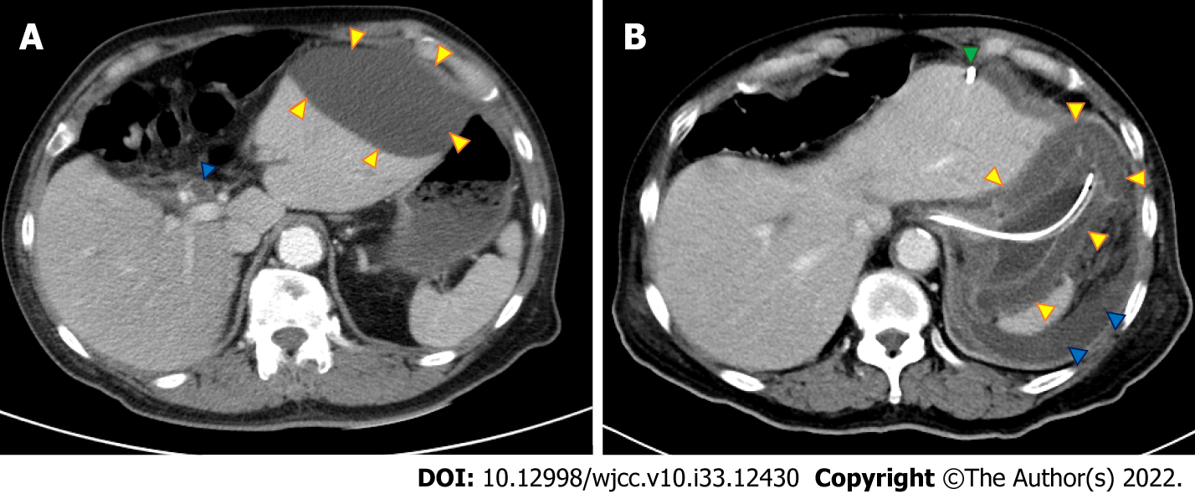
Figure 1 Abdominal computed tomography. A: Initial abdominal computed tomography (CT) showed a dilated common bile duct (blue arrow) and left subphrenic abscess (yellow arrows); B: Repeat abdominal CT after biloma drainage (green arrow) showed bile leakage (blue arrows) and enlarged wall of the stomach (yellow arrows).
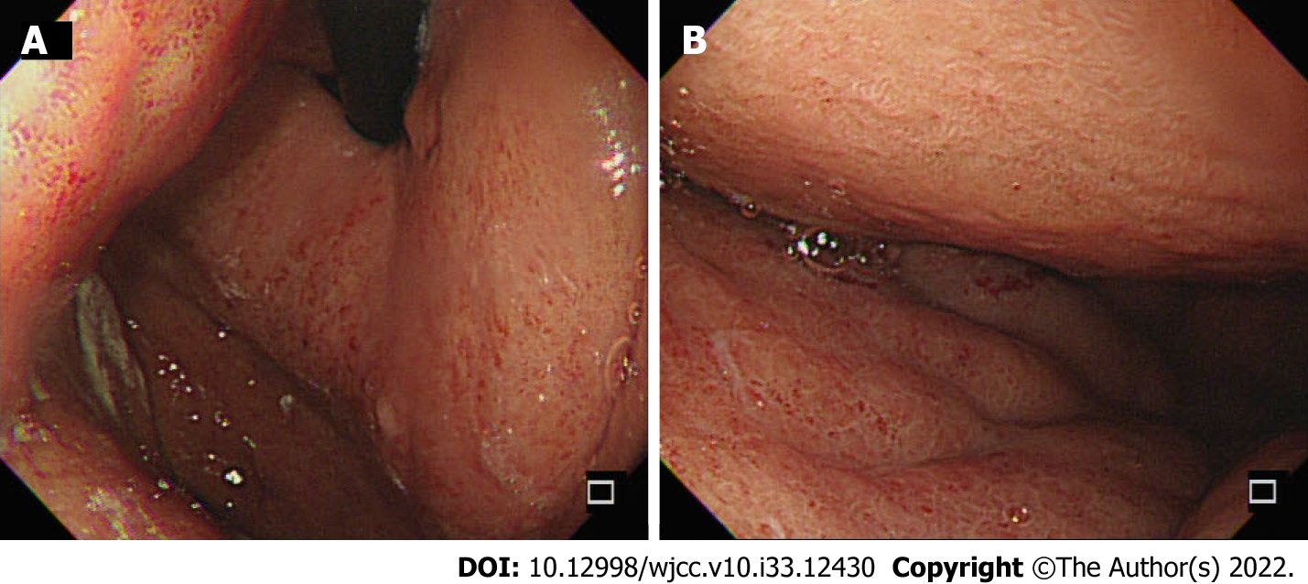
Figure 2 Esophagogastroduodenoscopy. Esophagogastroduodenoscopy showed an edematous, hyperemic gastric mucosa with poor distensibility in the body of the stomach and the fundus of the stomach. A: The body of the stomach; B: The fundus of the stomach.
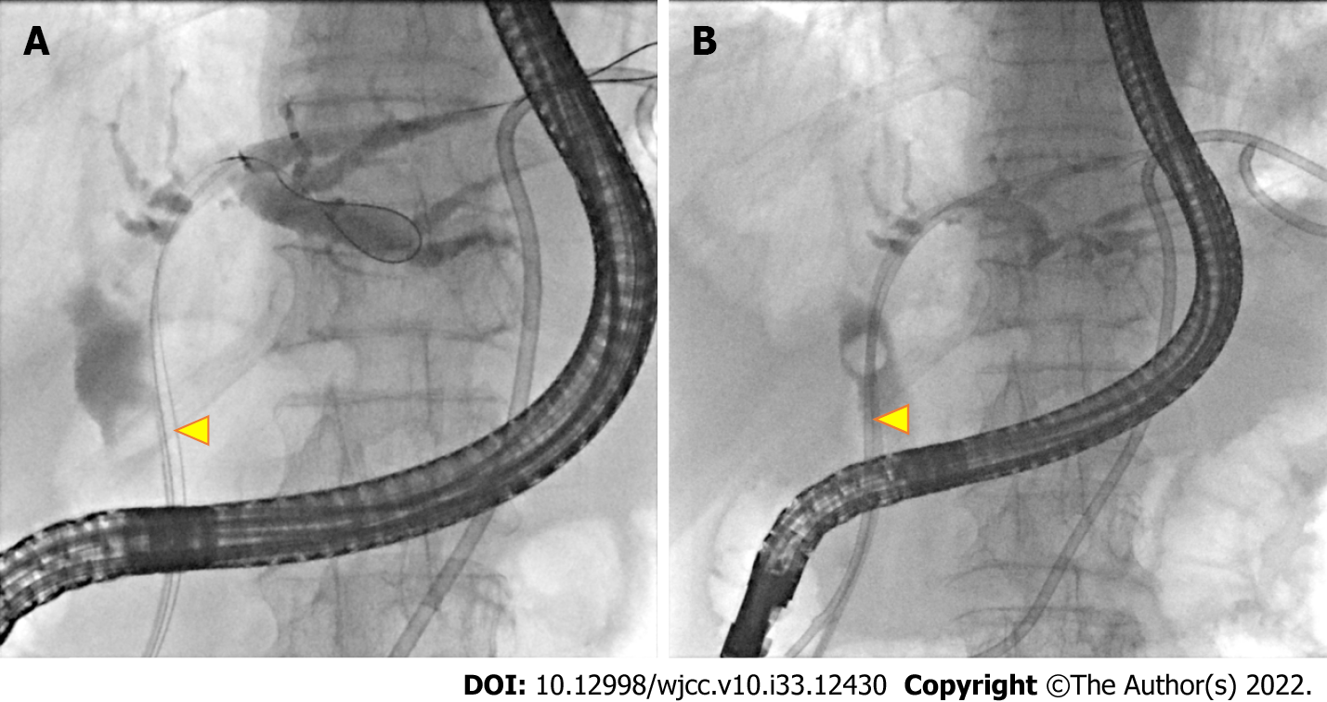
Figure 3 Endoscopic retrograde cholangiopancreatography. A: Dilated common bile duct (CBD) with one filling defect about 10 mm in size (yellow arrow); B: Endoscopic retrograde biliary drainage (yellow arrow) was performed for CBD stone-induced cholangitis.
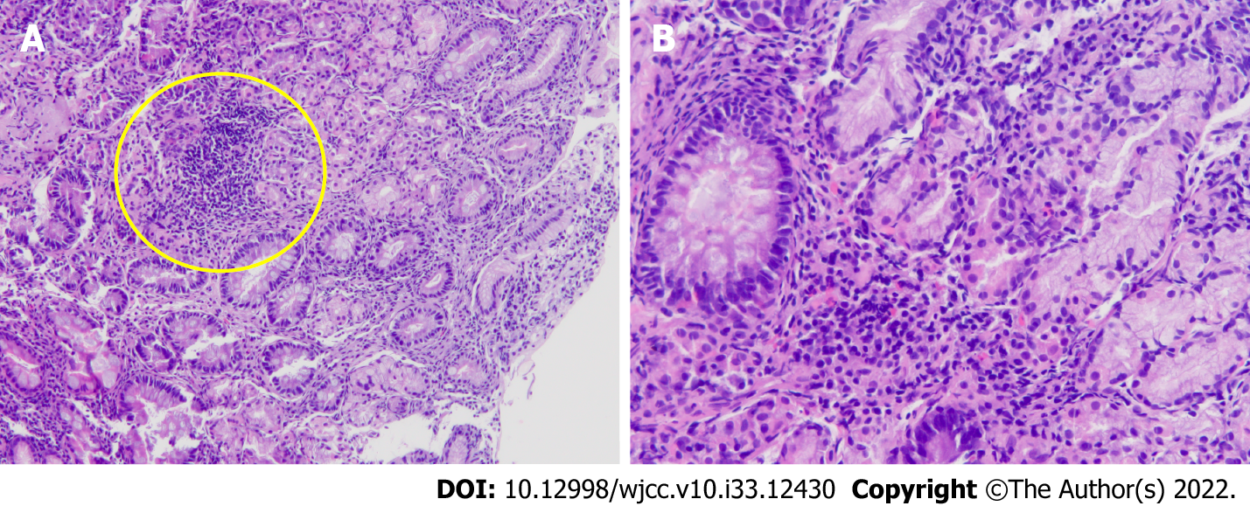
Figure 4 Hemoxylin and eosin staining of gastric mucosal biopsy. A: At × 10 magnification, gastric submucosal and mucosal infiltration was observed (yellow circle); B: At × 20 magnification, clusters of lymphocytes, neutrophils, and plasma cells infiltrated into the submucosa.

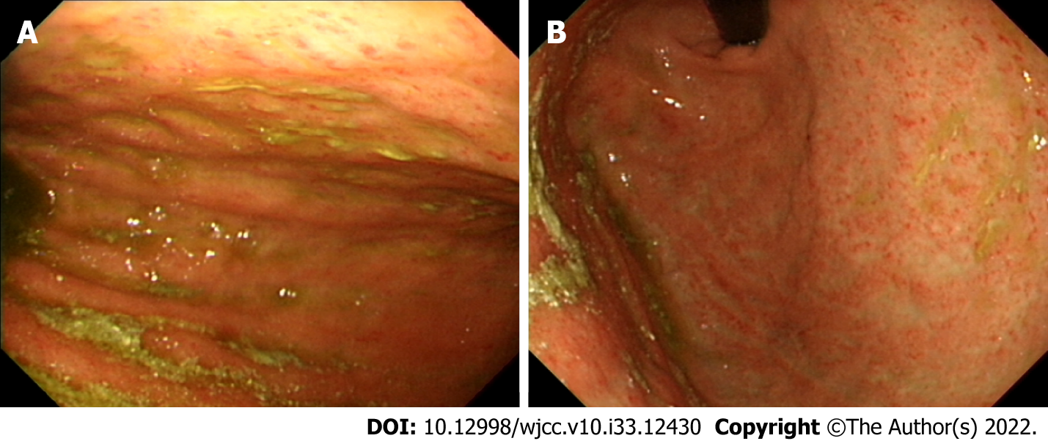
Figure 5 Follow-up esophagogastroduodenoscopy. A normal gastric mucosa with improved distensibility of the stomach was observed in the body of the stomach and the fundus of the stomach. A: The body of the stomach; B: The fundus of the stomach.

Table 1 Reported cases of phlegmonous gastritis between 2012 and 2022
Ref. | Year of publication | Age in yr | Sex | Risk factors | Type | Symptom | Diagnosis | Microorganism | Treatment | Result
Saito et al^{[5]} | 2012 | 55 | F | ALL | Diffuse | Septic shock | CT + EGD | Bacillus species | ATB | Discharge
Itonaga et al^{[6]} | 2012 | 70 | F | EUS-FNA | Diffuse | EP | CT + EGD | Streptococcus spp. | ATB | Discharge
Fan et al^{[7]} | 2013 | 65 | M | Splenectomy + esophagectomy | Diffuse | EP, fever | CT + EGD | Staphylococcus aureus | ATB | Discharge
Liu et al^{[8]} | 2013 | 84 | M | Nil | Diffuse | EP | CT + EGD | Nil | Gastrectomy | Discharge
Yu et al^{[9]} | 2013 | 52 | M | Liver cirrhosis, HBV, hepatectomy | Diffuse | EP, palpitation, dyspnea | EL + intraoperative EGD | Klebsiella pneumoniae | ATB | Discharge
Nair et al^{[10]} | 2013 | 72 | M | Nil | Diffuse | EP, fever, N/V | CT + EGD | Nil | ATB | Discharge
Alonso et al^{[11]} | 2013 | 55 | M | Nil | Localized | EP, fever, N/V, diarrhea | CT | Streptococcus pyogenes | ATB, endoscopic drainage | Discharge
Sahnan et al^{[12]} | 2013 | 56 | F | GAVE s/p APC | Diffuse | EP, palpitation | EL | Streptococcus | Total gastrectomy | Death
Cortes-Barenque et al^{[13]} | 2014 | 35 | M | Nil | Diffuse | EP, melena, hematemesis | CT + EGD | Group A streptococcus | ATB | Discharge
Rada-Palomino et al^{[14]} | 2014 | 62 | M | HIV | Diffuse | EP, N/V, hematemesis, diarrhea | CT + EGD | Streptococcus pyogenes | ATB | Discharge
Min et al^{[15]} | 2014 | 51 | F | Nil | Diffuse | EP, vomiting, palpitation | CT + EL | Streptococcus pyogenes | Total gastrectomy + ATB | Discharge
Morimoto et al^{[16]} | 2014 | 77 | M | DM, GU | Diffuse | N/V, palpitation | CT | Group A streptococcus | ATB | Death
Nomura et al^{[17]} | 2015 | 80 | F | SMA syndrome | Diffuse | EP, N/V | CT + EGD | Enterococcus faecium | Total gastrectomy + ATB | Discharge
Flor-de-Lima et al^{[18]} | 2015 | 7 | M | Acute tonsillitis | Diffuse | EP, N/V | CT + EGD | Streptococcus pneumoniae | ATB | Discharge
Kato et al^{[19]} | 2015 | 64 | M | Chronic pancreatitis, DM, subtotal gastrectomy | Diffuse | EP, N/V | CT + EGD | Peptostreptococcus spp. | ATB | Discharge
Matsumoto et al^{[20]} | 2015 | 74 | M | MF, MM | Diffuse | EP, N/V | CT + EGD | Bacillus thuringiensis | ATB | Death
Kim et al^{[21]} | 2016 | 74 | M | DM, alcoholic liver cirrhosis, HCC, GC | Diffuse | EP, N/V, palpitation | CT + EGD | Nil | ATB | Discharge
Kim et al^{[22]} | 2017 | 51 | M | AS s/p infliximab | Diffuse | N/V | CT + EGD | Nil | ATB | Discharge
Hagiwara et al^{[23]} | 2018 | 65 | M | ESCC | Localized | EP, fever | CT + EGD | Streptococcus viridans | ATB + total gastrectomy | Discharge
Ishioka et al^{[24]} | 2018 | 84 | F | Dementia | Diffuse | Hematemesis | CT + EGD | Proteus mirabilis, α-Streptococcus | ATB | Discharge
Ishioka et al^{[24]} | 2018 | 44 | M | DM | Diffuse | EP | CT + EGD | Staphylococci | ATB | Discharge
Ishioka et al^{[24]} | 2018 | 64 | M | Brain tumor s/p chemotherapy | Diffuse | N/V, hematemesis | CT + EGD | Nil | ATB | Death
De Davide and Beaudoin^{[25]} | 2018 | 42 | M | PA s/p infliximab | Diffuse | EP, N/V, fever | CT + EGD | Nil | ATB | Discharge
Yang et al^{[4]} | 2018 | 47 | M | URI, alcoholism, GU | Diffuse | EP, N/V, fever | CT + EL | Group A streptococcus | Total gastrectomy + ATB | Discharge
Ramphal et al^{[26]} | 2018 | 45 | M | Nil | Diffuse | EP, N/V, palpitation | CT + EL | Group A Streptococcus | Total gastrectomy + ATB | Discharge
Iqbal et al^{[1]} | 2018 | 56 | F | AML | Diffuse | EP, fever | CT + EGD | Citrobacter freundii, Enterococcus faecalis, Bacillus cereus | ATB | Discharge
Matsuura et al^{[27]} | 2018 | 76 | F | MDS, DM, GC s/p ESD | Diffuse | EP, fever | CT + EGD | Klebsiella pneumoniae, Pseudomonas aeruginosa | ATB | Discharge
Saeed et al^{[28]} | 2019 | 59 | M | Morbid obesity s/p laparoscopic sleeve gastrectomy | Localized | EP, N/V, fatigue, chills | CT | Streptococcus sanguinis | ATB + CT-guided drainage | Discharge
Shi et al^{[29]} | 2019 | 33 | M | ALL s/p chemotherapy | Diffuse | EP, hematemesis | CT | Stenotrophomonas maltophilia | ATB | Discharge
Yasuda et al^{[30]} | 2020 | 74 | F | Had eaten raw Ayu fish | Localized | EP, N/V, diarrhea | CT + EGD | Aeromonas hydrophila | ATB | Discharge
Campos-Murguía et al^{[31]} | 2019 | 37 | F | MG, thymoma s/p resection | Diffuse | EP, N/V, melena | CT + EGD | Streptococcus oralis | ATB + total gastrectomy | Discharge
Kuriyama et al^{[32]} | 2020 | 70 | F | Gastric DLBCL s/p chemotherapy | Diffuse | EP, N/V, fever | CT + EGD | Pseudomonas  aeruginosa | ATB | Discharge
Yakami et al^{[33]} | 2021 | 32 | M | Alcoholism | Diffuse | EP, N/V, fever | CT + EGD | Nil | ATB | Discharge
Yakami et al^{[33]} | 2021 | 33 | M | Alcoholism | Localized | EP | CT + EGD | Streptococcus viridans | ATB | Discharge
Yakami et al^{[33]} | 2021 | 19 | M | Nil | Localized | EP, N/V, fever | CT + EGD | Pseudomonas aeruginosa, Streptococcus viridans | ATB | Discharge
Taniguchi et al^{[34]} | 2021 | 21 | M | URI | Diffuse | EP | CT + EGD | Streptococcus constellatus/milleri | ATB | Discharge
DeCino et al^{[35]} | 2021 | 47 | M | DM | Diffuse | EP, N/V, fever | CT + EGD + EUS | Group A streptococcus | ATB | Discharge
Elisabeth et al^{[36]} | 2021 | 70 | F | Nil | Diffuse | EP, N/V, fever, diarrhea | CT + EGD + EL | Streptococcus pyogenes | ATB | Discharge
Modares and Tabari^{[37]} | 2021 | 67 | M | DM, s/p gastric mucosal biopsy | Diffuse | EP, N/V, fever | CT + EGD + EL | Group A Streptococci | ATB + total gastrectomy | Discharge
Takase et al^{[38]} | 2021 | 89 | F | DM, CKD | Diffuse | EP, N/V | CT | Nil | ATB | Discharge
Saito et al^{[39]} | 2021 | 70 | F | ALL s/p chemotherapy | Diffuse | Septic shock | CT + EGD | Bacillus cereus | ATB | Discharge
Wang et al^{[40]} | 2021 | 22 | M | Eating contaminated food | Diffuse | EP, N/V, fever, hematemesis | CT + EGD | Enterococcus cecorum | ATB | Discharge
Durdella et al^{[41]} | 2022 | 44 | F | Nil | Localized | EP, N/V | CT | Nil | ATB | Discharge
Yu et al^{[42]} | 2022 | 72 | F | Gastric adenoma s/p ESD | Localized | No | CT | Nil | Distal gastrectomy | Discharge
ATB: Antibiotic; ALL: Acute lymphoblastic leukemia; AML: Acute myeloid leukemia; APC: Argon plasma coagulation; AS: Ankylosing spondylitis; CKD: Chronic kidney disease; CT: Computed tomography; DLBCL: Diffuse large B cell lymphoma; DM: Diabetes mellitus; EGD: Esophagogastroduodenoscopy; EL: Exploratory laparotomy; EP: Epigastric pain; ESCC: Esophageal squamous cell carcinoma; ESD: Endoscopic submucosal dissection; EUS: Endoscopic ultrasound; EUS-FNA: Endoscopic ultrasound fine-needle aspiration; F: Female; GAVE: Gastric antral vascular ectasia; GC: Gastric cancer; GU: Gastric ulcer; HBV: Hepatitis B virus; HCC: Hepatocellular carcinoma; HIV: Human immunodeficiency virus; M: Male; MDS: Myelodysplastic syndrome; MF: Myelofibrosis; MG: Myasthenia gravis; MM: Multiple myeloma; N/V: Nausea/vomiting; PA: Psoriatic arthritis; SMA: Superior mesenteric artery; s/p: Status post; URI: Upper respiratory infection.

Published by Baishideng Publishing Group Inc
7041 Koll Center Parkway, Suite 160, Pleasanton, CA 94566, USA
Telephone: +1-925-3991568
E-mail: bpgoffice@wjgnet.com
Help Desk: https://www.f6publishing.com/helpdesk
https://www.wjgnet.com

© 2022 Baishideng Publishing Group Inc. All rights reserved.

