Name of Journal: World Journal of Clinical Cases
Manuscript NO: 76422
Manuscript Type: CASE REPORT

Macular hole following phakic intraocular lens implantation: a case report

Li XJ et al. Macular hole: A case report

Xue-Jing Li, Jia-Liang Duan, Jing-Xue Ma, Qing-Li Shang

Xue-Jing Li, Jia-Liang Duan, Jing-Xue Ma, Qing-Li Shang, Department of Ophthalmology, The Second Hospital of Hebei Medical University, Shijiazhuang 050000, Hebei Province, China

Author contributions: Li XJ and Duan JL reviewed the literature and wrote the manuscript draft; Ma JX and Shang QL performed the microbiological analyses and interpretation and contributed to manuscript drafting; Li XJ analyzed and interpreted the imaging findings; Duan JL and Ma JX performed the infectious diseases consultation, reviewed the literature and drafted the manuscript; all authors were responsible for the revision of the manuscript for important intellectual content, and approved the final version for submission.

Corresponding author: Qing-li Shang, MD, Associate Specialist, Department of Ophthalmology, The Second Hospital of Hebei Medical University, No. 215 Heping West Road, Xinhua district, Shijiazhuang 050000, Hebei Province, China. zhangp_w@163.com

Received: March 16, 2022
Revised: April 27, 2022
Accepted: May 27, 2022
Published online: July 16, 2022

Abstract
BACKGROUND
Phakic intraocular lens (pIOL) implantation has been commonly prescribed and is considered as a safe and effective option for correcting high myopia. However, it is associated with multiple complications.

CASE SUMMARY
This report describes a case of full-thickness macular hole (MH) in a patient with a history of bilateral pIOL implantation for the correction of myopia of –12.00 diopters in both eyes 7 mo ago. The MH closed after pars plana vitrectomy with internal limiting membrane removal and the best-corrected visual acuity improved to 20/40 in the left eye.

CONCLUSION
In rare cases, MH can occur following pIOL. In this present case report, we analyzed the formation process of MH following the surgery and emphasized that it is important to inform highly myopic patients about the risk of MH occurrence while being aware of the symptoms of this complication.

Key Words: Case report; Macular hole; Phakic intraocular lens; Pars plana vitrectomy; High myopia; Impaired visual acuity

©The Author(s) 2022. Published by Baishideng Publishing Group Inc. All rights reserved.

Citation: Li XJ, Duan JL, Ma JX, Shang QL. Macular hole following phakic intraocular lens implantation: a case report. World J Clin Cases 2022; 10(20): 7178-7183
URL: https://www.wjgnet.com/2307-8960/full/v10/i20/7178.htm
DOI: https://dx.doi.org/10.12998/wjcc.v10.i20.7178

Core Tip: Although phakic intraocular lenses have been commonly prescribed and are safe and effective, they are still associated with multiple complications. One of the rare complications is a full-thickness macular hole occurring after phakic intraocular lens implantation. Therefore, it is important to inform highly myopic patients about the risk of MH occurrence and be attentive to the symptoms of this complication.
INTRODUCTION
Phakic intraocular lens (pIOL) implantation has been commonly prescribed since the 1980s. It is accepted as a safe and effective option for correcting high myopia in patient’s ineligible for corneal refractive surgery^{[1]}. However, complications associated with pIOL include the reduced density of central endothelial cells, development of pigmentary dispersion, cataracts and glaucoma^{[1]}. In addition, a few cases of vitreoretinal complications such as giant retinal tears and retinal detachment have been reported^{[2]}. We present a rare occurrence of macular hole (MH) as a complication of pIOL implantation for the treatment of high myopia.

CASE PRESENTATION
Chief complaints
A 29-year-old female presented with a 10-day history of impaired visual acuity (VA) and distorted vision in the left eye.

History of present illness
The patient had undergone pIOL implantation in the posterior chamber for the correction of myopia of -12.00 diopters in both eyes 7 mo prior to the onset of symptoms described above. PIOL implantation improved the vision of the patient whose VA was 20/20 in both eyes after the treatment.

History of past illness
The patient had no history of systemic illness or obvious changes in the retina or vitreous before the pIOL implantation.

Physical examination
The initial examination showed that the best corrected visual acuity (BCVA) of this patient was 20/20 in the right eye and 20/100 in the left eye with normal intraocular pressure. The axial length was 27.18 mm in the right eye and 27.00 mm in the left eye. The slit-lamp examination showed that the pIOL was present in both eyes with an unremarkable anterior segment in the rest of the area. The funduscopic examination revealed a round-shaped MH in the left eye (Figure 1A) and the appearance of a tessellated fundus with a tilted disc in bilateral eyes.

Imaging examinations
An optical coherence tomography (OCT) revealed a full-thickness MH in the left eye with surrounding subretinal fluid and perifoveal cystic changes at the rim of the hole (Figure 1d), which had a diameter of 520 mm horizontally and 482 mm vertically. In addition, vitreoretinal traction that was induced by partial posterior vitreous detachment (PVD) was documented at the fovea as well as in the area close to the superior vascular arcade, with an increased retinal thickness and retinal layer splitting (Figure 1c). It should be noted that these findings were not present in the preoperative OCT examination of both eyes (Figure 2). The fundus autofluorescence image of the left eye revealed hyper-autofluorescence surrounding the MH (Figure 1b).

FINAL DIAGNOSIS
Full-thickness MH following bilateral pIOL implantation.

TREATMENT
The patient underwent 23-gauge three-port pars plana vitrectomy with triamcinolone-assisted PVD induction. Subsequently, the internal limiting membrane was removed by staining with 0.5% indocyanine green followed by gas tamponade (12% C3F8).

OUTCOME AND FOLLOW-UP
The MH closed at 2 wk after the operation (Figure 1e) and the BCVA had improved to 20/40.

DISCUSSION
Most MHs are idiopathic and frequently occur in the elderly and women. However, they may also be correlated to high myopia, trauma, and surgeries, including vitrectomy, pneumatic retinopexy, scleral buckling, laser-assisted in situ keratomileusis and cataract surgery^{[3,4]}. In rare cases, MH can occur following pIOL^{[5,6]}.
To our knowledge, three cases have been described in two previous reports^{[5,6]}. In one of these cases, the MH had a similar morphology as the traumatic MH with a rhomboid-shaped appearance. In addition, defects in the internal limiting membrane were present and a lack of subretinal fluid and cystic formation was observed. The remaining two cases had similar features as an idiopathic MH with a round-shaped appearance and edema in the perifoveal retina surrounded by subretinal fluid. The present case had characteristics similar to the latter MHs.
Previous case reports have proposed that a MH might have already existed and was misdiagnosed before pIOL implantation; otherwise, it might be a part of the natural course of high myopic change or induced by the surgery^{[7]}. In the present case, preoperative OCT examination revealed normal morphology at the fovea in both eyes, without PVD, posterior staphyloma or foveoschisis, which differs from myopic MH. Therefore, it is likely that the PVD formation was related to the surgery and subsequently led to the occurrence of MH^{[8,9]}.
As suggested by Gass, during the PVD process, MH formation is initiated by the tangential traction of the premacular vitreous cortex at the retinal interface which then leads to foveal dehiscence that progresses from foveolar detachment to a mature full-thickness MH^{[10]}. Highly myopic patients tend to show PVD at a younger age and the surgery might accelerate the process. Luna et al^{[11]} have demonstrated that PVD with vitreous liquefaction was not present prior to LASIK but was documented afterwards in 24%−50% of highly myopic eyes. In recent years, in-depth research on posterior precortical vitreous pocket (PPVP) has proved that the aqueous can flow into the PPVP through the Cloquet's canal^{[10]}, therefore, we speculated that the flow of aqueous humor caused by fluctuation of intraocular pressure during the surgery was drained into the premacular space which initiated the process of PVD.
Early in the PVD process, the vitreous detaches from the perifoveal area but maintains attachment at the central fovea, the optic disc and the vascular arcade area where vitreoretinal attachments are stronger. Over time, assisted by vitreous movement, anteroposterior tractional forces at the fovea were generated leading to pathogenic vitreous traction. Mori et al^{[12]} presented the hypothesis that dynamic traction attributable to vitreous movement associated with ocular saccades is the most important type of vitreomacular traction in MH formation. A larger PPVP in highly myopic eyes is associated with a greater level of concentrated force and a more pronounced shift in the force vector direction of the anteroposterior tensile stress^{[10]}. The traction force varies depending on the configuration and angle of vitreous insertion into the peripheral retina^{[12]}. Therefore, as the OCT revealed, the vitreofoveal attachment was released in the right eye (Figure 3) which led to a slight abnormality of retinal morphology. In contrast, the MH was formed in the left eye.
Furthermore, focal cellular proliferation of the vitreous face and weak adherence of the retinal pigment epithelium-photoreceptor should not be neglected. In addition, the effect of various refractive surgeries on choroidal thickness (CT) has been reported in recent years. Fang et al^{[13]} evaluated the changes in choroid thickness after pIOL surgery and found that the CT in the foveal was significantly increased at 3 mo after the surgery and then gradually recovered. In all three cases, which had similar features as the present case, the MH formed at 4, 7, and 18 mo after the surgery. Zeng et al^{[14]} considered that choroidal thinning might be one of the reasons for the development of MH. Therefore, the fluctuation of CT might play a role in the formation of MHs; however, the precise relationship needs to be elucidated by more clinical studies.

CONCLUSION
It remains difficult to determine the risk factors for MH formation after refractive surgery. Thus, further case-control studies are needed to address this question. Although the incidence rate of MH occurrence is low, the present case report emphasizes that it is important to inform patients about the risk of MH occurrence and be aware of the symptoms of this complication. The patients can then receive assistance promptly and efficiently after the onset of MH formation.

REFERENCES
1 Jiménez-Alfaro I, Benítez del Castillo JM, García-Feijoó J, Gil de Bernabé JG, Serrano de La Iglesia JM. Safety of posterior chamber phakic intraocular lenses for the correction of high myopia: anterior segment changes after posterior chamber phakic intraocular lens implantation. Ophthalmology 2001; 108: 90-99 [PMID: 11150270 DOI: 10.1016/s0161-6420(00)00403-6]
2 Jiang T, Chang Q, Wang X, Huang X. Retinal detachment after phakic intraocular lens implantation in severe myopic eyes. Graefes Arch Clin Exp Ophthalmol 2012; 250: 1725-1730 [PMID: 22476574 DOI: 10.1007/s00417-012-2002-z]
3 Arevalo JF, Mendoza AJ, Velez-Vazquez W, Rodriguez FJ, Rodriguez A, Rosales-Meneses JL, Yepez JB, Ramirez E, Dessouki A, Chan CK, Mittra RA, Ramsay RC, Garcia RA, Ruiz-Moreno JM. Full-thickness macular hole after LASIK for the correction of myopia. Ophthalmology 2005; 112: 1207-1212 [PMID: 15921746 DOI: 10.1016/j.ophtha.2005.01.046]
4 Papathanassiou M, Alonistiotis D, Petrou P, Theodossiadis P, Vergados I. Macular hole formation following phacoemulsification cataract surgery. Clin Exp Optom 2011; 94: 112-114 [PMID: 21198840 DOI: 10.1111/j.1444-0938.2010.00525.x]
5 Jun JH, Kim YC, Kim KS. Macular hole after phakic intraocular lens implantation: two cases with divergent manifestations. Semin Ophthalmol 2014; 29: 213-217 [PMID: 24171834 DOI: 10.3109/08820538.2013.835839]
6 Kumar A, Padhy SK, Dhiman R, Kumar P, Parekh T, Varshney T. Macular hole following phakic intraocular lens implantation and its management. Indian J Ophthalmol 2019; 67: 1758-1760 [PMID: 31546556 DOI: 10.4103/ijo.IJO_126_19]
7 Hayashi K, Manabe SI, Hirata A, Yoshimura K. Posterior Vitreous Detachment in Highly Myopic Patients. Invest Ophthalmol Vis Sci 2020; 61: 33 [PMID: 32334432 DOI: 10.1167/iovs.61.4.33]
8 Kishi S, Shimizu K. Posterior precortical vitreous pocket. Arch Ophthalmol 1990; 108: 979-982 [PMID: 2369358 DOI: 10.1001/archopht.1990.01070090081044]
9 Itakura H, Kishi S, Li D, Akiyama H. Observation of posterior precortical vitreous pocket using swept-source optical coherence tomography. Invest Ophthalmol Vis Sci 2013; 54: 3102-3107 [PMID: 23599325 DOI: 10.1167/iovs.13-11769]
10 Gass JD. Idiopathic senile macular hole. Its early stages and pathogenesis. Arch Ophthalmol 1988; 106: 629-639 [PMID: 3358729 DOI: 10.1001/archopht.1988.01060130683026]
11 Luna JD, Artal MN, Reviglio VE, Pelizzari M, Diaz H, Juarez CP. Vitreoretinal alterations following laser in situ keratomileusis: clinical and experimental studies. Graefes Arch Clin Exp Ophthalmol 2001; 239: 416-423 [PMID: 11561789 DOI: 10.1007/s004170100295]
12 Mori K, Gehlbach PL, Kishi S. Posterior vitreous mobility delineated by tracking of optical coherence tomography images in eyes with idiopathic macular holes. Am J Ophthalmol 2015; 159: 1132-1141.e1 [PMID: 25743339 DOI: 10.1016/j.ajo.2015.02.016]
13 Fang D, Li Q, Yan K, Xu S, Jiang J, Che X, Zhang Y, Qian Y, Wang Z. Retinal and Choroidal Thickness in relation to C-Reactive Protein on Swept-Source Optical Coherence Tomography. J Immunol Res 2021; 2021: 6628224 [PMID: 33564690 DOI: 10.1155/2021/6628224]
14 Zeng J, Li J, Liu R, Chen X, Pan J, Tang S, Ding X. Choroidal thickness in both eyes of patients with unilateral idiopathic macular hole. Ophthalmology 2012; 119: 2328-2333 [PMID: 22892154 DOI: 10.1016/j.ophtha.2012.06.008]

Footnotes
Informed consent statement: Informed written consent was obtained from the patient for publication of this report and any accompanying images.

Conflict-of-interest statement: The authors declare that they have no conflict of interest.

CARE Checklist (2016) statement: The authors have read the CARE Checklist (2016), and the manuscript was prepared and revised according to the CARE Checklist (2016).

Open-Access: This article is an open-access article that was selected by an in-house editor and fully peer-reviewed by external reviewers. It is distributed in accordance with the Creative Commons Attribution NonCommercial (CC BY-NC 4.0) license, which permits others to distribute, remix, adapt, build upon this work non-commercially, and license their derivative works on different terms, provided the original work is properly cited and the use is non-commercial. See: https://creativecommons.org/Licenses/by-nc/4.0/

Provenance and peer review: Unsolicited article; Externally peer reviewed.
Peer-review model: Single blind

Peer-review started: March 16, 2022
First decision: April 8, 2022
Article in press: May 27, 2022

Specialty type: Ophthalmology
Country/Territory of origin: China
Peer-review report’s scientific quality classification
Grade A (Excellent): 0
Grade B (Very good): B, B
Grade C (Good): 0
Grade D (Fair): 0
Grade E (Poor): 0

P-Reviewer: Gálvez Salazar P, Ecuador; Sheikh Hassan M, Somalia A-Editor: Zhu JQ, China S-Editor: Ma YJ L-Editor: Filipodia P-Editor: Ma YJ

Figure Legends
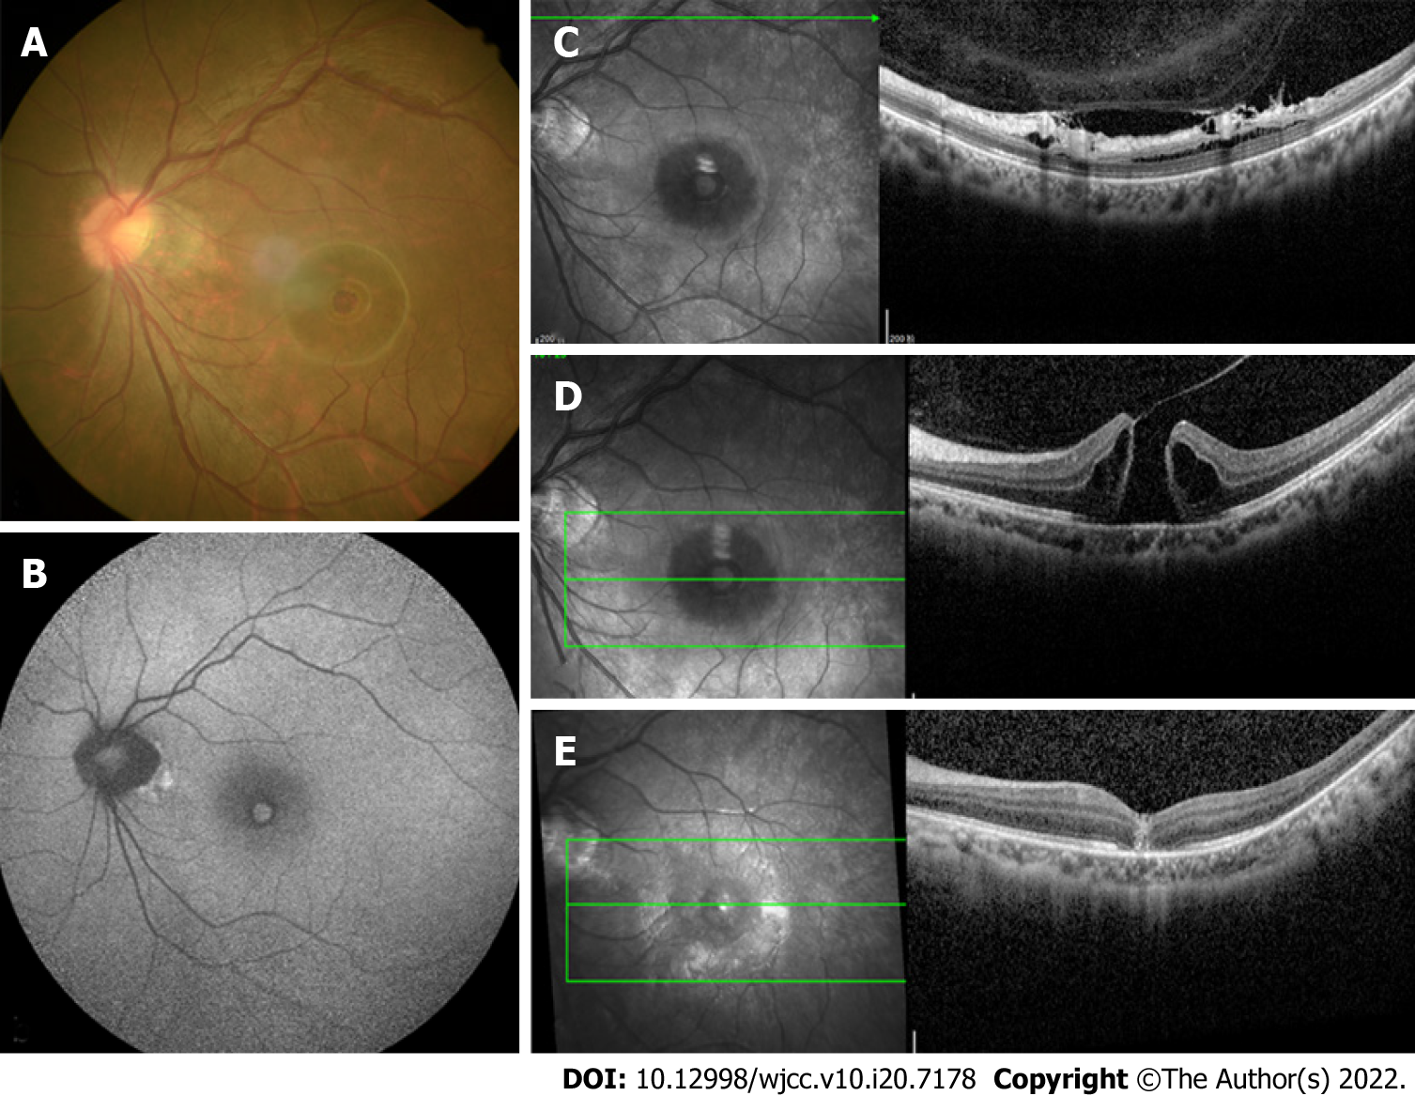
Figure 1 Examination of the left eye. a: Color photograph revealed a round-shaped macular hole (MH), appearance of temporal crescent and tessellated fundus with a tilted disc; b: Fundus autofluorescence image showing hyper-autofluorescence corresponding to the MH and a circumferential hypo-autofluorescence; c: optical coherence tomography (OCT) pre-operatively revealed vitreoretinal traction that was induced by partial posterior vitreous detachment in the area close to the superior vascular arcade; d: OCT pre-operatively revealed a complete thickness MH bordered by cystic spaces; e: Post-operatively at 2 wk showing anatomical closure of the MH.

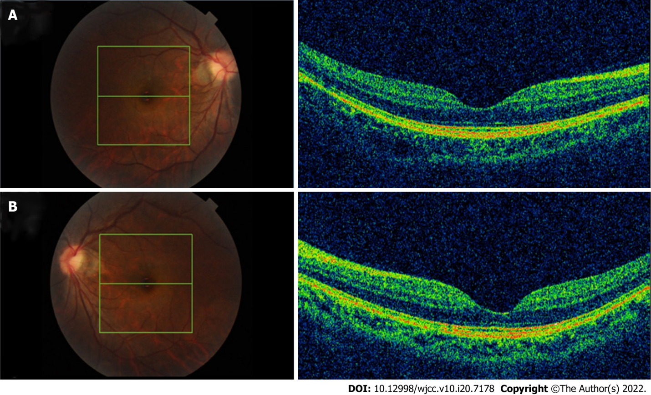
Figure 2 Optical coherence tomography examination of both eyes before phakic intraocular lens surgery revealed a normal macula, without posterior vitreous detachment, posterior staphyloma, or foveoschisis. a: Right eye; b: Left eye.

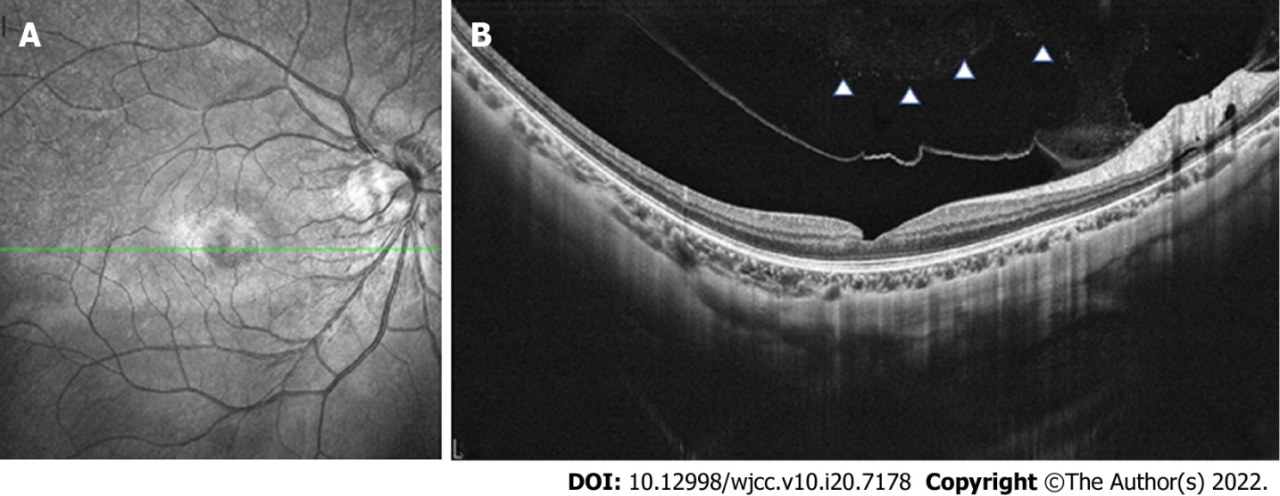
Figure 3 optical coherence tomography examination of the right eye. a: partial posterior vitreous detachment 7 mo after phakic intraocular lens (pIOL) surgery; b: complete posterior vitreous detachment 1 yr after pIOL surgery with a slight abnormality in retinal morphology.

Published by Baishideng Publishing Group Inc
7041 Koll Center Parkway, Suite 160, Pleasanton, CA 94566, USA
Telephone: +1-925-3991568
E-mail: bpgoffice@wjgnet.com
Help Desk: https://www.f6publishing.com/helpdesk
https://www.wjgnet.com

© 2022 Baishideng Publishing Group Inc. All rights reserved.

