Name of Journal: World Journal of Clinical Cases
Manuscript NO: 77639
Manuscript Type: CASE REPORT

Tension-reduced closure of large abdominal wall defect caused by shotgun wound: A case report

Li Y et al. TRC of LAWD

Yan Li, Jia-Hua Xing, Zheng Yang, Yu-Jian Xu, Xiang-Ye Yin, Yuan Chi, Yi-Chi Xu, Yu-Di Han, You-Bai Chen, Yan Han

Yan Li, Jia-Hua Xing, Zheng Yang, Yu-Jian Xu, Xiang-Ye Yin, Yuan Chi, Yi-Chi Xu, Yu-Di Han, You-Bai Chen, Yan Han, Department of Plastic and Reconstructive Surgery, The First Medical Centre, Chinese People’s Liberation Army General Hospital, Beijing 100853, China

Yan Li, Zheng Yang, Medical School of Chinese People’s Liberation Army, Chinese People’s Liberation Army General Hospital, Beijing 100853, China

Jia-Hua Xing, Yuan Chi, School of Medicine, Nankai University, Tianjin 300071, China

Author contributions: Li Y and Xing JH contributed equally to this work and as co-first author; Han Y and Chen YB as co-corresponding author of this study; Li Y, Xing JH, and Yang Z wrote the main manuscript text and prepared all the figures; Xu YC, Chen YB, Han YD, and Han Y suggested ideas and steps for the article; Xu YJ, Yin XY, and Chi Y participated in the revision of part of the article; and all authors read and approved the final manuscript.

Corresponding author: Yan Han, MD, Professor, Department of Plastic and Reconstructive Surgery, The First Medical Centre, Chinese People’s Liberation Army General Hospital, No. 28 Fuxing Street, Beijing 100853, China. 13720086335@163.com

Received: May 10, 2022
Revised: July 19, 2022
Accepted: September 8, 2022
Published online: October 16, 2022

Abstract
BACKGROUND
Large abdominal wall defect (LAWD) caused by shotgun wound is rarely reported.

CASE SUMMARY
Herein, we describe a case of LAWD caused by a gunshot wound in which the abdominal wall was reconstructed in stages, including debridement, tension-reduced closure (TRC), and reconstruction with mesh and a free musculocutaneous flap. During a 3-year follow-up, the patient recovered well without hernia or other problems.

CONCLUSION
TRC is a practical approach for the temporary closure of LAWD, particularly in cases when one-stage abdominal wall restoration is unfeasible due to significant comorbidities.

Key Words: Free flap; Shotgun; Hernia; Large abdominal wall defect; Tension relief closure; Mesh; Case report

©The Author(s) 2022. Published by Baishideng Publishing Group Inc. All rights reserved.

Citation: Li Y, Xing JH, Yang Z, Xu YJ, Yin XY, Chi Y, Xu YC, Han YD, Chen YB, Han Y. Tension-reduced closure of large abdominal wall defect caused by shotgun wound: A case report. World J Clin Cases 2022; 10(29): 10713-10720
URL: https://www.wjgnet.com/2307-8960/full/v10/i29/10713.htm
DOI: https://dx.doi.org/10.12998/wjcc.v10.i29.10713

Core Tip: The large full-thickness abdominal defect caused by gunshot wound is often associated with infection, multiorgan injuries, and poor patient conditions. Tension-reduced closure is a useful method for the temporary closure of large abdominal wall defect, particularly in cases in which one-stage abdominal wall reconstruction is unfeasible.

INTRODUCTION
Large abdominal wall defect (LAWD) is commonly caused by tumor resection, followed by infection, trauma, and radiation-induced injury^{[1]}. LAWD caused by gunshot wound has been rarely reported in the previous literature^{[2]}. Gunshot wounds often lead to full-thickness defects, infection, multiorgan injuries, and poor patient conditions making reconstruction of LAWD extremely challenging^{[3]}. Conventional one-stage reconstruction with mesh reinforcement plus free flap may be unfeasible and staged reconstruction is required^{[4]}.
Tension-reduced closure (TRC) is a novel technique for the closure of large wounds by reducing the tension across the wound edges based on the theories of stress relaxation and mechanical creep for skin stretching^{[5]}. Previous studies have shown that TRC is a simple, effective, and safe method for wound closure for a variety of reasons. However, no study to date has reported the use of TRC for LAWD caused by a gunshot wound. Here, we report a case of gunshot LAWD, who underwent staged abdominal wall reconstruction including debridement, temporary TRC, and definitive reconstruction with prosthetic mesh plus a free flap.

CASE PRESENTATION
Chief complaints
Abdominal wall hernia formation after abdominal gunshot wound.

History of present illness
A 44-year old man presented with a large abdominal bulge. He was robbed and shot in the abdomen in South Africa 1.5 years ago, resulting in open abdomen, hemorrhagic shock, infection, intestinal exposure, and severe multiorgan injures involving the transverse colon, greater omentum, spleen, diaphragm, and left kidney. Emergency surgeries including removal of bullets and foreign body, debridement, transverse colectomy, omentectomy, nephrectomy, and colostomy were performed at a local hospital in South Africa. The large full-thickness abdominal wall defect was initially covered by split-thickness skin mesh grafting on intestines harvested from the left thigh.

History of past illness
The patient had hepatitis and underwent left kidney removal after a gunshot wound on July 26, 2017.

Personal and family history
The patient denied a family history of infectious and genetic diseases.

Physical examination
The patient developed a large abdominal hernia and was referred to our hospital for abdominal reconstruction 1.5 years after the initial injury. A 26 cm × 28 cm full thickness abdominal defect covered with grafted skin mesh was found at the first consultation. The hernia was protruding when he was standing or lying on one side. Underlying peristalsis was observed. A colostomy stoma was located at 10 cm close to the skin grafts and connected with a colostomy bag.

Laboratory examinations
Laboratory examinations showed no significant abnormalities.

Imaging examinations
Ultrasound examination results were consistent with changes in the abdominal wall defect after trauma.

FINAL DIAGNOSIS
The final diagnosis were postoperative abdominal wall trauma, abdominal wall defect, and abdominal wall hernia.

TREATMENT
TRC
One-stage abdominal reconstruction was unfeasible due to the patient’s comorbidities and poor condition. The colostomy stoma may increase the risk of infection. Therefore, we carefully removed the grafted skin. The area of LAWD was 21 cm × 22 cm after the removal of the grafted skin. The operation duration was prolonged to 5.5 h due to the large area of severe adhesion between the grafted skin and viscera. Oliguria (urine volume < 90 mL) occurred during surgery owing to the mononephrous dysfunction, right renal pelvis stone, and ureteral obstruction diagnosed by ultrasonography. To reduce operation duration and surgical risks, a temporary TRC of the defect was performed using the Tension Relief System (TRS, Top Closure® 1S 8 mm sets, IVT Medical Limited, Israel). Briefly, seven pairs of attachment plates were placed 2 cm away from the wound edges and anchored with 3-0 silk sutures (Mersilk, Ethicon, United States) and staples (PROXIMATE, Ethicon, United States). Incremental approximation of wound edges was archived by pulling the bridging approximation straps through a lock/release ratchet mechanism (Figure 1). The patient developed hydronephrosis with a maximum blood creatinine level up to 511.3 μmol/L. He underwent hemofiltration dialysis and renal pelvis catheterization for 2 wk. The change in urine volume and creatinine is shown in Figure 2. The abdominal wound healed well without dehiscence or necrosis and TRS was removed 3 wk after installation.

Mesh reinforcement and anterolateral thigh flap reconstruction
Five months later, the patient underwent abdominal wall reconstruction with mesh reinforcement and a free anterolateral thigh (ALT) musculofascial flap to definitively repair his hernia (Figure 2). The original incision was reopened. Component separation was performed. The 15 cm × 20 cm peritoneal defect was repaired with a 20 cm × 20 cm hydrophilic mesh (Covidien, United States). The coverage ranged from the xiphoid and 2 cm inferior to the costal arch to 10 cm superior to the pubic symphysis vertically, and bilateral aponeurosis of external obliques horizontally. The mesh was secured with lock-stitch PDS II suturing. A 15 cm × 20 cm ATL musculofascial flap was elevated. The pedicle of descending branch of the lateral circumflex femoral artery was 14 cm. The microvascular anastomosis was performed on a branch of the superficial epigastric artery (Figure 2). The ALT flap was covered on the prosthetic mesh to repair the soft tissue defect (Figure 3).

OUTCOME AND FOLLOW-UP
The patient was followed for 3 years. He recovered well and reported significant improvement in quality of life without signs of hernial recurrence (Figure 4).

DISCUSSION
Shotgun wounds, a high-energy firearm injury, often result in trauma contamination, extensive tissue contusions, and open injuries that make treatment difficult^{[6-8]}. Current treatment principles regarding shotgun wounds include initial debridement followed by wound closure to prevent damage to deep tissue. However, closure of the wound should be delayed until 15 d in patients with more severe contamination^{[9]}. Further treatment is feasible after the patient’s vital signs have stabilized. The case that we report had a temporary local trauma closure due to multiple shotgun wounds throughout the body, resulting in a LAWD, multiple organ damage, and poor general condition. For the further resolution of the abdominal wall hernia, he came to our department for treatment.
Many techniques for reconstruction of LAWD have been reported, but this is to date the first case of staged reconstruction with temporary TRC and definitive reconstruction with mesh and a flap. Gu et al^{[10]} summarized the methods for abdominal wall reconstruction, including suture^{[11]}, prosthetic material^{[12]}, component separation technique^{[13]}, autologous tissue reconstruction^{[14]}, and abdominal wall expansion^{[15]}. However, none of these methods could be used during the first reconstructive surgery owing to the patient’s poor conditions. Therefore, we used a commercial TRS for temporary abdominal closure^{[16]}.
The TRS was a novel method for large wound closure. Topaz et al^{[5]} first introduced the use of TRS in 20 patients for preoperative skin stretching or intraoperative wound closure. Their study presented many cases who underwent TRS for larger defect closure after malignancy resection^{[17,18]}. Dan et al^{[19]} reported two cases of using TRS for wound closure of high-tension flap donor site following the harvest of deep inferior epigastric perforator flap and ALT flap. Choke et al^{[20]} described their successful experience of using TSR and vacuum-assisted closure techniques for the treatment of extensive soft tissue defects in four patients. Similarly, Li et al^{[21]} used a combined treatment with vacuum sealing drainage, TRS, and Ilizarov technique for traumatic hemipelvectomy in one case. The patient was able to ambulate and perform activities of daily life at the follow-up visit. Zhu et al^{[22]} reported a 61-year-old man with bladder exstrophy who received primary closure of a large abdominal defect using TRS. In addition, a simulation study using finite element modeling by Katzengold et al^{[23]} showed that the tensile stress generated by the TRS was only 4% of that generated by conventional sutures, suggesting that TRS significantly reduced local tissue deformations and stress concentrations during large wound closure. These studies have demonstrated that TRS reduced operative time, length of hospital stay, and costs, improved wound aesthetics, and minimized complications and obviated donor site morbidity caused by conventional skin grafting or flap reconstruction (Table 1).
There are several advantages of using TRS. First, TRS narrowed the width of the abdominal wall defect, thus reducing the flap area in the final abdominal reconstruction from 26 cm × 28 cm to 15 cm × 25 cm. Second, the operation time and associated risks were significantly reduced. The abdomen was successfully closed within 40 min using TRC, compared to hours of operation time for conventional reconstruction^{[24]}. At the last follow-up, the patient reported satisfaction with his treatment owing to significant improvement in quality of life without signs of hernial recurrence.

CONCLUSION
The large full-thickness abdominal defect caused by a gunshot wound is often associated with infection, multiorgan injuries, and poor patient conditions. TRC is a useful method for the temporary closure of LAWD, particularly in cases in which one-stage abdominal wall reconstruction is unfeasible.

REFERENCES
1 Muysoms F, Campanelli G, Champault GG, DeBeaux AC, Dietz UA, Jeekel J, Klinge U, Köckerling F, Mandala V, Montgomery A, Morales Conde S, Puppe F, Simmermacher RK, Śmietański M, Miserez M. EuraHS: the development of an international online platform for registration and outcome measurement of ventral abdominal wall hernia repair. Hernia 2012; 16: 239-250 [PMID: 22527930 DOI: 10.1007/s10029-012-0912-7]
2 Alhan D, Şahin İ, Güzey S, Aykan A, Zor F, Öztürk S, Nışancı M, Özerhan İH. Staged repair of severe open abdomens due to high-energy gunshot injuries with early vacuum pack and delayed tissue expansion and dual-sided meshes. Ulus Travma Acil Cerrahi Derg 2015; 21: 457-462 [PMID: 27054636 DOI: 10.5505/tjtes.2015.05942]
3 Bulic K, Dzepina I, Mijatovic D, Unusic J. Prosthetic mesh for infected abdominal wall defects? Report of a patient with a large full thickness abdominal wall defect and colostomy due to a gunshot wound. J Plast Reconstr Aesthet Surg 2008; 61: 455-458 [PMID: 17499567 DOI: 10.1016/j.bjps.2007.03.034]
4 Wechselberger G, Schoeller T, Rainer C, Papp C. Temporary closure of full-thickness abdominal-wall defects with mesh grafts. Langenbecks Arch Surg 1999; 384: 88-89 [PMID: 10367637 DOI: 10.1007/s004230050180]
5 Topaz M, Carmel NN, Silberman A, Li MS, Li YZ. The TopClosure® 3S System, for skin stretching and a secure wound closure. Eur J Plast Surg 2012; 35: 533-543 [PMID: 22719176 DOI: 10.1007/s00238-011-0671-1]
6 Ordog GJ, Wasserberger J, Balasubramaniam S. Shotgun wound ballistics. J Trauma 1988; 28: 624-631 [PMID: 3285016 DOI: 10.1097/00005373-198805000-00011]
7 Bender JS, Hoekstra SM, Levison MA. Improving outcome from extremity shotgun injury. Am Surg 1993; 59: 359-364 [PMID: 8507060 DOI: 10.1097/00005373-199012000-00008]
8 Asensi V, Perciaccante A, Lippi D, Charlier P, Appenzeller O, Bianucci R, Donell S. Tudor military surgery and the management of Sir Martin Frobisher's gunshot wound: Comparison with current treatment. Injury 2020; 51: 597-601 [PMID: 32044118 DOI: 10.1016/j.injury.2020.01.046]
9 Silva FE, Sorrentino BC. Selective conservative treatment for anterior abdominal gunshot: a literature narrative review. Rev Col Bras Cir 2020; 47: e20202523 [PMID: 32520133 DOI: 10.1590/0100-6991e-20202523]
10 Gu Y, Wang P, Li H, Tian W, Tang J. Chinese expert consensus on adult ventral abdominal wall defect repair and reconstruction. Am J Surg 2021; 222: 86-98 [PMID: 33239177 DOI: 10.1016/j.amjsurg.2020.11.024]
11 Kaufmann R, Halm JA, Eker HH, Klitsie PJ, Nieuwenhuizen J, van Geldere D, Simons MP, van der Harst E, van 't Riet M, van der Holt B, Kleinrensink GJ, Jeekel J, Lange JF. Mesh versus suture repair of umbilical hernia in adults: a randomised, double-blind, controlled, multicentre trial. Lancet 2018; 391: 860-869 [PMID: 29459021 DOI: 10.1016/S0140-6736(18)30298-8]
12 Mathes T, Walgenbach M, Siegel R. Suture Versus Mesh Repair in Primary and Incisional Ventral Hernias: A Systematic Review and Meta-Analysis. World J Surg 2016; 40: 826-835 [PMID: 26563217 DOI: 10.1007/s00268-015-3311-2]
13 Tandon A, Pathak S, Lyons NJ, Nunes QM, Daniels IR, Smart NJ. Meta-analysis of closure of the fascial defect during laparoscopic incisional and ventral hernia repair. Br J Surg 2016; 103: 1598-1607 [PMID: 27546188 DOI: 10.1002/bjs.10268]
14 Roubaud MS, Baumann DP. Flap Reconstruction of the Abdominal Wall. Semin Plast Surg 2018; 32: 133-140 [PMID: 30046289 DOI: 10.1055/s-0038-1661381]
15 Wooten KE, Ozturk CN, Ozturk C, Laub P, Aronoff N, Gurunluoglu R. Role of tissue expansion in abdominal wall reconstruction: A systematic evidence-based review. J Plast Reconstr Aesthet Surg 2017; 70: 741-751 [PMID: 28356202 DOI: 10.1016/j.bjps.2017.02.018]
16 Ribeiro Junior MA, Barros EA, de Carvalho SM, Nascimento VP, Cruvinel Neto J, Fonseca AZ. Open abdomen in gastrointestinal surgery: Which technique is the best for temporary closure during damage control? World J Gastrointest Surg 2016; 8: 590-597 [PMID: 27648164 DOI: 10.4240/wjgs.v8.i8.590]
17 Topaz M, Carmel NN, Topaz G, Zilinsky I. A substitute for skin grafts, flaps, or internal tissue expanders in scalp defects following tumor ablative surgery. J Drugs Dermatol 2014; 13: 48-55 [PMID: 24385119 DOI: 10.1016/j.jdermsci.2013.08.008]
18 Topaz M, Carmel NN, Topaz G, Li M, Li YZ. Stress-relaxation and tension relief system for immediate primary closure of large and huge soft tissue defects: an old-new concept: new concept for direct closure of large defects. Medicine (Baltimore) 2014; 93: e234 [PMID: 25526444 DOI: 10.1097/MD.0000000000000234]
19 Dan X, Hongfei J, Huahui Z, Chunmao H, Hang H. A Skin-stretching Wound Closure System to Prevent and Manage Dehiscence of High-tension Flap Donor Sites: A Report of 2 Cases. Ostomy Wound Manage 2015; 61: 35-40 [PMID: 26291899 DOI: 10.1177/229255031602400306]
20 Choke A, Goh TL, Kang GC, Tan BK. Delayed primary closure of extensive wounds using the TopClosure system and topical negative pressure therapy. J Plast Reconstr Aesthet Surg 2017; 70: 968-970 [PMID: 28528113 DOI: 10.1016/j.bjps.2017.04.007]
21 Li J, Shi JB, Hong P, Wang YS, Ze HR, Lee RJ, Tang X. Combined treatment with vacuum sealing drainage, TopClosure device, and Ilizarov technique for traumatic hemipelvectomy: A rare case report of successful repairing of large-size soft tissue defects. Medicine (Baltimore) 2019; 98: e14205 [PMID: 30681595 DOI: 10.1097/MD.0000000000014205]
22 Zhu Z, Tong Y, Wu T, Zhao Y, Yu M, Topaz M. TopClosure® tension-relief system for immediate primary abdominal defect repair in an adult patient with bladder exstrophy. J Int Med Res 2020; 48: 300060519891266 [PMID: 31875747 DOI: 10.1177/0300060519891266]
23 Katzengold R, Topaz M, Gefen A. Tissue loads applied by a novel medical device for closing large wounds. J Tissue Viability 2016; 25: 32-40 [PMID: 26750452 DOI: 10.1016/j.jtv.2015.12.003]
24 Patel NG, Ratanshi I, Buchel EW. The Best of Abdominal Wall Reconstruction. Plast Reconstr Surg 2018; 141: 113e-136e [PMID: 29280882 DOI: 10.1097/PRS.0000000000003976]

Footnotes
Informed consent statement: Written informed consent was obtained from the patient for the publication of this case report and any accompanying images.

Conflict-of-interest statement: All the authors report no relevant conflicts of interest for this article.

CARE Checklist (2016) statement: The authors have read the CARE Checklist (2016), and the manuscript was prepared and revised according to the CARE Checklist (2016).

Open-Access: This article is an open-access article that was selected by an in-house editor and fully peer-reviewed by external reviewers. It is distributed in accordance with the Creative Commons Attribution NonCommercial (CC BY-NC 4.0) license, which permits others to distribute, remix, adapt, build upon this work non-commercially, and license their derivative works on different terms, provided the original work is properly cited and the use is non-commercial. See: https://creativecommons.org/Licenses/by-nc/4.0/

Provenance and peer review: Unsolicited article; Externally peer reviewed
Peer-review model: Single blind

Peer-review started: May 10, 2022
First decision: July 13, 2022
Article in press: September 8, 2022

Specialty type: Medicine, research and experimental
Country/Territory of origin: China
Peer-review report’s scientific quality classification
Grade A (Excellent): 0
Grade B (Very good): B, B
Grade C (Good): 0
Grade D (Fair): 0
Grade E (Poor): 0

P-Reviewer: Musoni L, Morocco; Zharikov YO, Russia S-Editor: Wang JJ L-Editor: Wang TQ P-Editor: Wang JJ

Figure Legends
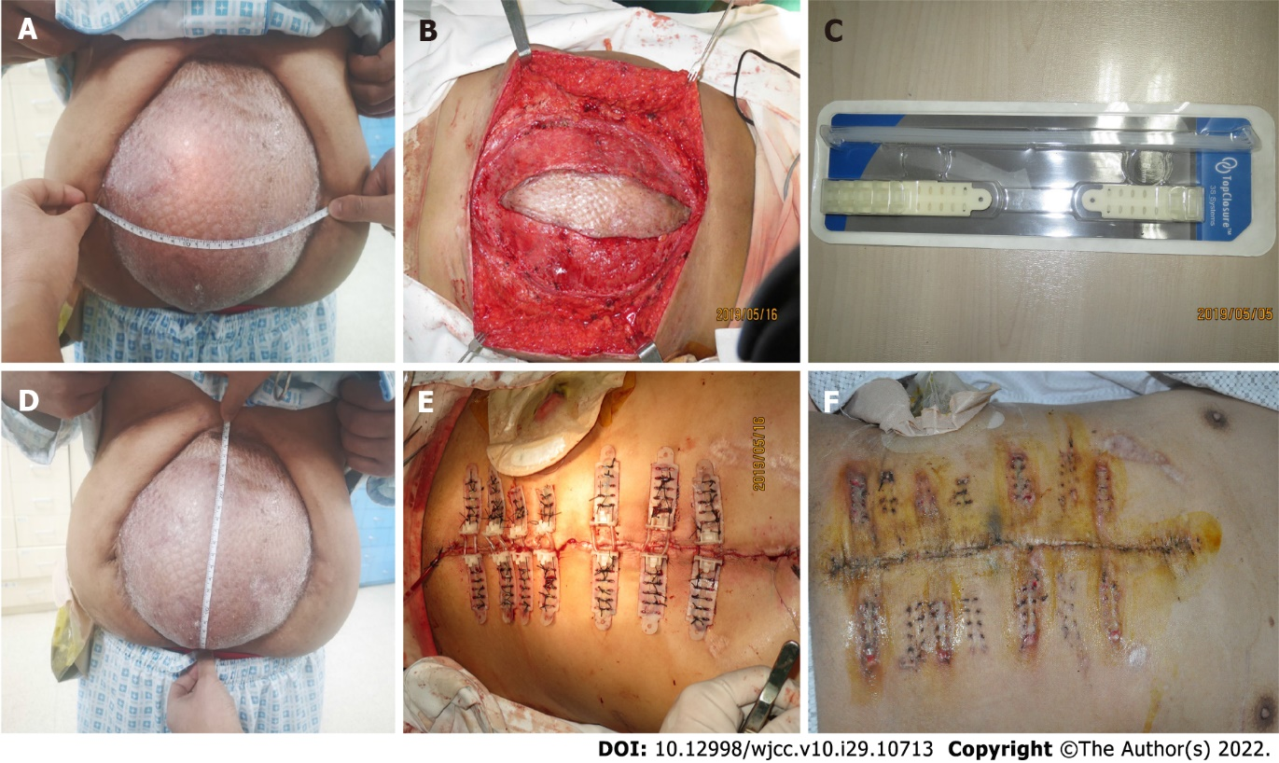
Figure 1 The patient’s first preoperative, intraoperative, and postoperative conditions in our department. A: Length of the abdominal bulge when the patient was standing; B: Width of the abdominal bulge when the patient was standing; C: Grafted skin of the abdomen was carefully removed; D: Immediate primary closure was achieved, utilizing 7 Top Closure® and 8 mm sets; E: Top Closure® 1S 8 mm sets; F: Tension Relief System was removed 3 wk after installation.

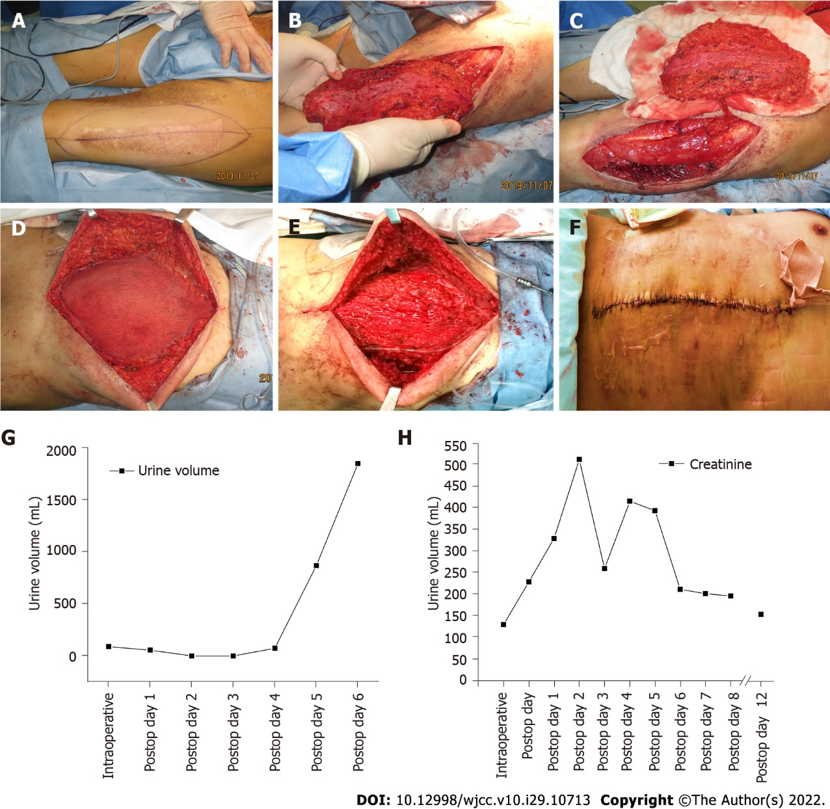
Figure 2 The patient’s surgical procedure and the dynamic changes in biochemical indicators. A: The anterolateral thigh perforator (ALT) flap was designed preoperatively according to the size of the defect in the recipient area; B: The skin and subcutaneous tissue were incised and the ALT flap was separated from the surrounding tissue; C: The ALT flap was freed and the tip was broken; D: Mesh was used to reinforce the abdominal wall hernia; E: ALT flap was grafted to the abdomen and vascular anastomosis was performed; F: The abdominal wound was closed and the abdominal skin was sutured; G: The patient’s volume of urine changes over time; H: The patient’s creatinine values over time.

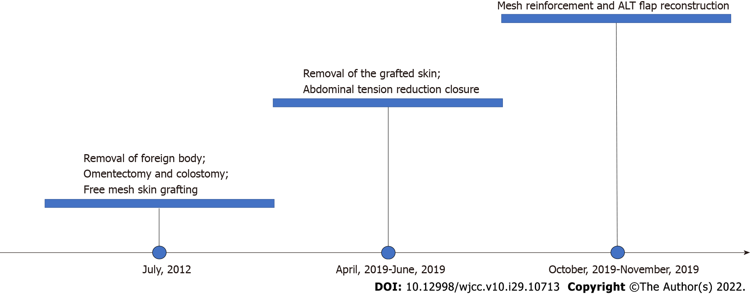
Figure 3 Timeline of treatment events. ALT: Anterolateral thigh perforator.

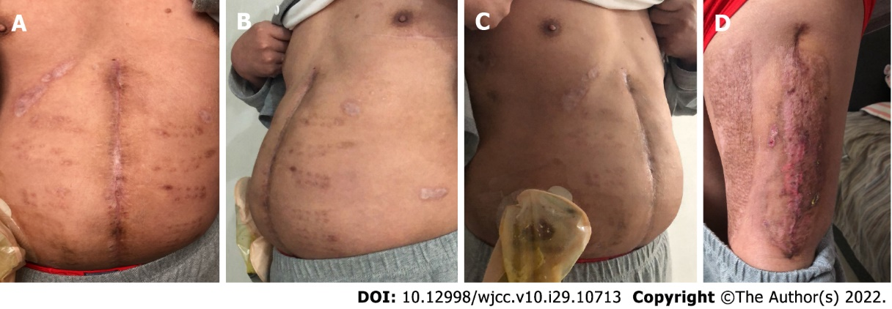
Figure 4 One year following surgery, the patient recovered well and reported significant improvement in quality of life without signs of hernial recurrence.

Table 1 Details of cases treated with Tension Relief System
Ref. | Case no. | Age (yr) | Gender (male/female) | Cause of defect | Region of defect | Size of defect | Application time (prior to, during, and/or after surgery) | Closure (immediate/delayed closure) | Time to closure (min/d)
Topaz et al^{[5]}, 2012 | 1 | 62 | Male | SCC | Left distal leg | 3 cm × 2 cm | Prior to surgery | Delayed | 16 d
 | 2 | 52 | Female | Scar | Lower abdominal | 7 cm × 8 cm | Prior to surgery | Delayed | 11 d
 | 3 | 26 | Male | High-voltage electric burn | Left lower limb | NA | During surgery | Immediate | NA
 | 4 | 12 | Female | Congenital nevus | Right thigh | Φ = 2 cm | Prior to surgery | Delayed | 14 d
 | 5 | 29 | Female | Infected surgical wound | Abdominal | NA | NA | Delayed | NA
 | 6 | 88 | Female | SCC | Left distal leg | Φ = 2.5 cm | Prior to surgery | Delayed | 12 d
Topaz et al^{[17]}, 2014 | 7 | 64 | Male | BCC | Parietal scalp | Φ = 3.5 cm | After surgery | Delayed | 5 d
 | 8 | 64 | Male | BCC | Parietal scalp | Φ = 3 cm | After surgery | Delayed | 1 d
 | 9 | 74 | NA | SCC | Frontal scalp | Φ = 3 cm | During surgery | Immediate | NA
 | 10 | 78 | NA | Ulcerated BCC | Occipital scalp | Φ = 3.2 cm | After surgery | Delayed | 5 d
 | 11 | 17 | NA | Scar tissue neoplasia | Parietal scalp | Φ = 2.5 cm | After surgery | Delayed | 2 d
 | 12 | 95 | Male | SCC | Occipital scalp | Φ = 4.5 cm | After surgery | Delayed | 17 d
 | 13 | 82 | NA | SCC | Parietal scalp | Φ = 3.5 cm | After surgery | Delayed | 21 d
 | 14 | 82 | NA | SCC | Occipital scalp | Φ = 3 cm | After surgery | Delayed | 2 d
 | 15 | 65 | NA | SCC | Occipital scalp | Φ = 4 cm | After surgery | Delayed | 5 d
Topaz et al^{[18]}, 2014 | 16 | 60 | Male | Basal cell carcinoma | Flank | 15 cm × 25 cm | During surgery | Immediate | 26 min
 | 17 | 35 | Male | Malignant melanoma | Scapular | 7 cm × 11.5 cm | During surgery | Immediate | 60 min
 | 18 | 41 | Male | Spindle cell sarcoma | Supraclavicular | 26 cm × 25 cm | During surgery | Immediate | 135 min
Dan et al^{[19]}, 2015 | 19 | 20 | Female | Tumor | Left groin | 10 cm × 8 cm | After surgery | Delayed | 28 d
 | 20 | 53 | Male | Traffic accident | Foot and ankle | 10 cm × 9 cm | After surgery | Delayed | 15 d
Zhu et al^{[22]}, 2020 | 21 | 3 | Female | Infantile hemangiomas | Scalp | 6.5 cm × 5.2 cm | During surgery | Immediate | 20 min
Choke et al^{[20]}, 2017 | 22 | 42 | Male | Bacterial infection | Limb | 91 cm × 17 cm | After surgery | Delayed | 60 d
 | 23 | 55 | Male | Sternal osteomyelitis | Chest | 28 cm × 8 cm | After surgery | Delayed | 42 d
 | 24 | 29 | Male | Hernia | Abdomen | 9 cm × 10 cm | After surgery | Delayed | 28 d
Li et al^{[21]}, 2019 | 25 | 4 | Female | Traffic accident trauma | Pubic symphysis | 14 cm × 9 cm | After surgery | Delayed | NA
SCC: Squamous cell carcinoma; BCC: Basal cell carcinoma; NA: Not available.

Published by Baishideng Publishing Group Inc
7041 Koll Center Parkway, Suite 160, Pleasanton, CA 94566, USA
Telephone: +1-925-3991568
E-mail: bpgoffice@wjgnet.com
Help Desk: https://www.f6publishing.com/helpdesk
https://www.wjgnet.com

© 2022 Baishideng Publishing Group Inc. All rights reserved.

