Name of Journal: World Journal of Gastrointestinal Oncology
Manuscript NO: 85392
Manuscript Type: MINIREVIEWS

Metastasis-associated lung adenocarcinoma transcript 1 molecular mechanisms in gastric cancer progression

Batista DMO et al. MALAT1 molecular mechanisms in gastric cancer

Daniel Mateus de Oliveira Batista, Jéssica Manoelli Costa da Silva, Carolina de Oliveira Gigek, Marília de Arruda Cardoso Smith, Paulo Pimentel de Assumpção, Danielle Queiroz Calcagno

Daniel Mateus de Oliveira Batista, Jéssica Manoelli Costa da Silva, Paulo Pimentel de Assumpção, Danielle Queiroz Calcagno, Núcleo de Pesquisas em Oncologia, Universidade Federal do Pará, Belém 66073-000, Pará, Brazil

Carolina de Oliveira Gigek, Departamento de Patologia, Universidade Federal de São Paulo, São Paulo 04023-062, São Paulo, Brazil

Marília de Arruda Cardoso Smith, Disciplina de Genética, Departamento de Morfologia e Genética, Universidade Federal de São Paulo, São Paulo 04023-900, São Paulo, Brazil

Author contributions: Batista DMO, Silva JMC, Calcagno DQ wrote the paper; Batista DMO designed the tables and the figures; Smith MAC, Gigek CO, and de Assumpção PP critically revised this paper; Calcagno DQ designed the article.

Corresponding author: Danielle Queiroz Calcagno, PhD, Núcleo de Pesquisas em Oncologia, Universidade Federal do Pará, R. dos Mundurucus, 4487-Guamá, Belém-PA, Belém 66073-000, Pará, Brazil. danicalcagno@gmail.com

Received: May 2, 2023
Revised: May 30, 2023
Accepted: July 27, 2023
Published online: August 15, 2023

Abstract
Gastric cancer (GC) remains among the most common cancers worldwide with a high mortality-to-incidence ratio. Accumulated evidence suggests that long noncoding RNAs (lncRNAs) are involved in gastric carcinogenesis. These transcripts are longer than 200 nucleotides and modulate gene expression at multiple molecular levels, inducing or inhibiting biological processes and diseases. Metastasis-associated lung adenocarcinoma transcript 1 (MALAT1) is one of the best-studied lncRNAs with comprehensive actions contributing to cancer progression. This lncRNA regulates gene expression at the transcriptional and posttranscriptional levels through interactions with microRNAs and proteins. In the present review, we discussed the molecular mechanism of MALAT1 and summarized the current knowledge of its expression in GC. Moreover, we highlighted the potential use of MALAT1 as a biomarker, including liquid biopsy.

Key Words: Long noncoding RNA; Gastric carcinogenesis; Transcriptional levels; Posttranscriptional levels; Prognostic biomarker; Liquid biopsy

©The Author(s) 2023. Published by Baishideng Publishing Group Inc. All rights reserved.

Citation: Batista DMO, Silva JMC, Gigek CO, Smith MAC, de Assumpção PP, Calcagno DQ. Metastasis-associated lung adenocarcinoma transcript 1 molecular mechanisms in gastric cancer progression. World J Gastrointest Oncol 2023; 15(9): 1520-1530
URL: https://www.wjgnet.com/1948-5204/full/v15/i9/1520.htm
DOI: https://dx.doi.org/10.4251/wjgo.v15.i9.1520

Core Tip: Gastric cancer (GC) is one of the leading causes of cancer-related deaths globally, highlighting the need for novel biomarker for improved evaluation. The long noncoding RNAs metastasis-associated lung adenocarcinoma transcript 1 (MALAT1) plays a crucial role in many cellular processes associated with GC progression, including proliferation, invasion, metastasis, and drug response. The current review summarizes the present knowledge of MALAT1 in GC, elucidating its molecular mechanisms of action and potential as a biomarker for the clinical management of GC.

INTRODUCTION
Gastric cancer (GC) is the fifth most prevalent neoplasm and the fourth leading cause of cancer-related deaths worldwide. Despite advancements in treatment modalities, the prognosis for advanced GC remains poor. Therefore, one of the main factors related to the high incidence and mortality of GC is complex tumor heterogeneity at the molecular level, which poses a major challenge to comprehensively understanding the mechanisms underlying gastric tumorigenesis^{[1]}. As such, identifying molecular biomarkers is critical for improving the clinical outcomes of GC patients.
Advanced RNA-sequencing techniques have allowed the discovery of novel contributors to tumor development, as noncoding RNAs (ncRNAs)^{[2]}. NcRNAs are essential regulators of gene expression that play a vital role in the progression of GC, including mainly microRNAs (miRNAs) and long ncRNAs (lncRNAs)^{[3-5]}.
MiRNAs are a class of small RNAs with an average 22 nucleotides in length that modulate negatively the expression of target mRNAs by base-pairing complementarity. This interaction between the two nuclei acids is dynamic and dependent on many factors, such as subcellular location of miRNAs, the abundance of miRNAs and target mRNAs, and the affinity of miRNA-mRNA interactions. Interestingly, these ncRNAs may play an essential role in intercellular signaling. Mature miRNAs transported to the cytoplasm may cross gap junctions (intercellular channels present in the plasma membrane of solid tissues, allowing communication between adjacent cell) and target mRNAs in neighboring cells^{[6–8]}.
In contrast, lncRNAs are transcripts highly heterogeneous with more than 200 nucleotides^{[9]} that play a crucial role as master regulators by interacting with DNA, RNA, or proteins to regulate gene expression^{[10,11]}.
Due to their complex characteristics, lncRNAs can be classificafied based on their genomic location relative to the nearest protein-coding genes. These classifications include (1) long intergenic ncRNAs, which do not overlap or are close to protein-coding genes; (2) sense lncRNAs, which are on the same strand and transcribed in the same direction; (3) antisense lncRNAs, which are situated on the opposite strand and overlap protein-coding genes; (4) intronic lncRNAs, whose sequence is within the boundaries of introns; and (5) bidirectional lncRNAs, positioned on the antisense strand and having their transcription start site (TSS) near the TSS of protein-coding genes, with transcription occurring in the opposite direction^{[12–14]}.
In addition, lncRNAs exhibit archetypes that distinguish them based on molecular functions: (1) Signals are stimuli expressed lncRNAs that interact with transcription factors or chromatin modifiers; (2) Decoy lncRNAs bind to regulatory factors, turning off their activity; (3) Guide lncRNAs recruit and direct chromatin modifiers or transcription factors to specific target genomic locations, either in cis (neighboring-genes) or in trans (distantly-located genes); and (4) Scaffold lncRNAs function as structural elements in the assembly and organization of ribonucleoprotein complexes^{[15]}.
Over recent years, evidence has suggested that lncRNAs are key players in the initiation, progression, and response to therapy in GC^{[16,17]}. Regarding their role in cancer, lncRNAs participate in different biological processes, including cell proliferation, angiogenesis, autophagy, apoptosis, differentiation, and immune responses. Consequently, they may be potential targets for clinical applications^{[18]}.
Among the lncRNAs involved in GC, metastasis-associated lung adenocarcinoma transcript 1 (MALAT1) has gained attention as a promoter of cancer progression and an inhibitor of cell sensitivity to therapies^{[19]}. Here, we summarized the current knowledge regarding MALAT1 function and its putative role in biological processes, including GC. Furthermore, we explored the association of MALAT1 overexpression with the clinicopathological features of GC patients and highlighted its potential as a biomarker for diagnosis, prognosis, and prediction of response to therapy.

MALAT1
MALAT1, also known as nuclear enriched abundant transcript 2, is a transcript > 8.7 kbp encoded on human chromosome 11q13.1 widely expressed in normal tissues, especially in the lung and pancreas. Compared to other lncRNAs, MALAT1 exhibits a distinctive triple helix structure at its 3' end. This unique structural feature has been demonstrated to provide protection against exonucleases, contributing to the enhanced stability of MALAT1^{[20,21]}. The subcellular localization determines the molecular functions of MALAT1. Generally, this lncRNA resides in nuclear speckles and specific nuclear bodies enriched with epigenetic regulators, splicing, and transcription factors. Within these nuclear bodies, MALAT1 can interact with various proteins, enabling it to exert regulatory control over alternative splicing (AS) and transcription processes^{[22]} (Figure 1).
MALAT1 has been shown modulate recruitment of pre-mRNA splicing factors, such as serine/arginine-rich (SR) proteins, acting as a sponge of these components. As illustrated in Figure 1, MALAT1 can influence endogenous pre-mRNA AS through the regulation of SR protein phosphorylation and dephosphorylation. This process leads to modifications in mRNA expression and subsequent alterations in cellular function^{[22,23]}.
Furthermore, MALAT1 plays a significant role in modulating gene expression through its interactions with transcription factors, such as members of the polycomb2 protein family and transcriptional enhanced factors with TEA/ATTS domain (TEAD). The crosstalk between MALAT1 and TEAD blocks their association with the coactivator Yes-associated protein, resulting in a negative modulation of gene transcription^{[24]}.
In addition to influencing splicing and transcription, MALAT1 also can act as a competitive endogenous RNA (ceRNA) or miRNA sponge to sequester miRNAs under various conditions. CeRNAs are genetic components that control gene expression at a posttranscriptional level. They share miRNA response elements and compete with mRNAs for miRNA binding^{[25]}. Consequently, binding of ceRNAs to miRNAs releases the target mRNA, allowing their translation^{[21,26,27]}. Accumulating evidence supports the regulatory role of MALAT1 in endothelial cell function and vascular growth. A study conducted by Michalik et al^{[28]} reported that inhibiting MALAT1 has an antiproliferative and promigratory effect on endothelial cells. Moreover, this transcript differentiates bone marrow-derived mesenchymal stem cells from endothelial cells, contributing to endothelial repair^{[29]}. However, further research is required to understand the role of MALAT1 in physiological processes.
Several studies have shown the involvement of MALAT1 in the molecular mechanisms of various complex diseases, including cardiovascular and neurodegenerative disorders, as well as solid tumors such as lung cancer, pancreatic cancer, breast cancer, and GC^{[30,31]}.

MALAT1 IN gc
MALAT1 overexpression has been linked with the clinical characteristics of GC patients, including histological subtype, tumor node metastasis stage, overall survival (OS), and drug resistance (Table 1).
Notably, drug resistance a major challenge in the clinical management of GC^{[32–36]}. For instance, Zhang et al^{[36]} showed that MALAT1 expression was noticeably higher in tissue samples from 24 GC patients with oxaliplatin (OXA) resistance than in GC patients without chemoresistance.
Recently, new avenues have opened in the complex field of GC-related lncRNAs. Circulating lncRNAs have attracted considerable attention as potential minimally invasive diagnostic, prognostic, and predictive biomarkers. Even in unfavorable circumstances such as severe potential of hydrogen and numerous freeze-thaw cycles, ncRNAs in body fluids are resistant to exonucleases and highly stable^{[16,36,37]}.
Notably, circulating MALAT1 levels in body fluids and clinicopathological traits of GC patients were related to in three studies. For example, Xia et al^{[38]} identified that circulating MALAT1 expression in plasma from GC patients was significantly higher at later stages of tumor development and in tumors that had undergone extensive metastasis. In contrast, circulating MALAT1 levels in GC patients without metastasis showed no significant difference compared to healthy controls. Taken together, these results suggest that circulating MALAT1 expression is linked to widespread metastasis and tumor stage, indicating its potential as a prognostic biomarker for GC.
Moreover, in their study, Lu et al^{[39]} observed higher circulating MALAT1 expression in sera from GC patients without metastasis than healthy controls. They also found that GC patients with advanced stage had higher levels of MALAT1 expression than GC patients within early stages, indicating the potential of MALAT1 as both a prognostic and diagnostic tool.
Similarly, Zhu et al^{[33]} conducted research with plasma samples from 64 GC patients. Circulating MALAT1 was overexpressed in plasma samples from GC patients compared to healthy controls. An estimated area under the curve value of 0.898 from receiver operating characteristic analyses indicates that MALAT1 may effectively discriminate against GC patients from healthy controls. These findings support the utilization of lncRNAs as valuable tools for improving the clinical management of GC.
Overall, the collective results of these studies consistently indicate that MALAT1 overexpression in plasma and serum is correlated with patients clinicopathological characteristics, highlighting its importance as a valuable prognostic and diagnostic biomarker in GC.

MOLECULAR MECHANISMS OF MALAT1 in GC
Several studies have also explored the molecular mechanism of MALAT1 using GC cell lines, highlighting that MALAT1 plays putative role in chemoresistance, metastasis, and angiogenesis (Table 2).

Chemoresistance
Cisplatin and OXA are platinum compounds and alkylating agents widely used in cancer treatment, and the latter is more commonly used in gastrointestinal malignancies. These molecules form metal adducts through their interaction with DNA, forming interstrand or intrastrand DNA crosslinks that disrupt DNA replication and transcriptional processes^{[40,41]}.
Among the observed miRNAs, miR-22-3p was the sole miRNA observed in more than one study. In GC, miR-22-3p acts as a tumor suppressor, effectively inhibiting cell proliferation and cell sensitivity to therapy^{[34,36]}. In the context of OXA resistance, MALAT1 functions as a ceRNA for miR-22-3p, exerting control over ZPF91 expression and increasing GC cell resistance to OXA. Notably, overexpression of MALAT1 enhances cell proliferation, confers resistance to OXA, and inhibits cell death mechanisms^{[36]}. Consistent with these findings, Zhang et al^{[36]} also reported the relationship between MALAT1 and cellular sensitivity to OXA in GC cell lines. Knockdown of MALAT1 using small interfering RNA MALAT1 (siMALAT1) reduced the level of ZPF91 protein and increased miR-22-3p expression. Furthermore, transfection of miR-22-3p in OXA-resistant cell lines yielded similar results.
Additionally, MALAT1 regulates phosphatidylinositol-4,5-bisphosphate 3-kinase (PI3K)/ serine/threonine-protein kinase (AKT) pathway promoting GC cell resistance to cisplatin. Knockdown of MALAT1 using siMALAT1 decreased PI3K and AKT activity, reducing GC cell proliferation, migration, and invasion. In contrast, GC cell lines treated with plasmid cloning DNA-MALAT1 (pcDNA-MALAT1) did not impact on the expression of PI3K, AKT, and signal transducer and activator of transcription 3^{[35]}.
These findings highlight the multifaceted involvement of MALAT1 in modulating drug resistance in GC, provide insights into the underlying mechanisms through which it influences cellular responses to therapy, and show the untapped potential of MALAT1 as a therapeutic target for GC treatment.

Metastasis
From the data of several studies described in this review, epithelial-mesenchymal transition (EMT) markers were the most frequently reported proteins associated with MALAT1 overexpression in GC cell lines. Specifically, Vimentin and E-cadherin emerged as the most reported proteins linked to MALAT1 dysregulation in GC. EMT is a crucial stage in the metastatic process, characterized by losing epithelial properties and acquiring of mesenchymal characteristics^{[42]}.
MALAT1 upregulation led to a reduction in E-cadherin expression and an increase in vimentin. In GC, E-cadherin acts as a tumor suppressor by preserving cell adhesion and inhibiting cell migration and invasion, while vimentin enhances GC cell migration and invasion^{[43,44]}.
Moreover, chemokine ligand 21 may upregulate MALAT1, promoting the expression of serine and arginine-rich splicing factor 1 (SRSF1) and the activation of the mammalian target of rapamycin (mTOR) pathway, consequently facilitating EMT^{[45]}. Transfection assays using overexpression vectors and siMALAT1 demonstrated that the upregulation of MALAT1 increased the expression of SRSF1 protein and the phosphorylation of the mTOR pathway, leading to the downregulation of E-cadherin and overexpression of vimentin, slug, snail, and twist. Furthermore, the role of MALAT1 as a ceRNA for miR-202-3p contributes to the positive regulation of SRSF1, enhancing EMT processes (Figure 2).
Additionally, MALAT1 overexpression significantly impacts themetastasis, invasion, and migration of GC cells through epidermal growth factor-like domain-containing protein 7 (EGFL7). Transfection assays with siMALAT1 in BGC823 cells demonstrated a reduction in acetylation of the promoter region EGFL7 located in histone H3, decreasing the EGFL7 protein level. Conversely, the injection of pcDNA-MALAT1 into MKN28 cells increased EGFL7 acetylation and EGFL7 protein concentration^{[46]} (Figure 3).
Therefore, MALAT1 plays a pivotal role in promoting EMT, invasion, and migration of GC cells, suggesting its potential as a therapeutic target for metastasis and EMT. These compelling findings underscore the need for further research in this area, warranting exploration to understand its potential as a therapeutic target and assess its clinical significance.

Angiogenesis
Angiogenesis comprises the growth of new blood vessels from preexisting vasculature, providing tissues with oxygen and nutrients essential to tumor progression^{[47,48]}. Vasculogenic mimicry (VM) is a phenomenon observed in highly aggressive tumors, where malignant cells imitate endothelial cells, contributing to the formation of microvascular channels that supply blood to cancer cells^{[49]}. A key player in this process is CDH5 or vascular endothelial-cadherin, a transmembrane protein commonly expressed in the endothelium that acts to form and maintain adherent junctions between endothelial cells ^{[50,51]}.
Furthermore, Li et al^{[49]} revealed that MALAT1 overexpression regulates the expression of CDH5 and β-catenin. Interestingly, the knockdown of MALAT1 in vitro showed a significant decrease in the expression of the CDH5/β-catenin complex. When upregulated, MALAT1 influenced the CDH5/β-catenin complex to initiate VM and increase vascular permeability.
MALAT1 expression was also associated with the extracellular signal-regulated kinase (ERK)/matrix metalloproteinase (MMP) and focal adhesion kinase (FAK)/paxillin complexes. Upregulation of MALAT1 increased the activity of ERK, FAK, and paxillin; and increased the expression of MMPs, enhancing VM.
These insights provide valuable evidence for the involvement of MALAT1 in the modulation of these processes. However, further studies are warranted to clarify the intricate mechanism on how MALAT1 exerts influence over CDH5, which may offer potential avenues for targeted therapeutic interventions against VM and angiogenesis in GC.

CONCLUSION
In summary, MALAT1 is an antisense lncRNA that acts as a fundamental regulator of gene expression through interactions with proteins or miRNAs. In GC, MALAT1 has the potential to be a pivotal contributor to various molecular mechanisms, including EMT, apoptosis, proliferation, cell migration, and invasion.
Accumulating evidence has demonstrated a significant tumor suppressor role of miR-22-3p and its interaction with MALAT1 in GC, inhibiting cell apoptosis and increasing GC cell resistance to OXA.
Moreover, studies have correlated MALAT1 overexpression in the tissues and liquid biopsy samples of GC patients with metastasis, staging, worse OS, tumor size, and chemoresistance. The presence of MALAT1 in plasma and serum samples allows the use of minimally invasive collection methods. Although additional validations are needed, these findings show the potential of MALAT1 as a prognostic biomarker and therapeutic target. Further research to elucidate MALAT1 mechanisms of action may identify a new target of interest for translation into clinical applications, thereby improving the personalized clinical management of GC.

ACKNOWLEDGEMENTS
We would like to thank Conselho Nacional de Desenvolvimento Científico e Tecnológico, Fundação Amazônia de Amparo a Estudos e Pesquisas and the Programa de Pós-Graduação em Oncologia e Ciências Médicas for their help and support.

REFERENCES
1 Sung H, Ferlay J, Siegel RL, Laversanne M, Soerjomataram I, Jemal A, Bray F. Global Cancer Statistics 2020: GLOBOCAN Estimates of Incidence and Mortality Worldwide for 36 Cancers in 185 Countries. CA Cancer J Clin 2021; 71: 209-249 [PMID: 33538338 DOI: 10.3322/caac.21660]
2 He X, Liu X, Zuo F, Shi H, Jing J. Artificial intelligence-based multi-omics analysis fuels cancer precision medicine. Semin Cancer Biol 2023; 88: 187-200 [PMID: 36596352 DOI: 10.1016/j.semcancer.2022.12.009]
3 Chen D, Ping S, Xu Y, Wang M, Jiang X, Xiong L, Zhang L, Yu H, Xiong Z. Non-Coding RNAs in Gastric Cancer: From Malignant Hallmarks to Clinical Applications. Front Cell Dev Biol 2021; 9: 732036 [PMID: 34805143 DOI: 10.3389/fcell.2021.732036]
4 Wu SR, Wu Q, Shi YQ. Recent advances of miRNAs in the development and clinical application of gastric cancer. Chin Med J (Engl) 2020; 133: 1856-1867 [PMID: 32649523 DOI: 10.1097/CM9.0000000000000921]
5 Gao Y, Wang JW, Ren JY, Guo M, Guo CW, Ning SW, Yu S. Long noncoding RNAs in gastric cancer: From molecular dissection to clinical application. World J Gastroenterol 2020; 26: 3401-3412 [PMID: 32655264 DOI: 10.3748/wjg.v26.i24.3401]
6 Lee S, Jiang X. Modeling miRNA-mRNA interactions that cause phenotypic abnormality in breast cancer patients. PLoS One 2017; 12: e0182666 [PMID: 28793339 DOI: 10.1371/journal.pone.0182666]
7 Saliminejad K, Khorram Khorshid HR, Soleymani Fard S, Ghaffari SH. An overview of microRNAs: Biology, functions, therapeutics, and analysis methods. J Cell Physiol 2019; 234: 5451-5465 [PMID: 30471116 DOI: 10.1002/jcp.27486]
8 Condrat CE, Thompson DC, Barbu MG, Bugnar OL, Boboc A, Cretoiu D, Suciu N, Cretoiu SM, Voinea SC. miRNAs as Biomarkers in Disease: Latest Findings Regarding Their Role in Diagnosis and Prognosis. Cells 2020; 9 [PMID: 31979244 DOI: 10.3390/cells9020276]
9 Djebali S, Davis CA, Merkel A, Dobin A, Lassmann T, Mortazavi A, Tanzer A, Lagarde J, Lin W, Schlesinger F, Xue C, Marinov GK, Khatun J, Williams BA, Zaleski C, Rozowsky J, Röder M, Kokocinski F, Abdelhamid RF, Alioto T, Antoshechkin I, Baer MT, Bar NS, Batut P, Bell K, Bell I, Chakrabortty S, Chen X, Chrast J, Curado J, Derrien T, Drenkow J, Dumais E, Dumais J, Duttagupta R, Falconnet E, Fastuca M, Fejes-Toth K, Ferreira P, Foissac S, Fullwood MJ, Gao H, Gonzalez D, Gordon A, Gunawardena H, Howald C, Jha S, Johnson R, Kapranov P, King B, Kingswood C, Luo OJ, Park E, Persaud K, Preall JB, Ribeca P, Risk B, Robyr D, Sammeth M, Schaffer L, See LH, Shahab A, Skancke J, Suzuki AM, Takahashi H, Tilgner H, Trout D, Walters N, Wang H, Wrobel J, Yu Y, Ruan X, Hayashizaki Y, Harrow J, Gerstein M, Hubbard T, Reymond A, Antonarakis SE, Hannon G, Giddings MC, Ruan Y, Wold B, Carninci P, Guigó R, Gingeras TR. Landscape of transcription in human cells. Nature 2012; 489: 101-108 [PMID: 22955620 DOI: 10.1038/nature11233]
10 Quinn JJ, Chang HY. Unique features of long non-coding RNA biogenesis and function. Nat Rev Genet 2016; 17: 47-62 [PMID: 26666209 DOI: 10.1038/nrg.2015.10]
11 Nandwani A, Rathore S, Datta M. LncRNAs in cancer: Regulatory and therapeutic implications. Cancer Lett 2021; 501: 162-171 [PMID: 33359709 DOI: 10.1016/j.canlet.2020.11.048]
12 Hrdlickova B, de Almeida RC, Borek Z, Withoff S. Genetic variation in the non-coding genome: Involvement of micro-RNAs and long non-coding RNAs in disease. Biochim Biophys Acta 2014; 1842: 1910-1922 [PMID: 24667321 DOI: 10.1016/j.bbadis.2014.03.011]
13 Spurlock CF 3rd, Crooke PS 3rd, Aune TM. Biogenesis and Transcriptional Regulation of Long Noncoding RNAs in the Human Immune System. J Immunol 2016; 197: 4509-4517 [PMID: 27913643 DOI: 10.4049/jimmunol.1600970]
14 Amodio N, Raimondi L, Juli G, Stamato MA, Caracciolo D, Tagliaferri P, Tassone P. MALAT1: a druggable long non-coding RNA for targeted anti-cancer approaches. J Hematol Oncol 2018; 11: 63 [PMID: 29739426 DOI: 10.1186/s13045-018-0606-4]
15 Wang KC, Chang HY. Molecular mechanisms of long noncoding RNAs. Mol Cell 2011; 43: 904-914 [PMID: 21925379 DOI: 10.1016/j.molcel.2011.08.018]
16 Uchôa Guimarães CT, Ferreira Martins NN, Cristina da Silva Oliveira K, Almeida CM, Pinheiro TM, Gigek CO, Roberto de Araújo Cavallero S, Assumpção PP, Cardoso Smith MA, Burbano RR, Calcagno DQ. Liquid biopsy provides new insights into gastric cancer. Oncotarget 2018; 9: 15144-15156 [PMID: 29599934 DOI: 10.18632/oncotarget.24540]
17 Syllaios A, Moris D, Karachaliou GS, Sakellariou S, Karavokyros I, Gazouli M, Schizas D. Pathways and role of MALAT1 in esophageal and gastric cancer. Oncol Lett 2021; 21: 343 [PMID: 33747200 DOI: 10.3892/ol.2021.12604]
18 Shao G, Zhao Z, Zhao W, Hu G, Zhang L, Li W, Xing C, Zhang X. Long non-coding RNA MALAT1 activates autophagy and promotes cell proliferation by downregulating microRNA-204 expression in gastric cancer. Oncol Lett 2020; 19: 805-812 [PMID: 31897197 DOI: 10.3892/ol.2019.11184]
19 Li ZX, Zhu QN, Zhang HB, Hu Y, Wang G, Zhu YS. MALAT1: a potential biomarker in cancer. Cancer Manag Res 2018; 10: 6757-6768 [PMID: 30584369 DOI: 10.2147/CMAR.S169406]
20 Zhang X, Hamblin MH, Yin KJ. The long noncoding RNA Malat1: Its physiological and pathophysiological functions. RNA Biol 2017; 14: 1705-1714 [PMID: 28837398 DOI: 10.1080/15476286.2017.1358347]
21 McCown PJ, Wang MC, Jaeger L, Brown JA. Secondary Structural Model of Human MALAT1 Reveals Multiple Structure-Function Relationships. Int J Mol Sci 2019; 20 [PMID: 31717552 DOI: 10.3390/ijms20225610]
22 Tripathi V, Ellis JD, Shen Z, Song DY, Pan Q, Watt AT, Freier SM, Bennett CF, Sharma A, Bubulya PA, Blencowe BJ, Prasanth SG, Prasanth KV. The nuclear-retained noncoding RNA MALAT1 regulates alternative splicing by modulating SR splicing factor phosphorylation. Mol Cell 2010; 39: 925-938 [PMID: 20797886 DOI: 10.1016/j.molcel.2010.08.011]
23 Arun G, Aggarwal D, Spector DL. MALAT1 Long Non-Coding RNA: Functional Implications. Noncoding RNA 2020; 6 [PMID: 32503170 DOI: 10.3390/ncrna6020022]
24 Chen Q, Zhu C, Jin Y. The Oncogenic and Tumor Suppressive Functions of the Long Noncoding RNA MALAT1: An Emerging Controversy. Front Genet 2020; 11: 93 [PMID: 32174966 DOI: 10.3389/fgene.2020.00093]
25 Su K, Wang N, Shao Q, Liu H, Zhao B, Ma S. The role of a ceRNA regulatory network based on lncRNA MALAT1 site in cancer progression. Biomed Pharmacother 2021; 137: 111389 [PMID: 33601150 DOI: 10.1016/j.biopha.2021.111389]
26 Zampetaki A, Albrecht A, Steinhofel K. Long Non-coding RNA Structure and Function: Is There a Link? Front Physiol 2018; 9: 1201 [PMID: 30197605 DOI: 10.3389/fphys.2018.01201]
27 Graf J, Kretz M. From structure to function: Route to understanding lncRNA mechanism. Bioessays 2020; 42: e2000027 [PMID: 33164244 DOI: 10.1002/bies.202000027]
28 Michalik KM, You X, Manavski Y, Doddaballapur A, Zörnig M, Braun T, John D, Ponomareva Y, Chen W, Uchida S, Boon RA, Dimmeler S. Long noncoding RNA MALAT1 regulates endothelial cell function and vessel growth. Circ Res 2014; 114: 1389-1397 [PMID: 24602777 DOI: 10.1161/CIRCRESAHA.114.303265]
29 Sun X, Luo L, Li J. LncRNA MALAT1 facilitates BM-MSCs differentiation into endothelial cells via targeting miR-206/VEGFA axis. Cell Cycle 2020; 19: 3018-3028 [PMID: 33121336 DOI: 10.1080/15384101.2020.1829799]
30 Esfandi F, Salehnezhad T, Taheri M, Afsharpad M, Hafez AA, Oskooei VK, Ghafouri-Fard S. Expression assessment of a panel of long non-coding RNAs in gastric malignancy. Exp Mol Pathol 2020; 113: 104383 [PMID: 31982396 DOI: 10.1016/j.yexmp.2020.104383]
31 Ghafouri-Fard S, Taheri M. Long non-coding RNA signature in gastric cancer. Exp Mol Pathol 2020; 113: 104365 [PMID: 31899194 DOI: 10.1016/j.yexmp.2019.104365]
32 Yan L, Zhang J, Guo D, Ma J, Shui SF, Han XW. IL-21R functions as an oncogenic factor and is regulated by the lncRNA MALAT1/miR-125a-3p axis in gastric cancer. Int J Oncol 2019; 54: 7-16 [PMID: 30387833 DOI: 10.3892/ijo.2018.4612]
33 Zhu K, Ren Q, Zhao Y. lncRNA MALAT1 overexpression promotes proliferation, migration and invasion of gastric cancer by activating the PI3K/AKT pathway. Oncol Lett 2019; 17: 5335-5342 [PMID: 31186750 DOI: 10.3892/ol.2019.10253]
34 Li X, Zhao J, Zhang H, Cai J. Silencing of LncRNA Metastasis-Associated Lung Adenocarcinoma Transcript 1 Inhibits the Proliferation and Promotes the Apoptosis of Gastric Cancer Cells Through Regulating microRNA-22-3p-Mediated ErbB3. Onco Targets Ther 2020; 13: 559-571 [PMID: 32021298 DOI: 10.2147/OTT.S222375]
35 Dai Q, Zhang T, Li C. LncRNA MALAT1 Regulates the Cell Proliferation and Cisplatin Resistance in Gastric Cancer via PI3K/AKT Pathway. Cancer Manag Res 2020; 12: 1929-1939 [PMID: 32214850 DOI: 10.2147/CMAR.S243796]
36 Zhang Z, Li M, Zhang Z. lncRNA MALAT1 modulates oxaliplatin resistance of gastric cancer via sponging miR-22-3p. Onco Targets Ther 2020; 13: 1343-1354 [PMID: 32104001 DOI: 10.2147/OTT.S196619]
37 YiRen H, YingCong Y, Sunwu Y, Keqin L, Xiaochun T, Senrui C, Ende C, XiZhou L, Yanfan C. Long noncoding RNA MALAT1 regulates autophagy associated chemoresistance via miR-23b-3p sequestration in gastric cancer. Mol Cancer 2017; 16: 174 [PMID: 29162158 DOI: 10.1186/s12943-017-0743-3]
38 Xia H, Chen Q, Chen Y, Ge X, Leng W, Tang Q, Ren M, Chen L, Yuan D, Zhang Y, Liu M, Gong Q, Bi F. The lncRNA MALAT1 is a novel biomarker for gastric cancer metastasis. Oncotarget 2016; 7: 56209-56218 [PMID: 27486823 DOI: 10.18632/oncotarget.10941]
39 Lu Z, Luo T, Pang T, Du Z, Yin X, Cui H, Fang G, Xue X. MALAT1 promotes gastric adenocarcinoma through the MALAT1/miR-181a-5p/AKT3 axis. Open Biol 2019; 9: 190095 [PMID: 31480991 DOI: 10.1098/rsob.190095]
40 Riddell IA. Cisplatin and Oxaliplatin: Our Current Understanding of Their Actions. Met Ions Life Sci 2018; 18 [PMID: 29394020 DOI: 10.1515/9783110470734-007]
41 Rogers BB, Cuddahy T, Briscella C, Ross N, Olszanski AJ, Denlinger CS. Oxaliplatin: Detection and Management of Hypersensitivity Reactions. Clin J Oncol Nurs 2019; 23: 68-75 [PMID: 30682002 DOI: 10.1188/19.CJON.68-75]
42 Ribatti D, Tamma R, Annese T. Epithelial-Mesenchymal Transition in Cancer: A Historical Overview. Transl Oncol 2020; 13: 100773 [PMID: 32334405 DOI: 10.1016/j.tranon.2020.100773]
43 Yin S, Chen FF, Yang GF. Vimentin immunohistochemical expression as a prognostic factor in gastric cancer: A meta-analysis. Pathol Res Pract 2018; 214: 1376-1380 [PMID: 30078472 DOI: 10.1016/j.prp.2018.07.014]
44 Bure IV, Nemtsova MV, Zaletaev DV. Roles of E-cadherin and Noncoding RNAs in the Epithelial-mesenchymal Transition and Progression in Gastric Cancer. Int J Mol Sci 2019; 20 [PMID: 31212809 DOI: 10.3390/ijms20122870]
45 Fu Q, Tan X, Tang H, Liu J. CCL21 activation of the MALAT1/SRSF1/mTOR axis underpins the development of gastric carcinoma. J Transl Med 2021; 19: 210 [PMID: 34001131 DOI: 10.1186/s12967-021-02806-5]
46 Deng QJ, Xie LQ, Li H. Overexpressed MALAT1 promotes invasion and metastasis of gastric cancer cells via increasing EGFL7 expression. Life Sci 2016; 157: 38-44 [PMID: 27259812 DOI: 10.1016/j.lfs.2016.05.041]
47 Li T, Kang G, Wang T, Huang H. Tumor angiogenesis and anti-angiogenic gene therapy for cancer. Oncol Lett 2018; 16: 687-702 [PMID: 29963134 DOI: 10.3892/ol.2018.8733]
48 Kretschmer M, Rüdiger D, Zahler S. Mechanical Aspects of Angiogenesis. Cancers (Basel) 2021; 13 [PMID: 34638470 DOI: 10.3390/cancers13194987]
49 Li Y, Wu Z, Yuan J, Sun L, Lin L, Huang N, Bin J, Liao Y, Liao W. Long non-coding RNA MALAT1 promotes gastric cancer tumorigenicity and metastasis by regulating vasculogenic mimicry and angiogenesis. Cancer Lett 2017; 395: 31-44 [PMID: 28268166 DOI: 10.1016/j.canlet.2017.02.035]
50 Vestweber D. VE-cadherin: the major endothelial adhesion molecule controlling cellular junctions and blood vessel formation. Arterioscler Thromb Vasc Biol 2008; 28: 223-232 [PMID: 18162609 DOI: 10.1161/ATVBAHA.107.158014]
51 Delgado-Bellido D, Serrano-Saenz S, Fernández-Cortés M, Oliver FJ. Vasculogenic mimicry signaling revisited: focus on non-vascular VE-cadherin. Mol Cancer 2017; 16: 65 [PMID: 28320399 DOI: 10.1186/s12943-017-0631-x]
52 Li J, Gao J, Tian W, Li Y, Zhang J. Long non-coding RNA MALAT1 drives gastric cancer progression by regulating HMGB2 modulating the miR-1297. Cancer Cell Int 2017; 17: 44 [PMID: 28396617 DOI: 10.1186/s12935-017-0408-8]
53 Zhang Y, Chen Z, Li MJ, Guo HY, Jing NC. Long non-coding RNA metastasis-associated lung adenocarcinoma transcript 1 regulates the expression of Gli2 by miR-202 to strengthen gastric cancer progression. Biomed Pharmacother 2017; 85: 264-271 [PMID: 27887846 DOI: 10.1016/j.biopha.2016.11.014]
54 Chen D, Liu L, Wang K, Yu H, Wang Y, Liu J, Guo Y, Zhang H. The role of MALAT-1 in the invasion and metastasis of gastric cancer. Scand J Gastroenterol 2017; 52: 790-796 [PMID: 28276823 DOI: 10.1080/00365521.2017.1280531]
55 Qi Y, Ooi HS, Wu J, Chen J, Zhang X, Tan S, Yu Q, Li YY, Kang Y, Li H, Xiong Z, Zhu T, Liu B, Shao Z, Zhao X. MALAT1 long ncRNA promotes gastric cancer metastasis by suppressing PCDH10. Oncotarget 2016; 7: 12693-12703 [PMID: 26871474 DOI: 10.18632/oncotarget.7281]
56 Lee NK, Lee JH, Ivan C, Ling H, Zhang X, Park CH, Calin GA, Lee SK. MALAT1 promoted invasiveness of gastric adenocarcinoma. BMC Cancer 2017; 17: 46 [PMID: 28077118 DOI: 10.1186/s12885-016-2988-4]
57 Li L, Geng Y, Feng R, Zhu Q, Miao B, Cao J, Fei S. The Human RNA Surveillance Factor UPF1 Modulates Gastric Cancer Progression by Targeting Long Non-Coding RNA MALAT1. Cell Physiol Biochem 2017; 42: 2194-2206 [PMID: 28942451 DOI: 10.1159/000479994]
58 Yang Z, Xie Q, Chen Z, Ni H, Xia L, Zhao Q, Chen Z, Chen P. Resveratrol suppresses the invasion and migration of human gastric cancer cells via inhibition of MALAT1-mediated epithelial-to-mesenchymal transition. Exp Ther Med 2019; 17: 1569-1578 [PMID: 30783423 DOI: 10.3892/etm.2018.7142]
59 Li H, He C, Wang X, Wang H, Nan G, Fang L. MicroRNA-183 affects the development of gastric cancer by regulating autophagy via MALAT1-miR-183-SIRT1 axis and PI3K/AKT/mTOR signals. Artif Cells Nanomed Biotechnol 2019; 47: 3163-3171 [PMID: 31352788 DOI: 10.1080/21691401.2019.1642903]
60 Xiao Y, Pan J, Geng Q, Wang G. LncRNA MALAT1 increases the stemness of gastric cancer cells via enhancing SOX2 mRNA stability. FEBS Open Bio 2019; 9: 1212-1222 [PMID: 31037832 DOI: 10.1002/2211-5463.12649]
61 Zhang YF, Li CS, Zhou Y, Lu XH. Propofol facilitates cisplatin sensitivity via lncRNA MALAT1/miR-30e/ATG5 axis through suppressing autophagy in gastric cancer. Life Sci 2020; 244: 117280 [PMID: 31926239 DOI: 10.1016/j.lfs.2020.117280]

Footnotes
Conflict-of-interest statement: Authors declare no conflict of interests for this article.

Open-Access: This article is an open-access article that was selected by an in-house editor and fully peer-reviewed by external reviewers. It is distributed in accordance with the Creative Commons Attribution NonCommercial (CC BY-NC 4.0) license, which permits others to distribute, remix, adapt, build upon this work non-commercially, and license their derivative works on different terms, provided the original work is properly cited and the use is non-commercial. See: https://creativecommons.org/Licenses/by-nc/4.0/

Provenance and peer review: Unsolicited article; Externally peer reviewed.

Peer-review model: Single blind

Peer-review started: May 2, 2023
First decision: May 9, 2023
Article in press: July 27, 2023

Specialty type: Oncology
Country/Territory of origin: Brazil
Peer-review report’s scientific quality classification
Grade A (Excellent): 0
Grade B (Very good): B
Grade C (Good): 0
Grade D (Fair): D
Grade E (Poor): 0

P-Reviewer: Agostino SD, Italy; Ma X, China S-Editor: Lin C L-Editor: A P-Editor: Zhang XD

Figure Legends
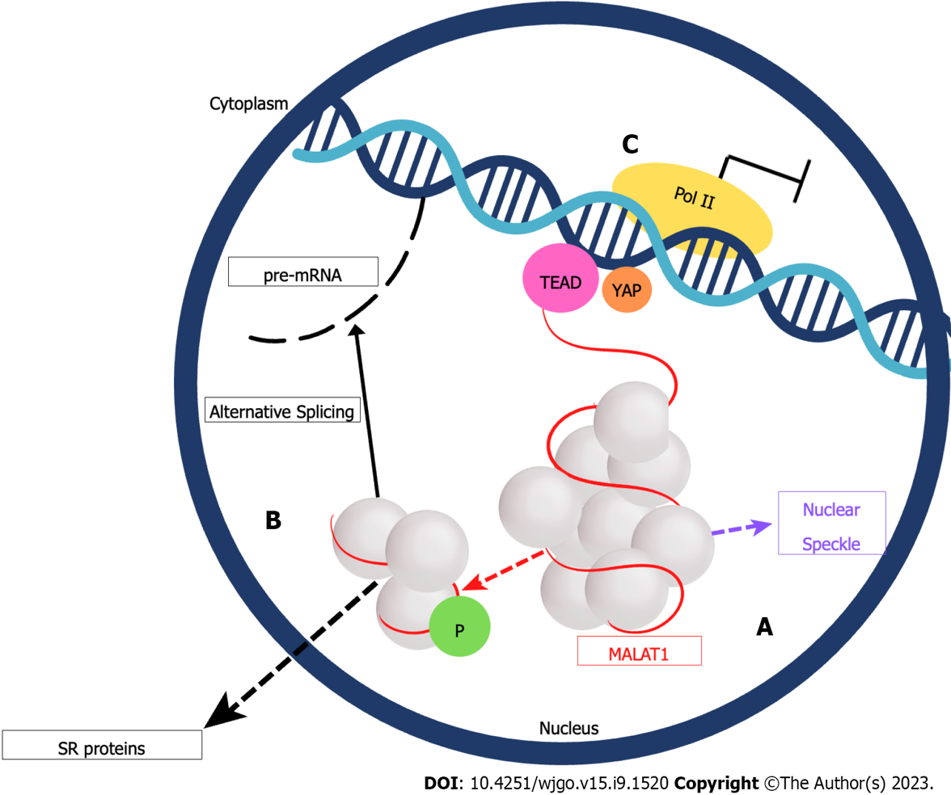
Figure 1 MALAT1 subcellular location. A: MALAT1 is the red strand around the nuclear spots (white spheres), MALAT1 can interact with proteins present in nuclear speckles; B: MALAT1 can interact with serine/arginine proteins to modulate alternative splicing of pre-mRNAs; C: MALAT1 binds with transcriptional enhancer factor transcriptional enhanced factors with TEA/ATTS domain, blocking Yes-associated protein, inhibiting gene transcription. MALAT1: Metastasis-associated lung adenocarcinoma transcript 1; SR: Serine/arginine-rich; TEAD: Transcriptional enhanced factors with TEA/ATTS domain; YAP: Yes-associated protein.
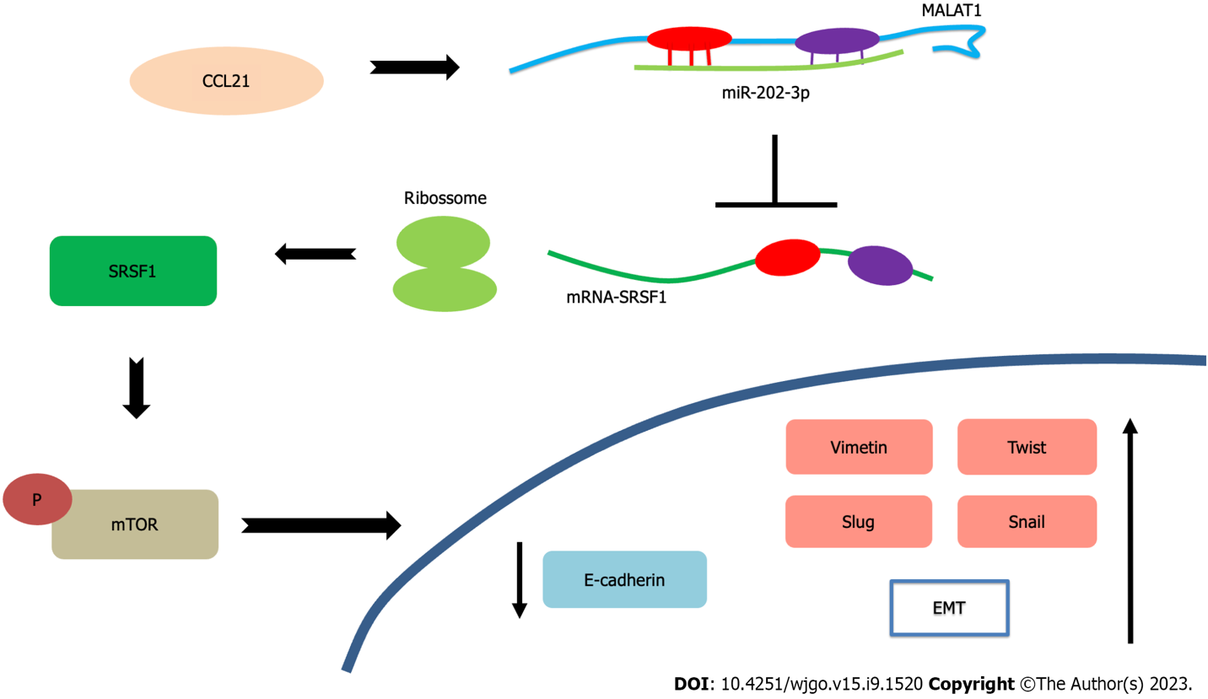
Figure 2 MALAT1 expression is influenced by protein CCL21. MALAT1 sponges miR-202-3p, then SRSF1 mRNA (serine and arginine-rich splicing factor 1) is translated in protein and activates mammalian target of rapamycin pathway improving epithelial-mesenchymal transition (EMT) factors and decreasing E-cadherin expression. EMT: epithelial-mesenchymal transition; MALAT1: Metastasis-associated lung adenocarcinoma transcript 1; SRSF1: serine and arginine-rich splicing factor 1; mTOR: Mammalian target of rapamycin.
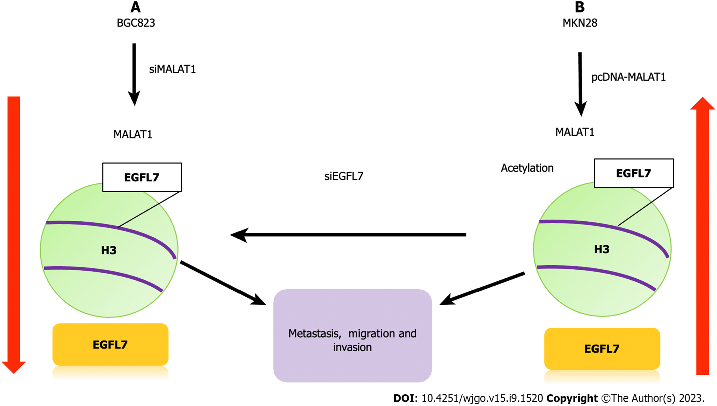
Figure 3 MALAT1 modulates acetylation in promoter region epidermal growth factor-like domain-containing protein 7 located in histone H3. A: Transfection of small interfering MALAT1 reduces acetylation on promoter region of EGFL7 gene (Epidermal growth factor-like domain-containing protein 7) ,decreasing metastasis, cell invasion and migration; B: Plasmid cloning DNA-MALAT1 transfection increases EGFL7 acetylation and protein expression, promoting migration, invasion, and metastasis of GC cells. EGFL7: Epidermal growth factor-like domain-containing protein 7; MALAT1: Metastasis-associated lung adenocarcinoma transcript 1; siMALAT1: Small interfering RNA MALAT1; pcDNA-MALAT1: Plasmid cloning DNA-MALAT1; siEGFL7: Small interfering RNA EGFL7.

Table 1 MALAT1 overexpression and clinical characteristics in GC patients
Samples | Sample | Clinical implications | Ref.
61 GC/DM, 50 GC/NDM, 36 C | Plasma, tissue | Staging  Metastasis | Xia et al^{[38]}
150 GC, 15 peritumoral paraffin-embedded | Tissue | OS  PFS | Li et al^{[49]}
78 GC, 78 NTAT | Tissue | Staging  LNM | Li et al^{[52]}
60 GC, 60 NTAT | Tissue | Staging  ]LNM  Tumor size | Zhang et al^{[53]}
20 GC, 20 NTAT | Tissue | Metastasis | Chen et al^{[54]}
70 GC, 70 C | Serum | Staging | Lu et al^{[39]}
89 GC, 89 NTAT | Tissue | LNM  Tumor size | Yan et al^{[32]}
64 GC, 64 NTAT, 64 C | Tissue, plasma | Metastasis | Zhu et al^{[33]}
30 GC, 30 NTAT | Tissue | Vascular invasion  Lymphatic invasion | Esfandi et al^{[30]}
37 GC, 37 NTAT | Tissue | Staging | Li et al^{[34]}
30 GC, 30 NTAT | Tissue | OS | Dai et al^{[35]}
24 GC, 24 NTAT, 24 GC/OXA | Tissue | Chemoresistance | Zhang et al^{[36]}

C: control samples without cancer; GC: gastric cancer patients; GC/OXA: gastric cancer patients treated with oxaliplatin; GC/DM: gastric cancer patients with distant metastasis; CG/NDM: gastric cancer patients withoutmetastasis; LNM: lymph node metastasis; OS: overall survival; NTAT: nontumoral adjacent tissues of GC patients; PFS: progression-free survival.

Table 2 MALAT1 molecular mechanism in GC
Cell line | Molecular interactions | Main discoveries | Ref.
MKN28, SGC7901, BCG823, GES1 | EGFL7 | MALAT1/EGFL7 axis promotes metastasis and cell invasion | Deng et al^{[46]}
MKN45, AGS, GES1 | EZH2/PCDH10 | MALAT1 recruits EZH2 to inhibit the synthesis of cadherin PCDH10, promoting metastasis | Qi et al^{[55]}
SGC7901,  MKN 45, BGC823  CTC141, CTC105  GES1 | miR-122/IGF1R | miR-122/IGF1R axis causes dysregulation of MALAT1, increasing cell invasion and migration of cells | Xia et al^{[38]}
SGC7901, MKN45, BGC823, AGS, SGC7901NM, SGC7901M, GES1 | E-cadherin, vimentin, SLUG, SNAIL, TWIST | MALAT1 contributes to cell migration, invasion, and proliferation by upregulating EMT markers and downregulating E-cadherin | Chen et al^{[54]}
MKN28, MKN74,  AGS | RASSF6, β-catenin | Dysregulation of MALAT1 improves the expression of β-catenin and other EMT markers, promoting metastasis | Lee et al^{[56]}
BGC823, SGC7901, HEK293T, GES1 | UPF1 | Overexpression of MALAT1 causes hypermethylation of the UPF1 promoter, increasing cell migration, invasion, and proliferation | Li et al^{[57]}
BGC823, SGC7901, MKN45, AGS, BGC803, MGC803, GES1 | VE-cadherin/β-catenin, ERK/MMP, FAK/paxillin | MALAT1 promotes angiogenesis by through vasculogenic mimicry | Li et al^{[49]}
BGC823, SGC7901, MKN45, MKN28, GES1 | miR-1297/HMGB2 | MALAT1/miR-1297 increases HMGB2 protein, promoting cell invasion and proliferation of cells | Li et al^{[52]}
SGC7901, SGC7901/VCR, BGC823 | miR-23b-3p/ATG12 | MALAT1/miR-23b-3p, promotes drug resistance via the ATG12 protein | YiRen et al^{[37]}
SGC7901, MKN45, MKN28, GES1 | miR-202/GLI2 | MALAT1/miR-202, increases GLI2 expression, inducing tumor progression and cell proliferation | Zhang et al^{[53]}
BGC823, SGC7901, GES1 | Vimentin, E-cadherin | MALAT1 decreases E-cadherin and increases vimentin expression, promoting EMT | Yang et al^{[58]}
BGC823, HGC27, SGC7901, GES1 | miR-183/SIRT1, PI3KCA/AKT/mTOR | MALAT1/miR-183 increases SIRT1 protein expression, increasing cell viability, and inhibiting cell apoptosis | Li et al^{[59]}
MGC803, GES1 | miR-181a-5p/AKT3 | MALAT1/miR-181a-5p increases AKT3 protein expression, promoting cell proliferation and inhibiting cell apoptosis | Lu et al^{[39]}
MKN45, SGC7901, GES1 | Vimentin, E-cadherin, SOX2 | MALAT1 increases cell stemness via the SOX2 protein, and promotes metastasis | Xiao et al^{[60]}
BGC823, HGC27  MKN45, AGS,  GES1 | IL-21R/miR-125a | MALAT1/miR-125a increases IL-21R expression, increasing cell invasion | Yan et al^{[32]}
AGS, SNU1 | PI3KCA/AKT | MALAT1 contributes to cell proliferation, invasion, and migration through the PI3KCA/AKT pathway | Zhu et al^{[33]}
MKN45, MKN28, MGC803, MGC803/CDDP, HGC27, NCIN87  AGS, GES1 | PI3KCA/AKT | MALAT1 increases PI3KCA, AKT and STAT3 activity, promoting resistance to cisplatin | Dai et al^{[35]}
SGC7901, BGC823, GES1 | miR-22-3p/ErbB3 | MALAT1/miR22-3p inhibits cell apoptosis | Li et al^{[34]}
CTC141, CTC105, MKN45, GES1 | miR-204/MAP1LC3B/TRPM3 | MALAT1/miR-204 increases the expression of LC3B and TRPM3, promoting autophagy | Shao et al^{[18]}
SGC7901, BGC823, SGC7901/OXA, BGC823/OXA | miR22-3p/ZFP91 | MALAT1 increases resistance to OXA | Zhang et al^{[36]}
SGC7901, SGC7901/CDDP | miR-30e/ATG5 | MALAT1 acts as a ceRNA to miR-30e, raising cisplatin resistance and autophagy via the miR-30e/AGT5 axis | Zhang et al^{[61]}
SGC7901, MGC803, HEK293T | CCL21,  miR-202-3p/SRSF1,  SRSF1/mTOR | MALAT1 promotes EMT through miR-202-3p/SRSF1/ mTOR | Fu et al^{[45]}

AKT: erine/threonine-protein kinase; ATG5: Autophagy related 5; ATG12: autophagy related 12; CCL21: C-C Motif Chemokine Ligand 21; ceRNA: Competitive endogenous RNA; EGFL7: Epidermal growth factor-like domain-containing protein 7; ERBB3: Erb-b2 receptor tyrosine kinase 3; ERK: Extracellular signal-regulated kinase; EMT: Epithelial-mesenchymal transition; EZH2: Enhancer of zeste 2 polycomb repressive complex 2 subunit; FAK: Focal adhesion kinase; GLI2: GLI family zinc finger 2; HMGB2: High mobility group box 2; IGF1R: insulin like growth factor 1 receptor; IL-21R: Interleukin 21 receptor; MALAT1: Metastasis-associated lung adenocarcinoma transcript 1; MAP1LC3B: Microtubule Associated Protein 1 Light Chain 3 Beta; mTOR: Mammalian target of rapamycin; MMP: Matrix metalloproteinases; OXA: oxaliplatin; PCDH10: Protocadherin 10; PI3KCA: Phosphatidylinositol-4,5-bisphosphate 3-kinase catalytic subunit alpha; RASSF6: Ras association domain family member 6; SIRT1: Sirtuin 1; SOX2: SRY-box transcription factor 2; SRSF1: Serine and arginine-rich splicing factor 1; STAT3: Signal transducer and activator of transcription 3; TRPM3: Transient receptor potential cation channel subfamily M member 3; UPF1: UPF1 RNA helicase and ATPase; ZFP91: Zinc finger protein 91.

Published by Baishideng Publishing Group Inc
7041 Koll Center Parkway, Suite 160, Pleasanton, CA 94566, USA
Telephone: +1-925-3991568
E-mail: bpgoffice@wjgnet.com
Help Desk: https://www.f6publishing.com/helpdesk
https://www.wjgnet.com

© 2023 Baishideng Publishing Group Inc. All rights reserved.

